# 

## IND-G-007

**EASR guidance:**

Version 1.0 August 2025

**Registration activity**

**Manufacturing of wood products**

# Contents

Introduction 3

What activity does this guidance apply to? 3

This guidance does not apply to: 3

Description of manufacturing of wood products activities 4

Diagram 1: Overview of the wood manufacturing process 5

Environmental controls 6

Site design, infrastructure and process controls 6

Process buildings 6

External yard area 6

Conveyors 7

Bulk Storage 7

Storage in totally enclosed containers and/or silos 7

Controls to achieve good combustion 8

Combustion start-up and shutdown emissions 9

Emissions controls and dispersion 9

Diagram 2: Examples of stack heights and distances 12

Abatement 13

Management techniques 13

Maintenance 14

Operator training 15

Resource use and efficiency 15

Raw materials 15

Water 16

Waste 16

Heat 16

Energy 16

Interpretation of terms 17

Disclaimer 18

If you would like this document in an accessible format, such as large print, audio recording or braille, please contact SEPA by emailing [equalities@sepa.org.uk](mailto:equalities@sepa.org.uk)

# 

# Introduction

This document provides information and guidance for anyone undertaking the manufacturing of wood products which may be authorised under the Environmental Authorisation (Scotland) Regulations (EASR). It should be read alongside the standard conditions for this activity.

# What activity does this guidance apply to?

This guidance applies to the manufacturing of wood products, with a throughput in any 12 month period that is likely to exceed one of the following:

* 10,000 m³ wholly or mainly of wood which is only sawn; or
* 1,000 m³ of wood which is sawed and/or drilled, sanded, shaped, turned, planed, shredded or cured.

# This guidance does not apply to:

The following related activities require a permit from SEPA:

* Any chemical treatment of wood including the preserving of wood or wood products with chemicals.
* Manufacture of wood-based panels of fibreboard, orientated strand board or particle board with a production capacity greater than 600 m³.

The following activities may be regulated by Local Authorities – please contact your relevant Local Authority for further information:

* Using waste wood for a purpose that isn’t incineration / burning;
* Impregnation of wood with solvents;
* Sites with a throughput of 10,000 m³ or less where wholly or mainly of wood which is only sawn; or
* Sites with a throughput of 1,000 m³ or less where wood is sawed and/or drilled, sanded, shaped, turned, planed, shredded or cured.

# Description of manufacturing of wood products activities

The processes covered by this guidance range from sawmills cutting sawn logs to the manufacture of furniture where, for example, MDF is worked.

A wood manufacturing plant generally comprises the following steps which can also be seen in Diagram 1 on the next page:

* Machining operations such as sawing, drilling, sanding, shaping, turning, planing, shredding, de-barking or chipping or other size reduction of soft or hard wood.
* Arrestment of wood particles in cyclone(s) or bag filter(s). Reference to wood particles in this guidance document includes wood shavings, wood powder, wood dust, wood chips and sawdust. Composite material such as chipboard and MDF (medium density fibreboard) which comprise mainly of wood are also included in this guidance.
* Kiln drying of wood product.
* Transfer of various sized wood products for further processing, bagging, stockpiling, storage or for transport off site.

### Diagram 1: Overview of the wood manufacturing process

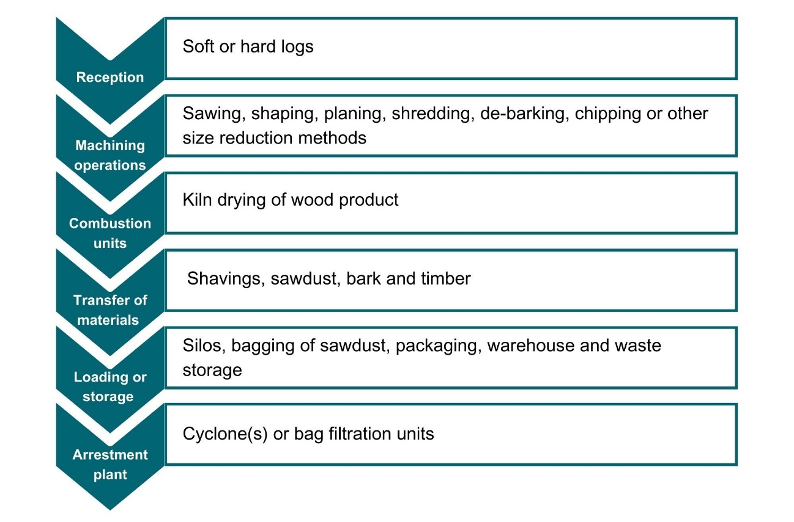

# Environmental controls

It is expected that the methods described in this section are utilised to control emissions from wood product manufacturing and associated activities. Where other methods are used, they should offer at least an equivalent level of environmental protection.

Containment and arrestment are considered the best ways to control dust from wood product manufacturing activities. Ensuring that good combustion is achieved helps control emissions from any associated combustion activities.

## Site design, infrastructure and process controls

### Process buildings

* Process buildings should be as dust tight as possible and fitted with self-closing doors and close-fitting entries and exits for conveyors.
* Where local exhaust ventilation is used within a building, dust arrestment of these emissions will be necessary.

### External yard area

* Surfaces subject to vehicle movements should have a consolidated surface which is kept in good repair.
* Thought should be given to the site layout to minimise vehicle movements and the double handling of dusty raw or waste materials.
* A wheel-wash for vehicles leaving the site may be necessary.
* Internal and external house-keeping and cleaning should be to a high standard – there should be no deposits of wood particles on or in process buildings, equipment, etc.
* Spillage of wood particles should be cleared up immediately, preferably by wet handling methods, or have dust suppressants applied if immediate clear-up isn’t possible.

### Conveyors

* Conveyors must not be overloaded.
* Drop-heights from conveyors should be minimised.
* Discharge points from conveyors should be fitted with a chute or similar equipment.
* Conveyor belts and surrounding areas should be kept clean and fitted with an effective means of keeping the return belt clean e.g. belt scrapers fitted at all head drum returns with catch plates fitted to contain falling.
* Conveyors must be protected from wind whipping by side enclosures e.g. wind boards.
* Where dust emissions from conveyors are visible, dust suppression equipment should be used or the plant should be vented to suitable arrestment equipment.

### Bulk Storage

* Stockpiles of wood particles other than wood dust should be screened on at least 3 sides and from above to prevent escape.

### Storage in totally enclosed containers and/or silos

* Wood dust must be stored in silos or other enclosed containers.
* The conveyance and handling of wood dust and wood particles must be carried out using pneumatic or enclosed handling systems.
* Displaced air from handling systems should be vented to cyclone(s) or bag filter(s).
* Waste wood product must be removed from the site in totally enclosed containers to prevent the escape of particulates to air.
* Storage silos and fixed containers should be equipped with audible or visual high-level alarms to warn of over filling.
* Storage silos or containers should be fitted with a pressure relief valve and a dust filter system with a suitable air flow capacity.

# Controls to achieve good combustion

Combustion plant may be in use for heat or as back-up/ancillary power. This type of combustion plant requires an additional authorisation either under Schedule 27 Medium Combustion Plant of EASR (plant with a net rated thermal input of between 1 and 50 megawatts) or Regulation 1 of Chapter 1 in Schedule 26 of EASR (combustion plant which generate electricity on the same site with an aggregated rated thermal input of 1 MW or more).

* The aim is to prevent any visible air borne emissions from any part of the process.
* Emissions from combustion processes should be free from smoke during normal operations.
* Emissions of carbon monoxide and other hydrocarbon emissions should be limited through good combustion of fuel and taking steps to avoid incomplete combustion.
* Sulphur oxides must be limited by using suitable low sulphur fuels compliant with the sulphur content of liquid fuels regulations.
* Nitrogen dioxides must be limited by using a short flame, low nitrogen fuel and a low temperature in the dryer.
* Fuel should be stored under cover to keep fuel dry.
* Different feedstock types (for example offcuts, briquettes, wood chips and dust) should be stored and fed separately to improve control of the combustion conditions.
* The following should be managed and controlled:
  + fuel content and its feed rate;
  + primary and secondary air;
  + temperature in the combustion chamber; and
  + oxygen levels.
* Flue gases should be recirculated to assist optimum combustion and reduce emissions of nitrogen oxides (NOx).
* Automatic fuel feed systems should be used where practical to prevent the emission of smoke and other pollutants.

## Combustion start-up and shutdown emissions

* The number of combustion plant start-ups and shutdowns should be kept to a minimum.

## Emissions controls and dispersion

Emissions that require control are mainly wood particles (including dust, chips and shavings) and odour. The aim must be to prevent any visible airborne wood particles.

The following parts of the process may give rise to wood particles:

* Machining operations such as sawing, drilling, sanding, shaping, turning and planing;
* Transfer and containment of wood particles created by sawing/machining operations;
* Stockpiles or storage containers;
* Arrestment plants;
* Bagging of sawdust or small wood chips.

Emissions from combustion plant connected to the manufacturing of wood products which require to be controlled include:

* dust,
* carbon monoxide,
* odour,
* oxides of nitrogen, and
* total volatile organic compounds.
* All reasonable steps should be taken to ensure there are no visible dust emissions from any plant, conveyor, transfer point or stockpile to ensure there are no visible emissions beyond the boundary of the authorised place.
* Dust emissions must be prevented by either containment or enclosure of dusty processes.
* Emissions from a stack need sufficient dispersion and dilution in the atmosphere so that they do not ground at concentrations harmful to human health or the environment.
* Flues and ductwork should be cleaned regularly so that a build-up of material does not affect emissions and their dispersion.
* Sufficient dispersion should not be impaired by low velocity or deflection:
* the stack(s) exit must be vertical,
* do not use a cap or other restriction at end of stack; and
* a cone can be useful to air dispersion.
* Emission stacks for connected activities to manufacturing wood products should have a height as follows:
* for a stack located on a building, the stack height should be greater than or equal to 3 metres above the building’s roof ridge height; or
* for a stack located separately to any building, the stack height should be great than or equal to 3 metres above the ground; and
* all stacks should be at least the same height of any building which is located within a distance of 5 times the uncorrected stack height.

Emission stack height examples:

* A stack exits through the roof of a building with a roof ridge height of 6 metres. The stack will need to be tall enough to extend to at least 9m from the ground line of the building so that it is 3 metres above the roof ridge. As it exits through the roof, the stack won’t need to be 9 metres long itself, just long enough to reach a 9 metres height from the building ground-level.
* A stack stands beside the building which it serves. The building roof ridge height is 6 metres. In this case the stack will need to be at least 9 metres tall.
* In both the above cases, there is another building located within 5 times the uncorrected stack height i.e. 5 x 9 metres = 45 metres. This building has a roof ridge height of 12 metres. Both stacks will need to be extended a further 3 metres in order to have a corresponding height of this additional building.

Diagram 2 below shows examples of stack heights and distances from other buildings as described on the previous page.

### Diagram 2: Examples of stack heights and distances

## A diagram illustrating stack heights and distances and when they should be used. It is a visual representation of the information provided on the previous page.

* Stack vents and process exhaust flues and ductwork should be cleaned as part of a routine maintenance programme to prevent accumulation of materials
* Where dispersion is necessary the target exit velocity should be 15 m/second under normal operating conditions. Avoid restrictions at the stack exit that may impair exit velocities.

## Abatement

* Emissions to air of particulates should be controlled with bag filter(s) or cyclone(s) if the wood being processed has a water content above 20% of the solid content by weight or is comprised of large particles.
* Wood dust and wood particles that may be affected by wind must be collected and ducted to the cyclone(s) or bag filter(s).
* An alarm system must be in place to alert when arrestment plant fails or malfunctions, providing visual or audible notifications.

# Management techniques

Good management techniques, training and well-maintained infrastructure are key to prevent and limit the consequences of accidents which could have an impact on the environment. For example, bunding should be used around liquid storage to contain any spillages, but good management and maintenance would take this a step further by ensuring that the integrity of the bunding is checked regularly to prevent leaks, and deliveries and movements around the site are well controlled. This will enable you to comply with environmental regulations, avoid incidents, and avoid any costs incurred through loss of resources.

* Effective control of emissions starts with proper management, supervision and training for process operators.
* Implement an environmental management system to help identify and provide a systematic approach to manage, monitor and control your environmental issues and maintain efficiency. These can be certified through ISO 140001, BS8555 or EMAS (Eco-Management and Audit Scheme) but can also be in-house.
* Develop and maintain an emergency response plans e.g. specific actions for preventing and mitigating spills or runoff that may affect water bodies. For best practice and guidance [read the CIRIA Guide to Containment Systems for the prevention of pollution (C736F)](https://www.ciria.org/ItemDetail?iProductCode=C736F&Category=FREEPUBS).

## Maintenance

Maintenance can be categorised as ‘preventative’ or ‘corrective’ (also known as ‘reactive’). Preventative maintenance includes regular planned checks, servicing and maintenance of equipment to prevent or reduce failures and breakdowns which can lead to pollution incidents, safety concerns and costly downtime. Corrective maintenance includes identifying and repairing a fault once it has occurred with the aim of restoring equipment or systems to their optimum operational condition(s).

* All aspects of the activity plant, buildings and equipment should be properly maintained and there should be a written maintenance programme with a record that the maintenance has been carried out.
* Equipment should be used properly, and preventative maintenance carried out and ensuring that operators know what to do in the event of an incident which may cause emissions from the activity.
* Spares and consumables should be held on site so that rapid repairs can be carried out and there is no temptation to continue operating with ineffective emission controls in place.
* Visual inspections of transport ducting should be undertaken to prevent any build-up of wood dust or wood particles.
* Where arrestment equipment is installed, it should be inspected at least once a day to ensure correct operation and identify any malfunctions. Depending on the type of arrestment plant this should include:
  + identification of any leaks in air handling equipment and ductwork in the case of combustion and arrestment equipment, the inspection should include verification of the operation of any continuous monitoring equipment, the presence of any blockages and also identification of any leaks of either air or liquid.

## Operator training

* Staff at all levels need to have training and instructions as to their duties to control emissions from the activity. This should include awareness of the SEPA registration requirements and actions to take in the event of incidents that may result in emissions from the activity.
* A training record should be kept for each member of staff.

## Resource use and efficiency

Best practice for resource use and efficiency is to review and implement any potential opportunities to reduce emissions and wastes. In addition to reducing the impact on the environment, you will also benefit because resource efficiency is also about:

* reducing costs (raw material and waste disposal);
* maximising output of product or service from a given level of materials and energy (competitive advantage);
* finding an outlet for surplus materials therefore removing them from the waste chain;
* helping Scotland achieve its goal of becoming a zero waste society;
* reducing pollution risks; and
* avoiding reputational impacts.

Resources include water, raw materials, energy, fuel and wastes used and produced throughout a regulated process. These can be manged in the following ways:

### Raw materials

Raw material use should be managed by tracking stores and ensuring that all resources are stored appropriately to avoid contamination, spoilage or leaks. Automatic dosing equipment should be considered to ensure that optimum measured quantities are used throughout the process. LEAN methodologies that focus on reducing waste could be beneficial.

### Water

Water should be stored in adequate containers and any pipework and taps maintained to avoid leaks and evaporation. Where possible use rainwater harvesting and recycled water.

### Waste

Ensure waste is managed in line with the waste hierarchy (prevention > prepare for reuse > recycle > recover value > disposal). Segregate any waste and store appropriately to ensure that it can be managed as high up the hierarchy as possible.

### Heat

Where heat is used or generated, ensure that optimum temperatures are maintained during the process; buildings, pipes and tanks should be insulated to minimise heat loss, and where possible any heat captured and used elsewhere.

### Energy

Ensure energy is used efficiently across the site by monitoring energy use, ensuring any lighting, motors, compressors or other equipment is well maintained and working at optimum, rather than maximum, levels. Consider replacing with more energy efficient equipment during upgrades. Servicing to manufacturer’s recommendations and preventative maintenance, instead of only reactive maintenance after plant faults, are also important in ensuring equipment works optimally.

# Interpretation of terms

|  |  |
| --- | --- |
| **Term** | **Definition** |
| arrestment plant | Equipment / plant used to mitigate the effects of emissions. |
| dust | Suspended solid particles and liquid droplets suspended in air which may be deposited on surfaces and may cause air pollution and/or nuisance. |
| environmental harm | (a) Harm to the health of human beings or living organisms,  (b) Harm to the quality of the environment, including:  (i) harm to the quality of the environment taken as a whole,  (ii) harm to the quality of air, water or land, and  (iii) other impairment of, or interference with, ecosystems,  (c) Offence to the senses of human beings,  (d) Damage to property, or  (e) Impairment of, or any interference with, amenities or other legitimate uses of the environment. |
| event | * Any accident which has caused or could cause environmental harm; or * Any malfunction, breakdown or failure of plant, infrastructure or techniques which has caused or could cause environmental harm; or   Force majeure or action taken to save human life or limb. |
| normal operation | Operation of the authorised activities excluding start-up and shut-down periods. |
| SEPA officer | an officer authorised under section 108 of the Environment Act 1995. |
| shut-down | The process of shutting down of all or part of a process within an authorised activity so that stable operating conditions are no longer reached. |
| start-up | The starting or restarting of all or part of a process following shutdown within an authorised activity before reaching minimum stable operating conditions. |
| wood | Includes any product consisting wholly or mainly or wood. |
| wood particles | Includes wood shavings, wood powder, wood dust, wood chips and sawdust and composite materials such as chipboard and medium density fibreboard. |

## Disclaimer

This guidance is based on the law as it stood when the guidance was published.

Whilst every effort has been made to ensure the accuracy of this guidance, SEPA gives no warranty, covenant or undertaking (express or implied) regarding the fitness for purpose of, or any error, omission or discrepancy in this guidance. Reliance on its contents and the contents of any websites that are linked to or from this guidance is entirely at the user’s own risk. SEPA is not liable for any loss or damage that may come from using this guidance. This includes:

* any direct, indirect and consequential losses
* any loss or damage caused by civil wrongs, breach of contract or otherwise.

SEPA reserves the right to depart from this guidance and take appropriate action as it considers necessary or appropriate. Operators are responsible for ensuring that they are compliant with the law. If necessary, independent legal / specialist advice should be sought.