




2024 Water Quality Monitoring Summary Report (LC-HRMS)
August 2026

Background
Following a successful pilot project in 2022, SEPA introduced an innovative new approach to water quality monitoring in 2024 to improve the identification and monitoring of chemicals in Scotland’s water environment. Using advanced liquid chromatography with high resolution mass spectrometry (LC-HRMS), SEPA can conduct large-scale analysis of diverse chemical compounds, including pesticides, pharmaceuticals, and veterinary medicines from the same sample at the same time. This represented a large step change in SEPAs analytical capabilities. The methodology uses smaller sample volumes and is more efficient, allowing larger sample numbers to be accommodated. In 2024, this new methodology allowed more than 400 chemicals to be analysed concurrently at approximately 300 locations across Scotland providing a more comprehensive understanding of Scotland’s aquatic ecosystems.

The 2024 surface water monitoring plan included a subset of locations from SEPA’s Classification network due to be monitored during 2024 (Figure 1). The river and loch classification locations were grouped to ensure proportional coverage of different river and loch types, pressures and geographical coverage across Scotland. From each of these groups, a specific number of locations were randomly selected to ensure the proportional representation from each group in the monitoring plan was similar to the relative proportion of these groups in Scotland’s water environment. This was a different approach than had historically been used to design monitoring plans for these types of substances which was generally highly targeted to investigate areas of concern or areas where substances were expected to be found. At each river and loch location, four samples were planned, with one sample to be collected each quarter.

In addition to the main surface water monitoring plan, groundwater samples were also collected from a small subset of SEPA’s Classification network in 2024. This groundwater monitoring, focussing on higher risk regions, was undertaken as a precursor to a wider national groundwater monitoring plan for trace organics in future. Groundwater locations were sampled once in 2024.

This report presents a summary of the results of the 2024 surface water quality monitoring by LC-HRMS. This report provides a summary of the substances found at concentrations above the method detection limit (MDL), for the targeted analysis (quantitative) and suspect screening (estimated). Detailed results are presented in subsequent reports in this series, and the targeted analysis and suspect screening datasets are available upon request.

Figure 1. Water quality (LC-HRMS) sampling locations in 2024.
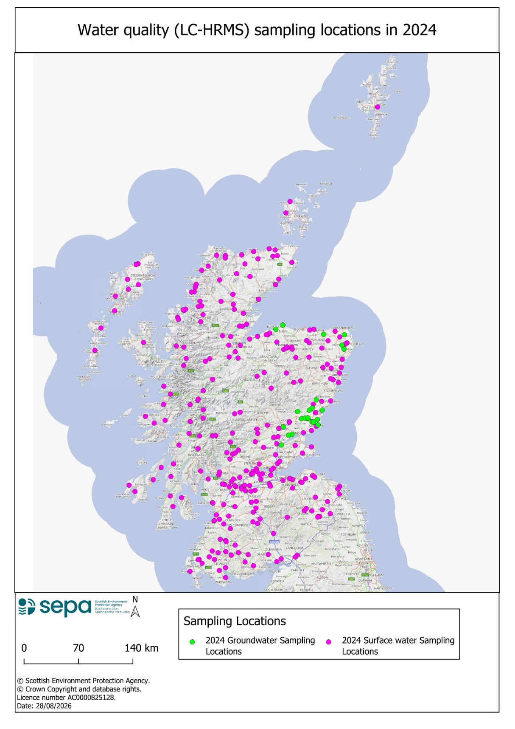

Surface Water Results
In 2024, water samples were collected from 274 surface water locations (238 rivers; 31 lochs and 5 canals) and analysed using SEPAs new LC-HRMS methodology (Table 1). Samples were analysed concurrently for 18 targeted substances (quantitative concentrations) and screened for 463 suspect substances (estimated concentrations when reported above MDL). In total 820 surface water samples were analysed (762 rivers; 44 lochs and 14 canals).

Table 1. Surface water summary statistics.
Statistic | Targeted Analysis (Quantitative) | Suspect Screening (Estimated) | Total
Number of substances detected above MDL at least once in surface water samples | 14 | 86 | 99
% of substances detected above MDL at least once in surface water samples | 77.8% | 18.6% | 20.6%
Number of surface water locations with at least one substance detected above MDL (in at least one sample) | 113 | 178 | 205
% of surface water locations with at least one substance detected above MDL (in at least one sample) | 41.2% | 65% | 74.8%
Number of surface water samples with at least one substance detected above MDL | 331 | 226 | 405
% of surface water samples with at least one substance detected above MDL | 40.4% | 27.6% | 49.4%

The 20 most frequently detected substances in surface water in 2024 are presented in Table 2, 15 were pesticides (plant protection products or biocidal products) and five were pharmaceuticals.
Table 2. Top 20 most frequently detected substances in surface water samples in 2024
Rank | Substance | Main use | No. of detects
1 | Azoxystrobin* | Fungicide | 94
2 | Fenpropathrin* | Insecticide | 78
3 | Tebuconazole | Fungicide | 72
4 | Carbamazepine | Pharmaceutical | 71
5 | Flufenacet | Herbicide | 64
6 | Clarithromycin | Pharmaceutical | 62
7 | Fipronil | Pharmaceutical (Veterinary) | 59
8 | Metribuzin* | Herbicide | 46
9 | Erythromycin | Pharmaceutical | 38
10 | Flutolanil* | Fungicide | 36
11 | Boscalid* | Fungicide | 35
12 | Flutriafol* | Fungicide | 34
13 | Terbutryn* | Herbicide | 34
14 | Thiabendazole* | Fungicide | 31
15 | Oxadixyl* | Fungicide | 30
16 | Atorvastatin | Pharmaceutical | 29
17 | Dimethenamid* | Herbicide | 28
18 | Propyzamide | Herbicide | 28
19 | 2,4-D | Herbicide | 26
20 | Propiconazole* | Fungicide | 26
* Denotes substances for which estimated concentrations are reported

The most frequently detected substance in 2024 in surface waters was azoxystrobin, a broad-spectrum systemic fungicide, which was detected above MDL in 94 (11.5%) surface water samples. The most frequently detected pharmaceutical in surface waters in 2024 was carbamazepine, an antiepileptic medication, which was detected above MDL in 71 (8.6%) surface water samples. The top 20 most frequently detected substances in surface water account for approximately 70% of the total number of detections in surface water in 2024.

River locations (238; 87.2%) and river water samples (762; 92.9%) made up most of the surface water monitoring network in 2024. Azoxystrobin was the most frequently detected substance in river water samples and was detected above the MDL in 91 (11.9%) river water samples. The most frequently detected pharmaceutical in river water samples was carbamazepine, which was detected above the MDL in 66 (8.7%) surface water samples.

Samples were collected from five canals sites. Thirteen substances were detected at least once. Three of the top five most frequently detected substances in canal samples were pharmaceuticals, with carbamazepine and clarithromycin detected in five out of 14 canal water samples (35.7% of canal water samples).

Samples were collected from 31 loch sites. Eight substances were detected at least once and all but one were pesticides. The most frequently detected pesticide in loch water was azoxystrobin which was detected in three out of 44 loch water samples (6.8% of loch water samples). Imidacloprid, a veterinary medicine used in pets was detected in a single loch water sample.

Thirty-three substances were detected (above MDL at least once) at the Back Burn at the A6093 road bridge (near Haddington). This was the location where the highest number of substances were detected and it was also the location where the highest concentration of any substance was detected, metribuzin on the 6 June 2024 (estimated concentration of 1814.59 ng/l).

Groundwater Results
In 2024, groundwater samples were collected from 24 groundwater locations and analysed using SEPAs new LC-HRMS methodology (Table 3). Samples were analysed concurrently for 18 targeted substances (quantitative concentrations) and screened for 463 suspect substances (estimated concentrations when reported above MDL). One sample was collected from each location, giving a total of 24 samples.

Table 3. Groundwater summary statistics.
Statistic | Targeted Analysis (Quantitative) | Suspect Screening (Estimated) | Total
Number of substances detected above MDL at least once in groundwater samples | 3 | 19 | 22
% of substances detected above MDL at least once in groundwater samples | 17% | 4% | 5%
Number of groundwater locations with at least one substance detected above MDL (in at least one sample) | 7 | 11 | 13
% of groundwater locations with at least one substance detected above MDL (in at least one sample) | 29% | 46% | 54%
Number of groundwater samples with at least one substance detected above MDL | 7 | 11 | 13
% of groundwater samples with at least one substance detected above MDL | 29% | 46% | 54%

The 20 most frequently detected substances in groundwater in 2024 are presented in Table 2, 12 were herbicides and eight were fungicides.

Substances were detected in 13 out of the 24 groundwater samples. In total, 22 substances were detected, which were predominantly pesticides (herbicides and fungicides). This reflects the predominantly rural settings of the groundwater locations monitored in 2024.

Table 4. Top 20 most frequently detected substances in groundwater samples in 2024
Rank | Substance | Main use | No. of detects
1 | Atrazine | Herbicide | 5
2 | Oxadixyl* | Fungicide | 4
3 | Atrazine-Desethyl* | Herbicide | 3
4 | Azoxystrobin* | Fungicide | 2
5 | Boscalid* | Fungicide | 2
6 | Bromacil* | Herbicide | 2
7 | Chlortoluron* | Herbicide | 2
8 | Dimefuron* | Herbicide | 2
9 | Flutriafol* | Fungicide | 2
10 | Lenacil* | Herbicide | 2
11 | Metrafenone* | Fungicide | 2
12 | Tebuconazole | Fungicide | 2
13 | Bensulfuron-methyl* | Herbicide | 1
14 | Dimethenamid* | Herbicide | 1
15 | Flucarbazone* | Herbicide | 1
16 | Flufenacet | Herbicide | 1
17 | Flusilazole* | Fungicide | 1
18 | Isoxaben* | Herbicide | 1
19 | Linuron* | Herbicide | 1
20 | Myclobutanil * | Fungicide | 1
* Denotes substances for which estimated concentrations are reported

The substances detected in groundwater include substances classed as hazardous to groundwater: atrazine, bromacil, chlortoluron, flusilazole, flutriafol, linuron, myclobutanil, propiconazole, and tebuconazole.

The most commonly detected substance in the groundwater samples was atrazine, which was detected in five samples (21%) with a maximum concentration of 40.42 ng/l. Atrazine is a herbicide, which was banned in 2004 and is thus no longer approved for use as a plant protection agent in the UK. Its continued presence in groundwater reflects its relative persistence. However, atrazine’s degradation product, atrazine desethyl, was also detected in three samples. This indicates that biodegradation of atrazine is likely to be occurring.

The second most commonly detected substance in the groundwater samples was oxadixyl, which was detected in four samples (17%), with a maximum concentration of 8.75 ng/l. Oxadixyl is a fungicide, which was withdrawn in 2003 and is no longer approved for use as a plant protection agent in the UK. Its continued presence in groundwater reflects its relative persistence.

The substance detected at the highest concentration in the groundwater samples was the herbicide bromacil. Bromacil was detected in two samples (8%), with a maximum concentration of 77.08 ng/l. This is below the relevant drinking water standard, which is 100 ng/l. Bromacil was withdrawn in 2012 and is no longer approved for use as a plant protection agent in the UK. Its continued presence in groundwater reflects its relative persistence.

Future
The representative monitoring approach will be used again in 2025 for surface waters and for groundwaters.

If you would like this document in an accessible format, such as large print, audio recording or braille, please contact SEPA by emailing equalities@sepa.org.uk

