Special Agency Board meeting

25 November 2025

Quarter 2 financial monitoring report for period ending 30 September 2025

Purpose:
This report is to provide an update to the Board on the following areas:

Overall financial position
This is the second quarter financial report for 2025/26. Actual financial results for period 6 (1 April 2025 to 30 September 2025) show SEPA forecasting a break-even position to the year-end. This break-even position accounts for the additional pay award costs, the consequence of which, has increased vacancy targets for each portfolio.

Capital budget
The capital summary for the period ending 30 September 2025 is provided in section 4 of this report.

Recommendations:
The Board is asked to note:
- SEPA’s financial performance for the period ending 30 September 2025, which is based upon financial returns from portfolios.

Authors: Ian Bryce, Deputy Head of Finance, Rosaleen Burke, Head of Finance.
Corporate Leadership Team Sponsor: Angela Milloy Chief Officer Finance, Modernisation and Digital.
Date: October 2025

Table 1: Year to date (YTD) actuals and full year forecast
Income and expenditure account at 30th September 2025 | Year to date actual  £'000 | Year to date budget  £'000 | Year to date variance  £'000 | Forecast outturn  £'000 | Annual budget  £'000 | Forecast variance  £'000
Grant in Aid | 13,000 | 13,000 | 0 | 53,471 | 53,471 | 0
Charging Schemes | 51,130 | 51,125 | 5 | 56,487 | 56,770 | (283)
Other income | 590 | 391 | 199 | 1,841 | 1,501 | 340
Total income | 64,720 | 64,516 | 204 | 111,799 | 111,742 | 57
Staff costs | 36,101 | 35,634 | (467) | 75,515 | 75,205 | (310)
Other staff costs | 853 | 555 | (298) | 1,279 | 817 | (462)
Transport costs | 432 | 450 | 18 | 991 | 1,058 | 67
Supplies & services | 7,337 | 7,442 | 105 | 22,106 | 22,723 | 617
Property costs | 2,602 | 2,704 | 102 | 4,528 | 4,559 | 31
Depreciation/impairment | 3,690 | 3,690 | 0 | 7,380 | 7,380 | 0
Total operating costs | 51,015 | 50,475 | (540) | 111,799 | 111,742 | (57)
Operating surplus/ (deficit) | 13,705 | 14,041 | (336) | 0 | 0 | 0

Net results
- At period 6, variances are £0.3m- additional expenditure of £0.5m has been offset by additional income for £0.2m.
- Net results for the full year report a balanced forecast.

Total income - £111.8m
  - Total income for the full year is forecast at £111.8m, which is £0.06m more than full year budget.

Charging Scheme income - £56.5m
  - The full year charging scheme income forecast outturn at end September is £56.5m, which is £0.3m lower than budget.
  - The net variance includes:

- Applications: £0.2m positive variance in the applications forecast. This is due to an increase in waste applications offset by decreases across other media.
- Subsistence: £0.5m negative variance in the subsistence forecast. This variance is mainly due to reduced income from water and waste media.

Graph 1: Charging Schemes by media
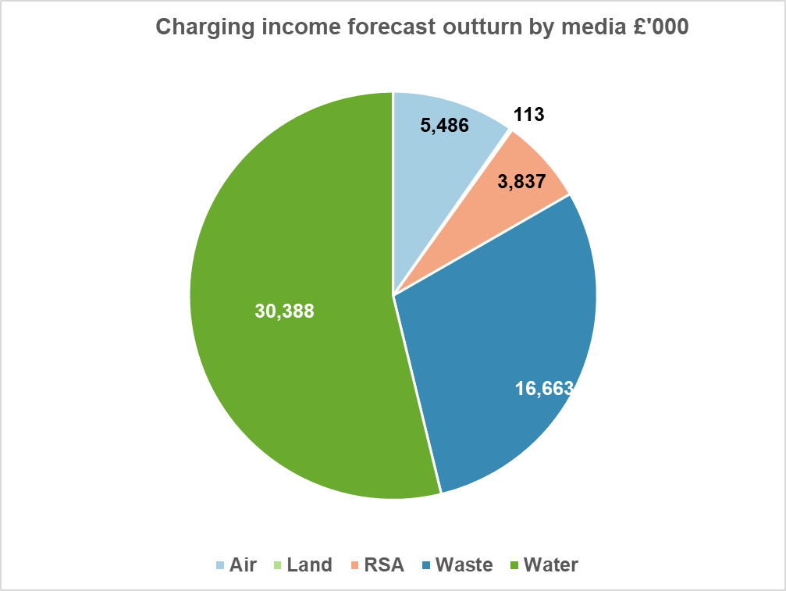
Graph 1 initialism: RSA – Radioactive Substances Activity

Other income - £1.8m
  - The full year other income forecast outturn is £1.84m, being £0.3m higher than the budget, mainly due to monies being returned to SEPA as result of unspent grants.

Revenue Grant in Aid (GiA) - £53.5m

Table 2: Grant in aid
 | Resource budget cash  £;000 | Resource budget non- cash  £’000 | Total  £’000
Base budget allocation 2025-26 | 42,400 | 7,377 | 49,777
Budget adjustments
Regulation systems | 995 |  | 995
Multi agency fish farm consenting | 261 |  | 261
Water Environment Fund (WEF) | 1,887 |  | 1,887
Flood Advisory Service | 150 |  | 150
Cleaner air (CAFS 2) | 30 |  | 30
Air quality (volcanic monitoring) | 28 |  | 28
Air quality (zephyre maint) | 12 |  | 12
ETS & Fgas | 331 |  | 331
Total adjustments | 3,694 | 0 | 3,694
Total revenue budget | 46,094 | 7,377 | 53,471

  - Revenue GiA for 2025/26 has increased by £3.7m since budget set following additional funds for WEF work, regulation systems, fish farm consenting and flood advisory service. The additional funds for fish farm consents and regulation monies were awarded following successful applications to Scottish Governments Public Service Reform (PSR) Invest to Save Fund.

Total revenue expenditure - £111.8m
  - Full year operating costs are forecast to be £111.8m, which is £0.06m higher than budget. The graph below provides a detailed breakdown by expenditure type.

Graph 2: Expenditure by type
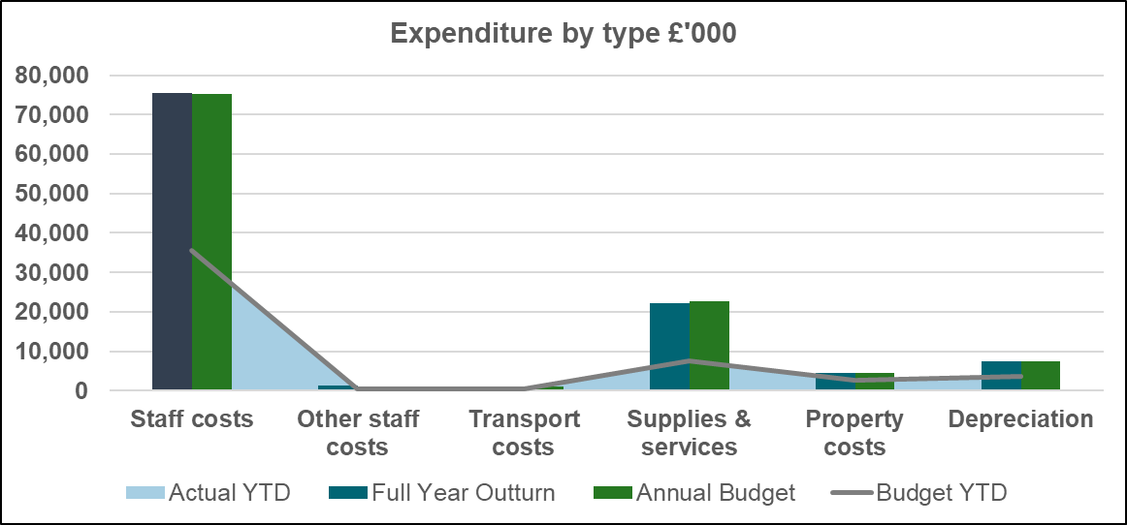

Staff costs
  - Budgeted staff costs represent 67% of total expenditure. The full year forecast for staff costs is £0.3m above budget; £1m lower than budgeted vacancy management savings are offset by £0.7m reduction in corporate costs.

Other staff costs
  - Other staff costs are currently forecasting an overspend of £0.5m mainly due to higher than budget forecast expenditure for temporary workers and recruitment costs. These costs are generally funded from vacancy savings, however with targets not currently being achieved they are funded from underspends in corporate costs.

Transport costs
  - Transport costs are forecast to have a full year underspend of £0.07m. This is the net movement due to reduced mileage claims primarily due to improved fleet provision.

Supplies and services
  - The full year forecast for supplies and services is currently reporting a forecast underspend of £0.6m. The underspend relates to budget movements between non-staff and staff expenditure lines to fund the pay award and potential in year budget pressures within some portfolios.

Property costs
  - The full year forecast for property costs is currently reporting an underspend of £0.03m, which mostly relates to utility and cleaning savings offset by overspends against maintenance.

Capital expenditure summary
  - SEPA’s capital budget provided by Scottish Government for the year is £5.64m. In year, SG confirmed funds of an additional £0.6m to support the creation of a foundational flood and coastal asset database for Scotland and £1m for wave buoy deployment, increasing the total capital budget to £7.21m.

  - The base budget was approved with an over commitment based on the historical knowledge that capital projects are liable to delays, slippage of spend or revision of original budget estimates during the procurement journey. The current forecast over commitment is £0.1m over budget, however, spend will be delivered within budget.

Table 3: Capital budget 2025/26
Function | Budget £'000 | Forecast £'000 | Main projects within function budgets
Digital transformation | 495 | 141 | Compliance project
Governance | 1,450 | 515 | Digital data architecture
Chemistry | 126 | 271 | Nutrients Analysers & labratory balances
Ecology | 66 | 199 | Microscopes & vacum systems
Environmental quality | 93 | 93 | Bathing waters signage
Info systems | 250 | 458 | High performance computing & laptop replacement
Info systems (digital) | 1,150 | 1,125 | Initigrated Authorisation Framework implementation
People systems | 70 | 70 | Applicant Tracking System
Finance systems | 50 | 50 | SaaS
Workspaces | 1,045 | 1,305 | Stirling Office dilapidations & fleet replacement
Hydrology | 3,398 | 3,096 | Gauging stations & flooding projects, flood & coastal asset database and wave buoy deployment
Savings to be identified | (983) | (113)
Totals | 7,210 | 7,210

  - At the end of period 6, there are 69 live projects with the main focus this year being the design phase of SEPA’s digital transformation, flood and hydrology, the continuation of the integrated authorisation framework system and work related to estates, especially the Stirling office.

Statement of financial position
  - The Statement of financial position is provided below.
Table 4: Statement of financial position
Statement of financial position | Period to September 2025  £'000 | Year to March 2025  £'000
Non current assets
Property, plant and equipment | 38,717 | 42,075
Intangible assets | 3,695 | 4,027
Assets under construction | 2,380 | 2,380
Employee retirement benefits | 0 | 0
Trade and other receivables | 232 | 232
Total non current assets | 45,024 | 48,714
Current assets
Trade and other receivables | 6,965 | 5,029
Cash and cash equivalents | 10,869 | 2,346
Total current assets | 17,834 | 7,375
Total assets | 62,858 | 56,089
Current liabilities
Trade and other payables | (6,197) | (13,683)
Provisions | (228) | (231)
Future Lease Payments | (508) | (1,306)
Total current liabilities | (6,933) | (15,220)
Total assets less current liabilities | 55,925 | 40,869
Non current liabilities
Provisions for liabilities and charges >1 year | (6,059) | (6,059)
Future lease payments | (5,475) | (5,475)
Total non-current liabilities | (11,534) | (11,534)
Total assets less total liabilities | 44,391 | 29,335
Taxpayers' equity and other reserves
General fund | 25,351 | 10,295
Revaluation reserve | 19,040 | 19,040
Total tax payers equity | 44,391 | 29,335

Recommendations
  - The Board is asked to note:

- SEPA’s financial performance for the period ending 30 September 2025, which is based upon financial returns from portfolios.

END

