



Chief Executive’s Report
June 2026

Contents

1. Introduction 2
2. Collaboration and partnership 6
3. Public Service Reform 12
4. Transformation 15
5. Focused on delivery 17
6. Spotlight on… 31

If you would like this document in an accessible format, such as large print, audio recording or braille, please contact SEPA by emailing: equalities@sepa.org.uk

Introduction
The last four months have been a period of continued progress, reflection, and forward momentum for the Agency. As we move into the summer months, our focus is firmly on delivering against our recently published Annual Operating Plan (AOP) for 2026/27.
As this is the final year of our current 2024-2027 Corporate Plan, this year’s AOP has particular significance. It not only sets a clear direction for the year ahead but also helps shape what comes next, in line with wider expectations around public service reform.
At the heart of this is our commitment to delivering our core services consistently and effectively, while evolving how we operate to meet future demands. Through the AOP, we will continue to protect and improve Scotland’s environment, support sustainable economic growth, and contribute to improved health and wellbeing across Scotland. Across the organisation, our portfolios are continuing to develop and embed their structures, ensuring that we are well-positioned not just to deliver our ambitions this year, but to support longer-term transformation.
This period has provided valuable opportunities to engage with colleagues, partners, and stakeholders. The Annual Colleague Survey, launched in March, created an important opportunity for colleagues to share their views and experiences. The insights will help us better understand our organisational culture and inform how we continue to evolve and improve. I was also fortunate to spent time with colleagues in Elgin, which was a valuable opportunity for open, face-to-face discussion.
Further engagements in March included the 22nd Annual Prosper Lecture in Aberdeen. Dr Angela Wilkinson, the Chief Executive and Secretary General of the World Energy Council, shared perspectives on the global energy transition and its implications for Scotland’s economy, industries and long-term competitiveness. This was followed by a day meeting Non-Departmental Public Body (NDPB) colleagues in one to ones and a thought-provoking Environment and Economy leaders’ group.
April marked a significant milestone for the agency as SEPA celebrated its 30th anniversary. This was an opportunity to reflect with pride on three decades of protecting and improving Scotland’s environment, and to look to ahead, with ambition to an impactful and innovative future. Our ongoing transformation is reshaping SEPA into a more modern, agile and digitally enabled organisation; capable of delivering smarter regulation and stronger partnerships. More detail on our anniversary activity is included in the ‘Spotlight on’ section.
Our anniversary month also created opportunities to engage with partners across sectors on emerging priorities and innovation. I attended the Institution of Civil Engineers (ICE) Scotland Fellows Breakfast Meeting, which explored the role of artificial intelligence (AI) in infrastructure, as well as the Scottish Water Regulating for Growth Conference in Edinburgh, which was a great opportunity to engage with regulators and colleagues from across the UK water sector.
Also in April, I was delighted to welcome John Wyllie as Head of Authorisations, a critical role within the Regulation, Business and Environment portfolio; and in May, Dr Richard Allan joined us as Chief Scientific Adviser. This is a new and important role that brings together leadership across data, evidence, monitoring, modelling and innovation.
This strengthened leadership is vital as we respond to Scotland’s most pressing environmental challenges. Flooding remains Scotland’s biggest climate adaptation challenge, and SEPA’s role as the nation’s flood forecasting and warning authority and strategic flood risk management authority places us at the centre of this agenda. I recently took part in the New Civil Engineer Flood Resilience Conference, held alongside the New Civil Engineer Water Conference in London, which reinforced the importance of resilience, innovation, and partnership in addressing these challenges.
Alongside flooding, increasing evidence of water scarcity highlights the need for a more holistic approach to building a water-resilient future. SEPA’s preparations have gone well for the start of the water scarcity season with the first water scarcity report successfully published on 7 May 2026. More detail on this can be found in our ‘Focused on delivery - Adapt’ section.
After a rigorous internal recruitment process, Kirsty-Louise Campbell – Chief Officer for Governance, Performance and Engagement (GPE) was appointed as Deputy Chief Executive (DCE). The DCE is a new role and will enable me to focus on external strategic reform and system wide change, while Kirsty-Louise will lead internal operational excellence, organisational capability and performance across the organisation. Kirsty-Louise will continue to lead our GPE portfolio, while also taking on the responsibilities of the DCE role.
May and June have been and continue to be busy with many positive engagements internally and externally. In May our Chair, Lisa Tennant, and I had the pleasure of meeting with Andy Kerr, the new Director General Net Zero, and Diarmuid O’Neill the outgoing Director of Environment and Forestry at the biannual assurance meeting.
I also attended the Kirking for the Seventh Session of the Scottish Parliament at St Giles Cathedral, Edinburgh. It was a rousing interfaith service to celebrate the next parliamentary session, attended by HRH The Duke of Edinburgh and both new and returning Members of the Scottish Parliament (MSPs).
We held an Agency Board site visit to Ayr which provided an opportunity to see first-hand the breadth and impact of our work - from bathing water monitoring to farm compliance. These visits bring to life the critical connection between policy and practice and demonstrate the strength of collaboration between colleagues, customers, and stakeholders in delivering environmental outcomes for Scotland.
More recently I attended the five agencies Chief Executives meeting, hosted by the Environment Agency in London on 3-4 June. This was quickly followed by a meeting with the First Minister, Depute First Minister and the new Cabinet Secretary for Public Service Reform at the SEC in Glasgow, with other public body leaders to learn more about the pace and expectation of Public Service Reform. The same week a site visit to Montrose & Brechin with the Environment & Economy Leaders Group to the South Esk Pioneer catchment programme to see strong collaboration, innovation and citizen focused delivery of Public Service Reform in action!
Engagements continued with attendance at the Royal Highland Show - two full days of stakeholder engagements, Political Party leader, MSP meetings, stakeholder receptions and the Cabinet Secretary’s reception - and to round off the month, co-chairing the European Heads of Environment Agencies Environmental Policy and Law Implementation Interest Group (EPLIG) meeting in Brussels on 26 June.
Finally, as the warmer weather of summer approaches, our bathing waters in Scotland become even more valued. Scotland’s 2026 bathing water season began on 1 June and will run until 15 September; further details can be found in the ‘Focused on delivery – Protect’ section. Designated bathing waters are important local spaces, supporting recreation, tourism and access to nature across Scotland, and I hope we all have the opportunity to enjoy them over the summer months.
This report showcases the achievements of our teams as they continue to deliver for Scotland with passion, purpose, and professionalism and pivot to simultaneously deliver on Public Service Reform.
For the future of our environment.

Collaboration and partnership
We recognise the impact of progressive partnerships and collaborative working across the public, private and third sectors, as well as with communities. We share service delivery so that we offer better outcomes more efficiently, and with a customer focus.
Strengthening waste carriers regime under EASR
On 1 April 2026, the new Environmental Authorisations (Scotland) Regulations 2018 (EASR) registrations for transporting waste, transporting your own waste, and acting as a broker or dealer went live. This marks a major milestone in the EASR programme and the culmination of several years of policy development, stakeholder engagement, and internal collaboration between policy and digital teams.
The result is a regulatory system for waste transport that is both simpler and stronger. It is now much clearer for customers and SEPA colleagues to identify which authorisation is required. The digital service efficiently processes around 99% of applications.
At the same time, SEPA now has a stronger regulatory position. We can more effectively refuse or revoke registrations where holders fail to comply with the conditions of their registration or with their wider duty of care obligations.
Significant Water Management Issues consultation
We recognise the importance of working in partnership and involving stakeholders, operators, the public and, communities in what we do. In December 2025, SEPA published the Significant Water Management Issues (SWMIs) consultation, setting out priorities for the water environment. The results of this consultation will inform the review and update of Scotland’s River Basin Management Plan (RBMP).
The consultation closed on 3 March 2026, with 99 responses received. Early analysis of findings show strong stakeholder support for the identified SWMIs and the high-level priorities of climate adaptation, nature recovery, and health and wellbeing. Notably, no respondents disagreed or strongly disagreed with including nature or health and wellbeing as overarching themes in the RBMP.
Further, more detailed analysis is now underway. The SWMI consultation can be viewed on our consultation page: Safeguarding Scotland’s Water Environment - Scottish Environment Protection Agency - Citizen Space
Hunterston B Power Station transfer of ownership
Ownership of Hunterston B Power Station transferred from EDF Energy Nuclear Generation Ltd to the Nuclear Decommissioning Authority (NDA) on 1 April 2026. This UK Government agreed transfer enables decommissioning by Nuclear Restoration Services Ltd (NRS), an NDA subsidiary.
This was an extremely complex task, with Hunterston B the first of the UK’s Advanced Gas-cooled Reactor (AGR) stations to go through this process. A coordinated, multi-agency approach - bringing together EDF, NDA, NRS, the Department for Energy Security and Net Zero (DESNZ), the Office for Nuclear Regulation (ONR), the Environment Agency (EA), and SEPA - ensured a seamless transition.
As part of the process, all environmental authorisations for the station, including the radioactive substances activities permit made under Environmental Authorisations (Scotland) Regulations 2018 (EASR), was successfully transferred to NRS. SEPA teams worked collaboratively across regimes to ensure all SEPA granted permits were in place on time. This places SEPA in a strong position to regulate the site through the next phase of decommissioning, maintaining environmental protection and public confidence.
SEPA Staff gain first-hand courtroom experience through mock trial
On 30 April, around 40 SEPA colleagues from across the organisation attended a mock trial at Stirling Sheriff Court. The event was organised by SEPA and delivered in partnership with the Scottish Courts & Tribunals Service and the Crown Office & Procurator Fiscal Service.
The mock trial was filmed and provided valuable, practical insight into court procedures and the experience of giving evidence as a SEPA witness. Colleagues took on a range of key roles, and the proceedings were presided over by a serving Sheriff who kindly volunteered their time. Feedback from participants has been very positive.
Work is underway to develop a training package using the filmed material. This will be made available to all SEPA colleagues, strengthening capability and confidence in giving evidence in court.
Farming and Water Scotland video
Karin Bloodworth, Team Manager, Regional Flooding Partnerships, and Andy Jardine, Environment Protection Officer, worked with Farming and Water Scotland on the North Esk to produce a video highlighting how we can support farmers and land managers to prepare for, respond to, and recover from flooding events: Working together to reduce flood impact - Farming and Water Scotland.
The video provides an overview of the practical tools and services we provide to help land managers understand their flood risk and build resilience as well as encouraging early engagement.
Developing DNA capabilities to support environmental monitoring in SEPA
We continue to make major advances in developing DNA methods to help transform our environmental monitoring. A successful knowledge exchange programme with the University of the Highlands and Islands (UHI) has delivered work across three main strands:
- Building in-house capability to use DNA to monitor fish in freshwater lochs for the first time.
- Exploring the use of DNA to monitor invertebrates in lochs, showing strong potential to replace more challenging current methods.
- Delivering a proof-of-concept study on microbial diversity in rivers across Scotland, complementing a larger study in England. This offers new insight into the biological impacts of emerging contaminants and provides new evidence to help diagnose and address the underlying causes of wider ecological impacts.
Interest in this area is growing across many partner organisations. On behalf of Co-ordinated Agenda for Marine, Environment and Rural Affairs Science (CAMERAS) partners, SEPA are leading a Scottish Environment, Food and Agriculture Research Institutions (SEFARI) fellowship project to develop a strategic route map for Scotland. This sets out the opportunities, challenges, and practical actions needed to accelerate the use of DNA-based monitoring tools.
The final report, due to be published in the week commencing 22 June 2026, makes recommendations for Scotland’s public sector and research community, highlighting the need to align with UK and international developments and to invest in standards, infrastructure and workforce capability.
Protecting fragile marine habitats
We are contributing to the protection of the Loch Creran Special Area of Conservation (SAC) and Nature Conservation Marine Protected Area (MPA) through our involvement in the Loch Creran Pressures and Activities Management Group, led by NatureScot.
Designated for its fragile serpulid reefs and horse mussel bed habitats, our involvement enables us to influence marine and coastal activities and fulfil our statutory responsibilities for regulated activities under the Conservation (Natural Habitats, &c.) Regulations 1994.
Air quality education programme
SEPA is supporting the continuation of the air quality education programme in 2026/27, delivered in partnership with the Glasgow Science Centre (GSC). This includes the Our Amazing Air Learning Lab and a dedicated event at GSC on Clean Air Day (18 June 2026).
The programme helps learners and educators build knowledge of air quality, health, and the environment, linking to wider climate science education in schools and at home. Since its launch in 2021, it has reached over 5,700 pupils across 14 local authorities, delivering around 70,000 learning hours.
The programme of work and the partnership with GSC provides a well-established and effective joint resource that can be delivered more widely across Scotland through existing education and community outreach programmes.
Clean Air Day is the UK’s largest air pollution campaign, bringing together communities, businesses, education and the health sector to raise awareness of the health impacts of air pollution and the actions people can take. SEPA will support GSC on 18 June 2026, with participating pupils attending themed activities to reinforce their learning.
Scotch Whisky Association
Following ongoing strategic engagement with the Scotch Whisky Association (SWA) throughout 2025/26, SEPA wrote to the SWA in March confirming that distillery residues can be classified as by-products, rather than waste, under Article 5 of the Waste Framework Directive when used as feedstock for anaerobic digestion.
This provides greater clarity for SWA members on the permitting requirements for this activity under EASR and builds on previous work undertaken by SEPA to assess the likely by-product status of distillery residues, by allowing analysis of robust primary data supplied by the SWA and the wider whisky industry. A further letter sent by SEPA in May reconfirmed the status of distillery materials put to other uses as previously agreed by SEPA, consolidating all previously agreed positions into a single communication. This provides clarity and continuity as we continue to support the sector. Further detail can be found on our website Non-waste anaerobic digestion less than 100 tonnes per day | Beta | SEPA.
Scottish Government & Ministry of Defence (MoD) partnership working - Export of used aquaculture nets to Ukraine
In late 2025, the Scottish Government’s Marine Directorate approached SEPA about the potential export of used aquaculture nets to Ukraine. These nets were identified for reuse in creating protective “safe corridors” over roads to prevent drone attacks on vehicles and used in areas of critical infrastructure such as schools and hospitals.
The nets, held in storage at the manufacturer’s facility, were no longer suitable for fish pens due to changes in pen design. In early 2026, SEPA worked with the Marine Directorate to assess their suitability for export for reuse and confirmed the regulatory approach with the Ministry of Defence in March, enabling rapid progress.
On 22 April, the Marine Directorate confirmed that the final shipment had left Scotland for Ukraine, bringing the total exported to 270 nets (around 300 tonnes). This collaborative approach delivered positive outcomes for both countries and the agencies involved.
SEPA host Joint Unit for Waste Crime & Partners
In February 2026, SEPA hosted a visit from the Joint Unit for Waste Crime (JUWC), alongside Police Scotland and Revenue Scotland. The JUWC is a multi-agency taskforce, working in partnership to tackle serious and organised crime in the UK waste industry. It is comprised of 11 enforcement organisations including SEPA and two partners that represent the waste industry.
The visit focused on sharing information, opportunities and insights on tackling environmental crime, including how partners are working together across the UK, both strategically and tactically. It provided an opportunity to showcase innovative techniques, tools, and new legislation used to detect, target, and disrupt waste crime, helping to protect the environment, communities, and legitimate businesses. There was also a focus on emerging risks and threats, supporting future regulatory and enforcement planning.
As part of the visit, multi-agency road stops were carried out on key routes between Scotland and England to target and detect any illegal waste movements. SEPA will continue to strengthen joint working with partners to tackle environmental crime.
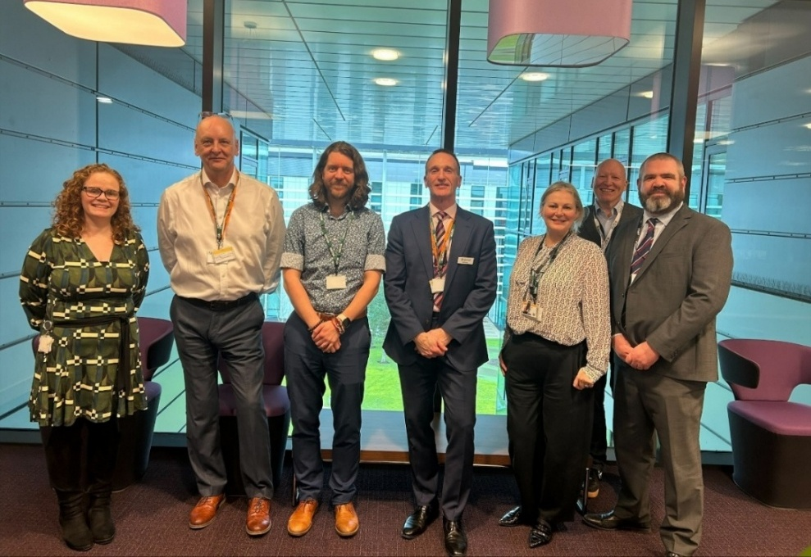
Figure 1: Joint Unit for Waste Crime partnership visit. Credit: SEPA

Legal engagement with the Environment Agency on cyber resilience and preparedness
SEPA’s Head of Corporate Legal and Leadership Support presented on cyber resilience and legal preparedness at the Environment Agency’s annual legal department conference in Birmingham on 23 April 2026. The presentation was well received, generating strong interest and questions, and forms part of ongoing collaboration and partnership working between the agencies’ legal teams. This is a good example of SEPA sharing knowledge and learning, while strengthening existing relationships with key partners.
Peat guidance
In March 2026, SEPA published revised guidance on the on-site management of excavated peat. This provides clarity for developers, planning authorities, and SEPA teams on when excavated peat, managed at its site of origin, becomes a waste management activity requiring authorisation. The guidance sets out clear criteria and conditions to support consistent application. Alongside SEPA’s role as a statutory consultee in planning, it will support positive environmental outcomes through proportionate regulation and oversight.

Public Service Reform
As a public service, we continue to respond effectively to the increasing pace of change, and we are committed to considering the best models for delivery of all our services. SEPA continues to work with other public sector bodies and communities to deliver services, with a focus on:
- Prevention: tackling issues early to reduce future risks and costs.
- Integration: ensuring services work together seamlessly across organisations.
- Efficiency: using resources wisely to deliver maximum value for communities.
SEPA engage with Scottish Sentencing Council for environmental offending sentencing guidelines
In February, SEPA met with the Scottish Sentencing Council to help inform its work on progressing sentencing guidelines in relation to environmental offending. We presented an overview of our decision-making considerations on appropriate enforcement action, our current priorities, the types of offending which we investigate and report for consideration of prosecution, and the impacts of such offending.
We also discussed equivalent sentencing guidelines in England and potential sentencing options proportionate to the scale of offending. This positive engagement will continue as the Scottish Sentencing Council progresses its work on these guidelines.
Road Stop Campaign
A year-long campaign, delivered in partnership with Police Scotland, Driver and Vehicle Standards Agency (DVSA), His Majesty’s Revenue and Customs (HMRC) and Driver and Vehicle Licensing Agency (DVLA), ran from May 2025 to April 2026. On average, 10–15 vehicles were checked at each stop, selected to meet partner priorities, with SEPA focusing on the illegal transportation of waste material for financial benefit without authorisation.
- Around 150 vehicles were stopped during the campaign.
- Advice and guidance were provided, with follow-up enquiries progressed.
- Awareness was raised of legal requirements for waste transport and duty of care.
- Six drivers obtained the required authorisation on the same day following SEPA intervention.
Achieving more through public sector collaboration
We are working in close partnership with Orkney Island Council to tackle sites where poor waste storage harms local amenities, including unauthorised farm waste, derelict buildings and neglected land.
Each organisation applies its statutory powers: the Council addresses land condition and visual impact through Amenity Notices under the Town and Country Planning (Scotland) Act 1997, while SEPA regulates waste management activities and ensures compliance with environmental controls.
This joined-up approach delivers efficient and effective outcomes—bringing sites back into compliance, improving local amenity, and often resolving issues without the need for formal enforcement. Joint working will continue to target priority sites and secure further improvements for communities.
Pioneer catchment initiative
The Public Service Reform pioneer catchment initiative continues to promote and trial a ‘resilience first’ approach to landscape scale change in the South Esk and Dee catchments. SEPA plays a lead role in the South Esk due to the mix of flooding and agriculture related risks and opportunities in that catchment. Work has focussed on:
- Trialling a new engagement approach with farmers, focused on business resilience and recognising that measures to support farming can deliver wider benefits across the catchment
- Working with Scottish Government agriculture policy colleagues to explore the potential for more effective funding approaches in the short and medium term
- Establishing a pioneer catchment finance group with representatives of other agencies, to develop and support a catchment specific private finance delivery model
- Participating in knowledge-sharing workshops with catchment managers from across Scotland
- Supporting field visits to the South Esk catchment by NatureScot’s Board in May and the Environment and Economy Leaders Group (EELG) in June.
- Strengthening internal coordination within SEPA.
Ongoing engagement with all private and public sector stakeholders shows strong support for the central approach, aligning public sector objectives, resources, and delivery to build climate change resilience at landscape scale, recognising that these measures will also deliver multiple benefits for society, economy and the environment.
Building leadership capability to support Public Service Reform
A key part of preparing the organisation for the opportunities of Public Service Reform is ensuring our leaders and managers have the skills they need to step into the roles we require.
In recent years, SEPA has supported 24 Senior Leaders and 80 Senior Managers through a leadership coaching programme, which received excellent feedback. Following a robust procurement process, we appointed the organisation The Power Within to provide this coaching for our next level of Management.
This next phase is currently underway with 102 managers enrolled on the programme. Each manager will attend a total of six group sessions across our Aberdeen, Stirling, Edinburgh and Angus Smith Building (ASB), locations as well as 1-1 online sessions with an experienced coach. All attendees have now completed one session, and we have received positive feedback.
On completion of this intake, we will look to arrange opportunities for managers who have not previously attended.
The skills our leaders and managers will gain as part of this investment will help prepare SEPA for our role in Public Service Reform and respond at pace to opportunities.

Transformation
To deliver effectively for Scotland, we need to transform areas of our organisation and embed a customer and delivery focus in everything we do. Doing so will mean we can design and offer better, more resilient services that meet the needs of our customers.
SEPA supports the launch of the new UK Digital Waste Tracking Public Beta Test Service
Digital Waste Tracking (DWT) is a UK-wide initiative led by the Department for Environment, Food & Rural Affairs (DEFRA) and delivered in partnership with governments and regulators. It will create a single digital service to track the movement of waste, from where it is produced to where it ends up.
SEPA has supported Scottish Government in drafting the new Digital Waste Tracking (Scotland) Regulations 2026, laid before parliament in January 2026 and made in March 2026. These new regulations introduce Phase 1 of the service, with mandatory use in Scotland from 1 January 2027. The equivalent regulations are currently being laid for England, Wales and Northern Ireland, and will come into force in October 2026. Phase 1 applies to any place where a waste activity is being carried out under a permit level authorisation and where controlled waste is received.
On 28 April 2026, the Phase 1 - Report Receipt of Waste Service was launched for voluntary use as part of a public beta test. This allows users to test the system, provide feedback, and work through any practical or technical questions ahead of mandatory use. The feedback to DEFRA will support further improvements to the service and help obligated businesses prepare for compliance.
Permitted waste receiving sites throughout the UK can register to begin submitting data. We have written to all in-scope Phase 1 operators to raise awareness of the new public beta service, to encourage participation and testing of the service, and to support the voluntary notification of digitally excluded operators.
We have also launched a dedicated web page and will publish further regulatory guidance for permitted facilities in scope of Phase 1. SEPA will continue to engage with stakeholders throughout the year to support readiness. Stakeholders can also contact SEPA at digitalwastetracking@sepa.org.uk for enquiries about how to comply with new DWT regulations when they become mandatory in January 2027 in Scotland.
SEPA supports progress towards Scotland’s Deposit Return Scheme launch.
Scotland is introducing a deposit return scheme (DRS) for single-use drinks containers that will help increase recycling, reduce litter and meet our climate change targets. Scotland’s DRS will launch alongside interoperable schemes in other parts of the UK, and SEPA has been working closely with the other UK Environmental Regulators, Scottish Government, UK Government and the Department of Agriculture, Environment and Rural Affairs (DAERA) in Northern Ireland to support the successful rollout of the scheme in October 2027.
SEPA has supported the designated scheme administrator, Exchange for Change, to complete several important milestones on the path to scheme launch. This includes providing review and approval of the new scheme logo and return code requirements, the material specifications guidance which supports return of packaging to reverse vending machines, and the process to consult on and confirm the flat rate 20p deposit amount.
SEPA has a new DRS web page which provides advice and guidance for obligated businesses on what the regulations mean and how to comply. Further guidance to support business is being drafted and will be published soon. We have published SEPA’s Approach to Regulation for DRS and released a Position Statement on the Collection of Scheme Packaging to support the establishment of a network of return points for collecting, sorting and storing waste scheme packaging.
Stakeholders can also contact SEPA at depositreturn@sepa.org.uk for enquiries about how to comply with new DRS regulations when they become mandatory in October 2027.
Public Register
Through our Future of Regulation transformation programme, we have recently released another set of improvements to the interim Public Register, continuing the steady progress made over recent months. These updates went live for the public on Tuesday 21 April 2026 and are a practical step forward as we shape future priorities through our ongoing digital transformation design work.
The latest improvements to the interim Public Register make it easier for customers to find and use authorisation information and documents. The previous ‘Find Authorisation Information’ and ‘Find Authorisation Documents’ pages have been brought together into a single Find Authorisations service. This gives users a cleaner interface, better filters and the option to download results, improving both transparency and day-to-day usability.

Focused on delivery
SEPA is Scotland’s principal environmental regulator, and our purpose is to protect and improve Scotland’s environment. Our approach to deliver for Scotland focuses on what we do and our corporate plan priorities. We also continue to develop our approaches to communicate and engage effectively with all our customers, the public and communities.

Protect 
SEPA lead multi agency illegal waste sites disruption
During April, SEPA, alongside partners from Police Scotland, His Majesty’s Revenue and Customs (HMRC), Revenue Scotland, and North Lanarkshire Council, carried out a series of intelligence-led days of action to disrupt significant illegal waste activity at two sites in Lanarkshire.
This resulted in a number of offences being identified for all partners involved which will be progressed under their respective remits. SEPA also co-ordinated response and awareness through the Local Resilience Partnership to wider partners, enabling effective response and actions to minimise potential harm and impact from the activity.
Illegal waste activity at both sites has now ceased due to our action and we are actively investigating the environmental offending and impact, in order to take appropriate enforcement actions.
Prosecution success - Bothlin Burn water pollution
On 24 March 2026, Devro (Scotland) Limited was fined £48,000, plus a £3,600 victim surcharge, after pleading guilty to carrying on a controlled activity liable to cause pollution of the water environment without the required authorisation from SEPA. In 2021, untreated industrial effluent was discharged from the company’s Moodiesburn site into the Bothlin Burn, significantly harming the environment.
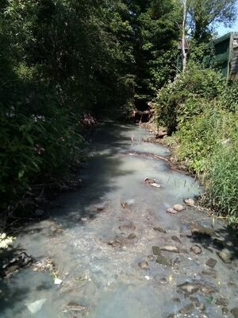
Figure 2: Bothlin Burn pollution.
The pollution incident was due to a blocked foul sewer which caused effluent to back up and overflow into a surface water drain, discharging directly to the burn. The case highlights the environmental, legal, and financial risks associated with drainage failures.
Interventions to prevent pollution from house building
Environmental impacts associated with housebuilding is a nationwide challenge. In Conon Bridge, Highlands, SEPA’s interventions to tackle pollution associated with a site being developed by Springfield Homes/Tulloch Homes has resulted in the installation of excellent mitigation measures to protect the water environment. The developers and their groundworks contractor reported a positive change in behaviour following engagement with SEPA.
Non Waste Anaerobic Digestion over 100 tonnes/day EASR Permit Call for evidence
On the 9 January 2026 SEPA closed our 14 week Call for Evidence on non-waste anaerobic digestion. As an evidence-led organisation, we were keen to ensure that operators had the opportunity to provide detailed information that we can draw on to develop our consultation on proposed permit conditions for non-waste anaerobic digestion (AD) sites handling more than 100 tonnes per day. The evidence and additional information and knowledge have been reviewed, and SEPA is currently drafting a further engagement piece which will set out the appropriate measures to inform the permit conditions, template, and guidance for anyone carrying out this activity after 1 April 2028.
The review concluded that the majority of relevant waste treatment Best Available Techniques (BAT) conclusions that we identified, were appropriate and achievable to include as appropriate measures in the permit. BAT are the economically and technically viable techniques which are the best for preventing or minimising emissions and impacts on the environment. Industrial installations undertaking specific types of activity are required to use BAT. ‘Techniques’ include both the technology used and the way an installation is designed, built, maintained, operated and decommissioned.
However, based on evidence and information received, we will consider different options for implementation of BAT 20, discharge to the water environment, based on the different capacity of specific receiving water environments. BAT 20 of the Waste Treatment BAT conclusions sets out the emission level range for direct discharges to a receiving waterbody from waste anaerobic digestion plants for a number of pollutants. These options will be reflected in the next stage of engagement during summer 2026.
Analysis of first year of new Packaging Producer Responsibility Regulations
The Producer Responsibility Obligations (Packaging and Packaging Waste) Regulations 2024 came into force on 01 January 2025. In Scotland, SEPA is the regulator responsible for monitoring compliance by businesses subject to these obligations.
The new UK regulations follow a lengthy period of policy development led by UK Government and involving UK devolved Governments and the four UK regulators. The new regulations which replaced the Producer Responsibility Obligations (Packaging waste) Regulations 2007, introduce significant new requirements for stakeholders and regulators founded on a principle of ‘full net cost recovery’ whereby the full costs of collecting and recycling waste packaging are paid for by the ones who place it on the market. The new regulations also include modulated fees which provide financial incentive for using easier to recycle packaging over difficult to recycle packaging.
The first compliance year closed on 31 January 2026, and analysis illustrates the significant amount of work SEPA has been involved in, including:
● Registration of approximately 2,000 producers
● Approval of three producer compliance schemes
● Approval of 31 reprocessors and exporters
● Issued a regulatory position statement
● Received regular data submissions from stakeholders
● Assessed and audited submitted data
● Carried out inspections of stakeholders
● Provided advice and guidance to stakeholders
● Identifying and addressing non-compliant operators
● Worked with DEFRA, Devolved Governments and UK regulators to ensure consistency of implementation.
The level of compliance for regulated stakeholders was noted to be high and identified non compliances are being investigated in line with SEPA policies. We are currently working with DEFRA, Devolved Governments and UK regulators on forthcoming amendments to the regulations.
Reservoirs
Reservoir safety in Scotland is regulated under the Reservoirs (Scotland) Act 2011 (the Act) and SEPA are the national regulator. The Act requires anyone who owns or operates a reservoir that can hold 25,000 cubic meters or more of water above the natural level of the land to register the reservoir with SEPA. These reservoirs are known as ‘Controlled Reservoirs’.
In December 2024, SEPA’s Chair of the Board wrote to the Cabinet Secretary for Net Zero & Energy raising the issue of unregistered, unregulated, controlled reservoirs and the risk they pose to downstream communities due to the lack of engineer oversight.
In March 2025, the Cabinet Secretary noted that officials had been instructed to support SEPA in working towards a viable solution. It has since been confirmed that SEPA will receive £1million of additional funding from Scottish Government for work on reservoir safety.
SEPA’s proposed use of this funding is currently with Scottish Government for approval. The majority of the work will focus on assessing the 461 unregistered, unregulated, controlled reservoirs, starting with work being undertaken to identify whether the reservoirs should be regulated by SEPA or not. Further work in subsequent years will be required to finalise the registration of the subset of reservoirs that meet the 25,000 cubic metres or more volume threshold. In addition, it is proposed that a review of SEPA’s reservoir inundation mapping methodology is undertaken. If approved, work is expected to commence in August.
2026 Bathing water season
Scotland’s 2026 bathing water season began on 1 June and will run until 15 September. This year SEPA are monitoring 90 designated bathing waters across the country, providing daily water quality predictions, real-time information and site-specific advice to help people make informed choices about using the water.

Figure 3: Seacliff, East Lothian. Credit: Alison Maxwell.
This year includes the addition of Ballachulish Peninsula, following its designation as a bathing water by Scottish Ministers earlier this year. It will receive its first classification at the end of this bathing season.
Our bathing waters website provides location profiles, helps users find their nearest designated bathing water, and offers up-to-date information throughout the season. Through regular sampling and close work with partners, we help identify pollution risks, support improvements in water quality and protect Scotland’s water environment.
Salmon processor fined £70,000 over fluorinated greenhouse gas rule breaches
Scottish salmon processor Scottish Sea Farms Limited has been fined £70,000 after breaches of fluorinated greenhouse gas regulations were identified at its salmon processing facility in Lerwick, Shetland. Two civil penalties of £35,000 each were issued after refrigeration equipment was found operating without required leakage detection systems.
Fluorinated gases are potent greenhouse gases, with some having a global warming potential thousands of times greater than carbon dioxide. Leakage detection systems are designed to identify losses quickly and prevent avoidable emissions reaching the atmosphere. Preventing avoidable emissions of greenhouse gases is an important part of efforts to tackle climate change.
Scottish Sea Farms Limited has since taken steps to address the issues and bring the equipment into compliance.

Improve 
Water Environment Fund (WEF) Programme of work
The Rosyth River Restoration project has secured funding for its next three phases, offering ‘huge potential’ for local ecology and community benefits. The project aims to restore two degraded watercourses, the Whinny and Brankholm Burns, to support wildlife, climate resilience and community wellbeing.
WEF and Dundee City Council's Concept Design for restoration of the Dighty Burn and surrounding greenspace in Dundee was featured on STV news. The item was headlined with exciting drone visualisations of what the project partners are working to create for Dundee in years to come. A great deal of work has been undertaken to engage community groups along the route of the Dighty, and the project promises to be one of WEF's most extensive and ambitious. Further information can be found here, The Dighty Burn Regeneration.
Funded by WEF, years of work have reshaped the Lyne Burn in Dunfermline from a forgotten waterway into a valued place of calm, connection and pride. As nature has returned, so too has a shared sense of belonging - improving well-being, rebuilding local identity and reconnecting people with the landscape around them. Through Lyne Burn Voices, a community storytelling and creative initiative led by Greenspace Scotland, local people shared what this transformation has meant in their everyday lives. Read more about the community stories behind the Lyne Burn transformation in SEPA’s 30th anniversary feature article.
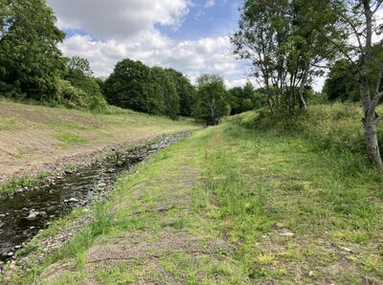
Figure 4: Lyne Burn following restoration
Glasgow tidal weir – enabling fish passage
Fish passage at the tidal weir in Glasgow on the River Clyde by Glasgow Green has improved significantly. Enforcement action undertaken resulted in Glasgow City Council taking action to ensure compliance with the weir operating plan. During 2026, monitoring has shown that the weir is now operating as effectively as possible to support both upstream salmon migration and downstream smolt migration. This is a huge success for salmonid populations in the River Clyde.
Number of Air Quality Management Areas (AQMAs) in Scotland has reduced
An Air Quality Management Area (AQMA) is an area declared by a local authority when air pollution levels are predicted to exceed, or have exceeded, national air quality objectives set to protect human health and the environment. These areas can range from a single street to larger urban areas. The main goal of declaring an AQMA is to focus efforts on improving air quality through targeted measures contained in an air quality action plan. AQMAs are intended as a measure which should only remain in place for as long as is necessary for the air quality objectives to be met with certainty.
Meeting legal air quality objectives helps protect Scotland’s environment and communities from harm, while improving the environment for future generations. Since 2022, all automatic monitoring stations across Scotland have met the air quality objectives for nitrogen dioxide (NO₂). In conjunction with improving trends in air quality, the number of Air Quality Management Areas (AQMAs) has reduced to 12, from a total of 43 AQMAs declared across Scotland.
The most recent AQMA revocation was for Falkirk Town Centre in April 2026. After several years of meeting the air quality objectives for NO₂, Falkirk Council made the decision to revoke the AQMA. This means that there are now no AQMAs within the Falkirk Council area, where a total of six had previously been declared, demonstrating continued progress in improving Scotland’s air quality.

Adapt 
Start of the water scarcity season
The first weekly water scarcity report of the season was published on 7 May 2026.
Current conditions continue to be mixed, with more areas recovering this week. Conditions throughout spring were dry across much of the east coast, with wetter conditions in the west. This has resulted in river flows being lower than normal for this time of year across the east.
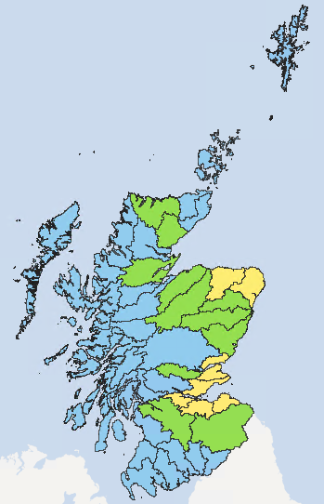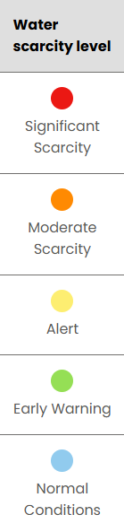
Figure 5: Map showing the water scarcity levels across Scotland, taken from the weekly water scarcity report dated 18 June 2026.
Groundwater levels remain largely normal across much of the country; however, very low levels persist at some monitoring locations in Fife and Angus. This reflects both the extreme low groundwater levels and deficits that had built up by the end of the 2025 drought, as well as the relatively dry spring. Levels at these locations are slightly higher than at the same time in 2025.
Recent showery weather and a wetter winter in eastern areas have helped to avoid early drought conditions. However, there remains a continued risk of water scarcity developing into summer, particularly across the east if summer rainfall is lower than normal.
Preparations have gone well for the start of the water scarcity season. Cross-functional lessons learned workshops and more detailed follow up sessions after last year’s unprecedented water scarcity season, have led to several improvements and efficiencies.
- The Water, Industry and Rural Economy (WIRE) team have led the variation of agricultural irrigation licences, incorporating a low flow protection condition so that water users know exactly what volume of water they will be permitted to take during significant water scarcity. This condition automatically kicks in when the significant water scarcity threshold is reached, with notifications sent to licence holders digitally via our Future Flood and Incident Messaging Service (FFIMS). This removes the need for formal written notices to be issued, reducing staff effort and improving clarity for water users. Non-agricultural abstraction authorisation holders are being contacted separately to clearly outline their responsibilities in the event of water scarcity. This includes outlining details of any reduction in permitted abstraction volumes.
- The Water Resources Unit has been working with Digital Services to update the Drought Risk Assessment Tool (DRAT). This tool, successfully completed with the website, now meets the required accessibility criteria and has been aligned with the new low flow protection conditions ensuring consistent evidence and messaging during periods of water scarcity.
- Pre-season engagement has taken place with key stakeholders, including the Scotch Whisky Association, Scottish Water, National Farmers Union Scotland (NFUS), Scottish Golf, NatureScot, and the Scottish Government. The weekly Joint Water Scarcity Management Group and Water Scarcity Communication Coordination groups stood up at the end of April 2026.
Transformation work has also begun on the evidence side as part of the wider flooding and water resilience transformation programme. The first step is focussing on data sources, processes and reporting, to improve automation and efficiencies, incorporate innovative technology and bring together all evidence in one user-friendly interface.
The latest update on the water scarcity situation is available on SEPA’s water scarcity webpages.

Avoid 
Flood Risk Management Plan (FRMP) Phase 1 Consultation
The Phase 1 Flood Risk Management Plan consultation closed on 22 April 2026 and achieved a strong level of engagement, with 446 responses received in total across all 14 Local Plan Districts. All responses have been securely captured in line with data processing requirements. Analysis is now underway to identify key priorities and geographic insights, with the volume and spread of responses providing a robust evidence base to help shape the next phase of the Flood Risk Management Plans. This will involve further targeted engagement with local authorities to refine objectives and actions and inform plan development.
Inverness Rail Depot - Preventing further pollution
Following the failure of two fuel tanks and associated spills of diesel at Inverness Rail Depot, both Network Rail and Scotrail were issued Final Warning Letters. Both tanks have now been replaced, and both Network Rail and Scotrail have introduced improved incident management and communication / reporting procedures across Scotland’s rail network to minimise the risk of similar incidents in the future.
Meetings have recently been held with SEPA, Network Rail and Scotrail, to discuss the incidents, the lessons learned and the improvements implemented. Network Rail have expressed an interest in setting up regular liaison meetings with SEPA to discuss environmental and sustainability issues as relevant across Scotland’s rail network.

Warn 
National Flood Risk Assessment
On 31 March 2026, SEPA published its latest National Flood Risk Assessment (NFRA) data on the Open Data Hub and the environmental data page. This data supports the NFRA report which was published in December 2025. This is a significant achievement after several years in the making. This is the first time we have run this assessment in house and developed new data architecture to support it. It is also the first time our flood risk data is available to download under an Open Government Licence. Our key partners within flood risk management planning also received detailed flood risk data under licence to allow them to perform their statutory flood risk management duties.
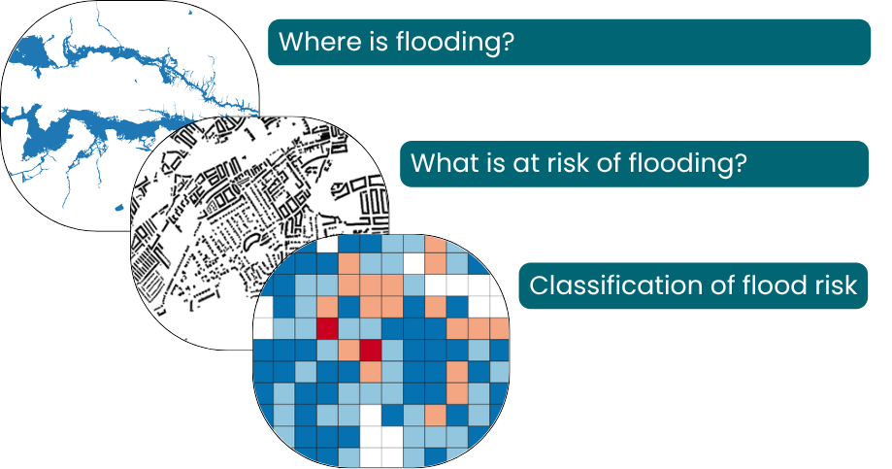
Figure 6: Component parts to NFRA 2025 methodology
The NFRA is a strategic tool that provides the most up-to-date national picture of current and future of flood risk to residential and non-residential buildings and is a vital evidence base that will support the implementation of Scotland's Flood Resilience Strategy and the next cycle of flood risk management planning. For more information, please visit the NFRA webpage. For any enquiries relating to the NFRA, please contact the FRAM@sepa.org.uk mailbox.

Communications
Our Communications team have collaborated with colleagues across the agency to support and enhance the delivery of a number of corporate priorities, including the Winter Water Situation Report and Water Environment Fund programme of work, as well as the publication of enforcement activity and outcomes.
Below is a breakdown of how our proactive media and public affairs work and incoming enquires relate to our purpose for quarter four.

Figure 7: Breakdown of proactive media and public affairs work and incoming enquires related to our purpose - January to March 2026 (Q4)
The high percentage of proactive “protect” and “warn” output over this quarter marked a return to core regulatory messaging in our press releases and published statements, following the dominance of water resilience in 2025.
We experienced a seasonal peak in “warn” media coverage over the quarter too, with just over half of mentions of SEPA linked to this priority. This can be common over the winter months where there are generally more flood warnings and alerts being issued by SEPA due to inclement weather.
Around two thirds of our media enquiries and official and ministerial enquiries (OME) over this period are linked to “protect”. This is even higher than last quarter and highlights the sustained interest in our core regulatory work from external stakeholders. It also underscores widespread interest in individual pollution incidents.
Together, media coverage over this period represents approximately 2.36B opportunities to see, based on current reach and circulation figures. In addition, we created more than 7,400 direct opportunities to see our strategic messages through proactive public affairs work.
You can view all of our media releases at beta.sepa.scot/news/.

Spotlight on…

Our 30th anniversary
On 1st April 1996, SEPA opened its doors with a simple but powerful purpose - to protect and improve Scotland’s environment for the communities and businesses who rely on it every day.
This year marks SEPA’s 30th anniversary. We are reflecting on the remarkable journey we have taken over the last thirty years and will highlight how we have helped to create cleaner rivers and coastlines, improve air quality, build resilience to flooding, drive compliance and shape regulatory standards through science led decision-making. See 'Our 30-year journey: a timeline’ video.
To mark the anniversary, we have introduced a special version of our brand. This updated identity reflects both our history and our future direction, supporting our transformation into a more agile and modern organisation. It has been designed for flexible use across our digital channels, with a refreshed logo at its core.

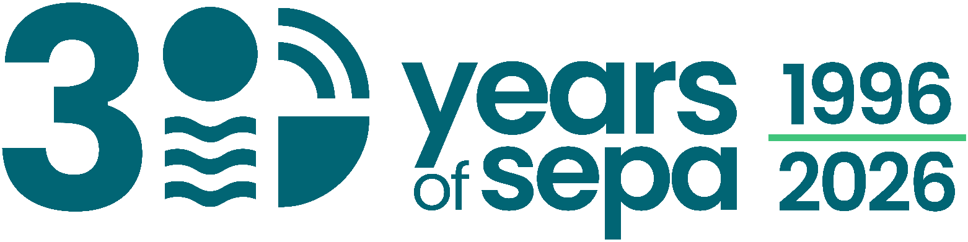
Figure 8: Special version of our brand to mark the 30th anniversary

Delivering for Scotland – a thirty-year legacy
Our anniversary is an opportunity to share the stories from the last thirty years and define the impact we have had on Scotland’s environment, communities and economy.
We published a special edition of our SEPA Update, highlighting our achievements, our passion and purpose and the difference we have made. This generated strong engagement across our social channels:
- LinkedIn impressions increased by 210% compared to the previous day, reaching 1,900 members
- Facebook content interactions increased by an average of 236% compared to the days before and after.
- The number of people visiting our Instagram profile grew by 250% compared to the previous day.
Our LinkedIn articles take a deep dive into the defining moments of our last thirty years and put a spotlight on the data, expertise and response of our people when Scotland needs them the most. These articles have proved to be some of our best performing content on LinkedIn to date. In April we shared:
- 30 years of flooding insights, highlighting how flood mapping and modelling have evolved, strengthening our understanding of long-term flood risk and helping Scotland build resilience for what lies ahead.
- The Lyne Burn, sharing stories of change along a restored river featuring the voices of the community.
- When the volcano erupted, outlining our pivotal role during the 2010 ash cloud event, demonstrating our rapid response and the reliance on our data for decision making.

Thirty years of Passion and Purpose
Every achievement we celebrate today carries the fingerprints of the people who’ve worked hard, cared deeply and believed in what SEPA could be. Internally, we have marked the anniversary by creating channels for our people to share their stories and celebrate the milestones that shaped us, supported by a content plan to span our 30th year and beyond.
Activities include:
- Leadership messages from the CEO and Chair, reflecting on SEPA’s achievements and future direction.
- A dedicated intranet hub bringing together anniversary content, future plans, and colleague stories. This is now one of the most visited areas of the intranet.
- A toolkit for managers and a discussion pack to support team conversations on learning from the past and shaping future delivery.
- A “Wall of Thanks” to recognise colleagues’ contributions and behaviours, with over 40 messages shared in the first two weeks.
These activities are helping to reinforce the culture and behaviours that underpin our transformation, creating space for colleagues to connect, reflect and shape how we move forward together. We will continue to co-create the story of SEPA across our channels as we move through this anniversary year, using our expertise to engage audiences at the right time with the right content.
This report represents an overview of SEPA’s delivery activity across the period.
For the Future of Our Environment.

Nicole Paterson
Chief Executive
June 2026

