# 

**WAT-G-012**

**EASR Guidance:**

Version 1.0, August 2025

**Registration Activity: Channel modification of a previously modified minor watercourse**

If you would like this document in an accessible format, such as large print, audio recording or braille, please contact SEPA by emailing [equalities@sepa.org.uk](mailto:equalities@sepa.org.uk)

# Purpose

This document provides information and guidance for anyone undertaking channel modification of a minor watercourse that requires an authorisation under The Environmental Authorisations (Scotland) Regulations.

This guidance does not cover any other permissions that may be required.

# What activity does this guidance apply to?

This guidance applies to engineering activities granted as a registration under the Environmental Authorisations (Scotland) Regulation 2018 for:

Channel modification of a minor watercourse;

(a) where the length of channel affected is less than or equal to 500 metres;

(b) where the channel has been previously modified; and

(c) that has a bed of sand, silt or clay.

# Understanding the activity

Channel modification includes diversion, realignment or re-sectioning of a watercourse.

This registration includes the channel modification activity and all associated construction works, such as access tracks, temporary works, crossings and structures.

This channel modification activity can only be undertaken on a minor watercourse with a bed of sand, silt and clay (i.e. sediment size with diameter of less than 2 millimetres) which has previously been subject to channel modification as defined above. (See Figure 1 and 2)

* This channel modification activity is restricted to an existing 500 metre length of channel. The channel modification can be undertaken:
* Over the full 500 metre length of channel (Scenario A – see Figure 4 in Annex 1), or
* Over a shorter length or multiple shorter lengths within a 500 metre length of channel (Scenario B – see Figure 5 in Annex 1), or
* Over an existing 500 metre length of channel resulting in new modified channel which is longer than 500 metres (Scenario C – see Figure 6 in Annex 1).

If your proposed activity exceeds any of the activity thresholds and/or you cannot comply with any of the standard conditions, you should apply for a permit activity under ‘All other channel modification not otherwise described’

# Understanding and minimising risks to the water environment

This channel modification activity and any associated construction works can cause harm to the water environment. It is important to carefully consider your design and construction options to ensure risks to the water environment and other users are minimised and that you fully comply with your standard conditions.

Due to the intrusive nature of undertaking channel modification activities careful consideration and planning should be done prior to conducting such activities as the bed and banks can be significantly impacted and become subject to erosion and instability that could also impact adjacent infrastructure.

Good practice should be followed in undertaking this activity to ensure environmental harm is minimised, design is sustainable long-term and maintenance requirements are low. To achieve good practice, you should minimise the footprint of the activity and consider the natural character and processes of the area you are working.

Further information on channel modification and sustainable design can be found in WAT-G-023 EASR Guidance: Engineering: Activity Guide: Channel modification.

## Risks to the Water Environment

The main risks to the water environment from carrying out this activity can be grouped as follows:

* **Harm to fish**
* Including impacts on fish migration, spawning and fry development, loss of habitat and direct impacts such as stranding or physical damage. For more information see WAT-G-032 EASR Guidance: Fish Protection.
* **Physical Impacts & Pollution**
* Physical impacts to the bed and banks of the watercourse which can lead to instability resulting in increased erosion or deposition, loss of habitats and increased flood risk.
* Pollution from sedimentation, leaking oil from machinery and the entry of potentially polluting materials into water such as unset concrete.

Further information on construction works and mitigation can be found in WAT-G-034 EASR Guidance: Construction works and silt/pollution mitigation.

* **Habitats and Species Protection**
* Spread of invasive non-native species**.** Further guidance can be found in EASR-G-001 EASR Guidance: Invasive non-native species (INNS).
* Impacts onspecies such as freshwater pearl mussels and otter. You should contact [NatureScot](https://www.nature.scot/) where your activity is in a Protected area or may impact protected species. For further information see WAT-G-008 EASR Guidance: Assessment of impact on Protected areas from inland water activities.
* **Impacts to other users of the water environment**

These risks to the water environment will vary according to:

* The type and design of the engineering activity
* The timing of the works.
* The working methods and mitigation.
* The reinstatement methods.

To minimise risks to the water environment and to help you comply with the standard conditions for this activity, you should follow the Do’s and Don’ts below.

# Do’s and Don’ts

### Activity Specific do’s and don’ts

* Don’t create any steps or sudden changes in the gradient of the channel bed either within the worked channel section or where it joins upstream and downstream of the worked section.

### General working in or near water do’s and don’ts

**Preventing Harm to Fish**

* Don’t undertake works if fish are likely to be spawning or young fish are still to emerge. In general, avoid the period between 1 October to 31 May. You should check the exact times with your local fishery board. Details are available from [Fisheries Management Scotland](https://fms.scot/#:~:text=Fisheries%20Management%20Scotland%20is%20the%20representative%20body%20for%20Scotland's%20District).
* Don’t impact fish migration.
* Do make sure all works such as temporary crossings, channel isolation or diversions, blasting, vibration or pile driving, sheet pilling or using artificial lighting at night so that fish or migrating fish are not adversely affected.
* Do carry out fish rescues, where appropriate etc.

**Preventing/ minimising physical and pollution Impacts**

* Do install and maintain suitable mitigation before, after and during the works. Including the points below.
* Do minimise the extent, location and duration of works in the wetted part of the channel or loch.
* Do keep vehicles, plant and other equipment out of water wherever possible.
* Do create and maintain a robust and secure dry working area of minimum size, where possible.
* Do minimise disturbance and reinstate banks, bed and vegetation as soon as possible.
  + Minimise vegetation removal and the area of bare earth/ exposed soil.
  + Re-seed or turf disturbed soil with native vegetation and ideally cover with biodegradable matting to provide temporary protection until vegetation is fully established.
* Don’t cause significant erosion.
* Do store all fuel, machinery and vehicles at least 10 metres from any watercourse, loch or permeable drain.
* Do have oil spill kits, drip trays and bunds on site and available to operators.
* Do prevent any pollutants entering the water environment.

**Habitats and Species Protection**

* Don’t spread invasive non-native species
* Check the banks and in water for invasive species.
* Use biosecurity measures.
* Do check what other species and habitats may be affected (e.g. otter).
* Don’t harm freshwater pearl mussels.

**Other Water Users**

* Do consider the potential impacts on other water users e.g. water supplies, fishing, kayaking etc.

# Glossary

A full list of terms is available in the main Glossary.

**Bank** is the side of a watercourse or loch between and including the bank toe and bank top.

**Bank height** is the height of the bank of a watercourse or loch measured vertically from the bank toe to the bank top, including any artificial heightening of the bank (e.g. embankments, retaining walls).

**Bank toe** is the lowest point on the bank of a watercourse or loch, where the bank meets the bed of the watercourse or loch.

**Bank top** is the first major break in slope in the bank or any watercourse or loch.

* This is considered the point beyond which cultivation or development is normally possible. Where there is no clear break in slope the bank top is considered to be the height of the average annual flood level in a watercourse,
* in relation to lochs where there is no clearly definable bank zone the bank top is the line along which terrestrial vegetation is present (this often equates to the average high-water level in a loch).

**Bed of watercourse** is the base of the watercourse, between the toe of one bank and the toe of the opposite bank.

**Bed width** means the straight-line distance between the opposite bank toes of a river, burn or ditch, and which spans the bed of the river, burn or ditch, including any exposed sediment bars and vegetated islands.

Bed width can be measured as an average along the length of the stretch to be worked or can be based on one measurement of a width that is representative of the stretch.

**Beyond the vicinity** is the zone that exists beyond the “in the vicinity” zone away from the watercourse or loch.

**Channel** is the area between the bank top on one side of a river, burn or ditch and the bank top on the opposite side. It includes the banks and bed of a watercourse, including any exposed sediment bars and vegetated islands

**Channel modification** is a term used to cover a range of different alterations that will affect some or all of a river channel’s course, planform, cross-sectional form or gradient. It includes diversion, realignment and re-sectioning (including culverting for land gain).

**Channel width** means the straight line distance between opposite bank tops of a river, burn or ditch and which spans the bed and banks of a river, burn or ditch, including any exposed bars and vegetated islands.

**Diversion** refers to the process of redirecting part or all of the flow of a watercourse from its original course into an entirely new channel.

**In the vicinity** For a watercourse this is the zone that extends away from the bank top for a distance of 10 metres or two channel widths (whichever is shorter). For a loch this is the zone that extends 10 metres away from the bank top.

**Left bank** is the left bank of a watercourse when facing downstream.

**Minor watercourse** is one that is not shown on the 1:50,000 scale Ordnance Survey maps (Landranger series)

**Protected area** means an area designated under International (Ramsar sites), European (Special Areas of Conservation and Special Protection Areas) or National (Sites of Special Scientific Interest) legislation, to provide protection of their notable natural features or biodiversity. This legislation places duties on SEPA to assess whether activities we regulate would harm these sites.

**Realignment** involves modifying the planform and/or gradient of an existing channel between two points.

**Re-sectioning** involves modifying the channel’s cross-sectional shape, but without altering its location and planform.

**Right bank** is the right bank of a watercourse when facing downstream.

**Riparian zone of a river** is thetransitional, semi-terrestrial area of land adjoining a river channel (including most of the river bank) that is regularly inundated and influenced by fresh water and can influence the condition of the aquatic ecosystem (e.g. by shading and leaf litter input).

**Riparian zone of a loch** is thearea of land extending from the bank top or the limit of terrestrial vegetation and capable of directly influencing the condition of the aquatic ecosystem (e.g. by shading and leaf litter input)

**Sediment** refers to the natural material of which the bed of a watercourse or loch is made (includes sand, silt, clay, gravel, cobbles and boulders).

**Temporary crossing** (Water Registrations and Permits) is a crossing which will be removed after the completion of the authorised activity.

**Temporary structure** (Water registrations and Permits) is a structure which will be removed after the completion of the authorised activity.

**Wetted part** is the part of any watercourse or loch that is wet while carrying out works in a watercourse or loch.

# Annex 1

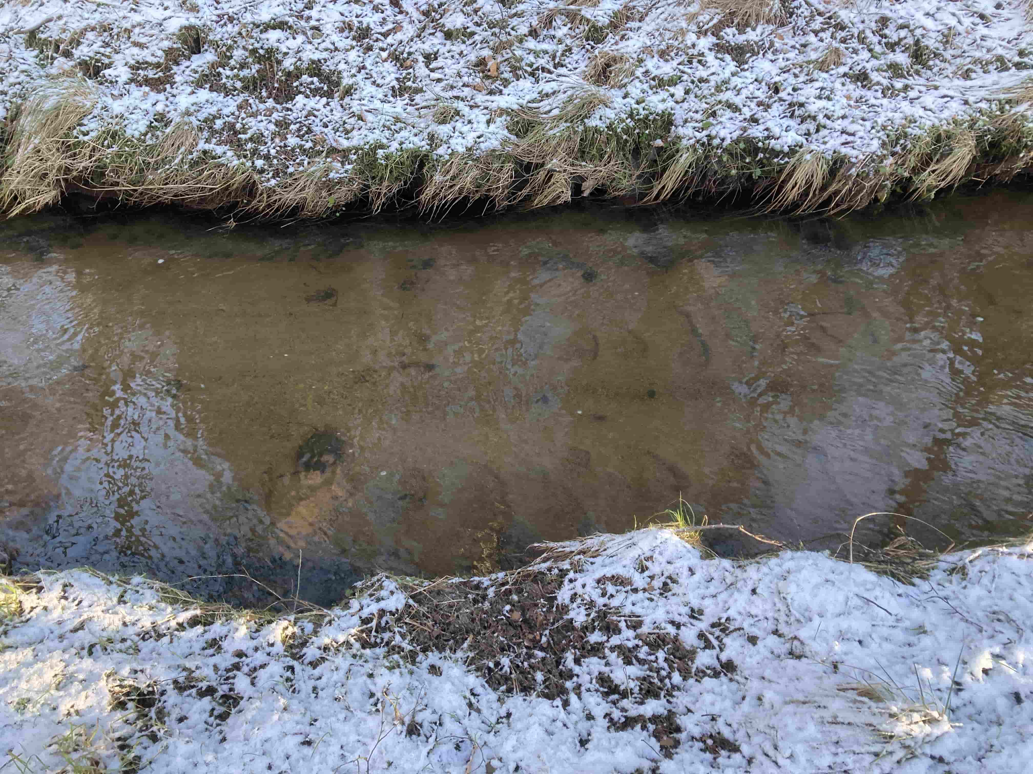

**Figure 1: Example A**

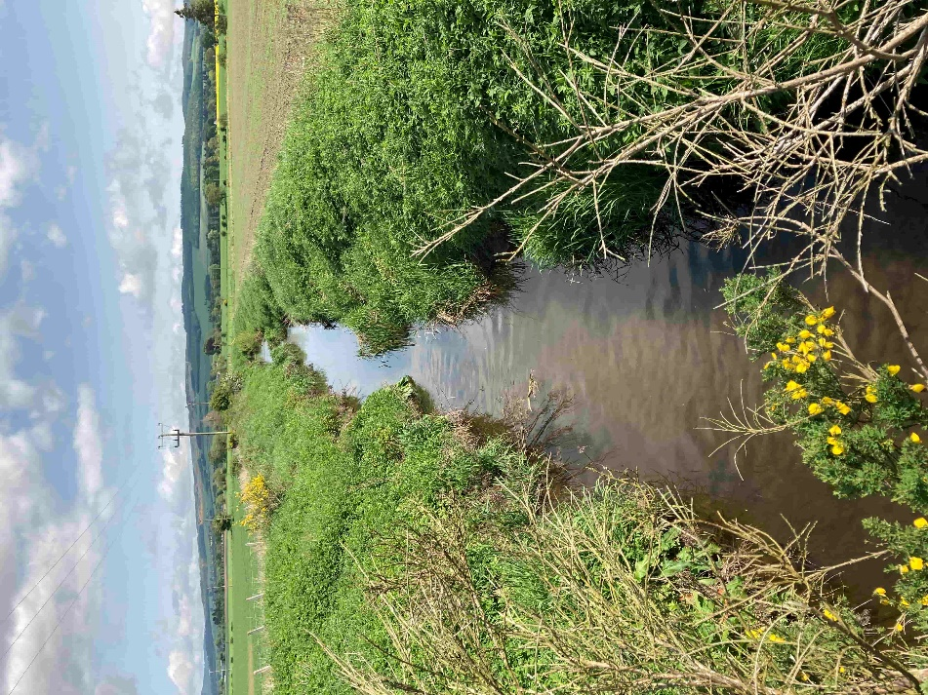

**Figure 2: Example B**

Diagram showing key parts of a watercourse. 
Parts shown and explained in the Glossary are:
Bank; bank top; bank toe; channel; bed; bed width; exposed sediment; left bank; right bank; wetted part; riparian zone; in the vicinity and beyond the vicinity.   **Figure 3: Key parts of watercourse**

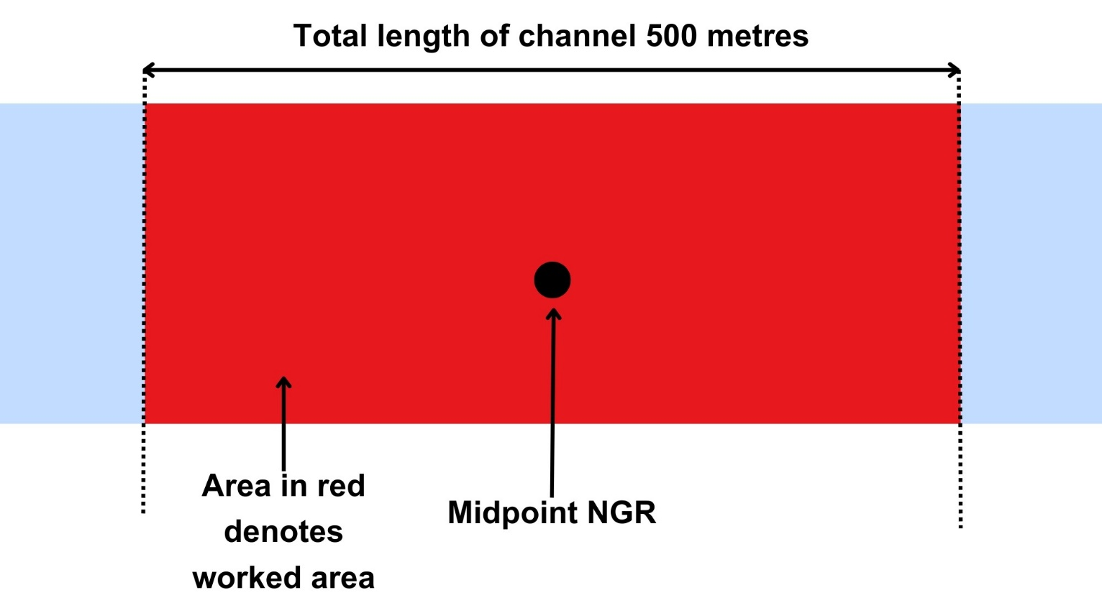

**Figure 4: Scenario A**

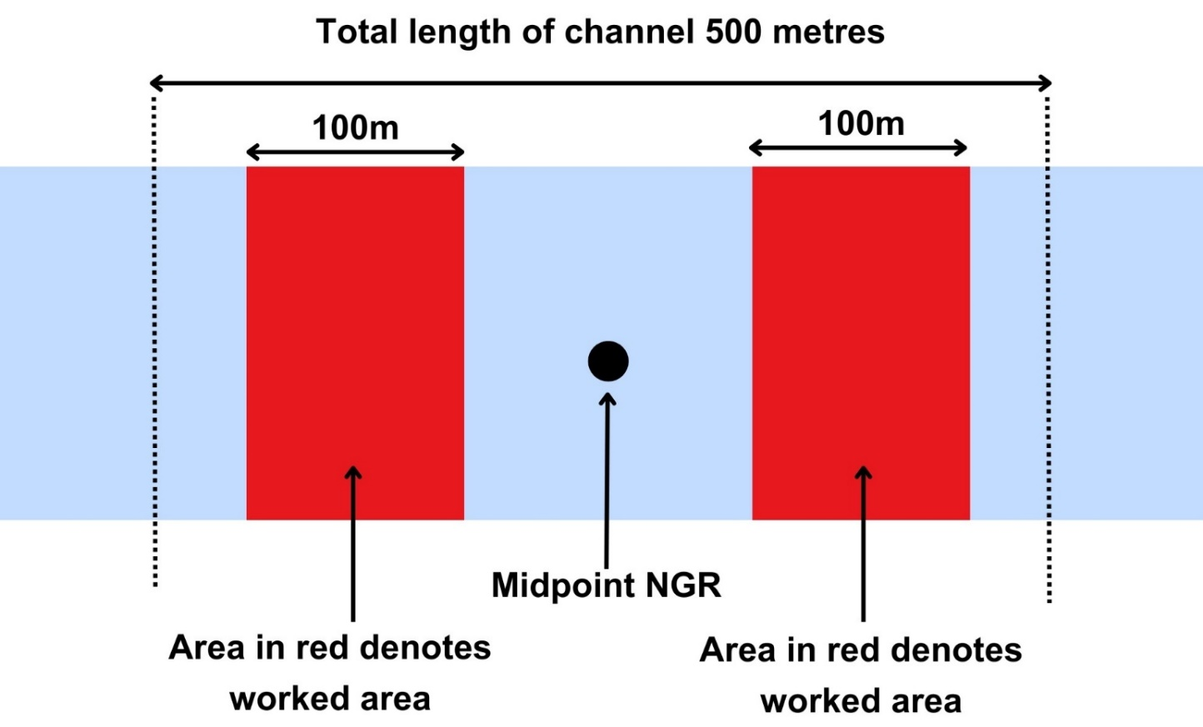

**Figure 5: Scenario B 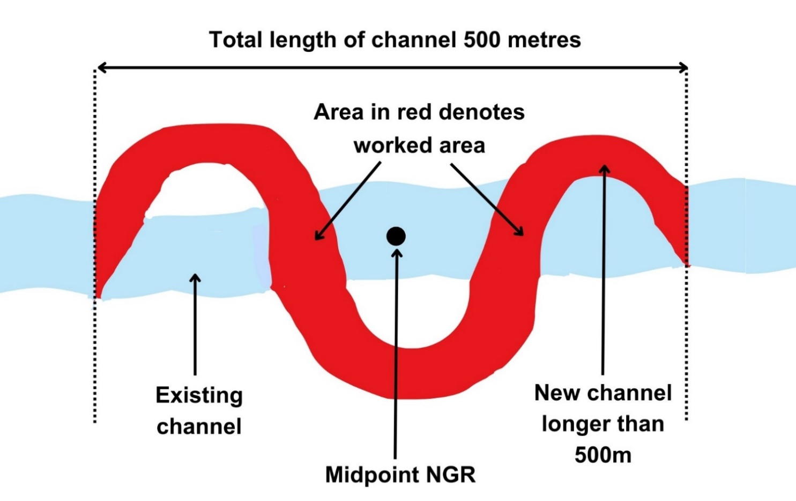Figure 6: Scenario C**

# Disclaimer

Whilst every effort has been made to ensure the accuracy of this guidance, SEPA gives no warranty, covenant or undertaking (express or implied) regarding the fitness for purpose of, or any error, omission or discrepancy in this guidance. Reliance on its contents and the contents of any websites that are linked to or from this guidance is entirely at the user’s own risk. SEPA is not liable for any loss or damage that may come from using this guidance. This includes:

* any direct, indirect and consequential losses
* any loss or damage caused by civil wrongs, breach of contract or otherwise

SEPA reserves the right to depart from this guidance and take appropriate action as it considers necessary or appropriate. Operators are responsible for ensuring that they are compliant with the law. If necessary, independent legal / specialist advice should be sought.