



Chief Executive’s Report
February 2026

Contents

1. Introduction 2
2. Collaboration and partnership 6
3. Public Sector Reform 10
4. Transformation 12
5. Focused on delivery 13
6. Spotlight on… 28

If you would like this document in an accessible format, such as large print, audio recording or braille, please contact SEPA by emailing: equalities@sepa.org.uk

Introduction
2025 marked a year of exceptional progress for the Agency. We moved decisively from reset into transformation, focusing on key areas of Public Sector Reform that position us to succeed and thrive in the years ahead. Our teams delivered with passion, purpose and professionalism, ensuring we not only met our commitments but built strong momentum as we head into the new year.
Since the last Agency Board meeting we have been exceptionally busy, with significant opportunities for engagement with Scottish Government and partner agencies. In October, we hosted a drop-in session at the Scottish Parliament - an open invitation for Members of the Scottish Parliament (MSPs) and their teams, to hear about the work we do, the impact we are making and to ask questions. This was a fantastic opportunity to engage directly with decision-makers and showcase how we are making a difference to communities, businesses, and the environment across Scotland. This was a timely engagement ahead of the next election and something we are looking forward to doing again in the new Parliament.
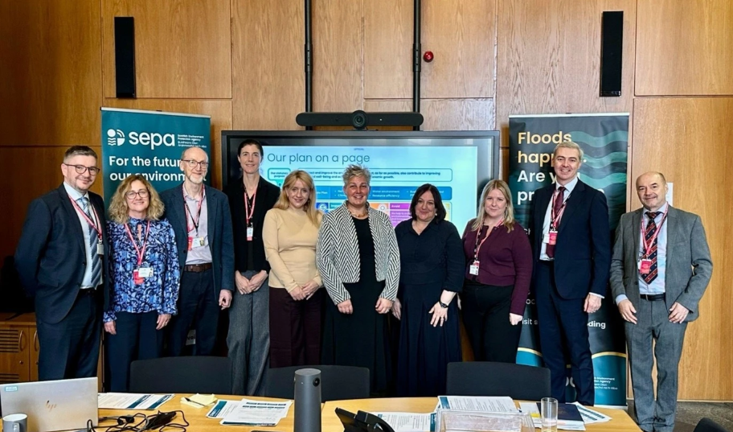
SEPA drop-in session at the Scottish Parliament on 7 October 2025. Credit: SEPA.
Later in the month, along with the Agency’s Chief Operating Officer for Data, Evidence and Innovation and representatives from the Scottish Government, COSLA and local authorities, I gave evidence to the Scottish Parliament’s Public Audit Committee on the vital topic of Scotland’s Flood Resilience. Throughout the session we reaffirmed our central role in helping Scotland prepare for, respond to and recover from flooding. These critical services save lives and protect livelihoods, but as climate change increases flood risk, we recognise Scotland must move beyond traditional defences and build truly flood-resilient places, using nature-based solutions and collaborative approaches.
It was also my privilege to attend the 44th plenary meeting of the European Heads of Environment Protection Agencies (EPA) Network in Cardiff to discuss critical issues related to environmental policy and implementation, and present our work on the Integrated Authorisations Framework as a case study in ‘simplification’ on behalf of the Environmental Policy & Law Implementation Group (EPLIG).
I was delighted to welcome Ross Haggart to the Agency as Chief Operating Officer for Regulation, Business and Environment following extensive external recruitment. Ross joins us at a pivotal time as we undertake an ambitious transformation programme to enhance our effectiveness and support our core delivery. His blend of strategic, regulatory and operational leadership skills and experience will enable us to deliver better for Scotland.
November marked an exceptional milestone for SEPA and for Scotland’s environment, with the amendments to the Environmental Authorisations (Scotland) Regulations 2018 (EASR) going live. This achievement reflects years of collaboration and commitment across SEPA, and delivers a more modern, integrated approach to regulating waste, water, and industrial activities. It is a cornerstone of our Future of Regulation programme, enabling smarter, more efficient regulation and better outcomes for Scotland’s environment, businesses, and communities. I am immensely proud of the dedication, professionalism and teamwork of SEPA colleagues that have made this milestone possible.
On 6 November, I joined delegates from around the world at Scotland’s Global Food Security Conference in Edinburgh where discussions focused on the ongoing work to ensure Scotland’s food resilience in a changing climate.
Later in the month, I was honoured to Co-Chair the European Heads of Environment Agencies Environmental Policy and Law Implementation Interest Group (EPLIG) in Brussels. The insightful presentations from delegates brought home the importance of continued collaboration and sharing best practice.
November also saw us reach an exciting milestone in one of our largest river restoration projects - the completion of phase four of the work in the upper catchment of the River Nith. Further details are included later in this report, along with news on the Levern Water Restoration Project winning the ‘Best Biodiversity Net Gain or Enhancement of a Brownfield Project’ at the Brownfield Awards – a well-earned achievement.
In December, I attended the Scottish Climate Leaders Summit in Edinburgh, where I was pleased to be able to share Scotland’s latest Flood Risk Assessment. A culmination of months of science, data, and modelling, the assessment is a key tool to help Scotland prepare and adapt with confidence. Further details are included later in this report.
The Agency also published the 2026 bathing water classifications, showing the national picture across Scotland’s coasts and inland waters. The majority of designated bathing waters continue to meet high environmental standards, with 47 rated Excellent and 26 rated Good for the year ahead.
We ended the year with the publication of our Annual Report and Accounts 2024 - 2025, highlighting the progress we have made and how we have delivered nationally important public services. The full report is now available in an accessible HTML format, ensuring ease of navigation for all users, including those using assistive technologies, and a short highlights report.

As we build on the successes of 2025, we enter 2026 with a strong foundation and a clear sense of direction. Development of the Agency’s Annual Operating Plan for 2026-2027 is well underway, ensuring alignment to Scottish Government objectives and outcomes, and we are well positioned to deliver yet another year of strong performance and meaningful impact.
Finally, on behalf of myself and colleagues, I am delighted to welcome our three new Board members, Lisa Blackett, Kate Lander and Paul Rooney to SEPA following their appointments in January. Our Board plays a vital role in setting SEPA’s overall direction, ensuring strong governance, overseeing performance, and like other Board members, their experience and insight will be invaluable as we work together to deliver for Scotland’s environment.
This report showcases the achievements of our teams as they continue to deliver with passion, purpose, and professionalism, protecting and improving Scotland’s environment for the future.

Collaboration and partnership
We recognise the impact of progressive partnerships and collaborative working across the public, private and third sectors, as well as with communities. We share service delivery so that we offer better outcomes more efficiently, and with a customer focus.
Packaging Extended Producer Responsibility (pEPR) Programme
We have worked closely with the UK Government, Scottish Government, UK regulators and other partners to help implement The Producer Responsibility Obligations (Packaging and Packaging Waste) Regulations 2024 which came into force on 1 January 2025. These efforts are part of SEPA’s broader journey to deliver value for Scotland’s environment and communities, while supporting future regulatory innovation.
The Packaging Extended Producer Responsibility (pEPR) programme is a UK Government circular economy initiative. The aim is to embed the ‘polluter pays principle’ to make companies responsible for the cost of managing their packaging waste after it is used (including collection, recycling, and disposal), while incentivising the use of more sustainable packaging by applying fees that reflect a packaging's recyclability and weight.
Specialist officers from SEPA have participated in events designed to raise awareness of the new regulations and the steps that businesses need to take to ensure compliance. These included the Chartered Institute of Waste Management (CIWM) Scotland Autumn Seminar in November alongside Scottish Government and presenting at the Scottish Grocers Federation Cross Party Group.
By working closely with government partners and UK regulators, this partnership approach has contributed to consistent regulatory standards and helped develop secure, data-driven systems that support more transparent and efficient compliance processes across the UK.
Temporary Enforcement Approach: Biodegradable Municipal Waste (BMW) Landfill Ban
SEPA published a temporary Regulatory Position Statement (tRPS) on 29 October 2025 following discussions with Scottish Government, industry trade bodies and other stakeholders. This tRPS detailed our approach to delay enforcement of the BMW ban until 31 December 2027, subject to certain conditions, to allow additional time for planned Energy from Waste (EfW) capacity to come online and ensure all BMW currently being landfilled could continue to be managed within Scotland’s borders. This will:
- prevent approximately 300,000 tonnes per annum of BMW being sent to England for disposal (with all associated environmental impacts),
- provide the Scottish waste industry with a short-term contingency for any unplanned EfW outages,
- allow sufficient time for industry and the Scottish Government to establish longer-term contingency plans, alongside a greater push on waste reduction and recycling messages.
This is a positive example of where balanced decision-making and specialist knowledge can help reduce environmental impact.
European Union Network for the Implementation and Enforcement of Environmental Law (IMPEL) Enforcement Actions Project on the enforcement of waste shipments
SEPA leads the IMPEL Enforcement Actions Project on the enforcement of waste shipments which seeks to foster stronger, more coordinated enforcement efforts across Europe. This includes the development of novel reporting and training tools, holding best practice meetings, and organising multi-country officer exchanges. In November SEPA officers delivered a four-day event in Felixstowe which enabled officers from competent authorities across Europe to learn about recent trends in illegal shipments in other jurisdictions and share best practice updates on the regulation of shipments of waste tyres and plastics, which are becoming increasingly difficult to regulate.
Publication of Radioactivity in Food and the Environment Report (RIFE 30)
SEPA and colleagues from UK environment agencies and the UK Food Safety Agencies published the 30th Radioactivity in Food and the Environment (RIFE) Report on 31 October 2025. The RIFE report contains the results of regulatory monitoring programmes, discharge data and includes a retrospective assessment of the impact of the permitted discharges on those most exposed, demonstrating that exposure remained below the legal limit (1 millisievert) in 2024. The independent monitoring of radioactivity in food and the environment is an important part of the regulatory process and provides reassurance to members of the public.
SEPA colleagues support relocation of oysters as part of Restoration Forth project
The Restoration Forth project aims to restore the once plentiful native oyster beds and seagrass beds in the Forth, to improve water quality and biodiversity. Since 2023, nearly 47,000 European flat oysters had been moved from Loch Ryan to four sites in the Forth. Four SEPA colleagues made use of their volunteering days in November to help with the relocation of the native oysters from Loch Ryan to their new home in the Firth of Forth. Colleagues removed sediment and epifauna from the oysters and prepared them to be safely released into the Forth. Some were released attached to ropes and others dispersed freely. A dive team from Heriot-Watt University has been monitoring the relocation project and has reported a high average survival rate of about 88% for the relocated oysters.
Stakeholder engagement and launch of MACS Compliance Audit Programme for the aquaculture sector
We have successfully engaged with key stakeholders in the aquaculture sector, including operators and their trade body, to introduce the forthcoming launch of a new auditing approach under the sector’s Measurement Assurance Certification Scotland (MACS) Scheme - the MACS Compliance Audit. This initiative is designed to ensure that operator monitoring practices supporting compliance align with SEPA’s standards for data integrity - our “red lines.”
By securing industry buy-in and reinforcing robust auditing standards, we are building confidence in the reliability of monitoring data and evidence used to assess compliance, helping to strengthen transparency and trust in SEPA’s compliance framework.
In addition to working with operators and the trade body, we continue to engage with service providers employed by the industry to carry out elements of sampling and analysis. This engagement ensures that these providers fully understand their obligations under MACS and are prepared to meet the required standards.
The new MACS audit approach was formally launched in January 2026. To support a smooth transition, SEPA made guidance available on our website at the start of the new year. This guidance document provides information to help authorisation holders and service providers prepare for MACS compliance audits.
The key benefits that the MACS Compliance Audits will bring include:
- Improved data integrity: ensures monitoring data meet SEPA’s minimum quality standards.
- Enhanced transparency: builds trust in compliance assessments through robust auditing.
- Industry collaboration: reinforces shared responsibility for compliance across operators and service providers.

National Flood Resilience Conference
The National Flood Resilience Conference was held on 27 and 28 January 2026. The conference is an opportunity for industry professionals, charities, community groups and others to get together and discuss flooding in Scotland. The themes for this year were Community engagement and coastal change and Embedding flood resilience in placemaking and collaborative working.
SEPA speakers at the conference included Lisa Harrison, Senior Specialist Scientist, talking about coastal flood maps and Andrea Johnstonova, Principal Policy Officer, providing policy updates. We hosted an exhibition stand with a focus on the hydrometric monitoring network. We offered attendees the opportunity to speak to us about accessing our hydrometric archive, which goes back almost 100 years, and our live data feeds for water level and rainfall. We also used the opportunity to highlight our recently published National Flood Risk Assessment and the live Phase One public consultation for our Flood Risk Management Plans (FRMPs).
Hydrogen production and use – SEPA’s expertise on show at Hydrogen Scotland and Health and Safety Executive conferences
The production of hydrogen as a fuel and green chemical source is recognised as a being a contributor towards the Scottish and UK Governments’ Net Zero commitments and ensuring a just transition. In May 2025, the Scottish Government announced £3.4 million of funding designed to accelerate Scotland’s hydrogen economy and support delivery of the Hydrogen Action Plan.
The production of hydrogen is a listed Environmental Authorisation (Scotland) Regulations 2018 (EASR) industrial activity (schedule 20 – inorganic chemical production) and almost all production will require a permit. The production of hydrogen by electrolysis of water, often referred to as “green” hydrogen, can use a significant quantity of water which may require abstraction authorisation. Storage of >5tonnes of hydrogen invokes Control of Major Accident Hazards (COMAH) requirements.
On 28 October 2025, SEPA colleagues attended Hydrogen Scotland's annual conference to present on sustainable water production and planning and permitting as well as participating on a Q&A panel session on public engagement. SEPA colleagues were then invited to present at the HSE Safe Net Zero conference alongside Environment Agency, with whom we have worked closely to develop and publish emerging techniques guidance (“GET”) on a number of activities around hydrogen production and use.
Both conferences enabled valuable engagement with developers, industry, fellow regulators and government, as well as ensuring our messages are being delivered to as wide an audience as possible. This is a developing industry and both we and operators are learning about implications of sustainable hydrogen production and its environmental effects. Further information can be found on our bespoke hydrogen webpage.

Public Sector Reform
As a public service, we continue to respond effectively to the increasing pace of change, and we are committed to considering the best models for delivery of all our services. SEPA continues to work with other public sector bodies and communities to deliver services, with a focus on:
- Prevention: tackling issues early to reduce future risks and costs.
- Integration: ensuring services work together seamlessly across organisations.
- Efficiency: using resources wisely to deliver maximum value for communities.
SEPA and Police Scotland – awareness raising of environmental crime
As part of our regular collaboration with Police Scotland to tackle environmental crime, we presented a module at the Police Scotland Intelligence Officers Training Course at the Scottish Police College, Tulliallan. Our contribution to the training course aims to:
- increase awareness of our role in tackling environmental crime,
- help Police Scotland understand key areas of interest to SEPA for intelligence sharing,
- help Police Scotland identify opportunities for partnership working from activities they come across in their day-to-day roles.
Benefits achieved to date include improved proactive intelligence on environmental crime and integrated access to relevant partner information that supports decision making in relation to SEPA investigations and collaboration opportunities.
SEPA Enforcement and National Health Service (NHS) Scotland
We are working closely with NHS Scotland to tackle fly tipping on their estate, demonstrating the value of partnership in addressing illegal waste disposal. SEPA colleagues are actively engaging with estates and facilities management at NHS sites across Scotland, and their teams to strengthen a collaborative response. Key progress includes:
- Standardised Evidence Gathering: NHS Scotland has adopted checklists aligned with SEPA’s approach, ensuring consistency and efficiencies in investigations.
- Enhanced Deterrence Measures: NHS Scotland is exploring CCTV solutions for high-risk sites, informed by best practice from local authorities facilitated by SEPA specialists.
- Knowledge Sharing: A joint session was held in January with NHS facilities staff to outline enforcement measures and build capability for 20 members of that team.
This collaboration is a strong example of how we are working with major landowners to prevent environmental crime and protect Scotland’s public spaces and the public purse while reducing future risks and costs.

Transformation
To deliver effectively for Scotland, we need to transform areas of our organisation and embed a customer and delivery focus in everything we do. Doing so will mean we can design and offer better, more resilient services that meet the needs of our customers.
The Transformation Team
The Transformation Team is now established and are leading our One SEPA Modernisation programme; building a future-focused organisation that is better equipped to serve Scotland’s environment, customers and communities.
Our current focus is on delivering the following key, measurable outcomes. This approach shifts the emphasis from delivering projects and outputs to achieving measurable business value, using programme management best practice to align strategy, delivery and benefits realisation.
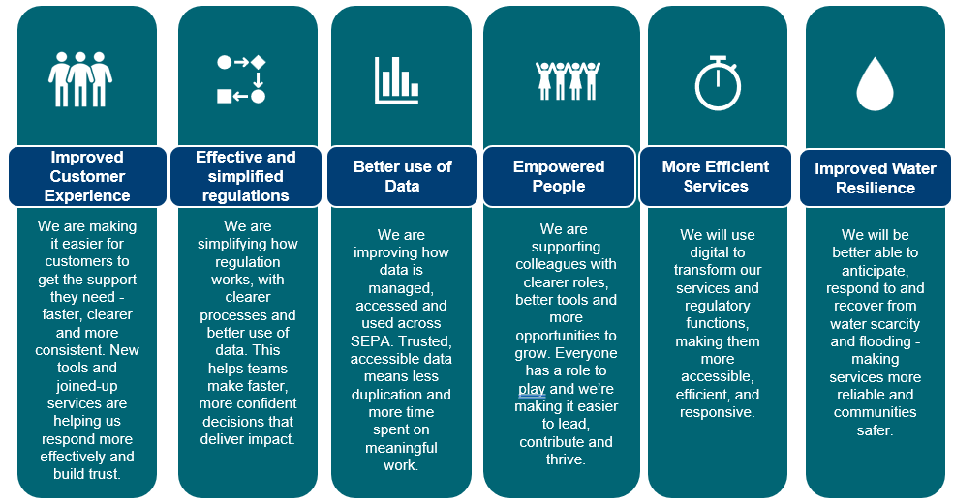
Diagram showing SEPA’s Transformation Outcomes

Launching our Transformation Hub
In October, work to develop a clear, concise and consistent internal communications approach for our Transformation programme led to the successful launch of our new Transformation Hub. The hub gives SEPA colleagues a single place to track progress across our programmes, ley contact points as well as context on how they fit together to help SEPA deliver for Scotland. It represents the achievement of an ambition we have held since the development of our initial One SEPA hub.
Since launching on 14 October, the Hub has attracted over 600 unique viewers - about 50% of SEPA colleagues. Views spike when we signpost new content, particularly through our weekly news round-up, highlighting the value of regular promotion. Strong initial engagement shows clear demand for this content, and positive feedback from programmes confirms it is a valuable tool for engaging with colleagues and leaders.

Focused on delivery
SEPA is Scotland’s principal environmental regulator, and our purpose is to protect and improve Scotland’s environment. Our approach to deliver for Scotland focuses on what we do and our corporate plan priorities. We also continue to develop our approaches to communicate and engage effectively with all our customers, the public and communities.

Protect 
Increasing our analytical chemistry capability
We have introduced a new monitoring programme for per- and polyfluoroalkyl substances (PFAS), a large group of substances widely known as forever chemicals. As a result, we are now able to measure concentrations of 33 PFAS compounds in freshwaters and groundwaters across the country. This is a huge step forward in our capability, allowing us to better understand the distribution of PFAS in Scotland’s environment, deliver our statutory reporting requirements, and provide an evidence base to inform future regulatory approaches.
Following major capital investment, we have installed two new Gas Chromatographs coupled with High Resolution Accurate Mass Spectrometers (GC-HRMS). These provide the capability to detect a wide range of semi-volatile organic substances, with the full method expected to be available late in 2026. This supports delivery of our statutory monitoring requirements for organic chemicals and future proofs us to meet new requirements.
We have conducted an extensive programme of monitoring for over 450 chemicals using our innovative liquid chromatography coupled with high resolution mass spectrometry methodology. The findings of the 2024 monitoring, which included samples from approximately 300 freshwater and groundwater locations, will be the subject of a series of reports.
The first report will summarise which chemicals were found and how frequently they were detected. The second report will detail the results for two contaminants of increasing concern, fipronil and imidacloprid. These are active ingredients in a wide range of topically applied pet flea treatments. The results on fipronil and imidacloprid concentrations in Scotland have been shared with the UK cross-government Pharmaceuticals in the Environment Group as part of SEPA’s contribution to the roadmap published by the group in July 2025 to reduce the levels of these substances found in the UK water environment.
UK Emissions Trading Scheme – Expansion and Readiness
The UK Emissions Trading Scheme (UK ETS) is a market-based mechanism designed to reduce greenhouse gas emissions by setting a cap on total emissions and enabling trading of allowances within that cap. It currently applies to energy-intensive industries, power generation and aviation. The scheme plays a central role in delivering the UK’s climate commitments.
From 1 January 2026, Waste operators (Incineration and Energy from Waste) have had the option to participate voluntarily in the scheme. From 1 July 2026, the scheme will be extended to cover Maritime operators. These developments represent a significant broadening of the scheme’s scope and will help drive emissions reductions across additional sectors.
We have engaged constructively with both sectors and are working closely with the other UK environment agencies to ensure a consistent regulatory approach. On 1 December 2025, we launched a public consultation on revisions to the ETS charging scheme to include Maritime charges. The consultation, which runs until 24 February 2026, seeks views on proposals to achieve full cost recovery for the additional resources required to regulate the Maritime sector. Further details and the consultation document are available here: UK ETS Charging Scheme Consultation.
Non-Waste Anaerobic Digestion: Call for Evidence
On 6 October 2025, we launched a Call for Evidence on the proposed technical requirements for plant carrying out non-waste anaerobic digestion (AD) over 100 tonnes per day. This closed on 9 January 2026.
As an evidence-led organisation, we are keen to ensure that operators have the opportunity to provide detailed information that we can draw on to develop our consultation on proposed permit conditions for anaerobic digestion (AD) sites handling more than 100 tonnes per day. These technical requirements will inform the permit conditions for anyone carrying out this activity after 1 April 2028.
To support operators and provide further opportunity for engagement and advice during the Call for Evidence stage, we held an online event on 26 November. The event was well attended and gained interest from operators, the supply chain, relevant associations, academic institutions and consultancies. The event provided the opportunity for further discussion on the process, advice and guidance on how to submit evidence and explanation of the next steps and timeline for developing permit conditions for non-waste anaerobic digestion.
Waste Crime Investigations – Operation Moonbeam
SEPA intelligence supported Operation Moonbeam, a Police Scotland public facing campaign to reduce criminality linked to bonfire night. We shared key intelligence regarding a warehouse advertising free sofas for ‘burning on bonfires’ via social media. SEPA conducted internet research to identify persons/location linked to the activity and shared this directly with the relevant Police Scotland division. As a result, Police resources attended, disrupted the activity and prevented further risks of uncontrolled fires and illegal waste disposal potentially endangering the environment and public safety.

Recognition for Corporate Legal Team at National Awards
At the Scottish Legal Awards, our Corporate Legal team was named In-House Legal Team of the Year. The Scottish Legal Awards, established in 2003, recognises excellence in Scottish law and is judged by a panel of sector experts. Being shortlisted was already a significant achievement; winning the award highlights the team’s expertise and the quality of their work in supporting SEPA and protecting Scotland’s environment.

Presentation of In-House Legal Team of the Year 2025 to SEPA’s Corporate Legal team. Credit: KD Media
Enforcement in partnership with Gumtree
SEPA’s enforcement and digital disruption activity through the Scottish Government’s National Litter and Flytipping Strategy has resulted in a positive collaboration with local selling platform Gumtree. Ongoing engagement has so far directly resulted in 15 adverts being removed due to our proactive identification of adverts portraying unauthorised or illegal waste operators in local communities. This proactive, interventions approach is helping to prevent rogue operators from negatively impacting communities, legitimate waste operators and the environment.

Improve 
Back Burn Restoration Project, Fife, Completes Construction
SEPA, through deployment of the Water Environment Fund (WEF), have successfully completed construction works at the Back Burn Restoration Project, Coul Den. The section of the burn at Coul Den has been returned to its historic route along with construction of ‘rock ramps’ to improve fish migration and multiple access improvements for the community, including new footpaths, boardwalks and footbridges. Around 100 new trees have been planted to further add to the project’s sustainability.
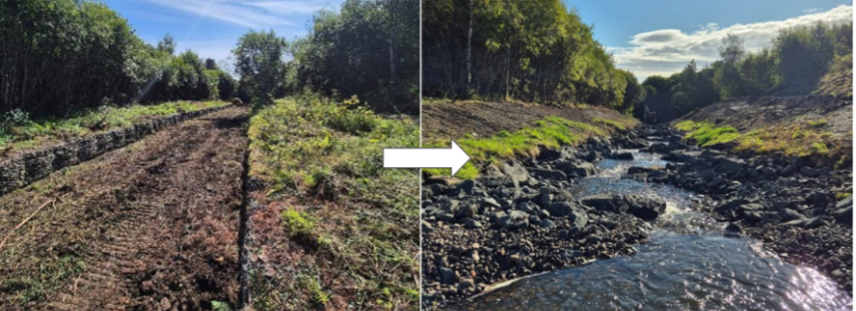
The Back Burn Restoration Project, Glenrothes, Fife. Before and after images of the channel downstream of Coul reservoir, showing gabions removed and rock ramp added to enable fish passage. Credit: McGowans Environmental
River restoration works complete on the Nith, New Cumnock
In November 2025, the River Nith restoration (phase four) completed groundworks. 280m of artificial embankment were set back to connect the river to its flood plain, and two hectares of wetland habitat was created at the site of a former sewage treatment works, providing climate resilience, improved biodiversity and reduced flood risk to local communities.
The four phases of this landscape scale restoration project, funded through the WEF and delivered over the last decade, have now restored over 3km of river length and created 7.5 hectares of floodplain habitat. The works were led by the Tweed Forum in partnership with SEPA and Castlemains Farm and carried out by Ebsford Environmental.
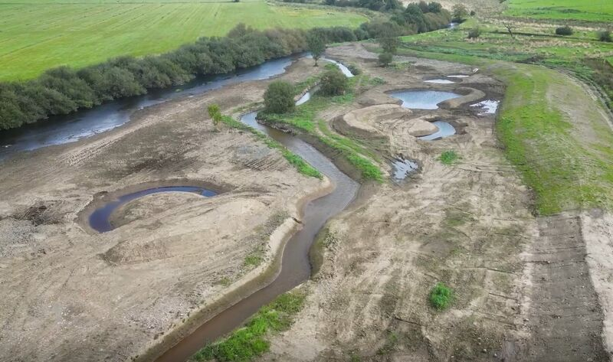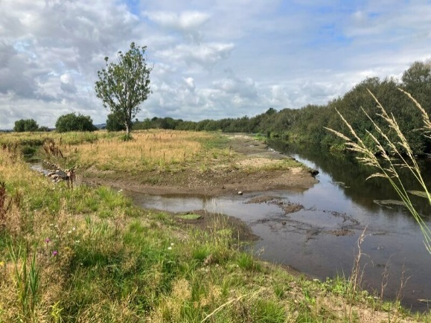
River Nith Restoration - Phase 4. Credit: SEPA
Removal of Halter Burn Weir in the Scottish Borders
The Halter Burn Weir in the Scottish Borders, a barrier to salmon and sea trout migration, was fully removed and the affected section of river restored in October 2025. This restored the river to a natural form and opened 1.6 km of upstream habitat. The project worked closely with local landowners and delivered added benefits: the old concrete was recycled for farm tracks, a local contractor reduced travel emissions, and further plans are in place to plant trees to offset carbon and enhance wildlife.
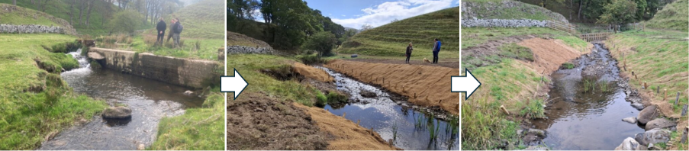
Halter Burn Before and After Weir Removal Works. Credit: Francis Hayes (SEPA)
The three projects above contribute to the delivery of the River Basin Management Plan programme of actions to improve the water environment, one of our Annual Operating Plan (AOP) objectives for 2025/26.
Salmon return to the Levern Water in Barrhead (and a Brownfield Award for Best Biodiversity Net Gain Project)
Following the removal of two fish barriers, salmon have spawned in Calibar Park for the first time in 170 years. Completed in 2023, the £2.8 million project restored a wider, natural river channel to improve flood resilience and biodiversity. It has been hailed as a model for habitat restoration and recently won the ‘Best Biodiversity Net Gain on a Brownfield Project’ at the highly esteemed Brownfield Awards in Manchester on 13 November 2025. Social media coverage from the awards has reached over 85,000 views. Link to article in The Herald Salmon return to small river near Glasgow after 170 years | The Herald
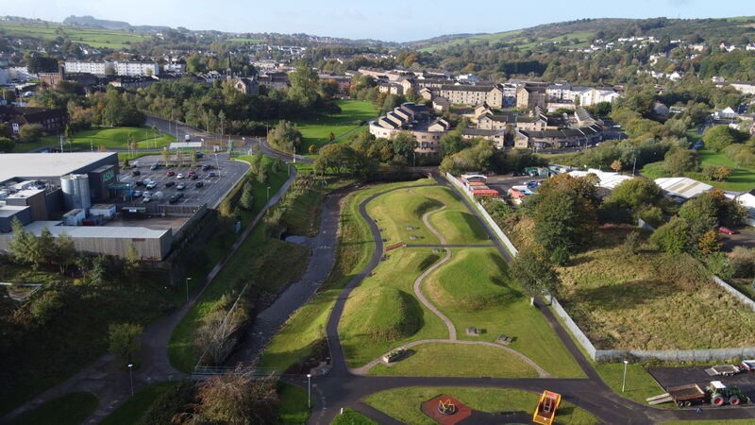
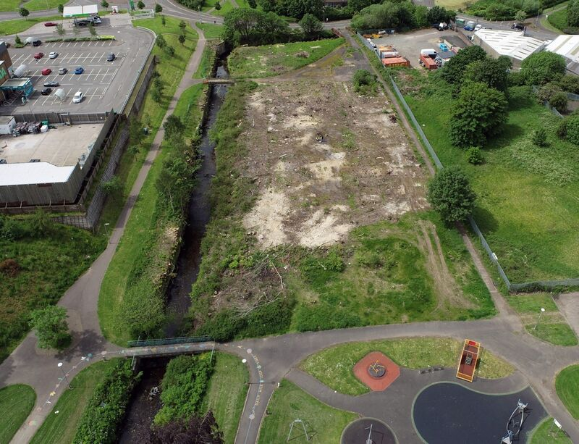
Levern Water, Water Environment Fund project, before (photograph credit: AmcoGiffen Ltd - Contractor) and after completion (photograph credit: East Renfrewshire Council).
Local Air Quality Management (LAQM)
Under the Environment Act 1995 and associated regulations, all Scottish local authorities are required to regularly review air quality in their areas against legal objectives for several pollutants of particular concern for human health. If this work indicates that any objective will not be achieved by the due date, the local authority concerned must declare an Air Quality Management Area (AQMA) and produce an action plan to tackle the issues identified.
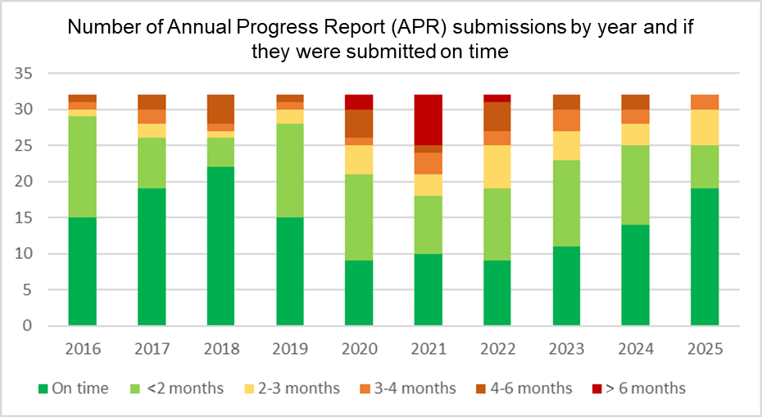
The local authority review and assessment reporting has now been completed for 2025, with all Annual Progress Reports (APRs) being submitted to the Scottish Government and SEPA and assessed. No enforcement action was required during the 2025 reporting process and local authority performance continues to improve, as shown in the chart below.

Chart showing the number of APR submissions by year and if they were submitted on time.

Since 2022, Scotland has met all air quality objectives at automatic monitoring stations across the country for nitrogen dioxide (NO2). In conjunction with improving trends in air quality, the number of Air Quality Management Areas (AQMAs) in Scotland has also reduced. In total 43 AQMAs have been declared during the period of Local Air Quality Management, and as of the end of 2025, only 13 remain in place. Further amendments and revocations are scheduled for completion during 2026. A further two Air Quality Action Plans (AQAPs) have also been updated and published since October 2025.
Cleaner Air for Scotland 2 Strategy (CAFS 2)
SEPA continues to provide technical support to the Scottish Government on the implementation of its CAFS2 Strategy and its subsequent review. Early discussions have been taking place on this review and SEPA will provide technical support in the fields of policy, regulatory, data and evidence on the development and implementation of the new Scottish Government long-term air quality policy framework which is due to be developed and in place during 2026.
Industrial greenhouse gas emissions continue to decrease
Greenhouse gas emissions from Scotland’s largest industrial facilities have fallen by almost a quarter in the past five years. The Scottish Pollutant Release Inventory (SPRI), published annually by SEPA, shows that Global Warming Potential, measured in million tonnes carbon dioxide equivalent (MtCO₂e), was 23.5% lower in 2024 than in 2019, continuing a long-term downward trend.
The energy sector remains the highest emitting sector, accounting for 38.6% of total industrial greenhouse gas emissions. However, emissions from the sector fell 7.4% in 2024, largely due to changes in production outputs. The sector is responsible for 40.2% of all carbon dioxide emissions, 15.2% of methane, 52.6% of nitrous oxide and 20.1% of hydrofluorocarbons.
Published as an Official Statistic, SEPA’s SPRI report was produced in a fully accessible and interactive format for the first time this year. Stakeholders can continue to find emissions from individual facilities from 2007- 2024 using the interactive visualisation tool on Scotland’s Environment web.

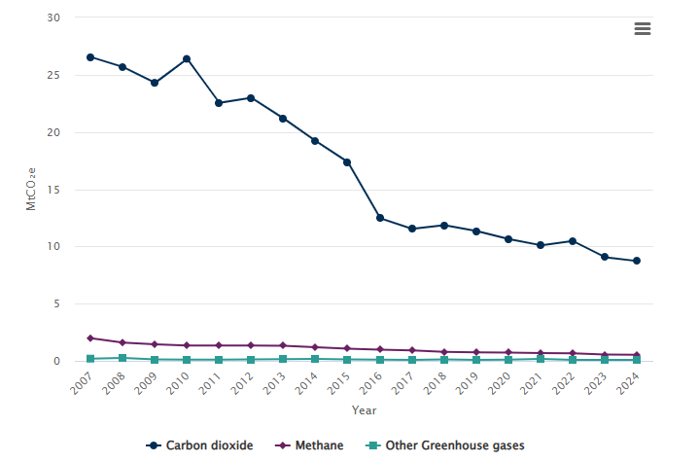
Global warming potential of carbon dioxide, methane and other greenhouse gases reported to SPRI since 2007.

Small rise in Scottish household waste recycling
Scotland’s latest househod waste statistics, published by SEPA in October 2025, show a small rise in recycling rates. In 2024, each person in Scotland generated an average of 0.42 tonnes of household waste. Of that, 0.19 tonnes was recycled, 0.05 tonnes was sent to landfill, and 0.19 tonnes was diverted away from landfill through other means, such as incineration.

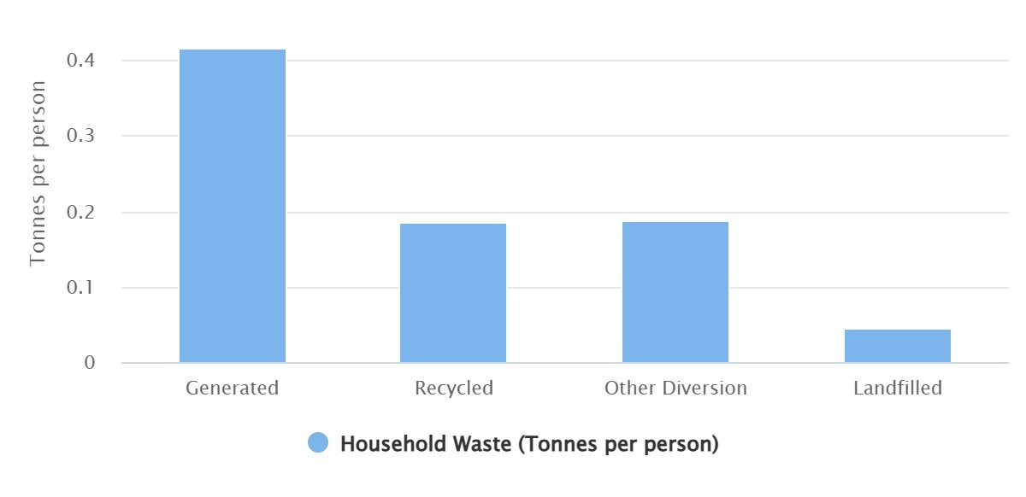
Scottish household waste generated and managed in 2024 – summary data – per person. Note: Other diversion includes all waste which is not recycled but is diverted away from landfill and includes waste incineration.

In total, householders in Scotland recycled 44.3% of their waste in 2024. Of the waste remaining, 36.8% was incinerated, 11.0% went to landfill and the remainder was sent for other treatment. That means that almost half of the waste from Scottish homes is still disposed of through incineration or landfill rather than being recycled.
While the overall amount of household waste generated in 2024 increased slightly on the previous year, the longer-term trend shows clear progress. Household waste generated has fallen by 11.2% since 2011, and the amount of household waste sent to landfill has reduced by more than three-quarters (82.5%) over the same period, reflecting Scotland’s transition away from disposal and towards recycling and recovery.

A changing landscape: Waste management
As well as Scottish household waste, SEPA waste data publications also include data and information on all waste landfilled and incinerated in Scotland.
The total quantity of all waste landfilled in Scotland in 2024 was 1.81 million tonnes, a reduction of 8.6% from 2023. This continues a long-term trend with a reduction of 74.3% from 2005 and is the lowest annual amount of waste landfilled in Scotland in the time series. The drop in waste landfilled between 2023 and 2024 is likely due to changes in the waste management sector preparing for the 2025 ban of biodegradable municipal waste (BMW) to landfill. The Agency’s temporary Regulatory Position Statement related to the BMW ban is mentioned earlier in this report.
The total quantity of all waste incinerated in Scotland in 2024 was 1.86 million tonnes, an increase of 14.7% from 2023, and an increase of 1.45 million tonnes (354%) from 2011.

Adapt 
Water Scarcity
Parts of Scotland went through an exceptionally long period of water scarcity this summer. Our autumn water scarcity report highlighted that this has been the dryest hydrological year in eastern Scotland since 1976, and that 2025 had the hottest March to August period since records began in 1884. During summer 2025, we saw rivers and groundwater levels reaching record lows, with prolonged periods of low flows. Scotland now needs above average levels of rainfall over winter to replenish groundwater levels. Without above average rainfall this winter, there is an increased risk of water scarcity for the east of Scotland into 2026. If conditions are drier than normal, the east of Scotland could experience even more serious water scarcity next year.
We have maintained engagement and carried out post-season reviews with National Farmers Union Scotland, Scotch Whisky Association, Scottish Government, Scottish Water, and NatureScot. Work to maintain our engagement and prepare for 2026 continues, and we are carrying out a SEPA review to ensure continuous improvement which involves the many teams across the business that have worked together.
Significant work has been required across SEPA and with partners to ensure clear messaging, promote resilient water use, and take regulatory action to protect the water environment. The period of significant water scarcity has had difficult implications for agriculture and distilleries in the east of Scotland, and we are working to ensure that these sectors increase their resilience, as we continue to develop our water scarcity approach. Irrigation licences are in the process of being varied ahead of next summer to help users plan and manage water more effectively. This forms part of broader work to develop national water resource planning in response to Scotland’s changing climate.

Avoid 
Launch of Phase one consultation on Scotland’s Flood Risk Management Plans for 2028 – 2034
The Flood Risk Management (Scotland) Act 2009 requires SEPA to produce Flood Risk Management Plans and to review and update them every six years. The plans are Scotland’s route map for reducing the impact of flooding in areas with the highest risk (called Potentially Vulnerable Areas) and are central to Scotland’s approach to tackling flooding.
SEPA, in our role as strategic flood risk management authority, is now developing Scotland’s Flood Risk Management Plans for the period 2028 to 2034, with final Flood Risk Management Plans due for publication in December 2027.
We have launched our phase one consultation to seek community views on flooding issues and priorities within Potentially Vulnerable Areas, to help shape these plans. We are also seeking information on projects and initiatives that are already happening to help manage flooding in these areas. This community-focussed consultation opened in January and runs until 22 April 2026.

Warn 
National Flood Risk Assessment (NFRA) Published
Flooding is Scotland’s most severe climate-related risk, and its impacts are accelerating as the climate changes. The National Flood Risk Assessment (NFRA) 2025 Summary Report was published in December 2025 and provides the most detailed picture yet of future risks and why urgent action is essential.
The NFRA is a strategic tool within Scotland’s flood risk management framework, offering a national overview to reduce flooding’s impact on people, property, the economy, and the environment. We regularly update the NFRA to ensure decisions are based on the most accurate evidence, supporting prioritisation of action, investment decisions, and access to reliable information for policymakers, practitioners, and communities.
Around 400,000 properties - 1 in 8 across Scotland - are currently at medium risk of flooding, up from 284,000 in 2018. By 2100, climate change could increase this to 634,000 properties, with coastal risk more than doubling. Flooding already costs Scotland an estimated £500 million annually and that figure is growing.
This year’s assessment introduces major improvements, including depth-based flood mapping, richer property data, and enhanced climate projections, enabling prioritisation of areas where impacts will be most severe. It confirms flooding is becoming more frequent, intense, and damaging, driven by surface water, small watercourses, rising sea levels, and river flooding. These insights will shape national and local flood risk management plans, identify Potentially Vulnerable Areas, and support Scotland’s Flood Resilience Strategy. We will publish underlying data in Spring 2026 for use by communities and authorities.
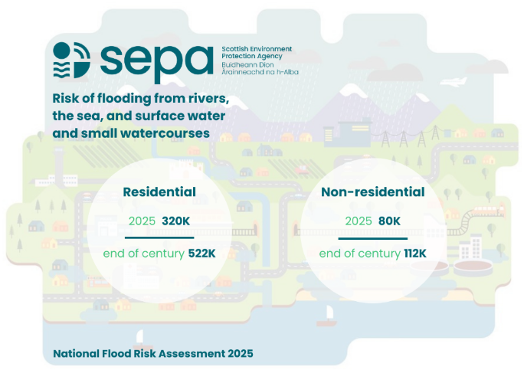
The total number of residential and non-residential properties in areas at current and future risk of flooding. Figure notes: Values to the nearest 1000. Scenario(s): medium risk and medium risk by 2100. Properties that are in areas at risk of flooding from multiple flood sources have been counted once.

Spotlight on…

SEPA Communications – enhancing our visibility and impact
Effective communication is central to public trust and accountability, responding to stakeholder expectations, supporting organisational performance, keeping our colleagues informed and engaged, and the delivery of our statutory and regulatory responsibilities. Our communications teams play a critical role in connecting people and regulated businesses with accurate information, supporting colleagues to deliver effective services and ensuring the Agency’s voice is credible and consistent. We are continuing to enhance our visibility and impact across all our communication channels, bringing to life some of the great coverage both internally and externally.
SEPA Update newsletter: driving engagement and trust
The SEPA Update newsletter reaches almost 31,000 subscribers every month across LinkedIn and email, making it one of SEPA’s most effective channels for engaging stakeholders and communities. Following its recent relaunch with the addition of themed editions such as Towards Net Zero, Our Water Environment and Business, the newsletter delivers personalised, accessible content that helps subscribers to stay informed and take action.
Produced entirely in-house and delivered weekly, the SEPA Update is a cost-effective channel for storytelling, sharing practical advice, promoting best practice and building trust with our audiences. It highlights strategic announcements, delivery and the everyday work we do that benefits our communities, businesses, and the environment. To sign up visit SEPA Update sign up | Scottish Environment Protection Agency (SEPA).
Reach  30,857 subscribers.  1164% from pre-launch.  23% year-on-year. | Engagement  45% average open rate vs 35% industry benchmark.  7% click through rate vs 3% industry benchmark. | Top topics  Flooding: 27% of total clicks.  EASR: 13% of total clicks.  Water environment: 9% of total clicks.
Social Media
Best performing social media content October to December 2025  - Promotion of changes implemented from Environmental Authorisations (Scotland) Regulations (EASR).  - Promotion of Scottish Pollutant Release Inventory and Household Waste Statistics.  - Scotland’s 2026 bathing water classifications.  - Restoration works completed on the River Nith.  - Significant Water Management Issues consultation.  - Flood updates.  - Climate Week content (water scarcity). | Facebook, Instagram, X and LinkedIn  Q3 compared to Q2  Total reach  Q3: 1,181,430. +12.5%  Total engagement  Q3: 9,112. +21.8%  Q3 result  New followers  Q3: 1,653
Website
We have improved the user journey on our website and digital accessibility by:
Implementing a new and improved Regulations landing page, providing a clearer overview of key sections. | Implementing a new and improved landing page for the ’Authorisations and Compliance’ section that prioritises users. |  | Improving content migrated into the beta website’s new ’Topic’ section, providing a foundation for future tagging and additional functionality.
Continuing to drive forward our HTML-first policy to boost digital accessibility within SEPA. | Publishing our Annual Report in an accessible HTML and PDF to provide a wider range of options to support user needs. | Continuing to collaborate via our Digital Accessibility and Digital Lived Experience groups to highlight positive change across the organisation.

To prepare for the launch of EASR, we built and uploaded:
382 activity pages | 130 guidance documents | 105 application forms
Internal Communications: Transformation
In October we launched the Transformation Hub, providing colleagues with a single, consistent view of progress across the Transformation programme. Early engagement has been strong, with around 50% of colleagues accessing the Hub and positive feedback highlighting its value for engagement. The launch of our Transformation Hub is covered in more detail earlier in this report.
Media and public affairs
Below is a breakdown of how our proactive media and public affairs work and incoming enquires related to SEPA’s purpose between October and December 2025. Our proactive coverage of water resilience messaging during the period is highlighted in the Adapt media releases. Media coverage is spread more evenly across our purpose themes, with Avoid coverage higher than our proactive media due to pick up of statutory responses to planning matters. The majority Official and Ministerial enquiries over this period are linked to Protect. This is in line with expectations and highlights the interest in our core regulatory work from these external stakeholders. You can view our media releases at beta.sepa.scot/news/.
Our purpose | Media releases | Media coverage | Official and Ministerial enquiries
Protect | 8% | 27% | 57%
Warn | 8% | 23% | 12%
Avoid | 0% | 9% | 2%
Adapt | 46% | 24% | 11%
Improve | 38% | 7% | 18%
Other | 0% | 10% | 0%

Together, media coverage over this period represents approximately 2.17bn opportunities to see based on current reach and circulation figures. In addition, we created more than 16,000 direct opportunities to see our strategic messages through proactive public affairs work.
This report represents an overview of SEPA’s delivery activity across the period.
For the Future of Our Environment.
Nicole Paterson, Chief Executive Officer, February 2026.

