

September 2023
2022 Pollutant emissions and waste transfers from SEPA regulated industrial sites
For information on accessing this document in an alternative format or language, please contact SEPA by emailing equalities@sepa.org.uk
If you are a user of British Sign Language (BSL), the Contact Scotland BSL service gives you access to an online interpreter, enabling you to communicate with us using sign language. contactscotland-bsl.org
This is an Official Statistics publication. These statistics have been produced to the high professional standards defined in the Code of Practice for Official Statistics, which sets out fourteen principles under the pillars of Trustworthiness, Quality and Value. More information on the Official Statistics Code of Practice can be found here: Code of Practice for Statistics (statisticsauthority.gov.uk)https://code.statisticsauthority.gov.uk/. Lead statistician: Rosaria Cartisano
This statistical release shows emissions of pollutants to air and water and offsite waste transfers reported by operators of industrial sites under the Scottish Pollutant Release Inventory (SPRI) for the 2022 calendar year. Some historic data is included for comparison. Information about the SPRI and on the methods used to prepare this release is provided in sections two and three of this document.
Complete SPRI data is available at: Scottish Pollution Release Inventory (sepa.org.uk)
This is a data analysis tool which allows you to view summarised information by industry sector for pollutants and waste transfers. Data can be downloaded in bulk, including at a site level. It is updated annually when the previous year’s data is published.
Media enquiries to: SEPA Communications Department: media@sepa.org.uk
Feedback on this document to: SPRI.Administration@sepa.org.uk

Contents
1. The statistics 4
1.1 Key information for 2022 4
1.2 Emissions and waste transfers for 2022 5
1.3 Greenhouse gas emissions 27
1.4 SPRI reporting data 34
2. Scope of this statistical release 40
2.1 User statement 40
2.2 Feedback 41
2.3 Revisions 41
2.4 Release 48
3. About the Scottish Pollutant Release Inventory 49
3.1 What is the Scottish Pollutant Release Inventory? 49
3.2 Who reports? 49
3.3 SEPA’s role 50
3.4 Information to consider when using SPRI data and technical notes 51

.

1. The statistics

1.1 Key information for 2022

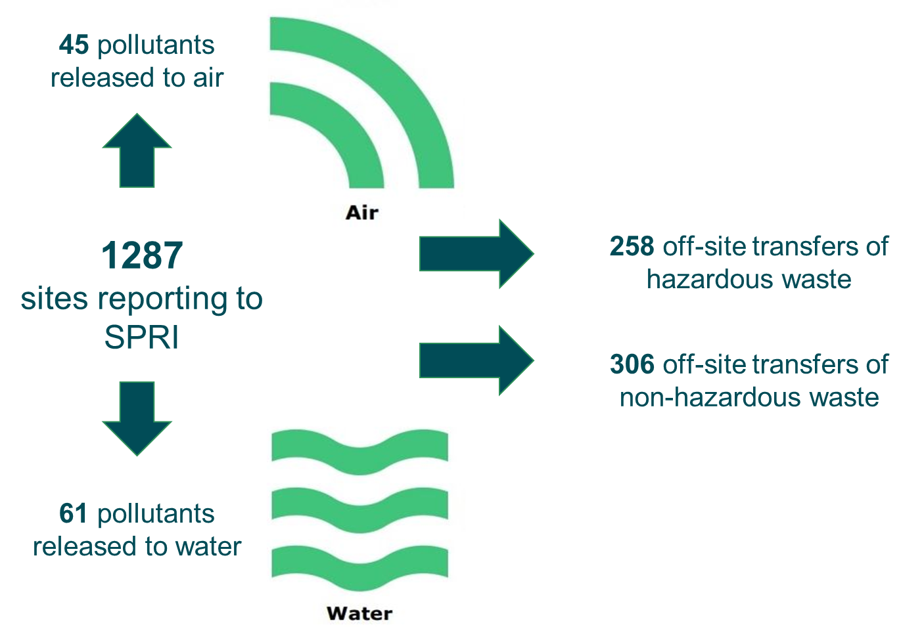

In 2022, 1,287 sites were expected to report to SPRI. Of these 1,241 (96.4%) submitted a return. Among the 46 remaining sites who did not submit a return, 9 of these sites were required to report air, water and waste data. The other 37 were required to provide data solely for waste, as their activities did not require them to report on other emissions. Of the 1,241 reporting sites, 213 (17%) had no reportable pollutant emissions or off-site waste transfers.
In many cases, as is normal for these types of industrial sites, changes to production or throughput were noted by many operators. Information reported by some operators reflected an increase in productivity following the 2020/2021 Covid-19 lockdowns, which resulted in increased emissions.
The overall global warming potential of greenhouse gas emissions from the SEPA-regulated industrial sites which report to SPRI (measured as kilograms of carbon dioxide equivalent (kg CO₂e)) increased by 2.7% between 2021 and 2022. Despite the increase from last year, the long-term trend continues to decrease since 2007, with year-to-year variations reflecting the complex interplay between economic recovery, production demands and post-pandemic dynamics. In fact, the global warming potential of greenhouse gas emissions in 2022 was less than the values recorded in 2018, 2019 and 2020. Emissions of all six greenhouse gases which are reportable to SPRI are discussed in section 1.3.

1.2 Emissions and waste transfers for 2022

Emissions
Summary data is provided for all “above reporting threshold” (‘ART’ – see note below) emissions to air and water in the tables below (and on the accompanying data sheet). This is followed by more detailed information on greenhouse gas emissions data captured within SPRI.
Tables provided below show:
- Table 1: Total ART emissions to air by pollutant and industry sector for 2022
- Table 2: Number of sites reporting ART emissions to air, and percentage of total ART emissions released, by industry sector and pollutant for 2022.
- Table 3: Total ART emissions to water by pollutant and industry sector for 2022. All values are kg.
- Table 4: Number of sites reporting ART emissions to water, and percentages of total ART emissions released, by sector and pollutant for 2022.

Notes on data provided in this publication:
- All values are in kilograms, with the exceptions of carbon dioxide to air which is given in tonnes (1,000kg) in some figures to simplify reporting.
- All pollutants in SPRI have a reporting threshold value. If a site’s emission is below this value, they report only ‘BRT' (Below Reporting Threshold). If emissions are ‘ART’ (Above Reporting Threshold) they must supply us with a value. See Figure 7 for a breakdown of ART and BRT reporting. Figures for total emissions and number of reporting sites provided in this document are for ‘ART’ submissions only.
- Percentage figures given to show proportion of total emissions from each industrial sector are rounded so may not total 100%.
- Precision of figures. Operators are asked to supply figures to three significant figures. Many provide more precise figures, and we have used these here. For some official reporting we are required to round each individual value to three significant figures which may cause slight discrepancies from the totals reported here.
- There are ten SPRI Industry Sectors, but only sectors with emissions of the pollutants listed, are reported in the tables below. For details of the activities which place a site within those sectors, including the minimum capacity a site must have to be required to report to SPRI, see Table 6 and section 3 (About the Scottish Pollutant Release Inventory).

Table 1: Total ART emissions to air by pollutant and industry sector for 2022. All values are kg except for carbon dioxide which is in tonnes.
Pollutant name | Reporting threshold | Total Release | 1 - Energy sector | 2 - Production and processing of metals | 3 - Mineral industry | 4 - Chemical industry | 5 - Waste and wastewater m/ment | 6 - Paper and wood production and processing | 7 - Intensive livestock production and aquaculture | 8 - Animal and vegetable products from the food and beverage sector | 9 - Other activities
Ammonia | 1,000 | 924,086 | 1,352 |  | 73,256 | 2,727 | 18,345 |  | 828,407
Antimony | 1 | 84.7 | 1.13 |  | 1.65 |  | 41.2 | 40.8
Arsenic | 1 | 54.5 |  |  | 11.3 |  | 3.68 | 39.5
Benzene | 1,000 | 84,400 | 18,014 |  |  | 66,385
Butadiene | 100 | 39,212 | 5,438 |  |  | 33,774
Cadmium | 1 | 12.8 |  |  | 4.21 |  | 4.86 | 3.72
Carbon dioxide (tonnes) | 10,000 t | 10,514,224 | 4,954,369 | 50,598 | 667,166 | 1,494,620 | 2,230,090 | 771,561 |  | 334,901 | 10,920
Carbon monoxide | 100,000 | 9,446,362 | 4,242,667 |  | 2,906,610 | 445,786 | 1,055,367 | 795,932
Chlorine and total inorganic chlorine compounds - as HCl | 10,000 | 52,459 |  |  |  |  | 28,081 | 24,378
Chlorofluorocarbons (CFCs) | 1 | 308 |  |  |  |  | 308
Chromium | 10 | 186 |  |  | 27.0 |  | 98.1 | 61.0
Copper | 10 | 104 |  |  | 27.7 |  | 11.1 | 64.9
Dioxins and furans - as ITEQ | 0.00001 | 0.000278 |  |  |  |  | 0.0000872 | 0.000191
Dioxins and furans - as WHO TEQ | 0.00001 | 0.000265 |  |  |  |  | 0.0000995 | 0.000165
Ethylbenzene | 100 | 684 |  |  |  | 684
Fluorine and total inorganic fluorine compounds - as HF | 1,000 | 18,885 |  | 17,878 | 1,007
Formaldehyde | 10 | 101,740 |  |  | 1,015 | 15.0 |  | 100,710
Hydrochlorofluorocarbons (HCFCs) | 1 | 205 |  |  |  |  | 205
Hydrofluorocarbons (HFCs) | 100 | 1,469 |  |  |  | 220 |  |  |  | 1,249
Hydrogen chloride | 10,000 | 67,250 |  |  |  |  | 67,250
Hydrogen cyanide | 100 | 130 |  |  |  | 130
Lead | 100 | 1,035 |  |  |  |  |  | 1,035
Manganese | 10 | 120 |  |  | 43.3 |  | 35.0 | 41.5
Mercury | 1 | 11.1 |  |  | 2.41 |  | 5.75 | 2.92
Methane | 10,000 | 23,233,842 | 2,481,538 |  | 31,252 | 357,919 | 19,760,080 |  | 576,094 | 26,959
Methyl chloride | 1,000 | 17,090 |  |  |  | 17,090
Methyl chloroform | 10 | 47.5 |  |  |  |  | 47.5
Methylene chloride | 1,000 | 105,917 |  |  |  | 105,917
Naphthalene | 100 | 345 |  |  | 345
Nickel | 10 | 165 | 18.8 |  | 40.9 |  | 46.8 | 58.8
Nitrogen oxides, NO and NO2 as NO2 | 100,000 | 10,732,470 | 5,507,745 |  | 1,368,608 | 1,700,466 | 1,376,091 | 779,560
Nitrous oxide | 10,000 | 49,575 | 38,795 |  |  |  | 10,780
Non-methane volatile organic compounds (NMVOCs) | 10,000 | 21,257,846 | 7,603,802 |  | 78,394 | 3,399,738 |  | 711,559 |  | 9,169,375 | 294,978
Particulate matter - PM10 and smaller | 10,000 | 613,104 | 55,919 | 14,108 | 308,284 | 78,051 |  |  | 156,742
Particulate matter - total | 50,000 | 276,985 |  |  |  |  |  |  | 276,985
Particulates - PM2.5 and smaller only | 1,000 | 5,909 | 1,398 |  | 3,382 |  | 1,129
Perfluorocarbons (PFCs) | 10 | 4,564 |  | 392 |  | 4,172
Phenols - total as C | 10 | 627 |  |  | 627
Polycyclic aromatic hydrocarbons (PAHs) (four indicator compounds of LRTAP) | 1 | 6.06 |  |  |  |  | 6.06
Selenium | 100 | 376 |  |  | 376
Styrene | 100 | 431 |  |  |  | 431
Sulphur hexafluoride | 10 | 230 |  |  |  | 230
Sulphur oxides, SO2 and SO3 as SO2 | 100,000 | 3,556,953 | 2,121,844 | 397,531 | 1,037,578
Toluene | 100 | 62,527 | 22,773 |  |  | 36,639 |  |  |  |  | 3,115
Xylene - all isomers | 1,000 | 24,264 | 19,714 |  |  | 4,550

Table 2: Number of sites reporting ART emissions to air, and percentage of total ART emissions released, by industry sector and pollutant for 2022.
Pollutant | ART Sites | Energy Sites | Energy % | Metals Sites | Metals % | Mineral Sites | Mineral % | Chemical Sites | Chemical % | Waste Sites | Waste % | Paper / Wood | Paper / Wood % | Live-stock / Aqua Sites | Live- stock / Aqua % | Food / Beverage Sites | Food / Beverage % | Other Sites | Other %
Ammonia | 114 | 1 | 0.15 |  |  | 2 | 7.93 | 1 | 0.3 | 9 | 1.99 |  |  | 101 | 89.6
Antimony | 8 | 1 | 1.33 |  |  | 1 | 1.95 |  |  | 4 | 48.6 | 2 | 48.1
Arsenic | 8 |  |  |  |  | 3 | 20.7 |  |  | 2 | 6.7 | 3 | 72.5
Benzene | 3 | 1 | 21.3 |  |  |  |  | 2 | 78.7
Butadiene | 4 | 1 | 13.9 |  |  |  |  | 3 | 86.1
Cadmium | 6 |  |  |  |  | 2 | 32.9 |  |  | 3 | 38.0 | 1 | 29.1
Carbon dioxide | 75 | 24 | 47.1 | 1 | 0.48 | 4 | 6.35 | 6 | 14.2 | 29 | 21.2 | 6 | 7.34 |  |  | 4 | 3.19 | 1 | 0.10
Carbon monoxide | 26 | 14 | 44.9 |  |  | 1 | 30.8 | 2 | 4.72 | 6 | 11.2 | 3 | 8.43
Chlorine and total inorganic chlorine compounds - as HCl | 2 |  |  |  |  |  |  |  |  | 1 | 53.5 | 1 | 46.5
Chlorofluorocarbons (CFCs) | 22 |  |  |  |  |  |  |  |  | 22 | 100
Chromium | 8 |  |  |  |  | 1 | 14.5 |  |  | 5 | 52.7 | 2 | 32.8
Copper | 3 |  |  |  |  | 1 | 26.7 |  |  | 1 | 10.7 | 1 | 62.6
Dioxins and furans - as ITEQ | 5 |  |  |  |  |  |  |  |  | 3 | 31.3 | 2 | 68.7
Dioxins and furans - as WHO TEQ | 4 |  |  |  |  |  |  |  |  | 2 | 37.6 | 2 | 62.4
Ethylbenzene | 1 |  |  |  |  |  |  | 1 | 100
Fluorine and total inorganic fluorine compounds - as HF | 2 |  |  | 1 | 94.7 | 1 | 5.33
Formaldehyde | 5 |  |  |  |  | 1 | 1.00 | 1 | 0.01 |  |  | 3 | 99.0
Hydrochlorofluorocarbons (HCFCs) | 19 |  |  |  |  |  |  |  |  | 19 | 100
Hydrofluorocarbons (HFCs) | 3 |  |  |  |  |  |  | 1 | 15.0 |  |  |  |  |  |  | 2 | 85.0
Hydrogen chloride | 3 |  |  |  |  |  |  |  |  | 3 | 100
Hydrogen cyanide | 1 |  |  |  |  |  |  | 1 | 100
Lead | 1 |  |  |  |  |  |  |  |  |  |  | 1 | 100
Manganese | 5 |  |  |  |  | 1 | 36.1 |  |  | 2 | 29.2 | 2 | 34.6
Mercury | 6 |  |  |  |  | 1 | 21.8 |  |  | 4 | 51.9 | 1 | 26.4
Methane | 104 | 16 | 10.7 |  |  | 1 | 0.13 | 3 | 1.54 | 60 | 85.0 |  |  | 23 | 2.48 | 1 | 0.12
Methyl chloride | 1 |  |  |  |  |  |  | 1 | 100
Methyl chloroform | 2 |  |  |  |  |  |  |  |  | 2 | 100
Methylene chloride | 2 |  |  |  |  |  |  | 2 | 100
Naphthalene | 1 |  |  |  |  | 1 | 100
Nickel | 6 | 1 | 11.4 |  |  | 2 | 24.8 |  |  | 1 | 28.3 | 2 | 35.6
Nitrogen oxides, NO and NO2 as NO2 | 24 | 10 | 51.3 |  |  | 3 | 12.8 | 3 | 15.8 | 5 | 12.8 | 3 | 7.3
Nitrous oxide | 3 | 2 | 78.3 |  |  |  |  |  |  | 1 | 21.7
Non-methane volatile organic compounds (NMVOCs) | 37 | 17 | 35.8 |  |  | 2 | 0.37 | 8 | 16.0 |  |  | 2 | 3.35 |  |  | 4 | 43.1 | 4 | 1.39
Particulate matter - PM10 and smaller | 20 | 2 | 9.12 | 1 | 2.30 | 8 | 50.3 | 1 | 12.7 |  |  |  |  | 8 | 25.6
Particulate matter - total | 3 |  |  |  |  |  |  |  |  |  |  |  |  | 3 | 100
Particulates - PM2.5 and smaller only | 4 | 1 | 23.7 |  |  | 2 | 57.2 |  |  | 1 | 19.1
Perfluorocarbons (PFCs) | 3 |  |  | 1 | 8.59 |  |  | 2 | 91.4
Phenols - total as C | 1 |  |  |  |  | 1 | 100
Polycyclic aromatic hydrocarbons (PAHs) (four indicator compounds of LRTAP) | 2 |  |  |  |  |  |  |  |  | 2 | 100
Selenium | 1 |  |  |  |  | 1 | 100
Styrene | 1 |  |  |  |  |  |  | 1 | 100
Sulphur hexafluoride | 2 |  |  |  |  |  |  | 2 | 100
Sulphur oxides, SO2 and SO3 as SO2 | 8 | 4 | 59.7 | 1 | 11.2 | 3 | 29.2
Toluene | 7 | 1 | 36.4 |  |  |  |  | 4 | 58.6 |  |  |  |  |  |  |  |  | 2 | 4.98
Xylene - all isomers | 2 | 1 | 81.2 |  |  |  |  | 1 | 18.8

Table 3: Total ART emissions to water by pollutant and industry sector for 2022. All values are kg.
Pollutant name | Reporting threshold (kg) | Total Release (kg) | 1 - Energy sector | 4 - Chemical industry | 5 - Waste and wastewater m/ment | 6 - Paper and wood production and processing | 7 - Intensive livestock production and aquaculture | 8 - Animal and vegetable products from the food and beverage sector
Aldrin | 0.001 | 0.0037 |  |  | 0.0037
Ammonia | 20 | 11,796,495 | 2,300 | 96.0 | 9,658,886 |  |  | 2,135,213
Anthracene | 0.1 | 35.2 |  | 0.41 | 34.8
Arsenic | 5 | 498 | 21.7 | 19.0 | 457
Asbestos | 0.1 | 75.4 |  |  | 75.4
Azamethiphos | 0.001 | 109 |  |  |  |  | 109
Benzene | 10 | 573 | 299 | 275
Benzo (g,h,i) perylene | 0.1 | 9.95 |  | 0.18 | 9.77
Benzo(a) pyrene | 1.0 | 1.04 |  |  | 1.04
Brominated diphenylethers - total as Br | 0.1 | 0.53 |  |  | 0.53
Cadmium | 1.0 | 73.8 | 2.33 | 3.00 | 31.1 |  |  | 37.4
Chlorides - total as Cl | 2,000,000 | 53,813,420 | 4,313,420 | 3,610,000 | 45,890,000
Chloroform | 5 | 46.2 |  |  | 46.2
Chromium | 20 | 571 |  | 68.5 | 389 |  |  | 113
Copper | 20 | 28,281 | 62.0 | 76.0 | 5,782 |  | 18,633 | 3,728
Cyanides - total as CN | 50 | 828 |  | 97.4 | 731
Cypermethrin | 0.005 | 0.426 |  |  | 0.426
Deltamethrin | 0.002 | 2.18 |  |  |  |  | 2.18
Di(2-ethylhexyl) phthalate | 0.100 | 1,740 |  |  | 1,740
Diazinon | 0.01 | 0.65 |  |  | 0.65
Dichlorvos | 0.001 | 0.004 |  |  | 0.004
Dieldrin | 0.001 | 0.004 |  |  | 0.004
Dioxins and furans - as ITEQ | 0.0001 | 0.00063 |  |  | 0.00063
Dioxins and furans - as WHO TEQ | 0.0001 | 0.00063 |  |  | 0.00063
Diuron | 0.05 | 5.53 |  |  | 5.53
Emamectin benzoate | 0.001 | 41.8 |  |  |  |  | 41.8
Endrin | 0.001 | 0.004 |  |  | 0.004
Ethylbenzene | 10 | 21.1 | 21.1
Fluoranthene | 0.1 | 8.15 |  | 2.32 | 5.83
Fluorides - total as F | 2,000 | 178,170 |  |  | 178,170
Halogenated organic compounds - total as AOX | 1,000 | 83,450 |  |  | 83,450
Hexachlorocyclohexane - all isomers | 0.01 | 1.29 |  |  | 1.29
Iron | 1,000 | 400,430 | 1,670 |  | 398,760
Isoproturon | 0.01 | 0.136 |  |  | 0.136
Lead | 20 | 728 |  |  | 728
Lindane | 0.1 | 0.849 |  |  | 0.849
Manganese | 200 | 1,970 |  |  |  |  |  | 1,970
Mercury | 0.1 | 12.7 |  | 1.04 | 11.0
Methylene chloride | 10 | 78.0 |  | 10.9 | 67.1
Naphthalene | 1.0 | 1,020 | 1.30 | 19.5 | 999
Nickel | 20 | 6,323 |  | 141 | 4,514 |  |  | 1,668
Nitrogen - total as N | 50,000 | 33,847,146 |  | 199,000 | 18,441,922 |  | 10,381,631 | 4,824,593
Nonylphenol ethoxylates | 1.0 | 3,570 |  |  | 3,570
Nonylphenols | 1.0 | 568 |  |  | 568
Nonyphenol and nonylphenol ethoxylates | 1.0 | 2,403 |  |  | 2,403
Octylphenol and octylphenol ethoxylates | 1.0 | 4.94 |  |  | 4.94
Octylphenols | 1.0 | 4.94 |  |  | 4.94
Organic tin compounds - total as Sn | 5.0 | 6.43 |  |  | 6.43
Permethrin | 0.001 | 3.46 |  |  | 3.46
Phenols - total as C | 20 | 3,083 | 1,746 | 1,213 | 102 |  |  | 22.0
Phosphorus - total as P | 5,000 | 4,679,184 |  | 36,556 | 2,055,060 |  | 1,559,323 | 1,028,245
Polychlorinated biphenyls | 0.001 | 0.652 |  |  | 0.652
Polycyclic aromatic hydrocarbons (PAHs) (four indicator compounds of LRTAP) | 1.0 | 71.3 |  | 1.40 | 69.9
Toluene | 10 | 340 | 229 | 111
Total organic carbon or COD/3 | 50,000 | 74,508,744 | 53,419 | 1,311,591 | 10,128,800 | 103,926 | 40,017,429 | 22,893,579
Tributyltin compounds | 0.01 | 1.32 |  |  | 1.32
Trichlorobenzene - all isomers | 0.01 | 9.94 |  |  | 9.94
Trifluralin | 0.001 | 0.03 |  |  | 0.03
Triphenyltin compounds | 0.1 | 0.772 |  |  | 0.772
Xylene - all isomers | 10 | 128 | 75.5 | 25.4 | 27.6
Zinc | 100 | 64,678 | 256 | 583 | 25,595 |  | 31,982 | 6,262

Table 4: Number of sites reporting ART emissions to water, and percentage of total ART emissions released, by sector and pollutant for 2022.
Pollutant | ART Sites | Energy Sites | Energy % | Chemical Sites | Chemical % | Waste Sites | Waste % | Paper / Wood Sites | Paper / Wood % | Livestock / Aqua Sites | Livestock / Aqua % | Food / Beverage Sites | Food / Beverage %
Aldrin | 1 |  |  |  |  | 1 | 100
Ammonia | 78 | 1 | 0.02 | 2 | 0.001 | 73 | 81.9 |  |  |  |  | 2 | 18.1
Anthracene | 54 |  |  | 1 | 1.16 | 53 | 98.8
Arsenic | 26 | 2 | 4.37 | 1 | 3.82 | 23 | 91.8
Asbestos | 71 |  |  |  |  | 71 | 100
Azamethiphos | 74 |  |  |  |  |  |  |  |  | 74 | 100
Benzene | 4 | 2 | 52.1 | 2 | 47.9
Benzo (g,h,i) perylene | 26 |  |  | 1 | 1.81 | 25 | 98.2
Benzo(a) pyrene | 1 |  |  |  |  | 1 | 100
Brominated diphenylethers - total as Br | 3 |  |  |  |  | 3 | 100
Cadmium | 17 | 1 | 3.16 | 1 | 4.06 | 13 | 42.1 |  |  |  |  | 2 | 50.7
Chlorides - total as Cl | 12 | 1 | 8.02 | 1 | 6.7 | 10 | 85.3
Chloroform | 4 |  |  |  |  | 4 | 100
Chromium | 8 |  |  | 1 | 12.0 | 6 | 68.2 |  |  |  |  | 1 | 19.8
Copper | 83 | 1 | 0.22 | 1 | 0.27 | 56 | 20.4 |  |  | 23 | 65.9 | 2 | 13.2
Cyanides - total as CN | 9 |  |  | 1 | 11.8 | 8 | 88.2
Cypermethrin | 14 |  |  |  |  | 14 | 100
Deltamethrin | 27 |  |  |  |  |  |  |  |  | 27 | 100
Di(2-ethylhexyl) phthalate | 73 |  |  |  |  | 73 | 100
Diazinon | 13 |  |  |  |  | 13 | 100
Dichlorvos | 1 |  |  |  |  | 1 | 100
Dieldrin | 1 |  |  |  |  | 1 | 100
Dioxins and furans - as ITEQ | 3 |  |  |  |  | 3 | 100
Dioxins and furans - as WHO TEQ | 3 |  |  |  |  | 3 | 100
Diuron | 26 |  |  |  |  | 26 | 100
Emamectin benzoate | 107 |  |  |  |  |  |  |  |  | 107 | 100
Endrin | 1 |  |  |  |  | 1 | 100
Ethylbenzene | 1 | 1 | 100
Fluoranthene | 22 |  |  | 2 | 28.5 | 20 | 71.5
Fluorides - total as F | 25 |  |  |  |  | 25 | 100
Halogenated organic compounds - total as AOX | 24 |  |  |  |  | 24 | 100
Hexachlorocyclohexane - all isomers | 15 |  |  |  |  | 15 | 100
Iron | 53 | 1 | 0.42 |  |  | 52 | 100
Isoproturon | 7 |  |  |  |  | 7 | 100
Lead | 12 |  |  |  |  | 12 | 100
Lindane | 5 |  |  |  |  | 5 | 100
Manganese | 1 |  |  |  |  |  |  |  |  |  |  | 1 | 100
Mercury | 37 | 2 | 2.77 | 3 | 8.20 | 31 | 87.0 |  |  |  |  | 1 | 2.05
Methylene chloride | 3 |  |  | 1 | 14.0 | 2 | 86.0
Naphthalene | 74 | 1 | 0.13 | 1 | 1.92 | 72 | 98.0
Nickel | 42 |  |  | 1 | 2.23 | 40 | 71.4 |  |  |  |  | 1 | 26.4
Nitrogen - total as N | 165 |  |  | 1 | 0.59 | 54 | 54.5 |  |  | 108 | 30.7 | 2 | 14.3
Nonylphenol ethoxylates | 73 |  |  |  |  | 73 | 100
Nonylphenols | 65 |  |  |  |  | 65 | 100
Nonyphenol and nonylphenol ethoxylates | 73 |  |  |  |  | 73 | 100
Octylphenol and octylphenol ethoxylates | 3 |  |  |  |  | 3 | 100
Octylphenols | 3 |  |  |  |  | 3 | 100
Organic tin compounds - total as Sn | 1 |  |  |  |  | 1 | 100
Permethrin | 22 |  |  |  |  | 22 | 100
Phenols - total as C | 10 | 4 | 56.6 | 2 | 39.3 | 3 | 3.32 |  |  |  |  | 1 | 0.71
Phosphorus - total as P | 181 |  |  | 2 | 0.78 | 48 | 43.9 |  |  | 129 | 33.3 | 2 | 22.0
Polychlorinated biphenyls | 20 |  |  |  |  | 20 | 100
Polycyclic aromatic hydrocarbons (PAHs) (four indicator compounds of LRTAP) | 23 |  |  | 1 | 1.96 | 22 | 98.0
Toluene | 4 | 2 | 67.4 | 2 | 32.6
Total organic carbon or COD/3 | 218 | 1 | 0.07 | 3 | 1.76 | 37 | 13.6 | 1 | 0.14 | 173 | 53.7 | 3 | 30.7
Tributyltin compounds | 27 |  |  |  |  | 27 | 100
Trichlorobenzene - all isomers | 1 |  |  |  |  | 1 | 100
Trifluralin | 1 |  |  |  |  | 1 | 100
Triphenyltin compounds | 1 |  |  |  |  | 1 | 100
Xylene - all isomers | 5 | 2 | 58.8 | 2 | 19.8 | 1 | 21.5
Zinc | 188 | 2 | 0.40 | 3 | 0.90 | 51 | 39.6 |  |  | 130 | 49.4 | 2 | 9.68

Waste transfers

Table 5: Offsite waste transfers by industry sector and type for 2022. All values are tonnes.
Industry sector | Hazardous Disposal | Hazardous Recovery | Non- Hazardous Disposal | Non- Hazardous Recovery
1 - Energy sector | 2,806 | 8,576 | 3,553 | 11,464
2 - Production and processing of metals | 2,944 | 1,302 | 159 | 4,338
3 - Mineral industry | 433 | 189 | - | 4,688
4 - Chemical industry | 256,912 | 45,007 | 4,178 | 8,372
5 - Waste and waste-water management | 106,059 | 156,805 | 2,786,028 | 3,909,189
6 - Paper and wood production and processing | 740 | 7,855 | 6,895 | 19,812
7 - Intensive livestock production and aquaculture | - | - | 4,332 | 58,436
8 - Animal and vegetable products from the food and beverage sector | 4,316 | 35.0 | 116,320 | 176,132
9 - Other activities | 318 | 1,169 | 8,203 | 4,564
Total | 374,528 | 220,938 | 2,929,668 | 4,196,995

Notes:
1. More detailed data on waste transfers are available on the SEPA website, which provides extensive reporting on waste data for Scotland.
2.The thresholds for reporting offsite waste transfers are 2 tonnes for hazardous and 2,000 tonnes for non-hazardous. No ‘BRT’ report is necessary as it is assumed all sites will produce some waste.
3. ‘Disposal” and “Recovery’ mean any of the operations provided for in Annex IIA and Annex IIB of EU Waste Directive 2006/12/EC

1.3 Greenhouse gas emissions
Emissions of four individual greenhouse gases, and two groups of greenhouse gases are reportable to SPRI.
Three of these are ‘Fluorinated greenhouse gases’ or ‘F-gases’; a family of chemicals that contain fluorine which are also powerful greenhouse gases that contribute to climate change. The UK has a regulation on the use of F-gases like hydrofluorocarbons (HFCs), perfluorocarbons (PFCs) and sulphur hexafluoride (SF₆). Note that the Kyoto ‘basket’ of greenhouse gases includes nitrogen trifluoride (an F-gas) which is not reportable to SPRI.
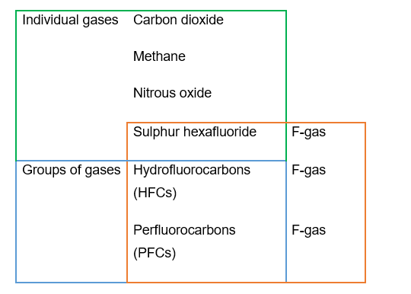

Global warming potential: a note on the use of ‘carbon dioxide equivalent’ (CO₂e) mass
The Intergovernmental Panel on Climate Change (IPCC) explains Global Warming Potentials as: “Global Warming Potentials (GWP) are calculated as the ratio of the radiative forcing of one kilogramme greenhouse gas emitted to the atmosphere to that from one kilogramme CO₂ over a period of time.”
The GWP values used in this publication are taken from the Intergovernmental Panel on Climate Change (IPCC) Fifth Assessment Report (AR5) over a 100-year period (in line with the approach taken for the Scottish Greenhouse Gas Statistics 2021).
The GWPs used for the individual greenhouse gases are:
Greenhouse gas | Lifetime (years) | 100 years GWP (AR5)
Carbon dioxide | 50-200 | 1
Methane | 12 | 28
Nitrous oxide | 114 | 265
Sulphur hexafluoride | 3200 | 23,500

For grouped gases:
It is currently not possible for us to reliably convert these to carbon dioxide equivalent (CO₂e) values as we do not formally collect information identifying individual species of hydrofluorocarbons and perfluorocarbons.
- For hydrofluorocarbons, we have used the value for HFC-23 (100 years GWP (AR5) = 12,400).
- In reality, most HFC releases are known to be of refrigerants and the gases most commonly specifically identified to SPRI have GWPs of between 1,000 and 4,000.
- For perfluorocarbons, we have used the value for PFC-116 (100 years GWP (AR5) = 11,100). We have very limited information on the species of PFC released from SPRI sites.
SPRI provides information on greenhouse gas emissions from industrial sites only. The Scottish Greenhouse Gas Statistics is the key tool for understanding the origins and magnitudes of greenhouse gas emissions in Scotland.

Long term view of global warming potential of SPRI releases
Figures 1 and 2 show the global warming potential of total emissions from SPRI since 2007 (when the current regulations which our core reporting is based on came into force).
The long-term trend continues to decrease since 2007, with year-to-year variations reflecting the complex interplay between economic recovery, production demands and post-pandemic dynamics. In fact, the global warming potential of greenhouse gas emissions in 2022 was less than the values recorded in 2018, 2019 and 2020.

Figure 1: Global warming potential of greenhouse gases reported to SPRI since 2007 (MtCO₂e).

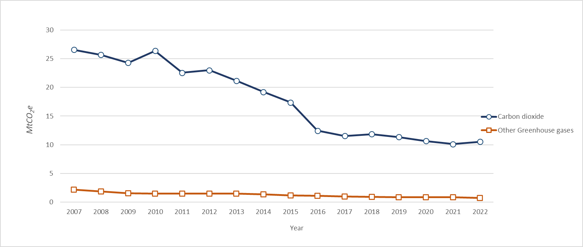

Figure 2: Global warming potential of greenhouse gases reported to SPRI since 2007 (MtCO₂e), excluding carbon dioxide and methane, to show relative scale of minor gases
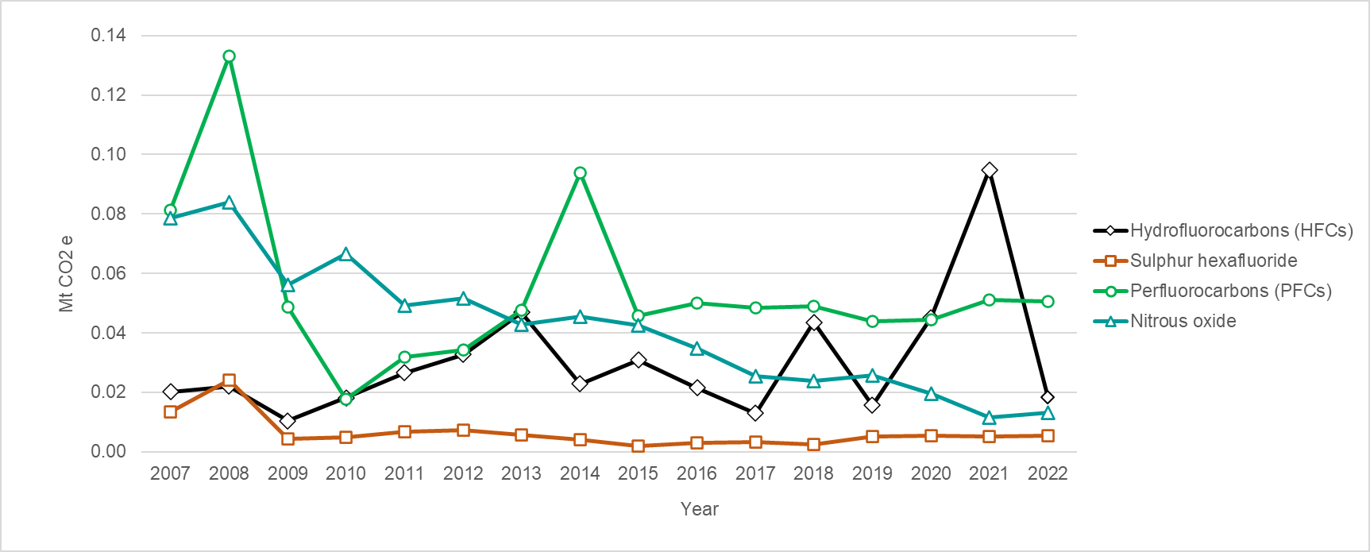

Long term trends in greenhouse gas emissions
Carbon dioxide, methane and nitrous oxide emissions continue to follow a downward trend over the last five years (Figure 3), although less pronounced than in the period from 2007 to 2016.
Hydrofluorocarbons, perfluorocarbons and sulphur hexafluoride do not follow this clear downward trend (Figure 4). For hydrofluorocarbons, this is partly because emissions are generally unplanned losses of refrigerant from chiller systems, from a relatively small number of sites. Perfluorocarbons and sulphur hexafluoride are now only reported from four sites in Scotland, and the biggest emissions for both come from one site which tends to be highly consistent between years.

Figures 3: Annual SPRI Greenhouse gas emissions normalised against 2007 values.
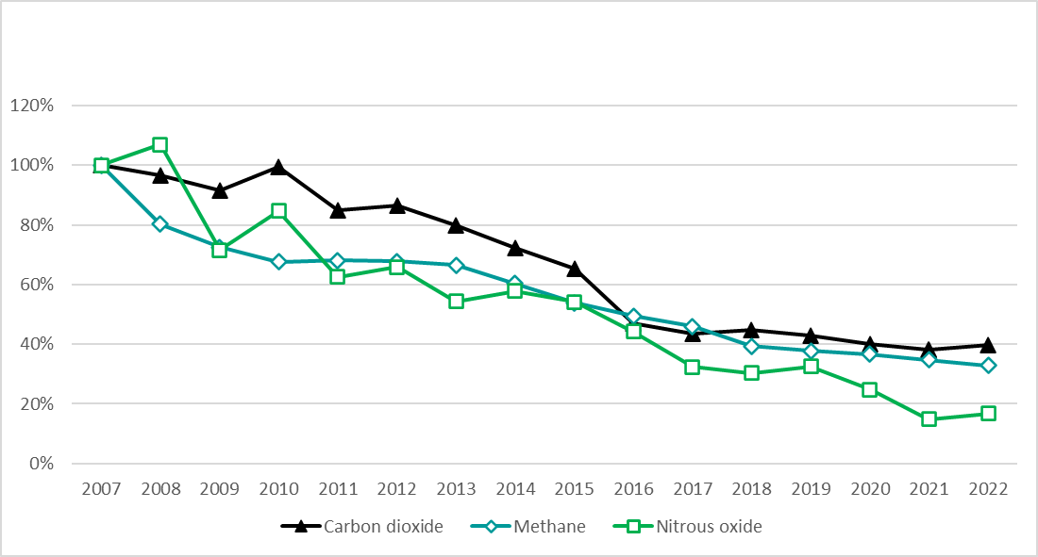

Figures 4: Annual SPRI F-gas emissions normalised against 2007 values.
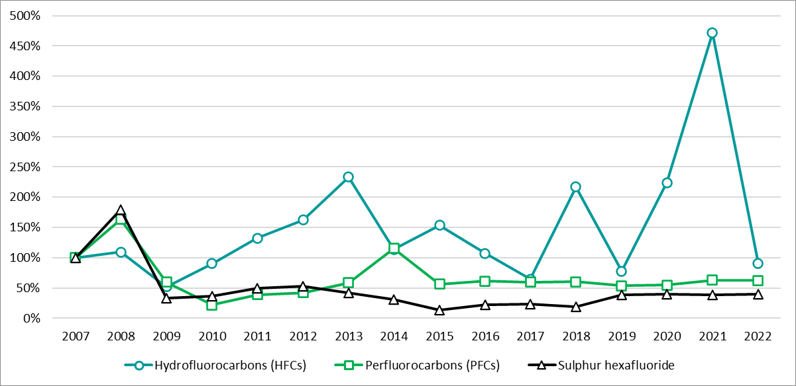

Short term variations in greenhouse gas emissions
The overall global warming potential of greenhouse gas emissions from the SEPA-regulated industrial sites which report to SPRI (measured as kilograms of carbon dioxide equivalent (kg CO₂e)) increased by 2.7% between 2021 and 2022.
Figure 5 shows the global warming potential of emissions by industry sector for 2021 and 2022. For reference, figures for the three F-gases are provided in Figure 6.

Figure 5: Global warming potential of greenhouse gases reported to SPRI by industry sector for 2021 and 2022 (kgCO₂e)
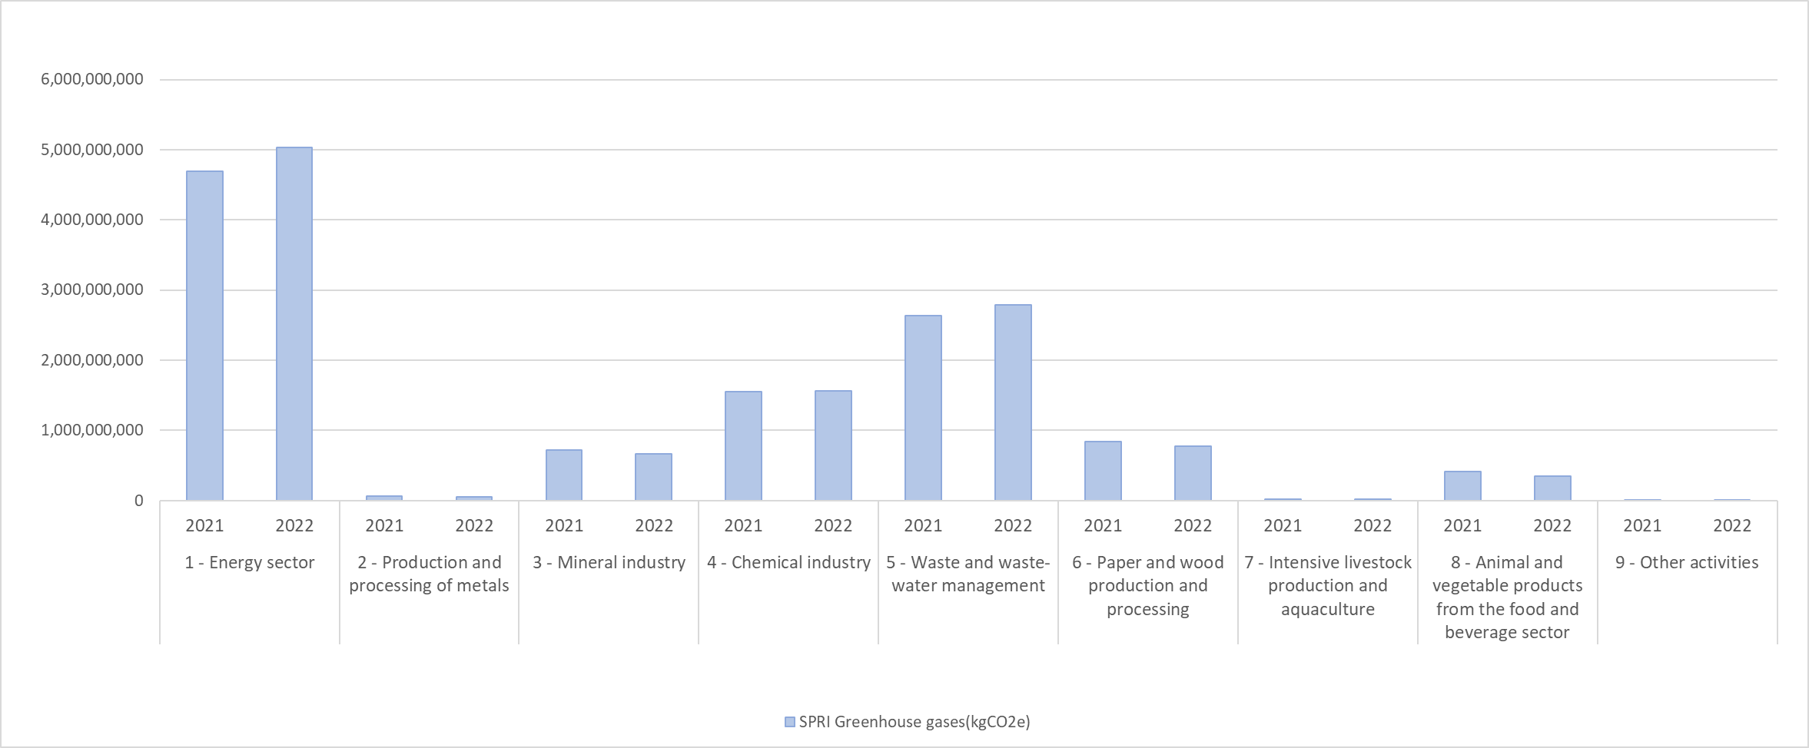

Figure 6: Emissions of F-gases reported to SPRI by industry sector for 2021 and 2022 (kgCO₂e).
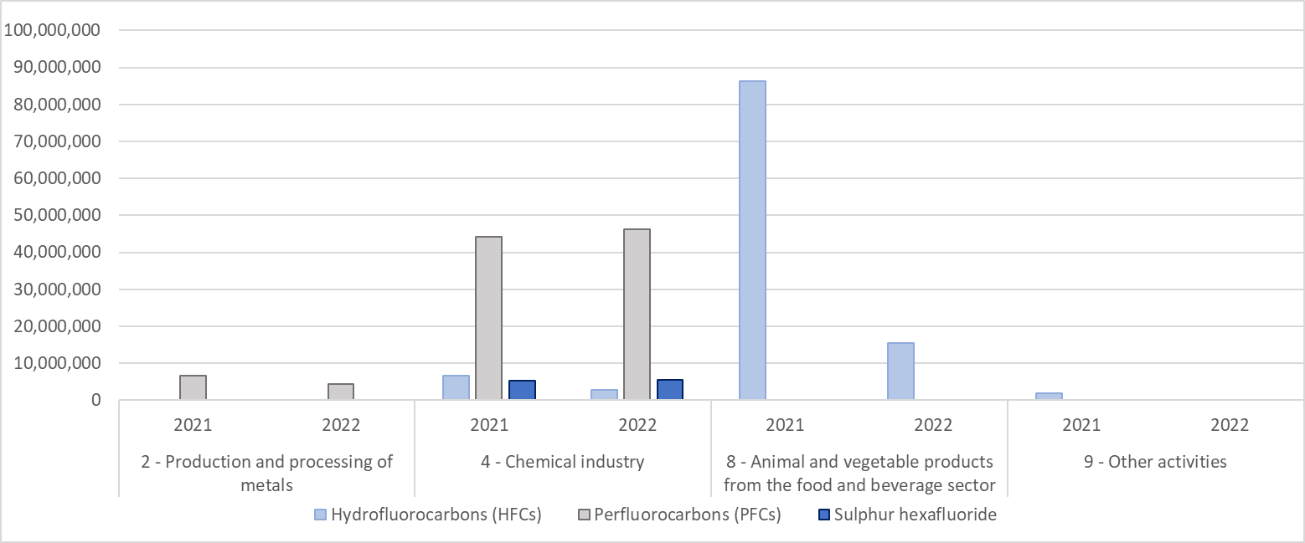

Notes on year-to-year variation in greenhouse gas emissions
In 2022, the overall global warming potential of greenhouse gas emissions from the SEPA-regulated industrial sites which report to SPRI was estimated to be 11.25 million tonnes carbon dioxide equivalent (MtCO₂e). This is 2.7% higher than the 2021 figure of 10.95 MtCO₂e (+0.30 MtCO₂e). Carbon dioxide accounted for the 93.4% of the total GHG emissions (10.5 MtCO₂e). Other greenhouse gases constituted smaller proportions with methane accounting for 5.78%, nitrous oxide for 0.12%, hydrofluorocarbons for 0.16%, perfluorocarbons for 0.45% and sulphur hexafluoride for 0.05%.
Carbon dioxide | Overall, there is a 4.1% increase in 2022 from 2021. However, it should be noted that the 2022 value is 1% lower than the 2020 value and 7% lower than the 2019 value.  The list of the top ten sites is the same as in 2021 and they are in almost the same ranking order. The carbon dioxide emissions from the top ten sites increased by almost 9%. This figure hides a large amount of variability with three reporting increases of more than 10% and the rest with decreases of more than 10%.  The Energy sector reported a 7% increase in emissions mostly for public electricity generation. Note that emissions from Waste and waste-water management sites increased by 9% driven mostly by Energy from Waste incineration. The Food and Drink sector had an increase of 3% with all sites reporting an increase. The Chemical sector increased by 1% in emissions compared to 2021.  Metal (-18%), Mineral (-7%) and Paper and wood (-8%) sectors have decreased their emissions from 2021.
Methane | Overall emissions decreased by 6%, but, as for carbon dioxide, some sites’ emissions have increased. 2022 emissions are 16% lower than the average of the last 5 years.  As in 2021, landfills accounted for 83% of the total methane emissions. It is important to note that landfill data is often modelled.
Nitrous oxide | There was an increase of 13% compared to 2021, due to increased production at the three sites that have reported this pollutant.
Hydrofluorocarbons (HFCs) | There was an 81% reduction in emissions compared to the previous year. Most reported emissions of HFCs are accidental. In 2022, no large accidental releases were reported, this compares to 2021 when a significant release was reported.
Perfluorocarbons (PFCs) | PFCs have decreased by 1% compared to 2021 because of one of the three reporting sites reduced production.
Sulphur hexafluoride | Only two SPRI sites reported ART emission values for sulphur hexafluoride in 2022, and the total has increased by 4% from 2021.

1.4 SPRI reporting data

SPRI sites by Activity code
The SPRI activity code reflects the activity or activities permitted to take place on a site as specified in the site authorisation. The codes allow Scottish sites to be compared to European sites by providing a common system of categorising industrial activities. The codes are largely the same as those listed in the European Pollutant Release and Transfer Register (E-PRTR) Regulation.
Note that when we refer to ‘Industry sectors’ we mean the top-level Activity code (e.g., Industry sector 1 is Energy).

Table 6: Number of sites required to report to SPRI in 2022 under each main Activity code, in bold (including numbers per sub-code, not in bold).
An asterisk indicates that there is no capacity threshold.
Code | Activity | Capacity threshold | Operator submits return | Waste system transfer
1 | Energy sector |  | 45
1(a) | Mineral oil and gas refineries | * | 15
1(b) | Installations for gasification and liquefaction | * | 2
1(c) | Thermal power stations and other combustion installations | With a heat input of 50 megawatts (MW) | 28
2 | Production and processing of metals |  | 15
2(c).i | Hot-rolling mills | With a capacity of 20 tonnes of crude steel per hour | 1
2(c).ii | Smitheries with hammers | With an energy of 50 kilojoules per hammer, where the calorific power used exceeds 20 MW | 1
2(d) | Ferrous metal foundries | With a production capacity of 20 tonnes per day | 1
2(e).i | For the production of non-ferrous crude metals from ore, concentrates or secondary raw materials by metallurgical, chemical or electrolytic processes | * | 2
2(e).ii | For the smelting, including the alloying, of non-ferrous metals, including recovered products (refining, foundry casting, etc.) | With a melting capacity of 4 tonnes per day for lead and cadmium or 20 tonnes per day for all other metals | 2
2(f) | Installations for surface treatment of metals and plastic materials using an electrolytic or chemical process | Where the volume of the treatment vats equals 30m3 | 8
3 | Mineral industry |  | 24
3(a) | Underground mining and related operations | * | 1
3(b) | Opencast mining | Where the surface of the area being mined equals 25 hectares | 18
3(c).i | Cement clinker in rotary kilns | With a production capacity of 500 tonnes per day | 1
3(e) | Installations for the manufacture of glass, including glass fibre | With a melting capacity of 20 tonnes per day | 3
3(g) | Installations for the manufacture of ceramic products by firing, in particular roofing tiles, bricks, refractory bricks, tiles, stoneware or porcelain | With a production capacity of 75 tonnes per day, or with a kiln capacity of 4m3 and with a setting density per kiln of 300 kg/m3 | 1
4 | Chemical industry |  | 36
4(a) | Chemical installations for the production on an industrial scale of basic organic chemicals, such as: | * | 1
4(a).i | Simple hydrocarbons (linear or cyclic, saturated or unsaturated, aliphatic or aromatic) | * | 5
4(a).ii | Oxygen-containing hydrocarbons such as alcohols, aldehydes, ketones, carboxylic acids, esters, acetates, ethers, peroxides, epoxy resins | * | 4
4(a).ix | Synthetic rubbers | * | 1
4(a).viii | Basic plastic materials (polymers, synthetic fibres and cellulose-based fibres) | * | 1
4(a).x | Dyes and pigments | * | 1
4(b).i | Gases, such as ammonia, chlorine or hydrogen chloride, fluorine or hydrogen fluoride, carbon oxides, sulphur compounds, nitrogen oxides, hydrogen, sulphur dioxide, carbonyl chloride | * | 6
4(b).ii | Acids, such as chromic acid, hydrofluoric acid, phosphoric acid, nitric acid, hydrochloric acid, sulphuric acid, oleum, sulphurous acids | * | 2
4(b).iv | Salts, such as ammonium chloride, potassium chlorate, potassium carbonate, sodium carbonate, perborate, silver nitrate | * | 2
4(b).v | Non-metals, metal oxides or other inorganic compounds such as calcium carbide, silicon, silicon carbide | * | 4
4(d) | Chemical installations for the production on an industrial scale of basic plant health products and of biocides | * | 2
4(e) | Installations using a chemical or biological process for the production on an industrial scale of basic pharmaceutical products | * | 6
4(f) | Installations for the production on an industrial scale of explosives and pyrotechnic products | * | 1
5 | Waste and wastewater management |  | 232 | 274
5(a) | Installations for the recovery or disposal of hazardous waste. | Receiving 10 tonnes per day | 44 | 16
5(b) | Installations for the incineration of municipal waste | With a capacity of 3 tonnes per hour | 17
5(c) | Installations for the disposal of non-hazardous waste | With a capacity of 50 tonnes per day | 12 | 256
5(d) | Landfills (excluding landfills of inert waste) | Receiving 10 tonnes per day or with a total capacity of 25,000 tonnes | 73 | 1
5(e) | Installations for the disposal or recycling of animal carcasses and animal waste | With a treatment capacity of 10 tonnes per day | 7 | 1
5(f).i | Municipal wastewater treatment plants | With a capacity below 100,000 population equivalent | 59
5(f).ii | Municipal wastewater treatment plants | With a capacity of 100,000 population equivalent | 14
5(g) | Independently operated industrial wastewater treatment plants which serve one or more activities of this list | With a capacity of 10,000m3 per day | 2
5(h).v | Recovery, or a mix of recovery and disposal, of non-hazardous waste with a capacity exceeding 75 tonnes per day | When the only waste treatment activity carried out is anaerobic digestion, the capacity threshold for this activity shall be 100 tonnes per day. | 4
6 | Paper and wood production and processing |  | 37
6(a) | Industrial plants for the production of pulp from timber or similar fibrous materials | * | 1
6(b) | Industrial plants for the production of paper and board and other primary wood products (such as chipboard, fibreboard and plywood) | With a production capacity of 20 tonnes per day | 8
6(c) | Industrial plants for the preservation of wood and wood products with chemicals | With a production capacity of 50m3 per day | 28
7 | Intensive livestock production and aquaculture |  | 482
7(a).i | Installations for the intensive rearing of poultry | With 40,000 places for poultry | 94
7(a).ii | Installations for the intensive rearing of pigs | With 2,000 places for production pigs (over 30 kg) | 14
7(a).iii | Installations for the intensive rearing of pigs | With 750 places for sows | 2
7(b).i | Intensive aquaculture | Not exceeding 1,000 tonnes of fish and shellfish per year | 150
7(b).ii | Intensive aquaculture | With 1,000 tonnes of fish and shellfish per year | 222
8 | Animal and vegetable products from the food and beverage sector |  | 57
8(a) | Slaughterhouses | With a carcass production capacity of 50 tonnes per day | 18
8(b).i | (i) Animal raw materials (other than milk) | With a finished product production capacity of 75 tonnes per day | 14
8(b).ii | (ii) Vegetable raw materials | With a finished product production capacity of 300 tonnes per day (average value on a quarterly basis) | 20
8(c) | Treatment and processing of milk | With a capacity to receive 200 tonnes of milk or more per day (average value on an annual basis) | 5
9 | Other activities |  | 19
9(a) | Plants for the pre-treatment (operations such as washing, bleaching, mercerization) or dyeing of fibres or textiles | With a treatment capacity of 10 tonnes per day | 2
9(b) | Plants for the tanning of hides and skins | With a treatment capacity of 12 tonnes of finished product per day | 3
9(c) | Installations for the surface treatment of substances, objects or products using organic solvents, in particular for dressing, printing, coating, degreasing, waterproofing, sizing, painting, cleaning or impregnating | With a consumption capacity of 150 kg per hour or 200 tonnes per year | 12
9(e) | Installations for the building of, and painting or removal of paint from ships | With a capacity for ships 100m long | 2
10 | Radioactive Substances sites |  | 66
10(a) | All nuclear installations (including plants undergoing decommissioning) and all non-nuclear installations holding authorisation for air, water and waste water releases: Radioactive substances activity – nuclear |  | 5
10(b) | All nuclear installations (including plants undergoing decommissioning) and all non-nuclear installations holding authorisation for air, water and waste water releases: Radioactive substances activity – non-nuclear |  | 61
Total |  |  | 1287
274 sites which have an activity of waste handling (under industry sector 5 - Waste and wastewater management) have SPRI data taken from their Waste Licensed Site Return data submission. The data submitted is only for waste and is provided as a condition of their licence.

Pollutants reported by Activity code
As noted above, the quantitative figures provided in this statistical release include only those reports of pollutants at levels above reporting thresholds (ART). SPRI also requires all sites to report where they do emit a pollutant but at a level below reporting thresholds (BRT), and there may be substantial numbers of these unquantified minor releases.
The graph shows the total number of individual pollutant releases reported by each industry sector, identified as either ART or BRT. For example, Energy sector sites reported 341 individual emissions to air, of which 244 were ART. (Tables 2 and 4 show more detail on the numbers of sites reporting each pollutant at ART).
A full breakdown by pollutant is included in the accompanying datasheet.

Figure 7: Number of individually reported emissions to air and water at above and below reporting thresholds in each industry area for 2022.
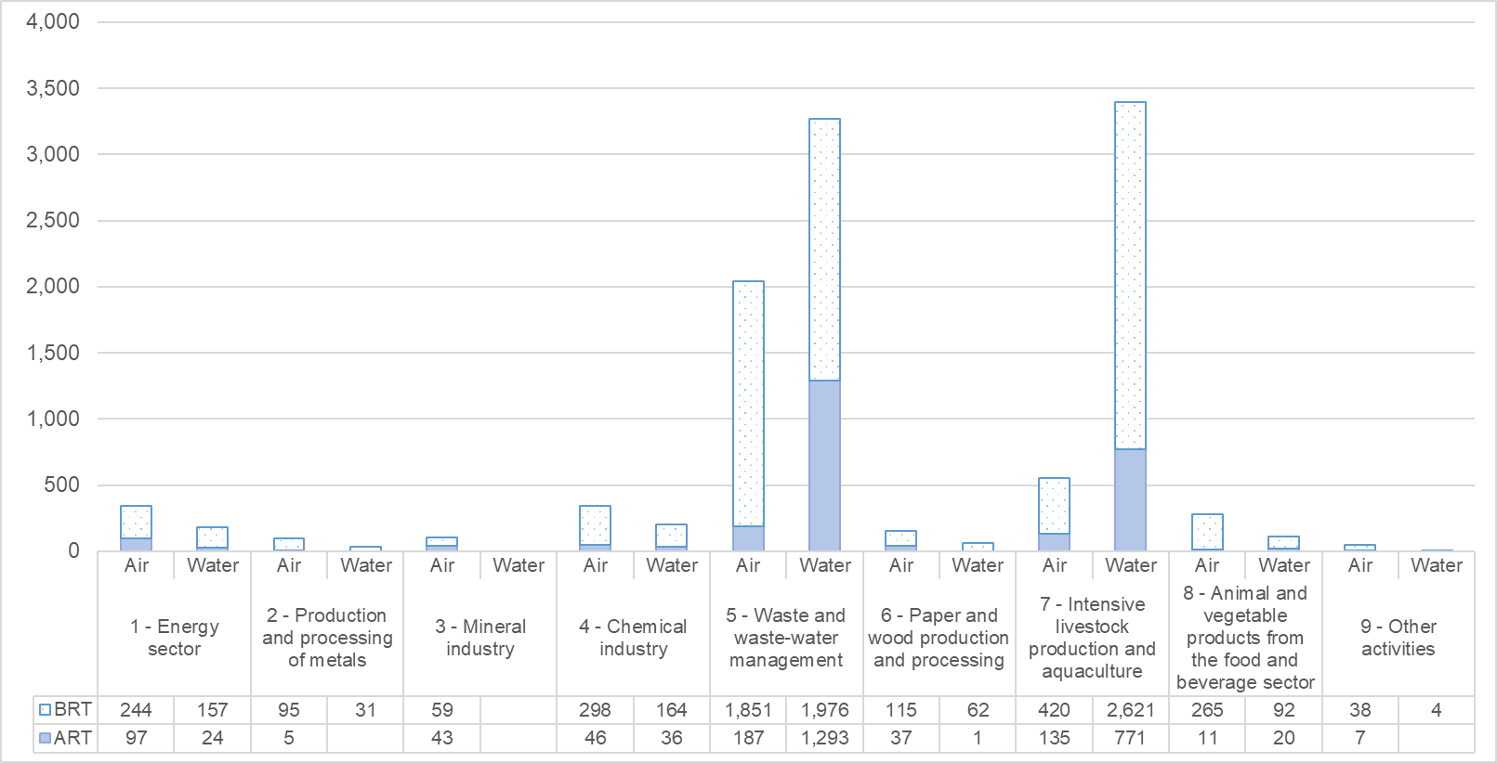

2. Scope of this statistical release
We have focussed on the emissions of pollutants to the environment and on offsite waste transfers from non-waste sites, as these are the areas where SEPA receives the most enquiries, and where SPRI provides data which is both significant and unavailable elsewhere. It's important to note that we have not included discussions on the following topics in this context; however, all relevant data can be accessed on Scotland's Environment Web:
- Radioactive substances
- Releases to wastewater
- Offsite waste transfers from waste sector sites

2.1 User statement
SPRI provides the Scottish part of the UK Pollutant Release and Transfer Register (UK-PRTR). The UK is a Party to the UN Kyiv Protocol on Pollutant Release and Transfer Registers which aims “to enhance public access to information through the establishment of coherent, nationwide PRTRs”. The Protocol requires Parties to provide information on pollution sources to members of the public. See Section 3 for more details.
SPRI data are also used to fulfil various other reporting requirements and obligations including those of the UK National Atmospheric Emissions Inventory (NAEI), and the UK Greenhouse Gas Inventory (UKGHGI), which fulfills the UN Kyoto Framework Convention on Climate Change (UNFCCC). Other obligatory uses are the OSPAR Convention and Scotland’s Marine Atlas.
The data are also used by central government, researchers and the general public.

2.2 Feedback
We welcome feedback on this publication and the data from all users including information on how and why the data are used. This helps us to understand the value of the statistics to external users. Please see our contact details at the bottom of the first page of this document.

2.3 Revisions
SEPA will provide information about any revisions made to published information in this statistics release and the associated datasets. Revisions could occur for various reasons, including when data from third parties is unavailable or provisional at the time of publishing or if there are subsequent methodological improvements or refinements. Requests for revisions may be made by SEPA or by Operators.
Note that revisions to individual returns may occur throughout the year. The revision process requires similar Quality Assurance (QA) checks to those carried out on annual data submissions and the return may be unavailable during this period.
Data available on Scotland’s Environment Web updates annually and will include all significant revisions to previous years. Where necessary, PRTR data revisions will be resupplied to Defra to allow the UK-PRTR to be updated.

Table 7: Revisions to historic SPRI pollutant emission data since last publication (all values are kg)
Site name | Dataset year | Pollutant | Medium | Original Mass (kg) | Update Mass (kg)
Barr Environ, Auchencarroch L/F, Jamestown | 2021 | Carbon dioxide | Air | 28,960,000 | 36,920,000
Barr Environ, Auchencarroch L/F, Jamestown | 2021 | Methane | Air | 1,300,000 | 1,700,000
Barr Environ, Auchencarroch L/F, Jamestown | 2021 | Chlorofluorocarbons (CFCs) | Air | 31.0 | 39.9
Barr Environ, Auchencarroch L/F, Jamestown | 2021 | Hydrochlorofluorocarbons (HCFCs) | Air | 21.3 | 36.2
Barr Environ, Auchencarroch L/F, Jamestown | 2021 | Carbon Monoxide | Air | 183,844 | 123,000
Barr Environ, Garlaff L/F, Skares Rd, Cumnock | 2021 | Carbon dioxide | Air | 18,680,000 | 27,380,000
Barr Environ, Garlaff L/F, Skares Rd, Cumnock | 2021 | Methane | Air | 999,000 | 1,470,000
Barr Environ, Garlaff L/F, Skares Rd, Cumnock | 2021 | Chlorofluorocarbons (CFCs) | Air | 13.7 | 46.3
Barr Environ, Garlaff L/F, Skares Rd, Cumnock | 2021 | Hydrochlorofluorocarbons (HCFCs) | Air | 13.3 | 34.2
Barr Environ, Garlaff L/F, Skares Rd, Cumnock | 2021 | Carbon monoxide | Air | 173,630 | 108,000
TWMA - Dales Ind Est, Peterhead | 2021 | Polycyclic aromatic hydrocarbons (PAHs) (four indicator compounds of LRTAP) | Air | BRT | 4
TWMA - Dales Ind Est, Peterhead | 2021 | Polycyclic aromatic hydrocarbons (PAHs) (four indicator compounds of LRTAP) | Wastewater | BRT | 1
Diodes Semiconductors GB Limited, Greenock | 2021 | Carbon dioxide | Air | 14,566,631 | 11,996,758
Gates Power Transmission, Heathhall, Dumfries | 2021 | Carbon dioxide | Air | 11,059,585 | 10,307,000
Gates Power Transmission, Heathhall, Dumfries | 2021 | Toluene | Air | 1,613 | 0
Dalmuir STW, Beardmore Street, Clydebank | 2021 | Ammonia | Water | 966,000 | 911,000
Flotta Terminal, Orkney | 2021 | Ra-226 | Water | 666 | 512
Flotta Terminal, Orkney | 2021 | Ra-228 | Water | 769 | 809
Flotta Terminal, Orkney | 2021 | Pb-210 | Water | 134 | 147
Flotta Terminal, Orkney | 2021 | Po-210 | Water | 134 | 147
Marine Harvest Ltd, Blar Mhor, Fort William | 2021 | Total organic carbon or COD/3 | Wastewater | 223,088 | 5,886
Easter Deans Farm,Leadburn,W.Linton,Tweedale | 2021 | Ammonia | Air | 34,359 | 32,812
Glengorm Landfill Site, Glengorm Rd, Tobermor | 2021 | Chlorofluorocarbons (CFCs) | Air | omitted | 1.53
Glengorm Landfill Site, Glengorm Rd, Tobermor | 2021 | Hydrochlorofluorocarbons (HCFCs) | Air | omitted | 1
Thornton Feed Mill, Thornton, Fife | 2021 | Particulate matter - PM10 and smaller | Air | 102 | 265
Lundie Castle Poultry Farm, Dundee | 2021 | Ammonia | Air | 7,360 | 7,436
Glasgow Royal Infirmary, Dennistoun | 2021 | Carbon monoxide | Air | 15,157 | 1,132
Glasgow Royal Infirmary, Dennistoun | 2021 | Nitrogen oxides, NO and NO2 as NO2 | Air | 96,674 | 3,760
Glasgow Royal Infirmary, Dennistoun | 2021 | Particulate matter - PM10 and smaller | Air | 2,914 | 103
Glenhead of Aldouran Farm, Stranraer | 2021 | Ammonia | Air |  | 11,520
Glenhead of Aldouran Farm, Stranraer | 2021 | Particulate matter - PM10 and smaller | Air |  | 1,400
Glenhead of Aldouran Farm, Stranraer | 2021 | Particulate matter - total | Air |  | 4,800
Grangemouth Chemical Plant | 2021 | Xylene - all isomers | Air | 3,200 | 3,670
Silberline Ltd, Banbeath Road, Leven | 2021 | Non-methane volatile organic compounds (NMVOCs) | Air | 108,100 | 7,848
Shell UK Ltd, St Fergus Gas Plant | 2021 | Nitrogen oxides, NO and NO2 as NO2 | Air | 208,001 | 635,890
Allanfearn Sewage Treatment Works, Inverness | 2021 | Arsenic | Water | 8.2 | 7.6
Alloa STW, Forth Bank Ind Est, Alloa | 2021 | Arsenic | Water | 5.1 | 4.8 (BRT)
Dumbarton West (Ardoch) STW | 2021 | Arsenic | Water | 7.1 | 6.7
Falkirk STW, Abbots Road, Falkirk | 2021 | Arsenic | Water | 12.0 | 11
Falkirk STW, Abbots Road, Falkirk | 2021 | Chromium | Water | 2.2 (BRT) | 1.8 (NA)
Daldowie STW, Glasgow Rd, Uddingston | 2021 | Arsenic | Water | 31.0 | 29
Dalmarnock STW, Cotton St, Dalmarnock,Glasgow | 2021 | Arsenic | Water | 23.0 | 22
Dalmuir STW, Beardmore Street, Clydebank | 2021 | Arsenic | Water | 65.0 | 61.0
Dunfermline STW, North Queensferry Road, Fife | 2021 | Arsenic | Water | 7.8 | 7.2
East Calder STW, East Calder | 2021 | Arsenic | Water | 8.6 | 7.9
Erskine STW, Old Mains Farm, Inchinnan | 2021 | Arsenic | Water | 8.2 | 7.5
Hamilton STW, Bothwell Rd, Hamilton | 2021 | Arsenic | Water | 5.6 | 5.2
Hatton STW, By Hatton Farm, Arbroath | 2021 | Arsenic | Water | 28.0 | 26
Inverclyde STW, Underheugh, By Gourock | 2021 | Arsenic | Water | 10.0 | 9.5
Kinneil Kerse STW, Boness Road, Grangemouth | 2021 | Arsenic | Water | 5.1 | 4.7 (BRT)
Paisley STW, Abercorn St, Paisley | 2021 | Arsenic | Water | 11.0 | 9.8
Levenmouth STW,Elm Park,Methilhaven Rd,Methil | 2021 | Arsenic | Water | 17.0 | 16.0
Meadowhead Sewage Treatment Works, Irvine | 2021 | Arsenic | Water | 26.0 | 24.0
Perth STW, Sleepless Inch, Perth | 2021 | Arsenic | Water | 7.8 | 7.3
Philipshill WWTW,Westerfield Rd,Busby,Glasgow | 2021 | Arsenic | Water | 5.1 | 4.7 (BRT)
Edinburgh Sewage Treatment Works, Leith | 2021 | Arsenic | Water | 86.0 | 80.0
Shieldhall STW, 38 Renfrew Rd, Glasgow | 2021 | Arsenic | Water | 46.0 | 43.0
Stevenston STW, Ludholm Rd, Stevenson | 2021 | Arsenic | Water | 12.0 | 11.0
Shell UK Ltd, St Fergus Gas Plant | 2020 | Nitrogen oxides, NO and NO2 as NO2 | Air | 241,679 | 671,450
Shell UK Ltd, St Fergus Gas Plant | 2019 | Nitrogen oxides, NO and NO2 as NO2 | Air | 234,559 | 692,660
Shell UK Ltd, St Fergus Gas Plant | 2018 | Nitrogen oxides, NO and NO2 as NO2 | Air | 270,592 | 731,600
McIntosh Donald, Portlethen, Aberdeen | 2021 | Ammonia | Air |  | 1,000
Elrig Farm, Port William, Newton Stewart | 2021 | Ammonia | Air |  | 13,920
Elrig Farm, Port William, Newton Stewart | 2021 | Methane | Air |  | 13,572
Elrig Farm, Port William, Newton Stewart | 2021 | Particulate matter - PM10 and smaller | Air |  | 5,800
Elrig Farm, Port William, Newton Stewart | 2021 | Particulate matter - total | Air |  | 17,400
Peacehill Farm, Wormit, Fife | 2021 | methane | Air |  | 29,640
Sullom Voe Terminal, Refinery | 2021 | Zinc | Water | BRT | ART
Blantyre Brick Plant | 2021 | Carbon dioxide | Air | 6,070 | 6,070,000
Daldowie RDF Plant | 2021 | Aldrin | Water | BRT | 0.0037
Daldowie RDF Plant | 2021 | Dichlorvos | Water | BRT | 0
Daldowie RDF Plant | 2021 | Dieldrin | Water | BRT | 0.0037
Daldowie RDF Plant | 2021 | Tributyltin compounds | Water | BRT | 0
Daldowie RDF Plant | 2021 | Trichlorobenzene - all isomers | Water | BRT | 9.94
Daldowie RDF Plant | 2021 | Trifluralin | Water | BRT | 0
Daldowie RDF Plant | 2021 | Xylene - all isomers | Water | BRT | 27.8
Edinburgh Sewage Treatment Works, Leith | 2021 | Methylene chloride | Water |  | 12.8
Daldowie RDF Plant | 2020 | Chloroform | Water | BRT | 9.26
Daldowie RDF Plant | 2020 | Copper | Water | 1,180 | 55.6
Daldowie RDF Plant | 2020 | Nitrogen - total as N | Air | BRT | 52,328
Daldowie RDF Plant | 2020 | Xylene - all isomers | Water | BRT | 27.8
Daldowie RDF Plant | 2020 | Tributyltin compounds | Water | BRT | 0.0774
Flotta Terminal, Orkney | 2020 | Nitrogen oxides, NO and NO2 as NO2 | Air | 364,700 | 203,083
Daldowie RDF Plant | 2019 | Benzene | Water | BRT | 10.080335
Daldowie RDF Plant | 2019 | Chloroform | Water | BRT | 29.6
Daldowie RDF Plant | 2018 | Chloroform | Water | BRT | 31.3
Daldowie RDF Plant | 2019 | Copper | Water | 605 | 46.8
Daldowie RDF Plant | 2019 | Nitrogen - total as N | Water | 1,050 | 82,087
Daldowie RDF Plant | 2018 | Nitrogen - total as N | Water | 795 | 84,310
Daldowie RDF Plant | 2018 | Xylene - all isomers | Water | BRT | 31.4
Daldowie RDF Plant | 2018 | Zinc | Water | 1,710 | 105
Daldowie RDF Plant | 2018 | Tributyltin compounds | Water | 0.03 | 0.0738
Daldowie RDF Plant | 2019 | Tributyltin compounds | Water | 0.0346 | 0.0844
Daldowie RDF Plant | 2019 | Xylene - all isomers | Water | BRT | 30.2
Daldowie RDF Plant | 2018 | Benzene | Water | BRT | 10.5
Versalis UK Ltd, Grangemouth | 2022 | Styrene | Air | 320 | 431
Nigg WWTW, Aberdeen | 2019 | Carbon dioxide | Air |  | 1,300,000
Norbord Europe Ltd, Station Rd, Cowie | 2021 | Formaldehyde | Air | 147,122 | 94,585
Norbord Europe Ltd, Station Rd, Cowie | 2021 | Particulate matter - total | Air | 64,097 | 52,636
Norbord Europe Ltd, Station Rd, Cowie | 2021 | Nitrogen oxides, NO and NO2 as NO2 | Air | 149,561 | 273,609
Gates Power Transmission, Heathhall, Dumfries | 2021 | Toluene | Air | NA | 1,613
Edinburgh Sewage Treatment Works, Leith | 2018 | Ammonia | Water | 631,000 | 2,850,000
Edinburgh Sewage Treatment Works, Leith | 2019 | Ammonia | Water | 695,000 | 2,610,000
Nigg WWTW, Aberdeen | 2018 | Ammonia | Water | 190,000 | 749,000
Nigg WWTW, Aberdeen | 2019 | Ammonia | Water | 200,000 | 607,000
Hatton STW, By Hatton Farm, Arbroath | 2019 | Ammonia | Water | 710,000 | 709,000
Hamilton STW, Bothwell Rd, Hamilton | 2018 | Ammonia | Water | 47,000 | 1,670
Stevenston STW, Ludholm Rd, Stevenson | 2019 | Ammonia | Water | 160,000 | 156,000

Table 8: Revisions to historic SPRI waste data since last publication (all values are tonnes)
Site Name | Dataset year | Waste Type | Recovery or Disposal | Original Mass (Tonnes) | New Mass (Tonnes)
Barr Environ, Auchencarroch L/F, Jamestown | 2021 | Hazardous | Disposal | 19,335 | Non-Hazardous Waste - Disposal
Rueval L/F Site, Market Stance, Benbecula | 2021 | Hazardous | Disposal | 17.0 | 0
North Forr Landfill Site, Crieff | 2021 | Hazardous | Recovery | 43.6 | 0
North Forr Landfill Site, Crieff | 2021 | Non-Hazardous | Disposal | 6,011.0 | 0
North Forr Landfill Site, Crieff | 2021 | Non-Hazardous | Recovery | 763 | 0
Gates Power Transmission, Heathhall, Dumfries | 2021 | Hazardous | Disposal | 7.20 | 0
Gates Power Transmission, Heathhall, Dumfries | 2021 | Hazardous | Recovery | 82.7 | 137
Gates Power Transmission, Heathhall, Dumfries | 2021 | Non-Hazardous | Disposal | 0 | 826
Gates Power Transmission, Heathhall, Dumfries | 2021 | Non-Hazardous | Recovery | 0 | 111
Raigmore Hospital, Inverness | 2021 | Hazardous | Disposal | 28.9 | 0
Raigmore Hospital, Inverness | 2021 | Hazardous | Recovery | 215 | 0
Marine Harvest Ltd, Blar Mhor, Fort William | 2021 | Non-Hazardous | Recovery | 2,624 | 0
Cononish Gold & Silver Mine Tyndrum | 2021 | Hazardous | Disposal | 0 | 5.46
INEOS Chemicals Grangemouth Ltd, Grangemouth | 2021 | Hazardous | Disposal | 1,568 | 1,559
INEOS Chemicals Grangemouth Ltd, Grangemouth | 2021 | Hazardous | Recovery | 723 | 688
INEOS Chemicals Grangemouth Ltd, Grangemouth | 2021 | Non-Hazardous | Recovery | 14,044 | 6,517
UK Waste Mgmt Ltd, Wellbank Quarry LF, Dundee | 2021 | Non-Hazardous | Disposal | 0 | 4,563
Dalmuir STW, Beardmore Street, Clydebank | 2021 | Non-Hazardous | Recovery | 27,820 | 30,285
Dalmuir STW, Beardmore Street, Clydebank | 2020 | Non-Hazardous | Recovery | 26,217 | 26,463

2.4 Release
The release of this publication is in line with practices specified in the Code of Practice for Official Statistics. The statistics are released at the standard time of 9.30 am on a preannounced weekday date. Pre-release access to the statistics in their final form is provided to Scottish Ministers and those on a list of named officials advising them five working days before the public release. This is to ensure that at the time of release Scottish Ministers are able to comment publicly on the statistics based on a correct understanding of them.

3. About the Scottish Pollutant Release Inventory

3.1 What is the Scottish Pollutant Release Inventory?
The SPRI is a Pollutant Release and Transfer Register (PRTR) and has the primary purpose of making publicly available officially reported annual releases of specified pollutants to air and water from certain SEPA-regulated industrial facilities. It also provides information on offsite transfers of waste and wastewater from these facilities.
The SPRI data is collected, quality assured and made public under the requirements of Freedom of Information and can be compared with PRTR information from other countries. SPRI datasets from 2002 to the present year (except 2003) are available and reported annually.
A full list of the pollutants whose emissions must be reported can be found on the SPRI Schedule, which is updated annually. SPRI pollutants are substances considered to be environmentally significant and of interest to the public.

3.2 Who reports?
Operators of sites carrying out specific activities (67 activities covering 10 major sectors) above defined capacity thresholds are obliged to report to SPRI on an annual basis. The activities and their thresholds are largely determined by previous European Union (EU) reporting requirements, but some activity thresholds have been lowered so more Scottish sites are included.
Below is a brief summary of the SPRI activities and thresholds:
- Most Part A processes defined in the Pollution Prevention and Control (Scotland) Regulations 2012 (as amended), together with any directly associated activities. These are the bigger industrial activities covering the energy, mineral, metal, chemical, waste management, food and drink, paper and pulp and intensive agricultural sectors.
- Municipal sewage treatment works with a design population equivalent of >15,000 population equivalent (where population equivalent has the meaning given in the Urban Wastewater Treatment (Scotland) Regulations (UWWTR)).
- All industrial wastewater treatment plants with a capacity to treat at least 10,000 m3/d (cubic metres per day).
- All marine-caged fish farms (no capacity limit).
- All opencast mining and quarrying sites where the surface area of the area effectively under extractive operation equals 25 hectares and above and includes all underground mining.
- All sites having a waste management licence (WML) with a capacity to accept at least 50 tonnes/day for the disposal of non-hazardous waste and sites with a capacity of receiving 10 tonnes/day for the recovery and disposal of hazardous waste.
- All nuclear installations (including plants undergoing decommissioning) and all non-nuclear installations holding authorisation for air, water and wastewater releases.
Most sites which are required to report to SPRI will have been notified by SEPA by either a Pollution Prevention and Control (PPC) Regulation 63(2) Notice or a notification letter. Sites with only Waste Management Licences (WML) report their offsite waste transfers quarterly to SEPA and are notified that SEPA will use this data to fulfil their reporting obligations.
Sites which have not operated and have no emissions must still submit a return while they retain an active authorisation or permit. Reports must be submitted annually for the previous calendar year; for most sites by 28 February each year.

3.3 SEPA’s role
We collect and quality assure (QA) the SPRI data, and then make it publicly available.
SPRI data remains the operator’s and it is their legal responsibility to supply accurate information. Our QA process is there to check that the data is complete, coherent and suitable for publication. In outline:
- We carry out data checks using historic data from the site and similar sites.
- Where data are flagged in our checking process, we may ask the operator to confirm their figures and provide more detail on the reasons for any variations. We also ask Site Officers to cross reference against other available data and to use their knowledge of the site to assess whether information is credible.
- We carry out a set of crosschecks against other SEPA data sources – for example the Emissions Trading System data on carbon dioxide emissions. We check that accidental releases have been notified to SEPA where appropriate.
- The overall data for each industry sector is reviewed by colleagues who have substantial knowledge of the sites and the processes they use, to help us understand each individual return’s place in the sector.
- Once data has been through QA, we will submit the required sub-set to Defra, who will use it in the UK-PRTR. Defra will carry out further checks and inform us of any issues they identify.
- Sub-sets of SPRI data are used to fulfil national and international reporting obligations (e.g. UK National Atmospheric Emissions Inventory), and these will often have their own quality assurance processes which provide us with feedback.
Note that we do not use SPRI data to assess regulatory compliance.

3.4 Information to consider when using SPRI data and technical notes

Regulatory and environmental impact
SPRI data can be used to broadly compare facilities or sectors and it provides a general overview of the total amounts of pollutants released or waste transferred. However, direct, detailed comparisons between sites are only possible where significant further information is available about all of the processes carried out on site; even where this is possible, few sites have direct equivalents.
SPRI data cannot provide assessments of the regulatory compliance of the facilities or the health or environmental impact of their releases. Compliance information can be found on SEPA’s website.
Annual mass emissions alone are not necessarily directly related to concentrations being emitted at any particular time and cannot be used to directly predict the resulting concentrations in the environment. High annual mass emissions are often due to the large size of the industrial process, where relatively low concentrations are released in very large flows of air or water. The efficiency of the site’s industrial abatement and treatment processes will have a significant impact on emissions. These are guided by relevant UK legislation and Scottish legislation.
Annual mass releases are not directly comparable with air or water quality standards. Reporting thresholds for each pollutant are set based on characteristics of the pollutant (such as its toxicity, transport and persistence in the environment) to indicate what mass emission may give rise to 'significant' environmental concentrations.

Technical notes on data:

Annual variability
Caution should be used when comparing one year’s data to the previous year’s, particularly on a site-by-site basis. Substantial year to year variability is expected within some sections of the SPRI data, and we allow for this in our QA process.
For example, within the industry sector 7 – Intensive livestock production and agriculture we would expect emissions from poultry farms to be some of the most consistent in SPRI, because operators will tend to stock to similar levels across the whole year, every year. Marine fish farms, on the other hand, have clearly defined production cycles which include fallow periods, so emissions are expected to vary accordingly.
Many sites will base their emission values on spot testing which has happened at different points throughout the year and again, in some industry sectors we can expect these to be quite variable.

Methods
There are three broad ways operators can produce their SPRI figures: measuring, calculating or estimating. Guidance on the SPRI webpage explains where and when each should be used in detail, but we expect the operator to use the best available data and method to produce their figure. In many cases this will be to use the methodologies described under the terms of their SEPA authorisations. In some cases, data may be modelled (e.g., many of the pollutants from landfills and wastewater treatment works), or we ask the operator to use an emission factor (e.g., poultry farmers’ ammonia emissions). The best available methods therefore have a wide range of both precisions and accuracies, and this should be kept in mind when data is used.

Figures reported
Related to the point about methods; we formally ask operators to supply data to three significant figures but, as noted in Section one, they normally provide much more than this. We do not receive information on confidence intervals; be aware that a figure which provides high precision may have lower accuracy.
Note that:
- All non-radioactive pollutants are reported in kilograms (kg)
- Offsite waste transfers are reported in metric tonnes (t)
We may display data using different units for ease of use. Commonly, carbon dioxide and overall greenhouse gas emissions are reported in kilotonnes (kt – 1,000,000kg) and megatonnes (Mt – 1,000,000,000kg).

Accidental releases
Figures for accidental releases are included within the main total. It is possible to have a quantified accidental release but for the total emission to be below the reporting threshold (BRT). SPRI has very clear and specific definitions of accidental releases.

United Kingdom Pollutant Release and Transfer Register – UK-PRTR
Most SPRI waste transfer data and a sub-set of pollutant emissions data, covering roughly half of the SPRI sites, is supplied to the UK PRTR and will be published on the UK’s PRTR webpage. The datasets have different reporting requirements: the UK-PRTR remains focused on emissions significant at the national and European scale, whereas SPRI is tailored to gather information which is useful from the Scottish national perspective. Around 20% of individual reported rows of SPRI pollutant data is included in the UK-PRTR, but as it covers the largest releases, it will generally represent around 90% of SPRI’s total emissions for each pollutant. Around 50% of the SPRI sites report releases and transfers above the PRTR thresholds although this varies from year-to-year.
Various Scotland-relevant pollutants and industrial sectors are included in the SPRI but not required by the legislation covering the UK-PRTR; for example the radioactive substances. In addition, Urban Wastewater Treatment Plants and marine fish farms have a lower activity threshold in SPRI, so more of our sites come into reporting requirements. Thresholds for some pollutants are set to less than the UK thresholds.
Full details of the SPRI and UK-PRTR reporting requirements are available on the SPRI website and the UK-PRTR website.

Note that this information is derived from the qualifications of the operators who are required to provide a valid explanation for a change or variation in pollutants at their site. We do not release this information at a site level.
The Fluorinated Greenhouse Gases (Amendment) (Eu Exit) Regulations 2021: The Fluorinated Greenhouse Gases (Amendment) (EU Exit) Regulations 2021 (legislation.gov.uk)
2019 Refinement to the 2006 IPCC Guidelines for National Greenhouse Gas Inventories. Available at: www.ipcc.ch/report/2019-refinement-to-the-2006-ipcc-guidelines-for-national-greenhouse-gas-inventories/
IPCC, 2013: Climate Change 2013: The Physical Science Basis. Contribution of Working Group I to the Fifth Assessment Report of the Intergovernmental Panel on Climate Change. Available at: www.ipcc.ch/report/ar5/wg1/
www.gov.scot/publications/scottish-greenhouse-gas-statistics-2021/
E-PRTR Regulation (EC) No 166/2006
Operators submit directly to SPRI via return form.
Data are collected separately by waste data team within SEPA.
Data for Scottish sites in 2022 will be published in Radioactivity in Food and Environment (RIFE 28) later this year.
https://unece.org/env/pp/protocol-on-prtrs-introduction
https://naei.beis.gov.uk/
https://unfccc.int/process-and-meetings/the-convention/what-is-the-united-nations-framework-convention-on-climate-change
www.ospar.org/
http://marine.gov.scot/data-source-types/scotlands-marine-atlas
https://informatics.sepa.org.uk/SPRI/
www.gov.uk/guidance/uk-pollutant-release-and-transfer-register-prtr-data-sets#search-the-prtr-database-on-your-chosen-parameters

