Report date: January 2026, Version 1



Aquaculture Modelling Summary Report:
Report date: August 2024

ARDNISH (ARDN1)

CAR/L/1002887
Report Date: March 2026; Version 1

For information on accessing this document in an alternative format or language, please contact SEPA by emailing equalities@sepa.org.uk.

If you are a user of British Sign Language (BSL), the Contact Scotland BSL service gives you access to an online interpreter, enabling you to communicate with us using sign language.

Scope of report
As part of the SEPA Aquaculture Regulatory Framework it is recommended that a proposed application for a marine finfish aquaculture site should undergo a Screening Modelling and Risk Identification process. SEPA carries out this work and this is described on the SEPA aquaculture website Pre-application section.
Screening modelling has not been undertaken for this site as there is no significant increase in risk to the wider environment from solids and/or bath medicines. However, conclusions and recommendations are made regarding the proposed site.

Executive summary
SEPA has received a proposal to vary an existing marine finfish aquaculture site called Ardnish (ARDN1), at location: 175520 781405 (Easting, Northing) at the head of Loch Ailort. The existing maximum biomass is 300t at this location. As this site is currently unable to meet environmental quality standards (conditions of its CAR permit), this proposal is part of enforcement action at this site; it consists of a 5-year plan (Table 1) to reduce the biomass of fish within open pens, and add biomass within semi-enclosed pens, resulting in a maximum standing biomass of 1760t of fish, all within semi-enclosed pens, at year 5. As this is a novel semi-enclosed farm, computational fluid dynamics (CFD) modelling is to be undertaken to assess the proportion of waste expected to be captured, however, this is expected to be in the region of 90%. A CFD modelling report has been provided to SEPA, the results of which will need to be incorporated into NewDepomod modelling to be submitted by the applicant, in addition to a lower waste capture rate scenario to allow an assessment of sensitivity of the results to the estimated capture efficiency. As the solids impact is expected to be local to the farm, with no increase in wider risk to the environment, screening modelling has not been undertaken. However, nutrients have been considered. Should CFD modelling suggest a significantly lower waste capture rate than the expected, it is unlikely that the proposal as stands will meet Environmental Quality Standards.

Table 1: Table showing proposed 5 year plan
Year | Semi-enclosed pen biomass (Tonnes) | Open pen biomass (Tonnes) | Total biomass on site (Tonnes)
Current | 0 | 300 | 300
1 | 336 | 270 | 606
2 | 503 | 250 | 753
3 | 1073 | 0 | 1073
4 | 1737 | 0 | 1737
5 | 1760 | 0 | 1760

Figure 1. (Left) Map showing location of Ardnish fish farm. (Right) The current pens are shown in blue. The black dots represent the proposed pen centres for year 1 of production. The top left point represents the semi enclosed pen.
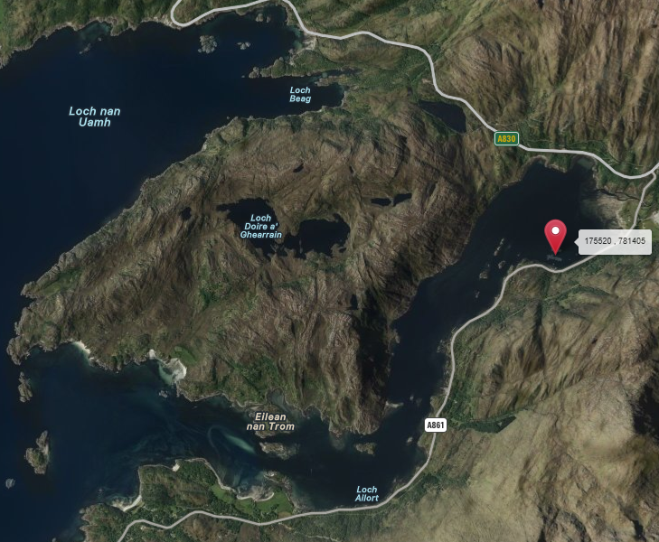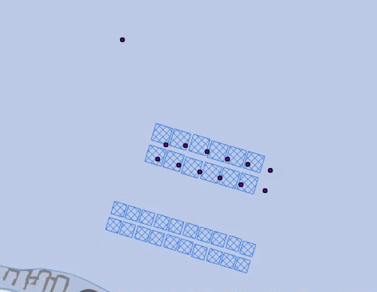

SEPA: Risk Identification
Features which require attention are presented with any additional comments and will need to be considered during the pre-application phase.

Flow properties
Based on current meter data previously collected at this site, we can make the following observations about the proposed site location:
- It lies in a low dispersion area.
- It lies in an area where water flow has a low capacity to erode material on the seabed.

Features of interest which require attention
Sensitive features in the area have been assessed, those considered at risk and therefore requiring additional consideration, can be found in the table below.

Table 2: Table of identified features of interest
 | Feature name | Feature type | Location (Easting, Northing) | Brief reason for identification
1 | Serpulid aggregations | PMF | Figure 2 | Increased nutrient risk
2 | Blue mussel beds | PMF | Figure 2 | Increased nutrient risk
3 | Sound of Arisaig (Loch Ailort to Loch Ceann Traigh) | SAC | Figure 3 | Features at risk from increased nutrients

Figure 2. Map of sensitive features
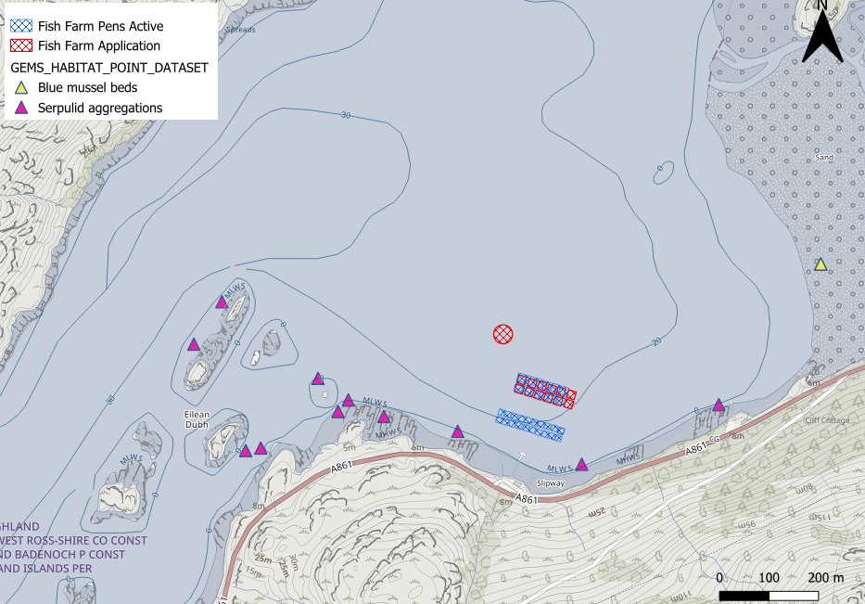

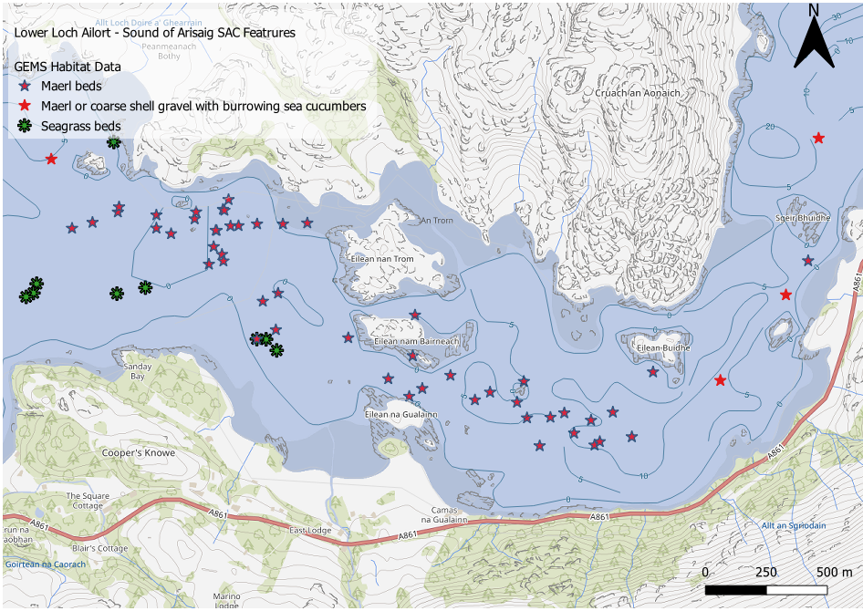
Figure 3. Lower Loch Ailort – Sound of Arisaig SAC Sensitive features

Additional comments on sediment influence
Whether this proposal is an improvement on the current farm, is strongly dependent on the percentage of waste captured by the semi-enclosed pens. CFD modelling will be required to determine the likely level of waste capture. A report detailing the required CFD modelling has been received by SEPA. These results will then need to be incorporated into the NewDepomod modelling. Due to the impoverished benthic faunal communities (with poor IQI scores) at this site, it is likely calibration of NewDepomod will be difficult. Therefore, it is recommended calibrated NewDepomod modelling of the current site is attempted, but default should also be provided. Default and calibrated NewDepomod model runs for each of the 5 proposed years will also be required, with additional conservatism built into the waste capture. For every year, these runs should demonstrate an improvement in the under cage and allowed mixing zone impact, leading up to year 5, which should pass modelling environmental quality standards. The modelled waste capture values will be incorporated into the licence, with evidence required that this percentage is being met. This should prevent additional risk to the environment should this novel technology not work as expected.
As standard, 90 days of current meter data will be needed to force NewDepomod modelling.
There is not expected to be a significant increased risk to the wider environment from solids, however, should CFD modelling suggest a significantly lower waste capture rate than the expected this may need to be reassessed.

Further processing of sediment
The sediments removed from the semi-contained system will require de-watering in order to transport onwards for further use. Any effluent produced from this process on land will need to be authorised as a trade effluent, information can be found on the SEPA website: Trade effluent discharges guidance on treatment requirements can be found in wat-g-069 and wat-g-066.
Information regarding the storage, transportation and use of the sludge can be found on the SEPA website Waste activities that do not require authorisation. Storage of the sludge prior and post de-watering can be done under temporary storage at the place of production.
The de-watered sludge/solids will then be eligible for use off site under the relevant General Binding Rules which are available at the link included above. Evidence will be required to demonstrate that all sludge/solids produced will be used by the chosen operator under the relevant legislation.

Additional comments on bath influence
No change to bath medicine amounts has been applied for.

Nutrient influence
The proposed site lies within Loch Ailort, a Category 3 waterbody according to the Scottish Government Locational Guidelines. Although a proportion of solid waste is expected to be captured, most nutrients are released in the form of dissolved nitrogenous compounds, which are not expected to be captured. This report outlines a first-pass nutrient risk assessment using the Equilibrium Concentration Enhancement (ECE) method described in Gillibrand et al. (2002).

Results
Sea loch morphological and tidal parameters required for the calculation are available in the Scottish Sea Loch catalogue. These were used alongside the proposed biomass to obtain an estimate of the Equilibrium Concentration Enhancement (ECE) of nitrogen due to the proposed increase in biomass. As the formulation the ECE calculation presented by Gillibrand et al. (2002) ultimately depends upon the sea loch area, biomass and tidal range, these parameters have been presented below. These results are presented in Table 3.

Results are also presented assuming a worst-case scenario of minimal flushing from the upper basin of Loch Ailort. Available bathymetry data are quite poor quality with low resolution in the upper reaches of Loch Ailort. It is difficult to see the morphology of the loch well, to determine any likely basins that might result in slower flushing in the upper reaches. There appears to be a possible distinct basin at the upper loch which might result in slower flushing, based on EMODnet bathymetry. Current meter datasets near the site indicate slow currents without a strong directional bias, which is also indicative of slow flushing. To address this risk, a highly conservative area around the very upper reaches of the loch was selected and used in the ECE calculation. This is also presented in Table 3.

Table 3: Equilibrium Concentration Enhancement (ECE) results
Scenario | Biomass (tonnes) | Area (km²) | Tidal Range (m) | ECE (µmol/l)
Current | 300 | 8.7 | 4.3 | 0.06
Proposed  (whole loch) | 1760 | 8.7 | 4.3 | 0.35
Proposed  (upper basin) | 1760 | 1.8 | 4.3 | 1.66

Results from Table 3 were then used to determine a Nutrient Enhancement Index (NEI; Gillibrand et al., 2002) and a consequent categorisation as per the Locational Guidelines. This is presented in Table 4. As the proposal includes solid waste capture, no change to the Benthic Impact Index (BII; Gillibrand et al., 2002) is modelled, which contributes to the overall categorisation. No change to the categorisation of Loch Ailort is predicted in any scenario.

Table 4: Locational Guidelines results
Scenario | Biomass (tonnes) | ECE (µmol/l) | NEI | Combined Index  (NEI + BII) | Categorisation
Current | 300 | 0.06 | 1 | 2 | 3
Proposed  (whole loch) | 1760 | 0.38 | 2 | 3 | 3
Proposed  (upper basin) | 1760 | 1.85 | 3 | 4 | 3

Finally, the enhancement values presented in Table 3 were compared to the environmental standard for dissolved inorganic nitrogen (DIN) from the River Basin District Standards Directions (2024). This is presented in Table 5. The standard presented is for the good-moderate boundary, for the mean dissolved inorganic nitrogen concentration (µmol/l)
during the period 1 November to 28 February. Background values are taken for the Northwest Mainland region from Gubbins et al. (2003). All scenarios do not breach the DIN standard.

Table 5: DIN standard results
Scenario | Biomass (tonnes) | ECE (µmol/l) | Background  (µmol/l) | Total (µmol/l) | Standard  (background + 50%;  µmol/l)
Current | 300 | 0.06 | 7.45 | 7.51 | 11.175
Proposed  (whole loch) | 1760 | 0.35 | 7.45 | 7.83 | 11.175
Proposed  (upper basin) | 1760 | 1.66 | 7.45 | 9.30 | 11.175

From these results, the eutrophication risk posed by the proposed development is predicted to be low according to the ECE calculation and no further modelling is required based upon these results.

Sea Lice Screening
Sea lice screening has not been carried out at this stage, due to this being a pre-application for a semi enclosed farm. However, suitable monitoring evidence will need to be provided to demonstrate that this technology prevents sea lice entering the pens/juveniles entering the surrounding area. Otherwise, mitigation techniques and a realistic sea lice number will need to be provided which can be included in screening to determine whether additional modelling is required.

Risks identified from contextual site data

Satellite Remote Sensing:
A preliminary assessment of loch eutrophication against the eutrophication risk criteria specified in “Water Framework Directive: The development and status of phytoplankton tools for ecological assessment of coastal and transitional waters” (Devlin et al., 2014) was conducted using satellite derived estimates of surface chlorophyll-a concentrations.
Data were sourced from the North West Shelf Region, Bio-Geo-Chemical, L4, daily observation product on Copernicus. Daily chlorophyll-a concentrations were averaged for days with greater than 50% pixel coverage of the loch, and data were de-spiked prior to averaging to exclude erroneously high concentrations. The resulting daily concentrations were averaged spatially across the whole loch.
These loch-averaged concentrations were then used to calculate the 90th percentile concentration over the growing season (March to October) for each year, for comparison against the eutrophication risk threshold (10µg/l). Results indicate the waterbody may have approached and exceeded the eutrophication threshold in 2023 and 2024, however the loch was generally below the threshold in the preceding years. These preliminary results indicate Loch Ailort may be at risk for eutrophication.
Figure 4: Satellite derived daily mean chlorophyll a concentration (µg/l) in Loch Ailort, also showing the seasonal 90th percentile (P90; µg/l). The growing season (March to October) is indicated via shading.
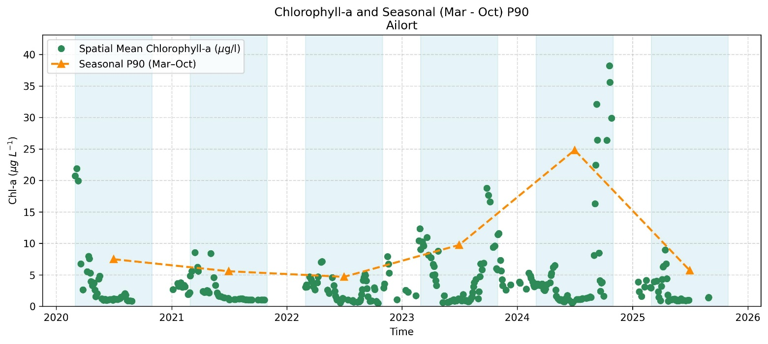

Seabed Monitoring:
Extensive operator monitoring has been carried out around this site, with the most recent 2024 results submitted to SEPA. The results (see Figure 4) indicate this first new framework multi-transect survey has failed both of SEPA’s benthic faunal standards. Findings are similar to previous surveys with little or no fauna found at most stations.
Ongoing benthic sampling is required and will be finalised at the formal application stage via submission of an Environmental Monitoring Plan (EMP) for assessment.
Figure 5. Map showing new framework multi transect monitoring survey in 2024 with the number of taxa in sample.
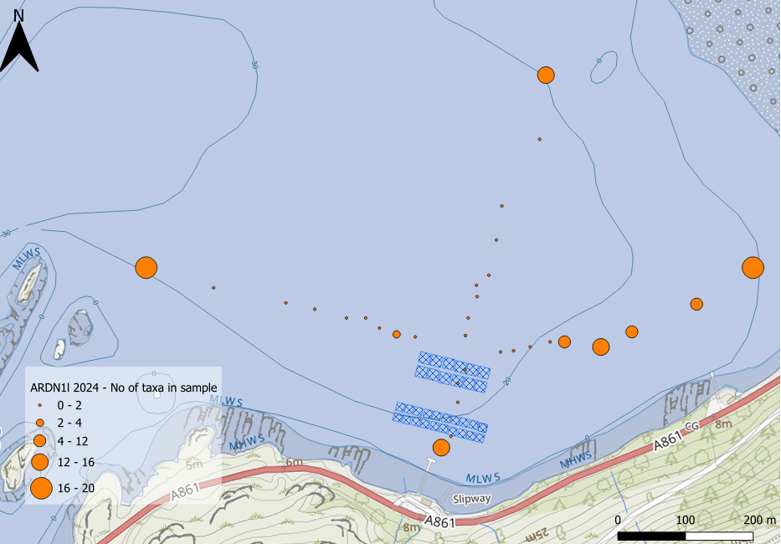

Baseline:
The semi-enclosed pen will be located to the north of the existing pens, at a location not sampled since 2016. SEPA recommend 5 stations are sampled (centre and 4 pen edges) to assess the current state at this location prior to installation of the semi-enclosed pen.
The fish farm lies ~2km east of maerl-beds, a protected feature of the Sound of Arisaig SAC. A SEPA survey in 2024 found possible enrichment effects on the maerl, which may be sensitive to nutrients at levels below the EQS. Nutrients are likely to increase the growth of ephemeral algae/ algal mats, which we have noted previously in the loch. Ephemeral algae are fast growing, short-lived, often fine, filamentous or sheet-like algae; they are usually green but can also be red or brown. They usually peak in the summer. Ephemeral algae have been reported alongside a decrease in condition of maerl. Possible causes are light occlusion, the algal mat itself can cause a build-up of nutrients, hydrogen sulphide and anoxic conditions in underlying sediments. SEPA recommends further visual surveying to assess the extent and condition of the maerl, against which to check for future deterioration with expansion of the fish farm.
To monitor the efficacy of the system and to ensure that the release of suspended solids does not exceed current emissions, continuous monitoring of flow rate, and suspended solids (dry weight equivalent mg/L) will be required at the inlet and outlet to the pens. Additionally, the total dry weight of sediment removed will be required to calculate the percentage removal.
To understand whether there is any environmental impact from changes in nutrient inputs, a baseline survey should be carried out to understand existing conditions and regularly repeated to monitor any change. This should include sample depth profiles both in the upper and lower basin of the loch, including in the vicinity of PMFs. Samples in the upper basin should be 100m away from the proposed site and at least 100m away from any other input sources. Samples will be required year-round for unionised ammonia and over winter (1 November and 28 February) for dissolved inorganic nitrogen (DIN) and salinity.
Surveys to monitor the extent and condition of the maerl should be carried out, specifically to assess the extent of live and dead maerl, algal growth on the maerl and changes in deposition. Maerl is particularly sensitive to ephemeral algae.
Further monitoring to help understand the percentage contribution of nutrients from the proposed site in relation to the wider nutrient input to Loch Ailort, and any changes in these, along with the movement of nutrients through the water column (in the direction of sensitive features), could be considered. This could include monitoring emissions of DIN and unionised ammonia from the proposed site, in transects away from the proposed site towards PMFs and also at inputs from other sources. Additionally, alongside these, temperature, salinity, pH dissolved oxygen chlorophyll, turbidity measurements and total nutrients could also be considered to help differentiate between nutrient related and other impacts.
Details of this monitoring regime should be provided in a monitoring method statement.

Table 6: Table of farms which should be included in any cumulative modelling
Site name | Location (Easting, Northing) | Biomass (Tonnes) | Last production cycle | Include in marine modelling?
ARDN1 | 175520, 781405 | 1760 | Proposed – Staged biomass increase with some semi-enclosed pens. | Marine modelling not required

SEPA: Conclusions

Conclusions
- According to historic data, the proposed site (Ardnish (ARDN1)) is in an area of low dispersion and has a relatively low capacity for erosion of material on the seabed.
- The current farm is unable to meet Environmental Quality Standards. The NewDepomod modelling will need to demonstrate this proposal is likely to result in an improvement.
- Whilst ECE predicts nutrients within the loch will be at acceptable levels, the risk of nutrients on the maerl is a concern for this proposal, with visual footage suggesting there is already enrichment. Ongoing monitoring will be required to ensure this is not getting worse.

Recommendations and further modelling
Following the engagement meeting(s), this report may be revised and this should allow the applicant to submit a method statement which address the issues raised in this document.
- CFD modelling will be required to determine the percentage of waste captured from the semi enclosed pens at Ardnish (ARDN1). A CFD modelling report has been provided to SEPA, the results of which will need to be incorporated into NewDepomod modelling, in addition to a lower waste capture rate scenario to allow an assessment of sensitivity of the results to the estimated capture efficiency.
- Due to the identified risks, SEPA recommends further visual surveying to assess the current state of the maerl, against which to check for future deterioration with expansion of the fish farm. This, along with continuous monitoring at the outlet/proximal to the pens, will help demonstrate whether any changes in the maerl status relates to the nutrients released from the farm, or other sources. Details of this monitoring regime should be provided in a monitoring method statement. Future modelling may also be required to help advise this relationship and expansion of the farm biomass may be halted should it appear the farm nutrients are having a significant impact.
- Evidence will need to be provided for sea lice mitigation techniques and a realistic sea lice number provided which can be included in screening modelling and determine whether additional modelling is required.

References
Devlin, M., Best, M., Bresnan E., Scanlan, C. and Baptie, M. (2014). Water Framework Directive: The development and status of phytoplankton tools for ecological assessment of coastal and transitional waters. United Kingdom. Water Framework Directive – United Kingdom Technical Advisory Group (WFD-UKTAG). Page 44.
Gillibrand, P. A., Gubbins, M. K., Greathead, C., and Davies. I. M. (2002). Scottish executive locational guidelines for fish farming: predicted levels of nutrient enhancement and benthic impact. Scottish Fisheries Research Report Number 63 / 2002.

