WAT-G-024

EASR Guidance:
Version 1.0, August 2025
Engineering:
Activity Guide:
Crossings

Contents
1 Purpose 3
2. Introduction 3
3. Crossings 3
3.1 What are Crossings 3
3.1.1 Single span structures 4
3.1.2 Span structures with in-stream supports 5
3.1.3 Closed culverts 6
3.1.4 Fords 7
3.1.5 Pipe and cable crossings 8
3.1.6 Crossings Key Considerations 9
3.2 Key parts of a watercourse and loch 10
3.3 What are the Potential Issues with Crossings? 11
3.3.1 Key Activity Specific Issues 12
3.3.2 Risks to the Water Environment 23
3.4 Crossings and Climate Change 24
4. Regulatory Position Statements 27
4.1 Regulatory Position on Culverting 27
4.1.1 Regulatory Position Aims 28
4.1.2 Impacts of Culverting 28
4.2 Regulatory Position: Fords 31
4.2.1 Construction of a new ford 31
4.2.2 Modification of an existing ford 31
4.2.3 Temporary fords 32
4.3 Regulatory Position: Fences and Watergates across rivers 33
4.4 Regulatory Position on Small Water Supply Pipes 35
5. Good Practice 36
5.1 Demonstrating need 37
5.1.1 Is there a demonstrated need? 37
5.2 Identify and Appraise Options 38
5.2.1 Location and alignment of crossings 40
5.2.2 Site specific requirements 48
5.2.3 Identify Options 49
5.2.4 Options Appraisal 60
5.3 Justify the selected option 61
5.3.1 Possible justifications for your chosen option 61
5.4 Use all reasonable mitigation 64
6. Post Works Monitoring 65
6.1 Post project appraisal and site management 65
Appendix 1 Good practice design: single span structures and span structures with in-stream supports 67
Appendix 2 Good practice design: closed culverts 73
Appendix 3 Good practice design: fords 82
Appendix4: Pipe and cable Crossings 86
Appendix 5 Maintenance of existing structures 89
Disclaimer 91

If you would like this document in an accessible format, such as large print, audio recording or braille, please contact SEPA by emailing equalities@sepa.org.uk

1 Purpose
This document provides information and guidance for crossings on watercourses and lochs which are subject to authorisation by the Environmental Authorisations (Scotland) Regulations 2018 (EASR)

2. Introduction
This activity guide aims to demonstrate Good Practice requirements and to help select sustainable engineering solutions that minimise harm to the water environment. This focuses on the environmental aspects that should be considered when undertaking a project. Using this document will help with the process of obtaining an authorisation for works. It is not intended as a technical design manual, and it is important to recognise that any engineering works must be designed to suit site specific conditions.
This guidance does not cover any other permissions that may be required when carrying out this activity.

3. Crossings

3.1 What are Crossings
Crossing is a term used by SEPA to describe any structure which is constructed and installed for the purpose of supporting a footpath, cycle route or transport route across any river, burn, ditch or loch or any pipe, pipeline or cable which crosses over or underneath any river, burn, ditch or loch, but excluding impounding works and culverts installed for land gain.
Whilst not fitting into scope of ‘crossing’ as described above, this document also covers our regulatory position in relation to fences and water gates which cross any watercourse.
There are five main types of crossing
- Single span structures
- Span structures with in-stream supports
- Closed culverts
- Fords
- Pipe and cable crossings
Other types of crossings such as causeways, which are built above the level of any inland waters (usually lochs) to enable safe passage, are not covered within this guide and it is recommended that you discuss any such proposals directly with us before submitting an application. All causeways would require an application for permit before construction.
A summary of the key issues for each crossing type is given in sections 3.1.1 to 3.1.5 below:

3.1.1 Single span structures
Single span structures are those that span the width of the channel with no in-stream support and do not affect the bed of the river.
- The natural bed is retained.
- Bank habitat can be maintained under the crossing if abutments are set back.
- They can come in a variety of forms including simple timber, steel or concrete beams/decks spanning between abutments on the banks, masonry arch bridges or prefabricated structures such as concrete/steel arches or portal frames sitting on foundations on either side of the channel.
- See further details in section 5.3.2.1 and Appendix 1
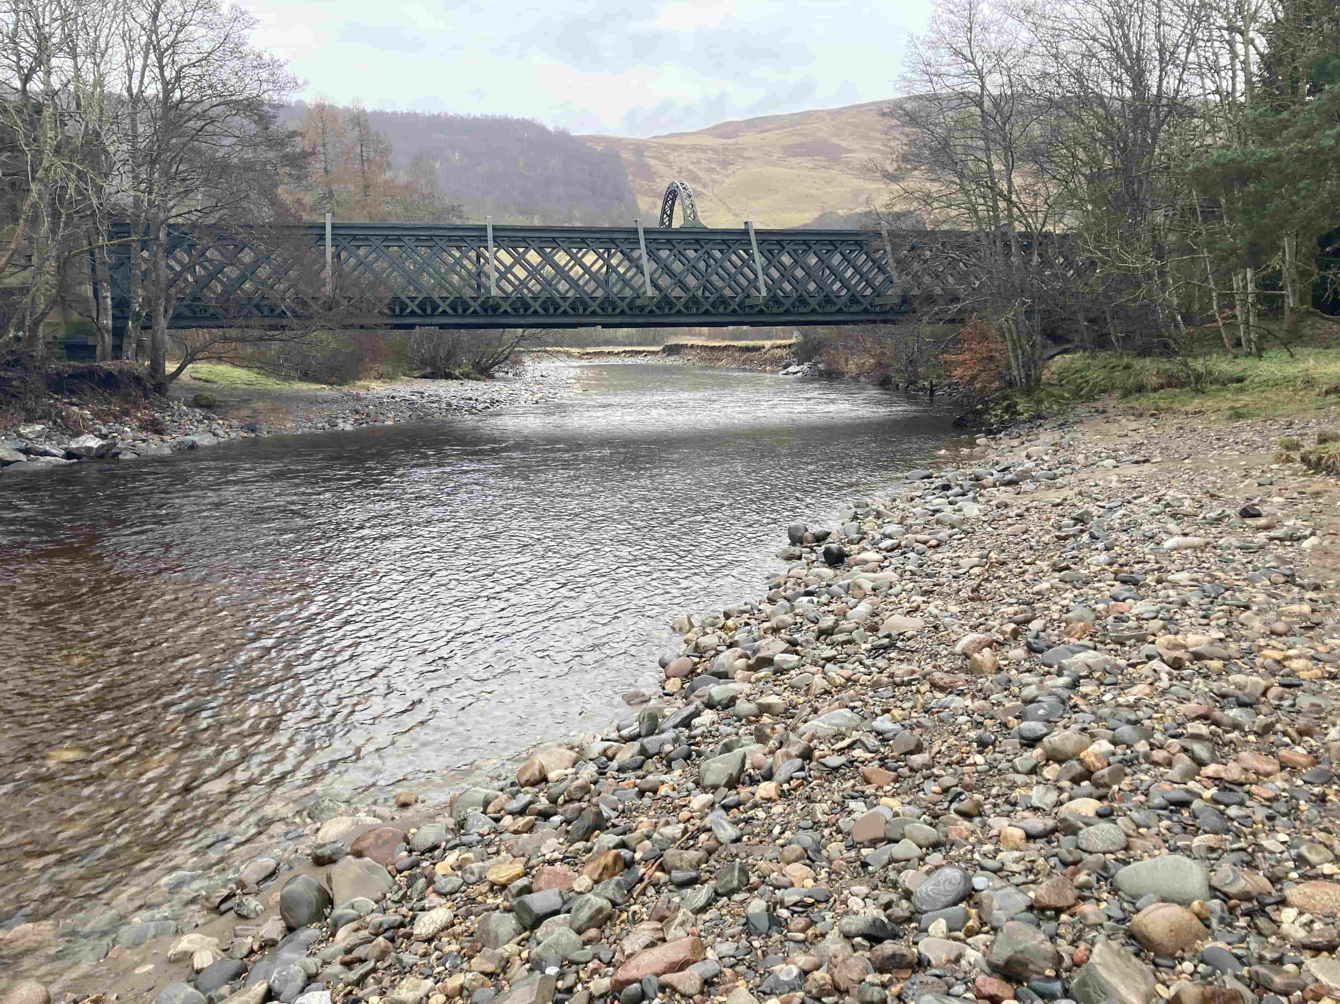
Figure 3A: Single span structure

3.1.2 Span structures with in-stream supports
In-stream supports (piers) can be used to increase the crossing width where single span is not possible or prohibitively expensive.
- They can come in a variety of forms, but typically include timber, steel or concrete beams/decks spanning between the abutments and in-stream supports or masonry arched structures.
- Bank habitat can be maintained under the crossing if abutments are set back.
- See further details in section 5.2.3.2 and Appendix 1
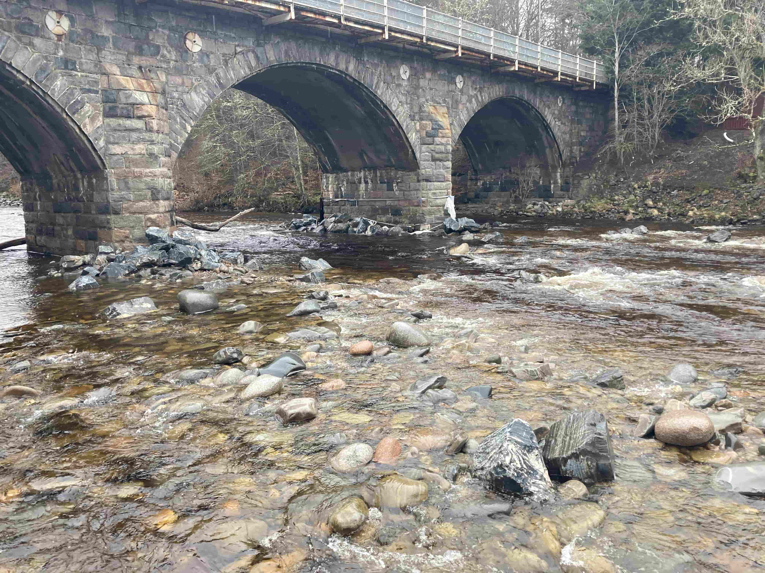
Figure 3B: Span structure with in-stream supports

3.1.3 Closed culverts
A closed culvert is a culvert with an artificial base (typically pipe or box culverts).
- They can be made from a variety of materials (e.g. concrete, steel, plastic) and come in a range of shapes (e.g. pipe or box) and sizes.
- The installation of a closed culvert causes significant disruption to the river/loch bed
- The impacts on the bed and banks of the river are significantly greater than other crossing types
- They should be designed to retain natural bed material on top of the artificial base (invert)
- If not designed correctly they can:
  - Cause a barrier to fish migration and other aquatic ecology
  - Restrict the downstream transport of sediment and floating debris.
  - Restrict flows during floods
- see our regulatory position on culverting of watercourses and further details in section 5.2.3.4 and Appendix 2
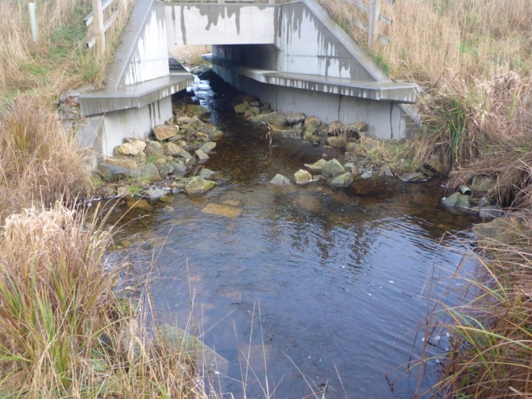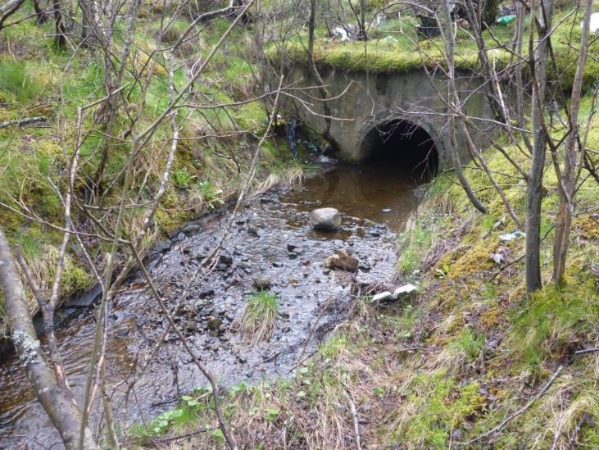
Figures 3C and 3D: Box culvert (left) and pipe culvert (right)

3.1.4 Fords
Fords are river crossings built or created at the level of the riverbed.
- They can be made of natural materials (natural bed and bank material maintained), or they can be reinforced with artificial material (bed and/ or banks).
- The bed need not be altered to create a ford if it is relatively flat and stable. Sometimes, the natural bed material is manipulated to create a flat section to facilitate crossing. This will often require maintenance after high flows.
- The bed is sometimes reinforced to provide a flat and stable crossing area.
- They may involve modification of the banks to allow vehicular access to the bed. Typically, this will include re-profiling of the bank and/or some form of reinforcement.
- Fords with reinforced beds can cause disruption to the downstream transport of sediment, scour of the riverbed downstream and block the upstream migration of fish and other aquatic ecology. They should be designed to avoid this.

See our regulatory position on fords, and further details in section 5.2.3.4 and Appendix 3
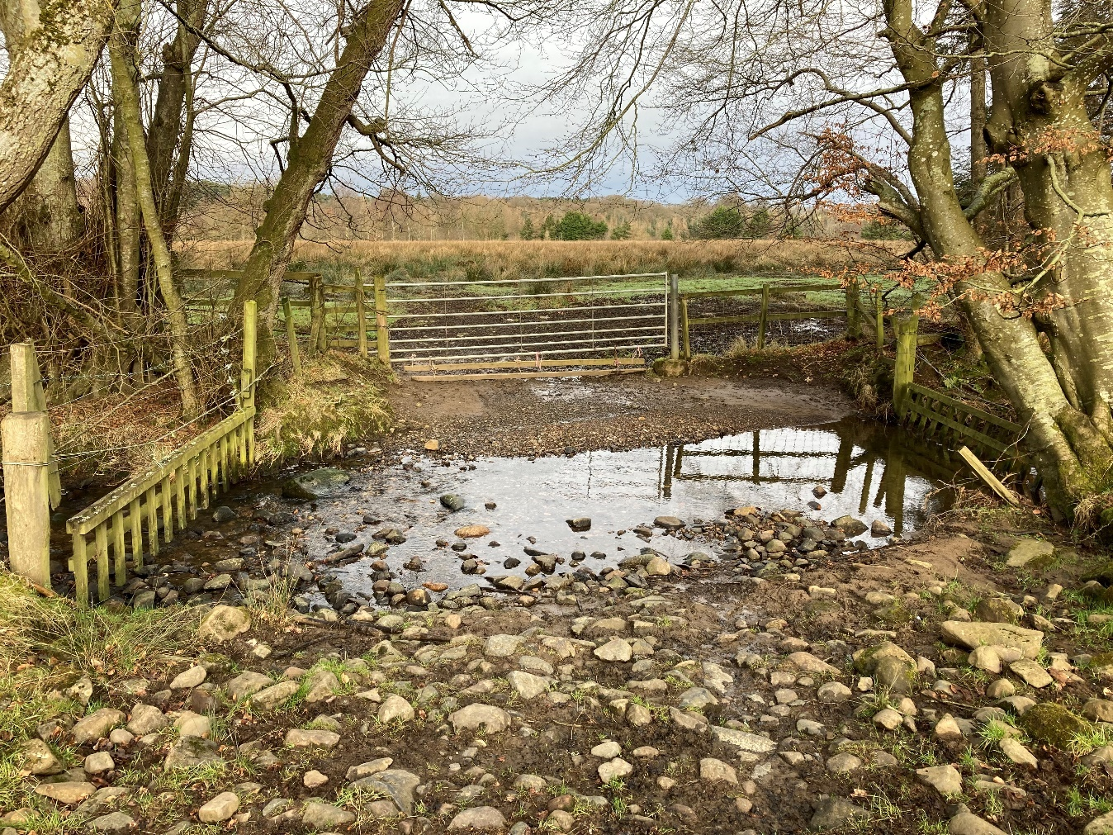
Figure 3E: Ford with natural bed and infrequent use

3.1.5 Pipe and cable crossings
Pipes or cables can be installed above or below the watercourses or lochs in a variety of ways with varying levels of impacts.
- Pipes or cables below the bed of a watercourse or loch can be installed by directional drilling, isolated open cut, open cut. Mole ploughing is sometimes used for very small watercourses.
- Pipes or cables above a watercourse or loch are usually supported by a single span structure or a structure with instream supports
- See further details in section 5.2.3.5 and Appendix 4
- Small livestock or drinking water supply pipes or small diameter cables are sometimes laid on the bed of a river or loch. Where this happens, they should normally be laid parallel to the flow and must follow good practice principles (see our regulatory position on small water supply pipes)
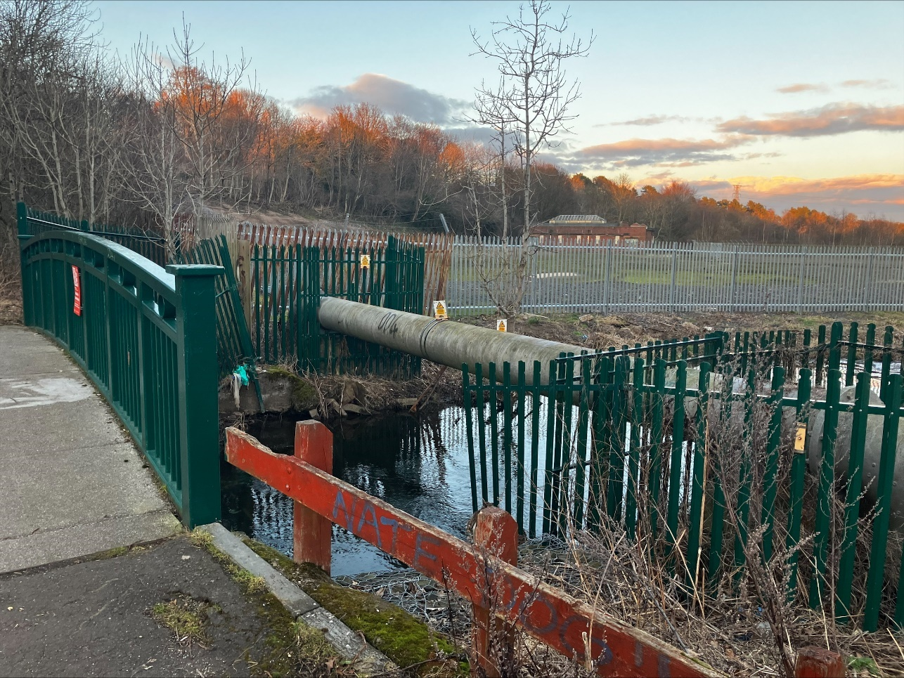
Figure 3F: Pipe crossing above watercourse supported on abutments on the banks

3.1.6 Crossings Key Considerations
Single span structures with no instream supports that don’t impact on the bed or banks are preferred due to their much lower environmental impacts compared to structures with instream support, closed culverts or bridges with bed reinforcement.
Careful design of a crossing should always ensure there is the minimum possible disruption to flow hydraulics and sediment transport processes, making allowances for climate change, and should not impede the free passage of fish (including migratory fish), other aquatic wildlife (such as otter), and floating debris.
Poorly designed river crossings can:
- Lead to the loss or damage of plants, animals and their habitats.
- Create a barrier to the movement of fish and other wildlife.
- Prevent sediment and floating debris (wood etc) being moved downstream
- Prevent natural river adjustment.
- Create or exacerbate unnatural levels of erosion and deposition upstream and downstream
- Increase flood risk
Following the good practice in this guide will help reduce the risk of these impacts.

3.2 Key parts of a watercourse and loch
Key parts of a watercourse and loch are shown in Figures 3G and 3H below and explained in our Glossary
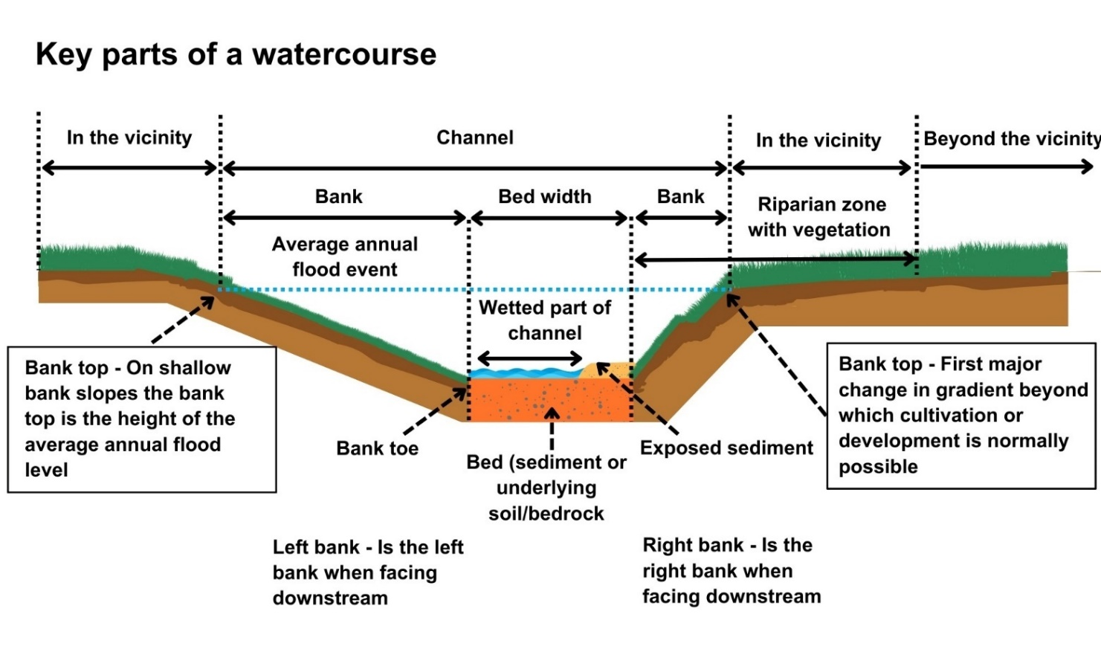
Figure 3G: Key parts of a watercourse
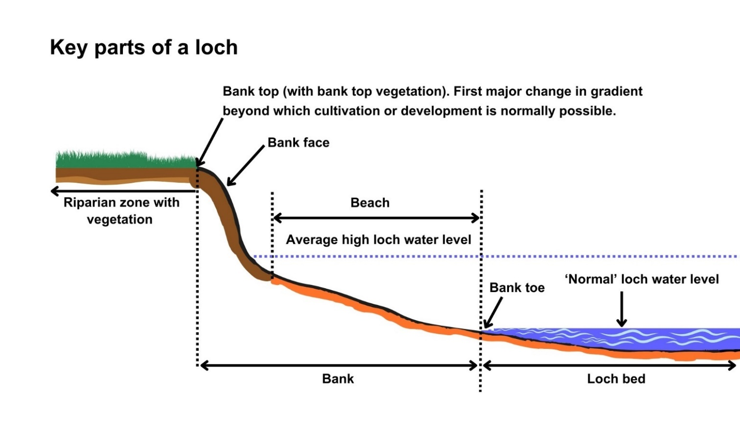
Figure 3H: Key parts of a loch.

3.3 What are the Potential Issues with Crossings?
Carrying out any engineering works and any associated temporary works, including works such as access and temporary crossings, can pose risks of harm to the water environment.
To minimise potential impacts, it is important: that a sustainable option is chosen, appropriately designed and constructed; that you understand the nature of the watercourse or loch and how it is likely to respond to the works, and that you consider the effect of the works on any nearby infrastructure or other water users.
This section summarises the main activity specific issues and general issues that need to be considered when designing crossings.

3.3.1 Key Activity Specific Issues

3.3.1.1 Barriers to Fish Passage and Other Wildlife
Migration and movement throughout the river catchment is essential to the survival of many animal species including salmon, trout, lamprey, otter and watervoles. Poorly designed river crossings such as bridges and culverts can prevent fish and mammals moving up and down river catchments. This prevents animals reaching essential areas in the catchment, such as breeding and feeding habitats, leading to a reduction in or loss of populations.
Salmon travel as adults from the sea up river to spawn and then, as juveniles, migrate back downstream to the sea. Other fish such as brown trout use different parts of the river catchment throughout their life cycle, migrating upstream to smaller headwaters to spawn and moving downstream to feed and grow in lochs or larger rivers where more food may be available. Sea trout, eels, sea lamprey and river lamprey also make significant migrations.
Other fish species may be involved in shorter migrations within the catchment and can be affected if a crossing creates a barrier and prevents access to a key area of habitat. For example, Arctic charr can make limited migrations from lochs to rivers and brook lamprey can also make smaller migrations, associated with spawning, within a catchment.
Poorly designed river crossings can be a significant barrier to fish passage. Some of the main problems than can result in barriers include:
- Perched inverts (bridge aprons, weirs or culvert outfalls that create a drop from the structure to the downstream riverbed). This can be the result of poor initial design or may arise if the invert is placed at bed level which leads to subsequent erosion downstream due to scour. In some cases, erosion may be triggered elsewhere in the river and move up or downstream to the structure, creating a drop.
- Crossings affecting the bed of the river that have an overly smooth surface, causing reinstated sediments to be flushed downstream, leaving the crossing bed exposed.
- Undersized crossings that are too small for fish to pass through and may also increase the speed of water flowing through the structure leading to flows that are too fast for fish t swim against.
- Excessively wide crossings which create flows that are too shallow for fish to swim through.
- A lack of resting places and pools. Some species of fish can jump up some obstructions if there are adequate pools downstream. If a crossing is difficult for fish to swim through or is very long and there are no resting places then fish can get exhausted and be washed downstream.
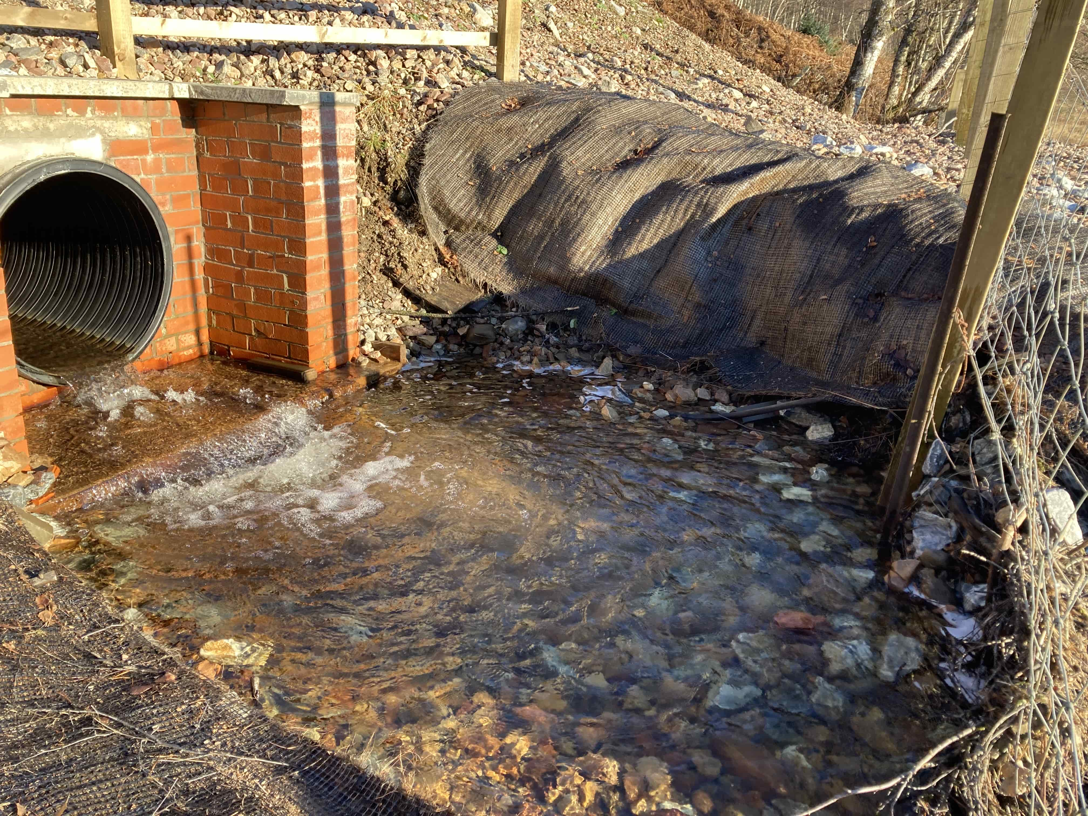
Figure 3i: Poor practice. Culvert installed with a drop from the culvert outfall to the downstream riverbed (perched culvert) creating a barrier to fish passage.
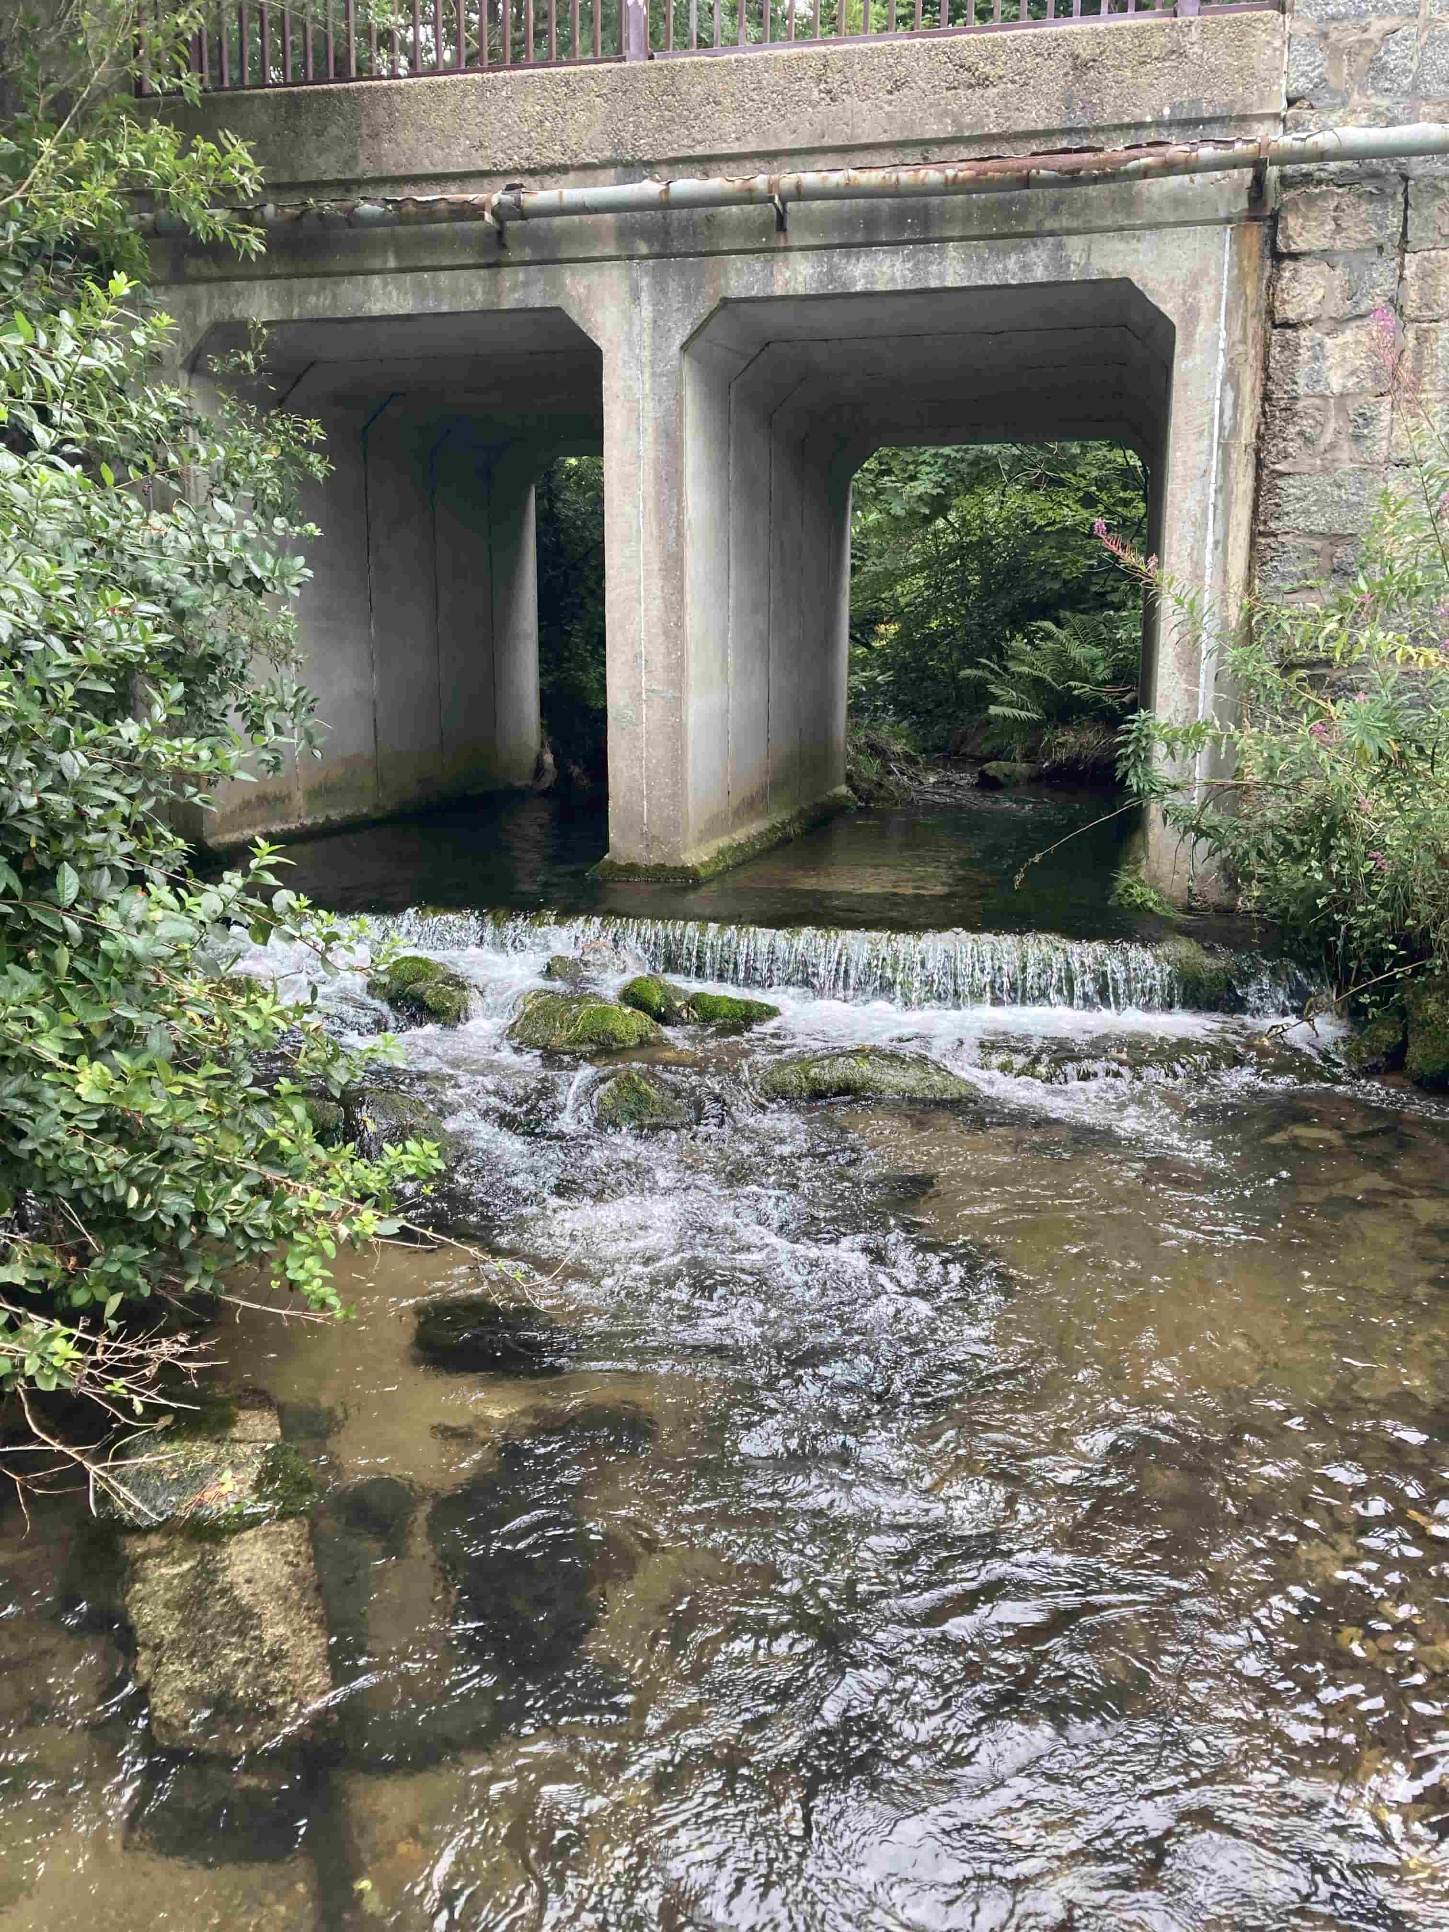
Figure 3J: Poor practice. A bridge invert may be level with the riverbed at the time of construction but subsequent erosion downstream due to scour can led to a drop forming (perched invert) that can create a barrier to fish passage, it can also lead to flows that are too shallow for fish to swim through.
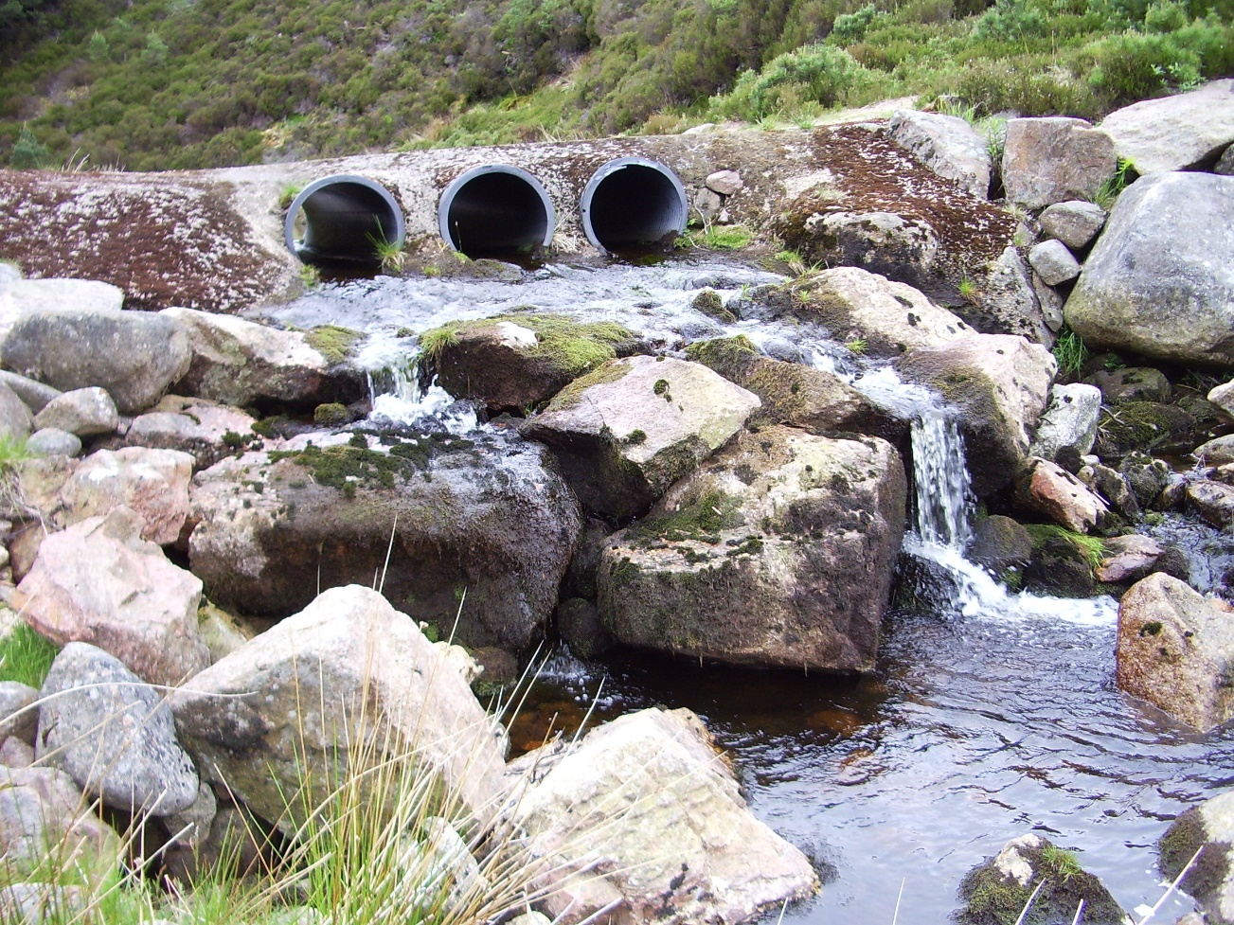
Figure 3K: Poor practice. Pipe bridge creating a barrier to fish passage, showing a drop from the invert to the riverbed (perched). Undersized pipes are too small and dark for fish to enter and in high flows water may be too fast for fish to swim against. Photograph courtesy of River Dee Trust.
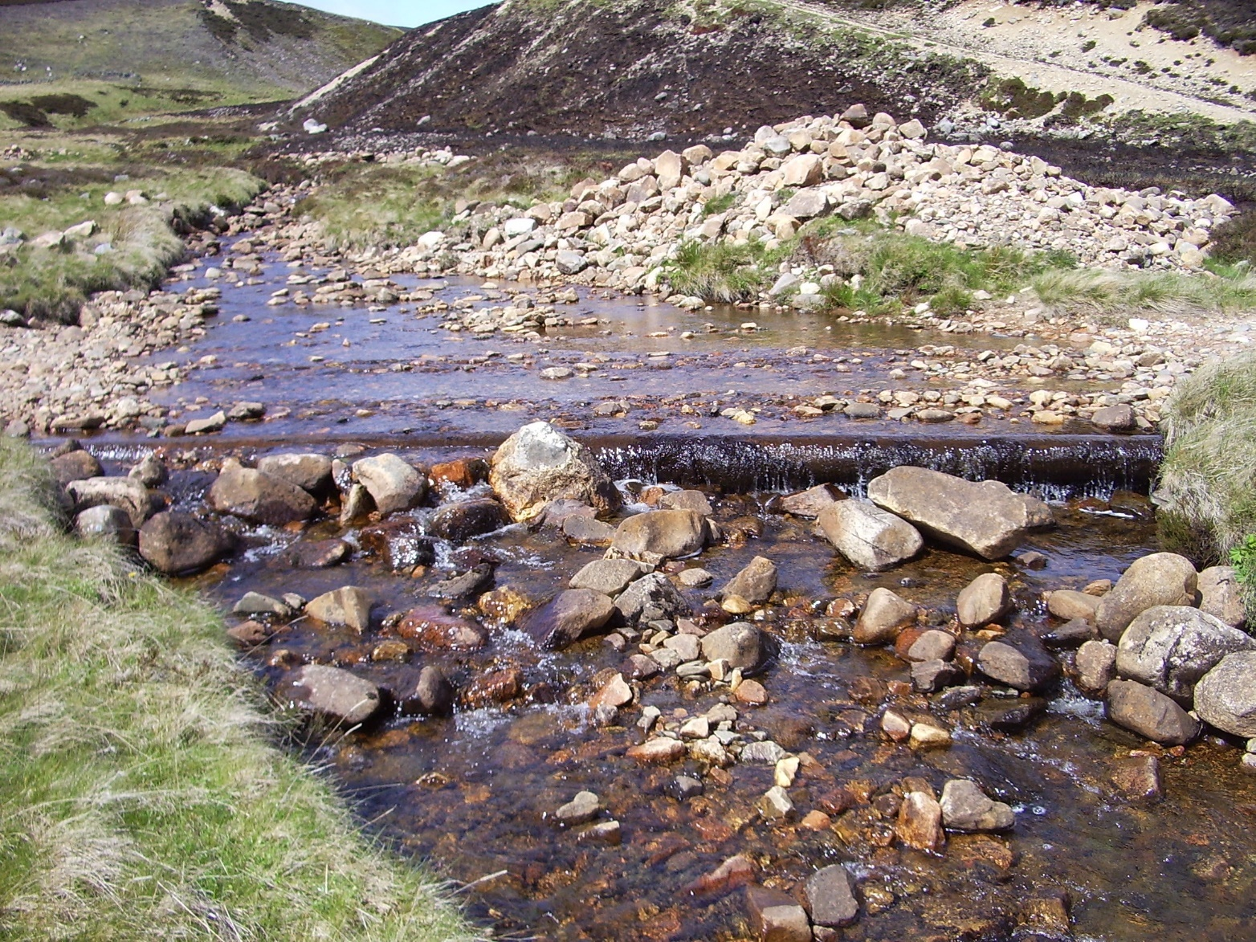
Figure 3L: Poor practice. This ford has widened the river, leading to flows that are too shallow for fish to swim through. Photograph courtesy of the River Dee Trust.
A single crossing can be a complete barrier to fish passage (i.e. it prevents all fish passage all of the time), leading to the loss of certain fish populations such as salmon upstream of the structure. Some crossings however may form partial barriers to fish passage (i.e. some fish can get past under certain conditions). Even if crossings form partial barriers the cumulative impact of these over a whole catchment can have a significant impact on fish populations. The River Dee catchment in Aberdeenshire is largely rural yet still has more than 500 crossings. Some of these crossings pose a complete or partial barrier to fish passage, which can prevent or reduce fish species such as salmon reaching parts of the catchment.

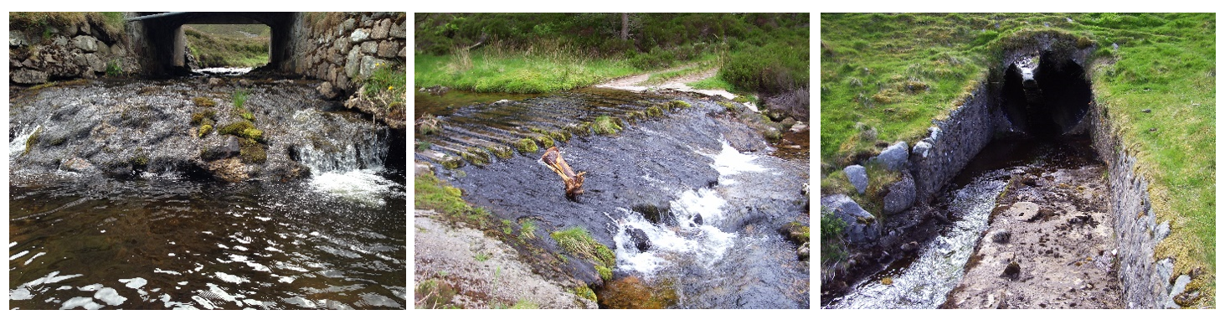
Figure 3M: Crossings in the River Dee catchment. Some of these pose a complete or partial barrier to fish passage and can negatively affect fish populations throughout the catchment. Photograph courtesy of the River Dee Trust.
Being able to move up and down a river is also essential for other wildlife such as otters and water voles. These species not only depend on a healthy river ecology (fish and invertebrates), but also on good bankside (riparian) habitat where they live and feed. This habitat is important in small burns and ditches as well as larger rivers e.g. water voles often use small watercourses including ditches and upland burns. Culverts and other crossings that do not maintain the riparian corridor can create barriers for these mammals as well, preventing them from reaching feeding grounds and establishing populations elsewhere. In more urban environments, the riparian habitat may be one of the few corridors they have left in which to move around. Ensuring mammal passage under river crossings may also help prevent animals such as otters crossing roads, reducing their risk of being hit by road vehicles.

3.3.1.2 Barriers to Sediment and Wood Transport
Rivers also carry a significant amount of sediment as well as water. River sediment covers all natural riverbed load including silts, sands, gravels, cobbles and boulders. This is stored and transported throughout the river network creating habitats for many species such as spawning gravels for fish and gravel bars and islands essential for many invertebrates.
Where crossings are poorly designed, sediment can deposit at bridges and culverts which can reduce flow capacity and increase flood risk This may lead to the need for regular dredging at the structure. Dredging increases long term maintenance costs and can lead to the loss of important species and habitats such as freshwater pearl mussels and fish spawning gravels and may also pollute the river with the release of finer sediments that can smother habitats and species downstream. See our guidance WAT-G-026 EASR Guidance: Engineering: Activity Guide: Sediment management for further details.
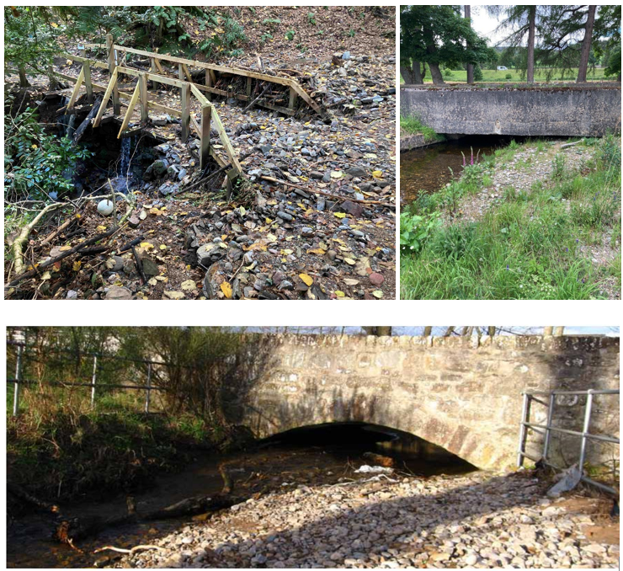
Figure3N: Three photos showing increased sediment deposition at a bridge can increase flood risk
Large woody material is important to river ecosystems and should be retained in the river channel where possible. It provides food for organisms and its presence increases the physical diversity of the channel. Woody material can be trapped at bridges which can increase flood risk and the risk of the bridge collapsing in high flows. This woody material is often removed from bridges and culverts to stop such potential impacts.

3.3.1.3 Preventing the Lateral Migration of Rivers
Many rivers move naturally across their floodplain through the process of erosion and deposition. This process is called lateral migration. The area within which a river channel is likely to move over a period of time is referred to as the channel migration zone. This movement or migration creates new habitats and re-works older habitats providing different habitat types and ages, important for maintaining a diverse range of plants and animals. For example, rare species of plants and insects, such as river shingle beetles, live on bare river gravels created by this movement.
If a structure is located poorly, it may prevent lateral movement of the river. This may interrupt the natural processes of erosion and deposition, therefore damaging habitats and it may also lead to damage to, or loss of, the crossing structure itself. This can result in the need for further engineering works to stabilise the structure or stabilise the river, increasing costs. Trying to stabilise a naturally dynamic river is likely to result in long term maintenance issues and may cause further impacts such as increased erosion upstream or downstream.
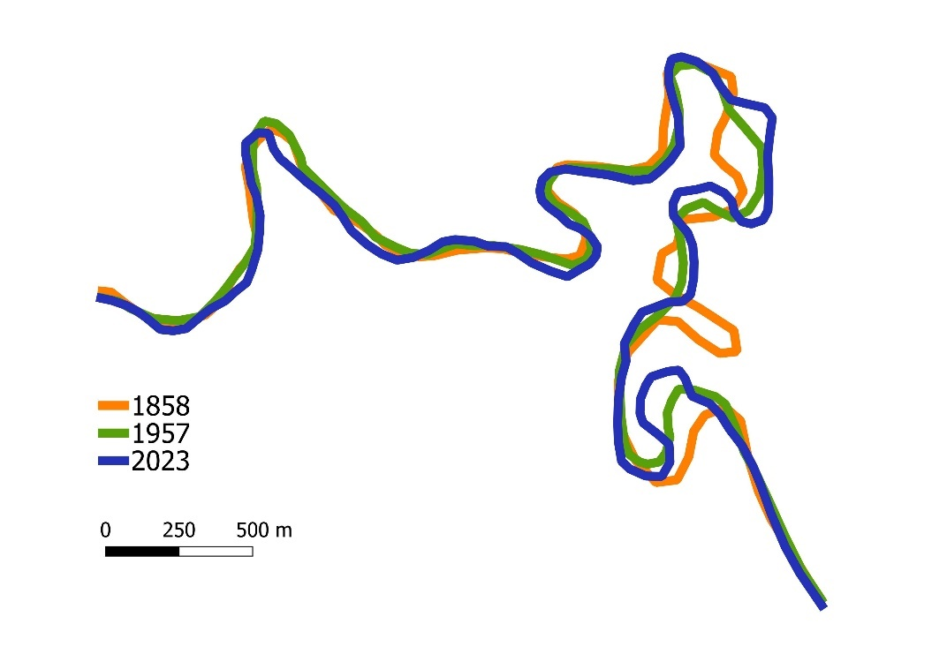
Figure 3P: Movement of the River Clyde and River Medwin between 1858 and 2023.
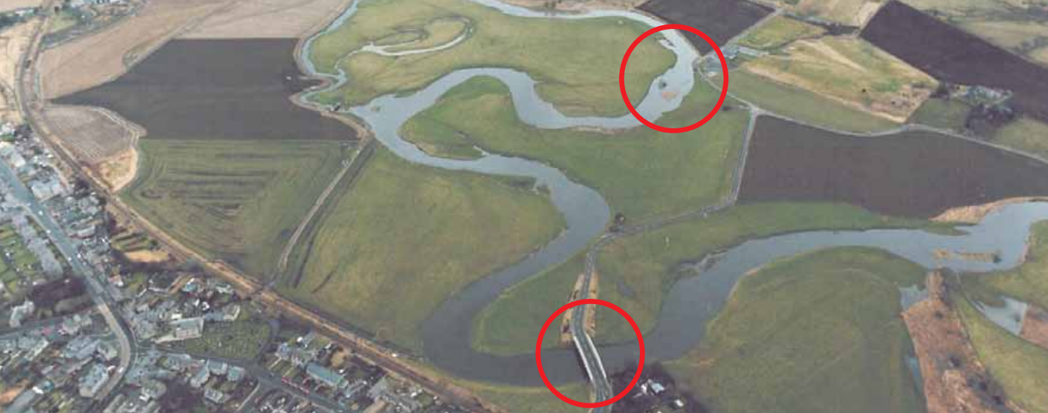
Figure 3Q: River migration affecting roads and river crossings. Photograph courtesy of Aberdeenshire Council.

3.3.1.4 Flooding and floodplain connectivity
Floodplains are an important part of the river system; they provide storage for water during high flows and, under natural conditions, can act as storage areas for sediment and nutrients and help to dissipate the energy of floodwaters. They also provide important food sources and nursery areas for fish and other aquatic plants and animals.
Poorly designed structures can increase flood risk upstream due to a lack of capacity beneath the structure. Other structures may have sufficient capacity to take even the highest flows but, if they block the floodplain (e.g. by road embankments, an increase in upstream flooding can still occur. Disconnecting the floodplain from the river can also lead to the loss of floodplain habitats.
Crossings can constrict flood flows, forcing flood flows through a relatively narrow opening at a crossing point This can increase bed and bank erosion, and alter sediment deposition damaging river habitats and crossing structures.
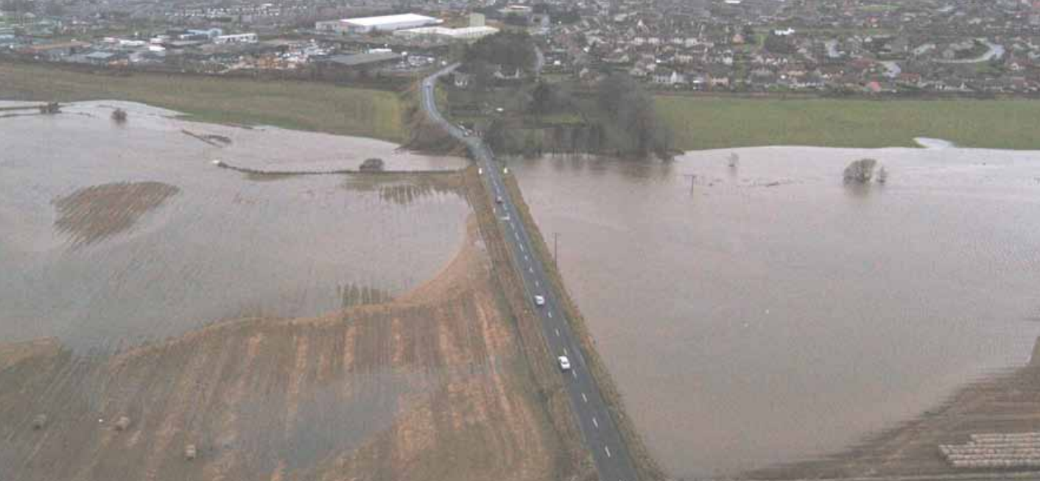
Figure 3R: Road embankment crossing a floodplain causing restricted floodplain flow. Photograph courtesy of Aberdeenshire Council.
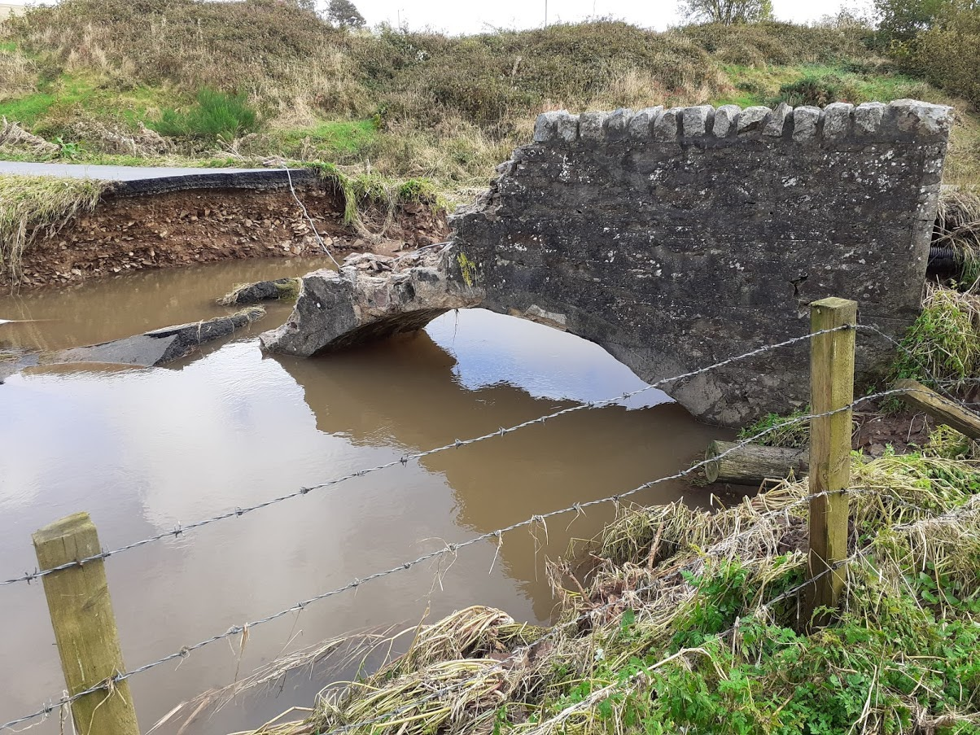
Figure 3S: Crossings can constrict flood flows which can increase bank and bed erosion and alter sediment deposition, damaging river habitats and crossing structures. Photograph courtesy of Aberdeenshire Council.

3.3.2 Risks to the Water Environment
The main risks to the water environment from carrying out this activity can be grouped as follows:
Harm to fish
This includes impacts on fish migration, spawning and fry development, loss of habitat and direct impacts such as stranding or physical damage.
Scheduling the timing of works to avoid fish spawning times and fish emergence times. Key fish species to consider include salmon and trout (normally October – May), lamprey species (normally March – July). However, these times can vary, and you should contact Fisheries Management Scotland if you are unsure what fish species are present or what times should be avoided.
Temporary works such as crossings, channel isolation or diversions, blasting, vibration or pile driving, sheet pilling or using artificial lighting at night can affect fish or migrating fish. You should carefully manage these works to minimise any impact and carry out fish rescues, where appropriate.
For more information see our guidance WAT-G-032 EASR Guidance: Fish Protection.
Physical Impacts & Pollution
Physical impacts to the bed and banks of the watercourse which can lead to instability resulting in increased erosion or deposition, loss of habitats and increased flood risk.
Carefully managing construction works is essential to prevent and minimise pollution from sedimentation, leaking oil from machinery and the entry of potentially polluting materials into water such as unset concrete.
Sites should be restored following works to manage impacts from disturbance.
Further information on construction works and mitigation can be found in our guidance WAT-G-034 EASR Guidance: Construction works and silt/pollution mitigation.
Invasive Non-Native Species
Any Invasive Non-Native Species (INNS) present in or adjacent to site could have the potential to spread. You should identify and plan works with adequate biosecurity measures in place to prevent any spread of INNS. Further guidance can be found in EASR-G-001 EASR Guidance: Invasive non-native species (INNS)
Protected areas and species
You should identify any Protected areas (e.g. SSSI, SAC, SPA) in or adjacent to site and consider any impacts from the works on Protected species such as freshwater pearl mussels and otter. You should contact NatureScot where your activity is in a Protected area or may impact protected species. For further information see WAT-G- 008 EASR Guidance: Assessment of impact on Protected Areas from inland water activities
Impacts to other users of the water environment
There could be potential impacts on other water users such as water supplies, fishing, water sports.
All the risks to the water environment, as detailed above will vary according to:
- The type and design of the engineering activity.
- The timing of the works.
- The working methods and mitigation.
- The reinstatement methods.

3.4 Crossings and Climate Change
Climate change is already affecting Scotland’s rivers and lochs. Climate change predictions indicate there will be significant increases in winter precipitation over the coming decades, which suggests that large floods will occur more frequently. Summer rainfall is also likely to become more intense. These effects are expected to become more severe and widespread.
These changes are making rivers more powerful, which means they will have a greater ability to erode their beds and banks, transport sediment, move from side to side on their floodplains and adjust their planform. These changes are a river’s way of dissipating the excess energy of floods.
Increasing flood frequency means that many channels will:
- Need to increase in size by eroding their beds and banks to accommodate larger volumes of water and,
- Have more energy and a greater ability to erode their beds and banks, transport sediment, and adjust their planforms.
There will also be more frequent water scarcity events, this will lead to:
  - The loss of aquatic habitats and,
  - Higher water temperatures, which can be lethal to species such as salmon.
Larger floods and more energy in our rivers means that they will adjust their planform, long-profile and channel shape more frequently and at a faster rate than in recent years. River crossings will often create a constraint on planform, long profile and channel shape. This can be very problematic as adjustment continues to occur upstream and downstream. Typical issues that this creates include scour (riverbed lowering) undermining structure foundations and outflanking of structures through bank erosion. In the worst cases, this can cause complete collapse/failure of a crossing structure. Remedial works to address these problems then leads to further impacts on river processes such as degrading bed and bank habitats and creating barriers to the natural movement of aquatic animals, river sediment and floating debris.
Undersized or poorly designed structures can also cause issues such as trapping of river sediment and floating debris such as wood, resulting in increased flood risk upstream from a structure. Such blocking or lack of capacity to deal with increased high flows could also cause overtopping of crossings resulting in severe damage and disruption to transport routes and infrastructure and threat to life. In recent years in Scotland, many main roads and railways have been closed for days or months due to damage or threat of damage to bridges and culverts. Examples include the extended closure of the west coast mainline railway due to structural damage of a bridge at Lamington (December 2015), and closure of the A90 Aberdeen to Dundee road at Finavon after Storm Babet (2023). Damage and disruption on smaller road networks throughout Scotland is now commonplace. There have also been cases of fatalities arising from trying to clear blocked culverts.

4. Regulatory Position Statements
We have a number of specific regulatory positions which set out our regulatory approach for certain types of crossing and fences and water-gates, these are set out in the sections below.

4.1 Regulatory Position on Culverting
We will follow the regulatory position below when responding to planning consultations and other enquiries and when assessing applications for authorisation under EASR.
Culverts are used to create artificial channels of varying length and purpose. They can either be open channels with artificial bed and banks, or they may be totally enclosed (example designs are shown at the end of this document).
The following provides a summary of SEPA’s position on culverting of watercourses.
- SEPA will use its statutory powers and duties under EASR and other legislation to actively promote the retention of existing open water habitat.
- SEPA is opposed to the enclosed culverting of watercourses for land gain and will actively seek to discourage such proposals. (Note culverts for land gain are a form of ‘channel modification’ as opposed to a ‘crossing’. Guidance on culverts for land gain is contained within the WAT-G-023 EASR Guidance: Engineering: Activity Guide: Channel modification).
- SEPA will presume against unjustified enclosed culverting (box or pipe) of watercourses as bridging structures for transport routes.
- SEPA will presume against other forms of unjustified open culverting of watercourses (e.g. brick, stone or concrete open channels).
- SEPA will seek improvements to existing culverts in line with this position statement when replacement or significant maintenance works are proposed.
- When assessing new proposals, SEPA will consider any over-riding social, economic and technical constraints. However, SEPA will exercise its powers and duties to prevent unnecessary and unjustified damage to river channels. Where it has been demonstrated that culverting is the only viable option, SEPA will seek adoption of mitigation measures to protect habitats, passage of fauna, and river form and flow.

4.1.1 Regulatory Position Aims
Culverts have a range of harmful local and system-wide impacts on the environment. The aim of this position statement is specifically to:
- Protect existing local open water habitat in Scotland.
- Protect valuable open water habitats from piecemeal cumulative loss.
- Protect the physical character, habitat, transport of sediment, free passage of fauna, establishment of other ecology, access to light, and chemical quality in small and urban watercourses from the harmful effects of culverting.
- Protect open water habitat for local amenity value.
- Protect the potential of previously modified waters to be restored or enhanced in the future.
- Ensure that room is made for rivers in all new development.
- Mitigate flood risk associated with poorly designed culverts.

4.1.2 Impacts of Culverting
Piecemeal losses of small watercourses can create wider cumulative impacts on the water environment, including ecology, channel form, flow regime and chemistry. Specific impacts are described below.

Ecology
Badly designed and poorly installed culverts can be impassable to riverine fauna. Increased water velocities combined with shallow water depth, “stepped” culvert entrances and smooth uniform surfaces all create barriers to fish passage. For example, in 1996 the River Tweed Foundation identified 1000 culverts in the River Tweed catchment which were impassable to fish on watercourses otherwise capable of supporting salmonid species.
Culverting results in the loss of natural in-stream and bank-side habitats through direct removal and loss of daylight. Piecemeal enclosure of watercourses leads to fragmentation and loss of wildlife corridors in urban environments. These corridors and habitats can be important for mammals, bird species and fish, along with other biodiversity interests such as vegetation. A number of priority species such as otters and voles depend on good quality river corridor habitats. The installation of culverting is not consistent with the Scottish Governments Scottish Biodiversity Strategy which seeks to restore and regenerate ecosystems to tackle biodiversity losses.

Pollution
Enclosed culverted urban watercourses are often highly polluted due to misconnected foul sewers, overflows from blocked sewers or discharges of contaminated surface water. These culverts create serious practical access difficulties in exercising effective pollution control duties, and maintenance by the riparian owner. SEPA believes that unjustified and inappropriate enclosure of watercourses within culverts hinders both its own efforts and those of other organisations to reduce pollutant inputs into watercourses and to improve the chemical biological and physical quality of running waters in Scotland.

Morphology and Erosion
Culverted sections may create or exacerbate downstream or upstream bank and bed erosion as well as sediment deposition, as a result of altered water velocities and disruption to the natural transport of sediment. This in turn drives demand for further hard engineering responses (e.g. gabion baskets, concrete banks) which may create additional erosion and deposition problems, and the need to carry out sediment removal.

Flooding
Culverts are prone to blockage by debris, both natural wood and litter, leading to localised flooding during periods of high river flow. Badly designed or undersized culverts also form restrictions to high flows causing upstream flooding. Once installed, if flood flows increase due to climate change or land management changes upstream, it is very difficult to change the amount of water a culvert can carry and therefore avoid flooding.

Restoration
Hard engineering structures, such as a concrete culvert, can hinder future restoration options if removal of such structures and other enhancements to the watercourse are being considered. This is particularly significant where urban development causes the burial of once open watercourses beneath housing or commercial centres, or where new development is placed on top of existing culverted watercourses which otherwise might be available for restoration. SEPA will take the opportunity to promote the restoration of culverts back to open water habitat during discussion of development proposals and will encourage and support appropriate river restoration techniques.

Landscape and Amenity
Culverting of urban waters leads to the loss and degradation of distinctive components of the local landscape. Culverting leads to the loss of green amenity space along riverbanks and reduced access for recreational opportunities, such as angling, walking or canoeing.

Human Health and Safety
Health and safety considerations are often cited as a reason for culverting in urban areas. However, culverts can create health and safety problems. Closed culverts increase local flood risk due to problems outlined above. Open culverts increase flow velocities during periods of high flow due to their confined nature. A more natural watercourse as part of a wider green corridor can dissipate flows during periods of flood over a larger area therefore reducing velocities and potential health and safety issues. However, issues of public health and safety and the building standards for new developments (which are subject to planning controls) are within the remit of the local authorities

4.2 Regulatory Position: Fords
We will follow the regulatory position below when responding to planning consultations and other enquiries and when assessing applications for authorisation under EASR.

4.2.1 Construction of a new ford
Authorisation is required where a new formal ford structure is created by installing bed and/or bank reinforcement or manipulation/addition of bed substrate.
Authorisation is not required where no formal structure is created, however care must be taken when vehicles are crossing watercourses to ensure there will be no destabilisation to the bed and banks and that crossing by vehicles, plant and machinery does not result in pollution of the water environment.
Where using informal fords for the purposes of carrying out another controlled activity this will be covered by conditions in the relevant authorisation – see temporary fords section below. Where using informal fords to carry out Water General Binding Rule (GBR) level activities or maintenance works, the rules of Water GBR 9 for the use of any vehicles, plant or other equipment within or near the watercourse and GBR 7 which cover any temporary crossings or works must be complied with.
Should an informal ford result in a significant adverse impact upon the water environment, SEPA may seek action to remediate any harms caused.

4.2.2 Modification of an existing ford
Modification works to maintain, repair or replace an existing ford can be undertaken without authorisation provided it meets all the criteria set out in our guidance WAT-G-027 EASR Guidance: Engineering: Maintenance, replacement and removal of existing engineered structures.
When carrying out maintenance of an existing ford the operation of any vehicle, plant or other equipment within or near any surface water or wetland must comply with Water GBR 9 and all temporary crossings, structures and temporary works must comply with Water GBR 7.
Where any additional bed or bank protection is proposed to be installed this will require authorisation as this will change the overall footprint of the structure.

4.2.3 Temporary fords
Where a ford is to be created and used on a temporary basis to carry out another water activity authorised by GBR then the temporary ford will be controlled by the rules within Water GBR 7. In all other cases where the Water Activity is controlled by a registration or permit then conditions relating to any temporary works will be included within the relevant authorisation.
Consideration should be made to:
- the watercourse bed substrate and bank material.
  - It may be necessary to put down temporary matting (e.g. geotextile) to protect the bed and bank material. The temporary matting must be removed as soon as practical after use and any damaged bed and bank(s) restored to their condition prior to the works.
- the location of ford.
  - Do not site crossing points where the river is active/dynamic because this can require regular maintenance and could be subject to damage by high flows.
- demarcation of the ford.
  - This could result in less disturbance of surrounding area by limiting traffic to a specific location of solid bank/bed.

4.3 Regulatory Position: Fences and Watergates across rivers
SEPA will not normally require authorisation for fencing that crosses inland surface waters provided that good practice as detailed below, is followed to prevent significant impact on the watercourse (see below).
Where fencing cannot follow good practice as outlined below, an application for authorisation will be required. If in doubt you should discuss this with SEPA.
Good Practice requires that:
- The structure should not prevent the free passage of migratory fish (the spacing of the sections spanning the watercourse should be at least 100 millimetres).
- Wooden posts/stobs supporting the fence should be land based and set back from the channel edge.
- The activity should not involve digging or installation that affects the banks or bed of the watercourse.
- Any wiring should be above high water flows such that it does not act as a screen to mammals or collect debris.
- The structure should be a ‘watergate’ feature that can swing open.
- Any wood used in the construction of the watergate should be untreated.
- Structures should be maintained in a good state of repair and kept clear of debris and obstructions.
Some examples of good and poor practice are show in the figures below:

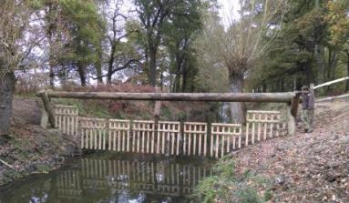
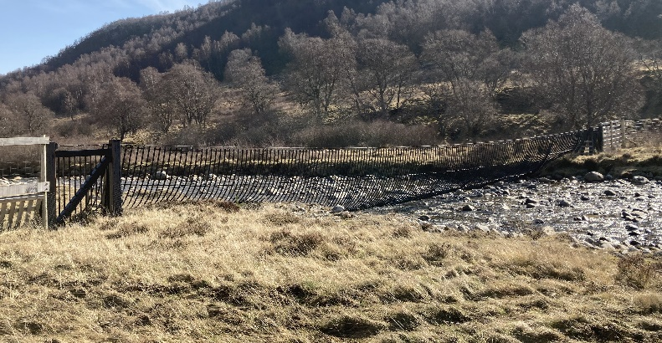
Figure 4A: Examples meeting good practice: All wiring is located above high water flow and wooden supporting posts are set back
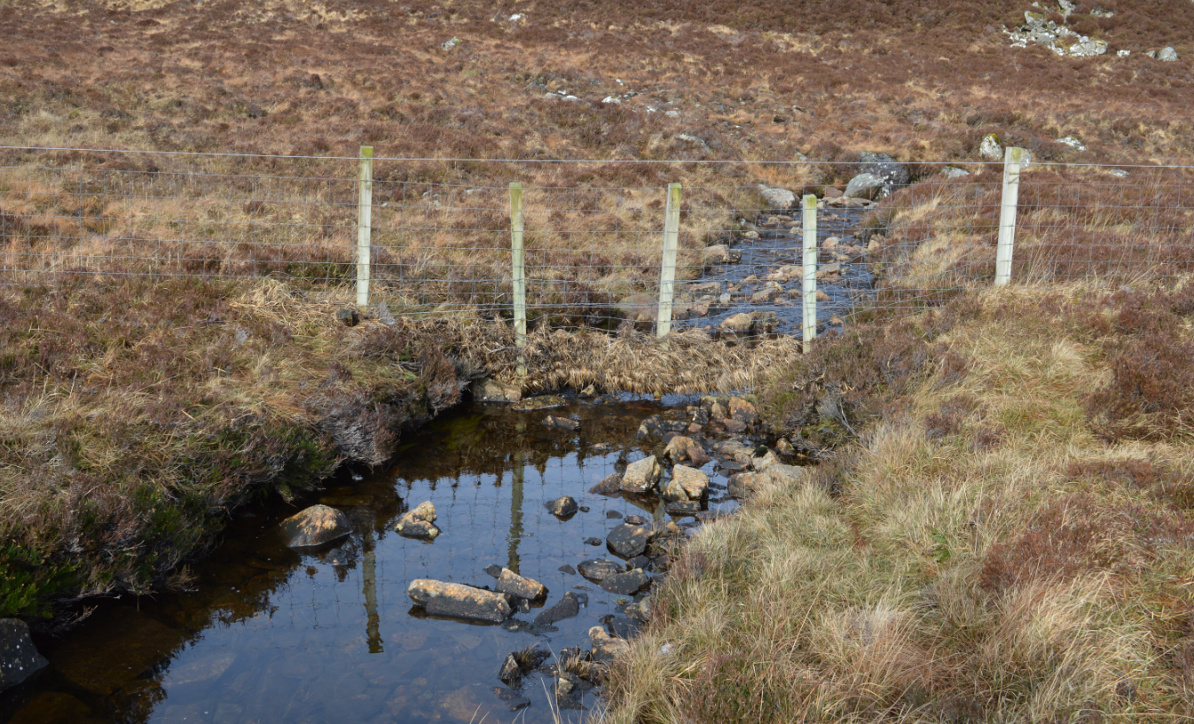
Figure 4B: Example that does not meet good practice- debris caught in wiring which is below high water flows and supporting posts are in the channel

4.4 Regulatory Position on Small Water Supply Pipes
SEPA are aware that in rural locations small water supply pipelines (abstraction systems) can be used for livestock or drinking water supply.
SEPA will not normally require an engineering authorisation for the installation of these type of small pipelines that are laid in/ across inland surface waters provided that good practice is followed (see below).
Note however that the abstraction of water from the water environment itself will always be authorised via Water General Binging Rule (GBR), registration or permit depending on the volume being abstracted.
Where laid pipes do not follow this good practice, as detailed below, or where it is not possible to lay the pipework in this way, an application for authorisation will be required. If in doubt you should discuss this with SEPA.
SEPA will not require authorisation for small water supply pipes laid in or near a watercourse when the good practice criteria below are met:
- Wherever possible, pipelines should be laid underground on land and not on the bed of a watercourse.
- If a pipeline is laid on the bed of a watercourse:
  - The construction of the abstraction system should not involve digging or installation that affects the banks or bed of the watercourse.
  - The abstraction system should use a pipe with an outside diameter of under 65mm, unless the abstraction is limited to 10 cubic metres per day by other means.
  - The abstraction system must only take water from the catchment it is placed in.
  - The abstraction system should not prevent the free passage of migratory fish.
  - The abstraction system should be maintained in a good state of repair and kept clear of debris and obstructions.
  - The abstraction system should be removed if no longer required/used.

5. Good Practice
All new and modified crossings should follow the principles of Good Practice. All permit applications must meet Good Practice to be granted.
Good Practice is achieved when the chosen option serves a demonstrated need, while minimising ecological harm, at a cost that is proportionate. Meeting Good Practice ensures that modifications to the morphology of rivers and lochs are sustainable.
To meet Good Practice the steps below should be followed.
Good Practice Summary
- Demonstrate need
- State the reasons for carrying out the activity and the benefits it will bring.
- Identify and understand the problem or need.
- Identify and appraise options
Use sustainable river management principles to:
- Identify a number of options (minimum of three, including do nothing)
- Carry out an options appraisal.
- Justify the selected option
- State why it represents the best practical environmental option.
- Use all reasonable mitigation
- State the mitigation measures you propose to minimise impacts
- Submit method statement(s) detailing how the works will be carried out.

5.1 Demonstrating need
Before undertaking any form of crossing there should be a clear and justifiable reason or need. You should also have a good understanding of the causes (including the underlying cause) and scale of the problem being addressed. You must:
- Specify the reasons for carrying out the activity and the benefits it will bring
- Identify and understand the scale and nature of any problem or need
- Demonstrate that you understand the underlying cause of any problem and have assessed its scale and significance; and
- Submit supporting evidence to support this.

5.1.1 Is there a demonstrated need?
The first step in identifying a sustainable engineering solution is to determine whether new engineering work is necessary.
The following considerations should be taken into account before deciding if a new crossing structure is required. It is essential that these considerations are taken into account in the early stages of the planning and design process.
- Can a route be chosen that minimises the number of crossings?
- Can existing structures be used?
- Can existing structures be upgraded or replaced (opportunity for environmental improvement).
Upgrading or replacing existing crossings
When upgrading or replacing an existing crossing the opportunity should be taken to improve any environmental impact the existing crossing may have. For example, fish and mammal passage can be provided if the existing crossing creates a barrier. If improving fish passage, you can contact the local district salmon fishery board and local fisheries trusts for advice, see Fisheries Management Scotland for details. They can advise on fish populations present (native as well as non-native) and any potential impacts of removing a barrier. Upgrading or replacing an existing crossing also provides the opportunity to improve the resilience of the structure especially to the effects of climate change. For example, to provide more space for the river, allow for higher flows, dissipate energy, and reduce the risk of blockage.
If an old crossing is being replaced, the old crossing should be removed rather than leaving it in place and building a new structure next to it. However, there may be exceptions to this, such as if structures need to be retained for access purposes, or if they have some historical or local significance. In such instances, Historic Environment Scotland and the local authority planning department should be consulted.
See Appendix 5 for further information on maintenance and improvement of structures

5.2 Identify and Appraise Options
It is a basic principle of good practice that when addressing any engineering problem, or need, that several options are identified and evaluated (using an options appraisal to compare the advantages and disadvantages) to determine the best solution.
In all cases we will expect you to identify and consider a minimum of three options for comparison, including doing nothing. In some instances there may be more than three possible options available.
There are three broad types of options to consider: do nothing; non-engineering options engineering options.
The key steps you should follow when considering and appraising options for crossings are:
- Consider the location and alignment of the crossing
  - avoid active river areas, particularly meander bends and depositional areas
  - make the crossing perpendicular to the river and consider flood plain issues
- Consider key site specific requirements
  - Identify ecological requirements (protected species etc) and other water users.
  - hydraulic requirements (size and capacity)
- Identify a range of options.
  - taking into account the principle of sustainable river management (see box below)
- Carry out options appraisal
  - Taking into account site specific requirements and long-term maintenance requirements.
To identify options for appraisal and help determine the best practical environmental option you should assess options against the sustainable river management principles detailed below:
Principles of sustainable river management
- address the scale, significance and underlying cause of the problem or need.
- consider the effects of climate change.
- allow the river some room to move (where feasible).
- respect channel form and processes.
- consider and minimise maintenance requirements.
- consider a range of options (i.e. modifying existing structure, non-engineering and engineering) for addressing the problem including ‘do nothing’.
- consider how it addresses the underlying cause of the problem.

The fundamental aim of sustainable river management is to design and carry out engineering in a way that works with, rather than against, river/loch processes. This helps the engineering works and the habitats to be more resilient to the changes that occur over time. A solution should be developed that strikes a balance between addressing a problem or meeting a need, and ensuring river/loch processes, and therefore habitats, are not unduly impacted. Further details on these principles can be found within our guidance WAT-G-30 EASR Guidance: Engineering: Meeting Good Practice.
The following sections provide information on selecting options for various types of crossings and aims to help you consider potential options for comparison and to aid selecting the best practical environmental option and ensure the works are a sustainable use of the water environment.

5.2.1 Location and alignment of crossings
It important to select an appropriate location for the crossing which takes into account the characteristics of the location. This is the first step in minimising:
  - The impact of the river crossing on the water environment.
  - The risk of damage to the crossing structure itself.
  - Future maintenance costs.
Key points
- Avoid crossings at active areas, particularly at meander bends.
- Avoid crossing rivers at depositional areas.
- Ensure the crossing is perpendicular to the river.
- Consider additional issues for flood plain crossings.

5.2.1.1 Channel migration/active areas
Failing to recognise the natural processes of adjustment in rivers and lochs may lead to the installation of a crossing damaging habitats and damage to or failure of the crossing structure.
Locate crossings on straight/stable sections of river. Avoid crossings in overly active areas where the channel regularly adjusts, particularly at meander bends, because there is a high risk that the structure will be damaged or fail due to river migration or localised scour. Extensive maintenance works to stabilise the structure and river may then be required, which will increase costs. Trying to stabilise a naturally dynamic river will result in long term, potentially significant, maintenance issues and may cause further impacts such as increased erosion and/or deposition upstream or downstream.
Active channels can be found in a variety of settings. Indications of an active river include:
- Signs of erosion especially on the outside of meander bends (Figures 5B and 5C)
- Depositions of unvegetated larger sediment sizes – gravel, pebble, cobble.
- Steeper river gradients (0.1 to 3 percent and above).
It can be difficult to predict how a river or loch might change over time and there are many ways in which a river may adjust. The impacts of climate change also mean that rivers are likely to change/adjust to a greater degree, more frequently and sometimes unexpectedly. If there are concerns that the river to be crossed has the potential to adjust significantly over time, then a suitably qualified geomorphologist should be consulted to assess the site and suggest appropriate mitigation measures.
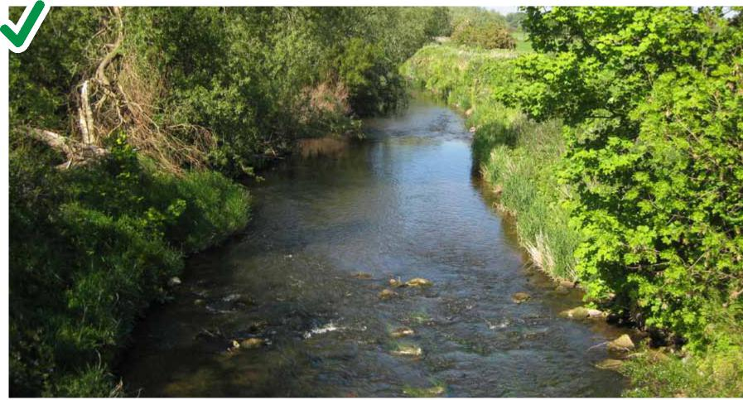
Figure 5A: Good practice, locate crossings on stable sections of a river to avoid erosion. This is an example of a straight, stable section of river, note no evidence of active erosion.
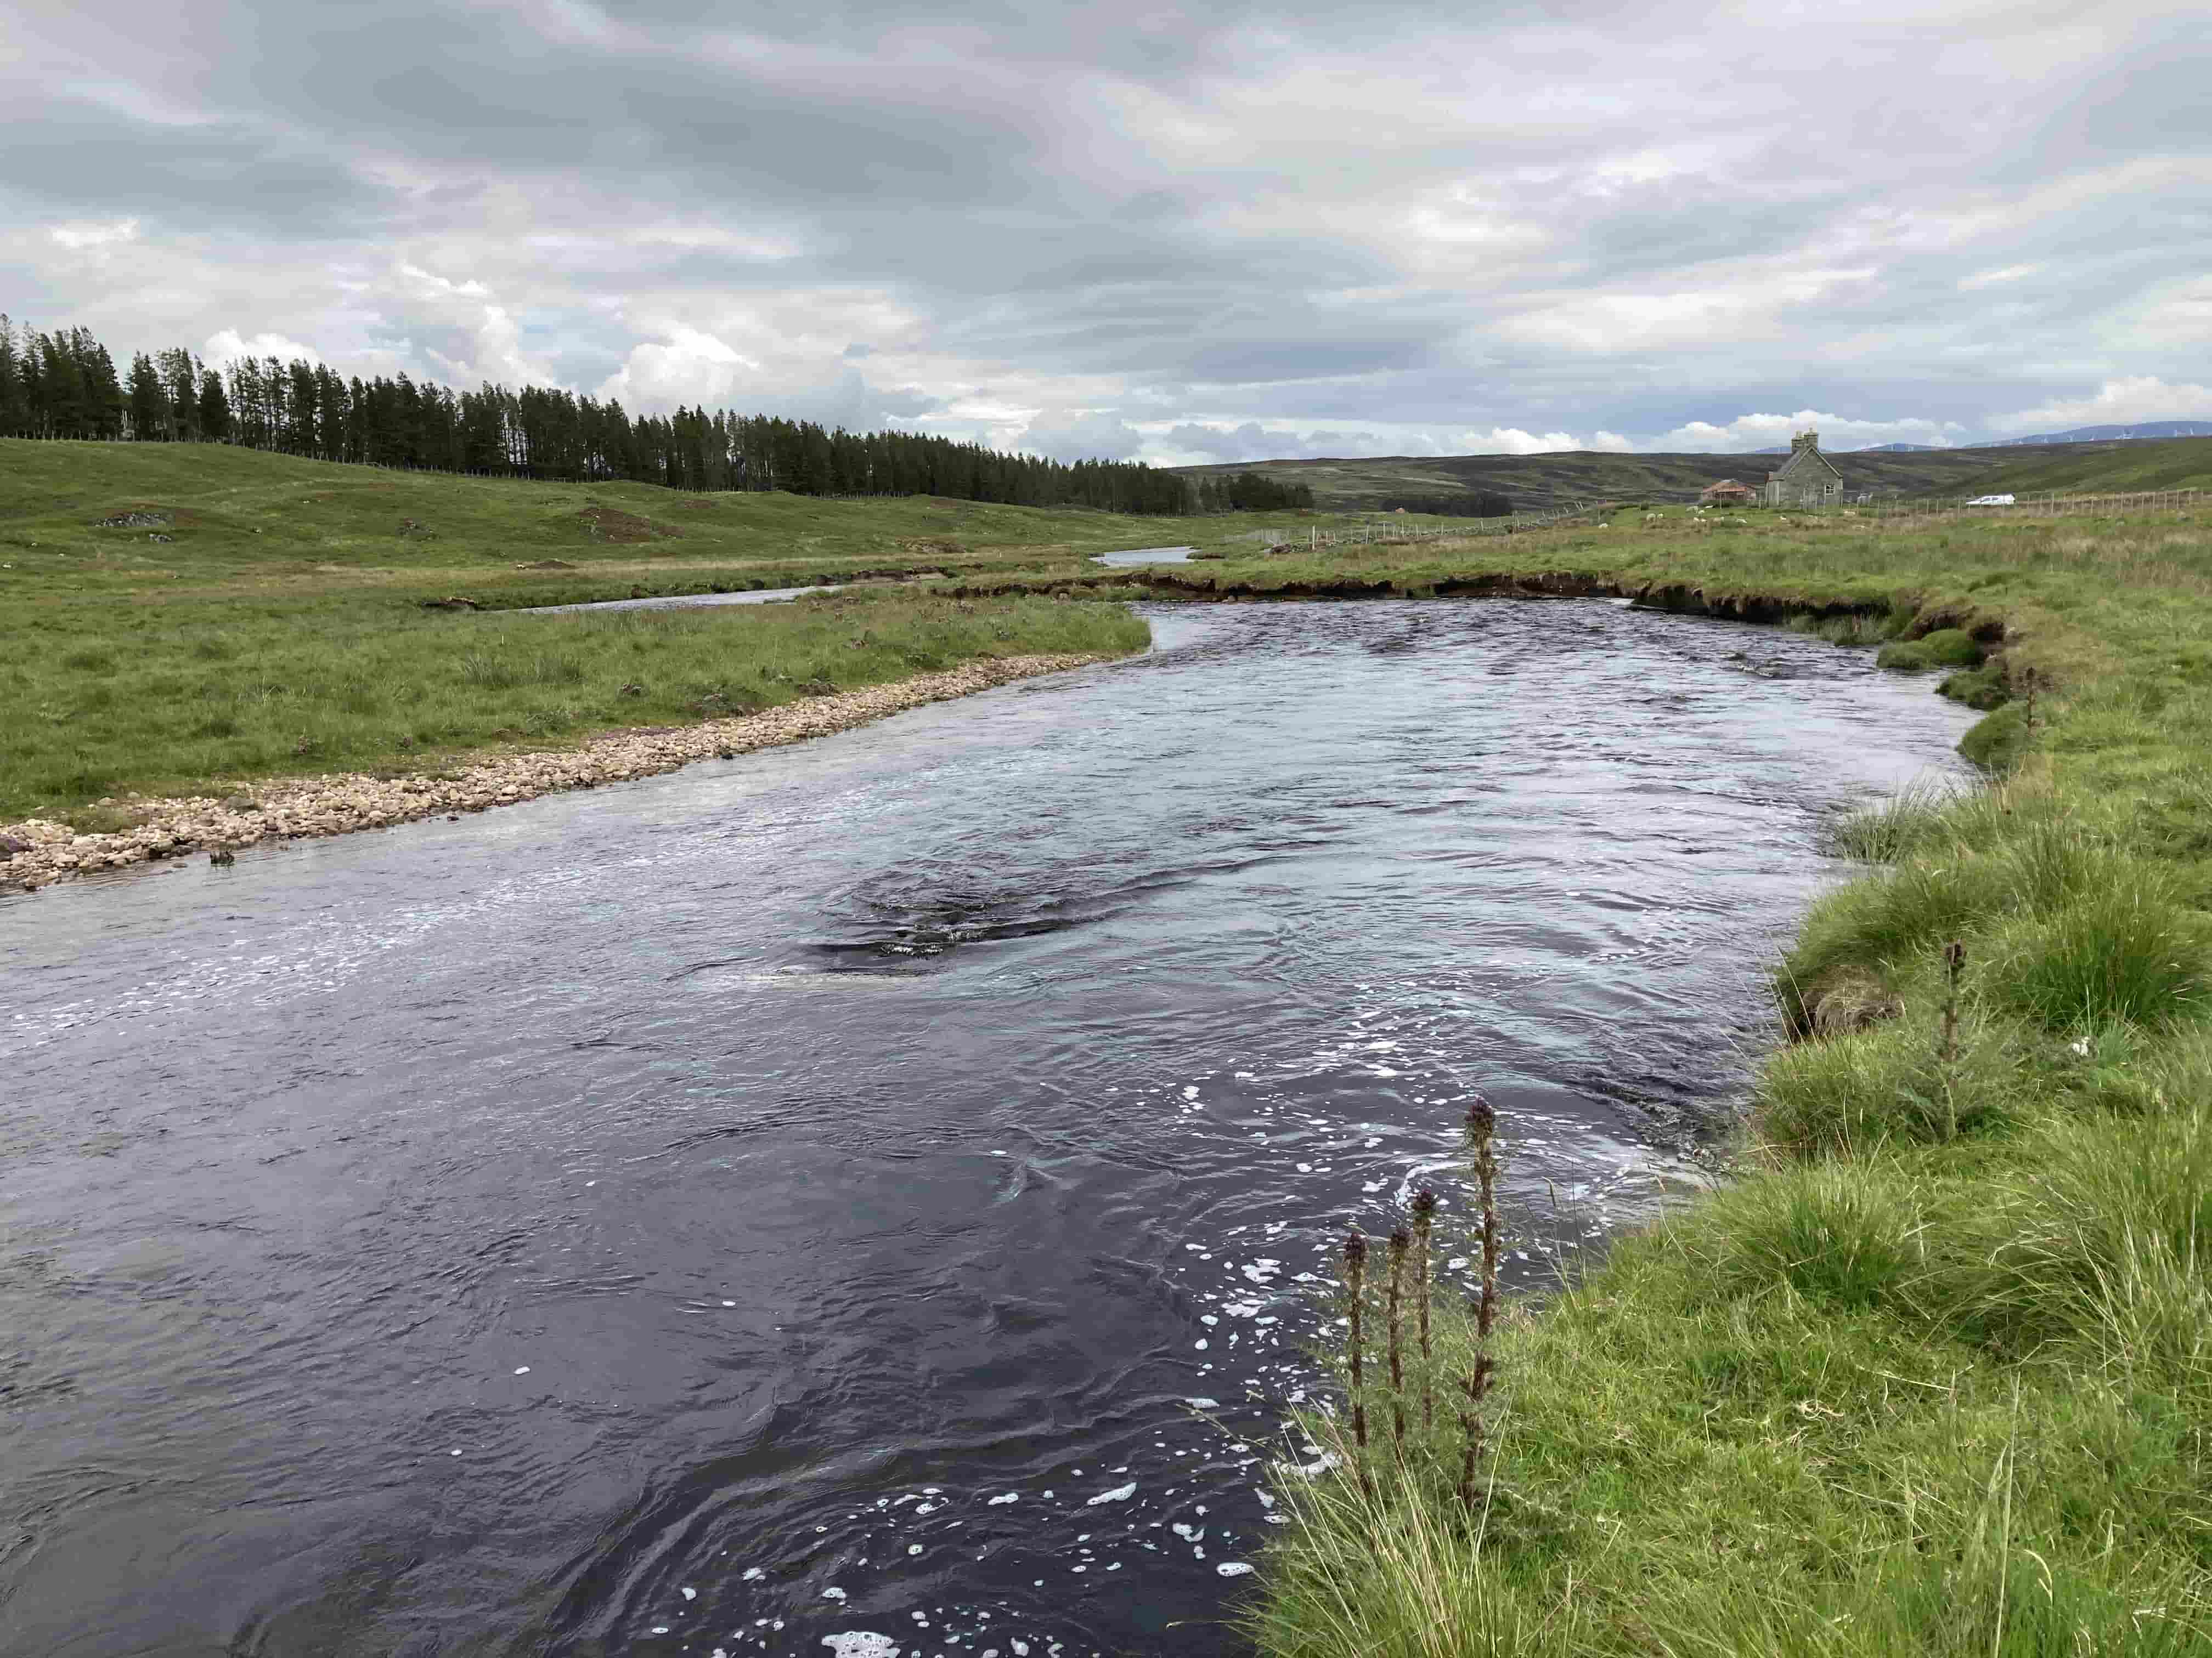
Figure 5B: Poor practice, do not locate crossings on actively eroding areas. Indicators of an active river include bank erosion on the outside of meander bends.
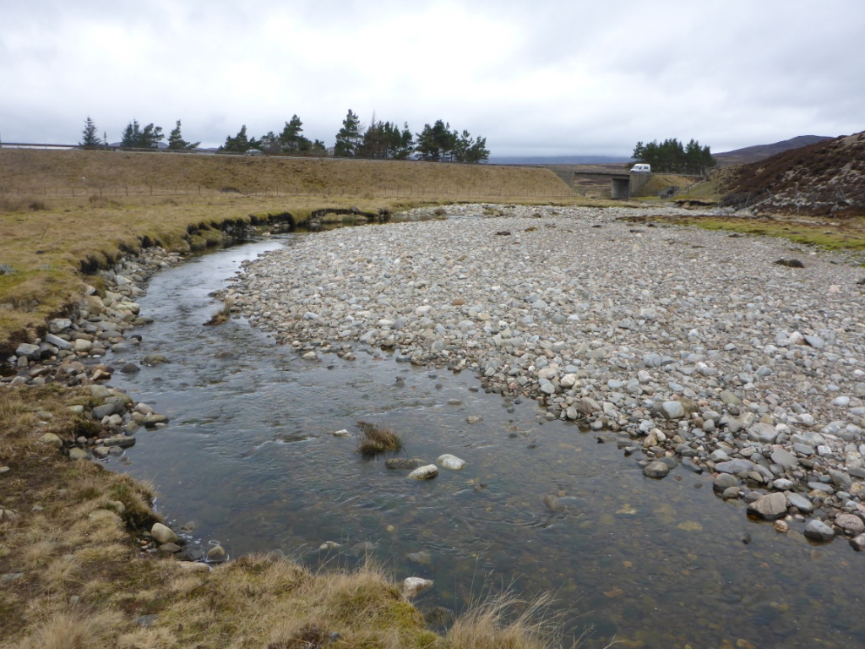
Figure 5C: Poor practice, do not locate crossings on actively eroding areas. Indicators of an active river include the presence of unvegetated sediment deposition.
5.2.1.2 Depositional areas
As rivers can carry a significant amount of sediment as well as water you should avoid crossing rivers at locations where sediment is depositing, as there is a risk that sediment will accumulate at the structure, reducing flow capacity and increasing flood risk.
Any modifications to the channel associated with installation of a crossing (e.g. over widening) could also lead to increased sediment deposition reducing flow capacity and increasing flood risk. This could lead to a need for regular dredging, which increases maintenance costs and damages the ecology of the river.
Other factors that influence deposition include valley confinement, geology, catchment hydrology, and the location and type of sediment sources.
In many rivers, deposition occurs where there is a reduction in channel slope. Lower channel slope means the river has less energy to continue the movement of sediment downstream so some or all is deposited in the channel. For example, this process frequently occurs where relatively steep tributaries with high sediment loads flow onto the relatively flat floodplain of a larger river. Large areas of deposition called alluvial fans can be formed in such locations. Deposition can also occur downstream of areas that supply large volumes of sediment such as downstream from eroding valley sides or downstream from confluences. Avoid such locations if possible.
Indicators of depositional areas include:
- Sediment deposits in rivers such as gravel bars and islands.
- A reduction in sediment size with distance downstream.
- Low channel slope or where the slope changes quickly from high to low.
If it is necessary to cross a river in a depositional zone, ask a suitably qualified geomorphologist to assess the site and suggest appropriate mitigation measures.
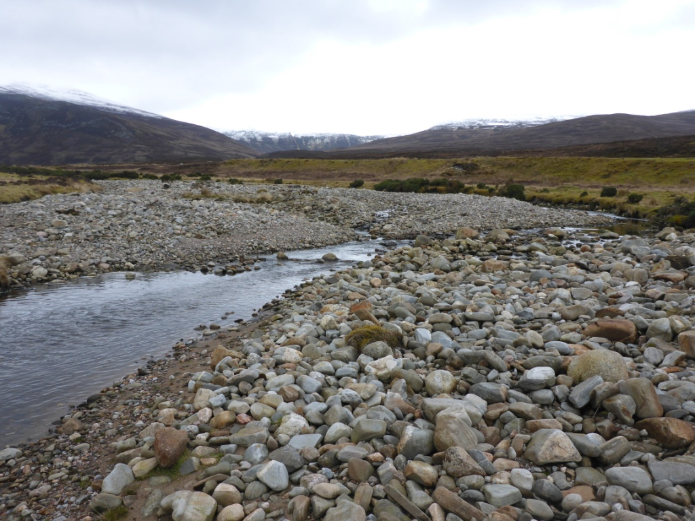
Figure 5D: Poor practice, do not locate crossings on depositional areas. Indicators of a depositional area include gravel islands and large gravel bars.

5.2.1.3 Alignment
Crossings should be perpendicular to the river (Figures 5E and 5F). This ensures that the crossing is as short as possible – reducing impact and, in some instances, cost. This also reduces the risk of localised scour at the structure.
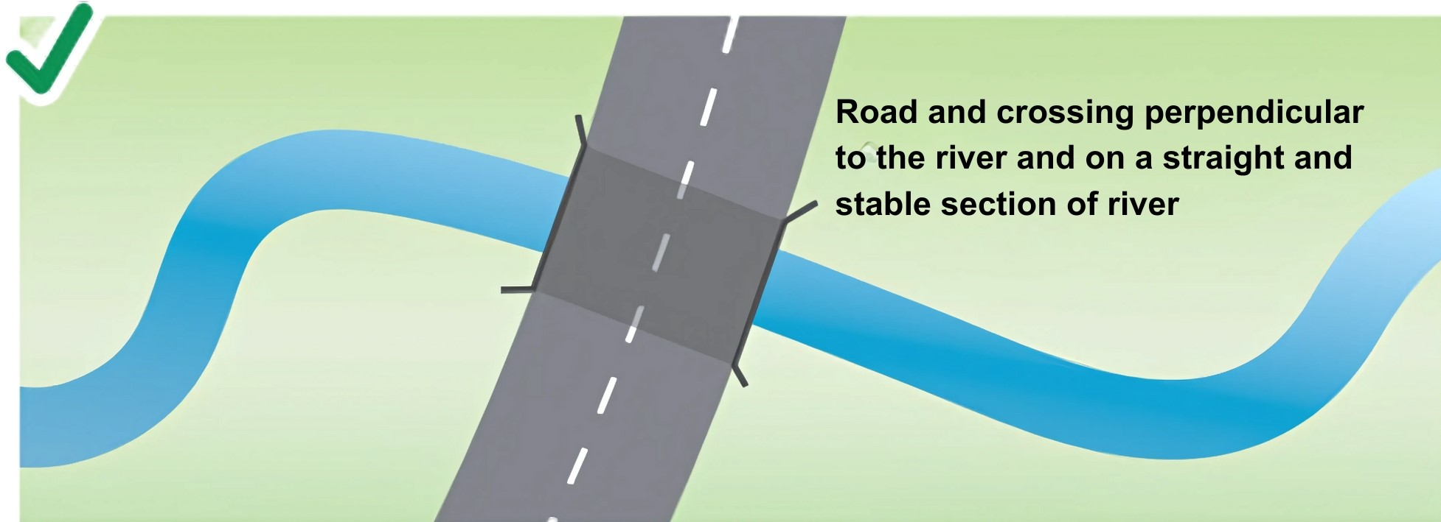
Figure 5E: Good practice location, ensure the crossing is perpendicular to river.
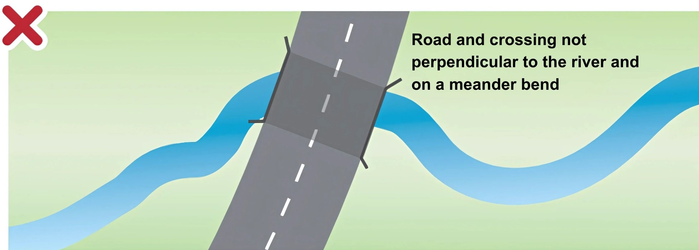
Figure 5F: Poor practice location, crossing not perpendicular to river and on a meander bend
Buried pipe or cable crossings (except small water pipes as covered in section 3.1.5) should also be perpendicular to the river. Do not use rivers as conduits for pipes or cables This can increase the risk of the pipe or cable being damaged which may lead to pollution of the watercourse and may also increase bed and bank erosion.
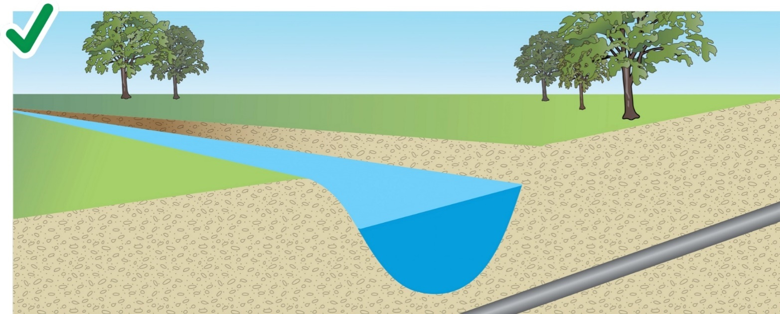
Figure 5G: Good practice, the pipe or cable should cross perpendicular to the river and should be buried below the riverbed.
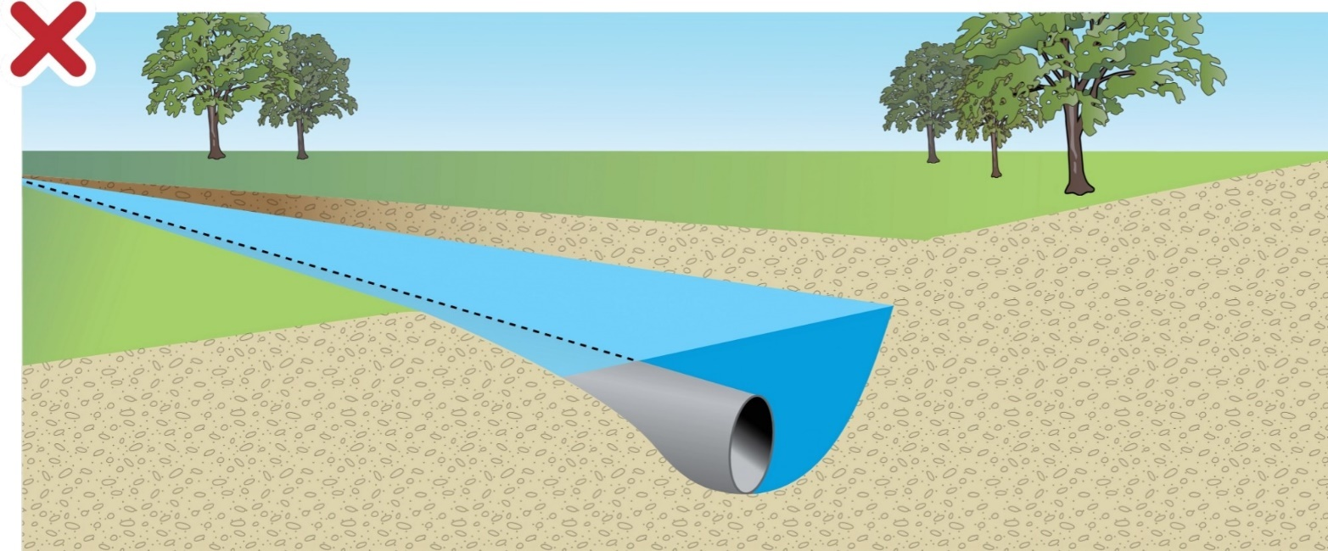
Figure 5H: Poor practice, do not lay pipes or cables on the riverbed or use rivers as conduits for pipes and cables.
If it is not possible to align the crossing perpendicular to the river then mitigation measures should be considered, including:
- Design a structure that can cope with channel migration (e.g. larger single span, additional spans with piers or viaduct structure).
- Realignment of the river should only be considered if other options are not possible. Careful consideration of the design of the new river channel is essential to ensure that it is geomorphically stable (i.e. the design does not result in increased erosion or deposition). If realignment of the watercourse is necessary, then a suitably qualified geomorphologist should be consulted to ensure the new river channel is designed appropriately.
Please refer to our guidance WAT-G-23 EASR Guidance: Engineering: Activity Guide: Channel Modifications for further information.

5.2.1.4 Crossing a floodplain
Floodplains are an important part of the river system because the spreading of high flow dissipates the energy in the main channel. Blocking floodplain flows concentrates high flows and energy in the main channel at the crossing. This significantly increases the risks of erosion causing issues at the structure, as well as upstream and downstream. Viaducts (a road deck spanning between piers) should be used to cross floodplains rather than embankments (Figure 5i). This option greatly reduces the impact on the floodplain but can have cost implications.
Where embankments are unavoidable, ‘normally dry culverts’ in embankments can be used to connect the floodplain upstream and downstream. There may be hydraulic design issues to overcome, which can result in reinforcement around the culverts to prevent scour and embankment failure during high flow events.
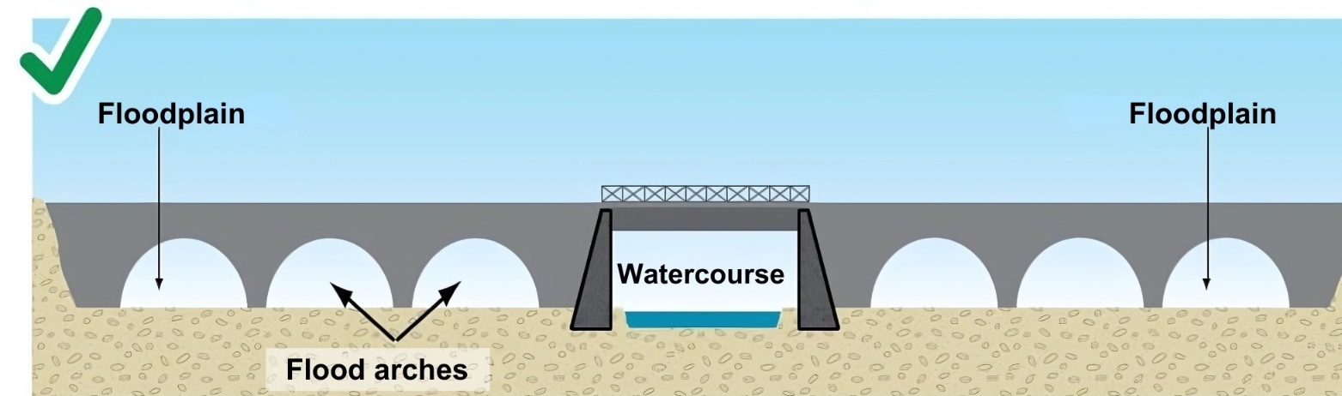
Figure 5i: Good practice, viaducts should be used to cross floodplains.

5.2.2 Site specific requirements
To carry out a thorough options appraisal, it is essential that the key requirements for a site are identified and met when assessing the options.
This could include identifying protected species, protected areas and valuable habitats; identifying water users and establishing whether this affects the design of any crossing, such as provision of mammal ledges etc), and to identify the hydrological requirements (size and capacity) required.

5.2.2.1 Identify the ecological requirements
You should identify:
- Any protected areas (such as SSSI SAC, SPA)
- Relevant protected species that are present such as freshwater pearl mussel, Atlantic salmon, lamprey and otter etc. Where these are present you should consult NatureScot for advice.
- Identify important habitats (e.g. fish spawning and rearing areas) and ensure they are not damaged.
These may all affect your designs, methods and timings of construction.

5.2.2.2 Other users of the river
Identify other users of the river and ensure the design does not affect the use (e.g. if the river is used for navigation, canoeing or rafting, ensure the structure design allows this to continue safely and unaffected).

5.2.2.3 Size and capacity of crossing
The hydraulic capacity of crossing structures will vary depending on the location of the crossing and the purpose the crossing infrastructure serves. Requirements must be discussed with the relevant organisations.
If crossing structures require planning permission, they should conform to Scottish Planning Policy. This states that no new development should increase the probability of flooding elsewhere.
Further information on flooding and the different responsibilities in relation to flooding can be found on our website at: Flooding
If a crossing is in an urban area, close to other development, close to or will affect a trunk road or will be adopted by the roads authority (this will be the Local Authority or Transport Scotland for trunk roads) then the relevant roads authority must be contacted to advise on hydraulic capacity and other requirements.
Consider the amount of freeboard that is required e.g. to aide passage of floating debris including large pieces of wood (whole trees, branches etc) and other water uses e.g. navigation and recreation.
Remember sediment moves down rivers as well as water, especially during high flows. Allowance for maintaining a natural bed of sediment and sediment transport during high flows should be taken into account when assessing capacity and the required size of structure.
These considerations must be taken into account in the early stages of the planning and design process.
For further information on hydraulic capacity of structures see:
CIRIA Culvert, Screen and Outfall Manual (C786) www.ciria.org
Highways Agency Design Manual for Roads and Bridges, CD 529 - Design of outfall and culvert details www.standardsforhighways.co.uk/dmrb

5.2.3 Identify Options
As previously covered, there are 5 broad types of crossing.
- Single span structures
- Span structures with in-stream supports
- Closed culverts
- Fords
- Pipe or cables crossings
Each type of crossing can be constructed in a variety of different forms. Typical examples of these different forms are outlined below, these are listed in a generally increasing order of potential morphological and ecological impacts.
As the nature of a problem or need for installing a crossing is varied and site specific, we cannot detail all possible solutions here. The key is to ensure impacts are minimised and mitigated as far as possible.
To help choose the most suitable option, details on each crossing type are set out below and in the supporting Appendices. Remember the option chosen should meet all the key site specific requirements identified (see Section 5.2.2).

5.2.3.1 Single Span Structures
Structures that span the width of the channel with no in-stream support and do not affect the bed of the river, i.e. they have no artificial invert and a natural bed is maintained. Bank habitat can be maintained under the crossing if abutments are set back.
They can come in a variety of forms from pre-cast concrete structures (arch or portal [rectangular]), panel bridges that come in prefabricated sections to bridges designed for site specific requirements. Some prefabricated structures require foundations to be constructed at the site and others can have prefabricated foundations.
Key Points Single Span Structures
- Crossing type generally with lowest impact
- May not be suitable for very wide rivers
- Bank habitat can be maintained under the crossing if abutments are set back
- Minimal disturbance to the river during the construction phase if abutments are set back
- Low risk of causing a barrier to fish and other wildlife if designed appropriately.
- Lower risk of disrupting navigation or recreation if designed appropriately.
- Prefabricated structures are generally cheaper than a site-specific design
- Span structures can take longer to install and may be more expensive than other crossing types as specialist construction techniques may be required.
- Can be used to carry pipe or cables across watercourses
- Single span bridge with abutments setback from the channel
This construction does not require any modification to the channel bed and the abutments are at or setback from the bank tops. Once completed, there will be no part of the structure on the bed or banks of the channel.
This can include pipelines or cables that cross the river using this technique
These are the preferred type of crossing as they have the lowest impact on river systems. Bank habitats can be maintained under the crossing and there can be minimal disturbance to the river if abutments are setback. In general, the further abutments are setback, the lower the risk of impacts to morphological processes and ecology. The risk of causing a barrier to fish, other aquatic and terrestrial ecology, sediment and floating debris is low. These may not be suitable for wide rivers.
- Arch or portal culvert
The culvert does not have an artificial base (invert), and the culvert walls sit on foundations that are setback from the banks.
The main advantage of these structures is that they can be installed without disturbing the bed and banks. The key difference between them and bridges is that the culvert walls and soffit are likely to be closer to the channel. This means that there is increased risk of high flow funnelling that will apply greater hydraulic forces to the bed and banks. For this reason, these structures should be designed to minimise high flow funnelling by setting back foundations as far as possible. The further foundations are setback, the less impact there will be on the channel.
Where the culvert walls are within the bank zone, foundations will be close to the bank toe or extend under the channel bed, so extensive disturbance of the bed and banks would be required during construction. Even with careful reinstatement of the bed and banks, this can often still lead to post construction instability (erosion) due to the funnelling of high flows and loss of bankside habitat. This scenario would therefore be considered significantly higher impact than if the foundations were setback and a similar or higher impact than a single span bridge with abutments on the bank. Where this is unavoidable, the disturbed bed & banks must be reinstated appropriately and this will require the input of a geomorphological specialist. Note that any significant changes to the channel bed such as introduction of larger bed material or the introduction of step-pool bed forms would be considered as a separate activity.
- Single span bridge with abutments between the bank toe and bank top
This includes pipelines or cables that cross the river using this technique
These structures have a higher impact because the bankside habitat is lost, and high flow forces are focussed on the channel bed because the abutments do not allow flow to spread out as water level rises. This can lead to changes in the morphological behaviour of the channel e.g. increased scour (erosion). During construction, excavation of the banks will be needed and it may also be necessary to excavate the bed to form the foundations. The disturbed bed & banks must be reinstated appropriately, and this will require the input of a geomorphological specialist. Note that any significant changes to the channel bed such as introduction of larger bed material or the introduction of step-pool bed forms would be considered as a separate activity.
Further good practice advice on single span crossing is provided in Appendix 1

5.2.3.2. Span Structures with in-stream support
This includes pipelines or cables that cross the river using this technique
In-stream supports (piers) can be used to increase the crossing width where single span is not possible or prohibitively expensive. As well as the impacts outlined for span structures above, the introduction of one or more in-stream supports introduces further potential risk of impact. Whilst avoiding the need for in-stream support structures would generally be considered a better option, it may be the case that the combination of using an in-stream structure and setting back abutments is overall better than a single span with abutments very close to the channel. This would require case-by-case assessment.
In-stream supports will require potentially significant disturbance of the bed during construction. The changes in hydraulics caused by the in-stream supports can also cause longer term changes to riverbed and channel morphology more generally following construction. Patterns of erosion and deposition may be altered locally and potentially spread upstream and downstream. Foundations for supports will typically need to be very deep to avoid structural issues associated with scour.
In-stream supports also introduce a higher risk of blockage by debris.
Key points: Spanned Structures with Instream Supports
- Crossing type with generally moderate impact
- Only appropriate where in-stream support is necessary to ensure structural integrity (i.e. very wide rivers).
- Bank habitat can be maintained under the crossing if abutments are set back.
- Low risk of causing a barrier to fish and other wildlife if designed appropriately.
- Careful consideration required if river is used for navigation or recreation.
- Higher risk of causing damage to the river during the construction phase (requires work in the riverbed).
- In-stream supports can significantly affect local channel hydraulics, increasing the risk of alteration to patterns of sediment transport, erosion and deposition.
- Higher risk of blockage by debris.
- Span structures with in-stream supports can take longer to install and may be more expensive than other crossing types as specialist construction techniques may be required.
- Can be used to carry pipe or cables across watercourses
Further good practice advice on spanned structures with instream supports is provided in Appendix 1

5.2.3.3 Closed Culverts
Closed culverts have an artificial invert (floor) and so have a greater impact on the bed and banks of the river. They can be made from a variety of materials and come in a range of shapes (e.g. pipe, box, closed arch) and sizes.
The installation of a closed culvert will cause significant disruption to the riverbed and, if not designed correctly, can be a barrier to fish migration and adversely affect sediment transportation. However, with a good design they can be constructed to retain natural bed materials to not hinder fish migration and allow the natural downstream movement of sediment
SEPA has a regulatory position on the culverting watercourses.
Key Points Closed Culverts
High Impact
- Only suitable for small streams in lowland rivers
- Higher risk of causing a barrier to fish and other wildlife passage.
- Higher risk of causing damage to the river during the construction phase (requires work in the riverbed)
- May not be suitable if river is used for navigation or recreation
- Higher risk of blockage by debris
- Culverts are generally cheaper than span structures because the design and construction process is generally less complex than for spanning structures.
- Not suitable for carrying pipelines or cables across rivers.
- Closed Box culvert (which retains natural bed materials)
A box culvert has a rectangular or square shape typically made from reinforced concrete. A box culvert is usually constructed using several pre-cast short culvert units (typically up to 2m long) joined together. For wider channels or to create two-stage channels, box culverts can also be laid side by side. The internal shape of the culvert can be moulded to form ledges, benches or ribs to aid mammal passage or retain sediment.
Installing a box culvert involves excavation of the channel bed and banks to form a foundation onto which the box culvert units are lowered and assembled. Once installed, suitable substrate is placed on top to form a flat surface for the crossing.
The base of a box culvert should normally be placed below the existing bed level of the watercourse such that a layer of natural bed material can be retained through the culvert.
The impacts of box culverts include
- Loss of bank habitat as the culvert walls are typically vertical concrete walls
- Simplification of channel planform as the culvert is usually straight
- Disruption and simplification of the channel bed as it is dug out and replaced
- Alteration of flow patterns and velocities. Increased velocities can result in erosion of natural bed material placed within the culvert. Abrupt changes in velocity at the inlet and outlet can cause significant scour creating steps in the channel bed and undermining of the structure. Decreases in velocity can result in excessive deposition of sediment in the culvert reducing flow capacity and creating maintenance issues.
- Closed Pipe culvert with natural bed
A pipe culvert is circular in shape and typically made from plastic, reinforced concrete or metal. A culvert is typically constructed using several shorter lengths of pipe (e.g. 6m long) joined together. For wider channels or to create two-stage channels, pipe culverts can also be laid side by side. Pipe culverts placed at a higher level than the watercourse can be used as mammal passes. Installation of baffles and ledges in pipes can be more difficult than in boxes due to the curvature of the internal surface.
Installing a pipe culvert involves excavation of the channel bed and banks to form a foundation onto which the pipe culvert lengths are lowered and assembled. Once installed, suitable substrate is placed on top to form a flat surface for the crossing.
The base of a pipe culvert should normally be placed below the existing bed level of the watercourse such that a layer of natural bed material can be retained through the culvert. Due to the shape of a pipe, it can sometimes be necessary to bury the base quite deep to create a bed through the pipe that is as wide as the watercourse upstream and downstream. This may mean that a large pipe is required to allow for the depth of bed material, flow capacity and freeboard.
The impacts of pipe culverts include
- Loss of bank habitat as the culvert walls are typically curved plastic, concrete or metal
- Simplification of channel planform as the culvert is usually straight
- Disruption and simplification of the channel bed as it is dug out and replaced
- Alteration of flow patterns and velocities. Increased velocities can result in erosion of natural bed material placed within the culvert. Abrupt changes in velocity at the inlet and outlet can cause significant scour creating steps in the channel bed and undermining of the structure. Pipes are more likely to increase velocities than boxes due to the curved internal shape which reduces width as water level rises above the centre. Decreases in velocity can result in excessive deposition of sediment in the culvert reducing flow capacity and creating maintenance issues.
Further Good Practice advice on Closed culverts is provided in Appendix 2

5.2.3.4 Fords
Fords are river or loch crossings that are situated on the bed. They may be informal with no construction on the bed/banks or formally constructed and reinforced with artificial material. The impacts of a ford can vary depending on things like the river type, the degree of works required and the type and frequency of usage.
Fords can harm the environment if they are not properly located, designed or installed. They can destroy habitats, impact aquatic species (loss of invertebrate and fish spawning grounds etc) and can impede fish migration and sediment transport. Vehicles and equipment crossing fords can cause pollution and siltation, and there is also a risk of spreading invasive non native species.
SEPA has a regulatory position on fords.
Key Points Fords
- Crossing type with low to -high impact (depending on type, river type and frequency of use)
- Only suitable if infrequent crossing is expected
- Should not be used where there is a high risk of pollution e.g. at construction sites
- Higher risk of pollution from surface water runoff and increased bed and bank erosion.
- Moderate risk of creating a barrier to fish passage.
- Risk of damaging fish spawning habitat.
- A low-cost solution
- Fords with natural bed material
The impacts should be minimal if they are located on a stable section of river, that requires little or no manipulation of the natural bed material to maintain a flat crossing, and it is used infrequently especially by heavy vehicles/machinery. The channel bed should also have a low fine sediment content i.e. predominantly be large gravel, cobble, boulder or bedrock.
Maintaining the natural bed minimises alteration to flow patterns and allows natural sediment transport processes to continue largely unaltered.
The impacts will be higher when created in less stable locations i.e. where there is natural regular adjustment of the bed or banks. In such situations it is very likely that regular manipulation of the natural riverbed will be required to maintain a flat crossing. This will impact more on flow patterns and sediment transport processes leading to increased instability upstream and downstream that ultimately may render the ford unusable. Note that manipulation of the riverbed will require separate authorisation as a sediment management activity.
If the ford is frequently used and/or the vehicles/machinery using the ford are heavy, this can increase impacts such as compaction of the riverbed, alteration of flow patterns, pollution, siltation and spread of invasive non-native species.
Ideally, the banks at a ford should be left unaltered to minimise impact on bankside habitats. Where reprofiling is necessary to facilitate access, this can lead to increased bank erosion and/or be a focal point for silt runoff from the road/track and surrounding land during heavy rainfall. Reprofiling and/or reinforcement of the banks increases impacts on bankside habitats.
- Fords with reinforced bed at riverbed level
It is expected that any reinforcement used on the bed will be laid at or below bed level. Reinforcement that is raised above bed level (e.g. a pipe bridge) is likely to have a significantly higher impact on flow patterns, sediment transport and the movement of aquatic ecology including fish. Even where reinforcement is at bed level, this can result in the loss of natural bed material and the destruction of riverbed habitats. It is also likely to alter flow patterns and sediment transport processes. This could cause scour of the bed downstream resulting in a hydraulic drop/step on the riverbed that can impact fish passage and undermine the reinforcement. The altered flow patterns could also result in bank erosion which would damage bankside habitats, introduce sediment downstream and could result in outflanking of the ford making it unusable.
Further Good Practice advice on fords is provided in Appendix 3

5.2.3.5 Pipeline/cable crossings:
Where possible, pipelines or cables should be buried well below the river /loch bed and use minimal disruptive techniques such a directional drilling. Bear in mind that pipelines and cables can also span over a river using a span structure which can be lower impact than the other techniques set out below.
Key Points:
- Crossing type with minimal impact (e.g. when buried) to high impact (depending on design and method of construction)
- Pipelines or cables can be carried above rivers using a single span bridging structure or span structure with in-steam supports.
- If they are not bridged over a river, they should be buried below the bed of the river and should not be laid in the channel.
- Depending on the construction technique there may be a high risk of causing damage to the water environment during the construction phase.
- Burying below the channel should be suitable for all types of rivers but may depend on ground conditions
- Buried below bed: directional drilling
This technique can be used to install pipes or cables by drilling from a location setback from the river or loch down and under the river or loch then back up to a location on the opposite side. This does not disturb the bed or banks of the river or loch and minimises the potential environmental impacts.
- Buried below bed: Isolated open cut
This technique involves excavating the bed and banks of a river or loch to install a pipe or cable below the bed. The excavated area is isolated from the water such that it is kept dry. This can include the use of cofferdams and/or overpumping. Once the pipe or cable is installed, the bed and banks are re-instated to their original condition, so operational impacts should be minimal.
- Buried below bed: Direct open cut
This technique is similar to isolated open cut, but the excavation is not isolated from the water. This means that there will be a lot more disruption during construction with significantly increased risks of pollution, siltation and harm to aquatic ecology. Once the pipeline or cable is installed the bed and banks are re-instated to their original condition however this will be a lot more challenging than if the excavation was isolated. Assuming good reinstatement can be achieved, the operational impact should be minimal.
Mole ploughing is a form of open cut pipe/cable laying where a plough attachment on a tractor or excavator is used to simultaneously cut a furrow and lay the pipe/cable in the trench. The furrow typically backfills automatically after the plough passes through however the ground surface will usually be lifted slightly above the previous level. Mole ploughing usually involves plant and machinery crossing a flowing watercourse so is liable to similar impacts to direct open cut. It is also typically only feasible in soft ground and on smaller watercourses.
- Pipeline/cable laid on riverbed
With the exception of small water pipes/cables as outlined in our Regulatory Position on small water supply pipe, laying pipes or cables on the bed of a river or loch is not viewed as good practice and will not be routinely authorised. While the pipe/cable could have significant impacts on sediment transport, erosion and deposition patterns which may extend beyond the site, the pipe/cable will likely be subject to damage by hydraulic forces and sediment impact. The scale of impact will clearly depend on the size and orientation of the pipe/cable and the morphology of the river affected.
Further Good Practice advice on pipe and cable crossings is provided in Appendix 4

5.2.4 Options Appraisal
The options appraisal should include:
- Comparison of at least 3 options (including doing nothing).
- Costs (including capital, construction and maintenance costs).
- Feasibility of construction.
- How well it addresses the problem or need and whether it tackles the underlying cause.
- Maintenance requirements.
- Impacts upon physical river attributes (morphology).
  - Channel form, allow the river room, riparian areas, sediment movement etc.
- Impacts on ecology.
  - Fish, other aquatic and riparian wildlife; and
  - Impacts on conservation designations, important species and habitat features.
- Impacts on other users of the water environment (such as angling, kayaking etc).
The cost evaluation should assess whether the costs for each option are proportionate.
The suitability of the best option will always depend on the needs and the details of each situation. In some cases, you may need to implement a variety of methods to address the problem or need.

5.3 Justify the selected option
After evaluating all the alternatives, the best practical and environmental option, with proportionate costs, should be chosen and justification provided.
This does not always mean adopting a lowest impact engineering approach or adopting the cheapest solution. The best practical environmental option means choosing the approach that effectively addresses the problem or need and minimises negative environmental impact as far as practical.
Proportionate costs are those that correspond to the level of environmental harm being minimised or the environmental benefits that the option provides.
Large absolute cost in itself does not constitute disproportionate cost.
For example, incurring significant costs to prevent significant environmental harm or achieve significant environmental benefits e.g. safeguarding protected species and designated sites, is likely to be considered proportionate. But incurring significant costs for minor environmental benefits would likely to be considered disproportionate
The reason for choosing your option may be a single factor or for multiple reasons. These should be made clear so we can assess whether Good Practice has been met.

5.3.1 Possible justifications for your chosen option
Some possible justifications for your chosen option are detailed below.
Channel Form
Channel type may help determine the most suitable crossing structure to use. Natural, un-modified channels are a particular shape for a good reason. They represent a long-term balance between the forces of water flowing downhill and resistance caused by sediment and vegetation. Any project that significantly alters channel form (i.e. width, depth, slope, planform) will affect the natural balance in the river with consequences for erosion and deposition of sediment. Options which accommodate natural river form and minimise alteration of flow and sediment transport patterns are encouraged.
Environmental Benefits
Justification for a chosen method could be related to the environmental benefits it creates or how it minimises environmental disruption. For example, the selected option may create/improve/retain habitat for terrestrial and aquatic wildlife, have no impacts on fish passage or other wildlife, improve water quality or increase climate resilience.
How well it addresses the problem or need
The chosen option may be the one which addresses the overall problem or need whilst minimising adverse impacts
Economic Savings
A long-term economic saving would be realised by a reduction in whole life costs. For example, the selected structure and design works with, rather than against, river processes such that it provides resilience to changes in patterns of flow and sediment transport as a result of climate change. This could both reduce the overall costs of repairing or replacing the structure and/or damage or disruption to adjacent infrastructure while also reducing environmental damage that would require remediation.
Costs
Whilst low environmental impact options are preferred, we recognise that the costs for a chosen option must be proportionate for the situation. Where an option with lower environmental impacts has been rejected due to financial cost you must provide details.
Feasibility of construction
In certain cases, for example where access is very limited or ground conditions are difficult, this may rule out lower impact approaches and mean that a higher impact structure is necessary.
Maintenance
How often will a structure have to be inspected, maintained, repaired or replaced? Structures that work against natural processes often result in high maintenance requirements. This in turn increases interventions, impacts and damage to the environment. A project which takes account of natural processes such as flow and sediment transport patterns could avoid or reduce the requirements for maintenance.
Aesthetic and Recreational Value/ Impacts on other water users
The preferred structure and/or design may be related to the appearance of the crossing and/or for a particular project requirement such as public access, angling, connection between agricultural land or infrastructure needs.
Health and Safety
The chosen structure and/or design may be necessary for the health and safety of people undertaking construction or accessing the structure for inspection and maintenance works.

5.4 Use all reasonable mitigation
To minimise impacts on the water environment and other water users you must plan to use all reasonable mitigation when carrying out any engineering works.
Key Points
- Design structure in accordance with good practice to limit impacts
- All reasonable mitigation should be used to prevent or minimise construction and operation impacts
  - such as damage or unnecessary alteration to the bed and banks, pollution, harm to fish and other wildlife, spread of invasive species and disruption to other water users.
- Method statements should be prepared to demonstrate how the works will be carried and what mitigation will be used.

Mitigation measures for a proposal should:
- Limit, or offset, potential impacts from both the construction and operation of the activity.
- Be proportionate to the environmental risk.
- Be prioritised by the balance of factors such as environmental benefit, cost, and ease of implementation.
- Not be used to compensate for the impacts of an unjustified activity
As every case is different there is no single answer to what type of mitigation is considered reasonable. Assessment of mitigation should be carried out on a case-by-case basis.
You should understand the risks and issues.as set out in section 3.3
A method statement should be submitted including details on how you intend to carry out the works including the mitigation measures you intend to take and how you will maintain them. Details can be found in our section 5.2 of our guidance WAT-G-030 EASR Guidance Engineering Meeting Good Practice.
Using suitable mitigation will help you to comply with Permit conditions. In certain cases, specific conditions relating to mitigation requirements will be specified within the Permit.
Further guidance is available in our in WAT-G-034 EASR Guidance: Construction works and silt/pollution mitigation.

Post Works Monitoring
After your engineering works have been completed, you should undertake post-project appraisal to help identify any problems that need to be investigated and addressed (e.g. post construction snagging issues and emerging issues) and to monitor how well the works address the original problem or need
It’s especially important to check the works after the first moderate to high flow events to see how they have coped and whether any issues have emerged or are at risk of emerging. This can include issues such as:
- Damage to restored bed and banks.
- Defective installation or materials (e.g. movement of the structure)
- New erosion of banks upstream or downstream that could threaten the integrity of the structure/infrastructure and damage habitats.
- New erosion of the bed or changes in sediment transport patterns upstream, downstream or through the structure that could threaten the integrity of the structure or cause issues with fish passage.

6.1 Post project appraisal and site management
Frequent inspection and maintenance of a crossing is required to ensure that any damage can be repaired before it progresses to a more significant failure. The following points summarise the suggested appraisal methods:
All projects should be inspected at reasonable intervals and at least annually. New projects should be inspected as soon as possible after the first significant high flow.
Photos of the works should be taken periodically at established points. Photos should be taken at least twice a year, ideally in the spring and autumn (when vegetation is low) to capture any changes due to winter high flows. To allow comparisons between repeated photographs, they should be taken during low water periods and at corresponding water levels. If it is safe to do so, you may wish to take extra photographs during higher flows to record the performance of the engineering.
The development of any vegetation planted as part of any mitigation efforts should be monitored to assess its effectiveness roughly once per growing season (preferably near the end of summer) for at least three consecutive years.

Appendix 1 Good practice design: single span structures and span structures with in-stream supports
The principles below should be followed for all types of single span structures and span structures with in-stream supports.
Minimise the potential for localised bed and bank erosion (scour) or excessive sediment deposition at the crossing structure through careful consideration of the location and alignment as discussed in Section 5.2.1.
Set abutments back from the river channel and banks to allow the continuation of the riparian corridor underneath the structure. This helps to minimise or prevent the need for bed and bank reinforcement, reduces the risk of creating a barrier to fish passage and allows mammal passage under the structure (see Figures A1A, A1B and A1C).
Make the distance between the bridge abutments as wide as possible and maintain the bank habitat, maximising the riparian corridor, allowing the river some space to move and providing high flow spread to dissipate energy.
Ensure the natural channel width is maintained and provide mammal passage if bank habitat cannot be retained and abutments cannot be set back.
Bury foundations (of abutments and in-stream piers) deep enough to minimise or prevent the need for bed or bank reinforcement or bridge weirs or aprons. This maintains the natural bed material and bed levels, protecting habitat and allowing fish passage (Figures A1A and A1C). The foundations should be buried deep enough to allow for scour during high flows, including consideration of climate change. A suitably qualified engineer or geomorphologist should be consulted to advise on an appropriate depth.
Design any structure that includes in-stream piers to facilitate the passage of floating debris.
Consider requirements for bed and bank reinforcement only if the risk of erosion cannot reasonably be eliminated through the above measures. Design such measures to help dissipate energy rather than transfer it to another part of the channel.
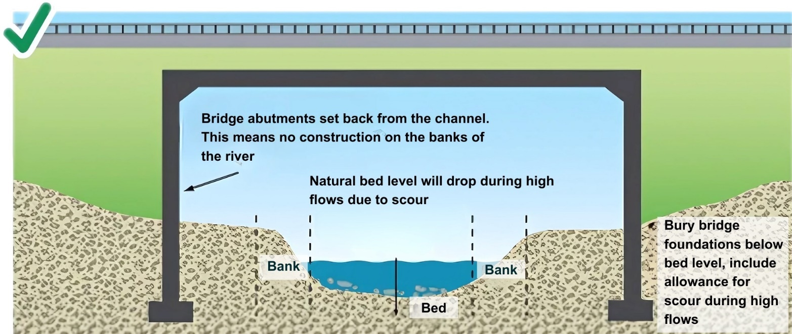
Figure A1A: Good practice, pre-cast span structure showing set back abutments and deep foundations
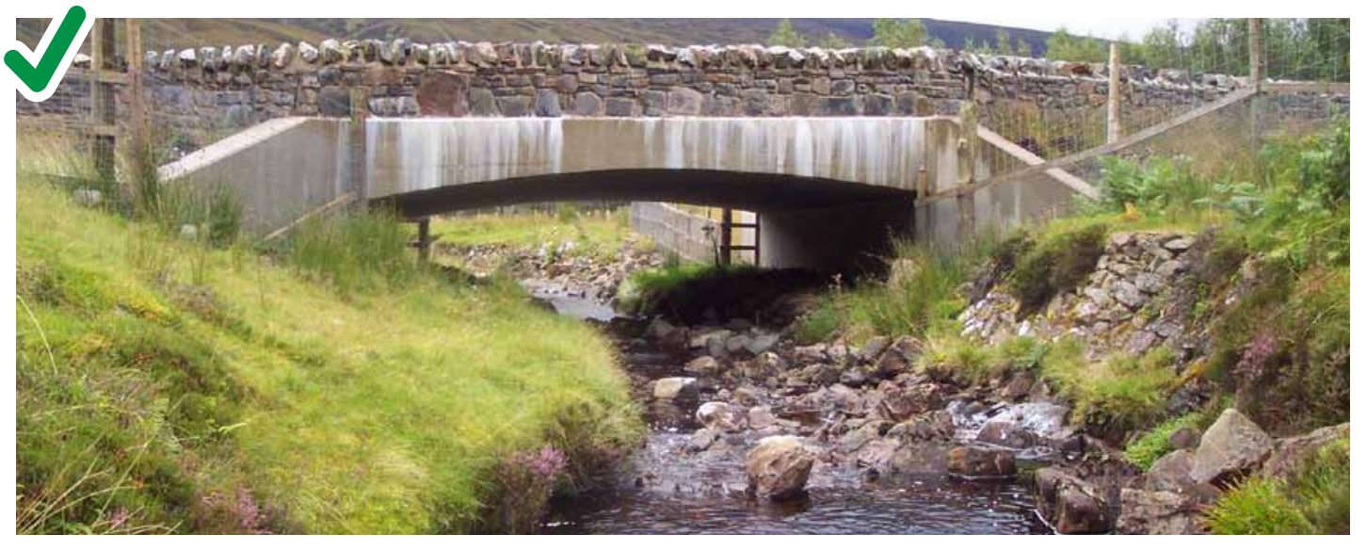
Figure A1B: Good practice, span bridge showing set back abutments and bank habitat maintained through the structure allowing mammal passage. Photograph courtesy of The Highland Council
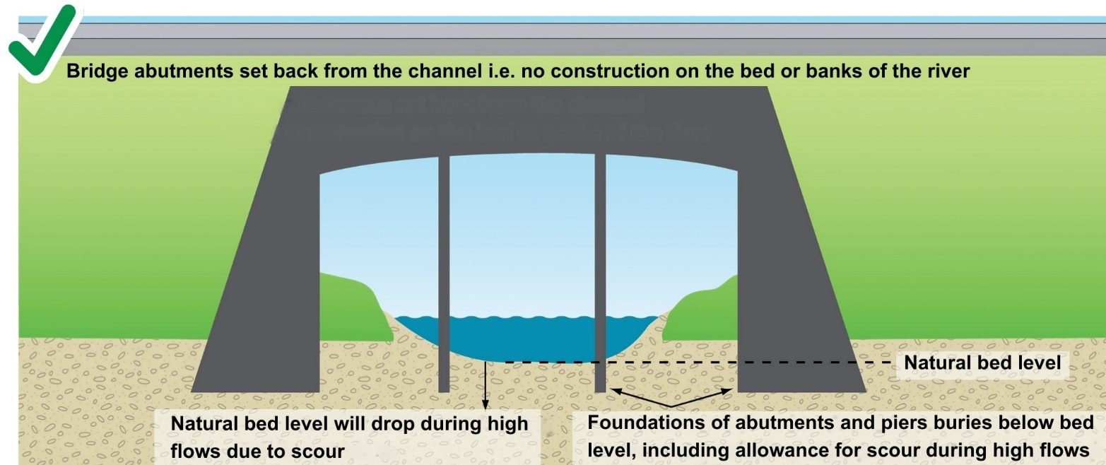
Figure A1C: Good practice, bridge with piers showing set back abutments and deep foundations
Piers increase the risk of floating debris such as large pieces of wood/trees becoming trapped which in turn can increase localised flooding and put the structure at risk of failing. Passage of floating debris through the structure should be considered, e.g. design piers to facilitate the passage of floating debris by streamlining the upstream facing side (Figure A1D)
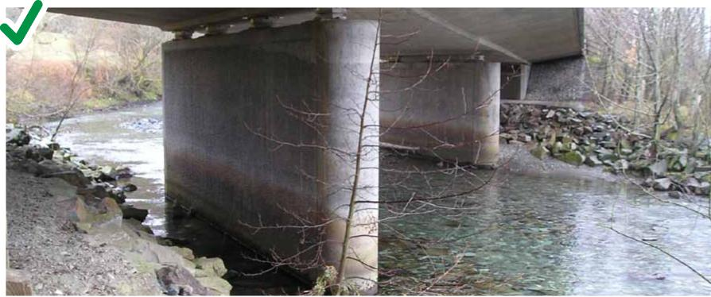
Figure A1D: Good practice, streamlined pier to facilitate passage of large woody debris.
Maintain natural channel width
Maintain the natural bed width if bank habitat cannot be retained under the bridge (Figures A1E and A1F). This will help ensure adequate water depth and velocity for fish passage. If the channel under the bridge is too wide this will increase the risk of creating slow and shallow flows. This can prevent fish from swimming through the bridge and may lead to sediment deposition, reducing the flow capacity at the structure which could increase flood risk. If the channel under the bridge is too narrow it may lead to faster flows that fish are unable to swim against and may increase erosion which could damage the structure. If necessary, a two-stage channel can be created under the bridge to maintain adequate water depth in low flows.
Mammal passage
Provide mammal passage if bank habitat cannot be retained under the bridge. In general, mammal passes should be designed with otters in mind, although if larger mammals such as badgers are present then larger passes may be required.
Passage can be provided by constructing a ledge under the bridge (Figure A1E) or providing a tunnel adjacent to the bridge (Figure A1F).
Minimum headroom of 60 cm should be provided. The width of the ledge or tunnel will depend on the length of the crossing but should be a minimum of 60 cm for tunnels and 45–60 cm for ledges but may need to be wider for larger mammals.
Both tunnels and ledges which are above the natural bank height should have access ramps leading up to them from ground level. Fencing may be required to guide mammals to the crossing areas if they are to be effective.
For further information see CIRIA Culvert, Screen and Outfall Manual (C786) www.ciria.org
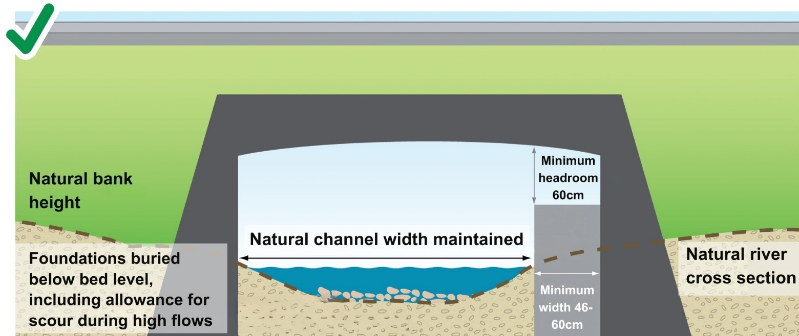
Figure A1E: Good practice, natural channel width maintained and mammal passage provided by a ledge where bank habitat cannot be retained.
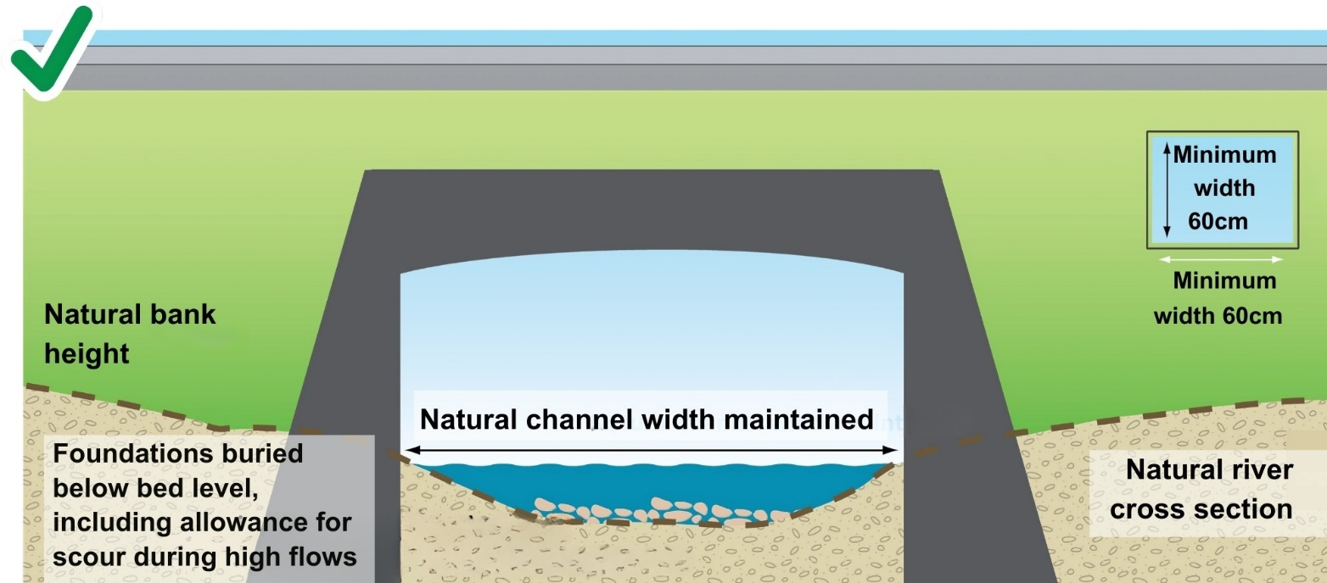
Figure A1F: Good practice, natural channel width maintained and mammal passage provided by a tunnel where bank habitat cannot be retained.
Other mitigation
Where a crossing affects a longer length of river, consider light penetration and soil moisture deficit. Lack of light and moisture can prevent the establishment of vegetation under the crossing and weaken the banks (Figure A1G). This can result in increased erosion under the crossing and potential exposure of the structure foundations. This may result in the requirement for bank reinforcement however the natural bed should still be maintained.
In general, the need for bank reinforcement should be minimised through careful consideration of the location and alignment as discussed in Section 5.2.1. However, where bank reinforcement is necessary, lower impact measures should be considered. Higher impact techniques may be needed if the crossing is located in a higher energy environment where there is high risk of erosion. These should, as far as possible, be designed to help dissipate energy rather than transfer it to another part of the channel though. For more information on bank reinforcement please see our guidance WAT-G-022 EASR Guidance: Engineering: Activity Guide: Bank Works for further details
Bed reinforcement should not be placed under a span structure. The structure should be designed in a way that does not increase scour/erosion and/or moved to a more appropriate location where natural scour risk is lower. If bed reinforcement is deemed necessary it should be buried below the natural bed level, be deep enough to allow for scour during high flows, have natural bed material replaced on top and retain the natural bed material even after high flows. This could be achieved by, for example, using baffles or step-pool bed construction.
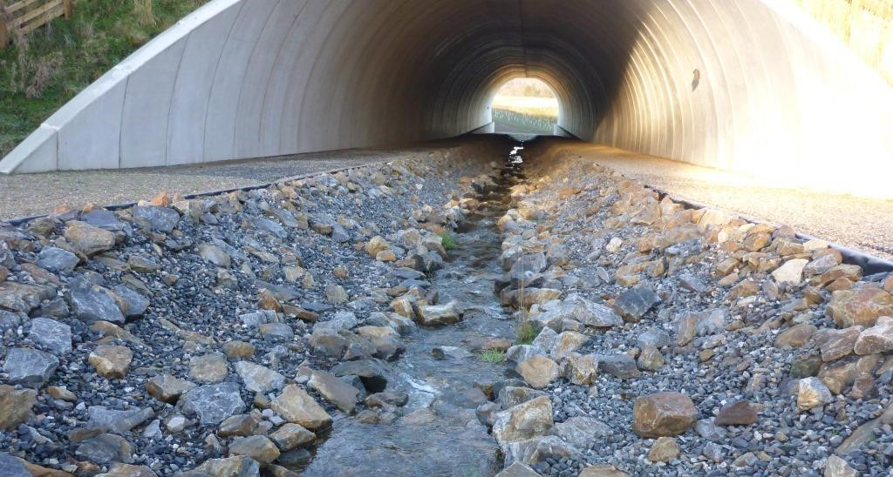
Figure A1G: Longer crossings may lack light and moisture which can prevent the establishment of vegetation under the crossing and weaken the banks. This may result in the requirement for bank reinforcement however the natural bed should still be maintained.

Appendix 2 Good practice design: closed culverts
Poorly designed closed culverts have a high risk of damaging aquatic habitats, creating a barrier to fish passage and mammal movement throughout the river corridor, interrupting the transport of sediment down a river and increasing erosion and deposition at the crossing as well as upstream and downstream.
- Following the principles below for all types of closed culverts will reduce these risks.
- Minimise the potential for localised bed and bank erosion (scour) or excessive sediment deposition at the crossing structure through careful consideration of the location and alignment as discussed in section 5.2.1 above.
- Design culverts so that they are passable to all fish species, even if some fish species are not present as the culvert could affect future measures to improve passage in the catchment.
Maintain a natural riverbed level and slope by burying the culvert invert below the natural bed level. On steeper culverts (e.g. steeper than about 1.5 percent), measures to retain the natural bed material such as baffles may be necessary. Where baffles are used, they should be of a height and spacing that does not create issues for fish passage. Designing them like a step-pool channel is a potential way to do this which also helps to dissipate energy through the culvert reducing the risk of erosion/scour downstream. See our WAT-G-023 EASR Guidance: Engineering: Activity Guide: Channel modification for further details.
- Channel modifications guide for details
- Maintain natural bed width. For pipe culverts, this may require the pipe invert to be buried quite far below the natural bed.
- Ensure there are no physical obstructions to fish passage. Avoid creating steps in the bed particularly at the outlet (downstream end) of the culvert. This can happen due to poor initial design/installation and/or subsequent erosion of the riverbed downstream. The change in hydraulics from the confined, higher energy closed culvert to the less confined, lower energy open channel downstream can often result in erosion/scour as energy is quickly dissipated. It can sometimes be useful to provide a mechanism to dissipate this energy such as a constructed scour pool. Use of step-pool baffle construction can also help dissipate energy within the culvert reducing the sudden energy transition and associated scour at the outlet.
- Ensure adequate water depth (maintaining natural bed level, slope and channel width contributes to this).
- Ensure appropriate water velocity (maintaining natural bed level, slope and channel width contributes to this).
- Ensure adequate fish resting places (pools or slower water) above and below the structure especially for longer culverts. Longer culverts may also require resting places within the structure.
- Ensure replaced natural bed material is of appropriate size and grading to prevent large voids and sub-surface flow during low flow conditions. If material is imported to be used as replacement bed material, it should closely match the shape of the natural bed material e.g. if the natural bed material is sub-rounded then the imported material should also be sub-rounded.
- Provide mammal passage.
Specific fish passage requirements will depend on the species of fish. Further information on culvert design can be found in CIRIA’s Culvert, screen and outfall manual (C786) at: www.ciria.org

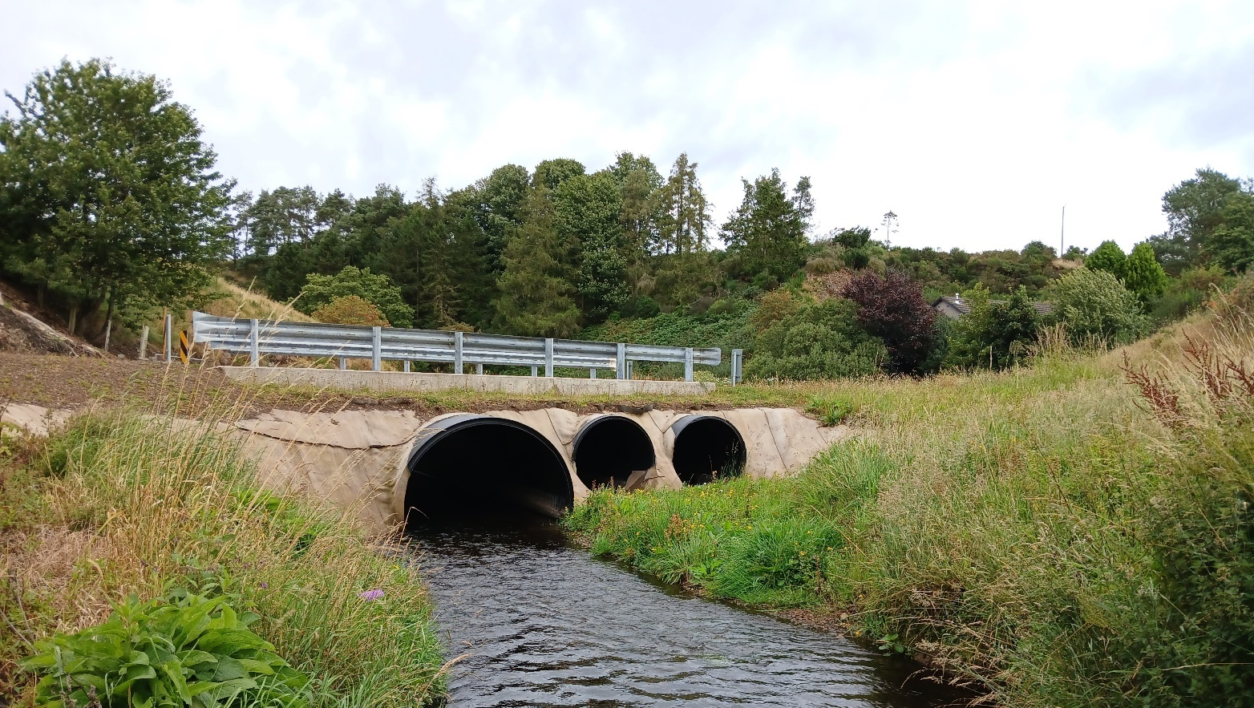
Figure A2A: Good practice, culvert maintaining natural channel width, bed level and slope ensuring adequate water depth and water velocity for fish passage. Photograph courtesy of Aberdeenshire Council.
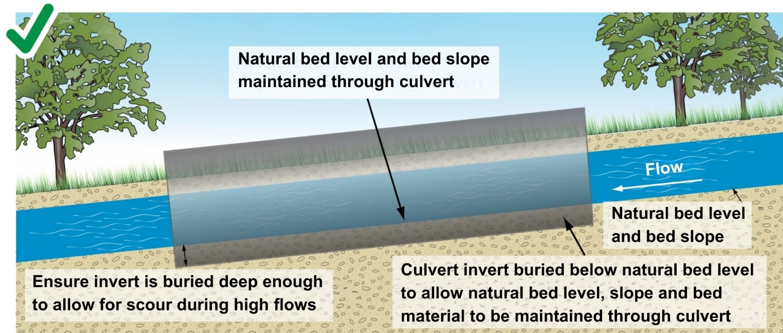
Figure A2B: Good practice, longitudinal section of a culvert showing invert buried below bed level allowing the natural bed level, slope and material to be maintained.
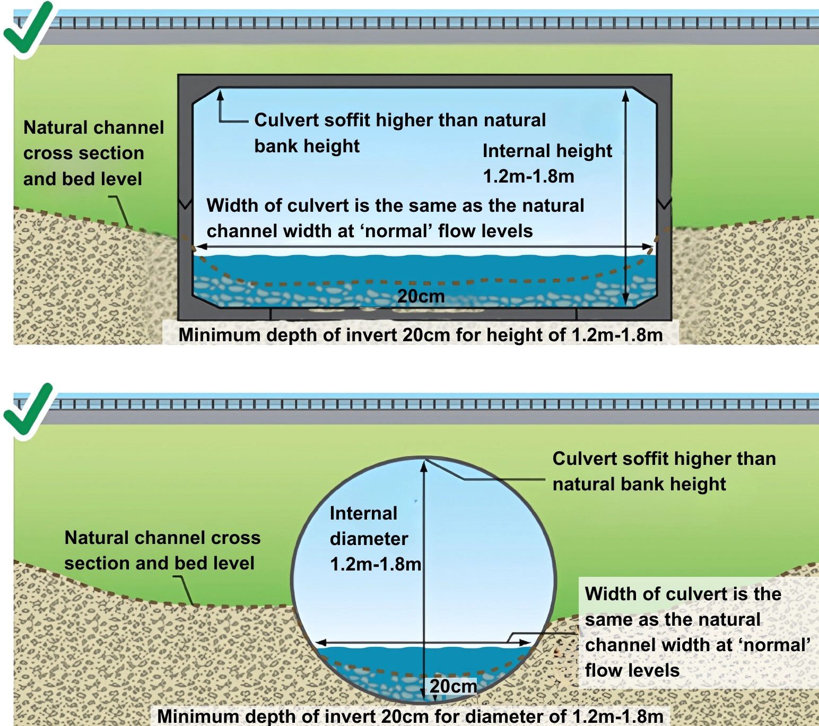
Figure A2C: Good Practice, culverts showing invert buried below bed level allowing the natural bed level, slope and material to be maintained. and also maintains natural channel width
Maintain natural channel width
The culvert should maintain the natural bed width (Figures A2A and A2C).
Maintaining the natural bed width will help ensure adequate water depth and velocity for fish passage. Culverts that are too wide will increase the risk of creating slow and shallow flows. This can prevent fish from swimming up or down the culvert and may lead to sediment deposition, reducing the flow capacity at the structure which could increase flood risk. If the culvert is too narrow it may lead to faster flows that fish are unable to swim against and may increase erosion and could lead to a drop forming downstream, creating a barrier to fish passage. Water velocities and depths in the culvert under different flow conditions should be checked to ensure they are adequate for fish passage. See Fish-Pass-Manual’ from the institute of fisheries management for detailed design guidelines.
Use larger single culverts rather than multiple smaller culverts or pipes as fish prefer larger barrel sizes and can be discouraged from entering smaller pipes. Smaller diameters also increase the speed of water during high flows that fish are unable to swim against (Figure A2D). Multiple smaller pipes may trap sediment that could increase flood risk and may stop river sediments moving downstream.
Twin barrels should only be used where a single span structure or single barrel culvert is not possible (Figure A2E). If a twin barrel is used the natural channel width should still be maintained
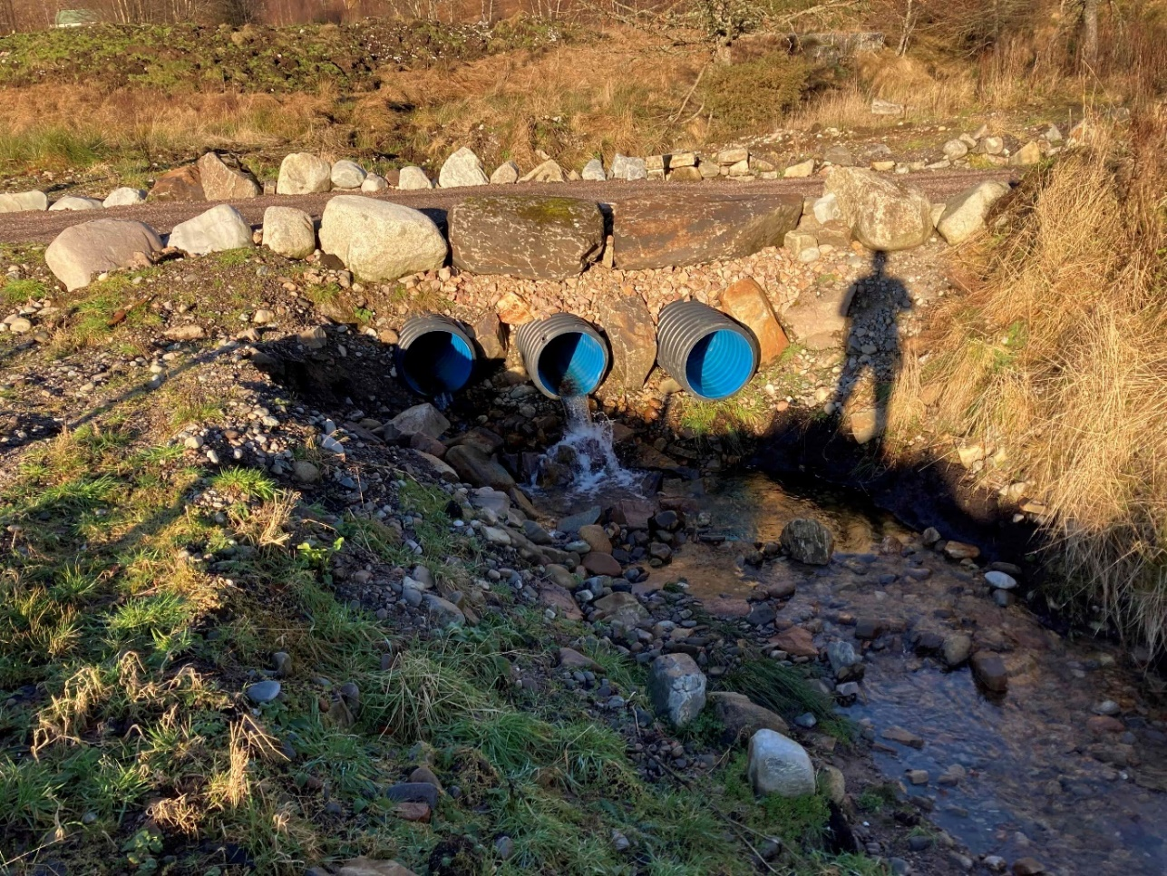
Figure A2D: Poor Practice do not use smaller multiple pipes; they create a barrier to fish passage. Note that there is also a big drop at the outlet of each pipe making them even less accessible.
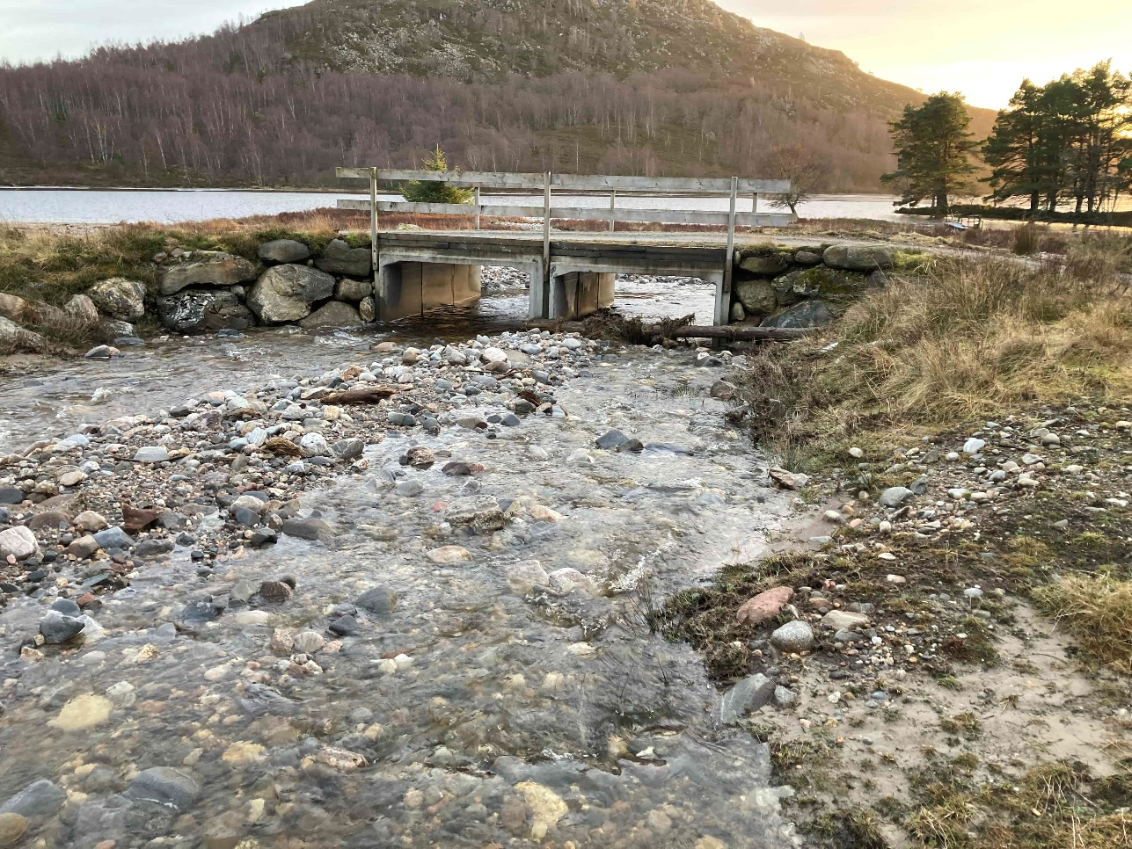
Figure A2E: Twin Barrel culvert that maintains natural channel width and invert buried below the natural bed level. Should only be used where single span structure of single barrel culvert is not possible.
Mammal passage
Mammal passage should be provided. In general mammal passes should be designed with otters in mind, although if larger mammals such as badgers are present then larger passes may be required.
Passage can be provided by constructing a ledge through the culvert (Figure A2F) or providing a tunnel adjacent to the culvert (Figure A2G).
Minimum headroom of 60 cm should be provided. The width of the ledge or tunnel will depend on the length of the crossing but should be a minimum of 60 cm for tunnels and 45–60 cm for ledges but may need to be wider for larger mammals.
For information on the height of ledges and tunnels see CIRIA C786 Culvert, screen and outfall manual www.ciria.org.
Both tunnels and ledges which are above the natural bank height should have access ramps leading up to them from ground level. Fencing may be required to guide mammals to the crossing areas if they are to be effective.
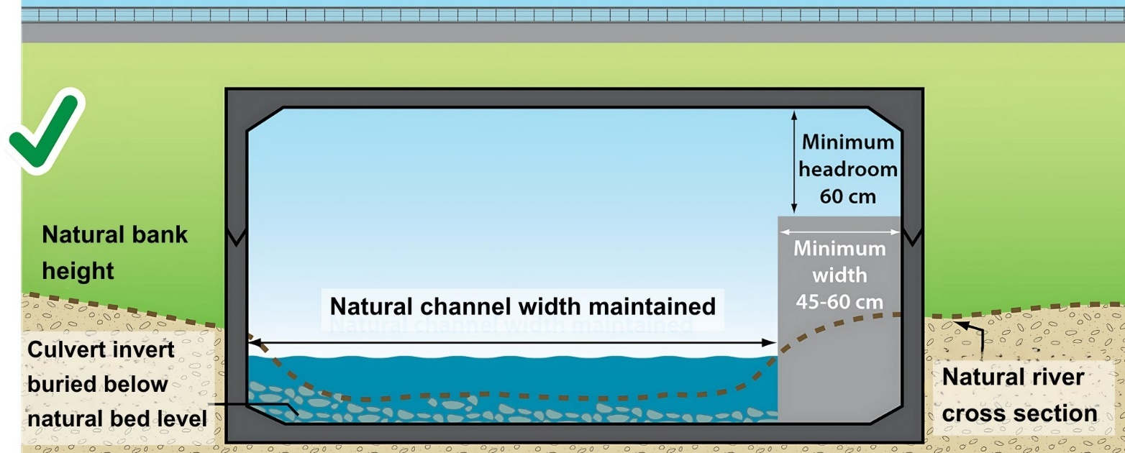
Figure A2F: Good Practice, mammal passage provided by constructing a ledge in the culvert
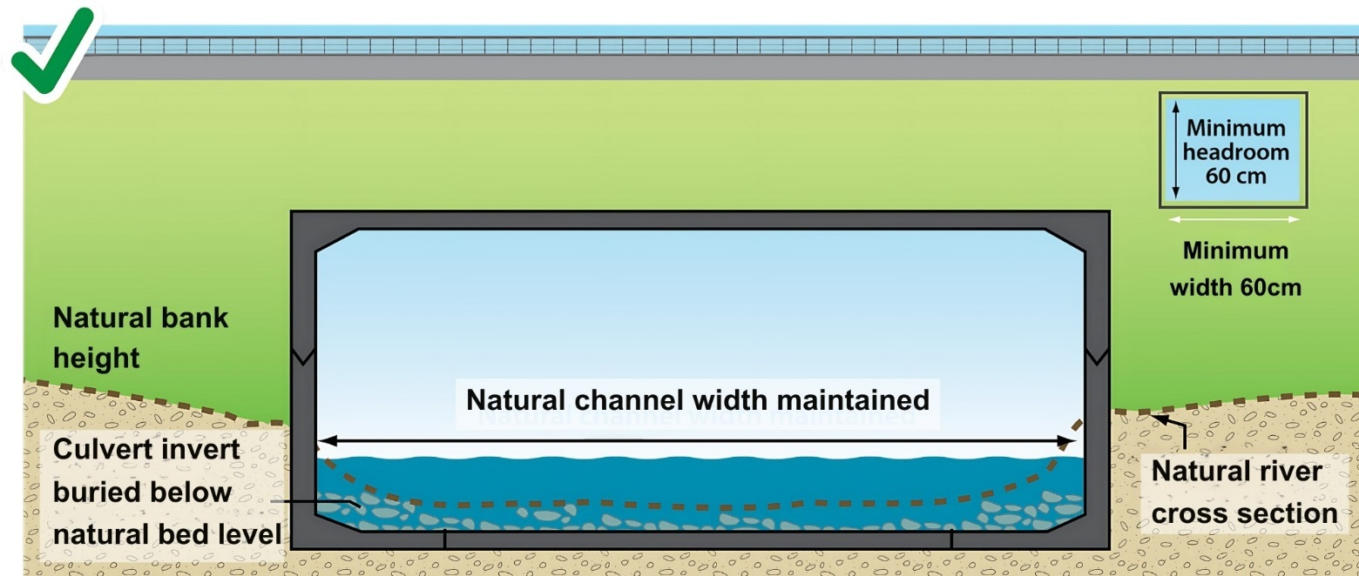
Figure A2G: Good Practice, mammal passage provided by constructing an additional tunnel
Other mitigation measures
The culvert soffit (top) should be higher than the natural bank height (Figure A2A and A2C).
Where culverts are required, identify practical enhancement measures along the affected reach or elsewhere on-site to offset some of the impacts caused by the culvert. For example:
- Re-establish riparian vegetation where it has been lost; or remove existing unnecessary man-made structures.
- Longer culverts may require baffles to aide fish passage. Further details on fish passage design can be found in the ‘Fish-Pass-Manual’ from the institute of fisheries management.
An assessment should be carried out to determine if trash screens are necessary. If trash screens are required bar spacing should be as large as possible to only trap larger debris that risks blocking the culvert. Smaller bar spacing could act as a barrier to fish passage and sediment transport, at least 230 mm spacing between each bar should be ensured. Smaller bar spacing can also trap a lot of smaller debris that can create a barrier to fish passage and may in itself cause some ‘blocking’ of the culvert and increase the risk of flooding if not cleared regularly (Figure A2H).For further information, see CIRIA C786 Culvert, screen and outfall manual www.ciria.org
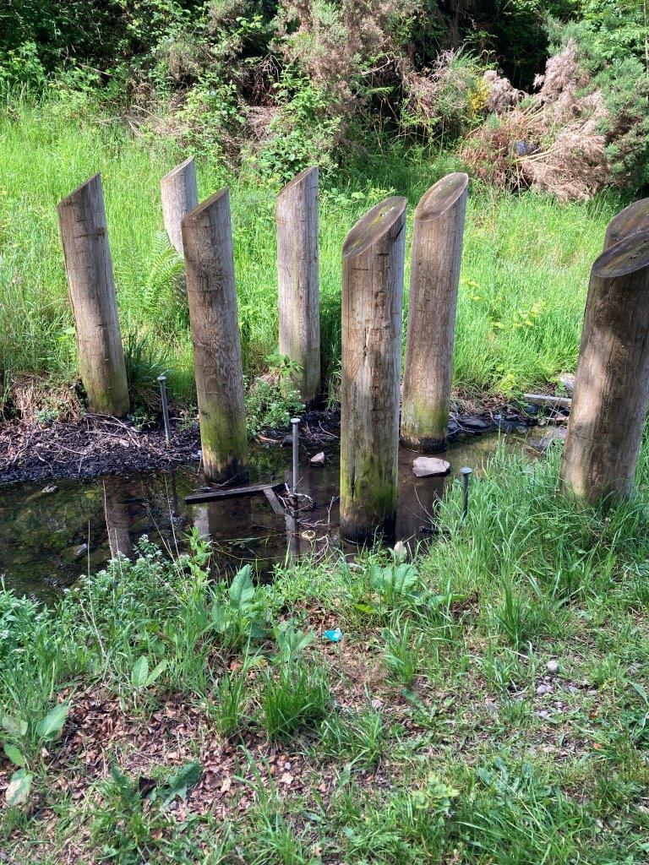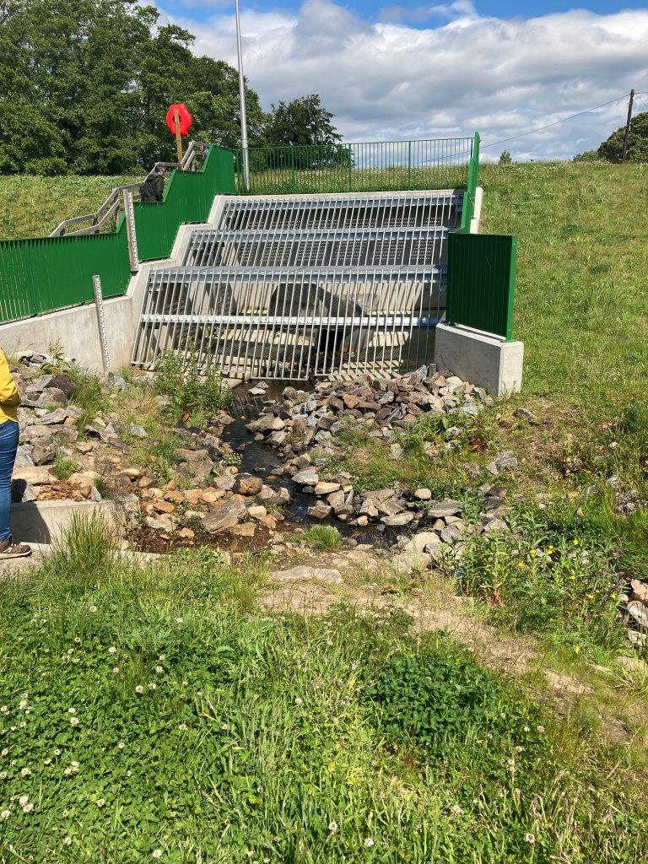
Figure A2H: (photo on left). vertical wooden poles across channel upstream from culvert to trap large debris (photo on right) trash screen with gap under bars to allow onward transport of sediment along the bed during high flow
Minimise the potential for localised erosion (scour) around the culvert through careful consideration of the location and alignment (section 5.2.1) and following the guidance above.
Careful design of a culvert using the guidance provided above can eliminate the need for bed reinforcement downstream of the outlet. If this is deemed necessary though, it should be laid below the natural riverbed level so that the natural bed level can be maintained and natural bed material retained on top.
Where bank reinforcement is necessary, lower impact measures should be considered. Higher impact techniques may be needed if the crossing is located in a higher energy environment where there is higher risk of erosion. These should, as far as possible, be designed to help dissipate energy rather than transfer it to another part of the channel though. For further information see WAT-G-022 EASR Guidance: Engineering: Activity Guide: Bank Works

Appendix 3 Good practice design: fords
Fords have the potential to cause pollution through erosion and the release of fine sediments. They can also create a barrier to fish passage where erosion leads to widening of the river and lowering of water depth (Figure 48), or where bed reinforcement leads to erosion downstream creating a step in the bed (Figure 49 and 51). It is important to ensure that an adequate water depth is maintained to allow fish passage.
The principles below should be followed to reduce the impact of fords:
- Only use a ford when infrequent vehicle use is planned. Fords should not be used between fish spawning and fish emergence times. Key fish species to consider include salmon and trout (normally October – May) and Lamprey species (normally March – July). However, these times can vary and you should contact your local district salmon fishery board if you are unsure what fish species are present and what times should be avoided.
- Do not use fords where there is a high risk of pollution e.g. at construction sites.
- Ensure designated sites (SSSIs, SACs, SPAs) or protected species (e.g. freshwater pearl mussels) are not harmed. Contact NatureScot for further information
- Avoid constructing fords where they may damage other important habitats such as fish spawning areas (e.g. riffles) and areas of aquatic plants.
- Minimise erosion and maintain natural channel width. Bank reinforcement may be required to minimise erosion (Figure A3C). This will reduce the risk of sediment pollution and prevent the river from widening, helping to maintain adequate water depth for fish passage. For further information see our guidance WAT-G-022 EASR Guidance: Engineering: Activity Guide: Bank Works
- Bed reinforcement should be avoided; if erosion is excessive then provision of a span structure or culvert should be considered. If bed reinforcement is constructed it is likely that a step will form between the reinforcement and the downstream riverbed which can cause a barrier to fish passage (Figure A3B and A3D).
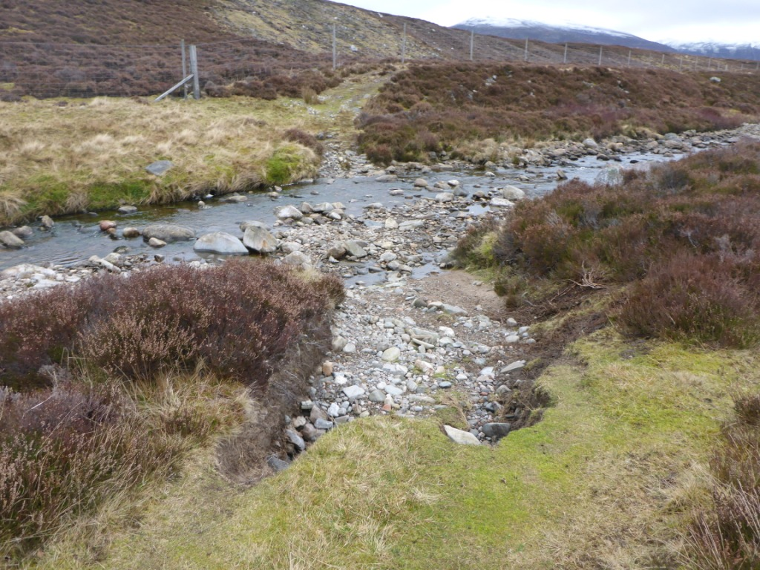
FigureA3A: Infrequently used natural bed ford. Note how near bank has been eroded
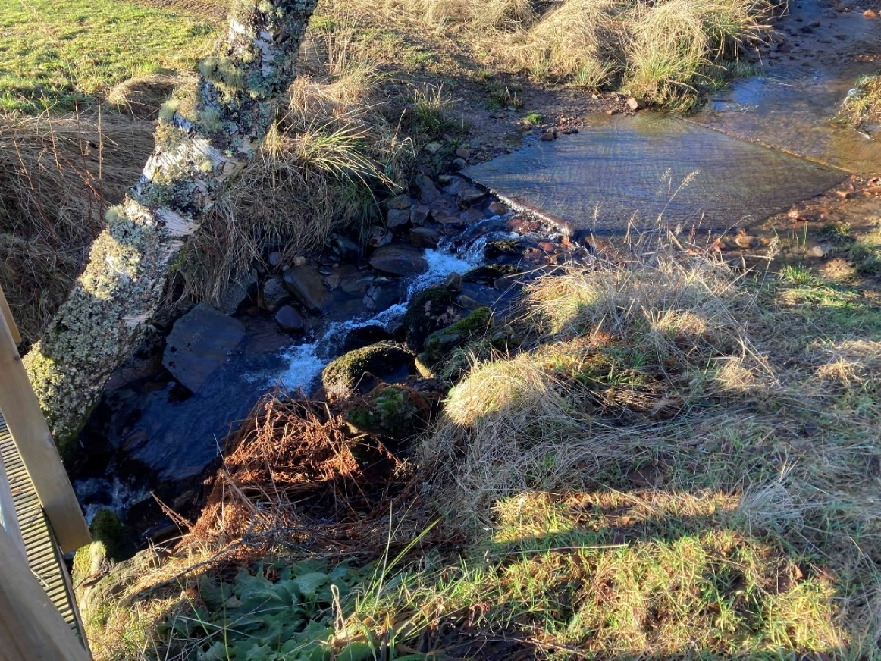
Figure A3B: Poor practice, bed reinforcement can lead to erosion downstream during high flows, this leads to a drop forming that can create a barrier to fish passage.
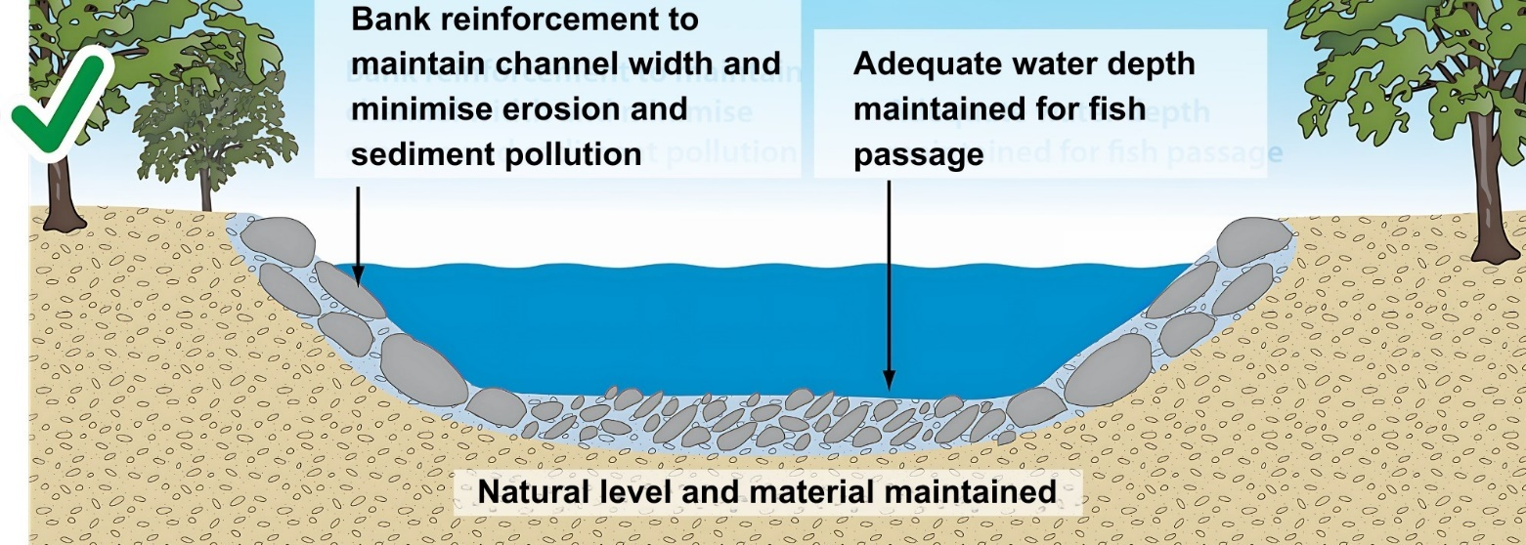
Figure A3C: Good practice, natural bed maintained and bank reinforcement constructed to minimise erosion, sediment pollution and to maintain the natural channel width and depth to ensure adequate water depth for fish passage.
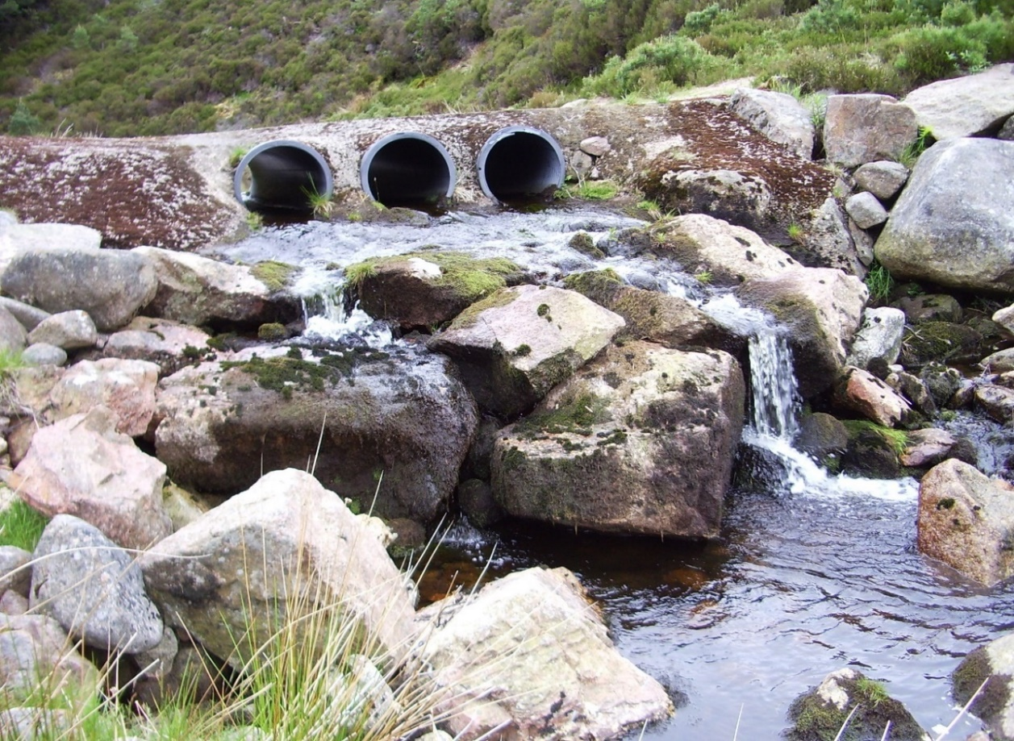
Figure A3D: Poor practice, this is not a ford! Fords should not be above the riverbed level and multiple pipes should not be used. This creates a barrier to fish passage and can prevent sediment being transported downstream. Raising the ford above bed level increases the risk of bed erosion downstream during high flows this can lead to a drop forming which creates further problems for fish passage and may lead to the need for further engineering. Photograph courtesy of The River Dee Trust

Appendix4: Pipe and Cable Crossings
If pipelines or cables are to be carried over a watercourse then the guidance for span structures should be followed. Where pipelines or cables are not carried over a watercourse by a single span structure or span structure with in-stream supports, they should be buried below the natural bed level of the watercourse.
The principles below should be followed to reduce the impact of pipeline and cable crossings:
- Remember the location and alignment guidance provided above, ensure the pipe crossing is perpendicular to the river and do not use rivers as conduits for pipes or cables.
- Maintain the natural bed level and bed material. Bury the pipeline or cable below the natural bed level to allow the natural bed level to be maintained (Figure A4A). It should be buried deep enough so that it is not exposed during high flows.
- Do not lay the pipeline or cable on the riverbed or in the channel or where it could obstruct high flows (Figures A4B A4C and A4D,). This increases the risk of the pipeline or cable being damaged and erosion of the bed and banks of the river. It may also increase flood risk.
- Minimise the risk of pollution when laying pipe or cable below the riverbed. Careful consideration should be given to the technique used to bury the pipe below the bed of the river. Boring underneath the river has the least impact as it does not affect the bed and banks if proper care is taken. If laying the pipe of cable in a trench, then the area to be crossed should be isolated and kept dry. For our guide WAT-G-034 EASR Guidance construction methods for more details
- After construction, restore the natural width, depth and bed material of the river and re-establish the banks with native riparian vegetation (Figure A4A). If necessary, bed material should be stored during construction and replaced. See our guide WAT-G-037 EASR Guidance riparian vegetation management for more details
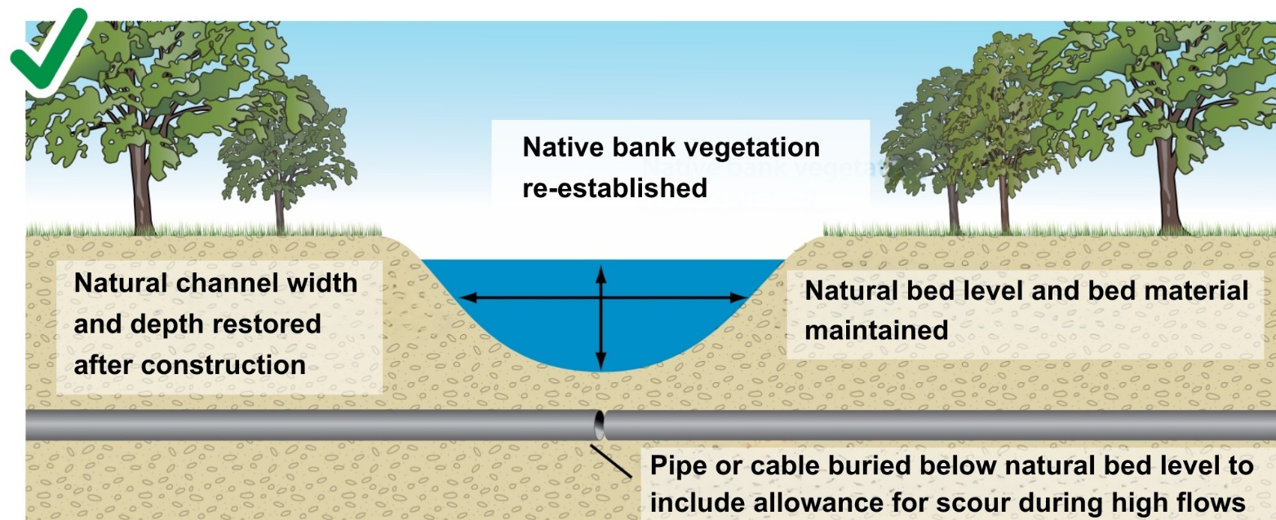
Figure A4A: Good practice, pipeline or cable buried below the riverbed deep enough to ensure it is not exposed due to scour during high flows.

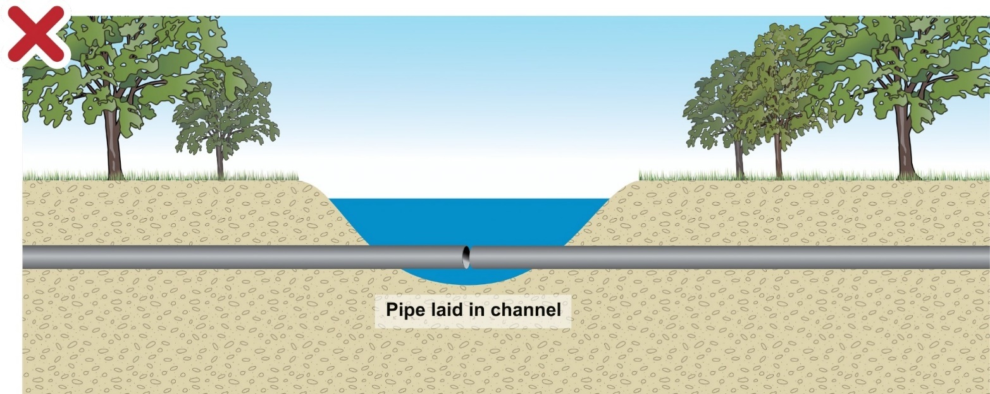
Figure A4B: Poor practice, pipeline or cable laid on the riverbed. Can cause scour around the structure and pipe is at risk of damage during high flows.
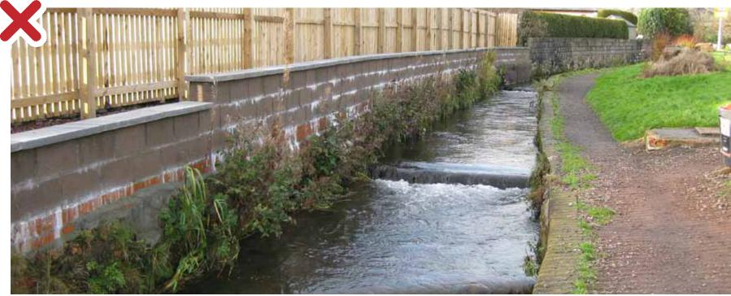
Figure 4C: Poor practice, pipeline laid on the riverbed. Can cause erosion of the bed and banks and scour around the structure which may damage the pipe during high flows.
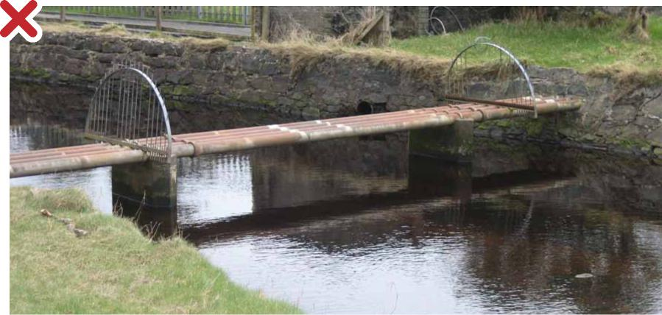
Figure 4D: Poor practice, pipeline laid in the river channel. Can cause scour around the structure and pipe is at risk of damage during high flows.

Appendix 5 Maintenance of Existing Structures
Before undertaking maintenance of an existing structure, you should consider some of key issues discussed below.
If erosion of the bed and banks at a structure is exposing bridge foundations or leading to a step in the bed forming at a bridge or culvert, the cause of the erosion should be identified and if possible addressed to ensure no further erosion takes place.
Erosion may be caused during high flows due to scour around the structure, but it may also be due to erosion that has been triggered elsewhere in the river that has propagated upstream or downstream. For example, ‘knick points’ (i.e. localised areas of very steep channel bed slope) can be created in river beds and during high flows the knick point can move upstream. This can result in significant bank erosion and bed incision (erosion and lowering of bed level), which can damage crossing structures. If bed incision is occurring, then a suitably qualified geomorphologist should be consulted to help identify the cause and determine sustainable solutions.
If the foundations of bridge abutments or piers are being exposed due to scour around the structure then you should consider making the foundations deeper, new bed reinforcement should be avoided.
If bed reinforcement needs maintained or replaced, then consideration should be given to removing the bed reinforcement and modifying the foundations so that bed reinforcement is not required e.g. consider making the foundations deeper. If this is not possible then replace bed reinforcement with new bed reinforcement buried below the natural bed level, deep enough to allow for scour during high flows. This allows the natural bed level and material to be maintained.
If bridge or culvert inverts are at bed level and a drop has formed due to scour around the structure, then you should consider replacing the crossing with a span structure allowing a natural bed or a structure with a buried invert below bed level. If this is not feasible then where possible the invert should be replaced below bed level so that the natural bed level and material can be maintained.
If crossings are posing a barrier to fish passage, then you should consider replacing the crossing with a structure that allows fish passage. If this is not feasible then you should consider modifying the structure to allow fish passage (e.g. baffles can be constructed in a culvert) or construct a fish pass. A suitably qualified ecologist should be consulted to ensure that any modification or fish pass is effective in providing fish passage.
Further details regarding the regulatory requirements of maintenance, replacing or removing existing structures can be found in our guidance WAT-G-027 EASR Guidance: Engineering: Maintenance, replacement and removal of existing engineered structures

Disclaimer
Whilst every effort has been made to ensure the accuracy of this guidance, SEPA gives no warranty, covenant or undertaking (express or implied) regarding the fitness for purpose of, or any error, omission or discrepancy in this guidance. Reliance on its contents and the contents of any websites that are linked to or from this guidance is entirely at the user’s own risk. SEPA is not liable for any loss or damage that may come from using this guidance.
This includes:
- any direct, indirect and consequential losses
- any loss or damage caused by civil wrongs, breach of contract or otherwise
SEPA reserves the right to depart from this guidance and take appropriate action as it considers necessary or appropriate. Operators are responsible for ensuring that they are compliant with the law. If necessary, independent legal / specialist advice should be sough

