


Aquaculture Modelling Screening and Risk Identification Report: Port Na Cro (FFMC55)
September 2026 Version 1

For information on accessing this document in an alternative format or language, please contact SEPA by emailing equalities@sepa.org.uk
If you are a user of British Sign Language (BSL), the Contact Scotland BSL service gives you access to an online interpreter, enabling you to communicate with us using sign language. contactscotland-bsl.org

Scope of report
As part of the SEPA Aquaculture Regulatory Framework it is recommended that a proposed application for a marine finfish aquaculture site should undergo a Screening Modelling and Risk Identification process (under EASR). Risks are highlighted and recommendations regarding the information required to assess the application, are raised at this early stage.
SEPA carries out this work and completed reports can be found on the SEPA aquaculture website Pre-application section along with additional information on SEPAs application process.

Executive summary
SEPA has received a proposal to vary an existing marine finfish aquaculture site called Port na Cro (FFMC55), at location: 176076 709829 (Easting, Northing). The existing maximum biomass is 1000t at this location and the proposed weight of fish to be farmed is 1000t. The applicant seeks approval to increase the quantity of azamethiphos administered in 24-hour bath treatments and has proposed the use of marine modelling to determine acceptable levels.
Following screening modelling and risk identification we have concluded the following:
- It is possible that discharges from Port na Cro (FFMC55) will be able to comply with the relevant aspects of the SEPA Aquaculture Regulatory Framework.
- Due to the identified PMFs, detailed 2D marine modelling of baths is required. Identified features should be considered.

List of abbreviations
AMZ Allowable Mixing Zone
AZA Azamethiphos
CTG Consenting Task Group
CFD Computational Fluid Dynamics
EASR Environmental Authorisation (Scotland) Regulations
ECE Equilibrium Concentration Enhancement
EIA Environmental Impact Assessment
HRA Habitats Regulations Appraisals
MPA Marine Protected Area
MPFF Marine Pen Fish Farm
PMF Priority Marine Feature
SAC Special Area of Conservation
SEPA Scottish Environment Protection Agency
SPA Special Protected Area
SSSI Site of Special Scientific Interest

Contents
Scope of report 2
Executive summary 2
List of abbreviations 3
List of figures 5
List of tables 5
Introduction 6
Screening modelling 7
Accuracy of model in the area surrounding the proposal 7
Dispersion and erosion capacity maps 8
Bath medicine influence maps and analysis 10
Risk Identification 12
Features of Interest which require attention 12
Additional comments on bath influence 13
Conclusions 14
Recommendations and Further Modelling 14

List of figures
Figure 1. Wider Loch Linnhe System model grid 7
Figure 2. Modelled average water speed (metres per second – m/s) in the area around the proposed site (Port na Cro (FFMC55)). 9
Figure 3. Modelled average Azamethiphos concentration over four days from neap tide release for the proposed site only (Port na Cro (FFMC55)). 11

List of tables
Table 1: Table of identified features of interest 12

Introduction
Screening Modelling and Risk Identification are important steps in the SEPA regulatory framework for marine pen fish farms. SEPA carries out this work and this is described on the SEPA aquaculture website Pre-application section.
This section presents screening output for the proposed site with comments. Risks identified from the screening output are detailed. Conclusions and recommendations about the suitability of the proposed site are then made.

Screening modelling

Accuracy of model in the area surrounding the proposal
The Wider Loch Linnhe System Model used for screening modelling has a relatively moderate to high resolution in this area.
Comparison against observational current meter data indicates that the model provides a reasonable performance of the physical processes in the vicinity of the proposed site.

Figure 1. Wider Loch Linnhe System model grid
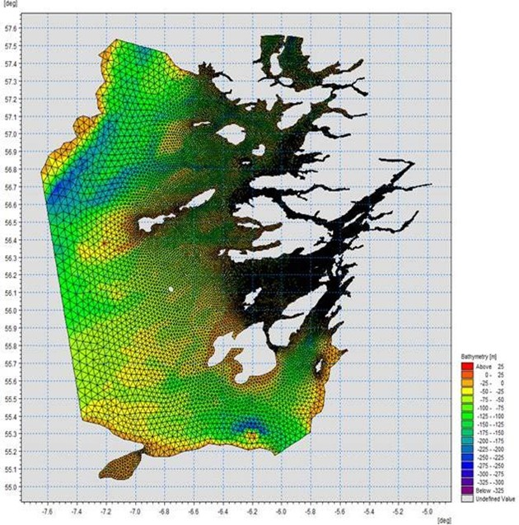

Dispersion and erosion capacity maps
Modelled water movement in a sea area can be used to show the capacity of the water to move and disperse discharged substances. It is also possible to show the capacity available to erode substances from the seabed. This information is a useful guide to the potential size of a marine pen fish farm at a particular location.
Marine pen fish farms using open-net pens will benefit from operating in locations where there are strong, repeating, water currents to erode and disperse waste.
Locations with average water flow speeds of greater than, or equal to, 0.12 metres per second (0.23 knots) are for screening purposes, considered generally suitable for larger farms.
A map of modelled average water flow speed for the area surrounding the proposed site is shown in Figure 2. The average water flow speed in each cell of the model grid has been assigned a shade. The darker the shading, the slower the average current speed and the lower the capacity for dispersion.
Licenced aquaculture farms in the vicinity of the proposed site are shown and discharges of material from these sites have been included in the screening modelling.

Modelled flow properties
Based on the maps of the modelled water flow properties we can make the following observations about the proposed site location:
- It lies in a low dispersion area.
- It lies in an area where water flow has a low capacity to erode material on the seabed.

Figure 2. Modelled average water speed (metres per second – m/s) in the area around the proposed site (Port na Cro (FFMC55))
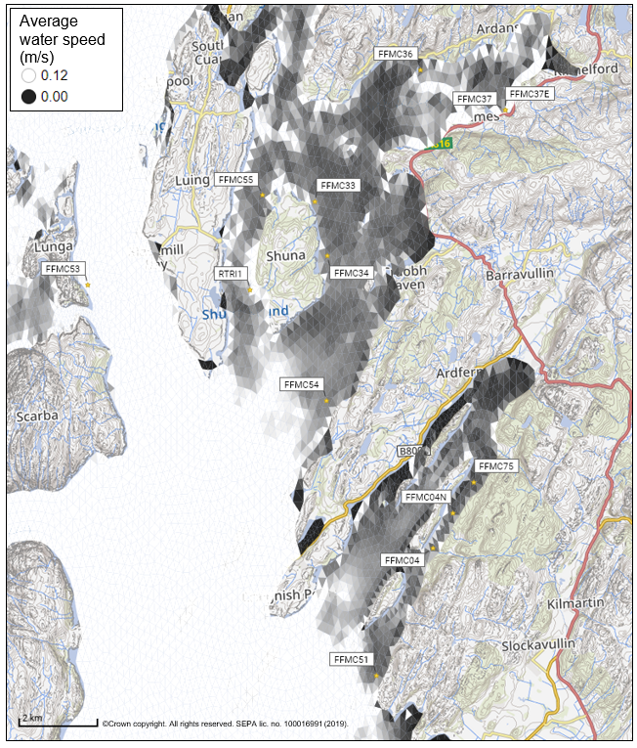

Bath medicine influence maps and analysis
Modelled particles in a sea area can be analysed for each modelled grid cell and presented to show the potential influence of discharged bath medicine on the surrounding sea area. Results presented are for the Azamethiphos medicine.
Figure 3 shows a map of the modelled average AZA concentration over four days for the proposed site only. Grid cells within the model which experience an AZA influence are shaded according to the concentration of AZA in nanograms per litre (ng/l). Cells which are shaded purple are similar to the average and those shaded pink are similar to the median (middle value in the range) intensity value shown on the map.
Values less than 10ng/l have been excluded from the map. These low concentration cells are produced by the particle tracking approach but they are not considered to be representative of the main influence of a discharge.
Please note that the Environmental Standard for Azamethiphos with the lowest concentration is 40ng/l. This must be met 72 hours after the material has been discharged. The estimate of influence detailed here is precautionary.

Figure 3. Modelled average Azamethiphos concentration over four days from neap tide release for the proposed site only (Port na Cro (FFMC55))
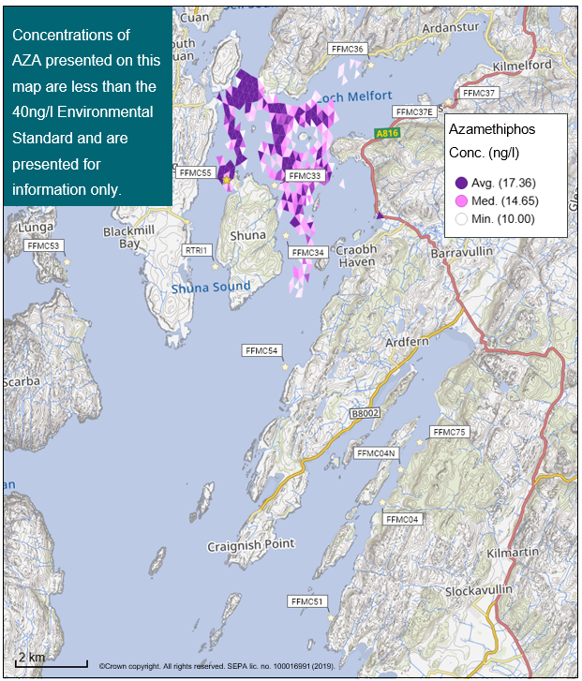

Risk identification
The screening modelling output summarised in the screening modelling section is compared against available information on features of interest. Features which require attention are presented with any additional comments and will need to be considered during the pre-application phase.

Features of interest which require attention
Sensitive features in the area have been assessed, those considered at risk and therefore requiring additional consideration, can be found in the table below.

Table 1: Table of identified features of interest
 | Feature name | Feature type | Location (Easting, Northing) | Brief reason for identification
1 | Loch Melfort | Shellfish Farm | 180400  711100 | At risk from baths
2 | Torsa | Shellfish Farm | 176600  711100 | At risk from baths
3 | Native oysters | PMF | Within 5km of the farm (Location cannot be disclosed. Modelled output will be assessed against specific location) | At risk from baths

Additional comments on bath influence
The conservative nature of the simple BathAuto model in areas of high current speeds, means quantities of bath medicines may be limited to impractical amounts for this site. Use of marine modelling of bath influence will enable more realistic bath medicine treatment quantities to be determined. Features identified as at risk within this area will need to be addressed in any marine modelling, however cumulative modelling of baths is not required. Dye/drogue calibration will not be required.

Conclusions
According to screening modelling, the proposed site (Port na Cro (FFMC55)) is in an area of low dispersion and has a relatively low capacity for erosion of material on the seabed.
The screening model provides a reasonable performance in the vicinity of the site when compared to observational data.

Recommendations and Further Modelling
Following the engagement meeting(s), this report may be revised and this should allow the applicant to submit a method statement which address the issues raised in this document.
Due to the identified PMFs, detailed 2D marine modelling of baths is required. Identified features should be considered.

