

IND-G-003

EASR guidance:
Version 1.0 August 2025
Registration activity
Blending or use of cement in bulk

Contents
Introduction 3
What does this guidance apply to? 3
Bulk cement processes 4
Overview 4
Concrete batching or ready mixed concrete 4
Diagram 1: Overview of the cement batching process 6
Bulk cement transfer 7
Pre-cast concrete manufacturing 7
Environmental controls 7
Site design and infrastructure 7
Bulk storage and associated dust arrestment 8
Cement packing 9
Aggregate 9
Conveyors 10
Delivery to silos or totally enclosed containers 10
Delivery of concrete to trucks 11
Pre-cast concrete manufacture 11
Water for dust suppression 11
Dust abatement (other than that fitted to silos) 12
Protection of the water environment 12
Management techniques 13
Maintenance 13
Operator training 14
Resource use and efficiency 15
Raw materials 15
Water 15
Waste 16
Heat 16
Energy 16
Interpretation of terms 16
Disclaimer 18

If you would like this document in an accessible format, such as large print, audio recording or braille, please contact SEPA by emailing equalities@sepa.org.uk

Introduction
This document provides information and guidance for anyone undertaking the blending or use of cement in bulk which may be authorised under the Environmental Authorisation (Scotland) Regulations (EASR). It should be read alongside the standard conditions for this activity.

What does this guidance apply to?
This guidance applies to:
- The blending or using cement in bulk including:
  - The bagging of cement and cement mixture.
  - The batching of ready-mixed concrete.
  - The manufacture of concrete blocks and other cement products.
It also applies to:
- The blending, packing or use in bulk of cement whether for internal use or sale.
- The temporary storage of materials used or generated as part of the activity including raw material storage and movement.
- The storage of product material at the place of production.
It does not apply to the blending or use of cement in bulk at a construction site.

Bulk cement processes

Overview
Cement is the basic ingredient of concrete, mortar, stucco, and non-speciality grout. It is a fine powder produced by heating limestone and clay minerals in a kiln to form clinker. The clinker, which is a solid material 3 to 25mm in diameter, is then ground to powder form and 2 to 3% of gypsum (a soft sulphate material) is added. The term cement includes Portland cements, blended cement, high alumina cements and other powders used as cementitious materials or partial cement replacements e.g. pulverised fuel ash or ground slag which aid circular economy by giving a route of re-use to certain materials.
The low cost and widespread availability of the raw materials (aggregates, cement & water) make concrete a cheap building material. The production of cement contributes to global warming by giving rise to 8% of the worldwide carbon emissions (in 2018) – this is mostly from the clinker manufacturing process which requires an Industrial Activities permit and therefore not covered by this guidance.
Bulk cement (meaning ‘loose cement’) will generally be transported in a tanker and stored in silos. There are instances where bulk silos are brought into use as mobile units.

Concrete batching or ready mixed concrete
This material is produced by carefully mixing controlled proportions of cement together with course and fine aggregates such as gravel, crushed stone, or sand, and also water. Small amounts of admixtures may be included to modify the properties of the mix. This creates the correct blend for the required performance or specification of the concrete. This can be a wet or dry process (where water is added at a later stage) and typically is as follows:
- Storage of cement materials in silos.
- Storage of aggregates in semi-enclosed bins.
- Conveying/transfer equipment to take raw materials to hoppers.
- Weigh hoppers where the correct amounts of materials can be selected.
- Storage of admixtures.
- Supply of water if using a wet batch process.
- Mixer where aggregate, cement, admixtures and possibly water are added together.
- Discharge point to vehicle for transport off site.
- Dust arrestment plant.
Diagram 1 on the following page shows a flow chart of main processes in this activity.

Diagram 1: Overview of the cement batching process
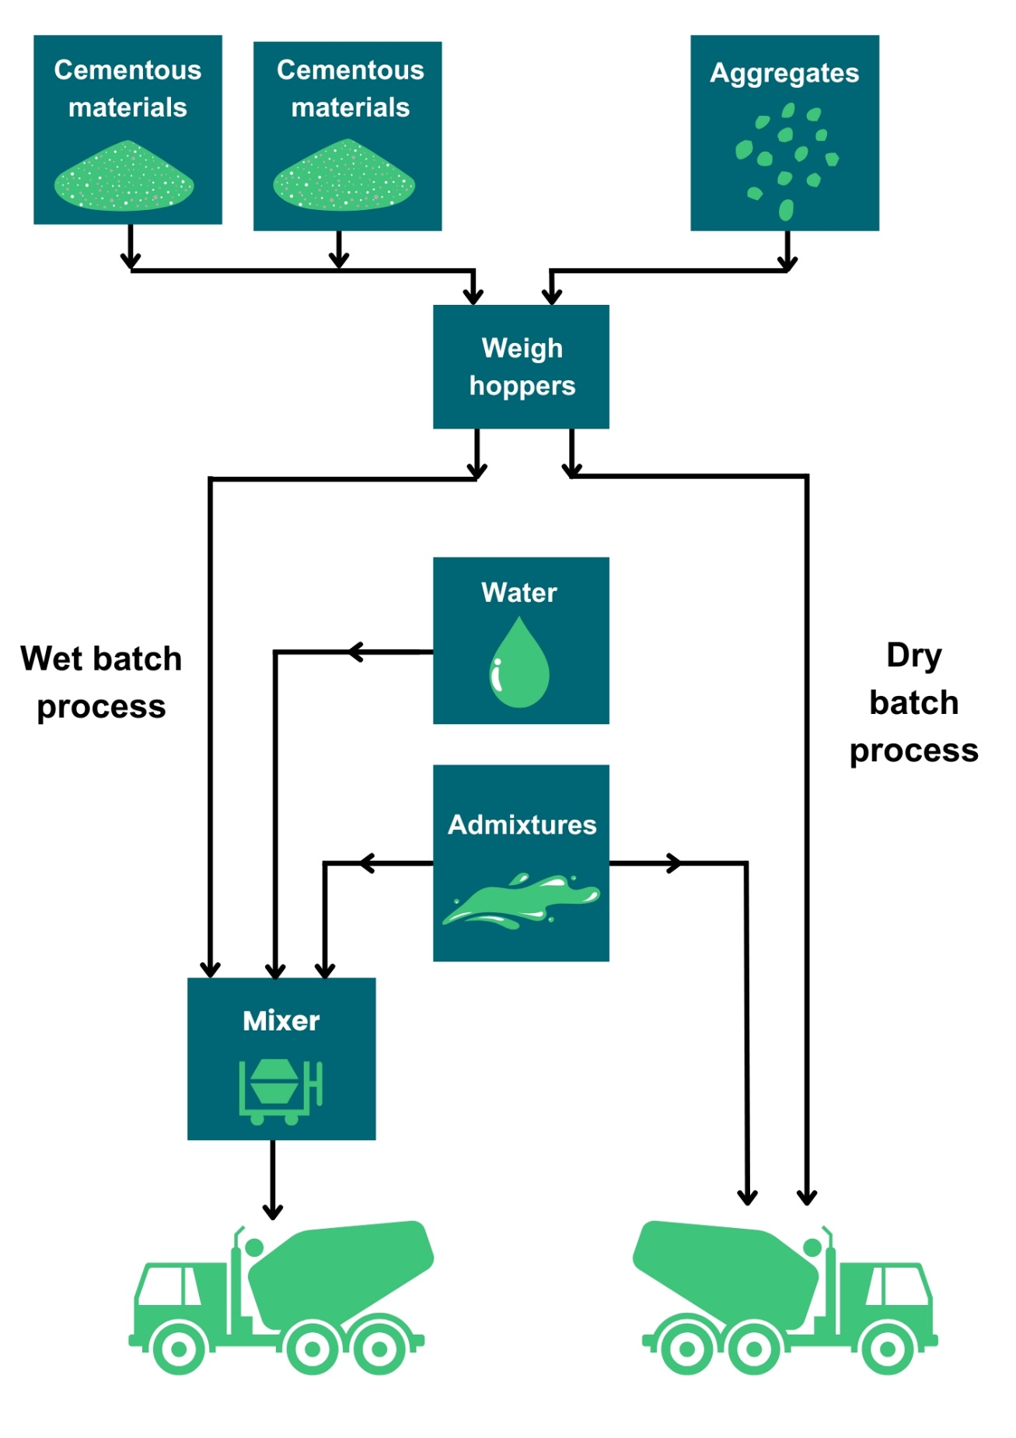

Bulk cement transfer
Cement may be delivered by road or rail in bulk tankers. The powdered materials are transferred through a closed system of heavy-duty hoses to storage silos, using compressed air as a carrier medium. Silos are vented to allow air to escape through filters, to control dust emissions. It is important not to exceed the flow capacity of the filter system of the silo as this will exert excessive pressure in the silo (which is not a pressure vessel). If the silo becomes pressurised, the pressure relief valve should lift to prevent the silo rupturing, or the filter unit being ejected from the top of the silo.

Pre-cast concrete manufacturing
This process starts off as the same as wet concrete batching process where the finished mix is deposited into pre-formed moulds, vibrated, compressed into shape, and cured. Curing may be at atmospheric temperature or by the use of heated air which will involve a combustion process. If the combustion process generates more than 1MW, either individually or as an aggregate, you will need a separate registration or permit depending on the size of the plant.

Environmental controls
It is expected that the methods described in this section are utilised to control emissions from the bulk cement activities. Where other methods are used, they should offer at least an equivalent level of environmental protection.
Containment or enclosure of dusty processes or suppression using water are considered the best ways to control dust from the bulk cement activities.

Site design and infrastructure
- Process buildings should be as dust tight as possible and fitted with self-closing doors and close-fitting entries and exits for conveyors.
- Where local exhaust ventilation is used within a building, dust arrestment of these emissions will be necessary.
- Surfaces subject to vehicle movements should have a consolidated surface which is kept in good repair.
- Thought should be given to the site layout to minimise vehicle movements and the double handling of dusty raw or waste materials.
- Vehicles entering or moving around the site should have exhaust pipes that do not point downwards to minimise fugitive dust emissions.
- Vehicles delivering aggregate materials should be covered e.g. sheeted.
- A wheel-wash for vehicles leaving the site may be necessary.
- Internal and external housekeeping and cleaning should be to a high standard – there should be no significant deposits of dust in process buildings or on equipment.
- Spillage of dusty materials should be cleared up immediately, preferably by wet handling methods, or have dust suppressants applied if immediate clear-up is not possible.
- Dusty materials for disposals should be stored in enclosed containers.

Bulk storage and associated dust arrestment
- Bulk cement and admixtures must be stored in silos or totally enclosed containers or buildings.
- Silos or totally enclosed containers must be installed with automatic protection systems to control the delivery of cement from tankers so that it is not possible to over-fill or over-pressurise the silo. In addition, the blowdown at the end of a delivery cycle must be adequately controlled.
- Silos and totally enclosed containers storing cement or admixtures should be designed to emit less than 10mg/m³ of dust.
- Cement or admixture silos or containers must be fitted with:
  - A pressure relief valve.
  - A dust filter system with a suitable air flow capacity.
- The pressure relief valve and filter system on silos or containers should be checked weekly or before a delivery takes place, whichever is the longer interval, and maintained to ensure they are fully operational as cement dust will rapidly set around the valve and/or filter causing blockages.
- The seating of the pressure relief valve should be checked once a week or before a delivery takes place, whichever is the longer interval.

Cement packing
- Packing of cement must be carried out in totally enclosed purpose-built plant fitted with dust arrestment equipment e.g. bag filters.

Aggregate
- Aggregate storage should be sited appropriately and considering the prevailing wind direction and proximity of neighbours.
- Aggregate and other potentially dusty materials should be:
  - Stored in storage bays.
  - Not filled above the external wall height or forward of the bay.
  - Any internal walls separating storage bays should be at least ½ metre lower than the external wall height.
- If necessary, aggregate storage should be fitted with covers or dust suppression for example fixed water sprays.
- Aggregate deliveries should be made in a manner that minimises fugitive dust emissions for example. use of water sprinklers, rubber socks, or low discharge heights.

Conveyors
- Conveyors should not be overloaded.
- Drop-heights from conveyors should be minimised.
- Discharge points from conveyors should be fitted with a chute or similar equipment.
- Conveyor belts and surrounding areas should be kept clean and fitted with an effective means of keeping the return belt clean for example chevron belts with catch plates fitted to contain dust falling from the underside of the belt at the turning point.
- Conveyor transfer points should be enclosed and may need arrestment equipment fitted.
- Conveyors should be protected from wind whipping by side enclosures for example wind boards.

Delivery to silos or totally enclosed containers
- Delivery of bulk cement or admixtures to silos or containers must be:
  - Totally enclosed, including the delivery vehicle.
  - Fitted with an automatic protection system and alarm to prevent over-filling or over-pressurising the silo or container by cutting off delivery should this occur. This system should be checked one a week or before a delivery takes place, whichever is the longer interval.
- Displaced air, resulting from delivery of bulk cement to silo must either be:
  - Vented to suitable abatement equipment e.g. cartridge/bag filters; or
  - back vented to the delivery tanker.
- All deliveries to silo from road vehicles must only be made using vehicles fitted with onboard pressure relief valves and filtration equipment.
- During a delivery, if dust emissions from the delivery are visible, the operation must cease and not recommence until the problem is remedied.
- Towards the end of a delivery, when the quantity of material entering the ducting is reduced and hence the air flow is increased, particular care must be taken to prevent over-pressurisation of the silo or container.

Delivery of concrete to trucks
- Loading of dry concrete mix into trucks must be via a rubber sock type chute.
- Loading of wet concrete mix into trucks should not create fugitive dust emissions.

Pre-cast concrete manufacture
The provision of heated air for the curing of pre-cast concrete may involve a combustion process. This type of combustion plant requires an additional authorisation either under Schedule 27 Medium Combustion Plant of EASR (plant with a net rated thermal input of between 1 and 50 megawatts) or Regulation 1 of Chapter 1 in Schedule 26 of EASR (combustion plant which generate electricity on the same site with an aggregated rated thermal input of 1 MW or more). You can find more information on the SEPA website.

Water for dust suppression
- Adequate water supply must be available to ensure dust suppression can take place when needed.
- Non-mains fed tanks should be fitted with low level alarms.
- The water suppression system should have adequate frost protection.

Dust abatement (other than that fitted to silos)
- Arrestment equipment must be:
  - Designed to emit less than 50mg/m³ of dust.
  - Fitted with continuously indicative monitor which provides visual and audible notification when 75% of the emission limit is reached.
- Arrestment equipment should be regularly checked and maintained to ensure it is fully operational.
- The method of collection of dust from dry arrestment plant should be done in a manner that does not create dust emissions.

Protection of the water environment
- Buffer zones should be created around water bodies where dust suppression activities are prohibited or restricted to prevent any potential contamination. Vegetative strips or silt fences should be used as physical barriers between the work area and water bodies to capture any potential runoff.
- Containment measures such as bunding, berms or dykes should be used around the site to prevent runoff or spillages from entering nearby water bodies.
- Areas where dust suppression is being carried should not be sloped toward water bodies, reducing the risk of water runoff entering the environment.
- Drip pans or liners should be placed underneath vehicles or equipment used for dust suppression to catch any potential leaks or spills.
- Spill response kits and equipment should be readily available on-site to deal with any accidental releases of chemicals, water or oils that could potentially harm the water environment.

Management techniques
Good management techniques, training and well-maintained infrastructure are key to prevent and limit the consequences of accidents which could have an impact on the environment. For example, bunding should be used around liquid storage to contain any spillages, but good management and maintenance would take this a step further by ensuring that the integrity of the bunding is checked regularly to prevent leaks, and deliveries and movements around the site are well controlled. This will enable you to comply with environmental regulations, avoid incidents, and avoid any costs incurred through loss of resources.
- Effective control of emissions starts with proper management, supervision, and training for process operators.
- Implement an environmental management system to help identify and provide a systematic approach to manage, monitor, and control your environmental issues and maintain efficiency. These can be certified through ISO 140001, BS8555 or EMAS (Eco-Management and Audit Scheme) but can also be in-house.
- Develop and maintain an emergency response plans e.g. specific actions for preventing and mitigating spills or runoff that may affect water bodies. For best practice and guidance read the CIRIA Guide to Containment Systems for the prevention of pollution (C736F).

Maintenance
Maintenance can be categorised as ‘preventative’ or ‘corrective’ (also known as ‘reactive’). Preventative maintenance includes regular planned checks, servicing and maintenance of equipment to prevent or reduce failures and breakdowns which can lead to pollution incidents, safety concerns and costly downtime. Corrective maintenance includes identifying and repairing a fault once it has occurred with the aim of restoring equipment or systems to their optimum operational condition(s).
- All aspects of the activity plant, buildings and equipment should be properly maintained and there should be a written maintenance programme with a record that the maintenance has been carried out.
- Equipment should be used properly, and preventative maintenance carried out and ensuring that operators know what to do in the event of an incident which may cause emissions from the activity.
- Spares and consumables should be held on site so that rapid repairs can be carried out and there is no temptation to continue operating with ineffective emission controls in place.
- Visual inspections of transport ducting should be undertaken to prevent any build-up of dust.
- Where arrestment equipment is installed, it should be inspected at least once a day to ensure correct operation and identify any malfunctions. Depending on the type of arrestment plant this should include identification of any leaks in air handling equipment and ductwork in the case of combustion and arrestment equipment, the inspection should include verification of the operation of any continuous monitoring equipment, the presence of any blockages and also identification of any leaks of either air or liquid.

Operator training
- Staff at all levels need to have training and instructions as to their duties to control emissions from the activity. This should include awareness of the SEPA registration requirements and actions to take in the event of incidents that may result in emissions from the activity.
- A training record should be kept for each member of staff.

Resource use and efficiency
Best practice for resource use and efficiency is to review and implement any potential opportunities to reduce emissions and wastes. In addition to reducing the impact on the environment, you will also benefit because resource efficiency is also about:
- Reducing costs (raw material and waste disposal).
- Maximising output of product or service from a given level of materials and energy (competitive advantage).
- Finding an outlet for surplus materials therefore removing them from the waste chain.
- Helping Scotland achieve its goal of becoming a zero-waste society.
- Reducing pollution risks.
- Avoiding reputational impacts.
Resources include water, raw materials, energy, fuel, and wastes used and produced throughout a regulated process. These can be manged in the following ways:

Raw materials
Raw material use should be managed by tracking stores and ensuring that all resources are stored appropriately to avoid contamination, spoilage, or leaks. Automatic dosing equipment should be considered to ensure that optimum measured quantities are used throughout the process. LEAN methodologies that focus on reducing waste could be beneficial.

Water
Water should be stored in adequate containers and any pipework and taps maintained to avoid leaks and evaporation. Where possible use rainwater harvesting and recycled water.

Waste
Ensure waste is managed in line with the waste hierarchy (prevention > prepare for reuse > recycle > recover value > disposal). Segregate any waste and store appropriately to ensure that it can be managed as high up the hierarchy as possible.

Heat
Where heat is used or generated, ensure that optimum temperatures are maintained during the process; buildings, pipes and tanks should be insulated to minimise heat loss, and where possible any heat captured and used elsewhere.

Energy
Ensure energy is used efficiently across the site by monitoring energy use, ensuring any lighting, motors, compressors, or other equipment is well maintained and working at optimum, rather than maximum, levels. Consider replacing with more energy efficient equipment during upgrades. Servicing to manufacturer’s recommendations and preventative maintenance, instead of only reactive maintenance after plant faults, are also important in ensuring equipment works optimally.

Interpretation of terms
Term | Definition
Aggregate | Inert granular materials such as sand, gravel or crushed stone used to make concrete.
Abatement equipment | Equipment / plant used to mitigate the effects of emissions.
Cement | Portland cements, high alumina cements and other powders used as cementitious materials which may be blended with other materials including for example: pulverised fuel ash (PFA) and ground granulated blast furnace slag (GGFS), in accordance with British or European Standards.
Dust | Suspended solid particles and liquid droplets suspended in air which may be deposited on surfaces and may cause air pollution and/or nuisance.
Environmental harm | - Harm to the health of human beings or living organisms.  - Harm to the quality of the environment, including:  - Harm to the quality of the environment taken as a whole.  - Harm to the quality of air, water, or land.  - Other impairment of, or interference with, ecosystems.  - Offence to the senses of human beings.  - Damage to property.  - Impairment of, or any interference with, amenities or other legitimate uses of the environment.
Event | - Any accident which has caused or could cause environmental harm; or  - Any malfunction, breakdown or failure of plant, infrastructure or techniques which has caused or could cause environmental harm; or  - Force majeure or action taken to save human life or limb.

Disclaimer
This guidance is based on the law as it stood when the guidance was published.
Whilst every effort has been made to ensure the accuracy of this guidance, SEPA gives no warranty, covenant or undertaking (express or implied) regarding the fitness for purpose of, or any error, omission, or discrepancy in this guidance. Reliance on its contents and the contents of any websites that are linked to or from this guidance is entirely at the user’s own risk. SEPA is not liable for any loss or damage that may come from using this guidance. This includes:
- Any direct, indirect, and consequential losses.
- Any loss or damage caused by civil wrongs, breach of contract or otherwise.
SEPA reserves the right to depart from this guidance and take appropriate action as it considers necessary or appropriate. Operators are responsible for ensuring that they are compliant with the law. If necessary, independent legal / specialist advice should be sought.

