

**WAT-G-013**

**EASR Guidance:**

Version 1.0, August 2025

**Registration Activity:**

**Crossing with part of crossing only on the bank**

Contents

Purpose 2

What activity does this guidance apply to? 2

Understanding the activity 2

Key parts of a watercourse and loch 6

Understanding and minimising risks to the water environment 7

Risks to the Water Environment 8

Do’s and Don’ts 9

Activity specific dos and don’ts 9

General working in or near water do’s and don’ts 9

Glossary 12

Disclaimer 15

If you would like this document in an accessible format, such as large print, audio recording or braille, please contact SEPA by emailing [equalities@sepa.org.uk](mailto:equalities@sepa.org.uk)

# Purpose

This document provides information and guidance for anyone installing a single crossing where part of the crossing is only on the banks and no part is on the bed and requires a registration, under The Environmental Authorisations (Scotland) Regulations.

This guidance does not cover any other permissions that may be required.

# What activity does this guidance apply to?

This guidance applies to engineering activities granted as a registration under the Environmental Authorisations (Scotland) Regulation 2018 for:

The installation of a crossing across a watercourse or loch where:

* no part of the crossing is on the bed and
* part of the crossing is on the bank and the total cumulative length of all banks affected is less than, or equal, to 50 metres.

# Understanding the activity

This activity covers the installation of a single crossing where part of the crossing is on the bank (one or both banks) but no part of the crossing is on the bed of the watercourse or loch and the natural bed of the watercourse or loch being crossed is retained.

It applies to any width of crossing and includes crossing types such as:

* single span bridges,
* arch or portal frame culverts
* pipe and cable crossings (installed above or below the watercourse)

This registration includes the crossing activity and all associated construction works, such as: access tracks, temporary crossings and temporary structures.

Note ‘no part of crossing is on the bed’ refers to the structure of the crossing itself not to any temporary construction methods on the bed such as any excavation required for preparation of foundations and abutments or open / isolated cut or mole plough for installing pipe or cable crossings. This registration does not apply if any part of the finished crossing structure is on the bed of the watercourse or loch,

This registration applies if foundations are installed solely in the bank zone (but below the level of the bed) (such as for a bottomless arch culvert) but would not apply if those foundations are installed directly under the bed of the watercourse or where bed reinforcement is installed.

All abutments and any directly associated bank protection works are considered to be part of the crossing. The total cumulative length of bank affected must be no more than 50 metres, this includes the total length of structures on both banks, including the length of bridge abutments and any dependant bank reinforcement. It does not include the length of any associated temporary bank works.

The standard conditions for this activity cover the installation of the crossing and all associated construction works. This includes access tracks, temporary crossings and structures, temporary works such as isolation of the channel and restoration of the bed and banks.

Note any crossing where no part of the crossing in on the bed or the banks of a watercourse or loch is subject to authorisation under Water General Binding Rule (GBR) 6.

Some of the main types of crossing are illustrated in Figures 1 to 4 below.

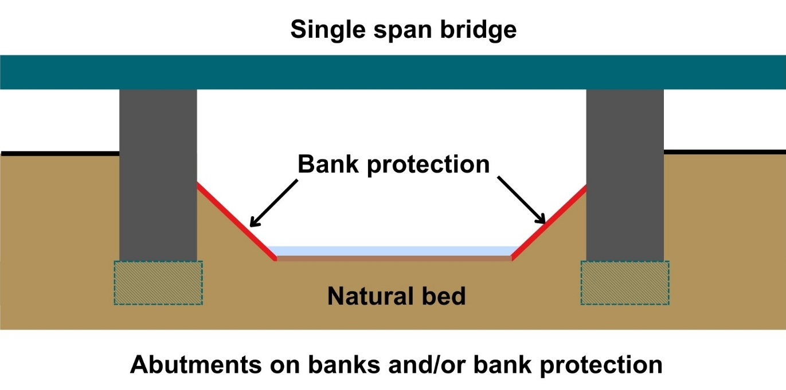

**Figure 1: Clear span bridge with bank works**

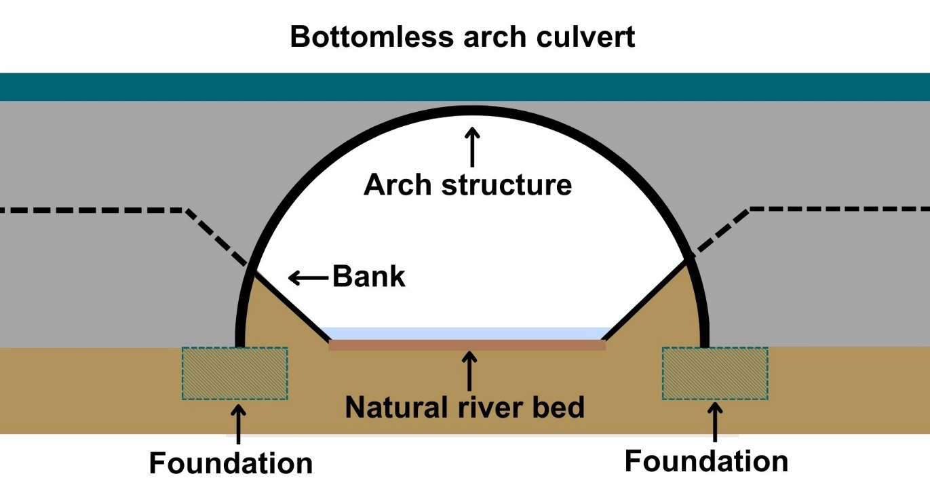

**Figure 2 Bottomless arch culvert**

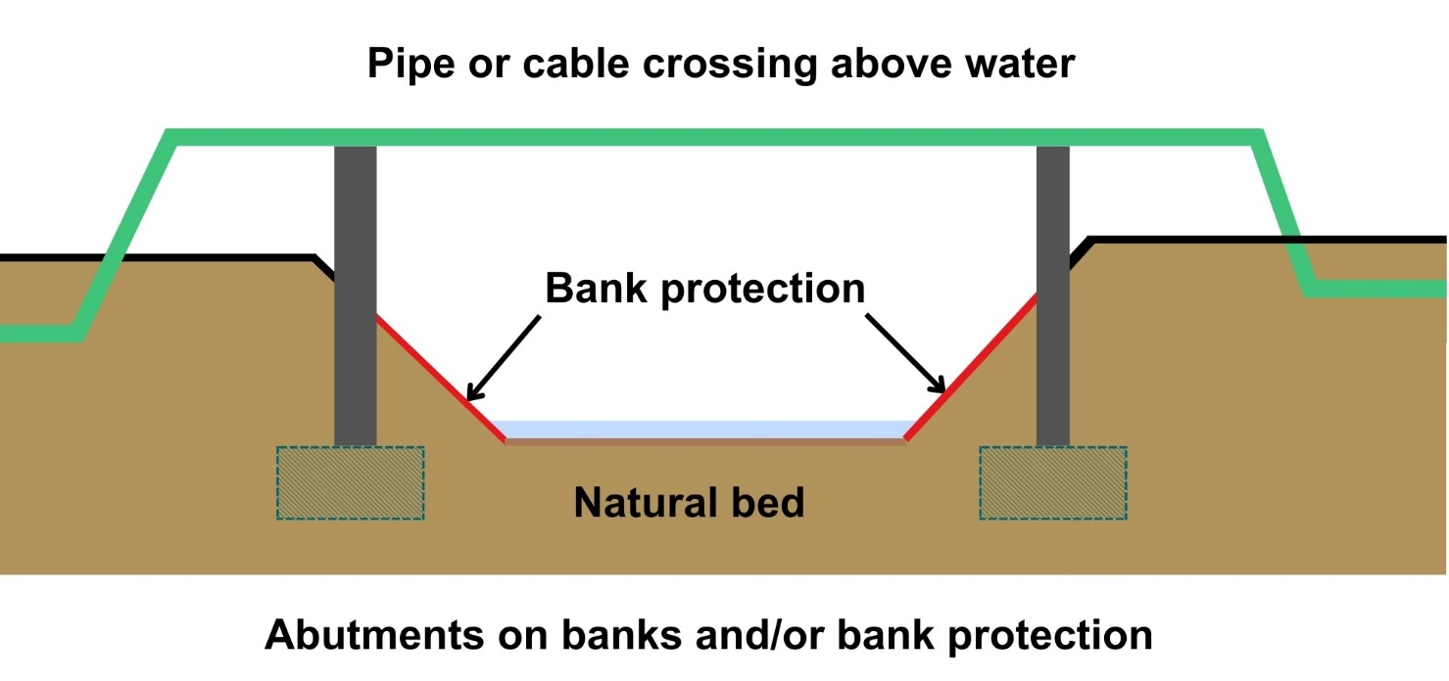

**Figure 3 pipe or cable crossings installed above the bed with bank works/protection using a single span bridge**

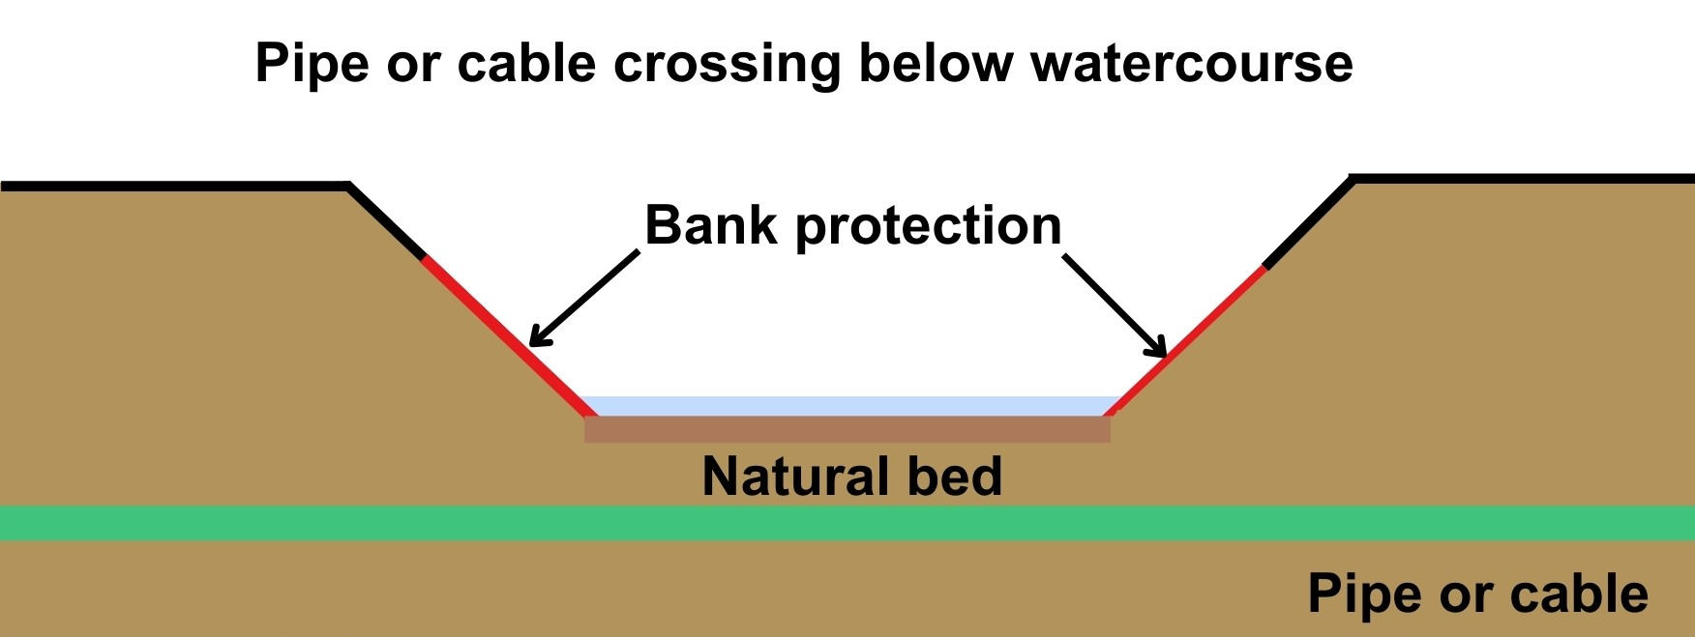

**Figure 4 pipe or cable crossings installed below the bed with bank works/protection**

## Key parts of a watercourse and loch

Figures 4 and 5 show the key parts of a watercourse and loch. and explained in the Glossary

Diagram showing key parts of a watercourse. 
Parts shown and explained in the Glossary are:
Bank; bank top; bank toe; channel; bed; bed width; exposed sediment; left bank; right bank; wetted part; riparian zone; in the vicinity and beyond the vicinity.  

**Figure 4: Key parts of a watercourse:**

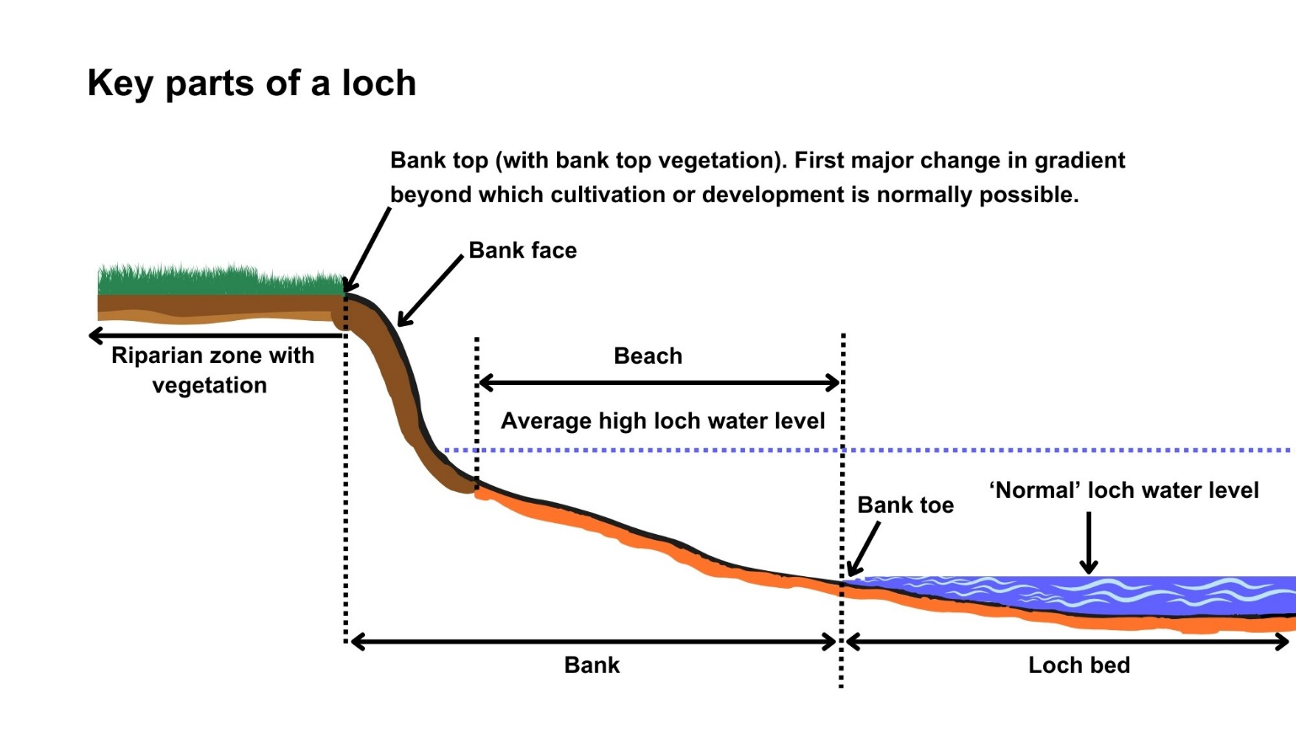

**Figure 5: Key parts of a loch**

# Understanding and minimising risks to the water environment

Installing a crossing and any associated construction works can cause harm to the water environment. It is important to carefully consider your design and construction options to ensure risks to the water environment and other users are minimised and that you fully comply with your standard conditions.

 Good practice should be followed in undertaking this activity to ensure environmental harm is minimised, design is sustainable long-term and maintenance requirements are low. To achieve good practice, you should minimise the footprint of the activity and should consider the natural character and processes of the area you are working.

When considering the design, construction and reinstatement of the crossing you should:

1. Consider the need. Is a new crossing really needed? Can an existing crossing be used/upgraded?
2. Consider the characteristics of the watercourse being crossed. Is the location selected suitable for a river crossing? Might river processes lead to damage to the structure and/or damage to the river in future?
3. Identify a range of options and selected the best option.
4. Ensure that the final design and construction of the crossing:

* does not alter the existing bank height,
* does not alter the existing bed width,
* allows fish other wildlife, sediment and floating debris (that might be carried along the river during high flows), to easily pass through without acting as a barrier
* takes into account anticipated increases in flow, erosion and deposition as a result of climate change.

1. Plan and design to minimise the risks to the water environment and other users.
2. Follow the dos and don’ts listed below

Further information on crossings and sustainable design can be found in WAT-G-024 EASR Guidance: Engineering: Activity Guide Crossings.

# Risks to the Water Environment

The main risks to the water environment from carrying out this activity can be grouped as follows:

* **Harm to fish**
  + including impacts on fish migration, spawning and fry development, loss of habitat and direct impacts such as stranding or physical damage. For more information see WAT-G-032 EASR Guidance: Fish Protection.
* **Physical Impacts & Pollution**
  + Physical impacts to the bed and banks of the watercourse which can lead to instability resulting in increased erosion or deposition, loss of habitats and increased flood risk.
  + Pollution from sedimentation, leaking oil from machinery and the entry of potentially polluting materials into water such as unset concrete.

Further information on construction works and mitigation can be found in WAT-G-034 EASR Guidance: Construction works and silt/pollution mitigation.

* **Habitats and Species Protection**
* spread of invasive non-native species. Further guidance can be found in EASR-G-001: Invasive non-native species (INNS)
* impacts onspecies such as freshwater pearl mussels and otter. You should contact NatureScot where your activity is in a Protected area or may impact protected species. For further information see WAT-G-008 EASR Guidance: Assessment of impact on Protected areas from inland water activities
* **Impacts to other users of the water environment.**

All the risks to the water environment detailed above will vary according to:

* the type and design of the engineering activity
* the timing of the works.
* the working methods and mitigation.
* the reinstatement methods.

To minimise risks to the water environment and to help you comply with the standard conditions for this activity, you should follow the Do’s and Don’ts below.

## Do’s and Don’ts

### Activity specific dos and don’ts

* Do provide sufficient flow capacity and design the crossing to take account of increased flows and the resulting increase in erosion, transport and deposition of sediment due to climate change.
* Do ensure the crossing allows for free passage for fish and other wildlife.
* Don’t alter the height of the bank. Heightening can increase erosion and alter flood risk.
* Don’t alter the bed width. Altering the width can alter erosion/deposition patterns and flood risk.

### General working in or near water do’s and don’ts

**Preventing Harm to Fish**

* Don’t undertake works if fish are likely to be spawning or young fish are still to emerge. In general, avoid the period between 1 October to 31 May. You should check the exact times with your local fishery board. Details are available from [Fisheries Management Scotland](https://fms.scot/#:~:text=Fisheries%20Management%20Scotland%20is%20the%20representative%20body%20for%20Scotland's%20District).
* Don’t impact fish migration.
* Do make sure all works such as temporary crossings, channel isolation or diversions, blasting, vibration or pile driving, sheet pilling or using artificial lighting at night so that fish or migrating fish are not adversely affected.
* Do carry out fish rescues, where appropriate etc.

**Preventing/ minimising physical and pollution Impacts**

* Do install and maintain suitable mitigation before, after and during the works. Including the points below.
* Do minimise the extent, location and duration of works in the wetted part of the channel or loch.
* Do keep vehicles, plant and other equipment out of water wherever possible.
* Do create and maintain a robust and secure dry working area of minimum size, where possible.
* Do minimise disturbance and reinstate banks, bed and vegetation as soon as possible.
  + Minimise vegetation removal and the area of bare earth/ exposed soil.
  + Re-seed or turf disturbed soil with native vegetation and ideally cover with biodegradable matting to provide temporary protection until vegetation is fully established.
* Don’t cause significant erosion.
* Do store all fuel, machinery and vehicles at least 10 metres from any watercourse, loch or permeable drain.
* Do have oil spill kits, drip trays and bunds on site and available to operators.
* Do prevent any pollutants entering the water environment.

**Habitats and Species Protection**

* Don’t spread invasive non-native species
* Check the banks and in water for invasive species.
* Use biosecurity measures.
* Do check what other species and habitats may be affected (e.g. otter).
* Don’t harm freshwater pearl mussels.

**Other Water Users**

* Do consider the potential impacts on other water users e.g. water supplies, fishing, kayaking etc.

# Glossary

Terms used in this guidance and supporting diagrams are explained below:

**Arch culvert** is a type of crossing that typically has a steel, concrete or masonry arch or semi-circular shape that is supported on foundations on one or both banks. No part of the structure (including the foundations) is on or under the bed.

**Bank** is the side of a watercourse or loch between and including the bank toe and bank top.

**Bank Height** is the height of the bank of a watercourse or loch measured vertically from the bank toe to the bank top, including any artificial heightening of the bank (e.g. embankments, retaining walls).

**Bank Toe** is the lowest point on the bank of a watercourse or loch, where the bank meets the bed of the watercourse or loch.

**Bank Top** is the first major break in slope in the bank or any watercourse or loch.

* This is considered the point beyond which cultivation or development is normally possible. Where there is no clear break in slope the bank top is considered to be the height of the average annual flood level in a watercourse,
* in relation to lochs where there is no clearly definable bank zone the bank top is the line along which terrestrial vegetation is present (this often equates to the average high-water level in a loch).

**Bank reprofiling** is any alteration of the slope of the bank of a river, burn, ditch or loch.

**Bank works** are any works on the bank between and including the bank top and the bank toe.

**Beach** is lower part of the bank of a loch (note in some cases the beach may form all of the bank)

**Bed of watercourse** is the base of the watercourse, between the toe of one bank and the toe of the opposite bank.

**Bed of loch** is the base of the loch extending from the deepest part of the loch to the edge of the ‘normal’ loch water level.

**Bed width** means the straight-line distance between the opposite bank toes of a river, burn or ditch, and which spans the bed of the river, burn or ditch, including any exposed sediment bars and vegetated islands.

Bed width can be measured as an average along the length of the stretch to be worked or can be based on one measurement of a width that is representative of the stretch.

**Beyond the vicinity** is the zone that exists beyond the “in the vicinity” zone away from the watercourse or loch.

**Bridge** is aspan structure used for crossing a watercourse or loch. The structure can sometimes be supported on piers.

**Channel** is the area between the bank top on one side of a river, burn or ditch and the bank top on the opposite side. It includes the banks and bed of a watercourse, including any exposed sediment bars and vegetated islands

**Channel width** means the straight line distance between opposite bank tops of a river, burn or ditch and which spans the bed and banks of a river, burn or ditch, including any exposed bars and vegetated islands.

**Crossing (for crossing registration activities)** meansany structure which is constructed and installed for the purpose of supporting a footpath, cycle route or transport route across any river, burn, ditch or loch or any pipe, pipeline or cable which crosses over or underneath any river, burn, ditch or loch, but excluding crossings with instream or in-loch piers, causeways , fords, temporary crossings, impounding works and culverts installed for land gain.

**High loch water level** is the average water level typically reached during wet periods.

**In the vicinity** for a watercourse this is the zone that extends away from the bank top for a distance of 10 metres or two channel widths (whichever is shorter). For a loch this is the zone that extends 10 metres away from the bank top.

**Left bank** is the left bank of a watercourse when facing downstream.

**Loch** isa body of standing inland surface water.

**Normal loch water level is** the water level that occurs for a large part of the year when the loch is not experiencing high water levels. Higher than the minimum water surface elevation.

**Portal frame culvert** is a type of crossing that consists of a rigid frame made up of a horizontal beam and two vertical columns (an upside-down U shape) supported on foundations on one or both banks.

**Protected area** means an area designated under International (Ramsar sites), European (Special Areas of Conservation and Special Protection Areas) or National (Sites of Special Scientific Interest) legislation, to provide protection of their notable natural features or biodiversity. This legislation places duties on SEPA to assess whether activities we regulate would harm these sites.

**Right bank** is the right bank of a watercourse when facing downstream.

**Riparian zone of a river** is thetransitional, semi-terrestrial area of land adjoining a river channel (including most of the riverbank) that is regularly inundated and influenced by fresh water and can influence the condition of the aquatic ecosystem (e.g. by shading and leaf litter input).

**Riparian zone of a loch** is thearea of land extending from the bank top or the limit of terrestrial vegetation and capable of directly influencing the condition of the aquatic ecosystem (e.g. by shading and leaf litter input)

**Temporary crossing** (Water Registrations and Permits) is a crossing which will be removed after the completion of the authorised activity.

**Temporary structure** (Water registrations and Permits) is a structure which will be removed after the completion of the authorised activity.

**Wetted part** is the part of any watercourse or loch that is wet while carrying out works in a watercourse or loch.

# Disclaimer

Whilst every effort has been made to ensure the accuracy of this guidance, SEPA gives no warranty, covenant or undertaking (express or implied) regarding the fitness for purpose of, or any error, omission or discrepancy in this guidance. Reliance on its contents and the contents of any websites that are linked to or from this guidance is entirely at the user’s own risk. SEPA is not liable for any loss or damage that may come from using this guidance. This includes:

* any direct, indirect and consequential losses
* any loss or damage caused by civil wrongs, breach of contract or otherwise

SEPA reserves the right to depart from this guidance and take appropriate action as it considers necessary or appropriate. Operators are responsible for ensuring that they are compliant with the law. If necessary, independent legal / specialist advice should be sought.