


SEPA annual statement: Public Services Reform (Scotland) Act 2010
2024/25
February 2026

Contents
Introduction 2
Payments with a value more than £25k 4
Staff paid more than £150,000 per annum 15
Shared services 15
Sustainability 16
Net zero SEPA 16
National Performance Framework - Our contribution to Sustainable Development Goals 17
Efficiency 18

Introduction
Under the Public Services Reform (Scotland) Act 2010 we have, along with other public bodies in Scotland, a duty to publish annual public statements relating to our expenditure in the following areas:
- Public relations
- Overseas travel
- Hospitality and entertainment
- External consultancy
There are further duties to publish certain information relating to the purchasing of goods, the remuneration of employees, and the steps we have taken to improve efficiency, effectiveness, and economy in our performance as well as the promotion of sustainable growth. This statement covers the period April 2024 - March 2025.
Table 1: Public relations
 | 2024/25
Communications and marketing | £1,282,074
Digital communications | £48,581
Employee engagement and public affairs | £13,746
Advertising | £76,644
Total | £1,421,044

Public relations costs reflect the total cost of communications for SEPA incurred in the promotion or publicity of SEPA or the services it provides.

Table 2: Overseas travel
 | 2024/25
Flights/Rail | £5,087
Hotels | £22,247
Expenses | £773
Conference costs | £0
Total | £28,107

The above costs include travel to and from the UK; the full cost of travel in connection with the trip from departure until return, and not simply the cost of the journey itself.

Table 3: Hospitality and entertainment
 | 2024/25
Hospitality | £0
Catering | £7,824
Room hire including catering | £20,274
Gifts | £235
Total | £28,333

Hospitality and entertainment includes any gifts, meals, receptions accorded by a public body to its members or employees or third parties for whatever reason. The payment of travel and subsistence allowances and the reimbursement of expenses that are reasonably incurred in relation to service as a member or employee of a public body are excluded.
Hospitality includes the cost of receptions, and events. Catering includes the provision of lunches and refreshments for meetings and training on or offsite.
Table 4: External consultants
 | 2024/25
Flood | £172,994
Organisation/Corporate | £192,575
Total | £365,569

.

Scottish Government guidance on consultancy used a definition of ‘external consultancy’ as “Investigating problems, providing analysis or advice, or assisting with the development of new systems, new structures or new capabilities within the organisation”. The main areas of spend within this area include assistance with a review of flood defence assets, development of a fleet strategy and the creation of a new job evaluation service, stakeholder engagement and research and development work.

Payments with a value more than £25k
Payments include all individual payment transactions, including payments for goods and services, grants or grant-in-aid to third parties and transactions with government departments or other public bodies. It does not however include information relating to remuneration or other payments made to an individual in relation to their service as a member or employee of a public body (including office holders and company directors or secretaries), such as salary, bonuses, allowances, fees, pension, voluntary severance, compromise agreements or redundancy payments. The below table provides a full list of individual transactions in excess of £25,000, in alphabetical order of account name.

Table 5: Payments over £25k
Account | Supplier | Amount £
Air Emissions Audit Monitoring | Socotec UK limited | 25,069
Computer Hardware PC's | HP Inc UK Limited | 32,602
Computer Hardware Peripherals | HP Inc UK Limited | 29,083
Computer Hardware Peripherals | HP Inc UK Limited | 68,201
Computer Hardware Peripherals | Softcat plc | 31,812
Computer Hardware Servers | Computacenter (UK) Ltd | 87,376
Computer Hardware Servers | Pulsant (South Gyle) Limited | 264,433
Computer Hardware Servers | Pulsant (South Gyle) Limited | 49,089
Computer Hardware Servers | Pulsant (South Gyle) Limited | 30,303
Consultancy Fees | Gartner UK Limited | 81,720
Consultancy Fees | Jacobs U.K. Limited | 26,607
Consultancy Fees | KPMG LLP | 72,000
Dilapidations | Carswell Properties Ltd | 30,000
Dilapidations | Kenman Holdings Limited | 35,000
Electricity | EDF Energy | 53,447
Electricity | EDF Energy | 55,891
Electricity | EDF Energy | 55,269
Electricity | EDF Energy | 53,055
Electricity | EDF Energy | 51,281
Electricity | EDF Energy | 52,260
Electricity | EDF Energy | 52,275
Electricity | EDF Energy | 57,505
Electricity | EDF Energy | 60,131
Electricity | EDF Energy | 27,274
Electricity | EDF Energy | 30,181
Electricity | EDF Energy | 61,838
Electricity | EDF Energy | 31,417
Electricity | EDF Energy | 61,756
Electricity | EDF Energy | 25,529
Electricity | EDF Energy | 53,340
Equipment Maintenance/Contract | Bruker UK Limited | 42,911
Equipment Maintenance/Contract | CEFAS | 95,400
Equipment Maintenance/Contract | CEFAS | 95,400
Equipment Maintenance/Contract | Thermo Fisher Scientific | 62,511
Equipment Purchase | Agilent Technologies LDA UK Limited | 46,081
Equipment Purchase | Bruker UK Limited | 867,120
Equipment Purchase | Computacenter (UK) Ltd | 58,391
Equipment Purchase | Computacenter (UK) Ltd | 31,996
Equipment Purchase | Coptrz Ltd | 38,399
Equipment Purchase | Gasmet Technologies (UK) Limited | 95,552
Equipment Purchase | JBA Consulting | 90,260
Equipment Purchase | Kisters AG | 89,124
Equipment Purchase | Kisters AG | 89,124
Equipment Purchase | LECO Instruments (U.K.) Ltd | 47,400
Equipment Purchase | Scientific Laboratory Supplies Limited | 31,609
Equipment Purchase | SciQuip Limited c/o Calibre Scientific | 34,702
Equipment Purchase | SciQuip Limited c/o Calibre Scientific | 32,815
Equipment Purchase | SciQuip Limited c/o Calibre Scientific | 29,652
Equipment Purchase | SciQuip Limited c/o Calibre Scientific | 55,781
Equipment Purchase | SciQuip Limited c/o Calibre Scientific | 28,624
Equipment Purchase | SciQuip Limited c/o Calibre Scientific | 72,184
Equipment Purchase | Shimadzu UK Limited | 39,600
Equipment Purchase | SKALAR Analytical | 65,203
Equipment Purchase | SKALAR Analytical | 65,907
Equipment Purchase | Valley Group Limited | 31,035
Equipment Purchase | Vodafone Corporate Ltd | 33,631
Equipment Purchase | Wolf Laboratories Ltd | 27,262
Equipment Purchase | Wolf Laboratories Ltd | 38,095
Equipment Purchase | Xylem Water Solutions UK Ltd | 69,926
Equipment Purchase | Xylem Water Solutions UK Ltd | 28,894
Equipment Purchase | Xylem Water Solutions UK Ltd | 45,180
Equipment Purchase | Xylem Water Solutions UK Ltd | 45,587
EUTS Registry Recharge | Environment Agency | 49,729
External Audit Fee | Audit Scotland | 25,670
External Audit Fee | Audit Scotland | 26,167
General Advertising | Republic of Media Limited | 33,209
Hydrological Supplies | OTT HydroMet Ltd | 31,851
Hydrological Supplies | Wallingford Hydro Solutions Ltd | 26,741
Insurance Running Costs | James Hallam Limited T/A James Hallam Corporate | 34,580
Legal Contingency | West Fraser Europe Ltd | 220,000
Licences | UK CEH Enterprise Limited | 63,090
Licences | ESRI (UK) Ltd | 28,248
Licences | ESRI (UK) Ltd | 35,083
Licences | ESRI (UK) Ltd | 28,034
Maintenance Contracts -Hardware | Insight Direct UK Limited | 297,950
Maintenance Contracts -Hardware | Pulsant (South Gyle) Limited | 39,824
Met Office Supplies | Meteorological Office | 113,135
Met Office Supplies | Meteorological Office | 113,135
Met Office Supplies | Meteorological Office | 113,135
Met Office Supplies | Meteorological Office | 113,135
Mobile Phones | Vodafone Corporate Ltd | 41,115
Partnership Project Contributions | Aberdeen City Council | 250,000
Partnership Project Contributions | DEFRA | 25,908
Partnership Project Contributions | Dumfries & Galloway Council | 600,000
Partnership Project Contributions | Dundee City Council (City Development) | 100,000
Partnership Project Contributions | Dundee City Council (City Development) | 525,000
Partnership Project Contributions | Edinburgh and Lothians Greenspace Trust | 215,000
Partnership Project Contributions | Fife Council | 78,750
Partnership Project Contributions | Fife Council | 350,000
Partnership Project Contributions | Glasgow City Council (Funding/Grants) | 100,000
Partnership Project Contributions | Glasgow City Council (Funding/Grants) | 1,200,000
Partnership Project Contributions | Glasgow City Council (Funding/Grants) | 85,000
Partnership Project Contributions | Green Action Trust | 135,000
Partnership Project Contributions | Renfrewshire Council | 100,000
Partnership Project Contributions | Tweed Forum | 150,000
Partnership Project Contributions | Tweed Forum | 150,000
Partnership Project Contributions | Tweed Forum | 318,298
Partnership Project Contributions | Tweed Forum | 100,000
Professional Fees | Environment Agency | 209,681
Professional Fees | HaskoningDHV UK Limited | 59,092
Professional Fees | HaskoningDHV UK Limited | 35,768
Professional Fees | Socotec UK limited | 35,910
Professional Services | Adaptovate Ltd | 43,200
Professional Services | Adaptovate Ltd | 99,120
Professional Services | BDO LLP | 56,280
Professional Services | BDO LLP | 27,299
Professional Services | Chatter Communications Limited | 55,080
Professional Services | Computacenter (UK) Ltd | 373,664
Professional Services | Computacenter (UK) Ltd | 392,348
Professional Services | The Scottish Government | 41,323
Professional Services | The Scottish Government | 53,772
Professional Services | The Scottish Government | 74,999
Professional Services | The Scottish Government | 72,641
Professional Services | The Scottish Government | 71,490
Professional Services | The Scottish Government | 74,133
Professional Services | The Scottish Government | 40,978
Professional Services | The Scottish Government | 45,779
Professional Services | The Scottish Government | 32,784
Professional Services | The Scottish Government | 48,497
Professional Services | Health & Safety Executive | 31,000
Professional Services | The Union Advertising Agency Ltd | 38,154
Property Maintenance | David Hardie Engineering Ltd | 46,787
Property Maintenance | McLaren Plant Ltd | 63,632
Property Maintenance | Mitie Technical Facilities Management Limited | 55,749
Property Maintenance | Mitie Technical Facilities Management Limited | 26,194
PRW Monitoring Recharge | Environment Agency | 291,207
Rates | Aberdeen City Council (Business Rates) | 234,221
Rates | Highland Council (Rates) | 44,690
Rates | North Lanarkshire Council - Rates | 278,382
Rates | Stirling Council / No 7 Rates A/C. | 153,725
Rent | Knight Frank LLP | 95,038
Rent | Knight Frank LLP | 95,038
Rent | Knight Frank LLP | 95,038
Rent | Knight Frank LLP | 107,527
Rent | Shelborn Asset Management Limited | 207,075
Rent | Shelborn Asset Management Limited | 207,075
Rent | Shelborn Asset Management Limited | 207,075
Rent | Shelborn Asset Management Limited | 207,075
Rent | The City of Edinburgh Council | 89,400
Repairs | CBRE Managed Services Ltd | 175,902
RS Monitoring Non-Recoverable | University of Stirling | 38,635
RSA Monitoring Recoverable | Food Standards Agency | 39,522
RSA Monitoring Recoverable | UK Health Security Agency - CRCE (Glasgow) | 104,477
RSA Monitoring Recoverable | UK Health Security Agency - CRCE (Glasgow) | 104,477
RSA Monitoring Recoverable | UK Health Security Agency - CRCE (Glasgow) | 96,471
RSA Monitoring Recoverable | UK Health Security Agency - CRCE (Glasgow) | 109,701
RSA Monitoring Recoverable | University of Stirling | 37,583
RSA Monitoring Recoverable | University of Stirling | 33,333
RSA Monitoring Recoverable | University of Stirling | 37,636
Service Charge | Knight Frank LLP | 25,799
Software - Business | British Telecommunications Plc | 90,000
Software - Business | British Telecommunications Plc | 252,800
Software - Business | British Telecommunications Plc | 72,000
Software - Business | CDSM Interactive Solutions Ltd | 35,994
Software - Business | eCom Learning Solutions TA eCom Scotland Ltd | 28,692
Software Maintenance - Business | BlueLight Commercial Limited | 43,758
Software Maintenance – Business | Deltares | 67,345
Software Maintenance - Business | Insight Direct UK Limited | 59,467
Software Maintenance – Business | Insight Direct UK Limited | 61,518
Software Maintenance – Business | Jacobs U.K. Limited | 33,096
Software Maintenance – Business | Kisters AG | 63,866
Software Maintenance - Business | Revvity Signals Software Inc. | 75,230
Software Maintenance – Business | UK centre for Ecology and Hydrology (UK CEH) | 30,346
Software Maintenance – Business | Unit4 Business Software Limited | 63,778
Software Maintenance – Business | Unit4 Business Software Limited | 181,575
Software Maintenance – IS | Computacenter (UK) Ltd | 25,602
Software Maintenance – IS | Computacenter (UK) Ltd | 27,855
Software Maintenance – IS | Computacenter (UK) Ltd | 34,119
Software Maintenance – IS | Computacenter (UK) Ltd | 64,650
Software Maintenance – IS | Computacenter (UK) Ltd | 73,006
Software Maintenance – IS | ESRI (UK) Ltd | 203,538
Software Maintenance – IS | ESRI (UK) Ltd | 203,538
Software Maintenance – IS | Halo | 42,084
Software Maintenance – IS | Halo | 43,347
Software Maintenance – IS | Halo | 43,347
Software Maintenance – IS | HP Inc UK Limited | 43,520
Software Maintenance – IS | I-KONIC Limited | 108,618
Software Maintenance – IS | Insight Direct UK Limited | 65,232
Software Maintenance – IS | Insight Direct UK Limited | 62,943
Software Maintenance – IS | Insight Direct UK Limited | 60,876
Software Maintenance – IS | Mason Advisory Limited | 61,095
Software Maintenance – IS | Quorum Cyber Security Limited | 179,593
Software Maintenance – IS | Softcat plc | 1,053,637
Software Maintenance - IS | Softcat plc | 88,539
Software Maintenance - IS | Softcat plc | 35,610
Subcontracted Work | Hennessy IT Consulting Limited | 31,608
Subcontracted Work | JBA Consulting | 53,983
Subscriptions | Haymarket Media Group Ltd | 25,997
Sundries/Miscellaneous | JBA Consulting | 25,588
Survey Vessel Hire | The Scottish Government | 34,486
Survey Vessel Hire | The Scottish Government | 41,582
Survey Vessel Hire | The Scottish Government | 46,557
Survey Vessel Hire | The Scottish Government | 26,156
Telephone | Environment Agency | 43,301
Telephone | Environment Agency | 46,384
Training | Hydro International Data, Insight and Analysis Ltd | 26,962
Unfunded Pension Provision | Strathclyde Pension Fund | 28,097
Total |  | 20,720,254

Staff paid more than £150,000 per annum
None.

Shared services
In the financial year 2024/25, SEPA provided accommodation and reception services at several of our buildings. We received a total contribution of £157,258 from the following organisations:
- NatureScot, locations: Aberdeen, Stirling, and Ayr.
- Joint Nature Conservation Committee (DEFRA), location: Aberdeen.
In the financial year 2024/25, we contributed a total of £453,312 towards the costs of eight buildings. This included:
- £218,924 to the Scottish Government for accommodation in Perth and Thurso.
- £31,680 to NatureScot for accommodation in Newton Stewart and Dingwall.
- £47,723 to Loch Lomond and The Trossachs National Park Authority.
- £63,323 to the Department for Work and Pensions (DWP) for Shetland.
- £14,000 to the Scottish Children’s Reporter Administration for Lochgilphead.
- £88,271 to the City of Edinburgh Council to co-locate at Waverley Court, Edinburgh.

Sustainability

Net zero SEPA
Our ambition is to be net zero in our emissions. We have adopted and are implementing a Route Map (covering the period 2024-2026), which sets ambitious but realistic targets and will guide our work to further reduce our emissions. It also resets our direct emissions baseline to 2022/23 when they were 1,742 tCO2e and sets a target to reduce them by 15% over the route map lifetime.

Our net zero routemap on a page
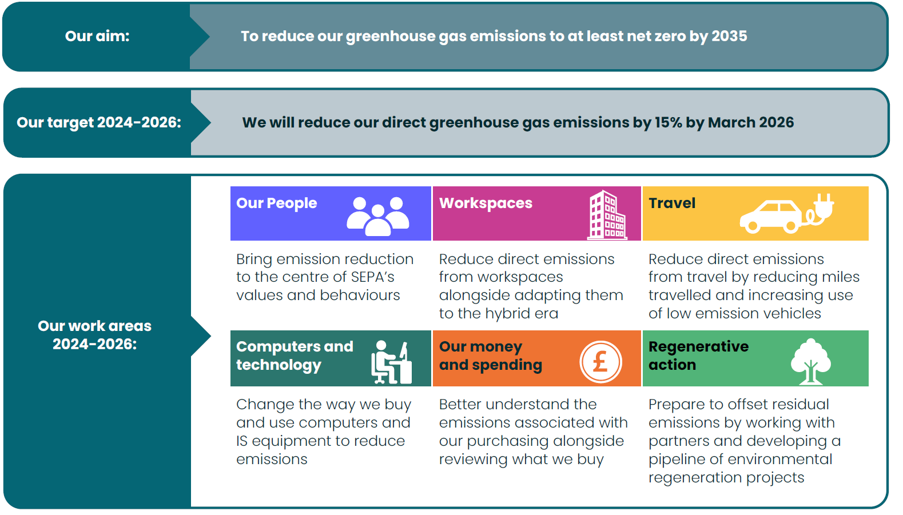

National Performance Framework - Our contribution to Sustainable Development Goals
Our work is integrated with environment goals set by Scotland and internationally. The 2030 Agenda for Sustainable Development, adopted by all United Nations member states in 2015, provides a shared blueprint for peace and prosperity for people and the planet, now and into the future.
We are dedicated to contributing to the ambitions of the United Nations 17 sustainable development goals and the National Performance Framework for Scotland.
The National Performance Framework sets out 11 national outcomes and explains which sustainable development goals each outcome contributes to. The examples on the following page show how our work helps deliver five of the national outcomes and nine sustainable development goals.

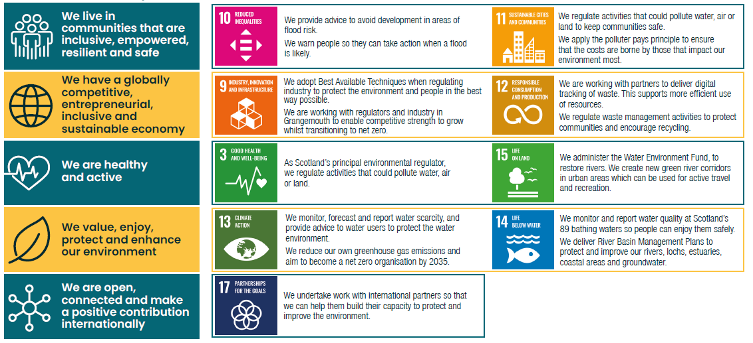
Sustainable Development Goals and how we live them

Efficiency
The Scottish Government sets efficiency savings targets for public bodies each year. We must identify how to make these savings in order to achieve a balanced budget in future years. This year we met our target of identifying organisational efficiencies of at least 3% of our grant-in-aid funding. The 2024/25 budget was balanced using non-recurring staff vacancy savings. Our annual expenditure was within the resource budget set by Scottish Government.

We have adopted and aligned with the Scottish Government’s procurement benefits reporting. In 2024/25 the organisational efficiencies achieved as a result of procurement activity equated to 6.6% of our contract spend with £937,351 cash savings and £855,994 non-cash savings realised.

If you would like this document in an accessible format, such as large print, audio recording or braille, please contact SEPA by emailing equalities@sepa.org.uk

