


Marine pen fish farm seabed mixing zone: compliance assessment methodology
September 2026

Introduction

This document explains how the seabed mixing zone compliance is assessed. This information is provided for fish farm operators and other interested parties.

SEPA assesses the mixing zone compliance following the authorisation of a fish farm and the subsequent collection and submission of survey data.

Further information on designing monitoring survey and provision of data is detailed in Designing an Environmental Monitoring Plan.

Assessment

To assess mixing zone compliance, we compare the size of the permitted mixing zone against the estimated area of impact.

Permitted mixing zone

The permitted mixing zone is the area in which the seabed is permitted to be below environmental standards.

It is equivalent to size of the non-overlapping area lying within 100 metres of pens in all directions.

The permitted area scales depending on the pen dimensions, the number of pens comprising the farm, and their respective positioning (see Figure 1). Therefore, the permitted area may vary; large farms have larger permitted areas and small farms, smaller permitted areas.

Figure 1: A farm’s permitted mixing zone, based on a 100 m buffer projected from pen edges
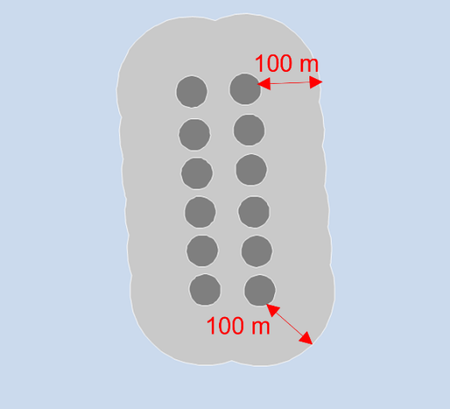

Standards

Chemical or biological standards used to assess compliance are provided in the farm’s permit. These standards are Emamectin benzoate measured in nanogram per kg (ng/kg) or Infaunal Quality Index (IQI) ratio.

IQI results can be based on Infaunal analysis or bacterial eDNA predicted IQI values.

Monitoring data

The monitoring requirements are set out in Designing an Environmental Monitoring Plan. This usually consists of four transects, each comprised of a minimum of seven sampling stations, radiating out from the fish farm in different directions.

The mixing zone compliance may also be assessed in circumstances where a reduced number of stations or transects have been sampled or where the permitted mixing zone consists of multiple pen groups.

Estimate the area of impact

SEPA uses an R package to calculate the estimated area of impact.

There are two methods used to estimate the area of impact:
- Interpolate values from each station along a transect to estimate the distance the standard is reached.
- Reduced Analysis Rule – Use the distance to the first of two consecutive stations reaching the compliance standard.

The reduced analysis rule is automatically used, rather than interpolation in cases where:
    - insufficient stations have been analysed to interpolate values; or
    - sufficient stations have been analysed, but the model used for interpolation is of insufficient quality to use.

The two methods used to estimate the area of impact are described in more detail in the following sections.
Figure 2: The estimated area of impact, based on monitoring data. Note that the area of impact may be offset from the farm’s centre
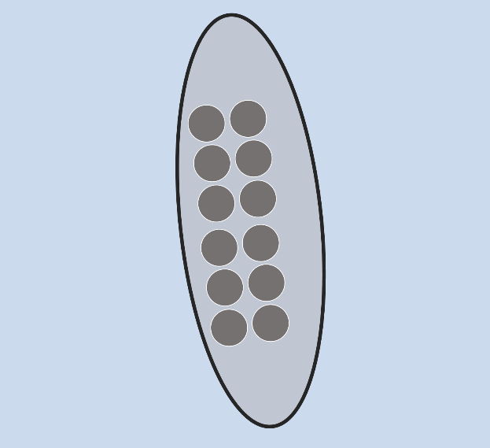

Interpolation

The interpolation approach can be used by collecting sampling data along a minimum of four transects, each comprised of a minimum of seven stations.

The limited number of stations means that the estimate of this distance will be uncertain, to some extent. To allow us to measure the uncertainty, multiple non-linear regressions are fitted to determine a plausible range of distances at which values pass the quality standard. We then use this range of distances to provide a measure of uncertainty.

The distance to compliant status along each of the transects are used to infer the shape of the area of impact. The simplest and most flexible assumption for this shape is an ellipse. The ellipse is consistent with the view that a farm’s discharge may be expected to spread further along the axis of the tidal flow rather than perpendicular to the flow.

The final step is to take the fifth percentile (P_{5%}) of the predicted distributions of distances/spatial positions along each transect where the standard is reached and construct an ellipse enclosing these positions. Such an ellipse is known as a minimum spanning ellipse. We then calculate the area of the ellipse to use as an estimated area of impact.

The P_{5%} statistic is consistent with SEPA being 95% confident that a site has failed, before classing it as failing.

A farm is non-compliant with the mixing zone standard when the estimated area of impact exceeds the permitted mixing zone.

Section 3 (the technical description) describes the interpolation method in greater detail.

Reduced analysis

The reduced analysis rule is used when provided with fewer than six monitoring stations (excluding pen edge station) on the transect but includes a minimum of two monitoring stations at sufficient quality.

The reduced analysis rule method will normally produce a greater distance to passing standard than the interpolation method and we expect the area of impact to be precautionary.

Technical description

This section provides detailed description of how the R package follows four key steps to estimate the area of impact:

Geospatial

This step calculates geospatial information for each transect which is used later in the method.

The calculated fields include:
- The bearing is calculated for each transect in the direction from the pen edge station to the averaged coordinates of the remaining stations
- Distances of each station from pen edge
- Spatial separation between stations.

Distances

The goal of this step of the process is to use the monitoring data to estimate the distance along each transect at which the environmental standard is attained. These distances are used later in the method to quantify a farm’s area of impact.

Although it may be reasonable to assume that true value changes monotonically with distance from the farm, this is not always true of real-world data since all measurements are subject to random variation.

The approach used here is to fit a non-linear model that adequately describes how the change with distance from the pen edge along each transect. Each transect is fitted separately.

This regression model can then be used to interpolate between observations and estimate the distance at which the value has reached the environmental standard.

Firstly, we calculate the distance to compliance along each transect based on the reduced analysis rule. We may use this distance in cases where the operator has explicitly chosen the reduced analysis approach to reduce analysis costs; it also acts as a useful fallback in cases where the data submitted is unsuitable for fitting regression models.

We fit an initial non-linear model to the data for reference purposes. We may supersede this first attempt later in the process. Note, we use the DRC package to fit all models used in the interpolation process.

During the fitting of the non-linear model, the step also checks if a simpler, linear regression is a better fit, this acts as an informal lack-of-fit test. Experience has shown that, for well-planned transects of appropriate length, it is highly unusual for a linear regression to out-perform a non-linear one. If it does, the package returns a warning to the output summary table.

This step then compares three alternative non-linear models to compare against each other.
Table 1: Formulation of models used. Note that x in all the parameterisations represents the distance from the pen edge.
Model | Parameterisation | Number of parameters
Shifted Michaelis-Menten | $$f\left(x\right)=c+\frac{d-c}{1+(e/x)}$$ | 3
Four-parameter logistic | $$f\left(x\right)=c+\frac{d-c}{1+exp⁡(-b\left(x-e\right))}$$ | 4
Five-parameter logistic | $$f\left(x\right)=c+\frac{d-c}{(1+exp⁡(-b\left(x-e\right)))f}$$ | 5

For the purposes of model comparison and final selection, these models are ordered using the Akaike Information Criterion (AIC) as presented in Lambert 2018. This metric is used to identify the best performing model overall.

Since it is important to balance model complexity against parsimony, the best performing model is then compared against simpler models (with fewer parameters). If a simpler model does not perform significantly worse than the best fitting one (ΔAIC ≤ 10), this model is preferred.

When trying to estimate any quantity, it is important to adequately acknowledge uncertainty. It is accepted that different ways exist to quantify uncertainty around model fits. Resampling the residuals between the best-fit curve and monitoring data is the approach favoured here. This generates a series of new datasets to which the model can be refitted. This approach has the advantage of performing well on non-linear models fitted to a relatively small number of data points, as described in Ritz et al 2008.

Within the present context, this means that rather than relying on a single best-fit estimate for the distance reaching the standard, we perform each regression multiple times on resampled data. This generates a series of curves, around the best-fit estimate (see Figure 3).

Figure 3: Approaches to interpolating between data points to determine distance(s) in this case showing where an IQI standard of 0.64 is reached. In (a), a single best-fit curve is fitted, which does not quantify the uncertainty around that fit. A single distance to IQI=0.64 is estimated (red, vertical line). In (b), the data are resampled to generate a series of curves (a spaghetti plot). These curves yield a region at which IQI is likely to reach 0.64 (grey, shaded area).
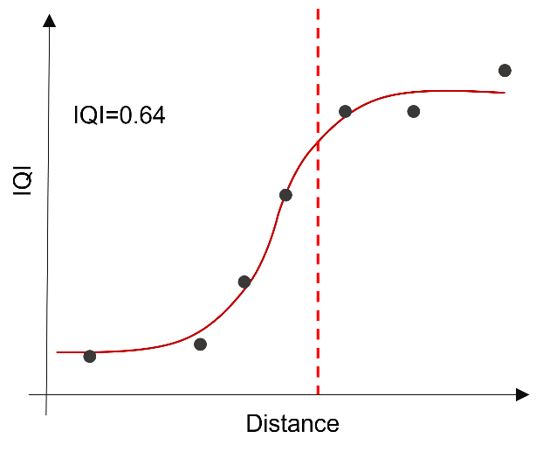 | 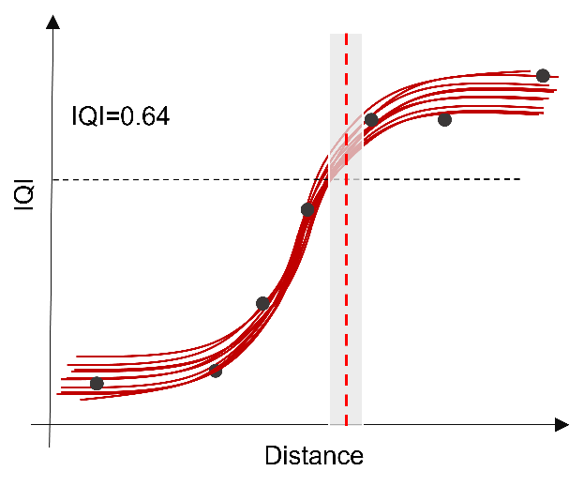
(a) | (b)

Up to a 1000 resamples attempts are made, when 500 attempts are successfully fitted to the model, an estimated distance can be modelled. If 500 resamples cannot be fitted, the model is not used. This allows the model to be fitted to 500 resamples in most situations and avoids unnecessary computation.

The distance at which the values on each of these curves reaches the standard are calculated. The result of this approach is a likelihood distribution (500 resamples) of the distance to where compliance standard is reached for each transect (see Figure 4).

Figure 4: Example of regression curves based on resampled data, and corresponding histogram of distances at where the IQI standard is reached (0.64).
 | 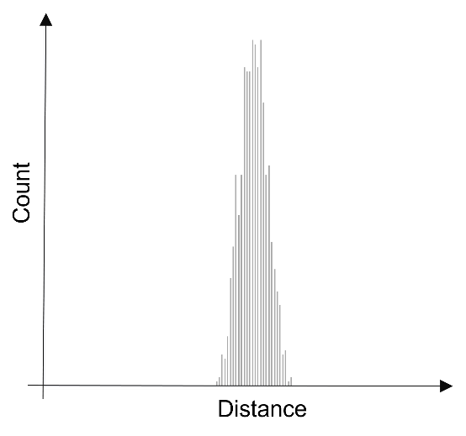
(a) | (b)

The package checks the percentage of these curves which reach the required standard. We ensure compliance and avoid ambiguity by ensuring 100% of curves reach compliance standard. If fewer than 100% of curves have reached compliance standard, we use reduced analysis rule for these transects.

For ease of visualisation and storage reasons, we summarize the resampled model fits to a single heatmap (see Figure 5), along with a distribution of estimated distances to compliance.

Figure 5: Different ways of displaying results of probabilistic regression. In (a), each curve is displayed in a spaghetti plot. In (b), these curves are distilled down to a heatmap, where each hexagon is coloured by the number of curves which pass through it.
 | 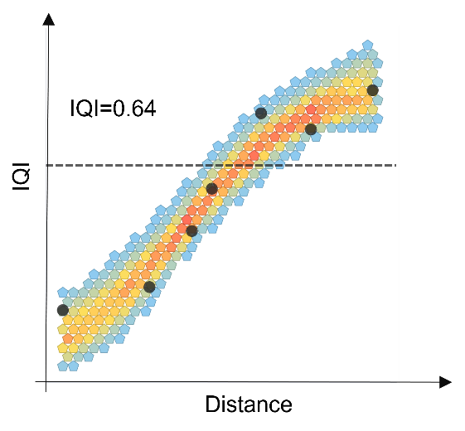
(a) | (b)

It is important to note that the number of data points used to construct these non-linear models is close to the lower limit of what is reasonable. This is a consequence of the challenges of acquiring and analysing samples. The placement of the stations must be carefully considered when the Environmental Monitoring Plan is produced.

Breach coordinates

This step takes the likelihood distributions, from the previous step, and transforms them into equivalent spatial coordinates (Figure 6).

A single set of breach coordinates is attained by projecting from the pen edge station by one of the distances to compliance along the bearing for that transect.

This is repeated for every distance to compliance which forms the likelihood distribution.

For each transect, the 5th percentile (P5%) of these distances are calculated. Consistent with SEPA being 95% confident in the estimate to breach distance.

The result is a single set of spatial coordinates indicating the P_{5%} distance from the pen edge for each transect, characterising the boundary in which the environmental standard is expected to be achieved.
Figure 6: Conversion of (a) distances to compliance into (b) corresponding spatial coordinates. Distribution of breach positions are indicated by red dots, sized by frequency.
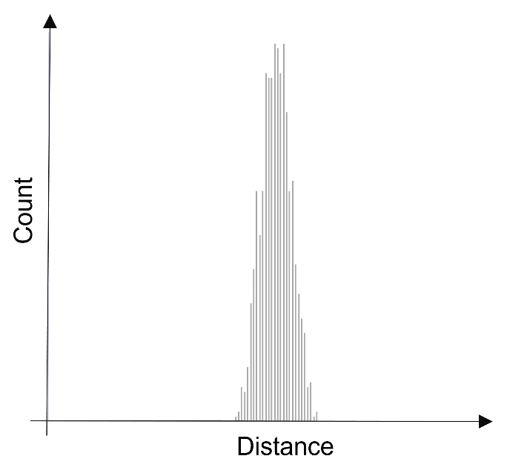 | 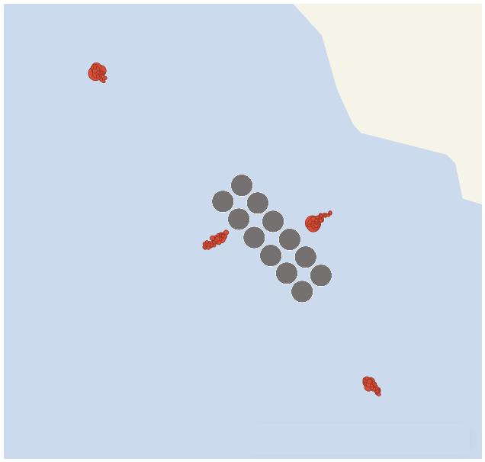
(a) | (b)

Area

The estimated breach coordinates are now used to quantify the area of impact.

This is accomplished by drawing the minimum spanning ellipse enclosing these points (Figure 7). The area of the resulting ellipse is then calculated providing an estimated area of impact.

Figure 7: Ellipse area of impact is shown, based on the best-fit regression results.
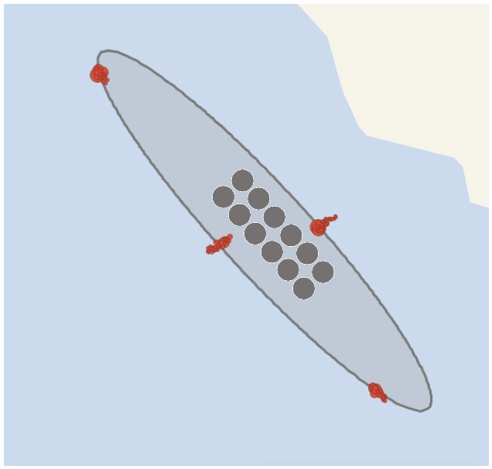

We then compare estimated area of impact against the permitted mixing zone. If this observed area is larger than what is permitted, SEPA can be confident that the site has failed to meet this standard.

Multiple pen group farms

A farm may be formed of multi-pen groups with monitoring data showing distinct areas of impact. To compare the total area of impact against the farm’s permitted mixing zone, these distinct areas of impact must be combined into single area.

To calculate an area of impact, the approach described in Section 3 can be adapted for use with multiple ellipses, such that:

Ellipses are dissolved to form a single polygon representing the combined P_{5%} estimated area of impact.

If you would like this document in an accessible format, such as large print, audio recording or braille, please contact SEPA by emailing equalities@sepa.org.uk

