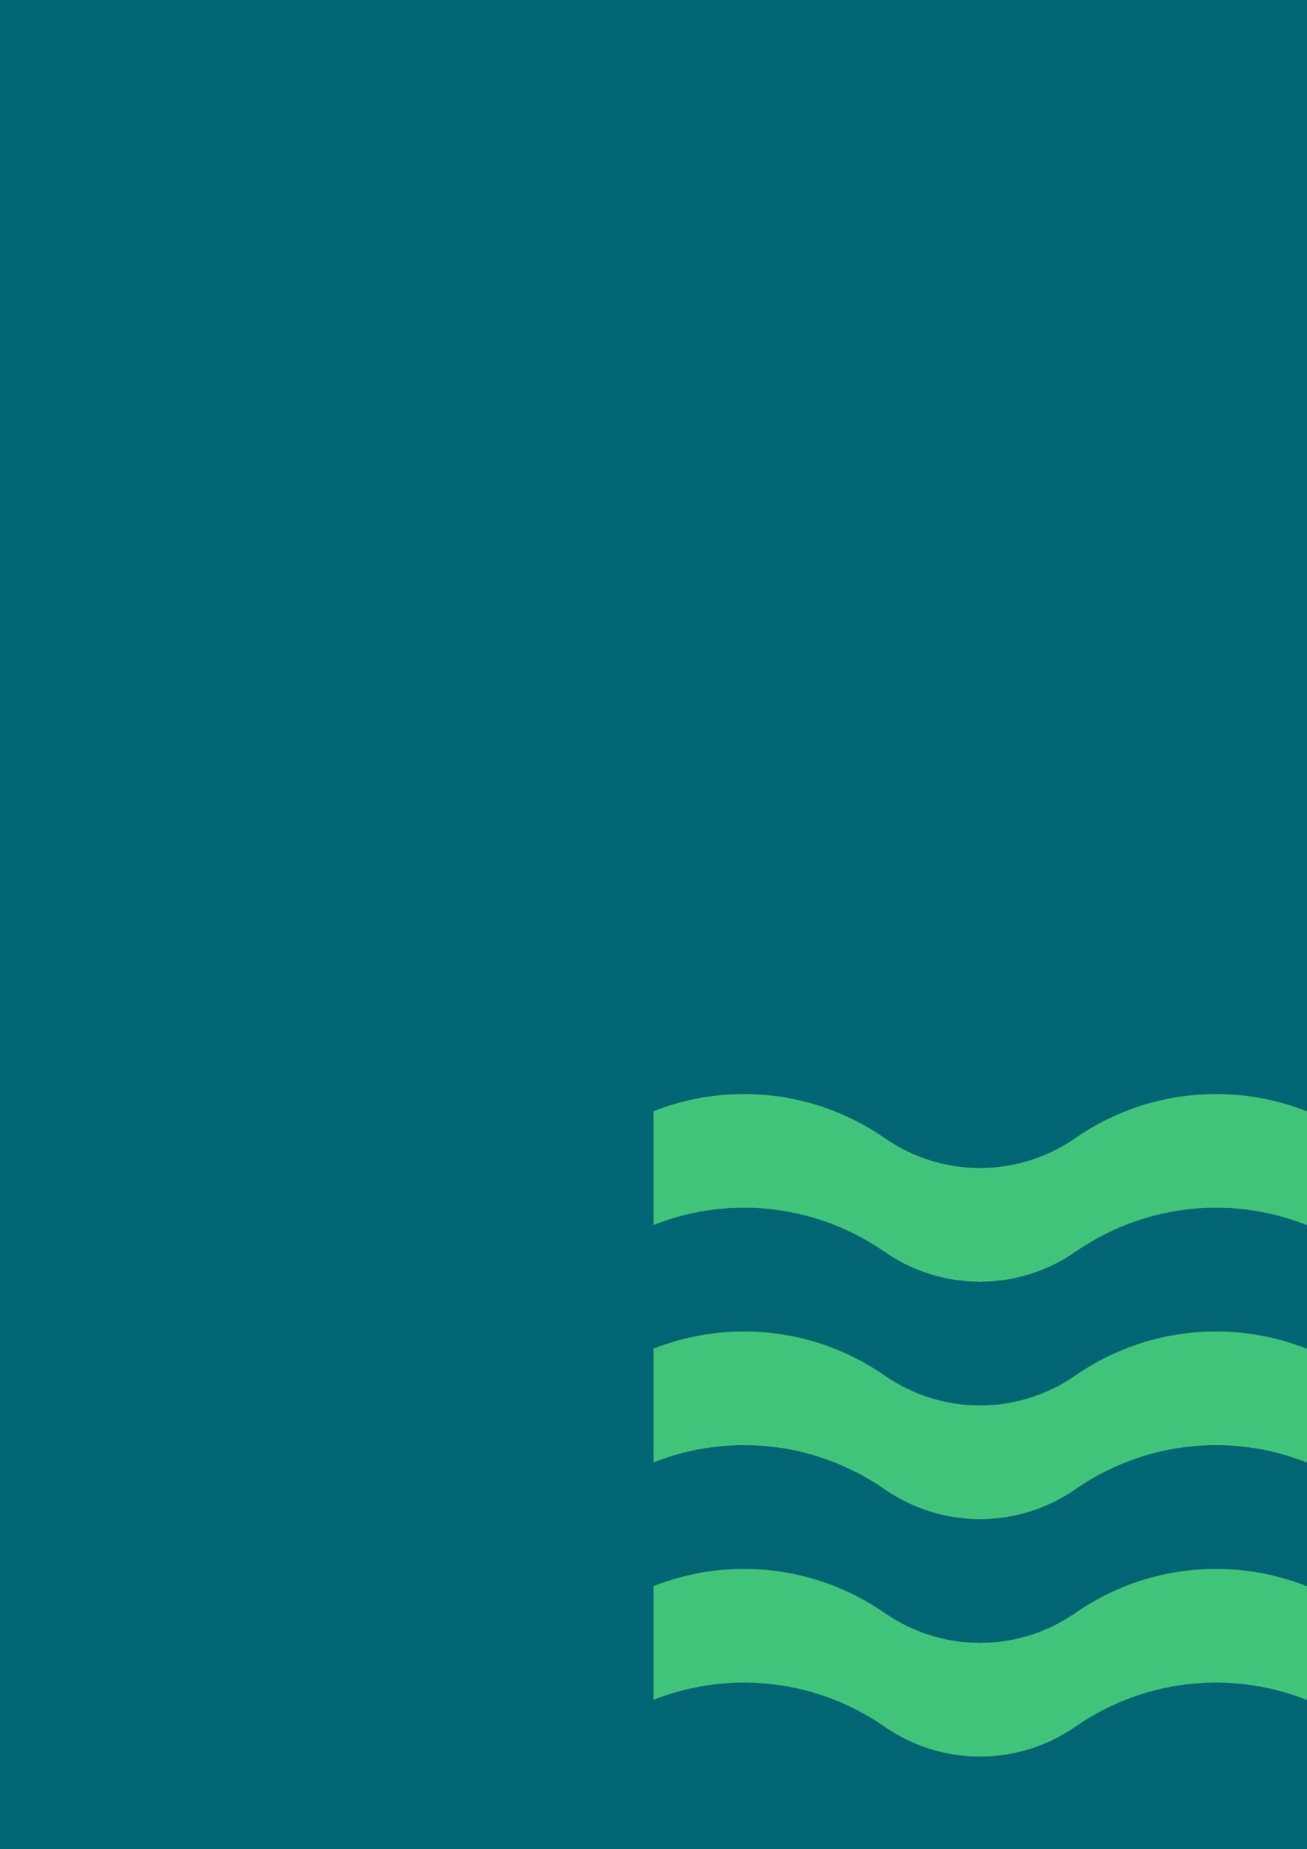


WAT-G-003

EASR Guidance Registration Activity: Abstraction from inland waters less than or equal to 50m³ per day
Version 1.0, August 2025

If you would like this document in an accessible format, such as large print, audio recording or braille, please contact SEPA by emailing equalities@sepa.org.uk

Purpose
This document provides information and guidance for anyone undertaking the abstraction of water from inland water which requires a registration under The Environmental Authorisations (Scotland) Regulations.
This guidance does not cover any other permissions that may be required.

What activity does this guidance apply to?
This guidance applies to the abstraction from inland waters granted as a registration under the Environmental Authorisations (Scotland) Regulations.

Understanding the activity
This activity covers the abstraction of water from inland waters (including wetlands, canals and lades), where the total daily volume is more than or equal to 10m³/day but is less than or equal to 50m³/day.

Understanding and minimising risks to the water environment

Risks to the water environment
The abstraction of inland water poses the following risks to the water environment:
- Drying out of rivers and wetlands.
- Changing water levels in reservoirs, leading to regular drying out of the shoreline and preventing growth of plants and fish from spawning.
- Interference to the flow of sediment, which reduces the amount of gravel available (needed by fish to spawn).
- Interference with other users of the water environment. For example, loss of dilution capacity and resulting deterioration of water quality, or loss of abstraction capacity.
- Spread of invasive non-native species
Operators should use the water in an efficient and sustainable manor. Everyone is strongly encouraged to build water resilience into their business as this can help with plans for the future. By taking the right steps now, it will ensure that river flows, loch and groundwater levels can sustain aquatic environments, while also allowing use of water for safe drinking, renewable energy and other agricultural and industrial purposes. It could also help reduce the impact of water scarcity in the future.
To minimise risks to the water environment and to help you comply with the standard conditions for this activity, you should follow the Dos and Don’ts below.

Dos and Don’ts
- Do take all reasonable steps to secure efficient and sustainable water use.
- Do regularly check your abstraction equipment to make sure it’s in good condition and fix any leaks straight away.
- Do check what other species and habitats may be affected.
- Do be aware of any protected areas (e.g. SAC’s, SSSI’s etc.).
- Do consider the potential impacts on other water users.
- Don’t spread invasive non-native species:
  - Check the banks and in water for invasive species.
  - Use biosecurity measures.
- Don’t locate your groundwater abstraction too close to another groundwater abstraction.
- Don’t block any watercourse with a dam.
- Don’t create a sump in a watercourse.

Glossary
A full list of terms is available in the main Glossary.
Abstraction means in relation to a body of surface water or groundwater, means the doing of anything whereby any water is removed by mechanical means from that body of water, whether temporarily or permanently, including anything whereby the water is so removed for the purpose of being transferred to another body of water within the water environment.
Coastal water means water (other than groundwater) within the area extending landward from the 3 mile limit up to the limit of the highest tide or, where appropriate, the seaward limits of any bodies of transitional water, but does not include any water beyond the seaward limits of the territorial sea of the United Kingdom adjacent to Scotland.
Groundwater means water which is below the surface of the ground in the saturation zone and in direct contact with the ground or subsoil.
Inland abstraction includes both inland surface water and groundwater abstractions.
Inland water means:
- All standing or flowing water on the surface of the land (other than transitional water) (e.g. rivers, lochs, canals, reservoirs), and
- All groundwater, within the landward limits of coastal water.
Protected area means areas designated under International (Ramsar sites), European (Special Areas of Conservation and Special Protection Areas) or National (Sites of Special Scientific Interest) legislation, to provide protection of their notable natural features or biodiversity. This legislation places duties on bodies such as SEPA to assess whether activities we regulate would harm these sites.
Surface water means inland water [other than groundwater], transitional water and coastal water).
Transitional water means water (other than groundwater) in the vicinity of river mouths which is partly saline in character as a result of its proximity to coastal water, but which is substantially influenced by freshwater flows.

Disclaimer
Whilst every effort has been made to ensure the accuracy of this guidance, SEPA gives no warranty, covenant or undertaking (express or implied) regarding the fitness for purpose of, or any error, omission or discrepancy in this guidance. Reliance on its contents and the contents of any websites that are linked to or from this guidance is entirely at the user’s own risk. SEPA is not liable for any loss or damage that may come from using this guidance. This includes:
- any direct, indirect and consequential losses
- any loss or damage caused by civil wrongs, breach of contract or otherwise
SEPA reserves the right to depart from this guidance and take appropriate action as it considers necessary or appropriate. Operators are responsible for ensuring that they are compliant with the law. If necessary, independent legal / specialist advice should be sought.

