


Waste Landfilled in Scotland – 2025
October 2026

Official Statistics

Waste Landfilled in Scotland 2025

An Official Statistics Publication for Scotland

Published on 27th October 2026 9:30 AM
This release provides a summary of all waste landfilled in Scotland for calendar year 2025. It excludes Scottish waste landfilled elsewhere, but includes waste from elsewhere landfilled in Scotland. Information on the methodology used to prepare this release and a definition of terms is in the landfilled waste quality report and glossary. Summary data tables are available to download in Excel format on SEPA’s web site.

Key points
- The total quantity of waste landfilled in Scotland in 2025 was 1.58 million tonnes (Figure 1), a reduction of 230,000 tonnes (12.7%) from 2024. This continues a long term trend with a reduction of 5.48 million tonnes (77.7%) from 2005 and is the lowest annual amount of waste landfilled in Scotland in the time series. The drop in waste landfilled between 2024 and 2025 is due to changes in the waste management sector preparing for the 2025 ban of biodegradable municipal waste to landfill which will take full effect from 1 January 2028.
- The largest reduction in waste landfilled in Scotland in 2025 compared with 2024 was seen in Sorting residues (a decrease of 216,000 tonnes or 38.5%). This was offset to a small extent by the amount of Household and similar wastes landfilled between 2024 and 2025, which increased by 8,300 tonnes or 2.8%.
- The top three categories of waste landfilled in 2025 were Soils (677,000 tonnes, 43.0% of total), Sorting residues (345,000 tonnes, 21.9% of total) and Household and similar wastes (302,000 tonnes, 19.2% of total) (Table 1).
- A total of 23,900 tonnes of hazardous waste was disposed of to landfill in 2025 (Table 2). This accounts for 1.5% of all waste landfilled in 2025. Over half of the hazardous waste landfilled in 2025 was Soils (14,500 tonnes, 60.7%), which primarily comprise insulating materials such as asbestos.
- The amount of Biodegradable Municipal Waste (BMW - the biodegradable component of Municipal Waste) disposed of to landfill in 2025 in Scotland was 303,000 tonnes (Figure 3). This was a reduction of 63,000 tonnes (17.3%) from 2024 and a reduction of 1.74 million tonnes (85.2%) from 2005.

Data and Trends

Total waste landfilled
The total quantity of waste landfilled in Scotland in 2025 was 1.58 million tonnes (Figure 1), across 36 permitted sites. This was a reduction of 230,000 tonnes (12.7%) from 2024 and is the lowest amount of waste landfilled since this record began in 2005. The long-term trend in the total amount of waste landfilled in Scotland is a decrease of 5.48 million tonnes (77.7%) since 2005. The drop in waste landfilled between 2024 and 2025 is due to changes in the waste management sector preparing for the 2025 ban of biodegradable municipal waste to landfill which will take full effect from 1 January 2028¹.
The decrease in waste landfilled between 2024 and 2025 was largely due to Sorting residues, which decreased by 216,000 tonnes (38.5%) followed by Mineral waste from construction and demolition which decreased by 15,000 tonnes (34.2%). Sorting residues have been trending lower since a peak in 2015, and the amount of Sorting residues landfilled in 2025 is the lowest in the time series. Sorting residues comprise outputs from the waste sorting process of materials which are less suitable for recycling or composting.
These reductions were offset to a small extent by an increase of 8,300 tonnes or 2.8% in Household and similar wastes between 2024 and 2025.
In 2025, four waste categories comprised over 90% of the waste landfilled in Scotland: Soils (677,000 tonnes, 43.0% of total), Sorting residues (345,000 tonnes, 21.9% of total), Household and similar wastes (302,000 tonnes, 19.2% of total), and Mineral wastes from waste treatment and stabilised wastes (138,000 tonnes, 8.8% of total) (Table 1).

Figure 1. Waste landfilled in Scotland by waste category 2005 - 2025 (tonnes)
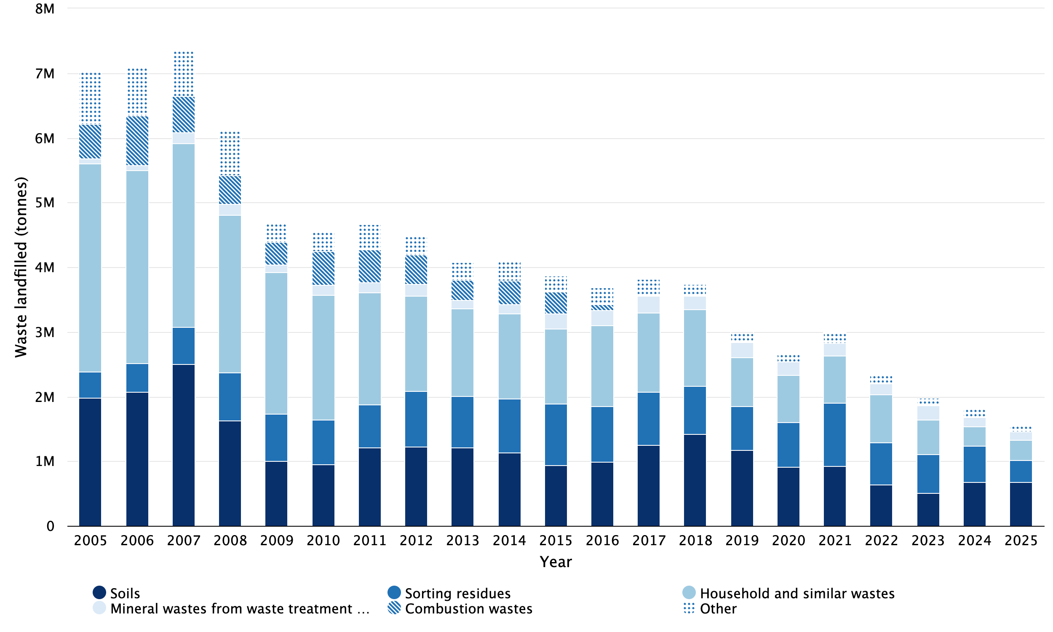
Notes:
‘Other’ categories comprise Acid, alkaline or saline wastes, Animal and mixed food waste, Animal faeces, urine and manure, Batteries and accumulators wastes, Chemical wastes, Common sludges, Discarded equipment (excluding discarded vehicles, batteries and accumulators wastes), Discarded vehicles, Dredging spoils, Glass wastes, Health care and biological wastes, Industrial effluent sludges, Metallic wastes, ferrous, Metallic wastes, mixed ferrous and non-ferrous, Metallic wastes, non-ferrous, Mineral waste from construction and demolition, Mixed and undifferentiated materials, Other mineral wastes, Paper and cardboard wastes, Plastic wastes, Rubber wastes, Sludges and liquid wastes from waste treatment, Spent solvents, Textile wastes, Used oils, Vegetal wastes, Waste containing PCB, and Wood wastes.
Tables contain the detail of the ‘Other’ breakdown.

Table 1. Waste landfilled in Scotland by waste category 2005 - 2025 (tonnes)
Waste category | 2005 | 2006 | 2007 | 2008 | 2009 | 2010 | 2011 | 2012 | 2013 | 2014 | 2015 | 2016 | 2017 | 2018 | 2019 | 2020 | 2021 | 2022 | 2023 | 2024 | 2025
Soils | 1,981,068 | 2,074,445 | 2,501,522 | 1,632,718 | 1,007,472 | 954,151 | 1,210,975 | 1,220,689 | 1,207,592 | 1,137,523 | 938,923 | 995,265 | 1,256,726 | 1,415,748 | 1,173,991 | 908,639 | 931,209 | 636,561 | 512,777 | 677,336 | 676,968
Sorting residues | 407,809 | 445,095 | 570,575 | 738,221 | 724,368 | 691,631 | 668,476 | 866,219 | 796,419 | 833,129 | 945,509 | 853,705 | 813,569 | 745,403 | 670,443 | 689,188 | 967,309 | 656,099 | 592,433 | 561,808 | 345,338
Household and similar wastes | 3,212,099 | 2,972,577 | 2,848,253 | 2,434,480 | 2,184,192 | 1,929,466 | 1,726,995 | 1,466,308 | 1,351,373 | 1,313,490 | 1,166,257 | 1,245,786 | 1,222,957 | 1,187,185 | 756,722 | 735,833 | 736,645 | 744,318 | 529,996 | 294,131 | 302,440
Mineral wastes from waste treatment and stabilised wastes | 79,464 | 88,267 | 164,900 | 176,633 | 124,430 | 146,216 | 157,486 | 189,298 | 132,803 | 145,234 | 233,680 | 242,993 | 262,487 | 214,429 | 234,959 | 207,576 | 188,302 | 161,190 | 222,260 | 146,599 | 138,232
Mixed and undifferentiated materials | 93,097 | 95,909 | 107,286 | 83,172 | 75,702 | 62,347 | 75,232 | 47,622 | 43,203 | 42,553 | 62,139 | 54,306 | 34,608 | 46,497 | 45,082 | 36,141 | 37,884 | 29,574 | 32,777 | 28,205 | 34,961
Mineral waste from construction and demolition | 456,289 | 411,666 | 427,337 | 416,514 | 103,923 | 97,703 | 178,669 | 95,703 | 60,305 | 150,915 | 61,182 | 82,855 | 97,834 | 36,891 | 25,905 | 29,027 | 49,390 | 40,044 | 35,240 | 44,245 | 29,098
Other mineral wastes | 90,782 | 82,091 | 49,154 | 42,674 | 38,159 | 69,432 | 51,090 | 56,410 | 78,922 | 54,991 | 50,135 | 46,244 | 54,522 | 39,504 | 31,318 | 18,105 | 31,335 | 35,251 | 28,918 | 24,649 | 20,023
Sludges and liquid wastes from waste treatment | 3,898 | 2,146 | 1,806 | 1,697 | 759 | 717 | 697 | 6,681 | 9,805 | 1,420 | 900 | 6,466 | 673 | 3,739 | 6,922 | 5,992 | 6,732 | 4,349 | 4,206 | 4,655 | 4,943
Health care and biological wastes | 11,643 | 15,987 | 14,155 | 9,561 | 5,944 | 5,448 | 5,589 | 5,885 | 5,397 | 3,589 | 6,813 | 5,042 | 8,025 | 8,549 | 9,290 | 9,021 | 6,902 | 6,437 | 6,381 | 6,067 | 4,715
Plastic wastes | 6,735 | 7,725 | 6,042 | 6,037 | 3,348 | 1,937 | 378 | 3,199 | 558 | 1,358 | 1,971 | 1,367 | 2,450 | 859 | 1,834 | 2,414 | 1,598 | 2,632 | 1,646 | 3,072 | 2,699
Animal and mixed food waste | 28,078 | 18,710 | 20,767 | 12,961 | 9,561 | 6,074 | 5,617 | 6,538 | 8,034 | 11,383 | 10,523 | 8,121 | 5,650 | 4,353 | 6,329 | 2,548 | 2,091 | 1,733 | 1,807 | 2,046 | 2,655
Industrial effluent sludges | 22,288 | 23,285 | 21,216 | 25,722 | 15,476 | 14,557 | 15,414 | 13,596 | 15,330 | 12,472 | 9,453 | 14,942 | 17,201 | 18,717 | 20,467 | 12,639 | 10,517 | 5,625 | 6,039 | 2,803 | 2,518
Dredging spoils | 21,070 | 11,514 | 1,999 | 245 | 80 | 15,185 | 1,765 | 60 | 2,420 | 202 | 1,536 | 0 | 63 | 2,334 | 73 | 0 | 0 | 216 | 251 | 206 | 2,404
Common sludges | 70,017 | 47,748 | 39,762 | 40,753 | 33,722 | 28,589 | 37,638 | 33,324 | 27,918 | 24,808 | 11,522 | 6,747 | 2,756 | 3,192 | 4,420 | 4,169 | 3,188 | 3,247 | 2,879 | 2,708 | 2,233
Combustion wastes | 532,420 | 758,621 | 555,923 | 436,725 | 353,903 | 521,327 | 511,178 | 453,593 | 318,714 | 364,588 | 333,996 | 83,765 | 1,385 | 723 | 4 | 468 | 2,150 | 1,480 | 1,120 | 1,136 | 1,922
Textile wastes | 3,989 | 3,092 | 2,062 | 1,635 | 3,025 | 6,262 | 6,295 | 1,655 | 1,495 | 6,738 | 8,331 | 6,581 | 2,864 | 996 | 844 | 548 | 1,781 | 1,562 | 1,260 | 2,783 | 1,801
Chemical wastes | 1,076 | 8,435 | 1,640 | 1,329 | 699 | 630 | 603 | 1,345 | 1,823 | 703 | 745 | 1,170 | 2,598 | 1,942 | 1,209 | 622 | 791 | 450 | 526 | 642 | 797
Glass wastes | 1,221 | 3,675 | 1,669 | 1,887 | 2,236 | 1,951 | 976 | 175 | 164 | 2,227 | 13,323 | 16,820 | 19,429 | 2,490 | 9,456 | 7,377 | 12,884 | 6,153 | 2,789 | 1,510 | 646
Vegetal wastes | 13,147 | 10,816 | 5,126 | 47,877 | 9,676 | 1,788 | 1,823 | 3,113 | 5,201 | 6,013 | 4,052 | 7,078 | 4,304 | 5,095 | 4,528 | 18,106 | 10,461 | 7,459 | 543 | 594 | 542
Metallic wastes, non-ferrous | 0 | 5,166 | 1,873 | 1,087 | 146 | 1,002 | 262 | 110 | 114 | 110 | 3,857 | 0 | 0 | 0 | 0 | 144 | 29 | 16 | 23 | 193 | 486
Paper and cardboard wastes | 12,773 | 14,684 | 10,320 | 9,245 | 779 | 821 | 435 | 420 | 493 | 844 | 568 | 17 | 25 | 36 | 40 | 49 | 36 | 29 | 71 | 79 | 187
Rubber wastes | 294 | 1,141 | 0 | 72 | 49 | 0 | 80 | 54 | 75 | 111 | 45 | 43 | 382 | 1,309 | 90 | 347 | 176 | 124 | 189 | 137 | 99
Discarded equipment (excluding discarded vehicles, batteries and accumulators wastes) | 60 | 82 | 94 | 16 | 1,291 | 47 | 586 | 946 | 1,105 | 2,460 | 2,900 | 1,400 | 214 | 75 | 509 | 336 | 621 | 243 | 319 | 69 | 83
Wood wastes | 4,590 | 2,670 | 922 | 11,637 | 10,641 | 4,088 | 2,899 | 3,217 | 3,655 | 1,588 | 987 | 437 | 297 | 332 | 78 | 20 | 34 | 113 | 61 | 36 | 71
Metallic wastes, mixed ferrous and non-ferrous | 112 | 13 | 533 | 32 | 1 | 9 | 93 | 7 | 3 | 7 | 2 | 5 | 15 | 18 | 51 | 19 | 3 | 1 | 3 | 12 | 39
Metallic wastes, ferrous | 156 | 210 | 6,955 | 126 | 44 | 949 | 9,331 | 3,096 | 0 | 8 | 25 | 26 | 0 | 37 | 38 | 0 | 47 | 9 | 0 | 0 | 24
Animal faeces, urine and manure | 201 | 181 | 187 | 186 | 192 | 9 | 12 | 128 | 147 | 156 | 148 | 135 | 61 | 27 | 72 | 106 | 24 | 30 | 28 | 14 | 14
Acid, alkaline or saline wastes | 0 | 1,838 | 9,705 | 1,922 | 0 | 0 | 0 | 0 | 0 | 0 | 0 | 0 | 0 | 0 | 0 | 3 | 0 | 0 | 0 | 0 | 0
Batteries and accumulators wastes | 0 | 0 | 0 | 672 | 0 | 0 | 0 | 0 | 0 | 0 | 0 | 0 | 0 | 0 | 0 | 0 | 0 | 0 | 0 | 0 | 0
Discarded vehicles | 326 | 0 | 0 | 21 | 143 | 0 | 0 | 0 | 0 | 0 | 0 | 0 | 0 | 0 | 0 | 0 | 0 | 0 | 0 | 0 | 0
Spent solvents | 0 | 0 | 45 | 0 | 0 | 0 | 0 | 0 | 0 | 0 | 0 | 0 | 0 | 0 | 0 | 0 | 0 | 0 | 0 | 0 | 0
Used oils | 37 | 25 | 0 | 0 | 0 | 194 | 198 | 116 | 55 | 0 | 0 | 0 | 0 | 0 | 0 | 0 | 0 | 0 | 110 | 122 | 0
Waste containing PCB | 0 | 0 | 0 | 0 | 0 | 18 | 0 | 2,039 | 0 | 0 | 0 | 0 | 0 | 0 | 0 | 0 | 0 | 0 | 0 | 0 | 0
Total | 7,054,739 | 7,107,813 | 7,371,828 | 6,135,857 | 4,709,961 | 4,562,548 | 4,670,792 | 4,481,546 | 4,073,123 | 4,118,620 | 3,869,522 | 3,681,316 | 3,811,095 | 3,740,480 | 3,004,674 | 2,689,437 | 3,002,139 | 2,344,945 | 1,984,652 | 1,805,857 | 1,575,938

Hazardous waste landfilled
The amount of Hazardous waste landfilled in Scotland in 2025 was 23,900 tonnes, 1.5% of the total waste landfilled and a decrease of 5,900 tonnes (19.9%) compared with 2024 (Figure 2). This is the lowest amount of hazardous waste landfilled in the current time series. The amount of hazardous waste landfilled in Scotland has reduced by 52,000 tonnes (68.5%) from 2005.
Between 2005 and 2012, the largest component of hazardous waste disposed to landfill was Soils which comprised between 62% and 76% of hazardous waste landfilled during the period. From 2013 onward, that percentage has dropped (now ranging from 2% to 50%), and in 2025 comprised 3% (800 tonnes) (Figure 2). This pattern corresponds to a change in 2012 when a landfill tax exemption for disposing of waste from contaminated land was removed. Soils have since been replaced by Other mineral wastes as the largest component of hazardous waste (ranging from 30% to 67% of the total since 2013). In 2025, over half the hazardous waste landfilled was Other mineral wastes (14,500 tonnes, 60.7%), which primarily comprise insulating materials such as asbestos.
Three waste categories comprised over 90% of the hazardous waste landfilled in Scotland: Other mineral wastes, Sludges and liquid wastes from waste treatment (4,800 tonnes, 19.9%), and Mineral wastes from waste treatment and stabilised wastes (3,700 tonnes, 15.5%).

Figure 2. Hazardous waste landfilled in Scotland by waste category 2005 - 2025 (tonnes)
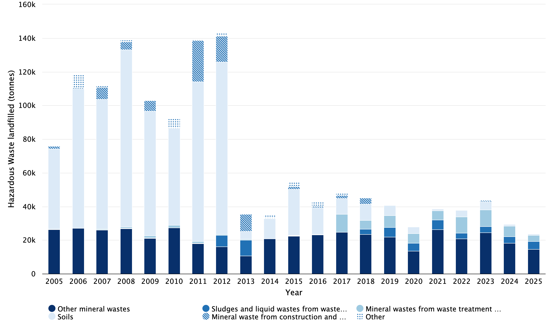
Notes:
‘Other’ categories comprise Acid, alkaline or saline wastes, Batteries and accumulators wastes, Chemical wastes, Combustion wastes, Discarded equipment (excluding discarded vehicles, batteries and accumulators wastes), Discarded vehicles, Dredging spoils, Health care and biological wastes, Industrial effluent sludges, Mixed and undifferentiated materials, Sorting residues, Spent solvents, Used oils, Waste containing PCB, and Wood wastes.
Tables contain the detail of the ‘Other’ breakdown.

Table 2. Hazardous waste landfilled in Scotland by waste category 2005 - 2025 (tonnes)
Waste category | 2005 | 2006 | 2007 | 2008 | 2009 | 2010 | 2011 | 2012 | 2013 | 2014 | 2015 | 2016 | 2017 | 2018 | 2019 | 2020 | 2021 | 2022 | 2023 | 2024 | 2025
Other mineral wastes | 26,337 | 27,047 | 26,046 | 26,796 | 21,113 | 27,373 | 17,990 | 16,223 | 10,586 | 20,748 | 22,493 | 23,065 | 24,671 | 23,521 | 21,939 | 13,676 | 26,377 | 20,727 | 24,428 | 18,269 | 14,522
Sludges and liquid wastes from waste treatment | 0 | 0 | 205 | 428 | 137 | 0 | 357 | 6,596 | 9,440 | 3 | 120 | 128 | 45 | 3,094 | 5,610 | 4,686 | 5,719 | 3,441 | 3,633 | 3,957 | 4,761
Mineral wastes from waste treatment and stabilised wastes | 191 | 14 | 472 | 661 | 1,535 | 1,491 | 1,033 | 615 | 482 | 189 | 402 | 178 | 10,709 | 5,299 | 7,033 | 5,509 | 5,418 | 9,682 | 10,061 | 6,143 | 3,717
Soils | 47,722 | 82,918 | 76,984 | 105,317 | 73,958 | 57,571 | 94,662 | 102,497 | 4,788 | 11,978 | 27,209 | 15,859 | 9,424 | 9,642 | 6,191 | 3,921 | 973 | 3,871 | 4,663 | 1,167 | 768
Discarded equipment (excluding discarded vehicles, batteries and accumulators wastes) | 1 | 18 | 22 | 6 | 0 | 0 | 1 | 2 | 0 | 0 | 0 | 0 | 0 | 0 | 0 | 189 | 517 | 132 | 110 | 69 | 83
Chemical wastes | 3 | 7,842 | 135 | 253 | 112 | 362 | 126 | 36 | 32 | 19 | 17 | 7 | 14 | 327 | 189 | 164 | 39 | 171 | 5 | 47 | 55
Mineral waste from construction and demolition | 1,585 | 626 | 7,060 | 4,769 | 6,175 | 139 | 24,587 | 15,265 | 10,189 | 192 | 1,637 | 890 | 1,790 | 3,473 | 38 | 98 | 158 | 9 | 512 | 89 | 23
Industrial effluent sludges | 157 | 42 | 73 | 18 | 11 | 129 | 419 | 0 | 0 | 34 | 0 | 0 | 0 | 0 | 0 | 0 | 0 | 0 | 0 | 0 | 0
Mixed and undifferentiated materials | 50 | 0 | 16 | 36 | 0 | 17 | 0 | 0 | 0 | 0 | 0 | 0 | 0 | 0 | 0 | 0 | 0 | 0 | 0 | 0 | 0
Used oils | 37 | 25 | 0 | 0 | 0 | 194 | 198 | 116 | 55 | 0 | 0 | 0 | 0 | 0 | 0 | 0 | 0 | 0 | 110 | 122 | 0
Acid, alkaline or saline wastes | 0 | 0 | 0 | 0 | 0 | 0 | 0 | 0 | 0 | 0 | 0 | 0 | 0 | 0 | 0 | 3 | 0 | 0 | 0 | 0 | 0
Batteries and accumulators wastes | 0 | 0 | 0 | 542 | 0 | 0 | 0 | 0 | 0 | 0 | 0 | 0 | 0 | 0 | 0 | 0 | 0 | 0 | 0 | 0 | 0
Combustion wastes | 0 | 0 | 702 | 0 | 0 | 248 | 159 | 0 | 0 | 1,644 | 2,647 | 2,579 | 1,165 | 557 | 0 | 0 | 0 | 0 | 0 | 0 | 0
Discarded vehicles | 0 | 0 | 0 | 20 | 0 | 0 | 0 | 0 | 0 | 0 | 0 | 0 | 0 | 0 | 0 | 0 | 0 | 0 | 0 | 0 | 0
Dredging spoils | 0 | 0 | 0 | 2 | 0 | 5,100 | 0 | 0 | 0 | 0 | 0 | 0 | 0 | 0 | 0 | 0 | 0 | 0 | 0 | 0 | 0
Health care and biological wastes | 0 | 0 | 0 | 0 | 0 | 0 | 0 | 7 | 0 | 0 | 0 | 0 | 0 | 0 | 0 | 0 | 0 | 0 | 1 | 0 | 0
Sorting residues | 0 | 0 | 0 | 0 | 0 | 0 | 0 | 0 | 0 | 0 | 0 | 0 | 0 | 0 | 0 | 0 | 0 | 0 | 296 | 0 | 0
Spent solvents | 0 | 0 | 45 | 0 | 0 | 0 | 0 | 0 | 0 | 0 | 0 | 0 | 0 | 0 | 0 | 0 | 0 | 0 | 0 | 0 | 0
Waste containing PCB | 0 | 0 | 0 | 0 | 0 | 18 | 0 | 2,039 | 0 | 0 | 0 | 0 | 0 | 0 | 0 | 0 | 0 | 0 | 0 | 0 | 0
Wood wastes | 0 | 0 | 279 | 122 | 0 | 0 | 0 | 0 | 0 | 0 | 0 | 0 | 0 | 0 | 0 | 0 | 0 | 0 | 0 | 0 | 0
Total | 76,084 | 118,534 | 112,039 | 138,970 | 103,041 | 92,642 | 139,532 | 143,396 | 35,572 | 34,807 | 54,525 | 42,706 | 47,818 | 45,913 | 40,999 | 28,246 | 39,201 | 38,033 | 43,819 | 29,863 | 23,929

BMW landfilled (2020 target)
Municipal waste is defined as waste within certain EWC codes (see Table 1 of the landfill quality report), namely all Chapter 20 codes and certain Chapter 15 and 19 codes. Biodegradable Municipal Waste (BMW) is the fraction of municipal waste that will degrade giving rise to methane emissions over time when landfilled.
It should be noted that the measure of BMW to landfill differs from that for the 2025 BMW landfill ban, which applies to the whole amount of waste containing BMW, not just the BMW fraction. Scotland had a target to reduce the quantity of BMW disposed of to landfill in Scotland to less than 1.26 million tonnes by 2020. This target was set as part of EU landfill legislation and has been adjusted for Scotland in Section 13 of the Making Things Last: a circular economy for Scotland report]. Scotland has met this target since 2012 (Figure 3).
In 2025, 303,000 tonnes of BMW were disposed of to landfill in Scotland (Figure 3). This was a decrease of 63,000 tonnes (17.3%) from 2024 and a reduction of 1.74 million tonnes (85.2%) since 2005.
In 2025 the BMW disposed of to landfill comprised mainly two waste categories: Household and similar wastes, predominantly EWC 20 03 01 (mixed municipal waste), which comprised 61.6% of the total and Sorting residues, primarily EWC 19 12 12 (Other non-hazardous wastes from mechanical treatment of waste), which comprised 36.9% of the total (data not shown).

Figure 3. BMW landfilled in Scotland 2005 - 2025 (tonnes)
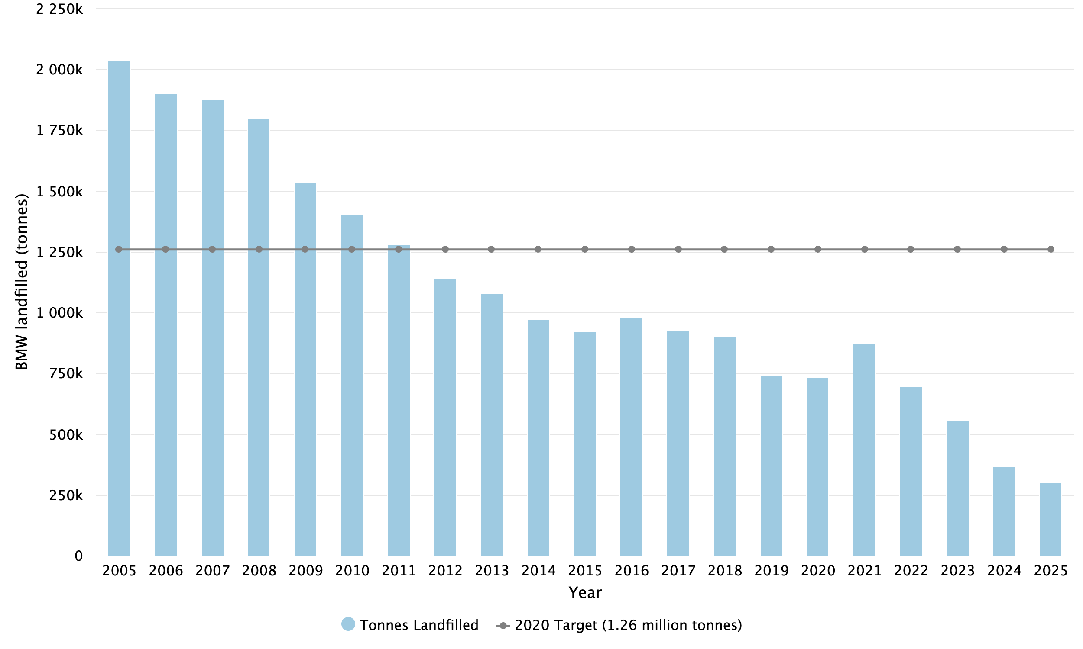

Table 3. BMW landfilled in Scotland 2005 - 2025 (tonnes)
Year | BMW
2005 | 2,039,328
2006 | 1,899,423
2007 | 1,877,891
2008 | 1,801,940
2009 | 1,538,060
2010 | 1,403,883
2011 | 1,281,683
2012 | 1,143,741
2013 | 1,079,867
2014 | 971,021
2015 | 922,057
2016 | 981,961
2017 | 924,188
2018 | 904,768
2019 | 743,767
2020 | 731,837
2021 | 876,868
2022 | 698,664
2023 | 555,004
2024 | 365,914
2025 | 302,556

About landfilled waste statistics

An Official Statistics publication for Scotland
This is an Official Statistics publication. These statistics have been produced to the high professional standards defined in the Code of Practice for Official Statistics, which sets out ten principles under the pillars of Trustworthiness, Quality and Value. More information on the Official Statistics Code of Practice web-site.
Lead Statistician - Peter Ferrett, SEPA

User statement
Data on waste generation and management are collected to support policy development and monitor policy effectiveness, particularly the commitments in Making Things Last - A Circular Economy Strategy for Scotland, and Scotland’s Circular Economy and Waste Route Map to 2030. The data contribute to the UK Statistics on waste and are also used extensively by local and central government, the waste industry, researchers and the general public.

Revisions policy
SEPA will provide information about any revisions made to this release and any associated datasets. Revisions could occur for various reasons, including when data from third parties are unavailable or provisional at the time of publishing or if there are subsequent methodological improvements or refinements. The figures are accurate at the time of publication. However, the data may be updated if further revisions are necessary. Normally these revisions will be published concurrent with the next release.
Revisions to the 2024 waste landfilled in Scotland data since the last statistical publication are shown in Table 4. These changes are due to revised waste returns.
The 2024 BMW landfilled has been revised from 336,030 tonnes to 365,914 tonnes. This change was due to a correction of a calculation error for the 2024 publication.

Table 4. Revisions to the 2024 landfill dataset (tonnes)
Waste category | Original | Revised
Acid, alkaline or saline wastes | 0 | 0
Animal and mixed food waste | 2,046 | 2,046
Animal faeces, urine and manure | 14 | 14
Batteries and accumulators wastes | 0 | 0
Chemical wastes | 642 | 642
Combustion wastes | 1,136 | 1,136
Common sludges | 2,708 | 2,708
Discarded equipment (excluding discarded vehicles, batteries and accumulators wastes) | 69 | 69
Discarded vehicles | 0 | 0
Dredging spoils | 206 | 206
Glass wastes | 1,510 | 1,510
Health care and biological wastes | 6,067 | 6,067
Household and similar wastes | 294,131 | 294,131
Industrial effluent sludges | 2,803 | 2,803
Metallic wastes, ferrous | 0 | 0
Metallic wastes, mixed ferrous and non-ferrous | 12 | 12
Metallic wastes, non-ferrous | 193 | 193
Mineral waste from construction and demolition | 44,245 | 44,245
Mineral wastes from waste treatment and stabilised wastes | 146,599 | 146,599
Mixed and undifferentiated materials | 28,205 | 28,205
Other mineral wastes | 24,649 | 24,649
Paper and cardboard wastes | 79 | 79
Plastic wastes | 3,072 | 3,072
Rubber wastes | 137 | 137
Sludges and liquid wastes from waste treatment | 4,655 | 4,655
Soils | 684,509 | 677,336
Sorting residues | 561,808 | 561,808
Spent solvents | 0 | 0
Textile wastes | 2,783 | 2,783
Used oils | 122 | 122
Vegetal wastes | 594 | 594
Waste containing PCB | 0 | 0
Wood wastes | 36 | 36
Total | 1,813,030 | 1,805,857
note: shaded cells represent a revision of more than 50 tonnes

Quality report
Data are taken from permitted waste site returns submitted to SEPA. Further information on the methodology can be found in the accompanying landfilled waste quality report.

Enquiries
Enquiries on this publication to: SEPA Communications Department: media@sepa.org.uk

Feedback
We welcome feedback on the data from all users including how and why the data are used. This helps us to understand the value of the statistics to external users. Please contact us at waste.data@sepa.org.uk.

Pre-release access
Pre-release access was made available to relevant persons five working days prior to publication in accordance with The Pre-release Access to Official Statistics (Scotland) Order 2008.
Besides analytical staff involved in the production and quality assurance of this publication, the following post holders in SEPA and the Scottish Government were given pre-release access up to 5 days before release:
- Cabinet Secretary for Climate Action and Rural Affairs
- Scottish Government Special Adviser x 1
- Scottish Government Analyst x 3
- Scottish Government Policy Official x 12
- Scottish Government Communications Official x 4
- Zero Waste Scotland Communications Official x 5
- Zero Waste Scotland Policy Official x 3
- SEPA Policy Official x 12
- SEPA Communications Official x 12
- SEPA Analyst x 5
For use in another publication:
Publication: National Atmospheric Emissions Inventory (NAEI)
- Analyst x 3

Glossary of terms
EWC Code
a six-digit code listed in the European Waste Catalogue. These codes are used to identify and classify waste into different categories. They are structured as three pairs of numbers, each representing chapters, sub-chapters, and individual entries. For example, 12 01 06*.
BMW
Biodegradable Municipal Waste. The biodegradable fraction of Municipal Waste that is capable of undergoing anaerobic or aerobic decomposition, such as food and garden waste, and paper and cardboard. It is calculated in this report by multiplying the tonnage for each EWC Code that comprises Municipal waste by the associated biodegradability factor listed in Table 1 of the landfilled waste quality report.
Hazardous Waste
waste with hazardous properties which may render it harmful to human health or the environment. Hazardous waste is also called Special Waste in Scotland as defined in the Special Waste Regulation 1996.
Municipal Waste
all wastes of EWC Chapter 20 and selected wastes of EWC Chapter 19 and Chapter 15 (see Table 1 of the landfilled waste quality report) are considered municipal sources.
Permitted Sites
waste management facilities which landfill waste and are permitted by SEPA under the Pollutions Prevention and Control (Scotland) Regulations 2012.
Sorting Residues
waste from mechanical sorting processes, including the sorting of residual waste to remove recyclable or combustible materials, the sorting of mixed wastes according to material or recyclability at a Materials Recovery Facility (MRF), and non-composted residues from composting.
Waste landfilled
waste from all sources (i.e. from commercial, industrial, construction and demolition and household sources) that is disposed of to landfill.
Waste categories
Definitions of the waste categories used within this report can be found in Annex I (Section 2) and Annex III (table of equivalence) of the EU waste statistics regulations.

For information on accessing this document in an alternative format or language please contact SEPA by email at equalities@sepa.org.uk.
If you are a user of British Sign Language (BSL) the Contact Scotland BSL service gives you access to an online interpreter enabling you to communicate with us using sign language. https://contactscotland-bsl.org

The Waste (Scotland) Regulations 2012 introduced a ban on biodegradable municipal waste (BMW) being disposed of to landfill from 31 December 2025 which was then transposed into the Environmental Authorisations (Scotland) Amendment Regulations 2025. SEPA’s temporary regulatory position statement sets out its regulatory approach during a transitional period while additional treatment capacity is developed, with full implementation of the ban expected from 1 January 2028. For further information, see the BMW landfill ban guidance on SEPA’s website.
The 2024 BMW landfilled was revised. Further detail are in the Revisions.

