

## IND-G-006

**EASR guidance:**

Version 1.0 August 2025

**Registration activity**

**Ensiling of fish and storage of ensiled liquor**

# Contents

Introduction 3

What does this guidance apply to? 3

Description of fish ensiling 4

Overview of a fish ensiling process 4

Diagram 1: Overview of a fish ensiling process 5

Environmental controls 6

Site design, infrastructure and process controls 6

Delivery and initial storage 6

Process controls 6

Containment (For storage of less than 10m3 of ensiled liquor) 7

Containment and bunding (For storage of above 10m3 of ensiled liquor) 7

Storage 8

Odour 8

Pests and Vermin 8

Management techniques 9

Management 9

Maintenance 9

Operator training 10

Resource use and efficiency 10

Raw materials 11

Water 11

Waste 11

Heat 11

Energy 12

Interpretation of Terms 12

Disclaimer 14

If you would like this document in an accessible format, such as large print, audio recording or braille, please contact SEPA by emailing [equalities@sepa.org.uk](mailto:equalities@sepa.org.uk)

# Introduction

This document provides information and guidance for anyone undertaking fish ensiling which may be authorised under the Environmental Authorisation (Scotland) Regulations (EASR). It should be read alongside the standard conditions for this activity.

# What does this guidance apply to?

This guidance applies to:

* Storage of dead fish/fish offal on site prior to ensiling.
* Fish ensiling process,
* Storage of ensiled liquor.

This guidance does not deal with further processing of ensiled liquor, for example rendering to separate the resulting oils, liquids and solids. Further processing requires a permit from SEPA.

# Description of fish ensiling

Fish ensiling is the production of ensiled liquor from whole fish, parts of fish or fish offal which are liquified by the action of enzymes in the fish in the presence of acid (usually formic acid) which accelerates the process. There are two important environmental benefits associated with this process:

* It is effective in disabling ISA (infection salmon anaemia) virus,
* It prevents the formation of offensive odours during storage.

The resulting ensiled liquor (also known as fish silage) is nutrient rich and particularly valuable in aquaculture and agriculture for feeding livestock or as a fertiliser.

## Overview of a fish ensiling process

A typical fish ensiling process includes:

* reception/unloading of dead fish/fish offal,
* storage of unprocessed dead fish/fish offal,
* treatment/maceration plant,
* addition of an acid (usually formic acid),
* storage of ensiled liquor,
* storage of chemicals associated with the process.

### Diagram 1: Overview of a fish ensiling process

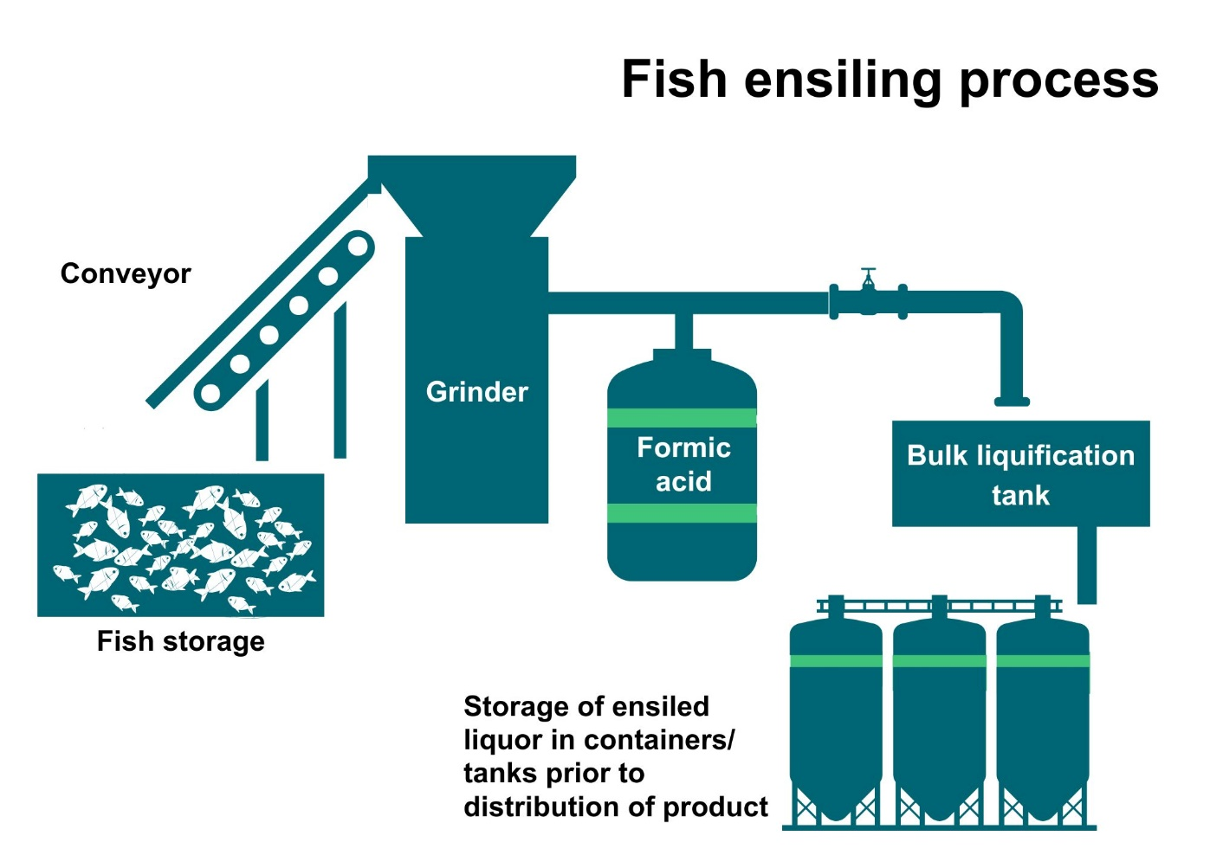

As can be seen in Diagram 1 above, a typical fish ensiling process is generally straight-forward;

* Fish mortalities or fish offal are delivered to site and loaded into a grinder/macerator as soon as possible.
* An acid is added to accelerate the liquification process and prevent spoilage (usually formic acid at 3.5%).
* The resulting liquor is stored in a sealed container or tank at a pH of below pH4 (ideally between 3.6 and 4 if using formic acid) and mixed occasionally to ensure all fish comes into contact with acid.
* The rate of liquefaction varies depending on the temperature and species being ensiled.
* The ensiled liquor is then stored in sealed tanks until required.

# Environmental controls

It is expected that the methods described in this section are utilised to control emissions from fish ensiling activities. Where other methods are used, they should offer at least an equivalent level of environmental protection.

Containment and pH control throughout the process are considered the best ways to control odour and ensure that vermin, such as rats and flies, are not attracted to the ensiling process.

## Site design, infrastructure and process controls

### Delivery and initial storage

* All materials should be transported to site by fully enclosed tankers and transfer to the storage tank must be enclosed.
* Fish that hasn’t been ensiled should be stored in enclosed containers and processed as soon as possible after delivery (preferably within 12 hours) to keep odours to a minimum.

### Process controls

* The maceration unit, process tank and any conveyance equipment should be covered / enclosed, where possible within a building.
* Ensiling requires a minimum of 24 hours at pH less than 4.0.
* Optimal process temperatures are between 5 and 40oC.
* Records should be kept of pH and temperature and be available for inspection.
* Any spillages occurring during delivery and processing should be cleaned up immediately.
* All chemicals (such as acids, disinfectants) should be stored in a suitable container, protected and stored within a bund.

### Containment (For storage of less than 10m3 of ensiled liquor)

* Containers used for the storage of ensiled fish and ensiling solutions must be kept closed and lidded.
* Base and walls of any storage system (including any container and the walls and joint of any pipes) must be:
  + impermeable and protected against corrosion,
  + capable of withstanding the loads on them when the storage is full.
* Any storage system used must be maintained in such a condition that no ensiled fish or ensiling solution escapes from the system.

### Containment and bunding (For storage of above 10m3 of ensiled liquor)

* Containers used for the storage of ensiled fish and ensiling solutions must be kept closed and lidded.
* Containers must be stored in a bund/secondary containment system that must:
  + For a single container, hold 110% of its capacity.
* For two or more containers, hold the greater of:
  + 110% of the capacity of the largest container, or
  + 25% of the capacity of all the containers together.
* Catch all spills from the containers and related parts.
* Be leak proof.
* Be located and/or protected, to prevent damage as far as reasonably practicable.
* Any spillages and/or rainwater must be removed as soon as reasonably practicable.

### Storage

* Ongoing storage should be in enclosed containers (as described above) and pH maintained at pH 4 or lower.
* High level alarms or visual indicators should be installed on tanks where levels cannot clearly be identified to avoid over filling.
* Containers should be cleaned and disinfected each time they are used.

### Odour

* Where there is potential for offensive odours beyond the site boundary, and for storage of over 10m3 of ensiled liquor:
  + Odour arrestment equipment should be installed, for example carbon filters, to vents on storage containers with the potential to release odour.
  + Odour arrestment equipment, for example carbon filters, should be used during deliveries and uplifts.

### Pests and Vermin

* Containers must be kept closed and lidded to ensure that pests and vermin are unable to access.
* Any spillages should be cleaned up immediately.
* A contract with a pest controller for should be in place for regular checks (quarterly or as advised by the pest controller).

# Management techniques

Good management practice, training and well-maintained infrastructure are key to prevent and limit the consequences of accidents which could have an impact on the environment. For example, bunding should be used around liquid storage to contain any spillages, but good management and maintenance would take this a step further by ensuring that the integrity of the bunding is checked regularly to prevent leaks, and deliveries and movements around the site are well controlled. This will enable you to comply with environmental regulations, avoid incidents, and avoid any costs incurred through loss of resources.

## Management

* Effective control of emissions starts with proper management, supervision and training for process operators.
* Implement an environmental management system to help identify and provide a systematic approach to manage, monitor and control your environmental issues and maintain efficiency. These can be certified through ISO 140001, BS8555 or EMAS but can also be in-house.
* Develop and maintain an emergency response plans e.g. specific actions for preventing and mitigating spills or runoff that may affect water bodies. For best practice and guidance [read the CIRIA Guide to Containment Systems for the prevention of pollution (C736F)](https://www.ciria.org/ItemDetail?iProductCode=C736F&Category=FREEPUBS).

## Maintenance

Maintenance can be categorised as ‘preventative’ or ‘corrective’ (also known as ‘reactive’). Preventative maintenance includes regular planned checks, servicing and maintenance of equipment to prevent or reduce failures and breakdowns which can lead to pollution incidents, safety concerns and costly downtime. Corrective maintenance includes identifying and repairing a fault once it has occurred with the aim of restoring equipment or systems to their optimum operational condition(s).

* All aspects of the activity plant, buildings and equipment should be properly maintained and there should be a written maintenance programme with a record that the maintenance has been carried out.
* Equipment should be used properly and preventative maintenance carried out.
* Spares and consumables should be held on site so that rapid repairs can be carried out and there is no temptation to continue operating with ineffective emission controls in place.
* Where odour arrestment equipment is installed, it should be inspected at least once a day to ensure correct operation and identify any malfunctions. Depending on the type of arrestment plant this should include identification of any leaks in air handling equipment and ductwork.

## Operator training

* Staff at all levels need to have training and instructions as to their duties to control emissions from the activity. This should include awareness of the SEPA registration requirements and actions to take in the event of incidents that may result in emissions from the activity.
* A training record should be kept for each member of staff.

## Resource use and efficiency

Best practice for resource use and efficiency is to review and implement any potential opportunities to reduce emissions and wastes. In addition to reducing the impact on the environment, you will also benefit because resource efficiency is also about:

* reducing costs (raw material and waste disposal);
* maximising output of product or service from a given level of materials and energy (competitive advantage);
* finding an outlet for surplus materials therefore removing them from the waste chain;
* helping Scotland achieve its goal of becoming a zero-waste society;
* reducing pollution risks and avoiding reputational impacts.

Resources include water, raw materials, energy, fuel and wastes used and produced throughout a regulated process.

### Raw materials

Raw material use should be managed by tracking stores and ensuring that all resources are stored appropriately to avoid contamination, spoilage or leaks. Automatic dosing equipment should be considered to ensure that optimum measured quantities are used throughout the process. LEAN methodologies that focus on reducing waste could be beneficial.

### Water

Water should be stored in adequate containers and any pipework and taps maintained to avoid leaks and evaporation. Where possible use rainwater harvesting and recycled water.

### Waste

Ensure waste is managed in line with the waste hierarchy (prevention > prepare for reuse > recycle > recover value > disposal). Segregate any waste and store appropriately to ensure that it can be managed as high up the hierarchy as possible.

### Heat

Where heat is used or generated, ensure that optimum temperatures are maintained during the process; buildings, pipes and tanks should be insulated to minimise heat loss, and where possible any heat captured and used elsewhere.

### Energy

Ensure energy is used efficiently across the site by monitoring energy use, ensuring any lighting, motors, compressors or other equipment is well maintained and working at optimum, rather than maximum, levels. Consider replacing with more energy efficient equipment during upgrades. Servicing to manufacturer’s recommendations and preventative maintenance, instead of only reactive maintenance after plant faults, are also important in ensuring equipment works optimally.

# Interpretation of terms

|  |  |
| --- | --- |
| **Term** | **Definition** |
| Bund/ secondary containment system | Bunds or secondary containment systems are used around areas where potentially polluting materials are handled, processed, or stored to ensure that any accidental releases cannot escape to allow for clean-up. They have walls and base which must be impermeable to liquids.  This may be a purpose-built concrete structure, a drip tray, or an entire building which has had impermeable steps, ramps or similar installed at any openings to ensure liquids are contained. |
| Ensiling | The processing of dead fish and fish offal by maceration and preservation in formic acid. |
| environmental harm | 1. Harm to the health of human beings or living organisms, 2. Harm to the quality of the environment, including: 3. harm to the quality of the environment taken as a whole, 4. harm to the quality of air, water or land, and 5. other impairment of, or interference with, ecosystems, 6. Offence to the senses of human beings, 7. Damage to property, or 8. Impairment of, or any interference with, amenities or other legitimate uses of the environment. |
| event | * Any accident which has caused or could cause environmental harm; or * Any malfunction, breakdown or failure of plant, infrastructure or techniques which has caused or could cause environmental harm; or * Force majeure or action taken to save human life or limb. |
| SEPA officer | an officer authorised under section 108 of the Environment Act 1995 |

## Disclaimer

This guidance is based on the law as it stood when the guidance was published.

Whilst every effort has been made to ensure the accuracy of this guidance, SEPA gives no warranty, covenant or undertaking (express or implied) regarding the fitness for purpose of, or any error, omission or discrepancy in this guidance. Reliance on its contents and the contents of any websites that are linked to or from this guidance is entirely at the user’s own risk. SEPA is not liable for any loss or damage that may come from using this guidance. This includes:

* any direct, indirect and consequential losses
* any loss or damage caused by civil wrongs, breach of contract or otherwise.

SEPA reserves the right to depart from this guidance and take appropriate action as it considers necessary or appropriate. Operators are responsible for ensuring that they are compliant with the law. If necessary, independent legal / specialist advice should be sought.