

**Annual Procurement Report**

December 2024

**2023-2024**

Contents

1. Introduction 5

2. Summary of procurement activity during the period 6

3. General duties under Procurement Reform (Scotland) Act 2014 10

4. Contract Register 12

5. Achievements against SEPA Procurement Strategy 13

6. Future regulated procurement activity 2023-2025 27

7. Benefits 29

Annex 1 - Regulated procurements completed in financial year 2023-2024 31

Annex 2 - Summary of business area procurements to be conducted in the next two financial years 37

## Introduction

The SEPA Annual Procurement Report meets the statutory duty of the Procurement Reform (Scotland) Act 2014 by detailing SEPA’s performance and progress during Financial Year (FY) 2023-2024 in alignment with the SEPA Procurement Operating Plan 2021–2024 (our Corporate Procurement Strategy).

Our Procurement activity supports SEPA’s contribution to the Scottish Government’s National Performance Framework Outcomes and the United Nations Sustainable Development Goals, set out within Scotland’s National Performance Framework and our procurement activity is embedded in the delivery of all our corporate outcomes.

The financial analysis has been conducted on data extracted from SEPA’s finance and procurement system, Agresso[1]. Table 1 summarises SEPA’s key procurement statistics for the FY’s 2022-2023 and 2023-2024.

Note: all figures in the report are exclusive of VAT.

#### Table 1 – Key procurement management information

| **Scottish procurement information Hub Dashboard (DXC Technology)** | **FY 2022-2023** | **FY 2023-2024** |
| --- | --- | --- |
| Total number of contracts placed | 151 | 147 |
| Total value of transactions reported | £19,707,137 | £20,943,102 |
| Number of transactions (purchase orders) | 6,132 | 6,537 |
| Expenditure with Small and Medium-sized Enterprises | 39.72% | 40.22% |
| Active supplier accounts in this period | 664 | 717 |

## Summary of procurement activity during the period

### Analysis results

The overall procurement activity remains high with 147 contracts let in FY 2023-2024. However, there continues to be a rise in the number of higher value procurements in both terms of volume and value. These have risen by 21% and 22% respectively since the previous FY 2022-2023 report.

These are ‘regulated’ procurements with a value greater or equal to £50k that require the necessary levels of scrutiny and robustness to ensure compliance with the Procurement Regulations as detailed in the next section 2.2. Details are provided in the following tables:

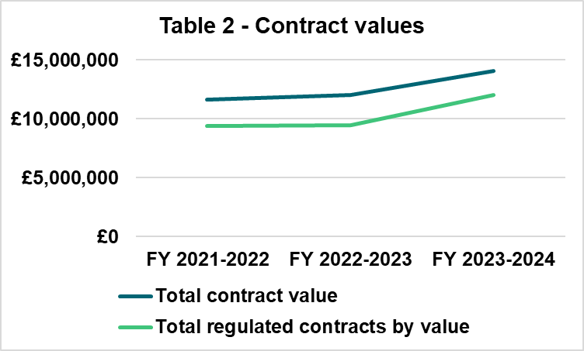

The procurement function continues to be extremely busy with demand increasing year on year and we capture our successes herein. We also show progress against our Corporate Procurement Strategy[2] and identify opportunities for improvement where appropriate.

### Legal and procedural framework

SEPA undertakes all regulated procurement within the legal and procedural frameworks, as shown below, and have ensured that our Procurement Strategy supports delivery in alignment with these frameworks.

* Procurement Legislation both domestic and international.
* The Scottish Government’s Procurement Journey (providing guidance on best practice).
* The Scottish Model of Procurement.
* The Scottish Government’s Sponsorship team instructions to SEPA.
* Scottish Procurement Policy Notes (SPPNs).
* SEPA Delegated Levels of Authority Policy.
* Regulated procurement activity.

In line with Procurement Legislation, this Annual Procurement Report must include:

**“(a) A summary of the regulated procurements that have been completed during the year covered by the report”**

As previously reported above at 2.1, the total regulated procurement commitment was £12,045,655. A listing of regulated contracts awarded is included in Annex 1.

**“(b) A review of whether those procurements complied with the authority’s procurement strategy”**

There were no regulated procurements i.e. greater than £50,000 which did not comply with the Procurement Strategy. A further analysis of our performance against our Strategy is shown in Section 3.

**“(c) A summary of any community benefit requirements imposed as part of a regulated procurement that were fulfilled during the year covered by the report”**

Procurement is required to consider whether to impose Community Benefit Requirements as part of any procurement which has an estimated value of the contract equal to or greater than £4,000,000 over the term of the contract. As part of our recent tender for Total Facilities Management, we included community benefit requirements in accordance with the Procurement Reform (Scotland) Act 2014. These requirements focused on training and recruitment, availability of sub-contracting opportunities, and initiatives aimed at improving the economic, social, or environmental wellbeing of Scotland.

While the community benefits will not be delivered in the FY 2023-2024, they were considered within the procurement undertaken during this period. Bidders were asked to provide details of the community benefits they would deliver as part of the contract, including a timetable for delivery and reporting mechanisms. Part of the award will be to contractualise and report outputs as part of contract and supplier management responsibilities**.**

**“(d) A summary of any steps taken to facilitate the involvement of supported businesses in regulated procurements during the year covered by the report”**

In February 2024, we invited a representative from the Scottish Government to provide an update on the Supported Business Dynamic Purchasing System (DPS) and sub-contract opportunities. This initiative was part of our efforts to facilitate the involvement of supported businesses in our regulated procurements. The meeting highlighted the benefits and processes of the Supported Business DPS, and our team discussed integrating these opportunities into our procurement strategies to promote inclusivity and social value. In addition, key prime contractors will also be encouraged to identify opportunities through their respective supply chains.

**“(e) A summary of the regulated procurements the authority expects to commence in the next two financial years”**

Annex 2 provides a summary of business area procurements to be conducted in next two financial years.

## General duties under Procurement Reform (Scotland) Act 2014

### Sustainable Procurement duty

The Sustainable Procurement Duty requires consideration of economic wellbeing, community and environment. What is commonly known as the triple bottom line. Where proportionate and pragmatic the Scottish Government’s Sustainability Test is applied.

SEPA has a target to reduce its emissions to net zero while at the same time taking actions that repair the environment. Our Net Zero Routemap sets our ambition to reduce greenhouse gas emissions and outlines the steps that we will take over the 2022-2024 time period to get there. Our future sourcing strategies and tenders will extend to include specific emissions targets to help us further embed sustainability measures wherever we are able to specify these.

Progress has been made as evidenced in our recent tender for Total Facilities Management, which included requirements for carbon net zero initiatives and asked suppliers to detail measures to reduce environmental impacts across GHG Emissions, Materials, Water, and Waste. Part of the award will be to contractualise and report outputs as part of contract and supplier management responsibilities**.**

Further progress is reflected in the case studies at section 5.

### Small and Medium-sized Enterprises (SME)

As part of the Scottish public sector, SEPA acknowledges it has a role in contributing to Scotland’s economic success. While we do seek to leverage existing available framework agreements in our strategies (e.g. internal or external frameworks), to further encourage SME suppliers, we advertise through Public Contracts Scotland using either the Quick Quotes functionality, or formal tendering formats.

SME expenditure for FY 2023-2024 was 40.22% compared with 39.72% in FY 2022-2023 representing an increase of 1.3% of overall expenditure.

Dynamic IT frameworks such as the Scottish Government’s Dynamic Purchasing System and the Crown Commercial Services G Cloud 13 allow for greater accessibility to the IT SME community.

The Procurement Team also consider opportunities for lotting requirements to allow access to the SME community as part of our procurement strategies. In addition, the Procurement Team has used the following opportunities to engage with potential suppliers:

* Supplier Development Programme (SDP) Membership - SEPA continues to actively engage with the SDP to enhance our procurement processes and support supplier growth.
* SEPA (when applicable and proportionate) uses soft market tests and wider market engagement to notify the suppliers of upcoming opportunities and help shape our procurement approaches. This proactive approach ensures that we are well-informed about market capabilities and trends. Some examples include the Scottish Borders Flood Forecasting Project and the Total Facilities Management procurements.

### Supplier payments

SEPA complies with the Scottish Government’s prompt payment policy and Scottish Government’s Public Finance Manual in that all suppliers’ invoices not in dispute are paid within the terms of the relevant contract, normally 30 days from receipt, however we strive to achieve payments within 10 days. Our performance has been consistent over the past two financial years as outlined below:

#### Table 4: Supplier payments

| **FY** | **Within 10 days** | **Within 30 days** |
| --- | --- | --- |
| 2022-2023 | 93% | 97% |
| 2023-2024 | 92.5% | 98.6% |

## Contract Register

The Public Reform (Scotland) Act 2014 requires a register of current contracts to be published on the Internet. SEPA’s contract register is accessible on our [website](https://beta.sepa.scot/about-sepa/access-to-information/guide-to-information/class-6-procurement/contract-register/).

## Achievements against SEPA Procurement Strategy

Our Procurement Strategy is part of an ongoing drive to be more commercial, flexible, responsive, and innovative; to do a better job at a lower cost and become a world class Environmental Protection Agency (EPA). The strategy documents four key aims:

**Figure 1 – SEPA’s Procurement Strategy (Procurement Operating Plan 2021-2024) four key aims**

**4**3

**3**

**1**

**2**

Our performance against each aim is monitored on an ongoing basis and forms a core part of the Procurement Team’s activity. Plans are underway to review and refresh the current Corporate Procurement Strategy to align with both wider organisational corporate change for the forthcoming three years 2024-2027. This will include a full refresh of current procurement policy and approach to contract and supplier management.

A summary of our performance to date against each aim is tabulated the following pages:

### Table 5 - Aim 1: Supporting the development of a Net Zero organisation

| **How will we deliver** | **What will success look like** | **Achievements thus far** |
| --- | --- | --- |
| Supporting effective decision making to drive down direct greenhouse gas (GHG) emissions.  Reducing supply chain GHG emissions, water use, waste and materials use by:   * working with our suppliers to understand their impacts; * joint action planning; * more robust procurement processes.   Improving governance for capital procurement. Working with relevant Central Purchasing Bodies (e.g., Scottish Government, Crown Commercial Service, Scotland Excel, etc.) to influence Framework Agreements so they remain fit for purpose.  Avoiding compromise with other key objectives including Fair Work First and contracting with Supported Businesses. | All new contracts which have an impact on direct emissions will have SEPA targets which align with our goal.  Our action plan is continually reviewed to ensure Net Zero targets are met and is supported by procurement roadmap activities.  Our high impact contracts will contain a requirement for suppliers to work with us towards achieving SEPA goals. | Consideration of our Sustainable Procurement Duty continues to be applied in a proportionate and pragmatic manner to achieve the triple bottom line of community, environment and economic benefits on a case by case basis. This and use of innovative technologies is best evidenced in the following two Water Environment Fund[3] (WEF) case studies:   * Flood Defenses Asset Assessment Project and; * Halter Burn Weir (Fish Barrier Removal Design). |

### Case study 1 - Flood Defenses Asset Assessment Project

#### The project

In Scotland flood protection schemes are owned and maintained by 32 different local authorities.

Following a competitive tender, SEPA appointed Jacobs to explore how a national consistent approach could be developed to better understand flood defences.

The work involved:

* Reviewing current UK regulatory guidance, specifications and standards for conducting detailed assessments of flood defence assets.
* Testing concepts through a case study in partnership with a local authority, focussing on how to account for uncertainty.

#### What innovative mapping technologies have we explored?

* Testing a new approach to determine the standard of protection of existing flood defences, accounting for uncertainty in the hydrology and hydraulic modelling chains.
* Exploring new methods to assess the likelihood and probability of failure of the flood protection schemes in Scotland based on their condition.
* Developing methods to economically quantify the benefits of our flood warning service in areas with of defences, the costs when defences may fail, and how this information could help with emergency planning.
* Establishing a baseline for the economic benefits that flood defences provide to Scotland’s communities across a range of events.

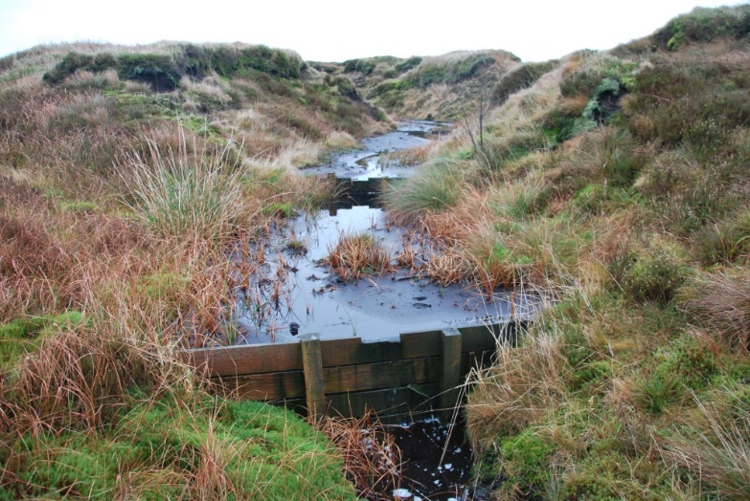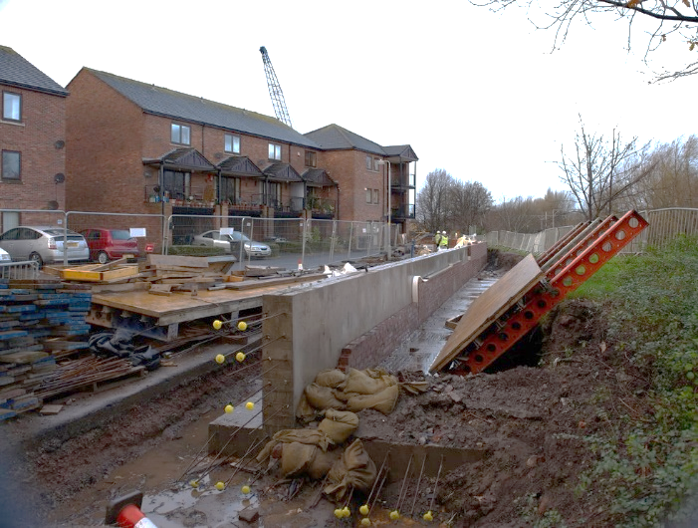

Figure 3: Urban Flood Alleviation Scheme

Figure 2: Nuclear (Copyright wiki)

**Low Tolerance to uncertainty High**

**High Consequence of failure Low**

Figure 4: Upland natural flood management

### Case study 2 - Halter Burn Weir (Fish Barrier Removal Design) - WEF Case Officer: Francis Hayes

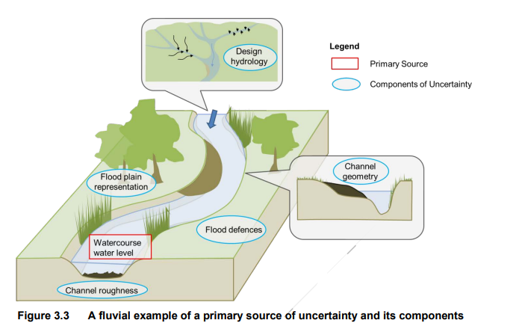

### Climate resilience

In the SEPA Corporate Plan 2024-2027, our ambition is:

* That the damaging impact of floods and droughts is reduced.
* That operators are prepared for and resilient to the impacts of a changing climate.

One way we will achieve this ambition is by improving our understanding of Scotland’s flood risk protection assets.

### What was achieved?

* The scope helped us explore innovative techniques to demonstrate how a national consistent approach could be taken for flood defences in Scotland and highlighted the importance of this work.
* The project identified the approaches taken by the UK regulatory authorities to understand flood defences in England, Wales and Northern Ireland.
* It outlined potential approaches, techniques and methods for achieving these goals.
* This approach was tested on a case study location to validate the theory and gather insights. This provided a valuable understanding of the scale of the task.
* Ultimately the project has identified the importance of this information for building resilient and sustainable communities.

#### How are we incorporating Net Zero?

The project began just as SEPA embarked on its ambitious approach to Net Zero, allowing Case Officer Francis Hayes to guide its direction early on, ensuring designers and contractors focus on reducing carbon emissions and enhancing sustainability.

The most sustainable and climate resilient way to improve fish passage at redundant weirs is often full weir removal. Installing an additional structure such as a concrete fish pass or modifying the existing weir means an increase in the carbon costs and long-term maintenance requirements. While not all weirs can be removed, the Halter Burn Weir project has been focussed solely on removal to ensure the most resilient and sustainable option from the start.

WEF observes that consultants and design engineers are increasingly focusing on low carbon, climate-resilient, and sustainable designs, and WEF is actively promoting and accelerating these approaches.

#### The project

SEPA has directly commissioned the design of a full weir removal operation at the Halter Burn, Yetholm Mains, Scottish Borders.

The removal of the weir, planned for 2025, will open around 4km of upstream river habitat to native migratory fish such as sea trout and Atlantic salmon.

In 2023 we completed a concept design for the weir’s removal and during 2024 we will develop a detailed design and procurement documentation to fully remove the weir.

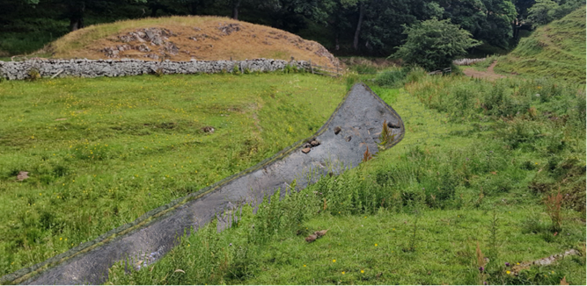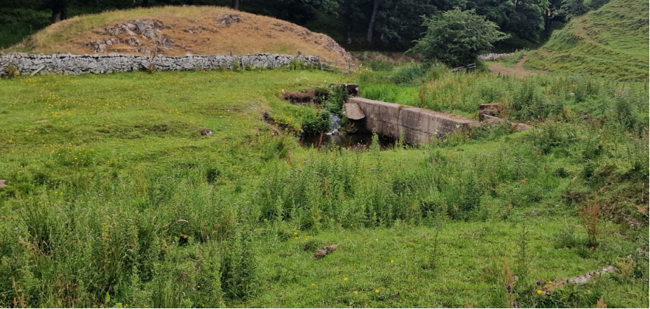

Figure 1: Image of Halter Burn Weir before (left image).

Figure 2: Image of Halter Burn Weir after concept design (right image).

### What techniques are being used?

The Halter Burn Project follows Royal Institute of British Architects (RIBA) principles to set sustainability outcomes at each stage, currently at RIBA 3 and 4 for Developed and Technical Design. The procurement process included legally binding requirements for designers and contractors to work sustainably and report carbon costs.

The project scope advertised within the tender informed bidders that they must adhere to SEPA’s core values of sustainability and in particular Net Zero carbon delivery of the weir removal project.

### What has happened so far?

The design work is at an early stage but already the designer has undertaken a single site visit for all surveyors on the same day, using only one vehicle for travel, to reduce the carbon cost of field work (as opposed to field surveyors attending site alone and using separate travel arrangements).

Additionally, the design team has begun reviewing the potential materials for use on the weir removal site and are actively assessing the carbon cost of each material. For example, assessing ‘rock roll’ bank protection versus natural materials sourced on-site, or even allowing the river to form its own riverbanks naturally after weir removal.

A carbon calculator is being identified for the project which best suits our needs and may either be the Environment Agency’s bespoke tool or an equivalent.

### Table 6 - Aim 2: Supporting SEPA’s modernisation

| **How will we deliver** | **What will success look like** | **Achievements thus far** |
| --- | --- | --- |
| Ensuring the support our Procurement Team offer is well informed, agile, and dynamic.  Evaluating, managing, and mitigating procurement and supply chain risk.  Delivering innovative contracting approaches.  Developing key commercial skills across the organisation through:   * Further development of our training on Discover and other corporate learning platforms. * Making the most of Microsoft 365 (Teams) – Running short masterclass style sessions for relevant colleagues will help to build the knowledge and skills required to be effective contract and supplier relationship managers. * Coaching relevant colleagues to deliver robust contract management. Supporting our staff through coaching will ensure they experience practical learning. * Delivering effective and efficient self-service. * Feeding into the new Job Evaluation Scheme and System at the appropriate time to ensure commercial skills are recognised as an important part of people’s roles. * ‘Rightsizing’ the procurement function depending on the developing role of the team. | Procurement is considered as an option early in decision making.  The Procurement Team are actively involved in key decision making across the organisation.  Our staff have the commercial skills to be confident in their management of our suppliers.  An increase in the £15k threshold for involving our Procurement Team in tendering exercises is feasible as competency across the organisation increases. | The Procurement Team continues to be flexible and resilient during financial year 2023-2024. There was a significant increase in the number of regulated procurements taken forward and contracts put in place by the Procurement Team. An increase in relative terms of c20% compared to the preceding FY 2022-2023.  Early and planned stakeholder engagement has led to the successful completion for award of £12m Total Facilities Management contract. This has been accomplished without challenge. Award expected early in next reporting period.  A focus on sustainable delivery has led to the development and use of weighted sustainability questions for tenders; these are aligned with and promoting SEPA corporate goals.  The Procurement Team participated in a series of Teams sessions during the Manager Development Programme in October and November 2023. These sessions were designed to engage with managers across the organisation, raise awareness of the procurement function and the regulations that govern procurement activities. Ensuring managers are well-equipped to navigate procurement processes effectively.  The Procurement Team supported WEF colleagues in developing an innovative construction related procurement strategy to support the move from traditional construction contracts to design and build approach and focus on maximising value for money (VFM).  The Head of Procurement and Contract Management role was successfully recruited and appointed in December 2023 as part of ‘rightsizing’ the Procurement function. In addition, the department is actively seeking to recruit two posts at Procurement Team Manager and Procurement Specialist levels to replace staff retirements. |

### Table 7 - Aim 3: Effectively managing risk and seeking opportunities with our supply chain

| **How will we deliver** | **What will success look like** | **Achievements thus far** |
| --- | --- | --- |
| Working with our suppliers to understand the risks and opportunities as they see them.  Working with our suppliers to ensure effective contingency plans are in place for key risks.  Assessing our supplier’s preparedness for the materialisation of developing risks such as cyber security and climate change.  Playing an active role in developing key markets where there is limited competition and/or resilience.  Working with the Scottish Supplier Development Programme (SDP) to reduce barriers to SMEs seeking to enter our supply chain. | Resilience and risk will be actively managed in our supply chain – reducing the likelihood and impact of future service disruption.  Strong, collaborative relationships with suppliers, leading to improved communication, trust, and mutual support in managing risks and opportunities.  A more diverse supplier base, including a higher number of SMEs, contributing to innovation and resilience in the supply chain. | As with all organisations, SEPA is facing external supply chain risks. Significant risks include:   * Higher energy costs. * Inflation. * Supply chain shortages. * Supplier workforce demographics and skill shortages. * The talent war with demand exceeding supply for key skills. * Geo-political considerations and international conflict. * Higher interest rates.   Ongoing management of risks is essential. More effective planning with consideration of supplier lead times was conducted during FY 2023-2024 through continual development of our procurement pipeline approach with a red, amber, green (RAG) status tracker and regular stakeholder planning sessions. |

### Table 8 - Aim 4: Supply chain management

| **How will we deliver** | **What will success look like** | **Achievements thus far** |
| --- | --- | --- |
| Identifying business areas where the supply chain impacts are most significant.  Working with the relevant stakeholders to support the effective articulation of supply chain risks and opportunities in procurement plans.  Supporting our regulatory colleagues to understand the supply chain impacts of our regulated businesses. | Plans will effectively consider those business areas with the most significant supply chain impact.  Regulatory colleagues, responsible for delivery, will feel well equipped to support and advise regulated businesses on reducing supply chain impact. | Regular capital spend planning meetings have taken place to ensure mitigation of risk where appropriate.  SEPA continues to be an associate member of the Advanced Procurement for Universities and Colleges centre of procurement expertise. This has allowed access to contractual coverage across a number business requirements.  The Procurement Team continues to support regulatory colleagues through regular Public Procurement Group[4] attendance. In addition, the Head of Procurement and Contract Management was nominated chair of collaborative Environment and Economy Leaders Group (EELG) and leading review of collective spend opportunities to capture efficiencies at government level and supporting colleagues throughout the public sector.  Leading SEPA’s first Procurement Capability Improvement Programme (PCIP) – a Government audit on the maturity of the procurement function. First review scheduled for 20 August 2024. This is linked to wider Scottish Government initiatives demonstrating alignment with policy, driving improvement plans for the function and enhancing brand and reputation of the function and SEPA. |

## Future regulated procurement activity 2023-2025

A summary of the regulated procurements expected to commence in the next two financial years is categorised by business area and project expenditure. This can be subject to change due to budgets and prioritisation (Annex 2).

Our Procurement Pipeline is managed by our Procurement Team Manager, in consultation with function heads. It is subject to change to meet operational demands and shifting priorities, however we recognise there are opportunities to improve the level of ‘real-time’ engagement from functions to ensure Procurement can make those pipeline adjustments in a more flexible manner.

Route to market is a key consideration in any procurement and this will be influenced by multiple factors including specification, market availability, suitability of existing contracts and available external collaborative framework agreements, the anticipated value of requirements, as well as our general and specific duties under the Procurement Reform (Scotland) Act 2014, S.18 and Part 2.

Procurement route selection continues to be a critical component in our sourcing strategies to ensure the optimal route to market is selected that will meet SEPA’s needs and Annual Operating Plan objectives, to deliver best value for money and ensure compliance with the legal and regulatory frameworks within which we operate.

1. **Framework for delivery**

The delivery of future regulated procurements and associated annual procurement reporting will be supported by the following framework:

**Figure 5: Framework for delivery**

* Procurement Policy Contract and Supplier Management Policy
* Annual Procurement Report
* Regulatory Compliance

* Customer focus and engagement
* Pipeline review and planning
* Market engagement
* PCIP Action Plan
* Customer focus and engagement
* Pipeline review and planning
* Market engagement
* Procurement capability and capacity review
* Scottish Government Procurement Strategy
* SEPA Corporate and Annual Operating Plans
* Corporate Procurement Strategy

## Benefits

The Scottish Government’s Procurement Benefits Reporting Guidance seeks to record and report benefits in a consistent manner across the public sector, allowing both non-cash and cash savings to be recorded. Benefits can be cash or non-cash and identified at the following stages:

* Forecast as part of a Procurement Strategy.
* Secured as a result of a sourcing process.
* Delivered throughout the life of the contract. What is the difference between cash and non-cash?
* Cash – reduced cost to SEPA against forecast as a result of the sourcing process. This can enable, for example, additional scope to be procured or budgets to be reduced or reallocated.
* Non-cash – benefits which may be measured in cash terms, but which do not free up financial resource – e.g. the delivery of community benefits.

Benefits calculation and recording, at all three stages and within cash and non-cash brackets, is at a relatively early phase within SEPA, albeit we continually achieve successes. This was identified as an opportunity for improvement in 2023-2024 with existing initiatives within our Procurement Strategy being directly mapped to benefits calculation skills, including how we assess best value in terms of environmental impacts, equality and diversity, community benefits and whole life-cycle costing into our tender evaluations where appropriate. Progress will continue to be demonstrated on an annual basis.

The table below represents the expenditure and benefits achieved as a result of procurement activity and progression from the previous reporting period.

#### Table 9: Value for money savings

|  |  |  |  |  |  |
| --- | --- | --- | --- | --- | --- |
| **FY** | **Influenceable spend** | **Cash savings** | **Non-cash savings** | **Total savings** | **% of contract spend** |
| 2022-2023 | £11,211,418 | £317,840 | 0 | £317,840 | 3% |
| 2023-2024 | £14,050,442 | £415,760 | £396,351 | £827,111 | 6% |

## 

This concludes SEPA’s 2023-2024Annual Procurement Report**.**

December 2024

Allan Ferguson

Head of Procurement and Contract Management

SEPA, Angus Smith Building,

6 Parklands Avenue, Eurocentral, Holytown,

North Lanarkshire,

ML1 4WQ



# Annex 1 - Regulated procurements completed in financial year 2023-2024

## SEPA’s regulated procurements completed in 2023-2024 per portfolio

### Compliance and Beyond

Please note a wide range of regulated procurements were conducted during financial Year 2023-2024. The contracts put in place have varying contractual timeframes. The total value for multi-year agreements / longer term contract arrangements has been published.

#### Table 10 – Data, Evidence and Innovation portfolio

| **Description** | **Value (Ex. VAT)** |
| --- | --- |
| AHER FTIR (Gasmet) | £127,999 |
| Azure Overages 2024 | £160,000 |
| Azure Overages December 2023 | £75,000 |
| Biochemical Oxygen Demand Analysers | £131,110 |
| Centrifugal Filters for Microbiology COVID19 Wastewater Sampling | £94,855 |
| Cloud Hosting Services | £273,250 |
| Coastal Flood Hazard Mapping (Scotland) Phase 2 | £294,929 |
| Digital Architecture Post | £77,875 |
| FEWS Support & Maintenance | £201,000 |
| Flood Defences Asset Assessment Project | £209,615 |
| Flooding Educational Project | £66,000 |
| HIMS Software S&M | £125,874 |
| ICP-OES Alkali metals analyser purchase | £66,971 |
| Interim Business Analyst Requirement | £50,000 |
| IS Policy & Procedures Review | £71,250 |
| Milton of Campsie Gauging Station | £153,014 |
| Network Strategy Review | £70,625 |
| Nucleic Acid Kits for Microbiology COVID19 Wastewater Sampling | £60,863 |
| Philiphaugh Gauging Station Rebuild | £54,386 |
| Seil Sound Shellfish Water Protected Area (SWPA) Tracer Study | £81,218 |
| SEPA SJM vessel maintenance expenses (transactional only) | £122,625 |
| Service Contract for Thermo QExactive Plus & Ultimate 3000LC | £156,276 |
| Software Licence, Development, Support & Maintenance for SEPA Flood Forecasting Models | £62,850 |
| Software Value Added Reseller Services (SVARS) | £80,000 |
| Spotfire Annual Support & Maintenance 2024-2027 | £241,291 |
| Supply of Fabricated Steel | £140,000 |
| Supply, Delivery, Installation & Commissioning of an Automatic Media Preparation and Dispensing System | £64,806 |
| Supply, Installation and Commissioning of a High Capacity Fully Automated System for the Measurement of pH, Alkalinity, Electrical Conductivity and Fluoride | £153,255 |
| Supply, Installation and Maintenance of Wave Buoys at Two Inshore Locations in SE Scotland | £279,000 |
| Technical Assurance Service for M/Soft Azure | £300,000 |
| Topographic Survey and Hydraulic Rating Development - Catchments in Scottish Borders | £72,443 |
| **Total** | **£4,118,380** |

#### Table 11 - Finance, Modernisation and Digital portfolio

| **Description** | **Value (Ex. VAT)** |
| --- | --- |
| Agresso Maintenance Support 2023-2024 | £50,768 |
| Audit Scotland Fees 2023-2024 | £76,161 |
| Citrix Universal Hybrid Multi Cloud Workspace | £90,720 |
| ESRI License | £480,000 |
| HALO Helpdesk License Renewal | £179,265 |
| Incident Response Retainer | £69,500 |
| LIMS Support & Maintenance | £59,365 |
| Microsoft Enterprise License Agreement | £2,686,151 |
| Oracle Software Update License & Support Service | £99,595 |
| Provision of Network Firewalls Security and Protection Services | £82,494 |
| Security Operations Centre (SOC) XDR Managed Service | £209,512 |
| Security Operations Centre annual Onboarding MDR | £450,000 |
| Senior leadership Coaching | £85,950 |
| **Total** | **£4,619,481** |

#### Table 12 - Governance, Performance and Engagement portfolio

| **Description** | **Value (Ex. VAT)** |
| --- | --- |
| Internal Audit Service | £292,000 |
| Provision of a Consultation Platform | £79,980 |
| **Total** | **£371,980** |

#### Table 13 - People, Workspaces and Development portfolio

| **Description** | **Value (Ex. VAT)** |
| --- | --- |
| Aberdeen Laboratory Refit | £590,786 |
| AHER Vehicles x 2 | £51,370 |
| Fieldwork Vehicles | £80,525 |
| Insurance & Associated Services | £185,000 |
| Interim IT Staff Services | £50,000 |
| Interim Professional Staff Services SP-22-001 4th Generation | £50,000 |
| Recruitment Services (Hays) | £60,000 |
| Temporary Admin & Manual Staff (South Region) | £150,000 |
| Temporary Admin & Manual Staff (North) | £50,000 |
| Temporary Admin & Manual Staff (South Region) (transactional only) | £50,000 |
| The Provision of Total Estate Management Services | £200,000 |
| **Total** | **£1,517,681** |

#### Table 14 - Regulation, Business and Environment

| **Description** | **Value (Ex. VAT)** |
| --- | --- |
| Esk Barriers Water Environment Fund (WEF) | £126,703 |
| General Office Supplies | £50,000 |
| OBCR Subject Matter Expertise | £80,000 |
| Provision of an Intelligence & Investigation Management System | £1,030,307 |
| Provision of Communications Media Management Software | £52,530 |
| Provision of NetRegs E-Learning and Assessments Platform | £78,593 |
| **Total** | **£1,418,133** |

#### Table 15 - Total regulated procurements completed in 2023-2024

| **Description** | **Value (Ex. VAT)** |
| --- | --- |
| **Overall total** | **£12,045,655** |



# Annex 2 - Summary of business area procurements to be conducted in the next two financial years

Refer to our externally published [contracts register](https://beta.sepa.scot/about-sepa/access-to-information/guide-to-information/class-6-procurement/contract-register/) to identify term contracts that are approaching their end and due for renewal. SEPA is actively working on a procurement pipeline, which includes a focus on enhancing market awareness of upcoming regulated procurement opportunities. Business specific procurements will be conducted as required to meet future business needs

#### Table 16 – Summary of business area procurements to be conducted in the next two financial years

| **Description** | **Function** | **Estimated start date** | **Estimated value** |
| --- | --- | --- | --- |
| Freshwater Sondes | Chemistry | 01/04/2024 | £60,000 |
| Technical Assurance Services | Information Systems | 01/07/2024 | £162,000 |
| Flooding Professional Services | Water and Planning Function | 06/10/2024 | £166,000 |
| Solution Architect | Information Systems | 07/10/2024 | £82,500 |
| Transformation Services | Transformation Programme Office | 07/10/2024 | £83,000 |
| Compliance and Onboarding Platform | HR | 01/11/2024 | £50,000 |
| High Performance Computer Modelling Infrastructure | Information Systems | 01/11/2024 | £83,333 |
| Provision of Embedding of Performance Framework (Phase 2) | Corporate Governance | 01/11/2024 | £50,000 |
| Ballathie - Station and Cableway Rebuild | Hydrology | 01/12/2024 | £50,000 |
| Craighead Mill Weir (RIBA3&4) [WEF] | Water and Planning Function | 01/12/2024 | £80,000 |
| Fleet Operating Model Support | Workspaces | 01/12/2024 | £75,000 |
| Mercury Analysers | Chemistry | 01/12/2024 | £50,000 |
| Pressure Sensors22 | Hydrology | 01/12/2024 | £100,000 |
| Employee Benefits (Child Care Vouchers) | HR | 08/12/2024 | TBC |
| Agresso Cloud Migration | Agresso | 01/01/2025 | £160,000 |
| Recalibration of Firths of Forths and Tay | Hydrology | 05/01/2025 | £150,000 |
| Waste Tracking | Energy, Industry and Materials | 06/01/2025 | £166,6676 |
| North Esks - Lasswade & Dalmore (RIBA 1b&2) [WEF] | Water and Planning Function | 07/01/2025 | £90,000 |
| Proficiency Testing | Chemistry | 27/01/2025 | £80,000 |
| Replacement Firewall Appliances | Information Systems | 27/01/2025 | £83,333 |
| Burnock Water & Water of Coyle (d/s Taiglum Burn) (RIBA 1b&2) [WEF] | Water and Planning Function | 01/02/2025 | £90,000 |
| Montgarrie Weir (RIBA 1b&2) [WEF] | Water and Planning Function | 01/02/2025 | £50,000 |
| User Research Web Refresh Project | Communications and Marketing | 01/02/2025 | £62,000 |
| Backup Refresh / Migration | Information Systems | 02/02/2025 | £375,000 |
| Debt Recovery Service | Finance | 07/02/2025 | £100,000 |
| Outstation and Shaft Encoder Replacements | Hydrology | 17/02/2025 | TBC |
| Bathing Water VMS System | Environmental Quality | 28/02/2025 | £215,000 |
| LIMS Support & Maintenance | Information Systems | 01/03/2025 | £59,365 |
| ASB Laboratory Reconfiguration | Ecology | 31/03/2025 | £100,000 |
| Fleet Replacement | Workspaces | 31/03/2025 | £125,000 |
| Nutrients Analyser | Chemistry | 31/03/2025 | £91,667 |
| Digital Programme | Information Systems | 01/04/2025 | TBC |
| Gas Chromatography High-Resolution Mass Spectrometry | Chemistry | 01/04/2025 | £1,550,000 |
| Legal Services | Corporate Legal and Leadership Support | 01/04/2025 | £650,000 |
| Network Firewalls Security & Protection Services | Information Systems | 01/04/2025 | £80,000 |
| Occupational Health Services | HR | 01/04/2025 | £50,000 |
| River Gauging Winch Framework | Hydrology | 01/04/2025 | TBC |
| Small (7M) Boat | Ecology | 01/06/2025 | £208,333 |
| Future of Regulation Programme - Compliance Platform | Permitting | 01/07/2025 | TBC |
| Postal Services Hybrid mail | Energy Function | 01/07/2025 | £75,000 |
| Cycle to Work Scheme | HR | 29/08/2025 | £90,000 |
| Travel Services | Finance | 12/09/2025 | £200,000 |
| Psychometric Testing Service for HR | HR | 23/09/2025 | £50,000 |
| North Esks - Montague Bridge Weir and Ironmills (Melville Castle) (RIBA 3,4&5) [WEF] | Water and Planning Function | 01/10/2025 | £1,200,000 |
| Stack Emission Monitoring Programme | Chemistry | 03/10/2025 | £166,000 |
| Bathing Water Signage Consultancy | Environmental Quality | 05/10/2025 | £60,000 |
| Cisco Nexus Core Network Device Replacement | Information Systems | 20/12/2025 | £124,548 |
| HydroAcoustic Equipment (ADCPs) | Hydrology | 01/01/2026 | £50,000 |
| Habits Surveys | Energy Function | 01/02/2026 | £390,990 |
| HVAS Maintenance and Provision & Replacement of Air Filters | Energy Function | 29/03/2026 | £450,000 |
| ESRI License | Information Systems | 01/04/2026 | £480,000 |
| Environmental Radioactivity Monitoring | Energy Function | 11/04/2026 | £200,000 |

If you would like this document in an accessible format, such as large print, audio recording or braille, please contact SEPA by emailing [equalities@sepa.org.uk](mailto:equalities@sepa.org.uk)

1. The Scottish Procurement and Commercial Directorate of the Scottish Government commission an external body DXC Technology, to conduct an annual national spend analysis programme through the Scottish Procurement Information Hub. This is carried out by organisations submitting specific transactional data for the relevant financial year. As such, the data included in this report was verified and provided by DXC Technology.
2. Hereafter references to SEPA Procurement Strategy means reference to our Procurement Operating Plan 2021–2024.
3. The [Water Environment Fund (WEF)](https://www.sepa.org.uk/environment/water/water-environment-fund/) enables rivers to be restored by repairing damage, removing and easing barriers to migrating fish and improving vital fish stocks. SEPA uses WEF to directly commission the removal or easement of redundant weirs, contribute towards a partnership with local authorities for the restoration of urban rivers and surrounding green spaces, and for compensation for land owners/managers for income forgone due to giving over productive land to river restoration.
4. The Public Procurement Group (PPG) is the leadership group for public procurement across Scotland, made up of the Heads of Procurement Centres of Expertise and senior Scottish Government procurement officials, who work together to set the strategic direction and priorities for public procurement in Scotland. 