

**WAT-G-028**

**EASR Guidance:**

Version 1.0, August 2025

**Engineering Activities:**

**In the Vicinity,**

**Beyond the Vicinity and**

**Affecting Wetlands**

Contents

1. Purpose 3

2. Introduction 3

3. Key parts of a watercourse and loch 4

4. Risks to the Water Environment 5

5. Engineering Works In the Vicinity 7

5.1 Engineering activities requiring authorisation 7

5.1.1 Set Back Embankments/Floodwalls* 7

5.1.2 Land Raising/Lowering 9

5.2 What are the potential issues with engineering activities in the vicinity zone 10

3.4 Engineering works in the vicinity and climate change 11

6. Engineering Works Beyond the Vicinity 12

6.1 Engineering activities requiring authorisation 13

7. Engineering Works that may significantly adversely impact wetlands 14

7.1 Identifying Wetlands 14

7.2 Engineering activities which may significantly adversely impact a wetland 18

7.3 When is Authorisation required 19

7.3.1 Permit level authorisation is required when: 19

7.3.2 Authorisation is not required when: 19

7.4 What are the potential issues with activities that significantly adversely impact wetlands 19

7.5 Engineering works affecting wetlands and climate change 20

8. Good Practice 21

8.1 Demonstrating need 22

8.1.1 Reasons for carrying out the activity 23

8.1.2 Identifying and understanding the problem or need 24

8.2 Identify and Appraise Options 25

8.3 Justify the selected option 27

6.4 Use all reasonable mitigation 29

Disclaimer 30

If you would like this document in an accessible format, such as large print, audio recording or braille, please contact SEPA by emailing [equalities@sepa.org.uk](mailto:equalities@sepa.org.uk)

# Purpose

This document provides information and guidance for engineering activities which take place in the vicinity, beyond the vicinity of inland surface waters or those significantly adversely impacting wetlands which are subject to authorisation by SEPA under the Environmental Authorisation (Scotland) Regulations 2018, (EASR).

# Introduction

This activity guide aims to demonstrate Good Practice requirements and to help select sustainable engineering solutions that minimise harm to the water environment. This focuses on the environmental aspects that should be considered when undertaking a project. Using this document will help with the process of obtaining authorisation for engineering works. It is not intended as a technical design manual, and it is important to recognise that any engineering works must be designed to suit site specific conditions.

This guidance outlines the regulation of engineering works within three distinct zones or areas of potential impact:

* In the vicinity of inland surface waters (watercourses and lochs)
* Beyond the vicinity of inland surface waters (watercourses and lochs)
* Wetlands (that are dependent on a body of surface water)

In the vicinity and beyond the vicinity zones of a watercourse and loch are shown in the Figures 1 and 2 below and explained further in Sections 5 ,6 and 7.

This guidance does not cover any other permissions that may be required to undertake your activity.

# Key parts of a watercourse and loch

**Diagram showing key parts of a watercourse. 
Parts shown and explained in the Glossary are:
Bank; bank top; bank toe; channel; bed; bed width; exposed sediment; left bank; right bank; wetted part; riparian zone; in the vicinity and beyond the vicinity.  **Key parts of a watercourse and loch are shown in Figures 1 and 2 below

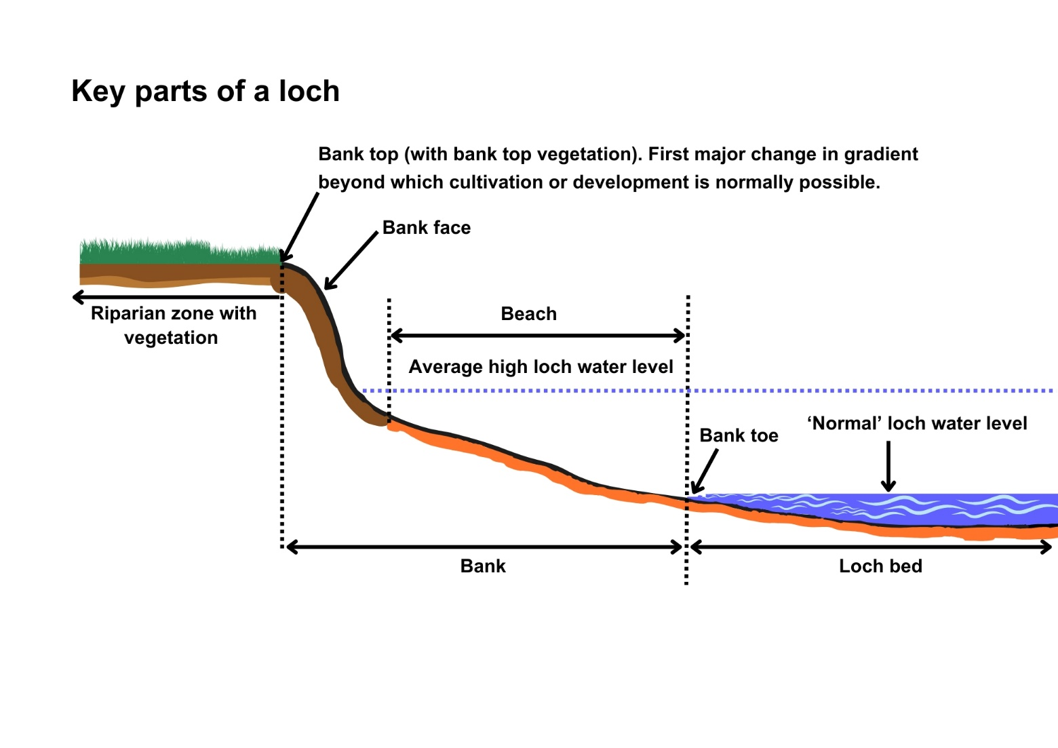**Figure 1** Key parts of a watercourse

**Figure 2** Key parts of a loch.

# Risks to the Water Environment

Engineering works in the vicinity and beyond the vicinity of watercourses or lochs or directly impacting a wetland can pose risks of harm to the water environment. Although engineering activities in these areas do not directly affect the water environment there are still risks to nearby water bodies during construction or immediately after construction due to soil and vegetation disruption and areas of exposed ground. Risks to the water environment can occur due to access requirements, poor silt mitigation particularly during heavy or prolonged rainfall or poor invasive species management.

The main risks to the water environment from carrying out engineering works in vicinity or beyond the vicinity of watercourses or lochs or wetlands can be grouped as follows:

**Harm to fish**

The main risks to fish come from the potential for pollution from the construction activity and from any temporary access routes which may directly affect water.

This including impacts on fish migration, spawning and fry development, loss of habitat and direct impacts such as stranding or physical damage.

Scheduling the timing of works to avoid fish spawning times and fish emergence times. Key fish species to consider include salmon and trout (normally October – May), lamprey species (normally March – July). However, these times can vary, and you should contact Fisheries Management Scotland if you are unsure what fish species are present or what times should be avoided.

Temporary works such as crossings, channel isolation or diversions, blasting, vibration or pile driving, sheet pilling or using artificial lighting at night can affect fish or migrating fish. You should carefully manage these works to minimise any impact and carry out fish rescues, where appropriate. For more information see WAT-G-032 EASR Guidance: Fish Protection

**Physical Impacts & Pollution**

Carefully managing construction works is essential to prevent and minimise pollution from sedimentation, leaking oil from machinery and the entry of potentially polluting materials into water such as unset concrete.

Sites should be restored following works to management impacts from disturbance.

Further information on construction works and mitigation can be found in WAT-G-034 EASR Guidance: Construction works and silt/pollution mitigation

**Invasive Non-Native Species**

Any Invasive Non-Native Species (INNS) present in or adjacent to the site could potentially be spread as a result of the works. You should identify and plan works with adequate biosecurity measures in place to prevent any spread of INNS. Further guidance can be found in EASR-G-001 EASR Guidance: Invasive non-native species (INNS)

**Protected areas and species**

You should identify any Protected areas (e.g. SSSI, SAC, SPA) in or adjacent to site and consider any impacts from the works on Protected species such as freshwater pearl mussels and otter. You should contact NatureScot where your activity is in a Protected area or may impact protected species. For further information see WAT-G-008 EASR Guidance: Assessment of impact on Protected areas from inland water activities

**Impacts to other users of the water environment**

There could be potential impacts on other water users such as water supplies, fishing, water sports.

All the risks to the water environment, as detailed above, will vary according to:

* The type and design of the engineering activity.
* The timing of the works.
* The working methods and mitigation.
* The reinstatement methods.

# Engineering Works In the Vicinity

An engineering activity is classed as being in the vicinity of a watercourse if it is within the zone that extends away from the bank top for a distance of 10 metres or two channel widths (whichever is shorter).

For a loch, ‘in the vicinity’ is the zone that extends 10 metres away from the bank top (see Figures 1 and 2).

Engineering activities which will require authorisation in the vicinity of watercourse or lochs are outlined in Section 5.1 below.

## 5.1 Engineering activities requiring authorisation

All engineering activities in the vicinity zone of a watercourse or loch which require authorisation will be controlled by Permit. This section outlines the activities that will require Permit level authorisation before being undertaken.

### 5.1.1 Set Back Embankments/Floodwalls*

Embankment and floodwalls are structures designed to protect land and property from flooding.

**Embankments** are raised earth structures often located along or set back from the bank tops to protect land from flooding (often agricultural land) when water levels are high. These structures can have a clay core and are often covered with grass.

**Flood walls** are vertical barriers constructed from concrete, brick or steel that are designed to be watertight to protect, generally, urban environments from flooding.

* Note, embankments and floodwalls which are located on the bank or on the bank top are authorised as a type of bank works which alters the bank height, not as an in the vicinity activity. Please refer to WAT-G-022 EASR Guidance Engineering Activity Guide Bank Works for more details.

Where embankments and floodwalls are set back from the bank top we refer to them as **set back embankments and floodwalls.** Authorisation is only required for new or alterations to existing set back embankments and floodwalls as set out in 5.1.1.1 below.

#### 5.1.1.1 Set Back Embankments/ flood walls which require a permit level authorisation:

1. Any new set back embankment or flood wall located in the in the vicinity zone.
2. Any extension in length (as measured along the bank) of an existing set back embankment or flood wall, located in the in the vicinity zone.
3. The heightening, lowering, or removing of an existing set back embankment or floodwall over a length of more than 500 metres as measured along the bank, located in the vicinity zone.
4. Heightening, lowering or removing set back embankments or floodwalls (located in the in the vicinity zone), over a length of less than, or equal to, 500 metres as measured along the bank, if this is expected to significantly increase erosion (circumstances where this may be the case could be where there is infrastructure, development or houses nearby and where the river is high energy (such as steeper rivers and those with high sediment loads see our guidance WAT-G-033 EASR Guidance: Inland surface waters and river subtypes)
   1. If you are unsure if your embankment or floodwall works will significantly increase erosion and therefore require a permit, please contact your us for advice before you start works.
5. The reinstating of existing set back embankments and flood walls, located in the in the vicinity zone, that are in a state of disrepair and failed more than 18 months ago (i.e. not delivering their original intention). Reinstatement of these structures would be considered increasing the current footprint and require authorisation as a new embankment or floodwall activity.

#### 5.1.1.2. Set Back Embankments and flood walls which do not require authorisation

1. Set back embankments and floodwalls located in the vicinity of minor watercourses (i.e. a watercourse that is not shown on the 1:50,000 scale Ordnance Survey maps, Landranger series).
2. Heightening, lowering or removing of set back embankments or floodwalls located in the in the vicinity zone, over a length of less than, or equal to, 500 metres as measured along the bank, which are **NOT** expected to significantly increase erosion.

If you are unsure if your embankment or floodwall works will significantly increase erosion and therefore require a permit, please contact us for advice before you start works.

1. Any new or alteration to existing set back embankments or floodwalls which are located in the beyond the vicinity zone, unless considered a risk to wetlands dependant on a surface water body, see sections 6 and 7 for further details.

### 5.1.2 Land Raising/Lowering

Land raising is the process of increasing the elevation of the land by adding soil, sediment or other fill materials. Land raising can be done for flood protection, to allow urban expansion, and for ecological restoration.

Land lowering is the process of decreasing the elevation of the land by removing soil, sediment or other fill materials. Land lowering can be done for flood protection and for ecological restoration

#### 5.1.2.1. Land raising/lowering activities which require a permit level authorisation

1. Any new raising of land levels (usually for development purposes), not considered embankments or floodwalls (this includes any extension) to existing artificially raised land) located in the in the vicinity zone.
2. Reinstating of existing artificially raised land, located in the vicinity zone, which is in disrepair (not delivering their original intention) in recent years. This would be considered increasing the current footprint and require authorisation as a land raising activity.
3. Any new lowering of land levels located in the in the vicinity zone.

#### 5.1.2.2 Land raising/lowering activities which do not require authorisation:

1. Land raising in the vicinity of minor watercourses (i.e. a watercourse that is not shown on the 1:50,000 scale Ordnance Survey maps (Landranger series)).
2. Land raising activities which are located in the beyond the vicinity zone, unless considered a risk to wetlands dependant on a surface water body see sections 6 and 7 for further details.

#### 5.1.3 Any activity (not covered above) likely to have a significant impact on a wetland (which is dependent on a body of surface water)

1. This can include activities such as removal of sediment and drainage activities see section 7 and 7.2  for details.

## 5.2 What are the potential issues with engineering activities in the vicinity zone

Engineering activities located within the vicinity of a watercourse or loch such as embankments, flood walls and land raising can have negative impacts on the water environment. Potential issues include:

* **Flood Risk** – altered channel and floodplain interaction can cause a change in flood extents and depths. This will depend on the activity and site but could lead to reduced flood risk at the immediate site, but increased flood risk elsewhere. For example, increased channel capacity at one location, increases conveyance of water to downstream. Likewise, only raising land on one side of the channel may increase flooding on the opposite bank where the land is now lower.
* Note, SEPA does not regulate flooding risks via EASR. Further information on flooding and the different responsibilities in relation to flooding can be found on our website at: [Flooding](https://www.sepa.org.uk/environment/water/flooding/)
* **Modified sediment transport processes** – changes in channel-floodplain connectivity and associated changes in river energy cause patterns of sediment erosion and deposition to alter. For example, increasing a channel’s capacity by placing set back embankments in the in the vicinity zone, can increase energy within the active channel during high flows and increase erosion and sediment transport through this section. This increases the amount of sediment transported downstream.
* **Channel instability** – changes to the floodplain can alter river energy and so the channel may respond by eroding more, often lowering its bed level and eroding its banks. These changes can increase energy further, continuously exacerbating the problem, which can lead to instability and in some instances cause a change in a channel morphology or its course within the floodplain.
* **Habitat degradation** – altered flow patterns and river adjustment can degrade habitats. For example, channel change could simplify habitat, reducing diversity. Likewise, changing flow could result in habitats to be become drier or wetter, increasing habitat fragmentation and species displacement. This can include the loss of wetlands that support many unique species and plants because they are disconnected from the channel.
* **Vegetation changes** – changes in floodplain elevation can affect the types of plants. This could lead to loss of native vegetation and encourage colonisation of non-native invasive species.
* Further potential environmental effects are changes to water quality, groundwater recharge, carbon storage potential and soil fertility and compaction.

Given the potential impacts of works within the in the vicinity zone, it is important that you consider the effects on the wider environment before undertaking any works.

## 3.4 Engineering works in the vicinity and climate change

Climate change predictions indicate there will be significant increases in winter precipitation over the coming decades, which suggests that large floods will occur more frequently. Summer rainfall is also likely to become more intense.

Changing flood frequency means that many channels will:

1. Need to increase in size via bed and bank erosion to accommodate larger volumes of water before spilling on the floodplain and
2. Have more energy and a greater ability to erode their beds and banks, transport sediment, and adjust their planform.

Any proposed set back embankments, flood walls or land raising should recognise the predicted changes in our climate and ensure their designs do not overly constrain the river and provide space for a degree of natural adjustment.

We always encourage people to set back any embankment, floodwalls and land rising activities as far back from the channel as possible. Setting-back these activities as much as is feasible reduces their effect on the river environment and gives the river space to move and adjust to the effects of climate change. Giving the river more space to adjust will also reduce longer term maintenance requirements. When works do not allow the river space to adjust they are more likely to

* Fail, potentially damaging infrastructure.
* Require more maintenance and higher ongoing costs.
* Damage species and habitats.
* Pose a greater threat to surrounding land uses upstream of, within, and downstream of the footprint of the works.

Setting embankment, floodwall and land raising back from the in the vicinity zone of a watercourse or loch could also mean you do not require authorisation under EASR. Further details on this are in Section 6: Engineering works beyond the vicinity.

# 6. Engineering Works Beyond the Vicinity

An engineering activity is considered as being in the ‘beyond the vicinity’ when it takes place in the zone further away from the watercourse or loch than the “in the vicinity” zone (i.e. is greater than 10 m or two channels (which is ever is shorter) away from bank top).

Engineering activities in the beyond the vicinity zone only require authorisation when they are expected to have a significant adverse impact on a wetland (which is dependent on a body of surface water). All such activities will require permit level authorisation.

## 6.1 Engineering activities requiring authorisation

#### Permit level authorisation is required for:

* Any activity in the beyond the vicinity zone that will significantly adversely impact a wetland (which is dependent on a body of surface water).

See: Section 7- Engineering works which may significantly impact wetlands for details on which activities may require authorisation.

#### Authorisation is not required for:

* Any activity in the beyond the vicinity zone that will not significantly adversely impacting a wetland (which is dependent on a body of surface water).

# 7. Engineering Works that may significantly adversely impact wetlands

SEPA will only seek authorisation (permit) under EASR for engineering works that are considered to have a likely significant adverse impact on a wetland which is dependent on a body of surface water. (e.g. one which has hydraulic connection to a nearby loch or river)

Whilst control is only sought for significant impacts on these types of wetlands, we encourage impacts on all wetland types to be minimised wherever possible as wetlands provide valuable and increasingly rare habitats.

To determine if authorisation is required you will need to establish

1. Whether there are any wetlands nearby (see section 7.1 below).
2. Whether it is dependent on a body of surface water (see section 7.1 below).
3. Whether your proposed activity (type and scale) is likely to cause a significant adverse impact (section 7.2)

In many cases you will need to contact SEPA for specialist advice to identify wetlands, to determine whether any wetland is dependent on a body of surface water and determine whether your proposed activity could have a likely significant adverse impact. The sections below try to assist you gathering information and assessing your proposals prior to contacting SEPA to obtain advice on whether authorisation is required.

## 7.1 Identifying Wetlands

To determine if authorisation is required you will first need to establish whether there are any wetlands nearby.

We suggest you identify any wetlands within a radius of 500m of your proposed activity.

A wetland is an area of land where the soil is saturated with water, either permanently or seasonally. Wetlands can occur in a wide variety of settings and are characterized by their distinct ecosystems, which include a variety of plants and animals adapted to wet conditions. They play a crucial role in the environment by filtering water, providing habitat for wildlife, and helping to control floods. Example wetland environmental include peatlands, saltmarshes, fens, and wet woodland.

If you are not clear on how to identify wetlands you should contact SEPA for help and advice.

To help identify a wetland and assess whether your works are likely to impact it you should consider:

* If there is permanent open water this is usually a loch, pond or lochan and not a wetland. However, if there are areas of wet ground around the edges of a loch, pond or lochan or adjacent to a river channel then those areas are classified as a wetland.
* If standing water frequently occurs due to flooding from areas of open water or due to rainfall not draining away this area is likely to be a wetland.
* If there is no standing water but the ground is generally very wet, squishy when you stand on it and water seeps out around your boots, this area is likely to be a wetland.
* If the soil type is peat (i.e. dark spongy soils with a high organic matter (plant material that has not completely broken down)) then the water table is likely very shallow and the likelihood of wetland being present is high.
* If there is a spatial change in the vegetation in an area towards more water loving or plant characteristics of a wetland environment (cotton grass, mosses, meadowsweet, marsh marigolds, bog myrtle), then this could be wetland area. Spatial changes in vegetation can also be used to define the extent of the wetland.

Further guidance is available here ([Wetlands | Scotland's environment web](https://www.environment.gov.scot/our-environment/land/wetlands/)) and several national datasets such as the Scottish wetland inventory, wetlands of international importance Ramsar, land cover and vegetation classification maps, can also be used to help you identify if your work will impact a wetland. These datasets are available from the Scottish Government Environment Map: [Map | Scotland's environment web](https://map.environment.gov.scot/sewebmap/).

It is also important to understand if your wetland is surface water or ground water fed.

* Surface water fed – water is received from rainfall, rivers and surface run-off e.g. floodplain wetlands, swamps, marshes.
* Ground water fed – water is received from underground aquifers e.g. fens.

Key wetlands which may be associated with surface waters e.g. river channels, loch sides, riverbanks, riparian zones and flood plains include (Figure 3):

* Wet Woodlands
* Marshy grassland
* Fen
* Swamp
* Reed Bed
* Wet heath
* Quaking bog

Photographic examples of these types of wetlands are shown in figure 3 below

**To determine if any wetland is dependent on a body of surface water you should contact SEPA for advice.**

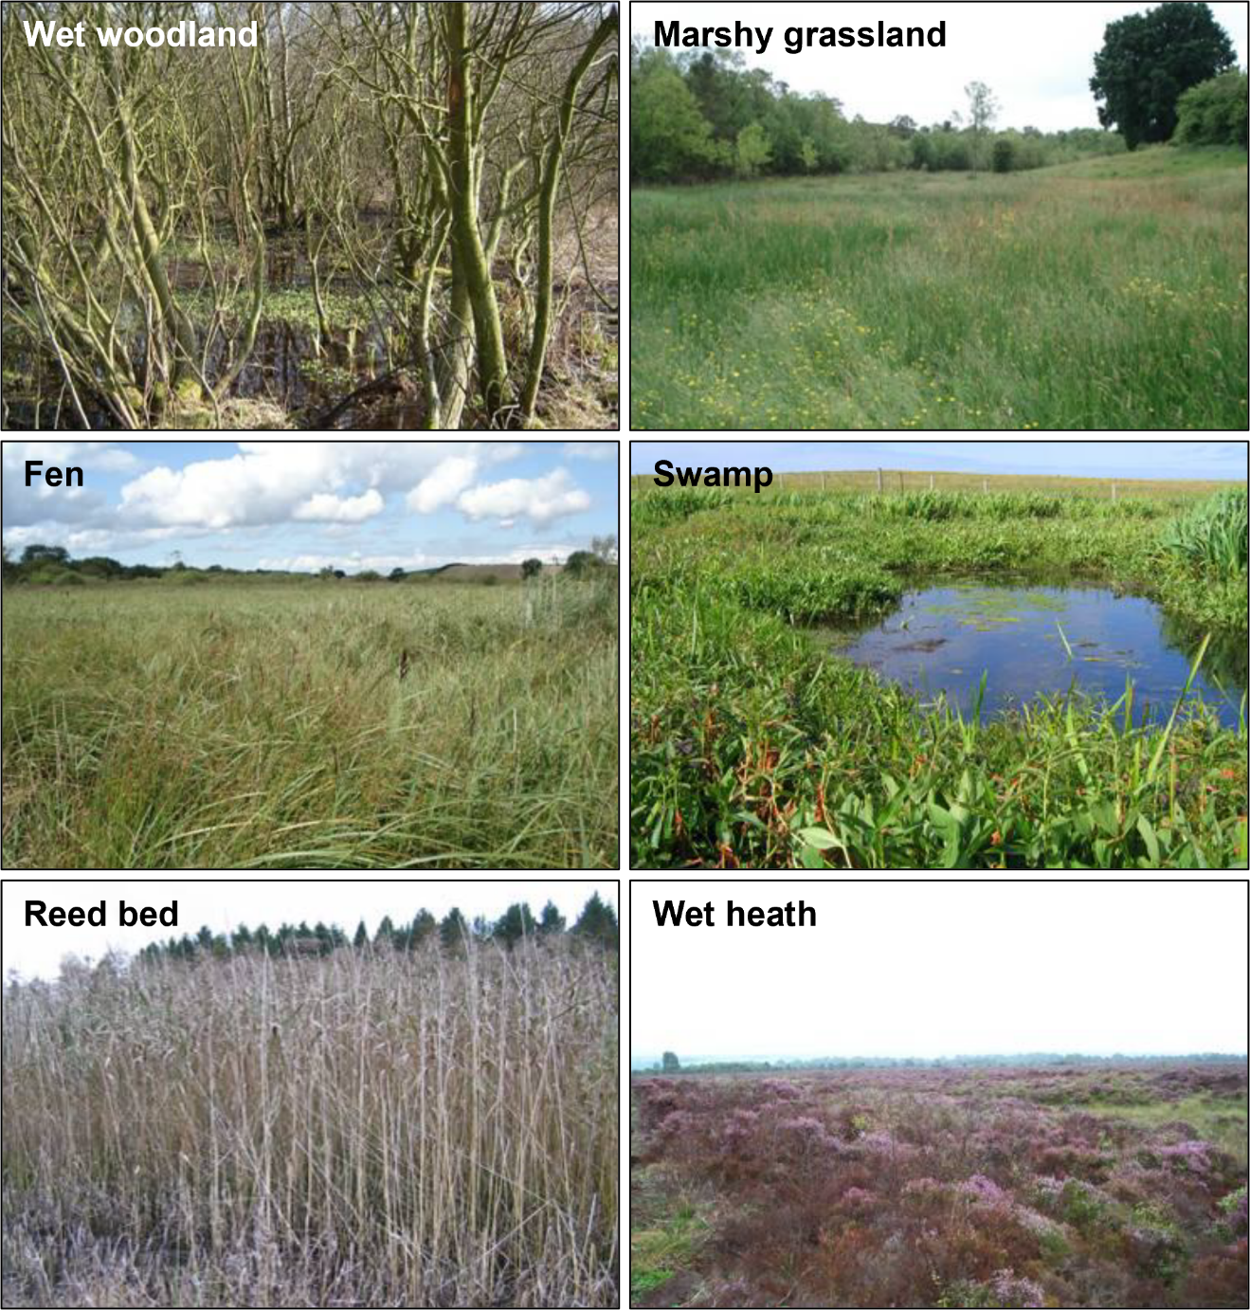

**Figure 3** – Example photographs of the main wetland types.

## 7.2 Engineering activities which may significantly adversely impact a wetland

Those activities which could have a significant adverse impact on a wetland which is dependent on a body of surface water include, but are not limited to):

* **Drainage operations** within, near to, or connected to a wetland such as the dredging/excavation of drainage channels, which can cause it to dry out or be permanently inundated.
* **Removal of sediment from a wetland** through excavation that can impact vegetation, water quality and hydrology of the area.
* **Changing ground levels in or near wetlands** that change the hydrology of the site and/ or change flood risk of the local area, such as land raising or land lowering.
* **Embankments or flood walls** (new, reinstate or extension of existing) that can change water levels between the surface water and wetland causing the wetlands to dry out or be permanently inundated.
* Any other activity that could have a significant adverse impact on a wetland. If you are unsure whether your activity will negatively affect a wetland, please contact your local SEPA team.

which are carried out in any of the following zones

* In the vicinity of an inland surface water (watercourse or loch).
* Beyond the vicinity of an inland surface water (watercourse or loch).
* Directly within a surface water dependent wetland.

Whether your activity could have a significant adverse impact will depend on the scale and extent of the activity and its location relative to the wetland.

**We recommend that you contact us to discuss this and establish whether there could be likely impact and to determine whether an application for permit would be required.**

## 7.3 When is Authorisation required

### 7.3.1 Permit level authorisation is required when:

* You plan to carry out any of the activities listed in 7.2 above located: in the vicinity, beyond the vicinity or directly in a wetland; and.
* There is a wetland (which is dependent on a body of surface water) nearby, and
* The proposed activity is likely to significantly adversely impact this wetland.

### 7.3.2 Authorisation is not required when:

* Your works do not involve any of the activities listed in Section 7.2, unless we have advised you otherwise; or
* Your proposed activity will not affect any wetland; or
* Your proposed activity may affect a wetland, but the wetland is not dependent on a body of surface water; or
* Your proposed activity may affect a wetland which is dependent on a body of surface water wetland, but the likely impact is not considered significant.

If you have any doubts about the effects of your proposed activity you should contact us for advice.

Note that when the need for authorisation is being evaluated, considerations will be made to whether there is a likely impact on the quantity and quality of the water that the wetland is dependent upon. If you wish to discuss this further, please contact us.

## 7.4 What are the potential issues with activities that significantly adversely impact wetlands

Engineering activities that significantly adversely impact wetlands can cause several issues:

* **Loss of Biodiversity:** Wetlands are home to a diverse range of plant and animal species. Engineering projects like construction, drainage, or filling can destroy these habitats, leading to a loss of biodiversity.
* **Water Quality Degradation:** Wetlands act as natural filters, improving water quality by trapping pollutants and sediments. Disrupting wetlands can result in increased pollution.
* **Flooding and Erosion:** Wetlands help in flood control by absorbing excess water. Removing or altering wetlands can increase the risks of flooding and erosion elsewhere.
* **Carbon Storage Loss:** Wetlands store significant amounts of carbon. Disturbing them can release this stored carbon into the atmosphere, contributing to climate change.
* **Altered Hydrology**: Engineering activities can change the natural water flow in wetlands, affecting their ability to recharge groundwater and maintain water levels.

It's crucial to consider these potential issues and implement sustainable practices to minimise the impact on wetlands. You should consider these potential impacts when planning your works.

## 7.5 Engineering works affecting wetlands and climate change

The predicted increases in temperature, change in the frequency of extreme rainfall events and altered precipitation patterns because of climate change are expected to have a significant effect on our wetlands. This is particularly concerning when over 80 % of wetlands in Scotland are already degraded. Climate change means that many wetlands will:

* Shrink in size or dry out completely due to increases in temperature and changing rainfall patterns. The drying out of wetland habitats due to climate change will have negative consequences for biodiversity (plant and animals) and carbon storage.
* Have poorer water quality as extreme events will wash more pollutants into these habitats and higher water temperatures will reduce oxygen availability making them less hostile many aquatic species.
* Have greater saltwater intrusion due to sea level raise making them more saline and reducing the number of species which are live in them.

Wetlands can increase our resilience to climate change by absorbing floodwaters, increasing carbon storage and improving water quality.

To reduce the pressure on these now rare and valuable systems and maximise their climate resilience benefits it is important that engineering activities that are likely to directly or indirectly effect these ecosystems are kept to a minimum.

# 8. Good Practice

All engineering works in the vicinity and those which may significantly impact wetlands should follow the principles of good practice. All permit applications must meet Good Practice. Good Practice is achieved when the chosen option serves a demonstrated need, while minimising ecological harm, at a cost that is proportionate. Meeting Good Practice ensures that modifications to the morphology of rivers, lochs and wetlands are sustainable.

A summary of the key steps in meeting good practice are set out in the box below:

**Good Practice Summary**

1. **Demonstrate need**

* State the reasons for carrying out the activity and the benefits it will bring.
* Identify and understand the problem or need.

1. **Identify and appraise options**

Use sustainable river management principles to:

* Identify a number of options (minimum of three, including do nothing)
* Carry out an options appraisal.

1. **Justify the selected option**

* State why it represents the best practical environmental option.

1. **Use all reasonable mitigation**

* State the mitigation measures you propose to minimise impacts
* Submit method statement(s) detailing how the works will be carried out.

## 8.1 Demonstrating need

Before undertaking any engineering works in the vicinity of a watercourse or loch or which may significantly impact a wetland there should be a clear and justifiable reason or need. You should have a good understanding of the causes (including the underlying cause) and scale of the problem being addressed. You must:

* Specify the reasons for carrying out the activity and the benefits it will bring.
* Identify and understand the problem or need.

### 8.1.1 Reasons for carrying out the activity

You must provide us with:

* Clear reasons why you wish to carry works in the vicinity of a watercourse or loch that will significantly impact a wetland dependent on a body of surface water.
* Where relevant the type and details of what is being protected (e.g. infrastructure, buildings, valuable land, wildlife reserve.)

The reasons for carrying out engineering activities in the vicinity in the vicinity of water will usually be one of the following:

#### Flooding

Engineering works (such as embankments and flood walls) can be undertaken to protect the built environment (commercial and residential property), infrastructure and valuable land and property from flooding. Other reasons include controlling wildlife or conservation reason.

Note SEPA does not regulate flooding risks via EASR. Further information on flooding and the different responsibilities in relation to flooding can be found on our website at: [Flooding](https://www.sepa.org.uk/environment/water/flooding/)

#### Active Travel

Engineering works such as creating an active travel route to allow provide people with a traffic way to commute between towns, encourage people to be more active for their general health and wellbeing and improve access to nature.

#### Recreation

Engineering works such as land raising may be required to create and maintain sports fields or play areas.

#### Drainage

Land is often drained to support agricultural practices or ensure recreation ground is available for more frequent use through-out the year. However, in some cases this land may naturally be a wetland area, so draining the land would result in a loss of this habitat.

### 8.1.2 Identifying and understanding the problem or need

To identify the best solution to a problem or need it is crucial to:

* Understand the problem or need
* Identify and understand, where relevant its causes,
* Understand its value in terms of ecology, river and wetland function, and
* Understand its impact on human activities, resources or health.

We can’t give specific detail on understanding the problem or need for engineering works in the vicinity of a watercourse or loch or those that will significantly impact a wetland. However, in general, identifying the cause of the problem, or addressing a need will require assessment and understanding of the environment you are working in. Further details on this can be found in guidance WAT-G-033 EASR Guidance: Inland surface waters and river subtypes. This assessment will help you to design appropriate engineering works that are sustainable long term and require minimal maintenance. It will also aid you in choosing and assessing suitable options to address the problem or need which have limited impacts on natural processes and habitats.

For example, if you are looking to place an embankment in the vicinity of watercourse or loch for flood protection or drain land for a sports ground, having an understanding of the site, adjacent reaches, and wider environment should allow you to answer:

* Is this a new or long-term problem?
* Have recent environmental factors (high flow events) caused or exacerbated the problem?
* Is there evidence that the problem will not resolve naturally?
* Is there any survey data (including photographs) to aid description of the problem?
* Has a similar problem occurred before (elsewhere) and how was this addressed?
* Is the problem associated with the watercourse or wetland’s response to climate change?
* Is there a surface water fed wetland that will be affected by the engineering works?

Supporting evidence should always be submitted to demonstrate the need for the any works being applied for in the vicinity of a watercourse or loch or that will affect a wetland. It should demonstrate why it is being done and the problem or need, including its scale. The evidence provided could take the form of photographs, historic maps, survey data, anecdotal evidence or expert opinion. The type and form of information provided will depend on the nature of the site and the scale of the problem.

## 8.2 Identify and Appraise Options

It is a basic principle of good practice that when addressing any engineering problem, or need, that several options are identified, and evaluated (considering the advantages and disadvantages) to determine the best solution. Each option should be fully evaluated in an options appraisal to determine the best practical environmental option for the situation. You should generally consider a minimum of three options, including ‘do nothing’.

There are three broad types of options to consider:

* Do nothing
* Non-engineering options.
* Engineering options.

Within each type there are usually a variety of methods which can be used.

Before selecting the preferred option, you should consider the principles of sustainable river management and incorporate these into your decision-making process. The principles of sustainable river are:

1. Address the scale, significant and underlying cause of the problem or need.
2. Consider the effects of climate change.
3. Allow the river some room to move (where feasible).
4. Respect channel and wetland form and processes.
5. Consider and minimises maintenance requirements.
6. Consider a range of options (i.e. modifying existing structure, non-engineering and engineering) for addressing the problem including ‘do nothing’.
7. Consider how it addresses the underlying cause of the problem

An example of how this would apply to land raising to protect an active travel route in the vicinity zone is shown in the green box below.

**Problem or need**

There is a dip in a well utilised active travel route which causes it to be frequently flooded preventing people from using the path when there is bad weather. It is also degrading the quality of the path so that it constantly needs to be repaired.

**Do Nothing**

Accept that the path is in immediate vicinity of river and will flood often and need constant repairs.

**Non-river engineering option**

Reroute the path so that it is no longer within the active floodplain. This will reduce maintenance costs and mean people can still use it in poor weather. Another non-river engineering option would be to change path surface to something that is more resistant to flooding which would reduce the maintenance burden.

**Engineering option**

Raise the land on which the path is located (i.e. so the path no longer dips down) so it floods very infrequently. (authorisation would be required for this)

Further details on these principles can be found within our guidance WAT-G-030 EASR Engineering Meeting Good Practice’.

## 8.3 Justify the selected option

After evaluating all the alternatives, the best practical and environmental option, with proportionate costs, should be chosen and justification provided.

This does not always mean adopting a lowest impact engineering approach or adopting the cheapest solution.

The best practical environmental option means choosing the approach that effectively addresses the problem or need and minimises negative environmental impact as far as practical.

**Proportionate costs** are those that correspond to the level environmental harm being minimised or the environmental benefits that the option could provide. A large absolute cost does not constitute disproportionate cost.

For example, incurring significant costs to prevent significant environmental harm or achieve significant environmental benefits e.g. safeguarding protected species and designated sites, is likely to be considered proportionate. But incurring significant costs for minor environmental benefits would likely to be considered disproportionate.

Given the potential justifications are site and activity specific we cannot give detailed examples here. However, the green box below presents an example of how you might approach this for the creation of an embankment/ land rising to protect an active travel route in the vicinity zone.

**Example of how you might justify the creation of an embankment to protect an active travel route from flooding:**

* A well utilised active travel route is being frequently flooded preventing people from using the path when there is bad weather. It is also degrading the quality of the path so that it constantly needs to be repaired.
* You can’t ‘do nothing’ because it is unsafe for people to access the path during high flows and the damage cause by the frequent inundation increases the risk of people tripping or damaging their bikes. The monitoring (to ensure path is closed in high flows) and maintenance costs are also extremely high.
* Adopting a non-river engineering solution of upgrading the path to more flood resistant material does not address the safety concerns of people trying to access and use the path during high flows.
* Moving the active travel route is not possible because it would involve rerouting over 3 km of path before it could connect to the original path again. This amount of rerouting was considered disproportionately extensive for in comparison relatively short (20 m) embankment/ section of land raising.
* Raising the land so the natural dip and low point in the floodplain is removed ensures the path is safe for people to access during bad weather and significantly reduced the maintenance costs for the path.

## 6.4 Use all reasonable mitigation

To minimise impacts on the water environment and other water users you must plan to use all reasonable mitigation when carrying out any engineering works.

Mitigation measures for a proposal should:

* Limit, or offset, potential impacts, including those from construction.
* Be proportionate to the environmental risk.
* Be prioritised by the balance of factors such as environmental benefit, cost, and ease of implementation.
* Must not be used to compensate the impacts of an unjustified activity
* On demonstrating need and options selection

As every case is different there is no single answer to what mitigation is considered reasonable.

You should understand the risks and issues of your activity (sections 5.2 and 7.4).

You should prepare a method statement including details on how you intend to carry out the works including the mitigation measures you intend to take and how you will maintain them. This must be submitted with any permit application.

Using suitable mitigation will help you to comply with authorisation conditions. In certain cases, specific conditions relating to mitigation requirements will be contained within an authorisation.

Further details on mitigation, including method statements, can be found within our guidance WAT-G-030 EASR Engineering Meeting Good Practice’

# Disclaimer

Whilst every effort has been made to ensure the accuracy of this guidance, SEPA gives no warranty, covenant or undertaking (express or implied) regarding the fitness for purpose of, or any error, omission or discrepancy in this guidance. Reliance on its contents and the contents of any websites that are linked to or from this guidance is entirely at the user’s own risk. SEPA is not liable for any loss or damage that may come from using this guidance. This includes:

* any direct, indirect and consequential losses
* any loss or damage caused by civil wrongs, breach of contract or otherwise.

SEPA reserves the right to depart from this guidance and take appropriate action as it considers necessary or appropriate. Operators are responsible for ensuring that they are compliant with the law. If necessary, independent legal / specialist advice should be sought.