


State of Scotland’s Water Environment
November 2025

Summary Report
2024

If you would like this document in an accessible format, such as large print, audio recording or braille, please contact SEPA by emailing equalities@sepa.org.uk

Introduction
SEPA has a key role in protecting and improving the status of the water environment in Scotland during a time when the impacts of climate change, urbanisation and land use have all been increasing. Consequently, preventing deterioration in the condition of our groundwater, rivers, lochs, transitional waters (e.g. estuaries) and coastal waters is a major focus of SEPA’s work. Improvements are driven by investment, required by SEPA from businesses to reduce their environmental impacts, or supported by Scottish Government funding. This report explains how the status of our water environment has changed between 2023 and 2024 and places this change in the context of classification results since 2008.

Classifying Scotland’s water environment
Classification is how we define the state of Scotland’s water environment and is based on EU and Scottish Government guidance. An annual classification is produced for all water bodies in Scotland, underpinned by environmental monitoring and modelling designed to assess long-term changes and driven by risk assessments based on pressure information and areas of known risk. All water features above a certain size threshold are split into management units called water bodies. Water bodies are placed into the following categories: rivers, lochs, estuaries (also called transitional waters), coastal waters, and groundwater. Table 1 shows the total number of water bodies classified in Scotland.

The classification provides evidence on where the status of the water environment is good and where it requires improvement. This information is used to understand long term trends showing improvements in overall status, and to inform actions undertaken in River Basin Management Planning.

Table 1: Number of water bodies classified in Scotland
Rivers | Lochs | Estuaries | Coastal | Groundwater | Total
2410 | 334 | 48 | 457 | 403 | 3652

Classification is based on an assessment of biological quality elements (invertebrate animals, aquatic plants and fish), supported by measurements of chemistry (physico-chemical properties, nutrients, pollutants and metals), hydrology (changes to water flows and water levels), morphology (changes to the physical condition of beds, banks and shores of water bodies), and assessment of invasive non-native species (INNS). A range of these assessments are incorporated into the classification of individual water bodies.

If any single aspect of a water body is classified as below good, that water body’s overall condition is reported as below good. Therefore, overall status can mask considerable improvements for individual elements.

Summary of 2024 classification results
Scotland’s water environment classification results have been updated for 2024, incorporating all data available up until 31/12/2024.

Since the previous results for 2023 were produced, the proportion of our water environment assessed as being in good or better overall condition has decreased from 67.9% to 67.1%. Of the 0.8 percentage point decrease, just over half of the decrease (0.43%) is due to changes in how we assess and report on classification quality elements, particularly flows and levels, and new information on natural conditions or pre-existing impacts. In real terms, this means there have been no actual environmental changes on the ground, we are just updating classification in line with new information. Just under half of the decrease (0.37%) is due to real environmental change, mainly due to downgrades in water quality.

There have also been improvements to individual aspects of classification themes, such as access for fish migration. However, these do not necessarily result in improvements to the overall condition due to the presence of other impacts. Table 2 shows the proportion of water bodies currently in good or better condition.

The detailed results for individual parameters will be published on SEPA’s water classification hub.

Table 2: Overall condition of Scotland’s water environment
 | Rivers  (%) | Lochs  (%) | Estuaries  (%) | Coastal  (%) | Groundwater  (%) | Total
High/good | 56.9 | 69.8 | 87.5 | 99.6 | 86.1 | 67.1
Below good | 43.1 | 30.2 | 12.5 | 0.4 | 13.9 | 32.9

Figure 1: Overview of the state of surface water bodies in 2024 classification
See Annex 1 for a table of detailed percentages for all themes in Figure 1. Surface water bodies include rivers, lochs, estuaries and coastal waters. Fish migration and water flows and levels parameters are not relevant to classification of estuaries and coastal waters.

Figure 2: Overview of the state of groundwater bodies in 2024 classification
Note: Groundwater bodies are classified as either good or poor status.

What has changed since 2023?

Overall condition
There are 16 water bodies that have moved from less than good overall condition to good or high overall condition, and 45 water bodies that have moved from good or high overall condition to less than good overall condition.

Of the 16 changes to good or better for overall condition:
- 1 is the result of improvements in the environment where we are confident these are sustained long-term changes.
- 8 are due to improvements that require further monitoring to confirm if they show a long-term improvement.
- 6 are a result of collecting new data on natural or pre-existing conditions, rather than actual environmental changes.
- 1 is due to a change in how we assess and report on the environment.

Of the 45 changes to less than good for overall condition:
- 1 is due to a change in the environment and this will be addressed through the RBMP process.
- 20 are due to deteriorations that are being addressed through regulatory processes and further monitoring to assess whether it is a long-term deterioration.
- 6 are due to new data on pre-existing conditions rather than actual environmental changes.
- 18 are due to changes in how we assess and report on the environment.

Figure 3 provides an overview of the overall condition and theme level changes we have observed for 2024. Not all theme level changes will contribute to a change in overall condition because this is determined by the worst-case condition of the five themes. The number of water bodies that downgraded in 2024 for overall condition is lower than the number of downgrades seen in the five RBMP themes. This is because some of the water bodies that have downgraded in 2024 for an individual RBMP theme (e.g. water quality) would have already had an overall condition of less than good due to another RBMP theme being at less than good in 2023. Therefore, they are not counted in the 2024 overall condition downgrades as there is no new downgrade overall.
In all cases where a water body has a new downgrade in overall condition in 2024, this was due to a change in only one of the RBMP themes.

Figure 3: Changes since 2023 classification; number of water bodies that have changed classification between good or better and less than good condition for both groundwater and surface water bodies for overall condition and the five themes.

Water quality
Many of the water bodies reported as downgraded in 2024 classification is as a result of new data. The new data is highlighting some potential water quality downgrades that have occurred since the last assessment of these water bodies. We are putting in place further monitoring to understand where there are real and sustained impacts on the environment, rather than statistical fluctuations in classification.

Flows and levels
Changes in the way we assess and report on flows and levels has resulted in some downgrades in classification that are not due to actual environmental change. Condition limit assessments were introduced following guidance at a UK level by the UK Technical Advisory Group for the Water Framework Directive. This assessment identifies rivers where flows are significantly elevated above the natural at low flows, and has resulted in some water bodies being re-classified as moderate status. These moderate statuses have now been incorporated into our assessments of the ecological potential of heavily modified water bodies (HMWBs). This means some HMWBs at good ecological potential for flows and levels have now been downgraded to moderate ecological potential. The low flows pressures will require a further assessment to determine whether they are at good ecological potential, which will be reported in future classification years.

Access for fish migration
Thirteen water bodies have had works completed to enable fish passage, including a Water Environment Fund funded project that benefitted 11 water bodies. Three of these improvements in fish passage have upgraded the overall water body condition to good.

Freedom from invasive species
There are new records of North American signal crayfish in four water bodies.

Long term trends
Since the start of water environment classification for River Basin Management Planning in 2008, the overall condition of Scotland’s water bodies has improved each year until 2024. In 2024, we are seeing a slight decrease, although the overall trend is positive, and fluctuations should be expected as we identify and respond to environmental changes. It is worth noting that SEPA’s actions to prevent deterioration and deliver improvements have led to overall status improving over the cycles, despite the impact of climate change, land use pressures and development.
The percentage of surface water bodies that were classed as good or better in 2008 was 61% (1972 water bodies out of 3233 water bodies) and is now 64.7% (2102 water bodies out of 3249 water bodies), demonstrating an improvement of 3.7 percentage points since 2008 (Figure 4).
The number of surface water bodies at bad overall condition has decreased from 224 in 2008 to 55 in 2024, indicating an upward trend in overall condition. The percentage of groundwater bodies that were classed as good in 2008 was 77.3% and is now 86.1%, demonstrating an improvement of 8.8 percentage points since 2008 (Figure 5).

Figure 4: Long term trend in the overall condition of surface water bodies

Figure 5: Long term trend in the overall condition of groundwater bodies

Next steps
Reporting on the state of our water environment is a key element of the river basin management process and helps us to evaluate where actions are contributing to improving the environment, and where further action is needed. In December 2025, the Significant Water Management Issues (SWMI) report will be published, setting out the biggest challenges for the future of Scotland’s water environment.

Annex 1
Table 1: Overview of the state of surface water bodies in 2024 classification
Classification theme | High (%) | Good (%) | Moderate (%) | Poor (%) | Bad (%)
Overall condition | 13.6 | 51.1 | 22.8 | 10.8 | 1.7
Water quality | 38.4 | 47.9 | 12.6 | 1.0 | 0.1
Flows and levels | 65.4 | 22.3 | 10.5 | 0.5 | 1.2
Access for fish migration | 87.5 | 2.6 | 0.9 | 9.0 | 0.0
Physical condition | 50.3 | 40.3 | 3.4 | 1.8 | 4.2
Freedom from invasive species | 95.9 | 2.6 | 1.5 | 0.0 | 0.0

Annex 2

Figure 1. Map of Scotland’s surface water bodies, showing the 2024 overall condition classification status
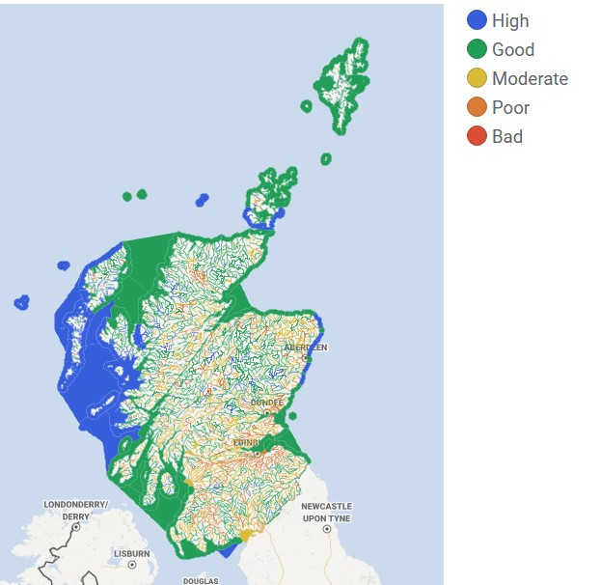

Figure 2. Map of Scotland’s groundwater bodies, showing the 2024 overall condition classification status
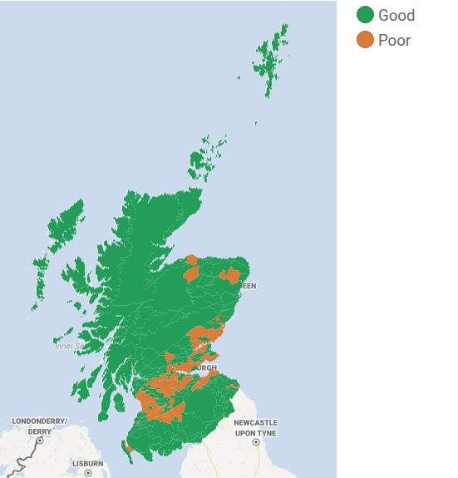

Annex 3

Glossary
Fish migration: SEPA evaluates structures such as weirs, culverts and bridges, which can block migratory routes for fish and deny them access to good quality habitat for spawning and rearing.
Freedom from invasive species: An assessment to evaluate the presence or absence of non-native species in the water environment.
Heavily modified water body (HMWB): A surface water body which, as a result of physical modifications by human activity, is substantially changed in character. The physical modifications must be for the purpose of providing specific socio-economic benefits, rather than commercial gain.
Overall condition: SEPA classifies the overall condition of surface water and groundwater bodies by combining data, where appropriate to the water body type, on biological and chemical quality elements, hydrology, morphology, and assessment of aquatic invasive non-native species (INNS). The overall condition is based on the worst condition of any of these elements.
Physical condition: SEPA assesses the physical condition of morphological elements of the water environment to understand the extent and impacts of modifications and structures, such as embankments; culverts; and the widening and straightening of rivers. All these activities can affect the benefits Scotland derives from the water environment, such as reduced flood risks; enhanced landscape quality; improved habitats for animals and plants; and health/wellbeing and recreation for people.
Reasons for classification status changes:
- Improvements in how we have assessed the environment: SEPA will make adjustments to our methods where necessary to more accurately assess the environment. Changes to methods are thoroughly reviewed to ensure that the most reliable and consistent data are used to inform classification status.
- New data on natural or pre-existing conditions: When SEPA carries out surveys we sometimes identify new natural or pre-existing conditions that were not previously known. This changes our understanding of the impacts and can result in a change in classification status.
Water body: A defined area of water. Surface water bodies are rivers, lochs, estuary, or coastal areas. Groundwater bodies are sub-surface areas of freshwater.
Water classification hub: An interactive data tool on Scotland’s Environment Web website that allows you to view classification data for the current and previous years.
Water flows and levels: Monitoring water resources (the flows and levels of water) indicates how much water is being used and how much is available to serve all its vital functions. This information is essential for managing water efficiently.
Water quality: SEPA monitors water quality to ensure that potentially harmful substances are within safe levels, and that the loss of valuable resources such as soil and nutrients can be identified and minimised.

