


METS – Operator user guidance
July 2023

Manage your UK Emissions Trading Scheme reporting service (METS) – Operator user guidance

Contents

Manage your UK Emissions Trading Scheme reporting service (METS) – Operator user guidance 1
Executive Summary 2
1. Accessing METS 3
Accessing METS for the first time 3
Accessing METS thereafter 5
2. Navigating METS 6
User homepage and task queue 6
Accounts tab 7
Installation homepage and task queue tab 7
3. Adding a User/Types of Users and Permissions 11
4. Starting different application workflows 13
5. Frequently Asked Questions 15
Annex 1 – 2FA on mobile devices 16
Annex 2 – 2FA on desktops 23

For information on accessing this document in an alternative format or language, please contact SEPA by emailing equalities@sepa.org.uk

If you are a user of British Sign Language (BSL), the Contact Scotland BSL service gives you access to an online interpreter, enabling you to communicate with us using sign language.

contactscotland-bsl.org

Executive Summary

The Manage your UK Emissions Trading Scheme reporting service (METS) is an online single secure platform that is used for managing UK Emission Trading Scheme permits and reports. It replaced the previous system ETSWAP.

The platform offers a range of workflows that will allow UK ETS operators to manage and maintain their permits, as well as submit all necessary reports as part of your MRV requirements. Accredited verifiers will use METS for all verification and regulators will use METS to ensure compliance with UK ETS.

METS will auto-generate emails and alerts for permits that an operator holds informing them of the specific task(s) to be completed or a reminder to complete a task. METS also records the various communications between operator’s, verifiers and the regulator.

This guidance is for installation operators only; it is not a step-by-step guide on the use of the platform, but rather an introduction for new users to onboard to METS and start to utilise workflows. This guidance has been developed by SEPA and is not a UK Government official document.

Accessing METS

Accessing METS for the first time
METS can be accessed directly via –

https://manage-emissions-reporting.service.gov.uk/landing

You will be issued an invitation email issued on your behalf either by your regulator or your Primary Contact, which will also provide advice on how to log into the system. You will need to follow the provided link to activate your account:

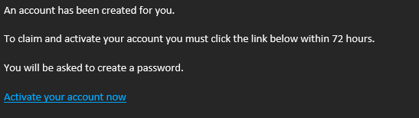

You will be asked to create a password following the security requirements:

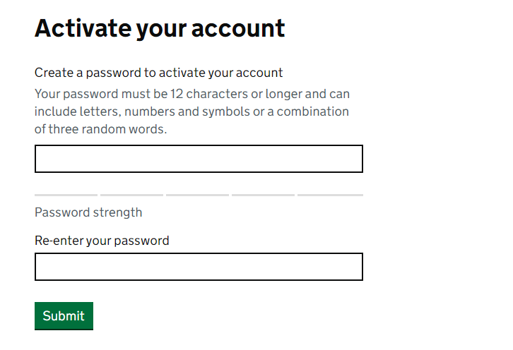
Next you will need to set up two factor authentication (2FA) which provides additional security for your account and is mandatory. You will have a choice of authenticators you can utilise on either mobile or desktop, instructions are provided on how to access the most common apps.

See Annex 1 and 2 on the use of the FreeOTP authenticator, most authenticators will follow a similar process.

Once you have downloaded your authenticator you can scan the onscreen QR code, this will create a permanent token associated with the device used.

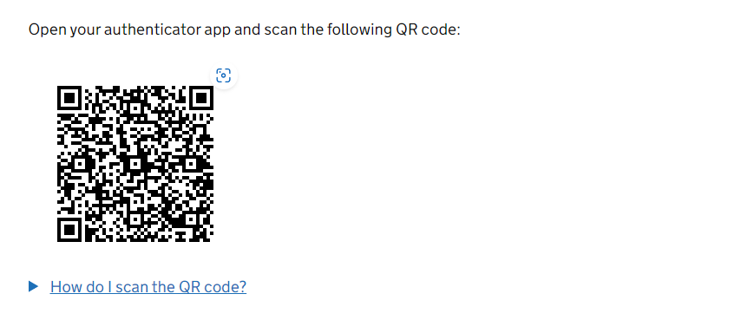

This token cannot be moved to another device (for example if you change phones) but the process can be reset by your regulator. This token provides a six digit code that you use to login to METS, it changes every minute.

After setting up your 2FA and accepting the terms and conditions you will see the following message:

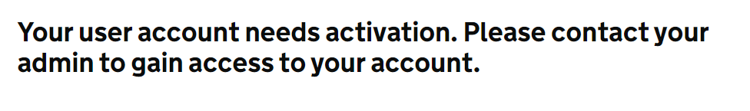
Your Primary Contact, who added your account initially, will need to set your account as active before you can access the installations account. Note that for Primary Contacts during the initial move from ETSWAP to METS your account will be activated by your regulator.

The Primary Contact will need to login and navigate to users (see section 2 on navigation) then find the activated account, it will be listed as accepted under account status, change this to active and select the relevant permissions:

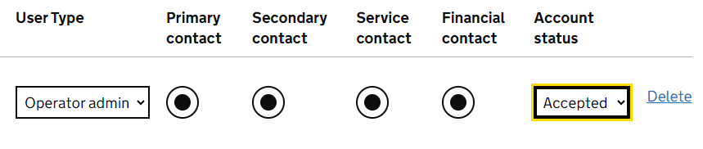
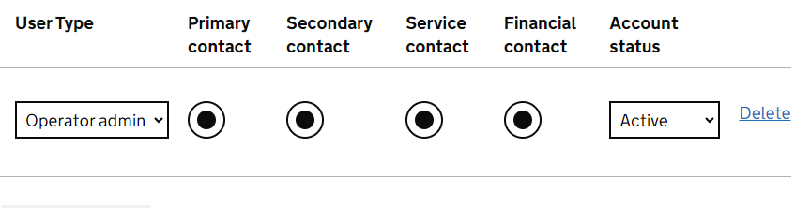
The new user will now be able to log into their account with the relevant permissions (see section 3 on permissions).

Accessing METS thereafter
METS can be accessed directly via –

https://manage-emissions-reporting.service.gov.uk/landing

The previous section should be followed whenever a new user is added to the installation account.

Navigating METS

User homepage and task queue
This is your user account homepage and is what you see when first accessing. You can access two tabs:

Tasks & Accounts

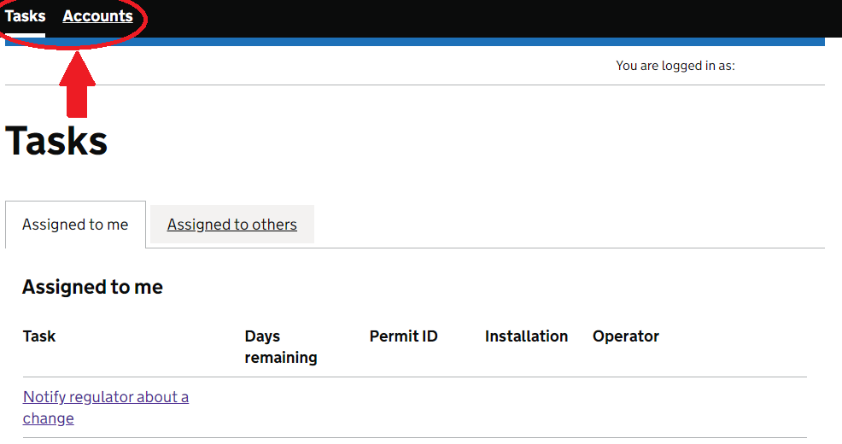

Tasks Tab

Open applications or actions you are required to take will be listed here, with relevant information such as the installation and the remaining time to act. You can also open tasks for users from your associated installations (Assigned to others).

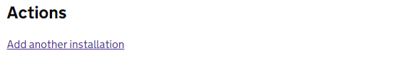

The user account homepage also provides you with the link to add another installation. You will have one when accessing METS for the first time, either as the Primary Contact assigned by your regulator or by your Primary Contact. This allows you to manage several installations.

Accounts tab
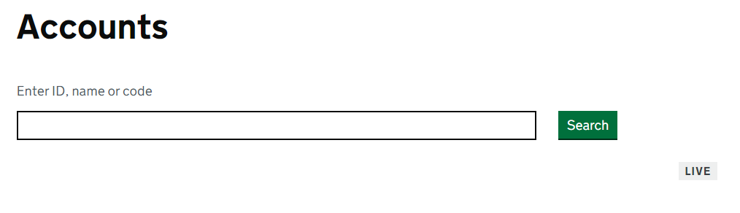
The accounts tab will list all installations attached to your user account, you can use the search bar to find installation accounts, but they will also be listed below the search bar.

To access the installation account click on the highlighted installation name, the installation account is where you will be able to start application workflows, as detailed below.

Installation homepage and task queue tab
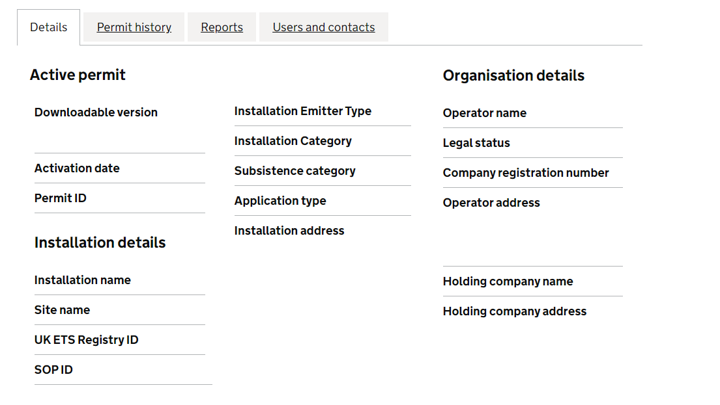

Details

Details is the tab you will start on when opening an installation account. This tab includes all of the relevant information for active UK ETS permit and the registered organisation. The permit and associated attached documents can be downloaded here by clicking on the highlighted links.

Permit History
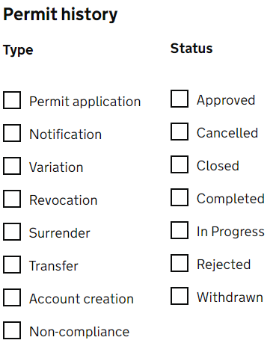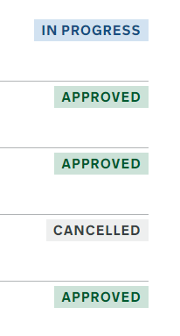

The permit history tab will include all applications that have been opened against the installation, from historic to those currently in progress. You can use the type and status bars on the side of this page to filter applications to your preference

All applications made under the UK ETS will be listed here, and you can click on the highlighted title of each application to the timeline and other information related to the task. Note that applications made on ETSWAP will not include this information only a reference for the application having been made.

Reports
The reports page will include a timeline of reports submitted on behalf of the installation under both UK ETS and EU ETS, again this can be filtered using the type and status options on the side of the page.

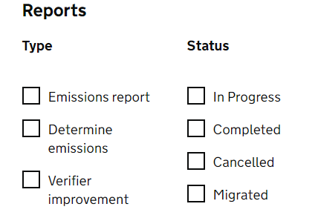

Each report can be open via the highlighted title on each, from here you will be able to download a copy of the report along with relevant attachments. Note that reports submitted through ETSWAP will not be available to download.

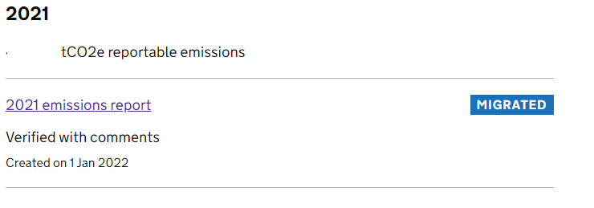

Users, contacts, and verifiers

The users, contacts and verifiers tab allow you to manage and add various types of users to be associated with the installation, these are; Operator, Operator Admin, Consultant/Agent, Emitter Contact and Verifier Body.

Start a new task

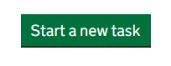

You will see the above button on any of the installation tabs and this allows you to start a new application, such as a variation or notification. Once you start a new task it will be added to your task list and you can proceed.

Adding a User/Types of Users and Permissions
Adding a User:

Accounts>Select Installation>Select Users and Contact Tab

When creating a new user, you will be able to select the type of user account and the permissions for those accounts, this will allow the user to conduct different types of activities on METS.

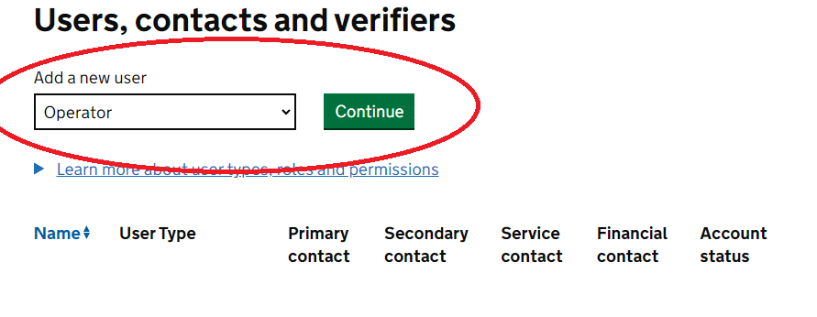
Note that each installation will have a Primary Contact initially which will be set up by your regulator, the Primary Contact will have maximum permissions. Every account must always have a Primary Contact. Remember only certain user accounts can add users see below:

Each user contact can be opened via the highlighted name, this will bring you to a page with the user details such as contact information, and this can be edited.

The types of user accounts are:

Operator Admin | Every permit holding account must have at least one person assigned as operator admin. Operator admins are able to add and delete other users on the account. They can also be assigned as the primary or secondary contact, the service contact or the financial contact.
Operator | Every permit holding account can have any number of operator users. These user types can be assigned as the primary or secondary contact, the service contact or the financial contact.
Consultant/Agent | You may wish to employ the services of a consultant agent to access this website and help you with all of the tasks relating to your permit. A consultant / agent can be assigned as the primary or secondary contact, the service contact or the financial contact.
Emitter Contact | This role enables a non-operational person to receive official notices and other legal communications. This person cannot be assigned any additional permissions.
Verifier body | You must appoint a verifier body before you submit your annual emissions report. The verifier body will verify the report.

The permissions you can assign to a user are:

Primary and secondary contacts | Responsible for day-to-day operations a site must have a primary site contact, and it is recommended that they have a secondary site contact. Both can send / receive messages to the relevant regulator and both can initiate and receive tasks on the system.
Financial contact | Person who receives all information regarding fees, fines or other charges. Can be primary and secondary site contact. Can be service contact.
Service contact | Person who receives all information regarding fees, fines or other charges. Can be primary and secondary site contact. Can be service contact.

Starting different application workflows

Tasks are the METS terms for the various applications you may make against your permit. You can start a new task under any of the tabs of the installation accounts.

NOTE: applications that will make changes to the permit cannot be made when there is an existing open variation. Notifications can be made while variations are open.

Task list displaying available application workflows that can be started.
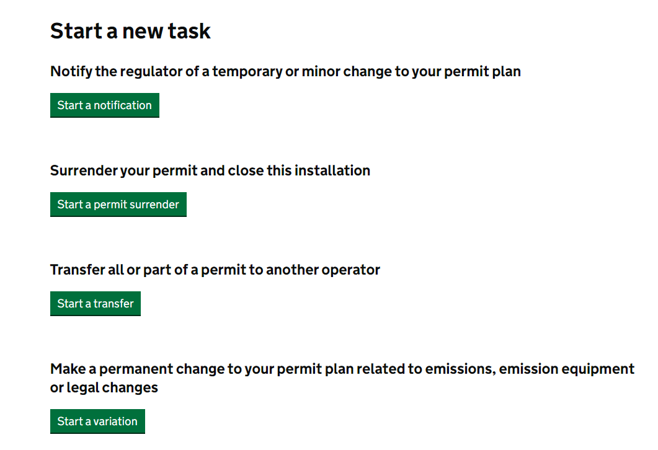
You can reassign or cancel tasks by opening the task and following the links below, which will be found at the top right of the task page.

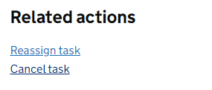

Once you open a task you can complete the workflow specific to the type of activity, you will be presented with the fields that need to be completed to progress workflow and METS will detail their status as shown below. You cannot submit until all show as completed.

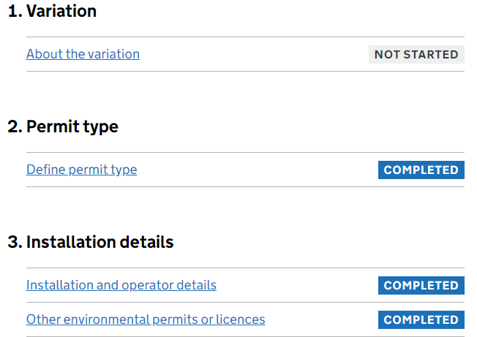

Frequently Asked Questions

- My 2 Factor Authentication (2FA) code is not working?

If during account set up you pair your account with your 2FA authenticator, but the code will not work, try removing the token from your application and adding it again.

If the code has worked previously but no longer works then you may need to reset your 2FA, see the steps in the following question.

- I have changed my device I use to access 2FA?

On the METS homepage follow the link for ‘I have lost access to my authenticator app’ which will provide instruction on contacting your regulator.

Once this has been confirmed by your regulator, they will process the resetting of your authentication, you will then be contacted to sign in to METS. From the homepage enter your password and you can then follow the steps taken under section 1 to associate the 2FA with your account.

- How do I add a user?

See section 3 on adding a new user.

- I cannot carry out tasks for my installation – why?

The most likely explanation is that your account does not have the correct permission to conduct the relevant task. Confirm with your Primary Contact whether you have the appropriate permissions.

If you believe your account has the correct permissions and should be able to conduct the relevant task, contact your regulator.

Annex 1 – 2FA on mobile devices

The following steps follow the journey for the FreeOTP application on mobile, however the steps will be applicable to most available 2FA authenticators including Microsoft and Google.

Accessing METS
FreeOTP Authenticator is a two-factor authentication app that generates one-time passcodes to add an additional level of security for online accounts. You’ll need to use the app to access METS and perform certain actions.
Downloading the app
When you create a METS account, you must download the FreeOTP Authenticator app onto your smartphone. If you cannot download apps onto your phone, contact your organisation’s IT helpdesk.
For Apple iOS
- On your iPhone, tap the App Store icon
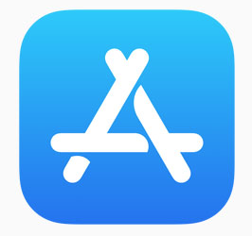
- Search for FreeOTP Authenticator by Red Hat
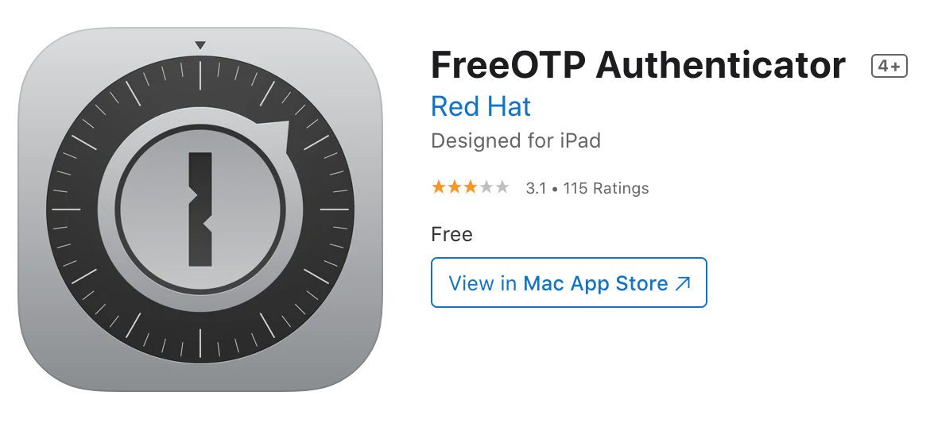
- Tap the app, then download and install it
- You’ll be asked to allow FreeOTP Authenticator to access your camera. Select ‘Yes’
Creating your METS account
During the creation of your METS account you will be asked to scan a QR code and follow further instructions on the page.
- Open the FreeOTP Authenticator app. At the top of the screen select the QR code icon
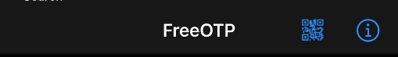
- Scan the code shown on the screen using the rear facing camera on your iPhone. If your camera does not activate, check your settings for the FreeOTP Authenticator app and set the slider to allow access to the camera
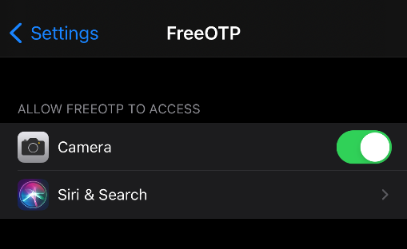
- After scanning the QR code you will be asked to choose an icon. You can use any icon shown on the app. This icon is specific to METS and will be shown whenever you open FreeOTP Authenticator. Tap on an icon to select it
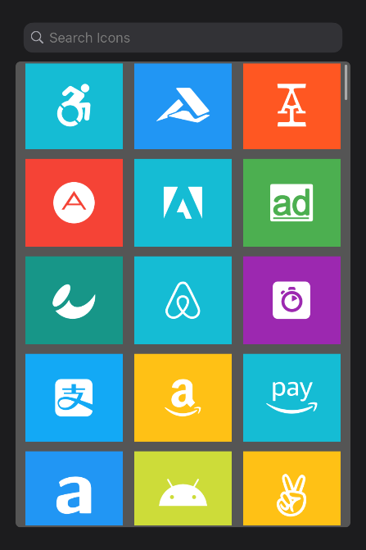
- After you have chosen an icon select 'Next' at the top of the screen
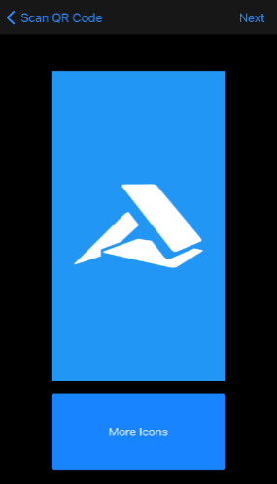
- You will be asked to choose whether you need to unlock your phone before being able to activate the token. Set the slider to your choice, then select 'Next' at the top of the screen
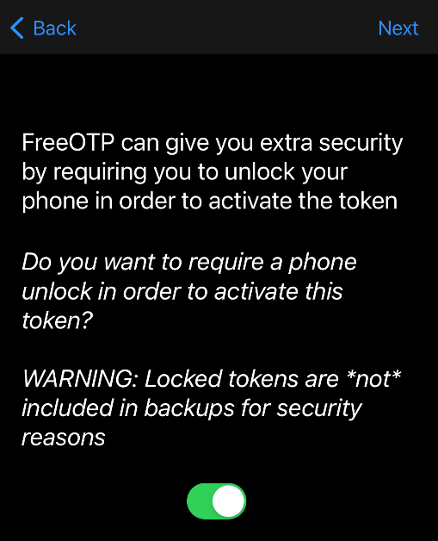
- Tap on the icon you chose for METS to generate your 6-digit code. You will have 60 seconds to enter your code into the METS page before it changes
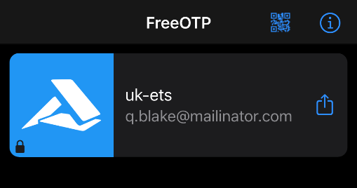

Using the app
- Use FreeOTP Authenticator whenever you are asked to enter a 6-digit code.
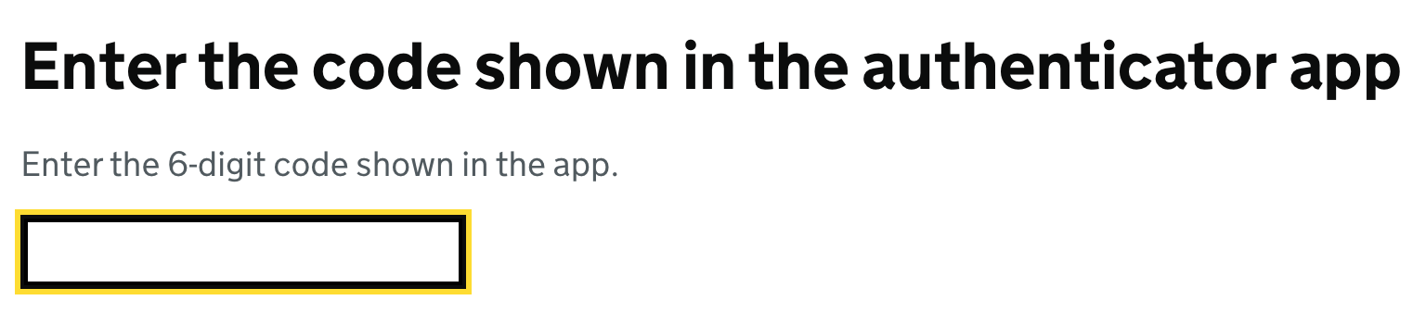
- If the code does not work, remove the token by swiping the icon from left to right. Select ‘Remove token’, then rescan the QR code.
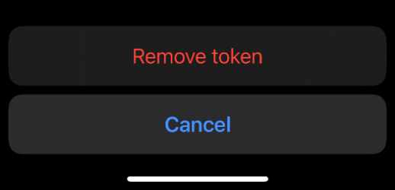

For Android
- On your phone, tap the Google Play Store icon

- Search for FreeOTP Authenticator by Red Hat
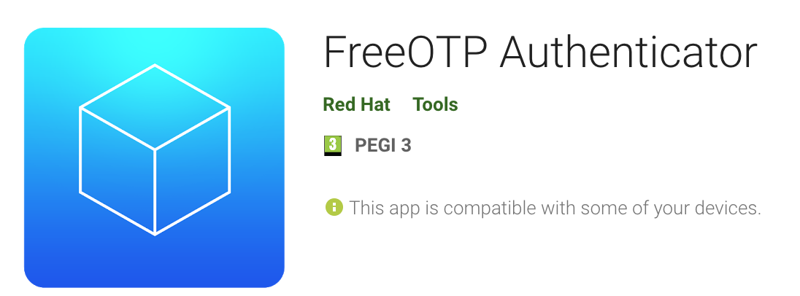
- Tap the app, then download and install it
- You’ll be asked to allow FreeOTP Authenticator to access your camera and files. Select ‘Accept’
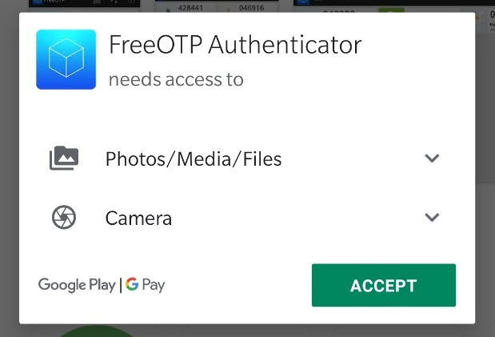
- Set the sliders to allow access
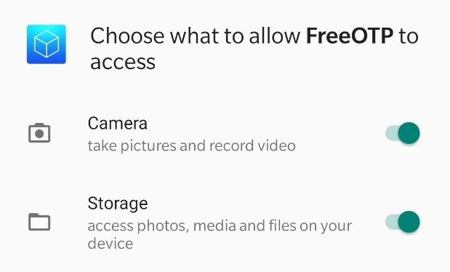
- Depending on your Android version you may see a message that the app was built for an older version of Android. Select ‘OK’
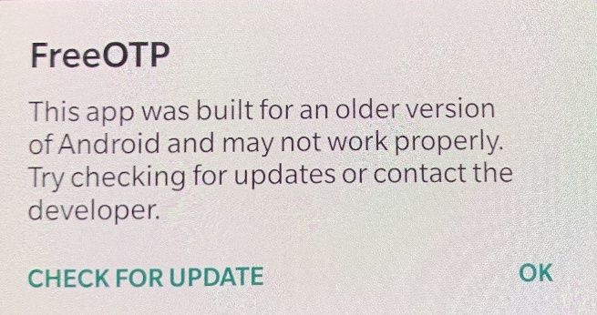

Creating your METS account
When you create a METS account you will be asked to scan a QR code and follow further instructions on the page.
- Open the FreeOTP Authenticator app. At the top of the screen select the QR code icon

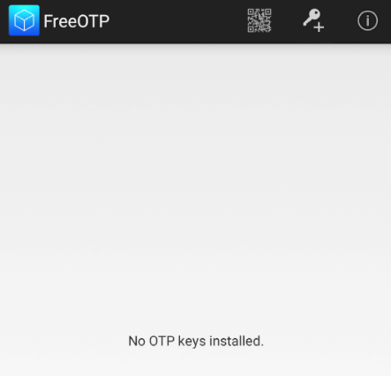
- Scan the code shown on the screen using the rear camera on your phone
- If you are unable to scan the code, select the key icon in the app, and select ‘Problems with scanning’ on the METS page.

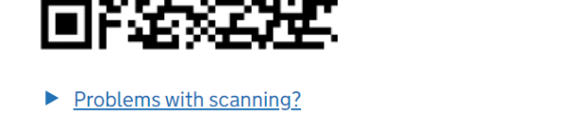
- Enter the information that you see on the METS page
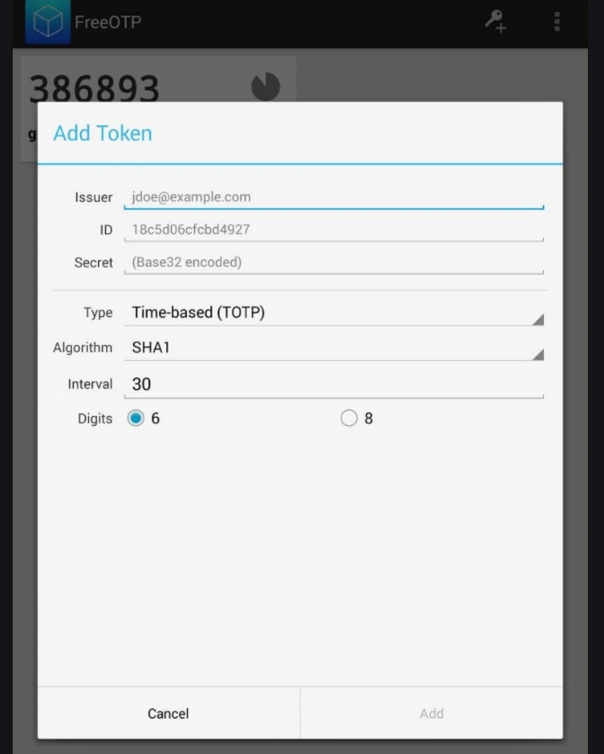
- Tap the icon for the email address you used to create your METS account. This will generate your 6-digit code. You will have 60 seconds to enter your code into the METS page before it changes
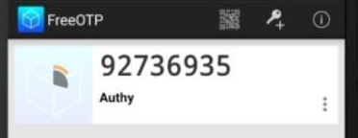

Using the app
- Use FreeOTP Authenticator whenever you are asked to enter a 6-digit code.
- If the code does not work, remove the token by selecting the three dots on the bottom right. Select ‘Delete’, then rescan the QR code or enter the ‘Problems with scanning?’ details again.
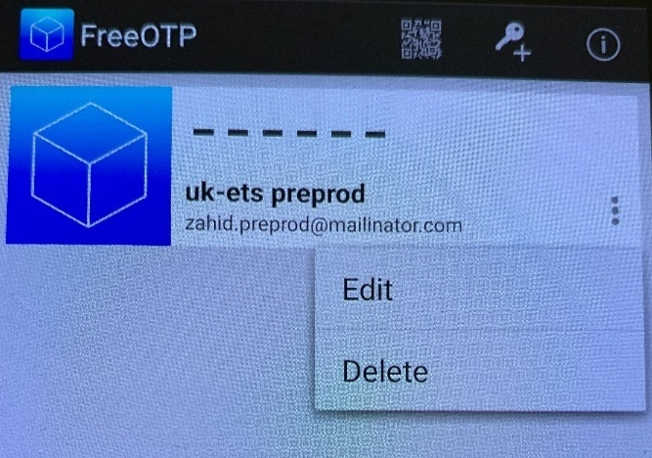

Annex 2 – 2FA on desktops

The following steps follow the journey for the FreeOTP application on windows desktops.,

Add Authenticator Extension to Browser

Access the links and Install the FreeOTP Authenticator plugin in your browser here:
Browser | Link
Chrome | https://chrome.google.com/webstore/detail/authenticator/bhghoamapcdpbohphigoooaddinpkbai?hl=en
Edge | Authenticator - Microsoft Edge Addons
Firefox | https://addons.mozilla.org/el/firefox/addon/auth-helper/

1.1 Open the link and you the link “Add to Chrome” | 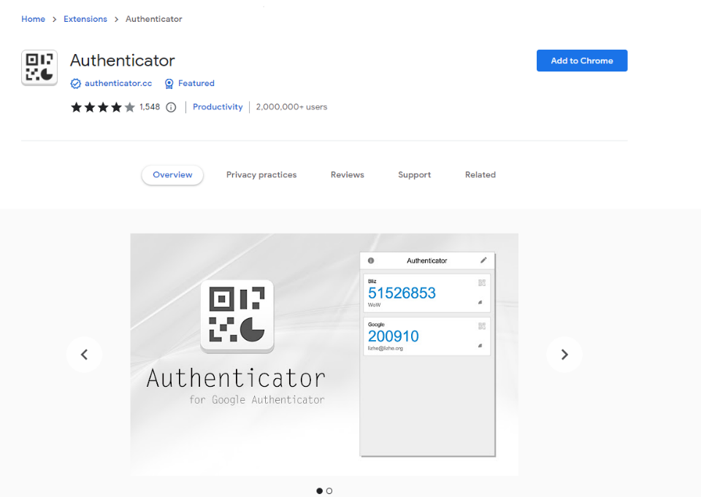
1.2 Pop-up Appears to ADD extension or cancel | 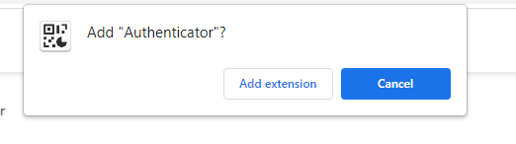
1.3 Add Extension | Notification appears advising extension is added and indicates the icon/symbol that you should use to open the authenticator app
1.4 Open the App  Click Extension and you see Authenticator App | 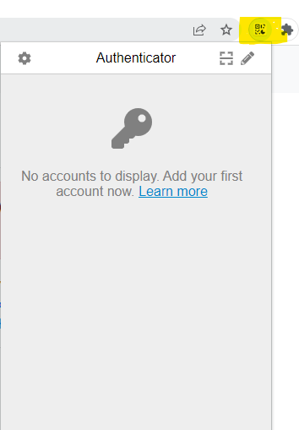  You can pin the Authenticator app to the browser so its seen whenever Browser is opened

Step 2: To add Account

Add Your First Account
https://authenticator.cc/docs/en/quickstart

This QuickStart explains how to add an example account to Authenticator Extension.
Prerequisites ( Step 1 should be completed)
Install Authenticator Extension (Chrome, Firefox, Edge)
When you first install Authenticator Extension in Chrome, you should pin its icon to the toolbar.
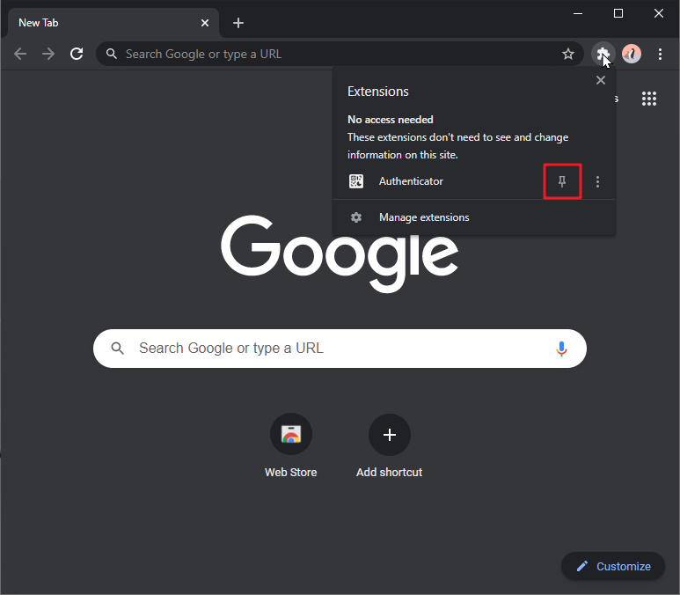
Add a QR Code
- Click Authenticator Extension’s icon in your browser
- Click the scan icon at the top right corner of the window.
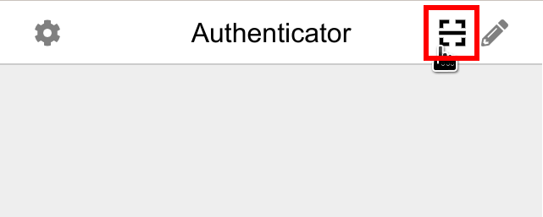
- Click and drag to draw a square that completely covers the QR code
- After the new account is added, you will see a new entry in the window.
The 6-digit number is your current one-time password, circle at bottom right corner tells you how much time left for the current password. If you want to add this account into a mobile app, you can click the QR icon at top right corner of the entry to show the QR code for this account.
Add an Account Manually
- Click Authenticator Extension’s icon in your browser
- Click the pencil icon at the top right corner of the window.
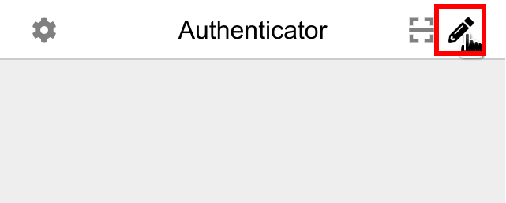
- Click the plus button at the top right corner of the window. Select Manual Entry
. 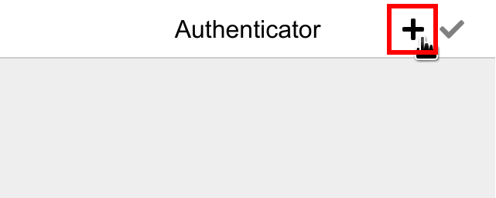
Input the name of the website that this account is associated with in Issuer field, the account secret given to you in the Secret field, and finally click Ok.
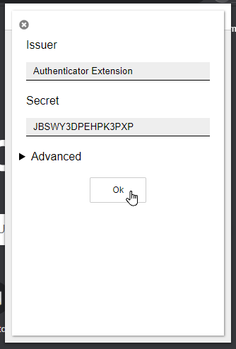
- After the new account is added, you will see a new entry in the Window 