




2025 Water Quality Monitoring Report: PFAS
July 2026

Executive Summary
This report presents findings from an initial scoping study into per- and polyfluoroalkyl substances (PFAS) in the 2025 SEPA water quality monitoring programme.
PFAS is the name given to a large group of highly persistent chemicals which are of global concern. SEPA has monitored PFAS since 2009. In 2025, SEPA significantly expanded the water monitoring programme to include more sites across Scotland and analyse a broader range of PFAS.
The purpose of the sampling and analysis was an initial scoping programme to determine concentrations of PFAS in the water environment in Scotland building a stronger evidence base to support statutory reporting and development of our approach to regulating emissions and legacy contamination of PFAS. In addition, it also aimed to determine whether the risk screening assessment undertaken by the Environment Agency detailing areas where PFAS concentrations may be higher was applicable in Scotland.
Testing was broadened to cover 29 PFAS, selected based on legislative requirements and substances of emerging concern. This included PFOS, a priority hazardous substance with an environmental quality standard (EQS), and the 20 PFAS included in the groundwater standard, both listed under The Scotland River Basin District (Standards) Directions 2024.
In 2025, samples were collected from 97 surface water sites (rivers and lochs) and 37 groundwater sites and were selected to represent a broad range of conditions, including different water body types and geographical locations. Surface water sites ranged from those expected to have low concentrations to those where a desk-based review suggested higher concentrations may be present.
In 2025, PFAS were widely detected in the Scottish water environment. At least one PFAS was detected in samples collected at 86 of the 97 surface water locations (89%) with concentrations ranging from 0.154 ng/L to 620 ng/L. PFAS were detected in samples collected at 21 of the 37 groundwater locations (57%), with concentrations ranging from 0.154 ng/L to 46.3 ng/L.
Early indications suggest that levels in Scotland are generally lower than those reported by the Environment Agency in England. PFAS concentrations in Scotland were higher in surface waters compared to groundwaters.
Elevated PFOS concentrations were most frequently detected in surface watercourses located near activities or sites with the potential to release PFAS into the environment. No PFOS concentrations in surface water were detected in excess of the PFOS EQS maximum allowable concentration value (36,000 ng/L), which has been set to protect surface water from short-term inputs (i.e. acute exposure).
Based on this dataset, PFAS were not detected above the PFAS groundwater standard maximum allowable concentration value (100 ng/L based on a sum of 20 PFAS) indicative of risks to the quality of water being abstracted, or intended to be abstracted, for human consumption.
Due to the early stage of the monitoring programme, comparison of PFOS data with the PFOS EQS annual average was not possible, but the data allows SEPA to establish monitoring at a number of sites to enable such comparisons to be undertaken in future.
The results of this study supported the findings of our initial desk-top review that the highest PFOS concentrations were detected in surface watercourses linked with activities associated with higher PFAS usage in the past. This information will be used to inform our regulatory approaches and ensure site specific evidence is gathered where appropriate.
The findings reflect the concentrations measured over a defined period. Continued monitoring and ongoing data assessment will enhance our understanding of the scale of PFAS contamination in Scotland. This evidence base will support SEPA in developing a targeted, proportionate and evidence-led regulatory approach to these globally challenging chemicals.

Table of Contents
Executive Summary 2
Table of Contents 4
List of Tables 4
List of Figures 4
List of Abbreviations 5
Introduction 6
Methodology 7
2025 Surface Water Sampling Results 8
2025 Groundwater Sampling Results 13
Conclusions and Next Steps 16
References 17
Appendix 1 18

List of Tables
Table 1. Summary statistics for surface water sites sampled in 2025 9
Table 2. Surface water sampling locations with top 5% individual PFOS concentrations 10
Table 3. Summary statistics for groundwater sites sampled in 2025 13

List of Figures
Figure 1. Surface water sampling locations with PFAS concentrations below and above MDL. 11
Figure 2. Surface water sampling locations with PFOS concentrations below MDL and above MDL.. 12
Figure 3. Groundwater sampling locations with PFAS concentrations below and above MDL 14
Figure 4. Groundwater sampling locations with PFAS (sum of 20) concentrations below and above MDL. 15

List of Abbreviations
Abbreviation | Definition
AA | Annual Average
CAS Number | Chemical Abstracts Service Number
EA | Environment Agency
EQS | Environmental Quality Standard
GW | Groundwater
LC-HRMS | Liquid Chromatography - High Resolution Mass Spectrometry
MAC | Maximum Allowable Concentration
MDL | Method Detection Limit
PFAS | Per- and poly- fluoroalkyl substances
PFAS (sum of 20) GW standard | PFAS groundwater standard (based on a sum of 20 PFAS) indicative of risks to the quality of water being abstracted, or intended to be abstracted, for human consumption [1]
PFOS | Perfluorooctane sulfonic acid
SPE | Solid Phase Extraction
SW | Surface water
WFD | Water Framework Directive

Introduction
SEPA’s PFAS monitoring programme in 2025 was designed as a step towards characterising the current state of Scotland’s water environment and determining the scope and areas where our efforts should be focused. The monitoring programme included 97 surface water sampling locations and 37 groundwater sampling locations, with a target of four and one samples taken each year respectively.
Surface water sites were selected to represent a broad range of situations where PFAS may be present and geographical spread across Scotland. This includes sites that were expected to have low concentrations to sites where a desk-based review suggested higher concentrations could be present. This was accounted for as follows:
- 80% were selected from the 2025 SEPA Water Framework Directive (WFD) Classification network, stratified based on geographic coverage, aiming to provide a representative network across Scotland with a range of sites and water body types over time.
- 20% of sites were selected to represent water bodies where the PFAS concentrations were expected to be higher, based on an understanding of activities that could impact watercourses.
This selection process was informed by an Environment Agency (EA) PFAS Risk Screening project which identified ten industrial sectors and industries with the highest likelihood of PFAS usage, which were:
- Civil airfields
- Military airfields
- Military bases
- Fire stations and fire training sites
- Wastewater treatment works
- Landfills
- Textile and leather manufacturing
- Carpet Manufacturing
- Paper and cardboard manufacturing
- Chrome plating
In addition to the EA list, SEPA added consideration of industrial sites with historic use of PFAS-based firefighting foams.
SEPA integrated this information with local expert knowledge to identify rivers where PFAS may be present. Sites were then stratified across the relevant industries where possible to ensure coverage of a range of potential exposure pathways. It was not possible to sample marine waters and so sites with emissions to marine waters were excluded at this stage.
Approximately 10% of SEPA’s current groundwater quality monitoring network was selected for the initial phase of monitoring. The subset of sites was chosen to provide reasonable, initial geographical coverage across Scotland, accounting for differences in geology and hydrogeology as well as regional differences in groundwater usage across Scotland.
Samples from springs were considered to be less likely to be at risk of cross-contamination from monitoring point infrastructure than samples from boreholes. For this reason, when selecting the subset of groundwater sites, preference was given to spring sources. However, it was not possible to achieve the desired geographical coverage using only spring sources. Thus, some borehole sources were also selected to ensure reasonable spatial coverage.

Methodology
PFAS concentrations were determined using large volume injection liquid chromatography high resolution mass spectrometry (LC-HRMS) analysis following sample extraction using Solid Phase Extraction (SPE). Appendix 1 captures the 29 substances measured and Method Detection Limits (MDL) achieved.
Frequency of detection (data above the Method Detection Limit (MDL)) was determined for surface water and groundwater. In order to provide a comparison, the surface water (SW) PFOS data was assessed against PFOS EQS-Maximum Allowable Concentration (EQS-MAC) (36,000 ng/L) [1], which has been set to protect the surface water environment from short-term or acute exposure.
If SEPA were to make comparisons with the PFOS EQS-Annual Average (EQS-AA) value (0.65 ng/L) [1], which has been set to protect surface water from long-term or chronic exposure, this would generally require data from 12 samples collected over the course of a year to calculate a robust annual average value that considered temporal variation. As fewer than 5 SW samples were available and the focus of the monitoring was to determine where monitoring efforts should be placed, it was not appropriate to use this comparator. However, all PFAS results will be used to help prioritise future monitoring plans and site-specific investigations. There are currently no surface water EQS in the Scottish Directions for the other PFAS in our monitoring suite.
Groundwater (GW) data was compared against the PFAS (sum of 20) GW standard MAC value of 100 ng/L indicative of risks to the quality of water being abstracted, or intended to be abstracted, for human consumption (Appendix 1) [1]. Additional monitoring would be required for SEPA to assess the data against the annual average based PFAS groundwater standard indicative of other significant environmental risks including those affecting the ability of groundwater to support human uses [1].
A direct comparison was made between an individual result and a Maximum Allowable Concentration (MAC) standard. An average (arithmetic mean) value was generated for comparison against Annual Average (AA) standards. Where a measurement was below MDL, a value of half of the MDL was used to calculate annual average concentrations, and the MDL value was used to calculate the MDL of an arithmetic sum (e.g. PFAS sum of 20 GW standard).

2025 Surface Water Sampling Results
An overview of our 2025 surface water monitoring programme is provided in Table 1. Samples were collected from 97 surface water sampling locations (98% of the 2025 PFAS SW network). The target annual sampling frequency was 4, in total 245 samples were collected.
PFAS were detected at 86 of the 97 surface water sites (89% of the 2025 PFAS SW network) (Fig. 1) ranging from 0.154 to 620 ng/L. PFAS concentrations were reported below MDL in 5884 of the 6743 PFAS results measured in surface water (87% of results) with 859 PFAS results detected above MDL (13% of results).
PFAS in Scotland were generally detected at lower concentrations than those reported in England by the Environment Agency [2]. The five most frequently detected PFAS in surface waters were: PFOS, PFBS, PFHxA, PFHpA, PFNA (ranging from 176 to 66 detects in 245 samples). The highest concentration of a PFAS substance in surface water (620 ng/L) was PFBS in the Blairvault Burn. There is currently no specific standard for PFBS in surface waters.
PFOS was detected at 75 of the 97 surface water sites (Fig. 2), ranging from 0.164 to 542 ng/L. The maximum concentration of PFOS detected in surface water (542 ng/L) was in the Mains of Dyce Burn. No PFOS concentrations were detected above the PFOS EQS-MAC (36,000 ng/L). Although it is not appropriate to compare the current data against the PFOS EQS-AA at this early stage of our programme, the data will be used to inform and prioritise the future development of monitoring plans and site-specific investigations as needed.
Concentrations of the other top 5 PFAS detected in surface water ranged from 0.252 to 620 ng/L (PFBS); 0.755 to 439 ng/L (PFHxA); 0.653 to 94.3 ng/L (PFHpA) and 0.202 to 9.98 ng/L (PFNA).
Table 1. Summary statistics for surface water sites sampled in 2025
Substance | Number of sites | Sites with detections | Number of samples | Samples with detections | Sites above EQS-MAC
PFAS | 97 | 86 (89%) | 245 | 195 (80%) | NA
PFOS | 97 | 75 (77%) | 245 | 178 (73%) | 0 (0%)
NA – Not applicable. No EQS-MAC available for PFAS as a group
The top 5% individual PFOS concentrations detected in surface water are listed in Table 2. All detections were observed in water bodies predicted to have higher concentrations, due to the activities close to those watercourses. The industries or sectors most frequently associated with these elevated concentrations were aviation sites and landfill operations.
Data collected from watercourses identified as having potentially higher concentrations can be used to provide an initial, albeit limited, validation of the relevance of the industries or sectors in Scotland highlighted through the EA risk screening project. Confidence in these findings will increase through additional monitoring, whilst further site-specific investigations may be required to verify the preliminary results and to support an evidence-led review of our regulatory approach.

Table 2. Surface water sampling locations with top 5% individual PFOS concentrations
Sampling Point Description | National Grid Reference | PFOS Concentration (ng/L) | Potential pressures
Mains of Dyce Burn @ d/s of Aberdeen Airport Fire Training Ground, Dyce | NJ 88308 13295 | 542 | Airport
Mains of Dyce Burn @ d/s of Aberdeen Airport Fire Training Ground, Dyce | NJ 88308 13295 | 284 | Airport
Mains of Dyce Burn @ d/s of Aberdeen Airport Fire Training Ground, Dyce | NJ 88308 13295 | 215 | Airport
Covesea Burn - Lossiemouth | NJ 21002 70699 | 188 | Airfield
Covesea Burn - Lossiemouth | NJ 21002 70699 | 113 | Airfield
Blackdog Burn - d/s Tarbothill Tip | NJ 96083 13717 | 63.8 | Landfill
River Kelvin 50M D/S of Summerston Landfill Peripheral Drain Discharge | NS 57218 71294 | 39.5 | Landfill
Pow Burn @ Powburn Bridge | NS 35612 26818 | 38.5 | Airport
Rigangower LF 100m d/s leachate ponds | NS 43410 75119 | 37.7 | Landfill
Pow Burn @ Powburn Bridge | NS 35612 26818 | 36.2 | Airport
River Kelvin 50M D/S of Summerston Landfill Peripheral Drain Discharge | NS 57218 71294 | 33.8 | Landfill
River Kelvin 50M D/S of Summerston Landfill Peripheral Drain Discharge | NS 57218 71294 | 24.7 | Landfill

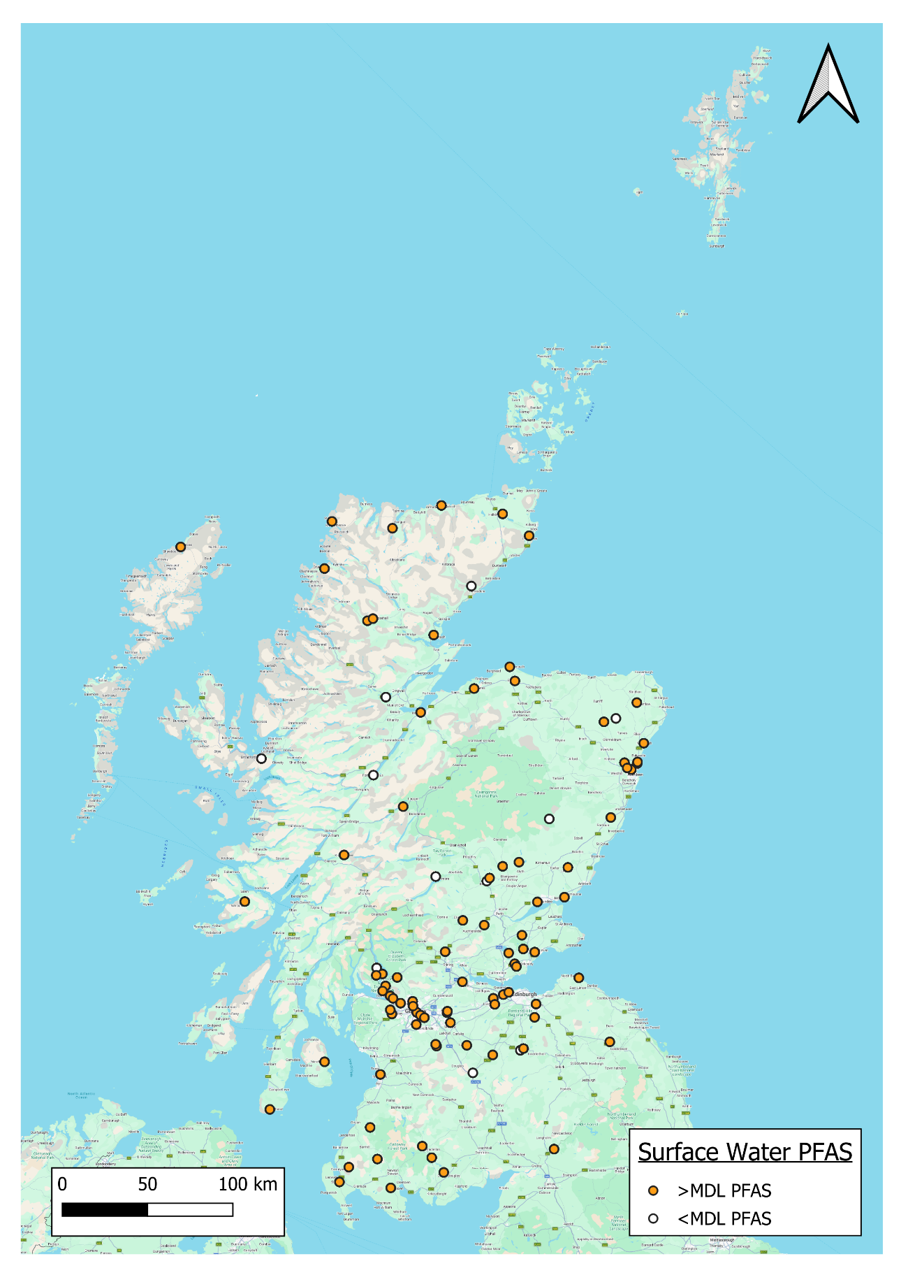
Figure 1. Surface water sampling locations with PFAS concentrations below and above MDL.

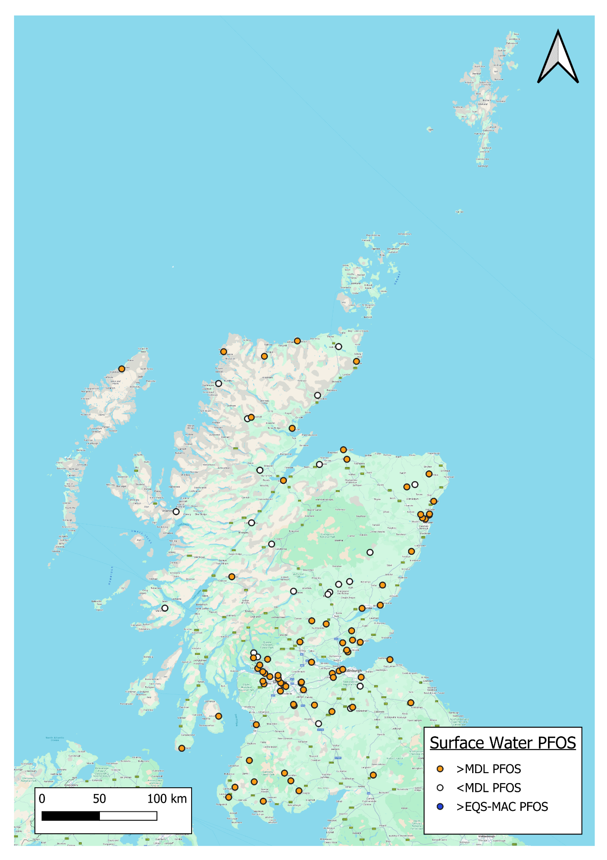
Figure 2. Surface water sampling locations with PFOS concentrations below MDL and above MDL. No exceedances of EQS-MAC were detected.

2025 Groundwater Sampling Results
An overview of our 2025 groundwater monitoring programme is provided in Table 3. Samples were collected from 37 groundwater (GW) sampling locations. Our target was to take one sample at each GW location in 2025, and a total of 38 samples were collected (Table 3).
PFAS were detected at 21 of the 37 groundwater sites (57% of the PFAS GW network) (Fig. 5) with concentrations ranging from 0.154 ng/L to 46.3 ng/L. PFAS concentrations were reported below MDL in 854 of the 983 PFAS results measured in groundwater (87% of results) with 129 PFAS results detected above MDL (13% of results).
Levels in groundwater were generally lower than surface waters. The six most frequently detected PFAS in groundwaters were: PFOS, PFDA, PFNS, MeFOSAA, FOSA and EtFOSAA (ranging from 18 to 8 detects in 38 samples). The highest concentration of a PFAS substance in groundwater was 46.3 ng/L PFBS at a borehole in Forfar. There is currently no specific individual standard for PFBS in groundwaters, although it is included within the PFAS (sum of 20) GW standard MAC value [1].
Concentration ranges for the top six detected PFAS in groundwater ranged from 0.154 to 3.77 ng/L (PFOS); 0.273 to 8.17 ng/L (PFDA); 0.205 to 1.37 ng/L (PFNS); 0.312 to 1.72 ng/L (MeFOSAA); 0.234 to 2.50 ng/L (FOSA) and 0.410 to 1.38 ng/L (EtFOSAA).
PFAS concentrations were not detected above the PFAS (sum of 20) GW standard (Fig. 6). The maximum concentration calculated for comparison against the PFAS (sum of 20) GW standard was 70.8 ng/L at a borehole in Forfar (same site as referenced in the preceding paragraph).
Table 3. Summary statistics for groundwater sites sampled in 2025
Substance | Number of sites | Sites with detections | Number of samples | Samples with detections | Sites above PFAS (sum of 20) GW standard
PFAS | 37 | 21 (57%) | 38 | 21 (55%) | 0 (0%)

Figure 3. Groundwater sampling locations with PFAS concentrations below and above MDL
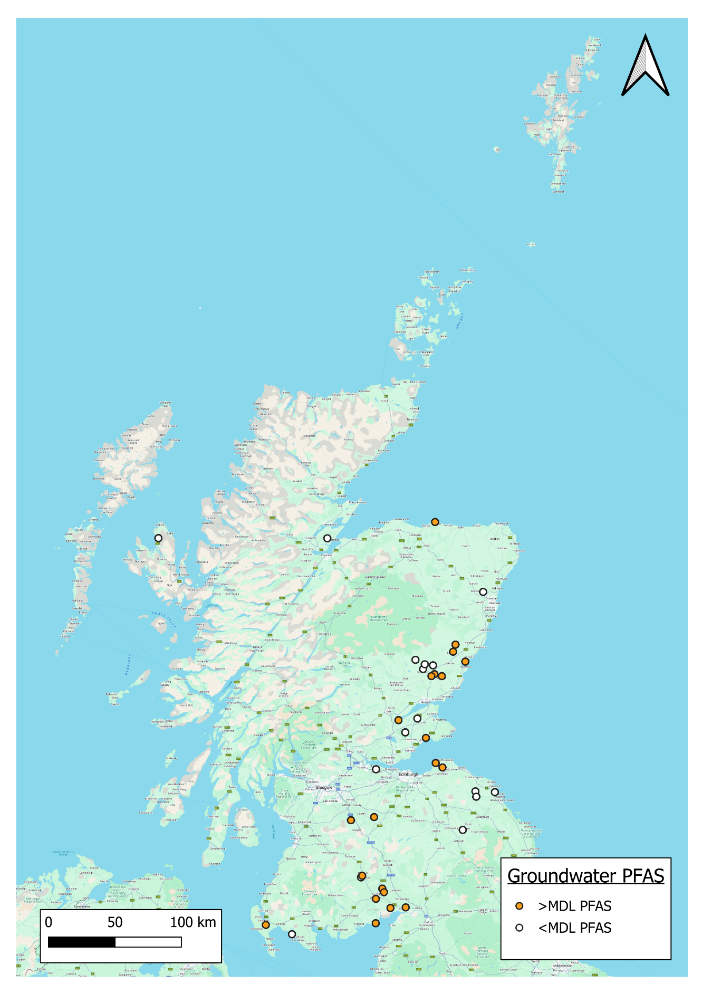

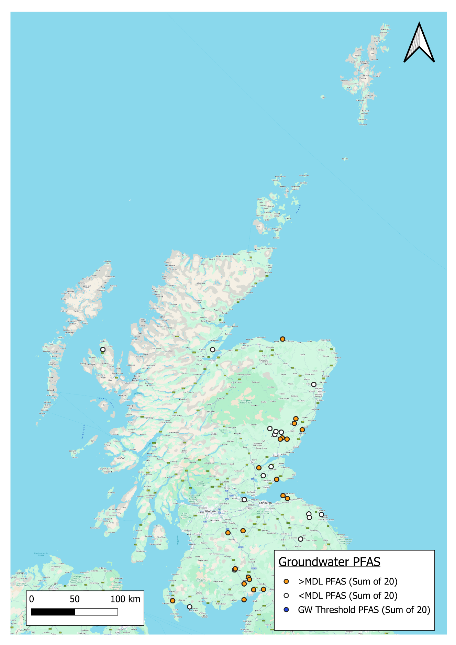
Figure 4. Groundwater sampling locations with PFAS (sum of 20) concentrations below and above MDL. No exceedances of PFAS (sum of 20) groundwater standard detected.

Conclusions and Next Steps
- Data was collected from a number of sites across Scotland as an initial scoping study to determine PFAS concentrations in the Scottish environment.
- The initial dataset is limited in terms of sites, sampling frequency, temporal, spatial and climatic conditions but demonstrates the capability to detect and monitor a wider range of PFAS in the water environment using newly developed methodologies.
- PFAS concentrations were generally lower than those detected by the EA in England.
- PFAS were detected (above the MDL at least once) at 89% of surface water locations and 57% of groundwater sites monitored for PFAS in 2025.
- No PFOS concentrations detected exceeded the PFOS Environmental Quality Standard Maximum Allowable Concentration (MAC) which was set to protect the water environment from short-term or acute exposure.
- There were no exceedances of the PFAS groundwater standard MAC value indicative of risks to the quality of water being abstracted, or intended to be abstracted, for human consumption detected in groundwaters.
- The nature of the study means that comparisons of the PFOS data against annual average based standards was not possible for this study. The data does allow SEPA to develop a programme of monitoring at a number of sites to allow this to occur in the future.
- An initial desk-top study indicated where higher concentrations of PFOS in watercourses may occur, this monitoring confirmed this work.
- This data will support statutory reporting and development of our regulatory approach.
- Continued monitoring and ongoing data assessment of PFAS in the water environment should continue in 2026 and expansion of the monitoring network should be considered.

References
- Scottish Directions 2024. The Scotland River Basin District (Standards) Directions 2024. Link accessed: 20/05/2026.
- Environment Agency. 2021. Poly- and perfluoroalkyl substances (PFAS): sources, pathways and environmental data. Link accessed: 20/05/2026.

Appendix 1
Table A. PFAS chemicals in SEPA’s analytical methodology with CAS number, associated Method Detection Limits (MDL)
Short Chemical Name* | Long Chemical Name | CAS Number | MDL (ng/L)
PFBA* | Perfluorobutanoic acid | 375-22-4 | 16.0
PFPeA* | Perfluoropentanoic acid | 2706-90-3 | 0.95
4:2 FTS | 4:2 Fluorotelomer sulfonic acid | 757124-72-4 | 0.55
PFBS* | Perfluorobutane sulfonic acid | 375-73-5 | 0.25
PFHxA* | Perfluorohexanoic acid | 307-24-4 | 0.75
HFPO-DA | 2,3,3,3-tetrafluoro-2-(heptafluoropropoxy)propionic acid | 13252-13-6 | 5.25
PFHpA* | Perfluoroheptanoic acid | 375-85-9 | 0.75
PFPeS* | Perfluoropentane sulfonic acid | 2706-91-4 | 0.65
ADONA | 2,2,3-trifluoro-3-(1,1,2,2,3,3-hexafluoro-3-(trifluoromethoxy)propoxy)propanoic acid | 919005-14-4 | 0.2
PFOA* | Perfluorooctanoic acid | 335-67-1 | 1.55
PFHxS* | Perfluorohexane sulfonic acid | 355-46-4 | 0.6
PFNA* | Perfluorononanoic acid | 375-95-1 | 0.2
PFHpS* | Perfluoroheptane sulfonic acid | 375-92-8 | 0.25
PFDA* | Perfluorodecanoic acid | 335-76-2 | 0.15
MeFOSAA | N-Methyl perfluorooctane sulfonamido acetic acid | 2355-31-9 | 0.25
PFOS* | Perfluorooctane sulfonic acid | 1763-23-1 | 0.15
EtFOSAA | N-Ethyl perfluorooctane sulfonamido acetic acid | 2991-50-6 | 0.2
PFUnDA* | Perfluoroundecanoic acid | 2058-94-8 | 0.2
9Cl-PF3ONS | 9-Chlorohexadecafluoro-3-oxanonane-1-sulfonic acid | 756426-58-1 | 0.25
PFNS* | Perfluorononane sulfonic acid | 68259-12-1 | 0.2
PFDoDA* | Perfluorododecanoic acid | 307-55-1 | 0.2
PFDS* | Perfluorodecane sulfonic acid | 335-77-3 | 0.35
PFTrDA* | Perfluorotridecanoic acid | 72629-94-8 | 0.25
11Cl-PF3OUdS | 11-Chloroeicosafluoro-3-oxaundecane-1-sulfonic acid | 763051-92-9 | 0.55
PFUnDS* | Perfluoroundecane sulfonic acid | 749786-16-1 | 0.4
PFTeDA | Perfluorotetradecanoic acid | 376-06-7 | 0.3
FOSA | Perfluorooctane sulfonamide | 754-91-6 | 1.1
PFDoDS* | Perfluorododecane sulfonic acid | 79780-39-5 | 0.5
PFTrDS* | Perfluorotridecane sulfonic acid | 174675-49-1 | 0.55

* 20 PFAS substances within the PFAS (sum of 20) groundwater standard (100 ng/L) [1]

If you would like this document in an accessible format, such as large print, audio recording or braille, please contact SEPA by emailing equalities@sepa.org.uk

PFOS - Perfluorooctane sulfonic acid
The Scotland River Basin District (Standards) Directions 2024

