


Waste Incinerated in Scotland – 2025
October 2026

Official Statistics

Waste Incinerated in Scotland 2025

An Official Statistics Publication for Scotland

Published on 27th October 2026 9:30 AM
This release provides a summary of all waste incinerated in Scotland for calendar year 2025. It excludes Scottish waste landfilled elsewhere, but includes waste from elsewhere landfilled in Scotland. Information on the methodology used to prepare this release and a definition of terms is in the incinerated waste quality report and glossary. Summary data tables are available to download in Excel format on SEPA’s web site.

Key points

Waste incinerated in Scotland – 2025 calendar year
- The total quantity of waste incinerated in Scotland in 2025 was 1.84 million tonnes (Figure 1), a decrease of 21,000 tonnes (1.1%) from 2024. This is the first year-on-year decrease in incineration since 2018. Nevertheless, the quantity of waste incinerated in 2025 remains substantially higher than in 2011, with an increase of 1.44 million tonnes (360%), consistent with the long term trend over that period.
- A total of 751,000 tonnes of waste incinerated was incinerated by recovery, 40.8% of the total waste incinerated. This was a a decrease of 37,000 tonnes (4.7%) from 2024.
- In 2025, Household and similar wastes were the waste category most incinerated in Scotland (857,000 tonnes, 46.5% of total), and there was a 102,000 tonnes (13.6%) increase in the incineration of these wastes since 2024. This increase is due to changes in the waste management sector preparing for the ban of biodegradable municipal waste to landfill which will take full effect from 1 January 2028. The increase in Household and similar wastes incinerated was offset by a reduction in Wood wastes (a decrease of 102,000 tonnes, 24.7%) and Sorting residues (a decrease of 26,000 tonnes, 4.7%).
- In 2025, only 30 tonnes of hazardous waste were incinerated in Scotland in 2025 which is <0.1% of the total waste incinerated (Table 3).

Data and Trends

Total waste incinerated
In 2025, 1.84 million tonnes of waste were incinerated in Scotland across 18 permitted incineration facilities. This was a decrease of 21,000 tonnes (1.1%) from 2024. This is the first year-on-year decrease in incineration since 2018. However, the quantity incinerated in 2025 is consistent with the longer term incineration trend in Scotland, with 1.44 million tonnes (360%) more waste incinerated in 2025 than in 2011 (Figure 1).
Household and similar wastes were the largest waste category incinerated in Scotland in 2025 (857,000 tonnes, 46.5% of total), and there was a 102,000 tonnes (13.6%) increase in the incineration of these wastes from 2024. This increase is due to changes in the waste management sector preparing for the ban of biodegradable municipal waste to landfill which will take full effect from 1 January 2028.
The increase in Household and similar wastes incinerated between 2024 and 2025 was offset by a reduction in Wood wastes (a decrease of 102,000 tonnes, 24.7%) and Sorting residues (a decrease of 26,000 tonnes, 4.7%). The reduction in incineration of wood wastes was almost entirely due to outages at one of Scotland’s biomass plants which normally incinerates EWC code 19 12 07 wastes - wood separated from mixed waste collections. A significant proportion of wood waste incinerated at this plant is imported from England, with over one third of the reduction being wood of English origin.

Figure 1. Waste incinerated in Scotland by waste category 2011 - 2025 (tonnes)
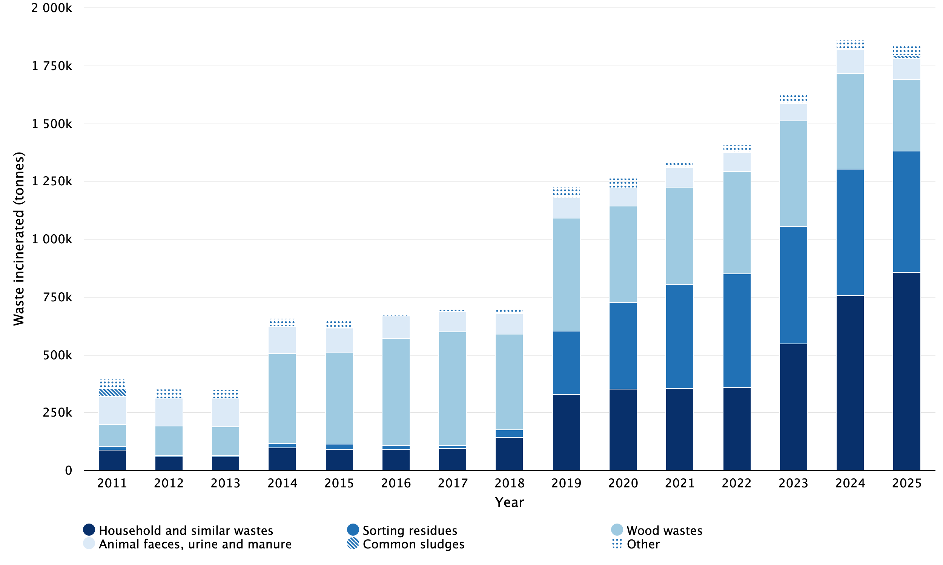
Notes:
‘Other’ categories comprise Animal and mixed food waste, Chemical wastes, Health care and biological wastes, Industrial effluent sludges, Mixed and undifferentiated materials, Other mineral wastes, Paper and cardboard wastes, Plastic wastes, Rubber wastes, Sludges and liquid wastes from waste treatment, Textile wastes, and Vegetal wastes.
Tables contain the detail of the ‘Other’ breakdown.

Table 1. Waste incinerated in Scotland by waste category 2011 - 2025 (tonnes)
Waste category | 2011 | 2012 | 2013 | 2014 | 2015 | 2016 | 2017 | 2018 | 2019 | 2020 | 2021 | 2022 | 2023 | 2024 | 2025
Household and similar wastes | 87,693 | 58,758 | 59,034 | 98,041 | 90,837 | 90,646 | 94,636 | 142,946 | 330,368 | 350,231 | 355,440 | 357,972 | 548,277 | 754,286 | 856,540
Sorting residues | 17,261 | 6,271 | 7,578 | 17,836 | 22,912 | 16,582 | 12,043 | 31,858 | 271,993 | 376,407 | 449,954 | 492,231 | 506,566 | 549,139 | 523,314
Wood wastes | 94,477 | 127,585 | 123,121 | 388,393 | 394,200 | 464,310 | 493,081 | 416,272 | 490,292 | 415,319 | 418,364 | 442,659 | 457,663 | 412,422 | 310,616
Animal faeces, urine and manure | 119,309 | 120,509 | 123,748 | 117,431 | 108,194 | 94,685 | 89,009 | 85,320 | 87,080 | 80,072 | 84,291 | 82,032 | 74,486 | 105,433 | 90,824
Animal and mixed food waste | 344 | 198 | 260 | 163 | 473 | 365 | 259 | 398 | 410 | 11,431 | 12,324 | 17,969 | 15,976 | 18,582 | 20,522
Common sludges | 37,200 | 0 | 0 | 0 | 0 | 2,027 | 0 | 0 | 0 | 0 | 0 | 0 | 0 | 0 | 13,781
Rubber wastes | 15,235 | 14,539 | 15,025 | 16,183 | 8,594 | 2,940 | 8,039 | 17,511 | 16,424 | 12,904 | 11,429 | 9,427 | 12,297 | 13,397 | 12,213
Mixed and undifferentiated materials | 3,456 | 431 | 2 | 2 | 2 | 2 | 1 | 1 | 28 | 342 | 1 | 19 | 144 | 1,403 | 5,983
Health care and biological wastes | 1,366 | 1,239 | 1,353 | 1,372 | 1,701 | 1,443 | 1,360 | 1,314 | 8,918 | 7,819 | 5,365 | 3,506 | 4,139 | 4,448 | 4,392
Industrial effluent sludges | 2,404 | 3,991 | 2,872 | 5,295 | 11,542 | 0 | 821 | 481 | 10,410 | 10,653 | 1,924 | 312 | 299 | 754 | 2,743
Sludges and liquid wastes from waste treatment | 8,745 | 7,150 | 4,082 | 10,410 | 1,476 | 82 | 112 | 2,307 | 10,583 | 0 | 0 | 2,060 | 4,548 | 3,179 | 661
Chemical wastes | 3,134 | 2,567 | 191 | 244 | 151 | 114 | 73 | 145 | 0 | 0 | 4 | 110 | 189 | 263 | 408
Other mineral wastes | 0 | 0 | 0 | 0 | 0 | 0 | 0 | 0 | 0 | 1 | 0 | 0 | 0 | 0 | 0
Paper and cardboard wastes | 85 | 54 | 1 | 19 | 33 | 38 | 2 | 2 | 2 | 0 | 0 | 0 | 0 | 0 | 0
Plastic wastes | 0 | 0 | 0 | 0 | 0 | 0 | 25 | 0 | 1 | 0 | 0 | 0 | 0 | 0 | 0
Textile wastes | 6,960 | 9,723 | 11,597 | 3,015 | 9,536 | 0 | 0 | 0 | 0 | 0 | 0 | 0 | 0 | 0 | 0
Vegetal wastes | 3 | 0 | 0 | 104 | 5,298 | 0 | 258 | 0 | 0 | 0 | 0 | 0 | 0 | 0 | 0
Total | 397,672 | 353,015 | 348,864 | 658,508 | 654,949 | 673,234 | 699,719 | 698,555 | 1,226,507 | 1,265,179 | 1,339,096 | 1,408,297 | 1,624,584 | 1,863,306 | 1,841,997

Incineration methods
In 2025, 40.8% of waste incinerated in Scotland was incinerated by recovery, 25.2% by co-incineration and 34.0% by disposal.
Between 2024 and 2025, incineration by recovery decreased by 37,000 tonnes (4.7%), co-incineration decreased by 89,000 tonnes (16.1%) and incineration by disposal increased by 105,000 tonnes (20.1%, Figure 2).

Figure 2. Waste incinerated in Scotland by method 2011 - 2025 (tonnes)
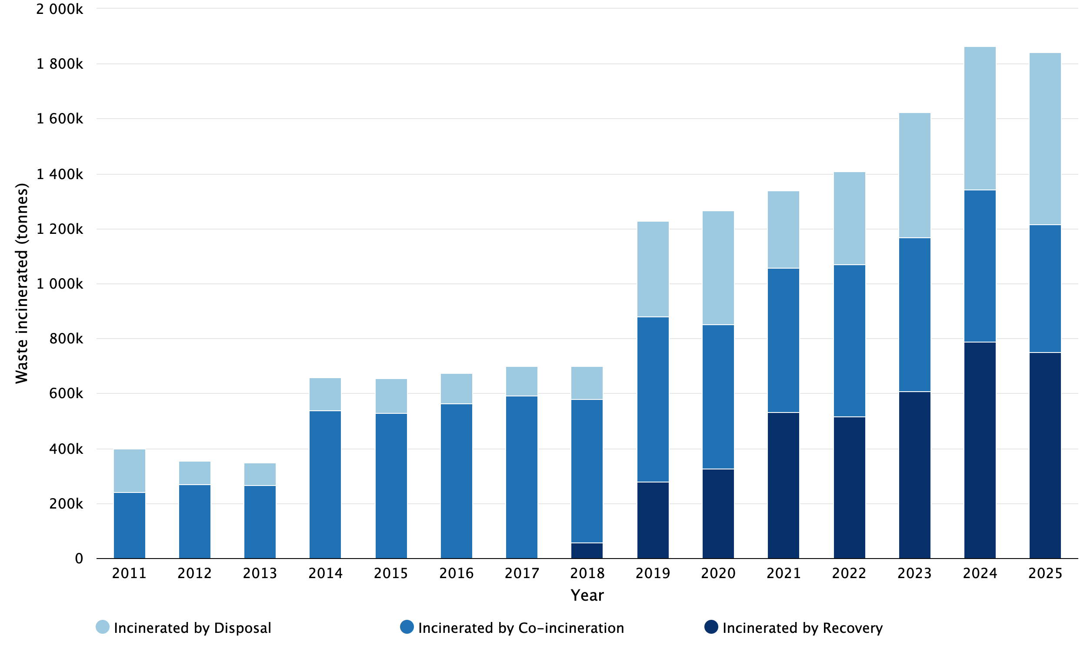

Table 2. Waste incinerated in Scotland by method 2011 - 2025 (tonnes)
Year | Incinerated by Recovery | Incinerated by Co-incineration | Incinerated by Disposal | Total
2011 | 0 | 239,669 | 158,003 | 397,672
2012 | 0 | 269,783 | 83,232 | 353,015
2013 | 0 | 265,976 | 82,888 | 348,864
2014 | 0 | 537,816 | 120,692 | 658,508
2015 | 0 | 529,304 | 125,645 | 654,949
2016 | 0 | 562,017 | 111,217 | 673,234
2017 | 0 | 590,499 | 109,220 | 699,719
2018 | 57,743 | 521,408 | 119,404 | 698,555
2019 | 277,240 | 602,672 | 346,595 | 1,226,507
2020 | 324,762 | 528,082 | 412,334 | 1,265,179
2021 | 531,073 | 526,238 | 281,785 | 1,339,096
2022 | 517,113 | 552,316 | 338,868 | 1,408,297
2023 | 607,410 | 560,216 | 456,958 | 1,624,584
2024 | 787,873 | 553,808 | 521,625 | 1,863,306
2025 | 750,939 | 464,678 | 626,380 | 1,841,997

Notes:
The definition for each method of incineration may be found in the glossary.
There were zero tonnes of waste recorded as incinerated by recovery from 2011 - 2018 as there were no municipal waste incinerators operating in that period that were or have since become accredited to the R1 standard.

Hazardous waste incinerated
As in the past two years, there was very little hazardous waste incinerated in Scotland, with 30 tonnes of hazardous waste incinerated in 2025 (Table 3), which was <0.1% of the total waste incinerated and an increase of 28 tonnes from 2024. In both 2024 and 2025, all the hazardous waste incinerated was Health care and biological wastes. Incineration of Health care and biological wastes was far higher in previous years, including the COVID-19 periods of 2020 and 2021, but has dropped markedly in recent years.
Although the hazardous waste incineration in Scotland has varied over time, the overall amount of hazardous wastes incinerated has fallen from 12,000 tonnes in 2011, mainly caused by a reduction in Sludges and liquid wastes from waste treatment and to a lesser extent Chemical wastes.

Figure 3. Hazardous waste incinerated in Scotland by waste category 2011 - 2025 (tonnes)
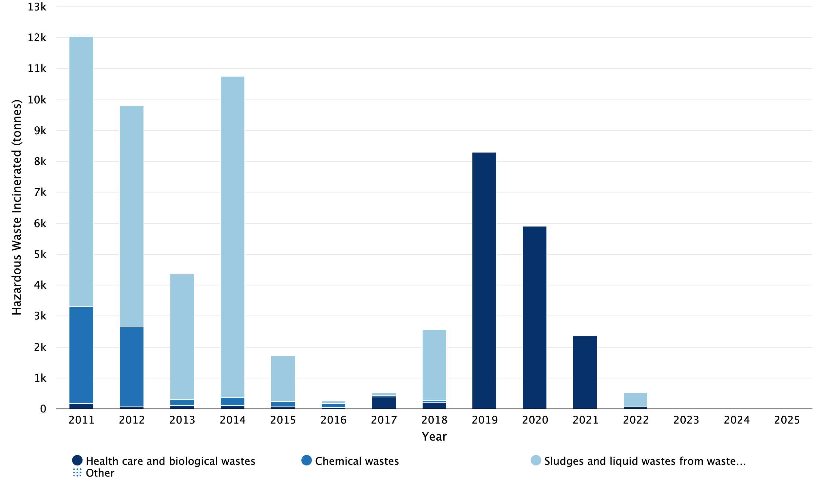
Notes:
‘Other’ categories comprise Mixed and undifferentiated materials, Other mineral wastes, Sorting residues, and Wood wastes.
Tables contain the detail of the ‘Other’ breakdown.

Table 3. Hazardous waste incinerated in Scotland by waste category 2011 - 2025 (tonnes)
Waste category | 2011 | 2012 | 2013 | 2014 | 2015 | 2016 | 2017 | 2018 | 2019 | 2020 | 2021 | 2022 | 2023 | 2024 | 2025
Health care and biological wastes | 172 | 90 | 112 | 107 | 82 | 49 | 387 | 207 | 8,304 | 5,911 | 2,362 | 57 | 0 | 2 | 30
Chemical wastes | 3,134 | 2,567 | 174 | 244 | 151 | 114 | 33 | 58 | 0 | 0 | 4 | 0 | 0 | 0 | 0
Mixed and undifferentiated materials | 18 | 0 | 0 | 0 | 0 | 0 | 0 | 0 | 0 | 0 | 0 | 0 | 0 | 0 | 0
Other mineral wastes | 0 | 0 | 0 | 0 | 0 | 0 | 0 | 0 | 0 | 1 | 0 | 0 | 0 | 0 | 0
Sludges and liquid wastes from waste treatment | 8,745 | 7,150 | 4,082 | 10,410 | 1,476 | 82 | 112 | 2,307 | 0 | 0 | 0 | 467 | 0 | 0 | 0
Sorting residues | 9 | 3 | 0 | 0 | 0 | 0 | 0 | 0 | 0 | 0 | 0 | 0 | 0 | 0 | 0
Wood wastes | 24 | 0 | 0 | 0 | 0 | 0 | 0 | 0 | 0 | 0 | 0 | 0 | 0 | 0 | 0
Total | 12,102 | 9,810 | 4,368 | 10,761 | 1,709 | 245 | 532 | 2,572 | 8,304 | 5,912 | 2,366 | 524 | 0 | 2 | 30

About incinerated waste statistics

An Official Statistics publication for Scotland
This is an Official Statistics publication. These statistics have been produced to the high professional standards defined in the Code of Practice for Official Statistics, which sets out ten principles under the pillars of Trustworthiness, Quality and Value. More information on the Official Statistics Code of Practice web-site.
Lead Statistician - Peter Ferrett, SEPA

User statement
Data on waste generation and management are collected to support policy development and monitor policy effectiveness, particularly the commitments in Making Things Last - A Circular Economy Strategy for Scotland, and Scotland’s Circular Economy and Waste Route Map to 2030. The data contribute to the UK Statistics on waste and are also used extensively by local and central government, the waste industry, researchers and the general public.

Enquiries
Enquiries on this publication to: SEPA Communications Department: media@sepa.org.uk

Feedback
We welcome feedback on the data from all users including how and why the data are used. This helps us to understand the value of the statistics to external users. Please contact us at waste.data@sepa.org.uk.

Revisions policy
SEPA provides information about any revisions made to this release and any associated datasets. Revisions could occur for various reasons, including when data from third parties are unavailable or provisional at the time of publishing or if there are subsequent methodological improvements or refinements. The figures are accurate at the time of publication. However, the data may be updated if further revisions are necessary. Normally these revisions will be published concurrent with the next release. There are no revisions to the 2024 incineration statistics since the previous publication.

Quality report
Data are taken from permitted waste site returns submitted to SEPA. Further information on the methodology can be found in the accompanying incinerated waste quality report

Pre-release access
Pre-release access was made available to relevant persons five working days prior to publication in accordance with The Pre-release Access to Official Statistics (Scotland) Order 2008.
Besides analytical staff involved in the production and quality assurance of this publication, the following post holders in SEPA and the Scottish Government were given pre-release access up to 5 days before release:
- Cabinet Secretary for Climate Action and Rural Affairs
- Scottish Government Special Adviser x 1
- Scottish Government Analyst x 3
- Scottish Government Policy Official x 12
- Scottish Government Communications Official x 4
- Zero Waste Scotland Communications Official x 5
- Zero Waste Scotland Policy Official x 3
- SEPA Policy Official x 12
- SEPA Communications Official x 12
- SEPA Analyst x 5
For use in another publication:
Publication: National Atmospheric Emissions Inventory (NAEI)
- Analyst x 3

Glossary of terms
Hazardous Waste
waste with hazardous properties which may render it harmful to human health or the environment. Hazardous waste is also called Special Waste in Scotland as defined in the Special Waste Regulation 1996.
Waste incinerated by co-incineration
wastes used as a fuel and incinerated at an incineration facility in which the main purpose is the generation of energy or production of material products (e.g. cement) and which uses waste as an additional fuel.
Waste incinerated by disposal
wastes incinerated at an incineration facility where the energy efficiency has not been demonstrated to meet the R1 criteria specified in the EU Waste Framework Directive.
Waste incinerated by recovery
wastes used as a fuel to generate energy and incinerated at an incineration facility where the energy efficiency has been demonstrated to meet the R1 energy efficiency criteria specified in the EU Waste Framework Directive.
Waste incinerated
Waste from all sources (i.e. from commercial, industrial, construction and demolition and household sources) that is incinerated in Scotland. Includes waste incineration by recovery, waste incineration by co-incineration and waste incineration by disposal.
Waste categories
Definitions of the waste categories used within this report can be found in Annex I (Section 2) and Annex III (table of equivalence) of the EU waste statistics regulations.

For information on accessing this document in an alternative format or language please contact SEPA by email at equalities@sepa.org.uk.
If you are a user of British Sign Language (BSL) the Contact Scotland BSL service gives you access to an online interpreter enabling you to communicate with us using sign language. https://contactscotland-bsl.org

Incineration by recovery is where wastes are used as a fuel to generate energy and the energy efficiency has been demonstrated to meet the R1 energy efficiency criteria specified in Annex II of the EU Waste Framework Directive
The Waste (Scotland) Regulations 2012 introduced a ban on biodegradable municipal waste (BMW) being disposed of to landfill from 31 December 2025 which was then transposed into the Environmental Authorisations (Scotland) Amendment Regulations 2025. SEPA’s temporary regulatory position statement sets out its regulatory approach during a transitional period while additional treatment capacity is developed, with full implementation of the ban expected from 1 January 2028. For further information, see the BMW landfill ban guidance on SEPA’s website.

