Particle Retrieval Advisory Group 2025 report into fragments of irradiated nuclear fuel in the Dounreay offshore environment

Publishing Organisation
Scottish Environment Protection Agency
Angus Smith Building
Unit 6, 4 Parklands Avenue
Holytown
Motherwell
ML1 4WQ

Publication Date: September 2026

Foreword
The Particles Retrieval Advisory Group (Dounreay) (PRAG(D)) was formed by SEPA in 2009 following completion of the work by the Dounreay Particles Advisory Group (DPAG) which was set up by UKAEA and SEPA in 2000 to provide independent scientific advice to UKAEA and SEPA on fragments of irradiated nuclear fuel (particles) around Dounreay, Caithness. PRAG(D) was formed to provide advice to SEPA and Dounreay and review information relating to the voluntary offshore recovery programme undertaken by the site following a public consultation on the Best Practicable Environmental Option. The Group has been focused on the effectiveness of the recovery programme and its impact on the occurrence of fragments of irradiated nuclear fuel on local beaches.

PRAG(D)’s first three reports considered the findings of all recovery work, provided advice on the optimisation of further work and considered the implications for future monitoring of fuel fragments in the environment. This publication provides an overview of the health risks from fragments generated at Dounreay; consideration of movement of fragments in the offshore environment; reviewing the numbers of fragments found through the beach monitoring programme and outlines potential numbers of fragments remaining in the environment. Additionally, the report outlines support to maintain the Food and Environment Protection Act Order, ongoing monitoring and sets out concerns in relation to plans to install high-voltage cables in the Dounreay offshore environment.

It is likely that this will be the final report from the group, however SEPA may elect to seek further advice in light of any change in the situation. SEPA is grateful for the advice provided over many years by all members of the group, both past and present.

Following publication of this report SEPA will consider how best to take forward work of the Group by using its national environmental radioactivity monitoring task team which oversees all national radiological monitoring undertaken in Scotland and has representation from Food Standards Scotland, Food Standards Agency (England, Wales and Northern Ireland), Nature Scot, United Kingdom Health Security Agency, Scottish Government and SEPA.

Executive Summary
Since 1984 fragments of irradiated nuclear fuel have been detected and removed from publicly accessible beaches around the Dounreay nuclear licensed site in Caithness, Scotland. These fragments are known as ‘particles’ and can arrive on local beaches at Sandside Bay and the Dounreay foreshore. SEPA is Scotland’s environmental regulator and has legal duties to ensure that the public are protected from exposure to ionising radiation from manmade sources. Nuclear Restoration Services are the site operator at Dounreay and are responsible for decommissioning the site and restoring the environment in line with Government policy and legal obligations.

PRAG(D) are a group of independent advisors to SEPA and Dounreay and are tasked with providing advice and information relating to the offshore recovery programme undertaken by the Dounreay site. This advice covers advice on the hazards posed by fragments of irradiated fuel and the scope of monitoring requirements in order that SEPA meets legal duties and obligations, ensuring that the public are protected.

PRAG(D)’s analysis suggests that there are at least two main types of particle present in the environment arising from activities involving MTR (Materials Test Reactor) material between 1958 and 1968; and DFR (Dounreay Fast Reactor) material between 1961 to 1979. The hazard posed by these particles depends on the amount of radioactivity contained in a particle, combined with the pathway of exposure and the age of the exposed individual. Particles found to date are dominated by their caesium-137, strontium-90 and its decay product yttrium-90. Caesium-137 is a strong gamma emitter and is the main method through which particles are identified within beach sediments.

Hazard
The most hazardous pathways for these type of particles is skin contact and internal ingestion. PRAG(D) reports that the highest activity particles, containing 10⁸Bq of caesium-137 could result in a skin contact dose exceeding the 2 Gray (Gy) threshold for acute ulceration in less than 2 minutes. The same particle, if ingested into the body, would lead to a whole-body radiation dose of some 80mSv in an adult or around 300mSv in a young child. These values are above the legal limits for radiation doses to members of the public.

PRAG(D) have continued the use of the Dounreay Particles Advisory Group (DPAG) particle classification system for Minor, Relevant and Significant particles being <10⁴, 10⁴ – 10⁵ and > 10⁶Bq respectively.

PRAG(D) have reiterated that the health risk to the public from particles found at Sandside Bay to date is low. For particles found on the Dounreay Foreshore, the health risk is not inconsequential. Potential doses from ingestion are in the 80mSv range and would be much higher if the ingested particle has a higher solubility. These significant doses have regulatory implications for the future management of this area for several decades to come.

Mapping
PRAG(D)’s predecessors’ analysis of particles found by Dounreay in the offshore area has resulted in a model of the offshore plume and a contour map of the potential density of particles per square metre. This is a useful guide as to where particles have been found, however caution is required when interpreting the areas where monitoring may not have been undertaken or around the limitations of monitoring undertaken. SEPA are aware of developments of offshore energy and power transmission in the local area and have noted that information on particles per hectare is being reviewed without consideration of the uncertainties and potential bias in the underlying data.

Long Term View
Monitoring and recovery in the offshore environment has resulted in the reduction in hazard in absolute terms, however the long-term management of particles depends on the total number of Significant particles likely to be present in the offshore environment.

The potential population of Significant particles in the offshore plume is unknown; however estimates have been made by DPAG and PRAG(D) and it is clear that this may be as high as 1000 Significant particles in the areas monitored to date to a depth of 600mm. PRAG(D) state that the estimate of remaining Significant particles must be taken as several hundred as an absolute minimum. This number would need to be scaled upwards to account for those present in deeper sediments.

Offshore sediments can be disturbed to a varying degree by storms, depending on the wave conditions and direction of the storm. Since the Remotely Operated Vehicle (ROV) operations in 2012, PRAG(D) estimated that there have been at least 5 extreme storm events that could have disturbed deeper buried particles below 600mm. SEPA are aware that the depth of sediment offshore may exceed 3m in some places. There is clearly a requirement for long term monitoring of local beaches to protect the public and to monitor the potential changes offshore.
PRAG(D) have considered what is required in the future and the implications that this will have on the radioactivity content of particles, the population of particles on beaches and in the offshore environment.
At Sandside Beach, PRAG(D) considered that there was some evidence to suggest a change in the arrival rate and activity of the particles arriving at Sandside Beach. Significant storm events and deeper sediment disturbance could result in a disruption of the plume and replenishment the supply of particles reaching Sandside Beach. Beach monitoring should therefore continue as it provides protection of the public but also, importantly acts as an indicator of what might be happening offshore.
The situation for the Dounreay Foreshore is clearer. PRAG(D) recommends that monitoring of the Foreshore must continue. Cessation of monitoring may lead to an equilibrium of particles arriving and leaving the Dounreay Foreshore, estimated to be around 3 Significant particles being on the Foreshore at any one time. This is particularly important considering potential changes to access over the next 100 - 150 years. Additionally, environmental processes may cause some Significant particles to split in two and the amount of Significant particles may actually increase over time. PRAG(D) suggests monitoring may be required for some 150 years, until the number of Significant particles reduces to zero.

Should consideration be given to repeating the offshore removal campaign of 2010 to 2012, then PRAG(D) estimates that a period of up to 25 years may be required to allow enough sediment disturbance from storms to disturb and recover 90% of the Significant particles remaining over a number of targeted ROV campaigns. Alternatively, consideration could be given to removal of fine sediments via hydraulic dredging down to bedrock. Either method may have an impact on reducing the number of years monitoring required on local beaches.

PRAG(D) have recommended that the zone bound by the Food and Environment Protection Act (FEPA) Order remains until at least until any effects of seabed engineering have been evaluated.
Any planned activity that may result in mobilisation of any radioactive contamination will be subject to authorisation by SEPA under the Environmental Authorisations (Scotland) Regulations 2018 (EASR18).

Table of Contents
Foreword 1
Executive Summary 2
List of Tables 8
List of Figures 9
1. Introduction 11
1.1 Background 11
1.2 Particle Types 13
1.3 Particle Finds 14
1.4 Ongoing work 16
2. Dosimetry of Dounreay Particles 17
2.1 Discharge and distribution of particles 17
2.2 Particle dosimetry 23
2.3 Conclusion 29
3. Dounreay Radioactive Particles in the Marine Environment: A Forward Look 30
3.1 Introduction 30
3.2 Synopsis of the history and behaviour of Dounreay 31
particles in the marine environment 31
3.3 Synopsis of the 3-D conceptual model of particle behaviour 39
3.4 Implications 52
3.5 “Potentially Disruptive Events” 63
3.6 Conclusions 65
4. Beach and Coastal Finds 68
4.1 Introduction 68
4.2 Overview of Particles Recovered 69
4.3 Removing the influence of Radioactive Decay from the trends in caesium-137 activity and particle classifications. 70
4.4 Conclusions 88
5. Conclusions 90
5.1 Numbers of particles remaining 90
5.2 Potential particle mobilisation 90
5.3 Beach monitoring 91
5.4 Source of Foreshore Particles 91
5.5 Future risk associated with particles 92
5.6 Active seabed particle recovery 92
References 93

List of Tables
Table 1.0 Nuclear operations at Dounreay 12
Table 2.1 Half-lives of radionuclides involved 22
Table 2.2 Contact times taken to reach threshold and ED50 absorbed doses 24
Table 2.3 Mean percentage (range) of ingested activity absorbed to blood 25
Table 2.4 Estimated doses to the rectosigmoid (mGy) 26
Table 2.5 Effective dose coefficients 27
Table 2.6 Organ and equivalent doses to an adult male from a soluble 105Bq particles (µSv) 28
Table 2.7 Risks from Sandside Bay and Foreshore particles 29
Table 4.1 Summary of Recovered Particles 70
Table 4.2 Summary of Sandside Particles Recovered 84
Table 4.3 Summary of Sandside Particles Recovered since 2007 classed within pre and post the period of offshore ROV particle recovery 86

List of Figures
Figure 1.1 Location of Dounreay and local beaches 11
Figure 2.1 Map of all particles found to date 18
Figure 2.2 Potential liquid discharge routes for particles. 20
Figure 2.3 3D section through the shaft showing the configuration of offshore installations and their links to the onshore Dounreay Establishment 21
Figure 3.1 Periods when radioactive particles might have been released into the marine environment 33
Figure 3.2 Particle recoveries from Dounreay East Foreshore, 1984 to 2022 35
Figure 3.3 Particle Recoveries from Dounreay West Foreshore, 1984 to 2022 35
Figure 3.4 Map showing all Significant offshore particle finds 1997 to 2012, and the East and West Foreshore areas. 40
Figure 3.5 Map showing all Relevant and Minor offshore particle finds 1997 to 2012. 41
Figure 3.6a The Wave Climate at Dounreay (Map) 42
Figure 3.6b The Wave Climate at Dounreay (Diagrams) 42
Figure 3.7 Depth distributions of Significant particles found and recovered by divers between 1997 and 2008, and by the ROV campaigns in 2010 to 2012 44
Figure 3.8 All recovered particles’ activities versus reported depth 44
Figure 3.9 Conceptual model of sand and particle transport 47
Figure 3.10 The annual maximum series of Significant Wave Height 50
Figure 3.11 Histogram of all estimates of total numbers of Significant particles offshore in the period since 2012 54
Figure 3.12. Location of Repopulation Areas, 2000 to 2004. 59
Figure 4.1 Summary of all Caesium-137 particles detected, including ROV. Activity reported at time of detection and decay corrected to 1/1/85 72
Figure 4.2 Summary of all particles detected on Dounreay East Foreshore. Activity reported at time of detection and decay corrected to 1/1/85, and includes linear trend lines 74
Figure 4.3 Summary of all particles detected on Dounreay West Foreshore 76
Figure 4.4 Summary of all particles detected on Sandside Beach 78
Figure 4.5 Summary of all particles detected on Sandside Beach since the introduction of Groundhog Evolution mid-2002 80
Figure 4.6 Summary of all particles detected on Sandside Beach with Groundhog Evolution 2 only since 2007 82
Figure 4.7 Total Number of particles recovered from Sandside Beach from 2007 and the underlying trends in the percentage abundance of Relevant particles, including correction for radioactive decay. 85
Figure 4.8 Distributions of log (base 10) of corrected caesium-137 activities for particles retrieved at each location. 87

1. Introduction

1.1 Background
1.1.1 The Dounreay site is located on the north Caithness coast, some 12km west of Thurso. Figure 1.1 shows a map of the coast and lists local beaches along the coastline from Strathy Beach west of Dounreay to Peedie Beach in the east.
Figure 1.1 Location of Dounreay and local beaches
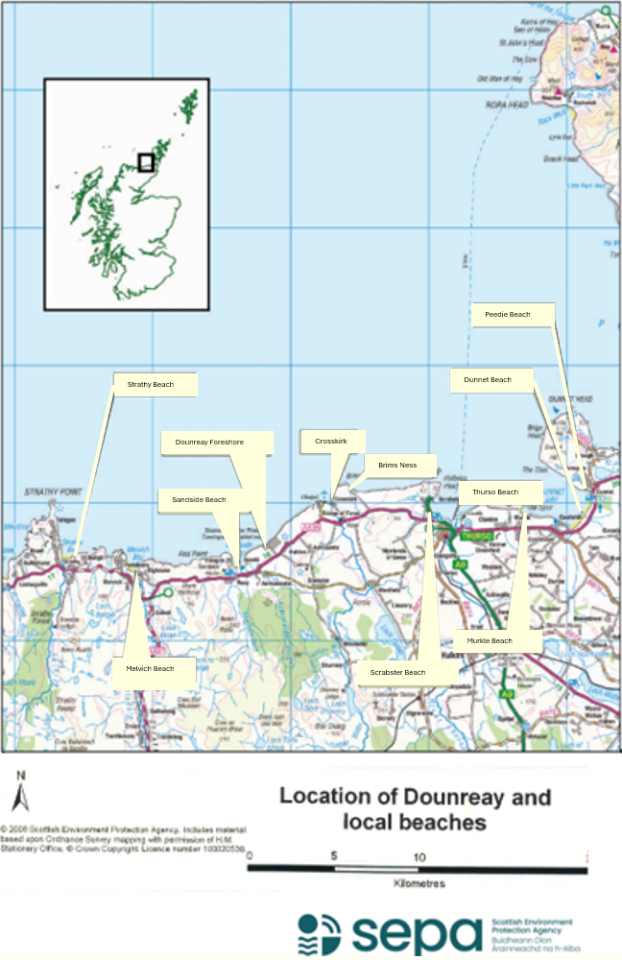
1.1.2 Construction of nuclear facilities by the United Kingdom Atomic Energy Authority (UKAEA) began in 1955. At Dounreay there are 3 reactors, together with fuel fabrication and fuel reprocessing facilities that have been in operation as shown in Table 1.0. The Royal Navy reactor test facility (HMS Vulcan) has 2 smaller reactors and is sited adjacent to the main Dounreay site. Liquid waste from HMS Vulcan continues to be routed through the Dounreay Low Level Liquid Effluent Treatment plant and discharged via the Dounreay liquid effluent discharge system.

Table 1.0 Nuclear operations at Dounreay
Area | Status | Date
Dounreay Materials Testing Reactor (MTR) | Achieved criticality | 1958
 | Shut down | 1969
MTR reprocessing plant | First fuel reprocessed | 1958
 | Shut down | 1968
Dounreay Fast Reactor  (DFR) | Achieved criticality | 1959
 | Achieved full power | 1963
 | Shut down | 1977
DFR reprocessing plant | Commissioned | 1960
 | First reprocessing | 1961
 | Last run | 1979
Prototype Fast Reactor  (PFR) | Achieved criticality | 1974
 | Shut down | 1994
PFR reprocessing plant | Commissioned | 1979
 | First reprocessing | 1980
 | Last run | 1996
Fuel cycle area | Fuel fabrication ceased | 2004
Vulcan (Royal Navy) | Reactor 1 operation | 1965-1987
 | Reactor 2 operation | 1987-1996, 2002-2015

1.1.3 This report is concerned with radioactive particles that have been discharged from the site and found on the adjacent seabed and beaches. These pose a potential radiation hazard, which is controlled by legislative and regulatory means.

1.1.4 In the International Commission on Radiological Protection (ICRP) recommendations (ICRP, 2007), a distinction is made between 2 categories of radiation exposure, practices and intervention. The former are situations where the exposures of individuals are being increased, with emphasis on the control of the source of the exposure; in most cases, this can be achieved prior to commencement of the practice. In contrast, interventions are situations where the sources, pathways of exposure and exposed individuals are already in place. In such cases, control can be achieved only by intervention, modifying or removing existing sources or pathways, or by reducing the numbers of people exposed.

1.1.5 In the situation around Dounreay, the fuel fragments have been discharged already and so control at source is not possible. Protection of people can be achieved only by intervention and so the radiation dose limits applied to practices are not applicable.

1.2 Particle Types
1.2.1 Two main types of particle have been identified. MTR (Materials Test Reactor) particles are believed to have originated when the outer cladding material of spent MTR fuel elements was being removed during reprocessing of spent fuel (1958 to 1968); due to the inherent imprecision of the methodology, some of these contained the underlying nuclear fuel. Work undertaken by UKAEA suggested that the second type of particles were produced by overheating incidents during DFR (Dounreay Fast Reactor) reprocessing (1961 to 1979).
    - Earlier investigations having ruled out other sources such as the shaft explosion of 1977, it is almost certain that the vast majority of particles were discharged via the liquid waste system which began operation in 1958.

    - Both MTR and DFR particles are most readily detected by the gamma radiation emitted by their caesium-137 content, but both also contain strontium-90 and its decay product yttrium-90. The latter are beta-emitters and are the most important contributors to contact doses for MTR particles. The highest activity particles found to date contained ~ 10⁸Bq of caesium-137 which would give rise to a skin contact dose exceeding the 2Gy threshold for acute ulceration in less than 2 minutes. If ingested, it would lead to a whole-body radiation dose of some 80mSv to an adult or 300mSv to a child (section 2.2). This may be compared to the annual background value of 2.5mSv and the 1mSv limit for radiation doses resulting from a planned discharge.

1.3 Particle Finds
1.3.1 The first radioactive particle originating from the Dounreay site to be found was located on the site foreshore in, 1983. There is fencing at each end of the foreshore, while a section forms part of the licensed nuclear site to which public access is prohibited. The Foreshore is thus essentially inaccessible to the public. A further particle was found on the publicly accessible Sandside Beach in 1984.
1.3.2 The initial findings were notified to Her Majesty’s Industrial Pollution Inspectorate (HMIPI), the responsible regulator, and thence to the UK Committee on Medical Aspects of the Environment (COMARE) whose Second Report, investigating a possible increase in the incidence of leukaemia in the vicinity of Dounreay, was published in 1988. Regulatory oversight was transferred to the Scottish Environment Protection Agency (SEPA), which was established in 1996.
1.3.3 The Old Diffuser was replaced by a New Diffuser outlet which became operational in 1992, but 4 of the 16 upstands in the Old Diffuser remained in operation until 1997. Two further particles were found on Sandside beach in 1997, while 35 were found on the seabed near the outlet of the liquid waste discharge system during the engineering project to close off the Old Diffuser outlets in the same year.
1.3.4 On advice from SEPA, the then Scottish Office imposed a 2km fishing exclusion zone under the Food and Environment Protection Act 1985. The full title of the Order is the Food Protection (Emergency Prohibitions) (Dounreay Nuclear Establishment) Order 1997, but, for convenience, it is referred to as the FEPA Order in the remainder of this report. The FEPA Order prohibits the removal of seafoods from a 2km zone centred on the outlet.
1.3.5 SEPA submitted a report to the Scottish Office in 1998, and, after consideration of the report and its recommendations, the Secretary of State for Scotland wrote to SEPA (31 December 1998) stating that:
“clearly these restrictions cannot be lifted until UKAEA find and quantify the extent of the contamination in the local marine environment”
and instructing that:
“SEPA ensures that there is sufficient monitoring in place to ensure that any particles finding their way to the beach at Sandside Bay are promptly detected and removed.”
1.3.6 The Dounreay Particles Advisory Group (DPAG) was created by SEPA as an independent advisory group in 2000 to provide independent scientific advice to the Scottish Environment Protection Agency (SEPA) and the UK Atomic Energy Authority (UKAEA) regarding radioactive particles found in the environment around the Dounreay nuclear site.
1.3.7 From 1997 until 2004, particle surveys of the seabed around the outlet were carried out by divers using hand-held radiation detectors and any found were isolated from sediment and returned to the surface for laboratory analysis. In total up to end November 2005 almost 1,000 particles have been recovered.
1.3.8 Between 2004 and 2007, seabed surveys in areas between Strathy Point and Dunnet Head were carried out using a robotic device but no attempts were made to retrieve detected particles. Following advice from DPAG and COMARE, SEPA requested that Dounreay Site Restoration Limited (DSRL) develop a remotely operated vehicle capable of detecting and recovering particles from the seabed. These operated from 2008 until 2012 and recovered about 1250 particles. The data confirmed that a cache of particles lies on the seabed, centred around the Old Diffuser outlet and forming a plume parallel to the coast.
1.3.9 Bi-weekly strandline monitoring of the Dounreay site Foreshore has been carried out since 1983, initially by use of hand-held Geiger-Mueller detectors. Area monitoring was introduced from 1984 with particles being found regularly thereafter. Monitoring has not usually been possible during May-August, the tern nesting season. A hand-held sodium-iodide detector (Groundhog 1) was introduced in 2002 and upgraded (Groundhog Evolution) in 2004.
1.3.10 No further particles were found on the strandline of Sandside Beach until the 2 in 1997, when the strandline monitoring frequency increased to weekly. The introduction of a vehicular system, with detection capabilities specified to SEPA by DPAG and COMARE, enabled surveys of the whole beach area to be undertaken from 1999 (a Unimog mounted Groundhog 1 detector array); the system was upgraded in 2004 (Groundhog Evolution) and 2007 (Groundhog Evolution II), its detection performance being confirmed by beach trials carried out by SEPA, and COMARE and DPAG. In early years, monitoring was restricted by access permissions but has been carried out monthly since 2012.
1.3.11Other beaches shown in Figure 1.1 were monitored as requested initially by DPAG and COMARE, with small numbers of finds indicating longshore drift to both east and west. Two beaches, Strathy to the west of Sandside and Murkle to the east of the Dounreay site, have continued to be monitored at a lower frequency as sentinels to determine any further spread of onshore contamination.

Ongoing work
1.4.1 DPAG and its successor group, the Particles Recovery Advisory Group (Dounreay) (PRAG(D), constituted in 2009 to provide advice and review information relating to the offshore recovery programme undertaken by the Dounreay site), have continued to examine data to try to establish the origin(s) of the particles, the numbers discharged and factors such as tidal currents, wind direction and seabed disturbance which may affect their long-term distribution.
1.4.2 Using the above data, DPAG and PRAG(D) have attempted to map and quantify the distribution of particles on the seabed, to develop a conceptual model to predict the future pattern and longevity of land contamination and to consider possible future actions.
1.4.3 Recent work has examined the finds from the Dounreay Foreshore and their implications for future land use in greater detail than previously, together with consideration of possible consequences of future engineering works such as remediation of the Old Diffuser Chamber (ODC) and the installation of subsea power cables to Orkney.

2. Dosimetry of Dounreay Particles

2.1 Discharge and distribution of particles
2.1.1 Given that the seabed recovery programme showed a plume of particles with the highest activity particles (>10⁶Bq) clustered around the Old Diffuser outlet (Figure 2.1), it may be assumed that the great majority of particles were discharged along with liquids from the site. Recent PRAG(D) work (Section 4.3) investigates whether another cache may exist as a source of the particles found on the Foreshore.

Figure 2.1 Map of all particles found to date. The map shows the area of the coastline off the Dounreay site where the particles were found.
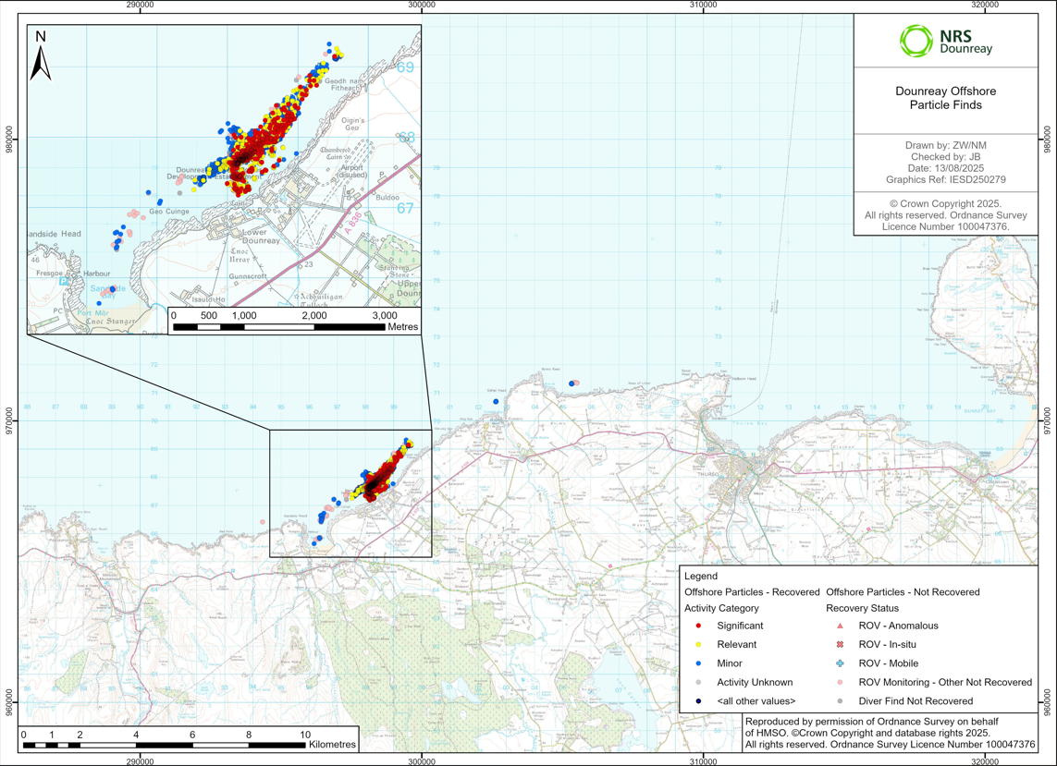

2.1.2 It should be noted that it is believed that 6 tonnes of swarf were disposed of to the shaft. This was considered initially as a potential major source of the particles, but geological and hydrogeological considerations made this unlikely. It is possible, however, that water pumped from the shaft into the Low Active Drains prior to the installation of a filter system in 1985 may have contained some particles. The shaft has now been surrounded by a ring of concrete grouting to reduce water inflow and this, in turn, has led to a 90% reduction in the volume of water being pumped out (Pers comm, SEPA, 2024).
2.1.3 The most likely source of the particles is the Low Active Drains, flowing into the Low Active Liquid Effluent tanks (sea tanks) and the Liquid Effluent Discharge Tunnel to the Old Diffuser Chamber (ODC) as shown in Figure 2.2. Sludge, containing an unknown number of particles, had settled at the bottom of the sea tanks; this was agitated by high-pressure hosing and so was discharged to the ODC along with the liquid effluent and thence to the seabed via the riser pipes (Figure 2.3). Analysis of events on the site indicates that this occurred during the 1960s and 1970s. As discussed in chapter 4.0, the number of particles released is unknown, as is the number remaining on the seabed.

Figure 2.2 Potential liquid discharge routes for particles. (Figure taken from
DPAG 3rd Report – 2006).

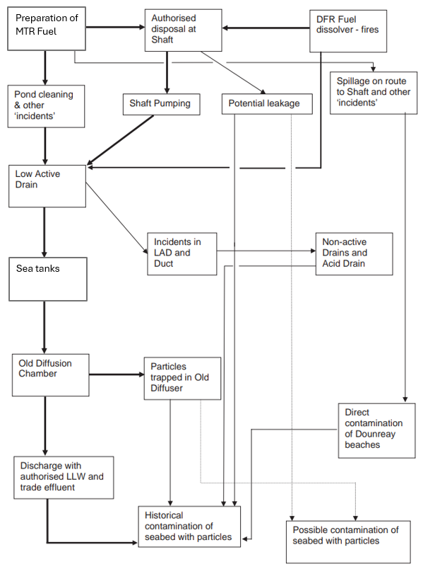

Figure 2.3 3D section through the shaft showing the configuration of offshore installations and their links to the onshore Dounreay Establishment (Figure taken from DPAG 4th Report 2008)
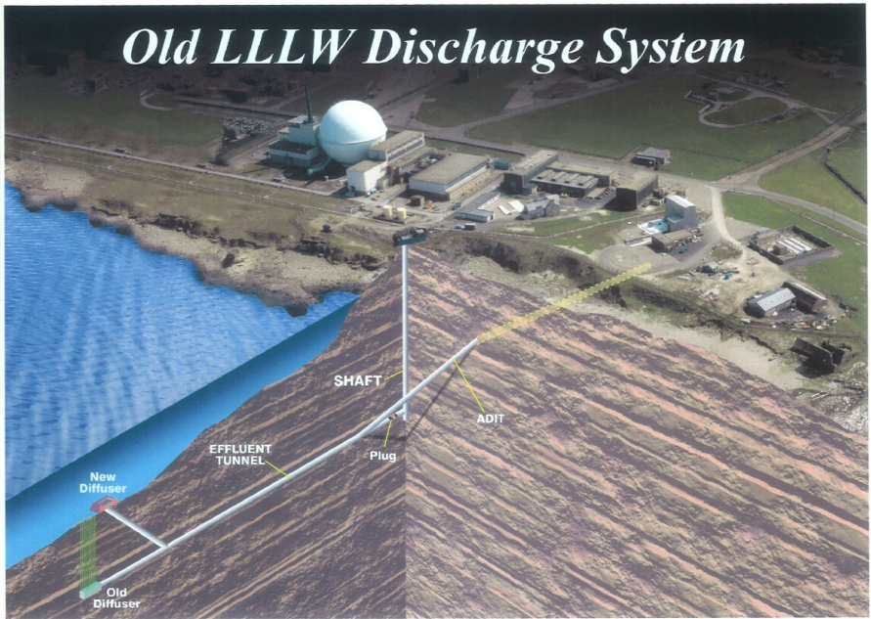
2.1.4 A video investigation of 1 of the 16 risers (number 1) from the ODC undertaken in 2007 showed luxuriant growth of the marine sulphur bacterium Beggatoa. Since Beggatoa flourishes under anaerobic conditions, it suggests that the riser was previously undisturbed for some time (i.e. there had not been any recent discharge via this route).
2.1.5 Surveys of the seabed by divers and remotely operated vehicles (ROVs) have shown that particles are present in a plume orientated southwest-northeast, running parallel to the shore and extending from Strathy (15km west of Dounreay) to Dunnet Bay (25km east of Dounreay) as shown in Figure 1.1. Initial monitoring of the shore was carried out in an extended number of locations from Strathy to Dunnet Bay, however on the basis of the numbers of particles found, this has been reduced to the main finds areas of Sandside beach and the Dounreay site Foreshore with low frequency monitoring of sentinel sites (Murkle and Strathy beaches).
2.1.6 High activity particles continue to be recovered from the Dounreay Foreshore which is the closest part of the coastline to the ODC, however, the foreshore is effectively inaccessible to the public.
2.1.7 Across the mouth of Sandside Bay, the main segment of the westward plume enters the Bay itself although some smaller particles appear to continue to the west as evidenced by the finding of a Minor particle. An earlier report (DPAG 4th Report, paragraphs 5.5.7 to 5.5.14) estimated that the transit time from the plume to Sandside is likely to be of the order of a decade.
2.1.8 Once in the Bay, particles can be washed onto the public beach from where they might be returned to the seabed in the Bay or be removed via the monitoring and removal programme. Some particles must return to the sea, evidenced by the fact that large numbers have not been found after long periods of interruption of the programme.
2.1.9 The primary detection of particles is via their caesium-137 content. The MTR particles contain caesium-137, strontium-90, yttrium-90, plutonium-238, plutonium-239 and americium-241. DFR particles contain caesium-137, strontium-90, yttrium-90 and niobium-94. In both cases, the radiation dose is dominated by the caesium-137 and strontium-90/yttrium-90 content. The half-lives of these radionuclides are shown in Table 2.1.
Table 2.1 Half-lives of radionuclides involved.
Radionuclide | Half-life
Caesium-137 | 30.17 years
Strontium-90 | 28.8 years
Yttrium-90 | 64.1 hours
Plutonium-238 | 87.74 years
Plutonium-239 | 24100 years
Americium-241 | 433 years
Niobium-94 | 20300 years
2.1.9 MTR particles give rise to a higher radiation dose per unit caesium-137 activity compared to DFR particles due to the higher ratio of strontium-90:yttrium-90 to caesium-137 activities in the MTR particles. Measurement has demonstrated a usual ratio of strontium-90:caesium-137 of 0.9. The ratio for plutonium-238:caesium-137 was estimated at 0.003, while those for both plutonium-239:caesium-137 and americium-241:caesium-137 were found to be 0.001.
2.1.10 A small number of particles containing only cobalt-60 have been recovered. Calculations by Harrison et al (2005) have shown that the associated radiation dose is approximately 70% of that for caesium-137 particles of the same activity and so the values for MTR particles will be a conservative estimate for this class as for DFR particles.
2.1.11 While a large part of the work carried out by SEPA, DPAG, PRAG(D) and COMARE has been concerned with the contamination of publicly accessible areas, principally Sandside Beach, the ongoing detection of particles on the East and West Dounreay Foreshores is becoming an increasingly important topic. At present, the Foreshore is effectively inaccessible to the public (paragraph 1.3.1), while the FEPA Order on fishing restricts consumption of marine foodstuffs. In the future, however, the aim is to release some parts of the site from regulatory control, and this means that the potential consequences of the significantly higher activities of the particles found on the Foreshore must be considered.

2.2 Particle dosimetry
2.2.1 The radiation dose to a person may be caused by surface contact, ingestion or inhalation. In terms of inhalation, the particles under consideration are too large to reach the airways of the lung and will deposit in the extrathoracic airways; the epithelial lining of the latter can be regarded as similar to skin for the assessment of the effects of local irradiation. The dose calculations detailed in Table 2.2 were carried out by Wilkins et al (2003) and Harrison et al (2005).
Skin dose
2.2.2 The important effect of external irradiation of the skin is acute ulceration, most of the data coming from studies of pigs with limited human data available. The harm to an individual coming into contact with particles recovered to date from Sandside Beach would most likely be limited to skin ulceration. In considering such reactions, ICRP Report 147 (ICRP, 2021) deems it more appropriate to consider absorbed dose rather than effective dose.
2.2.3 Calculations of absorbed dose were made for a 1cm² area of skin at a depth of 70µm (a nominal value for the basal layer of the epidermis). The threshold for acute ulceration was found to be approximately 2Gy, with a dose of 10Gy required to give an observable effect in 50% of cases (ED50). Given the composition of MTR particles, the contact times required to deliver these doses for a range of activities are shown in Table 2.2.
Table 2.2 Contact times taken to reach threshold and ED50 absorbed doses.
Activity  (Bq caesium-137) | Dose rate (Gy.h⁻¹) | Threshold (2Gy) | ED50 (10Gy)
10⁴ | 0.03 | 3 days | 2 weeks
10⁵ | 0.3 | 7 hours | 33 hours
10⁶ | 2-4 | 0.5-1 hours | 2-5 hours
10⁷ | 15-30 | 4-8 minutes | 20-40 minutes
10⁸ | 70-140 | 1-1.5 minutes | <10 minutes
2.2.4 Given that the individual activities of the particles recovered from Sandside Beach, have all been below 10⁶Bq of caesium-137, it was concluded that skin ulceration was the radiation effect of most concern. Since ulceration effects would be expected for stationary contact periods of between 0.5 hours and 1 hour, particles with an activity of 10⁶Bq and above were defined as Significant. Particles with activity of between 10⁵Bq and above and 10⁴Bq were categorised as Relevant and Minor respectively (DPAG Report, 2006). If only external radiation dose (i.e. to skin) is being considered, the solubility makes no difference and so the three-tier classification system is unaffected for particles such as MTR113 (paragraph 2.2.6). This classification is used throughout the remainder of this report.
Ingestion dose
2.2.5 The most important factor in calculating the radiation dose from ingestion of a particle is the proportion which is soluble in the gut and hence transferred into blood. Both in vitro and in vivo experimental values for radionuclide absorption into blood were obtained from a random sample of over 150 particles. A small number were dissolved in simulated gut fluid, the remainder being tested in hydrochloric acid. Almost all particles exhibited only low solubility as shown in Table 2.3.

Table 2.3 Mean percentage (range) of ingested activity absorbed to blood
Fragment type | % of caesium-137 ingested activity absorbed to blood | % of strontium-90 ingested activity absorbed to blood | % of plutonium-239 ingested activity absorbed to blood
MTR | 1 (0.02-2.0) | 0.01 (0.001-0.03) | 0.001  (5x10⁻⁵–5x10⁻³)
DFR | 0.03 (0.001-0.05) | 0.003 (0.001-0.02) | 0.001  (5x10⁻⁵–5x10⁻³)
2.2.6 About 5% of particles tested showed enhanced solubilities. Of these, 1 particle (categorised as MTR 113) showed some 50% of all radionuclide activities going into solution in simulated gut fluids. One hypothesis is that the particle was uranium oxide rather than the usual uranium-aluminium alloy; a few plates from experimental MTR fuel elements, believed to be triuranium octoxide aluminium alloy, were reprocessed prior to 1973.
2.2.7 As the organ receiving the greatest doses, potential radiation doses to the rectosigmoid region of the large intestine were calculated assuming no loss of activity from fragments due to dissolution in gut fluids. Two values are given in each case (Table 2.4). The first is an expectation value corresponding to random movement of the fragment through the lumen of the rectosigmoid; and the second is a maximum value, based on the cautious assumption that the fragment remined in contact with the wall of the rectosigmoid throughout transit. From animal data, the threshold for acute damage resulting in death has been estimated to be about 20Gy with an LD50 of 35Gy. Estimated doses are shown in Table 2.4, where 2 values are shown for each activity to take account of variations in transit times due to disease.

Table 2.4 Estimated doses to the rectosigmoid (mGy)
Activity  Bq  caesium-137 | Adult male  Bq  caesium-137  normal | Adult male  maximum | Adult female  normal | Adult female  maximum | One-year-old child  normal | One-year-old child  maximum
10³ | 0.01 | 0.08 | 0.01 | 0.1 | 0.04 | 0.2
10⁴ | 0.1 | 0.7 | 0.1 | 1 | 0.4 | 2
10⁵ | 0.9 | 6 | 1 | 8 | 3 | 16
10⁶ | 7 | 40 | 10 | 60 | 27 | 110
10⁷ | 46 | 230 | 67 | 340 | 185 | 640
10⁸ | 290 | 1200 | 420 | 1800 | 1200 | 3500
2.2.8 A separate calculation was undertaken for particles with the solubility exhibited by MTR113 which showed dose values of some 70% of those in Table 2.4. Fortunately, the 50µm range in tissue of the alpha radiation from the long half-life plutonium-239 is much lower than the depth of the rectosigmoid target cells (280-300µm) and so it makes little contribution to the radiation dose for this organ.
2.2.9 It can be seen that the dose from the most active particle found to date on the beach at Sandside Bay (5x10⁵Bq) would be at least 100 times less than the threshold for lethality. For adults, even the most active particle recovered from the Foreshore would be unlikely to cause lethality although, in extreme cases, the possibility cannot be excluded for a one-year-old (1yo) child.
2.2.10 The passage of material through the colon, however, is not one of constant flow but of periodic contractions with intervals of stasis. Should a 10⁸ Bq particle remain stationary against the luminal wall of the rectosigmoid for 6 hours, the local radiation dose would be about 240Gy. From animal data, this may be expected to produce local ulceration, which would not be easy to repair and could cause death.
2.2.11 In order to estimate stochastic risk (i.e. probability of cancer), the effective dose to a person ingesting a particle may be calculated from the effective dose coefficients shown in Table 2.5.

Table 2.5 Effective dose coefficients
Radionuclide | Effective dose coefficient (Sv.Bq⁻¹)
caesium-137 | 1.4x10⁻⁹
strontium-90 | 2.1x10⁻⁹
yttrium-90 | 2.7x10⁻⁹
2.2.12 Using the solubility of the majority of particles recovered, the estimated effective dose to a normal adult male upon ingestion of a 10⁵Bq caesium-137 particle, of which several have been recovered from the shore of Sandside Bay, would be 0.1mSv. For a 1yo child the ingestion of such a particle would give rise to an effective dose of around 0.5mSv. In an extreme case of prolonged transit through the colon, this would increase to approximately 3mSv.
2.2.13 For a particle of the same activity but with the solubility of MTR113, the effective dose to an adult male would be about 2mSv and about 8mSv to a 1yo child, with similar increases to those above for prolonged colon transit.
2.2.14 It has been found that particle size broadly increases with increasing radioactive content. This gives rise to a ‘self-shielding’ effect whereby radiation dose is not directly proportional to radioactive content. The effective doses to a normal adult male and to a 1yo child from an ‘insoluble’ particle containing 10⁸Bq caesium-137 would be approximately 80mSv and 300mSv respectively.
2.2.15 Using the dose ratio of 8:3 for plutonium-238:plutonium-239, the corresponding doses to an adult male for a soluble 10⁵Bq particle are shown in Table 2.6. A 1yo child would receive a dose some 3 times higher.
Table 2.6 Organ and equivalent doses to an adult male from a soluble 105Bq particles (µSv)
Organ | caesium-137  (µSv) | strontium-90  (µSv) | yttrium -90  (µSv) | plutonium-238  (µSv) | plutonium-239  (µSv) | americium-241  (µSv) | Total  (µSv)
Stomach | 830 | 50 | 150 | 2.2 | 0.82 | 0.8 | 1030
Colon | 910 | 170 | 310 | 2.2 | 0.82 | 0.8 | 1400
Red Bone Marrow | 790 | 8050 | 0.1 | 64.3 | 25.7 | 20 | 8950
Bone Surface | 830 | 18400 | 0.1 | 1328 | 472 | 540 | 21600
Liver | 820 | 28 | 0.1 | 270 | 120 | 34 | 1270
Gonads | 880 | 28 | 0.003 | 22.5 | 7.5 | 11 | 950
Committed Effective Dose | 820 | 1200 | 54 | 40.7 | 15.3 | 12 | 2140

2.2.16 Using the data from ICRP report 60 (ICRP, 1991), the risks of fatal cancer and overall detriment are 0.05Sv⁻¹ and 0.07Sv⁻¹ respectively. Table 2.7 shows the risks associated with the doses calculated above.

Table 2.7 Risks from Sandside Bay and Foreshore particles
Particle activity (Bq) and type | Fatal risk | Overall detriment
Typical 10⁵ (adult) | 5.0x10⁻⁶ | 7.0x10⁻⁶
Typical 10⁵ (1yo child) | 2.5x10⁻⁵ | 3.5x10⁻⁵
Typical 10⁸ (adult) | 3.9x10⁻³ | 5.5x10⁻³
Typical 10⁸ (1yo child) | 1.4x10⁻² | 2.0x10⁻²
Soluble 10⁵ (adult) | 1.0x10⁻⁴ | 1.4x10⁻⁴
Soluble 10⁵ (1yo child) | 3.0x10⁻⁴ | 4.2x10⁻⁴
2.2.17 These risks would be higher for someone with prolonged gut transit as noted above.
Given that the data in Table 2.6 are largely a consequence of soluble activity transferred to blood and there is a relatively small contribution from irradiation of the gut wall. However, for low solubility particles self-shielding becomes relevant, and the irradiation of the gut wall can become the dominant exposure pathway. A reasonable estimate of the effective dose to an adult male from a 10⁸Bq particle with the solubility of MTR113 would be in excess of 1Sv, giving a risk of fatal cancer of some 5%.
2.2.18 After 100 years, the caesium-137 activity of a particle will have decayed by a factor of 8, the plutonium-238 activity will have decayed by just over 50%, the americium-241 will have decayed by around 15% and the plutonium-239 will be unchanged. For a low solubility particle with a current activity of 10⁸Bq, the effective ingestion doses would still be approximately 10mSv and 35mSv for a normal adult and a 1yo child respectively. For a particle of the same current activity but the solubility of MTR113, the effective dose for a normal adult male would be some 100mSv to 200mSv, of which the alpha dose alone would contribute over 40mSv.

2.3 Conclusion
2.3.1 The above calculations show that the health risk to the public from particles found on Sandside Beach to date is low. The health risk from those found on the Foreshore, however, is not inconsequential. Even for a normal adult male, the effective dose from ingestion of an insoluble 10⁸Bq particle would be 80mSv, 4 times the intervention limit of 20mSv (ICRP,2007). Although less likely to be encountered, the dose from a high solubility particle would be much higher. The possibility of such doses has regulatory implications for the future management of this area for several decades to come.

Dounreay Radioactive Particles in the Marine Environment: A Forward Look

3.1 Introduction
3.1.1 The contamination of the seabed and beaches by radioactive particles from Dounreay has been demonstrated to have spread along a 30km length of the north Scottish coast, from Red Point in the west to Dunnet Beach in the east. The causes and history of this contamination have been pieced together over a 40 year period from Dounreay’s own operational records, from the results of surveys and routine monitoring for particles on beaches, from surveys of the seabed and particle recoveries made by divers and by the ROVs, from chemical, physical and radioactive characterisation of recovered particles, from seabed observations of wave pressure and sand movement, and from modelling studies of wave climate, wave heights and sand transport. Much of the work in gathering all of this evidence has been undertaken by the Dounreay Establishment itself, but the main synthesis of it into a conceptual understanding of the problem has been in a series of reports and papers prepared for SEPA, from 2000 by the Dounreay Particles Advisory Group (DPAG) and since 2009 by the Particles Recovery Advisory Group (Dounreay) (or PRAG(D)).
3.1.2 DPAG produced 4 Reports that were published by SEPA. Of these the 3rd and 4th Reports in 2006 and 2008 are the most important as they summarised our current conceptual understanding of the contamination and the behaviour of the radioactive particles in the marine environment. PRAG(D)’s reports to SEPA were more occasional, with the most important being the Annual Report for 2012 (not fully compiled and published until 2016). This assessed the impact of the major offshore particle recovery operations undertaken by Dounreay in 2010, 2011 and 2012 and made the first attempt to estimate the numbers of particles remaining on the seabed following those operations. Since 2016 PRAG(D) has mainly considered the continuing recoveries of particles from beaches at Dounreay Foreshore and Sandside plus the beaches between Murkle in the east and Strathy in the west. Other material relevant to the offshore environment that the Group has considered include a major modelling study of the wave climate along this section of the Scottish coast (HR Wallingford, 2018; PRAG(D), 2024a, 2024b, 2024c), and an assessment of the likely state and size of the offshore population of Significant particles at the present time (PRAG(D), 2024d).
3.1.3 This chapter reviews the main conclusions of the reports and studies mentioned in the previous paragraph but does not attempt to summarise the detailed arguments and evidence on which those conclusions are based. The key questions that we wish to address are:
- How many Significant radioactive particles remain in the marine environment at the present time?
- What is the ultimate fate of the radioactive particles if they remain in the marine environment?
- What are the causes of the longevity of the particle population offshore?
- Starting from the present position in 2025 (insofar as it is fully understood), what are the likely outcomes over the next 30 years under various management scenarios, such as:
  - Cease beach monitoring and do nothing,
  - Continue present monitoring and particle recovery but nothing more,
  - Attempt further offshore surveys and/or recoveries?
3.1.4 The background to these questions is of course the history of the offshore contamination, its causes, discovery and attempts to manage it. The chapter therefore begins with a synopsis of our conceptual understanding of the offshore particle population and its behaviour under natural processes in the marine environment including beaches.

3.2 Synopsis of the history and behaviour of Dounreay

particles in the marine environment
The origin and release of radioactive particles to the sea
3.2.1 Almost all the radioactive particles recovered from offshore belong to 2 categories. MTR particles originated from swarf milled from fuel plates used in the MTR at Dounreay. DFR particles were produced during reprocessing of fuel from the DFR. The exact timing of the release of radioactive particles into the environment is not known, but DFR particles were probably created in the period from 1969 to 1979, and it is likely that they were released during that decade. The currently accepted explanation for MTR particles is that during the period from 1958 to 1981, a large but uncertain number of swarf particles, a minority of them radioactive, were released through drains leading to the Old Diffuser. Figure 3.1 and its caption summarise the events and activities that might have produced such releases. In addition, certain storm drains and non-active drains leading from the site to the beach may have contained particle caches originating from spillage and leakage incidents in the 1960s, or possibly from liquid pumped from the Shaft may have been a minor source of particles up to 1985 when filters were installed. Irradiation dates on 16 MTR particles recovered from beaches in 1984 and 1993 all agree in placing irradiation in the mid-1960s. The likelihood is that the majority of MTR particles were released into the environment in the period from 1959 up to the end of milling operations on MTR in 1973 although potentially radioactive particles continued to be generated from MTR fuel until 1996 by “crushing and cropping” and could in principle have reached the sea via the Old Diffuser until its use finally ceased in 1998.

Figure 3.1 Periods when radioactive particles might have been released into the marine environment
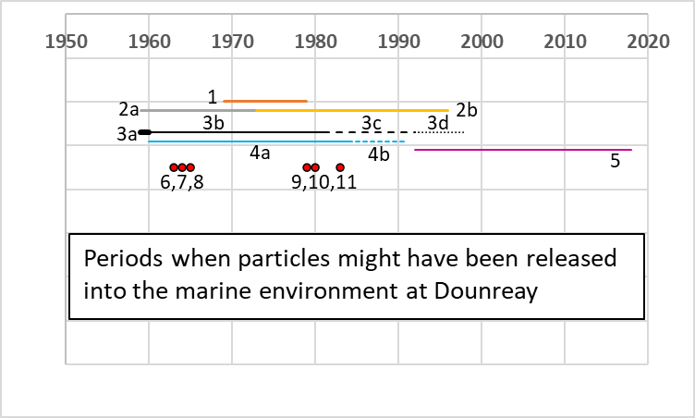
Key to Figure 3.1
The horizontal bars show times when particles may have been released into the marine environment.
      - Period of occasional formation of DFR particles.

      - Period of formation of MTR particles,

(a) by milling,
(b) by “crushing and cropping”.

      - Periods of discharging of solids from MTR milling ponds to ‘Sea Tanks’ and Old Diffuser,
(a) direct discharge of residual and ‘sludge’ after agitation,
(b) removal of most swarf to Wet Silo,
(c) Pipework in Old Diffuser broken,
(d) single pipeline to Old Diffuser still flushed regularly.
      - Wet Silo pumped discharge to Low Active Drain (LAD) and Old Diffuser,
(a) without filtration,
(b) with “candle filters”.
5. New Diffuser and pipeline in use.
- Record of cleaning of reprocessing cooling pond with ejection of sludge and particles into LAD.

- LAD leakage upstream of ‘Sea Tanks’, with swarf flushed into Non-Active drains.
8. Spillage of swarf on roadway, flushed into Storm Drain.

9. Seaward portion of LAD partially blocked (August), then suddenly freed again (December).

10. Diffuser upstands sandblasted by divers.

11. Upstands cleared by jetting.

The history of the contamination and of attempts at its management
3.2.2 The overall history of the contamination can best be divided into chronological periods by reference to the attempts made to manage it.
The ‘Prehistoric Period’, before 1984
3.2.3 As noted above, the timing of the release(s) of particles into the marine environment are not well characterised, but it is likely that the bulk of releases took place after 1958 and before 1981. It is also likely that the majority reached the sea via the Old Diffuser. The disposition of particles found on the seabed after 1997 is consistent with this (see below). The numbers released are very uncertain indeed as there is scarcely any data on which to base estimates of total amounts of radioactivity involved and none at all on the likely activity range of the particles in their primal state. The total number may have been between a few thousand to hundreds of thousands of radioactive particles, but these bounds are themselves largely guesswork. During this period, single particles were found off-site during routine strandline surveys on Dounreay Foreshore in November 1983. This find alerted Dounreay to the possibility that further particles might be present on or outside the site and led to the start of area monitoring of the Foreshore from 1984 onwards and recovery of any particles found.
The ‘Dounreay Foreshore Period’, 1984 to1997
3.2.4 Systematic monitoring of Dounreay Foreshore began in 1984 using hand-held instruments. The area covered was divided between the East and West Foreshores, the former being rocky (composed of predominantly Caithness Flagstone) and the latter consisting of a coarse sand beach overlying cobbles and boulders that rest on bedrock. The annual record for each is illustrated in Figure 3.2 and Figure 3.3. In these Figures the time scale is shown in “Wave Years”. A Wave Year is defined as the period between 1 July in 1 calendar year and 30 June in the next. The purpose of this is to ensure that the whole of the winter period (the period in which large waves are most likely to occur) is unbroken in each individual year.
3.2.5 Overall, 27 particles were found during 1984, but between 1985 and 1997 the average annual find rate was less than half of this, 11.9 per year. In 1996 the West Foreshore was excavated down to bedrock, and 4 particles were found, which demonstrated that there was no large store of particles on the beach itself. Particles must have been arriving from somewhere else. An extensive search of the site failed to find a source in the landward direction, but in summer 1997 divers accidentally found a particle on the seabed while undertaking work on the Old Diffuser. Further searching of the adjacent area of seabed revealed another 34 particles before diving operations ceased for the winter. Also in 1997, 2 particles were found on Sandside beach during routine strandline monitoring.
Figure 3.2 Particle recoveries from Dounreay East Foreshore, 1984 to 2022
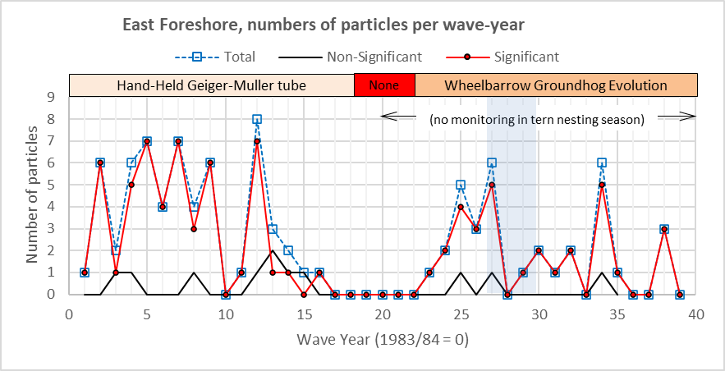

Figure 3.3 Particle Recoveries from Dounreay West Foreshore, 1984 to 2022
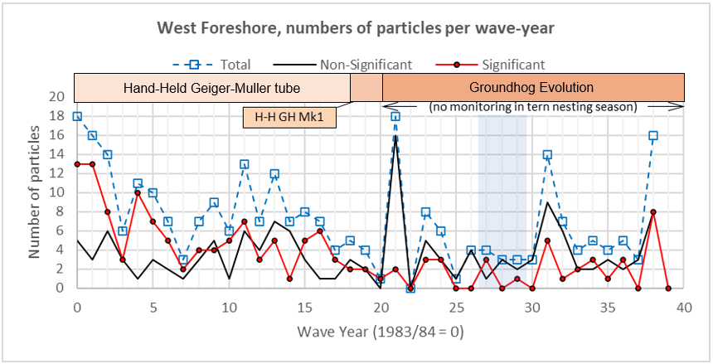

The ’Diver Period’, 1997 to 2005
3.2.6 The finds made on the seabed and on Sandside beach in 1997 caused an immediate expansion of investigations, both offshore and on beaches. The offshore areas were initially searched in a semi-systematic fashion, with divers covering quite extensive areas using hand-held detectors and digging for particles when they detected an increase in radioactivity above background. They were charged with recovering particles and financially rewarded when they did so, which may have biased their surveys towards places at which previous experience had suggested particles might be found. The depth of digging to each particle was estimated and the particles returned to shore along with the trowel-full of sand in which they had been raised. Activity of each particle was measured on shore. The data obtained in this way defined the distributions of particle numbers and radioactivity with depth.
3.2.7 In 2000 and 2001 a more systematic search method was used, with divers following lines laid out over the area between the Diffuser and the West Foreshore. This is an area of rocky outcrops like small crags, separated by corridors of sand. The purpose of these surveys was to discover whether there was a large cache of particles close to shore, but the relatively small numbers found suggested, at the time of survey that there was not.
3.2.8 A third mode of search began in 2000 and continued until 2004. Using metal pins driven around 600mm into the sandy seabed, divers attached a rope that could be stretched and held by a second peg to form 1 radius of a circular area of 2500m². By moving along the pegged rope, the diver searched a swath of ground between the centre and the circumference. The rope was then moved round the circumference by a half-swath width and the search renewed along the new radius. This procedure resulted in all points within the circle being searched at least twice and those towards the centre being searched many times, increasing the likelihood of particle detection. Crucially, the central pin could be revisited after an interval of a year or sometimes 2, and a new search made. The circular areas were termed Repopulation Areas and 12 were laid out in all, with 4 being added to by searching an outer annulus with a radius from the central pin of 50m. If new finds were made on second or subsequent searches, it could be assumed that they were particles that had either moved into the circle from outside or had been brought up from a buried position beneath detection level by wave disturbance of the sand.
3.2.9 The repeated searching of Repopulation Areas was crucial to understanding the dynamic behaviour of the particle population as it showed that the sand was regularly disturbed by wave action, especially in winter, down to depths of at least 500mm. The loss of the central pin of 1 area indicated that on occasion the bed might be disturbed to greater depths than this. In addition, Dounreay’s 1998 deployment of ‘Minipod’ instruments measuring wave pressure, bottom current speeds and the changing level of the sand surface over periods of 2 months had already demonstrated that tidal currents and waves frequently disturbed the sand down to 200mm depth in the area close to the Old Diffuser.
3.2.10 All the information from the diver searches and recoveries was synthesized into a plan-view map of particle distribution on and beneath the seabed, and a conceptual model of the offshore particle population’s dynamic behaviour. This is described in detail in DPAG’s 3rd and 4th Reports and summarised in paragraph 4.0.
3.2.11 Also in this period, the monitoring of Sandside beach was expanded with the introduction of the Groundhog Mk 1 vehicle-mounted detector system in 1999 and deployment of an improved detector system Groundhog Evolution, from mid-2002. At Dounreay Foreshore, a hand-held version of Groundhog Mk 1 was deployed from 2001 to 2004 when it was replaced by a wheelbarrow-mounted version of Groundhog Evolution. This change restricted the area being covered compared with hand-held instruments. Additionally, from 2004 onwards Foreshore monitoring was suspended from May to August during the tern nesting season.
The ’TROL Period’, 2005 to 2009
3.2.12 In 2005 Dounreay made the first trials of a remotely operated vehicle carrying particle detectors, termed the TROL. On initial trials the TROL was accompanied by divers who recovered any particles found. Over the following 3 years the TROL was developed to recover particles, as well as to estimate their depth beneath the sand surface. However, once the decision had been taken not to continue employing divers, only a very few particle recoveries were made. The locations of ‘particle strikes’ made in surveys by the TROL were incorporated into a revised map of particle distributions in DPAG’s 4th Report, largely confirming the previous version in the 3rd Report and the conceptual model.

The ‘ROV Recovery Period’, 2010 to 2012
3.2.13 For 3 summer and early autumn seasons a newly designed remotely operated vehicle, often termed ‘the ROV’ but more accurately named Seahog, was deployed from a barge moored offshore over the area of the particle plume as mapped by DPAG. The new ROV was designed to locate and recover particles of 10⁶ Bq down to depths of circa 600mm, 10⁷Bq to circa 750mm and 10⁸Bq to circa 950mm. During the 3 years of its deployment the ROV covered almost all of the area of seabed occupied by Significant particles as mapped by DPAG. The ratios of numbers of Significant, Relevant and Minor particles detected by the ROV were almost identical to the same ratios in the diver recoveries, so a similarly composed population was being sampled in both periods. However, the numbers of each category detected by the ROV were only around 1 quarter of the numbers predicted by DPAG from the diver surveys. The cause of this discrepancy was unresolved, but it was recognised at the time and made explicit in PRAG(D)’s 2012 Report (published 2016), that a substantial number of particles must have remained on the seabed after the recovery campaigns had been completed. For Significant particles, the 2012 Report put a lower bound on the numbers remaining of 90 to 220 particles, basing this estimate on an evaluation of the ROV’s performance in repeat surveys of the same ground, a standard technique used for estimating fish populations.
The ‘Post-Recovery Period’, 2012 – present
3.2.14 Since 2012 no attempts have been made to detect or recover particles from offshore, but monitoring of beaches has continued and particles have been recovered from both the East and West Foreshores at Dounreay and from Sandside beach. Figures 3.2 and 3.3 show the records of the Dounreay Foreshore recoveries. Significant particles have continued to arrive on the Foreshore as a whole at an average rate of about 4 per year, following a decline during the ROV recovery years. There must still be a substantial population of Significant particles offshore to maintain this onshore flux, which is roughly 40% of the rate during the ‘Dounreay Foreshore Period’ 1984 to1997, before any particle removals had occurred offshore.

3.3 Synopsis of the 3-D conceptual model of particle behaviour
The particle plume
3.3.15 Figure 3.4 shows the distribution of all Significant recoveries and contacts made offshore in the whole period 1997 to 2012, while Figure 3.5 shows the distribution of Relevant and Minor particles in the same stretch of coastline. Beyond the area shown in these Figures, Relevant and Minor particles have also been detected and recovered from the seabed between Dounreay and Sandside Bay, within the Bay itself, and on Sandside beach. Minor particles have been found on the seabed near Red Point, which is located west of Sandside Bay, and near Crosskirk and Brims Ness to the east of Dounreay, with Relevant particles also present at the last of these sites. On beaches, Minor particles have been found at Murkle and Dunnet. All but 1 of the Significant particle finds lie within 2km of the Old Diffuser (Figure 3.4) whereas the Relevant and Minor finds are more widely spread, the latter the most of all. The distribution of particles takes the form of a plume stretching away from the Old Diffuser in both directions along the coast, with the population density highest close to the Old Diffuser and falling away quite rapidly to seaward. The plume axis is parallel to the shore but for Significant particles it is asymmetric, being 10 times more extended to the north-east than to the west. No Significant particles were found beyond about 200m west of the Old Diffuser. Relevant and Minor particles are somewhat more symmetrically distributed between the 2 directions, at least in the fairly densely populated parts of the plume. A train of these particles extends circa 3km westwards from the Old Diffuser to Sandside Bay, which is roughly the same length as the densely populated north-eastward part of the plume. The more distal parts of the plume are strongly asymmetric, however, with the finds on Dunnet and Murkle beaches and those on the seabed at Crosskirk and Brims Ness confirming that Minor particles extend at least 25km eastwards while Relevant particles reach at least 8km east from Dounreay. In contrast, the western most find beyond Sandside Bay is a single Minor particle on the seabed, 5km from Dounreay.

Figure 3.4 Map showing all Significant offshore particle finds 1997 to 2012, and the East and West Foreshore areas. The pale grey ornament offshore indicates sand, the mid-grey nearer the shore is submerged rock and the dark grey indicates the intertidal area. (From PRAG(D)’s 2012 Report, Figure 3.6. Source DSRL)
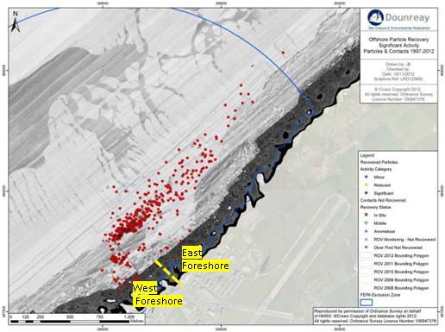

Figure 3.5 Map showing all Relevant and Minor offshore particle finds 1997 to 2012. The pale grey ornament offshore indicates sand, the mid-grey nearer the shore is submerged rock and the dark grey indicates the intertidal area. (From PRAG(D)’s 2012 Report, Figure 3.6. Source DSRL)
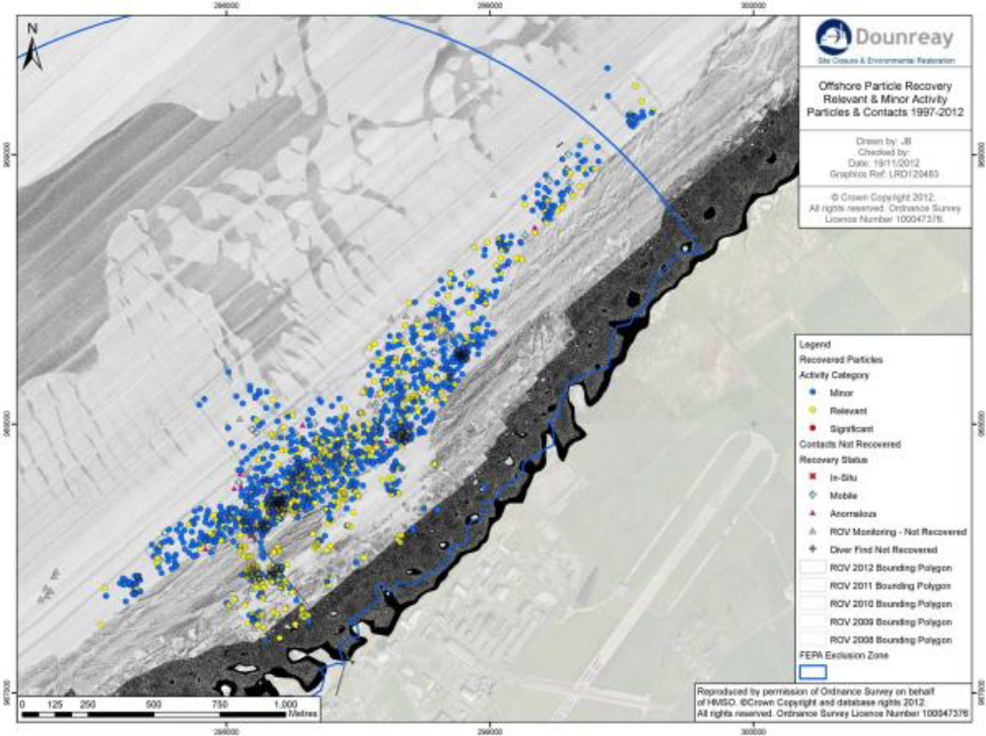
3.3.16 The reason for this asymmetry lies in the wave climate. There is an approximate correlation between the radioactivity of a particle and their size, which is in turn fairly similar to the natural grains of sand, so the particles behave in a broadly similar fashion to the sand grains that surround them. Modelling shows that tidal currents alone are insufficient to move the largest, most radioactive particles, and that Significant particles in particular require the extra energy of wind-driven waves and currents to move them. Relevant and Minor particles, being generally smaller, can be moved back and forth by tidal currents alone, so have spread westwards against the prevailing waves, as well as north-eastwards. Figure 3.6a shows that the dominant waves approach the coast from the north and northwest, except in the mouth of Sandside Bay where the shelter provided by the western point refracts the distribution to a more northerly dominance. It appears from Figure 3.1 that Significant particles on the west side of the Old Diffuser have been driven southwards onto the West Foreshore, whereas on the east side of the Diffuser the north-westerly waves are oblique to the coastline and have driven the particles north-eastwards. The north-westerlies also have the greatest proportion of very high waves as indicated by colour coding on Figure 3.6b.
Figure 3.6a The Wave Climate at Dounreay (Map). Part A: Locations of the 5 points used to determine wave climate by calculation from wind-speed records and an oceanographic model. The red line outlines the particle plume as mapped by DPAG. (Source: HR Wallingford, 2018)
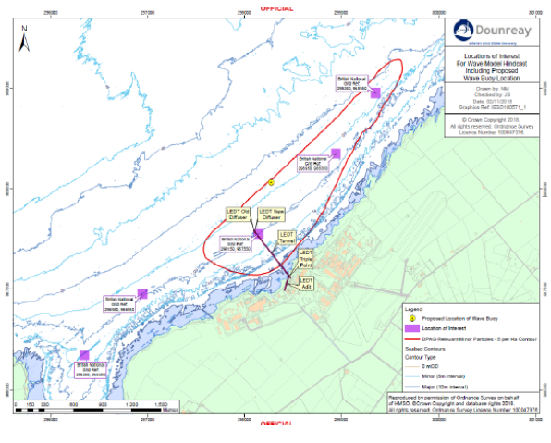

Figure 3.6b The Wave Climate at Dounreay (Diagrams). Part B: Wave rose diagrams for the 5 points shown in Part A, with wave heights indicated by colour. (Source: HR Wallingford, 2018)

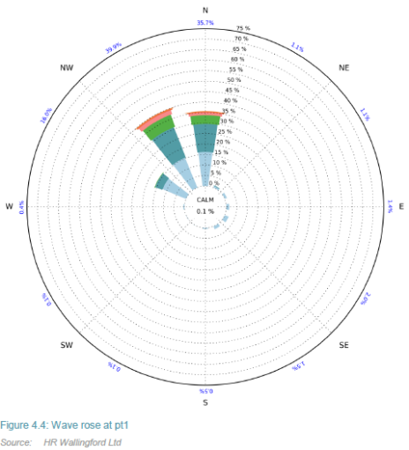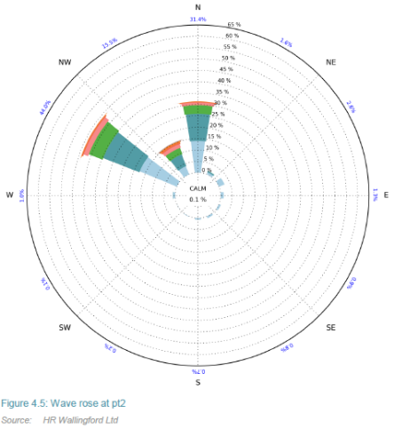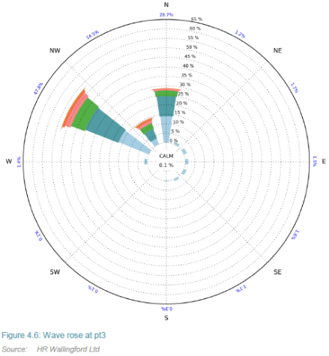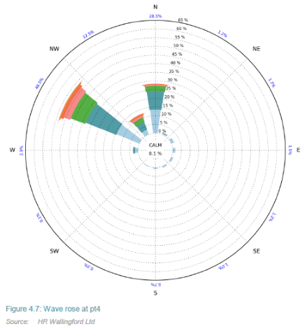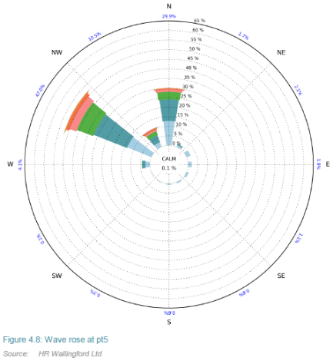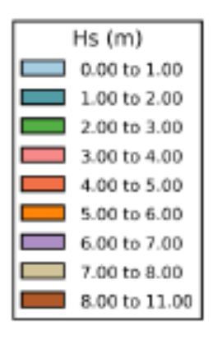

The third dimension: distribution of particles with depth beneath the seabed
3.3.17 The distribution of particles in the third dimension, that is depth of burial within the sandy sediment of the seabed, is known much less completely than the plan view of the plume. Figure 3.7 shows the depth distributions of Significant particles recovered by divers and by the ROV. Both distributions show a diminished number of particles at greater depths than 500mm (divers) and 600mm (ROV), which is likely due to these being the cut-off depths of detectability for particles of circa 10⁶Bq, that is at the lower limit of the Significant category. This is consistent with the pattern in Figure 3.8 that shows the activities of all recovered particles plotted against their recorded depth beneath the seabed. The solid red line indicates the theoretical detection capability for the Seahog ROV used in 2010 to 2012, as claimed by its makers, whereas the dotted line indicates a variation based on the simulation of the Seahog’s capability to detect a 10⁶Bq particle as discussed in PRAG(D)’s 2012 Report (published 2016). The orange curve indicates the detection limits of the hand-held devices used by the divers up to 2004 to 2005. Some reported depths appear to exceed the detection limit at all activities, and this may be due in part to overestimation of the depths by divers as they excavated the particles using a trowel within a small cylindrical enclosure that was pushed down into the seabed as excavation progressed. The ROV relied on liquefaction of sand to recover each particle, and this too may have caused some to sink downwards during the excavation process. Notwithstanding this bias, only 25 particles have been recovered from below 600mm depth which is the maximum theoretical limit for a 10⁶Bq activity at 95% probability of detection. Of these 25, 8 lay above their detection limit because they had higher activities up to 6x10⁷Bq, whereas 17 particles with activities ranging up to 1.1x10⁷Bq lay below their detection limits (0.8 % of the 2,087 recovered in total from offshore). Despite the potentially downwards bias in the depth data, there is a marked difference in the numbers of Significant particles detected at depths below 600mm, compared with their much greater population density at all shallower depths. Because this cut-off coincides with detection limits, neither Figure 3.7 nor Figure 3.8 is at all inconsistent with the possibility that an unknown number of particles were present during the recovery operations in 2010 to 2012 that were more deeply buried than the detection limit of the ROV. There is no reason why the processes of sand disturbance by large waves that buried the particles in the first place should not have buried many at greater depths than the detection limits. This point is extremely important, because it is likely to be from a store of more deeply buried and more rarely disturbed ‘undetected’ particles that the population in shallower layers and on the surface has been regenerated since offshore recovery operations ceased in autumn 2012.
Figure 3.7 Depth distributions of Significant particles found and recovered by divers between 1997 and 2008, and by the ROV campaigns in 2010 to 2012.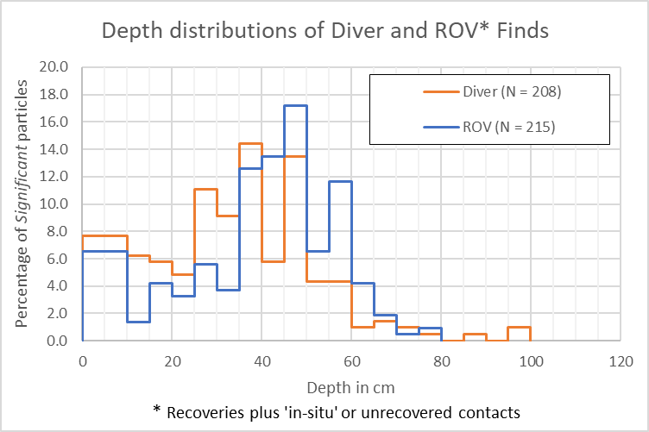
Figure 3.8 All recovered particles’ activities versus reported depth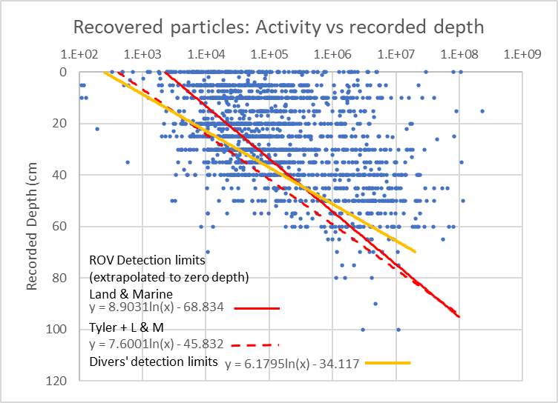

Natural processes affecting the particles and causing their spread
3.3.18 Images of a selection of particles obtained by Dounreay show that despite their origin as angular swarf, most of the metallic particles are rounded by abrasion caused by collisions with the natural sand grains around them. This process of rounding affects all natural sands, and the metal particles have been similarly abraded. The process takes time as abrasion only occurs when the particles and sand are in motion, so the fact that the majority of particles have been rounded suggests that they have been in the marine environment for a long time. The abrasion process will over time have reduced them in size, making them more susceptible to transport by tidal and wave-induced currents. Because Relevant and Minor particles are mostly smaller than Significant ones, these currents will tend to transport them further and this accounts for the fact that the average particle radioactivity falls off steeply with distance from the Old Diffuser along the plume axis.
3.3.19 A second process, particle splitting, also reduces the radioactive particles in size over time. DFR particles are made of friable materials and tend to fragment under mechanical stress. Because the metallic MTR fuel particles are composed in part of an alloy of uranium with aluminium, they are susceptible to electrochemical corrosion while in sea water. Though this process may act quite slowly, electron microscope images of the particles show that they may be fissured or pitted, probably where 1 metal has been dissolved at the expense of the other. This process weakens the particles and is evidenced by about 12% of the early diver finds being recovered in a fragmented state with the average number of fragments being 2.8. Clearly, successive fragmentation events will act to reduce the physical size of the particles and make them more susceptible to transport by currents.
3.3.20 It is not known whether abrasion or fragmentation is the more important in reducing the size of the particles over time. However, there is some information on the speed of the fragmentation process. It comes from a study of fragmented particles recovered from resurveys of the Repopulation Areas, which showed that around 15% of particles fragment within a year, if they have been moved by currents or waves during that year. For an individual particle this corresponds to an average fragmentation interval of between 6 and 7 years. The same study showed that when particles fragment, they produce any number up to 10 ‘daughter’ fragments, but that on average 80% of the radioactivity remains in the largest fragment.
3.3.21 However, it is not clear whether or not buried particles might remain whole for as long as they remained undisturbed, even while electrochemical chemical corrosion continued. For this reason, the average lifetime estimate of 6 to 7 years should be treated as a lower bound, and deeply buried particles might survive much longer without fragmenting, if the wave heights needed to excavate them were rare.
3.3.22 If we now put the 2 processes just described together, firstly the fact that abrasion and fragmentation both reduce the size and radioactivity of particles through time, and secondly the fact that smaller particles will be transported faster and further than large ones by tidal and wave currents, we have an explanation for the observed pattern of radioactivity in the plume. The differential transport leads to particle size sorting, so that both size (and radioactivity) decrease away from the source, namely from the Old Diffuser. This pattern is itself a powerful piece of evidence that the Diffuser was indeed the source for the majority of particles in the marine environment. Thus, Significant particles have been transported only to a maximum distance of just over 2km from their source, but many of the original particles have probably broken up many times, forming somewhat less radioactive but still Significant particles each time, until eventually they are reduced to the Relevant category. Each break-up event also adds Relevant and Minor particles to the population, and these break up in turn, adding further particles to these categories. While all this is going on, the smaller particles are being transported furthest, to the distal parts of the plume, being spread out to ever-lower population densities across the seabed.
3.3.23 This conceptual model is illustrated in schematic form in Figure 3.9 (from DPAG’s 4th Report) as a series of boxes with particle transfers between them. The model permits us to infer that the ultimate fate of the radioactive particles in the natural environment will come when they are reduced so far in size that prevailing currents can transport them in suspension. For this they must be silt-sized or smaller, but once they reach this size they will be dispersed over a much wider area, and they are likely to have individual radioactivity levels far below 10³Bq. By comparison with the known transport of dissolved radioisotopes derived from Sellafield, silt-sized particles from the Dounreay area would likely be transported into a wide area of continental shelf via the Pentland Firth with its strong tidal currents, and into the North Sea (cf. Kershaw and Baxter, 1995).

Figure 3.9 Conceptual model of sand and particle transport (Taken from DPAG 4th Report (2008))
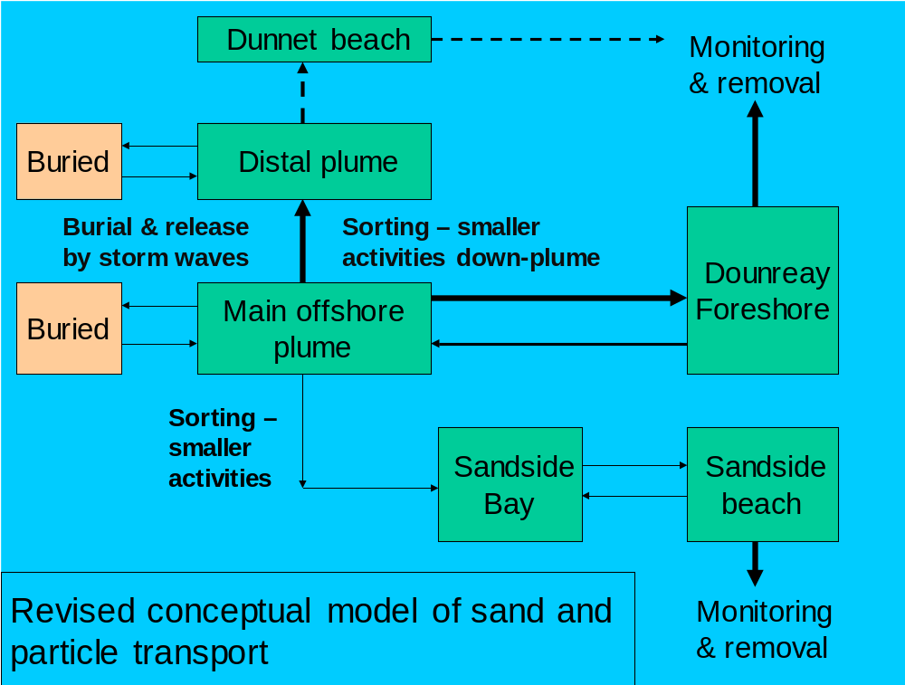
3.3.24 Additionally, waves drive particles from the core region of the plume onto the East and West Foreshores and onto Sandside beach. Under purely natural conditions particles might reside on the beach until taken off again by wave action. At Sandside there is also a possibility that some smaller particles might be picked up by wind and redeposited in the dunes on the landward side of this beach, although past monitoring of the dunes has not found any. However, all 3 areas are currently monitored regularly and all particles found are removed. Though some may remain undetected and are transported back into the sea, the removal comprises a sink that probably encompasses the majority of those that come on shore.
Burial and excavation of particles by natural processes
3.3.25 A modelling study of particle transport by the Hydraulics Research Establishment at Wallingford was commissioned by Dounreay to simulate the spread of particles. Named SandTrack, the numerical model was based on physical principles of sand transport. Though its predictions regarding the directions of particle transport agreed quite well with the observed dispersion of actual particles, the model’s calculations suggested that a majority of particles should have left the area within a few years. As the plume of Significant particles, and the Relevant and Minor populations that are fed from it have now persisted for at least 40 years, the timescale of sediment transport implied in the Wallingford model was clearly in error (HR Wallingford, 2000a, 2000b, 2002, 2005). What was missing was the fact that the majority of the particles are buried in the sand of the seabed for a large majority of the time. As Figure 3.8 shows, the vast majority of particles have been found below the surface of the sand, not on top of it, and the deepest particles recovered were from a reported depth of 1m.
3.3.26 If burial is taken into account, then the nett down-plume transport rate of an individual particle will be the average of its velocity during the relatively brief periods of time when it is at the surface and current strengths are fast enough to move it, and the much longer periods of time while it lies buried. Its nett transport rate will depend very strongly on the ratio between these periods. As tidal currents merely move the top few centimetres of sand across the bed, wave action is required to mix the sand from deeper layers with those nearer the surface, and to bring deeply buried particles up into the surface layers where currents can start to move them. The longevity of the plume as a whole will depend on the relationship between wave height and the depth of disturbance and mixing of the bed, as bigger waves produce deeper disturbance.
3.3.27 Disturbance of the bed by waves can take several forms. Wave-induced currents will mix the surface layers to a depth given roughly by the heights of the bedforms they produce, which are normally ripples less than 50mm high and rarely more than 200mm to 250mm. Deeper disturbance may come through wholesale excavation by scouring, with suspension of the excavated material in the water column. This process is very effective in mixing the previous bed material down to the level of scour, but when the waves wane and the suspended materials settle again, denser particles such as the DFR material may settle faster than the sand and so tend to be concentrated towards the base of the scoured layer. On the other hand, the MTR particles have densities fairly close to that of calcite and quartz, the main minerals in the sands, so they may be more evenly mixed. In both cases, scour and re-settling is an effective way by which buried particles may be brought into the surface layer where tidal currents and smaller waves can act upon them. A third process is fluidisation of the bed, in which the fluctuations in pore water pressure induced by the passage of large waves overhead reduces the grain-to-grain contact and allows grains to migrate both upwards and downwards. While the loss of the central stake from one of the Repopulation Areas indicates that wholesale scour definitely approached 600mm depth at least once during the period between 2000 and 2004, downward migration of particles during fluidisation of the bed provides an alternative mechanism by which particles could reach greater depths and subsequently be exchanged with the surface layers.
3.3.28 In all these processes, wave energy is the crucial factor, and this is related to the square of the wave height. The larger the waves, the greater the depth from which buried particles can be brought back towards the surface. Figure 3.10 shows a record of modelled wave height from 1958 to 2018 (produced by HR Wallingford at Dounreay’s request), together with estimated values for the threshold wave heights needed to disturb the bed to different depths. It is apparent that the bed is disturbed to 200mm depth every year and probably several times per year (the record is of the maximum wave height each year, so several periods of somewhat smaller waves that disturb to 200mm could occur during the same year). Disturbance to 500mm is likely to occur on average every 2 years (34 occurrences in 60 years), while disturbance to 700mm is likely on average every 6 to 7 years. The implications of this pattern can be best understood by a hypothetical example. Consider a particle that has become buried to exactly 500mm depth. For it to be mobilised by currents it must first be brought up into the upper layer of sediment that is in transport every few weeks, say within 50mm of the surface. If the storm waves that achieve this mix the sediment homogeneously, then the chance that it will settle within the actively transported layer is only 10%. However, the particle might settle at any depth within the top 500mm. The chance that a single event would place it within the top 200mm is 40%. Once in that more active layer, the particle might be disturbed upwards by events that occur several times a year so it might end up near the surface in a relatively short time and be transported some distance before becoming buried again, perhaps still within the top 200mm, so quite likely to be disturbed again within a year or 2. On the other hand, a new event that mixed the top 500mm of sediment is likely to occur within 2 years and this would have a 50% probability of moving the particle to a position below 250mm, where it might remain undisturbed again for several years. It is evident from this scenario that once a particle is buried to a depth well below 200mm it is unlikely to be liberated and transported for a period of years, and that the time it spends in the actively transported top 50mm of sand might be very short compared with the years spent buried. The ratio between ‘burial time’ and ‘transport time’ will be greater the more deeply the particle is buried initially. Wave events large enough to reach deeply buried particles will be rarer and therefore take much longer to move the particle into the top 200mm of sand from which it would have a fairly high chance of being moved on within a year into the top 50mm of actively transported sand. Even then, a majority of transport would be a back-and-forth movement by tidal currents, which would affect the smaller particles most but only produce a small nett transport. Larger (more radioactive) particles might remain immobile until wind-induced waves had produced bottom currents with enough velocity to move them, and these same events might bury them again rather than produce much horizontal transport.
Figure 3.10 The annual maximum series of Significant Wave Height. The horizontal lines indicate wave heights needed to disturb the bed to different depths, green=200mm, orange = 500mm, red = 700mm.
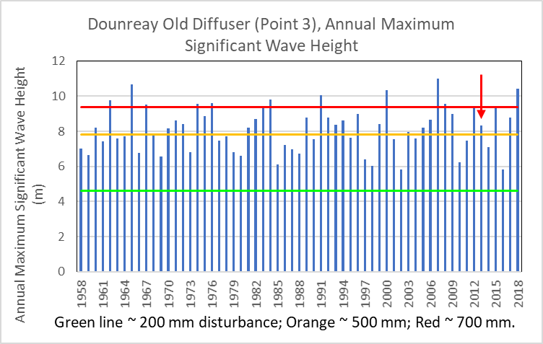
3.3.29 Overall, the effect of the burial and excavation processes is likely to be that individual particles spend only a tiny fraction of their time in active transport and that the average horizontal transport rate of all particles may be very slow as a result. The processes of burial and excavation may not discriminate very strongly between particles of different size (at least if their overall effect is to mix the sediment efficiently) but once in the surface layer the smaller particles will be transported faster than the larger ones. This accounts for the mapped pattern of activities in the plume (Figures 3.4 and 3.5) and also accounts for the longevity of the plume itself.
Biological contributions to burial and excavation processes
3.3.30 An additional and often overlooked process which may cause vertical movement of particles within the seabed sands is burrowing by animals such as worms, crustaceans, bivalves and echinoderms. Lugworms (Arenicola marina and A. defodiens) burrow to 400mm and 700mm to1000mm respectively (Cadman & Nelson-Smith, 1993). The habitat of A. defodiens extends below low tide level (Cadman, 1997) and it is widespread around the mainland Scottish coast (NBN Atlas, consulted 16-06-2024; Marine Biological Association: Marine Life Information Network, consulted 16-06-2024). In Scottish waters the thalassinidean shrimps Callianassa subterranea and Upogebia stellata have been shown to burrow to depths of 860mm and 920mm respectively (Nickell & Atkinson, 1995). Among the shellfish the sand gaper Mya arenaria is a widely distributed sub-littoral species that burrows to 500mm. A live sea urchin was found in its burrow within one core raised from the seabed for research purposes by Dounreay.
3.3.31 Notwithstanding these general considerations, DPAG’s assessment of a biological survey conducted for Dounreay (Scottish Association for Marine Science, 2005) was that the species list of burrowing fauna observed did not include many deep burrowers, and that “biological factors do not play a major role in the vertical distribution of particles within the offshore sediments” (DPAG, 2008, 4th Report p.115 to117). It should be noted, however, that at the time of survey the area was still in the very earliest stages of ecological recovery from its history of mobile gear fishing, a recovery process likely to take several decades (Reynolds et al., 2013; d’Avack et al., 2014; Marine Biological Association: Marine Life Information Network, 2025). The apparent absence of deep burrowers only 8 years after closure of the area to fishing may reflect this.
3.3.32 Until 1997 the seabed offshore from Dounreay may have been frequently disturbed by fishing activities. These may have included the use of bottom trawls and or scallop dredgers which could have disturbed the sand down to depths of tens of centimetres. The main plume of offshore particles occurs at water depths of 25 m or less relative to local chart datum, so most inshore fishing activity may have involved shooting nets rather than trawling or dredging. However, there is no firm information on this. In 1997 a ban was introduced on all fishing with a 2km radius of the Old Diffuser (itself 600m offshore) and since then the seabed has remained undisturbed by fishing activities such as trawling that could have inhibited the establishment of seabed vegetation such as seagrass. Despite this, there was no sign of such vegetation nor of extensive beds of shellfish in the video camera footage recorded in 2009 to 2012, nor in divers’ reports in the period before that. This is consistent with reports that initial recruitment of seagrass species to areas from which they were extirpated by disease in the 1930s took over 60 years on the east coast of North America (Reynolds et al., 2013) and is still incomplete around the British coast after many decades (d’Avack et al., 2014). The Marine Biological Association’s website “MarLIN: The Marine Life Information Network” gives a comprehensive bibliography under the topic “Zostera marina beds on lower shore or infralittoral clean or muddy sand” (consulted 10-04-2025). Nevertheless, if sea-bed vegetation were to become established it would have the effect of reducing wave energy at the bed and thereby slowing the transport of particles that were in the surface layer. Moreover, the binding effect of vegetation on the seabed sands would likely inhibit the excavation of buried particles by wave disturbance. These effects, if they were to occur, would prolong the future lifetime of the plume. For this reason, colonisation by new burrowing faunal species and seagrass beds should be kept under review and periodically resurveyed for, for as long as the potential for biological mobilisation of particles is an ongoing concern.

3.4 Implications
3.4.1 We are now in a position to address the 4 questions posed in the Introduction to this chapter. We shall take them in order.
- How many Significant radioactive particles remain in the marine environment at the present time?
3.4.2 This question was addressed in a paper presented to PRAG(D) on 26 February 2024 (PRAG(D), 2024d). Previous estimates were reviewed, and new estimates were made by different lines of argument that were independent of the previous estimates.
3.4.3 Firstly, DPAG’s 4th Report (2008) estimated the total number of Significant particles as 1350 ± 450, using a contouring technique based on diver and early ROV finds. After allowing for Significant particles removed by the ROV campaigns and from beaches, DPAG’s estimate is reduced to 728 ± 450.
3.4.4 Secondly, PRAG(D) made a partially independent estimate of numbers remaining following the ROV recovery campaign of 2010 to 2012, basing their estimate on the DPAG contours over the inshore areas that were not surveyed, plus the numbers of Significant ROV contacts made that were not recovered, plus a calculated number of ‘undetected particles’ based on the operational efficiency of the ROV as estimated from repeated surveys of certain areas (PRAG(D), 2016). PRAG(D) stated that their estimate of between 90 and 220 Significant particles remaining should be treated as a lower bound because it was impossible to estimate how many particles might have been buried more deeply than the ROV’s detection limit.
3.4.5 Two further estimates were made by a completely different methodology, quite independently of the first 2. The details are provided in the PRAG(D) paper of 26 February 2024 (PRAG(D), 2024d). Both estimates were based on a simplified box model of the plume (see Figure 3.9), and both used the history of Foreshore monitoring and recoveries as a means of calibrating a simple mathematical model and estimating the numbers of Significant particles in the offshore ‘feeder zone’ that provides the flux of particles recovered from the Foreshore since 2012. This zone is thought to extend to 200 or 250mm depth in the seabed, this being the depth to which the bed may be disturbed and mixed several times each year. The 2 estimates differ in the ways in which they each go on to estimate the numbers of particles buried more deeply than this, down to the limits of detection. One method extrapolates from the depth distributions of Significant particles as suggested by diver and ROV data. The other uses the assumption that deeper disturbance by waves supplies the upper 200 or 250mm of sediment with particles sufficiently often to keep it in a quasi-steady state and allow it to feed the Foreshore with particles at the observed average rate since 2012. These 2 methods lead to the same general conclusion, namely that the offshore population contains hundreds of Significant particles that lie above the ROV detection limits. The range of estimates for the first method is very broad, between 159 and 827, whereas that for the second method is narrower, 253 to 463. Two variants in the second method gave ranges of 203 to 372 and 166 to 661.
3.4.6 Figure 3.11 shows a histogram of all the estimated values for the residual Significant population in July 2021, using the 2 methods described in the last paragraph and having taken into account all the Foreshore recoveries up to that date. The large number of estimates derives from the multiple assumptions that must be made to encompass the uncertainties inherent in the calculations. The mean of all estimates is 395 Significant particles with a standard deviation among estimates of 216. It is notable from Figure 3.11 that the range of estimates made by PRAG(D) in their 2024 paper encompasses both earlier ranges produced by DPAG and PRAG(D) (see DPAG 4th Report; PRAG(D), 2016 and PRAG(D), 2024d). A reasonable conclusion is that in round numbers the residual population is most likely to be between 200 and 600, might perhaps be somewhat higher than this range, but is less likely to be lower because no perceptible decline in particle removal rates on the Foreshore has occurred so far.

Figure 3.11 Histogram of all estimates of total numbers of Significant particles offshore in the period since 2012. The DPAG, PRAG(D) estimates are shown as a mean plus range bars, in the same format as the mean and standard deviation of the 42 estimates.
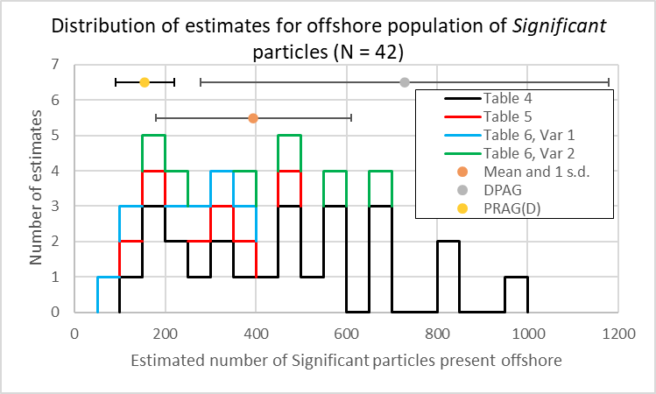
It cannot be emphasized enough that every 1 of the estimates of the remaining numbers should be taken as a minimum estimate, and that the actual numbers of Significant particles might be higher. This is because it is completely impossible to estimate how many might lie below the depths at which they could be detected by the ROV.
- What is the ultimate fate of the radioactive particles if they remain in the marine environment?
3.4.7 From the synopsis of our current conceptual understanding of the plume’s dynamics and behaviour, it is clear that the ultimate fate of radioactive particles is to be degraded by abrasion and/or corrosion and splitting into smaller and smaller sizes, until they are small enough to be kept in suspension as silt-sized grains (that is smaller than 0.065mm in the average diameter of their minimum cross section). Because silt can remain in suspension for long periods in turbulent waters, such particles can be transported and dispersed over wide areas. It is likely that the levels of radioactivity of such particles will be very low. As they will constitute only a tiny fraction of the natural sediments over a wide area, they will be undetectable by most practicable methods of surveying or monitoring the seabed.
3.4.8 Radioactive particles from Dounreay have been detected as far away as Dunnet and Murkle beaches, i.e. up to 25km from their original source. As these were Minor particles, they are likely to be of relatively fine sand size. The very small numbers found despite extensive and repeated surveys suggest that their concentration in the beach sands is probably very low. It is clear nevertheless, that radioactive particles can be transported tens of kilometres from Dounreay before they are fully degraded to silt size. The SandTrack hydraulic model developed for Dounreay by HR Wallingford (2000a, 2000b, 2002, 2005) predicted that sand-sized particles might be transported into the Pentland Firth. If so, they might accumulate in the banks of sediment that occur at each end of the narrows of the Firth itself, where grains transported by the fast tidal currents are deposited as the currents enter more open waters and slow down.
- What are the causes of the longevity of the particle population offshore?
3.4.9 The principal cause of the longevity of the offshore plume is the fact that most Significant particles are buried for a very large fraction of time. They are therefore immobile as far as horizontal transport in a down-plume direction is concerned. When they do reach the surface layers and become available for transport, they may be moved in one of several directions. There may be coast-parallel transport to the northeast, similar transport in the opposite direction, or transport from the offshore sand plain towards the coast and onto the Dounreay Foreshore.
3.4.10 A second factor seems to be the relatively large size of Significant particles, which means that currents fast enough to transport them do not occur as often as they do for the natural sand grains or for the generally smaller Relevant and Minor particles. The currents that are fast enough must be generated by waves, so the proportion of time in which Significant particles can be moved effectively depends on the proportion of time in which the necessary wave energies are equalled or exceeded. However, the same large wave events may bury particles at the same time as transporting them and once buried the particle may remain buried for several years if the waves were large enough to disturb the bed down to 250mm or more.
3.4.11 A third factor appears to be that particles undergo splitting with an average lifetime between splitting episodes of 6 to 7 years. When a Significant particle splits, the largest daughter particle is itself often a Significant particle. Sometimes the second largest or even third largest daughter particles might also be Significant, so splitting of high activity particles may tend to increase the overall numbers of Significant particles, even as their average activity decreases. Calculations based on a sample of around 100 particles recovered in fragments suggest that it may take 60 or 70 years to reduce the activity of a Significant particle to 1 tenth of its initial value, although radioactive decay of caesium-137 would shorten this to around 40 years. During this time, many of the smaller particles produced in successive splitting events would have low activities and fall into the Relevant and Minor categories. These would eventually be released to the surface sediments and could be transported much faster and further than their Significant parents, contributing to the distal parts of the plume, but also maintaining the population of the lesser radioactive particles within its core.
3.4.12 A final factor must be that the ROV recovery operations failed to find and recover a proportion of the Significant particle population. This is self-evident from the continuing arrival of particles on the Dounreay Foreshore. The number of Significant ROV contacts between 2009 and 2012 were only about 23% of those expected from DPAG’s estimate (PRAG(D) Report for 2012, published 2016). Such a large discrepancy is difficult to account for, and it is tempting to ‘explain it away’ by supposing that the DPAG estimates must have been too high, even though they were based on interpolation of actual finds of Significant particles. However, there is another possibility, which is that parts of the Significant particle population were buried too deeply at the time of the recovery operations for the ROV to have detected them efficiently.

- A 30-year “forwards look”
3.4.13 In this final section we consider the likely evolution of the situation under 4 management scenarios.
(i) Cease beach monitoring and do nothing
3.4.13 If beach monitoring were to cease altogether the numbers of Significant particles offshore, currently in the hundreds, would likely establish a new equilibrium with those on the Foreshore. The numbers stored on the Foreshore would build up until a balance was created between the flux arriving from offshore, currently about 4 Significant particles per year, and the return flux carried by swash from the beach into the offshore zone. A crude estimate of the numbers on the beach that would be required to balance the current onshore and offshore fluxes lies between 2 and 3 particles, so it is likely that a small number of Significant particles would be present on the Foreshore at all times into the future, although the number might lessen as the population in the offshore plume declined. If the Dounreay Foreshore were made accessible to the public at some point in the future, there would be a risk of encounter with one of these Significant particles.
3.4.14 Meanwhile the offshore plume would persist for an indefinite period into the future, probably exceeding 100 years, and continuing the present risk that a physically small but radioactively Significant particle might be transported to Sandside beach. Radioactive decay would roughly halve the caesium-137 activities of all particles in the plume over a 30-year period, but the effects of splitting might increase the numbers of Significant particles while at the same time reducing their average activity.
(ii) Continue present monitoring and particle removal from beaches but nothing more
3.4.15 Given that the likely number of Significant particles now present on the sea floor is at least in the range 200 to 600, and could be more, it will take between at least 50 and 150 years to clear all Significant particles from the plume at the present average removal rate from the Foreshore of 4 per year, other factors being equal. This may be an underestimate because the arrival rate on beaches would likely slow as the offshore population declines. On the other hand, there are other processes that lead to the loss of Significant particles from the core area of the plume. There is some down-plume transport (Figure 2.1), but the main process is particle splitting. This may eventually reduce the numbers of Significant particles and might lead to a shorter timescale, but it also has potential to increase the numbers of Significant particles while reducing their average radioactivity. This is an aspect that requires further investigation using the data on particles recovered in a fragmented state.
(iii) Continue monitoring and carry out limited offshore surveys
3.4.16 The current uncertainty regarding the size of the offshore population of Significant particles is a serious limitation for informed decision-making as to the best strategies for continued management of the contamination and of risks to the public. The only way to obtain new information on the numbers of particles offshore at the present time is to attempt direct offshore surveys. The original mapping of the plume in DPAG’s 3rd Report was the result of a cooperative effort with staff at Dounreay, who had designed and laid out the so-called Repopulation Areas on the seabed. These are illustrated in Figure 3.12. As described above in section 3.2 they were defined areas that were carefully searched by divers on repeated occasions. The purpose of the repetition of surveys at intervals of a year or more was to establish the mobility of the particle population, which would not be a necessary aim now. However, a survey of a dozen or so areas of comparable size to the Repopulation Areas (2500m², with some later enlarged to just under 8000 m²) would provide the data needed to contour the present-day population density and give an updated estimate of the number of Significant particles that are ‘visible’ to the detection system used. As Figure 3.8 shows, the ROV could detect Significant particles to greater depth than the equipment used by divers, so ROV deployment would probably be preferable to resuming diver operations. There would be no need to exactly replicate the divers’ Repopulation areas, as the ROV would only be needed to survey defined areas spaced along and across the plume, on one occasion each. However, although the results would enable an estimate to be made of the ‘visible’ portion of the population, this would inevitably be a lower bound for the total number, because some Significant particles might be buried too deeply for the ROV to detect. This extra number would remain unknown, although informed guesswork might be used to constrain its likely size.
3.4.17 Figure 3.12 shows the locations of the 2000 to 2004 Repopulation Areas relative to diver finds and includes areas searched by TROL in 2005 to 2007.

Figure 3.12. Location of Repopulation Areas, 2000 to 2004. (Also showing diver finds and TROL survey areas to 2007. After Figure 5.5 in DPAG 4th Report, 2008.)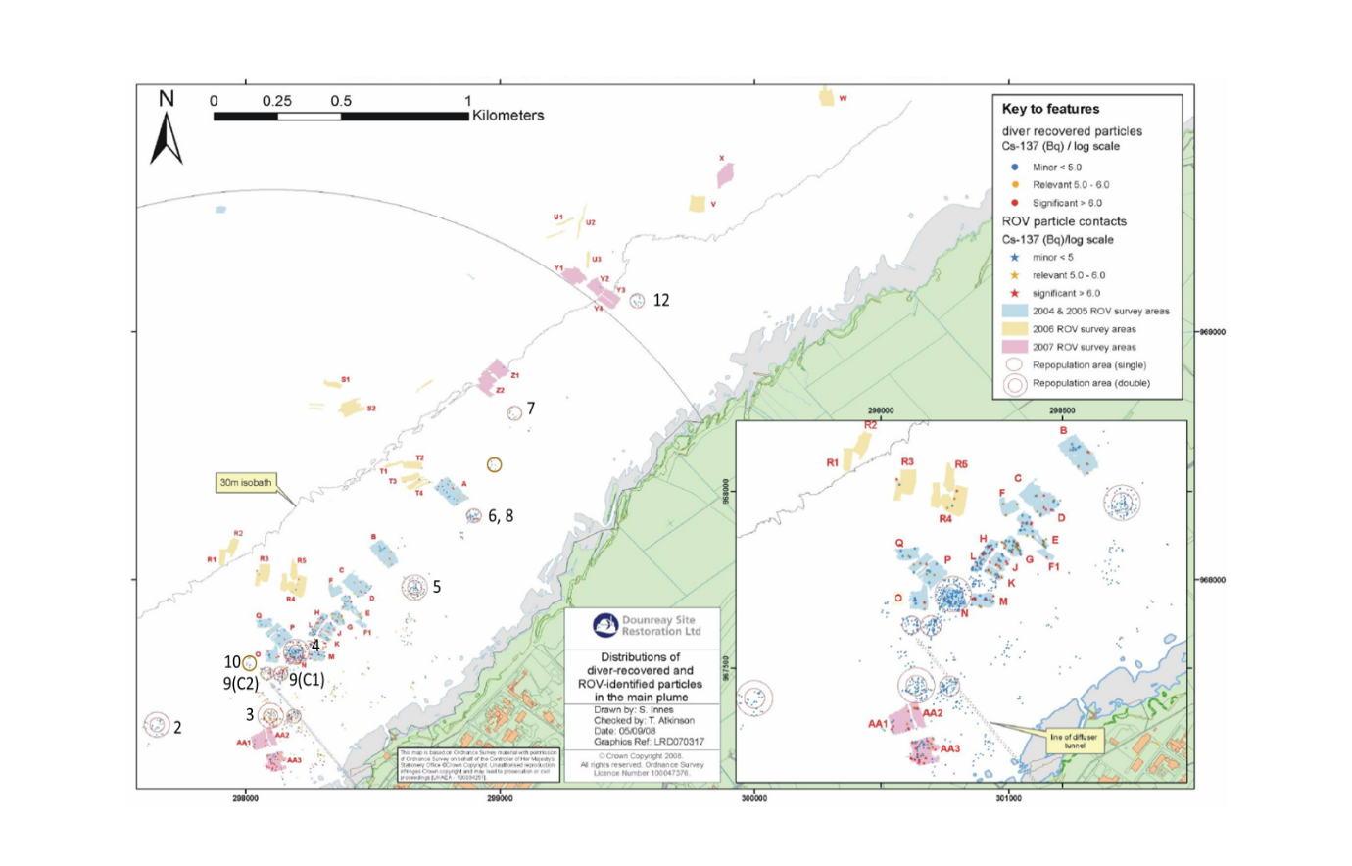(iv) Direct intervention by recovering Significant particles from the seabed
3.4.18 Given the probable longevity of the particle plume offshore, and the likelihood that Significant particles will continue to be present on Dounreay Foreshore while there are still Significant particles offshore, it is important to consider what interventions might reduce the longevity of the plume. Any reduction in the longevity of the problem would reduce risks to the public, especially if Dounreay Foreshore were to become more accessible to the general public during the site decommissioning. Moreover, a reduction in future longevity through appropriate interventions in the next few years might also reduce the duration for which continued monitoring would be necessary and might reduce the overall costs of protecting the public from the deleterious effects of radioactive particles being present in the environment. This begs the question, what interventions might be most appropriate? In this section we consider this question in the light of our current understanding of the behaviour of the particles in the marine environment, as already described in this chapter.
3.4.19 It is self-evident that a population of Significant particles remains offshore because some are still arriving on Dounreay Foreshore, with no sign so far of a permanent diminution of the rate of recovery of around 4 Significant particles per year. The most likely size of this population has been estimated as lying between 200 and 600 with circa 400 being the mean estimate (Figure 3.11). The only sure way to reduce the numbers of Significant particles offshore is to renew efforts to recover them from the seabed. The 2010 to 2012 ROV campaigns demonstrated the feasibility of this approach, but the findings then and since suggest that future efforts would have to be repeated at intervals of several years, rather than being a single all-out campaign.
3.4.20 The 2010 to 2012 ROV campaigns were very successful. One hundred and ninety-seven Significant particles were recovered, plus many more Relevant and Minor ones. Almost the whole area of the plume of Significant particles was covered and some parts of it were surveyed twice, with recovery operations on both occasions. These repeat surveys of the same areas by the ROV during 2010 to 2012 demonstrated that its operational detection efficiency was no lower than 78% to 85% and may have been close to 100%, that is it detected most or almost all of the particles that lay at shallower depths than the limits of its capability (Figures 3.7 and 3.8). When this is considered in combination with the quite rapid recovery of the arrival rate on Dounreay Foreshore after the ROV campaign was over, it implies that a reservoir of particles that the ROV could not detect must have become available for transport on shore. As any particles that were transported to the shore must have been close to the sand surface and within the ROV’s detection limit, it is likely that the sea floor had been disturbed to a sufficient depth to bring up Significant particles from below the detection limit, that is from deeper than 600mm to 700mm (Figure 3.8). In fact, as Figure 3.10 indicates, a wave height sufficient to disturb the bed to almost 700mm occurred during winter 2011 to 2012, with a second storm in January 2013 capable of disturbance down to about 550mm (the latter indicated by the red arrow on Figure 3.10). These storms may have disturbed enough deeply buried Significant particles to support the flux to the West Foreshore that was re-established in wave-year 31 (Figure 3.3), that is 2013 to 2014. Some of this flux, as well as that to the East Foreshore (Figure 3.2) may have come from areas not surveyed by the ROV, but the fact that the flux was sustained on both sectors in subsequent years suggests that the large waves that occurred in the winters of 2014 to 2015, 2016 to 2017 and 2017 to 2018 kept the sediment mixed down to depths greater than 600mm, and well over 700mm in winter 2017 to 2018 (Figure 3.10).
3.4.21 This has implications for any future recovery efforts using an ROV with the same detection capabilities as in 2010 to 2012. Once an area had been surveyed and almost all of the Significant particles that were ‘visible’ to the ROV had been removed, it would be fruitless to attempt further recoveries in the same area until a large storm has occurred, and the sediment has been stirred up enough to mix deeply buried particles up to the levels at which they would be ‘visible’. In practice this might mean waiting until a storm had occurred with waves large enough to disturb the bed to 700mm or more. According to Figure 3.11 such large waves have occurred at least 11 times in the 60 years of simulated wave record (1958 to 2018), with a further 3 occasions in which the annual maximum wave height approached the 700mm disturbance threshold. Thus, we might expect that in future such large storms might occur roughly every 3 to 4 years on average. This provides a rough estimate of the length of time for which one might have to wait before deploying the ROV over an area that had already been surveyed, if one were to capture Significant particles that had been deeply buried and ‘invisible’ to the ROV in the previous survey. Clearly it would be necessary to have a regularly updated long record of simulated wave height, so that once such waves had occurred, plans could be made to deploy the ROV on the relevant area. For comparability, the updated wave heights would have to be simulated by the same technique as the record in Figure 3.10.
3.4.22 A further question regarding the possible ROV operations in future concerns the effectiveness by which the Significant particles would be removed. This affects the number of repeat operations that would be need before clean-up of an area might be deemed complete. Given that the 2010 to 2012 ROV campaign recovered 197 Significant particles and given our estimate that the likely number still remaining may be estimated to be a minimum of 395 (Figure 3.11) the upper bound for the ROV’s effectiveness is that it recovered approximately 1 third of the population of seabed particles present at the time. As Figure 3.11 also shows, the 1 standard deviation range for the minimum population estimate is approximately 200 to 600, which implies a range for the upper bound of ROV recovery of between 50% and 25%.
3.4.23 It is thus clear from the ROV’s effectiveness that repeated surveys at intervals long enough to include suitably large waves will be necessary to remove most of the Significant particles offshore, unless some more efficient method of recovery can be found. It is important to remember that the population values just quoted are minimum estimates, as they do not include a possible reservoir of deeply buried particles. Nevertheless, if we ignore this and for the sake of argument accept the ROV effectiveness on a single survey as being somewhere in the range 25% to 50% with 33% as a best estimate, then the total number of surveys needed to recover a target percentage of the estimated minimum population can be found by rearrangement of the equation,
(100-T)/100 ={(100-EFF)/100}^{N}
where T is the target percentage, EFF is the ROV effectiveness as a percentage, and N is the number of surveys required. For example, if the target were to recover over 90% of the original population, and if EFF is taken as 33%, a total of 6 surveys of the target area would be required. If EFF were 25% then 8 surveys would reach the target, or if EFF were 50% then 4 surveys would exceed the target. These calculations are minimum estimates of the numbers of surveys needed, but if the surveys are spaced so that large storms occur between them, the repeated mixing of deeply buried ‘invisible’ particles into the upper 600mm of sediment should diminish the deeply buried population at a rate roughly comparable with the effectiveness of the ROV. The argument supporting this is as follows. We begin by supposing the ‘invisible’ population to be buried to between 600mm and 1000mm depth. If this 400mm thick layer is evenly mixed into the total depth of sand, then only 40% of the number originally below 600mm will remain below that depth. If the particles above 600mm are then removed by a ROV deployment, the remaining 40% will be depleted again by the next deep mixing event, giving a best-case number of mixing events (i.e. storm waves large enough to mix the sand down to 1000mm) of between 2 and 3 to reduce the deep population to 10% of its original value. Smaller waves would of course leave the deepest part of the ‘invisible’ population undisturbed, but the reduction in the part of the invisible population above their depth of disturbance would be quicker. In this manner, the effect of repeated surveys after intervals long enough to include deep disturbance of the sediments would be to reduce the ‘invisible’ population at roughly similar rate to the currently ‘visible’ one.
3.4.24 Although very crude, these calculations provide the basis for a scenario of potential particle recoveries, and a rough timescale for the efforts needed. If 5 surveys of the plume were needed, spaced at average intervals of 4 years (this being the average time between the largest storms in Figure 3.10) then around 20 years would be needed to affect a 90% recovery of Significant particles. As only about 1 third of the plume could be surveyed in a single season, this might necessitate a deployment in almost every year to achieve 5 repeat surveys of the whole plume. We have assumed that the present residual population is 400 as a minimum estimate. If it were 600 then 6 surveys over about 25 years might be required, or if it were as low as 200 then only 4 surveys and about 16 years.
3.4.25 It should be recognised at this point that the strategy for further surveys outlined in the previous few paragraphs is based on the assumption that the ROV would have the same detection system as the device used in 2010 to 2012. Improvements in detector technology might allow detection of particles at greater depths of burial than the limits shown in Figure 3.8, although the difficulty in assessing numbers of undetected particles would likely remain an issue. Completely different approaches to particle recovery, such as large-scale sand dredging, would have the same risks as construction activities on the seabed (see below). They have been ruled out in the past on grounds of the scale of the operation that would be required, the large-scale disturbance to the marine environment, and the possibility that buried Significant particles might be released in an uncontrolled manner into the marine environment.

“Potentially Disruptive Events”
    - ‘Potentially disruptive events’ are those which might disturb the seabed and cause a release of deeply buried particles, either as a one-off event such as a large storm or construction work on the seabed, or a change of regime such as lifting of the current FEPA Order on fishing within 2km radius of the Diffuser. Any event which disturbs the seabed within the footprint of the plume of Significant particles (Figure 3.4) has the potential to bring buried Significant particles to the surface of the seabed and release them for transport along the axis of the plume or towards the shore and to beaches that either are now publicly accessible or might become so in the future.
3.5.2 As described in the preceding sections of this chapter, estimates of the present offshore population of Significant particles refer only to those detectable above the depth of burial corresponding to the ROV’s threshold of detectability for a 10⁶Bq particle. This roughly corresponds to 600mm burial depth (Figures 3.7 and 3.8). Disturbance to depths below this, if within the Significant plume footprint, have the potential to release unknown numbers of particles – unknown because we have no reliable estimate of the size of any population buried so deeply, although the evidence of Figure 3.8 indicates that such a population may well exist.
Storms
3.5.3 Storms with waves large enough to disturb the bed down to 500mm have occurred at least 33 times in the past 60 years (Figure 3.10), and there have been 11 annual maxima of wave height large enough to disturb the bed to 700mm in at least some places. Disturbance beyond 600mm must occur with an intermediate frequency, that is between about 2 years and about 5 years. Thus, the sub-population of particles in the top 600mm of sediment will exchange some of its number with any more deeply buried sub-population every few years. As outlined above such moderately frequent exchanges will likely act to prolong the lifetime of the plume as a whole, but they could best be described as irregular events rather than as disruptive ones, because they have already played a role in the maintenance and spread of the particle plume during the past 40 years. Nevertheless, attention should be paid to the possibility that the frequency of storms, significant wave heights, and storm surges in sea-level has changed over time (Holt, 1999) and may show a long-term trend due to climate change (Hurrell & Deser, 2010; Weiss et al., 2014; Feser et al., 2015; Calafat et al., 2022).
Construction on the seabed
3.5.4 Human disturbance to the seabed for construction may take place for a number of reasons, the 2 most obvious being additional engineering works promoted by the Dounreay establishment itself, and the trenching and cable laying required to bring electricity generated by offshore wind, wave or tidal power on shore to the mainland. Into this latter category would also fall cables designed to connect wind-generated energy from Orkney or Shetland with the mainland.
3.5.5 Any form of trenching, mechanical excavation or hydraulic blasting of sand on the seabed within the area of the known particle plume would disturb radioactive particles and make them available to be mobilised and potentially to reach the shore and publicly accessible beaches. If the activity took place within the footprint of Significant particles it would potentially mobilise high-activity particles, providing increased risk of contact with divers or engineering personnel handling excavated materials, either on ship or on shore. There would also be an increased risk of such particles reaching Sandside Beach, or more likely the Dounreay Foreshore which may in the future become publicly accessible.
3.5.6 It is therefore clear that the mapped extent of the Dounreay particle plume should be carefully taken into account during the planning and assessment process for any form of seabed engineering or excavation, and that the risk of adverse contact with Significant particles should be evaluated as fully as possible for each potential project.
Fishing and Trawling within the area designated as banned by FEPA
3.5.7 Since 1997 there has been an embargo on all fishing within 2km of the Old Diffuser (itself located 600m offshore). During this time fish and other marine animals within the designated area appear to have increased and fishing boats sometimes shoot nets or locate pots just outside the zone because of this. Possibly the vegetation on the seabed (for example wracks and sea grass) may also have increased, although there is very little definitive evidence either way on this. Increased colonisation of the seabed might occur in future, however, and this would have the important effect of reducing bottom current speeds, binding sand and reducing disturbance of the bed by waves. More important, were the FEPA ban to be lifted, there are several fishing activities that have taken place along the north coast in the past that might be resumed. These include scallop dredging and bottom trawling. Either of these activities have a large potential for the release of radioactive particles because they both disturb the sand to a depth of 100mm or 200mm (trawling) or much deeper (scallop dredging). For this reason, if not also for protection of the public from exposure to radioactive particles that might accidentally enter the human food chain, PRAG(D) recommends that the FEPA Order be maintained for the foreseeable future.

3.6 Conclusions
- The 2010 to 2012 Particles Recovery Programme was successful in reducing the particle problem but unfortunately did not eliminate it. It confirmed the plume-like particle distribution that had already been deduced from the diver surveys, but it recovered only 197 Significant particles, less than a quarter of the number predicted at the time.
- The average number of particles recovered from Dounreay Foreshore in the years since 2012 is about 4 per year. This implies the continued existence since 2012 of a large enough offshore population of Significant particles to maintain the flux to the Foreshore.

- The 2010 to 2012 surveys also established that the ROV had a high operational efficiency in detecting Significant particles down to the design depth of circa 600mm, which implies that almost all particles with activities ≥10⁶Bq that were present above that depth would have been recovered. The implication of this is that the surface layers of the seabed sands must have been repopulated by upward movement of particles from below 600mm, and that the ‘unrecovered’ population is now distributed throughout the entire thickness of seabed sands. Since 2012 there have been at least 5 episodes of storm waves high enough to achieve this.
- The numbers of Significant particles currently present down to a depth of circa 600mm have been estimated by 3 independent methods, 1 with 2 supplementary variants. The estimates range widely but all agree that the present population is in the range of several hundred Significant particles and could be as high as 1000 (Figure 3.11). These numbers exclude any part of the overall population that is still buried below 600mm depth, so the total number present may be somewhat higher still. Nor do they include the estimate made by DPAG in their 4th Report, although the range overlaps with it.
- Looking into the future, the timescale for the numbers of Significant particles offshore to be reduced to zero by natural processes alone can only be very roughly estimated. It is likely to be over a century, although this would be reduced by radioactive decay.
- If monitoring of the Dounreay Foreshore were to cease, it is likely that between 2 and 3 Significant particles would be present on the Foreshore at all times, this being the approximate number required to balance on-shore and off-shore exchange with the plume if removal of particles by human agency had ceased. As the restoration of the Dounreay site proceeds it is likely that some part of the site will be released from regulatory control and may then allow improved access to the Foreshore. (Currently the Foreshore is effectively inaccessible to the public, paragraph 1.3.1.) There would then be a realistic risk of exposure of individual visitors to these Significant particles, hence there is a need for regulatory control of the Dounreay Foreshore.
- A timescale of 50 to 150 years to reduce Significant particle numbers towards zero can be very roughly estimated for a scenario in which monitoring of Dounreay Foreshore is maintained indefinitely, and the current average of 4 particles are removed each year. The effects of natural processes on this timescale is uncertain, because particle splitting might actually increase the numbers of Significant particles while reducing their average radioactivity. However, radioactive decay would act to shorten the timescale.
- An updated estimate of the numbers of Significant particles present offshore could be made to replace the currently uncertain estimates based on the arrival rate of particles on the Dounreay Foreshore. This could be achieved by deployment of a similar ROV to that used in 2010 to 2012, with single surveys of small areas spaced along and across the plume. An estimate of the offshore population would greatly improve some of the estimations made in this report regarding the longevity of the problem.
- Notwithstanding the need for better data on particle numbers, the only way to reduce the longevity of the problem is to make further attempts to recover Significant particles offshore. This would constitute an intervention at the current source of the radioactive contamination on beaches that are now or will in future become accessible to the public.
- A strategy for future recovery of Significant offshore particles, that takes into account our understanding of their behaviour and of the role of large waves in disturbing the seabed and both burying and excavating particles, is to redeploy a ROV with similar or improved detection capabilities to that used in 2010 to 2012. To ensure recovery of 90% of Significant particles might require between 4 and 6 repeated surveys, but these must be separated at intervals long enough for large storms to occur between them. A period of between 16 and 25 years might be needed to accomplish this, with ROV deployments on different parts of the plume in a majority of years.

4. Beach and Coastal Finds

4.1 Introduction
4.1.1 Since the discovery of the first particles in the offshore environment in 1997, SEPA have required the site operators for Dounreay to undertake systematic monitoring of the public beaches, providing public reassurance and protection. Whilst systematic monitoring has continued, the technologies deployed, the locations monitored, and the area covered have all changed with time. Offshore monitoring has been undertaken since 1997, although the approach has been less consistent than the beach monitoring approach. This has ranged from bounty driven diver surveys in 1997 with systematic monitoring starting in 2000 to Remotely Operated Vehicle (ROV) providing more systematic survey area coverage between 2010 and 2012. The 4 previous DPAG reports have documented the change in monitoring practice, improvements in approach, and recommended priorities for the subsequent phases of monitoring. Efforts have also been made to assess the efficacy of the monitoring technologies, taking account of changes in monitoring technology to estimate particle abundance, assess and interpret apparent changes in particle arrival rates, and establish the probability of encountering Significant particles (Tyler et al., 2010).
4.1.2 Despite these changes in approach, an extensive long-term data set has been collected, presenting an opportunity to explore evidence for change in both particle characteristics across all survey areas, and the observed rates of arrival on Sandside Beach and the Dounreay Foreshore. Here we focus on the proportion of the particle data collected in the most consistent manner, which for the beach environments began in 2002 with the introduction of the Groundhog Evolution system.
4.1.3 The questions addressed by this chapter are:
- Is there evidence of change to the physical characteristics of the particles (approximated by the amount of radioactivity in each particle) being recovered with time?
- Is there evidence of change in the numbers of particles observed and being recovered with time on either the Dounreay Foreshore or on Sandside Beach?
- Is there any evidence for a difference in the relative abundance of MTR and DFR particles from the offshore environment compared with Sandside Beach and the Dounreay Foreshores?
- Do any observed changes relate to any interventions such as particles recovered in the offshore environment?
- Are there any similarities in the statistical distribution of offshore particles and particles recovered on the Dounreay Foreshore?
- What are the implications for any observed changes for the future of the particle monitoring?
4.1.4 To address these questions, this chapter will summarise particle finds with time for the offshore environment, Dounreay Foreshore and Sandside Beach. The activity of the particle has become a necessary proxy for the physical size of the particle and so any change in particle activity and relative abundance of Minor, Relevant and Significant particles may reflect particle break up with time, as described in Section 3 of this report. To address this, particle activities have been corrected for radioactive decay to normalise activities to a single reference date, thereby removing the effect of radioactive decay from any interpretation. The monitoring effort (survey area coverage) is also taken into account to assess changes in observed particle arrivals on Sandside Beach.

4.2 Overview of Particles Recovered
4.2.1 Table 4.1 gives a summary of recovered particles classified by location, time period and activity level. The time periods have been broadly divided into the period before and after the offshore particle recovery that was undertaken between 2010 and 2012. The Table highlights the percentage abundance of Significant particles recovered.
4.2.2 For the offshore environment, the survey methodology deployed has changed from diver surveys, where areas were demarcated to establish particle repopulation, to systematic coverage from ROV surveys. The change in the percentage of Significant particles may reflect the changes in survey methods.
4.2.3 For the Dounreay Foreshore and Sandside Beach, the analysis focuses on the years that have the most consistent deployment of monitoring technology, the Groundhog Evolution generation of monitoring systems. Whilst the configuration for detector deployment varies between the Dounreay Foreshore and Sandside Beach, deployment has remained consistent within each site, with the exception of introducing digital technology in 2007. The relative abundance of Significant particles has remained more or less consistent for the Dounreay foreshore and absent for Sandside Beach.

Table 4.1 Summary of Recovered Particles
 | Minor | Relevant | Significant | Total | % Significant
- Offshore 2002-2006 | 288 | 135 | 131 | 554 | 23.6
- Offshore 2007-2009 | 62 | 52 | 61 | 175 | 34.9
- Offshore 2010-2012 | 701 | 243 | 141 | 1085 | 13.0
- Dounreay Foreshore East 2007-2009 | 0 | 1 | 8 | 9 | 88.9
- Dounreay Foreshore East 2013-2023 | 0 | 1 | 16 | 17 | 94.1
- Dounreay Foreshore West 2002-2009 | 5 | 24 | 13 | 42 | 31.0
- Dounreay Foreshore West 2013-2023 | 4 | 33 | 25 | 62 | 40.3
- Sandside Beach 2002-2009 | 114 | 19 | 0 | 133 | Nil
- Sandside Beach 2013-2023 | 79 | 4 | 0 | 83 | Nil

4.3 Removing the influence of Radioactive Decay from the trends in caesium-137 activity and particle classifications.
4.3.1 The following text explores the impact of radioactive decay on the interpretation of the underlying trends in particle activities. The data have been normalised to the reference date of the 1st January 1985, to assess whether any change can be attributed to the physical properties of the particles. This may manifest itself as the break-up or fragmentation of larger particles resulting in the relative increase in abundance of smaller particles. By removing the effect of radioactive decay, we investigate whether there is any difference in the abundance of Significant, Relevant or Minor particles. We consider each location in turn.
Summary of Offshore Finds
4.3.2 Figure 4.1 provides a summary of all particles detected. The full data set comprises some 2188 particles in total. Note that Table 4.1 includes only 1814 of these particles, because the selected time windows chosen for comparison purposes exclude all the finds dating prior to 2002.
4.3.3 The result of correcting particle activities for radioactive decay leads to only a very small fraction of particles changing class from Minor to Relevant (10⁵Bq) and from Relevant to Significant (10⁶Bq). Figure 4.1 shows a year-on-year decline in the maximum caesium-137 activity as part of the ROV surveys from 2009. This reflects a systematic shift in the survey area away from the centre of the plume, close to the Diffuser, in 2009 towards the margins of the plume in 2012.
4.3.4 Of the particles detected about 14% contained detectable concentrations of niobium-94, indicating the presence of DFR particles (DPAG, 2006). The mean detected particle niobium-94 activity was 234Bq, ranging from 16Bq to 5879Bq. However, the detection limits varied significantly since 2000, with a mean of 300Bq and ranging from 8Bq to 11000Bq. The 14% is therefore likely to be an underestimate of the relative abundance of DFR particles.

Figure 4.1 Summary of all Caesium-137 particles detected, including ROV. Activity reported at time of detection and decay corrected to 1/1/85
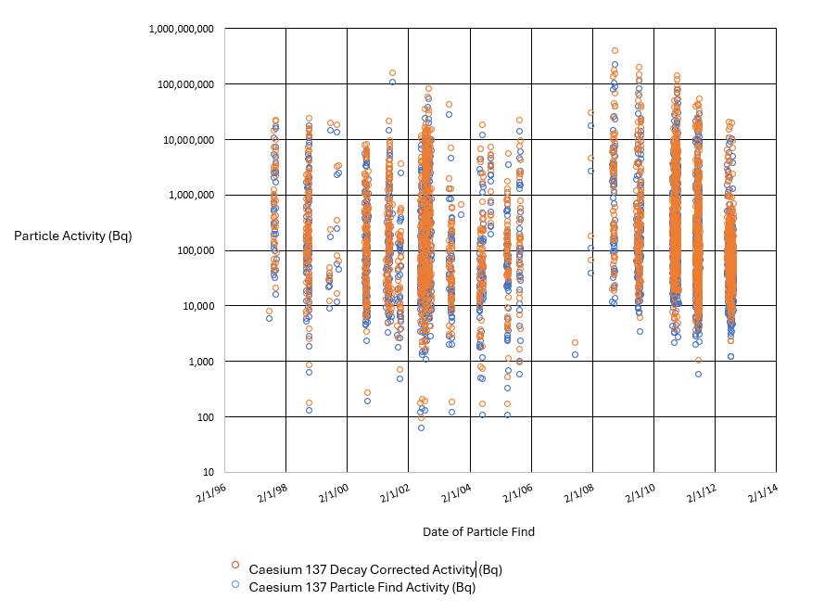

4.3.5 Statistical comparison of the three-time windows indicates that the proportion of particles classified as Significant is statistically significantly greater in 2007 to 2009 than in 2002 to 2006 (p<0.01, Fisher’s exact test), which is in turn a greater proportion than in 2010 to 2012 (p<0.001, Fisher’s exact test). These are follow-up tests to an overall Pearson Chi-squared test (p<0.001) for association, used to test if the proportion of particles classed as Significant varies over time periods.
4.3.6 In all cases of significant changes detected, the p-values are small enough to dispel any concerns that might arise around the issue of multiple hypothesis testing.
4.3.7 Due to concerns that the number of particles classed as Minor might be heavily dependent on detection limits, the analysis was repeated after excluding the Minor particles, and analysing the proportion of the remainder classed as Significant. This time the overall Pearson Chi-squared test for changes across the 3 time periods is still overwhelmingly significant (p<0.001), but the follow-up tests fail to detect any difference between the 2 earlier time periods 2002 to 2006 and 2007 to 2009 (p = 0.4, Fisher’s exact test). The later period 2010 to 2012 has a significantly lower proportion of particles which are Significant than each of the 2 earlier periods (p<0.01 in both cases, Fisher’s exact test).
Summary of Dounreay East Foreshore Finds
4.3.8 Figure 4.2 provides a summary of the particles recovered from the Dounreay East Foreshore. With the exception of the 2.0x10⁸Bq particle find in 1991, there appears to be no significant change in the observed trend of decay-corrected activities over the time series of particle finds. The uncorrected data, however, suggest a decline similar to that expected from caesium-137 radioactive decay. These trends are demonstrated by the second order polynomial trend lines.
Figure 4.2 Summary of all particles detected on Dounreay East Foreshore. Activity reported at time of detection and decay corrected to 1/1/85, and includes linear trend lines
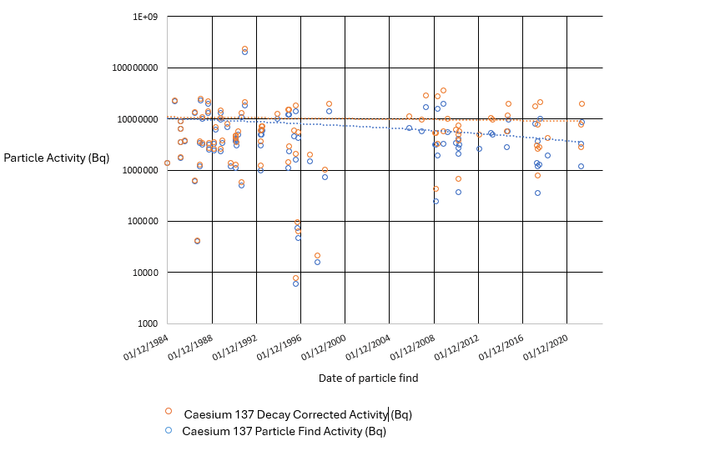

4.3.9 No account is taken for the changes in detection methodology including the detection systems and effort made in their deployment. Niobium-94 was not detected in any of the particles recovered, although the mean detection limit was 77Bq and ranged from 7.5Bq to 310Bq. Compared to the West Foreshore and Sandside Beach, this suggested that DFR particles were likely to be lower in abundance.
Cs-137 Particle Find Activity (Bq)
Cs-137 Decay Corrected (Bq)
4.3.10 Statistical comparison of the pre and post periods (relative to 2010 to 2012, that is the period of major offshore ROV particle recovery, namely 2007 to 2009 and 2013 to 2023 respectively) reveals no significant difference in the proportions of particles classed as Significant between the 2 periods. We should note that the sample sizes are very small in both cases, with almost all of the recovered particles being classed as Significant.
Summary of Dounreay West Foreshore Finds
4.3.11 Figure 4.3 provides a summary of the particles recovered from the Dounreay West Foreshore. When corrected for radioactive decay, particles of equivalent activity greater than 10⁷Bq are still present across the time series of data. No Minor particles have been recovered from the West Foreshore since 2015. The absence of Minor particles in the distribution, whilst Significant particles continue to arrive, may to some degree explain the upturn in the trend lines from 2012. This coincides with the period following the period of offshore particle recovery. A critical question, is whether this reflects the particle arrivals on the West Foreshore reaching a new equilibrium following offshore repopulation?
Figure 4.3 Summary of all particles detected on Dounreay West Foreshore. Activity reported at time of detection and decay corrected to 1/1/85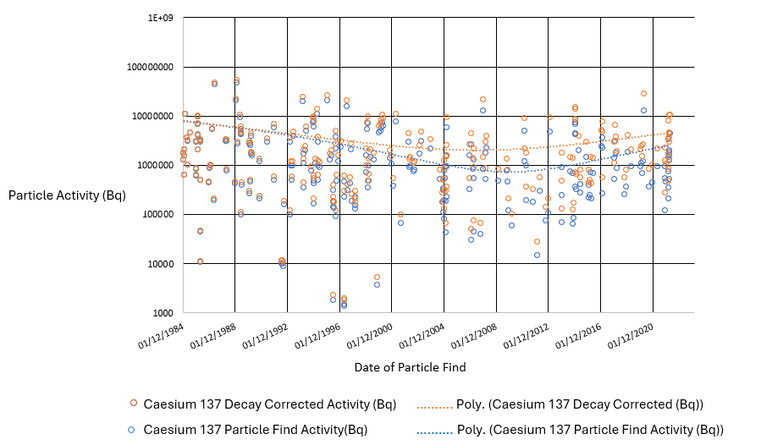
Date of particle find
.
4.3.12 No account is taken of the changes in detection methodology including the detection systems and effort made in their deployment. A limited number of niobium-94 bearing particles were detected on the West Foreshore, 1 in each of the years 2001, 2014, 2015, 2016 and 2022. The mean activity was 560Bq, minimum 120Bq and maximum 1400Bq. The mean detection limit was similar to the East Foreshore at around 85Bq and ranged from 2.6Bq to 1180Bq. Nevertheless, there is evidence of a limited number of DFR particles on the West Foreshore with a minimum abundance of 3% to 4%.
4.3.13 Statistical comparison of the pre and post periods relative to 2010 to 2012, (namely 2007 to 2009 and 2013 to 2023 respectively) reveals no significant difference in the proportions of particles classed as Significant between the 2 periods. This conclusion remains unchanged if we discard Minor particles. It is worth commenting that the sample sizes, whilst small, are considerably greater than for Dounreay East Foreshore, with a much smaller proportion of finds being classed as Significant on the West Foreshore.
Summary of Sandside Beach Finds
4.3.14 The complete Sandside data set is presented in Figure 4.4. The underlying time series trend for both the uncorrected and corrected particle activities show a decrease with time. Figure 4.4 also shows the start dates of important changes in monitoring capability, including:
- The introduction of the original Groundhog system in 1999, replacing handheld Geiger Counter technology,
- The Introduction of the Groundhog Evolution system in 2002
- The Introduction of the Groundhog Evolution 2 system in 2007
- A more intensive survey period in 2011, and 2012, with greater beach area coverage
The changes in detection capability are also shown in Figure 4.4.
Figure 4.4 Summary of all particles detected on Sandside Beach. Activity reported at time of detection and decay corrected to 1/1/85
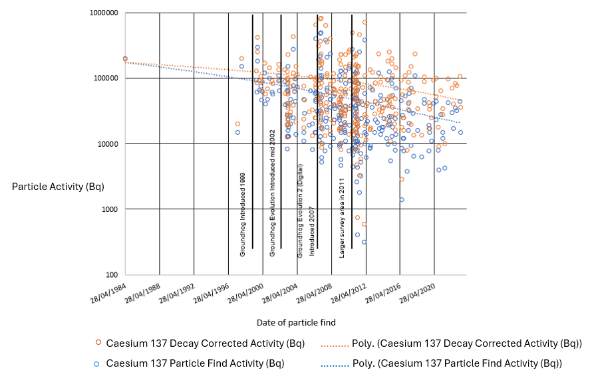
Groundhog Introduced 1999
Larger survey area in 2011
Date of particle find
.
4.3.15 To remove the effect of the single particle recovered in 1984 and to account for changes in particle detection capability, Figure 4.5 only includes particles detected and recovered using the Groundhog Evolution series of detectors from mid-2002 onwards. Again, the underlying trends demonstrate a decrease in particle activity with time.
Figure 4.5 Summary of all particles detected on Sandside Beach since the introduction of Groundhog Evolution mid-2002. Activity reported at time of detection and decay corrected to 1/1/85
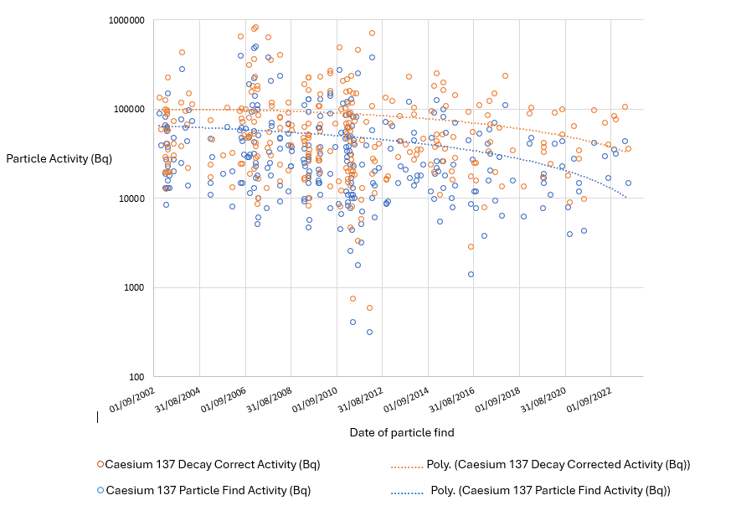

4.3.16 The most consistent data set is provided by the Groundhog Evolution 2 detectors, introducing digital technologies to the system in 2007. Figure 4.6 presents the time series of particles recovered from Groundhog Evolution alone.
4.3.17 Whilst the underlying trend in particle activities is still in decline, there is an apparent increase in particle activities recovered from around 2017. This is may in part be driven by the lack of small Minor particles under 10⁴Bq being detected in recent years. Since mid-2018, the number of Relevant particles has declined in abundance, even when taking account of radioactive decay.
4.3.18 The period of offshore particle recovery is also superimposed onto Figure 4.6 as a visual means of assessing change, both pre and post offshore (2010 to 2012) ROV particle recoveries.
4.3.19 There are no recorded detections of particles classed as Significant at Sandside Beach, but the proportion of particles classed as Relevant at Sandside does decrease (marginal statistical significance, p=0.04, Fisher’s exact test) going from the pre to the post offshore ROV particle recovery periods.
Figure 4.6 Summary of all particles detected on Sandside Beach with Groundhog Evolution 2 only since 2007. Activity reported at time of detection and decay corrected to 1/1/85
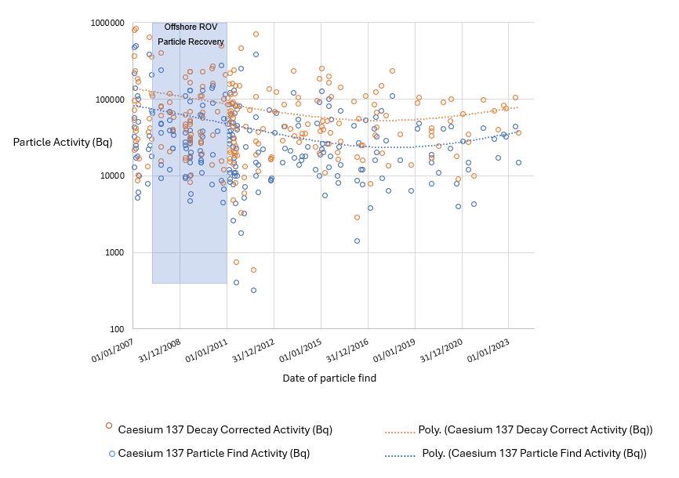

4.3.20 Table 4.2 provides a summary of the number of particles recovered from Sandside Beach, including the number categorised as Minor and Relevant. It also includes an estimate of the percentage DFR particles from the detectable niobium-94 reported from 2002. Most niobium-94 activities are quoted to be below detection limits. Prior to 2005, the detection limits ranged from 10Bq to 154Bq are therefore unlikely to be wholly reliable in estimating the relative abundance of DFR particles. From 2006, detection limits were kept at or below 10Bq. Detectable niobium-94 values ranged from 3Bq to 300Bq. The mean caesium-137 to niobium-94 ratio was 1592, ranging from 3 to 7327. The mean percent abundance of apparent DFR particles is around 17%, with no real evidence of change before or after the ROV offshore particle recovery period. This relative abundance is greater than observed in the Dounreay Foreshore and similar to that found in the offshore particles recovered.

Table 4.2 Summary of Sandside Particles Recovered, including abundance of Minor and Relevant Particles based on activity measured on date of particle recovery and the decay corrected equivalent. An estimate of the proportion of DFR particles is also provided, based on niobium-94.
Year | Total | % DFR from  Niobium-94 | Date of Particle Recovery Minor | Date of Particle Recovery Relevant | Date of Particle Recovery Percent Relevant | Decay Corrected Equivalent Minor | Decay Corrected Equivalent Relevant | Decay Corrected Equivalent Percent Relevant
1984 | 1 |  | 0 | 1 | 100.0 | 0 | 1 | 100.0
1997 | 2 |  | 1 | 1 | 50.0 | 1 | 1 | 50.0
1998 | 5 |  | 3 | 2 | 40.0 | 3 | 2 | 40.0
1999 | 5 |  | 4 | 1 | 20.0 | 3 | 2 | 40.0
2000 | 6 |  | 5 | 1 | 16.7 | 4 | 2 | 33.3
2001 | 3 |  | 2 | 1 | 33.3 | 2 | 1 | 33.3
2002 | 5 | 40 | 4 | 1 | 20.0 | 2 | 3 | 60.0
2003 | 24 | 4.2 | 22 | 2 | 8.3 | 20 | 4 | 16.7
2004 | 5 |  | 5 | 0 | 0.0 | 3 | 2 | 40.0
2005 | 6 | 33.3 | 6 | 0 | 0.0 | 4 | 2 | 33.3
2006 | 22 | 15.8 | 19 | 3 | 13.6 | 17 | 5 | 22.7
2007 | 27 | 14.8 | 19 | 8 | 29.6 | 17 | 10 | 37.0
2008 | 14 | 28.6 | 13 | 1 | 7.1 | 12 | 2 | 14.3
2009 | 27 | 27.3 | 24 | 3 | 11.1 | 19 | 8 | 29.6
2010 | 12 | 8.3 | 8 | 4 | 33.3 | 7 | 5 | 41.7
2011 | 45 | 22.2 | 42 | 3 | 6.7 | 35 | 10 | 22.2
2012 | 13 | 15.4 | 12 | 1 | 7.7 | 10 | 3 | 23.1
2013 | 8 |  | 7 | 1 | 12.5 | 6 | 2 | 25.0
2014 | 12 | 8.3 | 12 | 0 | 0.0 | 10 | 2 | 16.7
2015 | 16 | 18.75 | 14 | 2 | 12.5 | 11 | 5 | 31.3
2016 | 8 | 37.5 | 8 | 0 | 0.0 | 7 | 1 | 12.5
2017 | 10 | 20 | 10 | 0 | 0.0 | 8 | 2 | 20.0
2018 | 2 |  | 1 | 1 | 50.0 | 1 | 1 | 50.0
2019 | 6 |  | 6 | 0 | 0.0 | 5 | 1 | 16.7
2020 | 6 | 33.3 | 6 | 0 | 0.0 | 6 | 0 | 0.0
2021 | 5 | 40 | 5 | 0 | 0.0 | 5 | 0 | 0.0
2022 | 4 |  | 4 | 0 | 0.0 | 4 | 0 | 0.0
2023 | 2 |  | 1 | 1 | 50.0 | 1 | 1 | 50.0
4.3.21 To normalise for the effect of decay correction, the number of particles categorised for the decay corrected activities (1/1/1985) are also provided. It is perhaps interesting to note change in the relative abundance of equivalent Relevant particles, most noticeably in 2009, 2011 and perhaps 2015.
4.3.22 Figure 4.7 plots the change in the annual total of particles recovered from Sandside Beach since 2007. There is a clear decline in both the total numbers of particles recovered (shown as green) and the proportion of Relevant particles recovered (shown as orange). However, from the decay corrected data, the percentage of Relevant particles is decreasing more markedly (shown as blue), with many more particles being reclassified into the Relevant category. This trend is also reflected in the summary statistics presented in Table 4.3. The data summarise particles recovered from Sandside for the period for the 6 years prior to and 10 years following the offshore particle recovery. The data are aggregated for 3-year blocks in time. The results indicate a clear decline in the total numbers of particles being recovered from Sandside after 2012. The proportion of Relevant particles in those recovered is also decreasing systematically. Aggregating the small particle numbers over the final 6 years, indicates a proportion of 4.5% are relevant, which is consistent with the underlying decrease in numbers from 21.4% in 2007 to 2009. A similar trend is also reflected in the abundance of Relevant particles once radioactive decay is also accounted for, with the estimated relative abundance of decay corrected Relevant particles over the final 6 years of 9.5% compared with 41.7% in 2007 to 2009.
Figure 4.7 Total Number of particles recovered from Sandside Beach from 2007 and the underlying trends in the percentage abundance of Relevant particles, including correction for radioactive decay.
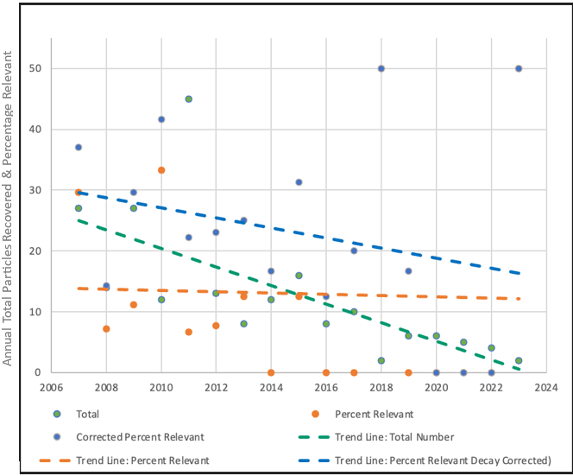

Table 4.3 Summary of Sandside Particles Recovered since 2007 classed within pre and post the period of offshore ROV particle recovery.
Years | Mean Annual Total | Mean Percent Relevant | Decay Corrected Mean Percent Relevant | Mean Annual Beach Area Surveyed Total  m² y⁻¹ | Mean Annual Beach Area Surveyed Footprint  m² y⁻¹
2007-2009 | 22.7 | 21.4 | 41.7 | 1,675,697 | -
2010-2012 | 23.3 | 12.9 | 34.6 | 5,168,368 | -
2013-2015 | 12.0 | 9.1 | 33.6 | 3,805,790 | 2,231,893
2016-2018 | 6.7 | 5.3 | 25.0 | 3,898,195 | 2,073,153
2019-2021 | 5.7 | 0.0 | 6.25 | 3,443,811 | 1,918,026
2022-2023 | 3.0 | 20.0 | 20.0 | 3,554,183 | 1,958,670
Overall comparison between finds for the 2010 to 2012 period
4.3.23 Comparing the offshore finds from the 2010 to 2012 period with the beach finds provides interesting comparisons. The proportion of particles classed as Significant is far lower in the offshore 2010 to 2012 period than for either Dounreay Foreshore East or Dounreay Foreshore West. This is highly statistically significant for both locations, for both the individual time periods pre and post 2010 to 2012, and also if we combine over the pre and post periods (Fisher’s exact test gives p<0.001 in all cases). If the particles classed as Minor are excluded, and we look at the proportion of the remainder that are classed as Significant, then the comparisons with Dounreay Foreshore East remain statistically significant, whether we look at pre or post 2010 to 2012 or combine (Fisher’s exact test gives p<0.001 in all cases). However, the comparisons with Dounreay Foreshore West cease to be statistically significant (Fisher’s exact test gives p>0.1 in all cases).
4.3.24 Figure 4.8 below shows comparisons of the distributions of particles for each of Offshore, Dounreay Foreshore East, Dounreay Foreshore West and Sandside.

Figure 4.8 Distributions of log (base 10) of corrected caesium-137 activities for particles retrieved at each location.
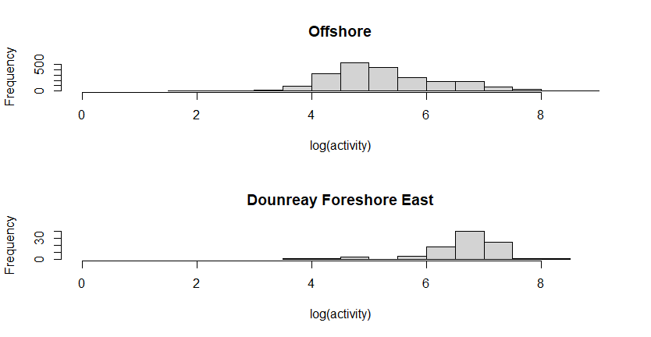
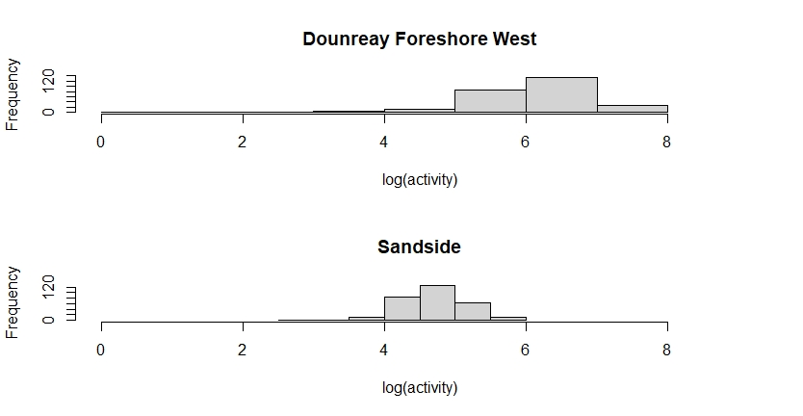
Influences on particle detection thresholds
4.3.25 Whilst assumptions around detection thresholds have been made, the approach taken to analysis is sensitive to changing detection thresholds, which may be influenced by several factors including detection capability of the technology deployed and the monitoring velocity.

4.4 Conclusions
4.4.1 With or without the removal of radioactive decay, there was no evidence that the physical characteristics of the particles has changed with time since 1984 for both the East and West Dounreay Foreshore. There is also no evidence for a significant change in the number of particles being recovered from either of the Dounreay Foreshore environments over the same time period. Sandside however does show a decrease in the particle activity (pre and post offshore particle recovery 2010 to 2012) and also in the number of particles being recovered. This declining trend remains when we account for both radioactive decay and for any variation in the annual monitoring effort, which has remained fairly consistent over the last decade.
4.4.2 The proportion of Significant particles recovered in the offshore environment is significantly less than the proportion recovered from either the West or East Dounreay Foreshores. This effect is clearly seen from the histograms in Figure 4.8, where the frequency bars to the right of the marker at value 6 correspond to the particles categorized as Significant. There are clear differences visible in terms of the shapes of the distributions at the different locations. Both Offshore and Sandside have a central mass in the Minor to Significant range (4 to 6 on the log scale) with Offshore having a tail of rarer Significant finds, while Sandside has none. The East and West Foreshores, by contrast, are both top heavy in the sense that the majority of finds (almost all in the case of the East Foreshore) are classed as Significant (>6 on the log scale).
4.4.3 The radioactive marker for DFR particles is niobium-94 and was measured in a number of particles in the offshore environment, Sandside Beach and the West Foreshore. The relative abundance of DFR particles does appear to vary from site to site, with the relative abundance appearing to Sandside (17%) ≥ Offshore (14%) > Dounreay Foreshore West (3%) > Dounreay Foreshore East (0%). However, the detection limits for niobium-94 varied significantly with time and it is therefore difficult to draw any substantive conclusions from these observations. We recommend that detection limits for niobium-94 are kept below 2Bq to establish whether there is a geographical difference between the proportion of MTR and DFR particles observed.
4.4.4 Whilst there is evidence for change in the rate and activity of particles arriving on Sandside Beach, we would urge caution in changing the monitoring regime. Table 4.2 shows significant year to year fluctuation in the particle numbers being recovered from Sandside and it is possible that a significant storm event resulting in deeper sediment disturbance in the seabed or any offshore engineering (Section 3.0) may result in the disruption of the offshore particle plume and result in the replenishment in the supply of offshore particles reaching the coastal environment, including Sandside Beach. The beach monitoring currently provides the only insight available to what might be happening in the offshore environment. It is recommended that the beach monitoring is continued to further build evidence for change and monitor the impact of any natural or engineered disturbances in the offshore environment.

5. Conclusions

5.1 Numbers of particles remaining
5.1.1 Several estimations have been made of the numbers of Significant particles in the offshore plume by both DPAG and PRAG(D). The current estimate of the numbers remaining is a minimum of between 200 and 600 (paragraph 3.4.6).
5.1.2 Section 3.5 however, notes that all the available subsea data are limited by the depth detection capabilities of the survey methods and equipment used. The numbers and activities of particles, which may have been buried at greater depths, is wholly unknown. Since the estimates of the number of particles discharged ranges from thousands to many hundreds of thousands and the time interval between likely discharge and earliest measurements is measured in decades, we should assume that sand disturbance by large (storm) waves or by fishing has buried particles to greater depths. This leads to the possibility of the existence of a long-term feeder population at depth which could resupply the upper sand layers.
5.1.3 The estimate of several hundred Significant particles remaining must therefore be taken as an absolute minimum.

5.2 Potential particle mobilisation
5.2.1 Removal of the FEPA Order would lead to a resumption of fishing in the area. When the initial exploration of the seabed around the ODC was undertaken, it was found that the risers had been snapped off, level with the sea floor, and it is possible that this was a result of scallop dredging or bottom trawling. Future such activity could lead to a significant disturbance of the sand within the plume, leading to exposure of particles from lower depths. It is recommended that the FEPA ban should remain in place at least until any effects of seabed engineering have been evaluated.
5.2.2 It is known that work has begun in connection with a plan to lay a sub-sea electricity cable between the mainland and Orkney (section 3.5), with 3 possible routes under consideration. As can be seen from Figure 2.1, it is certain that these will intersect particle flow pathways. This will undoubtedly lead to major disturbance of the seabed to a depth well below that which was capable of being surveyed by the ROVs. From the conceptual model developed from previous work, it is theorised that particles travelling from the plume to Sandside Beach might undergo several burial and splitting episodes and so works to the west of the Old Diffuser could lead to the potential mobilisation of further particles with activities higher than found at Sandside to date.
5.2.3 There may be further works associated with Dounreay’s plans such as decommissioning of the old and new Diffuser systems, which would affect particle mobility also.
5.2.4 Any planned activity that may result in mobilisation of any radioactive contamination will be subject to authorisation by SEPA under the Environmental Authorisations (Scotland) Regulations 2018 (EASR18).

5.3 Beach monitoring
5.3.1 While Section 2.0 demonstrates that the risks from particles found on Sandside Beach to date are small and Section 4.0 (Table 4.3) indicates a consistent decline in the numbers found following the 2012 ROV recovery programme, the on-going monitoring provides public reassurance, particularly in the light of the knowledge that particles of much higher activity exist offshore, and that subsea engineering works are proposed. It is also the only source of data to indicate change in the offshore environment. The recent finding of the first relevant particle on Sandside Beach for over a decade reinforces this point.
5.3.2 Following on from the analysis of the likely longevity of the offshore particle population in Section 3.4, it is clear that monitoring of beaches will be required for several decades to come.
5.3.3 Monitoring of the Foreshore must continue also. In the event of the cessation of monitoring, an equilibrium between the flux of particles arriving and the return swash would be created. Paragraph 3.4.13 estimates that this would lead to about 3 Significant particles being on the Foreshore at any time.

5.4 Source of Foreshore Particles
5.4.1 Past work has assumed that the Foreshore particles were driven directly onto the shore from the plume as described in Section 3.0 and this remains the most likely explanation.
5.4.2 Section 4.3.23 (Figure 4.8), however, shows that there is a significant difference in the particle activity distributions between the Foreshore and the plume. There is also a suggestion (Section 4.4.3) that, using niobium-94 activity as a marker, the proportion of Foreshore DFR particles is lower than for either the plume or Sandside Beach. In contrast to the Sandside Beach data, there is no evidence of a significant change in the numbers of particles found over time for the Foreshore finds (Section 4.4.1).
5.4.3 In light of these findings, further work is warranted to establish whether these particles could arise from a separate cache in areas where the ROVs were unable to be deployed.

5.5 Future risk associated with particles
5.5.1 As noted in Section 2.0, DPAG and PRAG(D) have concentrated on the risks to the public from accessible beaches. The data suggest that, for the particles recovered to date, the health risks are low. This is not true for the particles found on the Foreshore. The radiation doses quoted in Section 2.3 indicate that, for most of the particles found to date on the Foreshore, the values exceed the 20mSv intervention limit specified by ICRP. Even an insoluble MTR particle of current activity 10⁸Bq would give rise to a dose to a 1yo child in excess of this limit in 100 years’ time. This means that regulation will be required for the foreseeable future.
5.5.2 No routine studies of particle solubility have been undertaken since those reported by Hall et al (2007). While the numbers with higher-than-expected solubility was low, the existence of further such particles, possibly of much higher activities than MTR113, cannot be excluded.

5.6 Active seabed particle recovery
5.6.1 The alternative to continuing the present monitoring and removal system for a prolonged period would be to renew efforts to recover particles from the seabed. A possible scenario is detailed in Paragraphs 3.4.18 to 3.4.23 assuming a ROV similar to that of the 2010 to 2012 campaign but, given the improvement in technology, an improved performance may be achievable. It envisages a 16-year to 25-year programme during which each area of the plume would be surveyed every 4 years (the average time between large storms).
5.6.2 In recent years, there have been advances in hydraulic (suction) dredging to enable its use in removing fine sediments with minimal disturbance and resuspension and this may be worth further investigation. The aim would be to remove as much of the plume as possible, down to bedrock.

References

Reports
DPAG (Dounreay Particles Advisory Group), 2005. Third Report. 290pp.

DPAG (Dounreay Particles Advisory Group), 2008. Fourth Report. 162pp + 27pp Appendices.

HR Wallingford, 2018. Dounreay Long Term Wave Climate. Report DEM8298-RT001-00, 2018. 24pp + 14pp Appendices & Tables.

HR Wallingford, 2000b. Mathematical Model of Dounreay Coastal Sediment Movement. Phase 2 – 3D Model. Report by HR Wallingford to United Kingdom Atomic Energy Authority, EX4273, October 2000, 11pp + 47 pp Figures.

HR Wallingford, 2002. Mathematical Model of Dounreay Coastal Sediment Movement. Phase 3 – Sand and particle models. Report by HR Wallingford to United Kingdom Atomic Energy Authority, EX4457, July 2002, 42pp + 120 pp Tables, Figures and Appendices.

HR Wallingford, 2005. Mathematical Model of Dounreay Coastal Sediment Movement. Phase 4 – Particle model refinement. Report by HR Wallingford to United Kingdom Atomic Energy Authority, EX5236, November 2005, 40pp + 64 pp Tables, Figures and Appendices.

PRAG(D) (Particles Recovery Advisory Group (Dounreay)), 2016. 2012 Report. 76pp.
HR Wallingford, 2000a. Mathematical Model of Dounreay Coastal Sediment Movement. Phase 1 – Data Review and 2D Regional Model. Report by HR Wallingford to United Kingdom Atomic Energy Authority, EX4129, March 2000, 13pp + 85 pp Tables, Figures and Appendices.

PRAG(D) working papers
PRAG(D) (Particles Recovery Advisory Group (Dounreay)), 2024a. The Wave Climate at Dounreay – Summary. 2pp. (Meeting dates, 21 January 2020 & 16 February 2024).

PRAG(D) (Particles Recovery Advisory Group (Dounreay)), 2024b. The Wave Climate at Dounreay: Comments on the 2018 Report from HR Wallingford. 16pp. (Meeting dates, 21 January 2020 & 16 February 2024).

PRAG(D) (Particles Recovery Advisory Group (Dounreay)), 2024c. The Wave Climate at Dounreay – Figures. 8pp. (Meeting dates, 21 January 2020 & 16 February 2024).

PRAG(D) (Particles Recovery Advisory Group (Dounreay)), 2024d. A Canary In the Coal Mine? Monitoring and Removal Records for the Dounreay Foreshore and Estimates of the Number of Significant Particles Offshore. 20pp. (Meeting date, 16 February 2024).

Published scientific papers
Cadman, P.S., 1997. Distribution of two species of lugworm (Arenicola) (Annelida: Polychaeta) in South Wales. Journal of the Marine Biological Association U.K., 773, 389-398.

Cadman, P.S. and Nelson-Smith, A., 1993. A new species of lugworm: Arenicola defodiens sp.nov. Journal of the Marine Biological Association U.K., 73, 213-223.

Calafat F.M., Wahl, T., Tadesse, M.G., Sparrow, S.N., 2022. Trends in Europe storm surge extremes match the rate of sea-level rise. Nature, 603, 841-845.

d’Avack, E.A.S., Tillin, H., Jackson, E.L. and Tyler-Waters, H., 2014. Assessing the sensitivity of seagrass bed biotopes to pressures associated with marine activities. Joint Nature Conservation Committee Report No.505, Peterborough, Sect. 4.2.2.
Feser F., Barcikowska, M., Krueger, O., Schenk, F., Weisse, F. and Xia, L., 2015. Storminess of over the North Atlantic and northwestern Europe – A Review. Quarterly Journal of the Royal Meteorological Society, 141, 350-382.

Harrison JD, Fell TP, Phipps AW, Smith T, Ellender M, Ham GJ, Hodgson A, Wilkins BT,
Charles MW, Darley PJ and Aydarous ASh, 2005. Health implications of Dounreay fuel particles; estimates of doses and risks. Report RPD-RE-11, Health Protection Agency, Oxford.

Holt, T., 1999. A classification of ambient conditions during extreme surge events off Western Europe. International Journal of Climatology, 19, (2), 725-744.

Hurrell, J. and Deser, C., 2010. North Atlantic climate variability: The role of the North Atlantic Oscillation. Journal of Marine Systems, 79, (3-4), 231-244.
ICRP, 1991. 1990 Recommendations of the International Commission on Radiological Protection. ICRP Publication 60, Ann.ICRP 21(1-3).

ICRP, 2021. Use of dose quantities in radiological protection. ICRP Publication 147, Ann.ICRP 50(1).

ICRP, 2007. The 2007 Recommendations of the International Commission on Radiological Protection. ICRP Publication 103, Ann.ICRP 37(2-4)

Kershaw, P. and Baxter, A., 1995. The transfer of reprocessing wastes from north-west Europe to the Arctic. Deep Sea Research II, 42 (6), 1413-1448.

Nickell, L.A. and Atkinson, R.J.A., 1995. Functional morphology of burrows and trophic modes of three thalassinidean shrimp species, and a new approach to the classification of thalassinidean burrow morphology. Marine Ecology Progress Series, 128, (1), 181-197.

Reynolds, L.K., Waycott, M. and McGlathery, K.J., 2013. Restoration recovers population structure and landscape genetic connectivity in a dispersal-limited ecosystem. Journal of Ecology, 101, 1288-1297.

Tyler A, Scott EM, Dale P, Elliott AT, Wilkins BT, Boddy K, Toole J & Cartwright P (2010); Reconstructing the abundance of Dounreay hot particles on an adjacent public beach in Northern Scotland. Science of the Total Environment, 408 (20), pp. 4495-4503.
Weiss, J., Bernardara, P. and Benoit, M., 2014. Formation of homogenous regions for regional frequency analysis of extreme Significant Wave Heights. Journal of Geophysical Research, Oceans, 119, 2906-2922.

Wilkins BT, Harrison JD, Smith KR, Phipps AW, Bedwell P, Etherington G, Youngman M, Fell TP, Charles MW, Darley PJ and Aydarous A.Sh, 2003.

Websites
Marine Biological Association: Marine Life Information Network (consulted 16.06.2024)
Blow lug (Arenicola marina) - MarLIN - The Marine Life Information Network

Marine Biological Association: Marine Life Information Network. 2025. Zostera marina beds on lower shore or infralittoral clean or muddy sand (consulted 10-04-2025)

NBN Atlas (consulted 16.06.2024) Arenicola defodiens : Black Lugworm | NBN Atlas

Sand gaper (Mya arenaria) - MarLIN - The Marine Life Information Network

Acronyms, Abbreviations and Units
SEPA | Scottish Environment Protection Agency
PRAG(D) | Particle Recovery Advisory Group (Dounreay)
DPAG | Dounreay Particle Advisory Group
UKAEA | United Kingdom Atomic Energy Authority
MTR | Materials testing reactor
DFR | Dounreay fast reactor
PFR | Prototype fast reactor
ICRP | International Commission on Radiological Protection (Publication)
Bq | Becquerel (unit of measurement)
Gy | Grey (unit of measurement)
mSv | Millisievert (unit of measurement)
Sv | Sievert (unit of measurement)
HMIPI | Her Majesty’s Industrial Pollution Inspectorate (regulator at time of the first find)
COMARE | UK Committee on Medical Aspects of the Environment
FEPA | Food Protection (Emergency Prohibitions) (Dounreay Nuclear Establishment) Order 1997
DSRL | Dounreay Site Restoration Limited
ODC | Old Diffuser Chamber
LAD | Low active drain
ROV | Remotely operated vehicle
µm | Micrometers (a length of measurement equal to 1 millionth of a meter)
ED50 | Effective dose
LD50 | Lethal dose
1yo | One year old
TROL | A remotely operated vehicle carrying particle detectors, termed the TROL
Minor | Classification of particles with activity of 10⁵Bq and 10⁶Bq
Relevant | Classification of particles with activity of 10⁶Bq and 10⁷Bq
Significant | Classification of particles with activity of 10⁷Bq and above
Absorbed dose | Absorbed dose is the amount of energy deposited by radiation in a mass
Equivalent dose | Equivalent dose is calculated for individual organ
Effective dose | Effective dose is calculated for the whole body

Some images and figures contained in this report may not be accessible as they have been taken from older reports produced by the expert group.

If you would like this document in an accessible format, such as large print, audio recording or braille, please contact SEPA by emailing equalities@sepa.org.uk

