WAT-G-029

EASR Guidance:
Version 1.0, August 2025
Engineering:
Sustainable bank works

Version 1.0, August 2025

Contents
1 Purpose 2
2 Introduction 2
3 Why should I use the techniques? 3
4 Are there any restrictions on where I can use the techniques? 4
5 What do I need to know before I use this guidance? 4
6 How do I select the appropriate techniques? 6
7 What else do I need to think about when deciding on the technique to use? 10
8 Technical guide to the different techniques 11
8.1 How to use live willow stakes and spiling 11
8.2 How to use brash and small trees 15
8.3 How to use large wood 20
8.4 How to use large trees 21
8.5 How to use root wads 27
9 Key points and recommendations 35
9.1 Willow Spiling 36
9.2 Brash and small trees 37
9.3 Whole trees 38
9.4 Root Wads 39
Glossary 40
Disclaimer 40

If you would like this document in an accessible format, such as large print, audio recording or braille, please contact SEPA by emailing equalities@sepa.org.uk

1 Purpose
This document provides information and guidance on sustainable bank works which are subject to authorisation by SEPA under the Environmental Authorisations (Scotland) Regulations 2018, (EASR).

2 Introduction
This guidance describes practical ways you can protect eroding banks without increasing erosion risks to other banks while improving bankside habitat.
Bank erosion can be costly. It can result in loss of productive land and damage to fencing, tracks and other infrastructure.
Some bank protection techniques, as detailed in this guide, can be carried out without a written authorisation providing you are able to follow a set of specific rules relevant to the activity you are carrying out, these are known as General Binding rules (GBRs).
To use these techniques, you must comply with the rules in the following Water GBRs:
- GBR 25 for the placement of the trees or parts of trees.
- GBR 9 if you are going to operate a vehicle or other machinery in the surface water to carry out the work.
- GBR 7 if you are installing and removing any temporary crossings, temporary structures or temporary works to carry out the work.
If you cannot comply with these rules, an application for a registration or permit will be required.

3 Why should I use the techniques?
The most sustainable way to protect banks is by using living or dead tree stems, roots, or branches to cushion the bank from the force of the water. This guidance provides a step-by-step guide on how you can do this. However, it’s worth noting that simply fencing the banks to keep livestock away from the edge can by itself help prevent erosion problems and restore the bank by encouraging natural regeneration.
One of the main benefits of these techniques is that, unlike others, they don’t increase the risk of erosion to banks downstream. If you use live trees to cushion some of the force of flows, you will gain the added benefit that, as the roots of these trees grow, they will increase the strength of the bank.
Even if you do not use live trees, we recommend that you re-establish trees along the top of the bank behind the bank protection. This is because the trees’ root systems will make the banks more resistant to erosion and, as the dead wood decays, give long-term, sustainable protection against bank erosion.
Figure 1 Photographs of eroding banks lacking trees: River banks become vulnerable to erosion when they are not lined with trees or surrounded by wetlands, and when there is no wood in the river channel to cushion them from the force of the river.

4 Are there any restrictions on where I can use the techniques?
You can use the techniques to protect:
- Any eroding bank.
- The existing line of that bank.
GBR 25 will not allow you to:
- Reclaim land by placing protection on a previous line of the bank.
- Use trees or parts of trees to create a smooth, wood wall against the bank. Such a wall would not dissipate the force of the river. Instead, it would transfer the energy downstream, potentially putting other banks under stress.

5 What do I need to know before I use this guidance?
To make sure the protection you put in place works properly, we also recommend that you seek professional advice on its design. Other farmers and land managers who have used the techniques, your local river or fishery trust or the River Restoration Centre may be able to provide advice and/or point you to someone that has suitable experience.
See the Glossary for a description of the terms used in this document.

Parts of watercourse and loch
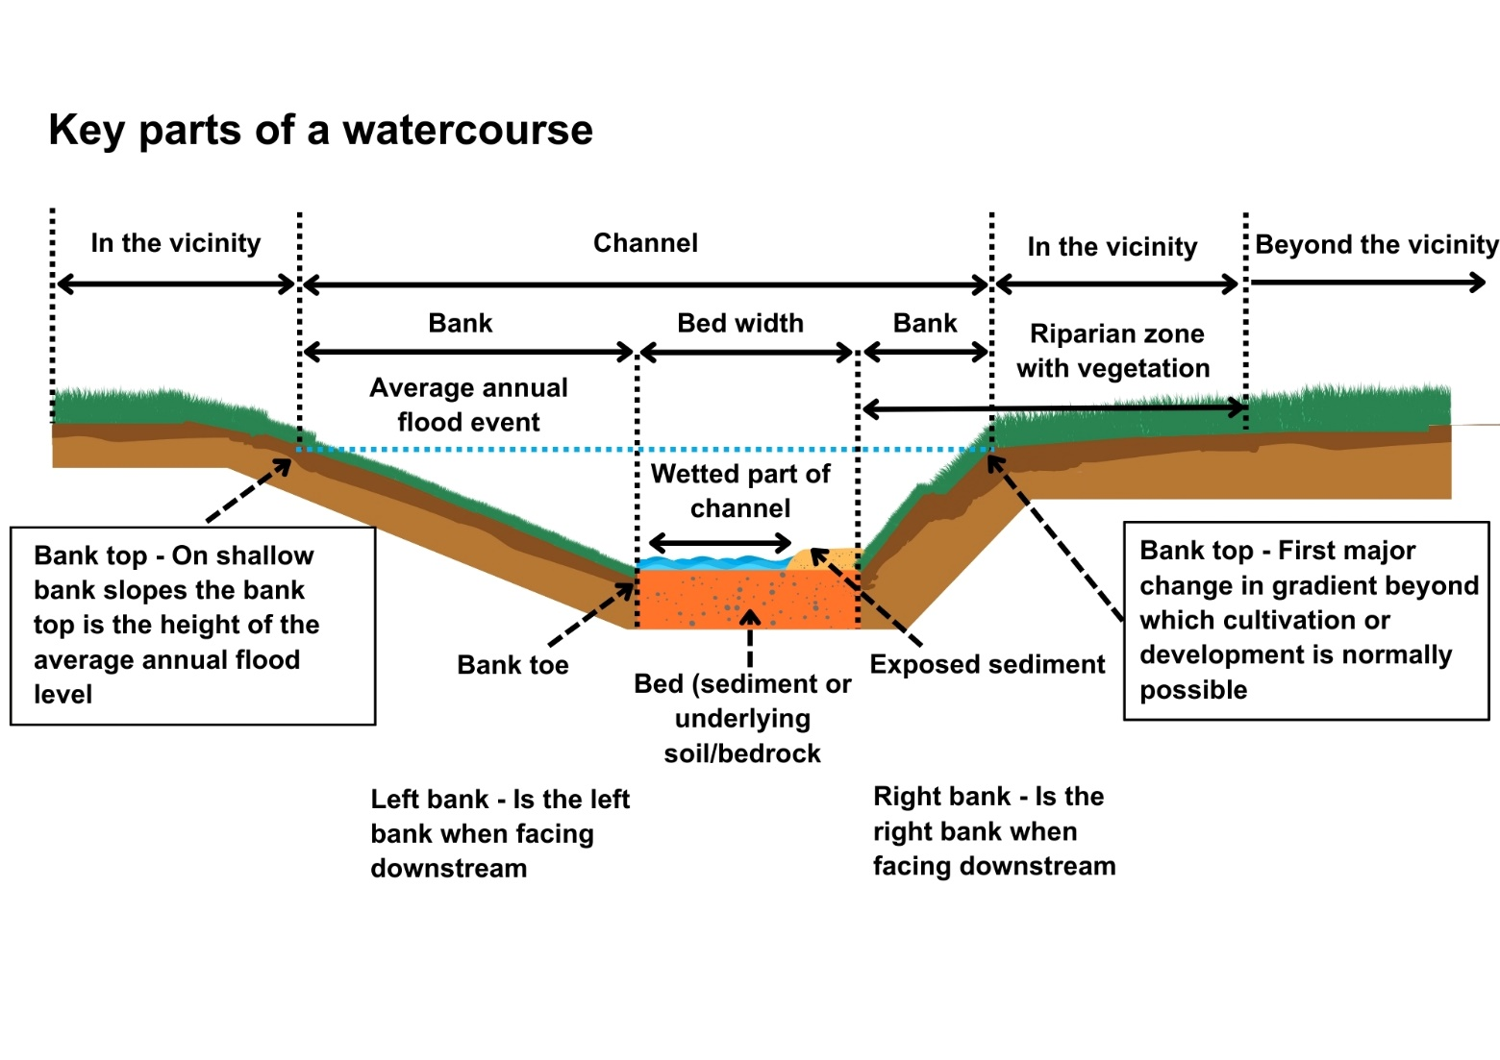
Figure 2 Parts of a watercourse

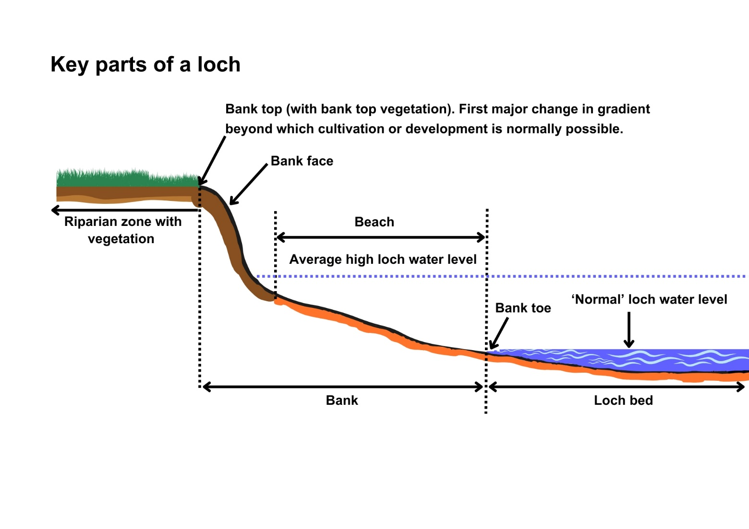
Figure 3 Parts of a loch

6 How do I select the appropriate techniques?
There are a number of different ways of using trees or parts of trees to protect eroding banks. You can find a step-by-step, technical guide on how to use each of the techniques in Section 8.
The technique or combination of techniques that will work best depends largely on the energy of the environment. Consequently, the first thing you need to do is to consider the energy levels.
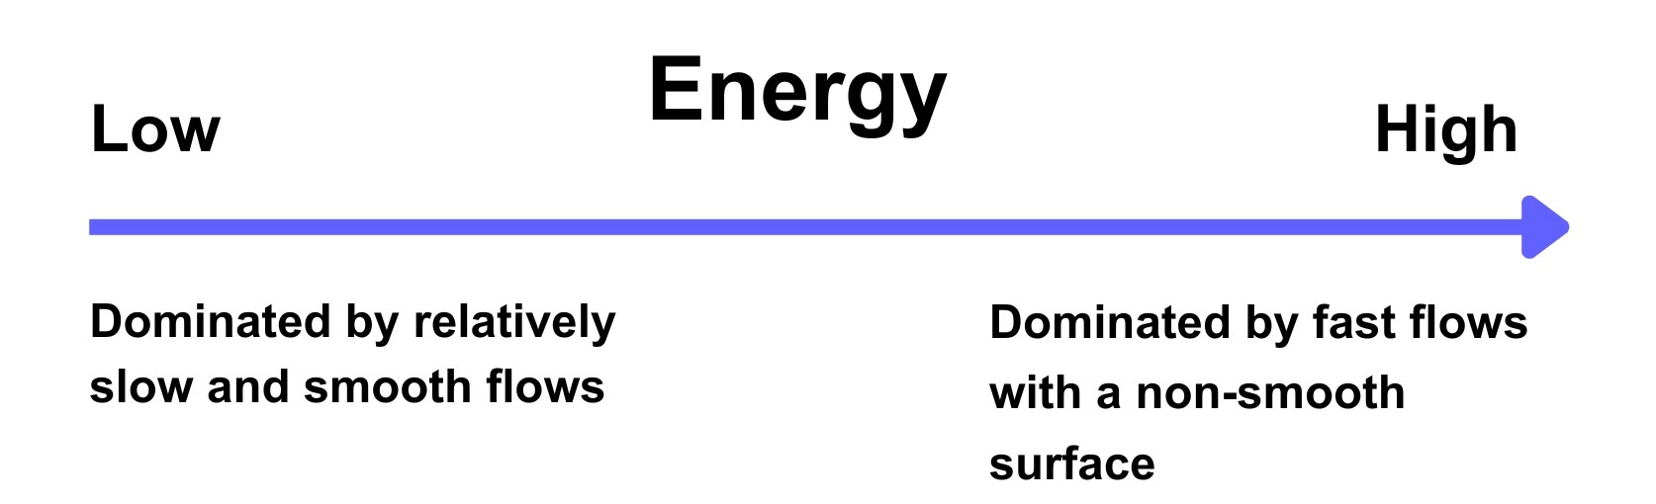 Figure 4 Description of low and high energy flows
Your environment will be somewhere on a spectrum from very low energy to high energy. Photographic examples are shown in figures 5 and 6. You can use Figure 7 below to help you identify the type of techniques likely to perform best depending on where your environment is on this spectrum. In general, the higher the energy, the larger the diameter of stems, roots and branches that you will need to use to cushion the bank from the force of the water.

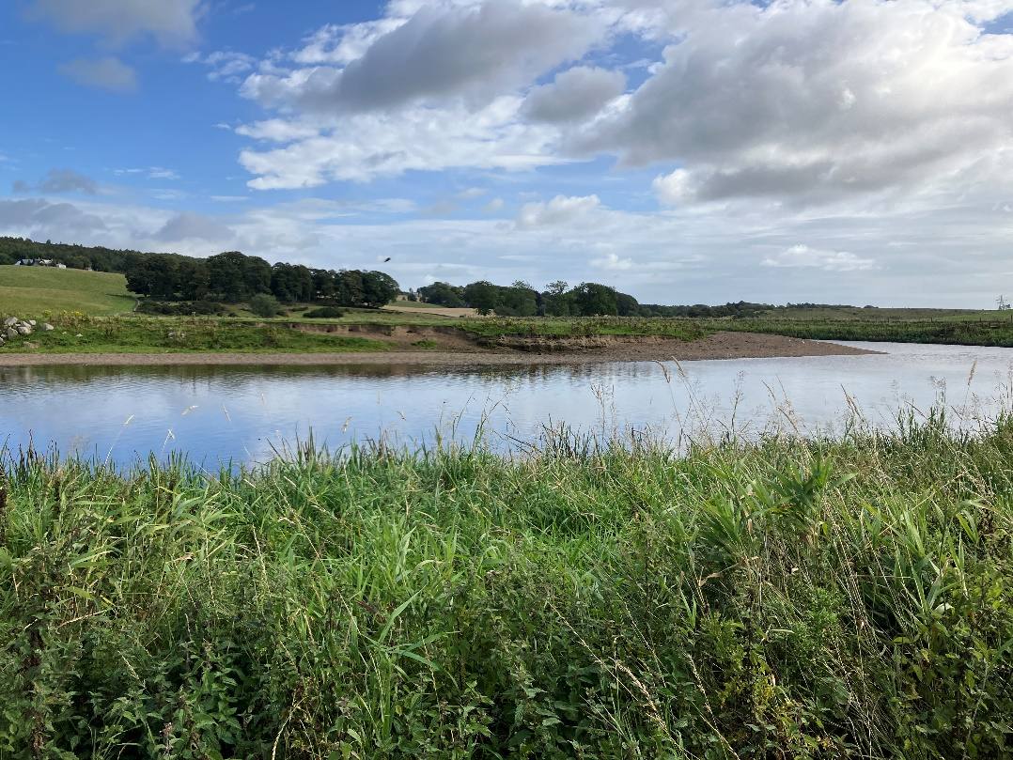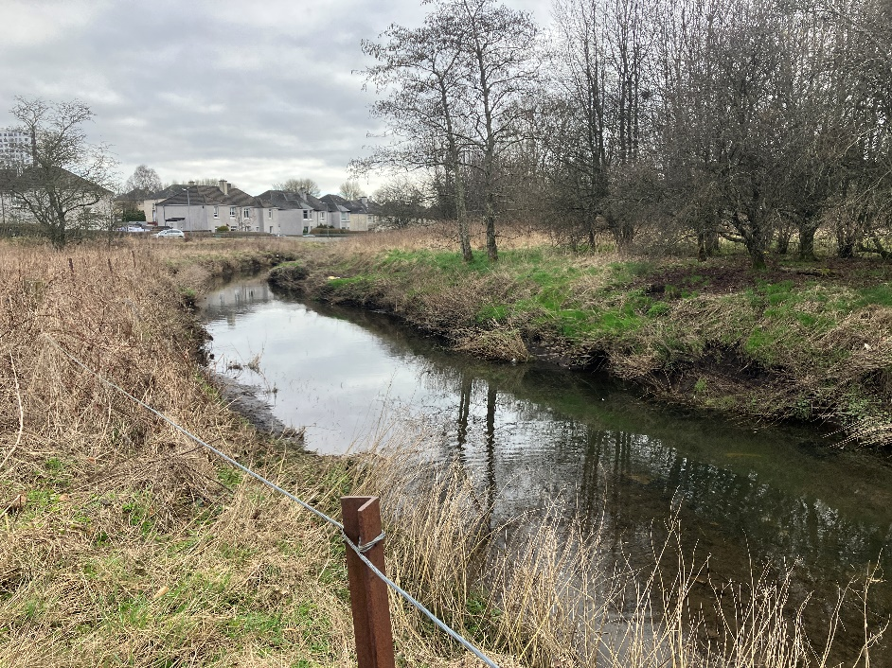
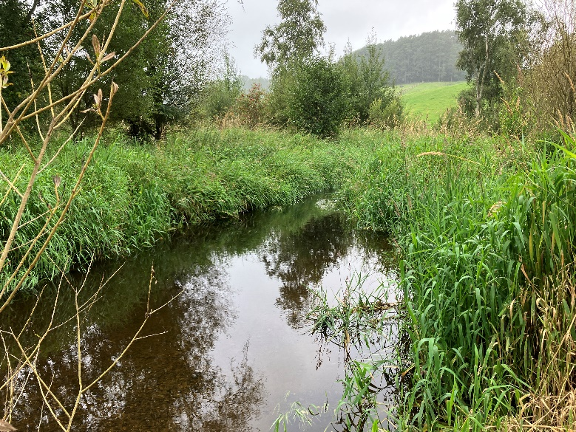
Figure 5 Examples of rivers with relatively low energy levels. Note the smooth water surface. Bed material is fine at sand or fine gravel.
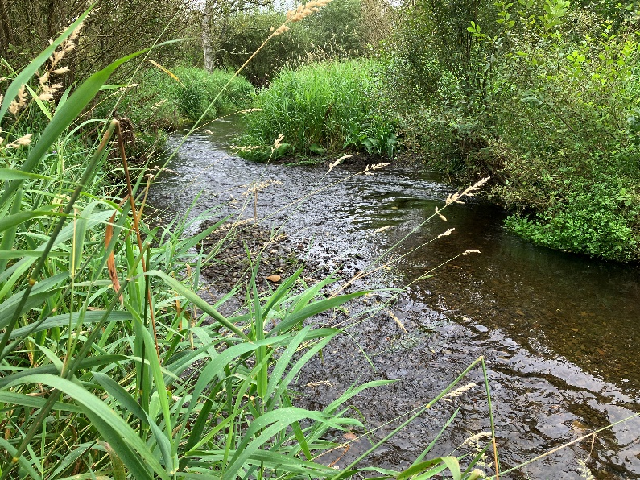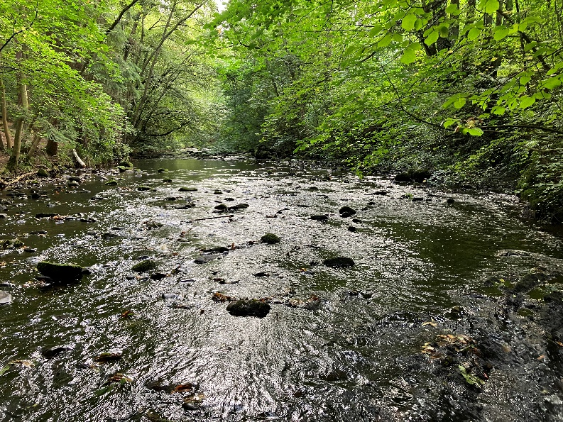
Increasing river energy
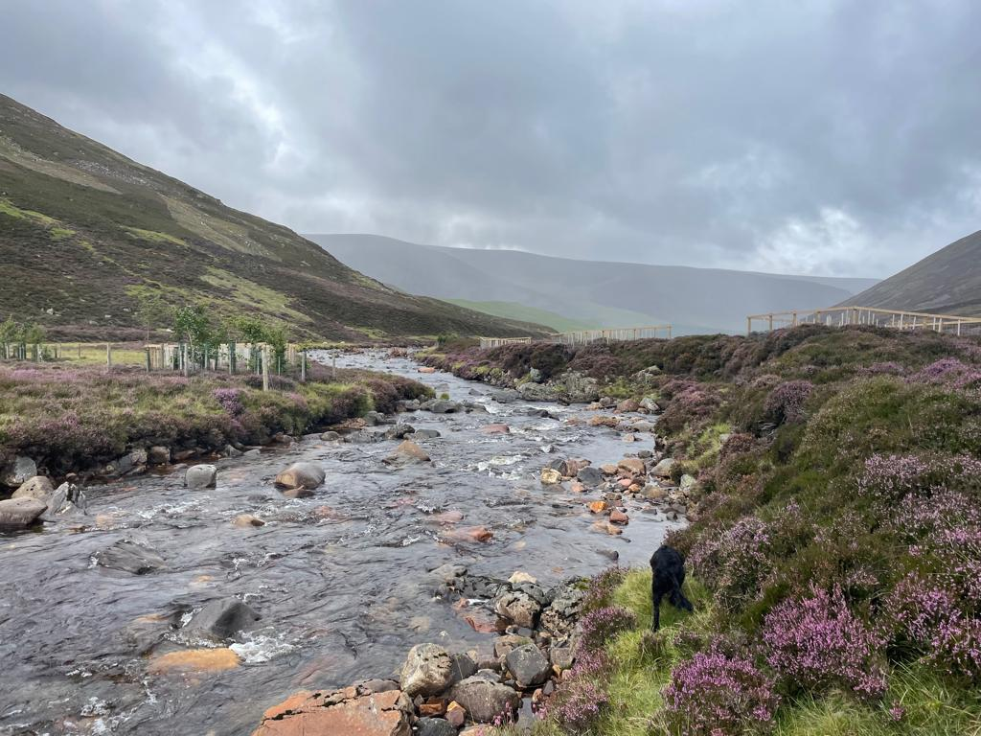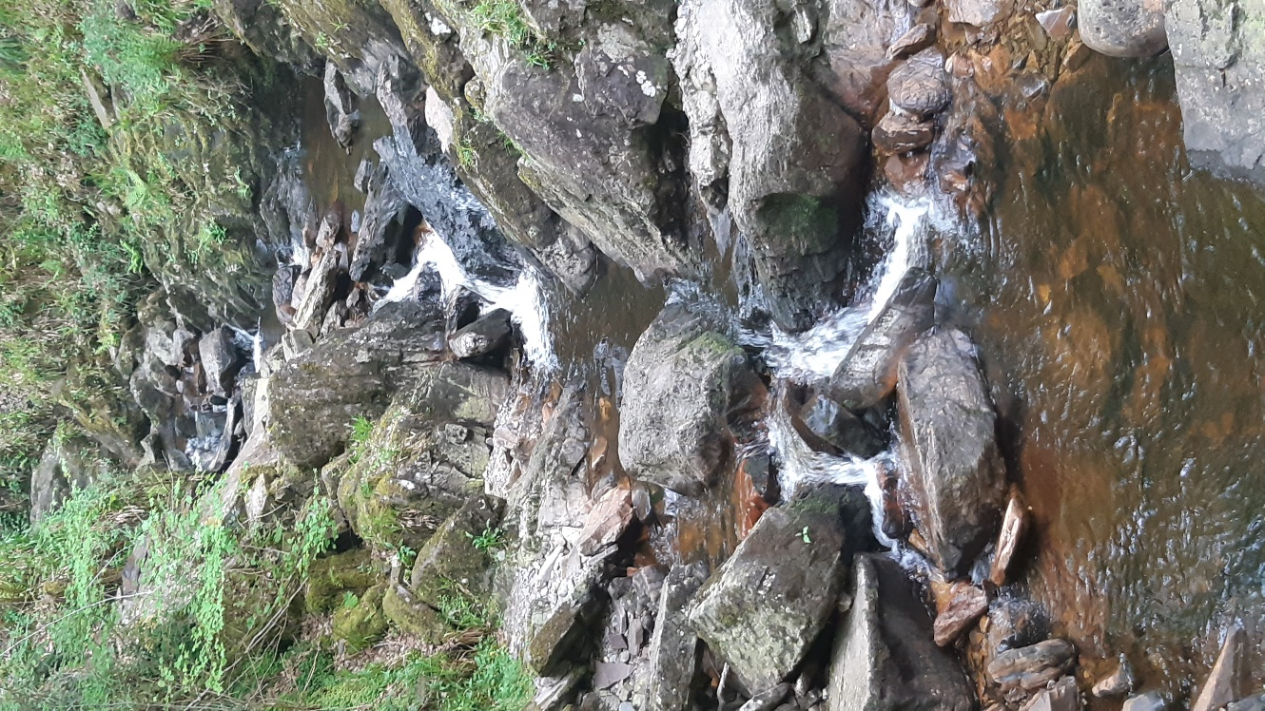
Increasing river energy
Figure 6 Rivers with medium to high energy levels. Note the uneven water surface and presence of white water corresponding to breaking waves. Bed materials range from gravel to boulders and bedrock. The coarser the bed material, the more energy the river has. River energy increases through the photos from left to right on each row.
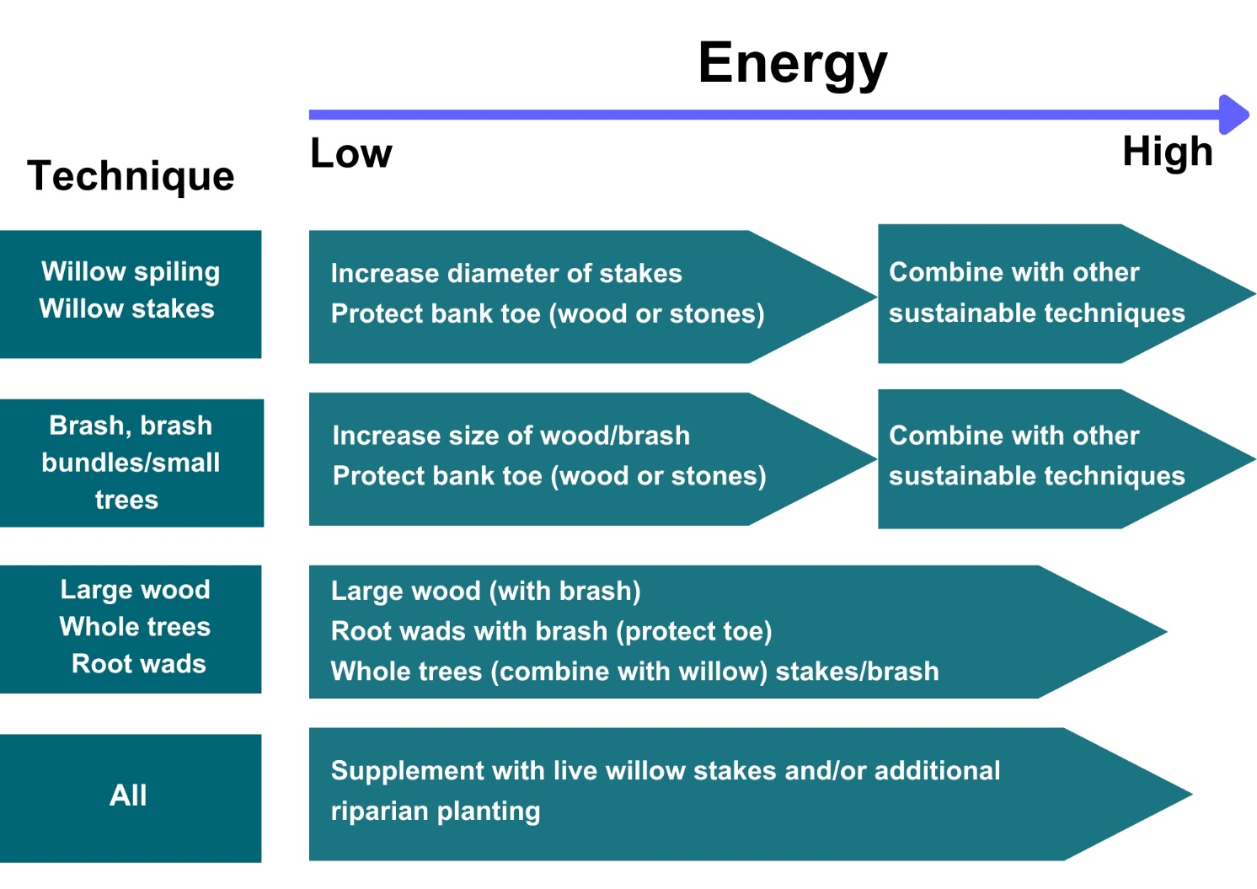
Figure 7 Matching the technique to energy Matching the technique to energy
Whatever technique you use, you will need to secure the trees and parts of trees in place to prevent them being washed away. This is particularly important if you are using large wood, large trees or root wads, which, if they were to break free, could cause damage to any bridges and other structures downstream.
The method you need to use for this will depend on the strength of the bank. Figure 5 provides a guide to help you select the most appropriate method.
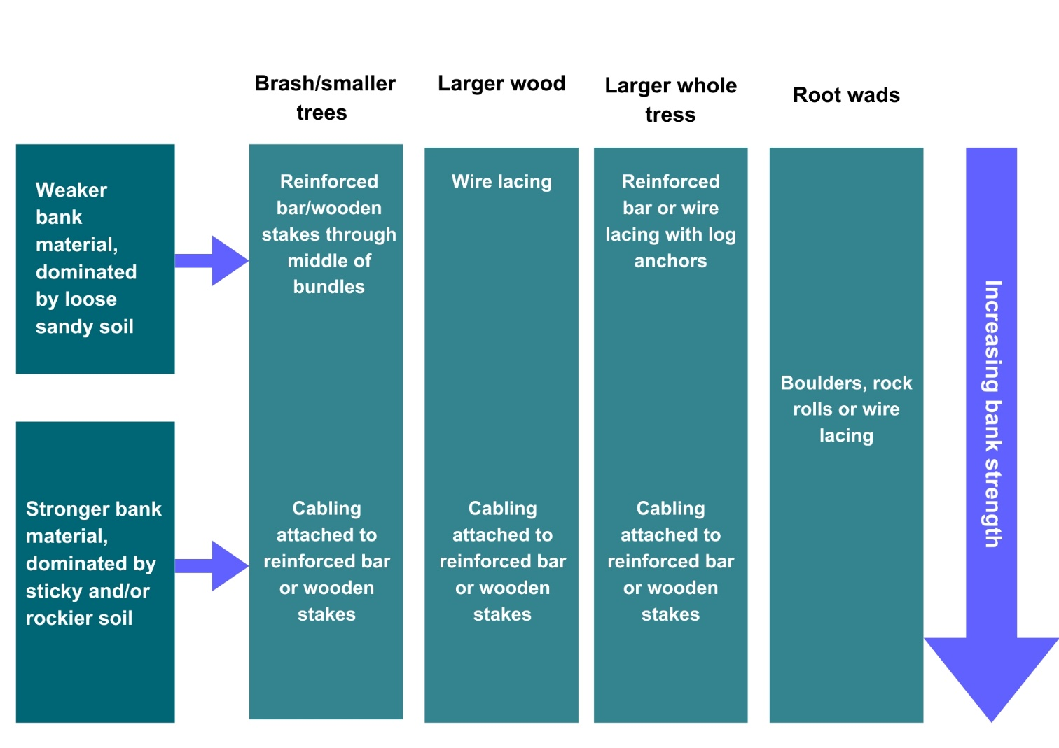
Figure 8 Selecting the most appropriate structure (bank strength)

7 What else do I need to think about when deciding on the technique to use?
The costs of bank protection will vary. For example, installing large wood, large trees and root wads requires mechanical assistance and, in the case of root wads, significant earth works. This may be a significant factor in your choice of technique, depending on whether or not you have to hire in contractors or machinery and the ease with which you can source trees.
Similarly, whether or not you need to buy-in trees or parts of trees is likely to affect your choice of technique. Root wads will require sourcing a greater number of trees per metre than using large trees at the bank toe. If you use willow spiling, you will normally need to buy the spiling.

8 Technical guide to the different techniques

8.1 How to use live willow stakes and spiling
Live willow stakes and willow spiling can provide protection and support to eroding banks within a range of soil types and flows. Steep banks should be terraced or reprofiled. They can also be used in combination with some of the other techniques described below. Willow stakes and spiling are one of the easiest and cheapest structures to install since they can be secured in place by simply hammering them into the bed or bank.
Installation should generally include the following steps:
- All willows should be planted or installed between November and March, this should be done in a manner which does not disturb fish redds (spawning sites) or introduce silt into the watercourse or loch. Planting in this period allows the willows to start growing as soon as the weather is warm enough and will ensure they have the entire growing season to become established. Live willow needs to be installed in moist and soft soil so that the roots can start to grow and penetrate to a greater depth, providing greater stabilisation. Planting in the summer months in dryer locations, such as the tops of banks, will decrease the likelihood of the willows becoming well established.
- Ideally, only freshly cut willow stakes and rods should be used, though as long as they are kept damp and cool, they can be stored for two to three weeks before installation.
- Stakes should be at least 50 to 100 millimetres thick, 2 metres long and should be hammered into the bank face, including a line along the bank toe if it is exposed, roughly every 0.5 metres. Stakes should be hammered through blocks of slumped material if present in order to stabilise them. At least two-thirds of the stake’s length should be driven into the ground to provide a strong anchor (Figure 12).
- Weave live willow rods between the live willow stakes. The rods should be about 2.5 metres long for use on lower energy rivers and from 6 to 7 metres long to produce stronger structures for use on higher energy rivers. 20 to 30 rods should be used for 1 metre high spiling. The surface created will initially be relatively smooth but, as the willow grows, it will develop the roughness and complexity required to dissipate flow energy.
- The bank toe may need to be protected while the willow becomes established. This is because erosion of the bank toe can lead to the bank being undercut and then collapsing. If there is evidence of scour at the bank toe or a likelihood of scour because of the energy of the environment, you can use one of the other techniques or stones to help protect the toe whilst the willow becomes established.

- If you use stones, they should be sized to the environment. You can do this by selecting sizes up to the size of the largest stones that have been deposited in the watercourse or loch in the vicinity of the eroding bank. On some river beds, there may be much larger rocks than those deposited by the river. These are rocks left from glacial periods and not representative of the size of stones you should use. You only need to protect the bank sufficiently to prevent undercutting. Once the willow has grown and its roots have become established, you should not need to maintain the toe protection as the willow will stabilise the bank and help resist undercutting.
- A willow spiling wall should be no more than 1 metre high. When banks are higher than this, they should be re-profiled into a series of terraced steps. This technique can be used in conjunction with the other forms of bank stabilisation described below to provide improved protection, especially in higher energy systems.
- Sheep, cows and deer eat young willow shoots, so fencing may be necessary to ensure the success of the structures in locations where this could occur.
Over time, the willow should establish a root network in the bank material, which reinforces it. Branches will grow and form flexible stems that will increase roughness, dissipate more energy and protect the bank from erosion.
Where individual trees grow out over the watercourse or loch at a steep angle, pruning (coppicing) may be required to stop the trees maturing into heavy trees that may fall and pull a section of bank with them.
B)
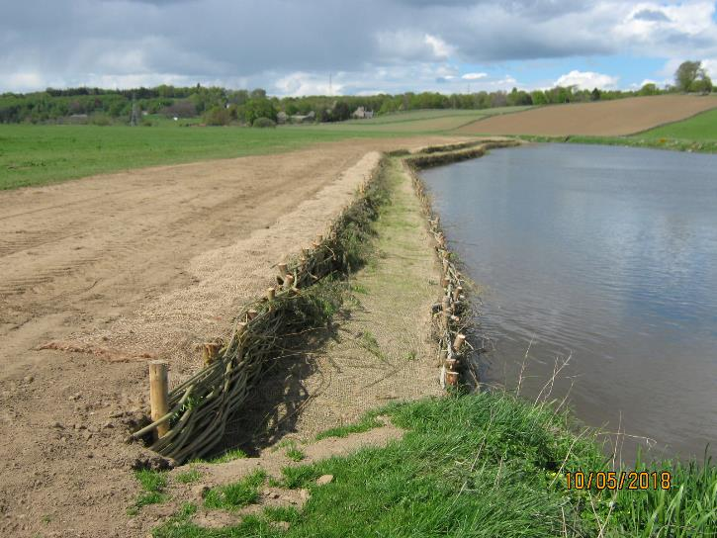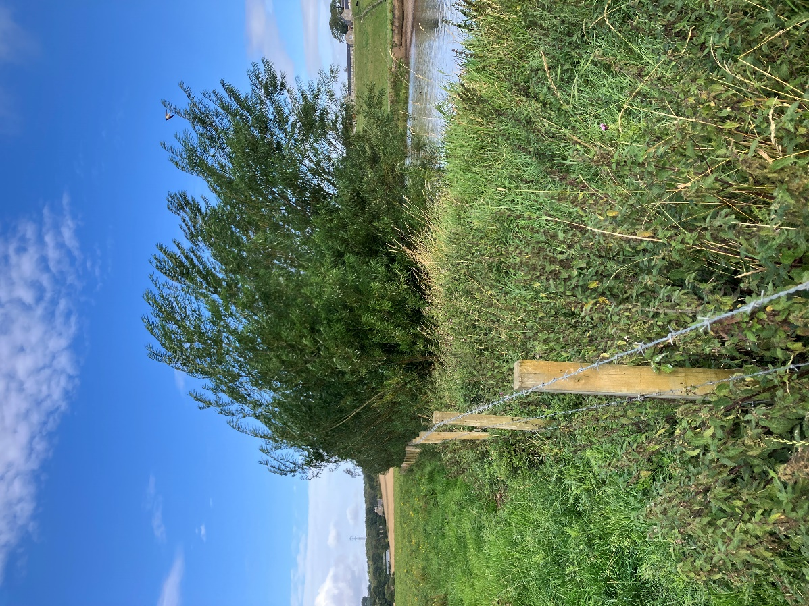
A)
Figure 9 Looking upstream along the River Don showing the site A) immediately after 2 terraces of willow spiling were installed and B) 7 years later after the will had grown up covering the bank.
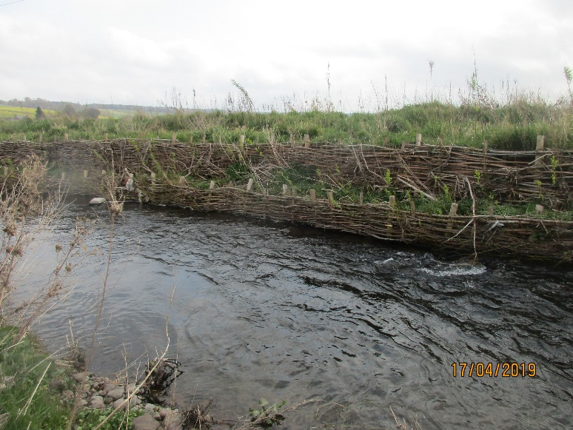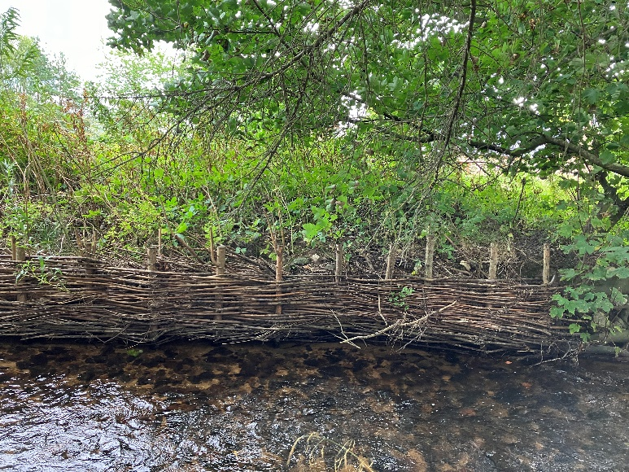
B)
A)
Figure 10 Two examples of newly installed willow spiling illustrating how they can be formed of a single or double tier, depending on the bank height and shape.
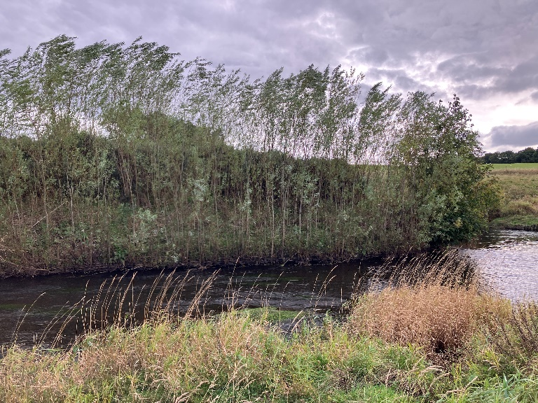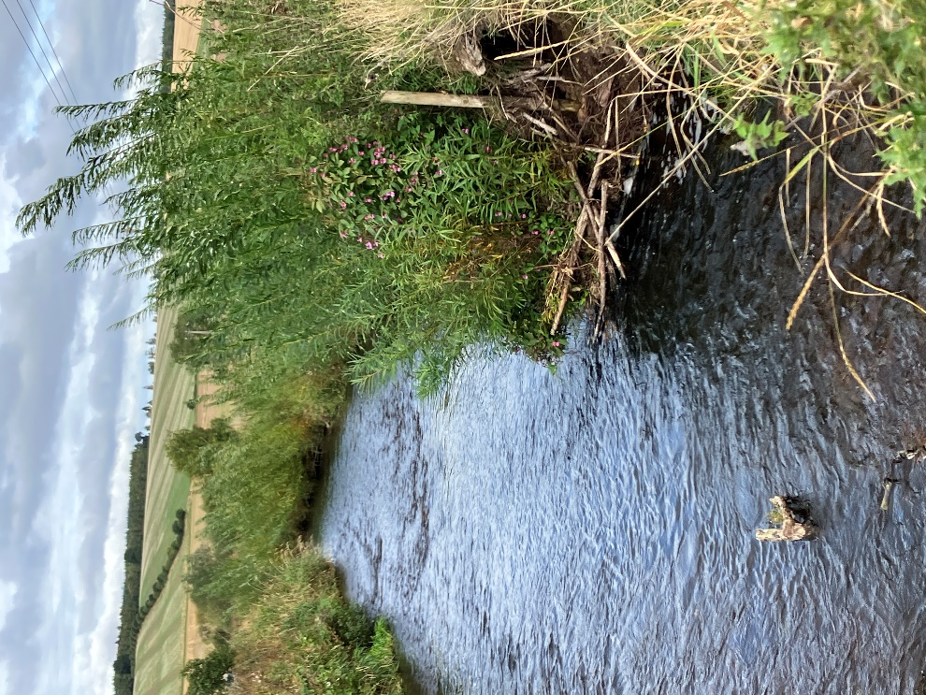
B)
A)
Figure 11 Two photographs showing mature willow spiling, illustrating the transformation into a living barrier of protection.
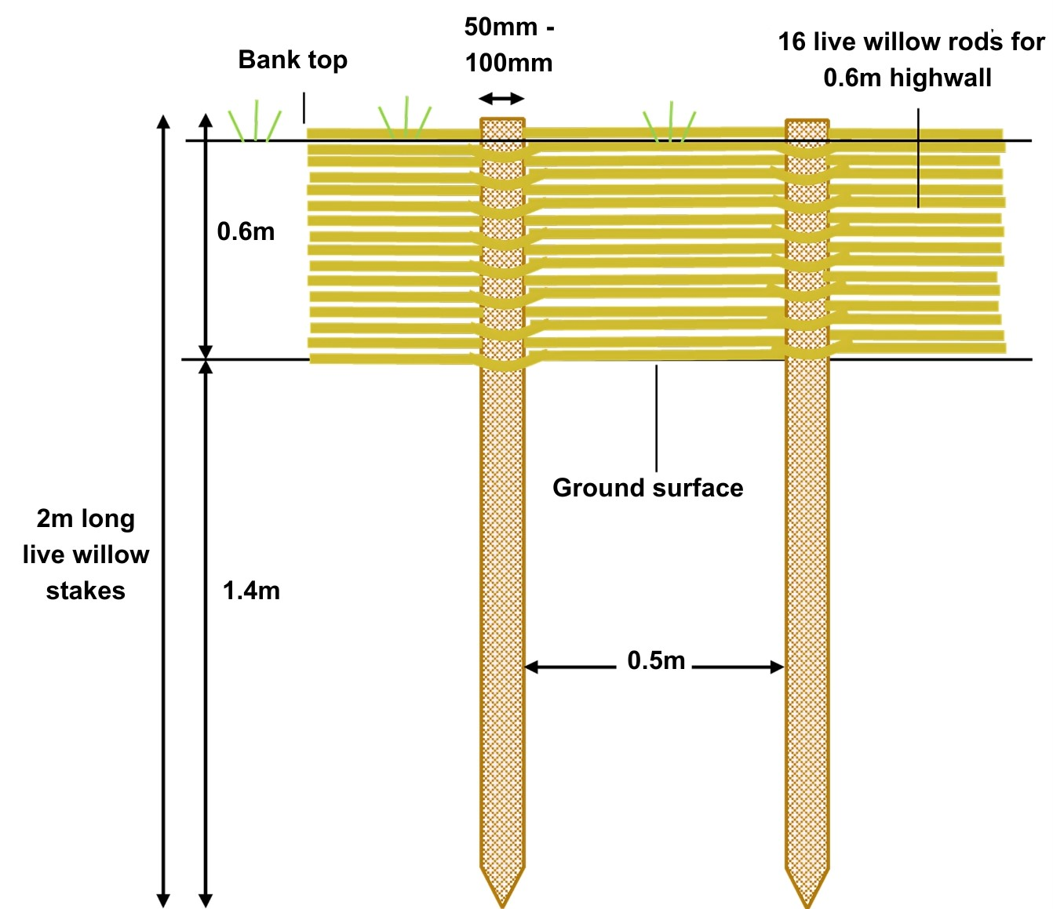
Figure 12 Details of willow stakes and rods installation

8.2 How to use brash and small trees
Brash and small trees with branches are good for diffusing flow energy due to their flexibility and because water loses some of its energy when flowing between and around the individual pieces of the brash or branches.
Brash and small trees can be used on a range of watercourse sizes and can be combined with willow spiling for additional stability. The size and weight of the brash and small trees can be adapted to reflect differences in energy conditions, with heavier more solid branches being used in higher energy environments.
The techniques involve:
- The use of bundles of brash tied together and pinned in place to protect the bank face; and /or
- Brash or small trees simply put in place in front of the eroding bank and secured using the techniques shown in Figures 13 to 18.
Brash use is appropriate for many situations. It can be used on its own but is particularly useful when used in combination with other techniques e.g. filling gaps between root wads.
Brash should be tied sufficiently tightly to form a coherent structure but not so tightly that there is virtually no space between the individual pieces.
Installation should proceed as follows:
- Hammer a matrix of wooden posts (50 to 100 millimetres in diameter) into the bank at regular intervals between a stable section of the bank top and the bed in front of the eroded bank. Two-thirds of each post’s length should be hammered into the bank. The area over which the posts extend should cover the eroded bank face and overlap with the unaffected bank at either side. Particular care should be taken to firmly secure the brash to the bank at either end to prevent flanking.
- Weave layers of brash between the posts and place a mixture of brash bundles, small trees and large branches between the eroding bank face and the line of posts closest to the wetted edge.
- Secure the brash, small trees and large branches using one of the following techniques:
- Drive live willow stakes through the structure at intervals along the eroding bank. The stakes should be long enough to just stick out above the structure and for at least two-thirds of their length to be driven into the bank face (Figure, 14).
- Drive live willow stakes into the bank top, set back about a metre from the bank edge, and into the bank toe. The bank toe stakes should be long enough to just stick out above the structure. The bank top and toe stakes should be long enough for at least two-thirds of their length to be driven into the ground and to at least a depth of 1 metre on the bank top. Stretch suitably strong stainless steel wire from the posts at the bank toe, tightly over the structure to the base of the bank top post. Attach the wire to the posts using stainless steel staples or similar (Figure 15).
- Augment the strength of the structure described above by weaving live willow rods or large branches between the stakes along the bank toe (Figure 16). If this approach is used, the stakes will need to be installed as described in Figure 12.
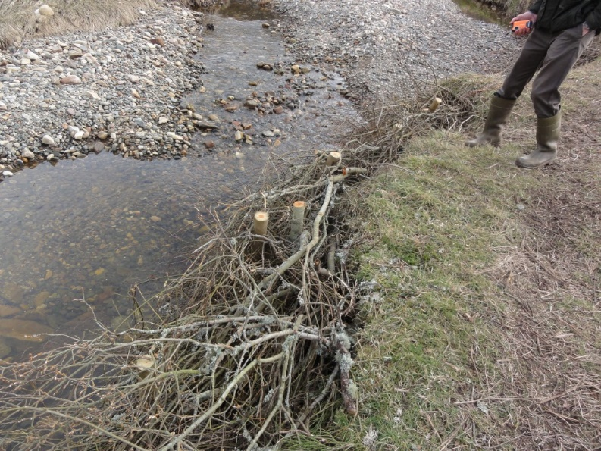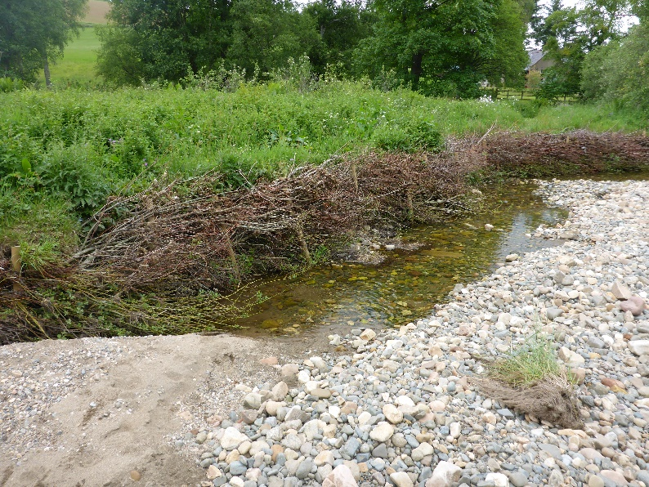
B)
A)
Figure 13 Two photographs showing banks which have been protected by brash being woven between stakes to cushion the bank. The bank behind is then planted with willow stakes to provide long-term protection.

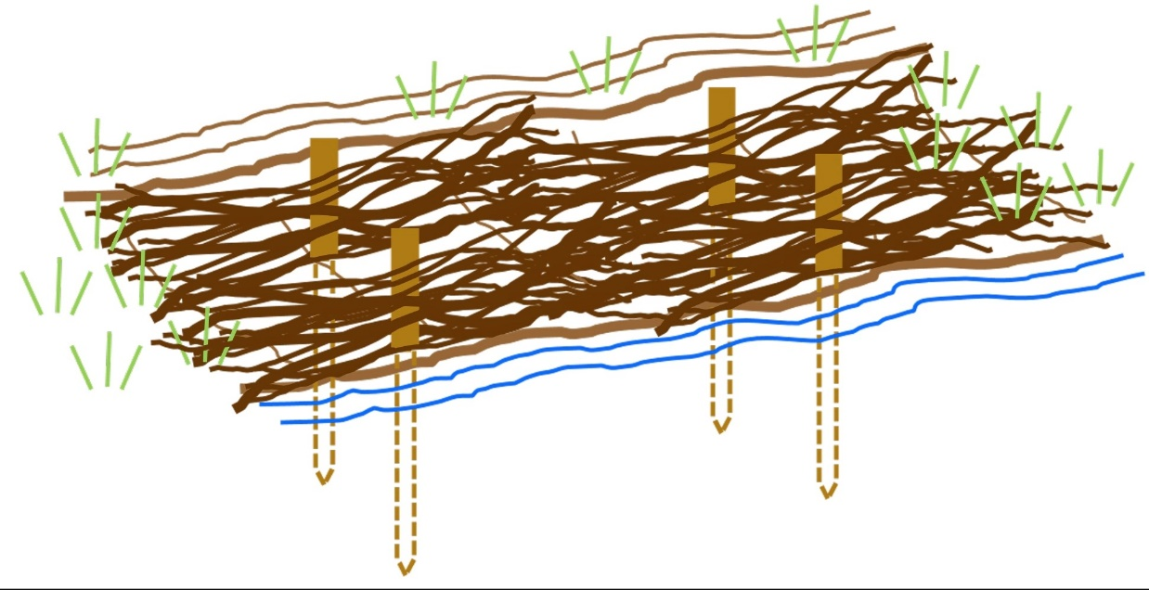
Figure 14 Securing brash, brash bundles, small trees or large wood to the
bank face with wooden stakes or reinforced bar
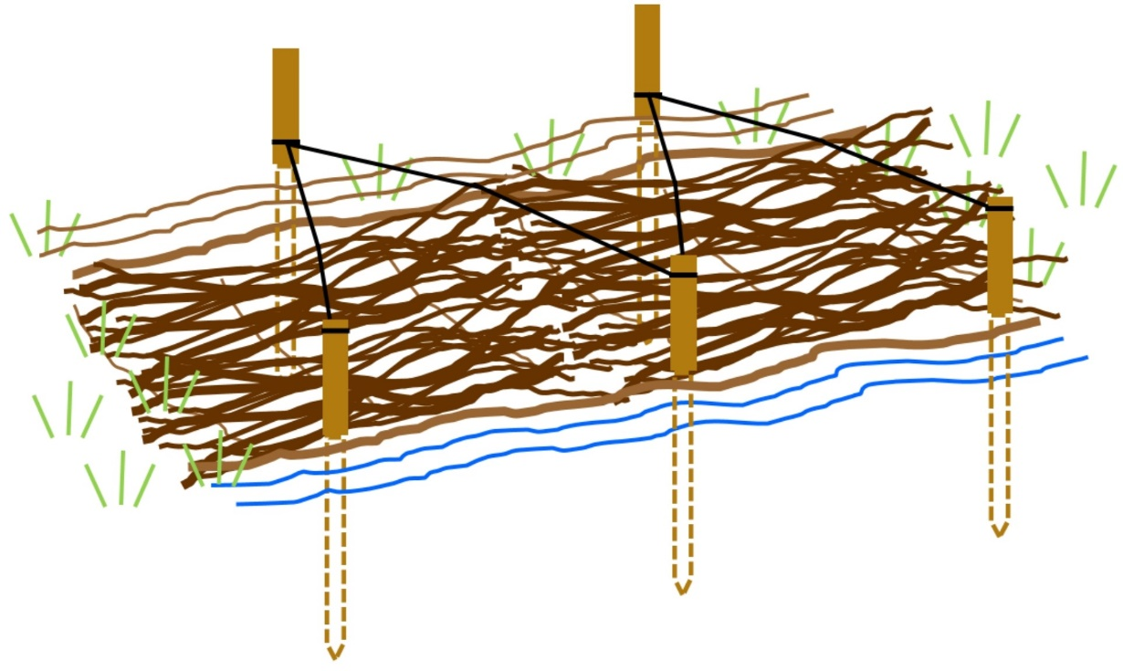
Figure 15 Securing brash, brash bundles, small trees or large wood to the
bank face with wooden stakes or reinforced bar and stainless steel cabling
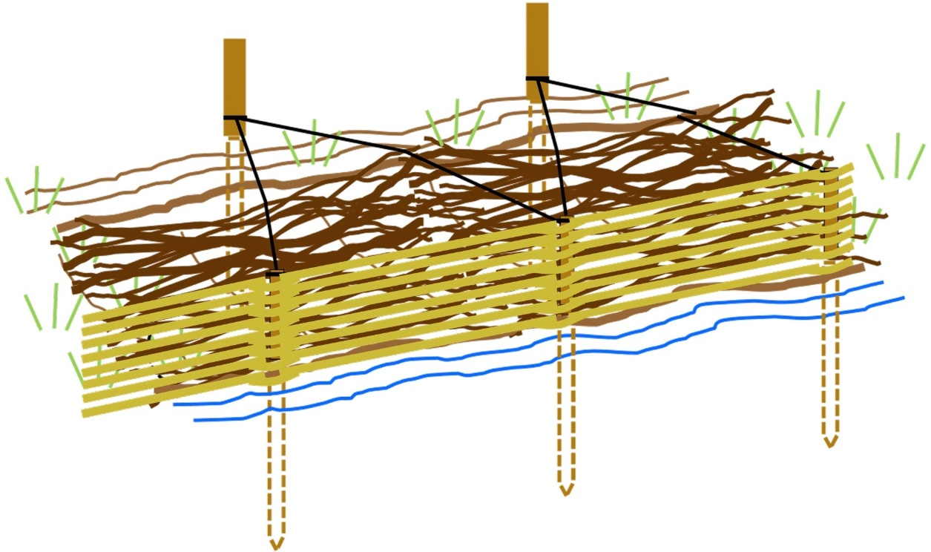

Figure 16 Securing brash, brash bundles, small trees or large wood to the bank face with wooden stakes or reinforced bar, stainless steel cabling and willow spiling

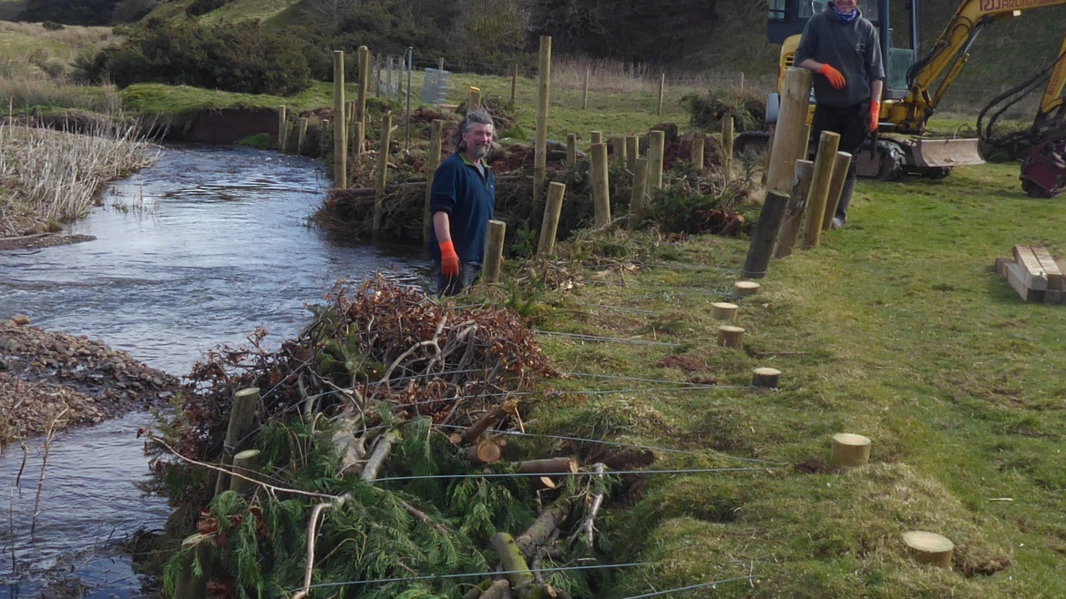
Figure 17 Looking downstream showing how the brash has been attached to the front of the bank using posts both on the edge of the channel and the bank top. Photograph courtesy of Tweed Forum.
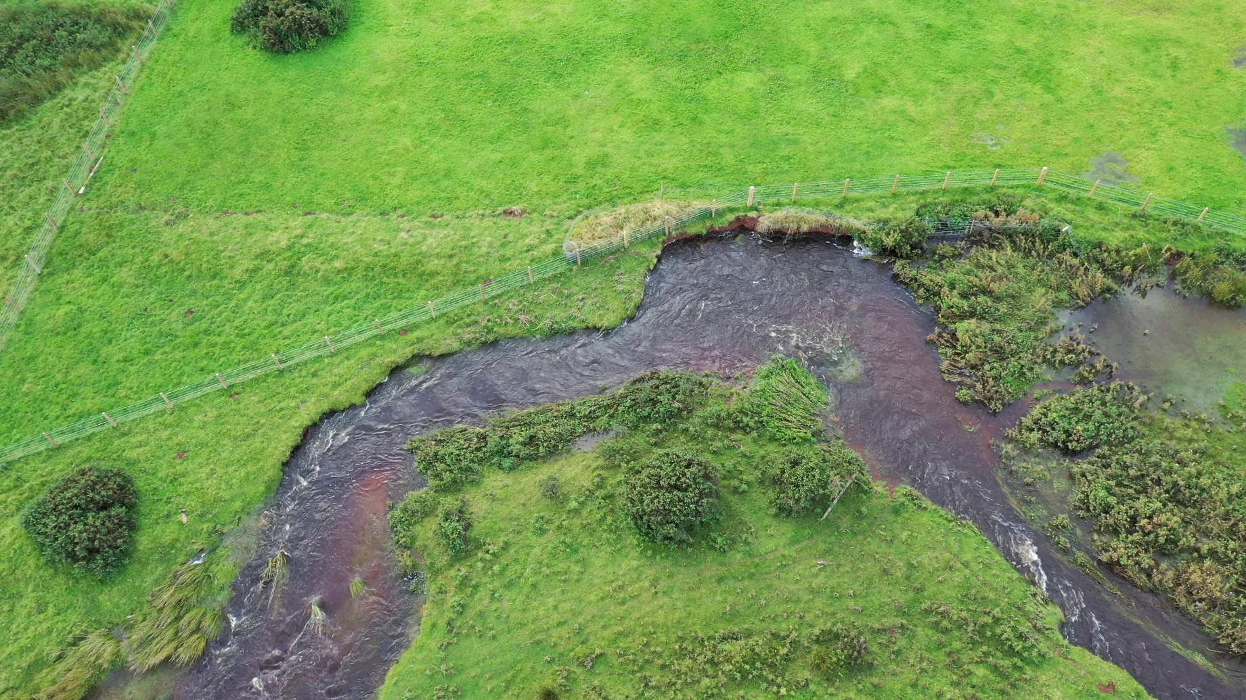
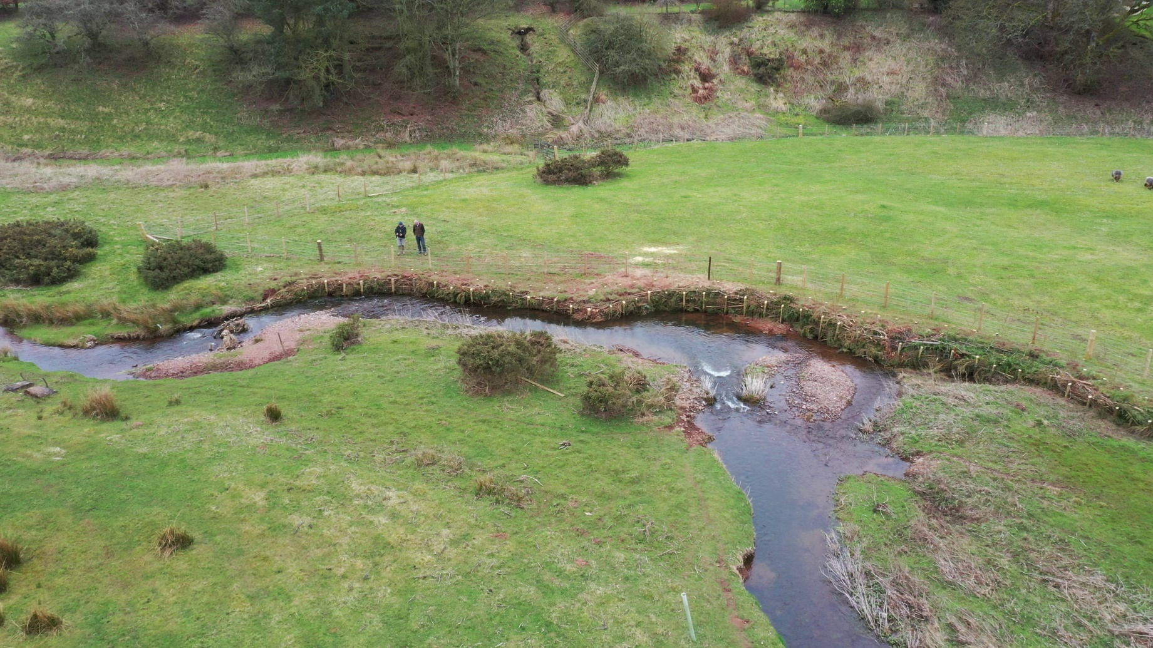
Figure 18 Before and after photographs of bank protection constructed using brash and small trees which have been anchored to the bank face using posts. Photographs courtesy of Tweed Forum.

8.3 How to use large wood
Large wood can be used on its own or in combination with the other techniques in the guidance. If the energy of your watercourse or loch is high, it can be used like a weightier form of brash and small trees. It can also be used to protect the bank toe from undercutting whilst willow spiling establishes.
Installation of protection using large wood should proceed as follows:
- Use a mixture of different sizes and shapes of large wood to create a complex and rough matrix.
- Starting at the bank toe, interweave the different large wood pieces so that a complex and strong matrix is created. Using at least some live wood will help create a stronger matrix, since live branches can take root in the bank or bed.
- Willow spiling or planting native species on the bank top can be used with this technique to help stabilise the bank.
- The same fixing techniques used for brash and small trees and illustrated in Figures 13 to 18, can be used for large wood protection.
- Steel reinforcement bars (rebar) can also be used to fix large trunks into the bed or bank for additional strength or if fixing to the bank top is not possible (Figure 23).
- Particular care should be taken to firmly secure the large wood to the non-eroding bank at the upstream and downstream ends to prevent water flowing around the protection.
As well as the points above many of the principles for its use are very similar to those outlined in Section 8.2 regarding brash and small trees above.

8.4 How to use large trees
Large trees can provide good protection in high energy situations. They should be properly secured in place to avoid risks to structures downstream should they break free.
The installation of protection using large trees (such as shown in Figures 19 to 21) should proceed as follows:
  - Select the right type and size of tree. Coniferous trees such as spruce, fir or pine are most appropriate, although any locally available trees can also be used. The diameter of the tree’s crown should be roughly two-thirds the height of the eroding bank face and the tree should not occupy more than one-third of the wetted channel width in a watercourse. Any long lengths of trunk which do not have any branches should be cut off.
  - Starting from the downstream end of the eroding section, place a tree tightly against the bank face with the trunk end facing upstream. The tree’s downstream end should extend over, and be securely attached to, a short section of non-eroding bank to prevent flanking (Figure 22).
  - The tree should be anchored both at its trunk and towards its tip using one of options (a) and (b) below to secure it to the channel bed and one of options (c) and (d) below to secure it to the bank:
- Drill a hole through the trunk and drive reinforced steel bar at least 1 metre into the channel bed. The reinforced bar should just stick out of the top of the trunk (Figure 23.
- Attach wooden stakes or reinforced steel bar to each end of a length of suitably strong stainless steel wire and hoop the wire over the trunk so that one stake is on either side. Drive these at least 1 metre into the bed so that the wire is tight across the trunk (Figure 24).
- Drive 150 millimetre diameter wooden stakes into the bank top to a depth of at least two-thirds their length and no less than 1 metre. Hoop suitably strong diameter stainless steel wire around the trunk and attach this to the base of the bank top post using cable ties or stainless steel staples (Figure 25). Trim off any excess post length. This technique may be more suitable if the bank material is stronger.
- Dig a 2 metre deep trench 5 metres back from the bank top that is big enough for a log anchor of length 2 - 2.5 metres and of 0.5 metres in diameter. Dig a narrower trench to the same depth running perpendicular to the first one and towards the bank top. Hoop suitably strong stainless steel wire around the whole tree trunk and attach this to the log anchor using cable ties or stainless steel staples. Place the anchor and cable into their trenches, backfill with soil and compact this down (Figure 26). This technique may be more suitable if the bank material is weaker.
  - The second tree should then be drawn into position to overlap with the first tree over about 25 percent of its length, ensuring no gap exists between the two. The cable used for securing the trunk of the first tree to the bank.
  - Repeat steps a to d from above until the whole length of eroding bank is protected. The upstream end of the cover should extend over, and be securely attached to, a short stretch of non-eroding bank to prevent the river going around the protection.
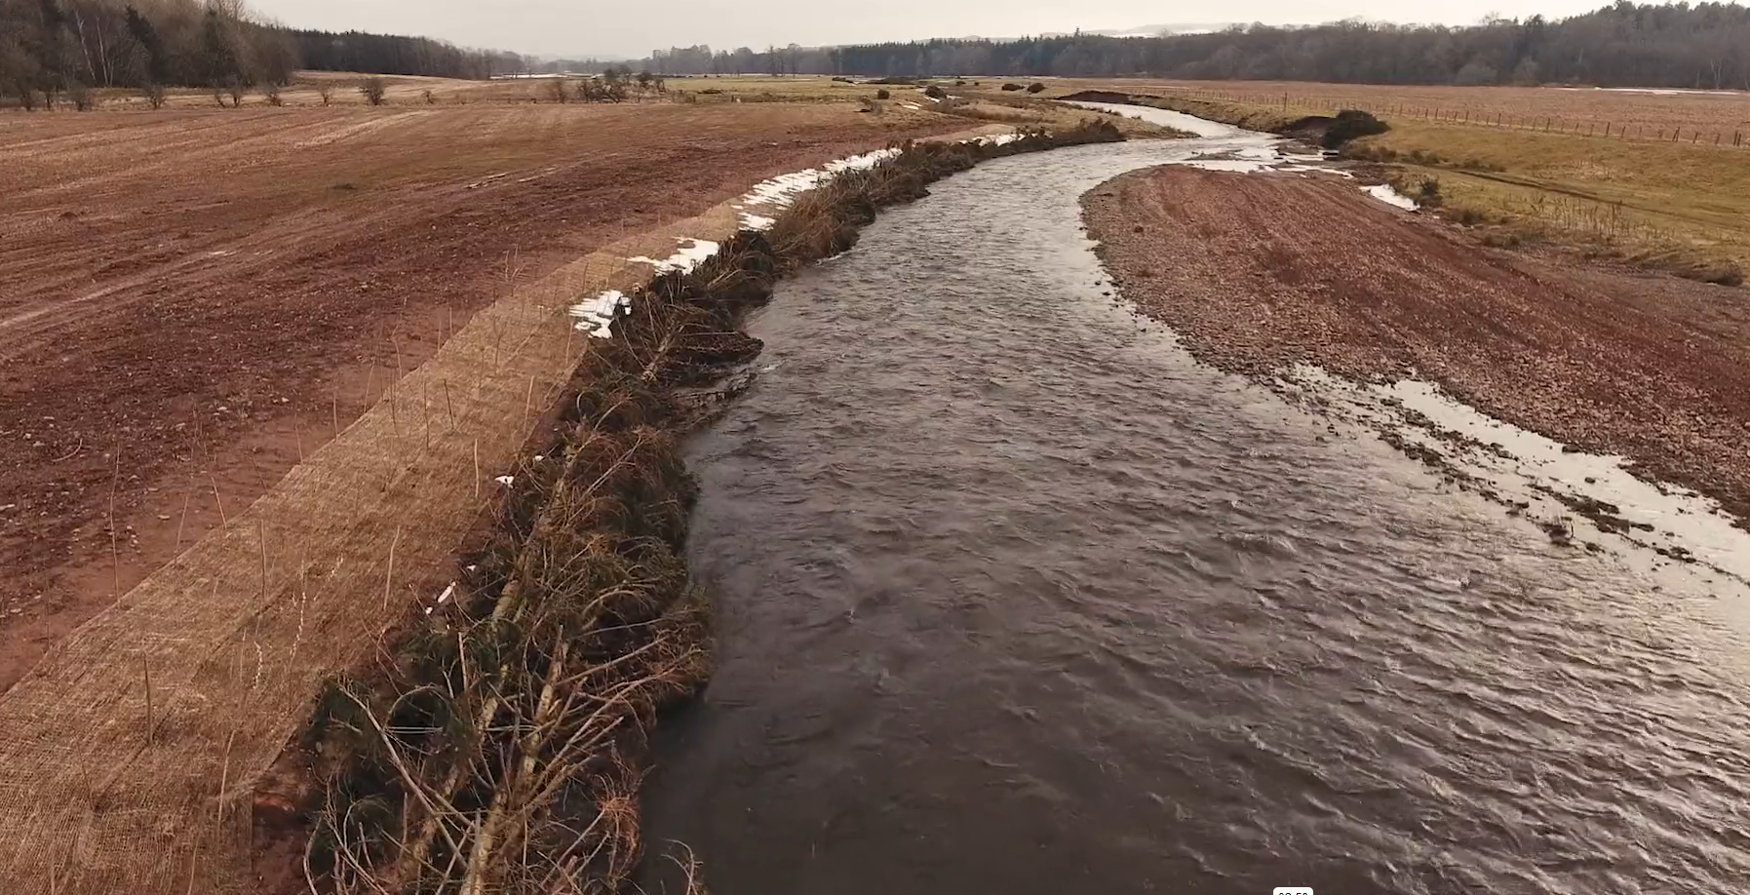
Figure 19 Looking downstream along an eroding bank where large trees have been installed along the channel edge.
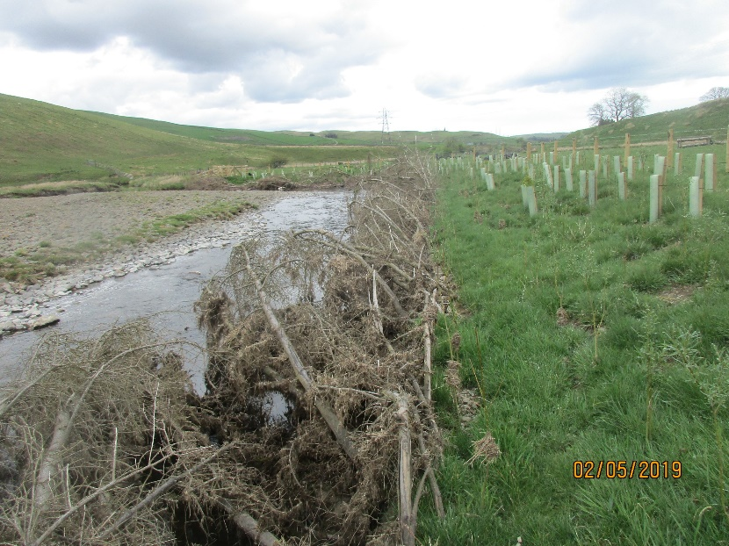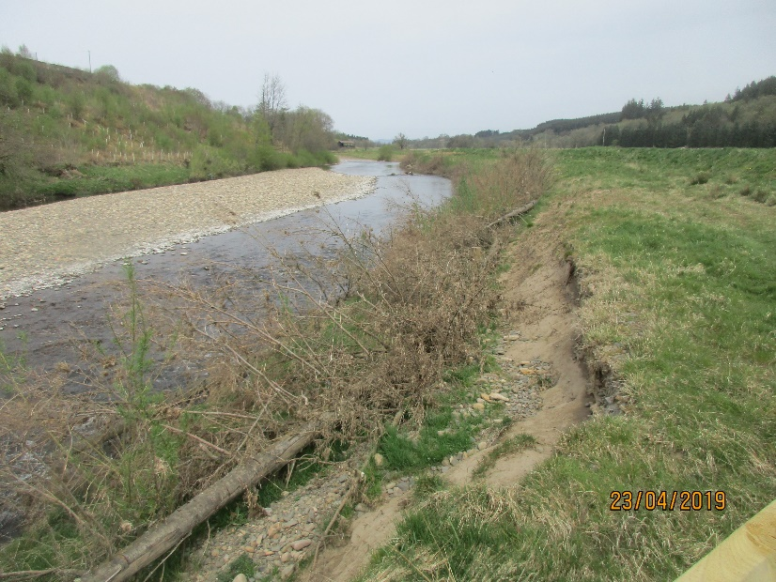
B)
A)
Figure 20 Examples of using large trees to protect river banks 18 months after installation. A) shows a location where the trees have been fixed by burying logs as anchors 5 m back from the bank face and attaching the logs using a wire cable. B) shows a site where the trees were attached with vertical stakes.
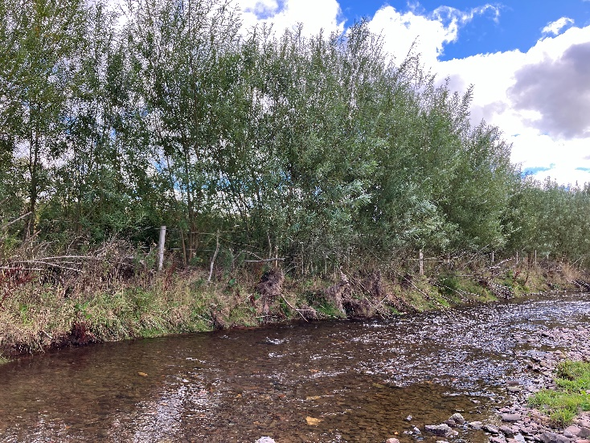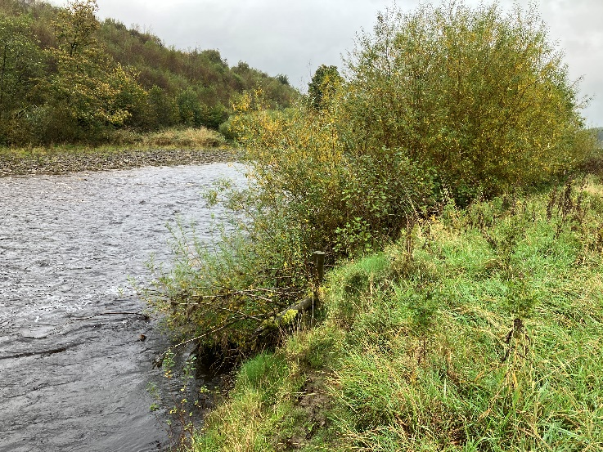
B)
A)
Figure 21 Sections of bank protection using trees after 7 years showing how many of the branches have been removed, but the trunk is still there and has become part of the bank with trees established on top (photograph B shows the same site as in Figure 20B above)

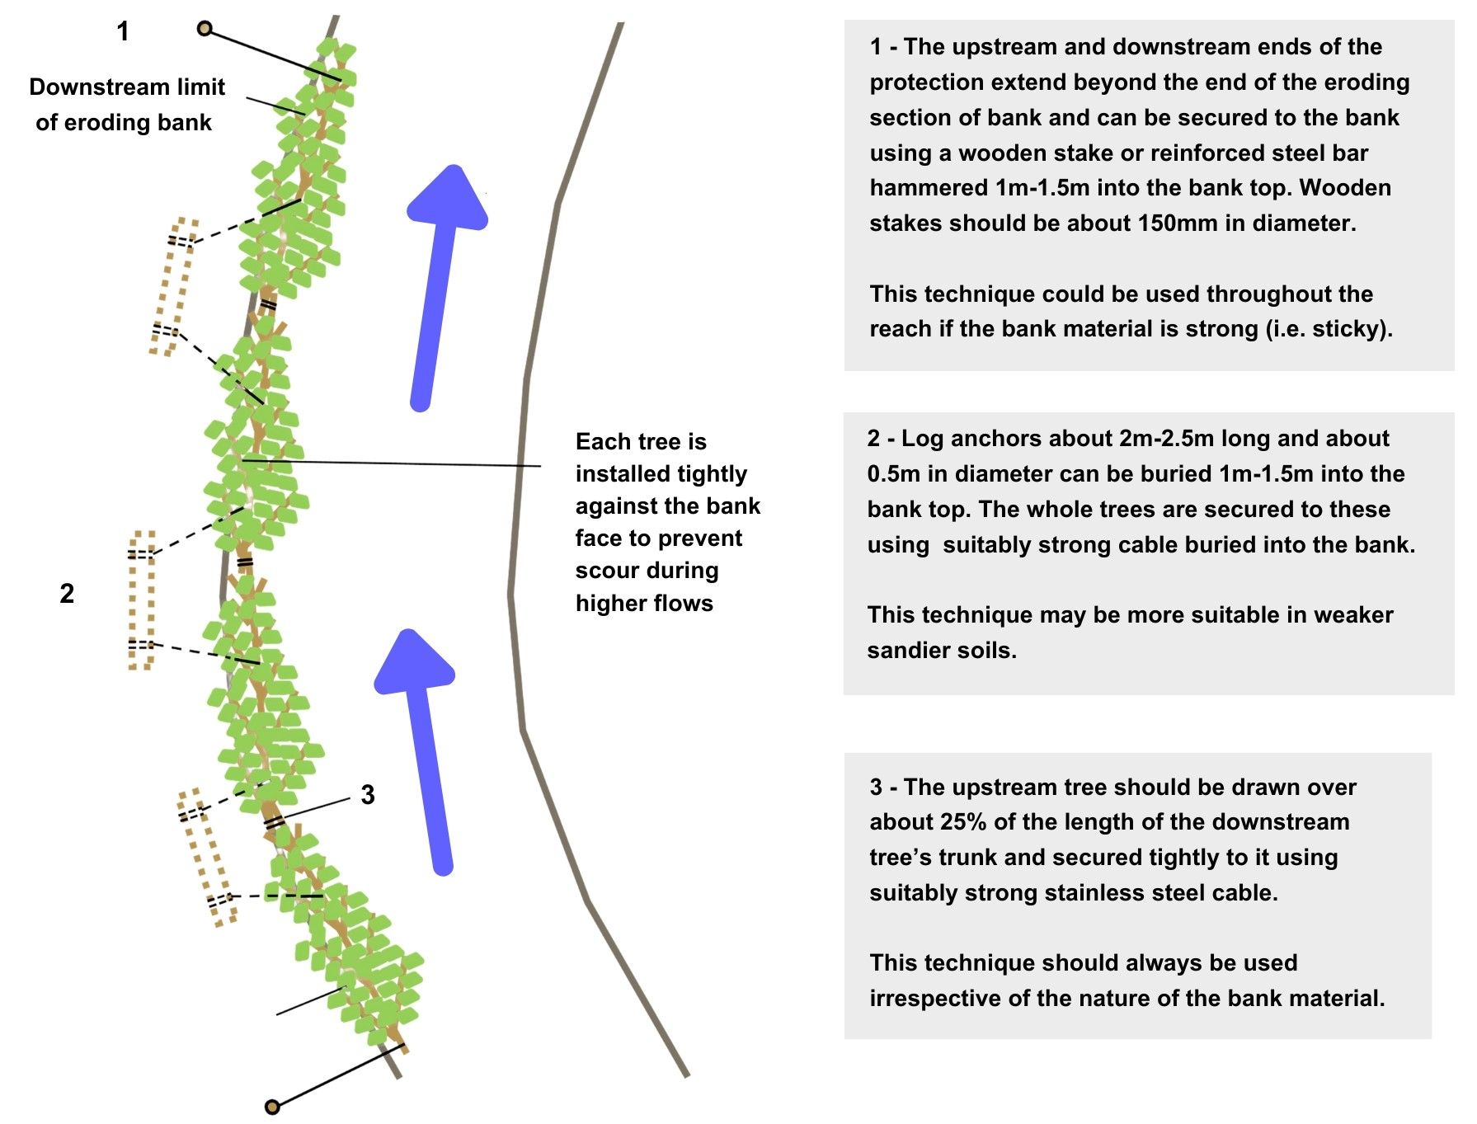
Figure 22 Plan view of large tree placement and fixing techniques for different bank material strength

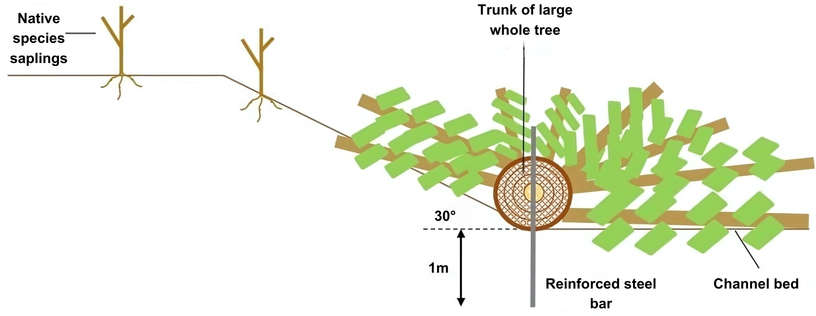
Figure 23 Cross-sectional view of large tree placement secured using reinforced steel bar driven into the channel bed

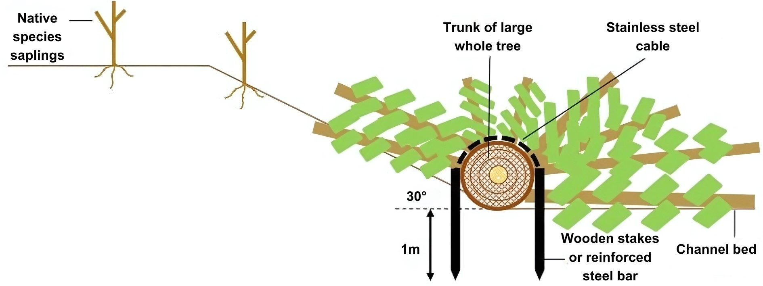
Figure 24 Cross-sectional view of large tree placement secured using wire lacing attached to wooded stakes or reinforced steel bar driven into the channel bed

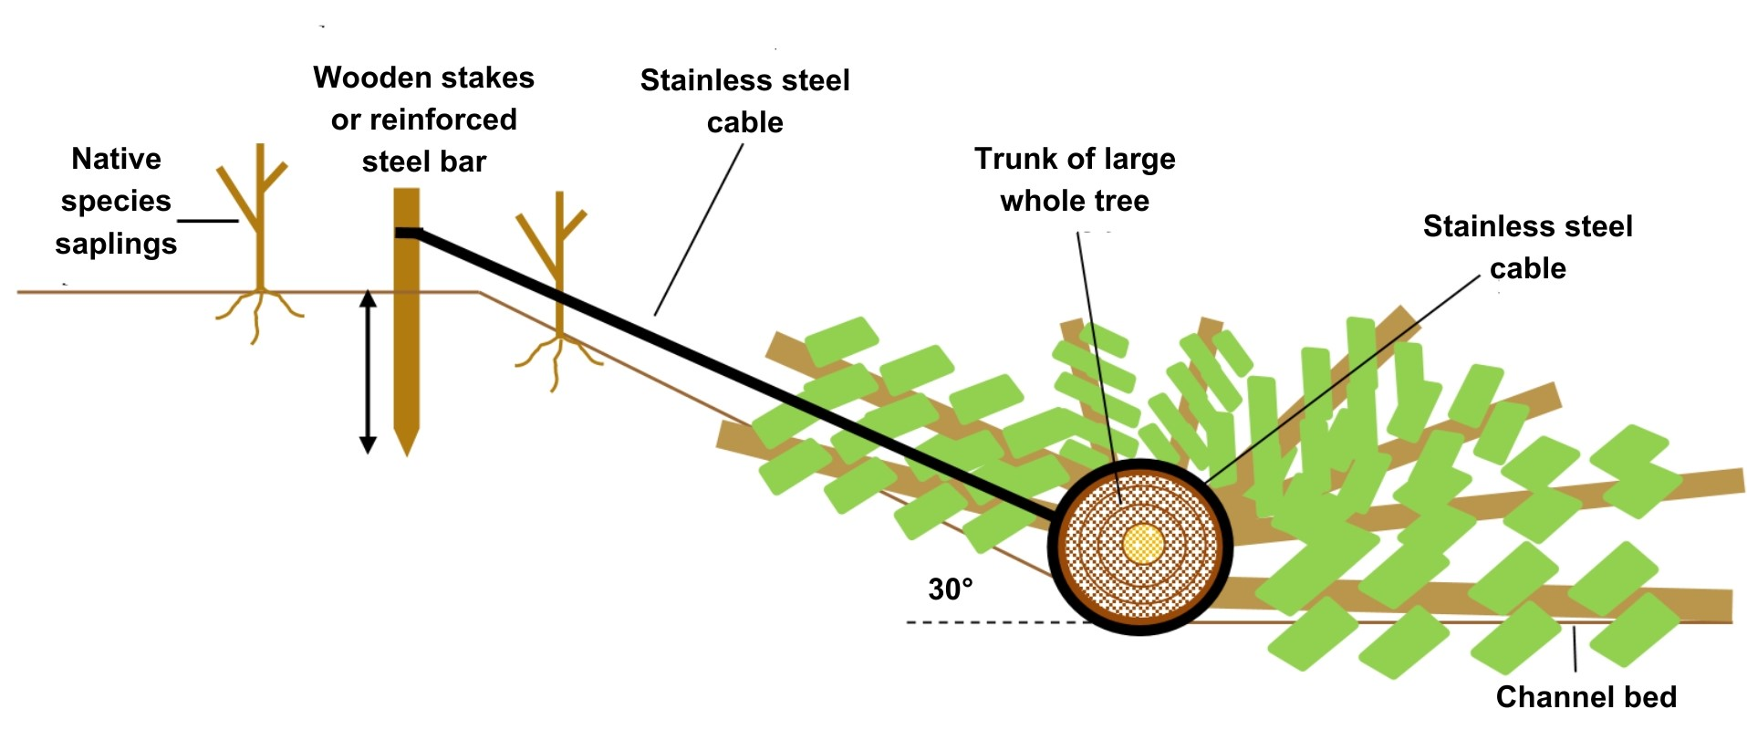
Figure 25 Cross-sectional view of large tree placement secured using steel cabling attached to bank top wooden stakes or steel reinforced bar
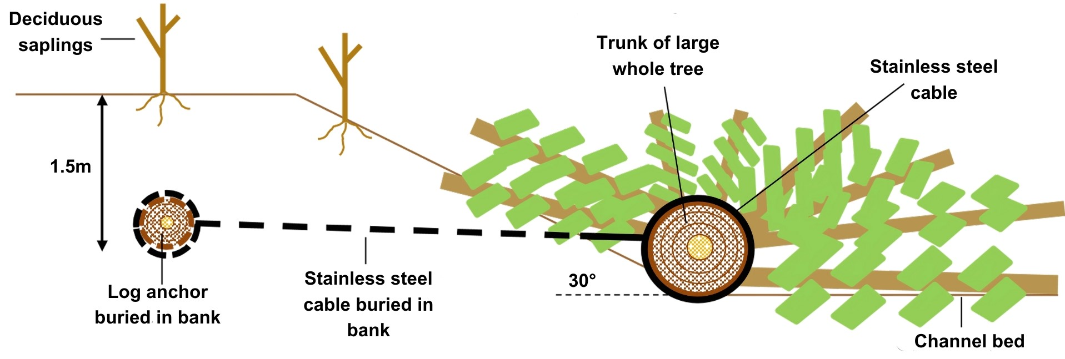
Figure 26Cross-sectional view of large whole tree placement secured using steel cabling attached to loch anchors buried in the bank

8.5 How to use root wads
Root wads can be used in combination with the large wood technique described earlier, with one or two root wads installed to provide additional strength. Root wads work well on the outside of bends and near to fast flows. They can be used to provide anchoring points for brash and large trees arranged in series along the bank to be protected.
The installation of root wads may require significant excavation and should proceed as follows:
- The length of trunk attached to the roots should be a minimum of three times the root plate diameter to help the structure remain stable during flood flows.
- Excavate a trench either parallel or at 20 degrees to the direction of flow (Figure 30) and sufficiently long to take the trunk length determined in step 1 above.
- Root wads can be susceptible to scour at the toe. It’s very important that the root plate is set into the bed and the stream side surface should be a rough as possible.
- If toe protection is considered necessary then footer logs approximately 30 centimetres in diameter can be partly set into the bed as show in Figure 35. The root wad is installed on top of this with the root plate on the stream side of the footer log. Additional live wood stakes and brash can be placed in front of the log to provide additional roughness.
- The lowest layer of the root plate wood should be sunk below the existing bed surface to a depth equivalent to at least half the diameter of the root plate. Lay the trunk on the bed of the trench with the root plate extending into the channel itself.
- To help ensure structural stability during floods use one of the following techniques before backfilling the trench with soil:
- Individual large boulders placed on top of the trunk (Figure 32).
- Wire rope lacing attached to stakes driven into the bed of the trench (Figure 33).
- Rock roll (i.e. a cylinder shaped bundle of rocks held together by wire or other binding material) lain over the trunk (Figure 34).
- Backfill the trench with soil and coarse sediment, compact this down and replant with live willow stakes and other native tree species (Figure 31).
- The use of live willow root wads can provide greater stability, since the new shoots will eventually develop a root network that binds the soil more effectively than a dead root wad with no root network.
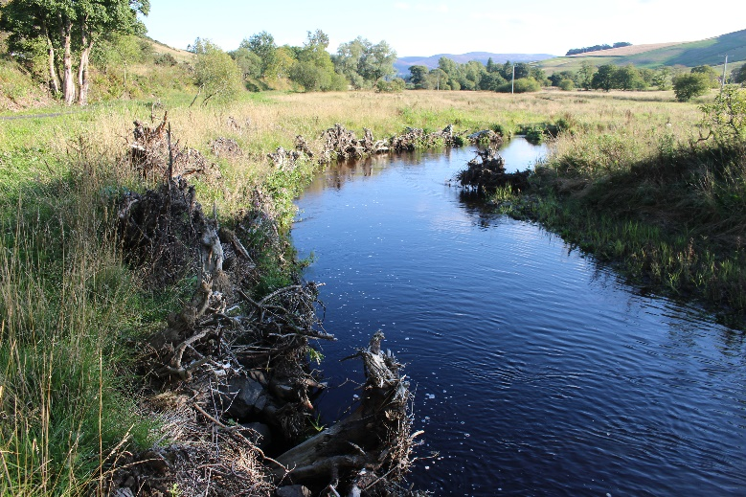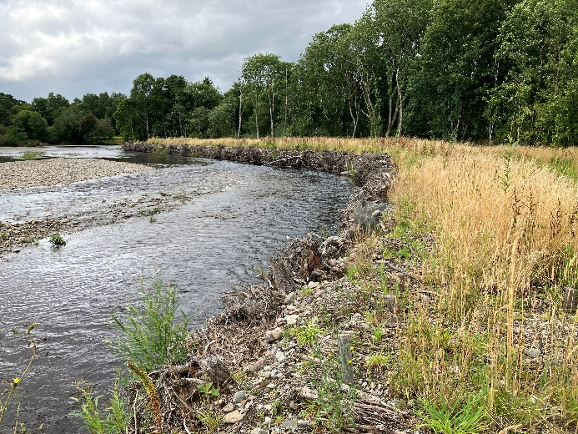
B)
A)
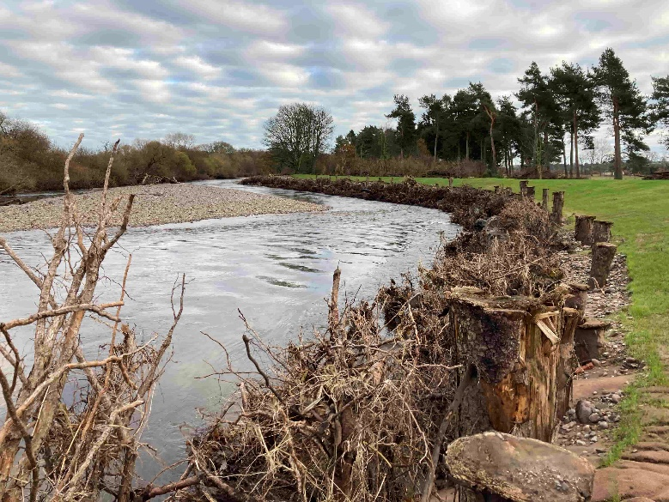
C)
Figure 27 Three examples of sites where root wads have been installed creating a rough and dense face on the surface of the bank. A) photo courtesy of Chris Spray. B shows root wads as used as part of a flood scheme and C) root wads downstream of Brechin which survived the > 200 year Storm Babet 2 months after installation.
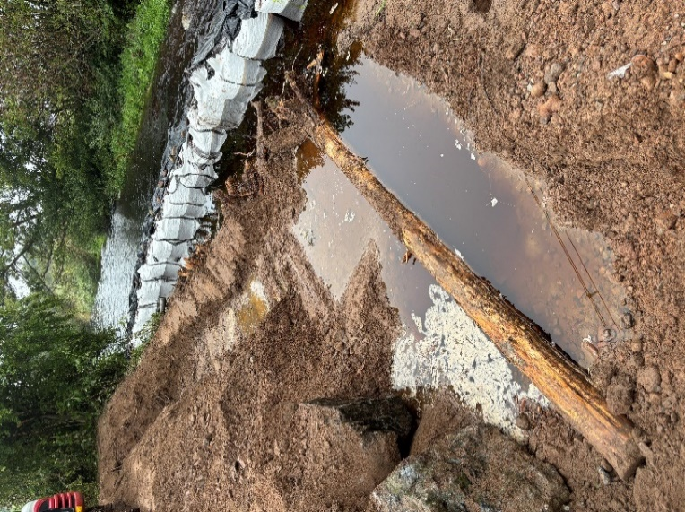
Figure 28 Root wad being installed into a bank illustrating how the bank is excavated to lay the root wad at the bank toe and then rebuilt on top of it. Photo courtesy of the Tweed Forum.
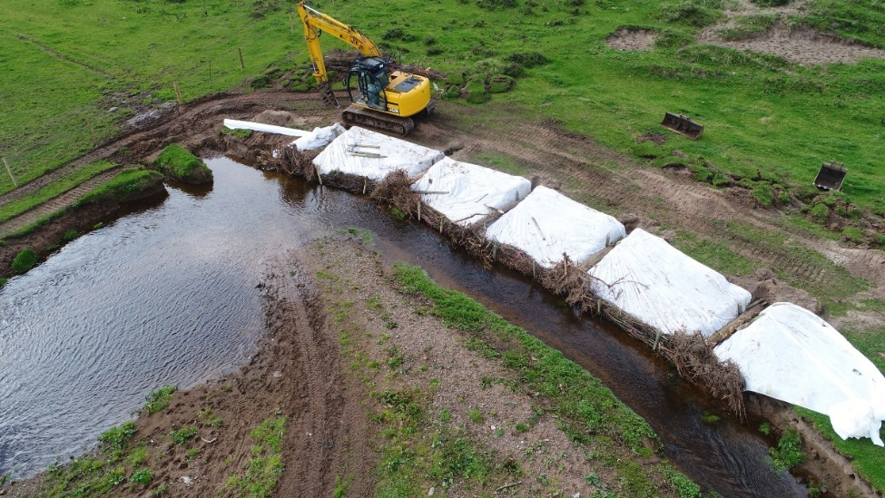
Figure 29 Photograph showing installation of root wads with brash bundles between them. A biodegradable lining was used to hold the banks while the planted willow established on the bank top. Photo courtesy of Chris Savage and Cassillis Estate.
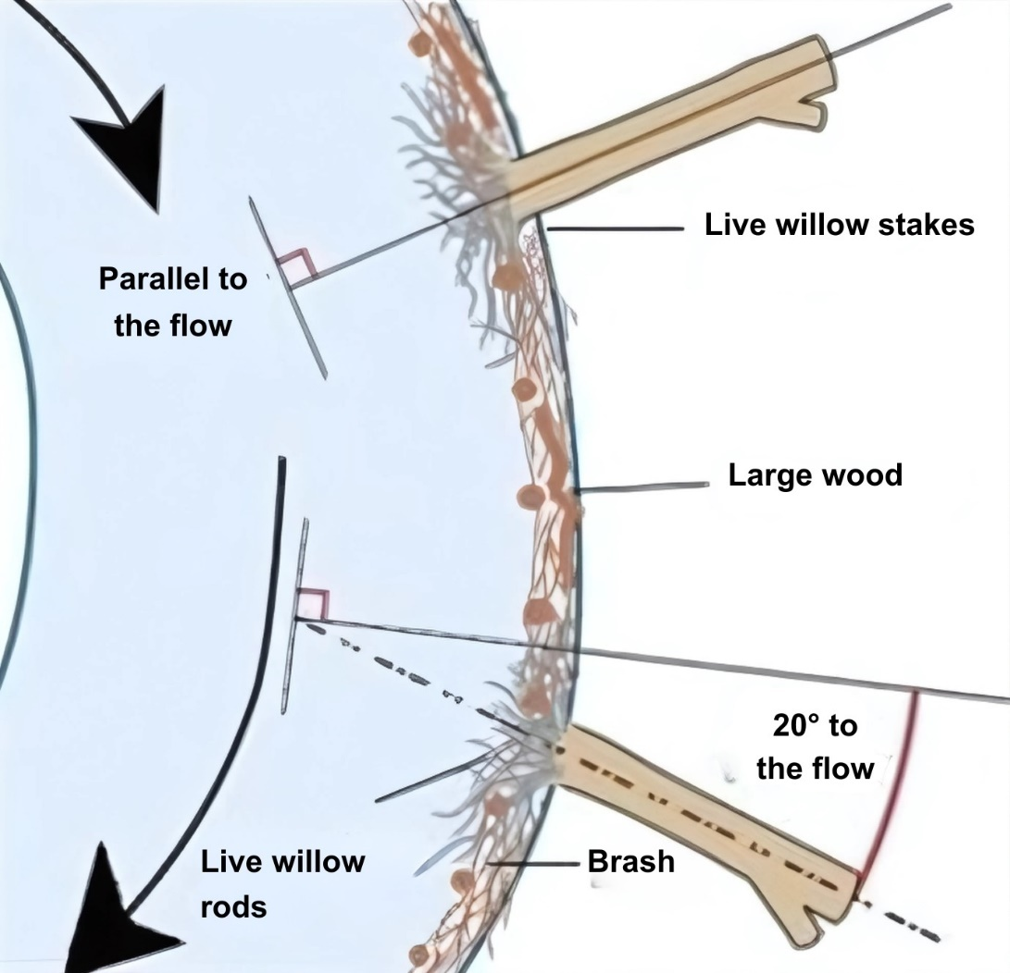

Figure 30 Root wads combined with large wood and brash

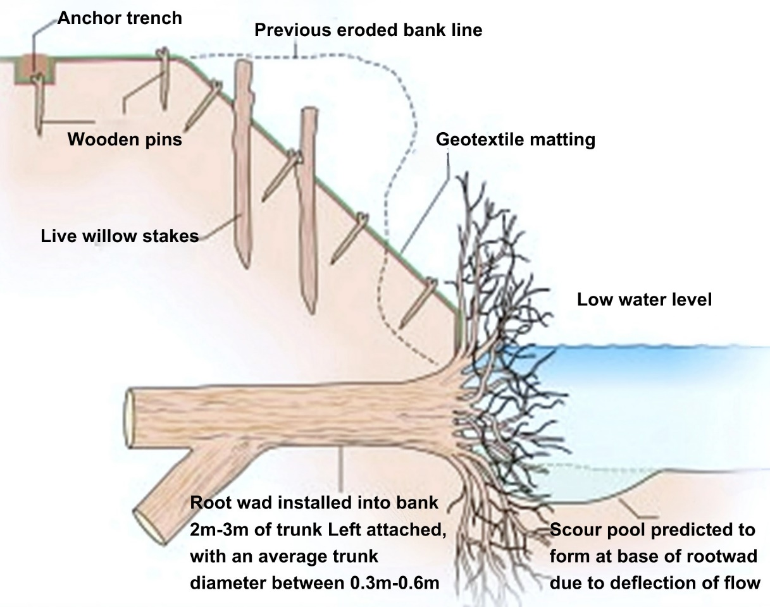
Figure 31 Profile view of bank root wads

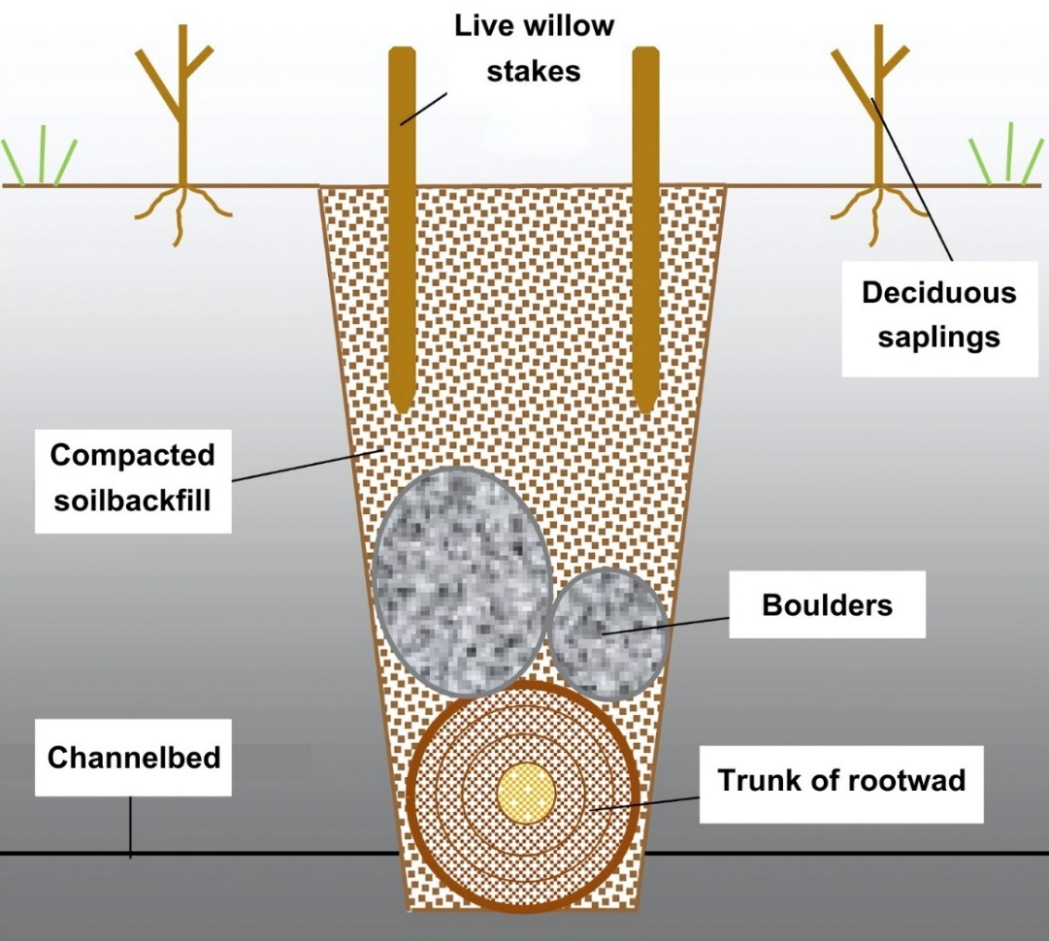

Figure 32 Cross-section showing root wad stabilisation using individual large boulders

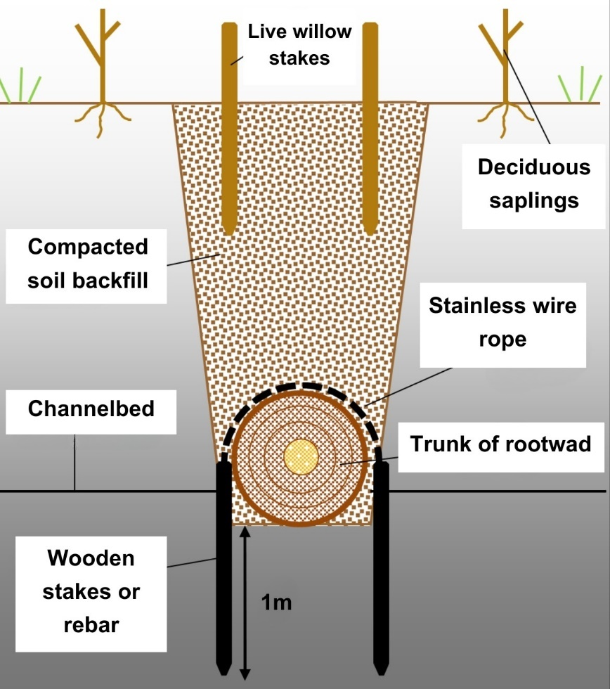
Figure 33 Cross-section showing root wad stabilisation using wire rope lacing

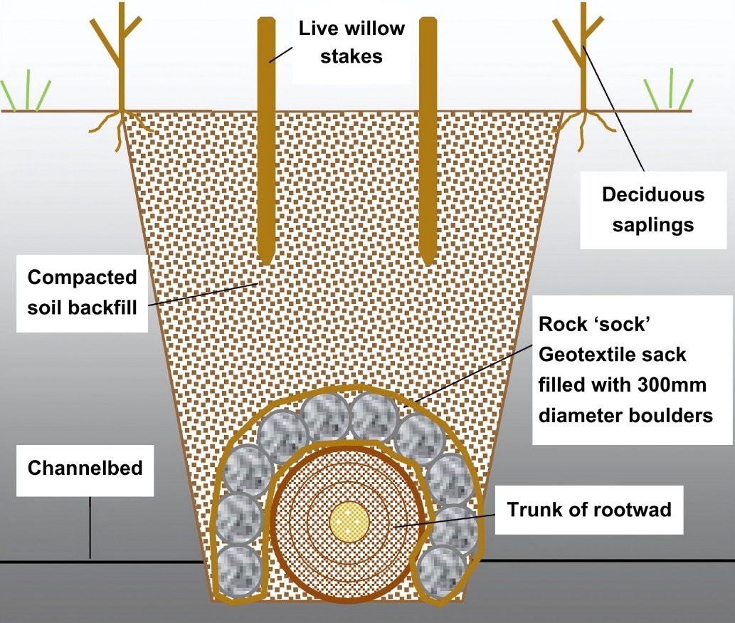

Figure 34 Cross section showing root wad stabilisation using rock roll
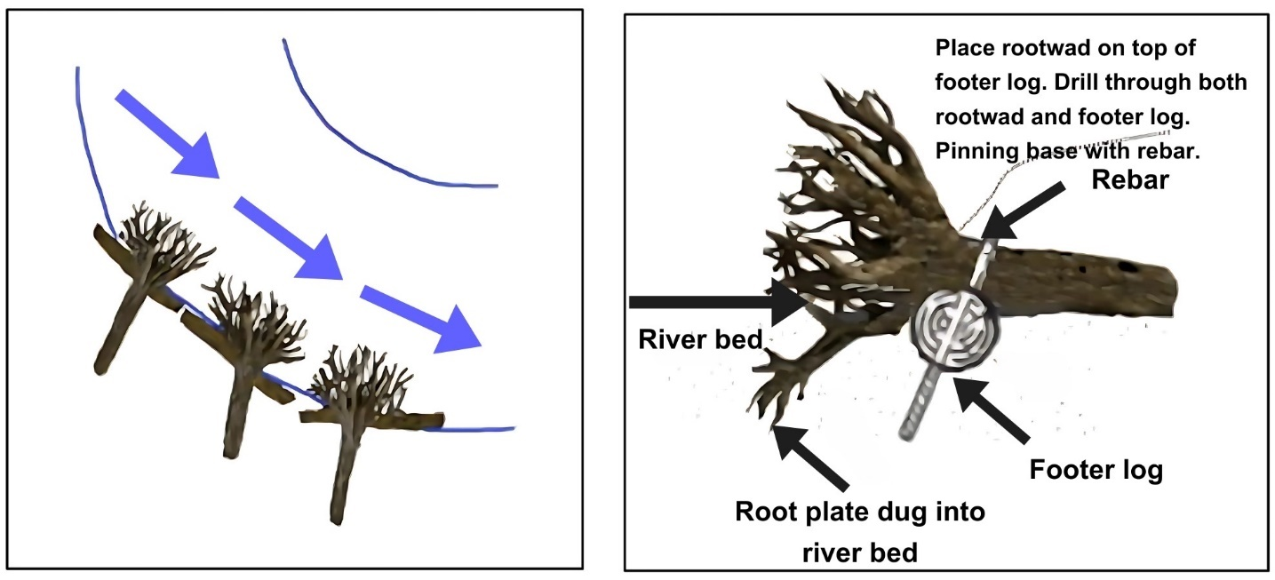
Figure 35 Toe protection achieved by setting a log partly into the bed and placing root wad on top. The root wad can then be secured to the footer log by drilling through both trunk using a rebar. It is important to maintain roughness in front of footer log.

9 Key points and recommendations
- Whole tree bank protection works have proven to be an especially effective technique in many high energy rivers in Scotland.
- It is best to install protection in the later part of winter (February to March) to reduce exposure of recently disturbed ground to high flows and to provide a full first year growing season to help the establishment of vegetation.
- The first two years of establishment and settling in are often the key to success.
- It is very important to inspect the works following high flows and make quick repairs. Some replanting may be necessary.
- Brash and large pieces of wood are very good for making small repairs.
- Livestock must be kept away from the finished works. Not only can they eat planted tress they can also do damage by trampling. Be aware that livestock may be able to access the works from the opposite bank.
- Species of willow especially suited for these techniques are osier; white and crack willow as they are fast growing and quick to establish.
- Goat willow is also suitable and will produce lower busy growth, however it can be slower to establish.
- Use live wood ‘willow’ stakes as much as possible as opposed to ‘normal’ timber posts as these can sprout and grow creating a living wall and resulting in a rougher and more resilient bank.
- Bank toe protection may be required in some situations to allow time for bank roughness to develop i.e. from planted trees. This protection should be rough wood/brash or small/medium sized stones similar to what is already on the channel bed and be submerged during normal flows.
- All methods benefit from riparian planting of trees on the banks and bank top.
- Species such as alder, aspen, hazel and willow are all suitable.
- Trees such as alder and willow should be coppiced after about 2 - 5 years to establish bushy growth and occasionally thereafter unless you want larger trees.

9.1 Willow Spiling
- White, Crack willow and Osier are well suited willow species.
- Whilst suitable note that goat willow is slower to establish than other species. However, once established this may require less maintenance.
- Steep upper banks should be re-profiled and terraced (no steeper than approximately 1 in 2).
- Vertical posts: ideally live wood, need to be driven in two thirds of length and installed at least every 0.5 metres.
- Willow rods 2 to 6 metres in length to make spiling walls (approximately 20 to 30 rods high). Each spiling wall should ideally be in the range of 0.6 to 1 metre high.
- Terrace width should be greater than the height of the spiling wall.
- Bank toe protection may be required in some cases to allow time for bank roughness to develop i.e. from planted trees. This protection should be rough wood/brash or small/medium sized stones similar to what is already on the channel bed and be submerged during normal flows.
- Install between November and the end March, later part is recommended.
- Exclude livestock. Be aware that livestock may be able to access the works from the opposite bank.
- Coppicing is recommended after approximately 2 years to promote bushy growth.
- Inspect after high flows and repair any damage quickly esp. in the first few years.
- During establishment watering may be needed if there are long dry periods.
- Where beaver were found to coppice the willow over the winter months, which then regrew in the spring, and did not damage the effectiveness of the protection.

9.2 Brash and small trees
- Use of brash is a very versatile and flexible technique and doesn’t need a high level of skill or experience to install.
- It can actively trap sediment helping to rebuild banks.
- Brash should ideally be secured using live willow stakes driven through matrix or live stakes and wire stretched over the matrix.
- Stakes and posts should be driven in around two thirds of their length, at least 1 metre deep.
- The effectiveness can be enhanced by weaving live willow rods or large branches between stakes.
- As with other techniques they should ideally be supplemented with live willow stakes and riparian planting.
- Exclude from livestock. Be aware that livestock may be able to access the works from the opposite bank.
- If continued access to the bank is required, non live brash and stakes can be used, with fencing this can still achieve a stable bank.
- Repair any weak spots that may show after high flows with further brash and live wood stakes/cuttings.
- This technique is also suited for making small repairs to other techniques. E.g. filling any small scour holes around spiling; root wads or whole trees.

9.3 Whole trees
- The technique is especially well suited to higher energy and mobile Scottish rivers.
- Attaching the trees with a stainless steel cable to buried log anchors or large anchor posts have both proven effective methods for securing the trees.
- Trees should be laid trunk pointing upstream, each tree overlapping by 25 percent. Banks can be re-profiled to no steeper than 30 degrees (approximately 1 in 2).
- It is important to supplement the works with tree planting especially live willow stakes (such as white or crack willow) to help provide long term bank strength.
- Pay particular attention to protecting the up and downstream ends of the works.
- Fence off the works and make sure livestock cannot gain access to the bank protection by crossing the river. Further trees brash etc. can help fend them off.

9.4 Root Wads
- The root wads must be partly set into the bed. The trunk should be level with or very close to the bed to help deal with toe scour.
- The root plate should contain as many roots and as rough as possible and be as large as is practical to transport and use.
- Use fairly fresh root wads as the roots will be more flexible. Old root wads may be brittle and not as effective.
- If live willow root wads can be obtained these are often the best as they will grow and further strengthen the bank.
- The root wads must also be properly backfilled with soil, rocks and brash and the ground well compacted. Otherwise a weak spot can be created which is susceptible to rapid erosion.
- To limit scour at the bank toe in higher energy situations make the bank toe as rough as possible (i.e. using brash or other large wood).
- Exclude livestock, be aware they may try to access from the opposite bank.
- Root wads work well in conjunction with brash.
- Supplement with tree planting around the root plate and on the bank to provide long term bank strength.
- Inspect regularly after high flows in the first few years and quickly repair any developing issues. Brash and large wood is especially useful for repairs.

Glossary
Bank Toe is the lowest point on the bank of a watercourse or loch, where the bank meets the bed of the watercourse or loch.
Brash Any of the following that are easily moveable by hand: parts of a branch, whole branches or parts of tree stems with branches attached.
Brash Bundles Individual pieces of brash tied sufficiently tightly together to form a coherent structure but not so tightly as to leave virtually no space between the pieces
Eroding banks A bank of a watercourse or loch that is being eroded by the action of the water when river/loch levels are sufficiently high.
Large trees Whole trees that are of such a size that they cannot be lifted and installed by hand.
Large wood Parts of the following that are of such a size that they cannot be lifted and installed by hand: tree trunks with their branches attached, tree limbs with their branches attached or large branches with smaller branches attached.
Root plate The portion of the tree that would normally be below ground before the tree is uprooted.
Root wad The lower part of the trunk of a tree with the roots still attached and as much of the soil as possible removed so that the roots are left exposed. The tree may be dead or alive.
Small trees Whole trees small enough to be lifted and installed by hand without any mechanical assistance.
Willow spilling Live willow rods woven between live willow stakes driven into the bank or bed of a watercourse.

Disclaimer
Whilst every effort has been made to ensure the accuracy of this guidance, SEPA gives no warranty, covenant or undertaking (express or implied) regarding the fitness for purpose of, or any error, omission or discrepancy in this guidance. Reliance on its contents and the contents of any websites that are linked to or from this guidance is entirely at the user’s own risk. SEPA is not liable for any loss or damage that may come from using this guidance. This includes:
- any direct, indirect and consequential losses
- any loss or damage caused by civil wrongs, breach of contract or otherwise
SEPA reserves the right to depart from this guidance and take appropriate action as it considers necessary or appropriate. Operators are responsible for ensuring that they are compliant with the law. If necessary, independent legal / specialist advice should be sought.

