


Accessing Groundwater Level Data
May 2026

Introduction
SEPA currently monitors groundwater levels at 57 locations. The geographical spread is uneven, but this reflects current water resource pressures, including groundwater abstraction.

Monitoring locations
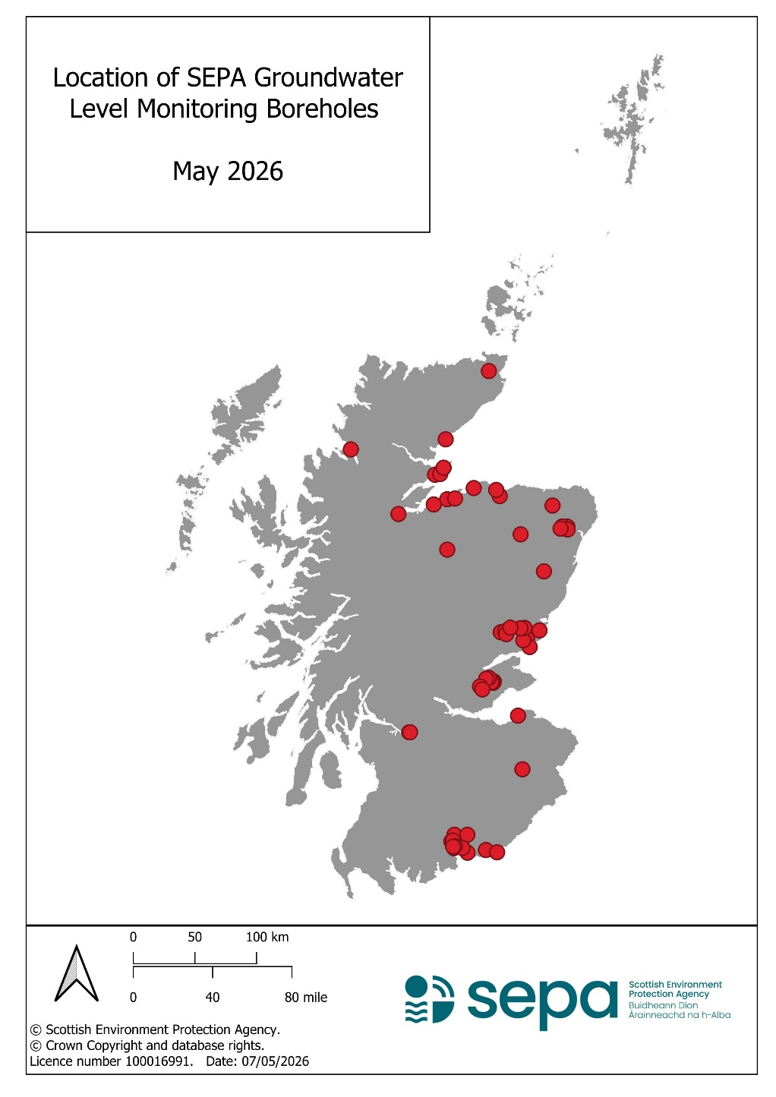
Groundwater level (GWL) data is available from SEPA for the locations in the map below. Full grid references are included in Table 1.

Groundwater level data can be downloaded directly from SEPA’s self-service API (Application Programming Interfaces): Time series data service (API)
The guidance contained within the two more-general documents relating to SEPA Hydrometric information also applies to our groundwater level data:
- Customer guide for accessing Hydrometric data
- Customer guide for understanding information received from Hydrometry
Unchecked status will apply to any ‘recent’ data that is available from the self-help options via the SEPA website, and this provisional data should be used with caution.
There are detailed instructions regarding the construction of appropriate API endpoints within the guidance available at the links above. However, here are some useful examples for understanding the available groundwater level datasets:
- The date range for which hourly groundwater level data is available at all sites
- The full list of available groundwater level time series
- Quick links for data and graphs for the last day, month and year for any one location can be found by editing the station_id reference number (highlighted in blue) in the link below:
timeseries.sepa.org.uk/KiWIS/KiWIS?service=kisters&type=queryServices&datasource=0&request=getTimeseriesList&format=html&station_id=40115&addlinks=true&returnfields=ts_id,station_no,station_name,stationparameter_name,ts_name,coverage
If you are unable to obtain the data you require from the API, then data can be requested by emailing foi@sepa.org.uk with the relevant SEPA station number from Table 1 below.

Table 1: Location details for SEPA groundwater level monitoring boreholes
Local Authority | SEPA Station No. | Station Name | API Station i.d. | Easting | Northing | Datum  (mAOD) | Approx. Depth  (m) | Horizon Monitored | Simplified Geology
Aberdeenshire | 365223 | Deerdykes Wood Deep Bedrock Borehole | 40243 | 388069 | 833722 | 60.20 | 38.45 | Bedrock | Metasediments
Aberdeenshire | 365228 | Mill of Keithfield BH | 40255 | 383944 | 833882 | 67.39 | 12.98 | Bedrock | Metasediments
Aberdeenshire | 365226 | Redmoss Oldtown BH | 40251 | 382541 | 832171 | 102.26 | 20.27 | Bedrock | Metasediments
Aberdeenshire | 323575 | Crows Nest LF BH W10 | 842021 | 369091 | 797430 | 75.76 | 23 | Bedrock | Schist
Aberdeenshire | 336852 | Delgaty | 40163 | 376081 | 850885 | 84.30 | 120 | Bedrock | Conglomerate
Aberdeenshire | 335798 | Rhynie | 40100 | 350125 | 827480 | 178.52 | 53 | Bedrock | Sandstone
Aberdeenshire | 365222 | Deerdykes Wood Shallow Bedrock BH | 40239 | 388058 | 833726 | 60.25 | 10.58 | Bedrock | Metasediments
Aberdeenshire | 365224 | Prop of Ythsie Borehole | 40247 | 388344 | 831456 | 65.01 | 14.56 | Bedrock | Metasediments
Angus | 348952 | Carmyllie War Memorial Obs BH | 40204 | 355278 | 742764 | 158.37 | 41.10 | Bedrock | Sandstone
Angus | 348956 | Crombie Country Park Obs BH | 40208 | 352293 | 741418 | 172.97 | 23.81 | Bedrock | Metasediments
Angus | 348936 | Mains of Balgavies Deep sst Obs BH | 40192 | 353386 | 751466 | 75.34 | 26.84 | Bedrock | Sandstone
Angus | 348935 | Murton Nature Reserve Observation BH | 40188 | 350033 | 751218 | 76.98 | 30.26 | Bedrock | Sandstone
Angus | 17064 | Cookston Deep | 39774 | 333958 | 747979 | 47.97 | 50 | Bedrock | Sandstone
Angus | 17067 | Glamis Castle (Solid) | 39786 | 337664 | 748844 | 61.63 | 34 | Bedrock | Sandstone
Angus | 17066 | Glamis Petrol Station | 39782 | 338540 | 746396 | 94.77 | 50 | Bedrock | Sandstone
Angus | 17069 | Redford | 39794 | 341854 | 751691 | 62.32 | 50 | Bedrock | Sandstone and Conglomerate
Angus | 7926 | Craigmill Burn Observation Borehole | 40498 | 357516 | 735964 | 14.32 | 25.04 | Bedrock | Sandstone
Angus | 348939 | Mains of Balgavies Shallow Sst Bedrock B | 40196 | 353385 | 751450 | 75.33 | 15.04 | Bedrock | Sandstone
Angus | 348944 | Kirkton Mill Drift Obs BH | 40200 | 365471 | 749434 | 11.34 | 14.46 | Superficial | Sand and Gravel
Angus | 17068 | Glamis Castle (Drift) | 39790 | 337664 | 748845 | 61.41 | 12 | Superficial | Sand and Gravel
Borders | 371826 | Easter Langlee Landfill BH 08-03S | 842022 | 351589 | 636649 | 153.81 | 31.91 | Bedrock | Greywacke
Dumfries & Galloway | 336398 | Annan (Creca) | 40115 | 321950 | 571050 | 99.33 | 78 | Bedrock | Sandstone
Dumfries & Galloway | 336403 | Gretna (Douglas Tanks) | 40119 | 331050 | 569250 | 46.61 | >50 | Bedrock | Sandstone
Dumfries & Galloway | 336526 | Newbridge | 40156 | 295150 | 578850 | 15.68 | 28 | Bedrock | Sandstone
Dumfries & Galloway | 336427 | Redbank | 40131 | 296750 | 574250 | 13.52 | 28 | Bedrock | Sandstone and Conglomerate
Dumfries & Galloway | 133760 | Longbridgemuir Farm | 39465 | 307033 | 568891 | 19.00 | 80 | Bedrock | Sandstone and Breccia
Dumfries & Galloway | 133763 | Racks Moss Deep | 39477 | 302936 | 572768 | 12.00 | 100 | Bedrock | Sandstone
Dumfries & Galloway | 460188 | Barbush Farm BH | 40348 | 296008 | 572608 | 35.00 | 52 | Bedrock | Sandstone
Dumfries & Galloway | 459910 | Duncow Deep Obs BH Dumfries | 40340 | 296417 | 583389 | 20.30 | 80 | Bedrock | Sandstone
Dumfries & Galloway | 459909 | Duncow Shallow Obs BH | 40336 | 296417 | 583389 | 20.30 | 44 | Bedrock | Sandstone
Dumfries & Galloway | 336419 | Lochmaben | 40127 | 306850 | 583450 | 61.03 | 77 | Bedrock | Sandstone
Dumfries & Galloway | 459908 | Maryfield Shallow Obs BH | 40332 | 293840 | 578162 | 39.00 | 22.30 | Bedrock | Sandstone
Dumfries & Galloway | 459911 | Waterside Farm Obs BH | 40344 | 295295 | 573894 | 40.70 | 49 | Bedrock | Sandstone
East Lothian | 17156 | Luffness Borehole | 39798 | 348010 | 680190 | 8.30 | 35 | Superficial | Sand and Gravel
Fife | 335659 | East Lathrisk Borehole | 40094 | 328365 | 708019 | 40.00 | 61 | Bedrock | Sandstone
Fife | 379369 | Knowehead shallow obs BH Freuchie | 40310 | 327907 | 706989 | 54.18 | 36 | Bedrock | Sandstone
Fife | 14458 | Knowhead | 39485 | 327830 | 706960 | 55.90 | 91 | Bedrock | Sandstone
Fife | 14419 | Newton of Falkland Borehole | 39481 | 326600 | 707442 | 46.64 | 60 | Bedrock | Sandstone
Fife | 379368 | Reedieleys Farm Obs BH Dunshalt | 40306 | 324334 | 710931 | 43.24 | 45 | Bedrock | Sandstone
Fife | 379370 | Strathmiglo Obs BH Strathmiglo | 40314 | 322160 | 710163 | 52.74 | 17.50 | Bedrock | Sandstone
Glasgow | 601657 | Sighthill Monitoring BH GRO101 | 842024 | 259713 | 666732 | 47.17 | 25 | Bedrock | Siltstone, Sandstone and Mudstone
Glasgow | 601658 | Sighthill Monitoring BH Z1_ROT_604 | 842023 | 260355 | 666739 | 57.97 | 30 | Bedrock | Sandstone
Highland | 300350 | Arabella Junction | 40018 | 280658 | 875922 | 4.00 | 30 | Bedrock | Sandstone
Highland | 300348 | Auldearn Junction | 40010 | 290557 | 856004 | 19.10 | 50 | Bedrock | Sandstone
Highland | 378644 | Drumine BH2 Brackley Junction West | 40302 | 279598 | 851768 | 30.60 | 34.50 | Bedrock | Sandstone and Conglomerate
Highland | 300351 | Hill of Fearn farm | 40022 | 284864 | 876558 | 11.90 | 40 | Bedrock | Sandstone
Highland | 602637 | Ardachu LF BH6 | 842025 | 289283 | 904693 | 56.00 | 13.08 | Bedrock | Sandstone
Highland | 601518 | Seater LF BH GMP24 | 842018 | 324364 | 960170 | 79.41 | 9 | Bedrock | Siltstone, Sandstone and Mudstone
Highland | 601515 | Granish Landfill BH GW2 | 842017 | 290540 | 815080 | 226.41 | 24 | Superficial | Sand and Gravel
Highland | 335201 | Scottish Seafarms BH2 | 40068 | 250924 | 844008 | 7.85 | 14 | Superficial | Sand and Gravel
Highland | 344550 | Strathain BH1 LF | 842020 | 212260 | 896480 | 104.00 | 4 | Superficial | Glacial deposits
Highland | 525685 | Wester Arboll BH | 842019 | 287595 | 881615 | 19.00 | 8 | Superficial | Sand, Gravel and Silt
Moray | 300349 | Feddan Junction | 40014 | 296864 | 856616 | 30.40 | 40 | Bedrock | Sandstone
Moray | 331473 | Roseisle Maltings | 40064 | 312100 | 865070 | 8.31 | 76.10 | Bedrock | Sandstone
Moray | 336517 | Dipple G | 40148 | 333159 | 858531 | 24.56 | 4.32 | Superficial | Sand and Gravel
Moray | 340431 | Maverston Farm BH3 | 40172 | 330329 | 863569 | 25.00 | 27 | Superficial | Sand and Gravel
Perth & Kinross | 335655 | Scotlandwell | 40090 | 319027 | 701557 | 119.84 | 118 | Bedrock | Sandstone
Perth & Kinross | 379371 | Easter Balgedie Farm Obs BH Kinross | 40318 | 317169 | 703970 | 158.70 | 42 | Bedrock | Sandstone

If you would like this document in an accessible format, such as large print, audio recording or braille, please contact SEPA by emailing equalities@sepa.org.uk

