Agency Board meeting

30 June 2026

Draft quarter 4 financial monitoring report for period ending 31 March 2026
Purpose:
This report is to provide an update to the Board on the following areas:
- Overall financial position
This is the quarter four financial report for 2025/26. Actual financial results for the year 1 April 2025 to 31 March 2026 show SEPA reporting a £41k underspend.
- Capital budget
The capital summary for the period ending 31 March 2026 is provided in section 4 of this report.
- Final accounts work is ongoing, and these figures should be considered draft as they may be subject to change following final year-end adjustments and/or external audit adjustments.

Recommendations:
The Board is asked to note:
- SEPA’s financial performance for the period ending 31 March 2026.
- That the results reported are draft results as they may be subject to year-end adjustments and external audit.
Authors: Ian Bryce, Deputy Head of Finance; Rosaleen Burke, Head of Finance.
Corporate Leadership Team Sponsor: Angela Milloy, Chief Officer Finance, Modernisation and Digital.
Date: 17 June 2026

Table 1: Full year outturn
Income and expenditure account at 31st March 2026 | Outturn £'000 | Budget £'000 | Variance £'000
Grant in Aid | 53,721 | 53,721 | 0
Charging Schemes | 56,394 | 57,032 | (638)
Other income | 1,654 | 1,551 | 103
Total income | 111,769 | 112,304 | (535)
Staff costs | 76,311 | 75,273 | (1,038)
Other staff costs | 1,386 | 943 | (443)
Transport costs | 916 | 1,050 | 134
Supplies & services | 20,921 | 23,119 | 2,198
Property costs | 5,244 | 4,539 | (705)
Depreciation/impairment | 7,380 | 7,380 | 0
Gain or loss on disposal of assets | (430) | 0 | 430
Total operating costs | 111,728 | 112,304 | 576
Operating surplus/ (deficit) | 41 | 0 | 41

Introduction
  - At March, there is a net underspend of £0.041m. This reflects an operating cost underspend of £576k, offset by reduced income of £535k.

Total income - £111.8m
  - Total income for the full year was £111.8m, which is £0.5m below the full year budget. This is due to:
    - £638k - Charging Scheme income lower than budget offset by.
    - £103k – Other income higher than budget.

Charging Scheme income - £56.4m
  - The full year charging scheme income for the year was £56.4m, which is £0.6m lower than budget. The net variance includes:
    - £85k under on application income (full year budget of £7.1m).
    - £553k under subsistence income (full year budget of £49.9m).

  - The reduction in income is mainly due to in year changes in licences, mothballed and surrendered licences across all media. These reductions are currently being offset by increased income from Radioactive Substances Activity (RSA) charges.

Graph 1: Charging Schemes by media
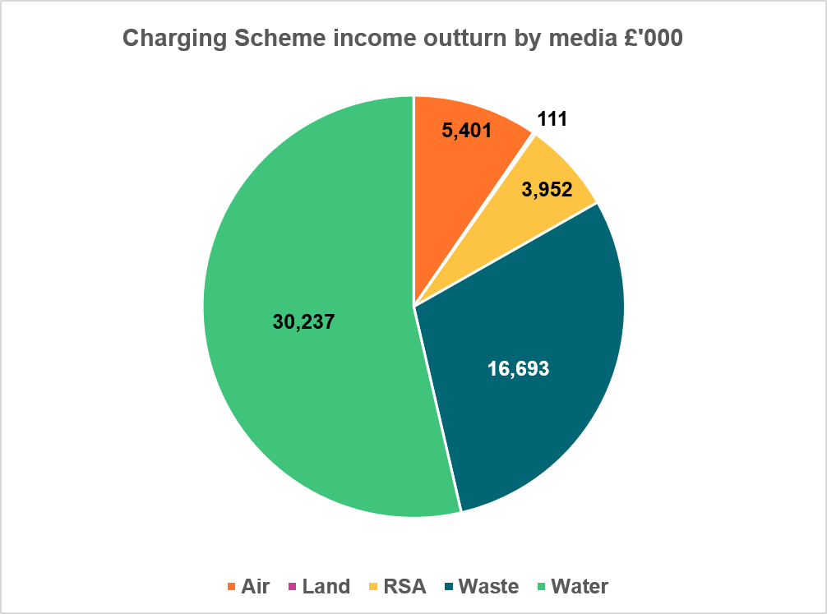
Note: Graph 1 acronym: RSA – Radioactive Substances Activity

Other income - £1.6m
  - The full year other income was £1.6m, being £103k higher than the budget, mainly due higher than budgeted bank interest.

Revenue Grant in Aid (GiA) - £53.7m

Table 2: Grant in Aid
 | Resource budget  cash  £’000s | Resource budget non- cash  £’000s | Total  £’000s
Base budget allocation 2025/26 | 42,400 | 7,377 | 49,777
Budget adjustments
Regulation systems | 995 |  | 995
Multi agency fish farm consenting | 261 |  | 261
Water Environment Fund | 1,887 |  | 1,887
Flood Advisory Service | 150 |  | 150
Cleaner Air (CAFS 2) | 30 |  | 30
Air Quality (Volcanic Monitoring) | 28 |  | 28
Air Quality (Zephyre Maintenance) | 12 |  | 12
Emission Trading Scheme & Fgas | 331 |  | 331
Water Environment Fund - SBR | 250 |  | 250
Total adjustments | 3,944 | 0 | 3,944
Total revenue budget | 46,344 | 7,377 | 53,721

  - Revenue GiA for 2025/26 has increased by £3.9m since budget set following additional funds for Water Environment Fund (WEF) work, regulation systems, fish farm consenting and flood advisory service. The additional funds for fish farm consents and regulation monies were awarded following successful applications to Scottish Government’s Public Service Reform (PSR) Invest to Save Fund.

Total revenue expenditure - £112m
  - Full year operating costs are £0.6m less than budget. The graph below provides a detailed breakdown by expenditure type.

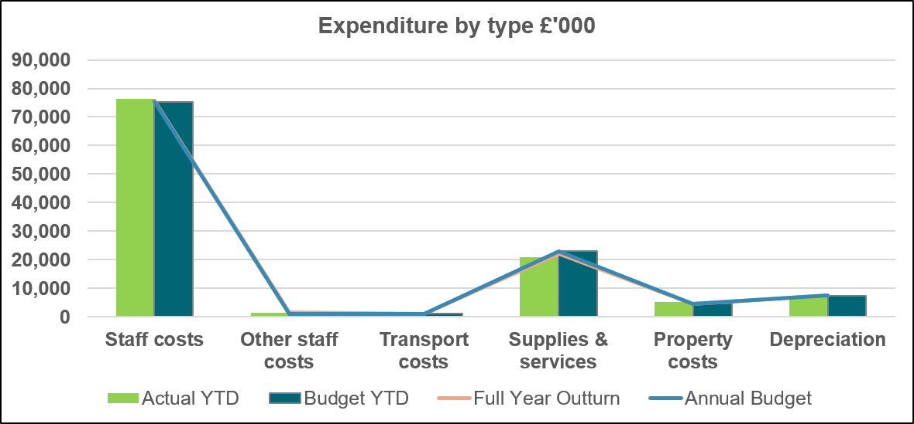
Graph 2: Expenditure by type

Staff costs
  - Budgeted staff costs represent 68% of total expenditure. The full year cost for staff was £1m above budget, mainly due a higher than budgeted pay settlement and lower than budgeted vacancy management savings.

Other staff costs
  - Other staff costs for the year resulted in overspend of £0.5m mainly due to higher than budget forecast expenditure for temporary workers and recruitment costs. These costs are generally funded from vacancy savings, however with targets not currently being achieved they are funded from underspends in corporate costs.

Transport costs
  - Transport costs for the year resulted in an underspend of £0.1m. This is the net movement due to reduced mileage claims primarily due to improved fleet provision.

Supplies and services
  - Supplies and services for the year resulted in a £2.2m underspend. This relates to budget movements between non-staff and staff expenditure lines to fund the pay award and potential in year budget pressures within some portfolios.

Property costs
  - Property costs for the year resulted in a overspend of £0.7m, which mostly relates to overspends on maintenance and lease termination costs.

Capital expenditure summary
  - SEPA’s capital budget provided by Scottish Government ((SG) for the year is £5.64m. In year, SG confirmed funds of an additional £0.6m to support the creation of a foundational flood and coastal asset database for Scotland and £1m for wave buoy deployment, increasing the total capital budget to £7.21m.

  - The base budget was approved with a planned over commitment based on the historical knowledge that capital projects are liable to delays, slippage of spend or revision of original budget estimates during the procurement journey. Actual expenditure for the year was £0.8m below budget relating to capital monies received in year.

Table 3: Capital budget 2025/26
Function | Budget £'000 | Outturn £'000 | Main projects within function budgets
Digital Transformation | 495 | 38 | Compliance Project
Governance | 1,450 | 107 | Digital Data Architecture
Chemistry | 124 | 429 | Nutrients Analysers & Lab Balances
Environmental quality | 93 | 72 | Bathing Waters Signage
Info Systems | 250 | 434 | High Performance Computing & Laptop Replacement
Info Systems (Digital) | 1,150 | 1,312 | Integrated Authorisation Framework Implementation
People Systems | 70 | 50 | Applicant Tracking System
Finance Systems | 50 | 55 | Charging Cost Review
Workspaces | 1,045 | 1,781 | Stirling Office Dilapidations & Fleet Replacement
Hydrology | 3,466 | 2,160 | Gauging Stations & Flooding projects, flood & coastal asset database and wave buoy deployment
Planned overcommitment | (983) | 0
Totals | 7,210 | 6,438

Statement of financial position
  - The Statement of financial position is provided over the page.

Table 4: Statement of financial position
Statement of financial position | Year to 31 March 2026  £'000 | Year to March 2025  £'000
Non-current assets
Property, plant and equipment | 38,555 | 42,075
Intangible assets | 3,618 | 4,027
Assets under construction | 5,008 | 2,380
Employee retirement benefits | 0 | 0
Trade and other receivables | 86 | 232
Total non-current assets | 47,267 | 48,714
Current assets
Trade and other receivables | 7,501 | 5,029
Cash and cash equivalents | 4,275 | 2,346
Total current assets | 11,776 | 7,375
Total assets | 59,042 | 56,089
Current liabilities
Trade and other payables | (16,752) | (13,683)
Provisions | (422) | (231)
Future lease payments | (1,070) | (1,306)
Total current liabilities | (18,244) | (15,220)
Total assets less current liabilities | 40,798 | 40,869
Non current liabilities
Provisions for liabilities and charges >1 year | (4,435) | (6,059)
Future lease payments | (3,523) | (5,475)
Total non-current liabilities | (7,958) | (11,534)
Total assets less total liabilities | 32,840 | 29,335
Taxpayers' equity and other reserves
General fund | 13,621 | 10,295
Revaluation reserve | 19,219 | 19,040
Total tax payers’ equity | 32,840 | 29,335

Recommendation
  - The Board is asked to note:
- SEPA’s financial performance for the period ending 31 March 2026.
- That the results reported are draft results as they may be subject to year-end adjustments and external audit.

END
<Report date here (month, year)>

