


Scottish Household Waste Generated and Managed – 2025
October 2026

Official Statistics

Scottish household waste generated and managed 2025

An Official Statistics Publication for Scotland

Publication Date: 27th October 2026 9:30 AM
This release shows the 2025 calendar year summary of household waste generated in Scotland and managed by or on behalf of Scottish local authorities. Information on the methodology used to prepare this release and a definition of terms is in the methodology and glossary. Summary data tables are available to download in Excel format on SEPA’s web site.

Key points
Scottish Household waste – 2025 calendar year
- The total amount of household waste generated in Scotland in 2025 was 2.31 million tonnes, a decrease of 1,500 tonnes (0.1%) from 2024 (Table 1A).
- For 2025, the Scottish household waste recycling rate was 42.8%, a decrease of 1.4 percentage points from the 44.3% rate achieved in 2024. The amount of household waste recycled between 2024 and 2025 decreased by 34,000 tonnes (3.3%) to 991,000 tonnes.
- For 2025, the total amount of Scottish household waste managed by other diversion from landfill was 1.09 million tonnes, an increase of 58,000 tonnes (5.6%) from 2024. Most of the diverted waste in 2025 was managed by incineration (901,000 tonnes, 82.4%), compared with 853,000 tonnes (82.3%) in 2024.
- The amount of Scottish household waste landfilled in 2025 was 228,000 tonnes, a decrease of 26,000 tonnes (10.3%) from 2024. This is the lowest amount of household waste landfilled in the current time series. It continues a long term trend, with a reduction of 1.23 million tonnes (84.3%) since 2011. The landfill rate in 2025 was 9.9% which was 1.1 percentage points lower than for 2024.

Waste Summary 2025

Generated and managed

Figure 1. Scottish household waste generated and managed in 2025 - summary data
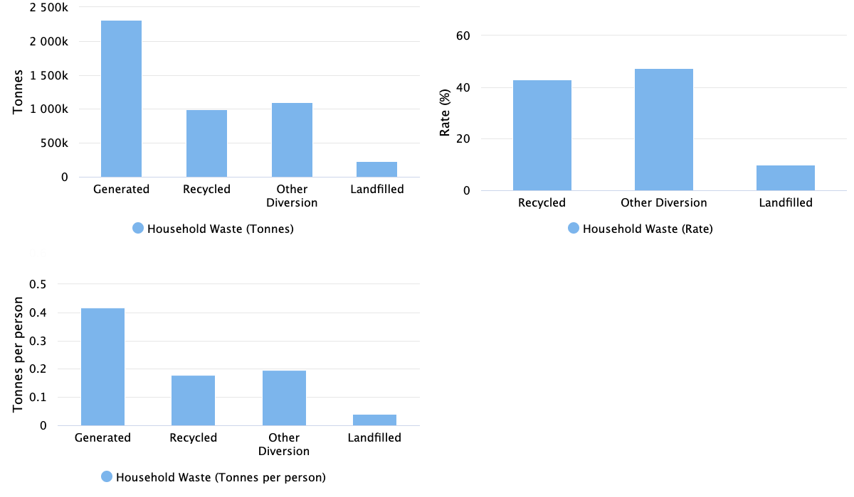

Table 1A. Scottish household waste generated and managed in 2025 - summary data
Local authority | Generated (tonnes) | Recycled (tonnes) | Recycled (%) | Other diversion from landfill (tonnes) | Other diversion from landfill (%) | Landfilled (tonnes) | Landfilled (%) | 2024 Recycled (%)
Aberdeen City | 88,462 | 35,924 | 40.6 | 44,375 | 50.2 | 8,163 | 9.2 | 43.1
Aberdeenshire | 109,430 | 48,963 | 44.7 | 48,559 | 44.4 | 11,909 | 10.9 | 44.7
Angus | 48,307 | 24,367 | 50.4 | 23,557 | 48.8 | 384 | 0.8 | 53.3
Argyll and Bute | 50,108 | 21,329 | 42.6 | 9,993 | 19.9 | 18,786 | 37.5 | 42.5
City of Edinburgh | 200,070 | 71,663 | 35.8 | 121,814 | 60.9 | 6,594 | 3.3 | 37.5
Clackmannanshire | 24,859 | 14,048 | 56.5 | 10,308 | 41.5 | 504 | 2.0 | 57.2
Dumfries and Galloway | 67,016 | 28,454 | 42.5 | 33,047 | 49.3 | 5,514 | 8.2 | 43.2
Dundee City | 63,540 | 21,652 | 34.1 | 41,182 | 64.8 | 705 | 1.1 | 35.1
East Ayrshire | 52,295 | 25,487 | 48.7 | 26,808 | 51.3 | 0 | 0.0 | 49.2
East Dunbartonshire | 50,706 | 26,373 | 52.0 | 24,183 | 47.7 | 151 | 0.3 | 54.3
East Lothian | 48,432 | 26,276 | 54.3 | 20,784 | 42.9 | 1,372 | 2.8 | 55.3
East Renfrewshire | 41,308 | 22,020 | 53.3 | 18,727 | 45.3 | 561 | 1.4 | 50.9
Falkirk | 64,651 | 32,889 | 50.9 | 31,749 | 49.1 | 13 | 0.0 | 51.5
Fife | 160,585 | 69,205 | 43.1 | 61,468 | 38.3 | 29,911 | 18.6 | 44.5
Glasgow City | 229,215 | 59,552 | 26.0 | 131,952 | 57.6 | 37,712 | 16.5 | 30.6
Highland | 107,249 | 49,156 | 45.8 | 45,662 | 42.6 | 12,431 | 11.6 | 42.5
Inverclyde | 26,654 | 14,158 | 53.1 | 10,015 | 37.6 | 2,481 | 9.3 | 50.3
Midlothian | 42,398 | 19,480 | 45.9 | 16,116 | 38.0 | 6,802 | 16.0 | 48.1
Moray | 44,890 | 22,809 | 50.8 | 21,554 | 48.0 | 528 | 1.2 | 56.7
Na h-Eileanan Siar | 13,574 | 4,801 | 35.4 | 234 | 1.7 | 8,538 | 62.9 | 40.3
North Ayrshire | 58,606 | 31,031 | 52.9 | 27,256 | 46.5 | 417 | 0.7 | 53.0
North Lanarkshire | 152,243 | 70,037 | 46.0 | 60,652 | 39.8 | 21,554 | 14.2 | 47.9
Orkney Islands | 11,655 | 2,118 | 18.2 | 5,127 | 44.0 | 3,679 | 31.6 | 21.1
Perth and Kinross | 73,178 | 35,686 | 48.8 | 25,548 | 34.9 | 11,970 | 16.4 | 50.9
Renfrewshire | 77,040 | 32,872 | 42.7 | 41,813 | 54.3 | 2,355 | 3.1 | 42.8
Scottish Borders | 51,142 | 22,825 | 44.6 | 20,467 | 40.0 | 7,850 | 15.3 | 53.2
Shetland Islands | 9,357 | 1,835 | 19.6 | 5,254 | 56.1 | 2,268 | 24.2 | 20.5
South Ayrshire | 51,559 | 28,398 | 55.1 | 23,116 | 44.8 | 45 | 0.1 | 53.3
South Lanarkshire | 142,776 | 60,095 | 42.1 | 80,498 | 56.4 | 2,184 | 1.5 | 40.7
Stirling | 38,521 | 20,266 | 52.6 | 15,250 | 39.6 | 3,017 | 7.8 | 53.2
West Dunbartonshire | 42,047 | 16,800 | 40.0 | 20,796 | 49.5 | 4,452 | 10.6 | 38.2
West Lothian | 71,750 | 30,218 | 42.1 | 26,206 | 36.5 | 15,326 | 21.4 | 49.3
Scotland | 2,313,624 | 990,788 | 42.8 | 1,094,071 | 47.3 | 228,176 | 9.9 | 44.3

Table 1B. Scottish household waste generated and managed per person in 2025 - summary data
Local authority | Generated (tonnes per person) | Recycled (tonnes per person) | Other diversion from landfill (tonnes per person) | Landfilled (tonnes per person)
Aberdeen City | 0.384 | 0.156 | 0.193 | 0.035
Aberdeenshire | 0.414 | 0.185 | 0.183 | 0.045
Angus | 0.421 | 0.213 | 0.206 | 0.003
Argyll and Bute | 0.574 | 0.244 | 0.114 | 0.215
City of Edinburgh | 0.377 | 0.135 | 0.229 | 0.012
Clackmannanshire | 0.482 | 0.272 | 0.200 | 0.010
Dumfries and Galloway | 0.461 | 0.196 | 0.227 | 0.038
Dundee City | 0.428 | 0.146 | 0.278 | 0.005
East Ayrshire | 0.431 | 0.210 | 0.221 | 0.000
East Dunbartonshire | 0.463 | 0.241 | 0.221 | 0.001
East Lothian | 0.416 | 0.226 | 0.178 | 0.012
East Renfrewshire | 0.414 | 0.221 | 0.188 | 0.006
Falkirk | 0.403 | 0.205 | 0.198 | 0.000
Fife | 0.429 | 0.185 | 0.164 | 0.080
Glasgow City | 0.350 | 0.091 | 0.202 | 0.058
Highland | 0.452 | 0.207 | 0.192 | 0.052
Inverclyde | 0.339 | 0.180 | 0.128 | 0.032
Midlothian | 0.422 | 0.194 | 0.161 | 0.068
Moray | 0.474 | 0.241 | 0.228 | 0.006
Na h-Eileanan Siar | 0.527 | 0.186 | 0.009 | 0.331
North Ayrshire | 0.438 | 0.232 | 0.204 | 0.003
North Lanarkshire | 0.443 | 0.204 | 0.176 | 0.063
Orkney Islands | 0.532 | 0.097 | 0.234 | 0.168
Perth and Kinross | 0.472 | 0.230 | 0.165 | 0.077
Renfrewshire | 0.407 | 0.174 | 0.221 | 0.012
Scottish Borders | 0.438 | 0.195 | 0.175 | 0.067
Shetland Islands | 0.412 | 0.081 | 0.231 | 0.100
South Ayrshire | 0.459 | 0.253 | 0.206 | 0.000
South Lanarkshire | 0.427 | 0.180 | 0.241 | 0.007
Stirling | 0.410 | 0.216 | 0.162 | 0.032
West Dunbartonshire | 0.476 | 0.190 | 0.235 | 0.050
West Lothian | 0.383 | 0.161 | 0.140 | 0.082
Scotland | 0.417 | 0.179 | 0.197 | 0.041

Data and Trends

Household waste generated
The total amount of household waste generated in Scotland in 2025 was 2.31 million tonnes, a decrease of 1,500 tonnes (0.1%) from 2024 and a decrease of 293,000 tonnes (11.2%) from 2011. Scottish household waste generated has been decreasing gradually since 2011, with the last four years the lowest recorded in the time series (Figure 2).

Figure 2. Household waste generated in Scotland 2011 - 2025 (tonnes)
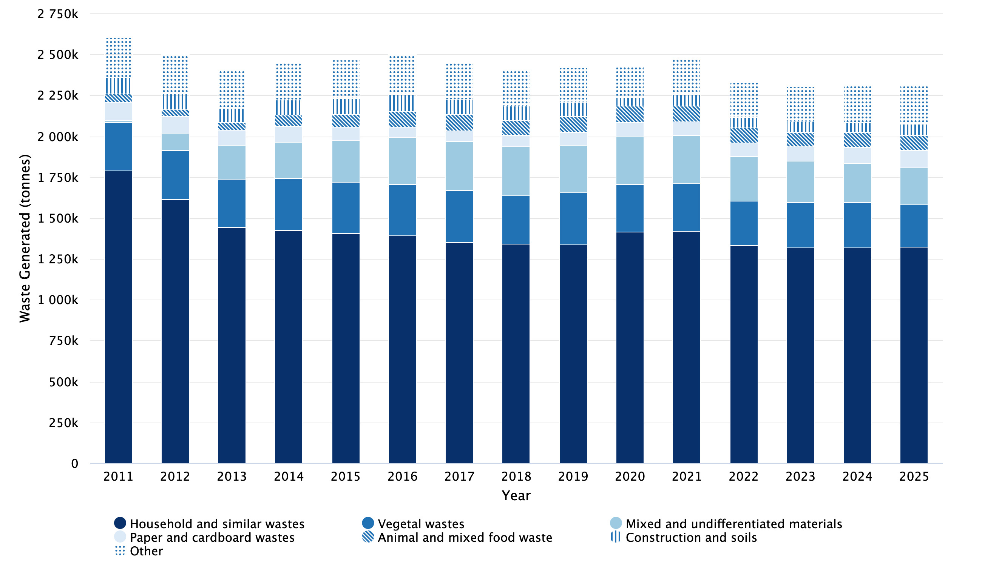

Notes:
‘Other’ categories comprise Batteries and accumulators wastes, Chemical wastes, Discarded equipment, Discarded vehicles, Glass wastes, Health care and biological wastes, Metallic wastes, Plastic wastes, Rubber wastes, Textile wastes, Used oils, and Wood wastes.
Tables contain the detail of the ‘Other’ breakdown.

Table 2. Household waste generated in Scotland 2011 - 2025 (tonnes)
Waste category | 2011 | 2012 | 2013 | 2014 | 2015 | 2016 | 2017 | 2018 | 2019 | 2020 | 2021 | 2022 | 2023 | 2024 | 2025
Household and similar wastes | 1,790,529 | 1,615,671 | 1,442,088 | 1,424,781 | 1,408,158 | 1,391,373 | 1,351,091 | 1,342,906 | 1,338,411 | 1,417,849 | 1,420,670 | 1,334,411 | 1,318,726 | 1,319,031 | 1,324,855
Vegetal wastes | 296,664 | 299,654 | 296,221 | 318,323 | 311,499 | 314,654 | 317,926 | 296,622 | 316,538 | 290,956 | 291,377 | 271,955 | 277,710 | 276,022 | 258,806
Mixed and undifferentiated materials | 11,124 | 106,172 | 210,928 | 222,125 | 256,705 | 285,885 | 302,998 | 298,624 | 291,611 | 292,494 | 294,487 | 271,761 | 252,156 | 239,063 | 225,421
Paper and cardboard wastes | 111,933 | 101,394 | 89,630 | 98,105 | 79,613 | 63,817 | 62,178 | 70,006 | 77,549 | 85,371 | 82,088 | 83,792 | 87,741 | 97,616 | 106,918
Animal and mixed food waste | 48,510 | 40,816 | 47,509 | 67,865 | 82,404 | 96,926 | 101,402 | 93,317 | 99,464 | 100,831 | 100,460 | 91,528 | 90,369 | 91,660 | 90,328
Wood wastes | 64,023 | 67,805 | 74,907 | 72,301 | 70,276 | 78,738 | 74,527 | 71,011 | 69,364 | 56,486 | 73,636 | 65,792 | 69,467 | 79,461 | 86,353
Glass wastes | 93,048 | 88,030 | 84,889 | 82,226 | 79,562 | 77,851 | 72,079 | 69,241 | 67,042 | 78,674 | 78,223 | 77,279 | 73,980 | 73,175 | 74,790
Construction and soils | 105,334 | 97,621 | 87,032 | 94,197 | 96,991 | 101,902 | 92,697 | 85,698 | 86,685 | 48,876 | 68,875 | 63,532 | 62,016 | 63,819 | 68,184
Discarded equipment | 36,226 | 33,955 | 31,308 | 31,762 | 33,734 | 37,546 | 36,484 | 33,028 | 32,866 | 26,210 | 30,513 | 28,266 | 28,656 | 30,628 | 30,340
Metallic wastes | 26,699 | 27,502 | 27,004 | 27,468 | 29,379 | 32,392 | 31,326 | 29,588 | 28,521 | 19,879 | 27,096 | 24,748 | 27,750 | 28,341 | 28,816
Textile wastes | 11,784 | 12,234 | 13,148 | 10,870 | 10,873 | 10,091 | 9,735 | 9,268 | 9,146 | 7,638 | 10,742 | 12,713 | 10,682 | 10,543 | 12,215
Plastic wastes | 8,127 | 7,409 | 5,439 | 6,961 | 6,951 | 4,633 | 4,829 | 2,723 | 706 | 1,334 | 2,225 | 3,444 | 3,414 | 3,372 | 3,827
Rubber wastes | 1,171 | 1,180 | 831 | 791 | 787 | 1,024 | 917 | 811 | 542 | 277 | 560 | 418 | 535 | 617 | 718
Batteries and accumulators wastes | 398 | 403 | 366 | 403 | 596 | 657 | 505 | 519 | 568 | 419 | 563 | 509 | 540 | 586 | 692
Used oils | 559 | 428 | 568 | 594 | 565 | 566 | 621 | 656 | 1,675 | 442 | 432 | 497 | 431 | 458 | 546
Chemical wastes | 241 | 303 | 416 | 383 | 236 | 515 | 1,102 | 865 | 755 | 323 | 427 | 324 | 452 | 510 | 489
Discarded vehicles | 389 | 356 | 320 | 404 | 450 | 408 | 403 | 363 | 348 | 193 | 228 | 253 | 224 | 247 | 326
Health care and biological wastes | 0 | 0 | 29 | 0 | 0 | 0 | 0 | 0 | 0 | 0 | 0 | 0 | 0 | 0 | 0
Total | 2,606,759 | 2,500,933 | 2,412,630 | 2,459,558 | 2,468,781 | 2,498,978 | 2,460,820 | 2,405,246 | 2,421,790 | 2,428,253 | 2,482,604 | 2,331,222 | 2,304,850 | 2,315,147 | 2,313,624

Segregated recyclate collected via kerbside
The amount of segregated recyclate collected for recycling via kerbside collections in 2025 was 633,000 tonnes, a decrease of 14,000 tonnes (2.2%) from 2024 (Figure 3). This decrease is larger than the overall decrease in waste generated (0.1%) (Figure 2). The decrease was offset by an increasein non-kerbside waste recyclate collected (10,000 tonnes).
The proportion of segregated recyclate collected in kerbside collections in 2025 (63.8% of the total recyclate collected) has decreased year-on-year since peaking at 70.7% in 2020. The 2020 spike in kerbside collections is likely due to the unavailability of other methods of collection during the COVID-19 restrictions during this period, such as household waste recycling centres.

Figure 3. Scottish segregated recyclate by collection method 2013 - 2025 (tonnes)
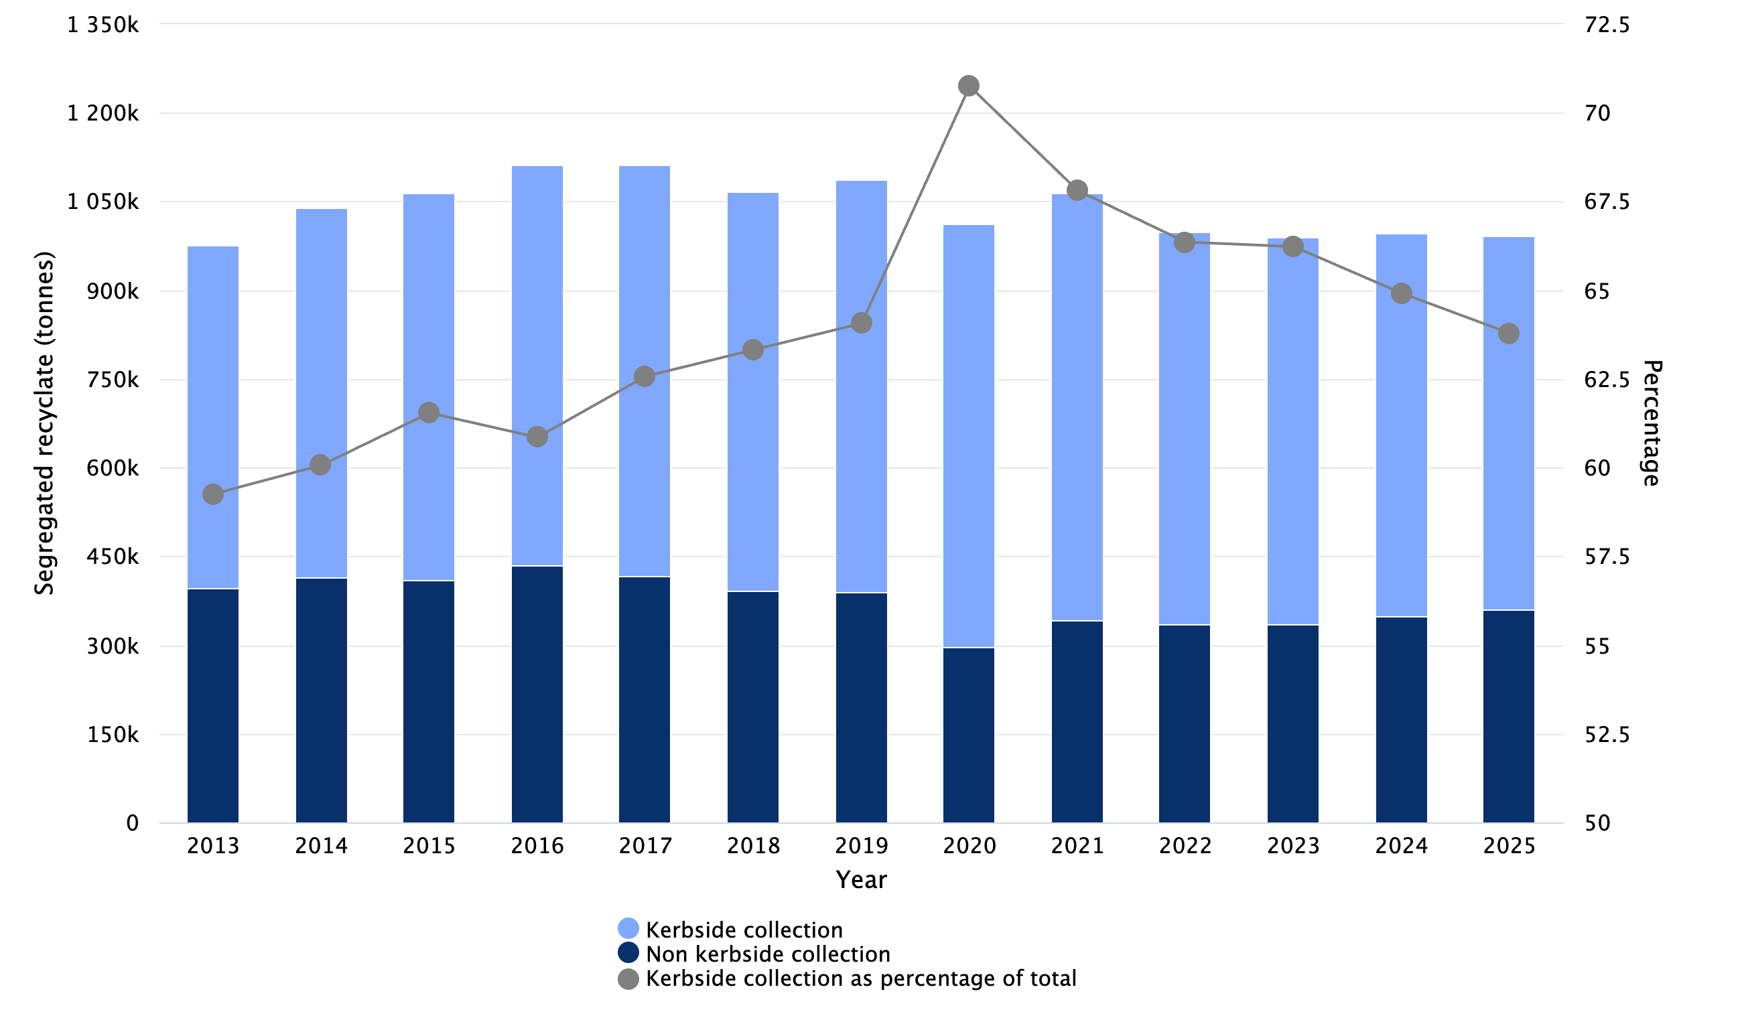

Notes:
Data series starts with 2013, which is the year data started to be collected in WasteDataFlow question 100.

Table 3. Scottish segregated recyclate by collection method 2013 - 2025 (tonnes)
Year | Kerbside collection (tonnes) | Non Kerbside collection (tonnes) | Total (tonnes) | Kerbside collectiion as percentage of total (%)
2013 | 578,096 | 397,481 | 975,578 | 59.3
2014 | 624,548 | 415,169 | 1,039,718 | 60.1
2015 | 655,866 | 409,845 | 1,065,710 | 61.5
2016 | 676,979 | 435,485 | 1,112,464 | 60.9
2017 | 696,414 | 416,542 | 1,112,956 | 62.6
2018 | 674,830 | 390,916 | 1,065,746 | 63.3
2019 | 695,937 | 390,359 | 1,086,297 | 64.1
2020 | 715,911 | 296,013 | 1,011,924 | 70.7
2021 | 721,275 | 342,384 | 1,063,659 | 67.8
2022 | 662,734 | 335,998 | 998,732 | 66.4
2023 | 655,483 | 334,222 | 989,705 | 66.2
2024 | 647,086 | 349,734 | 996,820 | 64.9
2025 | 633,133 | 359,423 | 992,556 | 63.8

Recyclate collected by rurality
The reduction in kerbside collection of segregated recyclate between 2024 and 2025 was due to urban authorities which had a decrease of 4.2% (15,900 tonnes) in kerbside collections, compared to rural authorities which had an increase of 0.7% (2,000 tonnes, Figure 4). Urban authorities are defined as those with greater than 75% population residing in “Large Urban Areas” or “Other Urban Areas” as listed in the Scottish Government Urban Rural Classification 2016.

Figure 4. Scottish segregated recyclate collected from kerbside by authority type 2013 - 2025 (tonnes)
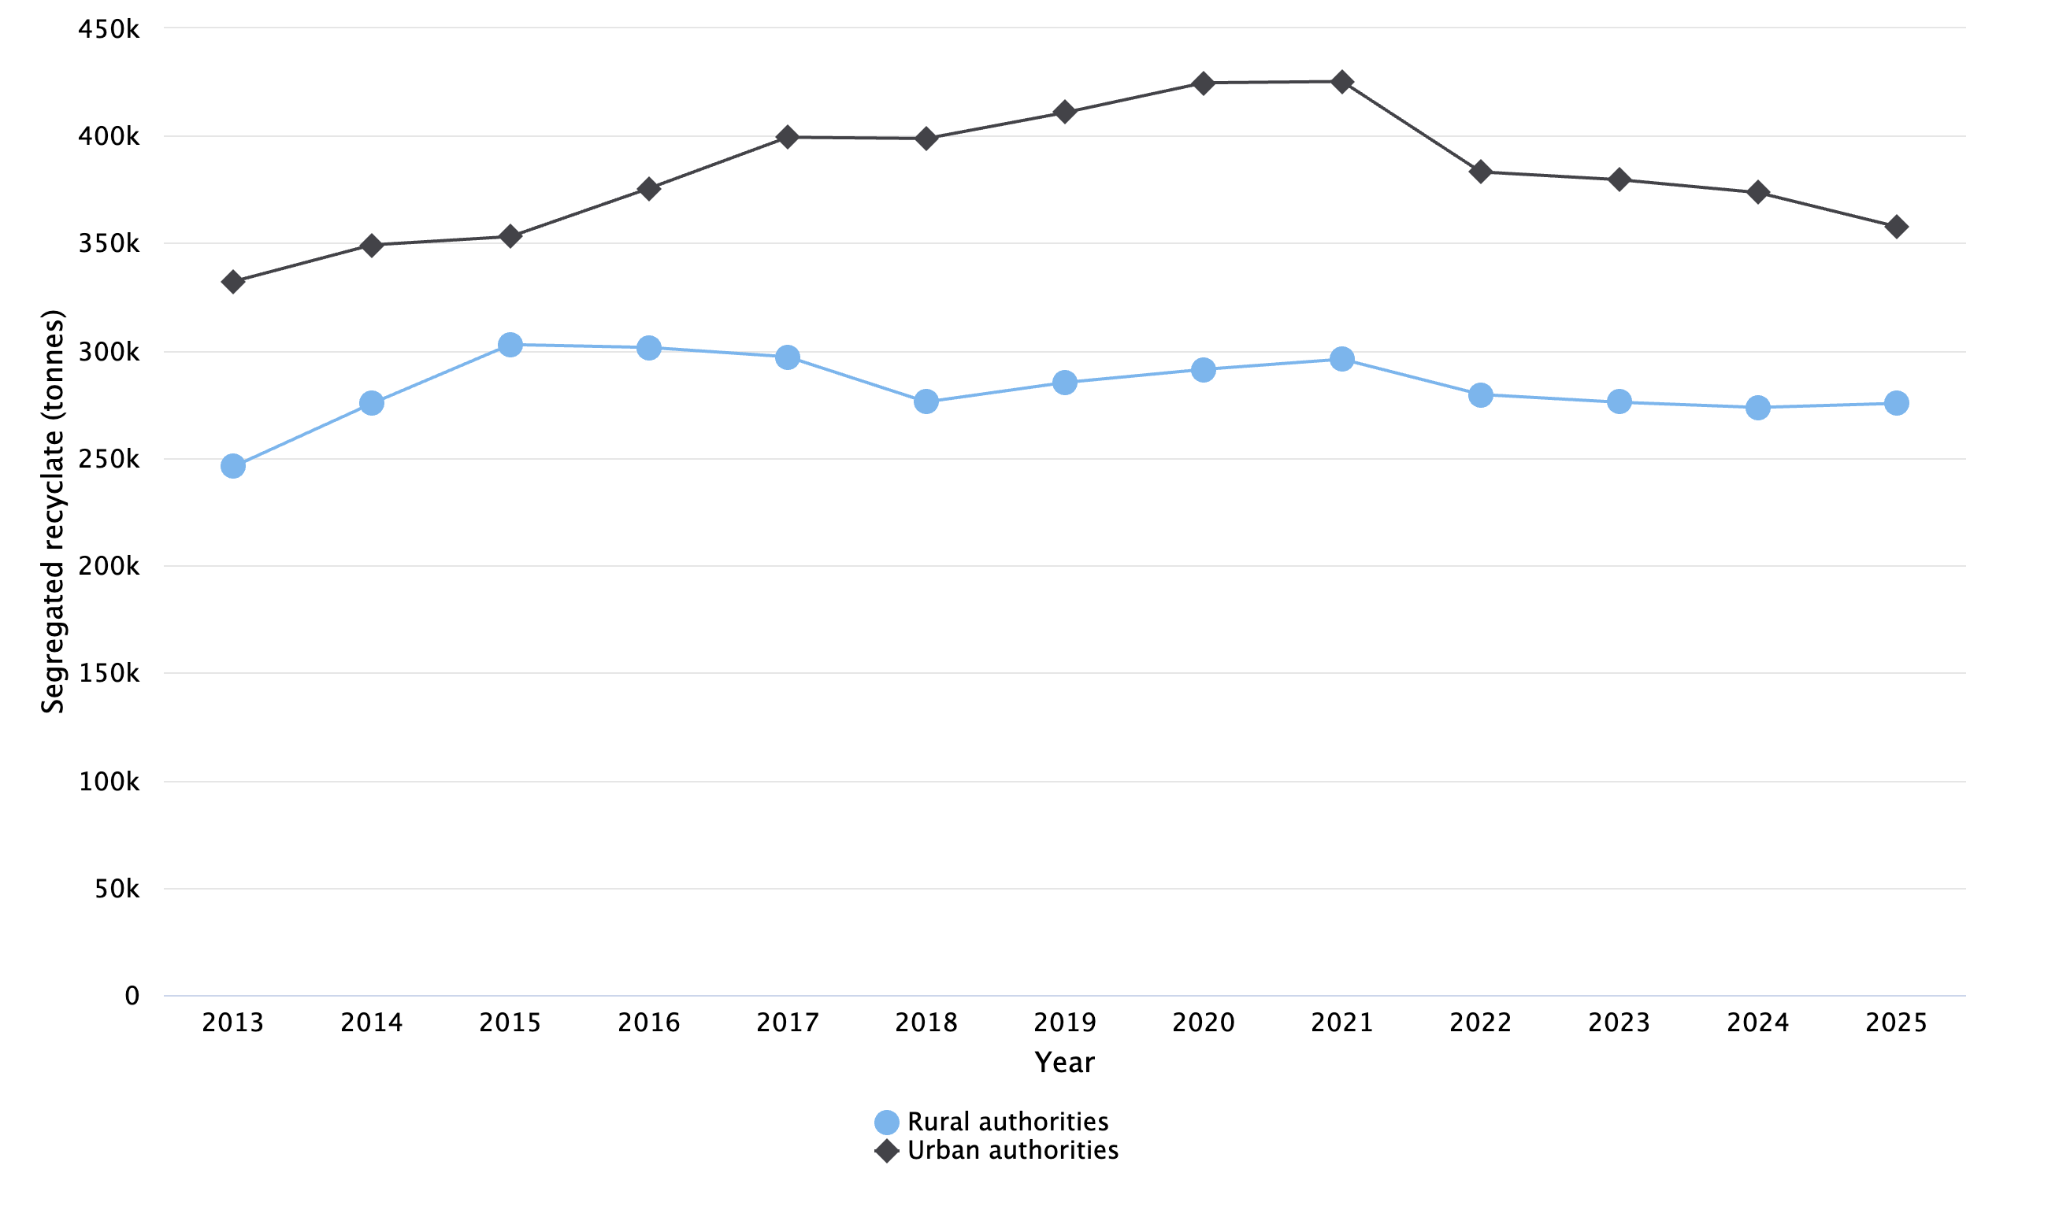

Notes:
Data series starts with 2013, which is the year data started to be collected in WasteDataFlow question 100.

Table 4. Scottish segregated recyclate collected from kerbside by authority type 2013 - 2025 (tonnes)
Year | Rural authorities | Urban authorities | Total
2013 | 245,958 | 332,139 | 578,096
2014 | 275,360 | 349,189 | 624,548
2015 | 302,797 | 353,069 | 655,866
2016 | 301,453 | 375,525 | 676,979
2017 | 297,114 | 399,300 | 696,414
2018 | 276,113 | 398,718 | 674,830
2019 | 285,147 | 410,790 | 695,937
2020 | 291,261 | 424,651 | 715,911
2021 | 296,000 | 425,275 | 721,275
2022 | 279,564 | 383,170 | 662,734
2023 | 275,943 | 379,540 | 655,483
2024 | 273,530 | 373,555 | 647,086
2025 | 275,437 | 357,697 | 633,133

Notes:
Data series starts with 2013, which is the year data started to be collected in WasteDataFlow question 100.

Household waste recycled
Waste recycled includes waste recycled or reused and waste composted. A full description of recycling is given in the glossary.
For 2025, the Scottish household waste recycling rate was 42.8% (Figure 5), a decrease of 1.4 percentage points from the 44.3% recycling rate achieved in 2024, and an increase of 3.2 percentage points from the 39.6% achieved in 2011.

Figure 5. Scottish household waste recycling rates 2011 - 2025
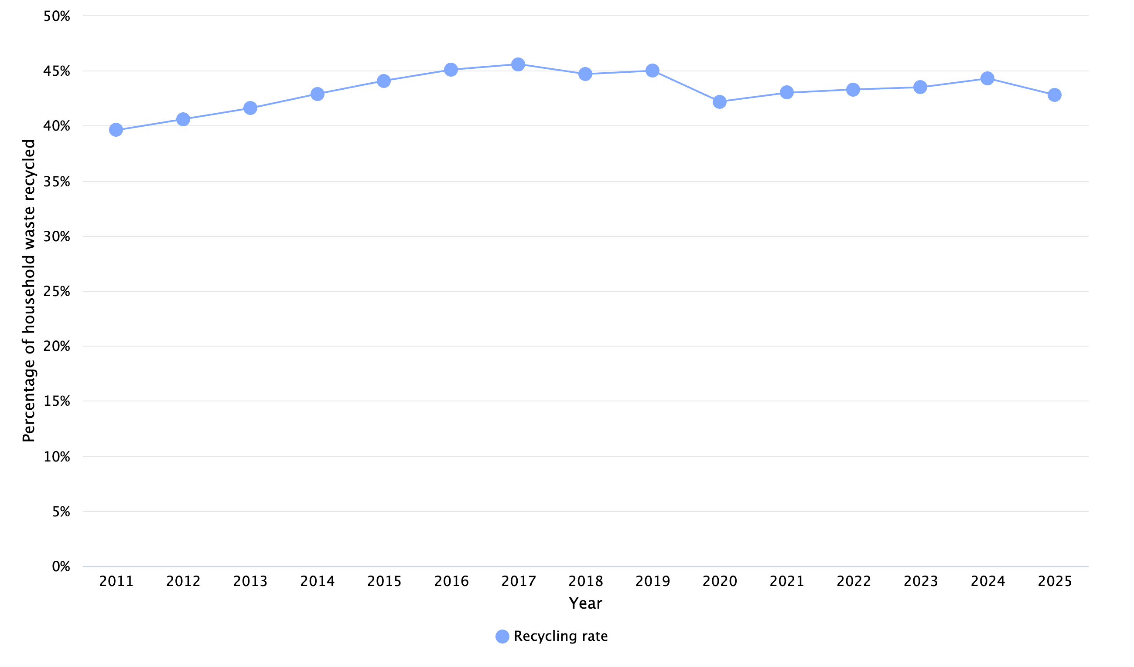

Table 5. Scottish household waste recycling rates 2011 - 2025
Year | Recycling rate (%)
2011 | 39.6
2012 | 40.6
2013 | 41.6
2014 | 42.9
2015 | 44.1
2016 | 45.1
2017 | 45.6
2018 | 44.7
2019 | 45.0
2020 | 42.2
2021 | 43.0
2022 | 43.3
2023 | 43.5
2024 | 44.3
2025 | 42.8

Breakdown of household waste recycled
In 2025, the total amount of Scottish household waste recycled was 991,000 tonnes, a decrease of 34,000 tonnes (3.3%) from 2024, and 41,000 tonnes (4.0%) less than the 1.03 million tonnes of waste recycled in 2011 (Figure 6), although it should be noted that the total amount of waste generated in 2011 was also higher.
Of the 991,000 tonnes of household waste recycled in 2025, the majority (649,000 tonnes, 65.5%) was recycled or reused, with household waste composted contributing the remaining 342,000 (34.5%).

Figure 6. Breakdown of Scottish household waste recycled 2011 - 2025 (tonnes)
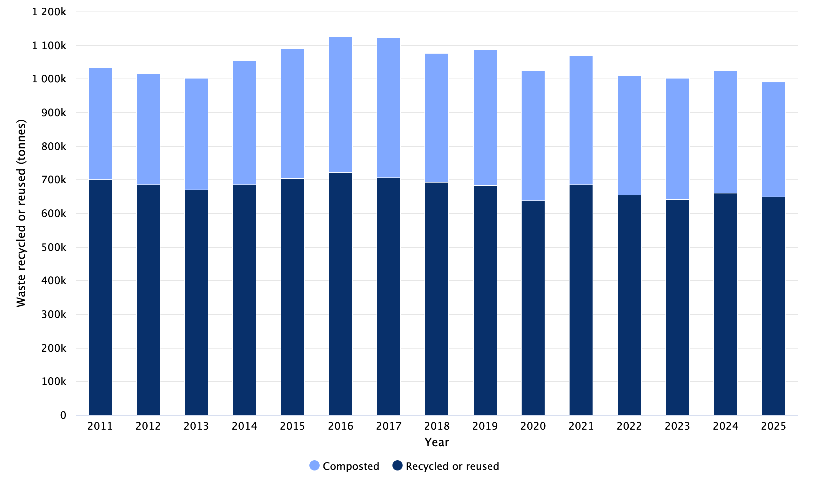

Table 6. Breakdown of Scottish household waste recycled 2011 - 2025 (tonnes)
Year | Recycled or reused | Composted | Total
2011 | 700,316 | 331,840 | 1,032,156
2012 | 686,024 | 328,997 | 1,015,021
2013 | 670,364 | 332,486 | 1,002,850
2014 | 685,180 | 369,040 | 1,054,219
2015 | 704,134 | 385,273 | 1,089,408
2016 | 722,197 | 403,743 | 1,125,940
2017 | 706,488 | 415,198 | 1,121,686
2018 | 693,618 | 382,716 | 1,076,334
2019 | 684,140 | 404,571 | 1,088,710
2020 | 637,131 | 388,370 | 1,025,501
2021 | 684,538 | 383,602 | 1,068,140
2022 | 655,294 | 354,601 | 1,009,895
2023 | 641,075 | 362,165 | 1,003,240
2024 | 661,264 | 363,439 | 1,024,703
2025 | 649,090 | 341,698 | 990,788

Household waste recycled or reused
The 649,000 tonnes of Scottish household waste recycled or reused in 2025 was a decrease of 12,000 tonnes (1.8%) compared with 2024 (Table 7).
Of the material categories of waste recycled or reused in 2025 (Table 7), Construction and soils showed the largest change compared with 2024 (a decrease 12,000 tonnes, 12.2%) followed by Metallic wastes (a decrease 3,100 tonnes, 3.3%). The change in Construction and soils is mainly due to a small number of large authorities, who attribute the reduction to operational issues with waste contractors which sort waste aggregate for recycling from the residual waste stream.
The largest material category of Scottish household waste recycled or reused in 2025 was Paper and cardboard wastes (166,000 tonnes, 25.6% of all household waste recycled or reused (Table 7)).
There is a longer term downward trend of Paper and cardboard wastes recycled or reused, with a reduction of 74,000 tonnes (30.8%) from 2011. The amount of Paper and cardboard wastes recorded as recycled in 2025 is marginally lower than in 2024, and was the lowest amount since the start of the current time series in 2011.

Figure 7. Scottish household waste recycled or reused by waste category 2011 - 2025 (tonnes)
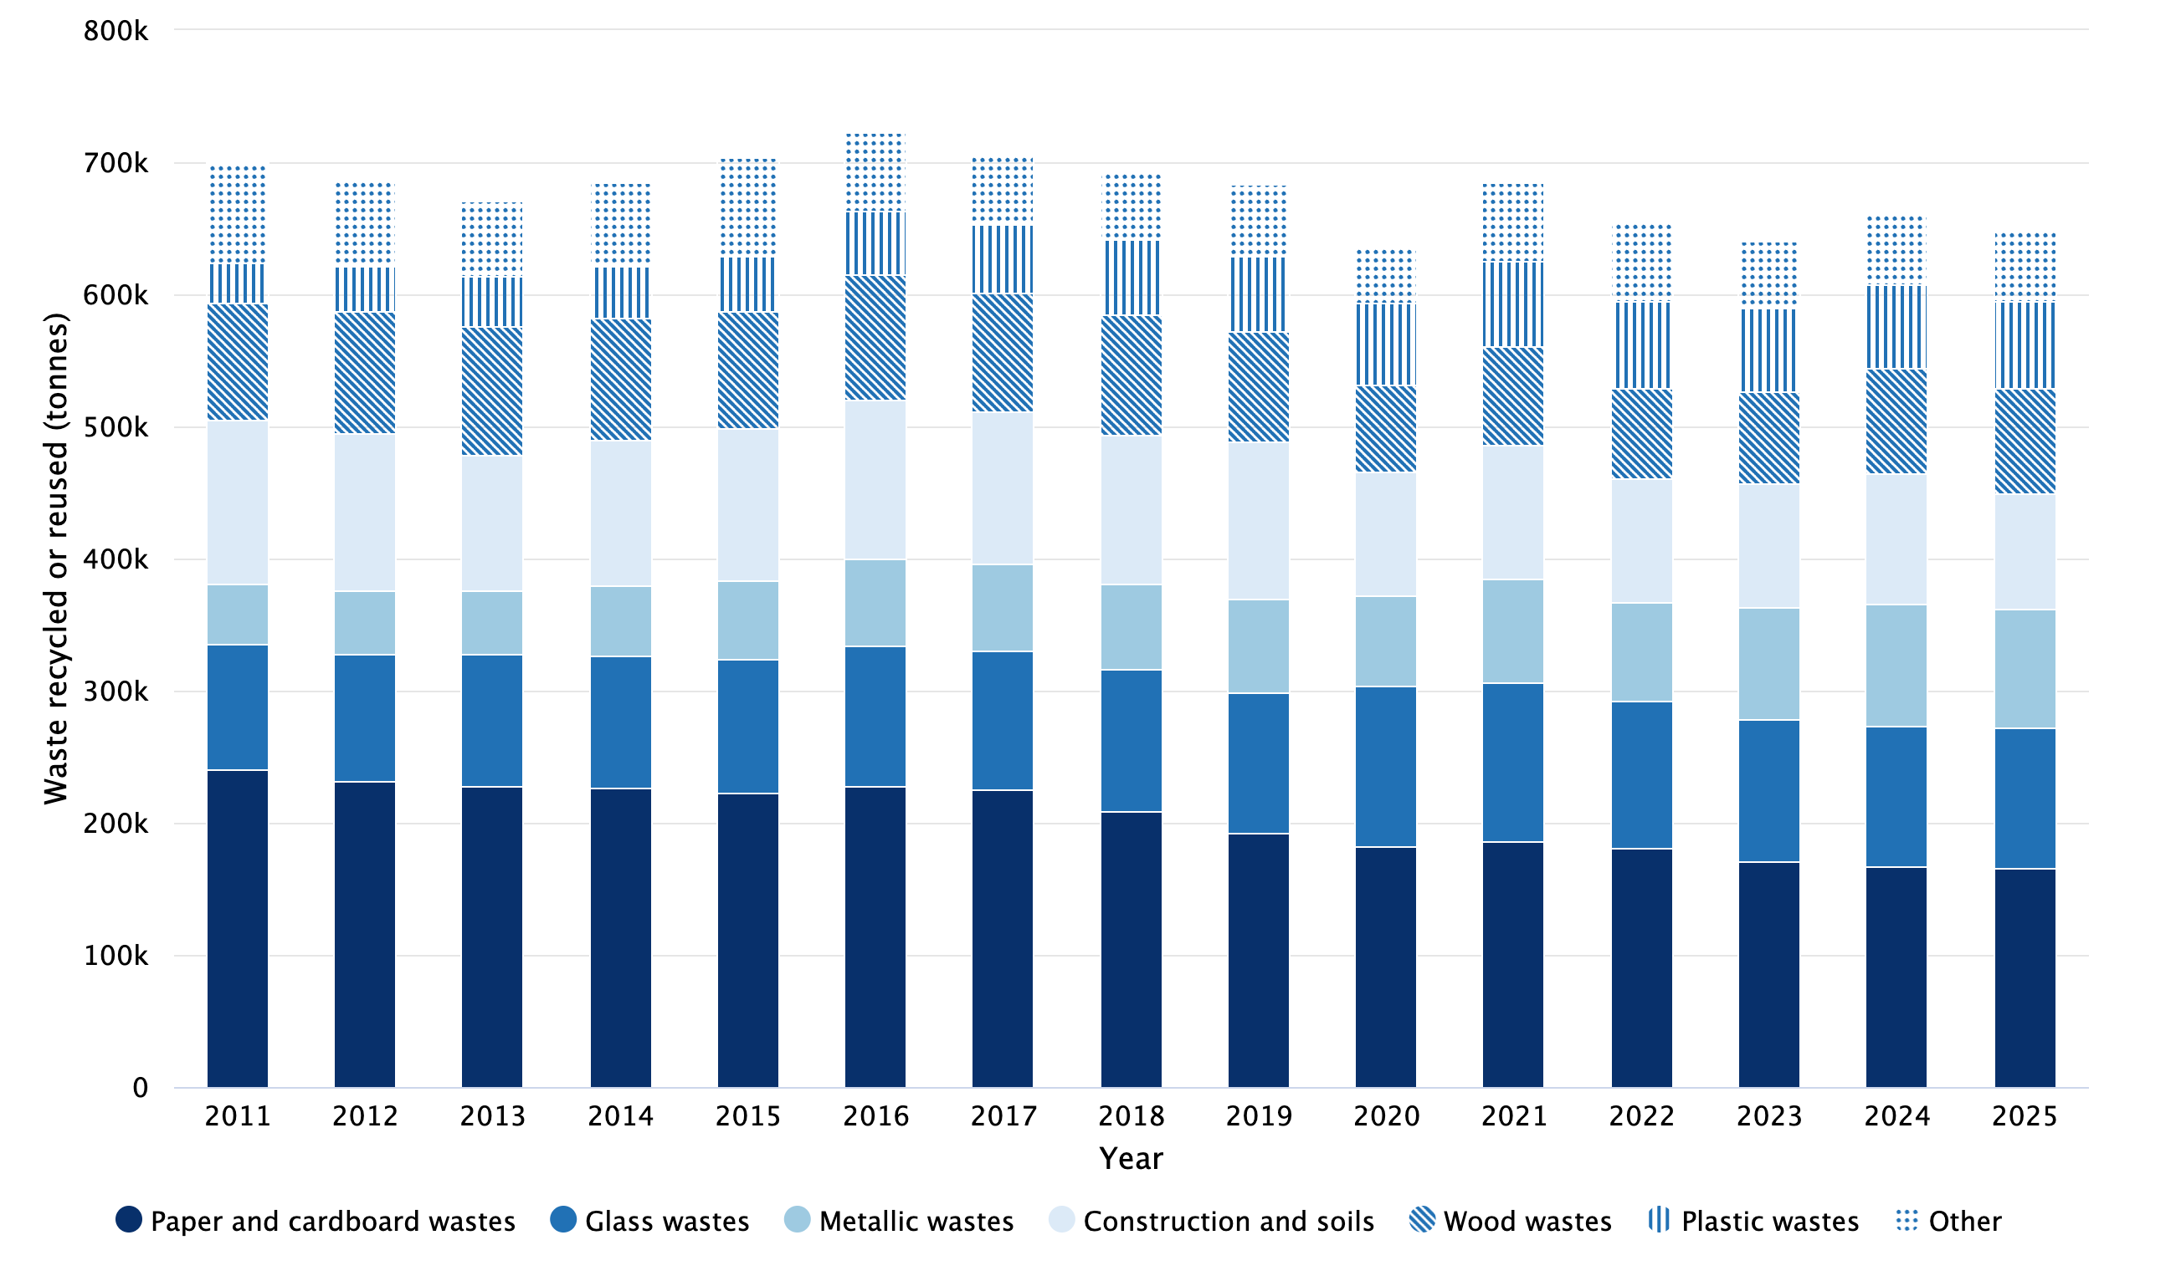

Notes:
‘Other’ categories comprise Animal and mixed food waste, Batteries and accumulators wastes, Chemical wastes, Discarded equipment, Discarded vehicles, Health care and biological wastes, Household and similar wastes, Mixed and undifferentiated materials, Rubber wastes, Textile wastes, Used oils, and Vegetal wastes.
Tables contain the detail of the ‘Other’ breakdown.

Table 7. Scottish household waste recycled or reused by waste category 2011 - 2025 (tonnes)
Waste category | 2011 | 2012 | 2013 | 2014 | 2015 | 2016 | 2017 | 2018 | 2019 | 2020 | 2021 | 2022 | 2023 | 2024 | 2025
Paper and cardboard wastes | 240,346 | 231,776 | 227,899 | 226,463 | 222,403 | 227,921 | 225,495 | 209,120 | 192,562 | 182,309 | 186,368 | 181,244 | 171,394 | 166,697 | 166,387
Glass wastes | 94,903 | 96,658 | 99,973 | 100,580 | 102,033 | 106,548 | 104,679 | 107,380 | 106,637 | 121,996 | 120,340 | 110,620 | 106,753 | 106,184 | 105,885
Metallic wastes | 45,668 | 48,148 | 48,636 | 52,106 | 59,099 | 65,632 | 66,170 | 64,814 | 70,317 | 68,149 | 77,567 | 75,451 | 85,433 | 93,154 | 90,098
Construction and soils | 124,335 | 118,167 | 102,126 | 111,046 | 114,901 | 120,559 | 115,345 | 112,869 | 119,095 | 93,485 | 101,835 | 93,085 | 92,924 | 98,563 | 86,532
Wood wastes | 89,002 | 92,403 | 96,827 | 92,324 | 89,212 | 93,897 | 89,426 | 90,547 | 83,232 | 65,320 | 74,881 | 68,165 | 69,495 | 79,401 | 79,616
Plastic wastes | 29,299 | 34,528 | 38,097 | 39,525 | 41,285 | 48,422 | 51,833 | 56,586 | 57,379 | 62,151 | 64,144 | 66,809 | 64,417 | 63,014 | 66,031
Discarded equipment | 36,616 | 33,743 | 31,366 | 31,748 | 31,740 | 34,378 | 33,604 | 30,946 | 31,142 | 24,722 | 28,696 | 26,536 | 26,818 | 28,333 | 28,414
Textile wastes | 14,589 | 14,474 | 15,009 | 13,578 | 12,202 | 11,364 | 10,695 | 10,010 | 9,854 | 8,326 | 11,185 | 13,306 | 11,401 | 10,813 | 12,097
Mixed and undifferentiated materials | 15,111 | 7,054 | 2,483 | 8,949 | 17,600 | 1,567 | 1,485 | 4,496 | 4,141 | 7,634 | 16,064 | 16,662 | 8,412 | 9,680 | 8,419
Household and similar wastes | 6,881 | 6,237 | 5,129 | 6,244 | 8,588 | 8,629 | 4,100 | 3,505 | 2,458 | 1,281 | 1,155 | 1,328 | 1,775 | 2,939 | 2,758
Rubber wastes | 1,388 | 1,195 | 1,022 | 796 | 792 | 1,028 | 940 | 832 | 583 | 324 | 582 | 430 | 570 | 672 | 757
Batteries and accumulators wastes | 541 | 415 | 381 | 414 | 609 | 655 | 505 | 522 | 568 | 422 | 592 | 528 | 551 | 598 | 714
Used oils | 559 | 430 | 570 | 596 | 568 | 562 | 621 | 652 | 1,674 | 442 | 430 | 497 | 432 | 458 | 546
Chemical wastes | 242 | 303 | 416 | 347 | 236 | 515 | 1,102 | 859 | 755 | 323 | 427 | 324 | 452 | 510 | 489
Discarded vehicles | 395 | 361 | 320 | 404 | 450 | 408 | 403 | 363 | 348 | 193 | 209 | 247 | 193 | 211 | 284
Animal and mixed food waste | 88 | 64 | 83 | 59 | 73 | 110 | 86 | 118 | 74 | 55 | 64 | 62 | 56 | 37 | 64
Health care and biological wastes | 0 | 0 | 29 | 0 | 0 | 0 | 0 | 0 | 0 | 0 | 0 | 0 | 0 | 0 | 0
Vegetal wastes | 352 | 68 | 0 | 0 | 2,343 | 0 | 1 | 0 | 3,324 | 0 | 0 | 0 | 0 | 0 | 0
Total | 700,316 | 686,024 | 670,364 | 685,180 | 704,134 | 722,197 | 706,488 | 693,618 | 684,140 | 637,131 | 684,538 | 655,294 | 641,075 | 661,264 | 649,090

Paper and cardboard wastes
The WasteDataFlow reporting categories that contribute to Paper and cardboard wastes recycled or reused, as depicted in Figure 8, indicate that the recycling or reuse of segregated paper waste has been in decline since 2013. 2025 had the highest amount of Mixed paper and cardboard wastes and the lowest amount of segregated Paper and segregated Cardboard wastes in the time series for each category. This change may be partly due to replacement of segregated collections with mixed paper and cardboard collections, for example, the increase of 6.4% in mixed collection recycling 2024 and 2025 has been attributed by several authorities to the introduction of paper and cardboard (fibre) bins. The decrease in segregated paper recycled or reused is also likely to be partly due to a move away from print media to electronic media.

Figure 8. Scottish Paper and cardboard wastes recycled or reused by WasteDataFlow categories 2013 - 2025 (tonnes)
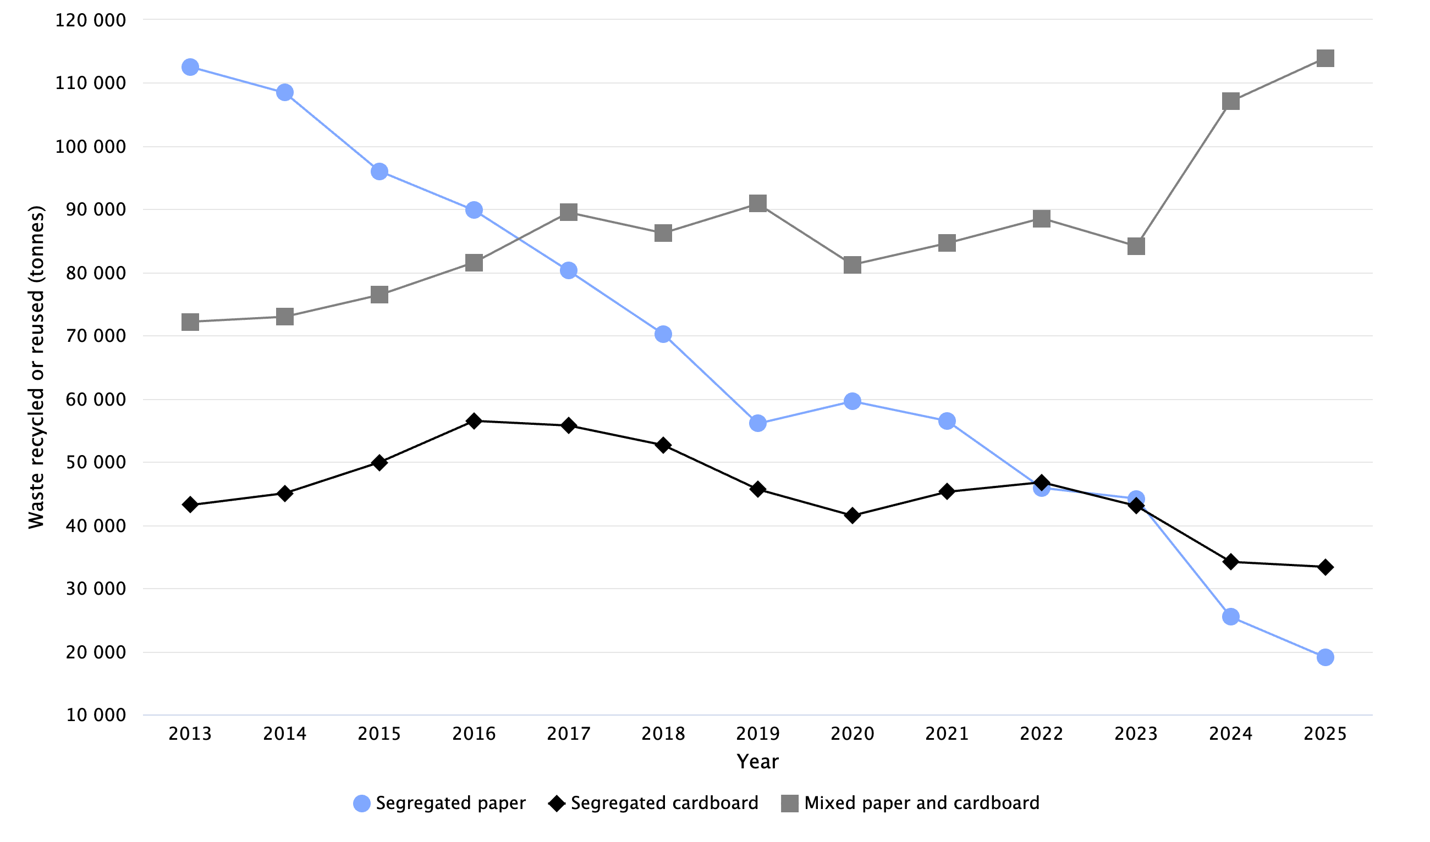

Table 8. Scottish Paper and cardboard wastes recycled or reused by WasteDataFlow categories 2013 - 2025 (tonnes)
Year | Segregated paper | Segregated cardboard | Mixed paper and cardboard | Total
2013 | 112,549 | 43,162 | 72,188 | 227,899
2014 | 108,438 | 45,042 | 72,983 | 226,463
2015 | 96,033 | 49,936 | 76,433 | 222,403
2016 | 89,846 | 56,495 | 81,580 | 227,921
2017 | 80,255 | 55,750 | 89,489 | 225,495
2018 | 70,236 | 52,653 | 86,232 | 209,120
2019 | 56,064 | 45,650 | 90,847 | 192,562
2020 | 59,593 | 41,493 | 81,223 | 182,309
2021 | 56,490 | 45,256 | 84,622 | 186,368
2022 | 45,890 | 46,772 | 88,582 | 181,244
2023 | 44,187 | 43,035 | 84,172 | 171,394
2024 | 25,431 | 34,168 | 107,097 | 166,697
2025 | 19,054 | 33,377 | 113,955 | 166,387

Notes:
Paper includes the WasteDataFlow category of Books.
Data series starts with 2013, which is the year data started to be collected in WasteDataFlow question 100.

Household waste composted
Waste composted is waste recycled by biological treatment, through composting at a composting plant or through digestion at an anaerobic digestion facility.
For 2025, the amount of Scottish household waste composted was 342,000 tonnes, a decrease of 22,000 tonnes (6.0%) from 2024, and an increase of 9,900 tonnes (3.0%) from 2011.
In 2025, about three-quarters (74.0%) of the household waste composted was Vegetal wastes with Animal and mixed food waste making up the remainder (26.0%, Figure 9). These proportions were similar in 2024. In 2011, however, the percentage of Vegetal waste was higher (94.6%) and the percentage of Animal and mixed food waste lower ( 5.3% ). The increase in the proportion of animal and mixed food waste between 2012 and 2017 corresponds to the roll out of segregated food waste collections by local authorities under The Waste (Scotland) Regulations 2012.
In 2025, the total tonnage of Vegetal wastes composted was 253,000 tonnes, a decrease of 20,000 tonnes (7.3%) from 2024, and a decrease of 61,000 (19.5%) from 2011. Therefore, much of the overall increase in waste composted between 2011 and 2025 was due to the composting of Animal and mixed food waste, which increased by 72,000 tonnes (410%) over this period.

Figure 9. Scottish household waste composted by waste category 2011 - 2025 (tonnes)
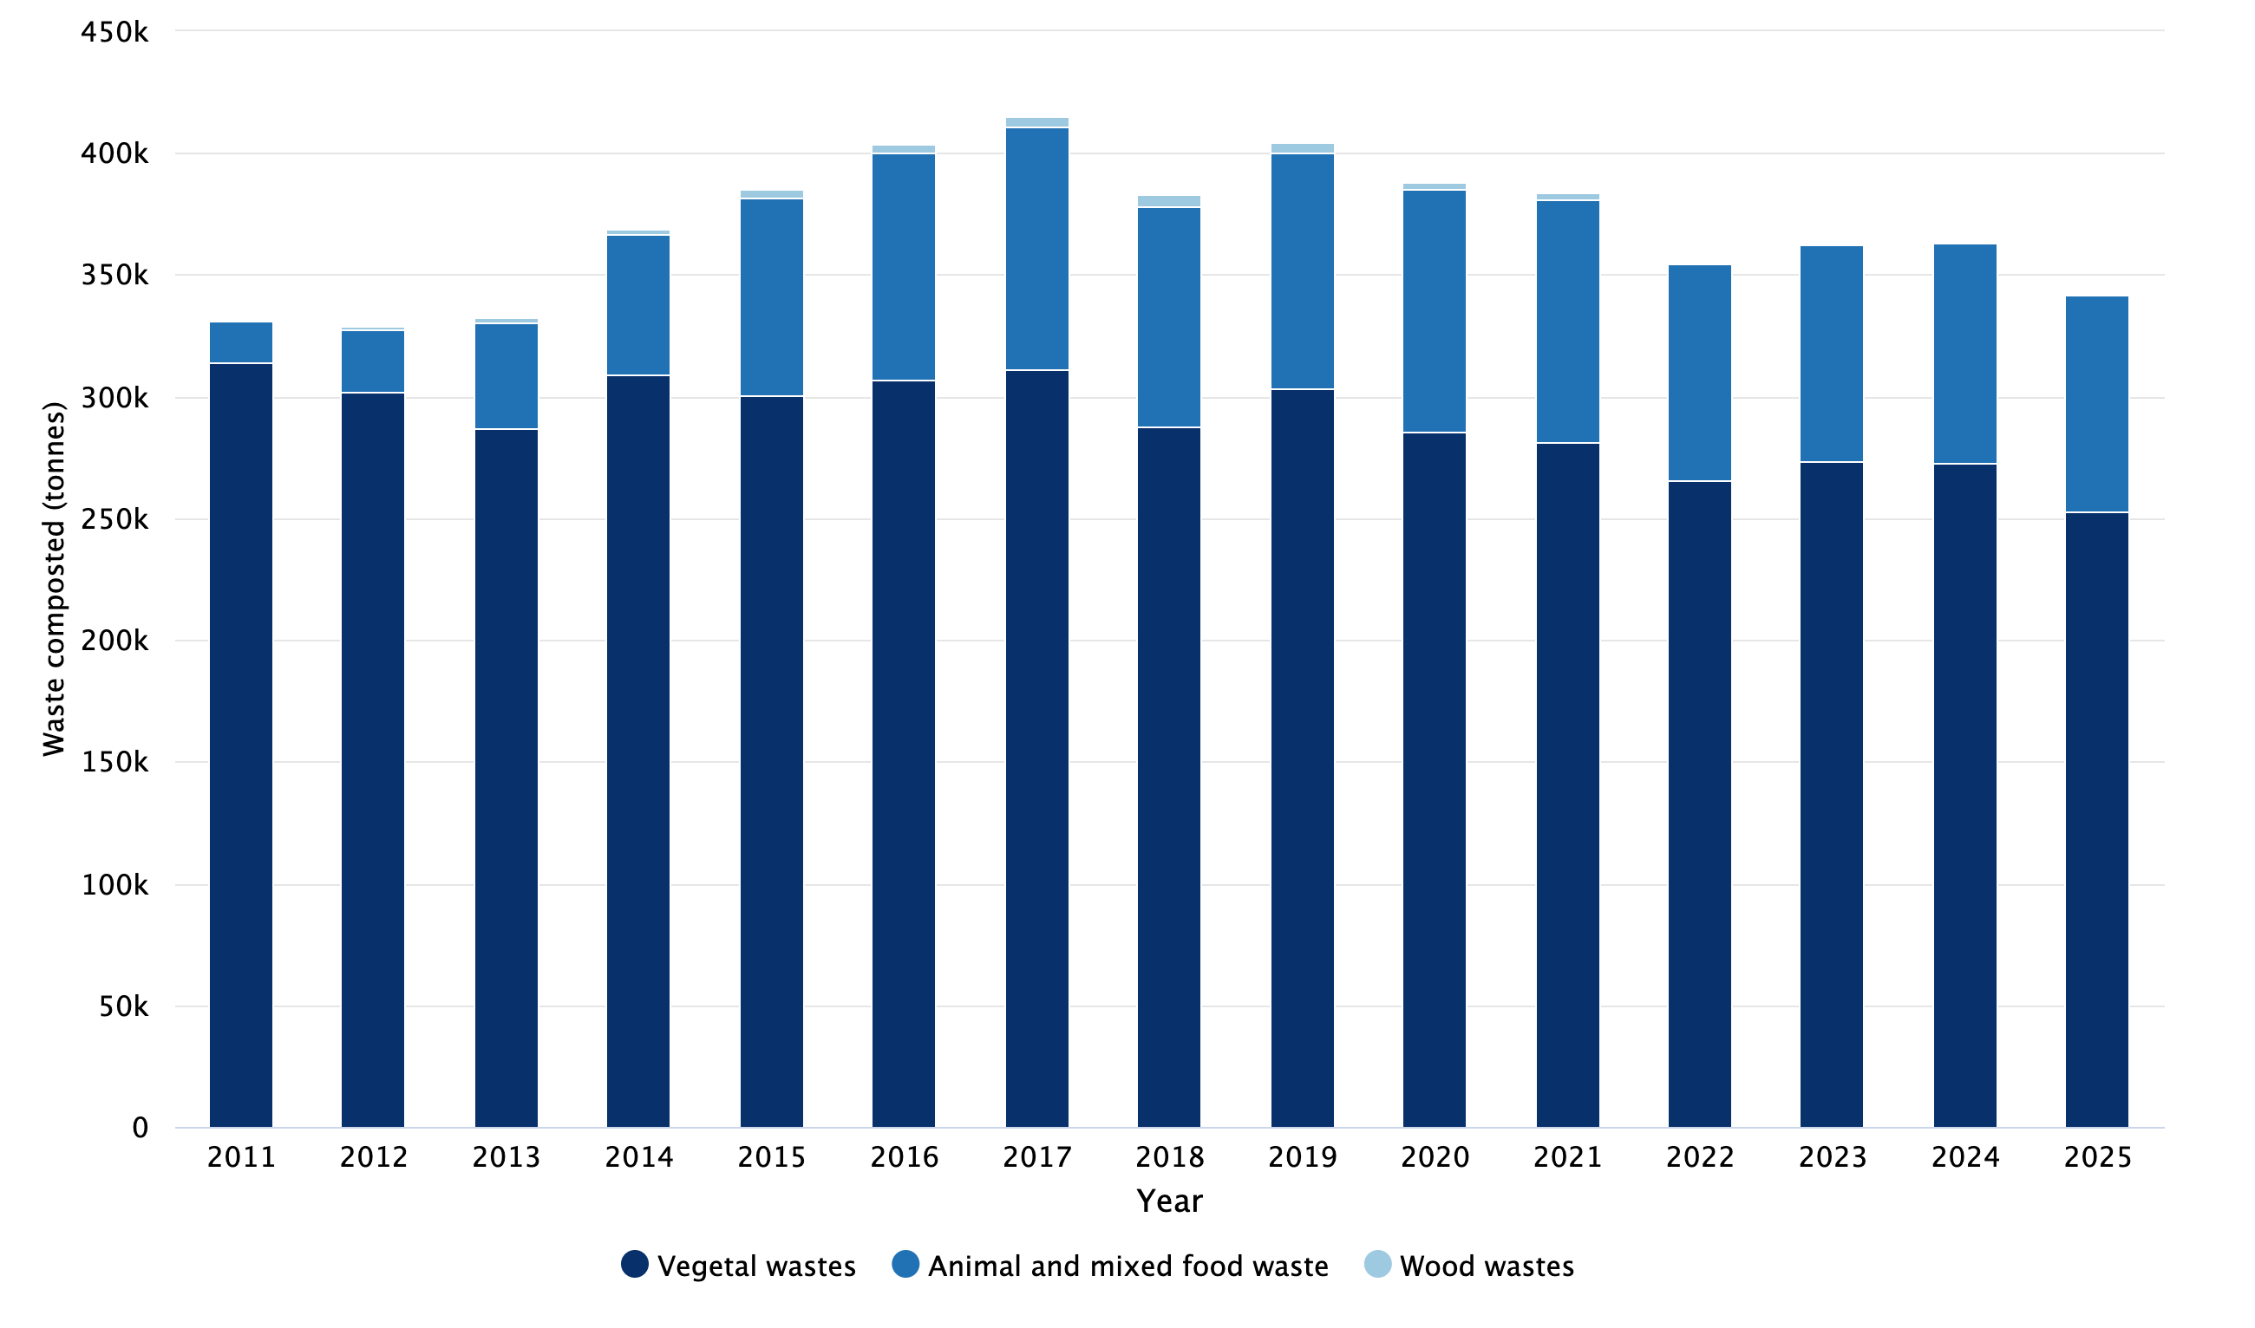

Table 9. Scottish household waste composted by waste category 2011 - 2025 (tonnes)
Waste category | 2011 | 2012 | 2013 | 2014 | 2015 | 2016 | 2017 | 2018 | 2019 | 2020 | 2021 | 2022 | 2023 | 2024 | 2025
Vegetal wastes | 313,948 | 302,224 | 286,885 | 308,705 | 300,463 | 306,681 | 310,962 | 287,309 | 302,986 | 285,813 | 281,480 | 265,288 | 273,085 | 272,611 | 252,736
Animal and mixed food waste | 17,426 | 25,319 | 43,740 | 57,858 | 80,951 | 93,287 | 99,722 | 91,076 | 97,063 | 99,363 | 99,175 | 89,312 | 89,080 | 90,828 | 88,962
Wood wastes | 466 | 1,454 | 1,861 | 2,477 | 3,860 | 3,775 | 4,514 | 4,331 | 4,521 | 3,195 | 2,948 | 0 | 0 | 0 | 0
Total | 331,840 | 328,997 | 332,486 | 369,040 | 385,273 | 403,743 | 415,198 | 382,716 | 404,571 | 388,370 | 383,603 | 354,601 | 362,165 | 363,439 | 341,698

Other diversion of household waste from Landfill
Other diversion from landfill is waste material not recycled or landfilled. This includes net waste incinerated, incinerator ash outputs recovered, and organic material recovered that does not meet quality standards. A full description is found in the glossary.
For 2025, the total amount of Scottish household waste managed by other diversion from landfill was 1.09 million tonnes , an increase of 58,000 tonnes (5.6%) from 2024 and an increase of 973,000 tonnes (807%) from 2011 (Figure 10).

Other diversion from landfill - treatment breakdown
In 2025, most of the waste managed by other diversion from landfill was incinerated (901,000 tonnes, 82.4%) with the remainder being other treatments (187,000 tonnes, 17.1%) and non-PAS compost (5,800 tonnes, 0.5%) (Figure 10). Other treatments (Figure 10) were primarily incinerator bottom ash (161,000 tonnes) from the incineration of household waste sent for recovery, used for example, in road construction.

Figure 10. Breakdown of treatment for Scottish household waste managed by other diversion from landfill 2011 - 2025 (tonnes)
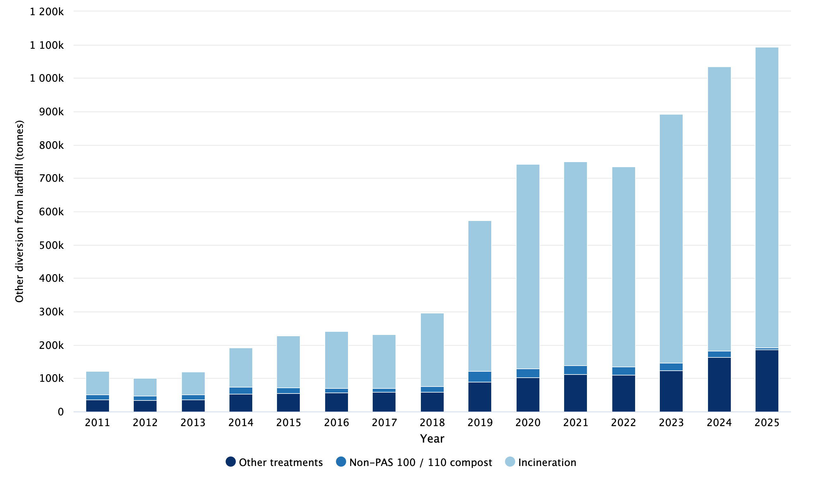

Table 10. Breakdown of treatment for Scottish household waste managed by other diversion from landfill 2011 - 2025 (tonnes)
Year | Incinerated | Non-PAS 100 / 110 compost | Other treatments | Total other diversion
2011 | 70,134 | 15,269 | 35,286 | 120,688
2012 | 51,473 | 14,504 | 33,844 | 99,821
2013 | 68,510 | 15,946 | 35,394 | 119,850
2014 | 118,678 | 19,713 | 53,776 | 192,167
2015 | 157,090 | 16,785 | 54,666 | 228,540
2016 | 170,601 | 13,002 | 57,167 | 240,770
2017 | 160,271 | 12,864 | 58,286 | 231,421
2018 | 220,792 | 17,984 | 57,923 | 296,699
2019 | 453,738 | 32,107 | 88,514 | 574,358
2020 | 612,727 | 26,903 | 102,949 | 742,579
2021 | 611,457 | 27,403 | 111,379 | 750,240
2022 | 600,389 | 23,658 | 110,747 | 734,794
2023 | 745,982 | 23,344 | 122,920 | 892,246
2024 | 852,774 | 19,860 | 163,030 | 1,035,664
2025 | 901,485 | 5,846 | 186,740 | 1,094,071

Household Waste Incinerated
In 2025, 901,000 tonnes of Scottish household waste were incinerated which was 49,000 tonnes (5.7%) greater than in 2024, and 831,000 tonnes (1,200%) greater than in 2011.
The majority of the waste incinerated in 2025 was Household and similar wastes (742,000 tonnes, 82.3%). The next largest category was Mixed and undifferentiated materials (134,000 tonnes, 14.9%).
The increase between 2024 and 2025 was mainly due to an increase in Household and similar wastes (66,000 tonnes, 9.8%) which comprise primarily general refuse. In previous years (before 2022) the main management route for such wastes was landfilling.

Figure 11. Scottish household waste incinerated by waste category 2011 - 2025 (tonnes)
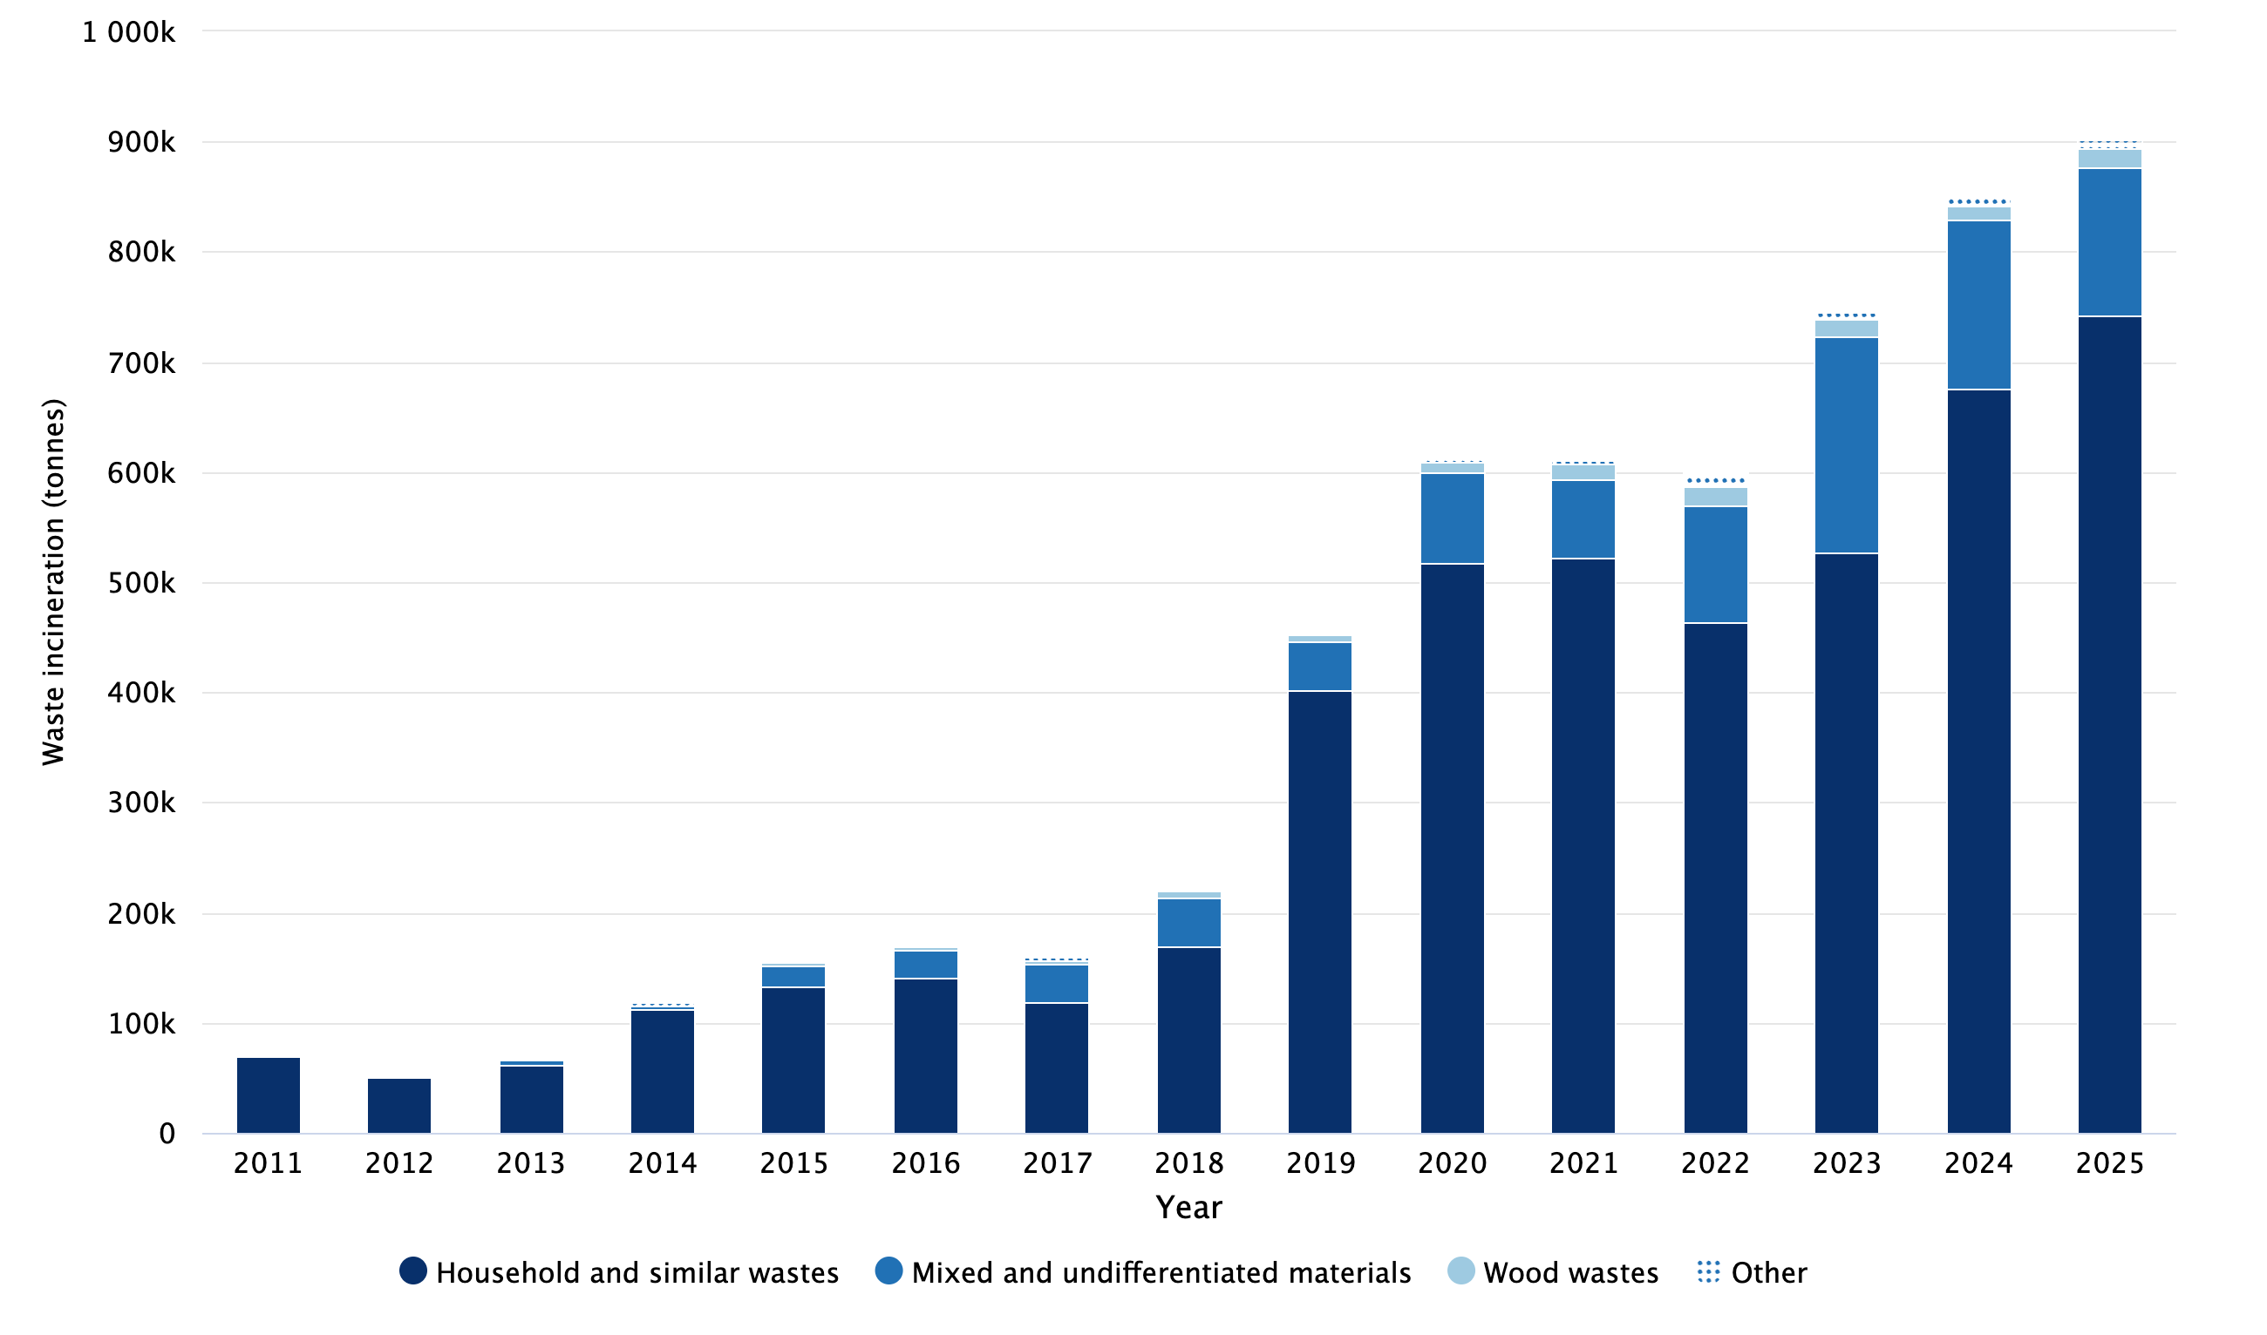

Notes:
‘Other’ categories comprise Animal and mixed food waste, Chemical wastes, Combustion wastes, Discarded equipment, Glass wastes, Metallic wastes, Paper and cardboard wastes, Plastic wastes, Rubber wastes, Textile wastes, and Vegetal wastes.
Tables contain the detail of the ‘Other’ breakdown.

Table 11. Scottish household waste incinerated by waste category 2011 - 2025 (tonnes)
Waste category | 2011 | 2012 | 2013 | 2014 | 2015 | 2016 | 2017 | 2018 | 2019 | 2020 | 2021 | 2022 | 2023 | 2024 | 2025
Household and similar wastes | 70,134 | 50,541 | 62,298 | 111,587 | 133,418 | 140,699 | 119,335 | 170,008 | 401,654 | 517,090 | 522,190 | 464,247 | 527,310 | 675,717 | 742,121
Mixed and undifferentiated materials | 0 | 429 | 4,621 | 4,131 | 17,803 | 25,198 | 33,980 | 44,019 | 44,575 | 83,223 | 70,710 | 106,096 | 196,106 | 153,160 | 134,308
Wood wastes | 0 | 0 | 694 | 534 | 4,514 | 4,094 | 3,476 | 6,005 | 5,550 | 8,507 | 14,244 | 16,493 | 15,122 | 13,200 | 17,443
Plastic wastes | 0 | 0 | 0 | 0 | 0 | 0 | 0 | 0 | 244 | 393 | 1,782 | 2,957 | 4,098 | 3,408 | 3,530
Combustion wastes | 0 | 0 | 0 | 1,832 | 949 | 69 | 2,763 | 126 | 706 | 991 | 0 | 5,848 | 0 | 4,143 | 1,528
Textile wastes | 0 | 0 | 0 | 67 | 0 | 0 | 0 | 0 | 247 | 1,503 | 769 | 282 | 447 | 574 | 920
Vegetal wastes | 0 | 502 | 898 | 496 | 406 | 515 | 660 | 525 | 621 | 529 | 1,085 | 3,104 | 1,298 | 1,117 | 750
Paper and cardboard wastes | 0 | 0 | 0 | 11 | 0 | 0 | 0 | 0 | 16 | 155 | 317 | 159 | 1,079 | 952 | 684
Animal and mixed food waste | 0 | 0 | 0 | 0 | 0 | 0 | 0 | 33 | 86 | 71 | 223 | 996 | 387 | 385 | 101
Metallic wastes | 0 | 0 | 0 | 0 | 0 | 0 | 0 | 0 | 0 | 227 | 93 | 148 | 120 | 94 | 100
Chemical wastes | 0 | 0 | 0 | 20 | 0 | 25 | 56 | 70 | 0 | 0 | 0 | 0 | 0 | 0 | 0
Discarded equipment | 0 | 0 | 0 | 0 | 0 | 0 | 0 | 0 | 39 | 37 | 45 | 41 | 3 | 0 | 0
Glass wastes | 0 | 0 | 0 | 0 | 0 | 0 | 0 | 0 | 0 | 0 | 0 | 16 | 12 | 25 | 0
Rubber wastes | 0 | 0 | 0 | 0 | 0 | 0 | 0 | 5 | 0 | 0 | 0 | 0 | 0 | 0 | 0
Total | 70,134 | 51,473 | 68,510 | 118,678 | 157,090 | 170,601 | 160,271 | 220,792 | 453,738 | 612,727 | 611,457 | 600,389 | 745,982 | 852,774 | 901,485

Household waste landfilled
The amount of Scottish household waste landfilled in 2025 was 228,000 tonnes, a decrease of 26,000 tonnes (10.3%) from 2024, and a reduction of 1.23 million tonnes (84.3%) from 2011. The amount of waste landfilled in 2025 is the lowest in the current time series.
For 2025, the Scottish household waste landfill rate was 9.9% (Table 1A). This is 1.1 percentage points lower than the landfill rate in 2024 (11.0%) and a decrease of 45.9 percentage points from 2011 (55.8%).
In 2025, most of the Scottish household waste landfilled comprised Household and similar wastes (135,000 tonnes, 59.4%, Figure 12). The next largest category was Combustion wastes (79,800 tonnes, 35.0%). Between 2024 and 2025, Combustion wastes landfilled fell by 25,000 tonnes (23.5%) and Household and similar wastes landfilled fell by 2,400 tonnes (1.8%).

Figure 12. Scottish household waste landfilled by waste category 2011 - 2025 (tonnes)
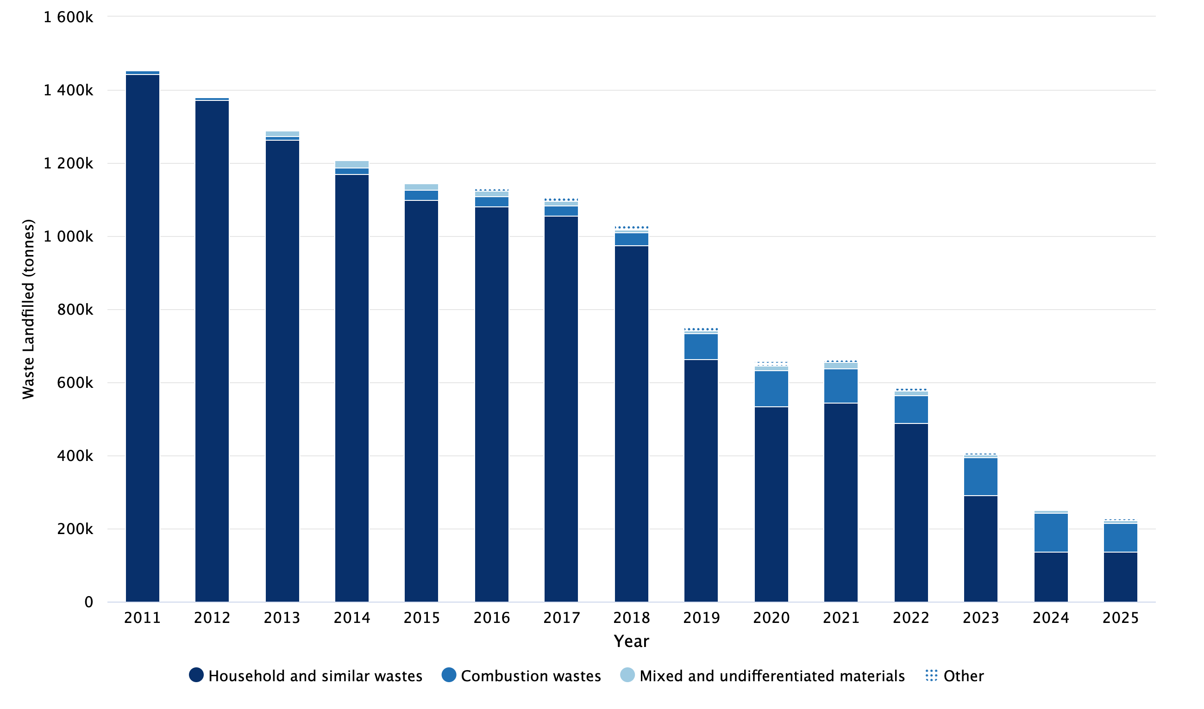

Notes:
‘Other’ categories comprise Animal and mixed food waste, Batteries and accumulators wastes, Chemical wastes, Construction and soils, Discarded equipment, Glass wastes, Metallic wastes, Paper and cardboard wastes, Plastic wastes, Textile wastes, Used oils, Vegetal wastes, and Wood wastes.
Tables contain the detail of the ‘Other’ breakdown.

Table 12. Scottish household waste landfilled by waste category 2011 - 2025 (tonnes)
Waste category | 2011 | 2012 | 2013 | 2014 | 2015 | 2016 | 2017 | 2018 | 2019 | 2020 | 2021 | 2022 | 2023 | 2024 | 2025
Household and similar wastes | 1,443,265 | 1,372,426 | 1,264,485 | 1,169,886 | 1,099,661 | 1,081,587 | 1,055,166 | 973,437 | 663,675 | 535,210 | 545,382 | 488,070 | 291,450 | 137,905 | 135,474
Combustion wastes | 10,524 | 8,050 | 7,815 | 18,281 | 25,918 | 26,917 | 27,170 | 36,804 | 70,432 | 96,962 | 92,580 | 76,861 | 103,237 | 104,278 | 79,758
Mixed and undifferentiated materials | 0 | 0 | 15,256 | 18,905 | 17,487 | 14,643 | 14,756 | 8,035 | 8,125 | 14,476 | 17,039 | 13,071 | 8,529 | 8,170 | 6,697
Vegetal wastes | 0 | 1,333 | 2,074 | 3,655 | 4,744 | 5,185 | 6,274 | 3,915 | 5,050 | 2,128 | 1,727 | 1,714 | 1,565 | 1,323 | 3,525
Animal and mixed food waste | 0 | 0 | 333 | 782 | 983 | 1,651 | 1,270 | 1,739 | 1,857 | 1,055 | 887 | 840 | 766 | 431 | 1,088
Glass wastes | 0 | 20 | 0 | 0 | 0 | 15 | 107 | 34 | 61 | 0 | 16 | 31 | 239 | 282 | 473
Wood wastes | 0 | 0 | 87 | 118 | 72 | 2 | 6 | 5 | 6 | 3 | 93 | 233 | 181 | 30 | 444
Discarded equipment | 0 | 0 | 91 | 93 | 779 | 893 | 814 | 703 | 598 | 283 | 376 | 335 | 327 | 353 | 297
Paper and cardboard wastes | 0 | 8 | 37 | 119 | 283 | 663 | 1,155 | 4,962 | 6,286 | 8,230 | 3,199 | 3,698 | 2,007 | 1,504 | 205
Construction and soils | 0 | 289 | 569 | 542 | 338 | 205 | 200 | 110 | 330 | 517 | 129 | 201 | 212 | 5 | 125
Textile wastes | 0 | 25 | 48 | 36 | 33 | 36 | 37 | 55 | 85 | 58 | 103 | 74 | 53 | 46 | 54
Metallic wastes | 0 | 2 | 0 | 1 | 201 | 1 | 2 | 1,662 | 1,636 | 449 | 1,538 | 209 | 98 | 96 | 37
Plastic wastes | 0 | 0 | 33 | 60 | 36 | 4 | 2 | 0 | 0 | 33 | 71 | 123 | 56 | 5 | 1
Batteries and accumulators wastes | 0 | 0 | 0 | 0 | 1 | 0 | 1 | 0 | 0 | 0 | 0 | 0 | 0 | 0 | 0
Chemical wastes | 0 | 0 | 0 | 0 | 0 | 0 | 0 | 6 | 0 | 0 | 0 | 0 | 0 | 0 | 0
Used oils | 0 | 0 | 0 | 0 | 0 | 4 | 0 | 0 | 0 | 0 | 0 | 0 | 0 | 0 | 0
Total | 1,453,789 | 1,382,153 | 1,290,829 | 1,212,479 | 1,150,537 | 1,131,806 | 1,106,959 | 1,031,467 | 758,141 | 659,406 | 663,140 | 585,461 | 408,719 | 254,429 | 228,176

About household waste statistics

An Official Statistics publication for Scotland
This is an Official Statistics publication. These statistics have been produced to the high professional standards defined in the Code of Practice for Official Statistics, which sets out ten principles under the pillars of Trustworthiness, Quality and Value. More information on the Official Statistics Code of Practice web site.
Lead statistician – Peter Ferrett, SEPA

User statement
Data on Scottish household waste generation and management are collected to support policy development and monitor policy effectiveness, particularly the commitments in Making Things Last - A Circular Economy Strategy for Scotland, and Scotland’s Circular Economy and Waste Route Map to 2030. The data contribute to the UK Statistics on waste and are also used extensively by local and central government, the waste industry, researchers and the general public.

Revisions policy
SEPA will provide information about any revisions made to published information in this statistics release and the associated datasets. Revisions could occur for various reasons, including when data from third parties are unavailable or provisional at the time of publishing or if there are subsequent methodological improvements or refinements. The figures are accurate at the time of publication. However, the data may be updated if further revisions are necessary. Normally these revisions will be published concurrent with the next official release.
There were no revision to 2024 local authority data since the last household waste statistical publication, published in October 2025.

Quality report
Data were submitted by Scottish local authorities using the web-based reporting tool WasteDataFlow. Further information on the methodology can be found in the accompanying household quality report. The carbon metric analysis is no longer being included in this publication. Please see the quality report for further information.

National Method vs UK method
Household waste recycling figures are calculated according to Scotland’s national recycling rate methodology. The methodology differs to the Waste from households measure published by Defra in its UK Statistics on waste publication. The differences are summarised in Table 14 below.
Table 14. Comparison of Scotland’s national recycling measure vs UK waste from households measure (key differences)
Measure | Scotland | UK
Include waste sent to non PAS compost facility | ✘ | ✔
Include construction waste from householders | ✔ | ✘
Include metals from incineration recycled | ✔ | ✔
Notes: A methodological change was made in 2022 to include metals from incineration bottom ash sent for recycling as part of the Scotland’s national recycling rate. Previously, these wastes were counted as Other Diversion from Landfill

Further information about differences between the national recycling measures of the four UK countries may be found in the Recycling Explainer published by Defra.

Enquiries
Enquiries on this publication to: SEPA Communications Department: media@sepa.org.uk

Feedback
We welcome feedback on the data from all users including how and why the data are used. This helps us to understand the value of the statistics to external users. Please contact us at waste.data@sepa.org.uk.

Pre-release access
Pre-release access was made available to relevant persons five working days prior to publication in accordance with The Pre-release Access to Official Statistics (Scotland) Order 2008.
Besides analytical staff involved in the production and quality assurance of this publication, the following post holders in SEPA and the Scottish Government were given pre-release access up to five days before release:
- Cabinet Secretary for Climate Action and Rural Affairs
- Scottish Government Special Adviser x 1
- Scottish Government Analyst x 3
- Scottish Government Policy Official x 12
- Scottish Government Communications Official x 4
- Zero Waste Scotland Communications Official x 5
- Zero Waste Scotland Policy Official x 3
- SEPA Policy Official x 12
- SEPA Communications Official x 12
- SEPA Analyst x 5

Glossary of terms
BSI PAS 100 / 110
a national compost/digestate benchmark that specifies the minimum requirements for the process of composting/anaerobic digestion, the selection of material from which compost/digestate is made, and standards for the compost/digestate product quality. PAS 100 is applicable to composting facilities while PAS 110 is applicable to anaerobic digestion facilities. The use of this standard to improve the quality of compost/digestate in Scotland became Scottish Government policy in 2011, with 2014 being the first year it was applied to the household waste official statistics.
Compost like output (CLO)
partially digested waste outputs generated from the biological treatment of residual municipal solid wastes at a process that involves both mechanical and biological treatment. Outputs typically do not conform to composting standards such as PAS 100/110.
Household waste
waste generated by households (see full definition in Paragraph 1.2 of the Zero Waste Plan - guidance for local authorities).
Kerbside Collection
a service provided by local authorities to households, of collecting and disposing of household waste and recyclables, which are presented to the authority on the kerb. It includes individual household waste containers, as well as communal bin stores provided to multiple tenants.
Landfill rate
waste landfilled as a percentage of all waste generated. Note that total waste generated does not equal total waste managed due to stockpiled waste, which is counted in the generation figures and will be included in the managed figures in the year it is sent to final management.

Other diversion from landfill
describes the fate of waste material not recycled or landfilled. It includes:
- household waste treated by incineration, including any incinerator bottom ash diverted from landfill
- weight loss that occurs during the composting/digestion of waste to PAS 100/110 and non PAS 100/110 compost/digestate where the output is landfilled
- CLO that is not landfilled
- weight loss that occurs during mechanical and biological treatment processes (e.g. production of CLO and RDF)
- from 2014, any waste composted/digested that has not reached the quality standards set by PAS 100/110 and is not landfilled.
Recycling rate
waste recycled as a percentage of all waste generated. Note that total waste generated does not necessarily equal total waste managed due to stockpiled waste, which is counted in the generation figures and will be included in the managed figures in the year it is sent to final management.
Refuse derived fuel (RDF)
waste separated from residual municipal solid waste with a calorific value suitable for use as a fuel in combustion processes.
Segregated recyclate
waste materials collected for recycling separately from residual waste collections. This includes collection of single materials as well as co-mingled materials.
Waste composted
waste recycled by biological treatment through composting at a composting plant or through digestion at an anaerobic digestion facility.
Waste generated
waste collected by or on behalf of local authorities that is managed within the relevant reporting year. This might include treated waste stockpiled prior to final management.

Waste landfilled
includes all household waste that is disposed of at a landfill site instead of being recycled or diverted from landfill through other methods. It also includes incinerator ash that is landfilled, plus any recycling and composting rejects that occur during collection, sorting or further treatment that go to landfill.
Waste managed
includes all wastes recycled, diverted from landfill and landfilled within the relevant reporting year. This includes stockpiled waste from a previous year sent to final management but excludes treated waste stockpiled prior to final management.
Waste recycled
includes recyclable materials that have been recycled or reused and also biodegradable materials that have been composted or digested. The amount of waste recycled, reused and composted is that accepted by the reprocessor facility. As such it excludes any recycling rejects that occur during collection, sorting or further treatment. It does not include any waste composted that has not reached the quality standards set by PAS 100/110. Includes metals from incineration sent for recycling.
Wastedataflow
a UK-wide system administered by Defra for local authorities to report waste collected and managed within their jurisdiction. Data entry is via a series of numbered questions and finalised data are available to the public following publication. Further information may be found on the Wastedataflow web site.

For information on accessing this document in an alternative format or language please contact SEPA by email at equalities@sepa.org.uk.
If you are a user of British Sign Language (BSL) the Contact Scotland BSL service gives you access to an online interpreter enabling you to communicate with us using sign language. https://contactscotland-bsl.org

Recycling rates refer to Scotland’s national measure which differs from the Waste from households measure published in Defra’s UK Statistics on Waste. For further information refer to the Methodology section.
The percentage unit change in recycling rate is calculated prior to rounding and may not add up to the difference of rounded recycling rates between 2024 and 2025.
Incineration is net inputs to incinerators. Metal waste outputs from incinerators sent for recycling are included in recycling figures. Ash outputs from incinerators sent to landfill forms part of the landfill figures and ash sent for recovery forms part of the Other Diversion from landfill figures. For gross inputs to Scottish incinerators refer to the Waste incinerated in Scotland official statistics.

