Agency Board meeting

30 September 2025

Quarter 1 financial monitoring report for period ending 30 June 2025

Purpose:
This report is to provide an update to the Board on the following areas:
- Actual results for quarter 1 (Q1) (1 April 2025 to 30 June 2025) show that SEPA is forecasting to deliver a balanced outturn and break-even position to the year end.
- A capital summary showing forecast spend in line with a budget of £6.2m.

Recommendations:
The Board is asked to note SEPA’s financial performance for the period ending 30 June 2025.
Authors: Ian Bryce, Deputy Head of Finance; Rosaleen Burke, Head of Finance.
Corporate Leadership Team Sponsor: Angela Milloy Chief Officer, Finance, Modernisation, and Digital.
Date: 17 September 2025

Table 1: Scottish Environment Protection Agency – income and expenditure account 2025/26
 | Year to date actual  £'000 | Year to date budget  £'000 | Year to date variance  £'000 | Forecast outturn  £'000 | Annual budget  £'000 | Forecast variance  £'000
Grant in aid | 13,000 | 13,000 | 0 | 53,070 | 53,070 | 0
Charging Schemes | 48,813 | 48,271 | 542 | 56,007 | 55,879 | 128
Other income | 336 | 242 | 94 | 1,594 | 1,501 | 93
Total income | 62,149 | 61,513 | 636 | 110,671 | 110,450 | 221
Staff costs | 17,897 | 17,636 | (261) | 75,751 | 75,307 | (444)
Other staff costs | 220 | 169 | (51) | 1,067 | 575 | (492)
Transport costs | 194 | 190 | (4) | 1,043 | 1,063 | 20
Supplies & services | 5,223 | 5,254 | 31 | 20,922 | 21,542 | 620
Property costs | 1,759 | 1,807 | 48 | 4,508 | 4,583 | 75
Depreciation/impairment | 1,845 | 1,845 | 0 | 7,380 | 7,380 | 0
Total operating costs | 27,138 | 26,901 | (237) | 110,671 | 110,450 | (221)
Operating surplus/ (deficit) | 35,011 | 34,612 | 399 | 0 | 0 | 0

Net results – balanced budget
- At Q1 (period 1 April 2025 to 30 June 2025), the year-to-date variance of £0.4m is due to £0.6m higher than budgeted income offset by £0.2m higher than budgeted expenditure.
- Net results for the full year forecast a balanced budget, it should be noted that the 2025/26 budget was set net of £4.7m savings in staff costs. These savings are forecast to be met in full.

Total income - £110.7m
- The total income for the full year is projected to be £110.7m, which is £0.2m higher than the full year budget. This is attributed to increased charging scheme income from a greater number of applications in waste, partially offset by a forecast reduction in annual charges for water. Additionally, bank interest is expected to exceed the budgeted amount.

Grant in Aid (GiA)

Table 2: GiA budget allocation
 | Resource budget cash  £’000 | Resource budget non-cash  £’000 | Total  £000s
Base budget allocation 2025-26 | 42,400 | 7,377 | 49,777

Budget adjustments
Regulation systems | 995 |  | 995
Multi agency fish farm consenting | 261 |  | 261
Water Environment Fund | 1,887 |  | 1,887
Flood Advisory Service | 150 |  | 150
Total adjustments | 3,293 | 0 | 3,293
Total revenue budget | 45,693 | 7,377 | 53,070

- SEPA’s revenue GiA is presented in Table 2 above at £53.1m. This is an increase of £3.3m since the budget was set. The table above provides a breakdown of confirmed in year budget adjustments; these will be fully offset by increased expenditure.

Charging Scheme income - £56.0m
- Graph 1 shows Charging Scheme income by media. The full year income outturn is £56m, which is 128k more than budget. This results in a net positive variance which includes:
- Applications - £0.9m positive variance in the applications forecast. The increase in applications income is mainly due to higher than budgeted applications from waste.
- Subsistence - £0.77m negative variance in the subsistence forecast in relation to reduced income from water and waste income.

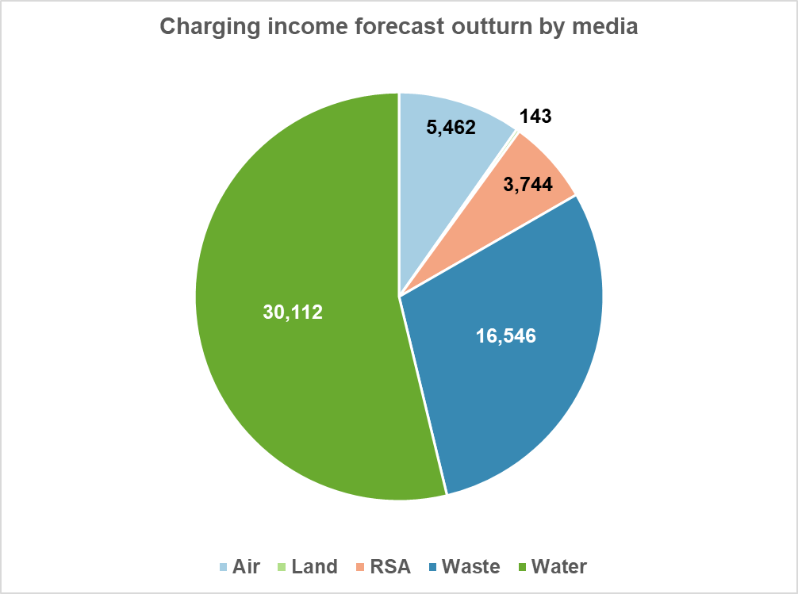
Graph 1: Charging Schemes by media

Note: Graph 1 acronym: RSA – Radioactive Substances Activity

Other income - £1.6m
2.4 The full year income outturn is £1.6m which is £93k higher than the budget. This overall movement is mainly represented by increases against bank interest (£75k).

Total expenditure - £110.7m
- Full year operating costs are £110.7m, £0.2m higher than budget. Graph 2 below shows actuals against budget for the year by expenditure type.

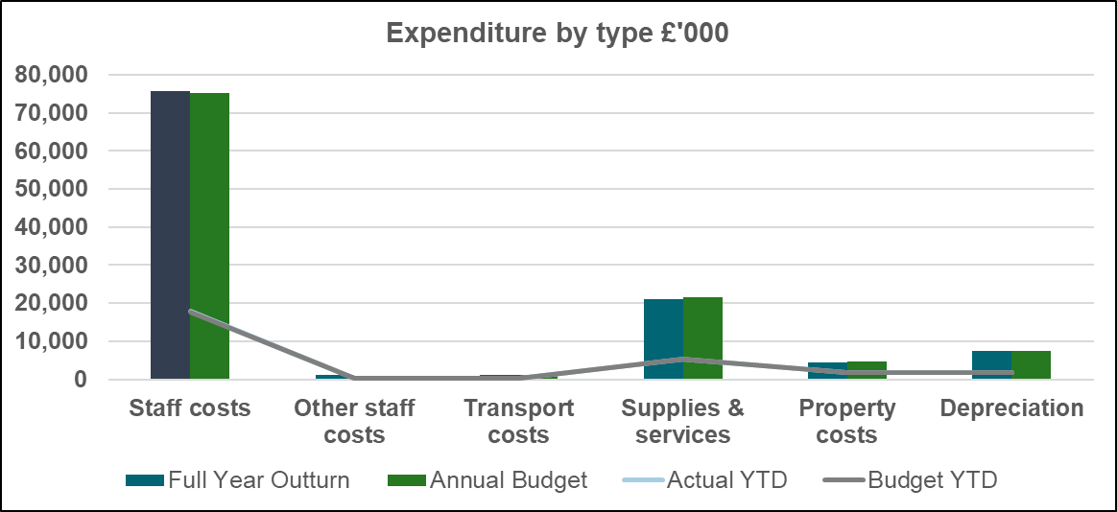
Graph 2: Expenditure by type

Note: Graph 2 acronym: YTD – year to date
Staff costs and other staff costs
- Budgeted staff costs represent 68% of total expenditure. The forecast overspend of £444k is primarily due to forecast pay pressures. The vacancy management level (which represents savings due to vacant posts) was set at 6% or £4.7m. These savings have been accounted for in the forecast outturn.
- Other staff costs need to be considered with staff costs. The forecast is an overspend of £492k mainly due to higher than budget forecast expenditure for temporary workers. These costs will require to be funded from vacancy savings.

Transport costs
- Transport costs are reporting a full year underspend of £20k which mainly relates to reduced mileage claims offset by a forecast overspend against vehicle hires.

Supplies and services
- The current full year forecast indicates an underspend of £620k. The underspend relates to provisions and contingencies being utilised to fund the pay award and potential in year budget pressures within some portfolios. This forecast will continue to change as we progress in the financial year with actions being taken to further manage vacancies and non-staff savings as identified.

- The supplies and services forecast currently includes £0.2m general contingency, these funds are available to help manage risks in relation to unplanned expenditure.

Property costs
- The full year forecast is currently reporting an underspend of £75k which mostly relates to electricity savings offset by overspends against maintenance.

Capital

Table 3: Capital expenditure 2025/26
Function | Budget £'000 | Forecast £'000 | Main projects within function budgets
Digital transformation | 1,495 | 1,495 | Compliance, Data Architecture, Customer Portal & CRM
Governance | 450 | 455 | Web project
Chemistry | 126 | 126 | Nutrients analyser
Ecology | 66 | 66 | Microscopes
Environmental quality | 93 | 93 | Bathing waters signage
Info systems | 250 | 250 | High performance computing
Info systems (Digital) | 1,150 | 1,065 | IAF Implementation
People systems | 70 | 70 | Applicant tracking system
Finance systems | 50 | 50 | Charging cost review
Workspaces | 1,045 | 925 | Stirling office dilapidations
Hydrology | 2,428 | 2,223 | Gauging stations & flooding projects, flood & coastal asset database.
Savings to be identified | (983) | (578)
Total | 6,240 | 6,240

- SEPA’s capital budget provided by Scottish Government for the year is £5.64m. The budget was approved with an over commitment based on the historical knowledge that capital projects are liable to pricing and lead time changes and revision of original budget estimates during the procurement journey. The current over commitment is 10% over budget, however, spend will be delivered within budget.

- In July, SG confirmed that they will transfer an additional £0.6m for supporting the creation of a foundational flood and coastal asset database for Scotland, increasing the total capital budget to £6.24m.

Statement of Financial Position
  - The Statement of Financial Position is tabled below. The 2024/25 figures are drafts pending external audit, which begins in September.

Table 4: Draft Statement of Financial Position period to 30 June 2025
 | Period to June 2025 £'000 | Year to March 2025 £’000

Non-current assets
Property, plant and equipment | 40,322 | 42,075
Intangible assets | 3,935 | 4,027
Assets under construction | 2,380 | 2,380
Employee retirement benefits | 0 | 0
Trade and other receivables | 232 | 232
Total non-current assets | 46,869 | 48,714

Current assets
Trade and other receivables | 18,282 | 5,029
Cash and cash equivalents | 18,632 | 2,346
Total current assets | 36,914 | 7,375
Total assets | 83,783 | 56,089

Current liabilities
Trade and other payables | (6,709) | (13,683)
Provisions | (157) | (231)
Total current liabilities | (6,866) | (13,914)
Total assets less current liabilities | 76,917 | 42,175

Non-current liabilities
Provisions for liabilities and charges >1 year | (6,059) | (6,059)
Future lease payments | (6,781) | (6,781)
Total non-current liabilities | (12,840) | (12,840)
Total assets less total liabilities | 64,077 | 29,335

Taxpayers' equity and other reserves
General fund | 45,037 | 10,295
Revaluation reserve | 19,040 | 19,040
Total tax payers’ equity | 64,077 | 29,335

Recommendation
- The Board is asked to note SEPA’s financial performance for the period ending 30 June 2025.
END
<Report date here (month, year)>

