




2024 Water Quality Monitoring Report: Fipronil and Imidacloprid
August 2026

1. Executive Summary
Following a successful pilot project in 2021/2022, SEPA introduced an innovative new approach to water quality monitoring in 2024 to improve the identification and monitoring of chemicals in Scotland’s water environment. The 2024 monitoring plan included a representative subset of surface water locations from SEPA’s Classification network due to be monitored during 2024 along with a small subset of groundwater locations. This report presents the results of the 2024 water quality monitoring for two substances, fipronil and imidacloprid, two active ingredients used in a range of externally applied veterinary treatments (spot-on treatments and collars) for the control of external parasites primarily in cats and dogs.

Fipronil was detected (at least once) in samples collected at 43 of the 274 surface water locations (16%). In total 814 surface water samples were analysed, and fipronil was detected in 59 samples (7%). The concentrations detected ranged from 1.06 ng/l to 19.95 ng/l.

Imidacloprid was detected (at least once) in samples collected at 11 of the 271 surface water locations (4%). In total 772 surface water samples were analysed, and imidacloprid was detected in 11 samples (1%). The concentrations detected ranged from 6.95 ng/l to 82.94 ng/l.

No fipronil or imidacloprid was detected in any of the 24 groundwater samples collected in 2024.

2. Background
Following a successful pilot project in 2021/2022, SEPA introduced an innovative new approach to water quality monitoring in 2024 to improve the identification and monitoring of chemicals in Scotland’s water environment. Using advanced liquid chromatography with high resolution mass spectrometry (LC-HRMS), SEPA can conduct large-scale analysis of diverse chemical compounds, including pesticides, pharmaceuticals, and veterinary medicines from the same sample at the same time. This represented a large step change in SEPAs analytical capabilities. The methodology uses smaller sample volumes and is more efficient, allowing larger sample numbers to be accommodated. In 2024, this new methodology allowed more than 400 chemicals to be analysed concurrently at approximately 300 locations across Scotland providing a more comprehensive understanding of Scotland’s aquatic ecosystems.

In 2024, the surface water monitoring plan comprised a subset of locations selected from SEPA’s Classification network which were due to be monitored during 2024. The river and loch classification locations were grouped to ensure proportional coverage of different river and loch types, pressures and geographical coverage across Scotland. From each of these groups, a specific number of locations were randomly selected to ensure the proportional representation from each group in the monitoring plan was similar to the relative proportion of these groups in Scotland’s water environment. This was a different approach than had historically been used to design monitoring plans for these types of substances which was generally highly targeted to investigate areas of concern or areas where substances were expected to be found. At each river and loch location, four samples were planned, with one sample to be collected each quarter. The locations sampled are shown in the map in Figure 1.

In addition to the main surface water monitoring plan, groundwater samples were also collected from a small subset of SEPA’s Classification network in November 2024. This groundwater monitoring was undertaken as a precursor to a wider national groundwater monitoring plan for trace organics in future. Groundwater locations were sampled once in 2024.

This report presents the results of the 2024 water quality monitoring for two substances, fipronil and imidacloprid, two active ingredients used in a range of externally applied veterinary treatments (spot-on treatments and collars) for the control of external parasites primarily in cats and dogs. Neither imidacloprid nor fipronil are listed in The Scotland River Basin District (Standards) Directions 2024. However, both have been identified as substances of increasing concern in surface waters, imidacloprid was included in the 1st Water Framework Directive Watch List in 2015 (EU/ 2015/495) and fipronil was added to the 4th Watch List in 2022 (EU/2022/1307). Imidacloprid is also classed as hazardous to groundwater. In August 2025, the UK cross-government Pharmaceuticals in the Environment Group set out a roadmap of activities to address the levels of these two substances in UK waters.

In 2022, the European Commission included a proposal for a new annual average Environmental Quality Standard for imidacloprid (EQS Directive 2022 proposals Annex 1) of 6.8 ng/l in freshwater. In 2021, the Swiss Centre for Applied Ecotoxicology published a proposed annual average Environmental Quality Standard for fipronil of 0.77 ng/l in freshwater (Tierbach et al. 2021). These values are used within this report to provide context only, as although these were derived using the same methodology as SEPA would use, the values have no legal basis in the UK. To avoid confusion these proposed EQS are hereafter called Predicted No Effects Concentrations (PNECs) so as not to be confused with EQS laid out in the Scottish Directions.

2.1 Pilot Study
Water samples were collected from ten locations between 21st November 2021 and 28th June 2022 (Figure 1). These sampling locations targeted areas downstream of urban centres and wastewater treatment facilities, where fipronil and imidacloprid was more likely to be detected. A total of 60 samples were collected (Appendix A, Appendix B).

Fipronil was found at concentrations above the Method Detection Limit (MDL) (1 ng/l) at two locations: the River Forth at Craigforth and the River Almond at Craigiehall. The concentrations ranged from 1.14 ng/l to 8.41 ng/l, with the highest concentration found at the River Almond at Craigiehall. Overall fipronil was detected above the MDL in eight out of 60 samples (13%) and as the PNEC is below the limit of detection, at least eight out of 60 samples had concentrations above the PNEC.

Imidacloprid was found at concentrations above the MDL (1 ng/l) at four locations: the River Forth at Craigforth, the River Almond at Craigiehall, the River Tweed at Norham gauge and the River Ayr at Victoria Bridge. The concentrations found ranged from 1.15 ng/l to 10.60 ng/l, with the highest concentration found at the River Almond at Craigiehall. Overall imidacloprid was detected above the MDL in 10 out of 60 samples (17%), with concentrations in three (5%) samples exceeding the PNEC (6.8ng/l), and five (8%) samples, four from the River Almond at Craigiehall, having concentrations above 5 ng/l.

Figure 1. Surface water and groundwater sampling locations.
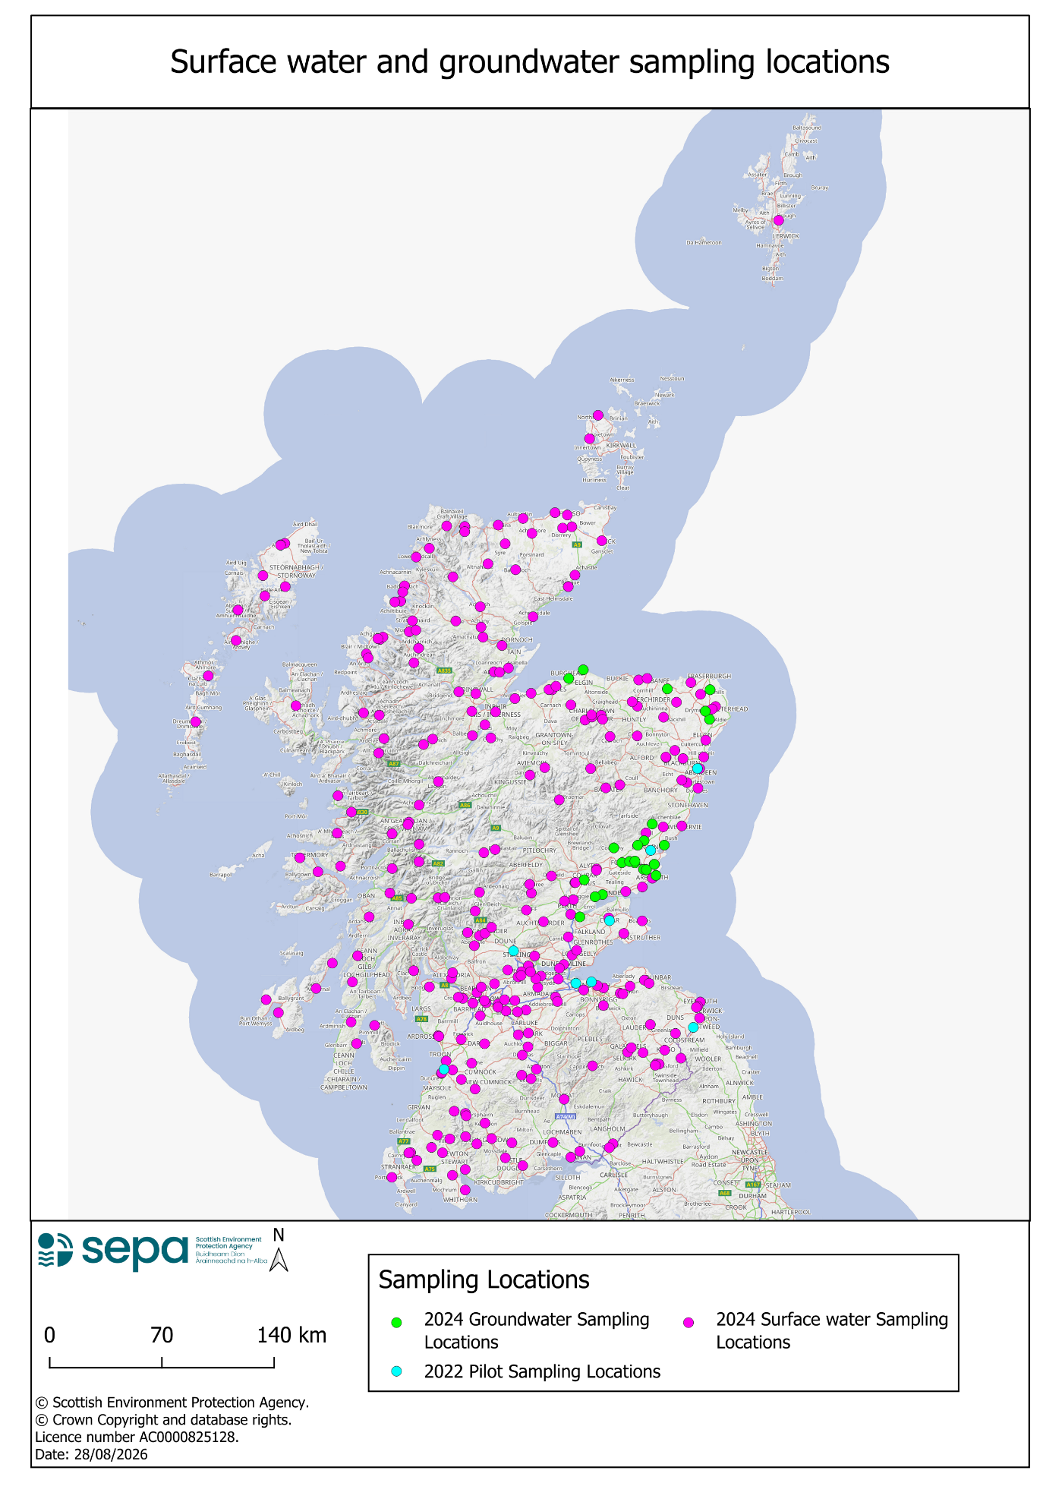

3. 2024 Monitoring
In 2024, water samples were collected from 298 locations across Scotland, 274 surface water locations and 24 groundwater locations. In total 844 samples were analysed (820 surface water samples and 24 groundwater samples). The method detection limits (MDL) for analysis conducted in 2024 were: fipronil 1 ng/l and imidacloprid 5 ng/l. All analysis was subject to quality control (QC) and quality assurance (QA) checks, compliant data is reported.

Surface Water Monitoring
Fipronil was found at concentrations above the MDL (1 ng/l) at 43 surface water locations (Figure 2; Appendix C, Appendix D). The concentrations ranged from 1.06 ng/l to 19.95 ng/l, with the highest concentration (19.95 ng/l) found in the sample collected on the 2 May 2024 from the Quhomery Burn, Inverquhomery, a tributary of the River Ugie in Aberdeenshire (Table 1; Figure 3). Overall fipronil was detected above the MDL in 59 out of 814 samples (7%) and as the PNEC is below the limit of detection, 59 out of 814 samples (7%) had concentrations above the PNEC (Table 1).

Imidacloprid was found at concentrations above the MDL (5 ng/l) at 11 locations (Figure 4; Appendix B). The concentrations found ranged from 6.95 ng/l to 82.94 ng/l, with the highest concentration (82.94 ng/l) found in the sample collected on the 6 February 2024 from the River Annan 500 m upstream of the Evan Water, Dumfries and Galloway (Table 1; Figure 5). Overall, in 2024 imidacloprid was detected above the MDL in 11 out of 772 samples (1%), with concentrations in 11 samples exceeding the PNEC (Table 1; Figure 3).

The reduction in the frequency of detections of imidacloprid in 2024 compared to the pilot study in 2022 is most likely explained by the change in the method detection limit, and in the change to the design of the monitoring plan which includes a change in the frequency of sampling.

Figure 2. Surface water sampling locations where fipronil was detected at concentrations above the method detection limit (>MDL).
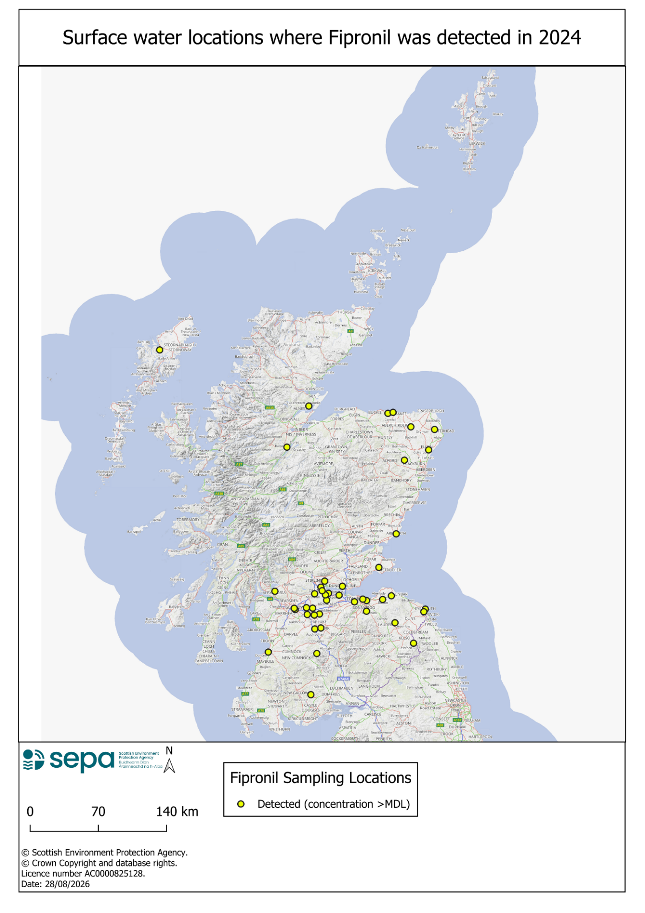
Table 1. Surface water summary statistics of Fipronil and Imidacloprid.
Statistic | Fipronil | Imidacloprid
Number of locations sampled | 274 | 271
Total number of samples reported (that comply with QA/QC) | 814 | 772
Number of locations with concentrations above MDL (in at least one sample) | 43 (16%) | 11 (4%)
Total number of samples with concentrations above MDL | 59 (7%) | 11 (1%)
Range of concentrations detected above MDL | 1.06 -19.95 ng/l | 6.95 - 82.94 ng/l
Location (and date sampled) where the highest concentration was found | Quhomery Burn, Inverquhomery, River Ugie, Aberdeenshire.  02/05/2024 | River Annan 500 m upstream of the Evan Water, Dumfries and Galloway  06/02/2024

Figure 3. Fipronil histogram of samples with concentrations >MDL. The dashed line represents the PNEC (0.77 ng/l).

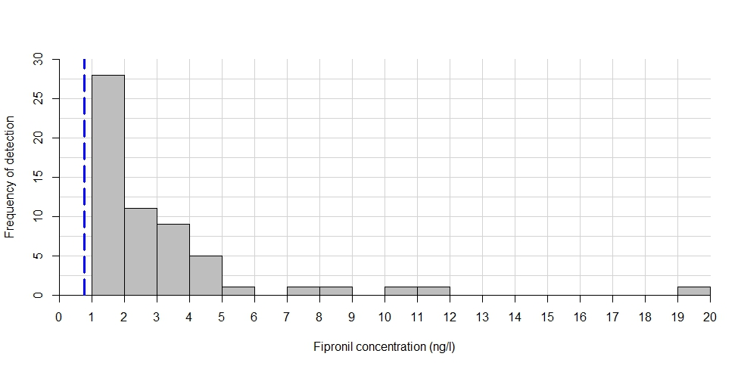
Figure 4. Surface water sampling locations where imidacloprid was detected at concentrations above the method detection limit (>MDL).
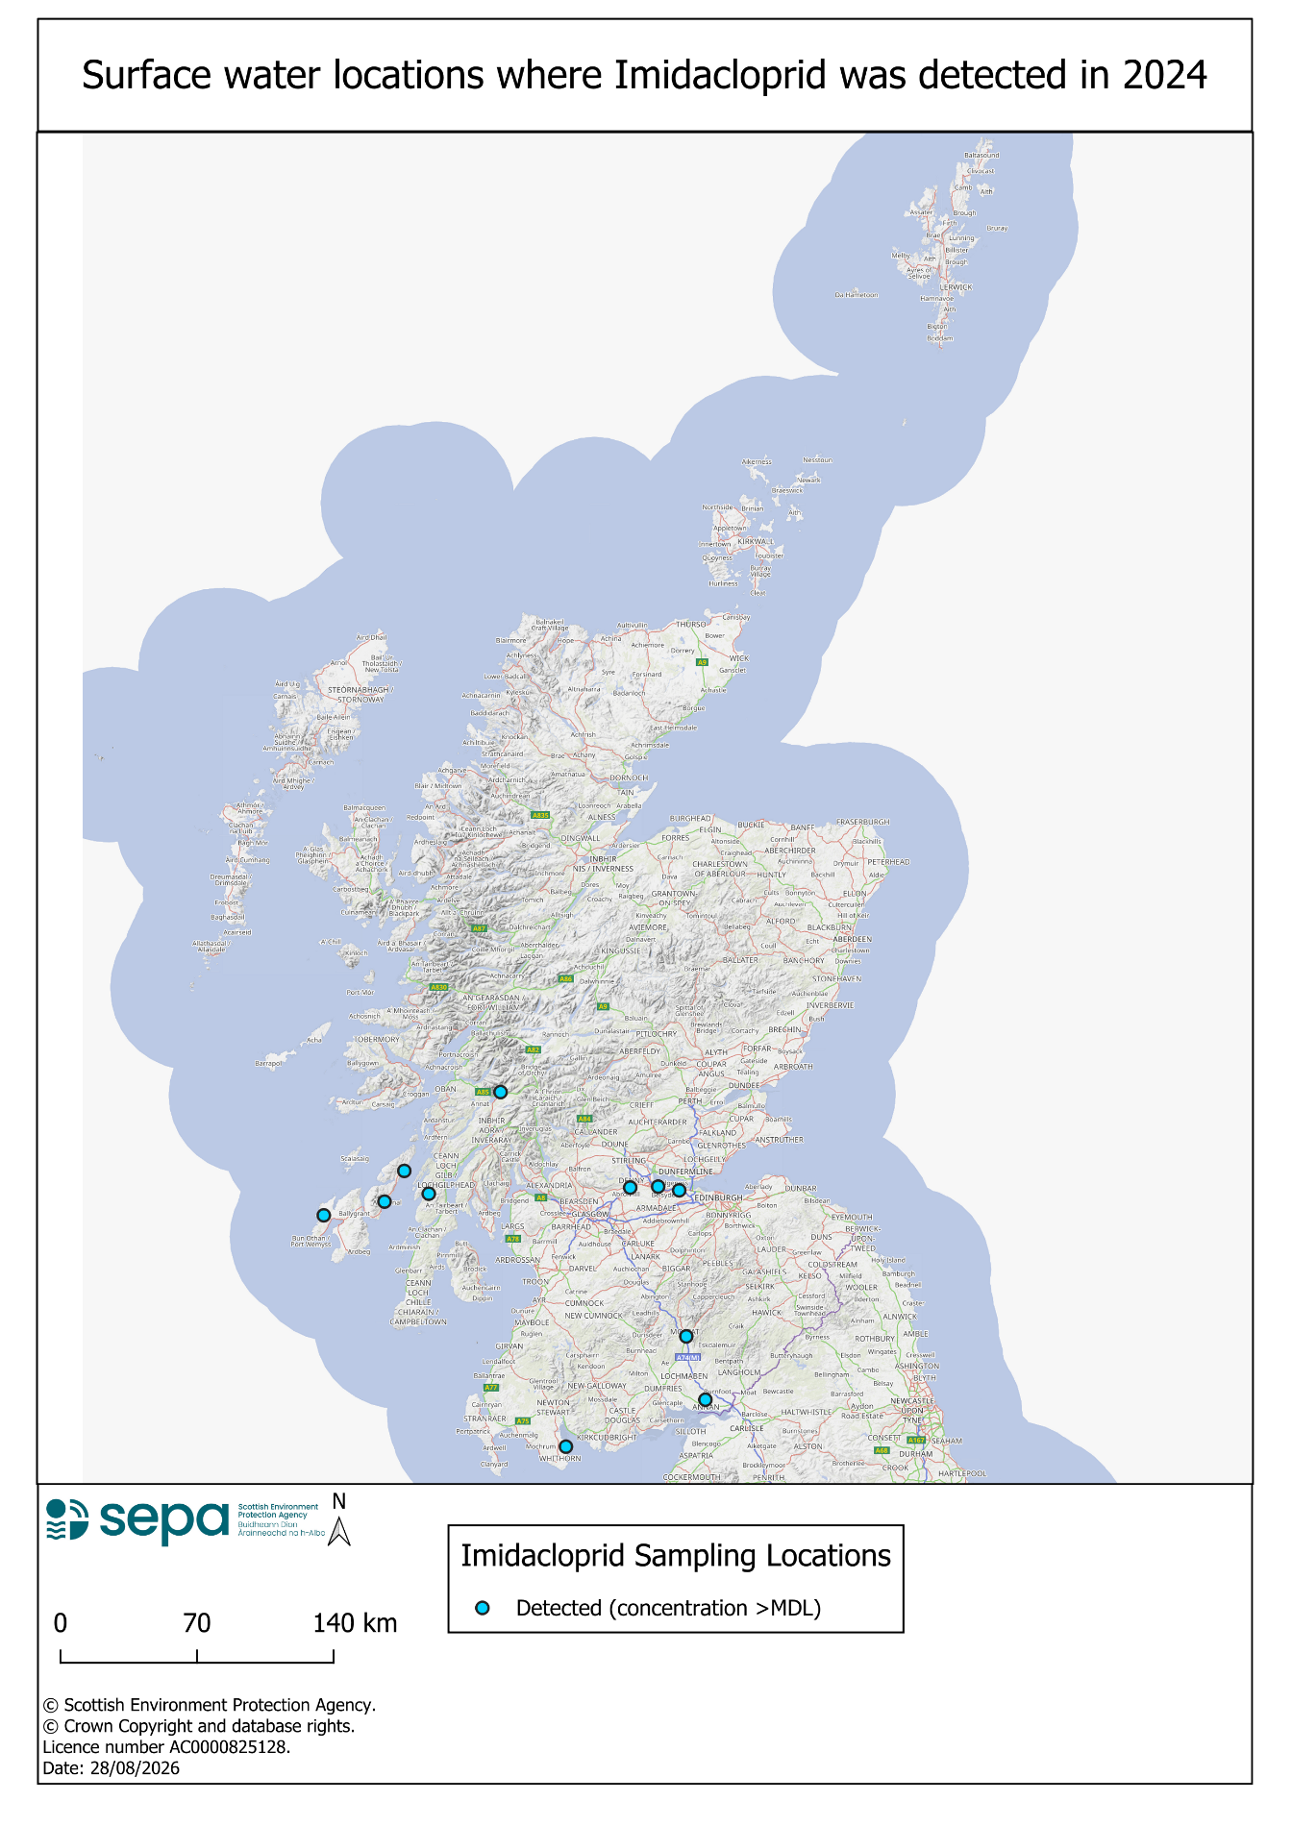
Figure 5. Imidacloprid histogram of samples with concentrations >MDL. The dashed line represents the PNEC (6.8 ng/l).

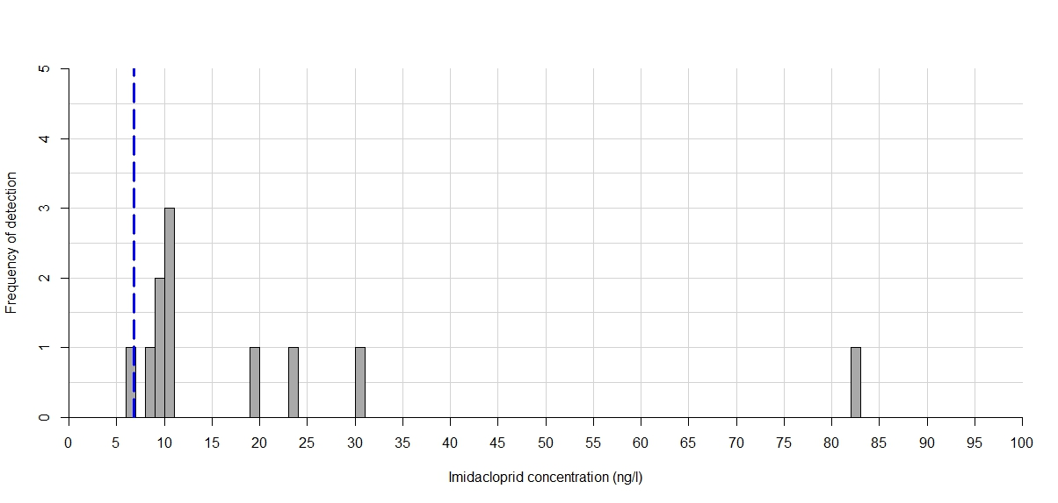

Groundwater Monitoring
No fipronil or imidacloprid was detected in any of the 24 groundwater samples collected in 2024.

4. Assessment of potential sources
Fipronil and imidacloprid are externally applied to pets. It has been reported that these substances can be transferred to people and materials that the pets come into direct contact with; a recent study has shown that these substances may be washed off pets during bathing several weeks after treatment (Perkins et al. 2024). Handwashing, laundry and bathing pets, may all therefore contribute to emissions into the wastewater network (Perkins et al. 2024)). Effluents from wastewater treatment have previously been identified as key sources of emissions of fipronil and imidacloprid to the environment (Diepens et al., 2023; Perkins et al., 2024). Laboratory studies have demonstrated that dogs swimming can release these substances into the water environment (Diepens et al., 2023; Perkins et al., 2025). A recent case study on Hampsted Heath in London found that surface waters near dog walking sites had higher concentrations of fipronil and imidacloprid compared to those sites inaccessible to dogs (Yoder et al., 2024).

Supporting data was investigated to identify potential sources of fipronil and imidacloprid at the sampling locations where fipronil and imidacloprid was found (values reported above the MDL).
Geographic information system software- QGIS (version 3.40.4) was used to identify wastewater treatment plants (WWTPs) within 5 km of each sampling location, and the distances sampling locations were downstream from the closest WWTP (Scottish Water Assets layer) were estimated and the size of the works was established (in population equivalents) using licence information. For sites where there were no WWTPs within 5 km upstream of the sampling locations, QGIS was used to determine whether there were any areas such as dog parks, golf courses, public parks or footpaths adjacent to, or in close proximity to, the sampling locations, where dogs could have accessed the watercourse.

The other substances found in the samples were also evaluated, to provide additional evidence on potential sources. These compounds were grouped as human pharmaceuticals, veterinary medicines or pesticides.

Wastewater treatment plants were identified as a potential source for 25 locations where fipronil was detected and seven locations where imidacloprid was detected. (Appendix C, Appendix D). Human medicines (such as atorvastatin, carbamazepine, clarithromycin, erythromycin) were also found at these sampling locations. These compounds cannot be fully metabolised by the human body, are not easily removed during wastewater treatment (Omuferen et al., 2019; Vineo et al., 2007; Zhang et al., 2020) and indicate wastewater effluents as a potential source of fipronil and imidacloprid at these locations.

Areas that may be frequented by dog walkers such as parks, golf courses and footpaths with potential access to watercourses were identified as a potential source of fipronil at 8 sampling locations.

Where this initial desktop review of potential sources did not identify a potential source of fipronil at 14 locations or imidacloprid at 4 locations, further investigation of potential sources is needed.

5. Conclusions and next steps

- Fipronil was detected (above the MDL and PNEC at least once) at 16% of surface water locations monitored in 2024 and was detected (above the MDL) in 7% of surface water samples collected in 2024.

- More than 80% of surface water samples where fipronil was detected had concentrations less than five times the PNEC. One sample had a concentration of fipronil that was more than 25 times higher than the PNEC.

- Imidacloprid was detected (above the MDL and PNEC at least once) at 4% of surface water locations monitored in 2024 and was detected (above the MDL) in 1% of surface water samples collected in 2024.

- More than 90% of surface water samples where imidacloprid was detected had concentrations less than five times the PNEC. One sample had a concentration of imidacloprid that was more than 12 times higher than the PNEC.

- Potential sources of fipronil and imidacloprid were identified through an initial desk-based review for approximately 60% of locations where they were detected.

- Potential sources of fipronil and imidacloprid were not identified through an initial desk-based review in over 30% of locations where they were detected.

- No fipronil or imidacloprid was detected in groundwater samples collected in 2024.

- The representative monitoring conducted in 2024 has detected fipronil and imidacloprid at locations across Scotland, that might not have been sampled had a more targeted monitoring plan have been employed.

- Representative monitoring should continue in 2025.

References
European Commission. 2015. Commission Implementing Decision (EU) 2015/495 of 20 March 2015 establishing a watch list of substances for Union-wide monitoring in the field of water policy pursuant to Directive 2008/105/EC of the European Parliament and of the Council.

European Commission. 2015. Commission Implementing Decision (EU) 2022/1307 of 22 July 2022 establishing a watch list of substances for Union-wide monitoring in the field of water policy pursuant to Directive 2008/105/EC of the European Parliament and of the Council.

Proposal for a Directive amending the Water Framework Directive, the Groundwater Directive and the Environmental Quality Standards Directive. 26 October 2022. Annex V- Annex I to Directive 2008/105/EC is amended.

Scottish Government. 2024. The Scotland River Basin District (Standards) Directions 2024.

Diepens, N.J., Belgers, D., Buijse, L. and Roessink, I., 2023. Pet dogs transfer veterinary medicines to the environment. Science of the Total Environment, 858, p.159550.

Omuferen, L.O., Maseko, B. and Olowoyo, J.O., 2022. Occurrence of antibiotics in wastewater from hospital and convectional wastewater treatment plants and their impact on the effluent receiving rivers: current knowledge between 2010 and 2019. Environmental Monitoring and Assessment, 194(4), p.306.

Perkins, R., Barron, L., Glauser, G., Whitehead, M., Woodward, G. and Goulson, D., 2024. Down-the-drain pathways for fipronil and imidacloprid applied as spot-on parasiticides to dogs: estimating aquatic pollution. Science of the Total Environment, 917, p.170175.

Perkins, R., Glauser, G. and Goulson, D., 2025. Swimming emissions from dogs treated with spot‐on fipronil or imidacloprid: Assessing the environmental risk. Veterinary Record, p.e5560.

Tierbach, A., Kroll, A., Junghans, M., 2021. CQC (AA-EQS) and AQC (MAC-EQS) – Proposal by the Ecotox Centre for: Fipronil. Dübendorf (CH): Swiss Centre for Applied Ecotoxicology; 112 pp.

Vieno, N., Tuhkanen, T. and Kronberg, L., 2007. Elimination of pharmaceuticals in sewage treatment plants in Finland. Water research, 41(5), pp.1001-1012.

Yoder, L.E., Egli, M., Richardson, A.K., Brooker, A., Perkins, R., Collins, C.T., Cardwell, J.M., Barron, L.P. and Waage, J., 2024. Dog swimming and ectoparasiticide water contamination in urban conservation areas: a case study on Hampstead Heath, London. Science of The Total Environment, 955, p.176686.

Zhang, K., Zhao, Y. and Fent, K., 2020. Cardiovascular drugs and lipid regulating agents in surface waters at global scale: Occurrence, ecotoxicity and risk assessment. Science of The Total Environment, 729, p.138770.

Appendices

Appendix A
Table A: Fipronil Pilot Study Results ordered by location description.
Date | Location Description | Fipronil  Concentration (ng/l)
09/12/2021 | Lunan Water at Kirkton Mill | <1
26/01/2022 | Lunan Water at Kirkton Mill | <1
16/02/2022 | Lunan Water at Kirkton Mill | <1
16/03/2022 | Lunan Water at Kirkton Mill | <1
20/04/2022 | Lunan Water at Kirkton Mill | <1
18/05/2022 | Lunan Water at Kirkton Mill | <1
08/06/2022 | Lunan Water at Kirkton Mill | <1
22/11/2021 | River Almond at Craigiehall | 3.535
26/01/2022 | River Almond at Craigiehall | 4.499
23/02/2022 | River Almond at Craigiehall | <1
23/03/2022 | River Almond at Craigiehall | 5.338
27/04/2022 | River Almond at Craigiehall | <1
24/05/2022 | River Almond at Craigiehall | 8.408
15/03/2022 | River Ayr at Victoria Bridge | <1
12/04/2022 | River Ayr at Victoria Bridge | <1
14/06/2022 | River Ayr at Victoria Bridge | <1
09/12/2021 | River Don at Grandholm Bridge | <1
26/01/2022 | River Don at Grandholm Bridge | <1
16/02/2022 | River Don at Grandholm Bridge | <1
16/03/2022 | River Don at Grandholm Bridge | <1
06/04/2022 | River Don at Grandholm Bridge | <1
28/06/2022 | River Don at Grandholm Bridge | <1
03/01/2022 | River Eden U/S South Bridge, Cupar | <1
16/02/2022 | River Eden U/S South Bridge, Cupar | <1
17/03/2022 | River Eden U/S South Bridge, Cupar | <1
05/05/2022 | River Eden U/S South Bridge, Cupar | <1
31/05/2022 | River Eden U/S South Bridge, Cupar | <1
15/11/2021 | River Forth at Craigfourth (Gauging Station) | 1.142
17/01/2022 | River Forth at Craigfourth (Gauging Station) | 1.33
14/02/2022 | River Forth at Craigfourth (Gauging Station) | <1
14/03/2022 | River Forth at Craigfourth (Gauging Station) | <1
04/05/2022 | River Forth at Craigfourth (Gauging Station) | <1
17/05/2022 | River Forth at Craigfourth (Gauging Station) | 3.246
15/06/2022 | River Forth at Craigfourth (Gauging Station) | 4.754
09/12/2021 | River South Esk at Kinnairds Mill | <1
26/01/2022 | River South Esk at Kinnairds Mill | <1
16/02/2022 | River South Esk at Kinnairds Mill | <1
16/03/2022 | River South Esk at Kinnairds Mill | <1
20/04/2022 | River South Esk at Kinnairds Mill | <1
18/05/2022 | River South Esk at Kinnairds Mill | <1
08/06/2022 | River South Esk at Kinnairds Mill | <1
22/11/2021 | River Tweed at Norham Gauge | <1
03/02/2022 | River Tweed at Norham Gauge | <1
02/03/2022 | River Tweed at Norham Gauge | <1
30/03/2022 | River Tweed at Norham Gauge | <1
11/04/2022 | River Tweed at Norham Gauge | <1
11/05/2022 | River Tweed at Norham Gauge | <1
06/06/2022 | River Tweed at Norham Gauge | <1
22/11/2021 | Water Of Leith at Anderson Place | <1
26/01/2022 | Water Of Leith at Anderson Place | <1
23/02/2022 | Water Of Leith at Anderson Place | <1
23/03/2022 | Water Of Leith at Anderson Place | <1
27/04/2022 | Water Of Leith at Anderson Place | <1
24/05/2022 | Water Of Leith at Anderson Place | <1
22/11/2021 | Water Of Leith at Anderson Place | <1
26/01/2022 | Water Of Leith at Anderson Place | <1
23/02/2022 | Water Of Leith at Anderson Place | <1
23/03/2022 | Water Of Leith at Anderson Place | <1
27/04/2022 | Water Of Leith at Anderson Place | <1
24/05/2022 | Water Of Leith at Anderson Place | <1

Appendix B
Table B: Imidacloprid Pilot Study Results ordered by location description.
Date | Location Description | Imidacloprid Concentration (ng/l)
09/12/2021 | Lunan Water at Kirkton Mill | <1
26/01/2022 | Lunan Water at Kirkton Mill | <1
16/02/2022 | Lunan Water at Kirkton Mill | <1
16/03/2022 | Lunan Water at Kirkton Mill | <1
20/04/2022 | Lunan Water at Kirkton Mill | <1
18/05/2022 | Lunan Water at Kirkton Mill | <1
08/06/2022 | Lunan Water at Kirkton Mill | <1
22/11/2021 | River Almond at Craigiehall | 6.336
26/01/2022 | River Almond at Craigiehall | 5.386
23/02/2022 | River Almond at Craigiehall | <1
23/03/2022 | River Almond at Craigiehall | 3.496
27/04/2022 | River Almond at Craigiehall | 9.986
24/05/2022 | River Almond at Craigiehall | 10.598
15/03/2022 | River Ayr at Victoria Bridge | <1
12/04/2022 | River Ayr at Victoria Bridge | <1
14/06/2022 | River Ayr at Victoria Bridge | 3.366
09/12/2021 | River Don at Grandholm Bridge | <1
26/01/2022 | River Don at Grandholm Bridge | <1
16/02/2022 | River Don at Grandholm Bridge | <1
16/03/2022 | River Don at Grandholm Bridge | <1
06/04/2022 | River Don at Grandholm Bridge | <1
28/06/2022 | River Don at Grandholm Bridge | <1
03/01/2022 | River Eden U/S South Bridge, Cupar | <1
17/03/2022 | River Eden U/S South Bridge, Cupar | <1
04/2022 | River Eden U/S South Bridge, Cupar | <1
05/05/2022 | River Eden U/S South Bridge, Cupar | <1
31/05/2022 | River Eden U/S South Bridge, Cupar | <1
15/11/2022 | River Forth at Craigfourth (Gauging Station) | <1
17/01/2022 | River Forth at Craigfourth (Gauging Station) | 1.15
14/02/2022 | River Forth at Craigfourth (Gauging Station) | <1
14/03/2022 | River Forth at Craigfourth (Gauging Station) | <1
04/05/2022 | River Forth at Craigfourth (Gauging Station) | 1.699
17/05/2022 | River Forth at Craigfourth (Gauging Station) | <1
15/06/2022 | River Forth at Craigfourth (Gauging Station) | 9.6
09/12/2021 | River South Esk at Kinnairds Mill | <1
26/01/2022 | River South Esk at Kinnairds Mill | <1
23/02/2022 | River South Esk at Kinnairds Mill | <1
23/03/2022 | River South Esk at Kinnairds Mill | <1
27/04/2022 | River South Esk at Kinnairds Mill | <1
24/05/2022 | River South Esk at Kinnairds Mill | <1
09/12/2021 | River South Esk at Kinnairds Mill | <1
22/11/2021 | River Tweed at Norham Gauge | <1
03/02/2022 | River Tweed at Norham Gauge | <1
02/03/2022 | River Tweed at Norham Gauge | <1
30/03/2022 | River Tweed at Norham Gauge | <1
11/04/2022 | River Tweed at Norham Gauge | <1
11/05/2022 | River Tweed at Norham Gauge | <1
06/06/2022 | River Tweed at Norham Gauge | 1.152
22/11/2021 | Water Of Leith at Anderson Place | <1
26/01/2022 | Water Of Leith at Anderson Place | <1
23/02/2022 | Water Of Leith at Anderson Place | <1
23/03/2022 | Water Of Leith at Anderson Place | <1
27/04/2022 | Water Of Leith at Anderson Place | <1
24/05/2022 | Water Of Leith at Anderson Place | <1
22/11/2021 | Water Of Leith at Anderson Place | <1
26/01/2022 | Water Of Leith at Anderson Place | <1
23/02/2022 | Water Of Leith at Anderson Place | <1
23/03/2022 | Water Of Leith at Anderson Place | <1
27/04/2022 | Water Of Leith at Anderson Place | <1
24/05/2022 | Water Of Leith at Anderson Place | <1

Appendix C
Table C: Fipronil positive detects, ordered by decreasing concentration.
Date | Location Description | Fipronil Concentration (ng/l) | Potential Source | Distance to nearest WWTP (km)
02/05/2024 | QUHOMERY BURN AT INVERQUHOMERY | 19.95 | Waste water | 4.7
13/05/2024 | BONNY WATER AT UNDERWOOD | 11.52 | Waste water | 4.6
05/08/2024 | BONNY WATER AT UNDERWOOD | 10.54 | Waste water | 4.6
18/11/2024 | NESS: ENRICK BELOW DRUMNADROCHIT SEWAGE WORKS. | 8.49 | Waste water | 0.5
07/05/2024 | BOYNE BURN - SCOTSMILL | 7.43 | Undetermined | 9.3
09/05/2024 | TARTY BURN MILL OF TARTY | 5.13 | Waste water | 1.0
12/08/2024 | THE STANK U/S OF B6352 ROAD BRIDGE, TOWN YETHOLM | 4.80 | Waste water, Dog walking area | 2.6
07/08/2024 | R AVON AT JINKABOOT BRIDGE | 4.15 | Waste water | 0.6
21/05/2024 | PARDOVAN BURN 20M U/S A904 RD.BR. (600M D/S PHILPSTOUN STW) | 4.10 | Waste water | 0.7
15/08/2024 | R CARRON AT CARRON IRONWORKS BRIDGE | 4.07 | Undetermined | 7.9
12/02/2024 | NESS: ENRICK BELOW DRUMNADROCHIT SEWAGE WORKS. | 4.06 | Waste water | 0.5
28/08/2024 | R TYNE AT EAST LINTON | 3.80 | Undetermined | 7.6
23/09/2024 | RIVER CLYDE AT RUTHERGLEN BRIDGE | 3.61 | Waste water, Dog walking area | 0.5
27/05/2024 | MONQUHITTER BURN - D/S CUMINESTOWN STW | 3.53 | Waste water | 2.6
12/08/2024 | BRAID BURN AT FIGGATE PARK | 3.48 | Dog walking area | N/A
23/09/2024 | RIVER CLYDE AT TIDAL WEIR | 3.27 | Waste water, Dog walking area | 2.6
20/05/2024 | R AVON AT JINKABOOT BRIDGE | 3.24 | Waste water | 0.6
07/08/2024 | POW BURN AT MOSSNEUK (R6656) | 3.22 | Waste water, Dog walking area | 3.3
19/11/2024 | COCKLEMILL BURN AT LATHALLAN HOME FARM | 3.20 | Waste water | 1.2
01/05/2024 | SOUTH CALDER WATER AT ORBISTON PARK | 3.07 | Dog walking area | 5.4
14/02/2024 | BONNY WATER AT UNDERWOOD | 2.88 | Waste water | 4.6
26/08/2024 | TOWER BURN AT PITTENCRIEFF PARK (R4223) | 2.84 | Dog walking area | N/A
01/05/2024 | SOUTH CALDER WATER AT COLTNESS BR (CHEMISTRY) | 2.72 | Waste water | 0.7
07/08/2024 | SOUTH CALDER WATER AT BOWHOUSEBOG BR (CHEMISTRY) | 2.33 | Waste water | 1.9
12/11/2024 | MANSE BURN 300 METRES BELOW WESTRUTHER STW | 2.29 | Waste water | 0.4
29/08/2024 | CARROCHAN BURN AT A813 ROAD CULVERT | 2.26 | Undetermined | N/A
13/05/2024 | NESS : ENRICK BELOW DRUMNADROCHIT SEWAGE WORKS. | 2.11 | Waste water | 0.5
07/08/2024 | SOUTH CALDER WATER AT COLTNESS BR (CHEMISTRY) | 2.10 | Waste water | 0.7
27/02/2024 | SOUTH CALDER WATER AT BOWHOUSEBOG BR (CHEMISTRY) | 2.05 | Waste water | 1.9
01/05/2024 | SOUTH CALDER WATER AT BOWHOUSEBOG BR (CHEMISTRY) | 2.04 | Waste water | 1.9
07/08/2024 | SOUTH CALDER WATER AT ORBISTON PARK | 2.03 | Dog walking area | 5.4
27/02/2024 | SOUTH CALDER WATER AT COLTNESS BR (CHEMISTRY) | 1.95 | Waste water | 0.6
23/07/2024 | GORE WATER D/S GOREBRIDGE STW | 1.95 | Waste water | 0.7
02/08/2024 | R ESK AT MUSSELBURGH GAUGING STATION | 1.94 | Waste water | 3.6
07/04/2024 | MONKLAND CANAL AT BLAIRHILL, COATBRIDGE | 1.89 | Undetermined | N/A
08/08/2024 | BROTHOCK W AT ARBROATH BROTHOCK BR. | 1.81 | Waste water | 5
19/09/2024 | NORTH CALDER WATER AT MONKLAND GLEN | 1.81 | Waste water | 3.1
26/08/2024 | COCKLEMILL BURN AT LATHALLAN HOME FARM | 1.72 | Waste water | 1.2
12/08/2024 | MURRAY BURN AT CONFLUENCE WITH WATER OF LEITH | 1.66 | Undetermined | N/A
27/02/2024 | SOUTH CALDER WATER AT ORBISTON PARK | 1.65 | Dog walking area | 5.4
13/08/2024 | BLACK DEVON AT MARY BRIDGE | 1.64 | Undetermined | 6.3
23/05/2024 | R CARRON AT CARRON IRONWORKS BRIDGE | 1.62 | Undetermined | 7.9
06/08/2024 | EYE WATER AT GAUGING STATION | 1.58 | Waste water | 3.9
05/08/2024 | SOUTH UGIE WATER - LONGSIDE | 1.54 | Undetermined | N/A
14/05/2024 | THE STANK U/S OF B6352 ROAD BRIDGE, TOWN YETHOLM | 1.51 | Waste water, Dog walking area | 2.6
28/08/2024 | BACK BURN AT A6093 ROAD BRIDGE | 1.49 | Undetermined | 5.9
01/08/2024 | UNION CANAL WEST OF REDDING BRIDGE | 1.43 | Undetermined | N/A
13/05/2024 | RIVER NETHAN AT BURNFOOT | 1.41 | Waste water | 0.03
22/08/2024 | POLLO BURN U/S OF B817 | 1.37 | Undetermined | N/A
07/05/2024 | NORTH CALDER WATER AT MONKLAND GLEN | 1.35 | Waste water | 1.9
07/08/2024 | R AVON AT STRATH HOUSE | 1.35 | Waste water | 3.1
15/08/2024 | FORDYCE BURN - D/S FORDYCE STW | 1.33 | Waste water | 0.6
20/05/2024 | POW BURN AT MOSSNEUK (R6656) | 1.31 | Waste water, Dog walking area | 3.3
06/08/2024 | EYE WATER AT AYTON BRIDGE | 1.29 | Waste water | 0.2
13/05/2024 | SLAPHOUSE BURN AT BELLEISLE BRIDGE | 1.27 | Dog walking area | N/A
20/05/2024 | MOUSE WATER AT MOUSEMILL BRIDGE | 1.20 | Undetermined | 5.6
13/02/2024 | GRIMERSTA RIVER AT B8011 RD BRIDGE, ISLE OF LEWIS | 1.19 | Undetermined | N/A
27/02/2024 | WANLOCK WATER U/S OF SPANGO BRIDGE | 1.11 | Undetermined | 5.7
14/02/2024 | URR WATER AT A712 CORSOCK BRIDGE (CHEMISTRY) | 1.06 | Waste water | 0.9

Appendix D
Table D: Imidacloprid positive detects, ordered by decreasing concentration.
Date | Location Description | Imidacloprid Concentration (ng/l) | Potential Source | Distance to nearest WWTP (km)
06/02/2024 | RIVER ANNAN, 500M U/S EVAN WATER | 82.94 | Waste water | 1.7
25/03/2024 | LOCH GORM NEAR OUTFLOW (SWQ SITE) | 30.24 | Undetermined | N/A
24/04/2024 | CORRAN RIVER A846 BR | 23.13 | Undetermined | N/A
13/05/2024 | RIVER ANNAN AT BRYDEKIRK GAUGING STATION | 19.05 | Waste water | 0.4
24/04/2024 | LUSSA RIVER AT ARDLUSSA BRIDGE | 10.91 | Undetermined | N/A
29/05/2024 | RIVER ORCHY AT UPSTREAM RIVER STRAE CONFLUENCE | 10.77 | Waste water | 2.6
21/05/2024 | PARDOVAN BURN 20M U/S A904 RD.BR. (600M D/S PHILPSTOUN STW) | 10.72 | Waste water | 0.6
13/05/2024 | R AVON AT JINKABOOT BRIDGE | 9.7 | Waste water | 0.6
20/05/2024 | BARANLONGART BURN D/S OF FISH FARM | 9.46 | Undetermined | N/A
25/06/2024 | BONNY WATER AT UNDERWOOD | 8.54 | Waste water | 4.3
02/04/2024 | POUTON BURN U/S GARLIESTON | 6.95 | Waste water | 3.5

If you would like this document in an accessible format, such as large print, audio recording or braille, please contact SEPA by emailing equalities@sepa.org.uk

