


Radiological Habits Survey:
Dounreay 2025
<Report date here (month, year)>

Authors and Contributors:
I. Dale, P. Smith, A. Audsley, D. Copplestone
External Reviewer:
P. McDonald

If you would like this document in an accessible format, such as large print, audio recording or braille, please contact SEPA by emailing equalities@sepa.org.uk.

Contents

List of Abbreviations and Definitions 7
Units 9
Summary 10
The aquatic survey area 11
The terrestrial survey area 12
Occupancy living/working within 1km of Dounreay 12
Comparisons with previous surveys 12
Suggestions for changes to the monitoring programme 14
1 Introduction 15
1.1 Regulatory Context 15
1.2 Definition of the Representative Person 16
1.3 Dose Limits and Constraints 16
1.4 Habits Survey Aim 17
2 The Survey 19
2.1 Introduction 19
2.2 Dounreay Site Activity 19
2.3 Estimated Activity Concentrations from Licensed Discharges from Dounreay 21
2.4 Survey Areas 24
2.5 Land Cover Data 25
2.6 Soil Data 25
2.7 Topographic Wetness Index 25
3 Methods 32
3.1 Introduction 32
3.2 Postal Survey 32
3.3 Radiometric Surveys 33
3.4 Conduct of the Survey 34
3.5 Meetings and Informal Contacts 35
3.6 Data Conversion and Analyses 35
3.7 Data Rounding and Grouping 36
3.8 Qualitative and Quantitative Observations 38
4 Postal Survey 40
4.1 Introduction 40
5 Aquatic Radiation Pathways 41
5.1 Introduction 41
5.2 Aquatic Survey Area Descriptions 41
5.3 Commercial Seafood Operations 41
5.4 Non-Commercial Fishing and Angling 43
5.5 Wildfowling 43
5.6 Royal National Lifeboat Institute 44
5.7 Sailing and Rowing 44
5.8 Diving Clubs and Surfing 44
5.9 Professional Dog Walkers 45
5.10 Animals Grazing 45
5.11 Seaweed and Foraging 45
5.12 Ramblers/Walking and Other Pathways 46
5.13 Internal Exposure – Phase 1 47
5.14 External Exposure – Phase 1 52
6 Terrestrial Radiation Pathways 61
6.1 Introduction 61
6.2 Private Food Production 61
6.3 Commercial Food Production 62
6.4 Wild Foods 62
6.5 Production of Honey 62
6.6 Farms 63
6.7 Other - Subsea Cable Installation 63
6.8 Internal Exposure – Phase 1 65
7 External Exposure 72
7.1 Introduction 72
7.2 Mobile Gamma Spectrometry Survey 72
7.3 In-situ Gamma Dosimetry 74
7.4 In-situ Beta Dosimetry 76
7.5 Occupancy Rates 76
8 Phase 2 Survey Results 84
8.1 Introduction 84
8.2 Phase 2 Internal Exposure 84
8.3 Phase 2 External Exposure 87
9 Post Covid-19 Habit Analysis 91
10 Comparisons with the Previous Survey 95
10.1 Introduction 95
10.2 Aquatic Survey 95
10.3 Terrestrial Survey 106
10.4 Occupancy living/working within 1km of Dounreay 109
11 Recommendations and Suggestions for Monitoring Programme Changes 111
11.1 Introduction 111
11.2 Ongoing Monitoring 111
11.3 Conclusions and Recommendations 111
References 113
Appendices 116
Appendix A 116
Appendix A1 Raw Data 116
Appendix A2 Postal Survey 190
Appendix A3 In-Situ Gamma Dose Rate Measurements 201
Appendix A4 Beta Skin Dosimetry Measurements 202
Appendix A5 Site Descriptions and Observations 203

List of abbreviations and definitions
ALB All-weather lifeboat
BBQ Barbeque
DORIS Dispersion of Radionuclides into the Sea
DSRL Dounreay Site Restoration Limited
EASR18 Environmental Authorisations (Scotland) Regulations 2018
ERL Environmental Radioactivity Laboratory, University of Stirling
EU European Union
FEPA Food and the Environment Protection Act
GSR General Safety Requirements
GRANIS Gamma Radiation above Nuclides in Soil
HSE Health and Safety Executive
IAEA International Atomic Energy Agency
ICRP International Commission on Radiological Protection
LLWF Low Level Waste Facility
MET Meteorological
MoD Ministry of Defence
MoGSS Mobile Gamma Spectrometry System
NDA Nuclear Decommissioning Authority
NDAWG National Dose Assessment Working Group
NRS Nuclear Restoration Services Limited
NRTE Vulcan Naval Reactor Test Establishment
ONR Office of Nuclear Regulation
PC-CREAM Consequences of Releases to the Environment: Assessment Methodology
PLUME Atmospheric dispersion model used within PC-CREAM

RESUS Resuspension of activity concentrations into air model used within PC-CREAM
RIFE Radioactivity in Food and the Environment
RNLI Royal National Lifeboat Institution
SEPA Scottish Environment Protection Agency
UK United Kingdom
UKAS United Kingdom Accreditation Service

Units
Bq | Becquerel | M | Mega (one million, E⁶)
Gy | Gray | m | milli (one thousandth, E⁻³)
[H*(0.07)] | Directional dose equivalent at 0.07mm skin depth | µ | micro (one millionth, E⁻⁶)
Sv | Sievert | % | percentage
mSv | milliSieverts | Ha | hectare
µSv | microSieverts | km | kilometre
nGy | nanoGray | m | metres
µGy | microGray | cm | centimetre
keV | kiloelectron volt | y⁻¹ | per year
L | Litres | h⁻¹ | per hour

Summary
This report presents the findings of the 2025 Dounreay Habits Survey to determine the habits and consumption patterns of people living and undertaking recreational activities in the vicinity of the Dounreay nuclear site which is operated by Nuclear Restoration Services Limited (NRS). The site is authorised by the Scottish Environment Protection Agency (SEPA) under Environmental Authorisations (Scotland) Regulations 2018 (EASR18) and is authorised to discharge liquid radioactive wastes into the Pentland Firth via a pipeline outfall 600m offshore. Authorised gaseous radioactive wastes are discharged via several stacks. The Vulcan facility also discharges authorised gaseous radioactive waste to the atmosphere and liquid radioactive wastes to the sea via the Dounreay Site outfall, which discharges into the Pentland Firth. Sources of direct radiation are also present.
The survey targeted the three areas that were likely to be affected by discharges from the site, defined as:
- A marine survey area: this included the intertidal areas and waters of the Pentland Firth extending from Armadale Bay in the west to Dunnet Head in the east.
- A terrestrial survey area: this included a 5km radial zone from the Dounreay nuclear licensed site boundary extending to Crosskirk in the east and Red Point in the west.
- The direct radiation survey area: extending 1km from the boundary of the nuclear licensed site (covering housing and land-use close to the site) which relates to ionising radiation emanating directly from the site.
During the survey, several potential exposure pathways were investigated through methods including postal and face-to-face surveys and general observations. The survey was conducted in two parts: (i) Phase 1 - the face-to-face survey during the summer of 2025, which was undertaken within and outwith the local school holiday period; and (ii) Phase 2 - a follow up survey during October of 2025.
Data obtained during the survey included the consumption of foods produced within the terrestrial survey area; occupancy of both terrestrial areas and within the direct radiation survey area; consumption of aquatic food from within the aquatic survey area; occupancy of aquatic and intertidal areas; and the handling of equipment used within the aquatic survey area.
Interviews with members of the public were carried out over a period of 14 days and data for 350 individuals are presented and discussed for the face-to-face Phase 1 survey and a further nine individuals were re-surveyed within Phase 2. Those high-rate individuals are identified using established methods comprising a ‘cut-off’ to define the high-rate group and 97.5th percentiles for dose assessment analysis.

The aquatic survey area
Fish, crustaceans, molluscs, wildfowl and seaweed are all consumed by adults. The mean consumption rates for adult high-rate groups for each of these food groups were:
- 16kg y⁻¹ for fish.
- 30kg y⁻¹ for crustaceans.
- 2kg y⁻¹ for molluscs.
- 2.5kg y⁻¹ for wildfowl.
- 0.7kg y⁻¹ for seaweed.
Three children were found to consume fish (mackerel) with a mean high-rate consumption of 3.9kg y⁻¹. Two children were found to consume crustaceans (brown crab and common lobster) with the mean high-rate consumption of 35kg y⁻¹. No aquatic consumption was determined for infants.
Aquatic activities for adults included body boarding, diving, outdoor swimming, snorkelling, stand-up paddle boarding, surfing, capsize training, free diving, sea aerobics, being on a dive boat, boat maintenance, canoeing, commercial fishing/creeling, kayaking, powerboating, sailing, sea angling, Royal National Lifeboat Association (RNLI) duties, on a boat – coracle and sea cadet activities.
Intertidal activities for adults included bait digging, sitting/picnicking/barbeque (BBQ), beachcombing, bird/nature watching, boat maintenance, camping, collecting limpets, collecting seaweed, dog walking, drone flying, fishing, jogging, litter picking, paddling, photography, playing, RNLI training, rock pooling, walking and working.
The mean rates for the adult high-rate group for occupancy within the aquatic survey area were:
- 669h y⁻¹ for activities in the water.
- 3421h y⁻¹ activities on the water.
- 3492h y⁻¹ handling equipment.
- 554h y⁻¹ handling sediment.
Twenty in-situ gamma dose rate measurements were made over intertidal surfaces during the survey period. Five beta dose rate measurements were made: three measurements over boat keels and two measurements over creels.

The terrestrial survey area
The mean consumption rates for the adult high-rate groups for terrestrial foods were:
- 21.9kg y⁻¹ green vegetables.
- 79.4kg y⁻¹ other vegetables.
- 20.1kg y⁻¹ root vegetables.
- 59.6kg y⁻¹ potatoes.
- 118kg y⁻¹ domestic fruit.
- 1.2kg y⁻¹ wild fruit.
- 2kg y⁻¹ wild mushrooms.
- 14.7kg y⁻¹ meat sheep.
- 72.5kg y⁻¹ meat beef.
- 42.8kg y⁻¹ eggs.
- 0.93kg y⁻¹ honey.

Occupancy living/working within 1km of Dounreay
The highest occupancy rates in 2025 within the direct radiation area were as follows (holidays were considered):
- 8760h y⁻¹ for the total occupancy rate.
- 5475h y⁻¹ for the indoor occupancy rate.
- 4004h y⁻¹ for the outdoor occupancy rate.
- 920h y⁻¹ for the working indoors occupancy rate.
- 4312h y⁻¹ for the working outdoors occupancy rate.

Comparisons with previous surveys
The results of the Dounreay 2025 Habits Survey were compared with the last habits survey carried out at Dounreay in 2018.
In the aquatic survey area, the mean consumption rate for the adult high-rate group for fish in the face-to-face interviews decreased in the 2025 survey compared to 2018. The main species of fish consumed by the adult high-rate group were bass, cod, flounder, haddock, halibut, ling, mackerel and pollock in 2025 compared to the main species of haddock, cod, bass, plaice, lemon sole and hake in 2018.
The mean consumption rate for the adult high-rate group in the face-to-face interviews decreased for molluscs in 2025 compared to 2018. In 2025 the main species consumed by the adult high-rate group were cockles and limpets compared with mussels, scallops and whelks in 2018.
The mean consumption rate for the adult high-rate group in the face-to-face interviews for crustaceans increased in 2025 compared to 2018. The main species of crustacean consumed by the adult high-rate group in both 2025 and 2018 were brown crab and common lobster.
Consumption of seaweed and wildfowl was determined within the 2025 survey while no consumption of wildfowl was determined in 2018. In 2018 seaweed one individual reported collection of a small quantity of seaweed for their own consumption but the amount consumed was not quantified.
The main species consumed by the adult high-rate group by the adult high-rate group in 2025 of seaweed was Dulse and of wildfowl was Mallard duck and Greylag goose.
The fish species consumed by the child high-rate group was mackerel in 2025 and pollock, cod and mackerel 2018. The mean consumption of fish within the children’s high-rate group decreased in 2025 compared to 2018.
No consumption of molluscs was determined for children in the 2025 survey, but it was found in 2018. Consumption of crustacean (brown crab and common lobster) was determined in the 2025 survey but not in 2018.
No child consumption of seaweed or wildfowl was determined in the 2025 or 2018 surveys.
No infant aquatic consumption was determined in 2025, but consumption of fish and crustaceans was found in 2018.
For adults the mean high-rate occupancy in 2025 for on water, in water, handling equipment and handling sediment increased compared to 2018. The adult highest total intertidal occupancy in 2025 increased compared to 2018.
Adult consumption rates of locally produced food items have increased in the 2025 survey in the other vegetables, potatoes, wild fruit, beef, eggs and honey food groups compared to the 2018 survey. Adult consumption rates decreased in the 2025 survey in the green vegetables, root vegetables, domestic fruit, wild fungi and sheep meat food groups compared to the 2018 survey. No adult consumption for game birds, game venison, poultry and pork was determined in 2025 compared to the 2018 survey.
The total occupancy was the same in 2025 compared to 2018. Indoor occupancy at home decreased in 2025 compared to 2018. Outdoor occupancy, indoor work occupancy and outdoor work occupancy all increased in 2025 compared to 2018.

Suggestions for changes to the monitoring programme
It is recommended that SEPA’s routine monitoring continues as is currently being undertaken. However, based on the findings of this habits survey, and considering the potential radiological significance of the various pathways that were identified, it is suggested that SEPA consider field mushrooms (Agaricus campestris) to be included in the routine monitoring programme for wild foods and sampled annually from within 1km of the Dounreay site.

1 Introduction

1.1 Regulatory Context
Dounreay is a nuclear licensed site located on the coastline of Caithness, close to Thurso that covers an area of 54 hectares (Nuclear Decommissioning Authority (NDA), 2014). Three reactors operated on the site. The site is currently undertaking decommissioning.
The current UK legislation, relating to radioactivity, provides uniform safety standards to protect the health of workers and members of the public. The UK’s statutory obligation is now under the International Atomic Energy Agency (IAEA) Basic Safety Standard, (General Safety Requirements) Part 3, Schedule III.3 for the 1mSv committed effective dose and 50mSv skin annual dose limit since leaving the EU (IAEA, 2014). This lays down basic safety standards for protecting people against the impact of exposure to ionising radiation. Following the UK’s departure from the EU, the UK agreed a nuclear cooperation agreement with the European Commission (2021), ensuring both parties continue working together on civil nuclear matters including safeguards, safety, and security.
The site discharges radioactive effluent and gases into the environment that may result in the exposure of the public by two primary pathways:
- Discharges to the aquatic environment.
- Discharges to the atmosphere.
From these pathways, members of the public may be exposed through inhalation, ingestion of locally sourced food and/or indirectly due to external exposure to contaminated materials (Smith and Jones, 2003). In addition, there may be a direct exposure pathway (commonly referred to as shine) from the site which members of the public could be exposed to as they undertake their day-to-day activities.
It is also recognised that enhanced doses from external exposure due to authorised discharges and the consumption of locally sourced foods may occur because of contemporary and historical discharges accumulating in the environment (Dale et al., 2008; Tyler et al., 2013). It is the responsibility of SEPA to regulate the discharges from the site to ensure that the public are not exposed to doses more than the legal limits. Exposure to shine from nuclear radiation or waste facilities is the responsibility of the Office of Nuclear Regulation (ONR) within a nuclear licensed site, and the Health and Safety Executive (HSE) outside a nuclear licensed site, where any direct exposure impacts on facility workers.

1.2 Definition of the Representative Person
The optimal approach for assessing doses to the public is through a combination of site-specific habit data and an environmental monitoring programme to determine ambient dose rates and concentrations in foodstuffs. In addition to the various interactions an individual may have with exposure routes, the actual doses received are also dependent upon age, size, and metabolism. Thus, the standard approach is to identify and consider these sources of variability in appropriate groups. The concept of the ‘representative person’ was introduced by the International Commission on Radiological Protection (ICRP) (2006) and recommended to replace the previously used concept of the ‘critical group’ in 2007 (ICRP, 2007). The representative person is the individual that represents the more highly exposed members of the public and is typically defined by a cut-off, for example the top 97.5% of the dose distribution within one or more routes of exposure. Within this concept, if the dose received by the representative person(s) can be demonstrated to be within the accepted dose limits and constraints, then the public are considered to be protected.
Within the scope of this report the information provided will assist SEPA in determining the representative person within the Dounreay area. The representative person is established using environmental monitoring data in conjunction with habits survey data.

1.3 Dose Limits and Constraints
The system of dose limitation recommended by ICRP (2007), and subsequently in UK legislation, requires that the retrospective maximum permissible dose limits do not exceed 1mSv y⁻¹ from all anthropogenic sources. For prospective assessments, the maximum permissible doses or constraints used by SEPA are:
- 0.3mSv y⁻¹ for any single source of radioactivity.
- 0.5mSv y⁻¹ for a single site from which radioactive discharges are made.
It is also accepted by the UK Government that it should be possible to operate existing nuclear facilities without exceeding the 0.3mSv y⁻¹ constraint (Hunt et al., 1982; Leonard et al., 1982). Under Schedule 9, paragraph 27 of the Environmental Authorisations (Scotland) Regulations 2018 (EASR18) SEPA are required to have regard to the dose constraints and ensure that they are not exceeded for authorised discharges of ionising radiation to the environment.

1.4 Habits Survey Aim
The aim of the habits survey is to collect site-specific data to allow a bespoke assessment to be made that identifies the representative individual(s). The identification of the representative person is a result of combining known information on the consumption of local foods and occupancy times with data from SEPA’s routine environmental monitoring programme. The survey aims to collect data on the consumption rates of locally grown foods and occupancy times to identify the doses to the most representative person(s). The survey also aims to identify any habits which the routine programme does not currently adequately cover and may recommend the adoption of new monitoring due to new or changing habits or the removal of monitoring that is no longer required. The survey does this by:
- Collecting data on a range of habits/activities by the public in the environment immediately surrounding the nuclear site and surrounding areas that might lead to exposure to radioactivity or radiation from any combination of licensed liquid or gaseous discharges, or direct radiation from on-site activities at Dounreay.
- Collecting information on consumption of food grown or produced (including wild and free foods) in the survey area and determining an annual rate of consumption for each individual surveyed and household members of all ages.
This report presents the findings for the 2025 habits survey of the Dounreay nuclear licensed site. All raw data can be found in Appendix A1. The previous survey was undertaken (fieldwork components) during the periods 24 – 30 May and the 5 – 11 July 2018 (Dale et al., 2022).

2 The Survey

2.1 Introduction
This chapter describes the site characteristics including recent and prospective site activities, and the surrounding land cover characteristics. In preparation for the survey, a meeting was held with site operators and the SEPA site inspector in February 2025.
The Dounreay Stakeholders Group meeting was attended by a member of the survey team bringing the Dounreay Habits Survey to the attention of interested stakeholder groups and public members from the Dounreay area.

2.2 Dounreay Site Activity

2.2.1 Current on-site activity
The Dounreay nuclear licensed site occupies 54 hectares (NDA, 2014) on the Caithness coastline close to the town of Thurso. The site was first developed in 1955 with the primary aim to develop research reactors. Three reactors were built and commissioned on the Dounreay site: Dounreay Materials Test Reactor was the first to begin operation in 1958; the Dounreay Fast Reactor was the second to start operation in 1959; and Prototype Fast Reactor was the third reactor to start in 1974. All three reactors and associated fuel processing activities ceased operation by 2006 (NDA, 2014) and the site is currently undergoing decommissioning with an end state expected in several decades (NDA, 2021). In 2023, all environmental permits were transferred by SEPA from Dounreay Site Restoration Limited (DSRL) to Magnox Limited when Dounreay joined with Magnox Limited (RIFE, 2024). Magnox Limited changed its company name in April of 2024 to Nuclear Restoration Services Limited (NRS) (RIFE, 2024). The NRS operation at Dounreay is authorised by SEPA under an EASR 18 radioactive substances authorisation, to discharge low level effluent into the Pentland Firth via a pipeline outfall 600m offshore and gaseous discharges via several stacks. There has been no overall change in the permit limits since the previous habit survey in 2018 however there were some changes made to the gaseous discharge subsidiary limits in October 2018 (RIFE, 2019).
A low-level radioactive waste disposal facility (LLWF) adjoins the licensed site (NRS hold the EASR18 authorisation for the LLWF). Following construction of two concrete vaults, they began receiving low level radioactive and demolition waste from the Dounreay site in 2015 (RIFE, 2024). Two additional construction phases are permitted (each phase comprising of two concrete vaults) with further phases dependent on the progress with the decommissioning of the Dounreay site (RIFE, 2023).
The Vulcan Naval Reactor Test Establishment was built around 1957 and operated two reactors. The Vulcan facility continues to discharge gaseous waste to the atmosphere and liquid waste to the sea via the Dounreay site outfall, which discharges into the Pentland Firth. Vulcan hold a Letter of Approval for the disposal of radioactive waste. A representative of the Vulcan facility provided the following information: “The Vulcan Naval Reactor Test Establishment (NRTE), adjacent to the Dounreay civilian nuclear site, has been used for prototype testing of submarine nuclear reactors. Reactor operations at Vulcan ceased in July 2015 and the reactors have now been defueled. Vulcan NRTE continues to support the UK’s nuclear submarine propulsion programme on fuel management to support ongoing safe operation of our current nuclear submarines, and we expect this to continue until at least April 2027. Following completion of these operations the plan is to hand over the management of the Vulcan site from the MoD to the NDA. The site will enter a phase of decommissioning and environmental restoration, including decommissioning and disposal of the reactors and their component parts to achieve Interim End State.”
For the purposes of this report, both the Dounreay site and Vulcan sites are considered together as one site.
Fuel reprocessing operations previously undertaken on the Dounreay site have resulted in the inadvertent release of fragments of fuel, known as particles, into the marine environment. Following the discovery of the first particles in the offshore environment (Tyler et al., 2010), the site operators were required to introduce rapid and extensive beach monitoring, which has been in place for around twenty-five years and has been the subject of several reports by the Dounreay Particles
Advisory Group and the Particles Retrieval Advisory Group (Dounreay).
Particles are recovered routinely from the Dounreay foreshore (which is largely inaccessible to the public) and Sandside Beach.

2.2.2 Off-Site Activity
NRS Limited operates an environmental monitoring programme around the site and across the local district. This monitoring programme considers the effects of liquid and aerial radioactive discharges from the site on land, water courses and the sea. Under their EASR permit, NRS is required to periodically review their environmental monitoring programme and to reflect any changes identified for on/off-site activity in the local area.

2.3 Estimated Activity Concentrations from Licensed Discharges from Dounreay
There has been no overall change in the permit limits since the previous habit survey in 2018 however there were some changes made to the gaseous discharge subsidiary limits in October 2018 (RIFE, 2019). Permitted limits of liquid discharges from Dounreay were used to calculate activity concentrations in water using the DORIS model within PC-CREAM version 1.7.3.130 (database 2.8.2) (Smith and Simmonds, 2009). Permitted liquid discharges from the site are tritium (6.90E+12 Bq y⁻¹), strontium-90 (1.77E+11 Bq y⁻¹), caesium-137 (6.29E+11 Bq y⁻¹), other alpha (modelled as plutonium-239 (3.40E+09 Bq y⁻¹)). Other non-alpha discharges (4.80E+10 Bq y⁻¹) were included in the caesium-137 calculations.
A continuous release was assumed when modelling unfiltered seawater, fish, seaweed, crustacean, and mollusc activity concentrations over a 50-year period. The default values for the Dounreay area in PC-CREAM were used for all element dependent parameters (e.g. sediment distribution coefficients, K_{d}, and concentration factors), local compartment details (e.g. depth, coastline length, volumetric exchange rate, suspended sediment load, sedimentation rate, sediment density and diffusion rate) and regional model information (e.g. volume, depth, suspended sediment load, sedimentation rate, sediment density, diffusion rate).
Activity concentration values reported at 50 years for unfiltered seawater in the immediate vicinity of Dounreay were estimated to be: 8.69E-02 Bq l⁻¹ for tritium, 2.23E-03 Bq l⁻¹ for strontium-90, 4.15E-05 Bq l⁻¹ for other alpha (plutonium-239), and 8.46E-03 Bq l⁻¹ for all other non-alpha and caesium-137.
Activity concentrations in different aquatic foodstuffs were estimated and are presented in Table 2.1.
Table 2.1. Estimated activity concentrations in foodstuffs
Radionuclide | Fish (Bq kg ⁻¹) | Crustaceans (Bq kg ⁻¹) | Molluscs (Bq kg ⁻¹)
Alpha (as Plutonium-239) | 2.07E-03 | 4.15E-03 | 6.22E-02
Non-alpha (as Caesium-137) | 8.26E-01 | 2.47E-01 | 2.47E-01
Strontium-90 | 4.41E-03 | 4.41E-03 | 2.19E-03
Tritium | 8.69E-02 | 8.69E-02 | 8.69E-02

Atmospheric activity concentrations were modelled using the PLUME model in PC-CREAM (Smith and Simmonds, 2009). The permitted gaseous discharges from Dounreay were modelled and included: tritium (1.72E+13 Bq y⁻¹), krypton-85 (5.69E+14 Bq y⁻¹), iodine-129 (1.08E+08 Bq y⁻¹), caesium-137 (as an analogue for other non-alpha) (1.70E+09 Bq y⁻¹) and plutonium-239 (as an analogue for other alpha) (3.10E+07 Bq y⁻¹) were used as input.
The activity concentrations in air for discharges from five stacks of 0 to 30m height were determined. The results for the 30m stack are reported here over a range of distances from 500 to 25,000 metres. The meteorological (MET) stability scheme was applied using the default settings with data extracted based on the MET Pasquill D with rain category, selected by reviewing the local meteorological data. The calculated activity concentrations in air are presented in Table 2.2.

Table 2.2 Calculated activity concentrations in air (Bq m⁻³) for permitted discharges from Dounreay discharged from five stacks at 30m height
Distance (m) | Tritium (Bq m⁻³) | Krypton-85 (Bq m⁻³) | Iodine-129 (Bq m⁻³) | Caesium-137 (Bq m⁻³) | Plutonium-239 (Bq m⁻³)
500 | 2.81E-01 | 9.28E+00 | 1.74E-06 | 3.55E-05 | 5.02E-07
1000 | 2.11E-01 | 6.98E+00 | 1.29E-06 | 3.07E-05 | 3.74E-07
5000 | 1.68E-02 | 5.55E-01 | 9.07E-08 | 3.01E-06 | 2.78E-08
10000 | 4.85E-03 | 1.60E-01 | 2.34E-08 | 8.14E-07 | 7.42E-09
15000 | 2.26E-03 | 7.48E-02 | 9.90E-09 | 3.52E-07 | 3.21E-09
20000 | 1.37E-03 | 4.53E-02 | 5.46E-09 | 1.97E-07 | 1.80E-09
25000 | 9.39E-04 | 3.11E-02 | 3.42E-09 | 1.25E-07 | 1.14E-09
The GRANIS (external exposure model) and RESUS (resuspension model) modules in PC-CREAM were used to estimate the total dose from atmospheric discharges at the same specified distances from the Dounreay site, using the data presented in Table 2.2. Table 2.3 reports the estimated external doses modelled from PC-CREAM for adults, children, and infants.

Table 2.3 Modelled Total External Doses (µSv y⁻¹) to adults, children or infants at the specified distances from Dounreay’s five stacks after 50 years of release
Distance (m) | Adult External Dose (µSv y⁻¹) | Child External Dose (µSv y⁻¹) | Infant External Dose (µSv y⁻¹)
500 | 2.29E+00 | 1.77E+00 | 1.23E+00
1000 | 6.44E-01 | 5.00E-01 | 3.51E-01
5000 | 4.03E-02 | 3.17E-02 | 2.28E-02
10000 | 1.31E-02 | 1.03E-02 | 7.54E-03
15000 | 6.71E-03 | 5.34E-03 | 3.93E-03
20000 | 4.40E-03 | 3.51E-03 | 2.59E-03
25000 | 3.17E-03 | 2.53E-03 | 1.87E-03

2.4 Survey Areas
The PC-CREAM outputs indicate that there are likely to be low activity concentration within the environment of Dounreay. The 2025 Habits Survey was designed to encompass the marine and terrestrial environments likely to be affected by discharges, including the area of potential direct radiation shine from ionising radiation emanating directly from the Dounreay nuclear licensed site. These areas are consistent with the previous habits survey (2018) and are shown in Figures 2.1 and 2.2.
A Mobile Gamma Spectrometry System (MoGSS) (carborne and handheld) survey of the full survey area (roads and coastline) was also undertaken.
The 2025 survey areas focused on:
- A 1km zone from the boundary of the nuclear licensed site (covering housing and land-use close to the site) which relates to the ionising radiation directly from the site.
- The terrestrial survey areas included a 5km radial zone from the Dounreay nuclear licensed site boundary.
- The aquatic survey areas include the intertidal areas and waters of the Pentland Firth extending from Armadale Bay in the west to Dunnet Head in the east. Particular attention will be paid to fishing activities near the 2km marine exclusion zone around the site and intertidal activities on Sandside Bay.

2.5 Land Cover Data
The land cover is presented in Figure 2.3. The Dounreay site is immediately surrounded by an area of improved grassland on all sides with the exception of a small coastal strip to the northeast of the site boundary which is unimproved grassland. It is in this latter area that the LLWF is situated.
Within 5km of the site, the main land use is agricultural with improved grassland for animal grazing. Isolated houses and farmsteads are scattered throughout the zone.
Beyond the 5km zone, to the west of the site, the coastal fringe is predominantly unimproved heather grassland with improved grassland along river valleys and estuaries. To the east, as far as Castletown, the land is predominantly improved grassland with extensive agricultural activity. Beyond Castletown, land use is unimproved grassland behind Dunnet Beach with a small area of plantation. Around Dunnet village the land use is improved grassland whilst Dunnet Head is acid grassland.

2.6 Soil Data
The soil data are presented in Figure 2.4. The Dounreay site sits on an area of non-calcareous gley soils which is the most common soil type to the east of the site around the coastal fringe as far as Castletown. Brown calcareous soils surround Dunnet Bay with a small area of brown earths around Dunnet village. Dunnet Head is covered by peaty gley podzols. Westwards, along the coast to Armadale Bay, the soils are more varied with differing peaty soil types including peaty podzols, peat and peaty gleys (The Macauley Institute for Soil Research, 2015).

2.7 Topographic Wetness Index
Catchment hydrology can be important in the redistribution of radionuclides. For example, organic soils can allow radionuclides (e.g. caesium-137 from fallout) to be transported in solution as well as in particulate form. When these hydrological flow paths cross from organic to mineral rich soils, the radionuclides can become bound to clays and oxides within the soil matrices. In extreme conditions, these areas have been shown to result in elevated concentrations of radioactivity (Tyler and Heal, 2000). Building on the soil and 50m resolution digital elevation model for Scotland using the Ordnance Survey Terrain 50 product (OS Terrain® 50 | Open Data Downloads | Data | OS Data Hub) Figure 2.5 shows details of the hydrological flow paths within the survey area. The lighter area indicates low flow, water flowing away, whilst areas of increasing blueness represent wetter areas. This provides more detail of hydrological flow pathways and highlights areas where radionuclides from atmospheric fallout might accumulate.

Figure 2.1 The terrestrial survey area for the 2025 Dounreay Habits Survey
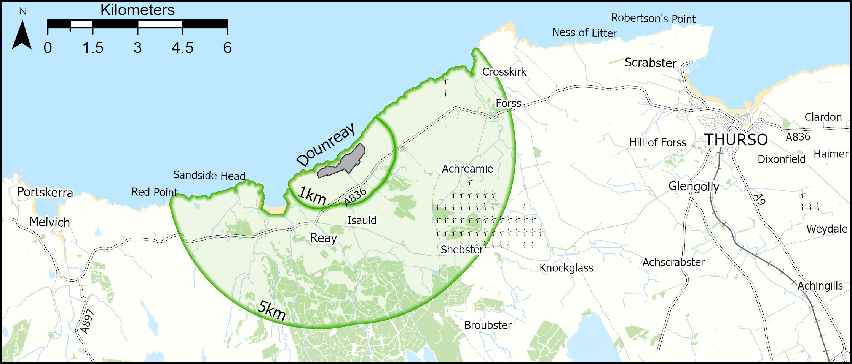
Figure 2.2 The marine survey area for the 2025 Dounreay Habits Survey
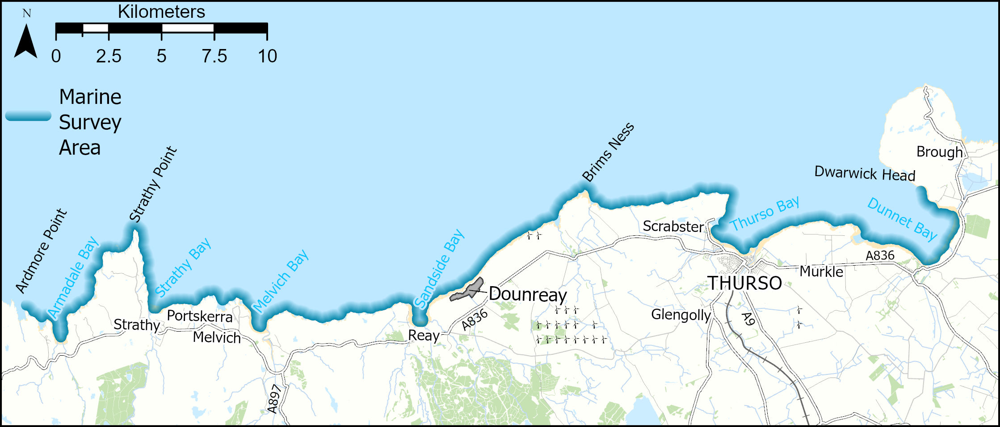

Figure 2.3 The land cover characterising the Dounreay survey area and surrounds (Land Cover Map, 2015; Ordnance Survey Great Britain, 2018)
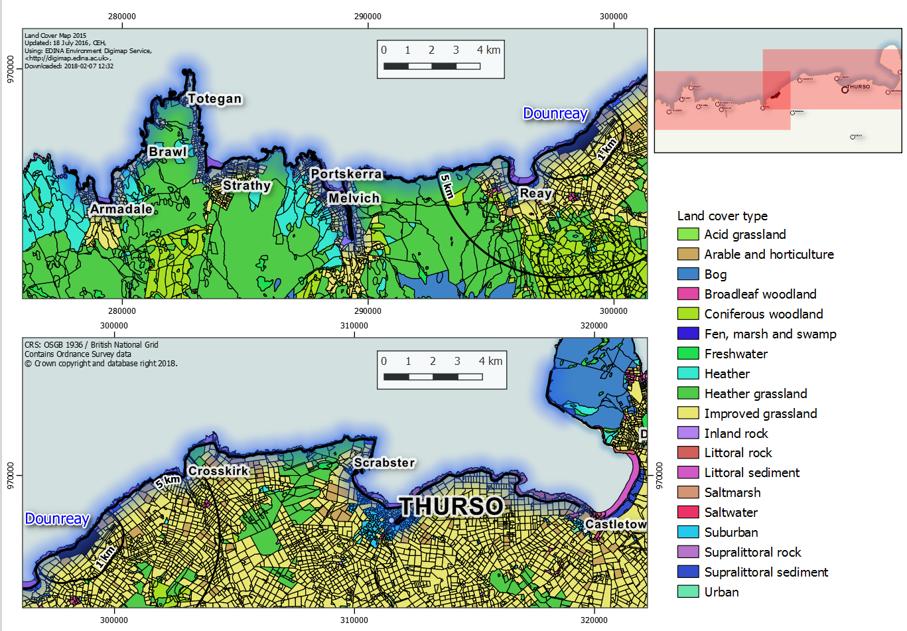

Figure 2.4 Soil types dominating the Dounreay survey area (The Macauley Institute for Soil Research, 2015)
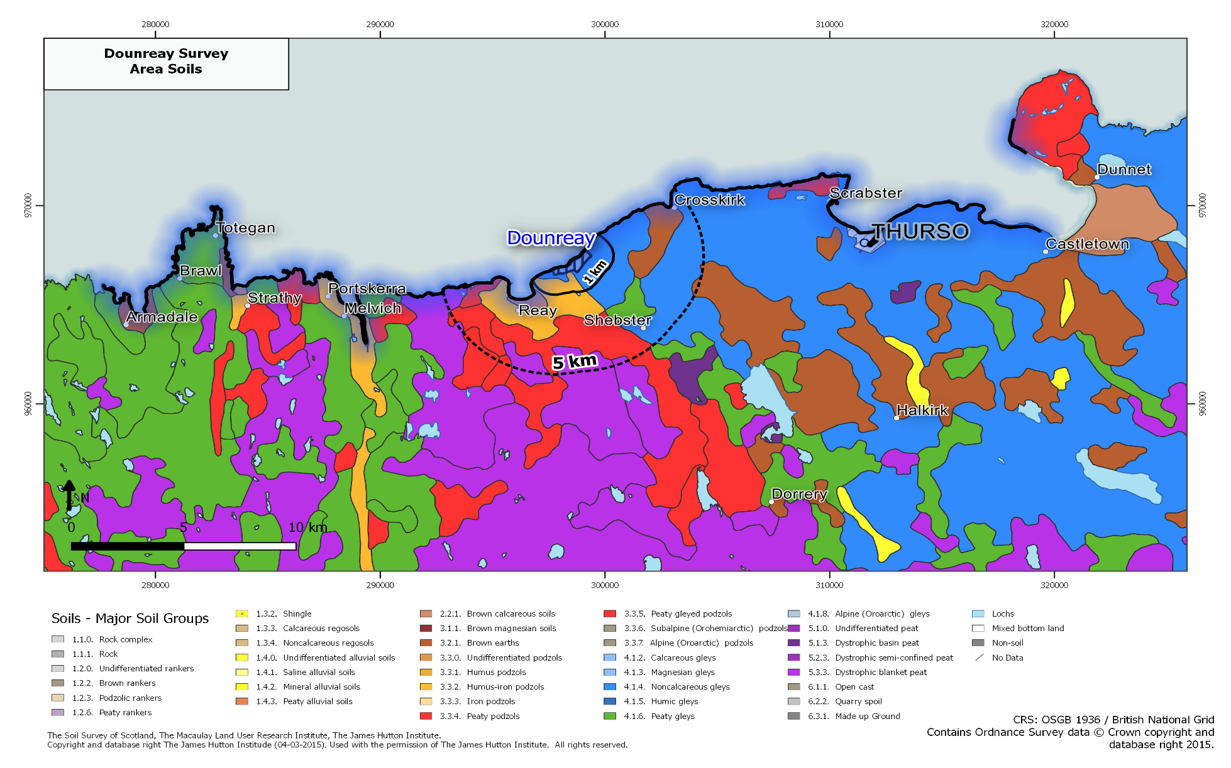

Figure 2.5 The Topographic Wetness Index in the Dounreay survey area (Ordnance Survey, 2018)
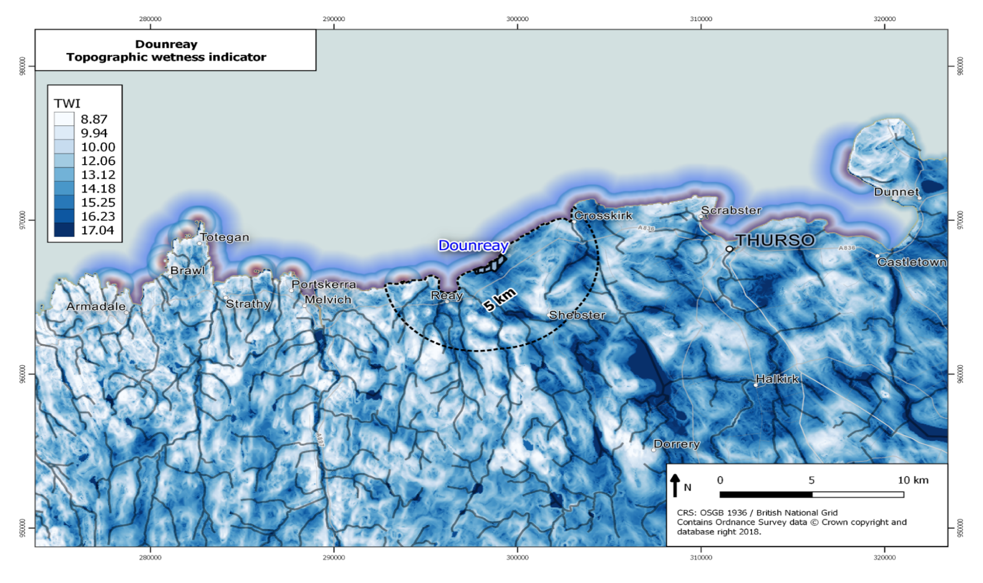

3 Methods

3.1 Introduction
To provide consistency and traceability to previous habit surveys, the methods employed and described in this chapter are largely based on the approach outlined in Leonard et al., (1982), Green et al., (2001) and National Dose Assessment Working Group (NDAWG) (2013). The previous habit surveys of the Dounreay nuclear licensed site provided a useful frame of reference for undertaking this survey. Following the desktop study described in Chapter 2, the habit survey was defined and includes:
- An initial postal survey.
- A mobile radiometric survey to characterise the heterogeneity of radiation in the environment surrounding the Dounreay site.
- Face-to-face surveys and follow-up telephone calls.
- A series of informal meetings during and after the face-to-face surveys to validate the data and findings.

3.2 Postal Survey
To obtain a provisional assessment of the activity and food consumption habits of the local community living within the survey area, a postal questionnaire was distributed to 2000 households. The households were selected using a random sampling method and numbers varied according to the number of households found within each area. While the survey was sent to a particular individual in the household, the survey questions were designed to collect information on the habits of the people living in that household. Only one individual per household was therefore selected to receive the postal survey. The selected households included individuals living in the following geographical areas (Figure 3.1):
- Within the 1km radius surrounding the Dounreay site and the geographical area (Zone A).
- Between 1km and 5km from the Dounreay site (Zone B).
- Between 5km and 10km from the Dounreay site (Zone C).
- Between 10km and 20km from the Dounreay site (Zone D).

Figure 3.1 Map showing the postal survey zones for the Dounreay survey
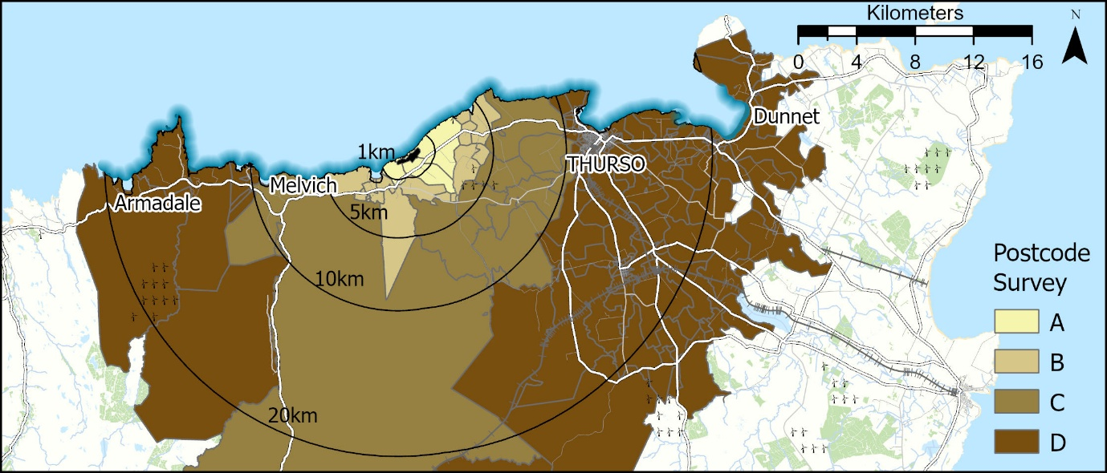
Using the open electoral register for each of the zones of interest, contact details for households were randomly selected. Some postcodes extend over zones and outwith the postal survey area (Figure 3.1), however, each household was applied to the relevant zone (Zone A, B, C or D). 2000 households were randomly selected for the survey. The percentage return for each zone was: 25%, 16%, 15% and 7.5% for Zones A, B, C and D respectively. The postal survey produced an independent data set from a broader cross section of the population living in the area, providing the means to identify potentially new habits to be targeted during the face-to-face surveys or focus group discussions.
The postal survey included questions on food consumption, activities, and a map for identifying whereabouts the different activities were undertaken by household members. Further information can be found in Chapter 4 and Appendix A2.

3.3 Radiometric Surveys
The radiometric surveys comprised a carborne and handheld MoGSS, in-situ gamma dose rate and in-situ beta skin dose rate measurements.

3.3.1 In-Situ Dosimetry
The Environmental Radioactivity Laboratory (ERL) at the University of Striling, has ISO 17025:2017 accredited procedures for the deployment and recording of gamma dose rate in air using two Thermo Radeye instruments. Measurements were undertaken at all locations where occupancy or location may lead to potentially higher exposure to radioactivity because of Dounreay site activities. These included areas that may have elevated radionuclide concentrations where fine sediment is known to accumulate (e.g. salt marshes and mudflats). The effective dose from terrestrial gamma radiation was calculated and reported in μSv h⁻¹.
Further details of the in-situ methodology can be found in Appendix A3.

3.3.2 Beta Dosimetry
A ruggedized Thermo BP19RD/Electra instrument was deployed to assess the beta dosimetry of skin dose [H*(0.07)]. The BP19RD provided a wide area monitor instrument (100cm²) and was used to monitor item(s) that were potentially exposed to the higher radioactivity concentrations within the survey area.
Further details of the beta skin dosimetry can be found in Appendix A4.

3.4 Conduct of the Survey
The pre-survey preparations involved:
- Discussions with SEPA over the requirements for the Dounreay survey.
- Reviewing past survey reports and maps to identify key information.
- Compiling a directory of key groups involved in activities in the area from web searches and from people living in the survey area with relevant knowledge.
- Agreeing the field survey programme with SEPA.
- University of Stirling staff conducting a carborne and handheld MoGSS survey.

3.5 Meetings and Informal Contacts
In the 2025 survey, habits data and information were collected through a variety of approaches. This included contacting relevant parties and individuals for potential focus groups as well as ‘standard’ face-to-face interviews. The multi-methods approach facilitated a means to ‘triangulate’ (verify) the data gathered through the different approaches: e.g. to check occupancy and activity data against the ‘snapshot’ observations recorded over a limited number of days in one season acquired from the individual face-to-face interviews. It also provided some additional information about local produce grown and consumed by householders, garden clubs, horticulturalists and farmers and consumption of types of local food such as honey and game. Such information also aided in the development of survey data collection with individual contacts within relevant groups providing additional contacts to follow-up. These groups were approached prior to, during and after the face-to-face interviews by telephone and email.
A directory of local groups, bodies and organisations that potentially undertake relevant activities within the survey area was compiled prior to the field surveys. The directory proved an invaluable resource through the survey period both for contacting groups and for use as a checklist against which responses and non-responses from potentially important groups about activity, occupancy, exposure and local food consumption could be recorded. For future surveys, the directory will provide a useful starting point and a means of monitoring any changes in group/business or other activity in the area.

3.6 Data Conversion and Analyses
During the face-to-face interviews, data on food consumption was recorded in units provided by respondents (e.g. pounds, grams, and ounces) and later converted into kilograms per year. The weights provided are for the fresh weight prepared and consumed. In some cases, respondents were unable to estimate food consumption in kilograms per year and instead gave the number of plants grown or the length and number of rows. These data were converted into consumption rates using conversion weights where possible e.g. one broccoli plant yields 700g (Garden
Forum Horticulture, 2009; Hessayon, 2014) so that all consumption figures were reported in kilograms per year. Data for each survey were transferred to a bespoke Microsoft Access database for analysis. The figures reported from individuals are utilised within this report after the percentage of any gifting or waste deducted from the final annual figure(s).

3.7 Data Rounding and Grouping
Data collected from the face-to-face and postal surveys are reported to three significant figures. Values less than 1.0 are rounded to two decimal places. External exposure data are reported as whole numbers of hours per year within tables and the text of the report, except for values less than 1h y⁻¹ which are reported to one decimal place.
For the food consumption data, the total annual consumption (kg y⁻¹) of different food types was calculated by multiplying the quantity (kg) and frequency (times per year). The food items were placed into groups with similar attributes (Table 3.1). These groups are like those used in previous survey reports but with a focus on the most encountered food types. Individuals were given the option to add any additional food items using an ‘Other’ food category. Not all food items within Table 3.1 were reported to being consumed during the survey period. It should also be noted that within the report the correct designation of domestic fruit and wild food has been determined when reporting consumption data.
The time (h y⁻¹) individuals spent carrying out activities was calculated by multiplying frequency (occasions per year) and duration (hours), whilst considering seasonality where appropriate. Data were reported after any holidays and working hours within the survey replies were accounted for. A ‘liquid’ category was also added to the survey for individuals who carry out aquatic activities that could result in their inadvertent ingestion of water, e.g. outdoor swimming/sailing.
The age groupings used in this report are based on ICRP recommendations and are listed below in Table 3.2.

Table 3.1 Food groups used in the Dounreay Habits Survey
Food group | Example of foods within group
Green leafy vegetables | Asparagus, broccoli, Brussel sprouts, cabbage, calabrese, cauliflower, celery, chard, herbs, kale, kohl rabi, lettuce, Pak choi, rhubarb, marrow, spinach
Other domestic vegetables (legumes) | Broad beans, French beans, pea, runner beans
Root vegetables | Beetroot, carrot, celeriac, fennel, garlic, Jerusalem artichoke, leek, onion, parsnip, radish, shallot, spring onion, swede, turnip
Potato | Potato
Domestic fruit | Apple, blackberry, blackcurrant, blueberries, corn, courgette, cucumber, gooseberry, grape, pear, pepper, plum, raspberry, redcurrant, strawberry, tayberry, tomato, white currant
Milk | Milk, yoghurt, cheese
Cattle meat | Beef, buffalo
Pig meat | Pork
Sheep meat | Lamb, mutton
Poultry | Chicken, duck, goose, turkey
Eggs | Eggs
Wild/free foods | Blackberry, chestnuts, crab apples, damson, dandelion root, garlic, elderberry, elderflower, nettle, raspberry, rowanberry, sloe, strawberry
Honey | Honey
Venison | Venison
Fish | Bass, cod, Dover sole, kipper (herring), mackerel, pollock, salmon, sea trout, trout (freshwater)
Crustaceans | Brown crab, common lobster, shrimps
Molluscs | Mussels, razor clams, scallops, winkles
Wildfowl | Mallard, pink-footed goose, teal, widgeon
Game - bird | Partridge, pheasant, quail

Table 3.2 ICRP age groups used in the dose assessment
Name of age group | Age range
Group 1 - Infant | 0 to 5 year old
Group 2 - Child | 6 to 15 year old
Group 3 - Adult | 16 year old and over

3.8 Qualitative and Quantitative Observations
Whilst undertaking the face-to-face surveys, observational data were acquired on any obvious changes to each location such as new build housing, along with information on site usage and numbers of individuals undertaking specific habits. Observations were acquired over a specified time, e.g. 20 minutes, with both onshore and offshore (including intertidal) activities noted. The number of individuals, their gender and their approximate age were noted for each activity witnessed. Where large groups of people were observed, the number of individuals was estimated. After the observation period, individuals were approached where possible and subsequent face-to-face surveys conducted. Contact with individuals during face-to-face interviews frequently allowed the accuracy of observations to be checked and sometimes to be expanded, e.g. dog walkers might also engage in beachcombing and sailing at other times. Along with noting the weather conditions at the time of survey, this approach provided a basis for making a comparison with habits at different times of both day and seasons (e.g. within and outwith the period of the local school holidays).
One of the problems with this type of survey is being confident in a persons recollection of portion size/mass or occupancy/activity times. To address this, the survey team had information on what might be considered a reasonable range for consumption of different foods. Where a survey individual’s response was outwith these ranges, the survey team challenged and verified the response. To achieve this, visual aids of, e.g. portions of vegetables or fruit, were shown to allow the individual to re-evaluate and confirm their data. With regards to occupancy, a similar approach was taken where all ‘extreme’ hours (again identified as being outwith reasonable ranges based on previous surveys’ findings) were also challenged. It is not possible to visualise ‘time’ so the survey individual’s initial times would be calculated to a per year basis to show how this might be compared with their other daily habits and work life. If the surveyed individual confirmed the ‘extreme’ value, then these were recorded as this is the information the survey team were given. While the survey team’s approach should minimise inaccurate information from being collected, it remains possible that extreme results could still be reported and thus may be a potential source of error within the survey.

4 Postal Survey

4.1 Introduction
The results from the postal survey provide an overview of the habits within an area of 20km radius centred on the Dounreay nuclear licensed site.
2000 postal surveys were sent out to households in the survey area, and 164 postal returns were used in the analysis (Figure 4.1). The number of returns is comparable with previous habit postal surveys around the different nuclear sites across Scotland.
The postal survey proved useful for identifying where households undertook popular activities and the proximity of these activities to the Dounreay site. The survey was not designed to capture the length of time individuals spent doing these activities. The postal survey results are presented in detail in Appendix A2.
Figure 4.1. Postal survey returns density map (number of returns are the number of postal surveys returned within each postcode area)
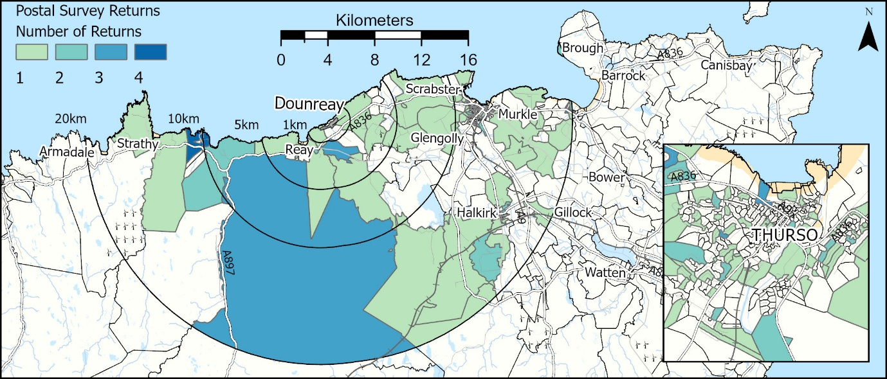

5 Aquatic Radiation Pathways

5.1 Introduction
Survey locations were established following the desktop review and to allow effective comparison with the previous Dounreay Habits Survey in 2018 (Dale et al., 2022). The survey locations were visited throughout the survey period and observations of offshore and onshore activities were undertaken. The survey schedule ensured that each location was visited at different times of the day, reflecting the different activities occurring at each location.
The survey locations were visited throughout two survey periods, the first outwith the school holiday period (6th – 12th June) and the second within the school holiday period (3rd to 9th July) of 2025. Offshore and onshore observations were undertaken at each site.

5.2 Aquatic Survey Area Descriptions
The survey area included the intertidal areas and waters of the Pentland Firth extending from Armadale Bay (including Port a’ Chinn) in the west to Dunnet Head in the east (Figure 2.2). A 2km fishing exclusion zone is in effect around the offshore diffuser at Dounreay (Food and Environment Protection Act (FEPA), FEPA Order – The Food Protection (Emergency Prohibitions) (Dounreay Nuclear Establishment) Order 1997). Part of the survey area forms a Site of Special Scientific Interest, which attracts bird watchers and wildlife enthusiasts to the area to observe the intertidal birdlife. The survey sites are reported from Armadale Bay in the west to Peedie Sands in the east. See Appendix A5 for site descriptions and observations.

5.3 Commercial Seafood Operations
Commercial seafood operations operate within the survey area with the main local fishing methods being creeling. Common lobster, Brown crab, Velvet crab, Green crab, mackerel, coley and pollock are landed at Scrabster harbour. The commercial seafood operators were unable to provide the weight of fish landed. A Scrabster
harbour representative reported that ten fishing vessels fish out of Scrabster harbour. Approximately three vessels operate part time while the remaining seven operate as full time fishing boats. One fishing boat launches out of Sandside harbour to fish and it was noted that one fishing boat no longer keeps a licence to fish from Portskerra harbour. While harbour representative was unable to provide any other information, they stated that there may be other small part time boats that work along the coast from small inlets that they are unaware of. Many other boats from outwith the survey area do come into Scrabster and land their catch at the harbour. The boats that fish outwith the survey area sell their white fish at the market at Scrabster harbour to local fish merchants for sale locally or are sold privately.
There are shellfish and whitefish buyers in Scrabster for the shellfish markets in France, Spain, Portugal, China and a small amount staying within Britain. The whitefish market reaches France, Spain and Britain. Two shellfish/fish wholesaler and one local fish merchant operate from Scrabster harbour. A small percentage of the shellfish is sold locally with approximately 30% of the whitefish sold through Scrabster market.
Local businesses within the aquatic survey area were contacted. Two local businesses reported that all their fish were sourced from Scrabster market. The fish sourced included: haddock, hake, cod and lemon sole. The fish is all sourced from outwith the survey area in the North Atlantic. Lobster sold at the businesses was sourced from the local fisherman (sourced from within the survey area). Crab and mussels were source from outwith the survey area and salmon was farmed.
It was reported to the survey team that commercial winkle and whelk pickers operated at Sandside beach, who then sell their produce at Scrabster. The survey team were unable to contact them. It should be noted, SEPA’s environmental sampling program contractors collect molluscs from this beach for analysis.
A Scottish Government moratorium came into force in 2016 which ceased all coastal letting and bag net catching of fish (e.g. salmon). Discussions with the Scottish Government established this was last reviewed in 2019 and the moratorium is still in place. Compensation was awarded to those affected based on net income that would have been generated between 2019 – 2028.

5.4 Non-Commercial Fishing and Angling
Angling was an activity determined within the survey area and the following text shows areas where non-commercial fishing, bait digging and collecting of molluscs and crustaceans occurred within the aquatic survey area. Catch and release was reported to be the popular practice with individuals, releasing most of their catch and consuming only a small percentage.
Two charter boats within the marine survey area provide fishing and wildlife trips taking individuals on excursions to catch fish and observe marine wildlife. These trips vary in time spent on the water but typically, fishing trips last around four hours with the number of people varying from four to ten persons. Some of the species of fish caught are cod, haddock, pollock, mackerel, plaice, common skate and shark fish. Rods and fishing equipment can be supplied but sometimes individuals bring their own to use. One of the boats provide the flexibility to cater for trips and these can vary between two hours to three days.
Bait Digging: Castletown beach (lug worms, rag worms and limpets), Dunnet beach (unknown bait).
Fishing from shore/rocks/pier/kayak: Sandside beach, Armadale beach, Strathy beach, Scrabster beach and Dunnet beach (coley, dab, flounder – catch and release) – from shore, Scrabster beach (pollock) – from rocks, Sandside Bay and Dunnet Bay (cod) – from boat, Scrabster Pier and Portskerra (mackerel) – for bait and for consuming, Pentland Firth (mackerel – near Scrabster, Dunnet Bay, Brims Ness and Sandside Bay) – from boat.
Mollusc/crustaceans picking (non-commercial): Portskerra (common lobster, brown crab – for consuming) – from boat, Dwarwick (common lobster – for consuming) – from boat, Thurso beach (limpets – for consuming) – on rocks.

5.5 Wildfowling
No wildfowling was identified within the marine survey area, however, one individual was gifted wildfowl that was shot at Sandside Bay. The survey team were unable to make contact with the wildfowler. The survey team contacted Highland Council and
subsequently a further Government body and it was reported that wildfowling permits were issued via local landowners. Landowners were not contacted during this survey. Wildfowling was not identified in the previous 2018 habit survey.

5.6 Royal National Lifeboat Institute
The RNLI has one all-weather lifeboat (ALB) for approximately four people which is based out of Scrabster harbour. The ALB covers the area from Duncansby to Cape Wrath lighthouse. There are 21 active volunteer crew members based at Scrabster and the crew are provided with training which is undertaken weekly for 2.5 hours per session. The crew are required to attend 12 of these training sessions annually. In 2024 there were 17 callouts and to date (June 2025) there have been seven callouts. The ALB is washed down outside with fresh water after each sail in the water. All crew waterproofs are washed on site with fresh water after each use.

5.7 Sailing and Rowing
Sailing and aquatic activity clubs within the survey area were contacted. Information was provided by two clubs and a youth charity. Clubs generally have a large membership with a small percentage being junior members (under 16 years old). Clubs provide canoeing, kayaking and dinghy sailing with the youth charity providing rowing. The activities mainly take place between April to September and outwith this period it is weather dependent. Safety boat cover is provided by the youth charity. Club boats and equipment are hosed down with fresh water after each time sailing. Individual members take their own personal kit/clothing home for washing/rinsing. The youth charity wash down and clean the boats at the end of the season when they are taken out of the water and stored on hard standing.

5.8 Diving Clubs and Surfing
A diving club was contacted and reported that they dive within the survey area. There are no junior members. Diving is undertaken from the shore or boat and diving is undertaken all year. The club boat is washed down after each occasion on the water and is stored in a container. All individual diving clothing and equipment is taken home and washed down with fresh water.
A surf school operating in the survey area was contacted and reported that they provide surf kit and lessons. Lessons are mainly taken by tourists and children. The lessons run all year and all kit and equipment are washed down after each occasion with fresh water.

5.9 Professional Dog Walkers
Professional dog walkers operate within the survey area. These groups will be active along the coastal strip for much longer periods. As dogs can enter the sea and the route of walks often encompasses muddy and sandy areas, the group may potentially have greater exposure to intertidal substrates.

5.10 Animals Grazing
Cows and sheep were observed grazing in several fields within and around the survey area. No cattle or sheep were observed grazing on seaweed or within intertidal areas anywhere within the survey area. In the 2013 and 2018 Dounreay radiological habits reports, farmers did not report cattle having access and grazing on the shore (seaweed consumption).

5.11 Seaweed and Foraging
Three individuals interviewed collect seaweed from Thurso beach and Sandside harbour for use to grow vegetables and as a weed suppressant. Methods of application vary between individuals with one individual hosing the seaweed down with fresh water before applying to the soil and digging it in for growing vegetables the following year. The other two individuals apply the seaweed directly to the soil and then allow it to compost before digging it in for growing vegetables the following year.
Two individuals collect 0.7kg each of Dulse seaweed (Palmaria palmata) to consume from Melvich beach. A third individual collected a small amount of Kelp seaweed from Scrabster beach to use for making specialist drinks.

5.12 Ramblers/Walking and Other Pathways
A visitor centre that was operational during the 2018 Dounreay Habit Survey is now closed to the public and only opens for specific arranged coastal activities several times a year.
Two mobile sauna businesses have been set up within the marine survey area. The saunas are situated off the intertidal substrate and provide the opportunity for individuals to have a sauna and then undertake aquatic and intertidal activities.
A local beach cleaning group was contacted and provided information. They are an active group of over 1000 online members of which 30 actively undertake litter picking on beaches within the survey area. Litter picking takes place on beaches within the Caithness area from Loch Eriboll in the west to Dornoch on the east coast (which covers the whole of the habit survey area). The litter picking is undertaken mainly by individuals and not as a group beach clean. All litter is weighed and documented as to what beach it came from, date collected and what type of litter it was. Gloves and litter pickers are used. It is reported that 95% of the litter that is collected is from fishing at sea with very little contributed from domestic waste. Occasionally there are the remains from a picnic and litter that is domestic tends to be after recycling day when it is windblown onto the beach. A small amount of litter is from onshore fishing. Where possible, litter is returned to fishing boats if identification can be made, e.g. plastic buoys with names on them - some plastic buoys are also sold to individuals within the fishing community.
Recycling of the litter is undertaken with ropes being made into doormats, creel boat hooks being recycled into wheelie bin hooks, plastic drums recycled as worm farms and salmon farm pipes are recycled and used as polycrub (polytunnel/greenhouse) and in fencing. All monies raised by the sale of recycled goods are used to fund the group for e.g. purchasing litter pickers, gloves, purchase of a quad bike and insurance.
It is reported that Highland Council work very well with the group and have provided a bin in Thurso due to the volume of litter being collected. In addition, Orkney Council recommend the purchasing of recycled creel hooks as wheelie bin hooks on their website. A local canoe/kayak club sometimes assist with the beach clean when there is litter around cliffs. The group will lower bags to the kayakers who then collect the litter and deposit it into the bags. The bags are then hoisted back up the cliff for recycling and/or disposal. Previously, approximately 1 tonne of litter was collected every month (with 2019 reaching 73 tonnes of litter collected from within the groups survey area). To date this year (end July 2025) 4.39 tonnes of litter have been collected. All litter collected by the group members that can be used for recycling is given to the group chairperson, all other litter is disposed of by group members using their own domestic bins.

5.13 Internal Exposure – Phase 1

5.13.1 Adult consumption rates
Table 5.1 presents a summary of the consumption rates for aquatic food types including fish, crustaceans, molluscs, wildfowl, and seaweed. Mean adult consumption rates for the high-rate groups and the observed 97.5th percentile rates are included in Table 5.1. The high-rate group was determined using a ‘cut-off’ method described by Hunt et al., (1982). This ‘cut-off’ method calculates the high-rate value by taking the mean of the values between the maximum observed rate and one third of the maximum observed rate. Therefore, the ‘cut-off’ method within this report is represented as the individuals derived to obtain the ‘high-rate group’. The table also includes mean consumption rates and 97.5th percentile rates based on the full dataset.

Table 5.1 Summary of adults’ consumption rates of foods from the aquatic survey area
Food Group | Number of observations | Number of people in the high-rate group | Observed maximum for the high-rate group (kg y⁻¹) | Observed minimum for the high-rate group (kg y⁻¹) | Observed mean for the high-rate group (kg y⁻¹) | Observed 97.5th percentile for the high-rate group (kg y⁻¹) | Full dataset – Observed mean (kg y⁻¹) | Full dataset – 97.5th percentile (kg y⁻¹) | National Data mean (kg y⁻¹) | National data 97.5th percentile (kg y⁻¹)
Fish | 25 | 12 | 30 | 10 | 16 | 27.4 | 8.6 | 24.2 | 15 | 40
Crustaceans | 11 | 6 | 50.7 | 18 | 30 | 48.7 | 19.8 | 46.8 | 4 | 10
Molluscs | 4 | 1 | 2 | 2 | 2 | 2 | 0.75 | 1.9 | 4 | 10
Wildfowl | 2 | 2 | 2.5 | 2.5 | 2.5 | 2.5 | 2.5 | 2.5 | ND | ND
Seaweed | 2 | 2 | 0.7 | 0.7 | 0.7 | 0.7 | 0.7 | 0.7 | ND | ND
ND – not determined
The generic mean and generic 97.5th percentile rates based on National Habit Data are also included (Smith and Jones, 2003). The national data are used to compare the high-rate mean and high-rate maximum consumers within the habits survey. During the Dounreay habits survey, it became apparent that the national data do not consider any extreme habits of consumption. For example, there may be regional or local differences in habits which may result in very different rates of consumption for crustaceans (Table 5.1), which are greater than the national mean and may represent an important local pathway. It may be necessary to consider that the national data cannot capture local or regional variations in habits, which may have local significance within habits-based assessments.
Adults consumed bass (four individuals), cod (five individuals), mackerel (12 individuals), pollock (three individuals), haddock (16 individuals), flounder (three individuals), halibut (one individual) and ling (two individuals), all sourced from within the aquatic survey area. Some adults consumed more than one fish type (flat and/or round). The observed maximum consumption (quantity multiplied by frequency) of fish was 30kg y⁻¹ and this individual consumed haddock (30kg⁻¹), all self-caught and sourced from within the aquatic survey area. The mean fish consumption for the adult high-rate group was 16kg y⁻¹.
Adults consumed crustaceans, which consisted of brown crab (11 individuals) and common lobster (11 individuals). The observed maximum consumption (quantity multiplied by frequency) of crustaceans was 50.7kg y⁻¹ and this individual consumed brown crab (31.2kg y⁻¹) and common lobster (19.5kg y⁻¹), all self-caught and sourced from within the survey area. The mean crustacean consumption for the adult high-rate group was 30kg y⁻¹.
Adults consumed molluscs, which consisted of cockles (one individual) and limpets (three individuals). The observed maximum consumption (quantity multiplied by frequency) of molluscs was 2kg y⁻¹ for one individual consuming limpets, all self-caught and sourced from within the survey area. The mean molluscs consumption for the adult high-rate group was 2kg y⁻¹.
Adults consumed wildfowl which consisted of mallard duck (two individuals) and greylag goose (two individuals). The observed maximum consumption (quantity multiplied by frequency) of wildfowl was 2.5kg y⁻¹ for both individuals, sourced and gifted to them from within the survey area. The mean wildfowl consumption for the adult high-rate group was 2.5kg y⁻¹.
Two adults consumed seaweed (Dulse). The observed maximum consumption (quantity multiplied by frequency) of seaweed was 0.7kg y⁻¹ for two individuals consuming seaweed, sourced from within the survey area. The mean seaweed consumption for the adult high-rate group was 0.7kg y⁻¹.

5.13.2 Child and infant consumption rates
Table 5.2 presents a summary of children’s consumption rates of fish and crustaceans from the aquatic survey area. Mean consumption rates for the high-rate groups and the observed 97.5th percentile rates are included in Table 5.2.
The table also includes mean consumption rates and 97.5th percentile rates based on the full dataset. There was no aquatic consumption determined for the infant age group during the survey period.
For the child age group, three individuals consumed fish (mackerel). The observed maximum consumption was 6.8kg y⁻¹ by one individual which was self-caught by a family member and sourced from within the survey area.
For the child age group, two individuals consumed crustaceans which consisted of brown crab (32.5kg y⁻¹) and common lobster (2.5kg y⁻¹). The observed maximum consumption was 35kg y⁻¹ by both individuals which was self-caught by a family member and sourced from within the survey area.
No consumption of mollusc, wildfowl or seaweed was determined for the child age group.

Food Group | Number of observations | Number of people in the high-rate group | Observed maximum for the high-rate group (kg y⁻¹) | Observed minimum for the high-rate group (kg y⁻¹) | Observed mean for the high-rate group (kg y⁻¹) | Observed 97.5th percentile for the high-rate group (kg y⁻¹) | Full dataset – Observed mean (kg y⁻¹) | Full dataset – 97.5th percentile (kg y⁻¹)
Fish | 3 | 3 | 6.8 | 2.5 | 3.9 | 6.6 | 3.9 | 6.6
Crustacean | 2 | 2 | 35 | 35 | 35 | 35 | 35 | 35
Table 5.2 Summary of children’s consumption rates of foods from the aquatic survey area

5.14 External Exposure – Phase 1
Occupancy rates for adult intertidal activities are presented in Table 5.3. Occupancy rates for adult aquatic (in water), aquatic (on water), handling rates of equipment and handling rates of sediment are presented in Table 5.4.
Intertidal activities for adults included bait digging, sitting/picnicking/BBQ, beachcombing, bird/nature watching, boat maintenance, camping, collecting limpets, collecting seaweed, dog walking, drone flying, fishing, jogging, litter picking, paddling, photography, playing, RNLI training, rock pooling, walking and working.
The activities undertaken by adults in the high-rate group over the following intertidal substrates included:
Sand: dog walking at Thurso beach, Scrabster beach, Crosskirk beach, Castletown beach and Dunnet beach; fishing at Sandside beach, Armadale beach, Strathy beach, Scrabster beach and Dunnet beach; litter picking at Armadale beach, Burnside (between Scrabster and Thurso), Castletown beach, Crosskirk beach, Dunnet beach, Dwarwick beach, Peedie Sands, Sandside beach, Scrabster beach, Thurso beach and Thurso East Mains beach; photography at Strathy beach; playing at Scrabster beach; and beachcombing at Thurso beach.
Sand and stones: walking at Port a’ Chinn beach.
Stones: photography near Dwarwick Pier.
Rock: photography at Sandside Head, Crosskirk Bay and Brims Ness; and fishing by Dwarwick Pier.
On a rock substrate, the highest occupancy was 876h y⁻¹ for one individual who spent time fishing at Sandside beach, Armadale beach, Strathy beach, Scrabster beach and Dunnet beach. On a sand substrate, the highest occupancy was 1095h y⁻¹ for one individual who spent time dog walking at Thurso beach. On a sand and stone substrate, the highest occupancy was 0.25h y⁻¹ for an individual who spent time walking at Port a’ Chinn beach. On a stone substrate the highest occupancy was 292h y⁻¹ for an individual who spent time undertaking photography
by Dwarwick Pier.
The highest total intertidal occupancy rate was 1668h y⁻¹ for an individual who spent time undertaking photography (1460h y⁻¹) and fishing (208h y⁻¹) on sand substrate, rock substrate and stone substrate within the survey area.

Intertidal Substrate | Number of observations | Number of people in the high-rate group | Observed maximum for the high-rate group (h y⁻¹) | Observed minimum for the high-rate group (h y⁻¹) | Observed mean for the high-rate group (h y⁻¹) | Observed 97.5th percentile for the high-rate group (h y⁻¹) | Full dataset – Observed mean (h y⁻¹) | Full dataset – 97.5th percentile (h y⁻¹)
Sand | 242 | 17 | 1095 | 365 | 549 | 969 | 85.9 | 548
Sand and stones | 1 | 1 | 0.25 | 0.25 | 0.25 | NA | 0.25 | 0.25
Stones | 5 | 1 | 292 | 292 | 292 | NA | 71.3 | 266
Rock | 16 | 2 | 876 | 312 | 594 | 862 | 104 | 665
Table 5.3 Summary of adults’ external exposure for intertidal activities over intertidal substrates

Table 5.4 Summary of adults’ external exposure for aquatic activities (in water and on water), handling of equipment and handling of sediment
Activity | Number of observations | Number of people in the high-rate group | Observed maximum for the high-rate group (h y⁻¹) | Observed minimum for the high-rate group (h y⁻¹) | Observed mean for the high-rate group (h y⁻¹) | Observed 97.5th percentile for the high-rate group (h y⁻¹) | Full dataset – Observed mean (h y⁻¹) | Full dataset – 97.5th percentile (h y⁻¹)
Aquatic (in water) | 62 | 4 | 978 | 345 | 669 | 975 | 67.8 | 664
Aquatic (on water) | 34 | 3 | 4238 | 2192 | 3421 | 4218 | 448 | 3905
Handling equipment | 50 | 3 | 4630 | 2192 | 3492 | 4581 | 331 | 3324
Handling sediment | 65 | 4 | 780 | 316 | 554 | 763 | 57.8 | 559
NA – not applicable
Activities in water included body boarding, diving, outdoor swimming, snorkelling, stand-up paddle boarding, surfing, capsize training, free diving and sea aerobics. The highest occupancy rate for adults in the water was 978h y⁻¹ for an individual who spent time undertaking sea aerobics (858h y⁻¹) and outdoor swimming (120h y⁻¹) and within the survey area. Activities on water included being on a dive boat, boat maintenance, canoeing, commercial fishing/creeling, kayaking, powerboating, sailing, sea angling, RNLI duties, on a boat – coracle and sea cadet activities. The highest occupancy rate for adults on water was 4238h y⁻¹ for an individual who spent time undertaking boat maintenance (2808h y⁻¹) and commercial fishing/creeling (1430h y⁻¹) within the survey area.
The activities for adults handling equipment comprises of handling boats and boating equipment, handling clothes and overalls and handling fishing gear. The highest level of handling equipment was 4630h y⁻¹, this individual spent time handling boats and boating equipment (3200h y⁻¹) and handling boats and undertaking commercial fishing/creeling (1430h y⁻¹) within the survey area. The highest level of handling sediment was 780h y⁻¹, and this is for an individual who spent time litter picking within the survey area. The occupancy data for intertidal activities were used for estimating the external gamma dose rate. Selected relevant intertidal activity occupancy data were also used to derive the handling sediment category which was then used for estimating the beta skin dose rate. Intertidal activities comprised of bait digging, sitting/picnicking/BBQ, beachcombing, camping, collecting limpets, collecting seaweed, litter picking, paddling, photography, playing, RNLI training and rock pooling.
Occupancy rates for children and infant intertidal activities are presented in Table 5.5. Occupancy rates for children and infant aquatic (in water), aquatic (on water), handling rates of equipment and handling rates of sediment are presented in Table 5.6.
Intertidal activities for children were beachcombing, dog walking, paddling, playing and walking.

The activities undertaken by children in the high-rate group over the following intertidal substrates included:
Sand: dog walking at Scrabster beach and Thurso beach; paddling at Scrabster beach and Dunnet beach; and playing at Dunnet beach and Strathy beach.
The highest total intertidal occupancy rate for a child was 516h y⁻¹ for an individual who spent time dog walking (258h y⁻¹) and playing (258h y⁻¹) on a sand substrate within the survey area.
Intertidal activities for infants included beachcombing, collecting seaweed, dog walking, paddling, playing, sitting/picnicking/BBQ and walking.
The activities undertaken by infants in the high-rate group over the following intertidal substrates included:
Sand: beachcombing at Thurso beach, Melvich beach, Strathy beach, Peedie Sands and Dunnet beach; collecting seaweed at Thurso beach; dog walking at Sandside beach and Dunnet beach; paddling at Strathy beach, Scrabster beach and Dunnet beach; playing at Strathy beach, Dunnet beach and Thurso beach; and walking at Sandside beach, Thurso beach, Strathy beach, Melvich beach, Peedie Sands and Dunnet beach.
Rocks: sitting/picnicking/BBQ at Crosskirk beach; and walking fields beside Dounreay.
On rock substrate, the highest occupancy was 4h y⁻¹ and this was for one infant who spent time sitting/picnicking/BBQ within the survey area.
On sand substrate, the highest occupancy was 292h y⁻¹, and this was for one infant who spent time beachcombing (78h y⁻¹), walking (208h y⁻¹) and collecting seaweed (6h y⁻¹) within the survey area. This infant also had the highest total intertidal occupancy rate.

Age Group | Intertidal substrate | Number of observations | Number of people in the high-rate group | Observed maximum for the high-rate group (h y⁻¹) | Observed minimum for the high-rate group (h y⁻¹) | Observed mean for the high-rate group (h y⁻¹) | Observed 97.5th percentile for the high-rate group (h y⁻¹) | Full dataset – Observed mean (h y⁻¹) | Full dataset – 97.5th percentile (h y⁻¹)
Child age group (6 to 15 years old) | Sand | 19 | 8 | 516 | 191 | 299 | 480 | 144 | 424
Infant age group (0 to 5 years old) | Sand | 18 | 6 | 292 | 110 | 194 | 283 | 72 | 262
Infant age group (0 to 5 years old) | Rock | 2 | 2 | 4 | 3 | 3.5 | 4 | 3.5 | 4
Table 5.5 Summary of children and infant external exposure for intertidal activities over intertidal substrates

Table 5.6 Summary of children and infant external exposure aquatic activities (in and on water), handling of equipment and
handling sediment
Age Group | Activity | Number of observations | Number of people in the high-rate group | Observed maximum for the high-rate group (h y⁻¹) | Observed minimum for the high-rate group (h y⁻¹) | Observed mean for the high-rate group (h y⁻¹) | Observed 97.5th percentile for the high-rate group (h y⁻¹) | Full dataset – Observed mean (h y⁻¹) | Full dataset – 97.5th percentile (h y⁻¹)
Child age group (6 to 15 years old) | Aquatic (in water) | 4 | 4 | 5 | 2 | 3.5 | 4.9 | 3.5 | 4.9
Child age group (6 to 15 years old) | Handling equipment | 3 | 2 | 2 | 2 | 2 | 2 | 1.55 | 2
Child age group (6 to 15 years old) | Handling sediment | 8 | 3 | 258 | 220 | 233 | 256 | 98.7 | 251
Infant age group (0 to 5 years old) | Aquatic (in water) | 2 | 1 | 156 | 156 | 156 | NA | 84.5 | 152
Infant age group (0 to 5 years old) | Handling sediment | 13 | 4 | 220 | 84 | 131 | 212 | 48.3 | 187
NA – not applicable

Child activities in the water included body boarding, outdoor swimming and stand-up paddle boarding. The highest occupancy rate for children in water was 5h y⁻¹ for one individual who spent time outdoor swimming (3h y⁻¹) and surfing (2h y⁻¹) within the survey area.
The activities for children handling equipment comprises of handling boats, boating equipment and fishing gear. The highest level of handling equipment was 2h y⁻¹ for two individuals who spent time body boarding. The highest level of handling sediment was 258h y⁻¹ for one individual who spent time playing within the survey area. The occupancy data for intertidal activities were used for estimating the external gamma dose rate. Selected relevant intertidal activity occupancy data were also used to derive the handling sediment category which was then used for estimating the beta skin dose rate. Intertidal activities comprised: beachcombing, paddling and playing.
There was no on water occupancy determined for children during the survey period.
Infant activities in the water included outdoor swimming and surfing. The highest occupancy rate for an infant in water was 156h y⁻¹ for an individual who spent time surfing within the survey area. The highest level for an infant handling sediment was 220h y⁻¹ for one individual who spent time paddling within the survey area. The occupancy data for intertidal activities were used for estimating the external gamma dose rate. Selected relevant intertidal activity occupancy data were also used to derive the handling sediment category which was then used for estimating the beta skin dose rate. Intertidal activities comprised of beachcombing, collecting seaweed, paddling, playing and sitting/picnicking/BBQ.
There was no on water or handling equipment occupancy determined for infants during the survey period.
Gamma dose rate measurements over different substrates within the survey area can be found in Chapter 7.

6 Terrestrial Radiation Pathways

6.1 Introduction
Chapter 6 reports on inland routes of exposure immediately adjacent to the Dounreay site, coastal and intertidal areas (Figure 2.1). This chapter also details the production and consumption of private food, including the results from face-to-face discussions.

6.1.1 Terrestrial survey area
The terrestrial survey area extends 5km radial from the site boundary to Crosskirk in the east and to west of Sandside House at Red Point in the west, extending inland to the Shebster area, taking in all conurbations with communities ranging from as small as one house to villages. Much of the land within the survey area is agricultural, predominantly arable and livestock (mostly cattle and sheep). Buldoo was included within the 1km direct radiation survey area due to the extensive land occupied by Dounreay resulting in limited house occupation within 1km of the site centre.

6.2 Private Food Production
No allotments were found within the survey area. One gardening group was identified, however, attempted contact was unsuccessful.
During both face-to-face survey periods many individuals were found to produce a wide variety of fruit and vegetables. Of those individuals interviewed, some were specific with the yield of their products, many of whom maintained detailed records of the crop grown and the respective yield. Face-to-face interviews indicated that much of the produce on the survey list was produced by one or more individual and the food grown was consumed by their families and friends. Over the survey period, 44 individuals consumed and/or grew and consumed fruit and vegetables within their own home gardens and land within the 5km terrestrial survey area. These individuals yielded data of sufficient quality for quantitative estimates of food quantities grown and consumed. Twenty-one individuals surveyed kept chickens and consumed their eggs. Twenty-four individuals consume chicken eggs sourced from suppliers within
the 5km terrestrial survey area.
No game was determined to be shot or consumed from within the 5km terrestrial survey area.

6.3 Commercial Food Production
Local businesses were contacted to determine where their produce was sourced. Of businesses contacted, none reported selling meat sourced from within the 5km terrestrial survey area.

6.4 Wild Foods
Within the terrestrial survey area wild food consumption was reported by 18 individuals. A breakdown of the foods, number of individuals, consumption and locations are detailed in Table 6.1.
Table 6.1 Wild food summary of total number of individuals, highest annual consumption, and locations
Food type | Total number of individuals | Maximum individual consumption (kg y⁻¹) | Location of maximum consumption foraged | Other locations of foraging
Blackberry | 12 | 1 | Reay | Sandside track, Reay, Isauld
Elderflower | 3 | 0.6 | Reay | Reay
Meadow Sweet | 2 | 0.25 | Reay | -
Mushrooms | 4 | 2 | Dounreay nuclear site and Buldoo | Reay
Raspberries | 3 | 1 | Reay | Upper Dounreay

6.5 Production of Honey
Beekeepers are not required to be a member of a bee keeping association or to be registered therefore the precise numbers in the survey area are unknown, however, if honey is to be sold commercially then a licence is required.
The local beekeeper’s association was contacted and provided information from one individual. Three beekeepers were interviewed. Two keep their bees within the 5km terrestrial survey area and the third keeps bees outwith the 5km terrestrial survey area. Following discussion with SEPA, the third individual’s consumption data were included as the beekeeper reported their bees forage within the 5km terrestrial survey area. Beekeepers were found to consume, sell, and gift honey produced. Apiaries consisted of several hives with yields varying up to 13.6kg y⁻¹.

6.6 Farms
Within the Dounreay terrestrial survey area, 12 working farms/crofts/small holdings were identified and provided information. Farming included cattle, sheep, crops, and mixed farming (crops and animals). Eight farms use water for human/animal consumption solely from the mains water. Four farms also obtained water from the mains supply for human and animal consumption, but their cattle and sheep can access ditch/stream water when out in the fields.
No farms shot and consumed game. Two farms consumed some of their own animal meat. Crops produced by farms identified within the 5km survey area were hay, barley, oats and silage. Eleven farms produce some of their own animal feed. Poultry (hens) were kept by two farms with one farm consuming, selling and gifting eggs and the second farm consuming and gifting eggs.

6.7 Other - Subsea Cable Installation
Immediately west of the Dounreay nuclear licensed site work is being undertaken which involves the substation at Dounreay and the laying of a subsea cable for energy transmission by a primary contractor. The work project is in three parts:
Part 1 – new substation in Finiston, Orkney
Part 2 – 14km of underground cable from Finiston to Werebeth in western Orkney
Part 3 – installation of subsea cable from Orkney to Dounreay and to the substation at Dounreay
This project links Orkney to the mainland allowing energy transmission in both directions. The work at Dounreay (Part 3) commenced in August/September 2024 and is planned to be completed toward the end of 2027. The primary contractor has and will continue to contract out work to various specialist companies (as work progresses) who subsequently come in with their own contractors. The primary contractor reported that for June 2025 there were:
Indoor work – 23 employees (no visitors) present on site between one and 20 days of the month of June 2025.
Outdoor work – 56 employees (of which seven were visitors) present on site between one and 25 days of the month of June 2025.
Mixture (indoor and outdoor work) – 36 employees (of which two were visitors) present on site between two and 29 days of the month of June 2025.
The Highland Council were consulted and agreed working hours during the planning process for weekdays and weekends. Currently the site is only open on occasional weekends, but this is expected to increase as the project progresses. During the two-week Christmas break the site will close. Twenty-four hour security for the site remains in place on days the site is closed.

Internal Exposure – Phase 1

6.8.1 Internal exposure adult consumption rate
Adult consumption data for locally produced foodstuffs potentially affected by atmospheric releases from Dounreay are presented in Table 6.2. The table presents the adult consumption rates summarising the number of observations made, the number of people in the high-rate consumer group, the minimum and maximum observed consumption rates for the high-rate consumer group and the observed 97.5th percentile consumption rate. The table contains the mean consumption rate for both the high-rate consumer group and the whole dataset collected from around Dounreay. The table also provides the mean and 97.5th percentile consumption rates from national data (Smith and Jones, 2003) for comparison. The national data are used to compare the high-rate mean and high-rate maximum consumers within the habits survey.
During the Dounreay habits survey, it became apparent that the national consumption data does not consider any extreme habits, and this may be an area for further research. For example, there may be regional or local differences in habits which may result in different rates of consumption, with many of the food groups showing greater consumption than the national mean and may represent an important local pathway. It may be necessary to consider that the national data (which is aggregated and is useful as a broad comparison) cannot capture local or regional variations in habits, which may have significance.

Table 6.2 Summary of adult consumption rate of foods from the terrestrial survey area
Food type | Number of observations | Number of people in the high-rate group | Observed maximum for the high-rate group (kg y⁻¹) | Observed minimum for the high-rate group (kg y⁻¹) | Observed mean for the high-rate group (kg y⁻¹) | Observed 97.5th percentile for high-rate group (kg y⁻¹) | Full dataset – Observed mean (kg y⁻¹) | Full dataset – 97.5th percentile (kg y⁻¹) | National mean (kg y⁻¹) | National 97.5th percentile (kg y⁻¹)
Green vegetables | 23 | 3 | 30 | 17.9 | 21.9 | 29.4 | 6.1 | 23.3 | 15 | 45
Other vegetables | 15 | 1 | 79.4 | 79.4 | 79.4 | NA | 10.3 | NA | 20 | 50
Root vegetables | 29 | 4 | 25.5 | 14.7 | 20.1 | 25.5 | 4.8 | 25.5 | 10 | 40
Potatoes | 24 | 3 | 62.4 | 54 | 59.6 | 62.4 | 13.4 | 62.4 | 50 | 120
Fruit domestic | 35 | 3 | 145 | 64.6 | 118 | 145 | 18.3 | 145 | 20 | 75
Fruit wild | 12 | 6 | 2 | 0.75 | 1.2 | 2 | 0.67 | 2 | 7 | 25
Wild fungi | 4 | 2 | 2 | 2 | 2 | 2 | 1.1 | 2 | 3 | 10
Meat sheep | 7 | 7 | 20 | 12 | 14.7 | 20 | 14.7 | 20 | 8 | 25
Meat beef | 3 | 1 | 72.5 | 72.5 | 72.5 | NA | 72.5 | NA | 15 | 45
Eggs | 37 | 6 | 63.5 | 24.1 | 42.8 | 63.5 | 14.8 | 63.5 | 8.5 | 25
Honey | 5 | 5 | 1.1 | 0.45 | 0.93 | 1.1 | 0.93 | 1.1 | 2.5 | 9.5
NA – not applicable
Four observed mean consumption rates for the high-rate consumer group were found to be greater than the national 97.5th percentile value, this was for other vegetables, domestic fruit, eggs and beef meat. All high figures were checked with individuals for verification. All the observed mean consumption rates for the high-rate consumer group were found to exceed the national mean consumption rates with the exception of wild fruit, wild fungi and honey.

6.8.2 Child consumption rates
Table 6.3 presents a summary of the child consumption rates. The table summarises the number of observations made, the number of individuals in the high-rate consumer group, the minimum and maximum observed consumption rates for the high-rate consumer group and the observed 97.5th percentile consumption rate. The table also contains the mean consumption rate for both the high-rate consumer group and the whole dataset collected from around Dounreay.
Child consumption of locally produced foods was identified for root vegetables, potatoes, domestic fruit, wild fruit, eggs and sheep meat. Infant consumption of locally produced foods was identified for green vegetables, other vegetables, root vegetables, potatoes, domestic fruit, wild fruit and eggs.

Table 6.3 Summary of children and infant consumption rates
Age Group | Food type | Number of observations | Number of people in the high-rate group | Observed maximum for the high-rate group (kg y⁻¹) | Observed minimum for the high-rate group (kg y⁻¹) | Observed mean for the high-rate group (kg y⁻¹) | Observed 97.5th percentile for high-rate group (kg y⁻¹) | Full dataset – Observed mean (kg y⁻¹) | Full dataset – 97.5th percentile (kg y⁻¹)
Child age group (6 to 15 years old) | Root vegetables | 1 | 1 | 25.5 | 25.5 | 25.5 | NA | 25.5 | NA
Child age group (6 to 15 years old) | Potatoes | 1 | 1 | 62.4 | 62.4 | 62.4 | NA | 62.4 | NA
Child age group (6 to 15 years old) | Fruit domestic | 2 | 1 | 1.8 | 1.8 | 1.8 | NA | 1 | 1.8
Child age group (6 to 15 years old) | Fruit wild | 2 | 1 | 2 | 2 | 2 | NA | 1.25 | 2
Child age group (6 to 15 years old) | Eggs | 3 | 1 | 18.1 | 18.1 | 18.1 | NA | 9.1 | 17.4
Child age group (6 to 15 years old) | Meat  sheep | 2 | 2 | 6.5 | 6.5 | 6.5 | 6.5 | 6.5 | 6.5
Infant age group (0 to 5 years old) | Green vegetables | 1 | 1.4 | 1.4 | 1.4 | 1.4 | NA | 1.4 | NA
Infant age group (0 to 5 years old) | Other vegetables | 1 | 2 | 2 | 2 | 2 | NA | 2 | NA
Infant age group (0 to 5 years old) | Root vegetables | 2 | 2 | 1.3 | 0.78 | 1.1 | 1.3 | 1.1 | 1.3
Infant age group (0 to 5 years old) | Potatoes | 2 | 2 | 9.2 | 6 | 7.6 | 9.2 | 7.6 | 9.2
Infant age group (0 to 5 years old) | Fruit domestic | 3 | 1 | 11.9 | 11.9 | 11.9 | NA | 4.3 | 11.3
Infant age group (0 to 5 years old) | Fruit wild | 2 | 2 | 0.5 | 0.2 | 0.35 | 0.49 | 0.35 | 0.49
Infant age group (0 to 5 years old) | Eggs | 1 | 1 | 19.3 | 19.3 | 19.3 | NA | 19.3 | NA
NA – not applicable

7 External Exposure

7.1 Introduction
Gamma dose rates can vary markedly over short distances due to external factors e.g. geology, nearby buildings, trees etc., anthropogenic releases and shine from nuclear power plant activities. An understanding of the spatial variation in dose rate is important for determining the implications of the habits of the local population. A mobile (both handheld and carborne, Section 7.2) and in-situ gamma dose rate survey (Section 7.3) was therefore undertaken. To achieve large-scale coverage, a MoGSS was used to measure the dose rates for the naturally occurring gamma emitting radionuclides (potassium-40 and the uranium-238 and thorium-232 decay series) alongside estimates for anthropogenic caesium-137.
In-situ beta dosimetry (Section 7.4) was undertaken on a boat in the Dounreay area to estimate the skin dose associated with radioactivity in the environment.

7.2 Mobile Gamma Spectrometry Survey
MoGSS was utilised to measure the differential dose estimations for the natural radioelements (potassium-40 and the uranium-238 and thorium-232 decay series) alongside estimates for anthropogenic caesium-137. The ability to separate dose contributors is especially important given that any potential contributions from caesium-137 could be identified from the spatially variable background element concentrations, particularly on beaches close to the site. Dounreay, as a condition of its permit, is required to survey beaches for the presence of fragments of irradiated fuel (particles), described in Section 2.2.1. The detection of discrete radioactive items was not the focus of this survey.

7.2.1 Survey Area
A carborne gamma spectrometry survey of the study area was undertaken supplemented by a handheld gamma spectrometry system along some of the coastal sections (from Armadale to Dunnet Head). Areas of particular focus were within 5km radius of the Dounreay site and around intertidal areas that could be accessed by the public. The roads surveyed covered more than 50km.
To obtain as broad a spatial sample as possible and to investigate as many environments as possible, two systems operating MoGSS were deployed. Firstly, one large volume sodium iodide detector was mounted in a box on top of a car, which was driven along the roads within the area of interest (Varley et al., 2020). The system, with a combined detector volume of four litres, has high counting efficiency but was restricted to areas of vehicular access and thus could only be used on roads and carparks. Secondly, to focus in on smaller areas not accessible by vehicle and to cover accessible coastline areas, a handheld system comprising a 71 × 71mm sodium iodide detector was used. All MoGSS units produced differential energy spectra recorded at one second integration time alongside high accuracy (<0.6m) differential Global Positioning System readings. Coverage of the handheld and carborne MoGSS are shown in Figure 7.1.
Figure 7.1 Coverage for handheld and carborne MoGSS
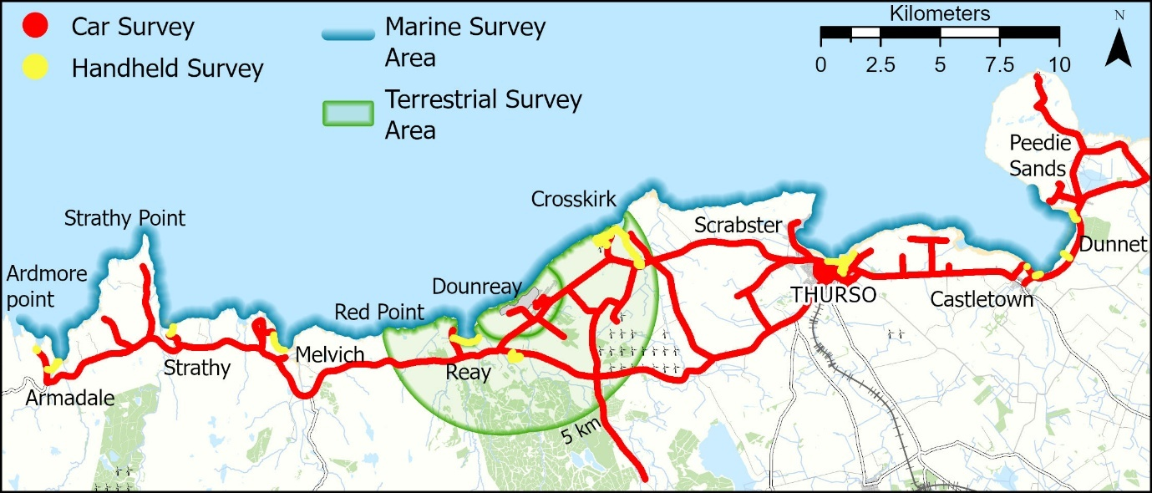

7.2.2. Carborne and handheld results
Overall, 25000 spectral measurements were made (~14732 – carborne; ~10735 – handheld).

Dose rates typically ranged from 0.002μGy h⁻¹ (2 nGy h⁻¹) to more than 0.022μGy h⁻¹ (22 nGy h⁻¹). Higher values between 0.022 and 0.138μGy h⁻¹ may be attributable to elevated natural radiation, for example high concentrations of potassium-40 from road and building construction materials.

7.3 In-situ Gamma Dosimetry
The ERL has ISO 17025:2017 accredited procedures for the deployment and recording of gamma dose rate in air, using ISO 17025:2017 accredited (United Kingdom Accreditation Service (UKAS)) calibrations for two Thermo Radeye instruments. Measurements were taken at all locations where occupancy or location may lead to higher exposure to radioactivity or radiation because of site activities.
Twenty in-situ gamma dose rate measurements were collected at intertidal sites during the survey. A UKAS accredited procedure was followed to estimate the terrestrial gamma dose rate. Since most of the dose contribution was thought to be from naturally occurring radionuclides, a radium-226 calibration was used to estimate dose rate for all gamma dose rate measurements. Radium-226 occurs naturally in the environment and emits several gamma-rays spanning the environmentally relevant energy spectrum (0-2204keV).
A summary of the dose rate measurements made across the survey area for terrestrial and intertidal areas can be found in Table 7.1. Note that most of the higher readings are made over rock and stone. Lower readings tended to be recorded on sandier areas. Spatially (Figure 7.2), there was little evidence to link patterns in dose rates to the Dounreay site.

Table 7.1 Summary of gamma dose rate measurements collected across the Dounreay survey area
Site | Surface | Eastings | Northings | Dose rate (μGy h⁻¹) | 2σ Uncertainty (μGy h⁻¹)
Port a’ Chinn | rock and sand | 2782 | 9650 | 0.0211 | 0.0036
Armadale Beach | sand and rock | 2794 | 9645 | 0.0056 | 0.0033
Strathy Beach | sand | 2840 | 9660 | 0.0103 | 0.0034
Portskerra Pier | stone and rock | 2882 | 9656 | 0.04364 | 0.00434
Portskerra Harbour | stone and rock | 2878 | 9663 | 0.0531 | 0.0047
Melvich Bay | sand | 2887 | 9649 | 0.01787 | 0.00357
Sandside Harbour | sand and rock | 2957 | 9660 | 0.02057 | 0.0036
Sandside Beach | sand | 2958 | 9655 | 0.0051 | 0.0033
Crosskirk Beach | rock | 3028 | 9699 | 0.0591 | 0.0049
Brims Ness | rock | 3040 | 9714 | 0.0316 | 0.0039
Scrabster Beach | sand | 3099 | 9699 | 0.0204 | 0.0036
Thurso Beach | sand | 3118 | 9687 | 0.0171 | 0.0035
Thurso East Mains | rock | 3124 | 9689 | 0.0554 | 0.0047
Murkle Beach | sand | 3167 | 9692 | 0.0057 | 0.0033
Castletown Harbour | sand and rock | 3198 | 9685 | 0.0281 | 0.0038
Dunnet Beach | sand | 3218 | 9704 | 0.0169 | 0.0035
Dwarwick Pier | stone | 3207 | 9712 | 0.0373 | 0.0041
Peedie Sands | sand and rock | 3203 | 9718 | 0.0101 | 0.0034
Castletown Beach | sand | 3202 | 9682 | 0.0095 | 0.0033
Strathy Point | rock | 2828 | 9696 | 0.0328 | 0.0040

7.4 In-situ Beta Dosimetry
Five in situ beta dosimetry measurement of skin dose [H*(0.07)] equivalent was measured. Measurements were on three boat keels and two creels that were situated close to the coast. The results were below the detection limit of 0.2µSv h⁻¹ per cm⁻² with the exception of one boat keel which was 0.3µSv h⁻¹ per cm⁻².

7.5 Occupancy Rates

7.5.1. Occupancy data for the survey area
The Phase 1 interviews revealed that individuals take part in a range of terrestrial, aquatic, and intertidal activities within the survey area (Table 7.2). For terrestrial activities, the most popular activity was gardening (34 individuals) and the terrestrial activity with the overall maximum occupancy was for an individual spending 4680h y⁻¹ farming within the terrestrial survey area. For the intertidal activities, dog walking was the most popular (129 individuals) with the highest individual occupancy being 1460h y⁻¹ for photography at Sandside Head, Brims Ness, Strathy beach, near Dwarwick Pier and Crosskirk beach. For the aquatic activities, outdoor swimming was the most popular (50 individuals) and the aquatic activity with the overall maximum occupancy was for an individual working on a commercial fishing/creeling 3328h y⁻¹ within the survey area.

Figure 7.2 Summary of the gamma dose rate measurements across the Dounreay survey area
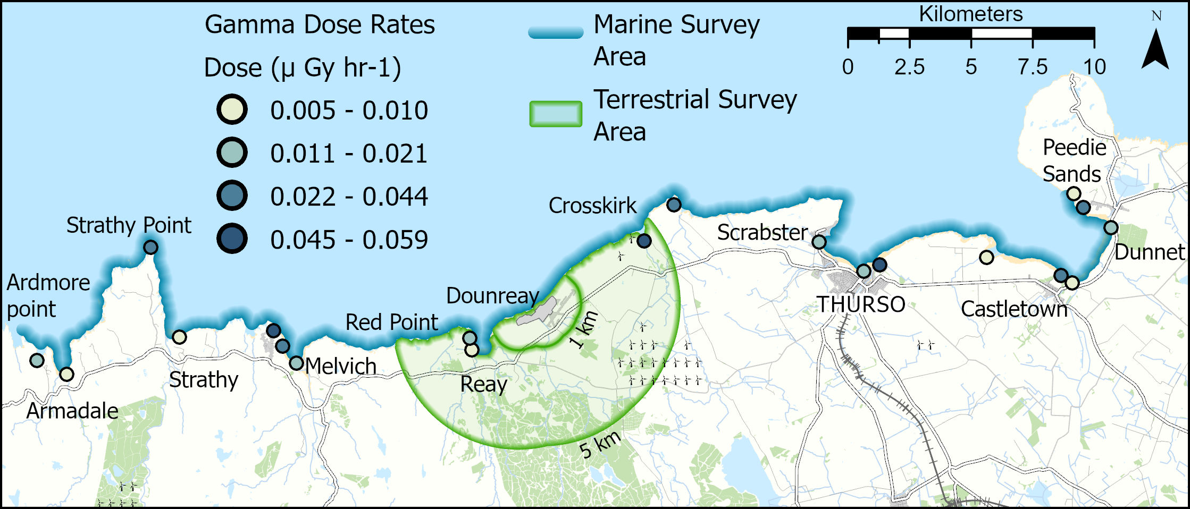

Table 7.2 Summary of terrestrial, intertidal and aquatic activities and total number of individuals that take part. The location of the maximum occupancy is also given.
Activity type | Activity | Number of Individuals | Maximum Occupancy (h y⁻¹) | Location of Maximum Occupancy
Terrestrial | Beekeeping | 2 | 58 | Within 5km
Terrestrial | Bird ringing | 1 | 130 | Reay
Terrestrial | Bird/nature watching | 9 | 1095 | Crosskirk
Terrestrial | Climbing/bouldering | 1 | 96 | Within 5km
Terrestrial | Collecting wild produce | 12 | 6 | Near Sandside
Terrestrial | Crofting and sheep dog training | 1 | 1460 | Within 5km
Terrestrial | Cycling | 19 | 52 | Within 5km
Terrestrial | Dog walking | 28 | 365 | Reay and Achvarasdal
Terrestrial | Farming | 17 | 4680 | Within 5km
Terrestrial | Fishing | 1 | 60 | Forss Water/River
Terrestrial | Gardening | 34 | 913 | Reay
Terrestrial | Golfing | 4 | 468 | Reay
Terrestrial | Groundworks | 2 | 0.5 | Sandside harbour
Terrestrial | Jogging | 3 | 520 | Reay
Terrestrial | Looking after hens | 1 | 91 | Within 5km
Terrestrial | Outdoor work | 3 | 2080 | Within 5km
Terrestrial | Photography | 1 | 416 | Shebster, Sandside wood, Achvarasdal and Broubster forest
Terrestrial | Playing | 5 | 104 | Reay
Terrestrial | Rambling/  walking | 33 | 208 | Reay
Terrestrial | Shooting | 3 | 24 | Broubster
Terrestrial | Sitting/  picnicking | 6 | 104 | Reay
Terrestrial | Small holding outdoor activities | 2 | 2190 | Within 5km
Terrestrial | Outdoor sports | 4 | 12 | Reay
Terrestrial | Visiting friends | 1 | 104 | Reay
Terrestrial | Watching outdoor football | 2 | 60 | Reay
Intertidal | Bait digging | 2 | 78 | Castletown beach
Intertidal | Sitting/  picnicking/BBQ | 14 | 15 | Scrabster beach
Intertidal | Beachcombing | 15 | 316 | Thurso, Thurso East Mains and Dunnet beaches
Intertidal | Bird/nature watching | 7 | 34 | Dunnet beach
Intertidal | Boat maintenance | 1 | 12 | Scrabster harbour
Intertidal | Camping | 3 | 20 | Strathy beach
Intertidal | Collecting limpets | 1 | 2 | Strathy and Thurso beaches
Intertidal | Collecting seaweed | 4 | 8 | Sandside harbour
Intertidal | Dog walking | 129 | 1095 | Thurso beach
Intertidal | Drone flying | 2 | 0.75 | Dunnet beach
Intertidal | Fishing | 13 | 312 | Near Dwarwick Pier
Intertidal | Jogging | 1 | 10 | Melvich beach
Intertidal | Litter picking | 6 | 780 | Sandside beach
Intertidal | Paddling | 22 | 220 | Scrabster and Dunnet beaches
Intertidal | Photography | 1 | 1460 | Sandside Head, Brims Ness, Strathy beach, near Dwarwick Pier and Crosskirk beach
Intertidal | Playing | 29 | 258 | Scrabster beach
Intertidal | RNLI training | 1 | 24 | Scrabster beach
Intertidal | Rock pooling | 1 | 24 | Thurso East Mains beach
Intertidal | Walking | 98 | 208 | Thurso, Strathy, Melvich, Dunnet beaches and Peedie Sands
Intertidal | Working | 3 | 33 | Dunnet beach
Aquatic | Being on a dive boat | 5 | 75 | Off Portskerra and Holborn Head
Aquatic | Boat maintenance | 8 | 2704 | Within survey area
Aquatic | Body boarding | 3 | 60 | Sandside Bay, Dunnet Bay, Thurso Bay, Strathy Bay and Dunnet Bay
Aquatic | Canoeing | 6 | 246 | Scrabster Bay, Strathy Bay and Melvich Bay
Aquatic | Capsize training | 1 | 4 | Strathy Bay
Aquatic | Commercial fishing/creeling | 4 | 3328 | Within survey area
Aquatic | Creel fishing/handling | 4 | 832 | Scrabster Bay
Aquatic | Diving | 5 | 48 | Off Portskerra and Scrabster Bay
Aquatic | Free diving | 1 | 234 | Thurso Bay, Brims Ness and Thurso Bay
Aquatic | Kayaking | 4 | 121 | Sandside Bay and Scrabster Bay
Aquatic | On boat - coracle | 1 | 2 | Brims Ness
Aquatic | Outdoor swimming | 50 | 123 | Scrabster Bay and Dunnet Bay
Aquatic | Powerboating | 1 | 18 | Scrabster Bay
Aquatic | RNLI duties | 2 | 104 | Scrabster Bay
Aquatic | Sailing | 2 | 182 | Scrabster Bay
Aquatic | Sea aerobics | 1 | 858 | Scrabster Bay
Aquatic | Sea angling | 13 | 1095 | Portskerra
Aquatic | Sea cadet activities | 1 | 195 | Thurso Bay
Aquatic | Snorkelling | 3 | 3 | Thurso Bay and Scrabster Bay
Aquatic | Stand-up paddle boarding | 7 | 39 | Sandside Bay
Aquatic | Surfing | 19 | 936 | Dunnet Bay, Strathy Bay, Armadale Bay, Sandside Bay and Thurso Bay

7.5.2 Occupancy rates within 1km of Dounreay (inside/outside work or home)
Individuals living or working within the immediate area of Dounreay were asked to estimate how much time they spend inside and outside their home or workplace. The results presented in Table 7.3 show the time spent indoors and outdoors on an annual basis. Eleven individuals interviewed lived and/or worked within 1km of the Dounreay nuclear licensed site. The highest time spent indoors at work for one individual each was 920h y⁻¹ and the highest time spent outdoors at work for two individuals was 4312h y⁻¹. The highest time spent indoors living within 1km for two individuals was 5475h y⁻¹ indoors, and the highest time spent in the immediate area outside their house was 4004h y⁻¹ for one individual. All figures consider any holiday period away from home with all figures checked and confirmed by the individuals. The highest total occupancy living and working within 1km of the Dounreay nuclear licensed site was 8760h y⁻¹ for one individual.

Table 7.3 Occupancy rates of those individuals working or living within 1km of Dounreay
Observation number | Indoors at home (h y ⁻¹) | Outdoors at home (h y ⁻¹) | Indoors at work (h y ⁻¹) | Outdoors at work (h y ⁻¹)
201 | 5475 | 4 | - | -
255 | 5475 | 1825 | - | -
210 | 3650 | 1460 | - | 3650
243 | 4732 | 4004 | - | -
242 | 4732 | 2964 | - | 1040
206 | - | - | - | 4312
263 | - | - | - | 4312
211 | - | - | 384 | 1536
241 | - | - | 920 | 920
148 | - | - | 96 | 288
182 | - | - | 96 | 288

8 Phase 2 Survey Results

8.1 Introduction
There were three aims to the Phase 2 surveys conducted. These were to i) validate the Phase 1 face-to-face surveys; ii) identify any major changes to internal/external exposure pathways; and, iii) identify any new pathways within a select group of individuals. To determine the individuals selected, the total dose from all exposure pathways for each survey participant was estimated. These data were then used to identify three individuals from different parts of the dose distribution (e.g. the top third, middle third and bottom third of the distribution). It was agreed with SEPA that the Phase 2 survey should target nine individuals. Additional considerations affecting selection were that some individuals (when asked during Phase 1) said they did not want to be contacted again, for some individuals we had incorrect contact details, or individuals did not respond to approaches made by the survey team during the Phase 2 surveys. For Dounreay, follow up surveys were made in October 2025. Seven individuals agreed to participate with the Phase 2 survey when contacted: one individual from the high group (A), three individuals from the medium group (D, E and F) and three individuals from the low group (G, H and I) group.

8.2 Phase 2 Internal Exposure

8.2.1 Internal Terrestrial
Within the high group individual A consumed produce within the Phase 1 and Phase 2 surveys and data are provided in Table 8.1. There was a change in some of the terrestrial food consumption for individual A with 8kg y⁻¹ determined in Phase 1 and 10.5kg y⁻¹ determined in Phase 2 for green vegetables. This was due to a smaller yield of Brussel sprouts consumed in Phase 2 and a consumption of herbs and lettuce which was not reported during the Phase 1 survey. Within the root vegetable food group, it was reported that there was an increase in the amount of spring onions consumed during the Phase 2 survey than was reported during Phase 1. It was also reported during the Phase 2 survey that the yield of domestic fruit was greater than had been reported for both raspberries and blackcurrants during the Phase 1 survey. Individual A reported that beef had not been consumed as had been reported during the Phase 1 survey. The individual reported it had been consumed during the previous year. It was also reported that elderflower had been foraged since the Phase 1 survey, and it was also reported during the Phase 2 survey that egg consumption was lower than had been reported during the Phase 1 survey.
Within the medium group one individual consumed produce within the Phase 1 and Phase 2 surveys and the data are provided in Table 8.2. Only eggs were consumed by individual E and there was no change in the consumption.
Within the low group only individuals G and H reported terrestrial food group consumption. Individual G consumed more eggs than was reported during the Phase 1 survey and individual H reported a substantially higher consumption of eggs during the Phase 2 survey than was reported during the Phase 1 survey. This was due to the individual not including eggs that were used for baking that the individual consumed (Table 8.3).
Table 8.1 Survey comparison of terrestrial consumption for the high group (kg y⁻¹)
Food type | A Phase 1 (kg y⁻¹) | A Phase 2 (kg y⁻¹)
Green leafy vegetables | 8 | 10.5
Root vegetables | 3.7 | 3.8
Domestic fruit | 14 | 20
Meat - beef | 5 | 0
Eggs | 15 | 9
Wild foods | 0.13 | 0.23

Food type | E Phase 1 (kg y⁻¹) | E Phase 2 (kg y⁻¹)
Eggs | 18 | 18
Table 8.2 Survey comparison of terrestrial consumption for the medium group (kg y⁻¹)

Table 8.3 Survey comparison of terrestrial consumption for the low group (kg y⁻¹)
Food type | G Phase 1 (kg y⁻¹) | G Phase 2 (kg y⁻¹) | H Phase 1 (kg y⁻¹) | H Phase 2 (kg y⁻¹)
Eggs | 2 | 3 | 2 | 18

8.2.2 Internal Aquatic
Individual F within the medium group was the only individual to consume aquatic food (all locally sourced within the marine survey area) and this individual consumed fish with no change in the consumption of reported during the Phase 1 and 2 surveys (Table 8.4).
Table 8.4 Survey comparison of aquatic consumption for the medium group (h y⁻¹)
Food type | A Phase 1 (kg y⁻¹) | A Phase 2 (kg y⁻¹)
Fish | 18 | 18

8.3 Phase 2 External Exposure

8.3.1 External Terrestrial
Terrestrial occupancy was reported within the high, medium and low groups (occupancy within 5km – terrestrial survey area). Within the high group individual A undertook terrestrial activities in both the Phase 1 and Phase 2 surveys and the data are provided in Table 8.5. There was no change to individual A’s activities and occupancy between the Phase 1 and Phase 2 surveys with the time spent dog walking reported being the same during both surveys and the time spent gardening and collecting wild produce being comparable during both surveys.
Within the medium group only two individual’s reported undertaking terrestrial activities within Phase 1 and Phase 2 surveys (Table 8.6). Individual E reported to spending time gardening within both the Phase 1 and 2 surveys. There was a slight increase in the occupancy reported during the Phase 2 survey with the individual reporting 0.7h gardening daily during spring, summer and autumn. The individual felt gardening occupancy was better reflected as 1h daily for eight months of the year when interviewed during the Phase 2 survey. Individual E also reported rambling/walking during the Phase 2 survey which they had not reported during the Phase 1 survey. Individual F undertook photography within both Phase 1 and 2 surveys with no change in occupancy reported.
Within the low group two individuals reported to undertaking terrestrial activities within Phase 1 and Phase 2 surveys (Table 8.7). Individual G reported comparable gardening occupancy between Phase 1 (64h y⁻¹) and Phase 2 (78h y⁻¹) surveys. Individual H reported a greater occupancy sitting/picnicking during Phase 1 survey than was reported during the Phase 2 survey. The individual reported that the Phase 1 survey occupancy was overestimated.

Table 8.5 Survey comparison of terrestrial occupancy for the high group (h y⁻¹)
Terrestrial activities | A Phase 1  (h y⁻¹) | A Phase 2  (h y⁻¹)
Dog walking | 365 | 365
Gardening | 90 | 91
Collecting wild produce | 0.5 | 0.66

Table 8.6 Survey comparison of occupancy for the medium group (h y⁻¹)
Terrestrial activities | E Phase 1 (h y⁻¹) | E Phase 2 (h y⁻¹) | F Phase 1 (h y⁻¹) | F Phase 2 (h y⁻¹)
Gardening | 205 | 243 | - | -
Rambling/walking | - | 26 | - | -
Photography | - | - | 416 | 416

Table 8.7 Survey comparison of terrestrial occupancy for the low group (h y⁻¹)
Terrestrial activities | G Phase 1 (h y⁻¹) | G Phase 2 (h y⁻¹) | H Phase 2 (h y⁻¹) | H Phase 2 (h y⁻¹)
Gardening | 64 | 78 | - | -
Sitting/picnicking | - | - | 104 | 52

8.3.2 External Aquatic
Intertidal and aquatic occupancy was reported within the high, medium and low groups within the marine survey area.
Within the high group individual A undertook dog walking on intertidal sand substrate (Table 8.8) in both Phase 1 and Phase 2 with no change reported during the surveys (18h y⁻¹ during Phase 1 and Phase 2 surveys).
Within the medium group both individuals D, E and F undertook marine activities in both Phase 1 and Phase 2 surveys, and the data are provided in Table 8.9. There was no change in marine activities and occupancy reported during Phase 1 and 2 surveys by individuals D and F. Individual E reported comparable occupancy walking on sand substrate during both Phase 1 (24h y⁻¹) and Phase 2 (26h y⁻¹) surveys.
Within the low group individuals G and I undertook marine activities in both Phase 1 and Phase 2 surveys, and the data are provided in Table 8.10. Individual G reported to underestimating time spent walking within the Phase 1 survey in the Phase 2 survey. Individual I reported they had spent less time dog walking, bird/nature watching and beachcombing on intertidal sand substrate occupancy in the Phase 1 survey than in Phase 2 (103h y⁻¹ and 120h y⁻¹ respectively). This was reported to be due to slightly underestimating the time spent on sand substrate. There was also a slight increase in handling sediment during the Phase 2 survey for individual I which reflects the slight increase in the intertidal sand substrate activities occupancy.
Table 8.8 Survey comparison of intertidal and aquatic activity occupancy for the high group (h y⁻¹)
Intertidal and aquatic activities | A Phase 1  (h y⁻¹) | A Phase 2  (h y⁻¹)
Occupancy on sand | 18 | 18

Table 8.9 Survey comparison of intertidal and aquatic activity occupancy for the medium group (h y⁻¹)
Intertidal and aquatic activities | D Phase 1 (h y⁻¹) | D Phase 2 (h y⁻¹) | E Phase 1 (h y⁻¹) | E Phase 2 (h y⁻¹) | F Phase 1 (h y⁻¹) | F Phase 2 (h y⁻¹)
Occupancy on sand | 559 | 559 | 24 | 26 | 500 | 500
Occupancy on rock | - | - | - | - | 876 | 876
Occupancy on stone | - | - | - | - | 292 | 292
Occupancy fishing gear | - | - | - | - | 218 | 218
Handling sediment | 559 | 559 | - | - | - | -

Table 8.10 Survey comparison of intertidal and aquatic activity occupancy for the low group (h y⁻¹)
Intertidal and aquatic activities | G Phase 1  (h y⁻¹) | G Phase 2  (h y⁻¹) | I Phase 1  (h y⁻¹) | I Phase 2  (h y⁻¹)
Occupancy on sand | 2 | 6 | 103 | 120
Handling sediment | - | - | 34 | 39

9 Post Covid-19 Habit Analysis
It was discussed with SEPA that due to the pandemic individuals’ habits may have somewhat changed for different reasons. Individuals were asked if any of their habits (terrestrial, intertidal, and aquatic) had changed since the Covid19 pandemic. Within the Phase 1 survey 241 individuals provided a definitive answer to whether there had been any changes to their habits. Figures 9.1 to 9.4 show individuals’ habits post Covid19.
Figure 9.1 shows that 173 individuals reported that there had been no changes to their habits, 29 individuals reported that they now spent more time outdoors (some individuals indicated that as a family they all spent more time outdoors), 8 individuals reported that they now spent less time outdoors and individuals reported that their habits had changed due to ‘other’ reasons. Figures 9.2, 9.3 and 9.4 provide a breakdown of each category within Figure 9.1.
Figure 9.1 Post Covid-19 changes identified from individuals surveyed

Figure 9.2 Breakdown of habits individuals reported post Covid-19 for those individuals reporting more time spent outdoors

Figure 9.3 Breakdown of habits individuals reported post Covid-19 for those individuals reporting less time spent outdoors

Figure 9.4 Breakdown of ‘Other’ contributors to post Covid-19 habit changes

10 Comparisons with the Previous Survey

10.1 Introduction
The results from the 2025 Dounreay Habits Survey have been reported in chapters 5-7 for both the postal survey and the face-to-face Phase 1 survey. These results can be compared with results from the previous habits survey, undertaken around Dounreay in 2018 by the University of Stirling.
The aquatic and terrestrial face-to-face survey area in the 2025 survey is consistent with the previous 2018 survey.

10.2 Aquatic Survey

10.2.1 Phase 1 - Adult consumption rates – Internal exposure
A comparison between 2018 and 2025 adult consumption rates of aquatic foods in the face-to-face interviews is presented in Table 10.1. The table also provides the mean consumption rates from national data (Smith and Jones, 2003) for comparison.
Table 10.1 Comparison between 2018 and 2025 adult consumption rates of aquatic foods
Food Group | 2018 Number of people in the high-rate group | 2018 Maximum consumption rate (kg y⁻¹) | 2018 Mean consumption rate for the high-rate group (kg y⁻¹) | 2025 Number of people in the high-rate group | 2025 Maximum consumption rate (kg y⁻¹) | 2025 Mean consumption rate for the high-rate group (kg y⁻¹) | National - Mean (kg y⁻¹)
Fish | 4 | 93.6 | 45.9 | 12 | 30 | 16 | 15.0
Crustaceans | 6 | 35 | 21.2 | 6 | 50.7 | 30 | 4.00
Molluscs | 2 | 21.3 | 21.3 | 1 | 2 | 2 | 4.00
Wildfowl | ND | ND | ND | 2 | 2.5 | 2.5 | ND
Seaweed | ND | ND | ND | 2 | 0.7 | 0.7 | ND
ND – not determined
In 2025 the mean consumption rate for the adult high-rate group decreased from 45.9kg y⁻¹ to 16kg y⁻¹ for fish, from 21.3kg y⁻¹ to 2kg y⁻¹ for molluscs and was increased for crustaceans (21.2kg y⁻¹ to 30kg y⁻¹) compared with 2018. In 2025 the mean consumption of seaweed and wildfowl consumption was determined for the adult high-rate group, 0.7kg y⁻¹ and 2.5kg y⁻¹ respectively. No consumption of seaweed or wildfowl was determined in the 2018. The main species of fish consumed by the adult high-rate group were bass, cod, mackerel, pollock, haddock, flounder, halibut and ling in 2025 compared to the main species being haddock, cod, bass, plaice, lemon sole and hake in 2018. The main species of crustacean consumed by the adult high-rate group in 2025 and 2018 was brown crab and common lobster. The main species of mollusc consumed by the adult high-rate group in 2025 was limpets compared with mussels, scallops and whelks in 2018.

10.2.2 Phase 1 - Children and infant consumption rates – Internal exposure
A comparison between 2025 and 2018 of children’s consumption rates of aquatic foods in the face-to-face interviews is presented in Table 10.2.

Table 10.2 Comparison between 2018 and 2025 children’s consumption rates of aquatic foods
Age Group | Food Group | 2018 Number of people in the high-rate group | 2018 Maximum consumption rate (kg y⁻¹) | 2018 Mean consumption rate for the high-rate group (kg y⁻¹) | 2025 Number of people in the high-rate group | 2025 Maximum consumption rate (kg y⁻¹) | 2025 Mean consumption rate for the high-rate group (kg y⁻¹) | National - Mean (kg y⁻¹)
Child (6 to 15 years old) | Fish | 2 | 42.1 | 38.1 | 3 | 6.8 | 3.9 | 15
Child (6 –to15 years old) | Crustaceans | ND | ND | ND | 2 | 35 | 35 | 4
Child (6 to 15 years old) | Molluscs | 2 | 0.5 | 0.4 | ND | ND | ND | 4
ND – not determined
The mean consumption of fish within the children’s high-rate group decreased in 2025 compared to 2018 (3.9kg y⁻¹ and 38.1kg y⁻¹ respectively). The children’s high-rate group consumed mackerel in 2025 compared with pollock, cod and mackerel 2018. The mean consumption of crustacean within the children’s high-rate group was 35kg y⁻¹ in 2025 compared with no consumption in 2018. The children’s high-rate group consumed brown crab and common lobster in 2025 compared with no consumption of crustacean determined in 2018. There was no consumption of molluscs in 2025 compared with consumption of molluscs (mussels and whelks) within the children’s high-rate group in 2018. In 2025 and 2018, no children were determined to consume wildfowl or seaweed.
No consumption was determined for infants in the 2025 survey compared with consumption of fish and crustaceans in 2018.

10.2.3 Phase 1 - Adult intertidal/aquatic occupancy – External exposure
External exposure was divided into five groups: intertidal activities, aquatic in water activities, aquatic on water activities, handling of equipment, and handling of sediment.
In 2025, the maximum occupancy on a rock substrate, sand substrate, and sand and stone substrate decreased in 2025 (876h y⁻¹, 1095h y⁻¹ and 0.25h y⁻¹ respectively) compared with 2018 (1107h y⁻¹, 1460h y⁻¹ and 117h y⁻¹ respectively). The maximum occupancy on a stone substrate increased in 2025 (292h y⁻¹) compared with 2018 (274h y⁻¹). A comparison is shown in Table 10.3.
The highest total intertidal occupancy in 2025 was 1668h y⁻¹ for an individual undertaking photography (1460h y⁻¹) and fishing (208h y⁻¹) on a sand substrate, a rock substrate and a stone substrate (Section 5.14), which has increased compared to 1460h y⁻¹ in 2018 for an individual who spent time on a sand substrate.
In 2025, the maximum in water and on water occupancy increased (978h y⁻¹ and 4238h y⁻¹ respectively) compared with 2018 (754h y⁻¹ and 2051h y⁻¹ respectively). In 2025, both maximum handling equipment and handling sediment occupancy increased (4630h y⁻¹ and 780h y⁻¹ respectively) compared with 2018 (1965h y⁻¹ and 730h y⁻¹ respectively). A comparison is shown in Table 10.4.

Table 10.3 Comparison of the 2018 and 2025 intertidal external exposure pathways for adults
Intertidal substrate | 2018 Number of people in the high-rate group | 2018 Maximum occupancy (h y⁻¹) | 2018 Mean occupancy for the high-rate group (h y⁻¹) | 2025 Number of people in the high-rate group | 2025 Maximum occupancy (h y⁻¹) | 2025 Mean occupancy for the high-rate group (h y⁻¹)
Sand | ND | 1290 | ND | 17 | 1095 | 594
Sand and stone | ND | 117 | ND | 1 | 0.25 | 0.25
Stone | ND | 274 | ND | 1 | 292 | 292
Rock | ND | 1107 | ND | 2 | 876 | 594
ND – not determined
Table 10.4 Comparison of the 2018 and 2025 aquatic external exposure pathways for adults
Activity | 2018 Number of people in the high-rate group | 2018 Maximum occupancy (h y⁻¹) | 2018 Mean occupancy for the high-rate group (h y⁻¹)) | 2025 Number of people in the high-rate group | 2025 Maximum occupancy (h y⁻¹) | 2025 Mean occupancy for the high-rate group (h y⁻¹)
Aquatic (in water) | 3 | 754 | 494 | 4 | 978 | 669
Aquatic (on water) | 2 | 2051 | 1801 | 3 | 4238 | 3421
Handling equipment | 2 | 1965 | 1837 | 3 | 4630 | 3492
Handling sediment | 1 | 730 | 548 | 4 | 780 | 554

10.2.4 Phase 1 – Children and infant intertidal/aquatic occupancy – External exposure
As with the adult intertidal/aquatic occupancy, external exposure was divided into five groups: intertidal activities, aquatic in water activities, aquatic on water activities, handling of equipment, and handling of sediment for both children and infant age groups.
For children, the highest total intertidal occupancy (Section 5.14) and highest occupancy on sand substrate in 2025 was 516h y⁻¹ for a child dog walking (258h y⁻¹) and playing (258h y⁻¹) which is increased compared to 156h y⁻¹ in 2018 for a child who spent time on a sand substrate. There was no occupancy for a child on rock substrate in 2025 compared with occupancy on rock (3h y⁻¹) in 2018.
For infants, occupancy on sand substrate increased in 2025 compared with 2018 (292h y⁻¹ and 107h y⁻¹ respectively). Occupancy on a rock substrate in 2025 for an infant was 4h y⁻¹ compared with no occupancy on rock determined in 2018. A comparison is shown in Table 10.5.The highest total intertidal occupancy (Section 5.14) in 2025 was 292h y⁻¹ for an infant who spent time beachcombing (78h y⁻¹), walking (208h y⁻¹) and collecting seaweed (6h y⁻¹) on a sand substrate, which is increased compared to 107h y⁻¹ in 2018 for an infant who spent time on a sand substrate.
In 2025, for the child age group, there was a significant decrease in maximum occupancy for in water compared with the 2018 survey (5h y⁻¹ and 507h y⁻¹ respectively) There was no on water occupancy determined in 2025 compared with on water occupancy (60h y⁻¹) in 2018. In 2025, the maximum occupancy for handling sediment increased to 258h y⁻¹ compared with 90h y⁻¹ in 2018. The maximum occupancy for handling equipment in 2025 decreased to 2h y⁻¹ compared with 78h y⁻¹ in 2018. A comparison is shown in Table 10.6.
In 2025 for the infant age group, the maximum occupancy was 156h y⁻¹ compared with no in water occupancy determined in 2018. There was no on water occupancy determined in either the 2025 or 2018 surveys. In 2025 the maximum occupancy for handling sediment was 220h y⁻¹ which has increased from 107h y⁻¹ in 2018. There was no handling equipment occupancy determined for either the 2025 or 2018 surveys. A comparison is shown in Table 10.6.

Table 10.5 Comparison of the 2018 and 2025 intertidal external exposure pathways for children and infants
Age Group | Activity | 2018 Number of people in the high-rate group | 2018 Maximum occupancy (h y⁻¹) | 2018 Mean occupancy for the high-rate group (h y⁻¹) | 2025 Number of people in the high-rate group | 2025 Maximum occupancy (h y⁻¹) | 2025 Mean occupancy for the high-rate group (h y⁻¹)
Child (6 to 15 years old) | Sand | ND | 156 | ND | 8 | 516 | 299
Child (6 to 15 years old) | Rock | ND | 3 | ND | ND | ND | ND
Infant (0 to 5 years old) | Sand | ND | 107 | ND | 6 | 292 | 194
Infant (0 to 5 years old) | Rock | ND | ND | ND | 2 | 4 | 3.5
ND – not determined

Table 10.6 Comparison of the 2018 and 2025 aquatic external exposure pathways for children and infants
Age Group | Activity | 2018 Number of people in the high-rate group | 2018 Maximum occupancy (h y⁻¹) | 2018 Mean occupancy for the high-rate group (h y⁻¹) | 2025 Number of people in the high-rate group | 2025 Maximum occupancy for the high-rate group (h y⁻¹) | 2025 Mean occupancy for the high-rate group (h y⁻¹)
Child (6 to 15 years old) | Aquatic (in water) | 1 | 507 | 507 | 4 | 5 | 3.5
Child (6 to 15 years old) | Aquatic (on water) | 2 | 60 | 60 | ND | ND | ND
Child (6 – 15 years old) | Handling equipment | 3 | 78 | 69 | 2 | 2 | 2
Child (6 – 15 years old) | Handling sediment | 1 | 90 | 90 | 3 | 258 | 233
Infant (0 to 5 years old) | Aquatic (in water) | ND | ND | ND | 1 | 156 | 156
Infant (0 – 5 years old) | Handling sediment | 2 | 107 | 106 | 4 | 220 | 131
ND – not determined

10.3 Terrestrial Survey

10.3.1 Phase 1 - Adult consumption rates – Internal exposure
Consumption rates of locally produced food items have increased in the 2025 survey in the other vegetables, potatoes, wild fruit, beef, eggs and honey food groups in comparison to the 2018 survey. Consumption rates decreased in the 2025 survey in the green vegetables, root vegetables, domestic fruit, wild fungi and sheep meat food groups in comparison to the 2018 survey. No consumption for game birds, game venison and pork was determined in 2025 compared to the 2018 survey. A comparison between the 2018 and 2025 mean consumption rates for adult consumption of the terrestrial food groups is presented in Table 10.7. The table also provides the mean consumption rates from national data (Smith and Jones, 2003) for comparison.

Table 10.7 Comparison between 2018 and 2025 mean consumption rates of local terrestrial food groups for adults (kg y⁻¹)
Food group | 2018 Mean consumption rate for the high-rate group (kg y⁻¹) | 2025 Mean consumption rate for the high-rate group (kg y⁻¹) | National mean
Green vegetables | 30.7 | 21.9 | 15
Other vegetables | 19.5 | 79.4 | 20
Root vegetables | 30 | 20.1 | 10
Potatoes | 51 | 59.6 | 50
Domestic fruit | 156 | 118 | 20
Wild fruit | 0.7 | 1.2 | 7
Wild fungi | 5 | 2 | 3
Meat beef | 52 | 72.5 | 15
Meat game (birds) | 5.3 | ND | ND
Meat game (venison) | 30.3 | ND | ND
Meat sheep | 26 | 14.7 | 8
Meat pork | 40 | ND | 15
Honey | 0.2 | 0.93 | 2.5
Eggs | 20 | 42.8 | 8.5
ND – not determined

10.3.2 Phase 1 – Children and infant consumption rates - Internal exposure
Child consumption rates of locally produced food items in the 2025 survey were in root vegetables, potatoes, domestic fruit, wild fruit, eggs and sheep meat food groups. Compared with 2018, consumption increased for root vegetables, potatoes and eggs in 2025 and decreased for domestic fruit. Green vegetables were not determined in 2025 compared to 2018, whilst wild fruit and sheep meat was consumed in 2025 compared with no consumption determined in 2018. For infants, consumption of green vegetables, other vegetables, root vegetables, potatoes, domestic fruit, wild fruit and eggs were determined during the 2025 survey compared to consumption of root vegetables, potatoes, game birds and venison in 2018. Compared to 2018, root vegetable was comparable in 2025, while potato consumption increased slightly in 2025. No game bird or venison consumption was determined in 2025 compared to consumption of game birds and venison in 2018. The mean consumption rates for children and infants are presented in Table 10.8.
Table 10.8 Comparison between 2018 and 2025 mean consumption rates of local terrestrial food groups for children and infants (kg y⁻¹)
Age Group | Food group | 2018 Mean consumption rate for the high-rate group (kg y⁻¹) | 2025 Mean consumption rate for the high-rate group (kg y⁻¹)
Child (6 to 15 years old) | Green vegetables | 4.2 | ND
Child (6 to 15 years old) | Root vegetables | 1 | 25.5
Child (6 to 15 years old) | Potatoes | 11.2 | 62.4
Child (6 to 15 years old) | Domestic fruit | 25.4 | 1.8
Child (6 to 15 years old) | Wild fruit | ND | 2
Child (6 to 15 years old) | Eggs | 5.57 | 18.1
Child (6 to 15 years old) | Meat sheep | ND | 6.5
Infant (0 to 5 years old) | Green vegetables | ND | 1.4
Infant (0 to 5 years old) | Other vegetables | ND | 2
Infant (0 to 5 years old) | Root vegetables | 1 | 1.1
Infant (0 to 5 years old) | Potatoes | 6 | 7.6
Infant (0 to 5 years old) | Domestic fruit | ND | 11.9
Infant (0 to 5 years old) | Meat game birds | 0.5 | ND
Infant (0 to 5 years old) | Meat game venison | 1 | ND
Infant (0 to 5 years old) | Wild fruit | ND | 0.35
Infant (0 to 5 years old) | Eggs | ND | 19.3
ND – not determined

10.4 Occupancy living/working within 1km of Dounreay
Table 10.9 presents the comparison between the 2018 and 2025 survey occupancy rates within the direct radiation survey area (h y⁻¹). The table displays the time spent indoors and outdoors of their home (living) and for those who work (spending time indoors and outdoors) within 1km of the Dounreay nuclear licensed site (Dounreay site workers were not included in this survey). In 2025 and 2018 total occupancy was the same. Indoor occupancy at home was lower in 2025 compared to 2018. Outdoor occupancy at home, and indoor and outdoor occupancy at work all increased in 2025 compared to 2018.

Table 10.9 Comparison between 2018 and 2025 occupancy rates for people living and working within the direct radiation area (h y⁻¹)
Occupancy | 2018  (h y⁻¹) | 2025  (h y⁻¹)
Highest total | 8760 | 8760
Highest indoor at home | 8395 | 5475
Highest outdoor at home | 1225 | 4004
Highest indoor at work | 730 | 920
Highest outdoor at work | 3650 | 4312

11 Recommendations and Suggestions for Monitoring Programme Changes

11.1 Introduction
The habits survey presents results for occupancy, activity, and food consumption from three main sources of community engagement: (i) Postal questionnaire (n = 164); (ii) face-to-face surveys (n = 350); and (iii) several meetings and informal contacts. These data have been supplemented with radiometric surveys including: (i) a carborne and handheld gamma spectrometry survey (n = ~ 14732 (carborne); n = ~10735 (handheld)); (ii) in-situ gamma dose rate measurements (n = 20 intertidal); and (iv) in-situ beta dose rate measurements (n = 5).

11.2 Ongoing Monitoring
The Radioactivity in Food and the Environment report (RIFE) (2024) demonstrates a comprehensive set of monitoring undertaken annually around the Dounreay site encompassing a range of food types and environmental substrates. The gamma dose rates reported by RIFE are generally higher than those reported here because the RIFE data include the cosmic contribution to dose. This assessment reports the terrestrial gamma dose rate only. When taking this into account, the results are similar. Samples taken and reported by SEPA are provided within the RIFE reports (RIFE 29, 2024) and cover cod, crabs, mussels, winkles, seaweed (Fucus vesiculosus), sediment, salt marsh, rock, seawater, apples, beef, cabbage, carrots, lamb, leeks, onion, parsnips, potatoes, rosehips, strawberries, swede, venison, grass and soil.

11.3 Conclusions and Recommendations
Information collected between Phase 1 and 2 surveys demonstrates that there can be differences in data due to a change in habits over the course of a year and/or there can be an over- or under-estimating when reporting information on consumption and occupancy. This is despite extensive steps taken to check the validity of the results collected during the face-to-face questions.
In some cases, there are differences in the surveyed individual responses between Phases 1 and 2. These differences may be genuine, e.g. a real change in consumption or occupancy between the different parts of the year when the Phase 1 and 2 surveys were conducted, or they may be due to different estimates of their consumption/activities, e.g. Phase 2 surveys are conducted via pre-arranged telephone interviews and the survey individuals may be able to better prepare for the questions than when they are approached in the survey area at random.
Overall, for Dounreay, the results of the Phase 2 surveys largely demonstrate that they provide confidence in the representativeness of the data collected throughout the Phase 1 surveys. It is anticipated that some work can still be done to explain the differences between Phase 1 and 2 surveys e.g. by establishing whether they are due to seasonal/weather conditions, or an over/under-estimating on the part of the survey individual. The survey team will consider additional ways to evaluate this in further surveys.
It is recommended that SEPA’s routine monitoring continues as is currently being undertaken. However, based on the findings of this habits survey, and considering the potential radiological significance of the various pathways that were identified, it is suggested SEPA consider field mushrooms (Agaricus campestris) to be included in the routine monitoring programme for wild foods and sampled annually from within 1km of the Dounreay site.

References
Dale, I., Smith, P., Tyler, T., Copplestone, D., Varley, A., Bradley, S., Bartie, P. (2022). Dounreay Radiological Habit Survey. University of Stirling.
Dale, P., Robertson, I., Toner, M. (2008). Radioactive Particles in Dose Assessments. Journal of Environmental Radioactivity. 99, pp. 1589-1595
Environmental Authorisations (Scotland) Regulations 2018 (Scottish Government, 2018)
European Commission. (2021). Agreement between the government of the United Kingdom of Great Britain and Northern Ireland and the European atomic energy community for cooperation on the safe and peaceful uses of nuclear energy. Available at https://eur-lex.europa.eu/eli/agree_internation/2020/2255/oj/eng
Food and Environment Protection Act (FEPA), FEPA Order – http://www.legislation.gov.uk/uksi/1997/2622/contents/made – The Food Protection (Emergency Prohibitions) (Dounreay Nuclear Establishment) Order 1997
Garden Forum Horticulture, 2009. http://www.gardenforumhorticulture.co.uk/gyo/Square-Foot-Gardening.pdf.
Green, N., Wilkins, B.T., Hammond, D.J., Davidson, M.F., Richmond, S., Brooker, S., (2001). Foods found in the wild around nuclear sites: An evaluation of radiological impact. Radiation Protection Dosimetry. 93(1), 67-73.
Hessayon, D.G. (2014). The New Vegetable & Herb Expert. Transworld Publications Ltd 2014, London.
Hunt, G.J., Hewett, C.J. and Shepherd, J.G., (1982). The identification of critical groups and its application to fish and shellfish consumers in the coastal area of the north-east Irish Sea. Health Physics, Vol. 43, No 6, pp. 875-889.
IAEA (2014) Radiation Protection and Safety of Radiation Sources: International Basic Safety Standards. General Safety Requirements. IAEA Safety Standards Series No. GSR Part 3, Vienna, 2014.
ICRP (2006). Assessing Dose of the Representative Person for the Purpose of the Radiation Protection of the Public. ICRP Publication 101a. Ann. ICRP 36 (3).
ICRP (2007). The 2007 Recommendations of the International Commission on Radiological Protection. ICRP Publication 103. Ann. ICRP 37 (2-4).
ICRP (2012). Compendium of Dose Coefficients based on ICRP Publication 60. ICRP Publication 119. Ann. ICRP 41(Suppl.).
Land Cover Map (2015). Updated in 2008 by the Centre for Ecology and Hydrology using EDINA environment Digimap service.
Leonard, D.R.P., Hunt, G.J., Jones, P.G.W., (1982). Investigations of individual radiation exposures from discharges to the aquatic environment: the technique of habit surveys. Pp. 512-517 In: ‘Proceedings of the Third International Symposium on Radiological Protection – Advances in Theory and Practice’, Inverness, 6-11 June 1982, Volume 2. The Society of Radiological Protection.
NDAWG (2013). Use of Habits Data in Prospective Dose Assessments. NDAWG Guidance Note 7.
Nuclear Decommissioning Authority (2014) Strategic Environmental assessment: Site Specific Baseline Dounreay. September 2014, pp 3.
Nuclear Decommissioning Authority (2021) Strategy: Effective from March 2021. Cleaning up the UK’s earliest nuclear sits, caring for people and the environment.
Ordnance Survey Great Britain (2018).
Punt, A; Tyler A; Saleh, S; Bradley S; & Copplestone D. (2011). Measurement and Assessment of External Radiation Dose Rates to People on Houseboats and using Riverbanks – using the Ribble Estuary as a case study. Environment Agency Report: SC060080/R4. ISBN: 978-1-84911-211-6.
Radioactivity in Food and the Environment (RIFE 24) Report, 2018 (published 2019).
Radioactivity in Food and the Environment (RIFE 27) Report, 2021 (published 2022).

Radioactivity in Food and the Environment (RIFE 28) Report, 2022 (published 2023).
Radioactivity in Food and the Environment (RIFE 29) Report, 2023 (published 2024).
Smith, J.G., Simmonds, J.R. (2009). The Methodology for Assessing the Radiological Consequences of Routine Releases of Radionuclides to the Environment Used in PC-CREAM 08, Health Protection Agency Report HPA-RPD-058.
Smith, K.R., Jones, A.L. (2003). Generalised habit data for radiological assessments. NRPB-W41. NRPB, Chiltern.
Soils of Scotland. The Macauley Institute for Soil Research (2015).
Tyler, A.N. and Heal, K.V. (2000). Predicting areas of Cs-137 loss and accumulation in upland catchments, Water, Air, and Soil Pollution, 121 (1-4): 271-288.
Tyler, A.N., Dale, P., Copplestone, D., Bradley, S., Ewen, H., McGuire, C., Scott, E.M. (2013). The radium legacy: contaminated land and the committed effective dose from the ingestion of radium contaminated materials. Environment International, 59, 449-455.
Tyler A, Scott EM, Dale P, Elliott AT, Wilkins BT, Boddy K, Toole J & Cartwright P (2010). Reconstructing the abundance of Dounreay hot particles on an adjacent public beach in Northern Scotland. Science of the Total Environment, 408, 4495-4503.
Varley, A., Tyler, A.N., Wilson, C. (2020) Near real-time soil erosion mapping through mobile gamma-ray spectroscopy. Journal of Environmental Radioactivity, 223-224, 106400.

Appendices

Appendix A

Appendix A1 Raw Data
Table A1.1 Phase 1 Adult fish consumption
Observation number | Food type | Sum of consumption (kg y⁻¹)
202 | Haddock | 0.6
280 | Haddock | 0.6
305 | Mackerel | 2.5
308 | Haddock | 30
342 | Bass | 0.89
45 | Cod | 6
45 | Pollock | 2
45 | Haddock | 5
60 | Mackerel | 4
76 | Cod | 6
76 | Haddock | 12
77 | Mackerel | 13
80 | Mackerel | 10
91 | Bass | 0.89
92 | Bass | 0.89
113 | Mackerel | 2.5
114 | Bass | 3.39
114 | Cod | 1.79
114 | Haddock | 10.4
114 | Flounder | 1.2
114 | Halibut | 3.59
136 | Mackerel | 4.5
136 | Haddock | 12
145 | Mackerel | 4.5
145 | Haddock | 7.5
145 | Flounder | 0.3
149 | Mackerel | 2.09
149 | Haddock | 1.8
158 | Mackerel | 0.53
170 | Mackerel | 4.5
170 | Haddock | 7.5
170 | Flounder | 0.3
200 | Cod | 5
200 | Haddock | 5
200 | Ling | 5
203 | Pollock | 0.2
203 | Haddock | 0.2
215 | Mackerel | 4.5
215 | Haddock | 12
257 | Cod | 5
257 | Haddock | 5
257 | Ling | 5
266 | Pollock | 0.2
266 | Haddock | 0.2
284 | Mackerel | 2.1
284 | Haddock | 1.8
Table A1.2 Phase 1 Child fish consumption
Observation number | Food type | Sum of consumption (kg y⁻¹)
22 | Mackerel | 6.8
24 | Mackerel | 2.5
25 | Mackerel | 2.5
Table A1.3 Phase 1 Adult crustacean consumption
Observation number | Food type | Sum of consumption (kg y⁻¹)
305 | Brown crab | 32.5
305 | Common lobster | 2.5
313 | Brown crab | 12
313 | Common lobster | 6
113 | Brown crab | 32.5
113 | Common lobster | 2.5
136 | Brown crab | 1.5
136 | Common lobster | 1.4
191 | Brown crab | 31.2
191 | Common lobster | 19.5
200 | Brown crab | 10
200 | Common lobster | 10
201 | Brown crab | 8
201 | Common lobster | 6
215 | Brown crab | 1.5
215 | Common lobster | 1.3
228 | Common lobster | 5.4
228 | Crab | 0.45
255 | Brown crab | 8
255 | Common lobster | 6
257 | Brown crab | 10
257 | Common lobster | 10
Table A1.4 Phase 1 Child crustacean consumption
Observation number | Food type | Sum of consumption (kg y⁻¹)
24 | Brown crab | 32.5
24 | Common lobster | 2.5
25 | Brown crab | 32.5
25 | Common lobster | 2.5
Table A1.5 Phase 1 Adult mollusc consumption
Observation number | Food type | Sum of consumption (kg y⁻¹)
95 | Limpet | 1
95 | Limpet | 1
140 | Cockles | 0.5
309 | Limpet | 0.25
346 | Limpet | 0.25

Table A1.6 Phase 1 Adult wildfowl consumption
Observation number | Food type | Sum of consumption (kg y⁻¹)
242 | Mallard | 1
242 | Greylag goose | 1.5
243 | Mallard | 1
243 | Greylag goose | 1.5
Table A1.7 Phase 1 Adult seaweed consumption
Observation number | Food type | Sum of consumption (kg y⁻¹)
118 | Seaweed | 0.7
119 | Seaweed | 0.7

Table A1.8 Phase 1 Adult in water activities. Where observation numbers are listed more than once for same activity, this indicates that the activity is undertaken at more than one location, e.g. outdoors swimming at multiple beaches in the survey area
Observation number | Aquatic activity | Sum of occupancy (h y⁻¹)
42 | Outdoor swimming | 70.2
42 | Outdoor swimming | 22.5
42 | Outdoor swimming | 3.9
42 | Outdoor swimming | 3.9
42 | Outdoor swimming | 1.2
42 | Outdoor swimming | 1.2
245 | Outdoor swimming | 26
340 | Outdoor swimming | 1.5
340 | Outdoor swimming | 0.5
340 | Surfing | 18
340 | Surfing | 8
43 | Outdoor swimming | 0.33
43 | Stand-up paddle boarding | 1
73 | Outdoor swimming | 39
83 | Outdoor swimming | 26
88 | Outdoor swimming | 60
139 | Outdoor swimming | 4.2
139 | Stand-up paddle boarding | 10
175 | Capsize training | 3.96
192 | Outdoor swimming | 1.5
192 | Outdoor swimming | 0.5
192 | Surfing | 18
192 | Surfing | 8
278 | Outdoor swimming | 6.5
280 | Outdoor swimming | 9
280 | Outdoor swimming | 1.6
283 | Outdoor swimming | 108
283 | Outdoor swimming | 12
283 | Sea aerobics | 858
294 | Outdoor swimming | 1.4
294 | Outdoor swimming | 0.36
294 | Outdoor swimming | 0.36
300 | Outdoor swimming | 0.5
303 | Outdoor swimming | 0.1
305 | Surfing | 10
306 | Outdoor swimming | 91.3
306 | Outdoor swimming | 31
306 | Outdoor swimming | 1
309 | Outdoor swimming | 0.33
309 | Outdoor swimming | 0.33
312 | Outdoor swimming | 52
313 | Outdoor swimming | 6
313 | Surfing | 78
322 | Outdoor swimming | 1.8
322 | Outdoor swimming | 1.8
322 | Stand-up paddle boarding | 4
322 | Surfing | 3
322 | Surfing | 3
322 | Surfing | 3
322 | Surfing | 3
323 | Body boarding | 12
323 | Body boarding | 12
323 | Body boarding | 12
323 | Body boarding | 12
323 | Body boarding | 12
323 | Surfing | 41.5
323 | Surfing | 41.5
323 | Surfing | 41.5
323 | Surfing | 41.5
323 | Surfing | 41.5
326 | Outdoor swimming | 0.12
327 | Outdoor swimming | 0.84
327 | Surfing | 4
334 | Outdoor swimming | 0.75
336 | Outdoor swimming | 39
336 | Outdoor swimming | 13
336 | Stand-up paddle boarding | 4
344 | Outdoor swimming | 0.33
344 | Outdoor swimming | 0.33
348 | Outdoor swimming | 0.12
349 | Outdoor swimming | 0.12
58 | Outdoor swimming | 45
58 | Outdoor swimming | 15
66 | Outdoor swimming | 0.12
68 | Surfing | 2
80 | Outdoor swimming | 3
107 | Outdoor swimming | 0.66
115 | Outdoor swimming | 45
115 | Outdoor swimming | 15
118 | Outdoor swimming | 13
118 | Surfing | 29.3
118 | Surfing | 29.3
118 | Surfing | 19.5
118 | Surfing | 19.5
118 | Free diving | 58.5
118 | Free diving | 58.5
118 | Free diving | 58.5
118 | Free diving | 58.5
138 | Outdoor swimming | 1
138 | Outdoor swimming | 1
147 | Outdoor swimming | 39
147 | Outdoor swimming | 3.6
149 | Outdoor swimming | 0.75
155 | Outdoor swimming | 4
162 | Outdoor swimming | 0.08
163 | Outdoor swimming | 3.3
169 | Outdoor swimming | 26
203 | Outdoor swimming | 3
203 | Outdoor swimming | 0.25
203 | Surfing | 546
203 | Surfing | 78
203 | Surfing | 78
203 | Surfing | 78
203 | Surfing | 78
203 | Surfing | 78
204 | Diving | 24
204 | Diving | 24
214 | Surfing | 13
218 | Stand-up paddle boarding | 12
218 | Stand-up paddle boarding | 12
218 | Surfing | 156
218 | Surfing | 78
218 | Surfing | 78
218 | Surfing | 39
218 | Surfing | 39
220 | Outdoor swimming | 0.33
229 | Outdoor swimming | 3
229 | Outdoor swimming | 3
229 | Snorkelling | 2.3
229 | Snorkelling | 0.75
231 | Snorkelling | 2.3
231 | Snorkelling | 0.75
233 | Diving | 15
233 | Diving | 7.5
237 | Diving | 15
237 | Diving | 15
237 | Diving | 11
237 | Stand-up paddle boarding | 39
240 | Diving | 15
240 | Diving | 15
240 | Diving | 11
240 | Stand-up paddle boarding | 9
240 | Stand-up paddle boarding | 6.8
240 | Stand-up paddle boarding | 4.5
249 | Outdoor swimming | 0.25
258 | Surfing | 8
262 | Diving | 24
262 | Diving | 24
262 | Snorkelling | 1.5
266 | Outdoor swimming | 3
266 | Outdoor swimming | 0.25
266 | Surfing | 52
271 | Outdoor swimming | 2
275 | Outdoor swimming | 0.24
288 | Surfing | 2
289 | Surfing | 2
Table A1.9 Phase 1 Children in water activities
Observation number | Aquatic activity | Sum of occupancy (h y⁻¹)
20 | Outdoor swimming | 3
35 | Body boarding | 2
35 | Surfing | 2
36 | Body boarding | 2
36 | Outdoor swimming | 3
41 | Surfing | 2
Table A1.10 Phase 1 Infant in water activities
Observation number | Aquatic activity | Sum of occupancy (h y⁻¹)
3 | Surfing | 156
7 | Outdoor swimming | 13

Table A1.11 Phase 1 Adult on water activities
Observation number | Aquatic activity | Sum of occupancy (h y⁻¹)
129 | Canoeing | 246
139 | Canoeing | 4
174 | Kayaking | 121
175 | Canoeing | 188
176 | Canoeing | 65
305 | Boat maintenance | 112
305 | Commercial fishing/creeling | 1248
305 | Creel fishing/Handling | 832
308 | Boat maintenance | 6
308 | Creel fishing/Handling | 516
308 | Sea angling | 774
313 | Sea angling | 312
315 | Canoeing | 9.8
341 | Sailing | 15
47 | RNLI duties | 26
68 | On boat - coracle | 2
76 | Sea angling | 32
77 | Boat maintenance | 20
77 | Sea angling | 52
78 | Sea angling | 20
114 | Sea angling | 150
134 | Power boating | 18
134 | Sailing | 182
134 | Sea Cadet Activities | 195
140 | Sea angling | 10
145 | Sea angling | 9
153 | Commercial fishing/creeling | 104
158 | Sea angling | 1
191 | Creel fishing/Handling | 26
191 | Sea angling | 117
200 | Boat maintenance | 9.3
200 | Sea angling | 168
201 | Boat maintenance | 2808
201 | Commercial fishing/creeling | 1430
204 | Being on a dive boat | 3
204 | Boat maintenance | 10
215 | Sea angling | 78
220 | Canoeing | 1
228 | Boat maintenance | 48
228 | Creel fishing/Handling | 156
228 | Sea angling | 1095
231 | Kayaking | 39
232 | Boat maintenance | 312
232 | Commercial fishing/creeling | 3328
232 | Kayaking | 90
232 | RNLI duties | 104
233 | Being on a dive boat | 75
237 | Being on a dive boat | 15
237 | Kayaking | 39
240 | Being on a dive boat | 15
262 | Being on a dive boat | 3

Table A1.12 Phase 1 Adult intertidal activities. Where observation numbers are listed more than once for same activity, this indicates that the activity is undertaken at more than one location, e.g. dog walking at multiple beaches in the survey area
Observation number | Intertidal activity | Occupancy on sand (h y⁻¹) | Occupancy on sand and stone (h y⁻¹) | Occupancy on stone (h y⁻¹) | Occupancy on rock (h y⁻¹)
42 | Dog walking | 104
42 | Litter picking | 4
87 | Dog walking | 371
282 | Dog walking | 196
307 | Walking | 1
318 | Bird/nature watching | 4
318 | Bird/nature watching |  |  | 12
329 | Walking | 15
53 | Walking | 0.33
63 | Paddling | 1
63 | Playing | 104
83 | Dog walking | 24
83 | Dog walking | 241
83 | Working | 7
84 | Dog walking | 12
84 | Paddling | 3.6
84 | Paddling | 7.2
84 | Rock pooling | 24
85 | Dog walking | 364
86 | Walking | 0.25
88 | Walking | 8.6
95 | Collecting limpets |  |  |  | 2
95 | Dog walking | 6
104 | Walking | 0.75
112 | Dog walking | 196
112 | Playing | 130
120 | Dog walking | 2
150 | Walking | 0.25 | 0.25
160 | Walking | 0.25
174 | Dog walking | 117
192 | Walking | 14
223 | Dog walking | 9
234 | Walking | 0.5
256 | Dog walking | 1095
264 | Dog walking | 24
264 | Sitting/picnicking/BBQ | 6
269 | Bird/nature watching | 4
269 | Walking | 156
276 | Walking | 0.25
277 | Walking | 1
278 | Jogging | 10
278 | Working | 0.08
279 | Dog walking | 2
280 | Dog walking | 141
280 | Litter picking | 142
281 | Dog walking | 78
281 | Paddling | 1
283 | Dog walking | 52
291 | Dog walking | 35
294 | Dog walking | 34.3
300 | Dog walking | 260
300 | Paddling | 3
300 | Walking | 52
301 | Dog walking | 2.5
302 | Walking | 2
303 | Walking | 0.4
304 | Dog walking | 2
306 | Beachcombing | 316
309 | Playing | 1
309 | Playing | 1
309 | Walking | 0.66
310 | Bird/nature watching |  |  |  | 1.5
310 | Sitting/picnicking/BBQ | 1
311 | Walking | 0.5
314 | Dog walking | 437
315 | Dog walking | 548
316 | Fishing from shore | 20
317 | Dog walking | 183
319 | Dog walking | 1
320 | Bird/nature watching | 4
320 | Bird/nature watching |  |  | 12
321 | Dog walking | 12
323 | Beachcombing | 15.6
323 | Beachcombing | 46.8
323 | Beachcombing | 15.6
323 | Collecting seaweed | 6
323 | Fishing from shore | 30
323 | Walking | 83.2
323 | Walking | 125
324 | Dog walking | 1.5
325 | Dog walking | 61
326 | Walking | 0.33
327 | Dog walking | 48
328 | Walking | 1
330 | Walking | 1
331 | Walking | 1
332 | Walking | 1
333 | Dog walking | 34.3
334 | Walking | 10
335 | Dog walking | 183
335 | Litter picking | 183
336 | Dog walking | 95
337 | Dog walking | 0.5
338 | Beachcombing | 1
339 | Dog walking | 0.5
341 | Dog walking | 383
342 | Dog walking | 286
343 | Walking | 0.5
344 | Playing | 2
344 | Walking | 0.66
345 | Dog walking | 0.9
345 | Playing | 2
347 | Sitting/picnicking/BBQ | 4.5
348 | Camping | 20
349 | Camping | 20
350 | Drone flying | 0.75
44 | Dog walking | 365
45 | Dog walking | 91.3
46 | Walking | 0.66
47 | Dog walking | 48
48 | Beachcombing | 34.3
48 | Bird/nature watching | 34.3
48 | Dog walking | 34.3
49 | Dog walking | 35
50 | Beachcombing | 13
50 | Dog walking | 730
51 | Beachcombing |  |  |  | 4
51 | Sitting/picnicking/BBQ |  |  |  | 4
52 | Walking | 0.45
54 | Walking | 1
55 | Dog walking | 4.5
56 | Paddling | 0.5
56 | Playing | 0.5
57 | Dog walking | 4
58 | Dog walking | 13
58 | Walking | 41.6
59 | Playing | 24
60 | Dog walking | 312
60 | Fishing from shore |  |  |  | 208
61 | Walking | 1
62 | Paddling | 1
62 | Playing | 30.5
64 | Walking | 0.33
65 | Dog walking | 0.5
66 | Camping | 20
67 | Drone flying | 0.75
69 | Dog walking | 3
70 | Dog walking | 4
71 | Dog walking | 730
72 | Dog walking | 9
74 | Walking | 0.75
76 | Fishing from shore | 208
76 | Photography | 292
76 | Photography |  |  |  | 876
76 | Photography |  |  | 292
78 | Litter picking | 780
79 | Walking | 1
80 | Dog walking | 258
80 | Playing | 258
81 | Boat maintenance |  |  |  | 12
82 | Walking | 0.25
90 | Walking | 1
93 | Dog walking | 2.5
94 | Dog walking | 34.3
96 | Dog walking | 2
97 | Walking | 0.5
98 | Walking | 2
99 | Paddling | 0.5
99 | Playing | 0.5
100 | Paddling | 0.5
100 | Playing | 0.5
101 | Paddling | 0.5
101 | Playing | 0.5
102 | Paddling | 0.5
102 | Playing | 0.5
103 | Walking | 1
105 | Walking | 1
106 | Fishing from shore | 20
107 | Dog walking | 4
108 | Fishing from shore |  |  |  | 208
109 | Walking | 0.66
110 | Dog walking | 48
111 | Playing | 24
114 | Bait digging | 78
114 | Fishing from shore |  |  |  | 312
115 | Walking | 41.6
116 | Dog walking | 3
117 | Dog walking | 3
118 | Playing | 13
118 | Walking | 208
119 | Walking | 208
121 | Walking | 0.5
122 | Walking | 0.5
123 | Beachcombing | 0.5
124 | Beachcombing | 0.5
125 | Walking | 0.25
126 | Walking | 0.25
128 | Dog walking | 117
130 | Dog walking | 78
131 | Walking | 12
132 | Walking | 0.08
133 | Dog walking | 183
133 | Playing | 8
135 | Walking | 0.5
136 | Playing | 6
136 | Walking | 36
137 | Walking | 1
138 | Paddling | 0.3
138 | Walking | 26
140 | Fishing from shore |  |  | 9
140 | Walking | 26
141 | Dog walking | 18
142 | Dog walking | 52
142 | Walking | 52
143 | Walking | 26
144 | Bird/nature watching | 1
145 | Fishing from shore | 3
145 | Walking | 104
146 | Walking |  |  |  | 3
147 | Dog walking | 183
148 | Dog walking | 12
149 | Dog walking | 208
151 | Beachcombing | 43.5
151 | Beachcombing | 2.3
151 | Walking | 45.8
152 | Dog walking | 40
152 | Fishing from shore | 5
154 | Dog walking | 312
155 | Dog walking | 13.5
156 | Sitting/picnicking/BBQ | 2
157 | Bait digging | 4
157 | Dog walking | 12
157 | Fishing from shore | 48
158 | Fishing from shore | 13.5
158 | Fishing from shore |  |  | 31.5
159 | Playing | 3
161 | Walking | 6
162 | Walking | 72
165 | Dog walking | 214
167 | Bird/nature watching | 1
168 | Walking | 26
169 | Dog walking | 52
169 | Walking | 52
170 | Walking | 104
171 | Walking |  |  |  | 3
172 | Walking |  |  |  | 3
173 | Walking |  |  |  | 3
177 | Paddling | 0.3
177 | Walking | 26
178 | Walking | 0.33
179 | Dog walking | 2
180 | Walking | 0.49
181 | Dog walking | 152
182 | Dog walking | 12
183 | Dog walking | 220
184 | Walking | 3
185 | Dog walking | 21.6
186 | Walking | 1
189 | Playing | 2
190 | Dog walking | 117
191 | Beachcombing |  |  |  | 1
191 | Beachcombing | 1
193 | Dog walking | 548
198 | Dog walking | 156
200 | Collecting seaweed | 8
200 | Dog walking | 183
203 | Dog walking | 183
203 | Fishing from shore |  |  |  | 12
204 | Walking | 19.5
205 | Dog walking | 6
205 | Paddling | 0.5
206 | Dog walking | 208
207 | Walking | 2
209 | Dog walking | 12
210 | Walking |  |  |  | 1
211 | Dog walking | 24
211 | Sitting/picnicking/BBQ | 6
213 | Walking | 24
214 | Dog walking | 52
216 | Dog walking | 152
218 | Working | 32.5
219 | Dog walking | 52
220 | Dog walking | 1
221 | Dog walking | 4
225 | Dog walking | 52
226 | Walking | 2
227 | Dog walking | 6
227 | Paddling | 0.5
229 | Dog walking | 416
231 | Dog walking | 416
232 | Dog walking | 312
232 | RNLI training | 24
233 | Walking | 15
235 | Walking | 26
236 | Litter picking | 559
237 | Sitting/picnicking/BBQ | 4
237 | Walking | 48
238 | Litter picking | 559
240 | Collecting seaweed | 0.25
240 | Dog walking | 12
240 | Dog walking | 65
240 | Sitting/picnicking/BBQ | 15
249 | Dog walking | 65.7
251 | Dog walking | 156
252 | Playing | 2
253 | Walking | 104
254 | Walking | 0.45
257 | Dog walking | 183
258 | Dog walking | 12
262 | Walking | 19.5
265 | Beachcombing |  |  |  | 8
265 | Sitting/picnicking/BBQ |  |  |  | 4
266 | Dog walking | 183
267 | Sitting/picnicking/BBQ | 2
268 | Sitting/picnicking/BBQ | 2
270 | Sitting/picnicking/BBQ | 2
271 | Dog walking | 214
272 | Walking | 1
273 | Walking | 3
274 | Dog walking | 21.7
275 | Walking | 0.25
285 | Dog walking | 1.5
286 | Beachcombing | 1
287 | Paddling | 0.34
288 | Dog walking | 3
289 | Walking | 6
290 | Playing | 3
292 | Dog walking | 312
293 | Beachcombing | 43.5
293 | Beachcombing | 2.3
293 | Walking | 45.8
295 | Dog walking | 13.5
296 | Dog walking | 13.5
297 | Dog walking | 13.5
298 | Dog walking | 13.5
299 | Dog walking | 13.5

Table A1.13 Phase 1 Children intertidal activities
Observation number | Intertidal activity | Sum of sand occupancy (h y⁻¹)
19 | Dog walking | 104
20 | Dog walking | 8
21 | Dog walking | 34.3
22 | Dog walking | 258
22 | Playing | 258
23 | Playing | 24
26 | Beachcombing | 13
26 | Dog walking | 26
29 | Dog walking | 12
30 | Dog walking | 12
31 | Paddling | 220
32 | Paddling | 220
33 | Dog walking | 183
33 | Playing | 8
34 | Beachcombing | 1
35 | Walking | 6
36 | Walking | 6
37 | Dog walking | 312
38 | Dog walking | 312
39 | Dog walking | 312
40 | Dog walking | 312
41 | Beachcombing | 45.8
41 | Walking | 45.8

Table A1.14 Phase 1 Infant intertidal activities
Observation number | Intertidal activity | Sum of occupancy on sand (h y⁻¹) | Sum of occupancy on rock (h y⁻¹)
1 | Paddling | 6
1 | Playing | 104
2 | Paddling | 6
2 | Playing | 104
3 | Dog walking | 8
4 | Paddling | 0.5
4 | Playing | 0.5
5 | Dog walking | 4.5
6 | Playing | 24
7 | Playing | 13
7 | Walking | 208
8 | Walking |  | 3
9 | Dog walking | 24
9 | Sitting/picnicking/BBQ | 6
10 | Playing | 2
11 | Dog walking | 12
12 | Dog walking | 208
13 | Sitting/picnicking/BBQ |  | 4
14 | Paddling | 220
15 | Paddling | 48
16 | Playing | 3
17 | Playing | 3
18 | Beachcombing | 78
18 | Collecting seaweed | 6
18 | Walking | 208

Table A1.15 Phase 1 Adult handling sediment
Observation number | Sum of handling sediment (h y⁻¹)
42 | 4
63 | 105
84 | 34.8
95 | 2
112 | 130
264 | 6
280 | 141
281 | 1
300 | 3
306 | 316
309 | 2
310 | 1
323 | 84
335 | 183
338 | 1
344 | 2
345 | 2
347 | 4.5
348 | 20
349 | 20
48 | 34.3
50 | 13
51 | 8
56 | 1
59 | 24
62 | 31.5
66 | 20
78 | 780
80 | 258
99 | 1
100 | 1
101 | 1
102 | 1
111 | 24
114 | 78
118 | 13
123 | 0.5
124 | 0.5
133 | 8
136 | 6
138 | 0.3
151 | 45.8
156 | 2
157 | 4
159 | 3
177 | 0.3
189 | 2
191 | 2
200 | 8
205 | 0.5
211 | 6
227 | 0.5
236 | 559
237 | 4
238 | 559
240 | 15.3
252 | 2
265 | 12
267 | 2
268 | 2
270 | 2
286 | 1
287 | 0.34
290 | 3
293 | 45.8

Table A1.16 Phase 1 Children handling sediment
Observation number | Sum of handling sediment (h y⁻¹)
22 | 258
23 | 24
26 | 13
31 | 220
32 | 220
33 | 8
34 | 1
41 | 45.8
Table A1.17 Phase 1 Infant handling sediment
Observation number | Sum of handling sediment (h y⁻¹)
1 | 110
2 | 110
4 | 1
6 | 24
7 | 13
9 | 6
10 | 2
13 | 4
14 | 220
15 | 48
16 | 3
17 | 3
18 | 84
Table A1.18 Phase 1 Adult handling equipment
Observation number | Sum of handling equipment (h y⁻¹)
42 | 25
43 | 0.5
129 | 253
139 | 5.5
174 | 10.3
175 | 219
176 | 65.9
300 | 0.2
303 | 0.03
305 | 2192
308 | 1296
313 | 312
315 | 9.8
316 | 20
323 | 90
334 | 0.25
336 | 6
341 | 0.16
60 | 260
76 | 250
77 | 72
78 | 20.3
81 | 12
106 | 20
108 | 260
114 | 465
134 | 27.8
140 | 19
145 | 12
152 | 5
153 | 156
157 | 48
158 | 50.5
191 | 169
200 | 201
201 | 4630
203 | 18
204 | 13
215 | 78
218 | 52
220 | 1.5
228 | 1347
229 | 3.8
231 | 5.41
232 | 3653
233 | 147
237 | 25
240 | 26
262 | 4.5
266 | 1

Table A1.19 Phase 1 Children handling equipment
Observation number | Sum of handling equipment (h y⁻¹)
20 | 0.64
35 | 2
36 | 2

Table A1.20 Phase 1 Adult terrestrial activities
Observation number | Terrestrial activity | Sum of occupancy (h y⁻¹)
174 | Cycling | 52
174 | Dog walking | 104
175 | Rambling/walking | 48
246 | Rambling/walking | 17.2
264 | Dog walking | 241
264 | Rambling/walking | 52
269 | Bird/nature watching | 163
269 | Gardening | 169
269 | Bird ringing | 130
281 | Visit friends | 104
310 | Cycling | 10.4
310 | Rambling/walking | 0.99
316 | Rambling/walking | 17.2
317 | Gardening | 208
321 | Shooting | 0.5
323 | Climbing/bouldering | 96
333 | Dog walking | 1
336 | Dog walking | 60
341 | Bird/nature watching | 12
347 | Cycling | 10.4
47 | Dog walking | 4
49 | Dog walking | 6.6
51 | Bird/nature watching | 1095
51 | Farming | 2373
51 | Watching outdoor football | 60
59 | Bird/nature watching | 130
59 | Cycling | 39
59 | Gardening | 24
59 | Playing | 104
59 | Rambling/walking | 208
59 | Running | 520
59 | Sitting/picnicking | 24
59 | Sports | 12
59 | Collecting wild produce | 6
76 | Photography | 416
80 | Playing | 8
81 | Dog walking | 12
82 | Cycling | 1
94 | Golfing | 160
111 | Bird/nature watching | 130
111 | Cycling | 39
111 | Gardening | 24
111 | Playing | 104
111 | Rambling/walking | 208
111 | Running | 520
111 | Sitting/picnicking | 24
111 | Sports | 12
111 | Collecting wild produce | 6
125 | Cycling | 1
126 | Cycling | 1
127 | Rambling/walking | 0.75
136 | Dog walking | 117
136 | Rambling/walking | 156
138 | Dog walking | 365
140 | Rambling/walking | 54
141 | Dog walking | 365
141 | Gardening | 90.3
141 | Collecting wild produce | 0.66
142 | Dog walking | 365
142 | Gardening | 156
143 | Gardening | 364
143 | Rambling/walking | 130
145 | Cycling | 6
145 | Gardening | 312
145 | Rambling/walking | 156
146 | Gardening | 234
146 | Rambling/walking | 3
148 | At work | 2080
151 | Gardening | 24
163 | Dog walking | 548
164 | Gardening | 181
168 | Rambling/walking | 130
169 | Dog walking | 365
169 | Gardening | 208
170 | Cycling | 6
170 | Rambling/walking | 156
171 | Rambling/walking | 3
172 | Rambling/walking | 3
173 | Rambling/walking | 3
177 | Dog walking | 365
181 | Dog walking | 365
182 | At work | 2080
187 | Farming | 2555
188 | Rambling/walking | 0.75
194 | Gardening | 26
195 | Sitting/picnicking | 104
196 | Groundworks | 0.5
197 | Gardening | 71
198 | Dog walking | 208
198 | Small holding outdoor activities | 2190
199 | Cycling | 3
199 | Rambling/walking | 18
199 | Outdoor work | 520
200 | Gardening | 104
200 | Fishing | 60
200 | Shooting | 24
201 | Gardening | 52
203 | Dog walking | 208
205 | Dog walking | 365
205 | Gardening | 52
205 | Rambling/walking | 10.3
205 | Collecting wild produce | 0.66
205 | Looking after hens | 91.3
206 | Collecting wild produce | 2
206 | Farming | 1885
206 | Crofting and training | 1460
207 | Gardening | 64
208 | Farming | 3120
209 | Rambling/walking | 18
209 | Farming | 364
210 | Farming | 3650
213 | Gardening | 205
214 | Dog walking | 274
214 | Gardening | 411
215 | Golfing | 468
216 | Dog walking | 365
216 | Gardening | 548
218 | Cycling | 1
219 | Dog walking | 52
219 | Running | 390
221 | Gardening | 208
222 | Gardening | 183
224 | Farming | 2555
225 | Dog walking | 52
225 | Gardening | 208
227 | Dog walking | 365
227 | Gardening | 52
227 | Rambling/walking | 10.3
227 | Collecting wild produce | 0.66
231 | Beekeeping | 58
232 | Cycling | 26
235 | Beekeeping | 40
235 | Cycling | 52
235 | Gardening | 52
237 | Rambling/walking | 6
240 | Dog walking | 29.3
240 | Collecting wild produce | 0.66
242 | Collecting wild produce | 1.5
242 | Farming | 1040
244 | Farming | 1300
247 | Bird/nature watching | 365
247 | Dog walking | 241
247 | Farming | 416
248 | Gardening | 913
248 | Rambling/walking | 7.92
249 | Dog walking | 183
249 | Gardening | 52
250 | Farming | 4680
251 | Dog walking | 208
251 | Small holding outdoor activities | 2190
253 | Bird/nature watching | 163
253 | Gardening | 169
255 | Gardening | 78
257 | Sitting/picnicking | 104
258 | Cycling | 24
258 | Rambling/walking | 18
258 | Shooting | 4
258 | Farming | 364
259 | Gardening | 274
260 | Farming | 780
261 | Farming | 1040
263 | Collecting wild produce | 2
263 | Farming | 2860
265 | Farming | 2373
265 | Watching outdoor football | 60
266 | Dog walking | 208
293 | Gardening | 25

Table A1.21 Phase 1 Children terrestrial activities
Observation number | Terrestrial activity | Sum of occupancy (h y⁻¹)
23 | Bird/nature watching | 130
23 | Cycling | 39
23 | Gardening | 24
23 | Playing | 104
23 | Rambling/walking | 208
23 | Sitting/picnicking | 24
23 | Sports | 12
23 | Collecting wild produce | 6
27 | Groundworks | 0.5
29 | Cycling | 24
29 | Golfing | 52
29 | Rambling/walking | 18
30 | Cycling | 24
30 | Golfing | 52
30 | Rambling/walking | 18

Table A1.22 Phase 1 Infant terrestrial activities
Observation number | Terrestrial activity | Sum of occupancy (h y⁻¹)
6 | Bird/nature watching | 130
6 | Cycling | 39
6 | Gardening | 24
6 | Playing | 104
6 | Rambling/walking | 208
6 | Sitting/picnicking | 24
6 | Sports | 12
6 | Collecting wild produce | 6
8 | Rambling/walking | 3
9 | Rambling/walking | 52
11 | Rambling/walking | 18
12 | Collecting wild produce | 2

Table A1.23 Phase 1 Adult green vegetable consumption
Observation number | Vegetable type | Sum of consumption (kg y⁻¹)
136 | Rhubarb | 1
136 | Kale | 1.5
136 | Lettuce | 2.7
138 | Rhubarb | 1
138 | Lettuce | 16.9
140 | Cauliflower | 3
140 | Cabbage | 18
140 | Lettuce | 9
141 | Brussel sprouts | 5
141 | Cabbage | 3
145 | Rhubarb | 6
164 | Cabbage | 3
164 | Brussel sprouts | 5
170 | Rhubarb | 6
177 | Rhubarb | 1
177 | Lettuce | 16.9
197 | Broccoli | 4.2
197 | Lettuce | 0.34
197 | Cabbage | 1.5
198 | Broccoli | 2.1
200 | Rhubarb | 2.5
200 | Chard | 1
200 | Kale | 3
203 | Rhubarb | 0.45
205 | Spinach | 0.67
206 | Broccoli | 2.8
215 | Kale | 1.5
215 | Lettuce | 2.7
215 | Rhubarb | 1
227 | Spinach | 0.67
235 | Lettuce | 1
235 | Cabbage | 0.75
239 | Cabbage | 0.75
239 | Lettuce | 1
250 | Lettuce | 0.34
250 | Cabbage | 1.5
251 | Broccoli | 2.1
257 | Kale | 3
257 | Chard | 1
257 | Rhubarb | 2.5
263 | Broccoli | 2.8
266 | Rhubarb | 0.45

Table A1.24 Phase 1 Infant green vegetable consumption
Observation number | Vegetable type | Sum of consumption (kg y⁻¹)
12 | Broccoli | 1.4

Table A1.25 Phase 1 Adult other vegetable consumption
Observation number | Vegetable type | Sum of consumption (kg y⁻¹)
138 | Runner bean | 9
138 | Broad bean | 8.4
138 | French bean | 0.33
140 | Runner bean | 13.5
140 | Pea | 52
140 | French bean | 4.9
140 | Broad bean | 9
146 | Pea | 1.9
171 | Pea | 1.9
172 | Pea | 1.9
173 | Pea | 1.9
177 | French bean | 0.33
177 | Broad bean | 8.4
177 | Runner bean | 9
200 | Broad bean | 12
205 | Pea | 2.3
227 | Pea | 2.3
229 | Broad bean | 1
231 | Broad bean | 1
235 | Pea | 0.75
239 | Pea | 0.75
257 | Broad bean | 12

Table A1.26 Phase 1 Infant other vegetable consumption
Observation number | Vegetable type | Sum of consumption (kg y⁻¹)
8 | Pea | 2
Table A1.27 Phase 1 Adult root vegetable consumption
Observation number | Vegetable type | Sum of consumption (kg y⁻¹)
269 | Carrot | 1.7
269 | Parsnip | 0.38
269 | Onion | 0.99
136 | Carrot | 1.1
136 | Garlic | 0.2
136 | Leek | 0.7
136 | Onion | 1.2
136 | Parsnip | 0.86
136 | Beetroot | 0.78
138 | Fennel | 0.23
138 | Beetroot | 1.3
138 | Onion | 2
138 | Parsnip | 0.75
138 | Radish | 0.08
140 | Carrot | 1.8
140 | Carrot | 2.3
141 | Spring Onion | 0.15
141 | Leek | 3.6
142 | Carrot | 3
146 | Carrot | 0.25
146 | Onion | 0.53
151 | Carrot | 13.5
151 | Onion | 11.9
164 | Spring Onion | 0.15
164 | Leek | 3.6
169 | Carrot | 3
171 | Onion | 0.53
171 | Carrot | 0.25
172 | Onion | 0.53
172 | Carrot | 0.25
173 | Onion | 0.53
173 | Carrot | 0.25
177 | Radish | 0.08
177 | Parsnip | 1.3
177 | Onion | 1.99
177 | Fennel | 0.23
177 | Beetroot | 1.3
197 | Carrot | 0.75
200 | Parsnip | 2.9
200 | Onion | 2
200 | Carrot | 6.3
200 | Leek | 3.4
205 | Carrot | 1.3
206 | Onion | 2
215 | Leek | 0.71
215 | Onion | 1.2
215 | Carrot | 1.1
215 | Parsnip | 0.86
215 | Garlic | 0.15
215 | Beetroot | 0.78
227 | Carrot | 1.3
229 | Radish | 0.5
231 | Radish | 0.5
235 | Carrot | 2
239 | Carrot | 2
250 | Carrot | 0.75
253 | Parsnip | 0.38
253 | Onion | 0.99
253 | Carrot | 1.7
257 | Leek | 3.6
257 | Onion | 2
257 | Parsnip | 2.9
257 | Carrot | 6.3
263 | Onion | 2
293 | Carrot | 14
293 | Onion | 12

Table A1.28 Phase 1 Child root vegetable consumption
Observation number | Vegetable type | Sum of consumption (kg y⁻¹)
41 | Onion | 12
41 | Carrot | 14
Table A1.29 Phase 1 Infant root vegetable consumption
Observation number | Vegetable type | Sum of consumption (kg y⁻¹)
8 | Onion | 0.53
8 | Carrot | 0.25
12 | Onion | 1.3
Table A1.30 Phase 1 Adult potato consumption
Observation number | Vegetable type | Sum of consumption (kg y⁻¹)
269 | Potatoes | 1.7
136 | Potatoes | 6.9
140 | Potatoes | 34.7
140 | Potatoes | 1.5
142 | Potatoes | 3.5
146 | Potatoes | 11.1
151 | Potatoes | 62.4
169 | Potatoes | 1.5
171 | Potatoes | 11.1
172 | Potatoes | 11.1
173 | Potatoes | 11.1
198 | Potatoes | 0.9
200 | Potatoes | 7.5
205 | Potatoes | 4.6
206 | Potatoes | 12
210 | Potatoes | 54
215 | Potatoes | 6.9
227 | Potatoes | 4.6
235 | Potatoes | 12.5
239 | Potatoes | 12.5
251 | Potatoes | 0.9
253 | Potatoes | 1.7
257 | Potatoes | 7.5
263 | Potatoes | 12
293 | Potatoes | 62.4
Table A1.31 Phase 1 Child potato consumption
Observation number | Vegetable type | Sum of consumption (kg y⁻¹)
41 | Potatoes | 62.4
Table A1.32 Phase 1 Infant potato consumption
Observation number | Vegetable type | Sum of consumption (kg y⁻¹)
8 | Potatoes | 9.2
12 | Potatoes | 6

Table A1.33 Phase 1 Adult domestic fruit consumption
Observation number | Fruit type | Sum of consumption (kg y⁻¹)
269 | Blackberry | 1.8
269 | Raspberry | 0.45
269 | Blackcurrant | 0.45
59 | Strawberry | 0.13
59 | Plum | 0.13
111 | Plum | 0.13
111 | Strawberry | 0.13
136 | Blackcurrant | 6.8
136 | Tomato | 12
136 | Pepper | 2
136 | Gooseberry | 4
136 | Courgettes | 2.9
136 | Raspberry | 1.5
136 | Cucumber | 1.9
136 | Strawberry | 2.7
138 | Plum | 0.25
138 | Tomato | 20
138 | Apple | 18
140 | Tomato | 16
140 | Strawberry | 8.1
140 | Tayberry | 6
140 | Raspberry | 3
140 | Redcurrant | 24
140 | Cucumber | 7.5
141 | Blackcurrant | 8
141 | Raspberry | 6
142 | Apple | 0.5
145 | Apple | 113
145 | Raspberry | 15
145 | Blackcurrant | 10
145 | Gooseberry | 1
145 | Plum | 6
146 | Cucumber | 3
146 | Tomato | 4.8
146 | Apple | 5.4
151 | Strawberry | 0.5
151 | Apple | 1.3
164 | Blackcurrant | 8
164 | Raspberry | 6
169 | Apple | 0.5
170 | Plum | 6
170 | Blackcurrant | 10
170 | Gooseberry | 1
170 | Apple | 113
170 | Raspberry | 15
171 | Cucumber | 3
171 | Apple | 5.4
171 | Tomato | 4.8
172 | Cucumber | 3
172 | Apple | 5.4
172 | Tomato | 4.8
173 | Tomato | 4.8
173 | Apple | 5.4
173 | Cucumber | 3
177 | Apple | 18
177 | Plum | 0.25
177 | Tomato | 20
197 | Gooseberry | 1
197 | Blackcurrant | 2.3
200 | Strawberry | 3
203 | Apple | 0.32
203 | Redcurrant | 0.05
203 | Blackcurrant | 0.05
205 | Raspberry | 0.25
205 | Strawberry | 2.3
205 | Tomato | 4
205 | Courgettes | 5.8
206 | Raspberry | 0.3
206 | Strawberry | 0.3
215 | Blackcurrant | 6.8
215 | Courgettes | 2.9
215 | Raspberry | 1.5
215 | Gooseberry | 4
215 | Pepper | 2
215 | Cucumber | 1.9
215 | Tomato | 12
215 | Strawberry | 2.7
227 | Tomato | 4
227 | Courgettes | 5.8
227 | Strawberry | 2.3
227 | Raspberry | 0.25
229 | Strawberry | 0.5
229 | Apple | 2
231 | Strawberry | 0.5
231 | Apple | 2
235 | Strawberry | 1.5
239 | Strawberry | 1.5
250 | Blackcurrant | 2.3
250 | Gooseberry | 1
253 | Blackberry | 1.8
253 | Raspberry | 0.45
253 | Blackcurrant | 0.45
257 | Strawberry | 3
263 | Raspberry | 3
263 | Strawberry | 0.3
266 | Redcurrant | 0.05
266 | Apple | 0.32
266 | Blackcurrant | 0.05
293 | Strawberry | 0.5
293 | Apple | 1.3

Table A1.34 Phase 1 Child domestic fruit consumption
Observation number | Fruit type | Sum of consumption (kg y⁻¹)
23 | Strawberry | 0.13
23 | Plum | 0.13
41 | Strawberry | 0.5
41 | Apple | 1.3
Table A1.35 Phase 1 Infant domestic fruit consumption
Observation number | Fruit type | Sum of consumption (kg y⁻¹)
6 | Strawberry | 0.13
6 | Plum | 0.13
8 | Cucumber | 2.5
8 | Tomato | 4
8 | Apple | 5.4
12 | Strawberry | 0.4

Table A1.36 Phase 1 Adult wild foods consumption
Observation number | Wild food type | Sum of consumption (kg y⁻¹)
59 | Blackberry | 0.5
111 | Blackberry | 0.5
138 | Blackberry | 0.65
138 | Elderflower | 0.1
141 | Meadow sweet | 0.13
145 | Elderflower | 0.6
151 | Blackberry | 1
151 | Raspberry | 1
164 | Meadow sweet | 0.25
177 | Blackberry | 0.65
177 | Elderflower | 0.1
206 | Blackberry | 0.15
210 | Raspberry | 0.25
263 | Blackberry | 0.15
293 | Blackberry | 1
293 | Raspberry | 1
Table A1.37 Phase 1 Child wild foods consumption
Observation number | Wild food type | Sum of consumption (kg y⁻¹)
23 | Blackberry | 0.5
41 | Blackberry | 1
41 | Raspberry | 1
Table A1.38 Phase 1 Infant wild foods consumption
Observation number | Wild food type | Sum of consumption (kg y⁻¹)
6 | Blackberry | 0.5
12 | Blackberry | 0.2

Table A1.39 Phase 1 Adult wild fungi consumption
Observation number | Wild fungi | Sum of consumption (kg y⁻¹)
138 | Mushrooms | 0.25
177 | Mushrooms | 0.25
242 | Mushrooms | 2
243 | Mushrooms | 2

Table A1.40 Phase 1 Adult sheep meat consumption
Observation number | Meat | Sum of consumption (kg y⁻¹)
187 | Lamb | 12
206 | Lamb | 20
209 | Lamb | 13.5
222 | Lamb | 12
224 | Lamb | 12
258 | Lamb | 13.5
263 | Lamb | 20

Table A1.41 Phase 1 Child sheep meat consumption
Observation number | Meat | Sum of consumption (kg y⁻¹)
412 | Lamb | 6.5
413 | Lamb | 6.5

Table A1.42 Phase 1 Adult beef meat consumption
Observation number | Meat | Sum of consumption (kg y⁻¹)
140 | Beef | 72.5
141 | Beef | 5
164 | Beef | 5

Table A1.43 Phase 1 Adult egg consumption
Observation number | Eggs | Sum of consumption (kg y⁻¹)
212 | Eggs | 9.1
281 | Eggs | 9.1
136 | Eggs | 9.1
138 | Eggs | 6
140 | Eggs | 12.1
141 | Eggs | 15.1
145 | Eggs | 18.1
151 | Eggs | 18.1
164 | Eggs | 15.1
166 | Eggs | 36.2
170 | Eggs | 15.1
177 | Eggs | 6
195 | Eggs | 2.1
198 | Eggs | 9.1
200 | Eggs | 4.2
205 | Eggs | 63.5
206 | Eggs | 34.8
207 | Eggs | 2.1
208 | Eggs | 5.3
209 | Eggs | 4.5
213 | Eggs | 18.1
215 | Eggs | 9.1
219 | Eggs | 18.1
225 | Eggs | 18.1
226 | Eggs | 2.1
227 | Eggs | 63.5
235 | Eggs | 24.1
239 | Eggs | 12.1
248 | Eggs | 2.1
251 | Eggs | 9.1
257 | Eggs | 4.2
258 | Eggs | 4.52
259 | Eggs | 5.3
260 | Eggs | 5.3
261 | Eggs | 5.3
263 | Eggs | 34.8
293 | Eggs | 18.1

Table A1.44 Phase 1 Child egg consumption
Observation number | Eggs | Sum of consumption (kg y⁻¹)
29 | Eggs | 4.5
30 | Eggs | 4.5
41 | Eggs | 18.1
Table A1.45 Phase 1 Infant egg consumption
Observation number | Eggs | Sum of consumption (kg y⁻¹)
12 | Eggs | 19.3
Table A1.46 Phase 1 Adult honey consumption
Observation number | Honey | Sum of consumption (kg y⁻¹)
229 | Honey | 1.1
230 | Honey | 0.45
231 | Honey | 1.1
235 | Honey | 1
239 | Honey | 1

Appendix A2 Postal Survey
The postal survey produces an independent data set from a broad cross section of the population living in the area potentially providing a means to identify new or modified habits to target during the face-to-face surveys or focus group discussions.
The postal survey helps refine and revise the face-to-face survey plans and identify optimal geographic areas to target during the face-to-face surveys. It provides additional information on potential sites for the collection of observational data and indicated the optimum timings to visit each survey location. Furthermore, the postal survey provides contacts for individuals and groups to follow up with and a wider list of activities that merit further investigation in the later face-to-face survey work. Follow up with contacts was only undertaken if specific permission was granted by the survey respondent(s).

A2.1 Postal Survey Results

A2.1.1 Terrestrial External Exposure
Several respondents report undertaking a range of terrestrial activities within 5km of the Dounreay site (Figure A2.1).
Rambling/walking, dog walking and cycling were the most popular activities within 1km of the site (3 respondents each).
Within 5km of the site rambling/walking was the most popular activity (22 respondents) followed by dog walking (17 respondents) and bird/nature watching (12 respondents).

Figure A2.1 Overview of the number of respondents participating in terrestrial activities in the 1km and 5km survey areas

The location where the range of activities within 5km are reported are listed below with Buldoo having the widest range of activities (10 different activities). Rambling/walking and dog walking were the two activities undertaken at more sites than any other activity, 25 and 21 locations respectively.
Beekeeping: Within 5km.
Bird/nature watching: Reay Golf Course, Sandside area, Achreamie, Crosskirk, Broubster forest, Achvarasdal, near Reay village hall, near Fresgoe, Wind Farm, Sandside beach, Sandside head, Buldoo, Cnoc na h-Uiseig (by Dounreay), east of Oigin’s Geo (by Dounreay), southwest of Reay, within 5km (just west of Broubster forest).
Boat maintenance: Reay.
Coastguard training: near Hill of Lybster.
Collecting wild produce: Achreamie, near Isauld, Buldoo.
Cycling: Reay, Broubster forest, near Shebster, near Stemster Hill, near Upper Dounreay, Buldoo, Bridge of Forss, near Achreamie, within 1km and all over 5km.
Dog walking: near Fresgoe, Reay, Shebster, Reay Golf Course, Sandside area, Achreamie, Crosskirk, Wind Farm, near Achvarasdal, Cnoc an Fhreiceadain, Broubster forest, west of Broubster forest within 5km, near Crosskirk, Cnoc Urray (by Dounreay), near Reay, Achvarasdal, near Reay village hall, West Shebster (by Broubster forest), Buldoo, all over 5km and near Oigin’s Geo (by Dounreay).
Farming: Achreamie, Skaill, Crosskirk, Buldoo and within 5km.
Flying drone: All over 5km.
Gardening: Crosskirk, Achvarasdal, Achreamie, Isauld, near Crosskirk, near Dounreay, Isauld, near Reay, Shebster, Buldoo, Reay.
Geocaching: Achvarasdal, St Mary’s Well (near Crosskirk) and Crosskirk.
Golfing: Golf Club.
Photography: Reay and the surrounding area.
Playing: Reay and Buldoo.
Rambling/walking: Achvarasdal, all over 1 - 5km, Wind Farm, Broubster forest, Buldoo, near Wind Farm, Cnoc Urray (by Dounreay), Crosskirk, Forss, Fresgoe, Hill of Lybster, Hill of Shebster, near Crosskirk, near Reay, near Reay village hall, Reay, Reay Golf Course, Sandside area, Sandside Head, Shebster, west of Reay within 5km, west of Sandside Bay, within 1km.
Running/jogging: Fresgoe and Broubster forest.
Sitting/picnicking/BBQ: Achreamie, Cnoc Urray (by Dounreay), Buldoo, Reay, Crosskirk and around Bridge of Forss.
Stalking/shooting: Buldoo.
Visiting: Lybster.
Work related (on farmland): All over 5km.

A2.1.2 Aquatic External Exposure
Several households reported they engaged in aquatic activities within the survey area. The total number of respondents undertaking each aquatic activity, either in or on the water are presented in Figure A2.2
Figure A2.2 Overview of the number of respondents participating in aquatic activities

Across the whole aquatic survey area, outdoor swimming (19 respondents) and travelling as a passenger on a ferry (16 respondents) were the most popular followed by sea angling on a boat (eight respondents), with canoeing/kayaking and surfing each having five respondents.
In terms of activity locations, Dunnet Bay had the highest range of activities (eight different activities) followed by Thurso Bay with seven different activities.
Canoeing/kayaking: Thurso Bay, Scrabster, All over Pentland Firth, Dunnet Bay and Melvich Bay.
Diving: All over Pentland Firth.
Freshwater angling: Thurso River.
Outdoor swimming: Thurso Bay, off Thurso East Mains beach, Dunnet Bay, Strathy Bay, off Scrabster beach, Dunnet Bay, Melvich Bay, off Portskerra, Sandside Bay, Armadale Bay, Murkle Bay and off Dwarwick Pier area.
Passenger on a ferry: Pentland Firth (off Scrabster).
Power boating: Dunnet Bay.
RNLI rescue/training: Thurso Bay and Dunnet Bay.
Safety boat duties: Thurso Bay.
Sailing: Thurso Bay.
Sea angling on a boat: Pentland Firth, Thurso Bay, Holborn Head, Sandside Bay, Dunnet Bay and off Melvich Bay.
Spear fishing: Holborn Head, Murkle Bay and Dunnet Bay.
Stand-up paddle boarding: Thurso Bay, Dunnet Bay, off Scrabster beach.
Surfing: Dunnet Bay, Thurso Bay, Armadale Bay and Strathy Bay.

A2.1.3 Intertidal External Exposure
Several households carry out activities in the intertidal zone within the survey area. The number of respondents undertaking each intertidal activity are presented in Figure A2.3. The activity with the highest number of respondents was rambling/walking (45 respondents) followed by dog walking, sitting/picnicking/BBQ and bird/nature watching (38, 25 and17 respondents respectively).
Figure A2.3 Overview of the number of respondents participating in intertidal activities
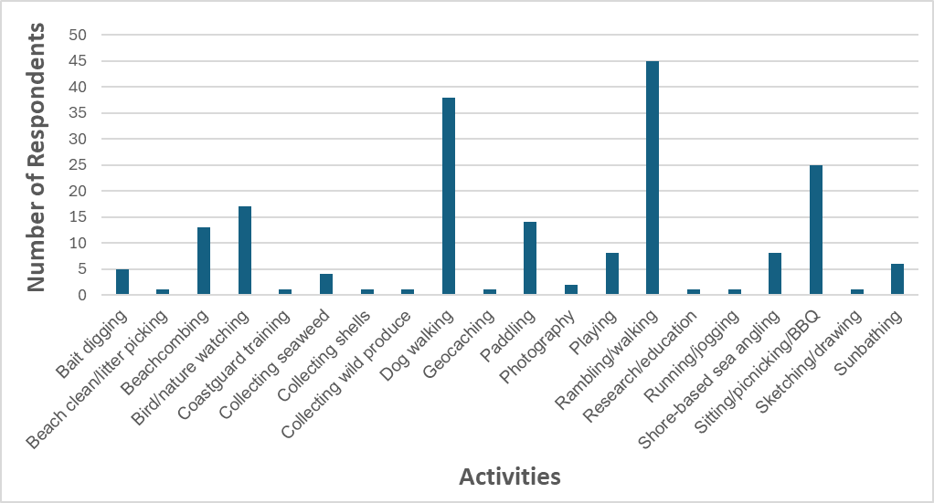
Intertidal activities were reported throughout the survey zone, as listed below. Dunnet beach and Melvich beach had the highest number of differing activities (each with 13 different activities), followed by Thurso beach with 12 different activities.
Bait digging: Dunnet beach, Sandside beach and Scrabster beach.
Beach clean/litter picking: Thurso beach and Thurso East Mains beach.
Beachcombing: Thurso beach, Thurso East Mains beach, Strathy beach, Scrabster beach, Castletown beach, Dunnet beach, Murkle beach, Crosskirk beach, Sandside harbour area, Sandside beach, Dwarwick pier area, Melvich beach, Strathy beach and Armadale beach.
Bird/nature watching: Melvich beach, Sandside beach, Dunnet Head, Sandside harbour, Strathy Point, Scrabster beach, Strathy beach, Thurso beach, Thurso East Mains beach, between Thurso East Mains beach and Murkle beach, Castletown beach, north of Castletown beach, Sandside Head, Dunnet beach, between Melvich beach and Portskerra harbour, Dwarwick Pier area and Armadale beach.
Coastguard training: all over coastal survey area.
Collecting seaweed: Castletown beach, Holborn Head, Sandside beach and Scrabster beach.
Collecting shells: Thurso beach.
Collecting wild produce: Sandside beach, Melvich beach, Dunnet beach and Thurso beach.
Dog walking: Armadale beach, Castletown beach, Dunnet beach, Dunnet Head, Melvich beach, Sandside beach, Scrabster beach, Strathy beach, Thurso beach and Thurso East Mains beach.
Geocaching: coastal west of Murkle beach and coastal west of Thurso beach.
Paddling: Castletown beach, Dunnet beach, Melvich beach, Peedie Sands, Sandside beach, Scrabster beach, Strathy beach and Thurso beach.
Photography: Brims Ness, coastal around Portskerra, Crosskirk beach, Dunnet beach, Dwarwick pier area, Melvich beach, Sandside beach, Sandside Head and Strathy beach.
Rambling/walking: coastal between Thurso and Scrabster, Armadale beach, coastal between Murkle beach and Castletown beach, Castletown beach, Castletown harbour, Crosskirk beach, Dunnet beach, Dwarwick, Sandside harbour, Holborn Head, Melvich beach, Murkle beach, Peedie Sands, coastal around Portskerra, coastal around Red Point, Sandside beach, Scrabster beach, Scrabster harbour, Strathy beach, Strathy Point, Thurso beach, Thurso East Mains beach.
Research/education: Dunnet beach and Thurso beach.
Running/jogging: Melvich beach and Sandside beach.
Shore-based sea angling: Dunnet beach, Dwarwick pier area, Melvich beach, Sandside beach, Scrabster beach, Strathy beach and Thurso beach.
Sitting/picnicking/BBQ: Armadale beach, Castletown beach, Dunnet beach, Dwarwick pier area, coastal north of Castletown beach, Melvich beach, Peedie Sands, Sandside beach, Scrabster beach, Strathy beach, Strathy Point, Thurso beach and Thurso East mains beach.
Sketching/drawing: Armadale beach, Dunnet beach, Melvich beach and Strathy beach.
Sunbathing: Armadale beach, Castletown beach, Melvich beach, Scrabster beach, Strathy beach and Thurso beach.

A2.1.4 Internal Exposure
Respondents were asked to provide information on where they sourced their food. Figure A2.4 shows the number of respondents sourcing food locally for each food group. Results show that the respondents bought most of their food from local shops or supermarkets within and outwith the terrestrial and marine survey area. This was consistent across all food groups reflecting the low numbers of respondents that sourced local produce. Potatoes were the most popular of locally sourced produce that was homegrown (nine respondents) whilst fish was the most popular of locally sourced foods from a fish shop/van/market/gifted/boats (76 respondents – Figure A2.4).
Leeks or onions were homegrown by eight respondents whilst green vegetables, root vegetables, domestic fruit and eggs were homegrown by seven respondents within the terrestrial survey area, along with fish (self-caught) from within the marine survey area also by seven respondents.
Table A2.1 provides an overview of where local produce within the survey area was sourced.

Table A2.1 Summary of locally produced food
Food Group | Number of respondents | Locally home grown/foraged/caught/shot
Green vegetables | 7 | Reay, Broubster, Shebster and Buldoo
Leeks or onions | 8 | Reay, Broubster, Shebster, Buldoo and Isauld
Root vegetables | 7 | Reay, Broubster, Shebster, Buldoo and Achvarasdal
Potatoes | 9 | Reay, Broubster, Shebster and Buldoo
Other vegetables | 5 | Reay, Shebster and Buldoo
Cow and/or goat milk | 1 | Shebster
Eggs | 7 | Reay and Shebster
Domestic fruit | 7 | Reay, Broubster, Shebster, Buldoo and Isauld
Wild/free food | 4 | Reay, Achreamie and Buldoo
Fish | 7 | Dunnet Bay, Thurso Bay, off Scrabster, Sandside Bay, Pentland Firth and off Portskerra
Crustaceans | 6 | Thurso Bay, off Scrabster, Pentland Firth
Molluscs | 2 | Pentland Firth and off Sandside Head
Wild meat (game) | 1 | Reay

Figure A2.4 Number of respondents sourcing food from food groups
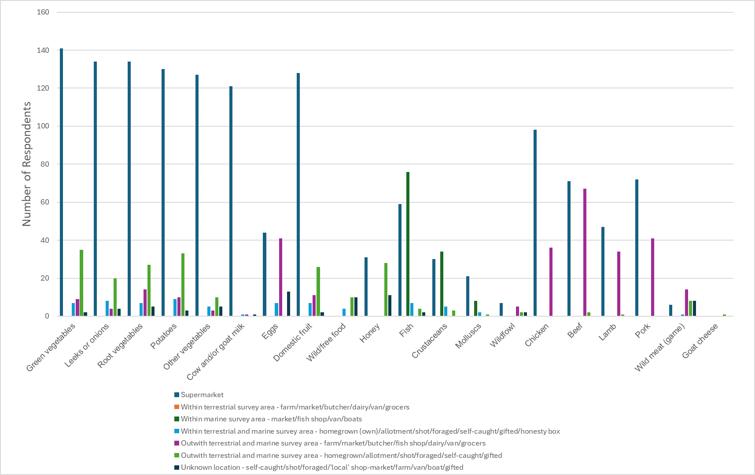

Appendix A3 In-Situ Gamma Dose Rate Measurements
The protocol requires the detector’s probe to be positioned 1m above the surface and counts acquired over a 600 second integration time. The cosmic and intrinsic components to the measurement are then subtracted. The protocol also requires persons operating the detector to be at least 5m from the probe during the count. Both instruments are calibrated using radium-226 and caesium-137 sources (the calibration being chosen to reflect naturally occurring or anthropogenic radionuclide sources respectively). Here, gamma dose rates were dominated by the natural background, so all results are reported with the radium-226 calibration and reported as μGy h¹.
For the dose assessment tool, gamma dose rates were converted to Effective Dose (µSv h⁻¹) using a conversion factor of 0.85, which assumes an individual is standing and exposed to terrestrial derived gamma radiation. This conversion factor is used for most statutory monitoring programmes (Punt et al., 2011). All survey measurements are reported as terrestrial gamma dose measurements as they have had the cosmic and intrinsic component subtracted.

Appendix A4 Beta Skin Dosimetry Measurements
The instrument was calibrated under UKAS accreditation against strontium-90 and yttrium-90, chlorine-36 and carbon14 (and put inside a file poly-pocket to protect the system from the weather). A 12mm Perspex shield was used to shield out any beta emissions and so enable the gamma contribution to the instrument to be established. All measurements were made with a 20 second integration time and in duplicate, with and without the 12mm Perspex shield, enabling the net beta contribution to skin dose rate to be estimated (effective dose, or ambient dose equivalent) and reported in μSv h¹. The system is estimated to have a detection limit of around 0.2μSv h¹.

Appendix A5 Site Descriptions and Observations

A5.1 Aquatic Survey Area Descriptions
The survey locations were visited throughout two survey periods, the first outwith the school holiday period (6th to 12th June) and the second within the school holiday period (3rd to 9th July) of 2025. Onshore and offshore observations were undertaken at each site.
The survey area included the intertidal areas and waters of the Pentland Firth extending from Armadale Bay (including Port a’ Chinn) in the west to Dunnet Head in the east. A 2km fishing exclusion zone is in effect around the offshore diffuser at Dounreay (Food and Environment Protection Act (FEPA), FEPA Order – The Food Protection (Emergency Prohibitions) (Dounreay Nuclear Establishment) Order 1997). Part of the survey area forms a Site of Special Scientific Interest, which attract bird watchers and wildlife enthusiasts to the area to observe the intertidal birdlife. The survey sites are reported from Armadale Bay in the west to Peedie Sands in the east.

A5.2 Armadale Bay to Portskerra
Armadale Bay is situated at the western side of the survey area. Access to this site was from a footpath leading from the road or via a footpath through a field at the western side of the beach. The beach is a large sandy beach backed by a field with cliffs on either side. To the west of Armadale Bay is Port a’ Chinn (Figure A5.1), a stony little cove with a sandy foreshore at low tide. This small cove is accessed via a field following a path down a steep grassy slope. Outwith the school holiday period only one individual was observed walking at Port a’ Chinn. Five individuals were observed walking on Armadale beach. Continuing east, Strathy Point is a grassy headland with a lighthouse. The area was surrounded by steep cliffs with access to the rocks difficult, no individuals were observed on the rocks outwith the school holiday period. The coastline remains fairly steep towards Strathy Bay which was accessed from a car park and a walk through relatively large, steep dunes down to the sandy beach (Figure A5.2). The River Strathy entered the sea to the west side of the beach at Strathy Bay. Outwith the school holiday period Strathy beach was popular with ten dog walkers, 23 walkers, a family sitting/playing and three adults swimming being observed.
Within the school holiday period, there were no aquatic or intertidal activities observed at Port a’ Chinn. Activities observed at Armadale Bay were three individuals camping on the grassy dunes, two individuals playing on the beach substrate and one individual swimming. Observations at Strathy Bay were five dog walkers and one individual walking. One cargo ship was observed sailing off Strathy Point. No other marine activities were noted at these sites.
Within this section of coastline, no spume was observed outwith or within the school holiday period.
Figure A5.1 Port a’ Chinn beach
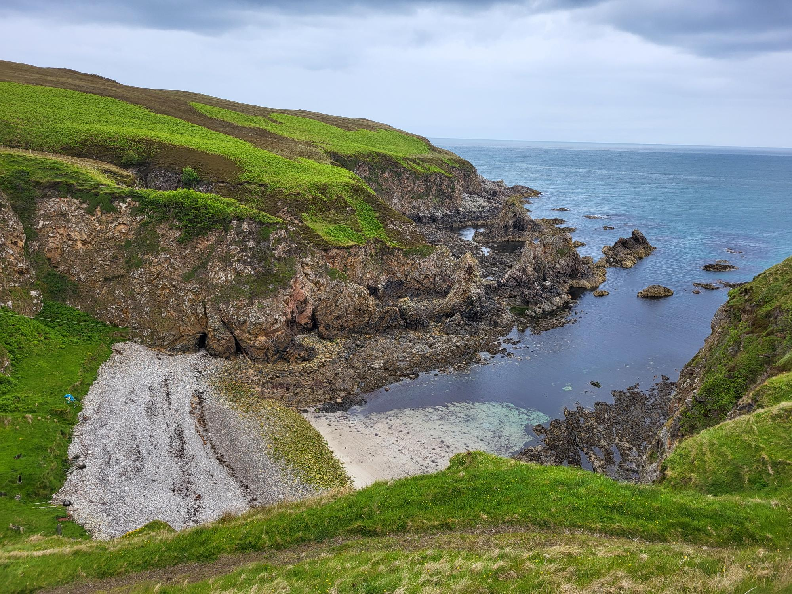

Figure A5.2 Strathy beach
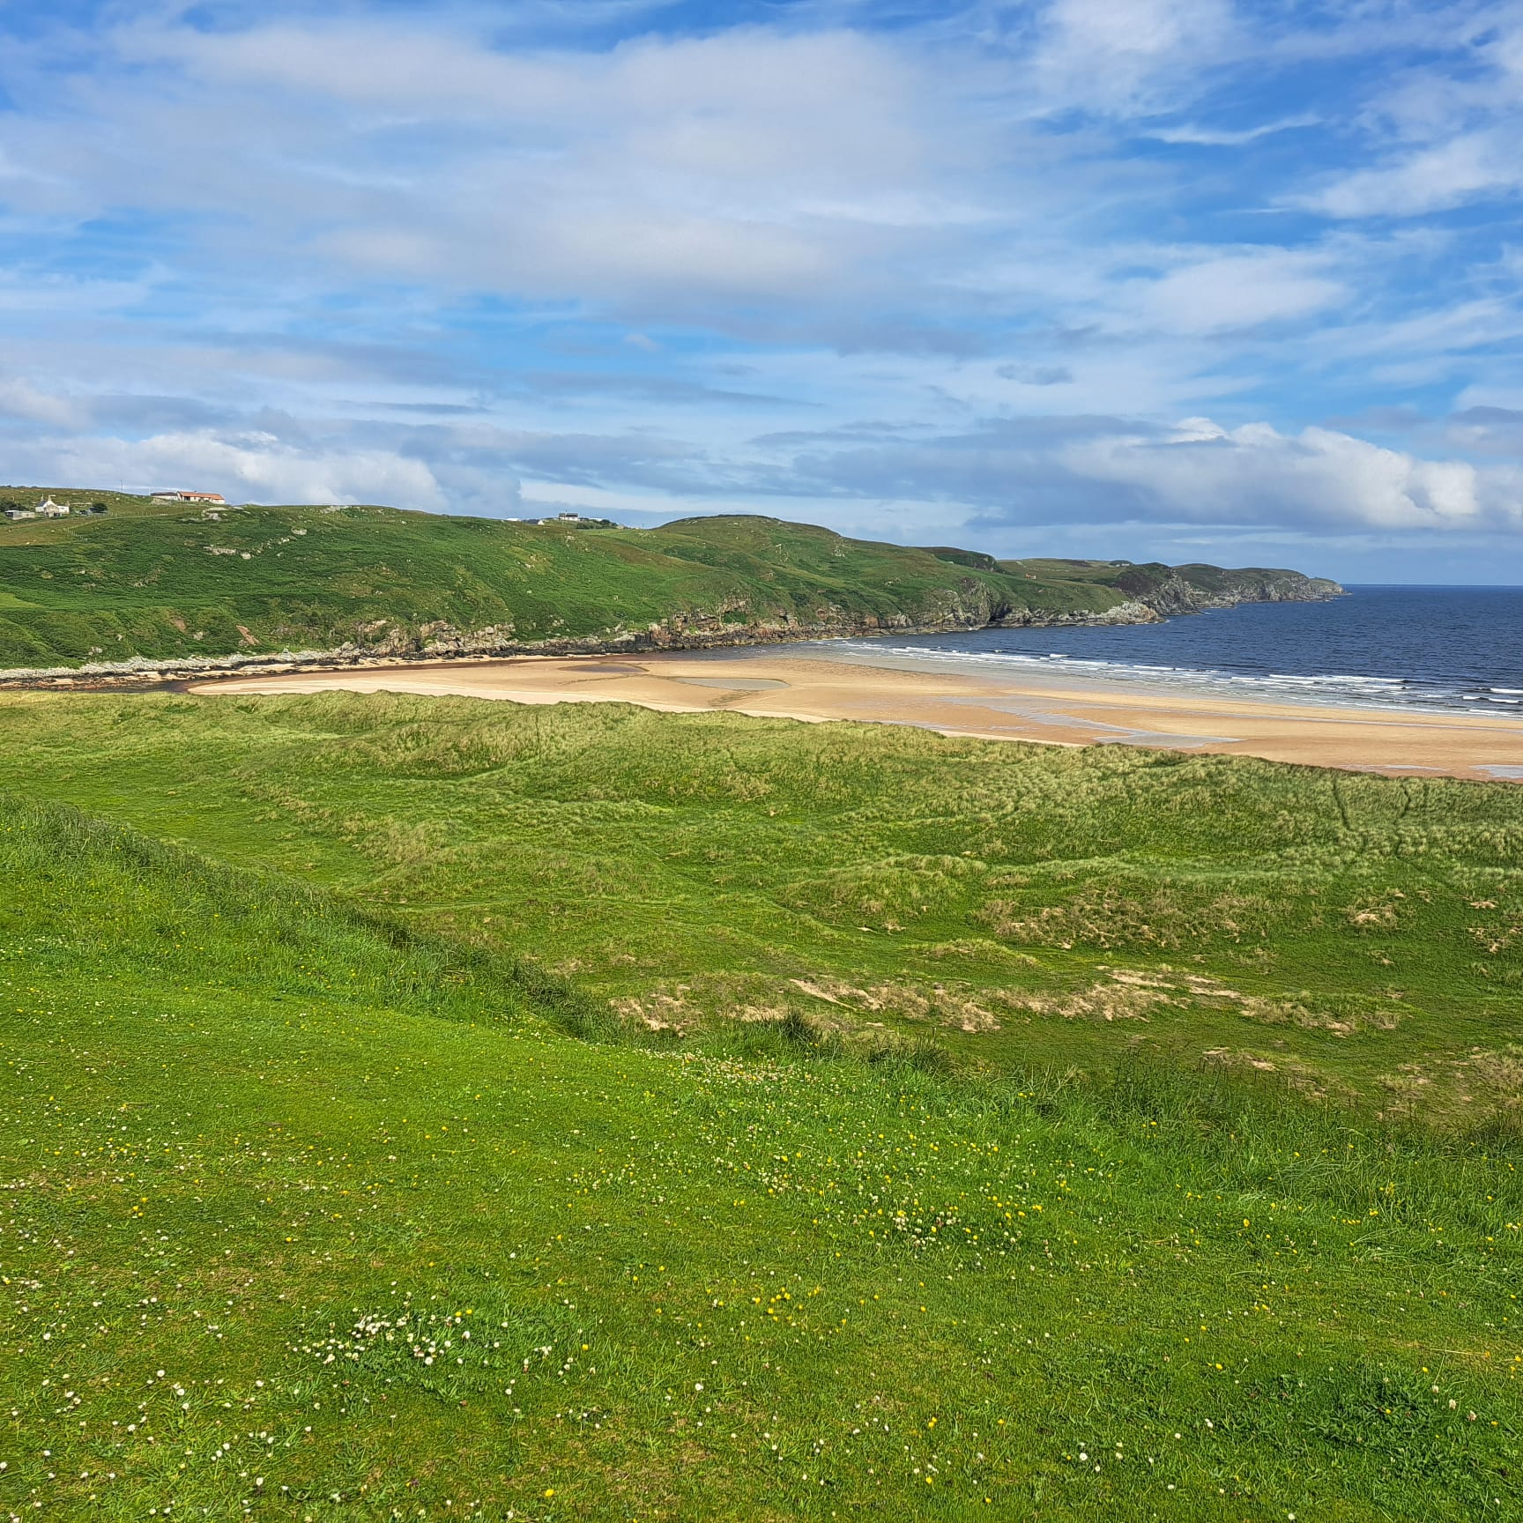

A5.3 Portskerra Harbour to Sandside Bay
Portskerra Harbour is a small natural harbour with easy access via the road. There is a small beach just to the west of the harbour (Figure A5.3) which is mainly stony with sand substrate on the foreshore and rocky at the back of the beach. Continuing east towards Melvich beach is Portskerra Pier with access to the water via a slipway. The substrate at this site was predominantly large rocks with several patches of sand visible (Figure 5.4). There were no observations of individuals or intertidal and aquatic activities at these sites outwith the school holiday period. The coastline continues to be rocky towards Melvich beach (Figure 5.5), a sandy beach backed with grassy sand dunes rising to grassy slopes on the eastern side of the beach. The Halladale River flows in at the eastern end of Melvich beach. Outwith the school holiday period 17 individuals walking, one jogger and two individuals sunbathing were observed at Melvich beach. No aquatic activities were observed.
Within the school holiday period at Portskerra Harbour six individuals walking were observed. No boats were resting on the intertidal substrate or moored at Portskerra Harbour. There were no intertidal or marine activities observed at Portskerra Pier. Within the school holiday period only four walkers and one family playing on the tidal riverbank at the east end of Melvich beach were observed.
Spume was noted at Melvich beach within the school holiday period. No spume was noted at any other time at Portskerra harbour, Portskerra Peir or Melvich beach.
Figure A5.3 Portskerra beach by Portskerra harbour
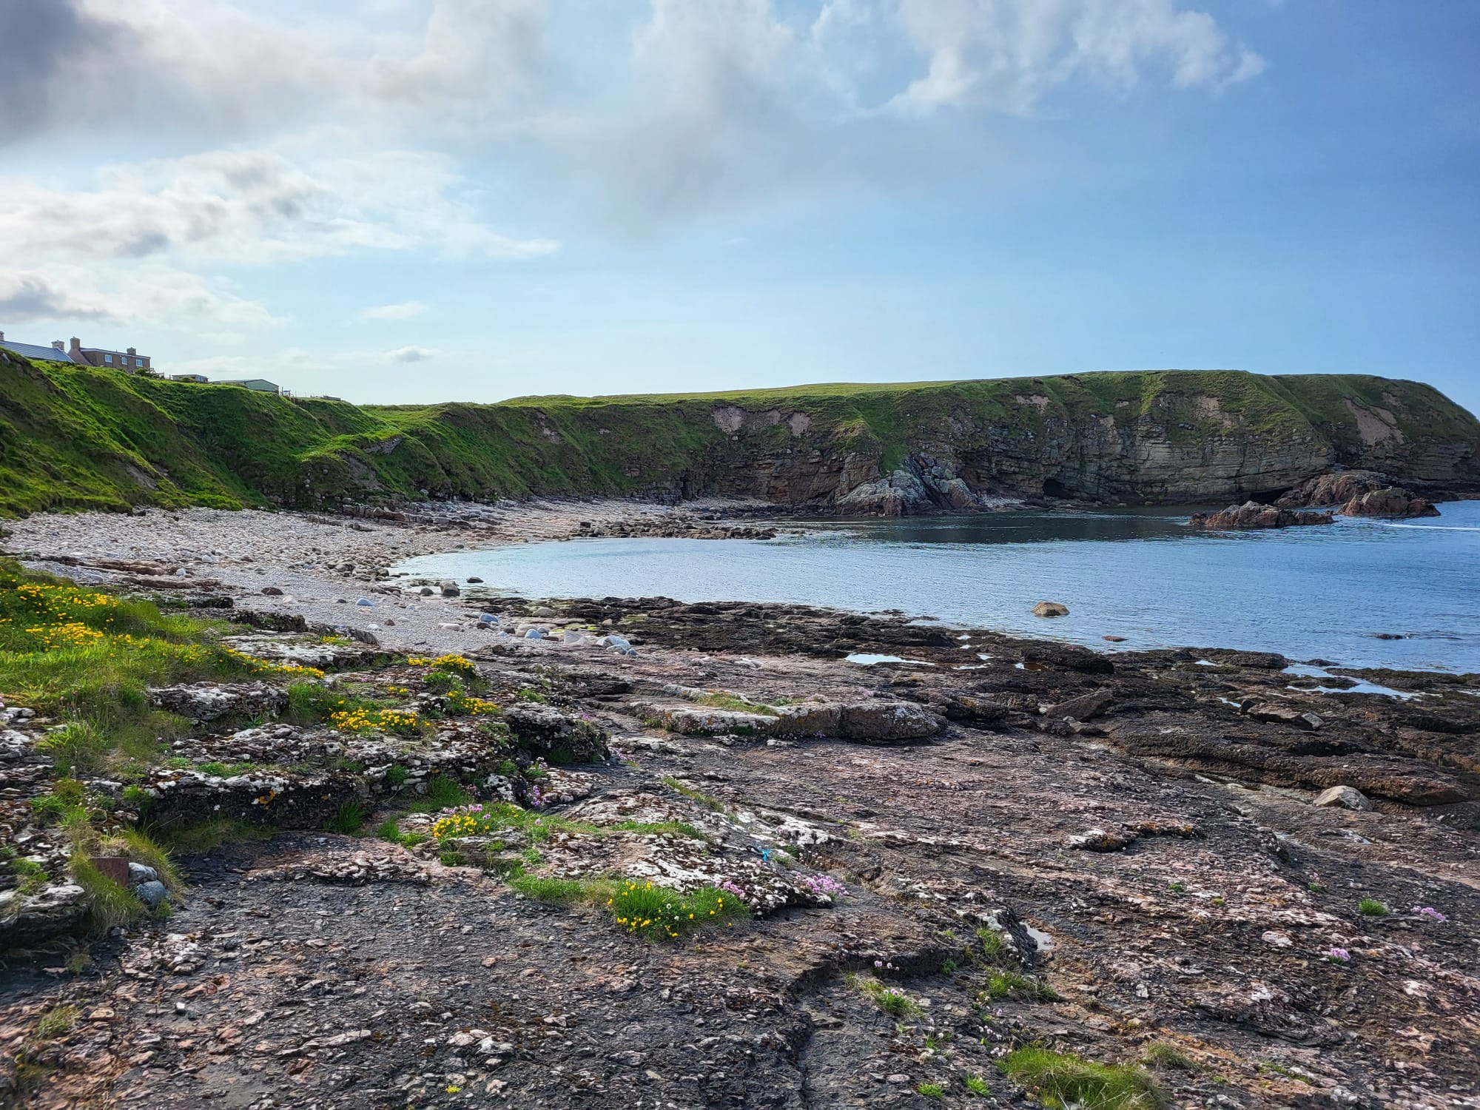
Figure A5.4 Looking to Melvich beach from the pier at Portskerra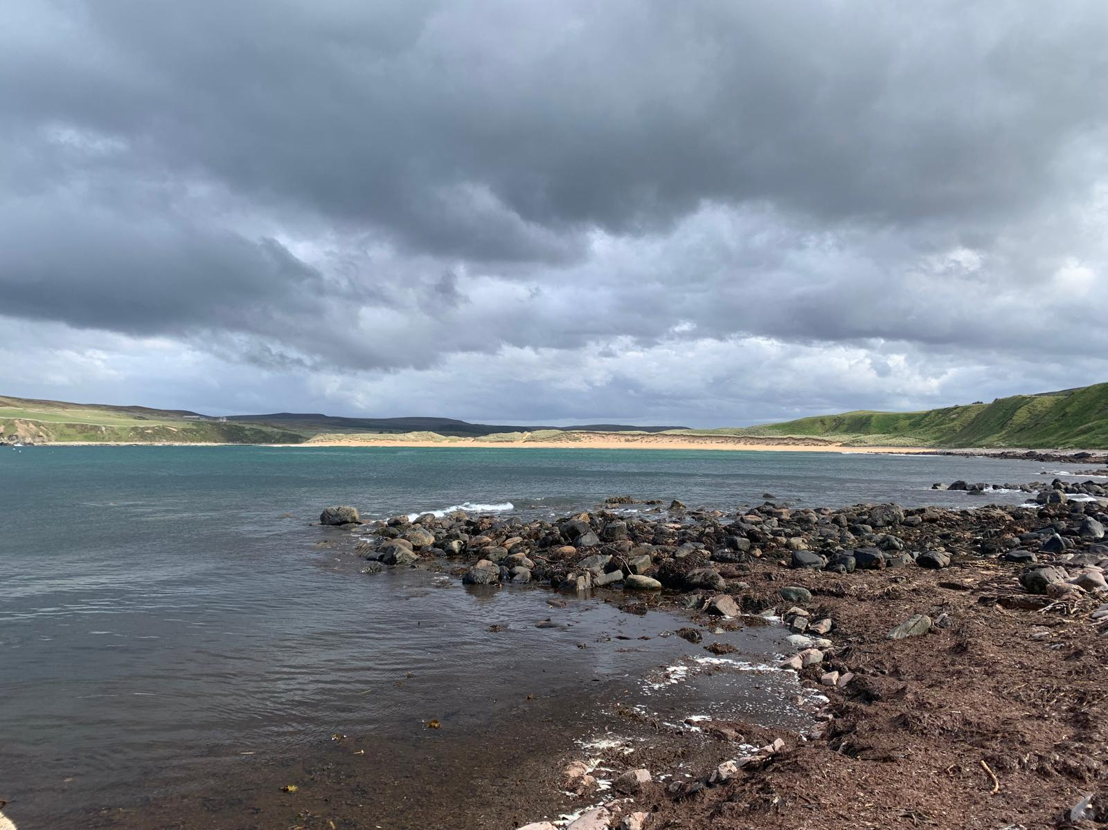

Figure A5.5 Melvich beach
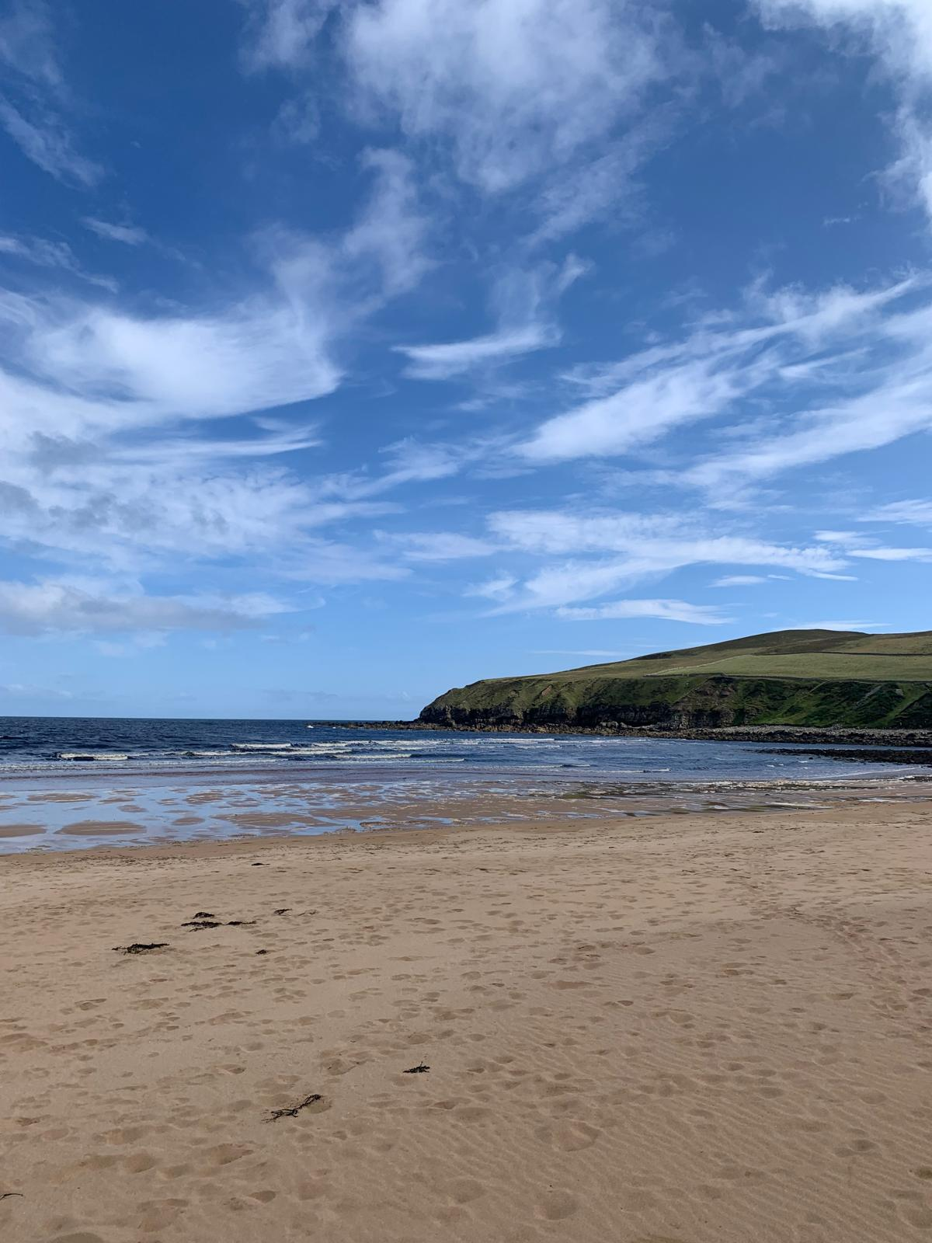

A5.4 Sandside Beach to Brims Ness
Continuing from Melvich beach, Sandside beach is a sandy beach with rocky outcrops on both eastern and western sides. It is backed by grassy coverage on sand dunes with the road behind it leading to Sandside Harbour (Figure A5.6), a small harbour to the west of Sandside beach. To the west of Sandside Harbour there is a small sandy beach which gives access to Sandside Head.
Outwith the school holiday period two fishing boats and one motorboat were moored on the water at the harbour. Activities noted at Sandside harbour were five dog walkers and two walkers. At Sandside beach activities observed outwith the school holiday period were 11 dog walkers and one individual dog walking and litter picking. No aquatic activities were observed.
From the eastern rocky outcrops on Sandside beach (Figure A5.7) it continues with steep rocky cliffs along the coastline with no access down to the coast. The Dounreay Nuclear Licensed Site is situated east of Sandside beach (Chapter 2) where the coastline continues to be inaccessible due to the steep rocky cliffs and a 2km stretch that is fenced off from public access.
Within the school holiday period only two individuals were observed walking at Sandside Harbour, one fishing boat was sailing offshore and one fishing boat and one small motorboat were moored in the harbour resting on sand. Activities observed at Sandside beach were 12 dog walkers, four individuals litter picking, one individual collecting seaweed, ten walkers, one cyclist and two groundhog operators (vehicle-based monitoring equipment checking for radioactive particles).
The survey team were told that commercial whelk or cockle pickers operate at Sandside beach, but they were not observed during the survey.
No spume was noted at these sites outwith or within the school holiday period.

Figure A5.6 Sandside harbour looking to Dounreay nuclear licensed site
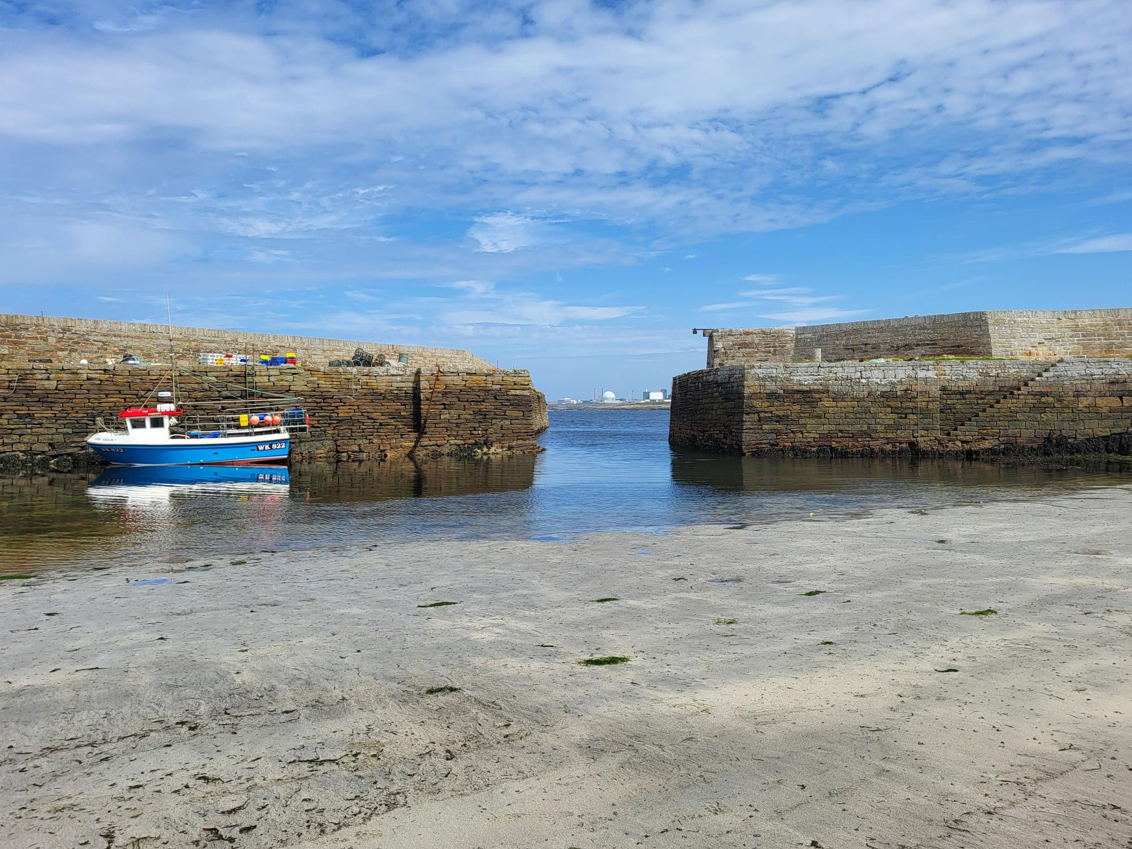

Figure A5.7 Sandside Bay
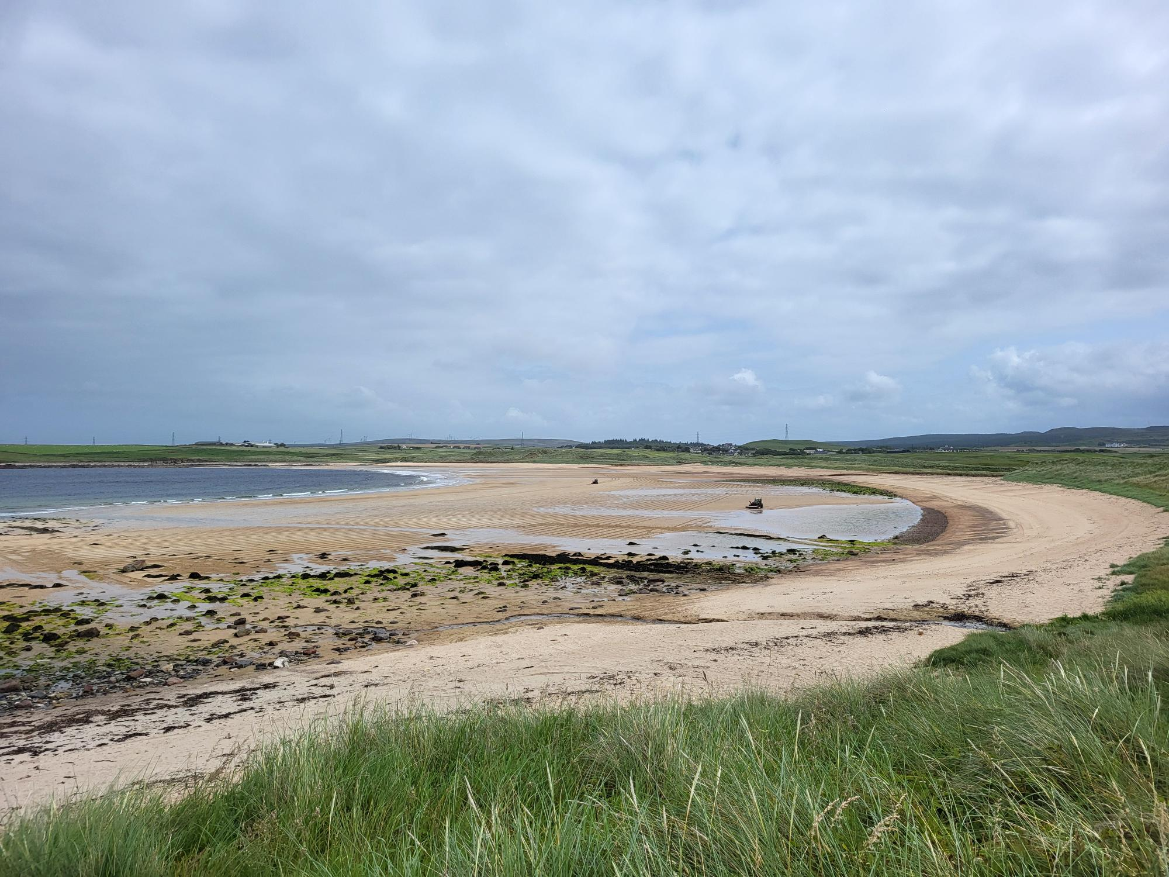
Continuing east from the Dounreay nuclear licensed site the coastline becomes accessible again at Crosskirk Bay. Access to the coast is via a farm road and a walk along a public path through farmland leading to a rocky/stony bay with cliffs to either side. The river, Forss Water, enters the sea at the western side of Crosskirk Bay. Outwith the school holiday period there were no aquatic or intertidal activities observed. The only accessible point between Crosskirk Bay and Holborn Head is a site called Brims Ness (Figure A5.8) with access through farmland. Outwith the school holiday period at Brims Ness, two campervans were parked with one individual with a coracle who had spent time on the water and one photographer. This site is reported to be popular with surfers, however, no aquatic activity was observed outwith the school holiday period at Brims Ness.
Within the school holiday period activities observed at Crosskirk beach were four individuals walking on farmland from the beach and two farm workers in the field. No aquatic or intertidal activities were observed. At Brims Ness within the school holiday period five surfers were preparing to go surfing. No other activities were observed.
No spume was observed outwith or within the school holiday period at either of these sites.
Figure A5.8 Brims Ness
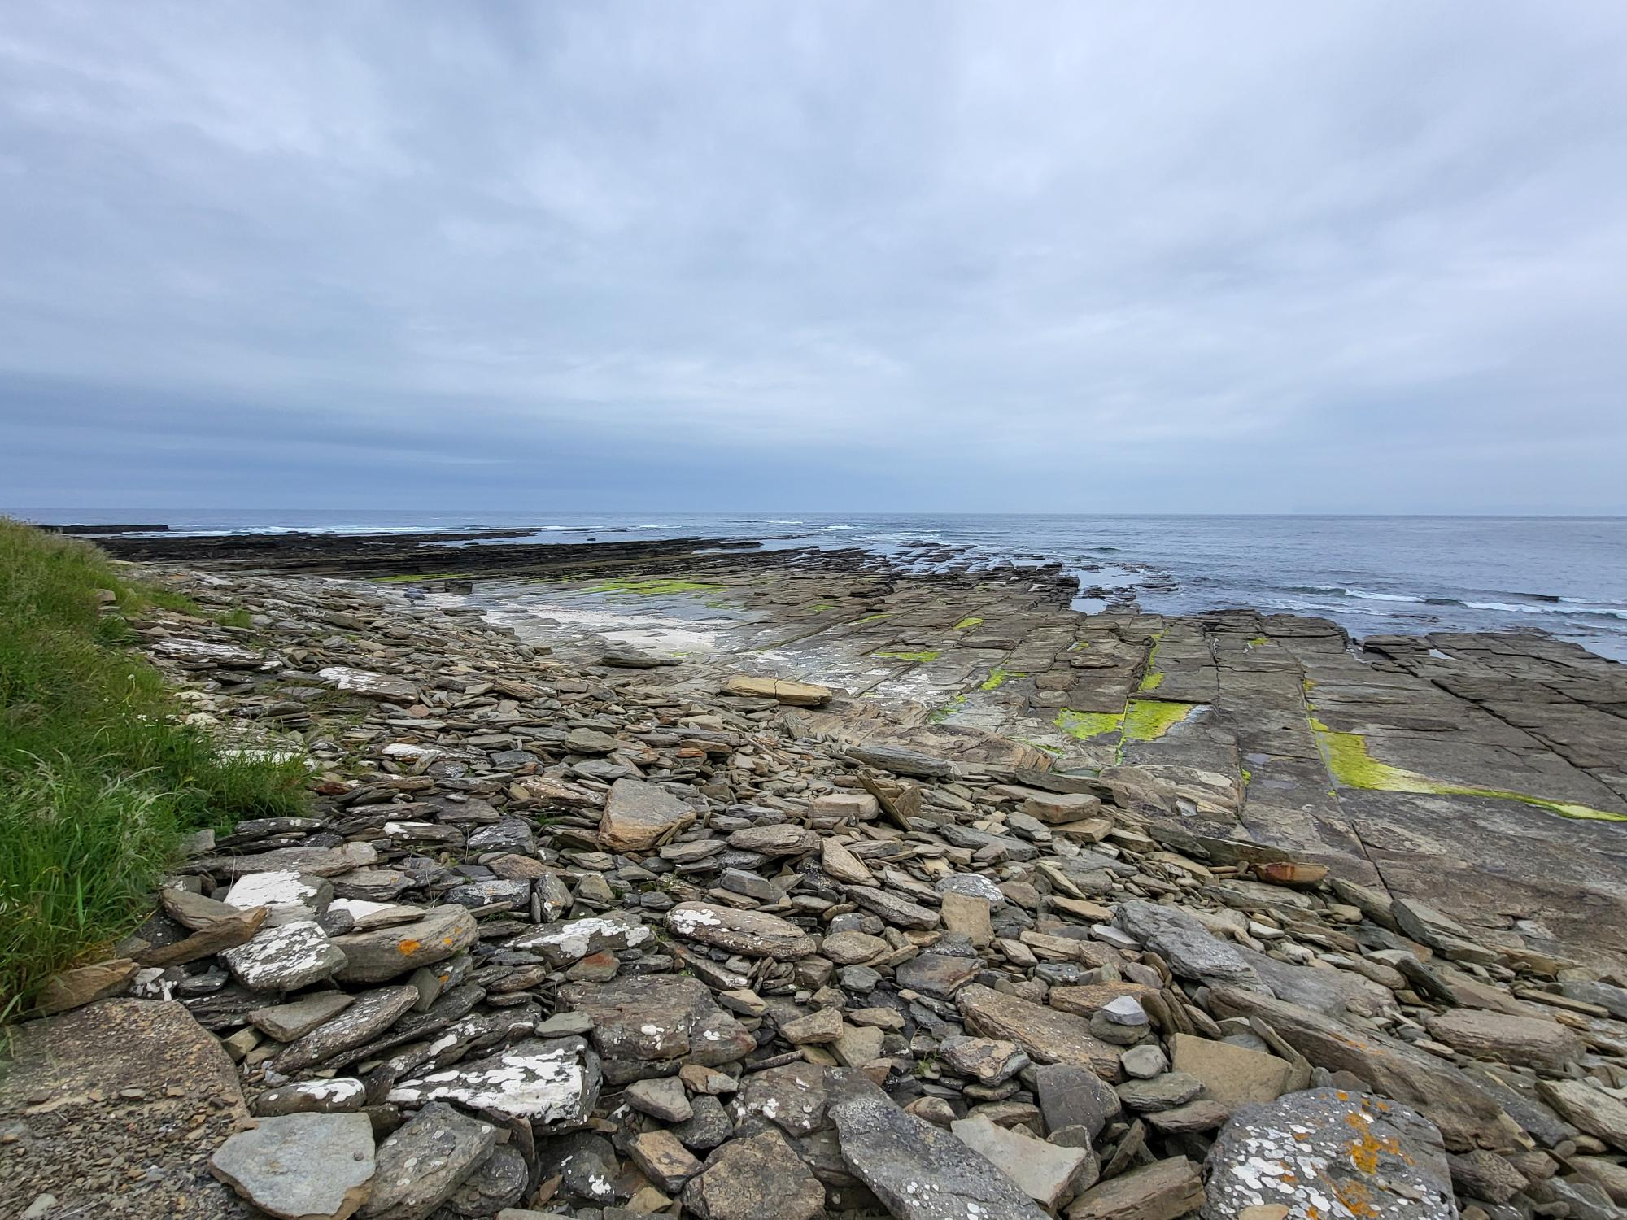

A5.6 Holborn Head to Thurso
Continuing along the coast, Holborn Head is an elevated piece of headland with extremely steep vertical cliffs allowing no access to the shore. The steep coastline continues to Scrabster lighthouse just north of Scrabster harbour with access only via steep rocky platforms. Scrabster harbour (Figure A5.9) is the main fishing port and hosts a ferry terminal taking passengers north to the Orkney Isles. The lifeboat station is situated at Scrabster harbour. Several individuals were observed fishing from the harbour wall, and several individuals were undertaking boat maintenance on a boat sitting on the hard standing of the harbour. Scrabster harbour is a busy fishing harbour with visiting boats from Norwegian waters in the North Atlantic that land their catch at Scrabster. Smaller local licenced fishing boats fish nearer the mainland and their catch is landed at Scrabster harbour. Fish market, processing and wholesale activities are undertaken at Scrabster harbour with the fish market taking place three to four times weekly.
Scrabster beach (Figure A5.10) is situated to the eastern side of the harbour and is a long narrow sandy beach backed by a sea wall with defence boulders and rocky substrate on the eastern side of the beach. Outwith the school holiday period activities observed at Scrabster beach were 16 dog walkers, 20+ adults and children taking part in a baptism, one family playing, seven individuals walking and approximately 30 individuals swimming. One motorboat, three fishing boats and one ferry were sailing and one small boat and one fishing boat were moored in the water.
Within the school holiday survey period, Scrabster beach activities being observed were 18 dog walkers, two children playing, nine individuals swimming, three children paddling and two individuals preparing to go diving. Two fishing boats were observed sailing offshore.
No spume was observed at either site outwith or within the school holiday period.

Figure A5.9 Scrabster harbour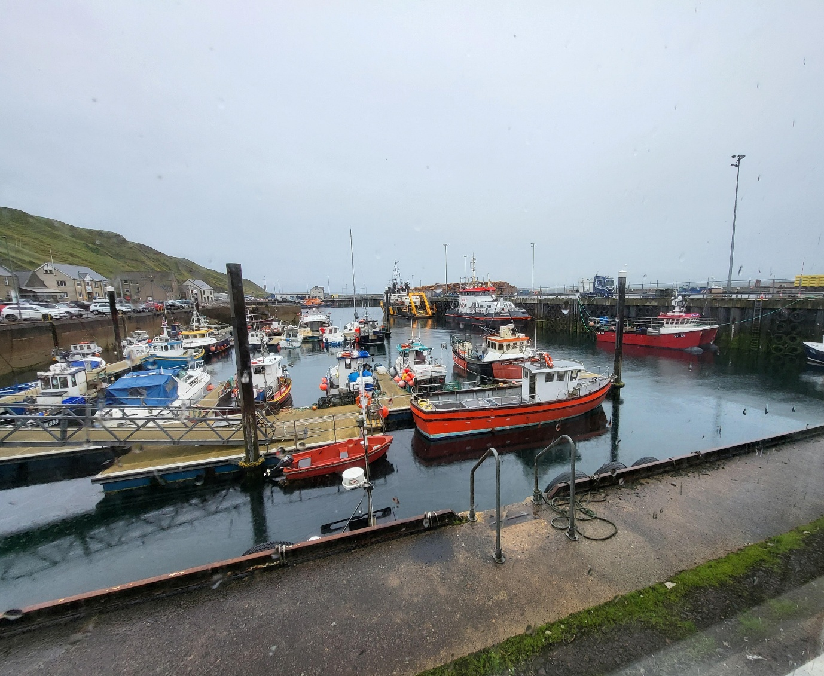

Figure A5.10 Scrabster beach looking to Scrabster harbour
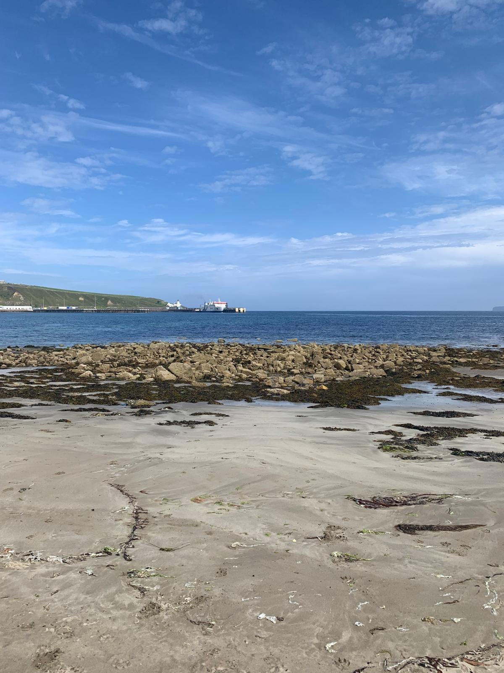

A5.7 Thurso to Castletown
Continuing east the coastline is rocky to Thurso beach (Figure A5.11) which is a large sandy beach backed by a sea wall with sea defence boulders on either side of the beach and Thurso Pier to the eastern side. The beach front consists of residential dwellings and a derelict café that no longer operates. A mobile sauna visits Thurso beach and is situated on hard standing at the back of the intertidal substrate. Thurso beach was popular with individuals and families outwith the school holiday period. Activities observed were approximately 50 dog walkers, 30 walkers, five swimmers, one individual beachcombing, three individuals camping on the beach, two individuals sitting on the rocks, one family paddling and one individual on a stand-up paddle board. Continuing east, on the eastern side of Thurso Pier, the River Thurso enters the sea and separates Thurso beach and Thurso East Mains beach. The Thurso Sea Cadets launch boats onto the river and undertake boating activities in the River Thurso and in Thurso Bay. No boats were observed moored or sailing on the River Thurso and no activities were observed at Thurso Pier. Thurso East Mains beach (Figure A5.12) substrate was rocky with boulders on the foreshore with some sand on the upper shore. Outwith the school holiday period only three surfers surfing were observed at Thurso East Mains beach. One fishing boat was sailing offshore. Individuals were reported to beachcomb for sea glass at Thurso East Mains, however, no intertidal activities were observed. Continuing towards Castletown the coastline was mainly rocky and inaccessible until Murkle Bay (Figure A5.13) which is a small sandy beach accessed via a rough road. No aquatic or intertidal activities were observed outwith the school holiday period.
Within the school holiday period Thurso beach was again relatively busy with 40 individuals dog walking, two individuals beach combing, eight individuals walking, six individuals swimming, four individuals paddling and one individual kite surfing. A mobile sauna was set up on the hard standing behind the intertidal substrate at Thurso beach and one fishing boat and one ferry were sailing offshore. No activities were observed at Thurso Pier or at Thurso East Mains beach within the school holiday period. At Murkle beach three campers were camping in the dunes and no other intertidal activities or aquatic activities were observed.
No spume was noted at these sites outwith or within the school holiday period.

Figure A5.11 Thurso beach
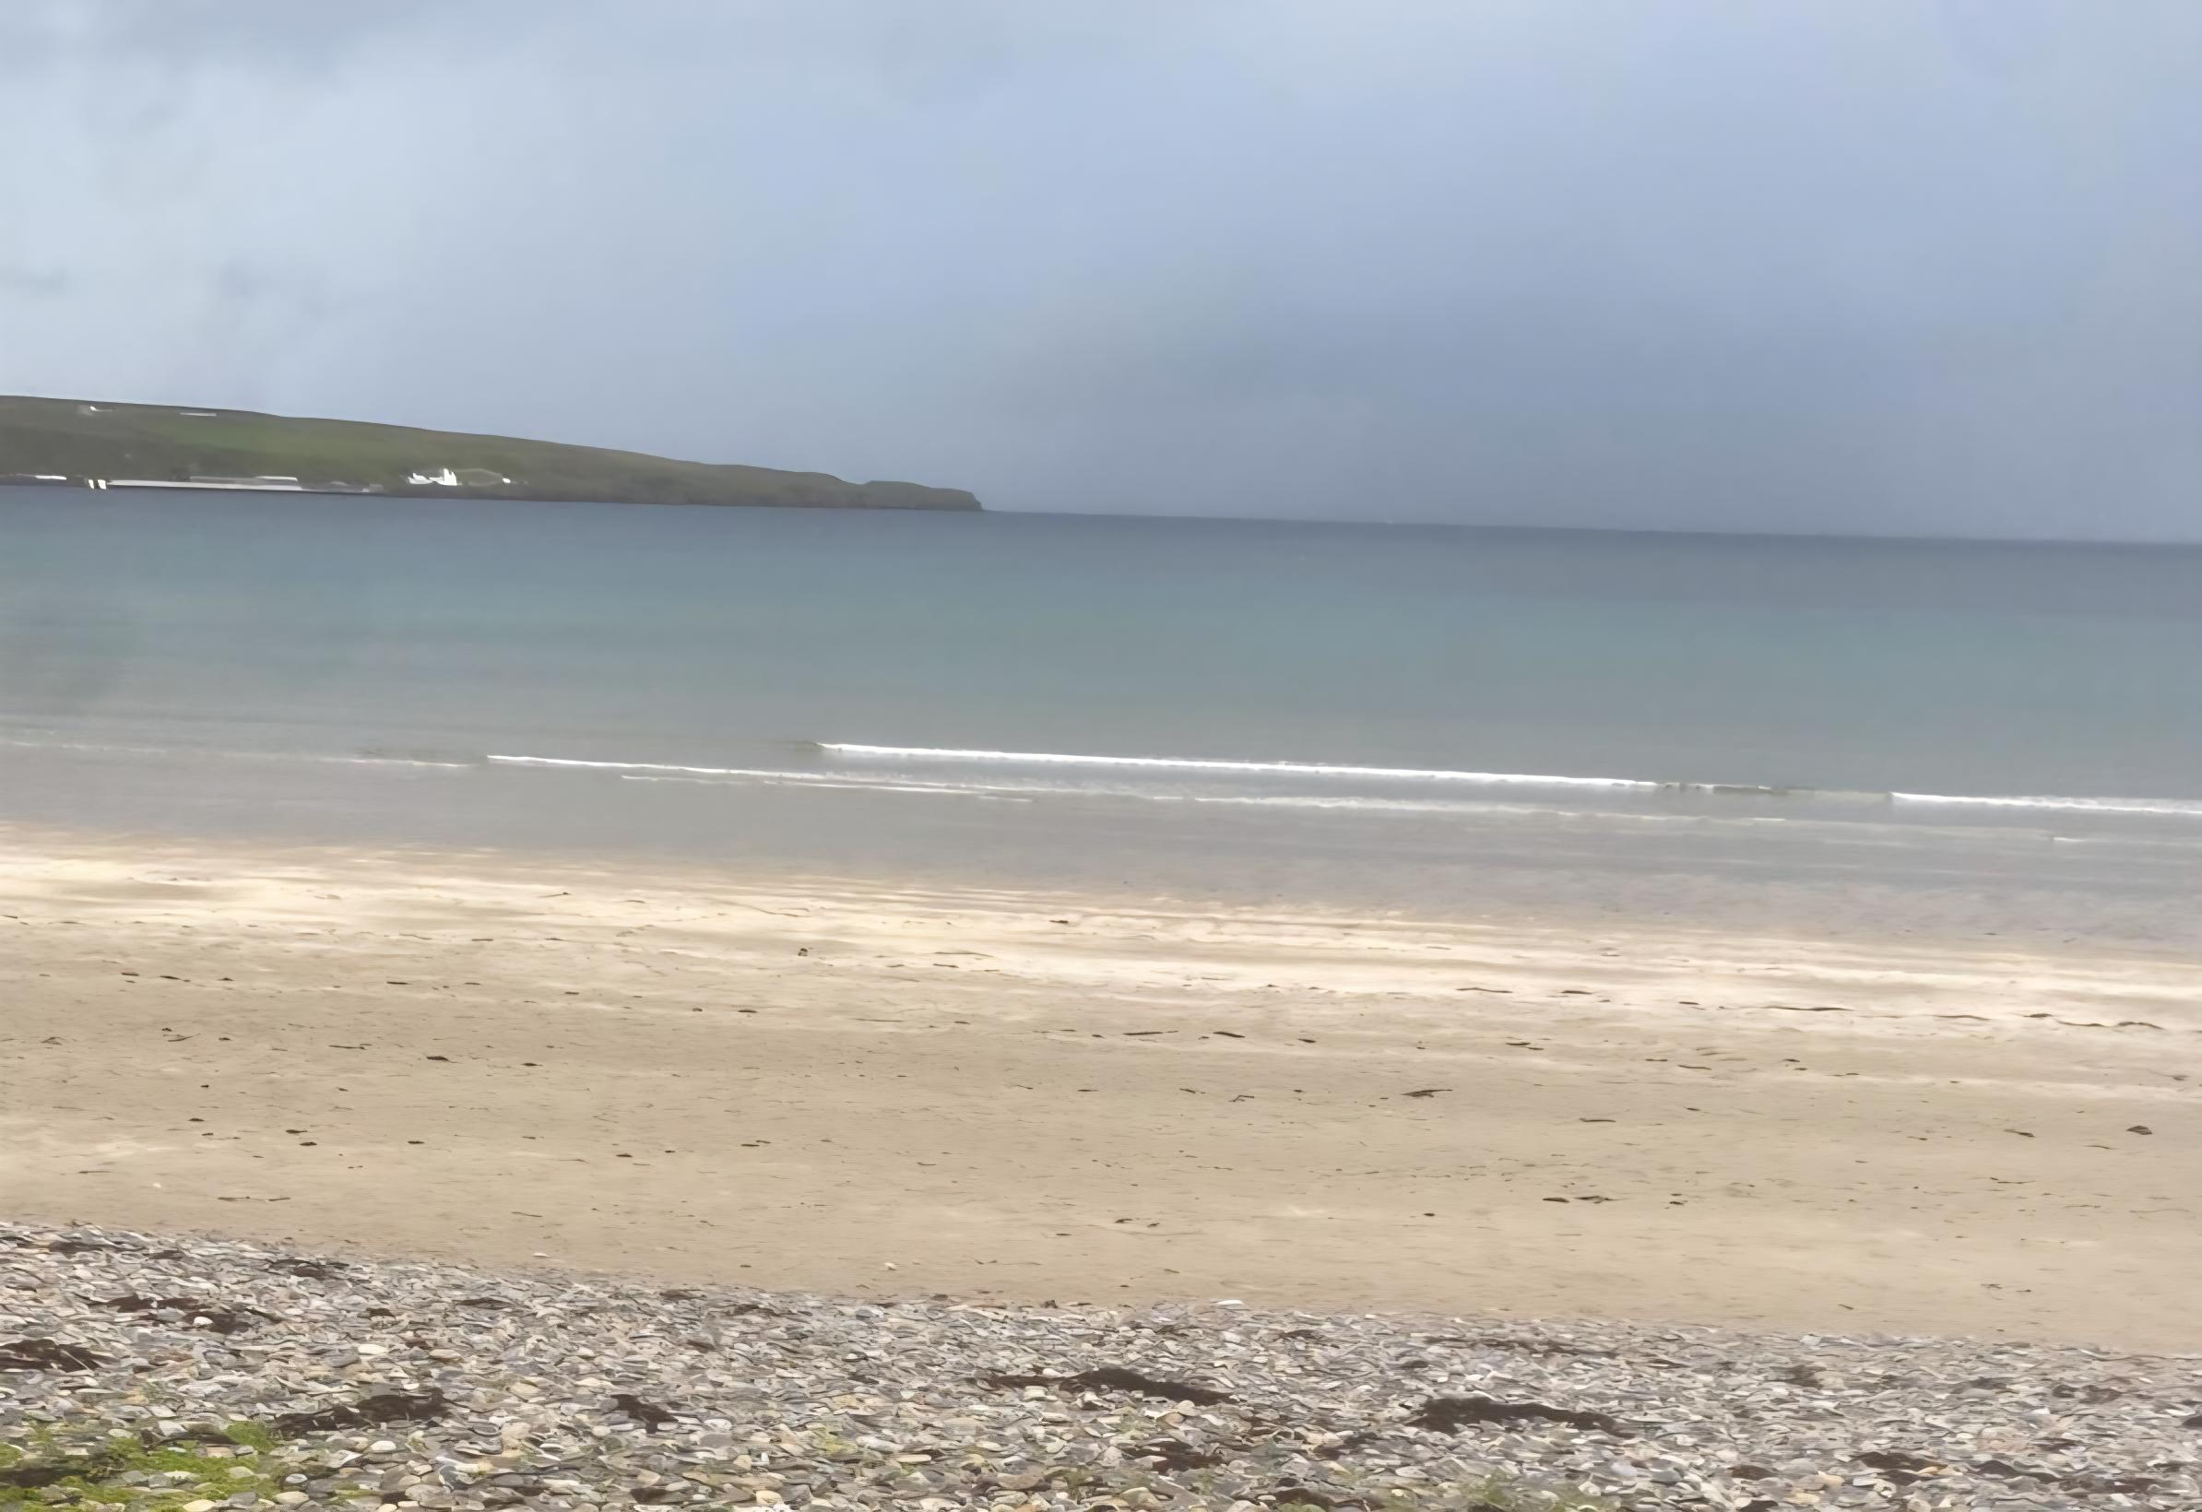

Figure A5.12 Thurso East Mains beach
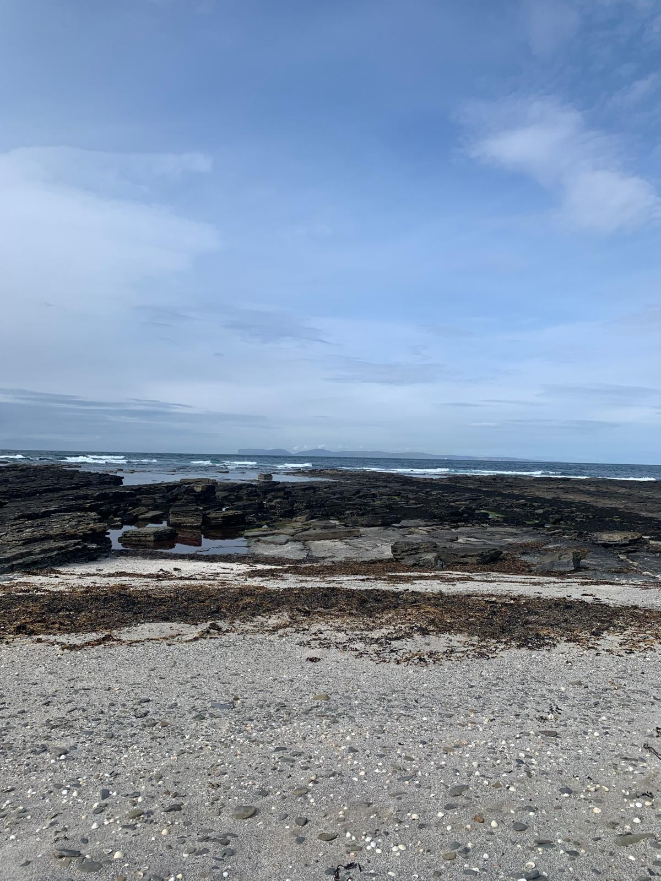

Figure A5.13 Murkle beach
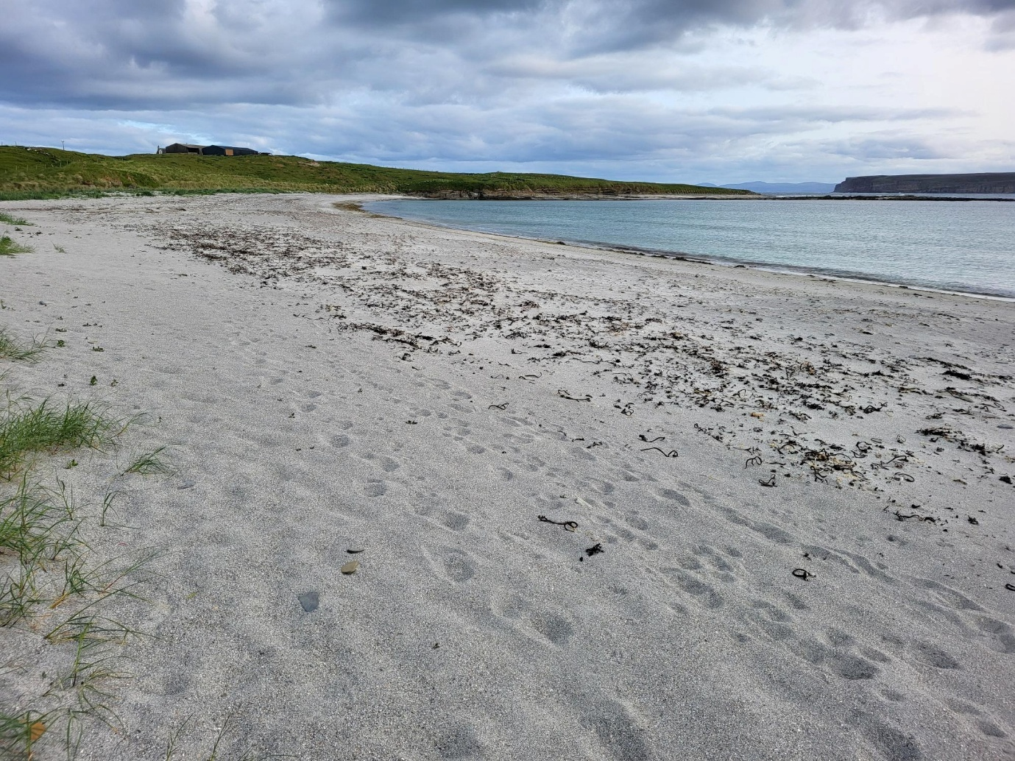

A5.8 Castletown to Peedie Sands
The coastline towards Castletown was mainly rocky and leads to Castletown Harbour (Figure A5.14) which is a small harbour with rocky substrate on either side. Outwith the school holiday period three individuals were observed sitting on the harbour wall along with two photographers, one individual walking on the substrate at the harbour, one Rigid Inflatable Boat sailing offshore and two fishing boats moored at the harbour on intertidal substrate.
Castletown beach (Figure A5.15) is a sandy beach and is situated along the coast from Castletown Harbour. Castletown beach leads into Dunnet beach.
North eastwards from Castletown, Dunnet beach (Figure A5.16) is a long stretch of sandy beach and sand dunes. Outwith the school holiday period there were many campervans parked in the car park and aquatic and intertidal activities consisted of five dog walkers, two walkers, one family sitting/picnicking and two individuals swimming. Continuing to Dunnet beach there are several access points to this beach, and it was observed to be a popular beach. Aquatic and intertidal activities consisted of approximately 50 dog walkers, one family beachcombing, 28 walkers, one family sitting in the dunes, four children having an introductory surf lesson on sand, two horse riders, two individuals flying a drone, three individuals swimming and 18 surfers. At the northern end of Dunnet beach there is a caravan and camping site. A visitor centre is situated by the caravan site, however, it is no longer open to the public and only opens for specific arranged coastal activities a few times a year.
To the north of Dunnet beach, the coastline becomes rocky towards the vertical cliffs of Dunnet Head, a popular bird and nature watching location. Dwarwick Pier is approximately one kilometre north of Dunnet beach and is a concrete pier and slipway with public parking and picnic area. Since the previous habit survey, local individuals have improved Dwarwick Pier facilities and provided a permanent BBQ area, a seating area and have built a shed that has fresh water facilities to clean boats. There are plans to improve the Pier wall and slip. The substrate is very rocky at this site and from the carpark there is a foot path north allowing access to Peedie Sands (Figure A5.17). Observations noted outwith the school holiday period at Dwarwick Pier were two surfers and one fishing boat checking creels in the water. Peedie Sands is a small sandy beach backed by steep rocky cliffs with rocky substrate at either side of the beach. Accessed via a footpath from Dwarwick Pier it provides an elevated walk leading down into the bay. There were no aquatic or intertidal activities observed at Peedie Sands.
Within the school holiday period there were no intertidal activities. Three fishing boats, one leisure boat, one rowing boat and four motorboats were moored at Castletown harbour. Castletown beach was fairly popular within the school holiday period with seven dog walkers, seven walkers, two swimmers, six individuals paddling, six individuals sitting on the rocks and one individual fishing from the rocks. One tent was pitched on the grass beside the intertidal substrate. Activities observed at Dunnet Bay were 18 dog walkers, 14 walkers, two families playing, three individuals swimming and 23 individuals surfing. At Dwarwick Pier activities observed were one individual snorkelling and one individual checking creels and bringing their boat in via the slip. No aquatic or intertidal activities were observed at Peedie Sands.
Spume was noted within the school holiday period at Castletown beach. No other observation of spume was noted at any other sites during the survey periods.
Figure A5.14 Castletown Harbour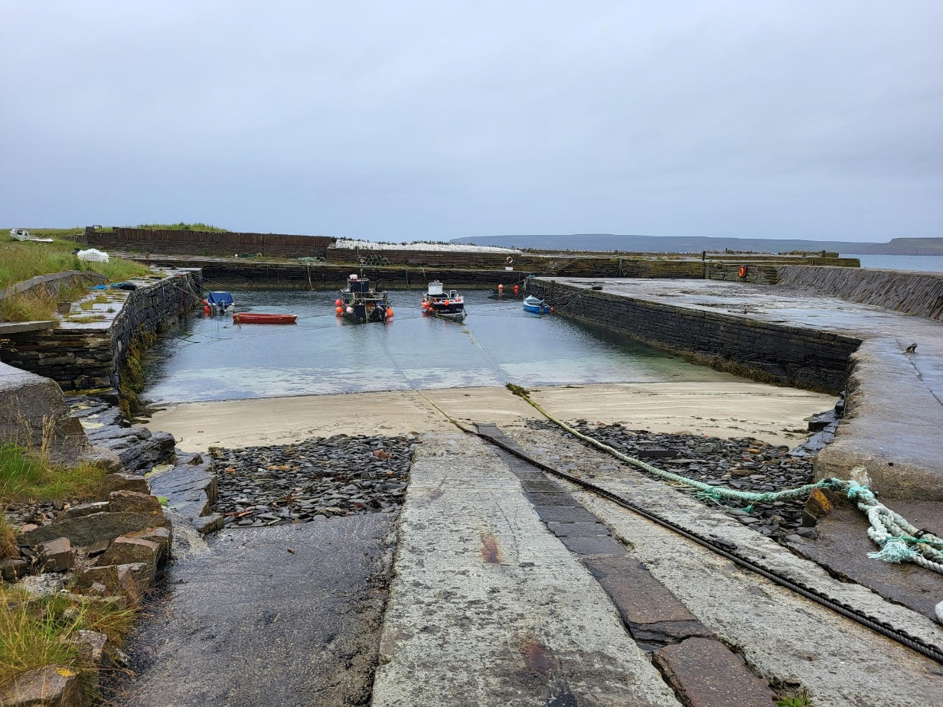
Figure A5.15 Castletown beach
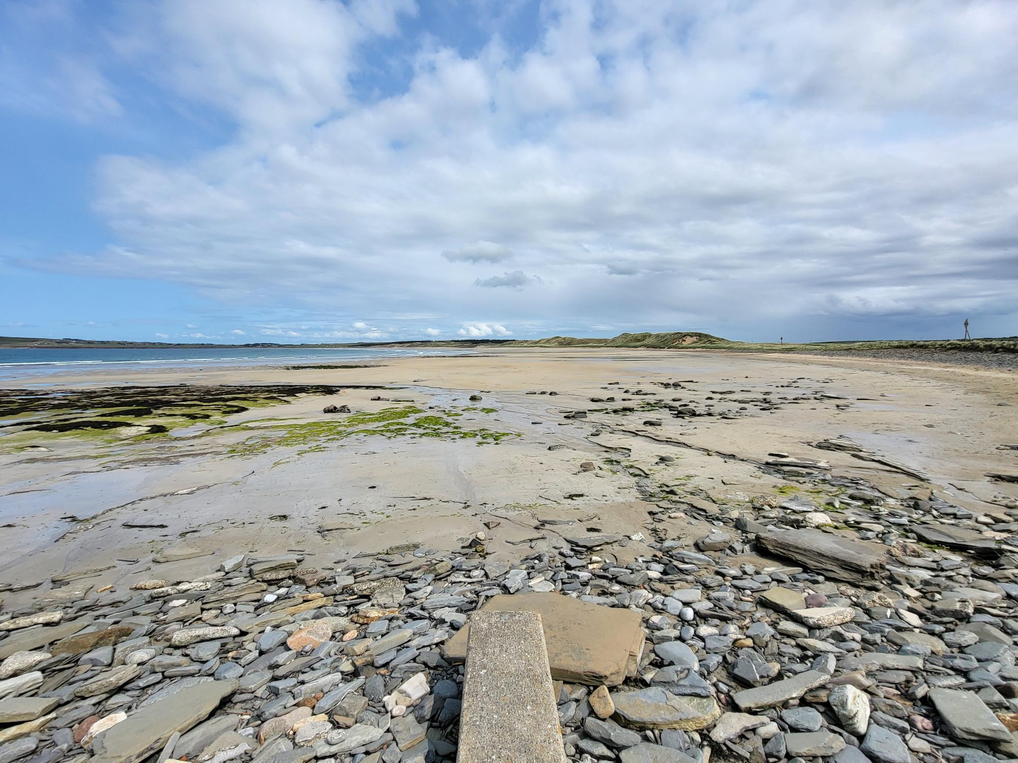
Figure A5.16 Dunnet beach
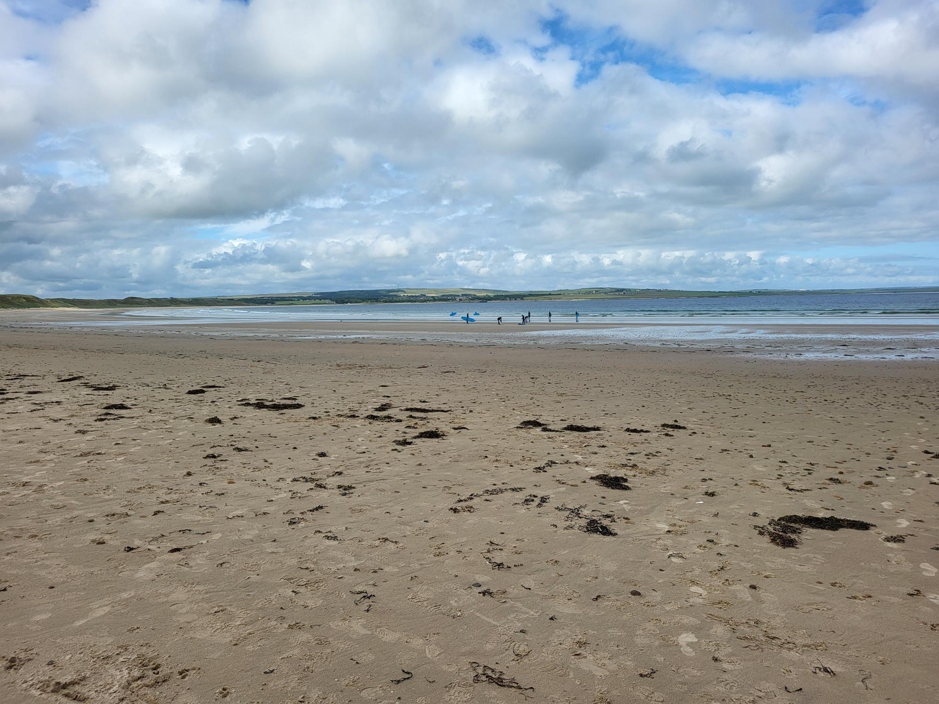

Figure A5.17 Peedie Sands
