


Aquaculture Modelling Screening & Risk Identification Report:

Rum 2 (RUM2)

VERSION 1
Report date: June 2025

Scope of report
As part of the SEPA Aquaculture Regulatory Framework it is recommended that a proposed application for a marine finfish aquaculture site should undergo a Screening Modelling and Risk Identification process. SEPA carries out this work and this is described on the SEPA aquaculture website Pre-application section
This report presents information arising from that process. Screening modelling methods are outlined and maps and tables describing the modelled impacts are shown. Risks arising from consideration of the model output are listed. Conclusions and recommendations are made regarding the proposed site.

Executive summary
SEPA has received a proposal for a new marine pen finfish farm called Rum 2 (RUM2). The proposed MPFF is at: 140557, 803378 (Easting, Northing). Pre-application advice has been requested early in the process and consequently the proposal is still in development and subject to change, however the maximum proposed weight of fish to be farmed is 3000t.
The proposed layout of the MPFF will be an 8 x 160m pen configuration with top nets and a feed barge. Farmed species would be Atlantic Salmon. The final location of the farm will be dependent on feedback from this pre-application process.

Following screening modelling and risk identification we have concluded the following:
- It is possible that discharges from Isle of Rum2 (RUM2) will be able to comply with the relevant aspects of the SEPA Aquaculture Regulatory Framework.
- Due to the dispersive nature of this site marine modelling is not required, unless marine modelling for baths is to be undertaken.
- Should marine modelling for baths be undertaken, cumulative modelling with RUM1 is required and features at risk from bath chemicals should be examined.
- Solids modelling should be addressed by Standard Default modelling with NewDepomod.
- The proximity to locational guidelines waterbodies has been assessed and is not considered a risk, however an Open Water ECE calculation will still be required.
- Sea lice screening has shown no effect on the exposure risk. No criteria for further work have been triggered. The outcome of current screening is that this site will not require a lice permit condition. No further modelling work is required, at this time.

List of abbreviations
SEPA Scottish Environment Protection Agency
MPFF Marine Pen Fish Farm
CTG Consenting Task Group
AMZ Allowable Mixing Zone
PMF Priority Marine Feature
EIA Environmental Impact Assessment
HRA Habitats Regulations Appraisals
SAC Special Area of Conservation
SPA Special Protected Area
SSSI Site of Special Scientific Interest
MPA Marine Protected Area
AZA Azamethiphos

Contents
Aquaculture Modelling Screening & Risk Identification Report: 1
Rum 2 (RUM2) 1
VERSION 1 1
Scope of report 2
Executive summary 3
List of abbreviations 4
List of Figures 6
List of Tables 7
Introduction 8
Screening modelling 9
Risk Identification 17
Conclusions 25

List of Figures
Figure 1. Wider Loch Linnhe System model grid 9
Figure 2: Modelled average water speed (metres per second – m/s) in the sea loch around the proposed site (Rum 2 (RUM2)). 11
Figure 3: Modelled average sediment intensity over one month for the proposed site only (Rum 2 (RUM2)). 13
Figure 4: Modelled average sediment intensity over one month for the proposed site (Rum 2 (RUM2)) and other relevant sites. 14
Figure 5: Modelled average Azamethiphos concentration over four days from neap tide release for the proposed site only (Rum 2 (RUM2)). 16
Figure 6: Protected Marine Features in the vicinity of the proposed site (RUM2) and the neighbouring site RUM1. 18
Figure 6: Map of the average modelled lice concentration over the simulated April and May period (in lice/m²) within the top two meters of the sea area. RUM2 site location shown as a blue circle. Fish tracks are shown as green lines with the WSPZs, which are highlighted by a white boundary. 22

List of Tables
Table 1: Table of identified features of interest 17
Table 2: Table of farms which should be included in any cumulative modelling. 19
Table 3: Influence of modelled sea lice from RUM2 on exposure in the relevant affected WSPZs. 23
Table 4: Location of RUM2 within the assessment matrix framework of WSPZ capacity and site contribution (for information only). 24

Introduction
Screening Modelling and Risk Identification are important steps in the SEPA regulatory framework for marine pen fish farms. SEPA carries out this work and this is described on the SEPA aquaculture website Pre-application section
This section presents screening output for the proposed site with comments. Risks identified from the screening output are detailed. Conclusions and recommendations about the suitability of the proposed site are then made.

Screening modelling

Accuracy of model in the area surrounding the proposal
The Wider Loch Linnhe System model used for screening modelling has a relatively low resolution in this area.
Comparison against observational current meter data at a neighbouring site (RUM1) indicates that the model provides a reasonable performance of the physical processes in the vicinity of the proposed site. Current meter data at the location of the proposed farm (RUM2) was not available at the point of writing.
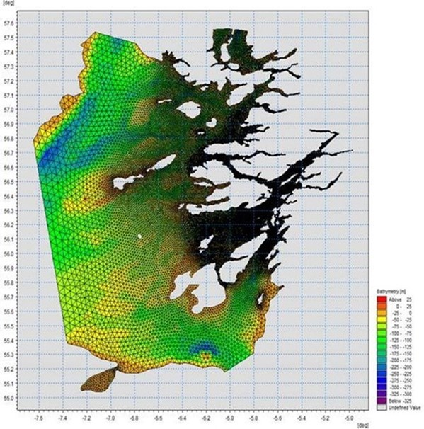
Figure 1. Wider Loch Linnhe System model grid

Dispersion and erosion capacity maps
Modelled water movement in a sea area can be used to show the capacity of the water to move and disperse discharged substances. It is also possible to show the capacity available to erode substances from the seabed. This information is a useful guide to the potential size of a marine pen fish farm at a particular location.
Marine pen fish farms using open-net pens will benefit from operating in locations where there are strong, repeating, water currents to erode and disperse waste.
Locations with average water flow speeds of greater than, or equal to, 0.12 metres per second (0.23 knots) are for screening purposes, considered generally suitable for larger farms.
A map of modelled average water flow speed for the area surrounding the proposed site is shown in Figure 2. The average water flow speed in each cell of the model grid has been assigned a shade. The darker the shading, the slower the average current speed and the lower the capacity for dispersion.
Licenced aquaculture farms in the vicinity of the proposed site are shown and discharges of material from these sites have been included in the screening modelling.

Modelled flow properties
Based on the maps of the modelled water flow properties we can make the following observations about the proposed site location:
- It lies in a high dispersion area.
- It lies in an area where water flow has a high capacity to erode material on the seabed.

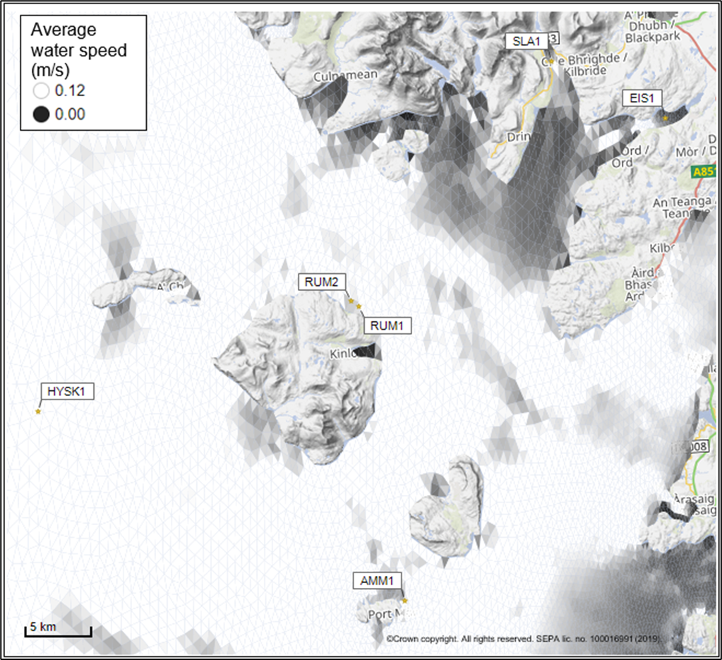
Figure 2: Modelled average water speed (metres per second – m/s) in the sea loch around the proposed site (Rum 2 (RUM2)).
©Crown copyright. All rights reserved. SEPA lic. no. 100016991 (2019).

Sediment influence maps and analysis
Modelled particles in a sea area can be analysed for each modelled grid cell and presented to show the potential influence of discharged sediment on the surrounding sea area.
Values less than 1 g/m² have been excluded from the map and subsequent calculations. These low concentration cells are produced by the particle tracking approach, but they are not considered to be representative of the main influence of a discharge.
Figures 3 and 4 show maps of the modelled average sediment intensity over one month (time average). Grid cells within the model that are influence by modelled sediment are shaded according to the intensity of the influence in grams per square metre (g/m²). Cells which are shaded purple are similar to the average and those shaded pink are similar to the median (middle value in the range) intensity value shown on the map.
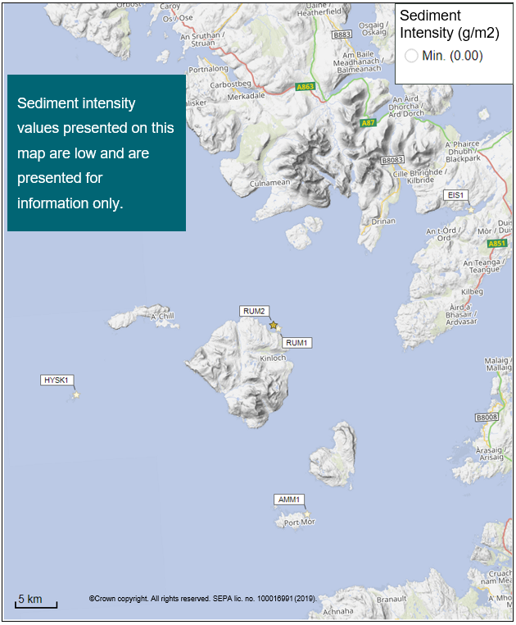
Figure 3: Modelled average sediment intensity over one month for the proposed site only (Rum 2 (RUM2)).

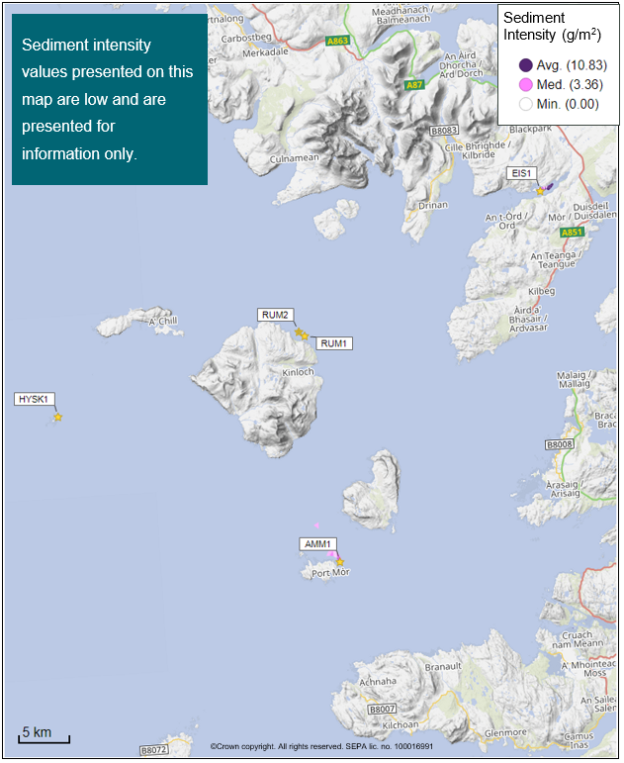
Figure 4: Modelled average sediment intensity over one month for the proposed site (Rum 2 (RUM2)) and other relevant sites.

Bath medicine influence maps and analysis
Modelled particles in a sea area can be analysed for each modelled grid cell and presented to show the potential influence of discharged bath medicine on the surrounding sea area. Results presented are for the Azamethiphos medicine.
Figure 5 shows a map of the modelled average AZA concentration over four days for the proposed site only. Grid cells within the model which experience an AZA influence are shaded according to the concentration of AZA in nanograms per litre (ng/l). Cells which are shaded purple are similar to the average and those shaded pink are similar to the median (middle value in the range) intensity value shown on the map.
Values less than 10 ng/l have been excluded from the map. These low concentration cells are produced by the particle tracking approach, but they are not considered to be representative of the main influence of a discharge.
Please note that the Environmental Standard for Azamethiphos with the lowest concentration is 40 ng/l. This must be met 72 hours after the material has been discharged. The estimate of influence detailed here is precautionary.

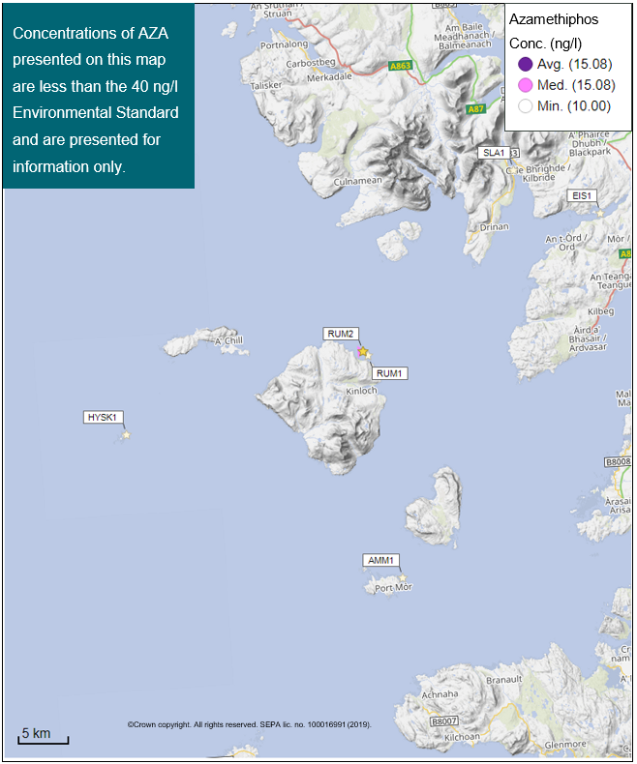
Figure 5: Modelled average Azamethiphos concentration over four days from neap tide release for the proposed site only (Rum 2 (RUM2)).

Risk Identification
The screening modelling output summarised in the screening modelling section is compared against available information on features of interest. Features which require attention are presented with any additional comments and will need to be considered during the pre-application phase.

Features of Interest which require attention
The proposed fish farm lies within the Sea of Hebrides MPA, Small Isles MPA, Inner Hebrides and Minches SAC, Isle of Rum SAC and the Isle of Rum SPA. The protected features have been assessed and those considered to be at potential risk and requiring further attention are included in table 1 and figure 6.
Table 1: Table of identified features of interest
 | Feature Name | Feature Type | Location (Easting, Northing) | Brief Reason for Identification
1. | Northern seafan and sponge communities | PMF/ MPA protected feature | 139694, 804546  139661, 804473 | At risk from bath chemicals
2. | Burrowed mud | PMF/ MPA protected feature | As determined via baseline survey | At risk from solids deposition (to be addressed with NewDepomod)

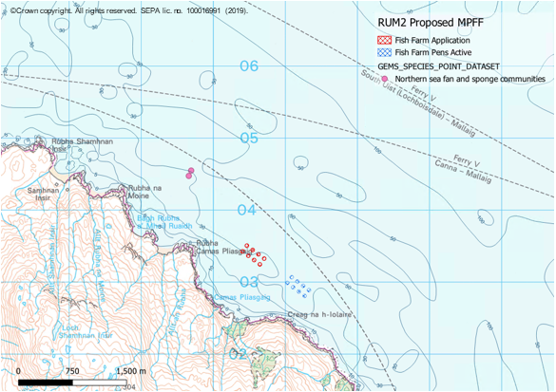
Figure 6: Protected Marine Features in the vicinity of the proposed site (RUM2) and the neighbouring site RUM1.

Additional comments on sediment influence
Due to the dispersive nature of this area, and the large distances between farms (with the exception of the existing Isle of Rum MPFF (RUM1)), the risk from discharges of sediment from all identified sites is considered to be low. Marine modelling of solids will not be required. However, benthic monitoring from neighbouring farm RUM1 suggests a small footprint exists underneath the pens. It is likely this could occur at RUM2 too and should be addressed with Standard ND modelling.
The risk from the discharge of sediment on the Burrowed mud protected feature will also be addressed with Standard NewDepomod modelling.

Additional comments on bath influence
Marine modelling can be used instead of BathAuto to get a less conservative bath medicine quantity. Cumulative modelling of baths with RUM1 is required, due to the close proximity of both sites.

Nutrient influence
The proximity to locational guidelines waterbodies has been assessed and not considered a risk, however an Open Water ECE calculation will still be required to ensure nutrient enhancement levels from this new farm are acceptable.

Risks identified from contextual site data
Table 2: Table of farms which should be included in any cumulative modelling.
Site Name | Location (Easting, Northing) | Biomass (Tonnes) | Last production Cycle | Include in solids marine modelling?
RUM2 | 140557, 803378 | 3000 | Proposed | No
AMM1 | 143201, 780365 | 4069 | Currently stocked (since September 2024) | N/A
EIS1 | 165232, 815801 | 1200 | No record of fish on site since they began in January 2011 | N/A
HYSK1 | 137900, 855500 | 500 | Proposed farm, currently at Pre Application | N/A
RUM1 | 141020, 802910 | 2850 | Currently stocked (since September 2024) | No

Sea Lice Screening
Sea lice screening was carried out using our standard method with the translated Scottish Shelf WLLS (Wider Loch Linnhe System) sub area model. This method is outlined in in Appendix 4 of the May 2023 second consultation document: Managing interactions between sea lice from finfish farms and wild salmonids, Proposed new regulatory framework, May 2023.

Modelled Sea Lice Concentration Map – RUM2
Figure 6 shows a map of the average modelled lice concentration over the simulated April and May period (in lice/m²) within the top two meters of the sea area. Model grid cells (triangles) are coloured according to the amount of sea lice particles within them.

Indicative Influence
The map serves as an indicative influence under average tidal and weather conditions. The focus is on areas of potential high influence for further fish track analysis within WSPZs.

Exclusion of Low Concentrations
Any grid cells with concentrations below 0.01 lice/m² are not shown on the map. This exclusion helps focus on more influential concentrations on the fish track analysis and WSPZs. However, these concentrations are not excluded from fish track exposure analysis below.

Colour Intensity, 90th Percentile and Median Concentrations
The more intense the colour in the grid cells, the closer the concentration is to the 90th percentile of all concentrations within the model cells. This brings attention to areas of higher modelled influence. The 90th percentile of sea lice concentrations is 0.1 lice/m², meaning that 90% of the concentrations are below this value. The median concentration is 0.02 lice/m², suggesting that half of the values are below this number. At baseline (before the introduction of the proposed site), the average 90th percentile concentration across modelled sites was 0.04 lice/m².

Focus Area
Screening modelling indicates that the site does not influence any WSPZ.

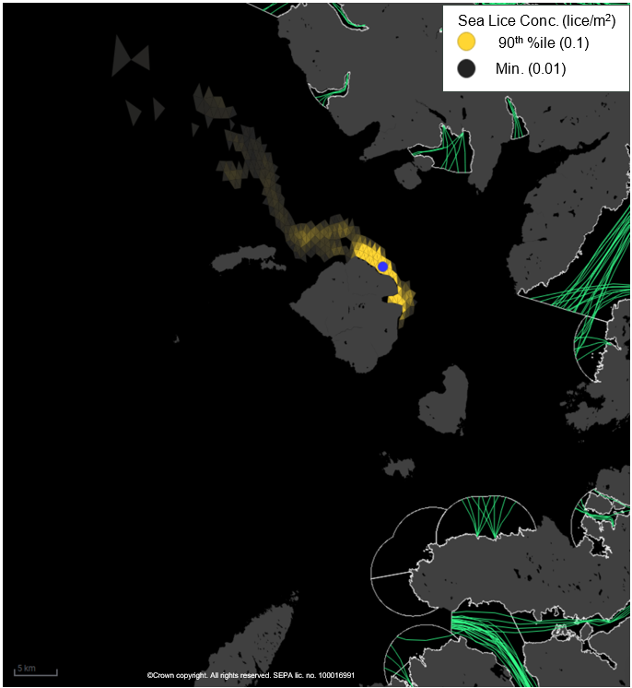
Figure 6: Map of the average modelled lice concentration over the simulated April and May period (in lice/m²) within the top two meters of the sea area. RUM2 site location shown as a blue circle. Fish tracks are shown as green lines with the WSPZs, which are highlighted by a white boundary.

Modelled Sea Lice Concentrations – Single Site Influence on Exposure – RUM2
Table 3 shows information relating to the influence of modelled lice concentrations, from RUM2 alone, on fish track exposure levels within the relevant WSPZs.
Table 3: Influence of modelled sea lice from RUM2 on exposure in the relevant affected WSPZs.
Wild Salmon Protection Zone (WSPZ) | 95th %ile of Fish Track Exposure (lice/m² days) | % of Exposure Threshold (0.7 lice/m² days)
None | None | None

WSPZ Influence
No WSPZs are influenced.

Exposure Threshold
The percentage of the exposure threshold is shown to illustrate the scale of a single site influence. The exposure influence of all sites is not simply the sum of the individual site percentages. The overlapping influence of all sites on modelled screening exposure is shown below.

Assessment Matrix
An assessment matrix is presented on page 57 of the SEPA December 2023 response to consultation feedback: Managing interactions between sea lice from finfish farms and wild salmonids, SEPA response to consultation feedback, December 2023.
Using the fish track exposure method, we establish the location of RUM2 within the assessment matrix framework of WSPZ screening capacity and site contribution. As RUM2 does not influence any WSPZ it does not have a location in the matrix. It is presented for information only.
Table 4: Location of RUM2 within the assessment matrix framework of WSPZ capacity and site contribution (for information only).
Contribution to infective-stage sea lice exposure | Remaining available capacity in WSPZ
Contribution to infective-stage sea lice exposure | Large (1) | Intermediate (2) | Little or none (3)
Negligible (A) | A1 | A2 | A3
Small (B) | B1 | B2 | B3
Moderate (C) | C1 | C2 | C3
Substantial (D) | D1 | D2 | D3
Table Cell Colour Key (Permit conditions controlling on farm sea lice levels (19th March to 31st May)
A1 to A3, B1 to B2, C1 | No sea lice limit conditions.
B3, C2, D1 | Sea lice limits proposed by the developer and used in the screening assessment.
C3, D2 | Sea lice limits derived from an appropriate modelling assessment demonstrating that the farm will not compromise achievement of the sea lice exposure threshold.
D3 | Sea lice limits derived from an appropriate modelling assessment demonstrating that the farm will not compromise achievement of the sea lice exposure threshold.

Combined Influence of RUM2 on all Wild Salmon Protection Zones
Using the fish track exposure method, we can calculate the latest combined influence of all sources on the exposure threshold within all WSPZs, including the proposed at the time of its submission.
RUM2 has not reduced the screening capacity in any nearby WSPZs.

Conclusion of Sea Lice Screening
The outcome of current screening is that this site will not require a lice permit condition. No further modelling work is required, at this time.

Conclusions

Conclusions
- According to screening modelling, the proposed site (Rum2 (RUM2)) is in an area of high dispersion and has a relatively high capacity for erosion of material on the seabed.
- The screening model provides a reasonable performance in the vicinity of the site when compared to observational data.
- Benthic monitoring at neighbouring farm RUM1 suggests a small footprint exists underneath the pens, it is likely this could occur at RUM2 too and should be addressed with ND modelling.

Recommendations and Further Modelling
Following the engagement meeting(s), this report may be revised, and this should allow the applicant to submit a method statement which address the issues raised in this document.
- Due to the dispersive nature of this site, marine modelling is not required, unless marine modelling for baths is to be undertaken.
- Should marine modelling for baths be undertaken, cumulative modelling with RUM1 is required and features at risk from bath chemicals should be examined.
- Solids modelling should be addressed by near field modelling with Standard Default NewDepomod.
- The proximity to locational guidelines waterbodies has been assessed and not considered a risk, however an Open Water ECE calculation will still be required.
- Sea lice screening has shown no effect on the exposure risk. No criteria for further work have been triggered. The outcome of current screening is that this site will not require a lice permit condition. No further modelling work is required, at this time.

For information on accessing this document in an alternative format or language, please contact SEPA by emailing equalities@sepa.org.uk
If you are a user of British Sign Language (BSL), the Contact Scotland BSL service gives you access to an online interpreter, enabling you to communicate with us using sign language. contactscotland-bsl.org

