



## IND-G-009

**EASR guidance:**

Version 1.0 August 2025

**Registration activity Coating roadstone with bitumen**

# Contents

Introduction 3

What does this guidance apply to? 3

Description of roadstone coating activities 3

Diagram 1: Overview of a roadstone coating process 4

Diagram 2: An overview of the batch process 6

Diagram 3: Overview of drum mix process 8

Environmental Controls 9

Site design, infrastructure 9

Bulk Storage 10

Aggregate delivery 10

Stockpile storage 11

Bitumen 11

Conveyors 12

Delivery to silos or totally enclosed containers 13

Delivery to trucks 13

Protection of the water environment 14

Controls to achieve good combustion 14

Combustion start-up and shutdown emissions 15

Emissions controls and dispersion 16

Emissions monitoring 17

Diagram 4: Examples of stack heights and distances 18

Abatement 19

Dust arrestment (general) 19

Dust arrestment (fitted to silos) 20

Dust arrestment (fitted to roadstone coating plant) 20

Dust arrestment (other than that fitted to silos or roadstone coating plant) 20

Management techniques 21

Maintenance 21

Operator training 22

Resource use and efficiency 23

Raw materials 23

Water 23

Waste 23

Heat 24

Energy 24

Interpretation of Terms 24

Disclaimer 27

If you would like this document in an accessible format, such as large print, audio recording or braille, please contact SEPA by emailing [equalities@sepa.org.uk](mailto:equalities@sepa.org.uk)

# Introduction

This document provides information and guidance for anyone undertaking the coating of roadstone with bitumen which may be authorised under the Environmental Authorisation (Scotland) Regulations (EASR). It should be read alongside the standard conditions for this activity.

# What does this guidance apply to?

This guidance applies to coating roadstone with bitumen.

This guidance does not deal with roadstone coating using tar or other binders. The use of tar or other binders requires a permit from SEPA.

# Description of roadstone coating activities

Roadstone coating, also known as asphalt production, is commonly used for surfacing roads, parking areas, and pathways. Asphalt is a mixture of aggregate, sand, filler, a binder (in this case, bitumen), and sometimes various additives. Bitumen is a residual product derived from the refining of crude oil.

The process design for roadstone coating can vary based on the available equipment and the specific product being manufactured. The primary methods involve either batch or continuous drying of materials, with mixing occurring in a drying vessel, batch heater, or a separate vessel. Asphalt mixes can be hot, warm, or cold bitumen emulsion mixes, with the latter being dusty and typically associated with mobile plants. The diagrams and descriptions that follow outline the Batch and Drum mix methods.

Hot mix asphalt is composed of approximately 92% well-graded aggregates, along with filler and sometimes additives. Bitumen serves as the binder that "glues" the asphalt together, comprising less than 8% of the final product. Fillers are used to fill the smallest voids and stabilize the binder.

In some applications, bitumen emulsion is used as a binder, resulting in what are known as ‘cold mixes’. The properties of cold mix asphalt differ from those of hot mix asphalt. Mobile cold mix production is similar to concrete batching, involving no heating and incorporating dusty solids.

Warm mix asphalt is an energy-efficient variation of hot mix asphalt, where not all ingredients are heated before mixing.

### **Diagram 1: Overview of a roadstone coating process**

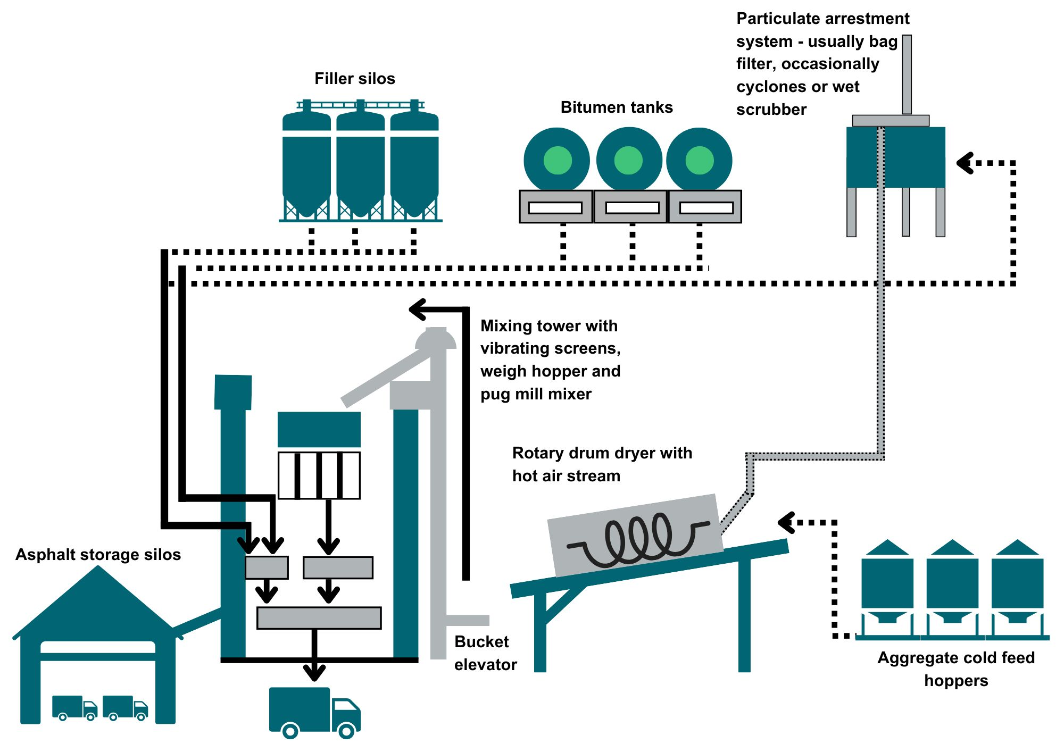

As shown in Diagram 1 on the previous page, a typical roadstone coating process includes:

* Hoppers of the cold feed.
* Aggregate heater and dryer (a rotary drum dryer shown above).
* Bitumen storage tanks.
* Filler silos.
* Mixer plant including vibrating screens, weigh hopper, pug mill mixer.
* Silos for storing hot asphalt.
* Storage of quarried stone or recycled roadstone.
* Storage of ash, concrete waste, fly ash, incinerator ash where they are to be used in the road stone coating process.
* Dust arrestment system, usually a bag filter, but occasionally cyclones or wet scrubber.

### Diagram 2: An overview of the batch process

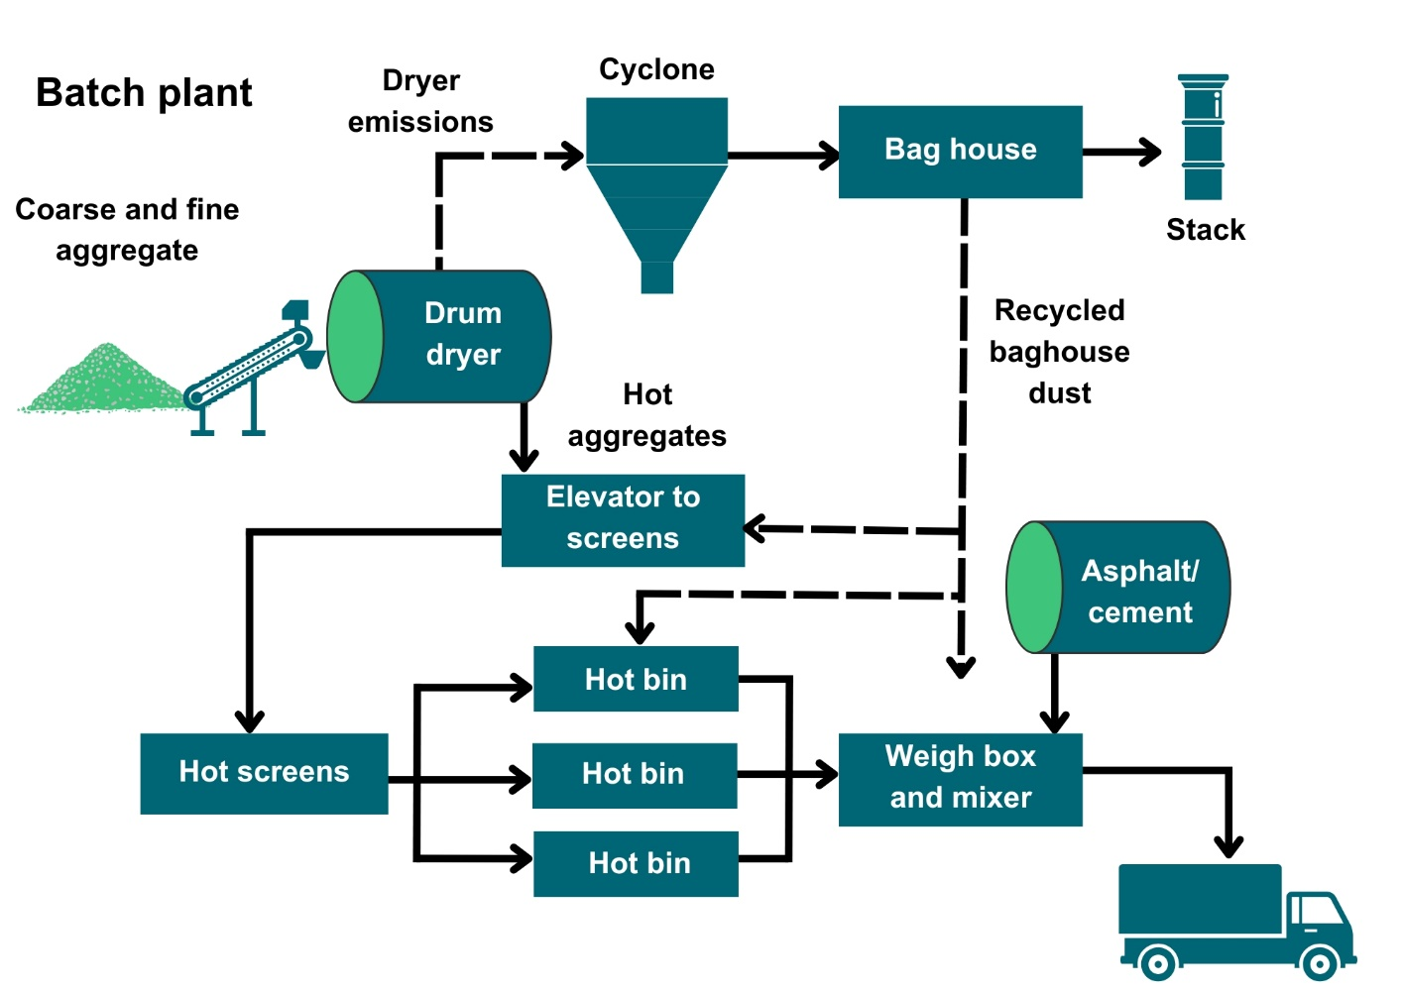

The main process method used in the UK is the batch process which can be seen in Diagram 2 above and is described below:

* Aggregates stored in cold feed hoppers in varying quantities (depending on the mix required) are conveyed into the intake of a rotary drum dryer (a steel cylinder placed at a slight angle). The drum rotates and flights placed on the inside of the drum lift the material and let it fall through a hot air stream.
* The hot air stream is usually against the flow of the aggregated material and is from a gas or oil fired burner positioned at the bottom end of the drum.
* Water vapour and exhaust air are extracted from the cold end of the drum to a dust arrestment plant, usually a bag filter, although occasionally cyclones or wet scrubbers are also used.
* The dust collected is usually fed back into the process or kept separate in a silo.
* The hot aggregates (135°C to 180°C) drop into a bucket elevator and are lifted to the top of the mixing tower.
* The aggregates are separated by vibrating screens into different grades and stored in separate bins.
* The required grade of aggregate is dropped into a weigh hopper and then to a pug mill (mixer) where it is coated in bitumen.
* Bitumen is stored in heated storage tanks which is then pumped, weighed and injected into the mixer. Mixing times vary but are generally 25 to 90 seconds, depending on the plant and mix type.
* This mix is then either transferred directly into a waiting truck for immediate delivery or stored in heated asphalt storage silos until required.

### Diagram 3: Overview of drum mix process

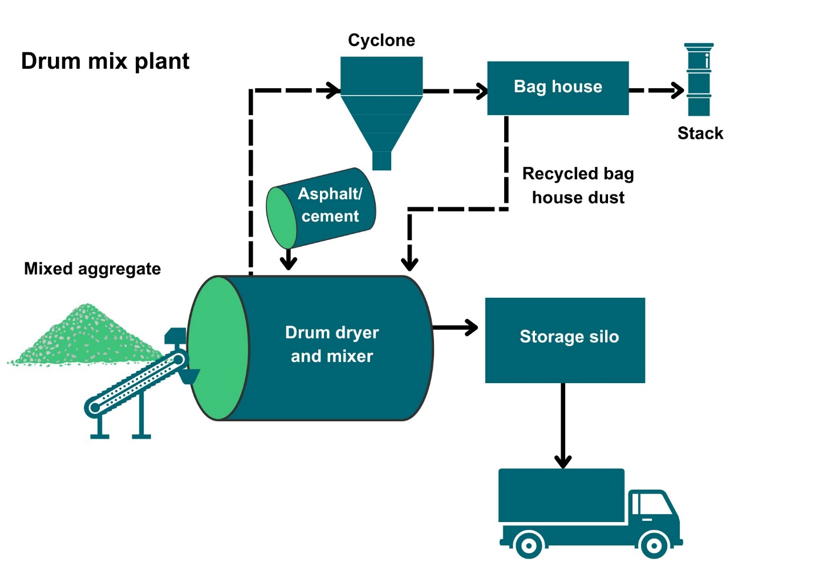

Drum mix plants are less flexible in changing mixes and are not as common, these are illustrated in Diagram 3 on the previous page.

* This differs from the batch plant method as both heating and drying of aggregates and the mixing with filler and bitumen takes place in the drum, i.e. no pug mill is involved.
* Proportional feed controls are used to ensure the correct mix is delivered to the drum.
* The aggregate is fed into the revolving drum and heated and dried by the burner gases.
* About midway along the drum, filler and liquid bitumen are injected where they mix with and coat the dried aggregates.
* From the drum, the finished asphalt is discharged to a conveyor and carried to heated storage bins.

Both processes may vary if reclaimed materials are used.

# Environmental Controls

It is expected that the methods described in this section are utilised to control emissions from the roadstone coating activities. Where other methods are used, they should offer at least an equivalent level of environmental protection.

Containment, arrestment and water suppression are considered the best ways to control dust and odour from roadstone coating and associated activities. Measures to ensure protection of the water environment from water used to suppress dust should also be implemented.

## Site design, infrastructure

* Process buildings should be as dust tight as possible and fitted with self-closing doors and close-fitting entries and exits for conveyors.
* Where local exhaust ventilation is used within a building, dust arrestment of these emissions will be necessary.
* There must be an adequate supply of water available for use as dust suppression.
* Surfaces subject to vehicle movements should have a consolidated surface which is kept in good repair.
* Thought should be given to the site layout to minimise vehicle movements and the double handling of dusty raw or waste materials.
* A wheel-wash for vehicles leaving the site may be necessary.
* Internal and external house-keeping and cleaning should be to a high standard – there should be no significant deposits of dust on or in process buildings, equipment, etc.
* Dust emissions must be prevented by either containment or enclosure of dusty processes or by suppressing dust using water.
* Spillage of dusty materials should be cleared up immediately, preferably by wet handling methods, or have dust suppressants applied if immediate clear-up is not possible.

### Bulk Storage

* Dusty materials or powders must be stored in silos, totally enclosed containers or buildings.
* Silos or totally enclosed containers for dusty materials must be fitted with:
  + A pressure relief valve.
  + A dust filter system with a suitable air flow capacity.
* The pressure relief valve and filter system on silos or containers should be checked weekly or before a delivery takes place, whichever is the longer interval, and maintained to ensure they are fully operational and free from dust or powders to prevent blockages.

### Aggregate delivery

* Aggregate deliveries should be made in a manner that minimises fugitive dust emissions e.g. use of water sprinklers, rubber socks, or low discharge heights.
* Where a new plant is situated in a quarry it should be fed with stone directly by conveyor from storage hoppers, bays or covered stores.
* Where aggregate and other dusty materials are offloaded, appropriate dust control measures should be in place which may include:
  + An enclosure fitted with extract ventilation to arrestment plant.
  + An enclosure fitted with water sprinklers.
  + A structure consisting of at least three walls and a roof.

### Stockpile storage

* No material should be stored in the open except for:
  + Material that has been screened to remove material 3mm and under;
  + Sand.
  + Scalpings.
  + Material used for road sub-bases (commonly known as ‘MOT material’) that has been conditioned before deposition.
  + Crusher run material or blended material that has been conditioned before deposition.
* Stockpiles of aggregates and dusty materials should be sited away from the site boundary. The prevailing wind direction and proximity of neighbours should be taken into consideration.
* Stockpiles must be:
* Fully covered, or
* Shielded using wind-breaks, bunding or fencing, or
* Profiled to reduce wind-whipping.

### Bitumen

* Temperature should be controlled to ensure it is appropriate for the grade of roadstone being produced. Maximum handling temperatures are important for odour prevention. Please see [Model Code of Safe Practice Part 11: Bitumen safety code | EI - Publishing (energyinst.org)](https://publishing.energyinst.org/topics/environment/model-code-of-safe-practice-part-11-bitumen-safety-code2) for further information.
* Bulk bitumen tanks must be fitted with a high-level alarm to warn of overfilling.
* To prevent odours from bitumen storage and processing, one or a combination of the control techniques listed below should be used:
  + Fume arising from storage tank vents may be ducted to the drier burner provided it is in operation; this should combust any odour arising.
  + Emissions of bitumen fume from deliveries can be reduced by fitting ground-based pumps.
  + Where lorry-based compressors are used to discharge the delivery, emissions of odour and fume can be reduced; one procedure which can be used in some cases, when clearing hose and lines, is to use two short bursts of air rather than one long one.
  + Choose low odour bitumen, bitumen from some sources is more odorous than from others.
  + Use additives which are designed to reduce the odour of bitumen.

### Conveyors

* Where dust emissions from conveyors are visible, dust suppression equipment should be used, or the plant should be vented to suitable arrestment equipment.
* Conveyors must not be overloaded.
* Drop-heights from conveyors should be minimised.
* Discharge points from conveyors should be fitted with a chute or similar equipment.
* Conveyor belts and surrounding areas should be kept clean and fitted with an effective means of keeping the return belt clean e.g. belt scrapers fitted at all head drum returns with catch plates fitted to contain falling.
* Conveyor transfer points should be enclosed (which might include a bucket elevator) and should be ducted to arrestment equipment.
* Conveyors should be protected from wind whipping by side enclosures e.g. wind boards.

### Delivery to silos or totally enclosed containers

* Delivery of powders to silos or containers must be:
  + Totally enclosed, including the delivery vehicle.
  + Fitted with automatic protection systems and high level alarms to control the delivery of materials from tankers so that it is not possible to over-fill or over-pressurise the silo. This system should be checked one a week or before a delivery takes place, whichever is the longer interval.
* Displaced air, resulting from delivery of powder to the silo must either be:
  + Vented to suitable abatement equipment e.g. cartridge/bag filters.
  + Back vented to the delivery tanker.
* All deliveries to silo from road vehicles must only be made using vehicles fitted with onboard pressure relief valves and filtration equipment.
* During a delivery, if dust emissions from the delivery are visible, the operation must cease and not recommence until the problem is remedied.
* As the delivery ends and the material flow decreases, causing increased air flow, extra care must be taken to prevent over-pressurisation of the silo or container.

### Delivery to trucks

* Loading of dry material into trucks should be via a rubber sock type chute.
* Loading of asphalt into trucks should not create fugitive dust emissions.
* Vehicles entering or moving around the site should have exhaust pipes that do not point downwards to minimise fugitive dust emissions.
* Vehicles delivering aggregate materials should be covered or sheeted.

### Protection of the water environment

* Create buffer zones around water bodies where dust suppression activities are prohibited or restricted to prevent any potential contamination. Vegetative strips or silt fences should be used as physical barriers between the work area and water bodies to capture any potential runoff.
* Containment measures such as bunding, berms or dykes should be used around the site to prevent runoff or spillages from entering nearby water bodies.
* Areas where dust suppression is being carried out should not be sloped toward water bodies, reducing the risk of water runoff entering the environment.
* Drip pans or liners should be placed underneath vehicles or equipment used for dust suppression to catch any potential leaks or spills.
* Spill response kits and equipment should be readily available on-site to deal with any accidental releases of chemicals, water or oils that could potentially harm the water environment.

## Controls to achieve good combustion

Combustion plant may be in use for heat or as back-up/ancillary power. This type of combustion plant requires an additional authorisation either under Schedule 27 Medium Combustion Plant of EASR (plant with a net rated thermal input of between 1 and 50 megawatts) or Regulation 1 of Chapter 1 in Schedule 26 of EASR (combustion plant which generate electricity on the same site with an aggregated rated thermal input of 1 MW or more). You can find out more information on the SEPA website.

* Emissions from combustion processes should be free from smoke during normal operations.
* Waste oil (including waste oil referred to as ‘recovered oil’) must not be used as a fuel.
* Emissions of carbon monoxide and other hydrocarbon emissions should be limited through good combustion of fuel and taking steps to avoid incomplete combustion.
* Sulphur oxides must be limited by using suitable low sulphur fuels compliant with the sulphur content of liquid fuels regulations.
* Nitrogen dioxides must be limited by using a short flame, low nitrogen fuel and a low temperature in the dryer.
* Automatic fuel feed systems should be used where practical to prevent the emission of smoke and other pollutants.
* Flue gases should be recirculated to assist optimum combustion and reduce emissions of nitrogen oxides (NOx).
* The following should be managed and controlled:
  + Fuel content and its feed rate.
  + Primary and secondary air.
  + Temperature in the combustion chamber.
  + Oxygen levels.

### Combustion start-up and shutdown emissions

* The number of start-up and shutdowns of combustion plant should be kept to a minimum.
* All appropriate precautions must be taken to minimise emissions during start up and shut down.

## Emissions controls and dispersion

* Emissions from a stack need sufficient dispersion and dilution in the atmosphere so that they do not ground at concentrations harmful to human health or the environment.
* Flues and ductwork should be cleaned regularly so that a build-up of material does not affect emissions and their dispersion.
* Where dispersion is necessary, the target exit velocity should be 15 m/sec under normal operating conditions.
* To ensure sufficient dispersion which is not impaired by low velocity or deflection:
  + The stack(s) exit must be vertical.
  + A cap or restriction at the end of the stack should not be used.
  + A cone may be used to aid air dispersion.
* Emission stacks for the roadstone coating activities must have a height as follows:
* For a stack located on a building, the stack height should be greater than or equal to 3 metres above the building’s roof ridge height.
* For a stack located separately to any building, the stack height should be great than or equal to 3 metres above the ground.
* All stacks should be at least the same height of any building which is located within a distance of 5 times the uncorrected stack height.
* Emission stack height examples:
* A stack exits through the roof of a building with a roof ridge height of 6 metres. The stack will need to be tall enough to extend to at least 9m from the ground line of the building so that it is 3 metres above the roof ridge. As it exits through the roof, the stack won’t need to be 9 metres long itself, just long enough to reach a 9 metres height from the building ground-level.
* A stack stands beside the building which it serves. The building roof ridge height is 6 metres. In this case the stack will need to be at least 9 metres tall.
* In both the above cases, there is another building located within 5 times the uncorrected stack height i.e. 5 x 9 metres = 45 metres. This building has a roof ridge height of 12 metres. Both stacks will need to be extended a further 3 metres in order to have a corresponding height of this additional building.

Diagram 4 on the next page shows examples of stack heights and distances from other buildings.

## Emissions monitoring

* Dust emissions from the roadstone coating plant must not exceed 50mg/m3.
* Monitoring must be carried out:
  + At the roadstone coating stack using monitoring standard BS EN 13284-1.
  + Within the first 4 months of starting operations and then annually after that.
  + Without adding air to dilute emissions.
  + During normal operations and under stable conditions.
* The sample point should be:
  + Designed according to BS EN 15259.
  + Installed, maintained and clearly marked to ensure safe and representative collection.

### Diagram 4: Examples of stack heights and distances

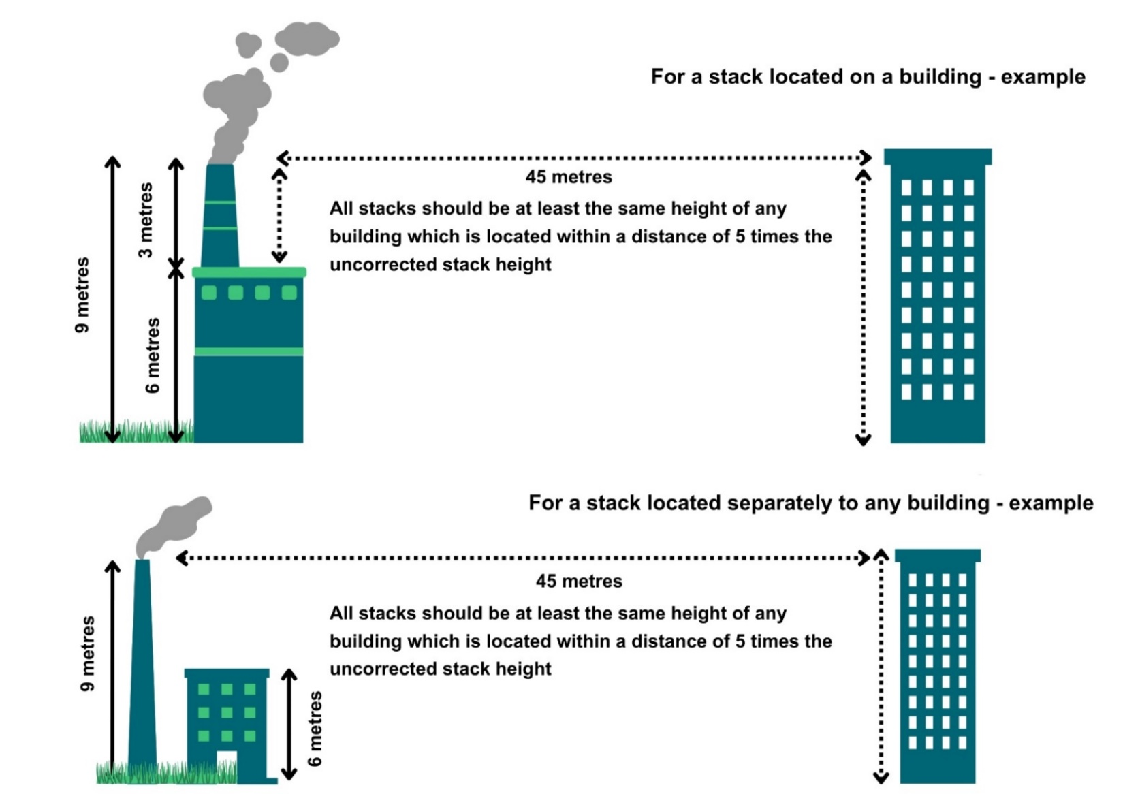

## Abatement

### Dust arrestment (general)

* Arrestment equipment should be regularly checked and maintained to ensure it is fully operational. Recommended timescales are listed below:
  + Fitted with reverse jets – at least once per month.
  + Fitted with mechanical shakers – at least once per week.
  + Requiring manual shaking - daily inspection, or prior to any delivery if deliveries are not daily.
* Reduced inspection frequency of bag filter (or cartridge) arrestment plant may be appropriate, as follows:
  + Where pressure drop sensors or other continuous monitors are used to monitor the arrestment plant; such monitors should be inspected according to manufacturer’s recommendations to ensure their proper operation.
  + Where continuous camera operation enables observation of all emission points from the arrestment plant and pressure relief valves.
  + For filters fitted with reverse jets or with mechanical shakers where operating experience has demonstrated satisfactory operation of the arrestment plant.
  + Where the process operation is infrequent.
* All hot storage bins should have level indication and any overflow chutes should have dust arrestment which feeds into the main dust arrestment system.
* The method of collection of dust from dry arrestment plant must be done in a manner that does not create dust emissions.
* Alarm systems must be provided and maintained to provide visual and/or audible notification when arrestment equipment fails or malfunctions.
* Where wet arrestment (i.e. wet scrubber) is used as abatement in the process, unacceptable emissions of droplets may occur if the linear velocity exceeds 9m/sec. This should be avoided by fitting mist arrestors, or, in existing plant without mist arrestors, reducing this velocity as far as practicable.

### Dust arrestment (fitted to silos)

* Arrestment equipment on silo inlets and outlets should be designed to emit less than 10mg/m3 of dust.

### Dust arrestment (fitted to roadstone coating plant)

* Arrestment equipment on roadstone coating plant must be designed to emit less than 50mg/m3 of dust.

### Dust arrestment (other than that fitted to silos or roadstone coating plant)

* Arrestment equipment on other plant must be:
  + Designed to emit less than 50mg/m3 of dust.
  + Fitted with continuous filter leak monitoring.

# Management techniques

Good management techniques, training and well-maintained infrastructure are key to prevent and limit the consequences of accidents which could have an impact on the environment. For example, bunding should be used around liquid storage to contain any spillages, but good management and maintenance would take this a step further by ensuring that the integrity of the bunding is checked regularly to prevent leaks, and deliveries and movements around the site are well controlled. This will enable you to comply with environmental regulations, avoid incidents, and avoid any costs incurred through loss of resources.

* Effective control of emissions starts with proper management, supervision and training for process operators.
* Implement an environmental management system to help identify and provide a systematic approach to manage, monitor and control your environmental issues and maintain efficiency. These can be certified through ISO 140001, BS8555 or EMAS but can also be in-house.
* Develop and maintain an emergency response plans e.g. specific actions for preventing and mitigating spills or runoff that may affect water bodies. For best practice and guidance [read the CIRIA Guide to Containment Systems for the prevention of pollution (C736F)](https://www.ciria.org/ItemDetail?iProductCode=C736F&Category=FREEPUBS).

## Maintenance

Maintenance can be categorised as ‘preventative’ or ‘corrective’ (also known as ‘reactive’). Preventative maintenance includes regular planned checks, servicing and maintenance of equipment to prevent or reduce failures and breakdowns which can lead to pollution incidents, safety concerns and costly downtime. Corrective maintenance includes identifying and repairing a fault once it has occurred with the aim of restoring equipment or systems to their optimum operational condition(s).

* All aspects of the activity plant, buildings and equipment should be properly maintained and there should be a written maintenance programme with a record that the maintenance has been carried out.
* Equipment should be used properly, and preventative maintenance carried out and ensuring that operators know what to do in the event of an incident which may cause emissions from the activity.
* Spares and consumables should be held on site so that rapid repairs can be carried out and there is no temptation to continue operating with ineffective emission controls in place.
* Where odour arrestment equipment is installed, it should be inspected at least once a day to ensure correct operation and identify any malfunctions. Depending on the type of arrestment plant this should include:
  + Identification of any leaks in air handling equipment and ductwork in the case of scrubbing equipment, thermal oxidisers and other combustion equipment, the inspection should include verification of the operation of any continuous monitoring equipment, the presence of any blockages and also identification of any leaks of either odorous air or liquid.

## Operator training

* Staff at all levels need to have training and instructions as to their duties to control emissions from the activity. This should include awareness of the SEPA registration requirements and actions to take in the event of incidents that may result in emissions from the activity.
* A training record should be kept for each member of staff.

## Resource use and efficiency

Best practice for resource use and efficiency is to review and implement any potential opportunities to reduce emissions and wastes. In addition to reducing the impact on the environment, you will also benefit because resource efficiency is also about:

* Reducing costs (raw material and waste disposal).
* Maximising output of product or service from a given level of materials and energy (competitive advantage).
* Finding an outlet for surplus materials therefore removing them from the waste chain.
* Helping Scotland achieve its goal of becoming a zero waste society.
* Reducing pollution risks and avoiding reputational impacts.

Resources include water, raw materials, energy, fuel and wastes used and produced throughout a regulated process. These can be manged in the following ways:

### Raw materials

Raw material use should be managed by tracking stores and ensuring that all resources are stored appropriately to avoid contamination, spoilage or leaks. Automatic dosing equipment should be considered to ensure that optimum measured quantities are used throughout the process. LEAN methodologies that focus on reducing waste could be beneficial.

### Water

Water should be stored in adequate containers and any pipework and taps maintained to avoid leaks and evaporation. Where possible use rainwater harvesting and recycled water.

### Waste

Ensure waste is managed in line with the waste hierarchy (prevention > prepare for reuse > recycle > recover value > disposal). Segregate any waste and store appropriately to ensure that it can be managed as high up the hierarchy as possible.

### Heat

Where heat is used or generated, ensure that optimum temperatures are maintained during the process; buildings, pipes and tanks should be insulated to minimise heat loss, and where possible any heat captured and used elsewhere.

### Energy

Ensure energy is used efficiently across the site by monitoring energy use, ensuring any lighting, motors, compressors or other equipment is well maintained and working at optimum, rather than maximum, levels. Consider replacing with more energy efficient equipment during upgrades. Servicing to manufacturer’s recommendations and preventative maintenance, instead of only reactive maintenance after plant faults, are also important in ensuring equipment works optimally.

# Interpretation of terms

|  |  |
| --- | --- |
| **Term** | **Definition** |
| abatement / arrestment plant | Equipment / plant used to mitigate the effects of emissions. |
| asphalt | A mixture of dark bituminous pitch with sand or gravel, used for surfacing roads. |
| coal tar | A thick black liquid produced by distilling bituminous coal, containing benzene, naphthalene, phenols, aniline, and other organic chemicals. Asphalt waste containing coal tar is considered to be hazardous waste where the level of coal tar is more than 0.1%. Asphalt waste containing coal tar is considered to be hazardous waste where the level of coal tar is more than 0.1%. |
| dust | Suspended solid particles and liquid droplets suspended in air which may be deposited on surfaces and may cause air pollution and/or nuisance. |
| emission limit value | The mass, expressed in terms of specific parameters, concentration or level of an emission, which may not be exceeded during one or more periods of time.  All emission limit values are defined at:  (a) temperature of 273.1K;  (b) a pressure of 101.3kPa;  without correction for water vapour content. |
| environmental harm | (a) Harm to the health of human beings or living organisms,  (b) Harm to the quality of the environment, including:  (i) harm to the quality of the environment taken as a whole,  (ii) harm to the quality of air, water or land, and  (iii) other impairment of, or interference with, ecosystems,  (c) Offence to the senses of human beings,  (d) Damage to property, or  (e) Impairment of, or any interference with, amenities or other legitimate uses of the environment. |
| event | * Any accident which has caused or could cause environmental harm; or * Any malfunction, breakdown or failure of plant, infrastructure or techniques which has caused or could cause environmental harm; or * Force majeure or action taken to save human life or limb. |
| normal operation | Operation of the authorised activities excluding start-up and shut-down periods. |
| SEPA officer | an officer authorised under section 108 of the Environment Act 1995 |
| shut-down | The process of shutting down of all or part of a process within an authorised activity so that stable operating conditions are no longer reached. |
| start-up | The starting or restarting of all or part of a process following shutdown within an authorised activity before reaching minimum stable operating conditions. |
| uncorrected stack height | The stack height before any required increases in height are made to account for any nearby buildings. |

## 

## Disclaimer

This guidance is based on the law as it stood when the guidance was published.

Whilst every effort has been made to ensure the accuracy of this guidance, SEPA gives no warranty, covenant or undertaking (express or implied) regarding the fitness for purpose of, or any error, omission or discrepancy in this guidance. Reliance on its contents and the contents of any websites that are linked to or from this guidance is entirely at the user’s own risk. SEPA is not liable for any loss or damage that may come from using this guidance. This includes:

* Any direct, indirect and consequential losses.
* Any loss or damage caused by civil wrongs, breach of contract or otherwise.

SEPA reserves the right to depart from this guidance and take appropriate action as it considers necessary or appropriate. Operators are responsible for ensuring that they are compliant with the law. If necessary, independent legal / specialist advice should be sought.