



Chief Executive’s Report
September 2026

Contents

1. Introduction 2
2. Collaboration and partnership 7
3. Public Service Reform 11
4. Transformation 14
5. Focused on delivery 19
6. Spotlight on… 28

If you would like this document in an accessible format, such as large print, audio recording or braille, please contact SEPA by emailing: equalities@sepa.org.uk

Introduction
Since the last report, the Agency has continued to deliver for Scotland during a period characterised by sustained environmental pressures, significant organisational transformation and continued progress towards Public Service Reform.
Over the summer, I have been pleased to see the breadth of work being delivered by colleagues across SEPA to address Scotland's environmental challenges through innovation, partnership working and evidence-based action. Whether at a local, national or international level, this work demonstrates our commitment to protecting and improving Scotland's environment while supporting wider societal and economic outcomes.
As we move through the second quarter of 2026/27, our focus remains on delivering our core statutory responsibilities while transforming how we work. This means making better use of digital technology and data, strengthening our organisational capability, and ensuring our services remain effective, resilient and focused on the needs of our customers, communities and partners. This approach is reflected in the continued progress of our Transformation Programme, which is moving at pace from strategy into delivery and helping position SEPA to respond confidently to future challenges.
The summer period has once again highlighted the increasing impacts of climate change on Scotland's environment. Prolonged dry weather has resulted in deteriorating conditions across many catchments, with more areas moving into water scarcity as pressure on rivers, lochs and groundwater resources continues. I am particularly encouraged by the way our proactive, science-led approach has helped protect Scotland's water environment while strengthening resilience across regulated sectors during this time.
By working closely with water users, representative bodies and key partners, and through targeted regulatory interventions, we have supported effective water management, maintained high levels of compliance and helped businesses prepare for deteriorating conditions. We continue to publish weekly Water Situation Reports to highlight risks and provide data, advice and guidance to water users and abstractors. You can read more about this work later in the report.
The challenges presented by water scarcity also underline the importance of having the right data, intelligence and partnerships in place to support effective decision-making. This commitment to innovation and resilience is reflected in our award-winning Satellite Emergency Mapping Service (SEMS), which provides critical intelligence to emergency responders during environmental incidents across Scotland. Further information on SEMS and its recent achievements can be found in our 'Spotlight on' section later in this report.
The last few months have provided an opportunity to showcase the breadth of transformation activity underway across SEPA. Through our communications marking 30 years of the Agency, we highlighted how digital innovation, organisational transformation and a focus on long-term resilience are helping ensure we continue to deliver the greatest impact for Scotland's environment and communities.
I am pleased to note that our laboratories and sampling activities have successfully maintained ISO 17025 accreditation following this year's UKAS re-assessment. This achievement provides independent assurance that the scientific evidence underpinning our regulatory and environmental work continues to meet internationally recognised standards of quality and technical competence. It is a testament to the expertise, professionalism and commitment of colleagues across our laboratories, sampling teams and quality management functions.
We have also continued to strengthen our work on chemicals and emerging contaminants. Our recently updated chemicals webpage brings together key information on how we monitor, regulate and reduce the environmental impacts of chemicals, providing a valuable resource for businesses and stakeholders. It highlights key areas of activity, including our PFAS monitoring programme and work on persistent organic pollutants (POPs). You can find out more about this important work later in the report.
I was delighted that our Chief Scientific Adviser, Dr Richard Allan, was appointed as Chief Operating Officer, Evidence and Water Resilience at the end of June. Richard will lead the portfolio at a critical time, ensuring that robust science and evidence continue to underpin our work as we respond to the growing impacts of climate change and other emerging environmental challenges. With Richard now in place, we are actively recruiting for a new position within the Corporate Leadership Team for a Chief Digital and Information Officer. This recognises the critical role that digital, data and technology will play in supporting our organisational capabilities and services, our transformation programme and our future ambitions.
As I’ve mentioned, collaboration remains central to how we deliver environmental outcomes. In June, we were pleased to support the launch of the OneWater Research and Innovation Centre at Robert Gordon University, with Dr. Richard Allan contributing to the event. This new multidisciplinary hub brings together researchers, industry, policymakers and environmental organisations, including SEPA, to develop practical solutions for sustainable water management, clean water technologies and environmental resilience. It reflects our commitment to connecting research, policy and practice to address shared environmental challenges.
This initiative, together with the SEFARI Gateway Fellowship report discussed in my June report, highlights the benefits of bringing together expertise from across sectors to inform decision-making and support innovation. Both demonstrate the ambitions of public service reform in practice, showing how collaboration, research and evidence can help tackle complex challenges, strengthen environmental understanding and deliver better outcomes for Scotland's environment and communities.
Over the summer, I have had the opportunity to engage with a range of partners, stakeholders and members of Scottish Government. These conversations highlighted the expertise, innovation and shared commitment that exist across the sectors and organisations with whom we work and reinforced the benefits of working together to address environmental and public service challenges.
I mentioned in my June report that I was due to co-chair the European Heads of Environment Agencies Environmental Policy and Law Implementation Interest Group (EPLIG) meeting in Brussels. It was an insightful meeting focusing on simplification, with excellent thought-provoking presentations from colleagues across Europe. I was particularly pleased that SEPA’s John Wylie, Head of Authorisations, and Scott Crawford, Senior Manager Authorisations, were able to attend virtually to present Environmental Authorisation (Scotland) Regulations 2018 (EASR) – Streamlining Environmental Regulations in Scotland.
I was pleased to host Kersti Berge, the new Director of Environment and Forestry (ENFOR), at SEPA's Angus Smith Building on 6 July. Kersti took up the position in May, and this was our first opportunity to meet. Kersti also met with other members of our Corporate Leadership Team and received a tour of our laboratories.
Attending the Business & Biodiversity Live event in Edinburgh on 15 July provided a valuable opportunity to engage with colleagues from across business, the public sector, investment and environmental organisations. I was encouraged by the quality of the discussions, the practical examples of action already underway and the strong willingness to collaborate. I left feeling optimistic about the commitment and momentum that exists to support nature recovery and climate resilience.
August continued to be busy. It was a privilege to serve as a judge for this year's Scottish Civil Engineering Awards, delivered in conjunction with the Institution of Civil Engineers (ICE) Scotland and CECA Scotland. The exciting array of projects reviewed demonstrated civil engineering excellence in delivery and the profession's significant contribution to critical infrastructure and wider society.
I was pleased to host the Cabinet Secretary for Public Service Reform at SEPA's Angus Smith Building with our Chair Lisa Tennant, to discuss opportunities and challenges associated with reform. Further information on the visit is included later in this report.
I also had the pleasure of participating in a Royal Academy of Engineering roundtable at the University of Strathclyde, discussing the Academy’s ‘Reviving Our Ageing Infrastructure Report’. It was an excellent opportunity to share SEPA's perspective on the future climate risks facing Scotland's infrastructure, including flooding, water scarcity and other emerging climate-related challenges.
At the end of the month, I met informally with members of the new Climate Action Committee of the Scottish Parliament following their visit to see the excellent partnership work being delivered with the Tweed Forum at Eddleston Water. It was a valuable opportunity to work with Dr Richard Allan, to share our work and the outcomes we deliver for Scotland, our readiness for reform, and our role as Scotland’s principal environmental regulator and national flood forecasting, flood warning and strategic flood risk management authority.
On the 3 September, I met the Climate Action Committee again, this time to give evidence on behalf of SEPA to inform early consideration of the Committee’s priorities for the parliamentary session. Alongside colleagues from NatureScot, Zero Waste Scotland, Scottish Water and Scottish Environment LINK we demonstrated our collective commitment to public service reform and the delivery of better outcomes for Scotland.
Our Business Summit on 10 September focused on Enabling Business Growth: The Environmental Advantage. Held at the University of Strathclyde, it formed part of our 30th anniversary programme. Bringing together leaders from business, industry, economic development and the public sector, the event provided an opportunity to explore how environmental regulation can support sustainable growth and innovation, while showcasing the benefits of Scotland's environmental advantage.
Finally, on 1 September we welcomed the Scottish Government’s announcement, outlined in the 2026-2031 Programme for Government, to create a new, integrated national environment, nature and circular economy body, bringing together expertise to make our interventions more impactful. Further information is provided later in the report however it is vital to stress that as this ambition progresses, our work will not stop. We will continue to deliver vital services for Scotland to the highest possible standard, keeping our customers at the heart of everything we do while advancing the nation's environmental priorities.
This report showcases the achievements of our teams as they continue to serve Scotland with passion, purpose and professionalism, while delivering the transformation needed to meet future challenges.
For the future of our environment.

Collaboration and partnership
We recognise the impact of progressive partnerships and collaborative working across the public, private and third sectors, as well as with communities. We share service delivery so that we offer better outcomes more efficiently, and with a customer focus.
Partnership working supports waste compliance in Govanhill
In August, our Enforcement Officers joined colleagues from Glasgow City Council, Govanhill Housing Association and Govanhill Community Council on partnership visits to local businesses and community locations in Govanhill. The visits promoted good waste management practices, addressed local environmental concerns and strengthened engagement with businesses and community stakeholders.
The visits demonstrated strong levels of compliance, with most businesses engaging positively and no significant compliance issues identified. Partners also observed tangible improvements at several locations previously affected by waste accumulation and fly-tipping concerns, indicating that earlier interventions and ongoing engagement are helping to improve the local environment.
The activity highlights how coordinated, partnership working between SEPA, local authorities, community organisations and businesses can deliver positive local environmental outcomes, support business compliance, reduce the risk of future waste issues and contribute to cleaner, more sustainable communities.
Biodegradable Municipal Waste (BMW) ban and long-term contingency planning
In June, we worked with industry stakeholders and Scottish Government to establish a working group to consider long-term contingency plans for residual waste disposal once the BMW ban takes full effect in January 2028. Since its formation, the group has met regularly to identify and address potential resilience challenges associated with significant or prolonged Energy from Waste (EfW) facility shutdowns for those wastes in scope of the ban, as well as the ongoing need for landfill beyond 2028.
Landfill will remain essential in Scotland in the long term for contaminated soils, asbestos, water industry wastes, industrial residues and other wastes for which no practicable alternative exists, and which do not fall within the scope of the BMW ban. It is important therefore for this group to consider how the ongoing availability of landfill in Scotland can be balanced with Scottish Government policy aims and the wider regulatory risks around a declining area of waste management infrastructure over time.
This collaborative approach will help to provide greater certainty and preparedness across the waste sector, enabling operators to plan effectively and supporting a smoother transition. By proactively developing contingency arrangements well in advance of the 2028 deadline, the collaborative working is intended to help reduce operational risks, strengthen the resilience of Scotland's waste infrastructure and ensure that residual waste can continue to be managed in a compliant and environmentally responsible manner, although this is a significant task with challenging timescales.
Strengthening UK Collaboration to Tackle Waste Crime
We continue to engage with public sector stakeholders across the UK to identify and raise awareness of organised criminal activity in the waste sector and its societal, economic and environmental impacts.
Working with members of the Scottish Government’s Serious Organised Crime Task Force and the UK Joint Unit for Waste Crime (JUWC) has identified opportunities for increased SEPA participation in UK-wide enforcement campaigns. This ensures businesses and sectors involved in waste crime can receive focused multi-agency attention.
As part of this approach, officers from our Environmental Crime Team participated in a joint operation with the Environment Agency and JUWC. We visited sites in Northwest England as part of an investigation into the illegal deposit of waste at sites in Southwest Scotland. Partners remain committed to aligning resources and objectives to improve the effectiveness of enforcement activity and strengthen the collective response to environmental crime.

SEPA Engagement at Lanarkshire Partnership Against Rural Crime Event
On 16 July, officers from our Enforcement Support Team attended the Lanarkshire Partnership Against Rural Crime event at Strathclyde Park. Officers spoke with members of the public about the wide range of work undertaken by SEPA, covering topics including fly-tipping, bathing waters and climate change. We were delighted by the positive engagement and enthusiasm shown by children and young people visiting the stall, many of whom demonstrated a strong interest in protecting their environment and learning more about SEPA's role.
These engagement activities are an important part of raising awareness of our work and increasing our visibility within local communities. They also provide valuable opportunities to highlight the role everyone plays in managing waste responsibly and helping to prevent illegal waste disposal and waste crime.
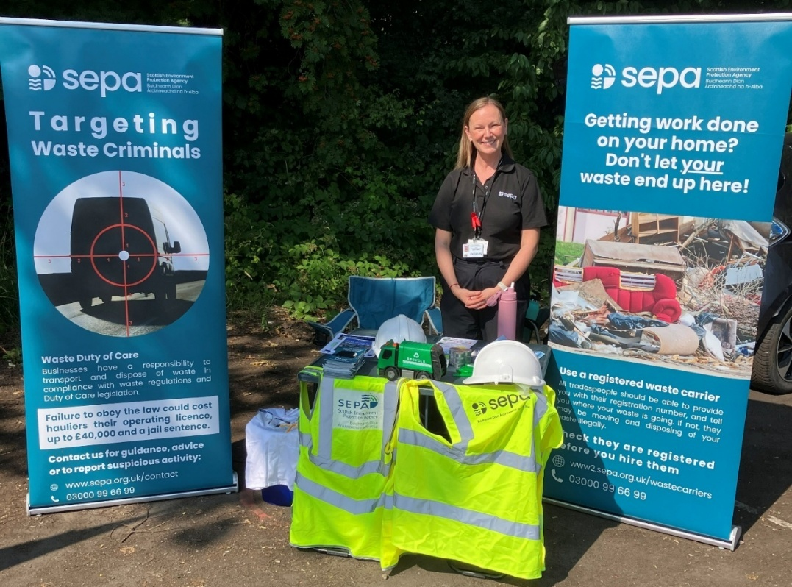
Figure 1: Lanarkshire Partnership Against Rural Crime (LPARC) event at Strathclyde Country Park. Credit: SEPA
Review of commercial recycling requirements
One of the commitments set out in the Scottish Government’s Circular Economy and Waste Route Map is to work alongside SEPA and delivery partners to undertake a targeted review of compliance with Scotland’s commercial recycling requirements. In response, we have commenced this work and identified opportunities to collaborate with local authorities in key areas to undertake targeted audits of commercial recycling arrangements.
The collaborative audit programme will provide a robust evidence base on current levels of compliance, helping to identify good practice, common barriers and areas where further intervention may be required. Findings from the review will inform a national report of compliance, due later this year. It will support the development of targeted regulatory and engagement activities to improve commercial recycling performance.
SEPA and partners win collaboration award for innovation in aquaculture monitoring
On 16 June, we were delighted to win the Collaboration Award at the UK Aquaculture Awards in Glasgow alongside our partners, Scottish Association for Marine Science (SAMS), University of the Highlands and Islands (UHI), Salmon Scotland, Technical University of Kaiserslautern, Mowi and Scottish Sea Farms. The Bacterial metabarcoding (BactMetBar) project was recognised for addressing a key industry challenge through the development of an innovative environmental DNA (eDNA) monitoring tool, with the potential to transform how seabed health beneath marine pen fish farms is monitored and regulated in future.
The BactMetBar project combined expertise from across research, industry and regulation to devise software that uses machine learning and environmental DNA (eDNA) to quickly check for bacterial diversity in the seabed and use this to predict the health of that environment. The project demonstrates how collaborative, data-driven innovation can help the sector meet increasing regulatory demands while improving efficiency, sustainability and environmental stewardship.
SEPA’s lead aquaculture specialist, Mike Montague, said: “The BactMetBar project is a fantastic example of how collaborative working can deliver solutions to shared challenges. By bringing together partner expertise, resource and data, it has developed outputs that are useful for both industry and SEPA and sets an example for future ways of working and how we adopt innovative science into our regulatory toolkit.”
SEPA has also been shortlisted in the Best Water Quality Monitoring Project category at the 2026 Environmental Monitoring & Measurement Achievement Awards (EMMAs) for this project. The awards ceremony is due to take place in September 2026.

Public Service Reform
We continue to respond effectively to the increasing pace of change. We are committed to considering the best models for delivery of all our services. SEPA has, and will continue to, work with other public sector bodies and communities to deliver services, with a focus on:
- Prevention: tackling issues early to reduce future risks and costs.
- Integration: ensuring services work together seamlessly across organisations.
- Efficiency: using resources wisely to deliver maximum value for communities.
Programme for Government
On 1 September, the Scottish Government published its 2026-2031 Programme for Government. This sets out plans to create a new, integrated and overarching national environment, nature and circular economy body for Scotland as part of its wider public service reform programme. This proposal would bring SEPA, NatureScot, Zero Waste Scotland, and potentially elements of other organisations into a new organisation.
The Scottish Government believes that as many of Scotland's environmental challenges, including climate change, biodiversity loss, pollution and resource pressures, are interconnected they could potentially be addressed more effectively through a more integrated approach.
The new body will take on the key functions of each existing organisation, integrating their expertise and authority with the aim of delivering better outcomes for people, nature, the economy, and future generations. The purpose is to remove unnecessary barriers, improve efficiency, create clearer decision-making and accountability, and make environmental interventions more impactful.
Importantly, this proposal is not a negative reflection on SEPA's performance or value. SEPA has a strong track record of protecting and improving Scotland's environment, responding to environmental incidents, providing flood forecasting and warnings, regulating industry, supporting sustainable development, and helping Scotland adapt to climate change. ​This work remains essential to Scotland's communities, environment and economy. It will remain essential throughout any period of reform.
We held an all-colleague call on the day the new environmental body was announced, followed by a programme of colleague engagement sessions and communications. A formal consultation is expected later this year, and the Scottish Government has committed to engaging with staff and trade unions as proposals are developed.
Ivan McKee, Cabinet Secretary for Public Service Reform, visits SEPA
On 19 August, Ivan McKee, Cabinet Secretary for Public Service Reform, visited SEPA's Angus Smith Building to discuss the opportunities and challenges of public service reform with the CEO, Chair and Corporate Leadership Team. During the visit, colleagues showcased SEPA's scientific expertise and innovation across laboratory and field operations and how they support better outcomes for Scotland's environment and communities. This included our advanced chemical monitoring, genomics and environmental DNA techniques, and the use of satellite imagery, drones and field technologies to support environmental protection and tackle waste crime.
The visit provided an opportunity to showcase our role in delivering environmental improvements for Scotland, the strength of our partnerships, and the progress we're making as part of a more connected public service system. Discussions also focused on how SEPA's expertise, evidence and regulatory role can help support the ambitions of public service reform. Mr McKee was impressed by the passion, expertise and commitment demonstrated by colleagues across the organisation. He recognised the value of the work already underway and was positive about the opportunities ahead as we continue to evolve and deliver for Scotland's environment.
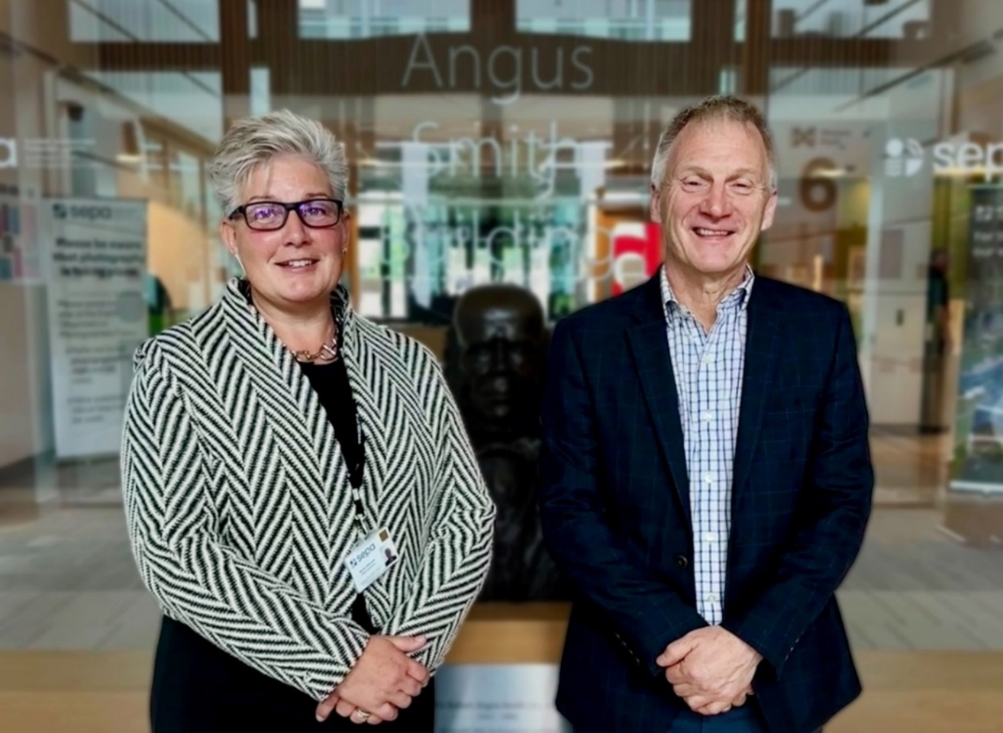
Figure 2: Nicole Paterson and Ivan McKee, Cabinet Secretary for Public Sector Reform, at our Angus Smith Building. Credit: SEPA
Delivering impact in a changing public sector
In July, we shared insights from Angela Milloy, Chief Officer, Finance & Commercial, on how public sector organisations can continue to deliver impact in an increasingly complex environment.
In the LinkedIn feature, Angela highlighted how we are responding to growing pressures and supporting the ambitions of Scotland’s Public Service Reform agenda through transformation and collaboration. From building customer-first digital services to making better use of data and evidence, we're focusing our resources where they can deliver the greatest value for Scotland's environment and communities

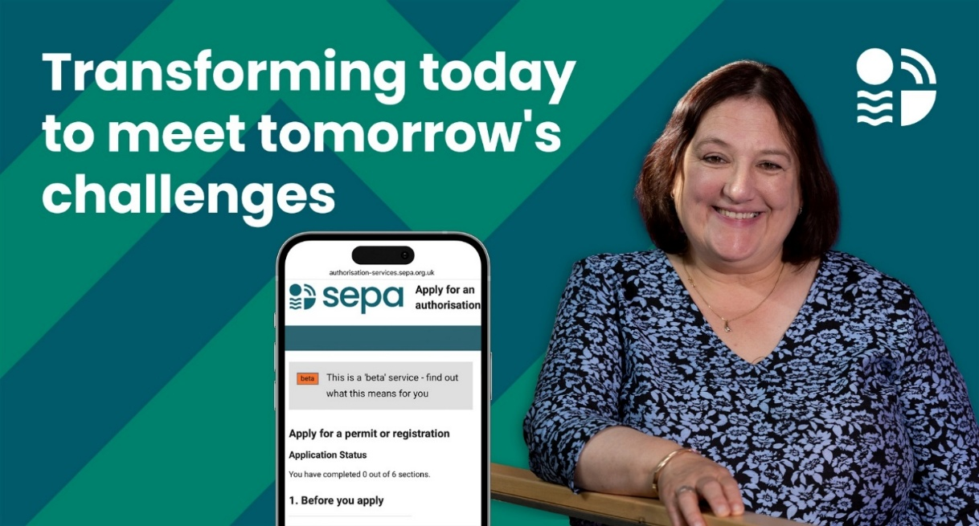
Figure 3: Image used in the LinkedIn feature showing Angela Milloy, Chief Officer, Finance & Commercial. Credit: SEPA
Lithium-ion batteries guidance
Following a recent Scottish Government-chaired meeting on the growing risk of battery fires at waste sites, we have published good practice guidance for Household Waste Recycling Centre operators on managing waste batteries and battery-containing Waste Electrical and Electronic Equipment (WEEE). The guidance aims to promote greater consistency, reduce fire risks, and help sites ensure that suitable arrangements are in place if damaged or suspect batteries are received. This is planned as part of a series of guidance documents, with separate guidance on downstream battery treatment to follow on top of the existing guidance on WEEE treatment.

Transformation
To deliver effectively for Scotland, we need to transform areas of our organisation and embed a customer and delivery focus in everything we do. Doing so will mean we can design and offer better, more resilient services that meet the needs of our customers.
SEPA's Transformation Programme: From strategy to delivery
Our Transformation Programme is moving from strategy into delivery, supporting public service reform through simpler ways of working, better use of digital and data, improved customer experience and stronger service performance. It is now focused on measurable outcomes: improved delivery confidence, reduced duplication and clearer evidence of value for customers, communities and the environment.
We are taking forward our approved Transformation Programme for 2026/27 through strengthened governance, refreshed prioritisation and a new benefits realisation framework. This is supporting a more consistent approach, clearer portfolio-level reporting and stronger leadership oversight as benefits are validated and tracked.
Key progress this period includes approval of the service review framework and outline business case for our digital transformation programme covering regulatory, customer and data services. We are also working with Scottish Government to assess digital services that could be reused by the Agency, helping us make better use of shared public sector capability and avoid unnecessary duplication.
Together, this work is strengthening our ability to deliver better outcomes for customers, communities and the environment while improving value, resilience and long-term organisational capability. It also helps position SEPA to make more deliberate choices about where to invest, where to reuse existing public sector capability and where transformation can have the greatest organisational impact.
Strengthening organisational resilience through health, safety and risk management
SEPA is delivering a broad programme of transformation to modernise health, safety, and risk management, strengthening workforce safety, organisational assurance, and operational resilience. This includes the introduction of a new digital Health & Safety Hub, providing a single, accessible source of health and safety information, guidance, risk assessments, learning resources, and assurance information.
Alongside this, digital tools are being developed to improve the management of risk assessments, training records, audits, actions, and safety documentation, supported by enhanced data quality, reporting, and performance monitoring. Together, these developments are creating a more integrated, evidence-based approach to decision-making while improving access to information, strengthening governance and reducing administrative burden.
The programme is also enhancing the identification, management, and oversight of operational risks. Strengthened risk assessment arrangements, improved assurance processes, and the development of a new framework for work undertaken in, on or near water are critical components. Reviews of lone and remote working arrangements are ensuring controls continue to reflect changing operational activities and emerging risks. We are strengthening asbestos governance arrangements through improved oversight, monitoring, and competence development. Finally, expanded provision of personal protective equipment and improved visibility of workforce training and competence requirements are further supporting employee safety and wellbeing.
Developed in collaboration with operational teams, managers, employee representatives, and subject matter experts from across SEPA, these improvements are helping to embed consistent approaches and strengthen the collective ownership of health and safety. By bringing together information, systems, assurance activities and governance arrangements, SEPA is creating a more connected and resilient approach to managing risk. This is enabling the organisation to deliver its environmental protection responsibilities safely, efficiently, and effectively.
Developing leadership capability across SEPA
We continued to progress the third phase of our Leadership Coaching programme with more than 100-line managers completing three of the six programme sessions. Participants have also received one-to-one coaching to focus on specific areas and have access to a comprehensive range of online learning resources and tools to support their ongoing development.
Feedback has been very positive, with participants reporting a stronger sense of investment in their professional development while developing new skills and benefitting from opportunities to share experiences and learn alongside colleagues from across the organisation. By strengthening leadership skills and management confidence, the programme is helping to equip managers to lead their teams more effectively, support organisational change and improve delivery of outcomes across SEPA.
Evolving how we communicate with colleagues
We continue to evolve our internal communications approach in line with industry standards and informed by colleague feedback and our organisation's maturing appetite. Our focus on Public Service Reform (PSR) and maximising efficiency is helping us provide constructive challenge where processes or customer focus can be improved.
We are moving to quarterly all-colleague calls, providing an opportunity for a high-level view of our organisation, setting direction of travel, celebrating success, acknowledging challenges and delivering some of our leadership visibility ambitions.
Our regular Transformation drop-in sessions are an important part of our overall Transformation communications strategy. As our Transformation programme continues to mature progress, we can use a wider range of communication channels to reach, engage and listen to colleagues.
We are providing professional support for online events through speaker preparation sessions, guidance materials and event hosting services. Discussion guides for the Senior Leadership Group on key topics, such as Public Service Reform, provide a consistent narrative and enable leaders and managers to set the tone ahead of important discussions with their teams.
We are also increasing the impact of our advice and guidance by offering more teams the opportunity to participate in deep dive internal communications planning workshops, helping increase understanding, support forward planning and enable collaboration across small, busy teams. This is particularly valuable where teams do not yet have a firm delivery plan in place for the year, allowing us to advise based on themes and priorities while reducing low-value transactional requests through the development of more proactive and engaging communications that deliver results.
Chemical recycling of plastics
In August, colleagues from across SEPA collaborated on a proposed permitting approach for the chemical recycling of plastics, including thermal depolymerisation and pyrolysis, under Environmental Authorisations (Scotland) Regulations (EASR). There is growing interest in chemical recycling as a complement to mechanical recycling for plastics, and Project Willow has identified it as a potential growth industry for Grangemouth. We are developing an appropriate and proportionate permitting approach for these novel technologies, with the regulatory route determined case by case according to the principal purpose and characteristics of each proposal.
Consultation on when used motor vehicles become waste
In August, we launched a consultation on an update to SEPA’s position on when a used vehicle becomes waste, particularly for insurance damaged vehicles. The proposal places more onus on operators to evidence if they consider a vehicle to be non-waste and is in line with our overarching guidance on when something becomes waste. This update provides clarity to operators on what is required of them, and to SEPA staff regulating affected operators. It is being proposed to reduce the potential for harm to human health and the environment that can arise from accident damaged vehicles, particularly while they are stored on sites awaiting insurance assessments.
SEPA provides evidence on the presence of two pet parasiticide ingredients in Scotland’s water environment
In June, SEPA provided written evidence to the UK Parliament Environment and Climate Change (ECC) Select Committee in response to their inquiry into Pet Parasite Medication. We also provided evidence to the UK Veterinary Medicines Directorate in response to their call for evidence on veterinary medicines containing fipronil or imidacloprid.
Our evidence centred around the findings from our 2024 water quality monitoring programme that used our new innovative approach to water analysis, which uses liquid chromatography coupled with high resolution mass spectrometry. This new approach has allowed us to conduct largescale analysis of a diverse chemical compounds, including pesticides, pharmaceuticals, and veterinary medicines. This also included the two substances, imidacloprid and fipronil, at the heart of the Environment and Climate Change Committee (ECC) inquiry.
Neither imidacloprid nor fipronil are listed in The Scotland River Basin District (Standards) Directions 2024 and consequently there are no statutory environmental standards for either substance in surface waters in Scotland. However, both substances are highly toxic particularly to invertebrates and have both been identified as of increasing concern in surface waters. In 2024, we monitored just under 300 locations across Scotland and analysed over 800 samples for these substances. Detection rates were lower than those reported elsewhere in the UK; however, the concentrations detected, particularly for fipronil, indicate that these substances, where present, pose a potential risk to wildlife.
Our monitoring has continued and reports and results will be published once available. Our data on fipronil and imidacloprid is enabling us to characterise the distribution of these substances, understand more about potential sources and risks. Through our partnership with the cross-government Pharmaceuticals in the Environment Group our data is helping to inform UK activities to address levels of fipronil and imidacloprid in UK waters.

Focused on delivery
SEPA is Scotland’s principal environmental regulator, and our purpose is to protect and improve Scotland’s environment. Our approach to deliver for Scotland focuses on what we do and our corporate plan priorities. We also continue to develop our approaches to communicate and engage effectively with all our customers, the public and communities.

Protect 
Bathing Waters - Collaborating to protect the environment and public health
Throughout the bathing season, we work to reduce the risk of pollution at Scotland’s 90 bathing waters and respond promptly to any pollution incidents. This work includes pre-season checks of any Scottish Water infrastructure close to bathing waters, managing pollution incidents, communicating to protect public health, and longer-term work to ensure that Scottish Water investment is targeted where improvements are needed to protect or improve bathing waters.
An example of this can be seen at Stevenston, where repeated bursts on Scottish Water's sewage rising main over the summer adversely affected bathing water quality at Saltcoats and Ardrossan. In response, a coordinated, cross-agency approach ensured that environmental and public health risks were effectively assessed, managed and communicated throughout the bathing season. This helped drive accountability from Scottish Water, protect bathing water users through a proportionate, risk-based approach, and reinforce our reputation as an effective environmental regulator.
However, significant challenges remain. Ageing infrastructure continues to hinder efforts to improve water quality, and addressing these issues requires action beyond SEPA's direct control. The advisory against bathing and paddling, which remained in place throughout the school holiday period, limited opportunities for residents and visitors to safely enjoy the coastline. This had the potential to affect local businesses and communities, impact livelihoods, reduce visitor confidence, and place additional pressure on the local economy during its busiest trading season.
We recognise the longstanding nature of the issues at this site. We will continue to engage with Scottish Water to ensure it remains focused on delivering sustainable solutions and strengthening long-term infrastructure resilience. This will be critical to reducing the risk of future incidents and protecting both local communities and the environment.
ISO 17025 accreditation successfully maintained
Following this year's United Kingdom Accreditation Service (UKAS) re-assessment visit, our laboratories and sampling activities have successfully maintained accreditation to ISO 17025, the international standard for the competence of testing and calibration laboratories. Our accreditation provides independent assurance that our scientific data and evidence continue to meet internationally recognised standards of quality and technical competence, supporting regulatory decision-making, environmental assessments and enforcement activities.
The assessment outcome was very positive, with UKAS recognising the strength of SEPA's management review process and our robust internal audit programme, both of which provide effective oversight and drive continual improvement. Excellence in laboratory and field proficiency testing was also highlighted, demonstrating the ongoing reliability and consistency of our analytical performance. We were further encouraged by the commendations from UKAS on the professionalism, expertise and commitment of colleagues across our quality management system, laboratory and sampling functions.
Persistent Organic Pollutants (POPs)
In July, we published a new webpage on our SEPA beta site, bringing together information on the regulation of Persistent Organic Pollutant (POP) wastes in a single, more accessible location. The webpage provides detailed background information on these chemicals, outlines the regulatory framework that applies to them, and signposts users to the existing, specific guidance documents previously published on POPs. This includes Waste Electrical and Electronic Equipment (WEEE), Waste Upholstered Domestic Seating (WUDS), lead-acid batteries, institutional mattresses and fire-fighting foams.
By providing a single point of access to information on POPs regulation, the webpage makes it easier for businesses, waste operators and anyone handling POP waste to understand their responsibilities and access the guidance they need to manage POP wastes safely and compliantly. This supports greater regulatory compliance, helps reduce the risk of inappropriate handling or disposal of hazardous materials, and promotes a more consistent approach across the sector.
We designed the webpage to evolve over time, allowing new and updated guidance documents to be added and providing users with links to the ongoing work on Per- and Polyfluoroalkyl Substance (PFAS) monitoring. This helps stakeholders stay informed about emerging environmental challenges and future regulatory developments.
PFAS water quality monitoring published
Per- and Polyfluoroalkyl Substance (PFAS) are a large family of man-made chemicals that have been used since the 1940s in many industrial processes and everyday products – including firefighting foam, non-stick pans, waterproof clothing, sealants and a wide range of other items. They are often called "forever chemicals" because they breakdown very slowly. They can persist in the environment and in people and some PFAS are linked with harmful health effects. Scientific understanding of the sources, environmental concentrations, and risks of PFAS in the environment continues to develop nationally and globally.
In 2025, we reviewed our approach to monitoring PFAS in the water environment and completed a pilot programme monitoring surface waters (rivers and lochs) and groundwaters. In July 2026, we published findings from our initial PFAS scoping study which was part of our 2025 water quality monitoring programme.

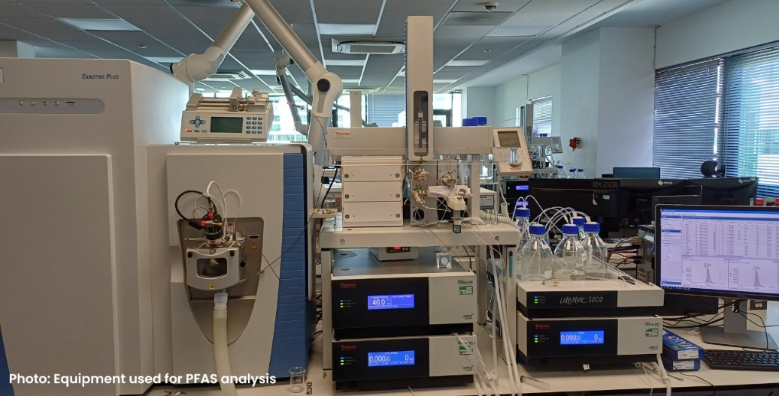
Figure 4: Equipment used for PFAS analysis. Credit: SEPA
The pilot programme covered 97 surface water sites and 37 groundwater sites and was designed to provide a clearer picture of where PFAS are present in Scotland's water environment. We measured 29 types of PFAS including those listed in The Scotland River Basin District (Standards) Directions 2024 alongside substances of emerging concern.
The programme found PFAS at just under 90% of surface water sites monitored and around 60% of groundwater sites monitored. Higher concentrations were generally associated with locations where sources are already known or expected, including activities linked to higher PFAS use or emissions, such as airports and landfills. No samples exceeded relevant environmental or groundwater standards in this initial dataset.
Monitoring will continue as part of a multi-year programme, with additional sampling planned during 2026 to further improve understanding of PFAS distribution across Scotland's water environment. Our improved data will enable us to begin to characterise the current distribution of PFAS in Scotland’s environment, support our mandatory reporting requirements, and will inform the development of regulatory approaches, further monitoring programmes and how we can implement actions set out in the recently published UK PFAS Plan.
Patersons of Greenoakhill Landfill
Since early June, we have received more than 190 complaints relating to odour impacts from Patersons of Greenoakhill Landfill.
Our officers confirmed offensive odours beyond the site boundary in June and have undertaken a programme of inspections and assessments to investigate community impacts. Where non-compliance has been identified, we have advised the operator that both the non-compliance and the resulting impacts are unacceptable. We also served a Regulatory Notice on the site in July. The notice currently remains in force and the number of complaints received has reduced in recent weeks. Engagement with the operator, local community and elected representatives remains high, with ongoing interest in the site's environmental performance and SEPA's regulatory response.
Patersons of Greenoakhill Landfill is an operational site and holds an EASR Industrial Activities Permit and continues to receive waste for disposal. We remain focused on monitoring operations at the site, assessing compliance with authorisations and taking appropriate regulatory action where required to protect communities and the environment in line with our enforcement policy.
Medium Combustion Plant Directive - completion of Phase 2
On 20 December 2015, the Medium Combustion Plant Directive came into force to reduce air emissions from medium combustion plants, helping to reduce pollutants that can impact air quality and human health. The Directive is being implemented in phases. New medium combustion plants require a SEPA permit before first use. Existing plants between 5MW and 50MW were required to obtain a permit by January 2024. Existing plants between 1MW and 5MW will require a permit before 2029.
A small project team from across SEPA worked to establish a position on a number of issues specific to permitting medium combustion plants, together with a package of guidance, procedures and templates. Our processes and policy decisions were aligned as far as possible with those of other UK regulators to ensure consistency across the UK.
As it was recognised that many of these combustion plants were operated by individuals not previously regulated by SEPA, a package of stakeholder information was developed for trade associations, environmental consultants, plant hire companies, and business sectors known to operate combustion plants. A series of social media animations and a bespoke outward-facing webpage were developed to raise awareness and provide assistance to applicants. Information notices were served on more than 550 regulated sites, requiring them to confirm details of the medium combustion plants operated on their sites.
This work generated 171 applications, which were processed by a temporary team established to address unusual and bespoke permitting situations, or cases where non-compliance with new emissions limits and monitoring standards had been identified. This commonly required the development of bespoke policy and regulatory positions.
The last medium combustion plant application was granted in July 2026, and this marks the completion of Phase 2. Planning for the next implementation phase will commence shortly where we hope to build on the experience and knowledge gained so far where SEPA is expecting to have to permit another circa 500 plants.

Improve 
Water Environment Fund: Delivering River Restoration and Improved Fish Passage
Water Environment Fund (WEF) funded river restoration projects continue to deliver improvements to Scotland’s water environment and fish passage.
Fish passage works at Ness Falls Weir on the Water of Coyle, Ayrshire, have been successfully completed. The project, delivered by Ayrshire Rivers Trust and supported through the Water Environment Fund (WEF), removed part of a concrete weir that had blocked migratory fish, opening up to 80 km of upstream habitat. Material from the weir was recycled locally, and a low-impact technique using expandable grout was employed, reducing the need for heavy machinery and building on a method previously used at SEPA’s Davington Weir project in 2025.
Work is also progressing well on the WEF-funded restoration of the Back Burn at Balbirnie Park, Markinch, in partnership with Fife Council. Upstream works have been completed, including the removal of hard engineering and weirs, and the construction of rock ramps to improve fish passage. The project has now moved downstream, where further river restoration and access improvements are underway. Completion is expected by September 2026. A recent article in Fife Today covers the restoration progress.
Strengthening an online community
We continue to mark our 30th anniversary year by sharing highlights of our transformation and how we have delivered for Scotland. In July, we reached a significant milestone on our social channels surpassing 30,000 followers on LinkedIn. Reaching this milestone is about more than numbers. It reflects the growing community that supports, challenges and contributes to conversations about Scotland's environment. It also reflects the investment we have made in our brand and content, listening to audience feedback and sharing information in a way that is understandable, engaging and impactful. Through this community, our messages can travel further and reach new and broader audiences.

Adapt 
Water scarcity
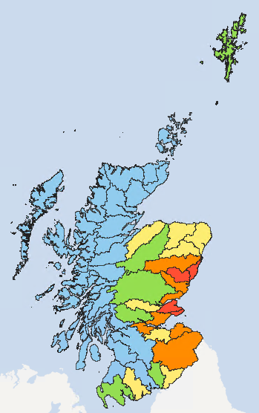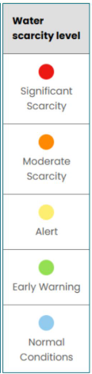
Figure 5: Map showing the water scarcity levels across Scotland, taken from the weekly water scarcity report dated 10 September 2026.
Recent rainfall has not been enough to reverse the impact of months of drier than average conditions on parts of Scotland’s east coast. Very low river flows continue across these parts with four areas currently at Significant Water Scarcity.
Our proactive, science-led response to the 2026 water scarcity season has helped protect Scotland’s water environment while strengthening resilience across regulated sectors. We have been highlighting the risks associated with 2026 water scarcity in our weekly reports.
Through early regulatory engagement with abstractors, representative bodies and key partners, including Scottish Government and Scottish Water, Scotch Whisky Association, Scottish Golf and the agricultural sector, SEPA helped to reduce pressure on vulnerable water resources, maintained high levels of compliance and enabled businesses to prepare for deteriorating conditions before restrictions became necessary. This preventative approach has supported both environmental protection and business continuity.
We have used targeted regulatory intervention and enhanced use of environmental data to enable us to improve outcomes through earlier identification of risks and more effective management of vulnerable catchments. Over 7,000 communications have been issued to water users, supported by 42 inspections that showed full compliance at sites under temporary abstraction restrictions. Proactive authorisation variations and evidence-led regulation reduced environmental risks, improved preparedness among operators and minimised the need for reactive enforcement activity.

Avoid 
What goes down the drain matters: Community action at Linlithgow Loch
At the iconic Scottish location of Linlithgow our local Environment Protection Officer has been working in partnership with the community, Scottish Water, West Lothian Council and Historic Environment Scotland, to protect the health of the water and raise awareness that many roadside drains flow directly into the loch.
Everyday activities such as washing vehicles and applying fertiliser to gardens can contribute to pollution when rain washes residues into drains. However, it is also important to remember that street drains are not for disposal of waste substances such as paints, detergents, oils or chemicals. Over time, pollutants entering the loch in this way can affect water quality and wildlife and may contribute to blue-green algae blooms.
In July, the group came together to install drainage discs to highlight the connection, provide a visible reminder, and encourage behaviour change. By working together, we are seeing how local knowledge, community pride and practical action can help prevent pollutants from entering the loch, protecting and improving the water environment.
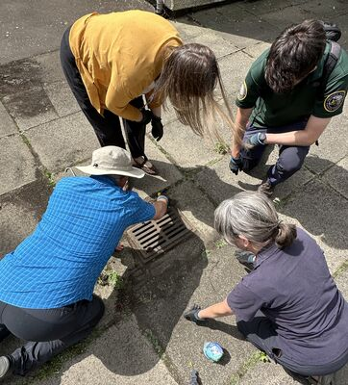
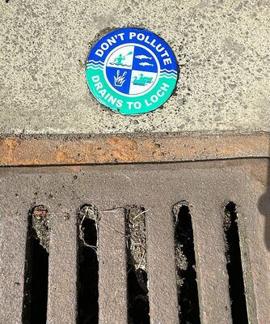
Figures 6 & 7: Linlithgow Loch drainage discs. Images showing a disc in place (figure 6) and a disc being inserted (figure 7). Credit: SEPA

Warn 
Smarter flood warnings, more resilient communities
We have continued to improve our services to help communities become more resilient to flood risk. In the Scottish Borders, we upgraded our existing forecasting models to better represent flooding at a local level and provide more targeted, community-specific flood warnings. We have also redesigned our flood webpages and simplified our messaging ahead of and during flood events.
Developed using a user-centred design approach, our new live flooding information pages have been shaped through engagement with flood-risk communities and delivered in line with the Scottish Government Digital Scotland Service Standard. The enhanced service provides a more accessible and intuitive user experience, with improved integration of water level information.
For communities, finding the relevant flood messages is now easier, with interactive maps and near real-time water level data. We have also refined our messaging based on customer feedback. 'No Longer in Force' messages are now only issued for local Flood Warnings and Severe Flood Warnings and no longer used for regional Flood Alerts. This is helping people focus on the information that matters most during a flood event.
These improvements were supported by a local campaign that engaged directly with Floodline customers to explain the changes. We also worked with resilience partners to help them understand the changes and their implications for response arrangements, and with community representatives to support local flood resilience. Working with Scottish Borders Council, we also reached local residents through the Scottish Borders alert system.
This is part of our ongoing commitment to increasing Scotland's resilience to flooding. By combining expertise in flood forecasting with a strong focus on the needs of the people and communities we serve, we're making flood information clearer, more relevant and easier to use.

Spotlight on…

Satellite Emergency Mapping Service Supporting Scotland's Resilience
Our Satellite Emergency Mapping Service (SEMS) continues to demonstrate the value of innovation and partnership working in supporting Scotland's response to environmental emergencies.
The service provides emergency responders with rapid access to critical intelligence thorough satellite imagery and specialist analysis. This helps inform decision-making when it is needed most through major incidents such as wildfires, flooding, storm damage, landslides and pollution events. Operating 24/7, SEMS brings together expertise from across SEPA, including colleagues in Resilience, Informatics, Flooding and Science, while working closely with emergency responders, government partners, international space agencies and commercial satellite providers.
Most recently, SEMS played a significant role in supporting the multi-agency response to the Glenmore wildfire in the Cairngorms National Park. Through collaboration with Police Scotland, the Scottish Fire and Rescue Service and international partners, the service provided satellite-derived intelligence including hotspot detection, burn scar mapping, smoke source identification and situational awareness products. This information helped support response and recovery activities during a complex and evolving incident, contributing to the protection of communities, infrastructure and nationally important natural assets.
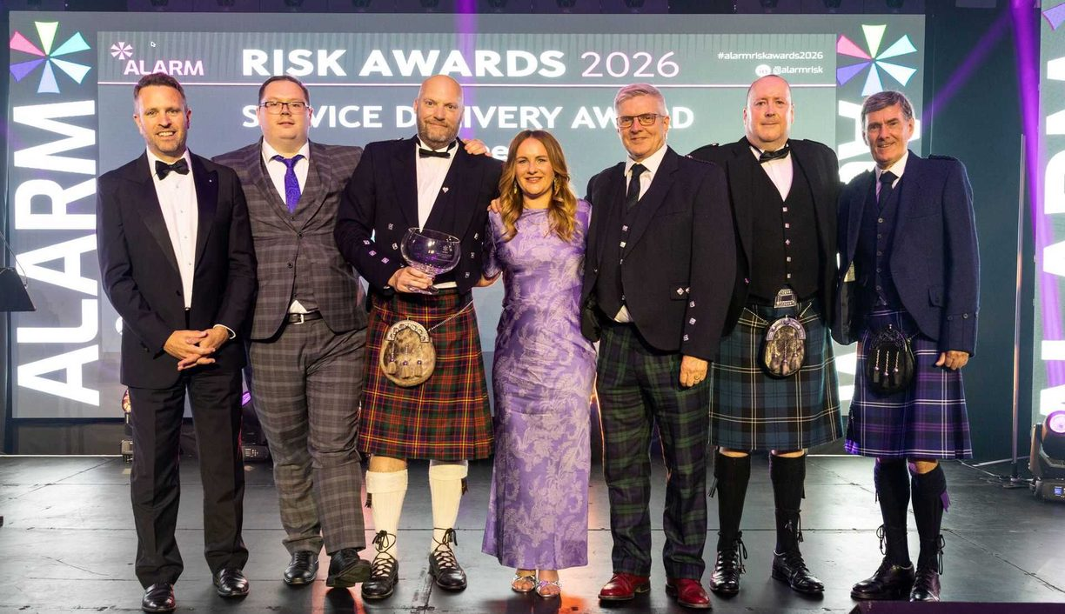
Figure 8: The SEMS team comprising colleagues from SEPA’s Resilience, Informatics and Flooding teams, receiving the Service Delivery Award at the Alarm Risk Awards. Credit: ALARM, alarmrisk.com.

The impact and success of the service have recently been recognised nationally. In July, the SEMS team comprising colleagues from Resilience, Informatics and Flooding, received the Service Delivery Award at the Alarm Risk Awards in Manchester, recognising its innovative use of satellite technology to support first responders and emergency services during emergency situations. Since becoming fully operational almost two years ago, the service has been activated for a range of incidents across Scotland, demonstrating our leadership in applying advanced technology to support environmental protection, public sector resilience and effective partnership working.
The service is an excellent example of innovation delivering practical benefits, strengthening Scotland's resilience and reinforcing our role as a trusted resilience partner in protecting communities, the environment and national infrastructure.
Nicole Paterson
Chief Executive
September 2026

