


Hydrographic Data Guidance for Aquaculture Applications
January 2024

New updates in this version
- Updated formatting for improved accessibility

Introduction
This guidance provides information on Hydrographic (HG) data submitted for modelling use under the new aquaculture framework.

It is highly recommended that this data is submitted for checking at the pre-application stage. Where data varies from these guidelines, justification for its use should be submitted alongside it. SEPA will determine on a case-by-case basis the risks associated with its use. As this data is fed into any subsequent modelling, it is important that any current meter data submitted is as representative as possible of the conditions at the site. Current meter data which is not representative may result in a modelled footprint and the determination of a passing biomass, which in reality cannot be supported by the conditions at the site.

In order to be as representative as possible, a minimum of 90 days of current meter data is now required for NewDepomod modelling. This can be a single deployment, however it is recommended several shorter deployments are undertaken and submitted for checking individually, to help prevent having to repeat a full 90-day dataset. SEPA would recommend month long deployments, but they can be shorter, with a minimum period of 15 days. Individual datasets should be stitched to form a continuous 90-day dataset, with the aim of preserving, as far as possible, the semi-diurnal (i.e. flood-ebb) and spring-neap tidal cycles. The simplest way to do this is to stitch the same phase of the tidal cycle at/near the end of one deployment to the same phase near the start of the next.

It is strongly recommended that for larger sites (>2000 t) flow data is collected on a continuous basis.
Contents
Hydrographic Data Guidance for Aquaculture Applications 0
New updates in this version 1
Introduction 1
Figures 3
Tables 4
Current Meter Standards 5
Resolution 6
Deployment Position 7
Deployment Lengths 7
Depth of Data Retrieval 8
Data Repair 8
Data processing 9
Data to be submitted for Pre – App data checks 10
For each current meter deployment: 10
For stitched 90-day datasets: 11
Data to be submitted as part of an application (at Pre-Val/ PreApp) 12
HGData Report 12
Weighted average calculations: 15

Figures
Figure 1. Figure showing weighted average calculation terminology. 14
Figure 2. Figure showing weighted average calculations for 3 deployments of differing lengths and deployment depths. 15
Figure 3. Figure showing example weighted calculations for 3 deployments of differing lengths and deployment depths. Includes example weighted calculations for near bed and surface cell height above bed. 17

Tables

Table 1: Table showing minimum standards for current meters. 4
Table 2: Table showing minimum standards for acoustic instruments. 4

Current Meter Standards
Current meters used should meet the minimum standards specified in Table 1.
Table 1: Table showing minimum standards for current meters.
 | ACCURACY | PRECISION | RESOLUTION | RANGE
Speed | ≤ 1 cm/s | ≤ 2 cm/s | ≤ 1 cm/s | ≥ 3 cm/s
Direction | ≤ 5° | ≤ 3° | ≤ 1° | 0° to 360°
Pressure | ≤ 0.05 dBar | ≤ 0.02 dBar | ≤ 0.01 dBar | ≥ 0 dBar

Acoustic Instruments should also include the minimum standards specified in Table 2.
Table 2: Table showing minimum standards for acoustic instruments.
 | ACCURACY | PRECISION | RESOLUTION | RANGE
Tilt/Roll | ≤ 0.5° | ≤ 0.5° | ≤ 0.1° | 0° to 20°
Temperature | ≤ 0.5 °C | ≤ 0.5 °C | ≤ 0.1 °C | ≤ 0° to >25 °C

Where ‘accuracy’ is the measure of the discrepancy between the value returned by a sensor and the true value.
Where ‘precision’ is the measure of the variability of the values returned by a sensor for any true value, calculated as standard deviation.
Where ’resolution’ is the measure of the smallest interval that a sensor can determine.
Where speed refers to horizontal speed; some instruments provide estimates of 3D speed precision which may be biased by the generally higher precision of the vertical speed component; the manufacturer should be contacted for clarification.

Where profiling instruments are used, they must be fitted with suitable ancillary sensors and set up carefully with respect to averaging interval, number of ‘pings’, cell size and deployment depth, to ensure that the following criteria are also met:
The height of the transducers above the bed, blanking distance and cell size should be set such that the centre of the first cell meets the near-bottom depth criterion.
Sound-speed should be determined in real-time from measured temperature and an appropriate salinity.
During deployment the device should not tilt away from the vertical to an extent that would invalidate the flow estimates – this angle is device specific, however Pitch and roll variations must not exceed 20 degrees. Any significant variations in heading, pitch or roll, will be assessed by SEPA and data following the variation may not be accepted.
Horizontal speed precision should not exceed 10% of the mean.
Acoustic frequency of the device should be chosen to return reliable flow estimates through the full deployment depth.
Please be aware that disinfectant has the potential to dissolve the rubber coating surrounding the transducer heads, causing water leakage to interfere with measurements. The effects of this can be seen in the current meter data as a significant offset with unrealistically fast flows throughout the water column. SEPA recommends current meters are checked for this issue regularly, as data with unrealistic offsets will not be accepted for use in modelling.

Resolution
The lowest acceptable temporal resolution for flow and water level measurements is 20 minutes.
Multiple deployments should share the same temporal resolution if they are to be combined.

Deployment Position
The meter should be within 150m of the centre of the site pens. If multiple deployments are used, then the mean position of all deployments should be within 150 m of the centre of the pen group. In addition, each deployment should be no more than 100 m from the centre of the nearest pen.
To obtain data representing flow in the vicinity of the pens, the meter should be in a similar depth. A desirable target is ±5m of the mean depth of the pen corners.
The mooring should be sited to avoid local currents associated with topographic features such as reefs, skerries, points and the pens themselves.
Where any of these criteria are compromised by site-specific limitations, the report should include the rationale behind the selection of the mooring site and an assessment of the degree to which the data represent current around the pen groups.
Cage corner positions and the current meter deployment positions should be measured with an electronic satellite navigation technique accurate to <25m.
Depth measurements at the cage corner positions should be collected, to an accuracy of ±0.5m. In areas poorly represented in Admiralty (UKHO) bathymetric charts, a minimum of four additional depth measurements should also be obtained. Where calibrated NewDepomod or high resolution marine modelling is likely to be undertaken, the collection of multibeam data is highly recommended.

Deployment Lengths
Deployments should be at least 15 days (i.e. 1 neap – spring tidal cycle) to allow for harmonic reproducibility and allow effective stitching of multiple datasets.
One deployment of less than 15 days may be accepted within a 90 day dataset, assuming it can be demonstrated to be sufficiently representative of conditions at the site. The shorter the dataset, the more difficult this will be.
If a shorter than 15 day dataset is used as part of a stitched dataset, the whole original dataset has to be submitted to SEPA for checking.
The longer the dataset, the more flexibility it will provide for data stitching, and the more harmonically reproducible it will be.
A margin of 5% of data (i.e. 4.5 days in a 90 day dataset), can be repeated or used without successful stitching/ preservation of harmonics.

Depth of Data Retrieval
Where water depth exceeds 15m, data should be selected to represent 3 depths:
  - Sub-surface should be as close to the surface as possible without suffering from effects such as wave breaking or side-lobe interference. In order to be representative of conditions near the surface, this should be from a depth within 5m of the lowest predicted spring tide during the deployment period.
  - Pen-bottom - at a depth corresponding to the bottom of the pens at mean sea level ±1m.
  - Near-bottom - as close to the bed as is practicable, typically 1-2m above the bed. 3m is the maximum permissible distance from the bed for near-bottom data.
Where water depth is less than 15m, 2 bins (near-bottom and sub-surface) can be used.
For profiling devices, the above measurement depths should be the centres of data collection cells (bins).

Data Repair
Data repair of up to 2% of the 90-day dataset submitted is acceptable.
Data repair methods should be briefly described. Where the processing of current data involves the removal of spikes, filtering or the repair of missing records, the affected records should be identified, and the repair method should be reported.
SEPA will assess the scientific robustness of any synthesis technique to repair missing or erroneous data and may reject data deemed unlikely to represent the flow conditions.

Data processing
All time references are to be standardized to GMT (equivalent to UTC or GPS time)
All depths are to be standardized to Chart Datum (CD)
All bearings (i.e. current data directions) are to be standardized to Grid or True North (i.e. from Magnetic North), prior to performing statistical analyses. The values of magnetic variation and grid convergence that have been used should be reported.
The datum of the positioning systems (preferably WGS84/ETRS89) should be reported, and positions converted to Ordnance Survey National Grid references (NGR relative to OSGB36 datum) via a recognised transformation algorithm.
Each flow record is also to be decomposed into orthogonal vector components (u, v) which are required for several purposes including the derivation of summary statistics, harmonic analysis and plotting.
Data should not be rounded to less than 3 decimal places.
Data following a pitch/roll change >10 degrees should be discarded.

Data to be submitted for Pre – App data checks.

For each current meter deployment:
Raw data files.
Screenshots of raw water depth (pressure), flow speed, flow direction, u and v contour plots, pitch, roll and heading plots. Where available (software dependent) signal strength, standard deviation, intensity of each beam, percent good contour plots and scatter plots for each selected bin should also be provided.
Processed data (this can be in csv format or HGAnalysis sheets, but must contain speed, direction, u and v time series, as well as summary data including major axis, mean speed, residual speed and direction), with any repaired data identified. These should follow the naming convention: ‘CurrentMeterData_siteName_Surface_DeploymentYear.xlsx’. Highlight any repaired cells and provide a brief explanation on how these cells have been repaired.
Scatter plots and speed, direction, and water pressure time series plots of processed data for each bin chosen. Harmonically reproduced time series plots should also be included/ superimposed for speed and direction.
Location (eastings and northings) of the deployment.
Water depth at the start of the deployment.
Distance above bed and cell number for each selected bin.
Time period of deployment with start and end dates.
Instrument used (type of current meter and serial number).
Information on any issues observed with the data, along with a short description explaining what is suspected to have caused the issues.

For stitched 90-day datasets:
Stitched processed datasets (this can be in csv format or HGAnalysis sheets but must contain speed, direction, u and v time series, as well as summary data including major axis, mean speed, residual speed and direction) of the combined dataset. These should follow the naming convention: ‘CurrentMeterData_siteName_Surface_90days_SubmissionYear.xlsx’
The joining of datasets should be done with the aim of preserving, as far as possible, the semi-diurnal (i.e. flood-ebb) and spring-neap tidal cycles. The simplest way to do this is to match the tidal cycle stage at the end of one deployment, with the start of the next. If stitching is not possible, a discontinuity in the tidal pattern is acceptable only where the data to be added is <5% of the 90-day submitted dataset. Alternatively, a repeat of <5% of the 90-day dataset, correctly stitched, is acceptable. Scatter plots and speed, direction, and water level time profiles of stitched processed data for each bin chosen.
Table with start and end dates and days before spring tide at start and end for each deployment (or part of deployment chosen).
Pressure data plot with stitched segments and each deployment segment marked separately.
Admiralty chart/ bathymetry map of area, including positions of each current meter deployment location, the weighted average current meter location, pen corners and cage group centre.
Weighted average of the deployment location, depth and chosen cell depths (see below for calculations/diagram).

Data to be submitted as part of an application (at Pre-Val/ PreApp)

HGData Report
Including:
Depths and locations of all deployments
Distance above bed and cell number for each selected bin for each deployment.
Summary table of flow conditions for each deployment (or part of deployment chosen), e.g. mean flow speed, residual speed, and ratio of residual to mean flow speed (in percent).
Table with start and end dates and days before spring tide at start and end for each deployment (or part of deployment chosen).
Weighted - average deployment depth and cell distances above bed, weighted by time of deployment. These should be calculated by:
Weighted average deployment depth =
Zav = ((Z1 * T1) + (Z2 * T2) + (Z3 * T3) + …) / (T1 + T2 + T3 + …)
E.g. Zav = ((20 * 10) + (25 * 30) + (30 * 50)) / (10 + 30 + 50)
= 2450 / 90
= 27.22m

Weighted average cell height above bed =
Dav = ((D1 * T1) + (D2 * T2) + (D3 * T3) + …) / (T1 + T2 + T3 + …)
E.g. Dav = ((15 * 10) + (20 * 30) + (25 * 50)) / (10 + 30 + 50)
= 2000 / 90
= 22.22m
Where:
Z = Deployment depth (m)
T = Length of deployment (days)
D = Height above bed (m)
(See Weighted average calculations section for more detail)

The site depth and cell depths for the flowmetry file are specified as negative values in NewDepomod and correspond to distances below the water surface. If the mean deployment depth is representative of the bathymetry at the farm location, the depth values should be calculated as follows:
  - Bed Flowmetry Value = (Zav - Dav Bed Cell)*-1
  - Surface Flowmetry Value = (Zav – Dav Surface Cell)*-1
  - Mid Flowmetry Value = (Zav – Dav Mid Cell)*-1
  - Site Depth = (Zav)*-1

Where the farm is over or at the edge of a steep slope, but the current meter is in much deeper water (i.e. more than 10m difference), the depth used in the bathymetry and flowmetry files should be adjusted to better reflect the water depth in the vicinity of the farm.
In these cases, the bathymetry (site depth) and near-bed flowmetry depth in NewDepomod should use the average depth (or the most representative depth) of the seabed underneath the farm rather than the time-averaged deployment depth:
  - SD = mean (or most representative) depth at site location
  - Bed Flowmetry Value = (SD - Dav Bed Cell)*-1
  - Site Depth = (SD)*-1

The flowmetry mid and surface cell depth calculation is unchanged.

Description of bathymetry at site, and an admiralty chart plot.
Brief description of general flow dynamics at site.
Instrument and configuration parameters for each deployment.
Location of cage group centre.
Locations of all current meter deployment positions and average current meter positions.
Plot showing cage configuration, all current meter deployment positions, and average current meter deployment position.
Distance of each deployment from nearest cage centre and distance of average deployment position from cage group centre. Where any of the deployment criteria are compromised by site-specific limitations, the rationale behind the selection of the mooring site and an assessment of the degree to which the data represent current around the pen groups should be included.

The HGData Report should be updated as required for every application to reflect any changes (including bins chosen to reflect cage depth).
Please note: All information submitted in support of an application will be held on SEPA’s public register.

Weighted average calculations:
Current meter cell height is defined as distance above bed (Figure 1). Flowmetry value should be taken from the depth below surface, calculated by depth of deployment minus distance above bed for each cell.
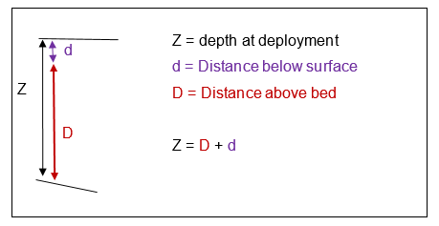
Figure 1. Figure showing weighted average calculation terminology.
Weighted - average deployment depth and cell distances above bed (for each extracted cell), need to be weighted by time of deployment (Figures 2 & 3).

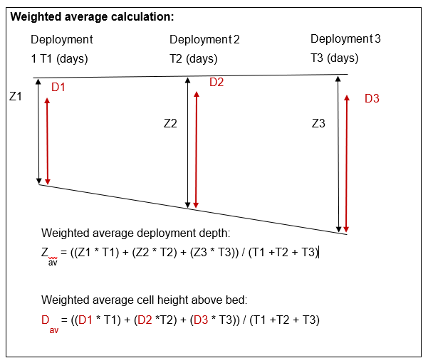
Figure 2. Figure showing weighted average calculations for 3 deployments of differing lengths and deployment depths.
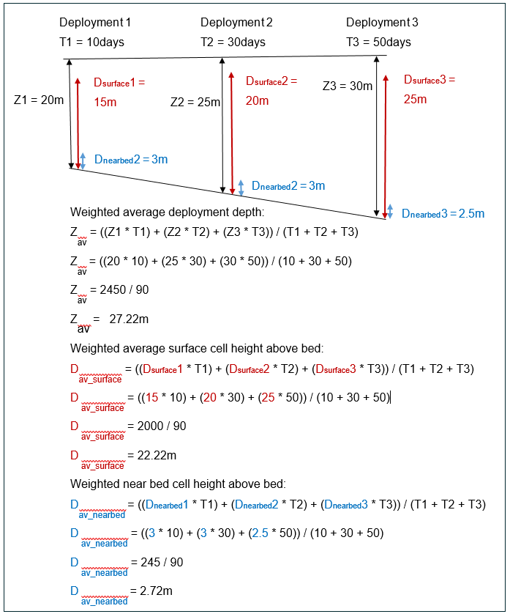
Figure 3. Figure showing example weighted calculations for 3 deployments of differing lengths and deployment depths. Includes example weighted calculations for near bed and surface cell height above bed.

For information on accessing this document in an alternative format or language, please contact SEPA by emailing equalities@sepa.org.uk
If you are a user of British Sign Language (BSL), the Contact Scotland BSL service gives you access to an online interpreter, enabling you to communicate with us using sign language. contactscotland-bsl.org

